Energy Industries of Ohio (EIO) Team Weekly Status Report

Report covers the NCSX Modular Coil Winding Form Activities Under Production Contract S005242-F

Week ending May 5, 2006

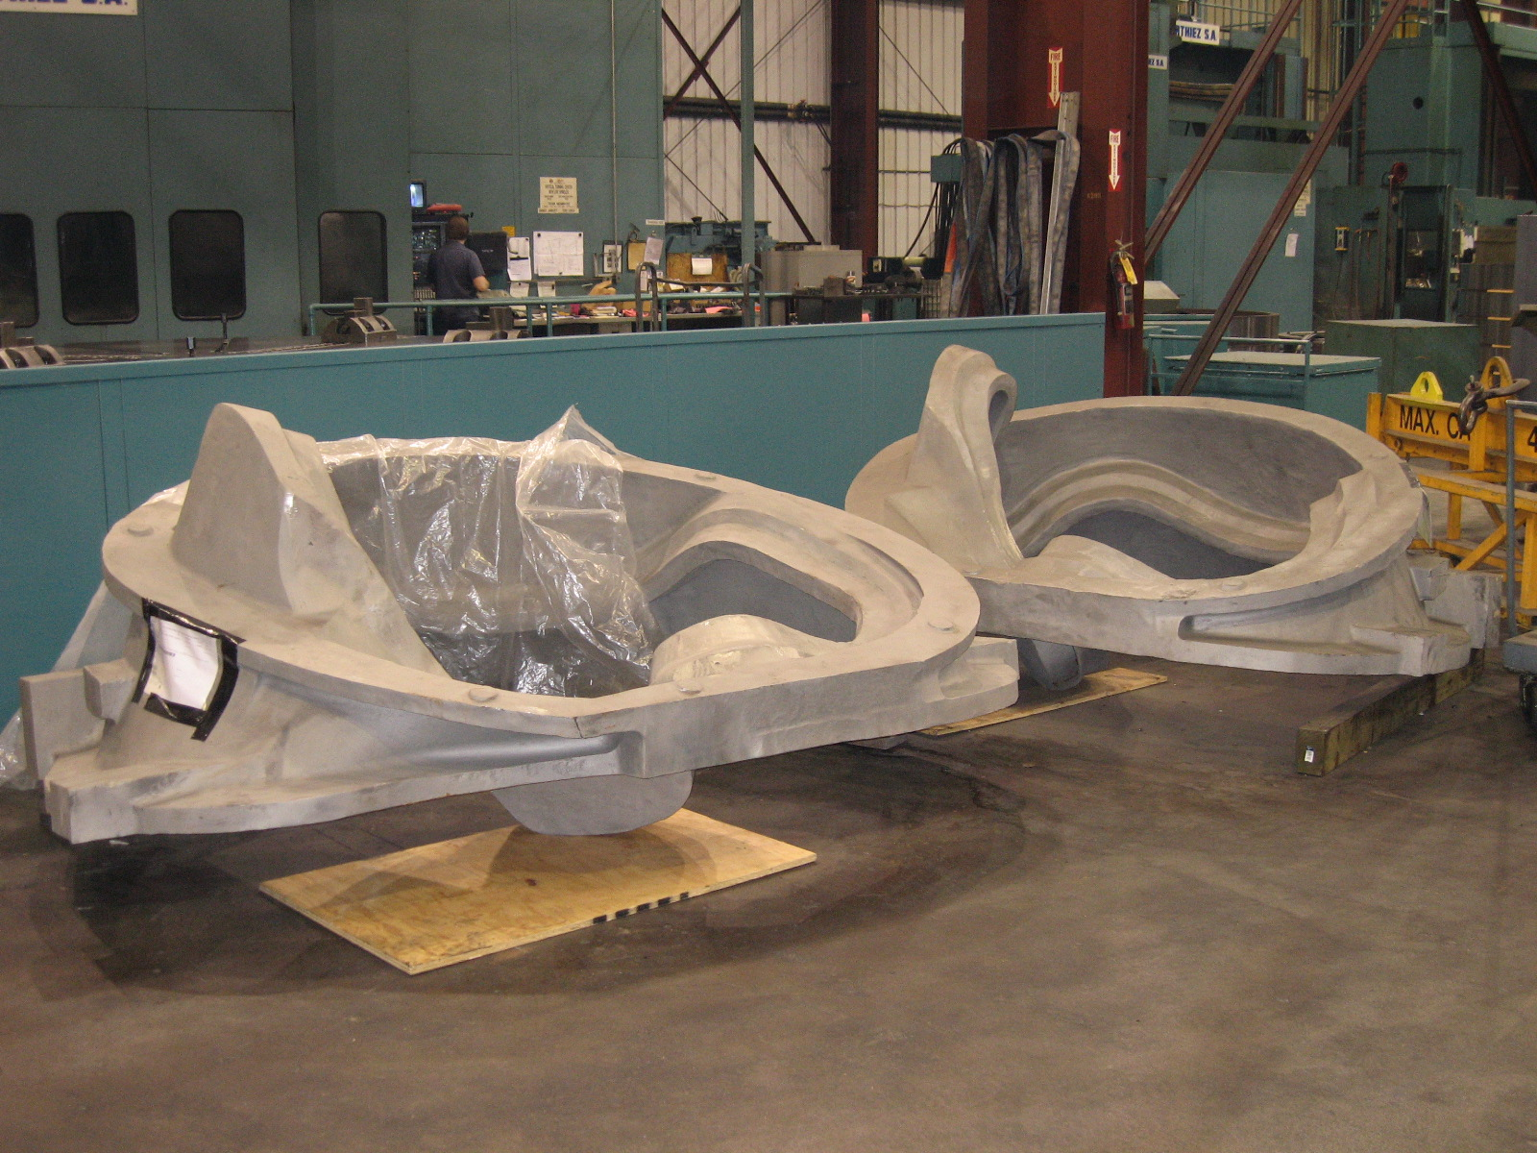

B-1 and B-2 Staged for 40T Lucas

Administrative Highlights

On 5/3, EIO completed and submitted the monthly report. It is worth noting that despite the many challenges reported each week, the team is adhering closely to our schedule goals, as outlined and agreed to with PPPL in February. We have succeeded in delivering one winding form to PPPL each month and continue at roughly that pace. We completed the last of the 18 pours in April and are on-track to complete foundry activities by June 30. PPPL has shared the results of their early inspection and winding activities with the team and where possible, the team has made adjustments to facilitate PPPL activities. We were told that C-5, which was received at PPPL on 5/1, has had the fewest problems yet and has moved expeditiously into the winding area. With delivery of the next casting, we hope to have the ferromagnetic contamination problem completely resolved.

And with that goal in mind, the team continued our investigation of the magnetic permeability issue with a team telecon on 5/1. Detailed notes on this topic are included under QA Highlights and were shared with PPPL at the QA telecon on Tuesday 5/2. Plans are underway for MTK and EIO to travel to MTM the week of 5/15.

We learned Friday, 5/5 that PPPL has found a secure indoor storage area to house all three patterns. Phil Heitzenroeder advises that they are coordinating the plan in-house and will provide direction when approved.

FTP Postings this week
(found at: ftp.atc-inc.org:/PPPL/shared_info)
Location | File Name | Date
\Quality_Review\Open_NC-CA-RFD | CA1671A-65-5-06.pdf | 5/7/06
\Quality_Review\Closed_NCR-CA-RFD\NC | PPPLcoverltr4-29-06NCR19713.pdf | 5/7/06
\Quality_Review\Closed_NCR-CA-RFD\NC | SignedoffNC19713_C5IDC_Tgrind.pdf | 5/7/06
\Quality_Review\Closed_NCR-CA-RFD | Iso_car041006_signed.doc | 5/7/06
\Quality_Review\Closed_NCR-CA-RFD\NC | PPPLcoverltrforNC19587.19718.pdf | 5/7/06
\Quality_Review\Closed_NCR-CA-RFD\NC | SignedoffNC19718_C5_cleanup.pdf | 5/7/06
\Quality_Review\Closed_NCR-CA-RFD\NC | Updated_signedNC19587PTaftergrinding.pdf | 5/7/06
\Quality-Meeting_notes | PPPLQualityNotes5-1-06.updated | 5/7/06
\Photos\A1 | CA1625_PicturesofDatumDaftermachining5.5.06.pdf | 5/7/06
\Reports_Weekly-Monthly\Monthly | Milestone_Schedule_for_Monthly_Report_5.2.06.xls | 5/3/06
\Reports_Weekly-Monthly\Weekly | 06-04-28_eio_wk.doc | 4/30/06
**note – file names may be changed from the original for clarity

Administrative Action Items
- (EIO, MTK) List of additional changes desired by PPPL for machining on C-2 and beyond, as covered on 10/13 & 10/14
Status: (Open) Amendment 11 was executed by PPPL and EIO to accomplish the desired changes. Since that time, the use of bearing plates, (part of this amendment) resurfaced, as none of the acquired plates met permeability requirements. Under the direction of PPPL Change Order 1, MTK is casting new bearing plates which will be machined by MTM. Previously procured/rejected plates will be shipped to PPPL when new plates are available. PPPL issued Amendment 13, definitizing this change, on 4/19/06 and EIO issued subtier contract amendments to MTK and MTM on 4/20. Still waiting signed agreement from MTK, at which point EIO will sign and return amendment 13 to PPPL. As of 5/5, Joe Edwards is investigating - thought it was signed.

- (PPPL) Pattern Storage after six castings have been delivered to MTM.

Status: (Open ) Resequencing of machining the C coils means that the C pattern will need to be stored for an extended period and outdoor storage is not an option. PPPL has identified a suitable indoor location in their motor generator building and is processing the necessary paperwork to direct the EIO team. The “A” and “B” patterns are also ready for storage and similar disposition from PPPL is sought. On 5/5, Phil Heitzenroeder advised that PPPL is making progress arranging for an on-site, indoor location for all three patterns.

- (EIO) Submission of monthly report for April

Status: (Closed) Report was submitted 5/3.

- (PPPL, EIO, MTM) Return of shipping crates to MTM

Status: (Open) On 5/2, MTM inquired about whether the shipping crate for C-4 had been loaded on the truck for return to MTM when C-5 was delivered. Phil will investigate and talk to Larry Sutton. Also, Mike Griffith requested that sides of the crate be returned as well. Phil made a note.

Technical Highlights

C-5
The casting was received at PPPL on 5/1 and by the end of the week - 5/5, Phil informed us that it had processed faster than all the others and was already over in the winding area. It appears that all of the coordination and collaboration prior to shipment was a success. PPPL did advise that they found some 30 spots registering high permeability, adding that the spots were easily cleaned away.
A-1

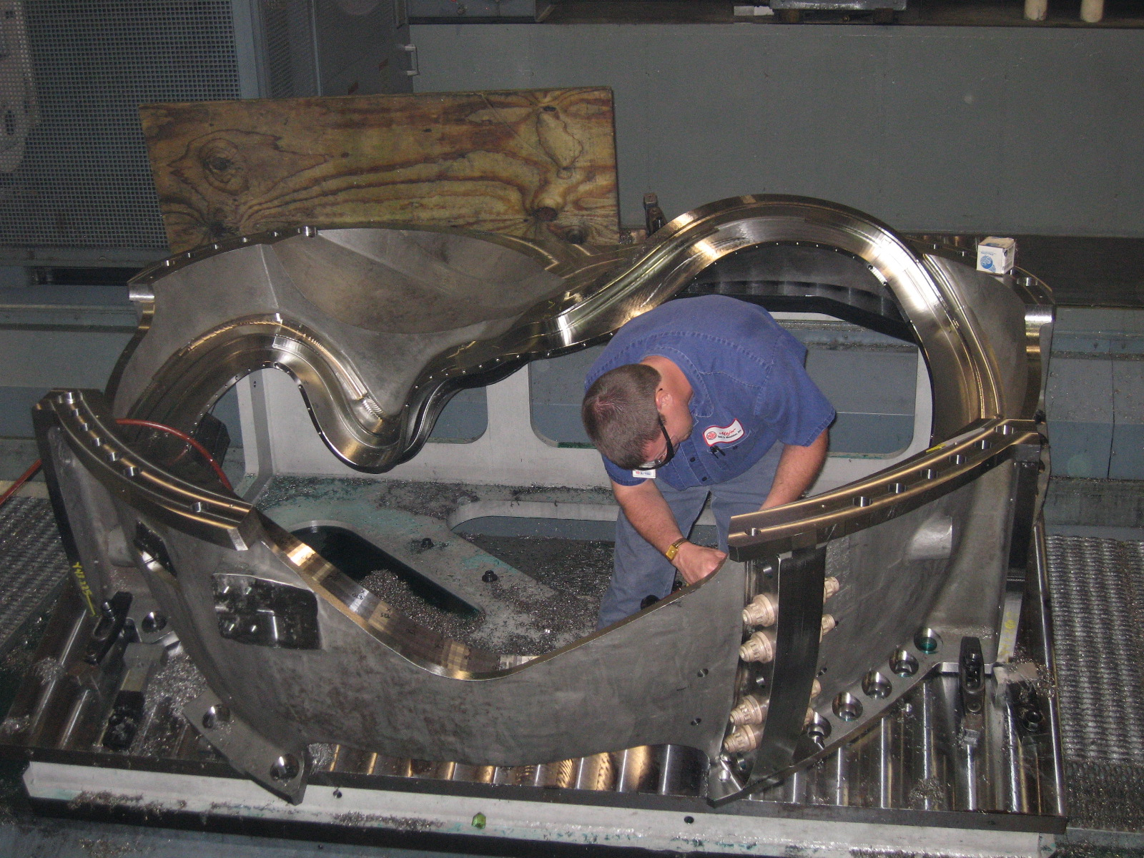
A-1 on U5, Op 1 of 3 complete

This week we were reminded that in addition to the learning curve experienced during machining of the C’s, there is now additional required learning as we complete machining of the first of the A series. Machining of A-1 on the U-5 continued to move along well this week until Thursday, when it was discovered that counterbore holes in the Tee section were measuring random depths (some too shallow, some too deep and some just right!). The root cause was not immediately known, but the problem was not caught in Vericut.

On Friday morning, EIO & MTM initiated a telecon with PPPL/ORNL to discuss and determine the best method to proceed. The holes and corresponding depths were mapped and submitted for review. Mike advised that MTM would re-drill shallow holes to appropriate depth. After discussion with NCSX, MTM also agreed to a corrective action that would entail drilling holes exceeding the requirement to a consistent depth. MTM will manufacture an insert which will then enable PPPL to utilize existing hardware. A full description of the proposed plan will be documented by MTM on a Non-conformance/corrective action report and submitted to EIO/PPPL for approval. Using the rapid response, PPPL provided input on the appropriate modified bushing.

A-2
3-axis machining of A-2 progressed very well this week and despite the reported loss of two days last week, it is very probable that MTM will be able to reach the 4 week machining goal for the A’s. This week’s progression on the part is reflected in the photos below.

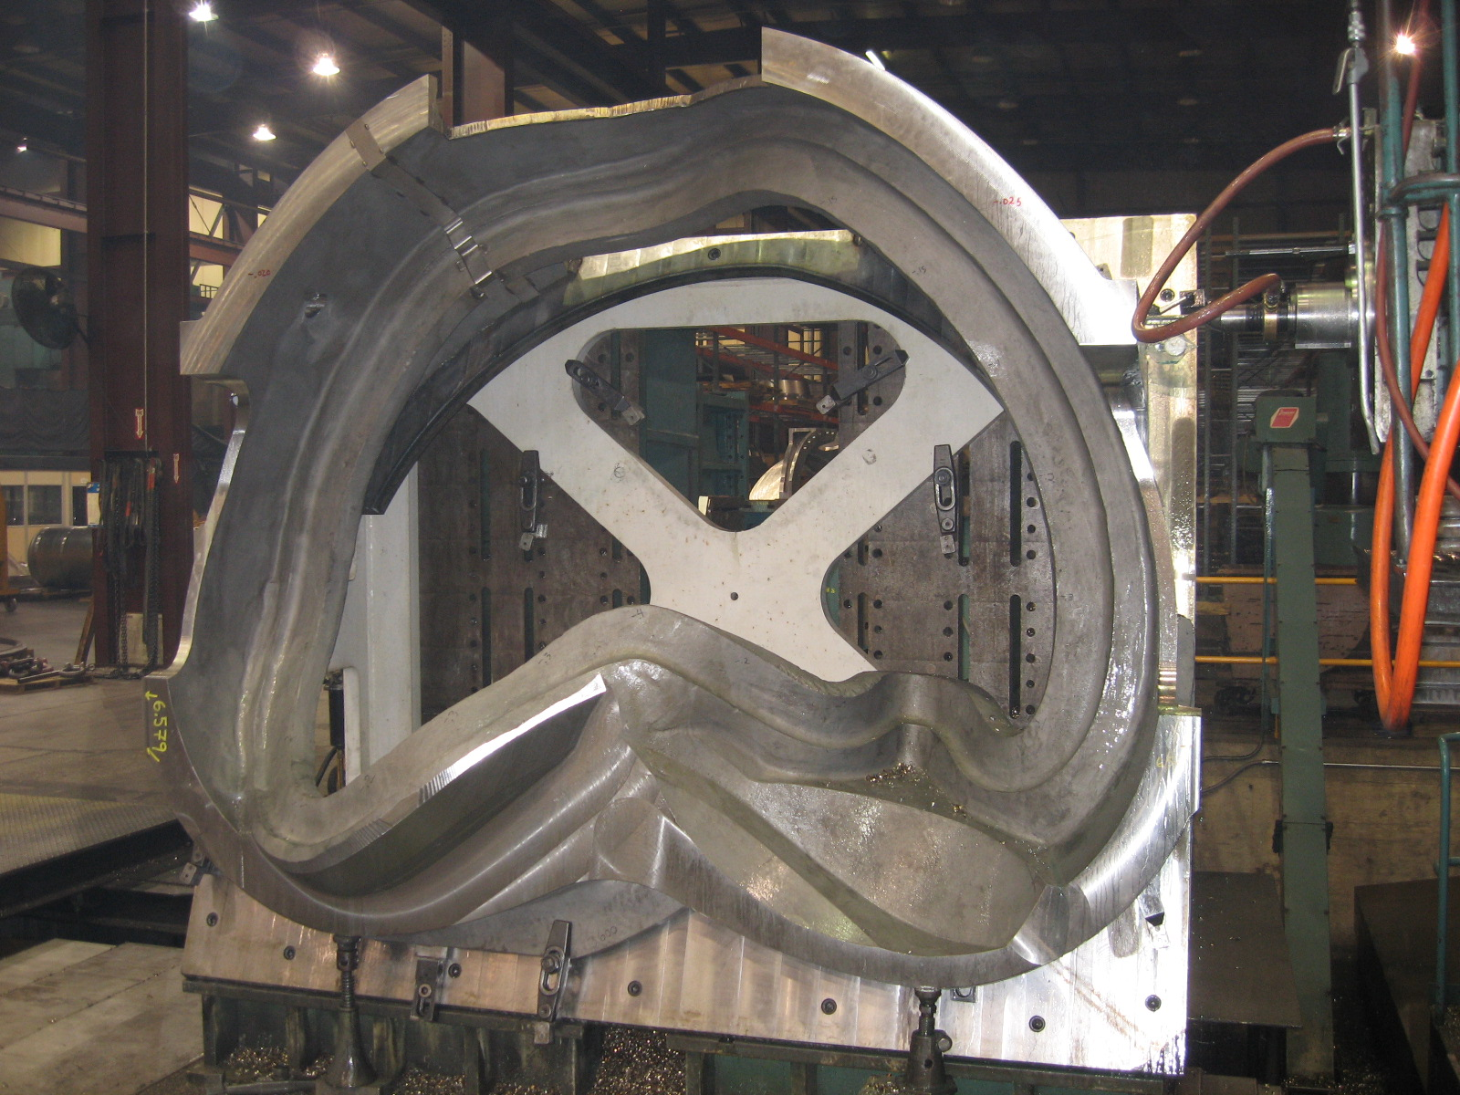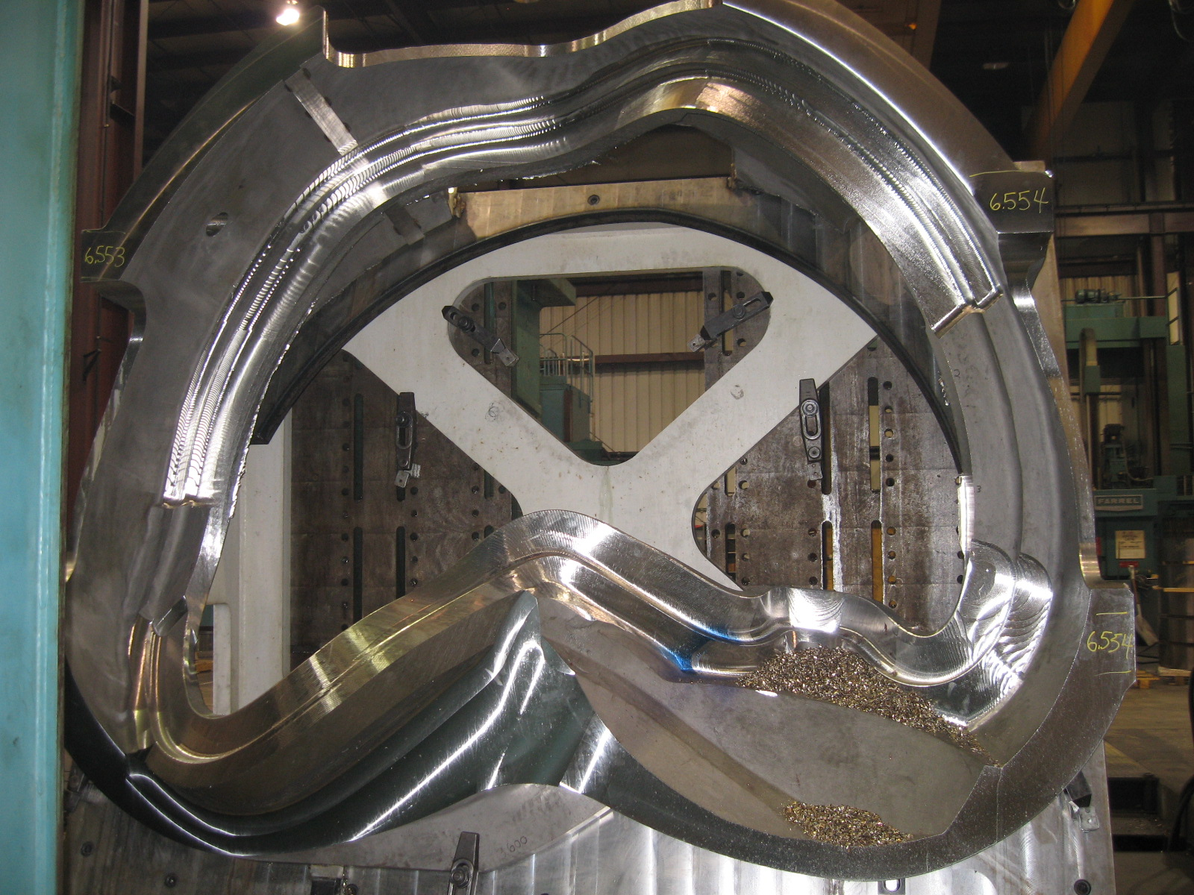
A-2 on Mitsubishi 4/28 A-2 on Mitsu 5/5

C-6

Both operations planned for C-6 on the Lucas were completed this week and C-6 has been moved off the center and back into storage.

B-1 & B-2

As reflected in the upfront photo of this report, B-1 and B-2 are staged and ready to commence machining. The problems with A-1 have set back the start date for putting the parts on the 40T Lucas, as they require the same fixture currently in use on A-1. Assuming that all goes well with the corrective action on A-1, MTM will be machining these parts on Monday, 5/8.

B-3

B-3 was scheduled to return from X-ray on 5/5. The part will be heat treated next week and pending successful outcome of final inspection, MTK hopes to ship by the end of the week.

B-4

Chuck Ruud submitted the first weld-map for B-4 this week. As of 5/3, only nine (9) initial welds were required. By Friday, 5/5, the part was being weld repaired and Barry Craig reported that he intends to send the part back to MQS next week for X-ray. This part continues to progress on schedule.

B-5

Heat Treat was completed and B-5 was sent to MQS for X-ray. It is expected back from X-ray next week.

B-6
As of Friday, 5/5, B-6 was completing Arc. Plans are in place to commence grinding next week. The part will be sent to X-ray the week of the 15th.

Bearing Plates

Barry Craig, MTK, reported that the A style bearing plates had passed X-ray and were shipped to MTM late in the week. The patterns for the B/C style plates had been modified and the pour was scheduled for late night 5/5. MTM should be able to include the new hardware on upcoming castings.

Technical Action Items

- (PPPL) Receipt & Inspection of C-5
Status: (Closed) Part received on 5/1. In winding by 5/5.
- (Major Tool) Machining C-6
Status: (Open) Completed both ops on the Lucas. Back in storage

- (Major Tool) Machining of A-1
Status: (Open) On U-5
- (Major Tool) Machining A-2
Status: (Open) On Mitsubishi
- (Major Tool) Machining A-3
Status: (Open) On deck for Mitsubishi

- (Major Tool) Processing B-1
Status: (Open) Going on Lucas 5/8
- (Major Tool) Machining A-4
Status: (Open) Staged for Mitsubishi
- (Major Tool) Processing A-5
Status: (Open) On-hold
- (Major Tool) Machining A-6
Status: (Open) On hold
- (Major Tool) Processing B-2
Status: (Open) Staged for Lucas
- (Metal Tek) Processing B-3
Status: (Open) Back from X-ray 5/5. Projected ship 5/12
- (Metal Tek) Processing B-4
Status: (Open) In weld repair
- (Metal Tek) Processing B-5
Status: (Open) At MQS
- (Metal Tek) Pouring B-6
Status: (Open) Completing Arc
- (Metal Tek) Processing Bearing plates
Status: (Open) “A” style shipped. Pouring remaining plates

Quality Highlights
As mentioned above, we kicked off the week with an internal telecon Monday morning (5/1) to discuss the root cause(s) of high permeability. Mike Griffith shared photos he had taken of B-2, which had been delivered to MTM the previous Friday (4/28). According to Mike, using the same visual method that they have used on previous parts, the permeability issues seem to have been greatly improved. The spots where he did find high permeability were in areas that MTM will be machining (and these were isolated to the rusted areas - see photo below for example).
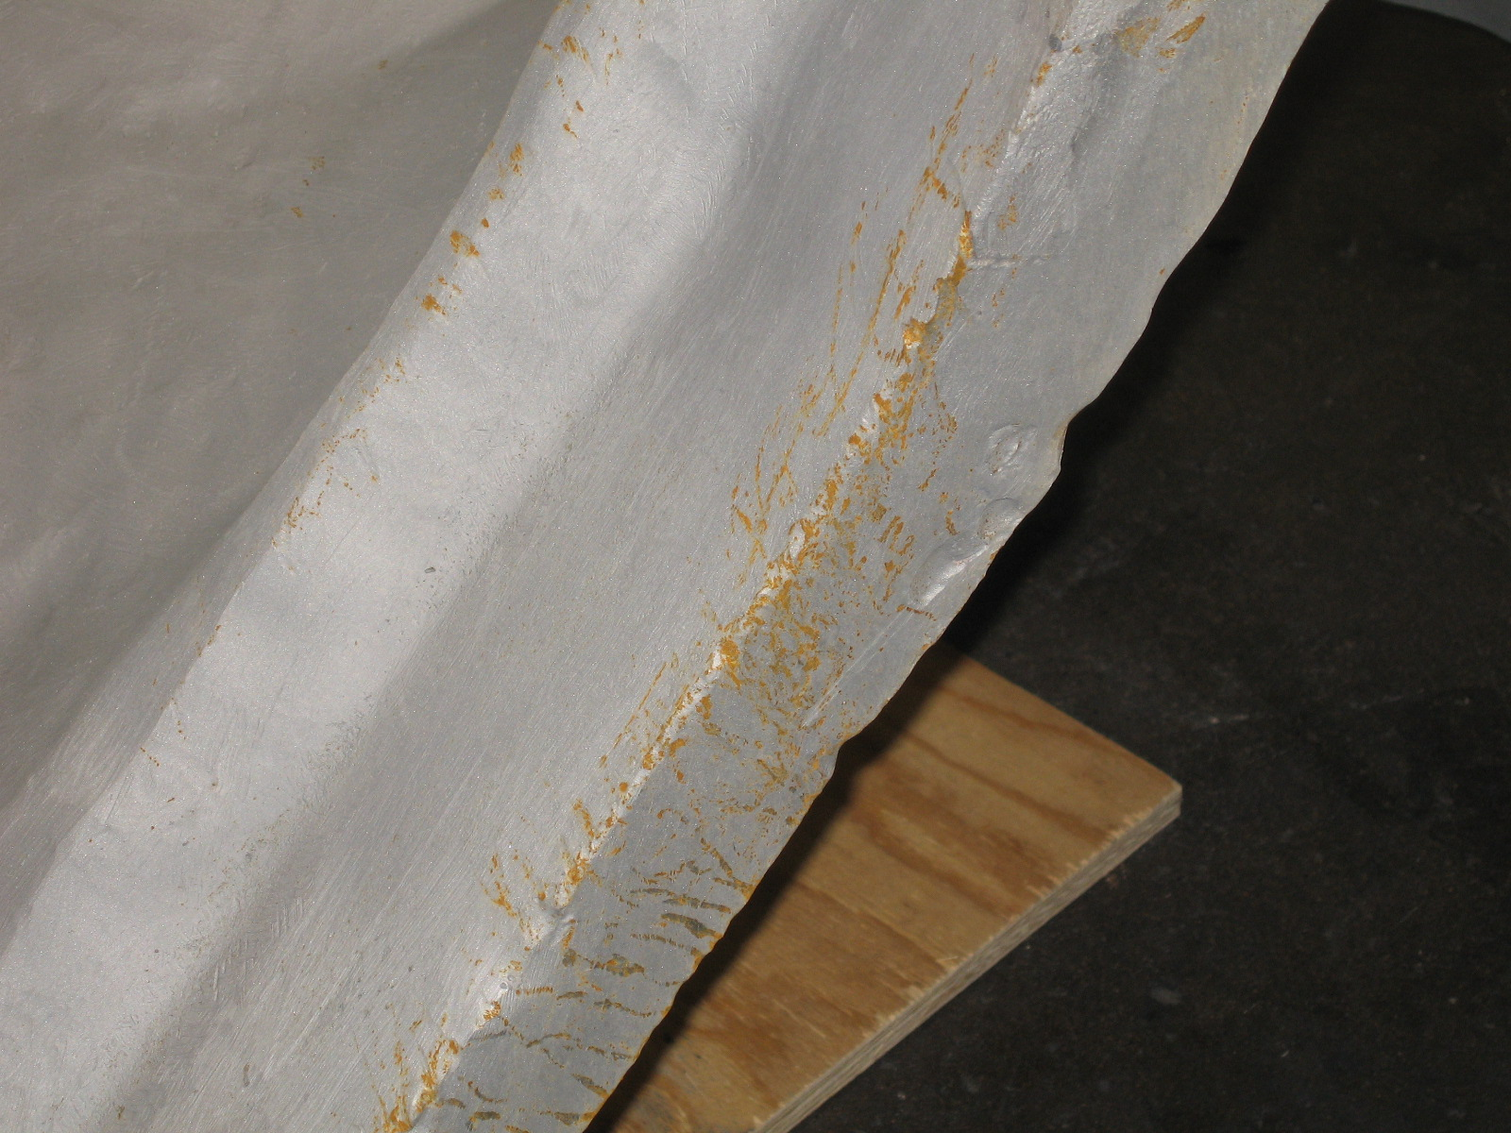
B-2: Rust Like Area on Tee found at MTM

Chuck Ruud of Metal Tek had just received confirmation from Severn that their gauge was in-fact out of tolerance by .01. This certainly could explain why some of the areas which had passed inspection at MTK were then picked up at MTM. Meanwhile, MTK has been running numerous tests on the bearing plates, including an embedded iron test and a number of sand blasting experiments. These and other related theories and findings on the topic of permeability were shared with PPPL at the weekly QA meeting on Tuesday, 5/2. Their current plan is to set several plates outside, some known to fail mag perm and some known to pass. They will review the plates after each day. Chuck Ruud plans to submit a summary report when his investigation is complete. Meanwhile, Metal Tek, accompanied by EIO, will travel to Major Tool the week of May 15th to examine the castings and MTK will cleanup rejected areas, as required.

As part of the on-going investigation, on 5/4, PPPL inquired as to whether MTK could try using new garnet sand on the next winding form to see if this resolved the surface permeability issues. Peter Djordjevich discussed this with MTK and advises that it may not be possible because of the tonnage of sand involved that would have to be removed from the system. He noted that an alternative may be to add more new sand, thus reducing the percentage of old sand, but this still needed to be assessed. Peter added that the problem may solve itself now that MTK has re-calibrated their permeability gauge. Based on preliminary testing, Chuck has advised that areas previously undetected now show higher ranges, especially on the bearing plates. The previous gauge was only detecting areas above 1.03, rather than < 1.02.

As far as the relation of permeability to the used sand is concerned, testing was accomplished earlier in the program and this was not found to be detrimental. Chuck pointed out that on one plate where 8 - 10 points initially exceeded the 1.02, the part was sandblasted and retested and all areas passed the 1.02 and all but one passed the 1.01. According to Chuck, this would “vindicate the garnit sand” as a root cause. Chuck adds that they will continue testing to verify this theory. Additionally PPPL has requested that MTK investigate/comment on the extended corrosion checks in the prototype phase that strongly suggested that the Stellaloy does not rust.

The A-1 casting also continues to provide many opportunities for QA discussion, as reported in the technical highlights. Regarding a linear indication found by MTM at the commencement of machining on A-1 and reported by MTK on CA 1625, Mike Griffith reports that the area has been mostly cleaned-up after further machining. As shown below, the area that was of greatest concern is gone. There are still some remaining visible indications similar to those found on other castings; however it is anticipated that these can be accepted as-is. They will be documented on a non-conformance report after final Penetrant inspection. Additional pictures have been posted to the EIO ftp site.

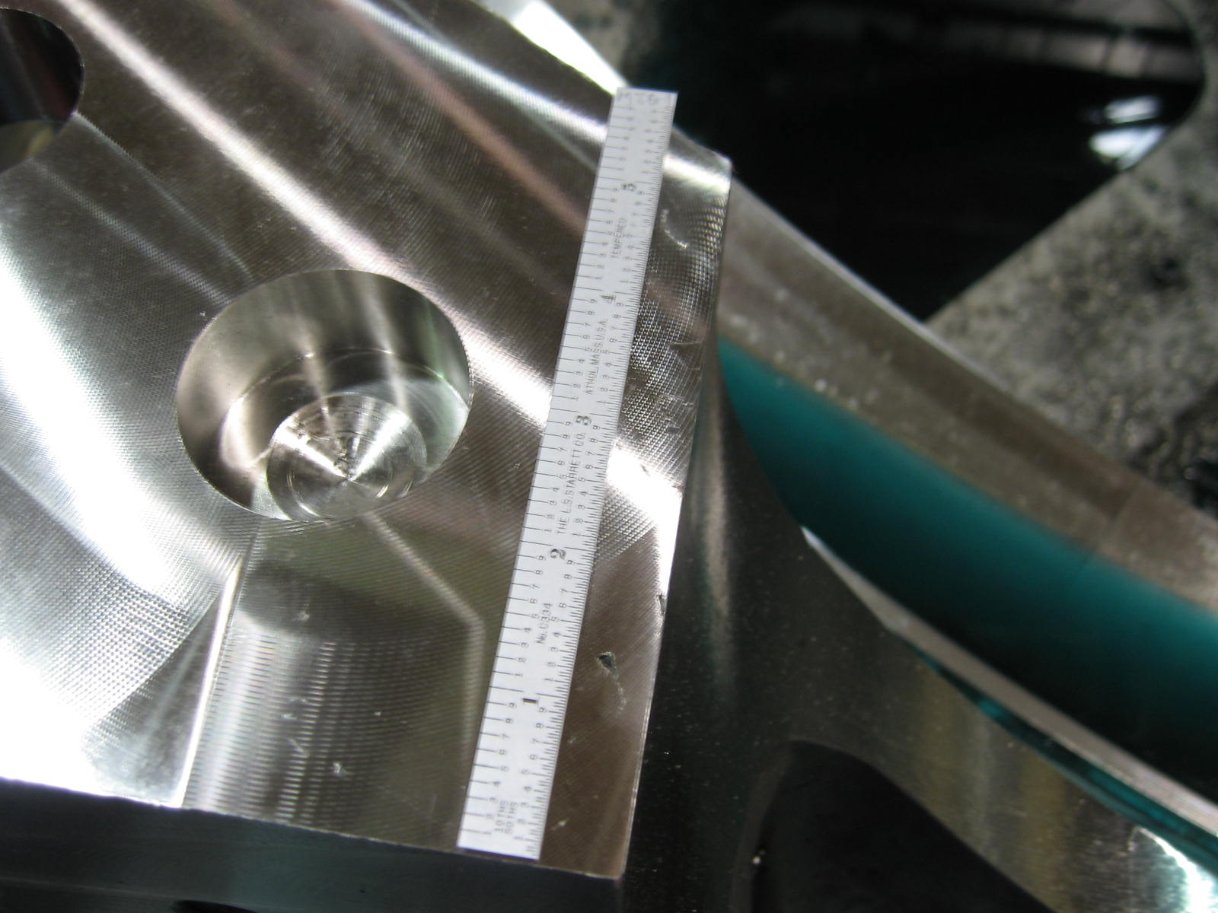
A-1: Datum D after machining

Upcoming QA Activities
- Heat Treat & Scan of B-3
- X-ray & Mag Perm Check of Bearing Plates

QA Action Items
- Closed Items: (EIO Recommended)
  - IsoCAR041006 (2.6. below)

- Pending from EIO:

  - (EIO) Provide final documentation packages for completed MCWF’s.
    - C-2 (reopened)
Status: (Open) PPPL on reviewing package noted missing documents:
1) The weld map does not correspond to the attached photos. Frank has provided copies of photos for inclusion in the package.
2) The data package is missing NCR CA 1320 Note – will add after resolving above
3) The data package is missing NC’s 18830 & 18831. These are for weld wire and elongations that were not to specification. This weld wire was used to repair C-2 (8/05) before the CSPEC was changed in 11/15/05 and so the NCR’s should also be in the C-2 package.
EIO to update week of 5/8
    - C-3 (reopened)
Status: (Open - No update) Comments from PPPL in process at EIO:
1) It should be made clear, through initials or signature or similar, that Steps on the MetalTek MTS that are marked “N/A” or “Do Later” have been deleted, skipped, or re-sequenced by authorized personnel. – FOR FUTURE PACKAGES (although this comment has been made before!)
2) MetalTek CA 1581 should be part of their documentation package. Roy will take care of this. NOTE – Have this from MTK – Roy will add week of 5/8/06
4) Some MTM reports, especially some RT reports, are fairly faint. Please generate or scan to be more legible. – FOR FUTURE PACKAGES (Mike Griffith noted that use of electronic signature will improve document legibility). Mike also sent Frank an original scan of the RT report. This is more legible, but shows that care is needed when generating the reports to ensure legibility.

    - C-4
Status: (Open) –Films already provided. Need open NCR 19475 Rev.1 (3.2 below) to complete

    - C-5
Status: (Open) – Doc package in preparation

  - (EIO, MTK, MTM) Update CA 1625 (A-1 linear indication) after machining.
Status (Open) On 5/5 Mike Griffith reported that after machining, this area has been mostly cleaned-up and remaining indications will likely be acceptable as-is. A full non-conformance report will be issued after LPI. Interim pictures of the area after clean-up have been posted to EIO ftp and will be forwarded to PPPL for review at this week’s QA meeting.

  - (EIO, MTK) Update CA 1671 (for A6 test results below spec for elongation) with inspection and analysis results.
Status (Open - Ready to Close?) – During QA meeting, Frank explained that the CA should state that there was a presumption that there were flaws in the bars and that they were retested because of the flaws. ON 5/6 Chuck submitted the updated CA to incorporate Franks’ recommendation. The CA has been forwarded to PPPL and posted to EIO ftp.

  - (EIO, MTK, MTM) Investigate and take steps to mitigate source of ferromagnetic contamination seen on C-4 & B-1. Report back so that PPPL can disposition NCR 3633.
Status: (In-Progress) – EIO & MetalTek to get together to look at grey spots at MTM. MetalTek has examined the first bearing plates and confirmed some, but not all of the high perm. spots. MetalTek also sandblasted one plate and all high perm spots passed a 1.02 check, while 9 of 10 passed a 1.01 check. PPPL found another 30 spots of high permeability on receipt inspection of C-5. For discussion:
- Results of EIO 5/1 team teleconference.
- If not part of the previous, MetalTek discuss the extended corrosion checks in prototype phase that strongly suggested that the Stellalloy does not rust.
- MetalTek DCMA is witnessing a magnetic permeability check through LPI developer, which is followed by grinding of Permeability spots and LPI indications. MetalTek’s “final” magnetic permeability check, that should be witnessed by DCMA, should be after all processing (per MTS) and on a clean surface. MTK sent their Severn gauge back for calibration and found that it was off by 0.01 (0.005 above calibration limit). This is thought to account for a large part of the issues. Chuck will submit a report so we can discuss during next week’s call. He also plans to visit MTM the week of 5/15 to examine contaminated regions on the castings there and clean up as required. At PPPL suggestion, MTK is investigating merit of using new garnet sand on the next winding form.

  - (EIO, MTM) Disposition rejected SS316 bearing plate material documented on EIO’s NC 19233 & 19234.
Status: (Open) Will close after 316 bearing plate material is shipped back to PPPL, which will be after Stellalloy bearing plates are in use. The bearing plates are currently being cast for the C and B style coils. Additionally, the first plates received at MTM were found to have magnetic permeability higher than the CSPEC limit and are under review at MTK.

  - (EIO, MTM) Process CA for C-4 features compliant to SE141-116, Rev. 7, but not to Rev. 8.
Status: (Closed) On 5/2 MTM submitted updated CA which was accepted by Peter Djordjevich of EIO and forwarded to PPPL for informational purposes. The matter of whether or not MTM’s suggestion to have NCSX circulate drawings for review and initialing prior to formal distribution is being reviewed by PPPL for feasibility.

  - (EIO, MTM, MTK) Results of C-5 Review
Status: (NEW) Frank noted that C5 inspection indicated a “step” region in the height of the T. His measurements (using straight edge and scale) showed the step to be ~1/32” on one end, and ~1/16 on the other. Mike thought the steps must have been within the profile tolerance of +/- 0.050”. Feedback otherwise: 30 spots of permeability >1.02 were found. The “feet” were the worst regions, but the spots were only on as cast surfaces.

- Pending from PPPL

  - Provide updated requirements documents incorporating the following changes:
    - CSPEC update addressing revised poloidal break inspection/tolerances. Poloidal break flange fit-up, 0.005” through and 0.015” at edges – edge defined as no more than 1/8” penetration.
Status: (Open) Rapid response guidance sent 3/16. Wording for next CSPEC revision is in process.

    - PPPL to incorporate guidance on Type A MCWF thermocouple hole placement provided 3/20 into requirements documents.
Status: (Open) – EIO has delivered marked up drawings with proposed locations. Dave Williamson is working on the revision.

  - Return signed NC19475 (C-4 misc. discrepancies) revision 1, posted 3/29, to EIO.
Status (Open) – This also has the info on the thin flange region. PPPL is overdue - planned to get it to EIO by 4/25. During the QA meeting, Mike reminded us that the NCR was revised to note that one of the gouges (that was to be left as is) was removed by blending. Phil will process this week.

- Discussion Topics for Teleconference:

  - New Specification & Drawing Changes
    - PDF Drawings se141-137-R2-a and -138-R2-a have been revised to change the flatness and parallelism of the poloidal break shim from .001” to .005”.

    - E-mail from PPPL/ORNL dated 5/4 with Slides on the Type A flange hole changes - Intralink models SE140-130.ASM and SE140-150.ASM show the changes without actually modifying the parts. MTM was investigating other alternatives. PPPL will require MTM to define exactly how MTM proposes to make the change on -1 in lieu of filling the holes with weld and drilling & tapping them. Topic remains open for discussion.

  - Possible meeting at PPPL to discuss potential changes to Type B MCWF that could help expedite machining process. Still waiting for input from MTM regarding availability.

While it remains difficult to predict casting completion dates with precise certainty (the last two castings were shipped within two weeks of projected goals), it is still very feasible that we will achieve on-time delivery of the first field period, which includes two castings of each style. The upcoming weeks machining the B castings will certainly be telling. We will continue to monitor closely and keep PPPL informed.

If you have any questions or comments about anything in this report, please feel free to contact me at any time.

Nancy Horton

EIO Program Manager for NCSX

216-496-2314

