Energy Industries of Ohio (EIO) Team Weekly Status Report

Report covers the NCSX Modular Coil Winding Form Activities Under Production Contract S005242-F

Week ending June 2, 2006

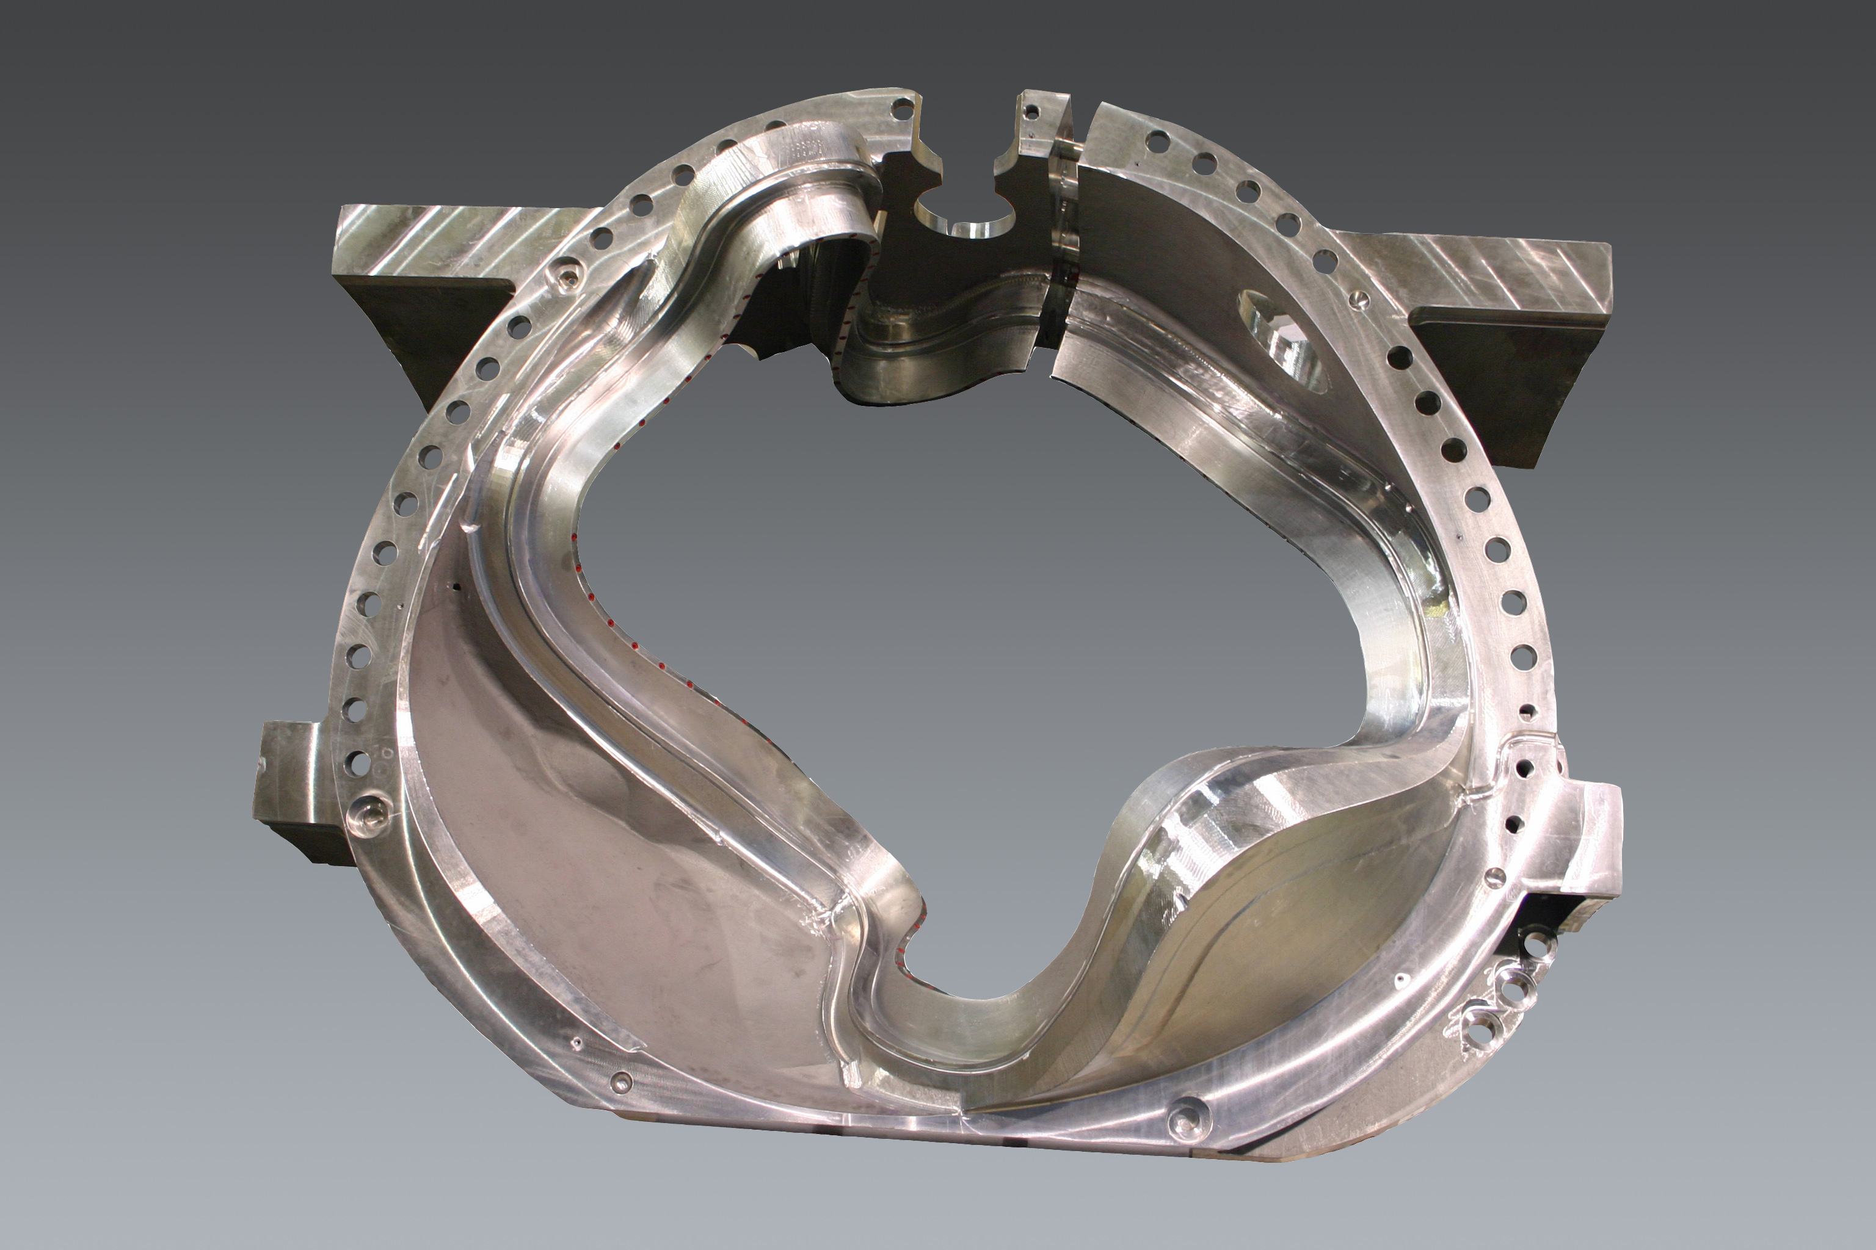

Administrative Highlights

The month of June was off to a good start on Thursday, (6/1) when A-1, the EIO team’s 6th completed casting, (and first of the A style), was released for shipment to PPPL. By Friday, 6/2, MTM had the part on a truck for a Monday morning delivery to the lab.

In addition to the significant effort that went into completing A-1, the team is actively processing five other castings: B-5 and B-6 are entering their final stages at MTK and A-2, A-4 & B-2 are all being machined simultaneously by MTM.

Along with Mike Griffith’s engineering and project management duties, Mike has also proven himself a respectable photographer, providing the team with many of the shots used for our weekly report. The picture featured above is one of several photos of the C coils provided by Mike this week. We’ve been told that Princeton will be making enlargements of these shots to hang in their lobby.

FTP Postings this week
(found at: ftp.atc-inc.org:/PPPL/shared_info)
Location | File Name | Date
\Quality_Review\C3_Doc | C3_Doc_Package_Combined_5-31-06.pdf | 5/31/06
\Quality_Review\C2_Doc | C-2_Doc_Package_Combined_5-31-08.pdf | 5/31/06
\Quality_Review\Bearing_Plates | bearing_plate_shipment5-31-06.zip | 6/3/06
\Quality_Review\Closed_NCR-CA-RFD\NC | Signed_off_NC19933_A1MiscDefects.pdf | 6/3/06
\Quality_Review\Closed_NCR-CA-RFD\NC | Signed_off_NC19916_A1RTRej.pdf | 6/3/06
\Quality_Review\Open_NCR-CA-RFD\A-1 | NC19709_a1_gouge.zip | 6/3/06
\Quality_Review\Closed_NCR-CA-RFD\NC | NC19709_Signed_Off_A1Gouge.zip | 6/3/06
\Quality_Review\Open_NCR-CA-RFD\A-1 | NC19942IDCattachment.zip | 6/3/06
\SOW_Spec_Drawings | flange_adapter_rfq.zip | 6/3/06
\Quality_Review\A1_Doc | a1_igs.zip | 6/3/06
\Quality_Review\A1_Doc | A1VerisurfAttachment.doc | 6/3/06
\Quality_Review\A1_Doc | A-1SR.pdf | 6/3/06
\Quality_Review\A1_Doc | PROFILEPOCKETESIDE.zip | 6/3/06
\Quality_Review\A1_Doc | PROFILEOFDATUMD.zip | 6/3/06
\SOW_Spec_Drawings | Hole_drilling_on_hold5-31-06TypeBTholes.pdf | 6/3/06
\Quality_Review\B5_Doc | B-5Weldmap5-31-06.pdf | 6/3/06
\SOW_Spec_Drawings | SE141-114drawingclarification.doc | 6/3/06
\Quality_Review\Open_NCR-CA-RFD\A-1 | NC19891A1PTSummaryrev1.zip | 6/3/06
\Quality_Review\Open_NCR-CA-RFD\A-1 | NC19933_misc_prob_A-1.zip | 6/3/06
\Quality_Review\Casting_Scan | MTK_B4_Scan.pdf | 6/3/06
\Quality_Review\Open_NCR-CA-RFD | RFD-14-022_leadslots_B-5-25-06.pdf | 6/3/06
\Quality_Review\Closed_NCR-CA-RFD\RFD | Signed_Off_RFD-14-018R2.pdf | 6/3/06
\Reports_Weekly-Monthly\Weekly | 06-05-12_eio_wk.doc | 6/3/06
\Reports_Weekly-Monthly\Weekly | 06-05-19_eio_wk.doc | 6/3/06
\Reports_Weekly-Monthly\Weekly | 06-05-26_eio_wk.doc | 6/3/06
\Quality-Meeting_notes | PPPLQualityNotes5-22-06.doc | 6/3/06
\Quality-Meeting_notes | PPPLQualityNotes5-29-06.doc | 6/3/06
**note – file names may be changed from the original for clarity

Administrative Action Items

- (PPPL) Pattern Storage after six castings have been delivered to MTM.

Status: (Open ) Resequencing of machining the C coils means that the C pattern will need to be stored for an extended period and outdoor storage is not an option. A & B patterns are also ready for storage. We were informed this week that with rising oil prices, PPPL is concerned about the high cost for shipment of the patterns. Phil Heitzenroeder has asked EIO/MTK to investigate the cost for securing local storage in the St. Louis area to see if this might be a more economical option for housing the patterns until the program is complete.

- (PPPL, EIO, MTM) Return of shipping crates to MTM

Status: (Open) Phil advised on 6/1 that arrangements were in place to have the crates returned to MTM when A-1 is delivered.

- (PPPL, EIO, MTM) During the meeting at PPPL, Princeton requested (under RFD14-020) that EIO/MTM investigate and provide any potential cost/schedule impact for manufacturing pucks for the A-1 casting. Formal RFP was received from PPPL on 6/1 requesting a total of 24 adapters. Requested due date for proposal is 6/9.

Status: (Open) EIO immediately forwarded the request to MTM. Proposal to be submitted by next Friday, 6/9.

- (EIO) EIO Team Monthly Report for May

Status: (Open) In process, to be submitted on 6/5.

Technical Highlights
A-1
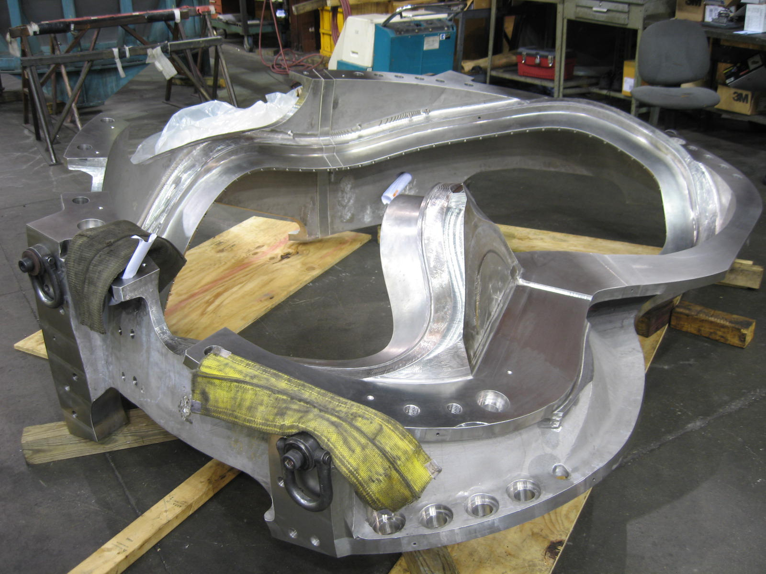
A-1 – final cleaning
The team achieved another major milestone this week shipping the 1st of the “A” style MCWF to PPPL. The casting was shipped out on 6/2 for arrival at the lab on 6/5.

As the first of the A style castings to go through the CMM inspection process, MTM experienced some new challenges in analyzing and submitting the resulting reports. Early in the week we were advised that MTM was experiencing problems translating the initial reports into Verisurf. The matter was further complicated by some “dead surfaces” where they didn’t pick-up adequate points, coupled with a few dimensional issues induced during assembly which caused difficulty for finding the “best fit.” Once all of these matters were identified and addressed, the data fell into place and late on 5/31 MTM was able to start sending the IGS data and Verisurf reports over to PPPL. The IDC followed on the morning of 6/1 and Tom Brown and Dave Williamson spent a busy day reviewing the dimensional documentation and discrepancies. A follow up telecon with MTM and EIO was held that afternoon at 4:00pm, and after a thorough discussion, PPPL/ORNL advised that all of the nonconforming points could be accepted “as is.” Frank Malinowski worked into the evening to complete the formal shipping release that same day.
A-2
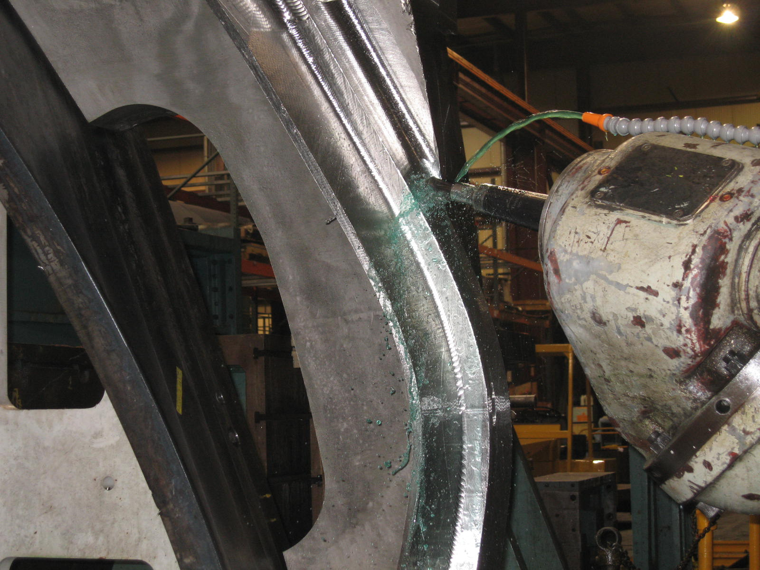
A-2 on 40’ Mitsubishi
Mike Griffith reported that MTM got a full week of production on A2 this week. The casting is currently on the 40’ Mitsu operation (2 of 2). This operation is expected to be complete mid to late next week. After that the casting will move immediately onto the U-5 for final 5-axis machining. The goal is to complete the part by the end of the month, if not sooner!
A-4
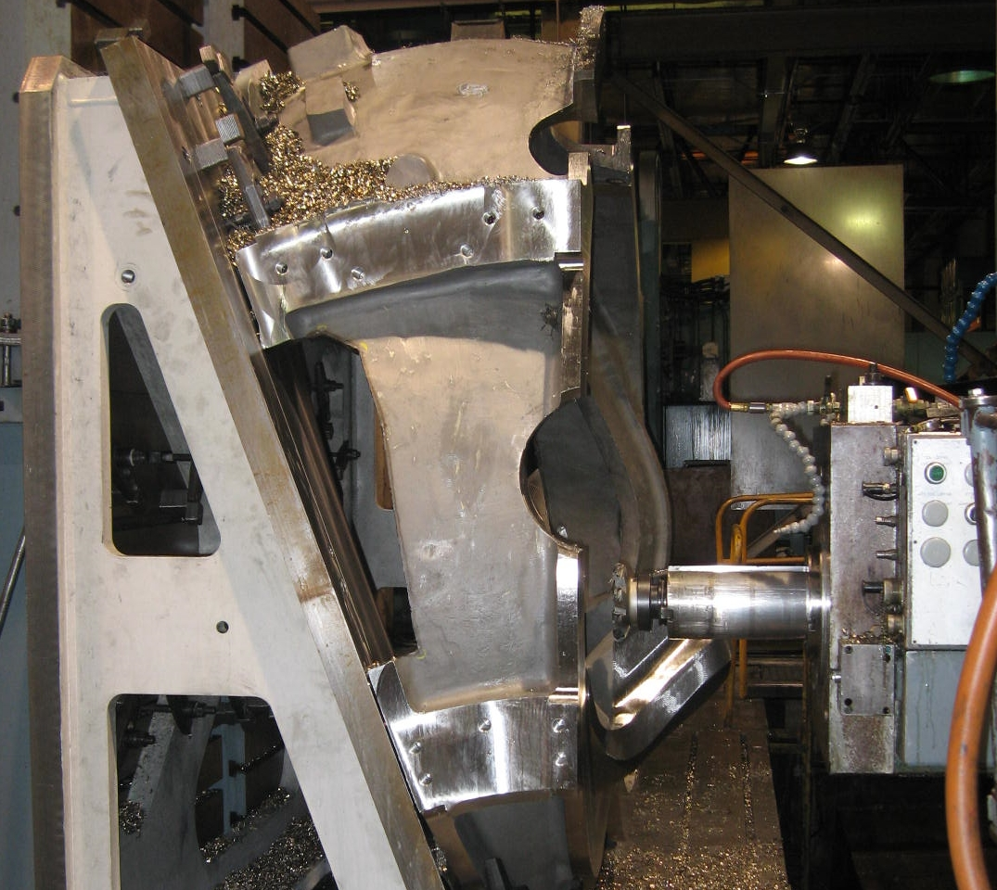
A-4 on 30’ Mitsubishi
MTM reports another full week of machining on A4 as well. The casting is on the 30’ Mitsubishi, in the 1st op. Unlike A-3, which will have the 2nd op done on the 40’ Mitsu, A-4 will remain on the 30’ for the 2nd op, as MTM continues to resource level operations between the machining centers.

B-1 & B-2
The machining ‘duet’ continues with the first B castings. B1 is now through the 1st of 3 operations on the 40T Lucas and is staged for the 2nd operation. MTM expects to start this setup by the end of next week.
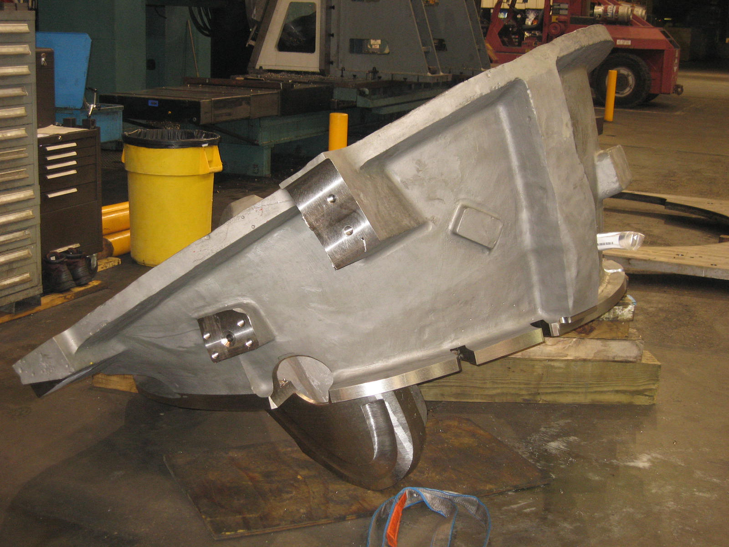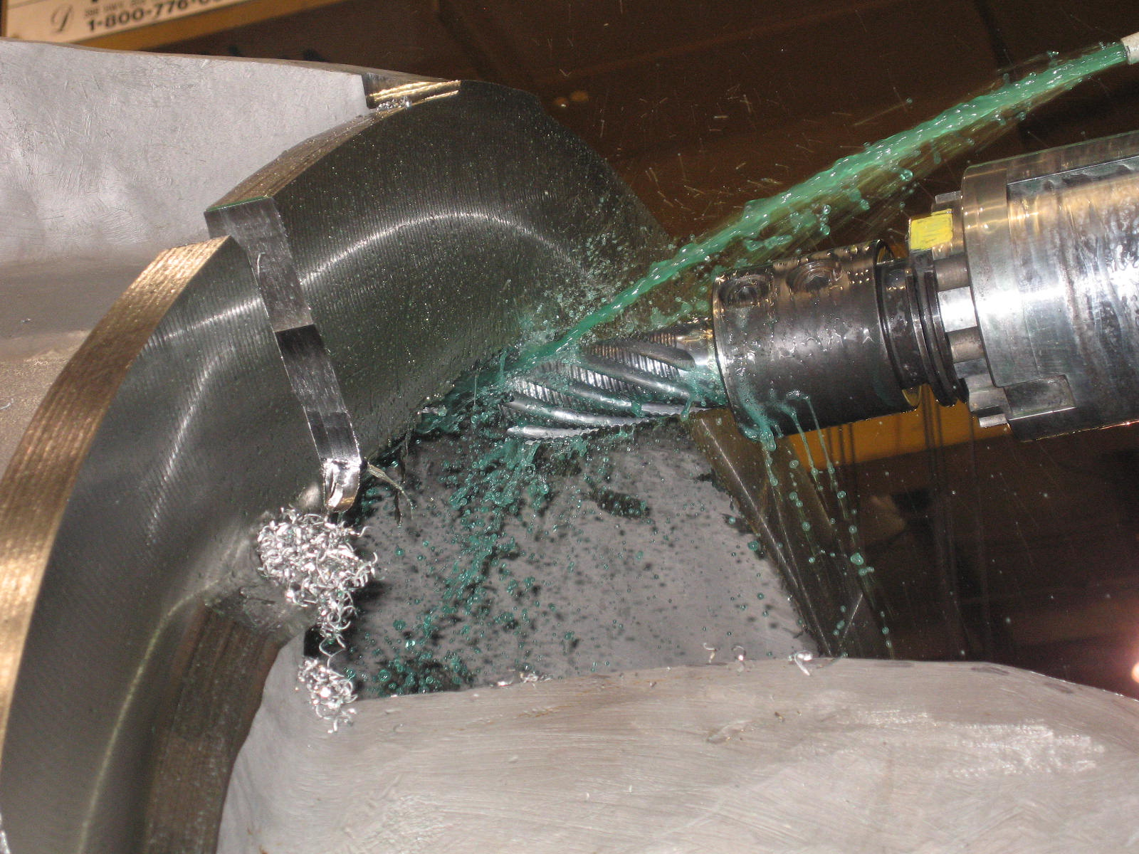

B2 is currently in the 1st op on the 40T. This operation should be complete by the end of next week.

B-5

MTK completed excavations and mapping of 1 side of B-5 this week and commenced welding on the casting. After completion, the casting will be flipped over so upgrading can be finalized. MTK will need to send B-5 back to MQS for final RT validation after welding.

B-6

Chuck Ruud reported that B-6 is now in the queue for weld repair and will immediately follow B-5. According to Barry Craig, both castings are well underway and should ship by month’s end.

Bearing Plates

On 5/31, MTK shipped the balance of the bearing plates to MTM. Chuck Ruud, MTK, forwarded the paperwork to EIO for review (copied to FTP site). MTM has shipped the balance of the old style 316SS plates to PPPL.

Technical Action Items

- (Major Tool) Machining C-6
Status: (Open) On hold

- (Major Tool) Processing of A-1
Status: (Closed) Shipped
- (Major Tool) Machining A-2
Status: (Open) On 2nd Mitsu op
- (Major Tool) Machining A-3
Status: (Open) In queue for 40’ Mitsu

- (Major Tool) Machining B-1
Status: (Open) Finished 1st op on Lucas
- (Major Tool) Machining A-4
Status: (Open) Machining 1st op on 30’ Mitsu
- (Major Tool) Processing A-5
Status: (Open) on hold
- (Major Tool) Machining A-6
Status: (Open) on hold
- (Major Tool) Processing B-2
Status: (Open) Machining 1st op on Lucas
- (Major Tool) Machining B-3
Status: (Open) on hold
- (Major Tool) Machining B-4
Status: (Open) on hold
- (Metal Tek) Processing B-5
Status: (Open) in welding
- (Metal Tek) Processing B-6
Status: (Open) in queue for welding
- (Metal Tek) Processing Bearing plates
Status: (Closed) Shipped 5/31

Quality Highlights
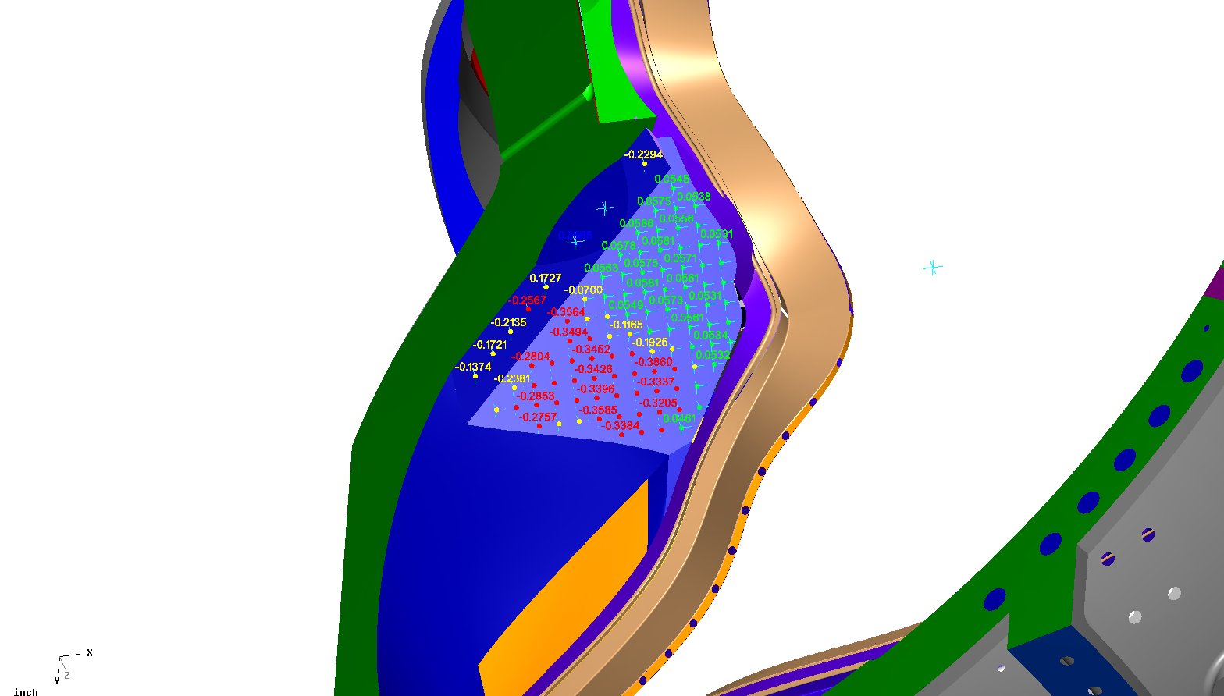
Slide from A-1 - Verisurf

Most of this week’s QA efforts focused on finalizing the inspections to ship out A-1. The efforts of everyone were successful and A-1 was released for shipment on 6/1.

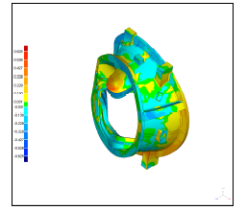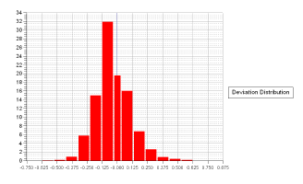
B-4 Casting Scan Report

MTK forwarded the casting scan for B-4 to EIO this week. A copy has been posted to the FTP site for review. Again, (as shown below) we can see the very tight distribution of points indicating the close dimensional tolerances MTK has been able to achieve. The scan consists of 1,185,606 data points.

The EIO team discussed the timing for MTK’s next trip out to MTM, to finalize mag perm testing on A-2 & B-1, the 2 castings which were not accessible on the last visit. The challenge will be to time the visit when A-2 is just coming off of the U-5. At this point, B-1 should still be offline and accessible as well. Chuck Ruud expressed that he will need a minimum of 3 days notice (preferably 1 week) to coordinate this effort. Mike Griffith will keep us posted.

Upcoming QA Activities
- Permeability check of A-2 & B-1 at MTM (by MTK)
- C-3 & C-4 Doc packages from MTM
QA Action Items

- Closed Items: (EIO Recommended)
  - EIO submitted C-1 & C-2 combined Doc packages (see 2.1.1 & 2.1.2 below)
  - CA 1625 for an indication on A-1 discovered during initial machining (see 2.2 below)
  - Shipped SS bearing plates with A-1 closing out 2.5 (below)
  - NC19916 for RT rejections on A-1 submitted to EIO (3.5 below)
  - (3.2) PPPL Drawing for Hockey Pucks
  - (3.4) Signed NC19891 for PT on A-1
  - (3.5) Signed NC 19916 for RT on A-1
  - (3.6) Signed NC 19933 for Visual Inspection
  - (3.7) Signed NC 19942 for IDC

- Pending from EIO:
  - (EIO) Provide final documentation packages for completed MCWF’s.
    - C-2 (reopened)
Status: (Closed) Completed & uploaded on 5/31
    - C-3 (reopened)
Status: (Closed) Completed & uploaded on 5/31
    - C-4
Status: (Open) – Needs MTM portion. Mike Griffith promises to address these in the upcoming week (by 6/6)

    - C-5
Status: (Open) – Needs MTM portion Mike Griffith promises to address these in the upcoming week (by 6/6)

  - (EIO, MTK/MTM) Update CA 1625 (A-1 linear indication) after machining.
Status (Closed) MetalTek CA 1625 lists root cause of the initial indication as lack of fusion and sand inclusion, both documented and dispositioned on earlier CA’s 1371 and 1403. Since the subsurface indications passed RT and LP, they were not detected until machining commenced. While they appeared somewhat startling at the beginning of machining, (thus prompting EIO to request a Corrective Action from MTK) by the end of the process, they were all mostly eliminated or were found by PPPL to be acceptable as is. MTM issued NC19891 for PT indications on the part, which included what is left of the indication on CA1625. PPPL accepted the remaining indications “as-is” and NC19891 was closed. Closeout of CA1625 was discussed this week in a telecon with Nancy Horton, Frank Malinowski & Roy Sheppard and it was agreed that since CA 1371 & 1403 were internal EIO team documents discussing problems with welding experienced at the foundry and the indication uncovered and reported in CA1625 (another internal EIO team document) had already become a “non-issue”, no further approval from PPPL would be required. The documentation trail will be maintained in the doc package, as well as on the EIO ftp.

  - (EIO, MTK) Update CA 1671 (for A6 test results below spec for elongation) with inspection and analysis results.
Status (Open) – MetalTek updated the CA on 5/5 to state that the plates had flaws. Per discussion on 5/8 with PPPL, MetalTek will update again to include photographs with individual plate identification. MTK sent one half of a fractured test bar back to lab to prepare sample for photo macrograph. Lab lost sample and cannot photograph it. MTK has sent other half for photo and expects close-out by 5/25. The matter is currently under discussion and evaluation between Chuck Ruud, MTK and Peter Djordjevich of EIO. A report of the latest status will be provided at the QA meeting on 6/6.

  - (EIO) Investigate and take steps to mitigate source of ferromagnetic contamination seen on C-4, B-1 and subsequent castings. Report back with update to CA 1695 so that PPPL can disposition NCR 3633.
Status: (Open) –Corrective action was updated on 5/24 to document MTK remediation of all but 2 parts at MTM. Since then, EIO & PPPL found only 5 high permeability spots, all dark in color, on A-1. B-1 & A-2, inaccessible at the time, need to be checked and cleaned up. Then the checks on receipt of the next few MCWF’s may provide information to close this issue. MTK intends to send out personnel for the remaining castings when they are accessible. PPPL to report back to the team about any spots they may find on A-1.

  - (EIO, MTM) Disposition rejected SS316 bearing plate material documented on EIO’s NC 19233 & 19234.
Status: (Closed) SS316 plates shipped with A1.

  - (EIO, MTM) Document Corrective Action to close NC 19783 (A-1Tee hole counter-bore depths).
Status: (Open) Corrective action requires MTM to provide PPPL with 14 bushings to compensate for the machining error in the holes that require clamps. At this week’s QA meeting, Mike Griffith reported that he is waiting for PPPL input regarding their investigation into mag perm of hardware before he manufactures the required bushings. Phil Heitzenroeder agreed that this would be prudent and will follow-up with EIO/MTM when their internal review is complete (see Action Item #3.3 below).
  - (EIO, MTM) Document Corrective Action to close NC19710 (C-5 weld repairs w/o RT)
Status: (Open - No update) Rework router/update after A-1 ships.

  - (EIO, MTM) MTM to propose new location/orientation for B style thermocouple holes.
Status: (Open - No update) after A-1 ships.

- Pending from PPPL
  - Provide updated requirements documents incorporating the following changes:
    - CSPEC update addressing revised poloidal break inspection/tolerances. Poloidal break flange fit-up, 0.005” through and 0.015” at edges – edge defined as no more that 1/8” penetration.
Status: (Open- No Update) Rapid response guidance sent 3/16. Wording for next CSPEC revision is in process.

    - PPPL to incorporate guidance on Type A MCWF thermocouple hole placement provided 3/20 into requirements documents.
Status: (Open- No Update) – EIO has delivered marked up drawings with proposed locations.

  - PPPL will provide drawings and a formal request for the “hockey pucks” that were discussed during MTM’s visit.
Status: (Closed) Drawings (and associated RFP) were provided to EIO/MTM on 6/1. EIO/MTM response will be tracked under Administrative Actions (#3 in this week’s Admin Action Item list).

  - PPPL will check and advise MTM on Bushings with acceptable magnetic permeability.
Status: (Open)

  - NC19891 for PT rejections on A-1
Status: (Closed) PPPL Signed Disposition received from L. Sutton on 6/3
  - NC19916 for RT rejections on A-1
Status: (Closed) ) PPPL Signed Dispositioned received on 6/1.
  - NC19933 for rejections found during visual inspection of A-1
Status: (Closed) PPPL Signed Dispositioned forwarded to EIO by L. Sutton on 6/1.
  - NC19942 IDC – A-1 casting
Status: (Closed) PPPL Signed Disposition received from L. Sutton on 6/3
- Discussion Topics for Teleconference:
  - New Specification & Drawing Changes
    - MTM submitted a request for a clarification on a drawing inconsistency noted on SE141-114 – The A MCWF. The dimensioning called out in the cross section Q-Q varies from the dimensioning in the main view (see below). PPPL agreed. The cross sectional view dimensioning is correct. Drawing SE141-114 will need to be revised.

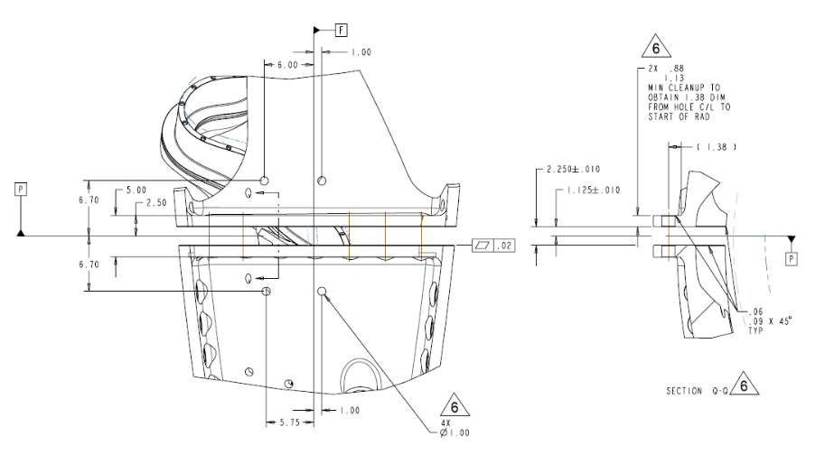

Once again we must thank our counterparts at PPPL for the tremendous cooperation and collaboration required to expeditiously review and disposition the many inspection reports issued during the final week of the casting production process. Flexibility and on-call access by numerous experts at PPPL and ORNL are inevitably required in order to closeout last minute conformance issues and finalize approvals. This time, we also send a special thanks to Frank Malinowski, the last man in the line-up for releasing the castings, who invariably ends-up working well into the evening to ensure that a comprehensive shipping release is issued before the day is over. At the end of a long relay, a strong finisher is always appreciated!

Nancy Horton

EIO Program Manager for NCSX
216-496-2314

