Energy Industries of Ohio (EIO) Team Weekly Status Report

Report covers the NCSX Modular Coil Winding Form Activities Under Production Contract S005242-F

Week ending June 9, 2006

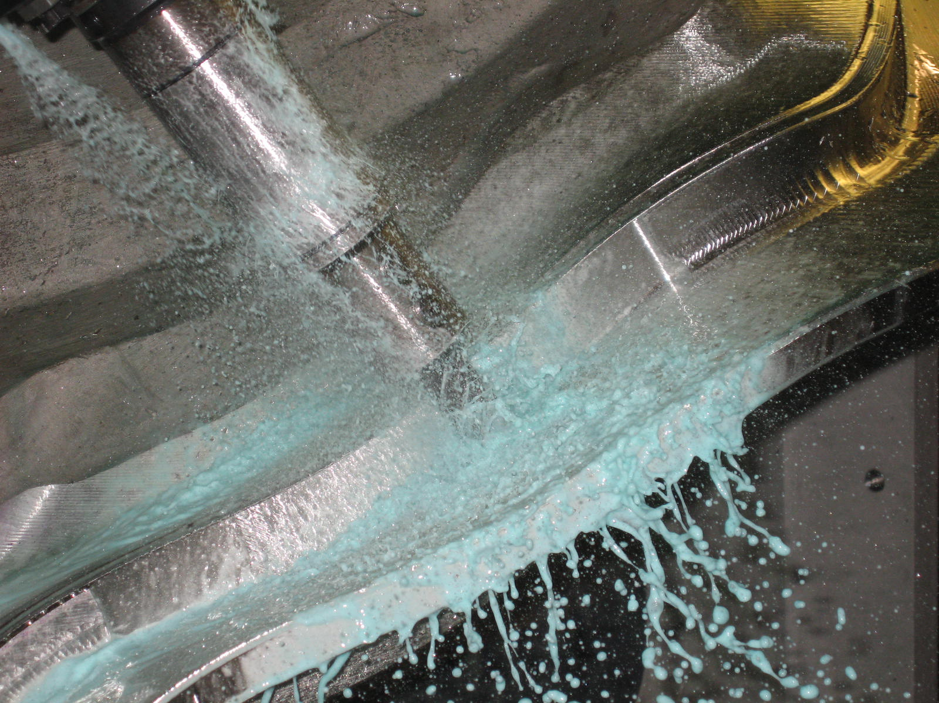

A-2 in final machining

Administrative Highlights

Monday, 6/5, we kicked-off the week with the good news from PPPL that A-1 had been successfully delivered/received and was “looking great.” Phil Heitzenroeder was particularly impressed with the surface finish on the Tee. Weighing-in at 5,280 pounds, it was also noted that the part is “less weighty” - in fact several hundred pounds lighter- than the C style coils.

The team continued to progress well with another full week of production at the sub-tiers. A-2 (pictured above) is now in final machining and Major Tool reports good advancement on the other castings in process (see Tech highlights below).

At Metal Tek the news is similarly positive. As reported below, B-5 left Friday for final RT verification & B-6 moved into weld upgrade. MTK remains on schedule for completion of their contract deliverables by the end of the month!

On 6/9, during the EIO/MTM weekly meeting, the team looped in Phil Heitzenroeder and Dave Williamson to discuss status of open actions, including design elements on the B style MCWF. As MTM continues the advanced programming for machining the B castings, it is essential that the last remaining items be clarified so that a new model can be generated. Over the course of the week, files had been transferred back and forth between the parties, as ideas were exchanged. During our impromptu telecon, a consensus was finally reached on what needed to be changed on the model. The files have been posted and the changes discussed are detailed in section 4.1 of the QA Action Items below. The group also discussed the point file needed for A style MCWF (QA action # 4.3) and was able to close out the RFQ for the Stellalloy pucks (see item # 3 below).

FTP Postings this week
(found at: ftp.atc-inc.org:/PPPL/shared_info)
Location | File Name | Date
\Quality_Review | iso_car041006_1P_rev-5-22-06.doc | 6/9/06
\Quality_Review\Closed_NCR-CA-RFD\NC | Signed_Off_NC19942_idc_A1.pdf | 6/9/06
\Quality_Review\Closed_NCR-CA-RFD\NC | Signed_Off_NC19891rev1_A1DP.pdf | 6/9/06
\Quality_Review\Closed_NCR-CA-RFD\NC | Signed_off_NC19709_Welded_A1Gouge_w-Atts.pdf | 6/9/06
\photos\test_bars | Test_bar_photos.zip | 6/9/06
\Quality_Review\B5_Doc | B-5Weldmap6-5-06.pdf | 6/9/06
\Quality_Review\B5_Doc | B-5Weldmap6-9-06.pdf | 6/9/06
\Reports_Weekly-Monthly\Monthly | Milestone_Schedule_for_Monthly_Report-6.5.06.zip | 6/9/06
\Quality_Review\Open_NCR-CA-RFD | CA1671-test_bars-6-2-26addendum.pdf | 6/9/06
\Reports_Weekly-Monthly\Weekly | PPPLQualityNotes6-5-06_plus.doc | 6/9/06
\SOW_Spec_Drawings\B-changes | S5242l6-07-06holelocTypeBshim.pdf | 6/9/06
\SOW_Spec_Drawings\B-changes | bleeder_hole_B.gif | 6/9/06
\SOW_Spec_Drawings\B-changes | bleed_holes.ppt | 6/9/06
\SOW_Spec_Drawings\B-changes | TYPEBSHT8C2.zip | 6/9/06
\SOW_Spec_Drawings\B-changes | FlangeHoleProposalforBcasting.doc | 6/9/06
\SOW_Spec_Drawings\B-changes | THERMOCOUPLE.jpg | 6/9/06
\SOW_Spec_Drawings\B-changes | 00BLEEDERHOLESA.jpg | 6/9/06
**note – file names may be changed from the original for clarity

Administrative Action Items
- (PPPL) Pattern Storage after six castings have been delivered to MTM.

Status: (Open) Resequencing of machining the C coils means that the C pattern will need to be stored for an extended period and outdoor storage is not an option. A & B patterns are also ready for storage. We were informed this week that with rising oil prices, PPPL is concerned about the high cost for shipment of the patterns. Phil Heitzenroeder has asked EIO/MTK to investigate the cost for securing local storage in the St. Louis area to see if this might be a more economical option for housing the patterns until the program is complete. EIO addressed this question with Barry Craig on 6/9. He will check on prices for pattern storage with an outside service he has used previously for this purpose.

- (PPPL, EIO, MTM) Return of shipping crates to MTM

Status: (Closed) A-1 was delivered on 6/5 and Phil advised that the crates were loaded on the truck to head back to Indianapolis.

- (PPPL, EIO, MTM) During the meeting at PPPL, Princeton requested (under RFD14-020) that EIO/MTM investigate and provide any potential cost/schedule impact for manufacturing pucks for the A-1 casting. Formal RFP was received from PPPL on 6/1 requesting a total of 24 adapters. Requested due date for proposal is 6/9.

Status: (Closed) We were advised on Friday that Princeton is switching to an internal “fix” using A-286 machined nuts, tack welded in place.

- (EIO) EIO Team Monthly Report for May

Status: (Closed) Submitted on 6/5.

Technical Highlights
A-2
MTM completed 3-axis operations on A-2 and on Thursday, the casting was moved over to the U-5. The set-up was completed on Thursday afternoon and machining commenced during the 2nd shift. There are 3 operations that need to be run on this center with an estimated (total) time of 2 weeks. Mike Griffith is optimistic that they are on track to ship by the end of the month.
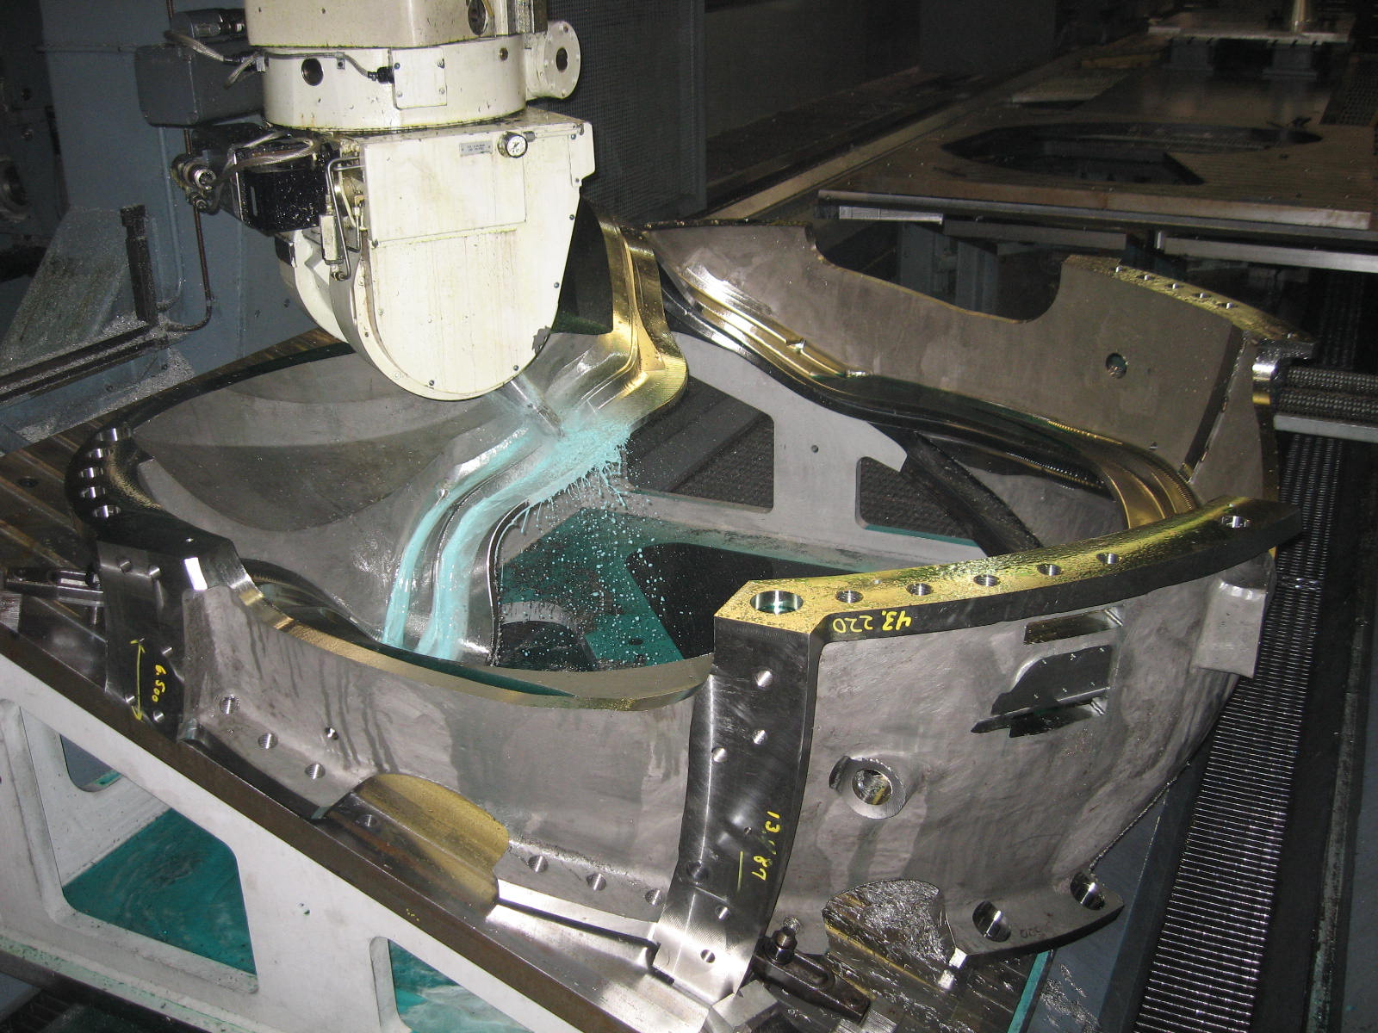
A-2 on U-5
A-3
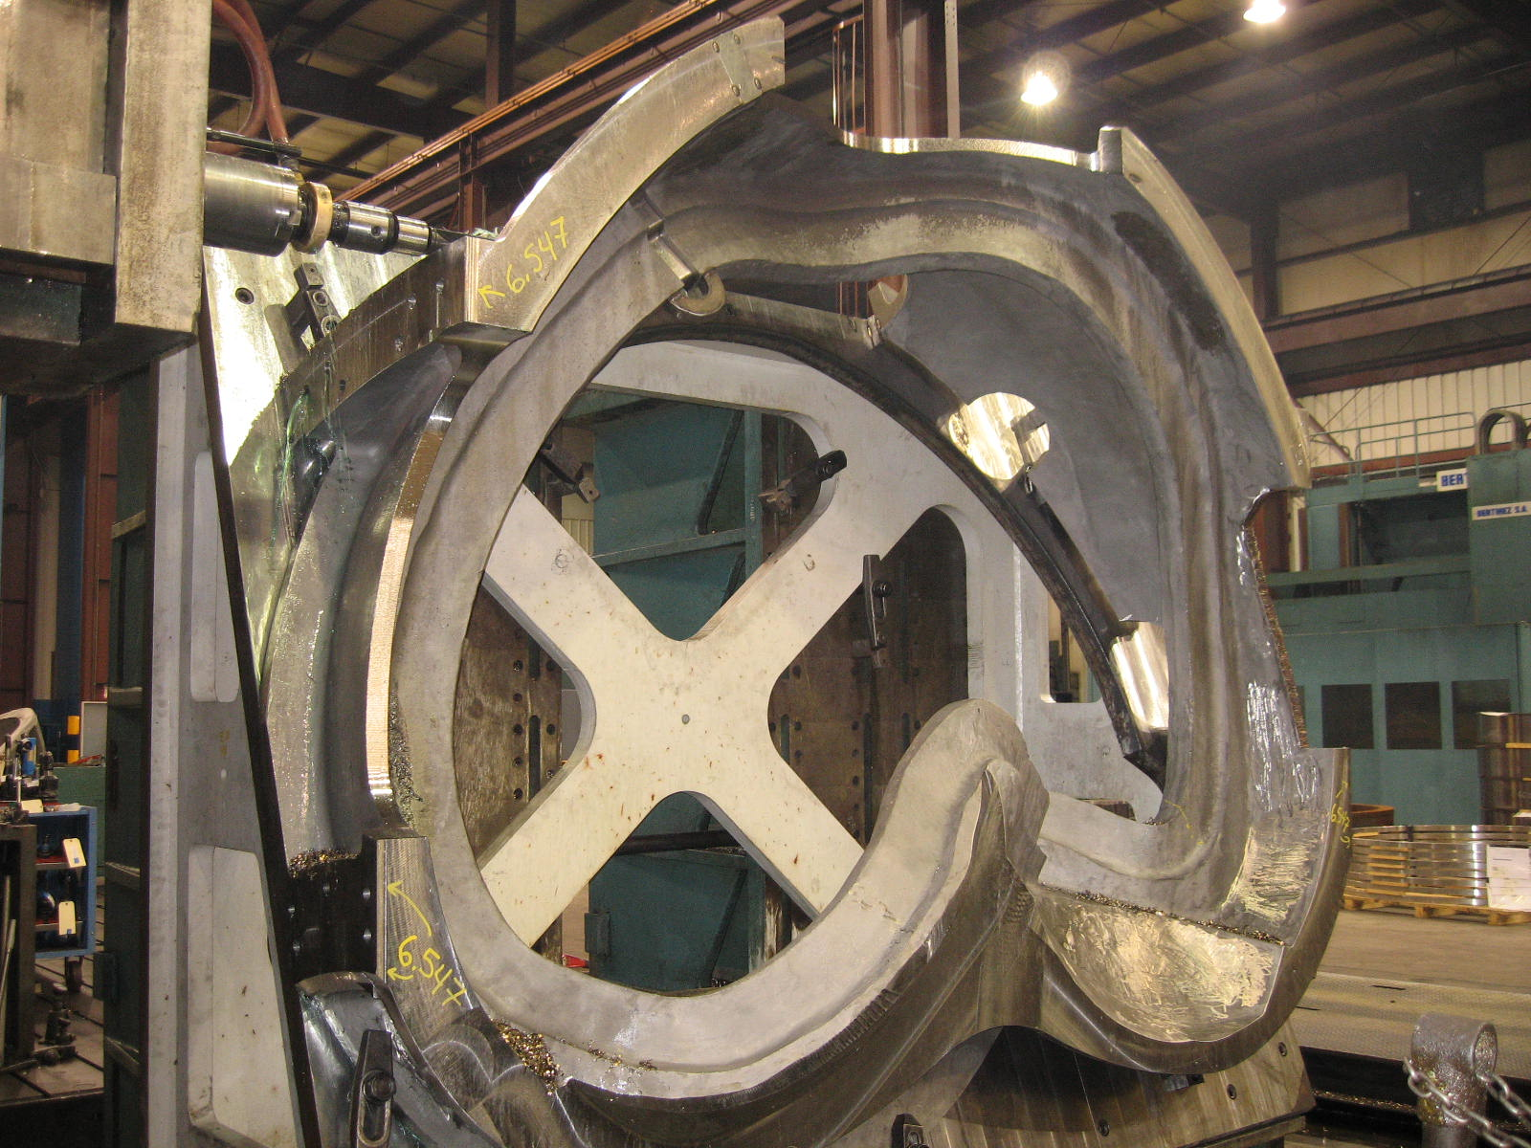
A-3 on 40’ Mitsubishi
A-3 quickly replaced A-2 on the Mitsu on Thursday. MTM began machining on Thursday afternoon. Although this is the 1st operation on the 40’ Mitsubishi for the coil form, A-3 has already had an initial op done on the 30’ Mitsubishi. With this resource leveling, the cut time on the Mitsu should be significantly reduced.

B-1 & B2
MTM finished the 1st op on B-2 this week as projected. The casting was quickly moved off the center & is now staged to follow B-1 through the 2nd operation.
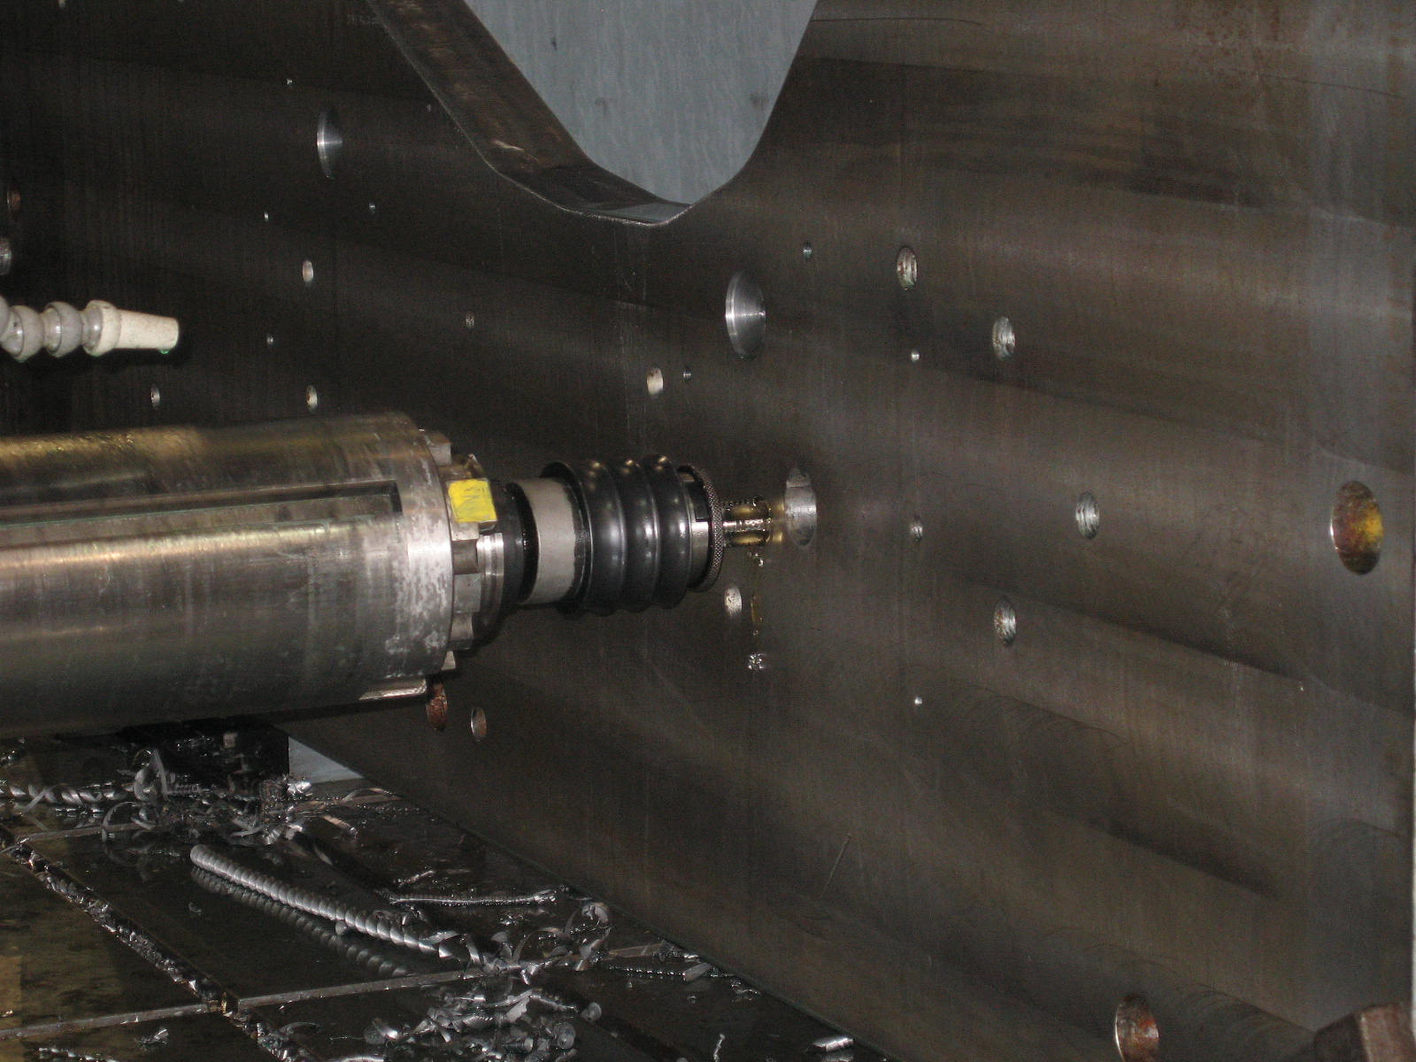
Fixture plate preparation for B style
MTM prepped the fixture plate early Friday morning in order to start the 2nd op on the 40T Lucas. As this is the 1st time a B coil has been run through this operation, the plate needed some customizing. Clamping holes were added to the fixture and the plate was set back up on the Lucas. B1 was scheduled to be set up on the fixture on Saturday morning, for machining throughout the weekend.
B-5

Barry Craig reported that B-5 completed welding this week at MTK and was shipped back to MQS on Friday, 6/9 for final RT verification. The casting is expected back in house early next week, with the probability that final processing will be done on B-5 by the end of the week. Assuming it would not have any negative impact on schedule at MTM, the casting may be held at MTK for concurrent shipment with B-6 at the end of the month.

B-6

B-6 is now in welding. MTK expects to complete welding by the end of next week. The casting will be shipping back to MQS for final RT verification shortly after that. As noted, MTK is well on track to ship B-6, their final casting, by the end of the month.

Technical Action Items

- (Major Tool) Machining C-6
Status: (Open) On hold

- (Major Tool) Machining A-2
Status: (Open) On 1st op U-5
- (Major Tool) Machining A-3
Status: (Open) On 40’ Mitsu

- (Major Tool) Machining B-1
Status: (Open) On 2nd op on Lucas
- (Major Tool) Machining A-4
Status: (Open) Completed 1st op on 30’ Mitsu
- (Major Tool) Processing A-5
Status: (Open) on hold
- (Major Tool) Machining A-6
Status: (Open) on hold
- (Major Tool) Processing B-2
Status: (Open) Completed1st op on Lucas
- (Major Tool) Machining B-3
Status: (Open) on hold
- (Major Tool) Machining B-4
Status: (Open) on hold
- (Metal Tek) Processing B-5
Status: (Open) at MQS – final RT
- (Metal Tek) Processing B-6
Status: (Open) In welding

Quality Highlights

The close coordination between the EIO & NCSX teams has helped to reduce the number of open QA items. Many of the remaining EIO team items (dealing with submission of paperwork) should be closed out early next week.

During this week’s QA meeting Chuck Ruud discussed the full set of photos forwarded on the A-6 test bars (CA 1671), along with the updated report. The photos and the amended CA are under review at PPPL (see 2.2 below).

The discussion on eradicating high permeability on cast surfaces continued this week (see 2.3 below). Frank Malinowski reported that Colin Phelps had found an additional 20 spots of high permeability on as cast surfaces of the A-1 casting. Several of these were clustered around the cast-on lettering. PPPL will remediate these in house. MTK is moving closer to scheduling a return visit to MTM to address A-2 and B-1. Now that A-2 is on the U-5 center, it is easier to predict a date when the casting will be available for inspection. At this point it appears that this will happen around 6/26. The team will continue to firm-up the date as machining progresses.

Upcoming QA Activities
- Permeability check of A-2 & B-1 at MTM (by MTK)
- C-3 & C-4 Doc packages from MTM
- Final inspection on B-5 at MTK
- Scan of B-5 at MTK
QA Action Items

- Closed Items: (EIO Recommended)
  - (2.6, 3.6 & 4.1) All related to B style casting drawings

- Pending from EIO:

  - (EIO) Provide final documentation packages for completed MCWF’s.
    - C-4
Status: (Open) – In progress at MTM for delivery to EIO by 6/12

    - C-5
Status: (Open) – In progress at MTM for delivery to EIO by 6/12

    - A-1
Status: (New) – In-progress at MTM

  - (EIO, MTK) Update CA 1671 (for A6 test results below spec for elongation) with inspection and analysis results.
Status (Open - In review at PPPL) – MetalTek updated the CA on 5/5 to state that the plates had flaws. Per discussion on 5/8 with PPPL, MetalTek will update again to include photographs with individual plate identification. MTK sent one half of a fractured test bar back to lab to prepare sample for photo macrograph. Lab lost sample and cannot photograph it. MTK has sent other half for photo and expects close-out by 5/25. MTK submitted a revised corrective action on 6/5, reporting that the photos of the half of the bars remaining did not uniformly support the premise of flaws at the fracture interfaces. Only the 2nd round Z-3 clearly shows a defect. On samples that failed outside of the expected region the external surfaces become quite distorted, making identification of even the gauge length difficult. MTK feels that these Stellalloy tests of multiple bars in specified locations fails are in a “gray” area and more discretion concerning re-testing may be appropriate. PPPL will review the update and advise.

  - (EIO) Investigate and take steps to mitigate source of ferromagnetic contamination seen on C-4, B-1 and subsequent castings. Report back with update to CA 1695 so that PPPL can disposition NCR 3633.
Status: (In-Progress) – Awaiting update to corrective action. EIO & PPPL found only 5 high permeability spots, all dark in color, on A-1. B-1 & A-2, inaccessible at the time, need to be checked and cleaned up. Then the checks on receipt of the next few MCWF’s may provide information to close this issue. Some 20 spots were found by PPPL on A-1. MTK continues to run tests on scrapped bearing plates.

  - (EIO, MTM) Document Corrective Action to close NC 19783 (A-1Tee hole counter-bore depths).
Status: (Open) MTM is waiting for PPPL input (3.2) regarding their investigation into mag perm of hardware before manufacturing the required bushings.

  - (EIO, MTM) Document Corrective Action to close NC19710 (C-5 weld repairs w/o RT)
Status: (Open) Rework router/update after A-1 ships. Expected by 6/13 when C-5 doc package is completed.

  - (EIO, MTM) MTM to propose new location/orientation for B style thermocouple holes.
Status: (Closed) Forwarded to PPPL on 6/9

  - When will the Stellalloy bearing plates and replacement fasteners for MCWF’s on site be shipped to PPPL?
Status: (Open) All fasteners are not in-house yet & bearing plates are not machined yet. MTM to provide expected date.

- Pending from PPPL

  - Provide updated requirements documents incorporating the following changes:
    - CSPEC update addressing revised poloidal break inspection/tolerances. Poloidal break flange fit-up, 0.005” through and 0.015” at edges – edge defined as no more that 1/8” penetration.
Status: (Open- No Update) Rapid response guidance sent 3/16. Wording for next CSPEC revision is in process.

    - PPPL to incorporate guidance on Type A MCWF thermocouple hole placement provided 3/20 into requirements documents.
Status: (Open- No Update) – EIO has delivered marked up drawings with proposed locations.

    - PPPL to correct drawing SE-141-114, Rev. 6 - the dimensions shown in Sect. Q-Q are the correct ones, and the remnant incorrect dimensions will be deleted.
Status: (New) –An ECN will be required.

  - PPPL will check and advise MTM on Bushings with acceptable magnetic permeability.
Status: (Open) PPPL to run magnetization curves. The results may allow raising the permeability limits.

  - Review C-2 & C-3 documentation packages posted 5/31
Status: (New).

  - Disposition (mark) rejected SS316 bearing plate material and then close EIO’s NC 19233 & 19234.
Status: (New). PPPL to verify that all plates are marked with their permeability.

  - Prepare ECN addressing bleed holes in SE141-115, sheet 5.
Status: (New) Status: NCSX has this on their TO DO list. MTM provided a sketch on 6/9 showing preferred trajectory of the holes from the machining point of view.

  - NCSX to reply to Mike G’s question concerning the location of the NCSX requested additional clamping hole in the Type B poloidal break shims; Phil will check with Jim C. on this. PPPL needs to add these holes to drawings.
Status: (Closed) PPPL forwarded information on extra shim hole location to EIO. Discussed and agreed to during a telecon on 6/9.

  - NEW: MTM confirmed that the bolts on A1 were torqued to the full 1500 ft-lbs now that the permanent hardware was installed. MTM also checked the permeability of the new hardware and confirmed that they were within spec. MTM will also add an IDC torque check.

- Discussion Topics for Teleconference:

  - New Specification & Drawing Changes
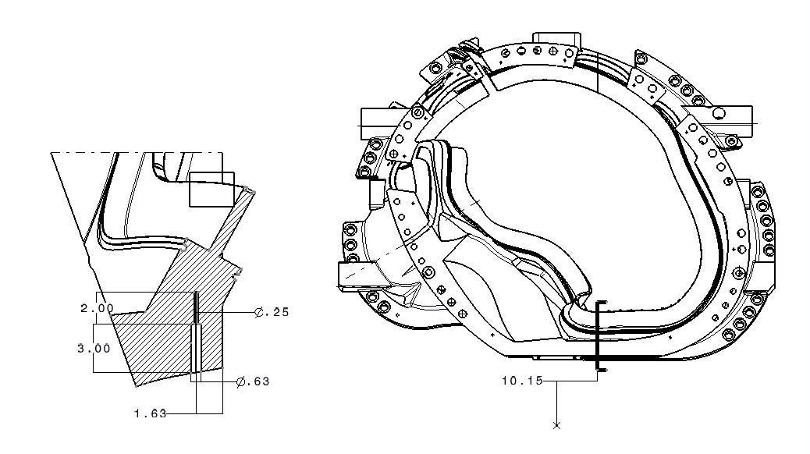
    - MTM sent in proposal for new location of thermocouple hole on B casting – Will be incorporated into new model
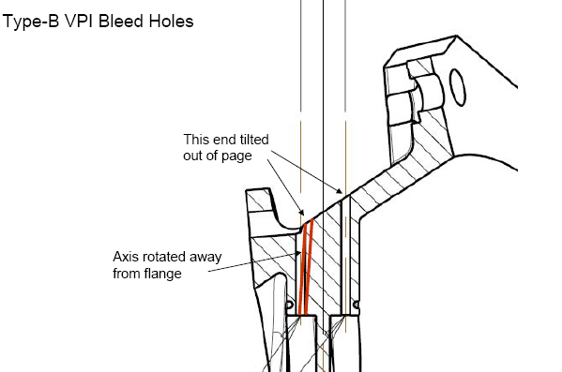
    - MTM sent in file for new VPI bleeder hole size, location & angle on B casting – Will be incorporated into new model
    - MTM resubmitted flange hole information on thru holes being converted to tapped on B – under review
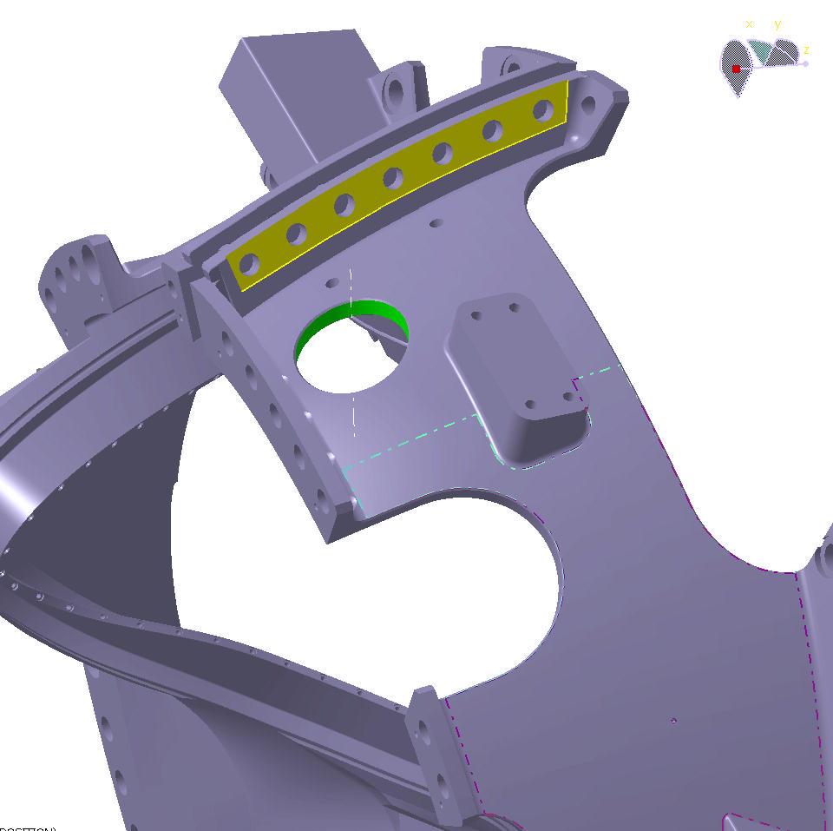
    - MTM sent IGS of port cutout - on B casting – Will be incorporated into new model

  - PPPL to forward new point file for A castings – points below VPI groove.

With the progression of A-2 onto the final machining station this week, it is appropriate to begin contemplating travel plans for inspection of the A-2 casting. MTM is aggressively working toward delivery by the end of the month, which means that those interested in participating in the final inspection process, will most likely need to set-aside time between the 27th and 29th. Note that these are not “firm” dates yet, so the team will want to reassess and discuss during the upcoming week as machining on the U5 continues. If you have any questions or comments about travel dates or any other matter discussed in this report, please give me a call.

Nancy Horton

EIO Program Manager for NCSX
216-496-2314

