Energy Industries of Ohio (EIO) Team Weekly Status Report

Report covers the NCSX Modular Coil Winding Form Activities Under Production Contract S005242-F

Week ending June 23, 2006

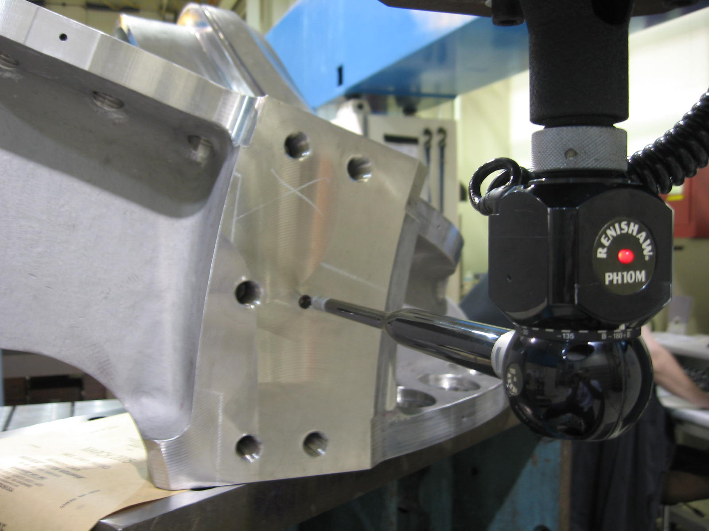

A-2 on the CMM

Administrative Highlights

A quiet week with steady progress: that’s the best way to characterize this week’s highlights. The last two castings at Metal Tek, B-5 and B-6 are both in their final processing steps in preparation for delivery to Major Tool next week. At MTM, A-2 entered the inspection stage this week, for anticipated delivery to PPPL next week. An MTK rep was at MTM on 6/19 to conduct Mag Permeability Inspection of A-2 (see QA Highlights). Peter Djordjevich, EIO and Steve Raftopoulos, PPPL, are scheduled to visit MTM on 6/26 and 6/27 for on-site review in conjunction with A-2’s release.

Meanwhile, several outstanding submissions from previous weeks were resolved and dispositioned by PPPL. The documentation packages for C-2 and C-3 were both completed and closed this week and the complete C-4 and C-5 doc packs, submitted last week, are currently under review at PPPL. The A-1 documentation package was awaiting direction from PPPL which was received this week. Overall, through benefit of an administrative learning curve, on-going submissions and closure of supporting documentation associated with production activities continue to align more closely with the MCWF production schedule.

FTP Postings this week
(found at: ftp.atc-inc.org:/PPPL/shared_info)
Location | File Name | Date
\Quality_Review\C3_Doc | C3_Doc_Package_Combined_6-19-06.pdf | 6/21/06
\Quality_Review\B5_Doc | B-5Weldmap6-20-06.pdf | 6/21/06
\Quality_Review\B6_Doc | B6Coilweldmap6-20-06.pdf | 6/21/06
\Quality-Meeting_notes | PPPLQualityNotes6-19-06_plus.doc | 6/21/06
\Quality_Review\A1_Doc | A-1coilRT1readersheet.pdf | 6/21/06
\Quality_Review\A1_Doc | PPPL_OK_A-1_bushings.pdf | 6/21/06
\SOW_Spec_Drawings | Readme.doc | 6/22/06
\SOW_Spec_Drawings | production_mcwf_pdf_r13.zip | 6/22/06
\SOW_Spec_Drawings | production_mcwf_step_r8.zip | 6/22/06
\Quality_Review | BCoilRTtechnique.pdf | 6/22/06
\Quality_Review\B6_Doc | B6Coilweldmap6-21-06.pdf | 6/22/06
\Quality_Review\Open_NCR-CA-RFD | LP_MTM-NC20044-A2.zip | 6/22/06
\Quality_Review | DP-51Penetrant.pdf – MSDS for LP | 6/23/06
\Reports_Weekly-Monthly\Weekly | 06-06-16_eio_wk.doc | 6/23/06
\Quality_Review\A1_Doc | MTK_Trip_Report_Bob_C.pdf | 6/23/06
**note – file names may be changed from the original for clarity

Administrative Action Items
- (EIO, MTK, PPPL) Pattern Storage after six castings have been delivered to MTM.

Status: (Open - No update) Resequencing of machining the C coils means that the C pattern will need to be stored for an extended period and outdoor storage is not an option. A & B patterns are also ready for storage. We were informed this week that with rising oil prices, PPPL is concerned about the high cost for shipment of the patterns. Phil Heitzenroeder has asked EIO/MTK to investigate the cost for securing local storage in the St. Louis area to see if this might be a more economical option for housing the patterns until the program is complete. EIO addressed this question with Barry Craig on 6/9. He will check on prices for pattern storage with an outside service he has used previously for this purpose.

- (EIO, MTK, MTM) Submission of EIO Team Monthly Report for June

Status: (New) EIO to collect updates and compile the report

Technical Highlights
A-2
With the personal assistance of Mike Griffith, A-2 was assembled this week and went through LPI. Mike reports that the assembly operation went seamlessly. The alignment appears to be well within tolerance. The CMM inspection is currently under way. MTM plans to wrap up all inspections by the 27th with an anticipated ship date of 6/28. This would get A-2 to PPPL prior to the holiday weekend.
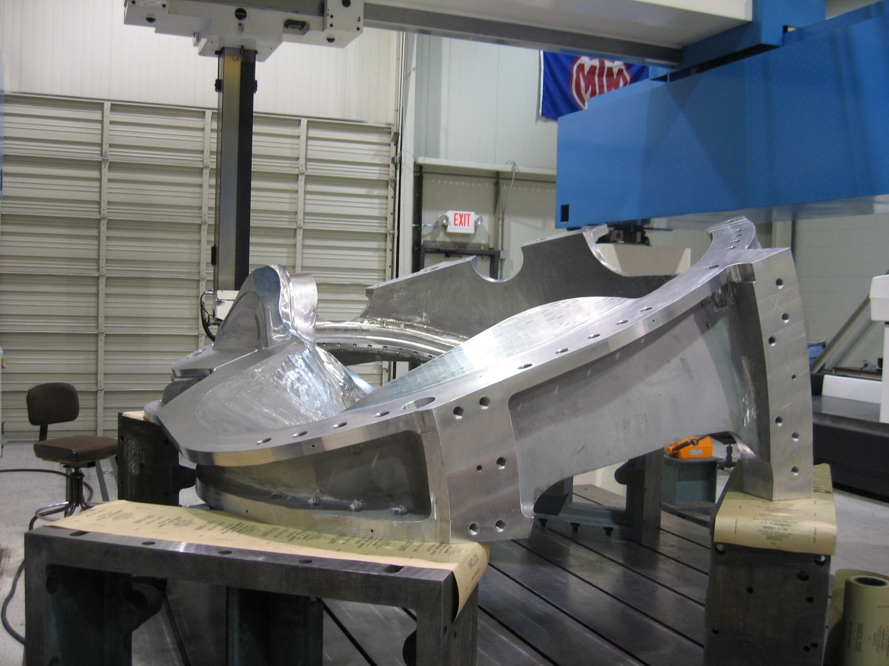
A-2 on CMM
A-3
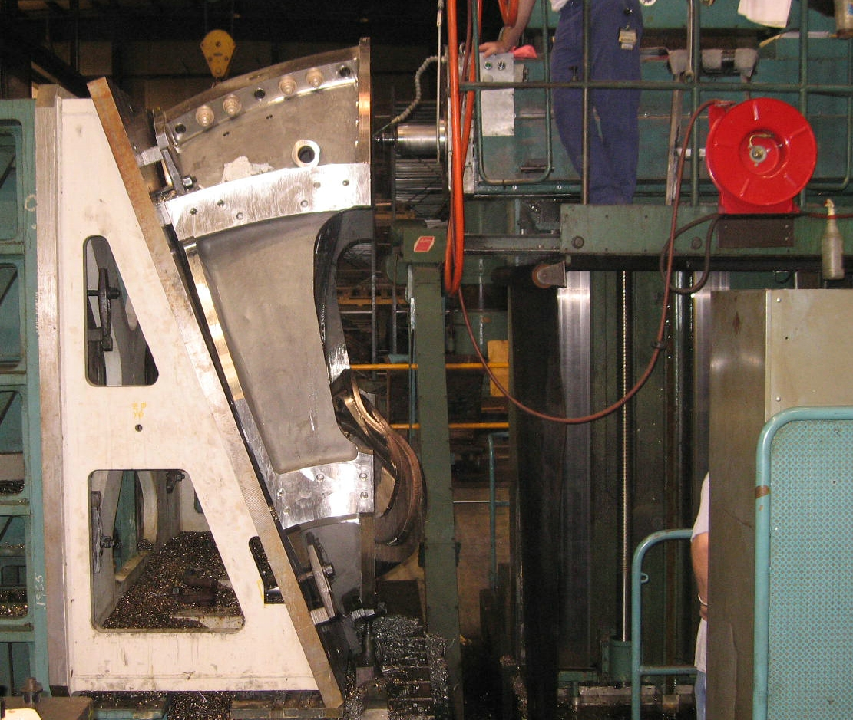
A-3 on 40’ Mitsu
A-3 is making good progress on the 40’ Mitsu. The 1st setup (1 of 2) is expected to be completed over the weekend with setup 2 starting on Monday. Mike is still hopeful that A-3 will finish 3-axis operations by the end of next week and move onto the U-5 on 7/5.
B-1 & B2
The 40 T Lucas remained offline this week, but supposedly, the problems have now been fixed. MTM sent the drive, motor & power supply to the manufacturer in Texas for refurbishing. As of 6/23, these components have been repaired & successfully tested. The parts are now en route to MTM and are expected to be installed & the Lucas brought back on-line early next week. Once that happens, MTM will setup B-2 on this center for the 2nd Lucas op.
Due to equipment problems on the 40T Lucas, B1 was moved to the 30’ Mitsu earlier in the week to complete what would have been the 40T 2nd op work scope. It is anticipated that this operation will be completed early next week, after which the part will be setup on the rotary table for the poloidal break and thermocouple operations. In the photo below, C6 is still set-up on the rotary table.
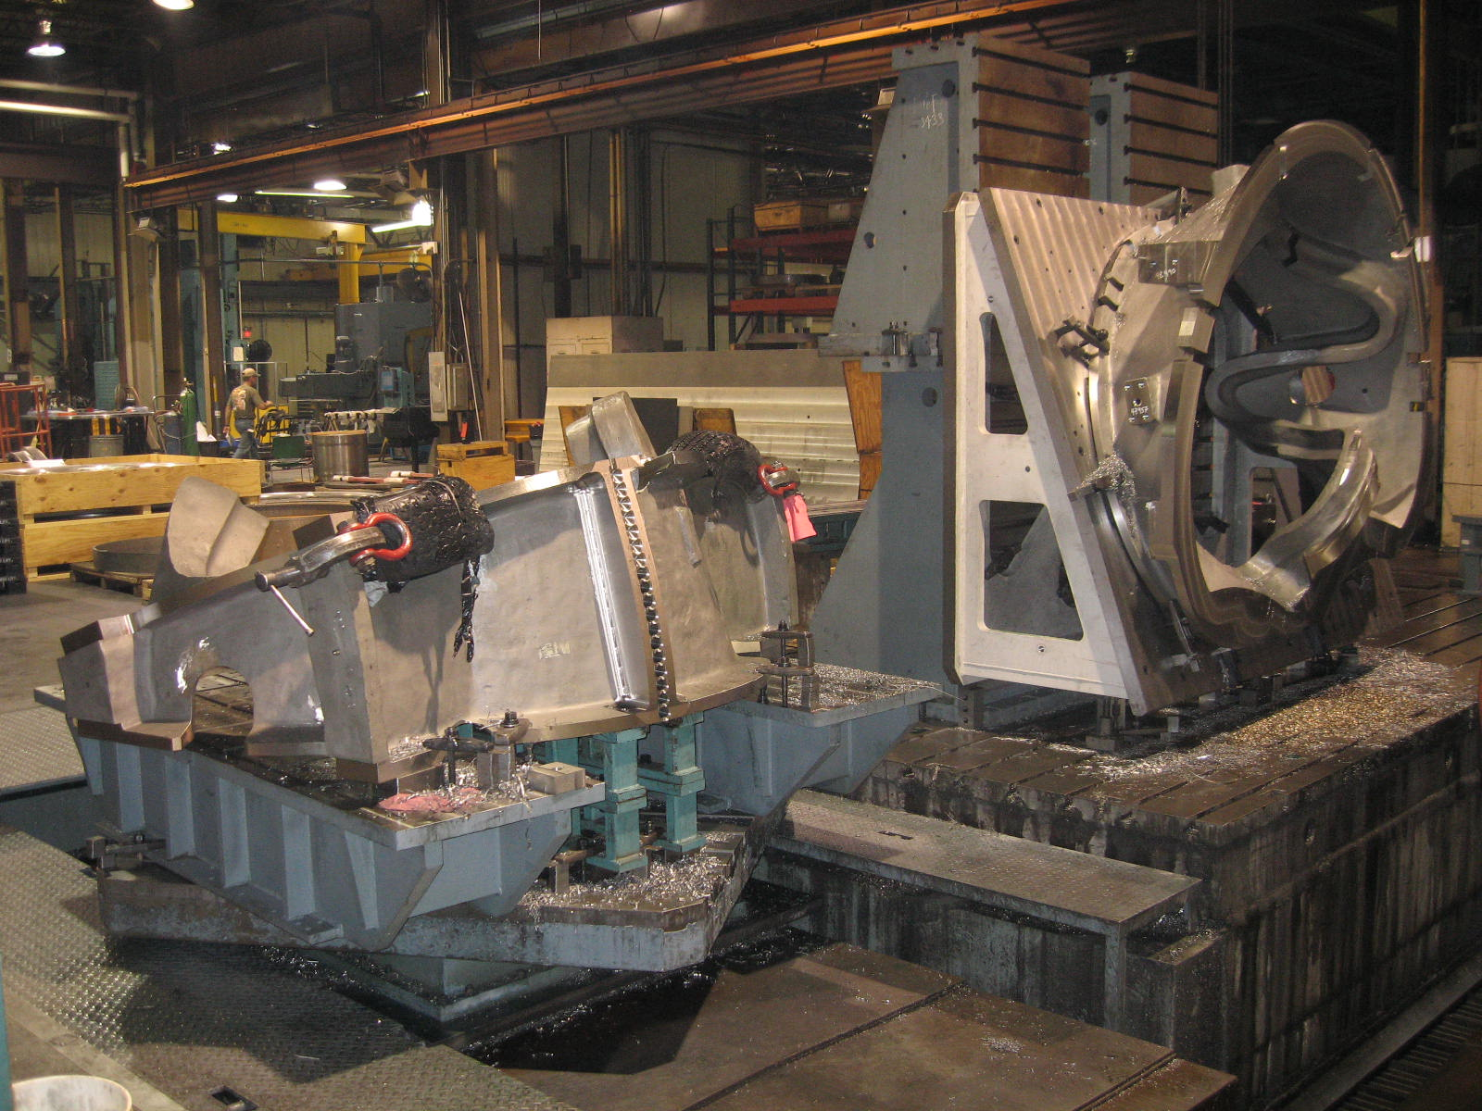
C-6 & B-1 on the 30’ Mitsu
C-6
When the decision was made to transfer B-1 to the 30’ Mitsu, work ceased on the poloidal break operation for C-6. Although the casting is shown on the rotary table, MTM will need to take the casting down so that B-1 can be setup on the table for its 3rd operation early next week.

B-5

B-5 passed through stress relief this week and is now scheduled for final LPI, mag permeability & visual inspection on Monday, 6/26. MTK plans on shipping B-5 with B-6.

B-6

B-6 was shipped up to MQS on Wednesday (6/21) for final RT. Metal Tek was able to get a quick turn around again & the casting was shipped back to Pevely on Friday (6/23). B-6 still needs to be stress relieved & scanned, prior to final inspection. MTK has scheduled the final inspection for 6/29, with the goal of shipping B-6 (along with B-5) that evening, or early on 6/30, so that the last 2 castings get to Major Tool prior to the holiday weekend.

Technical Action Items

- (Major Tool) Machining C-6
Status: (Open) Back on hold
- (Major Tool) Inspecting A-2
Status: (Open) CMM inspection this weekend
- (Major Tool) Machining A-3
Status: (Open) Finishing 1st op on 40’ Mitsu

- (Major Tool) Machining B-1
Status: (Open) Moved onto 30’ Mitsu
- (Major Tool) Machining A-4
Status: (Open) On hold
- (Major Tool) Processing A-5
Status: (Open) on hold
- (Major Tool) Machining A-6
Status: (Open) on hold
- (Major Tool) Processing B-2
Status: (Open) Going on Lucas T
- (Major Tool) Machining B-3
Status: (Open) on hold
- (Major Tool) Machining B-4
Status: (Open) on hold
- (Metal Tek) Processing B-5
Status: (Open) Final inspection on 6/26
- (Metal Tek) Processing B-6
Status: (Open) Shipping back from MQS 6/23

Quality Highlights

Bob Carlton, QA Metal Tek, was at Major Tool on 6/19 to check A-2 for magnetic permeability. Bob’s findings were similar to his previous visit. Areas were found on A-2 that pulled 1.02 on MTM’s severn gauge. The majority of these spots appeared to be caused by small sand inclusions and heat treat scale. These areas were ground and subsequently passed permeability test. A copy of his report has been posted to the FTP site.

MTM completed LP inspection this week on A-2. Although there are several inclusions and indications that failed, based on input from PPPL/ORNL on past LPI results on previous castings, neither Mike Griffith nor Pete Djordjevich perceive any of them as cause for concern. MTM generated NC-20044 for the penetrant indication which was forwarded on to PPPL for review. See 2.8

Next week will be a very busy week for QA, with A-2 moving into the final processing and the last 2 castings preparing to ship from the foundry! Plans were finalized this week for both Steve Raftopoulos & Pete Djordjevich’s trip to MTM on 6/26/ & 6/27. Steve & Pete will be on hand for the final inspection of A-2.

The CMM inspection of A-2 should be finalized this weekend. As MTM now has 2 inspectors trained on this coil form, they should be able to avoid the 22 hour shifts encountered during the A-1 CMM! Mike Griffith expects to have the CMM data ready for internal review on 6/26, with a hand off to EIO by 6/27.

Upcoming QA Activities
- Final inspection on B-5 at MTK
- Scan of B-5 at MTK
- Scan of B-6 at MTK
- Final inspection B-6 at MTK
- Final inspection A-2 at MTM
- CMM results for A-2
- Shipping release A-2
QA Action Items

- Closed Items:
  - Corrective action for MTM NC19710 (C-5 weld repairs without RT) has been documented and the NC closed.
  - MTM IDC changed to add torque check to poloidal break hardware See 2.5

- Pending from EIO:
  - (EIO) Provide final documentation packages for completed MCWF’s.
    - C-4
Status: (Open) –EIO sent preliminary copy sent to PPPL 6/12 and is awaiting feedback. See 3.6
    - C-5
Status: (Open) – EIO sent preliminary copy sent to PPPL 6/13 and is awaiting feedback. See 3.7
    - A-1
Status: (Open) – In-progress at MTM-MTM was awaiting bushing info, which was sent 6/20 – Per Mike G. on 6/23 he will meet with project manager & get back to EIO with completion date – This is the last remaining item holding back completion on data package

  - (EIO) Investigate and take steps to mitigate source of ferromagnetic contamination seen on C-4, B-1 and subsequent castings. Report back with update to CA 1695 so that PPPL can disposition NCR 3633.
Status: (In-Progress) –MTK inspected and cleaned-up A-2 on 6/19. B-1 was not accessible at the time - Inspection/Clean-up TBD.

  - (EIO, MTM) Document Corrective Action to close NC 19783 (A-1Tee hole counter-bore depths).
Status: (Open) PPPL sent EIO/MTM direction on 6/20 to use 316 material regardless of the permeability. MTM to initiate manufacture of the bushings.

  - (EIO, MTM) Provide Stellalloy bearing plates and replacement fasteners for MCWF’s C-1 through C-5. (Needed to close NCR’s 3618 & 3651.)
Status: (Open) Replacement hardware received. MTM is working on the plates - most of the plates are being machined as a group, so they will ship when all are done. As of 6/23, Mike Griffith did not feel that this would be accomplished by the time A-2 ships.
  - (EIO, MTM) MTM will add an IDC torque check of poloidal break hardware.
Status: (Closed) Added - will see on A-2 For now, copy of revised IDC sent to PPPL which closes this item.
  - (EIO, MTK) Provide R-1 RT report(s) for A-1.
Status: (Open) Sheets from MQS provided to EIO & Forwarded to PPPL. PPPL has requested additional photographs of the model. Chuck Ruud is working on this.
  - (EIO, MTM) MTM to obtain ingredients information for Sherwin penetrant (seen on A-1 PB insulator).
Status: (Open) MSDS sent to EIO & forwarded to PPPL on 6/23. Frank has requested that we try to get a list of ingredients. MTM to contact Sherwin again.
  - (EIO, MTM) NC 20044 generated for LP indications on A-2
Status: (New) sent to PPPL for review.

  - (EIO, MTK) RT technique MQS developed for the B style MCWF
Status: (New) Posted to ftp on 6/22.

- Pending from PPPL
  - Provide updated requirements documents incorporating the following changes:
    - CSPEC update addressing revised poloidal break inspection/tolerances. Poloidal break flange fit-up, 0.005” through and 0.015” at edges – edge defined as no more that 1/8” penetration.
Status: (Open- No Update) Rapid response guidance sent 3/16. Wording for next CSPEC revision is in process.

    - PPPL to incorporate guidance on Type A MCWF thermocouple hole placement provided 3/20 into requirements documents.
Status: (Open) –ECN-5218R2 implementing change described by RFD-14-017 and included in drawing SE141-114, Rev-7, to be issued, along with SE141-115, Rev.8. Received on 6/21

    - PPPL to correct drawing SE-141-114, Rev. 6 - the dimensions shown in Sect. Q-Q are the correct ones, remnant incorrect dimensions deleted.
Status: (Open) –ECN-5218R2 Received 6/21

    - ECN needed to capture changes discussed on 6/9 regarding Type B thermocouple hole, VPI bleeder hole, thru/tapped holes, & port cut-out.
Status: (Open) –ECN-5218R2 received 6/21

    - ECN needed to address hole added to poloidal break.
Status: (Open) – ECN-5218R2 covers this also. Drawing SE141-058 was at Rev-2, with ECN-5112(RFD-14-019), "add lifting holes", pending. We will make this change and the new hole and issue it as Rev-3. Received 6/21

  - PPPL will check and advise MTM on Bushings with acceptable magnetic permeability.
Status: (Open) PPPL & MTM discussing options. Received 6/20

  - Review C-2 & C-3 documentation packages posted 5/31
Status: (Open).due 6/16 Acceptance Received 6/20

  - Disposition (mark) rejected SS316 bearing plate material and then close EIO’s NC 19233 & 19234.
Status: (Open). PPPL to verify that all plates are marked with their permeability. Phil requested a check today.

  - Review updated CA 1671 (for A6 test results below spec for elongation) with inspection and analysis results.
Status (Open) – in progress – Phil has been discussing with Brad, but no signed disposition yet. Frank will check on what happened with this

  - Review preliminary C-4 Doc. Package
Status: (Open) – By 6/27

  - Review preliminary C-5 Doc Package
Status: (New) – discuss date on 6/27 QA meeting

- Discussion Topics for Teleconference:
  - New Specification & Drawing Changes

    - NCSX accepted Mike Griffith's proposal of 6/12/06 to convert (17) clearance holes on the Type B winding form, datum E flange, to 1.375-6 UNC x 1.5" min. thread depth holes. The revised drawing is expected to be posted early this week; NCSX will advise when it is posted. NOTE – Drawings as well as new solid model were posted to both PPPL & EIO FTP sites and as of 6/23, MTM reported that the files had been downloaded & information passed on to programmers.
Misc:
EIO/MTM agree that an NCSX/EIO teleconference to discuss the drawing revisions (3.1.2 – 3.1.5) is appropriate. After downloading documents/preliminary review, MTM reported on 6/23 that they had not found any discrepancies in the new files. Suggest that that the discussion be added to QA meeting (6/27)

Please feel free to contact me if you have any questions or comments.

Nancy Horton

EIO Program Manager for NCSX
216-496-2314

