Energy Industries of Ohio (EIO) Team Weekly Status Report

Report covers the NCSX Modular Coil Winding Form Activities Under Production Contract S005242-F

Week ending June 30, 2006

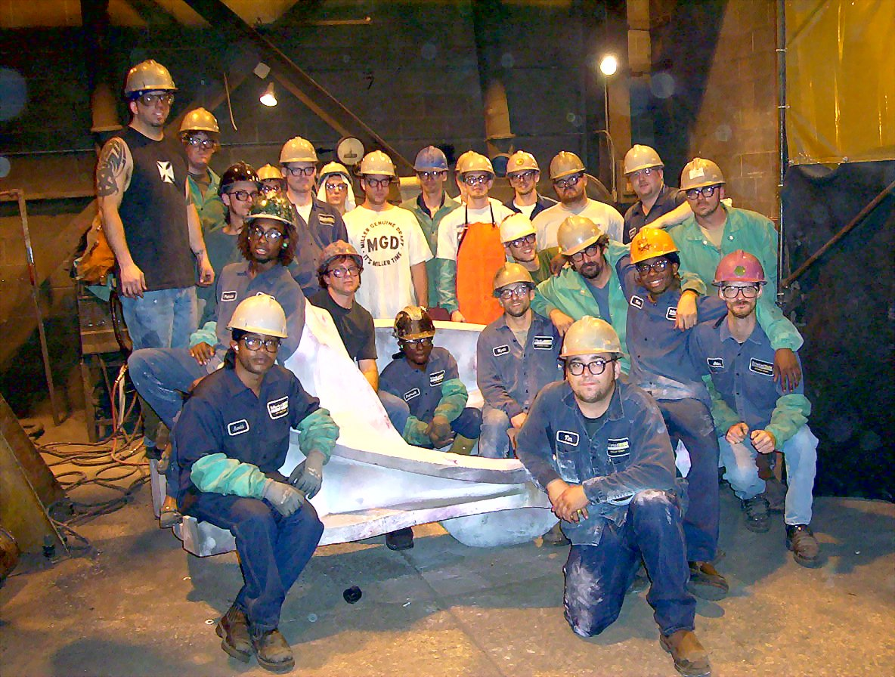

The Proud MetalTek Crew with B-6

Administrative Highlights

This has been a very big week for the EIO Team resulting in numerous accomplishments. First, we close out a significant chapter of the program with completion of the last 2 castings at Metal Tek. Late Friday, 6/30/06, EIO released both B-5 and B-6 for shipment. The castings, along with two shims, are scheduled for delivery to MTM just after the holiday on 7/5. The foundry has successfully completed 18 MCWF castings under their subcontract with EIO, bringing their primary role in this project to an end. While a few lingering Quality & Administrative actions remain open, these will be finalized shortly.

The EIO team achieved a third major milestone this week: completion of A-2 at Major Tool and delivery of our 7th casting to PPPL. Pete Djordjevich, EIO, & Steve Raftopoulos, PPPL, were at MTM on Tuesday, 6/27 to witness final inspection prior to its release on 6/28/06. According to those on-hand, it was a beautiful casting. Early Friday morning, 6/30, the casting had been received at PPPL and was already moved into the lab for in-house inspection.

FTP Postings this week
(found at: ftp.atc-inc.org:/PPPL/shared_info)
Location | File Name | Date
\SOW_Spec_Drawings\B-changes | type-b_new_vpi_holes.igs | 6/30/06
\SOW_Spec_Drawings | Readme.doc | 6/30/06
\Quality_Review\Closed_NCR-CA-RFD\NC | Signed_off-NCR20080-IDC-visual.pdf | 6/30/06
\Quality_Review\Closed_NCR-CA-RFD\NC | Signed_off-NC20044.pdf | 6/30/06
\Quality_Review|A2_Doc | A2-IDC.pdf | 6/30/06
\Quality_Review|A2_Doc | PPPLShippingReleaseFormforA2.pdf | 6/30/06
\Quality_Review|A2_Doc | A2RTmapandreadersheet.pdf | 6/30/06
\Quality_Review|A2_Doc | PROFILEOFQTON.zip | 6/30/06
\Quality_Review|A2_Doc | HOLEPOSITONSINFEET.zip | 6/30/06
\Quality_Review|A2_Doc | INSPECTIONPOINTS.zip | 6/30/06
\Quality_Review|A2_Doc | B6Coilweldmap6-26-06.pdf | 6/30/06
\Reports_Weekly-Monthly\Weekly | 06-06-23_eio_wk.doc | 6/30/06
\Quality-Meeting_notes | PPPLQualityNotes6-26-06_plus.doc | 6/30/06
\Quality_Review\Open_NCR-CA-RFD | CA16954-30-06revised6-30-06.pdf | 6/30/06
\Reports_Weekly-Monthly\Monthly | Milestone_Schedule_for_Monthly_Report_7.1.06.xls | 7/1/06
\Reports_Weekly-Monthly\Weekly | 06-06-30_eio_wk.doc | 7/1/06
**note – file names may be changed from the original for clarity

Administrative Action Items
- (EIO, MTK, PPPL) Pattern Storage after six castings have been delivered to MTM.

Status: (Open) Resequencing of machining the C coils means that the C pattern will need to be stored for an extended period and outdoor storage is not an option. A & B patterns are also ready for storage. We were informed this week that with rising oil prices, PPPL is concerned about the high cost for shipment of the patterns. Phil Heitzenroeder has asked EIO/MTK to investigate the cost for securing local storage in the St. Louis area to see if this might be a more economical option for housing the patterns until the program is complete. To date, Barry Craig reports that he has not been able to locate suitable storage, but he is continuing to investigate.

- (EIO, MTK, MTM) Submission of EIO Team Monthly Report for June

Status: (Closed) Report submitted 7/1/06

Technical Highlights
A-2
A-2 completed CMM operations over the previous weekend, with MTM in-house data evaluation on Monday 6/26. By Tuesday, Mike Griffith was reporting that the CMM data was so good that no best fitting would be required! (see QA Highlights for more details).
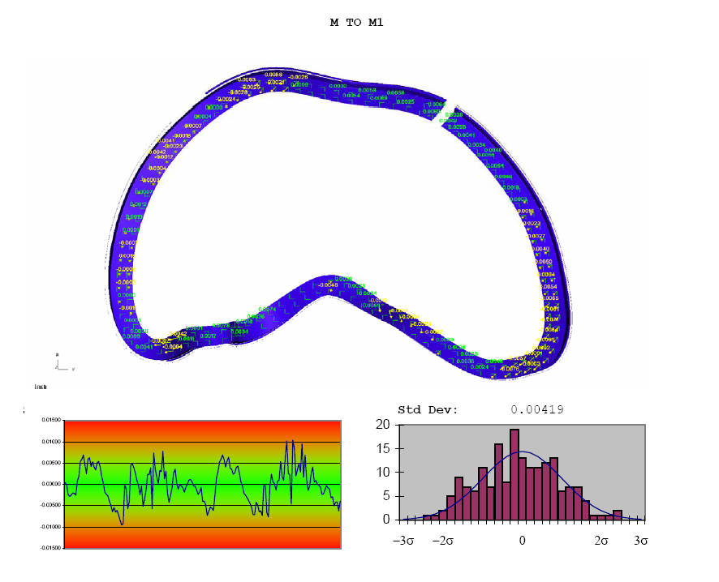
Portion of Verisurf report – A-2
A-2 was shipped Thursday, 6/29 to PPPL and arrived safely at the lab Friday morning. By all accounts, A-2 is the “best” casting to date from both visual and dimensional criteria.
A-3
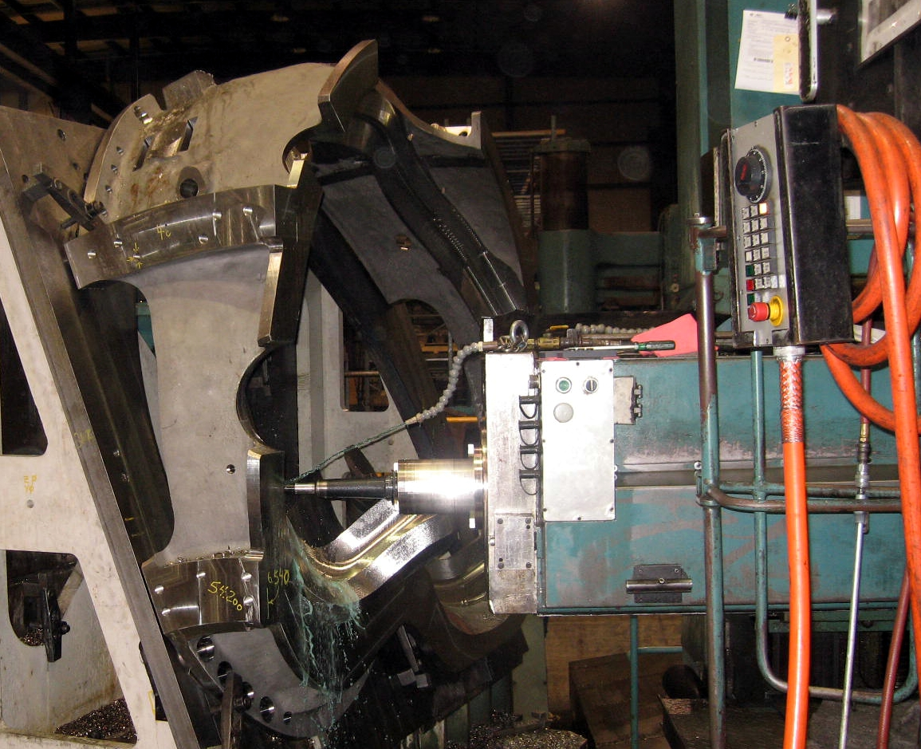
A-3 on 40’Mitsu
MTM completed the 1st operation on the 40’ last weekend and is well into the 2nd operation this week. Mike expects to complete this operation shortly after coming back from shutdown on 7/5 – 7/6. At that point, A-3 will move to final machining on the U-5.
B-1
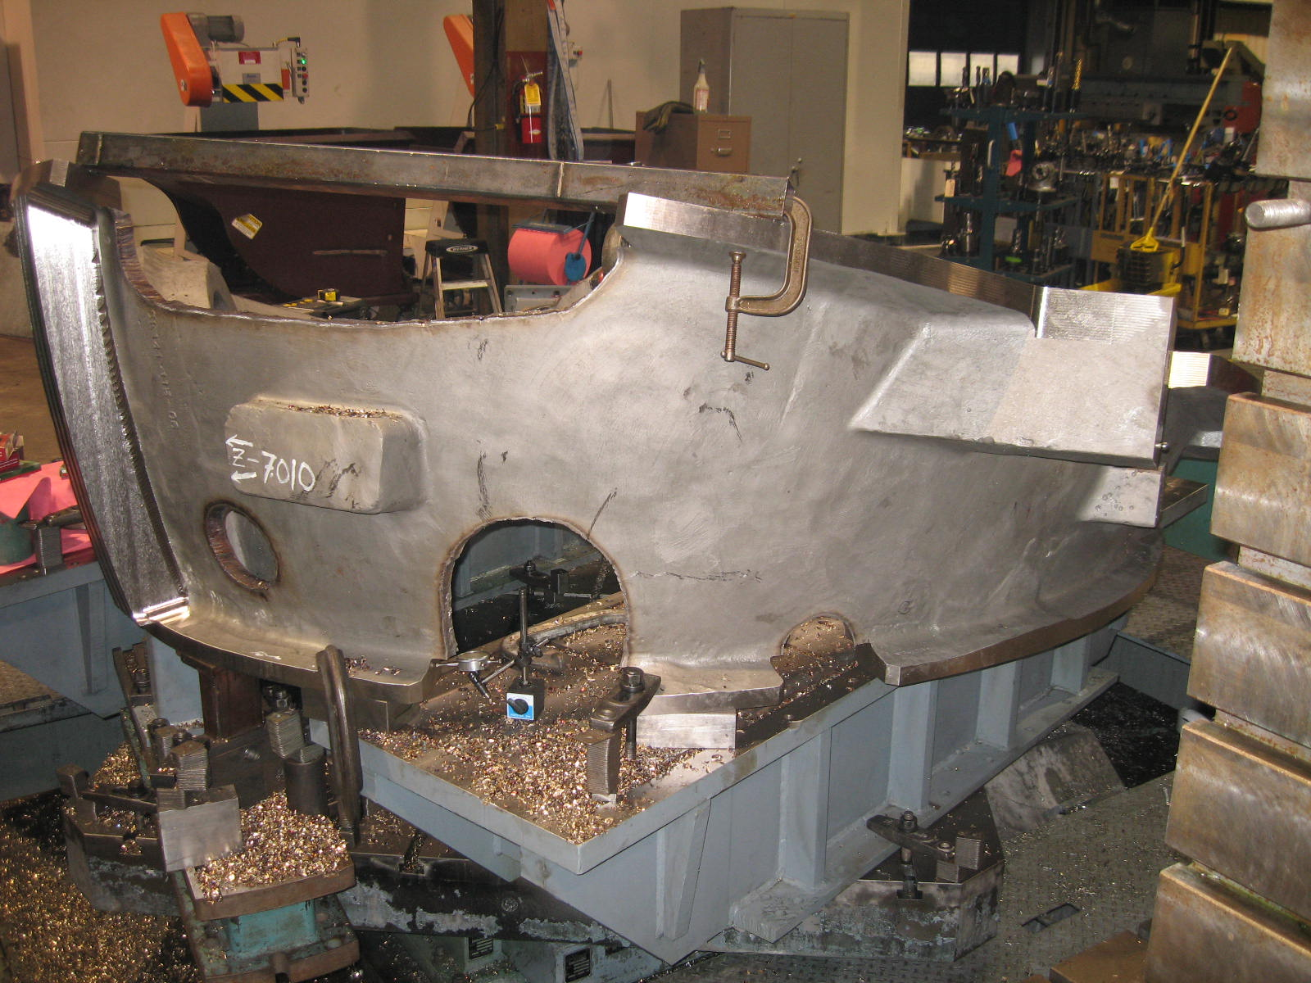
B-1 set up on 30’ Mitsu
Last week we reported that B-1 was moved off the 40T Lucas when an equipment problem was not readily corrected. The part was set-up on the 30’ Mitsu and over the weekend, the large openings on B-1 were removed. Unfortunately, the 30’ Mitsubishi also went down at the beginning of this week and was not readily repaired either. In addition to replacing some of the bearings, MTM sent the ball screw out for repair. The ball screw is expected to be returned to MTM on Saturday, 7/1, so MTM has scheduled a repair crew to work on this center over the shutdown. They intend to have the 30’ Mitsubishi back on line by 7/5 at which time they will commence the poloidal break operation. The delays on B-1 will likely translate to an overall delay in the projected delivery date. MTM will assess any potential impact when the part moves to the 40’ Mitsu.
B-2
There was some good news on the 40 T Lucas this week. Although it took longer than expected, MTM was able to bring the Lucas back on line late Thursday and chips are once again flying on B-2. During the downtime, MTM reset B-2 back up on the 1st operation which had been interrupted earlier in the machining sequence, when they were trying to get B-1 completed. They estimate that they have a few days of machining left on this operation before proceeding to the second operation.
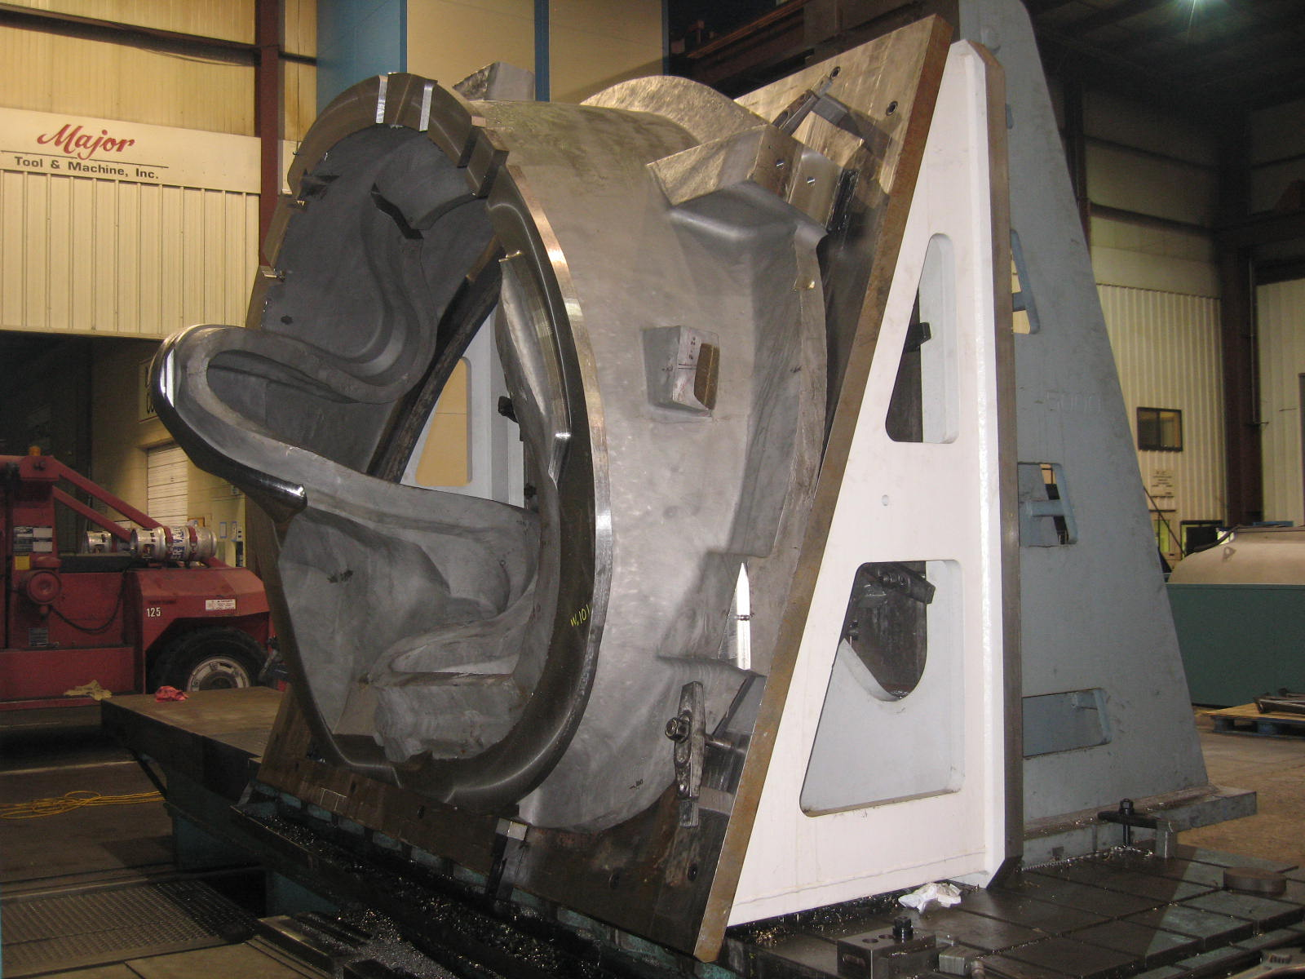
B-2 setup on 40T Lucas
B-5 & B-6

The majority of Metal Tek’s work on the program came to a close this week. On 6/30, MTK completed the last 2 castings, B-5 & B-6. The castings were released for shipment on Friday, 6/30, for a 7/5 delivery to the machine shop. At 7:51 am, on 7/1/06, we received the following message from MTK: “Elvis has left the building. He took B-5 and B-6 coils with him.” What a great way to celebrate Independence Day!

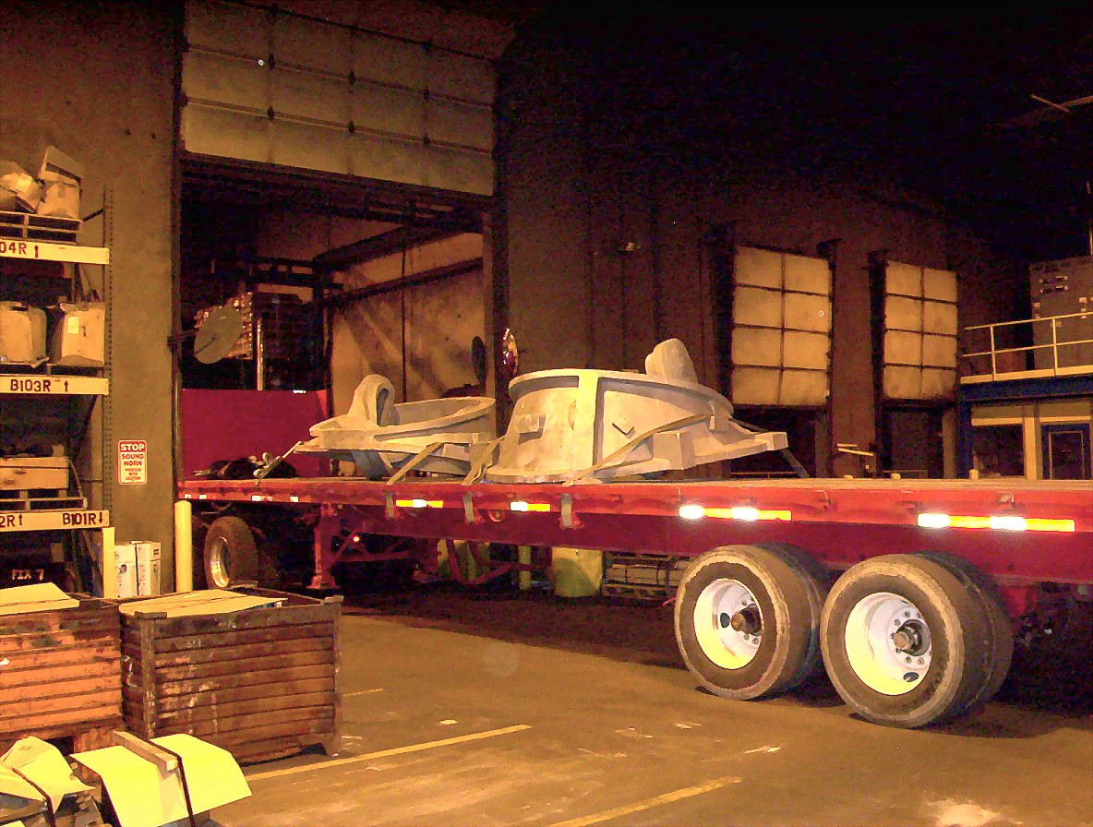

The last castings, B-5 & B-6, leaving Metal Tek

Technical Action Items

- (Major Tool) Machining C-6
Status: (Open) Back on hold
- (Major Tool) Inspecting A-2
Status: (Closed) Shipped to PPPL
- (Major Tool) Machining A-3
Status: (Open) Working on 2nd operation on Mitsu

- (Major Tool) Machining B-1
Status: (Open) 30’ Mitsu off line – expect to resume 7/5
- (Major Tool) Machining A-4
Status: (Open) On hold
- (Major Tool) Processing A-5
Status: (Open) on hold
- (Major Tool) Machining A-6
Status: (Open) on hold
- (Major Tool) Processing B-2
Status: (Open) On Lucas T
- (Major Tool) Machining B-3
Status: (Open) on hold
- (Major Tool) Machining B-4
Status: (Open) on hold
- (Metal Tek) Processing B-5
Status: (Closed) Shipped 6/30
- (Metal Tek) Processing B-6
Status: (Closed) Shipped 6/30

Quality Highlights
With three castings released for shipment, this was a busy week for QA! Pete Djordjevich and Steve Raftopoulos traveled to MTM on Monday & Tuesday this week to witness many of the final inspection procedures as well as conduct an initial review of the data package. Both attended the weekly QA meeting remotely from MTM. During the course of the meeting Mike Griffith informed the team that the CMM data was so good that no best fitting would be required! The Verisurf data followed showing the closest tolerances achieved to date on the program.

A second QA meeting was held Wednesday morning to discuss the Verisurf data and the 2 outstanding Non Conformances (NC-20044 for LP & NC-20080 for IDC). Dave Williamson led the discussion on the IDC, reporting that all of the reported non-conformances were within acceptable tolerances and did not cause concern. The other visual flaws on the casting were also disposed of quickly & NC-20080 was dispositioned. During the review of the PT report, Larry Dudek expressed concern over an indication on the T of the casting in a high stress area. This surface indication was also picked up in RT (but did not qualify as “rejectable” under RT criteria). Pete Djordjevich postulated that this indication was caused by a small “feather” shrink, exposed by machining and noted that it would not have been visible in the foundry RT shots and should not propagate. After their own internal review offline, PPPL concurred & signed off on the remaining NC and the shipping release by mid day, clearing A-2 to ship by the next morning.

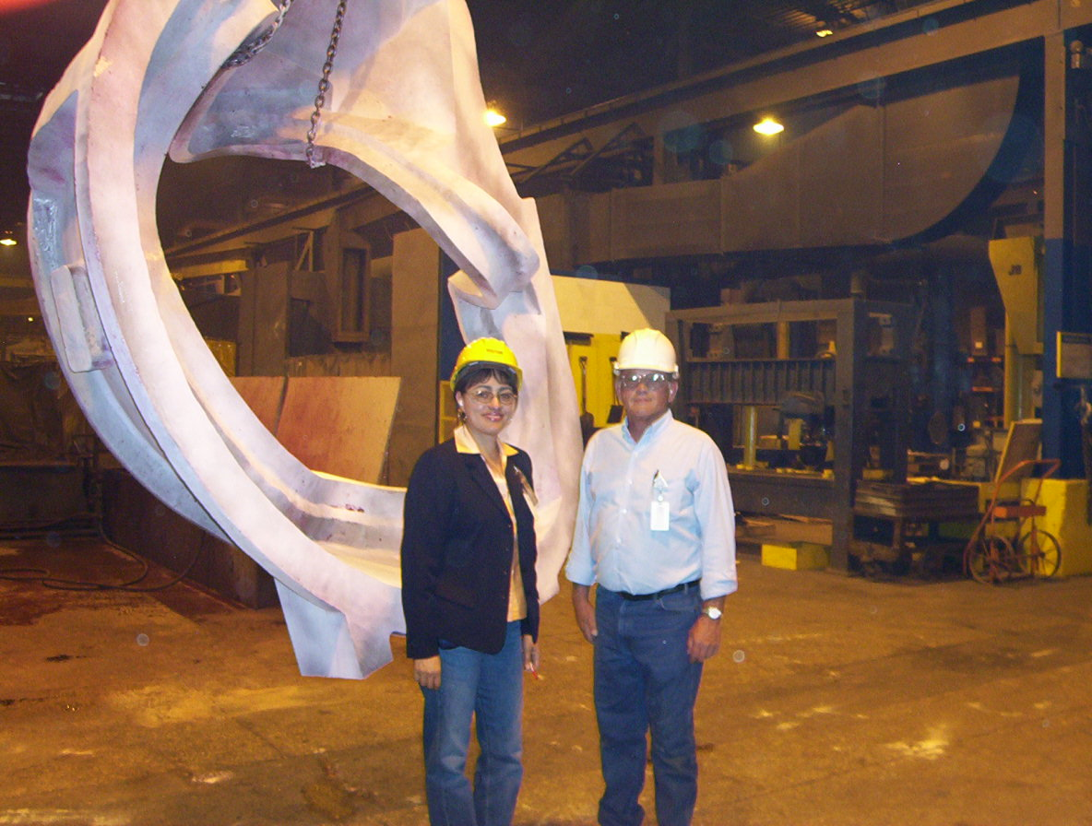

Rosa Medina, DCMA & Chuck Ruud, MTK QA Manager with B-6

Also during the week, Metal Tek worked diligently to complete final inspections on both B-5 and B-6 castings. Rosa Medina of DCMA was on-hand to witness the tests. Final paperwork for both castings was submitted to EIO late Friday and after review, Peter Djordjevich gave Chuck Ruud the “go ahead” to release the castings for shipment.

Upcoming QA Activities
- A-1 Doc package from MTM
- A-2 Doc packages from MTM & MTK
QA Action Items
- Closed Items: (EIO Recommended)

  - Additional photos (model) for Type A technique to help match locations to film have been submitted. (2.6)

- Pending from EIO:

  - (EIO) Provide final documentation packages for completed MCWF’s.
    - C-4
Status: (Open - No update) –EIO sent preliminary copy sent to PPPL 6/12. Feedback provided 6/26.
    - C-5
Status: (Open - NO update) – EIO posted preliminary copy - Feedback provided 6/30/06
    - A-1
Status: (Open) – In-progress at MTM. MTM was awaiting bushing info, which was sent 6/20. Mike Griffith reported on 6/30 that the requirements are in the hands of MTM purchasing agent (see also 2.3)
    - A-2
Status: (New) – In-progress at MTM.

  - (EIO) Investigate and take steps to mitigate source of ferromagnetic contamination seen on C-4, B-1 and subsequent castings. Report back with update to CA 1695 so that PPPL can disposition NCR 3633.
Status: (Open) – MTK inspected and cleaned-up A-2 on 6/19. B-1 was not accessible at the time - Inspection/Clean-up will be done by MTM as part of final. In light of MTM’s plans to complete B-1, Frank Malinowski recommended that MTK update CA1695 to reflect previous findings and submit to EIO for review. On 6/30, Chuck Ruud submitted the updated CA 1695 to EIO, which was forwarded to PPPL for information and to close out these actions.

  - (EIO, MTM) Document Corrective Action to close NC 19783 (A-1Tee hole counter-bore depths).
Status: (Open) PPPL sent EIO/MTM direction on 6/20 to use 316 material regardless of the permeability. MTM has initiated manufacture of the bushings. PPPL informed EIO that bushings are needed in house by mid August. Mike Griffith confirmed that his Purchasing department was informed of this requirement.

  - (EIO, MTM) Provide Stellalloy bearing plates and replacement fasteners for MCWF’s C-1 through C-5. (Needed to close NCR’s 3618 & 3651.)
Status: (Open - No update) Replacement hardware received. MTM is working on the plates - most of the plates are being machined as a group, so they will ship when all are done, probably with A-3

  - (EIO, MTM) MTM to obtain ingredients information for Sherwin penetrant (seen on A-1 PB insulator).
Status: (Open - No update) Initial contact of Sherwin got no response. MTM will pursue. In the interim, MTM has sent the MSDS which only lists alcohol as a hazardous substance.

  - (EIO, MTK) Provide additional photos (model) for Type A technique to help match locations to film.
Status: (Closed) Chuck Ruud of MTK submitted the photos to EIO late 6/30. The photos have been forwarded to PPPL and will be posted to the ftp.
  - (EIO, MTK) Provide film locations for Type B RT technique
Status: (Open - No update) per e-mail from Chuck Ruud, hardcopies were provided to Peter Djordjevich of EIO. EIO follow-up required.

- Pending from PPPL

  - Provide updated requirements documents incorporating the following changes:
    - CSPEC update addressing revised poloidal break inspection/tolerances. Poloidal break flange fit-up, 0.005” through and 0.015” at edges – edge defined as no more that 1/8” penetration.
Status: (Open- No Update) Rapid response guidance sent 3/16.

    - CSPEC revision to update the inspection points.
Status: (Open) Rapid response guidance sent 5/16.

  - Disposition (mark) rejected SS316 bearing plate material and then close EIO’s NC 19233 & 19234.
Status: (Open). PPPL to verify that all plates are marked with their permeability. Unmarked plates are being marked.

  - Review updated CA 1671 (for A6 test results below spec for elongation) with inspection and analysis results.
Status (Open) – in progress

- Discussion Topics for Teleconference:

  - New Specification & Drawing Changes - The production winding form folder of the manufacturing ftp site has been updated with the addition of an IGES file (typeb-new-vpi-holes) that shows the new VPI bleed holes for the Type-B modular coils.

Frank Malinowski submitted updated QA notes on 6/30/06 with notice that there will not be a QA telecon next week. In lieu of the QA meeting, a telecon may be scheduled to review the above change. As of 6/30, Mike Griffith reported that the change was in the hands of the programmers and thus far no problems or questions had surfaced.

I am extremely privileged to be reporting our team’s highlights this week! Despite complex and challenging moments, the results speak for themselves. I am proud to be associated with what has proven to be an extremely strong and competent team of players. We at EIO send heartfelt thanks to our partners at MetalTek for their dedication to this endeavor and look forward to our on-going partnership with Major Tool as we enter the home stretch. Of course, all of us are grateful to our partners within NCSX for this opportunity. Wishing you a Safe and Happy Independence Day!

Nancy Horton

EIO Program Manager for NCSX

