Energy Industries of Ohio (EIO) Team Weekly Status Report

Report covers the NCSX Modular Coil Winding Form Activities Under Production Contract S005242-F

Week ending July 28, 2006

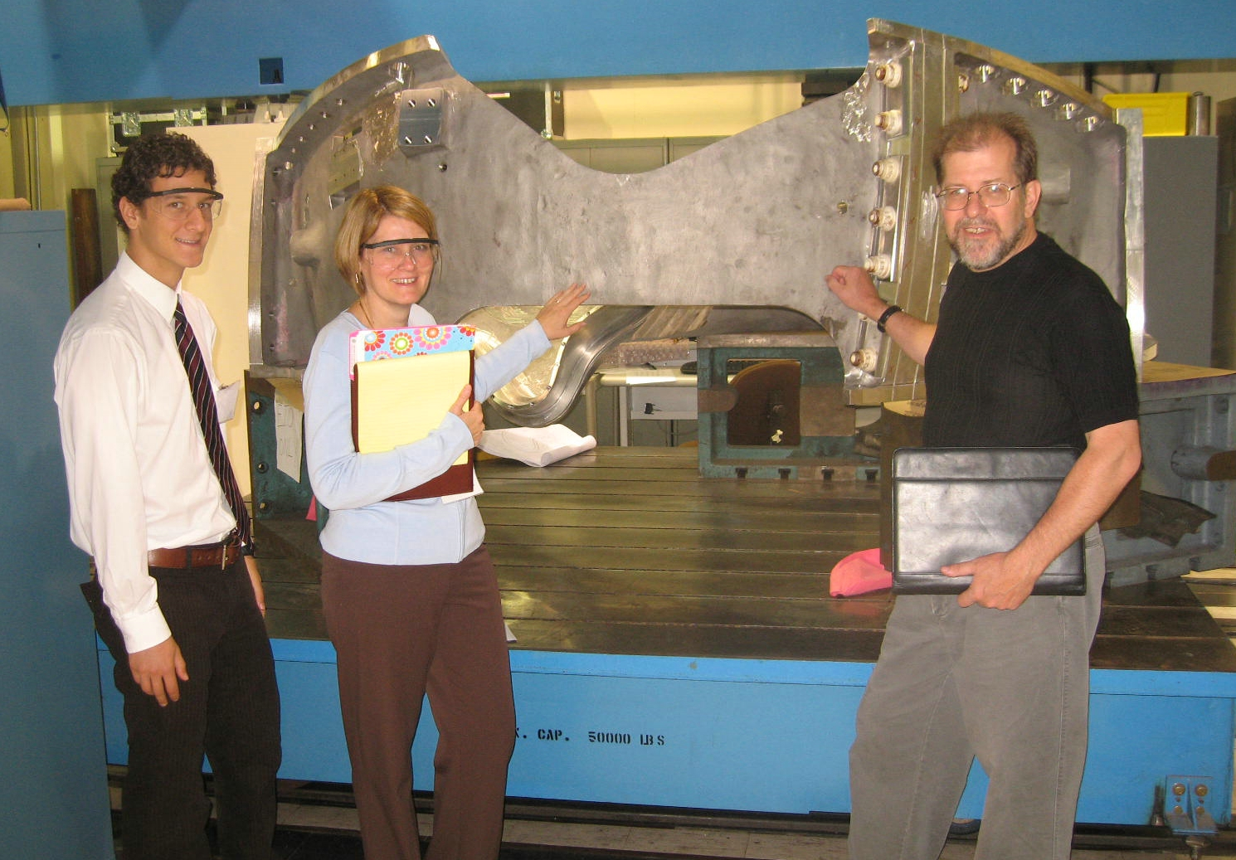
Martin, Nancy & Roy Admiring A-3 at Major Tool

Administrative Highlights

Good News again this week as A-3, the team’s 8th casting was released for shipment on Thursday, 7/27/06. The part is scheduled for delivery to PPPL at 8:00am Monday 7/31/06.

Nancy Horton, Martin Mudry (summer intern) & Roy Sheppard, of EIO were at Major Tool on Tuesday 7/25 and Wednesday 7/26 for a program and casting review meeting. Participants from Major Tool included Jim Flanagan, Mike Griffith, Joel Manship and Kevin Bowling. The meeting covered the contract schedule & on-going risk mitigation plans; topics which will also be covered in the 8/10-8/11 EIO meeting at PPPL. As always, MTM hospitality was greatly appreciated and made for a productive meeting.

Our meeting also covered draft revision 12 to the spec. Although the review is still ongoing, our initial look found no “show stoppers”. The major change in the new spec is that NCSX has redefined both the method of locating high stress areas & the actual location on each coil form. As depicted below, locations are now defined by T-hole locations.

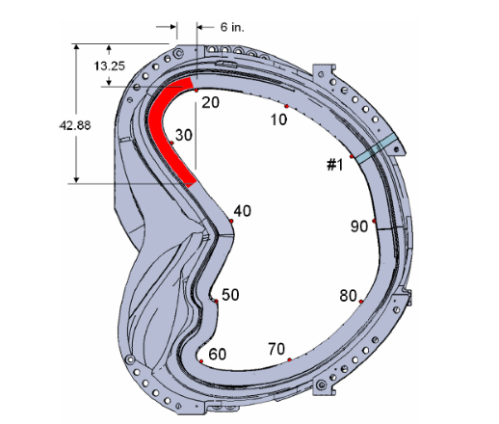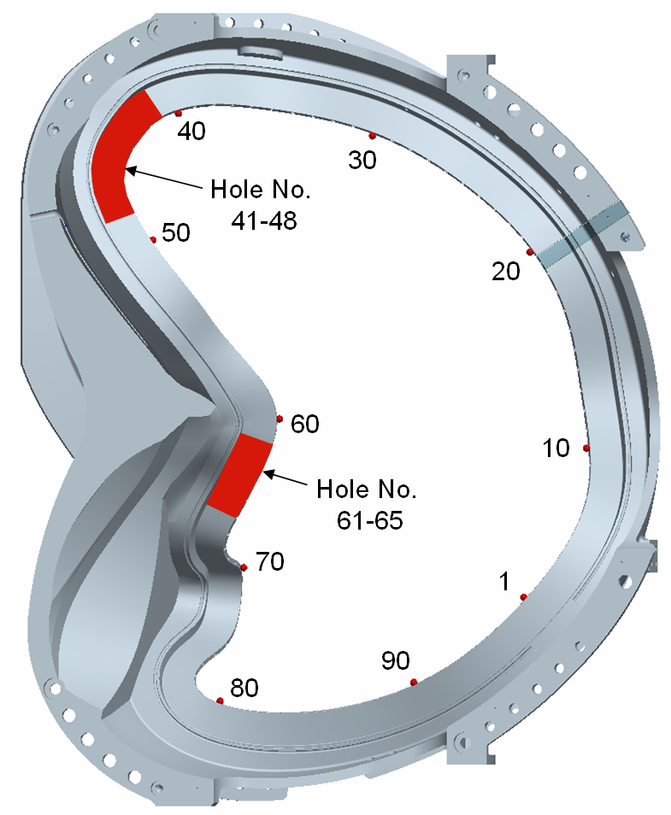

Original & newly defined high stress areas on A

Although the spec has not been approved yet, at PPPL’s direction, MTM implemented the new RT location shots for the A-3 casting.

FTP Postings this week
(found at: ftp.atc-inc.org:/PPPL/shared_info)
Location | File Name | Date
\Quality_Review\ Open_NCR-CA-RFD | NC20166-A-3_lpi.zip | 7/28/06
\Sow_Spec_Drawings | Draft_rev12_spec.zip | 7/28/06
\Quality_Review\ Closed_NCR-CA-RFD\CA | Signed_off_CA1671-A-6_testbar.zip | 7/28/06
\Quality_Review\ Open_NCR-CA-RFD | NC20124Rev1_A-3_oversized_hole.rtf | 7/28/06
\Quality_Review\A-3_Doc | A-3_grind_photos.zip | 7/28/06
\Quality_Review\ Open_NCR-CA-RFD | A3IDCattachmenttoNC20201.pdf | 7/28/06
\Quality_Review\ Open_NCR-CA-RFD | A3IDCattachmenttoNC20201.zip | 7/28/06
\Quality_Review\A-3_Doc | A-3_Verisurf_reports.zip | 7/28/06
\Quality-Meeting_notes | PPPLQualityNotes7-24-06-plus.doc | 7/28/06
**note – file names may be changed from the original for clarity

Administrative Action Items
- (EIO, MTK, PPPL) Pattern Storage after six castings have been delivered to MTM.

Status: (Open) Re-sequencing of machining the C coils means that the C pattern will need to be stored for an extended period and outdoor storage is not an option. A & B patterns are also ready for storage. We were informed this week that with rising oil prices, PPPL is concerned about the high cost for shipment of the patterns. Phil Heitzenroeder has asked EIO/MTK to investigate the cost for securing local storage in the St. Louis area to see if this might be a more economical option for housing the patterns until the program is complete. Barry Craig expects to have a quote to the team on 7/31 for outside pattern storage.

- (EIO, MTM) Revised Specification 12

Status: (New) On 7/21 Larry Sutton issued draft Specification Rev 12 to EIO for comment. Input is due to PPPL by 7/31.
Status: (Open) Initial comments on wording & formatting problems were sent to Larry Sutton on 7/28. Type B inspection points were added to the PPPL ftp site late Friday, 7/28. These still need to be reviewed.

- (EIO) EIO Monthly Report for July

Status: (Open) In process at EIO, the report will likely be submitted on or before 8/1/06.

- (EIO, PPPL) EIO Contract Status Meeting at PPPL

Status: (Open) Meeting at PPPL has been scheduled for 8/10 and morning of 8/11 as needed. Hutch Neilson has been coordinating the agenda at PPPL with Nancy Horton of EIO.

Technical Highlights
A-3
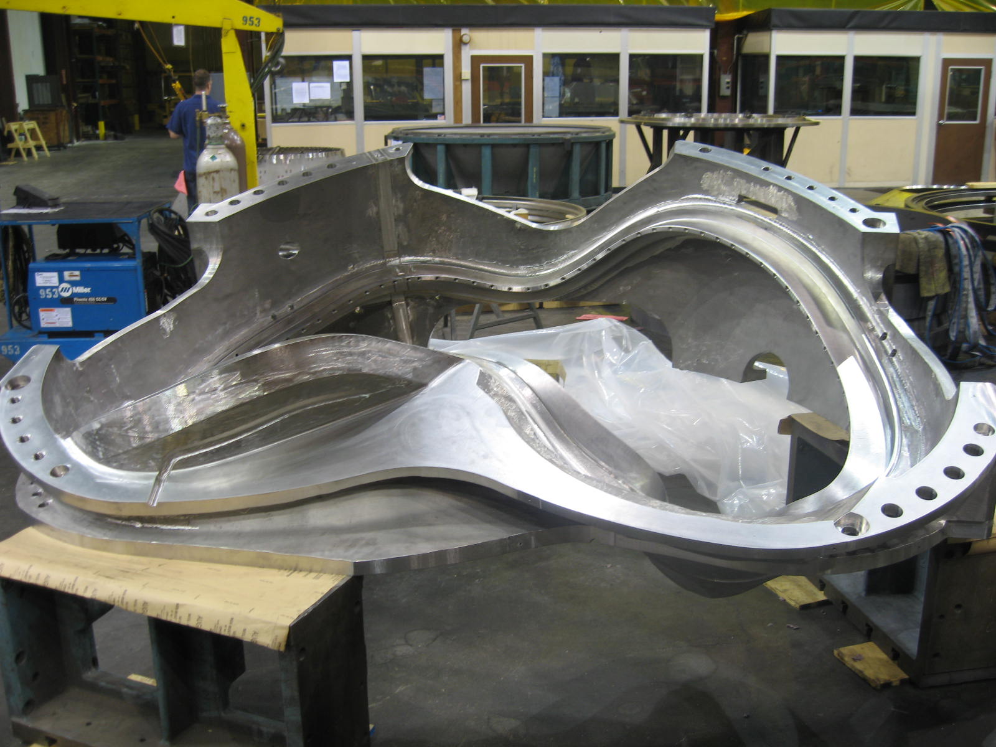
A-3 ready to ship
As mentioned in Administrative Highlights, the team completed work, including inspections on the A-3 casting this week, which resulted in the shipping release from PPPL on 7/27. Most of the inspection results were extremely positive, including x-ray, mag perm and electrical resistance which all passed. During review of the CMM inspection data, there was one non-conformance on the as-cast surface which required further analysis and ultimately corrective action. A raised area was found with material appearing to exceed the casting allowance. According to Tom Brown, this material would have caused interference during the assembly operations (see Quality Highlights below). Although the root cause of this problem still needs to be determined, MTM agreed to grind this detail off.
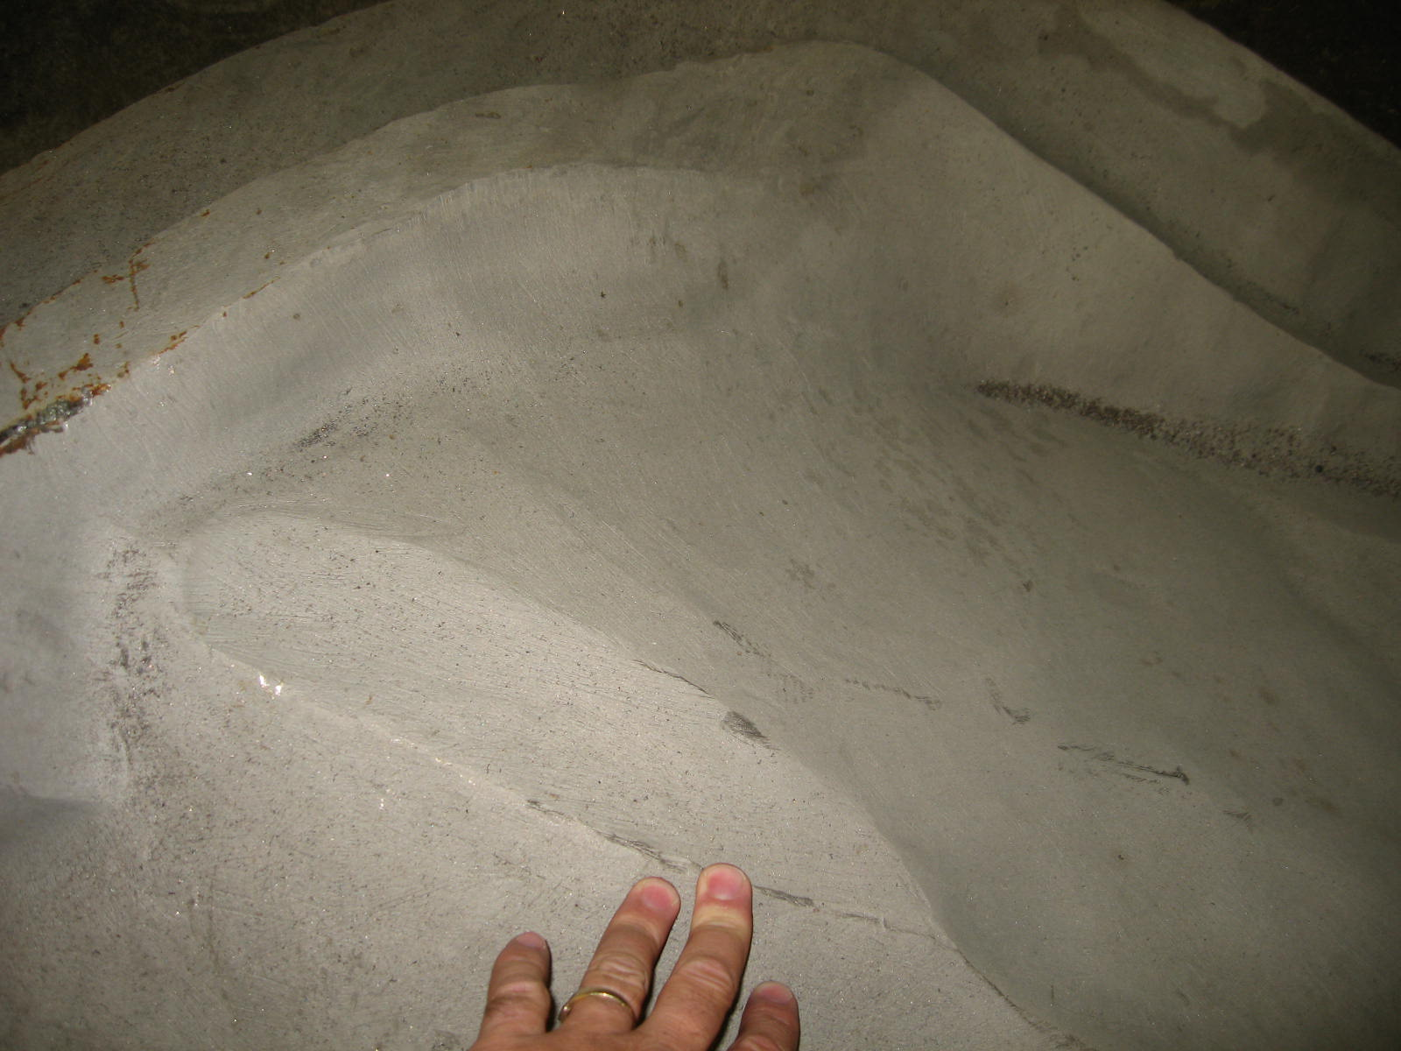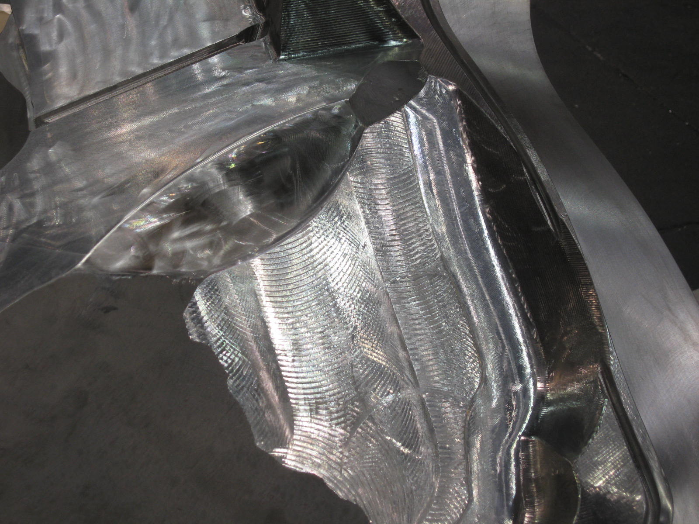

Shots of A-3 before and after grinding affected area

B-1

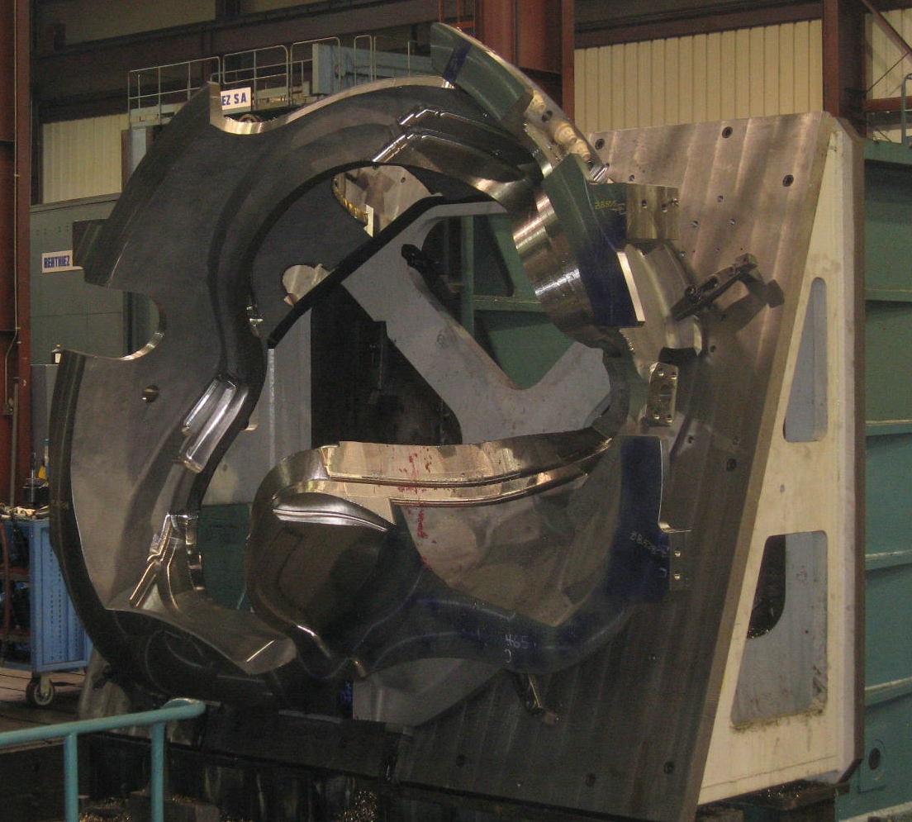
B-1 on 40’ Mitsu

B-1 made very good progress this week on the 1st operation (of 2) on the 40’ Mitsubishi. Mike Griffith expects to be on the 2nd op sometime next week. There is quite a bit more cut-time on the current operation, leading Mike to speculate that his 4-week lead time for this center will be held.

B-2
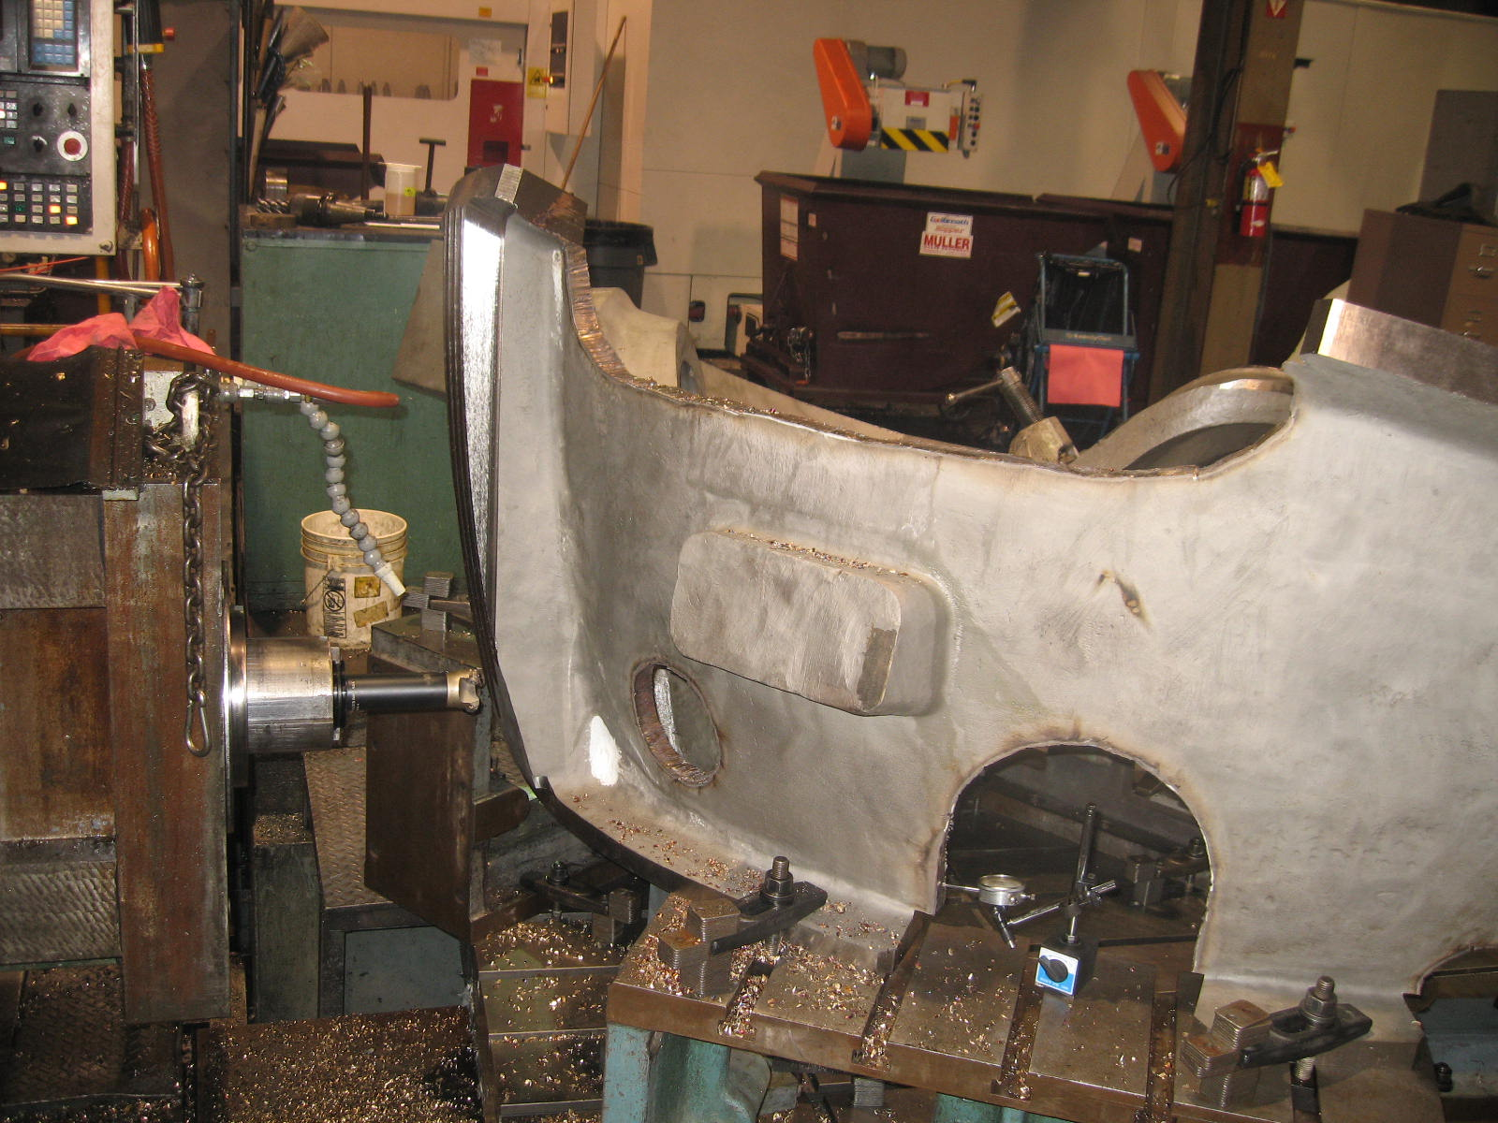
Cutting the break

As projected, MTM started the poloidal break operation this week on the 30’ Mitsubishi. After the break is cut, MTM will machine in the thermocouple hole prior to moving B-2 over to the 40’ Mitsu

B-3

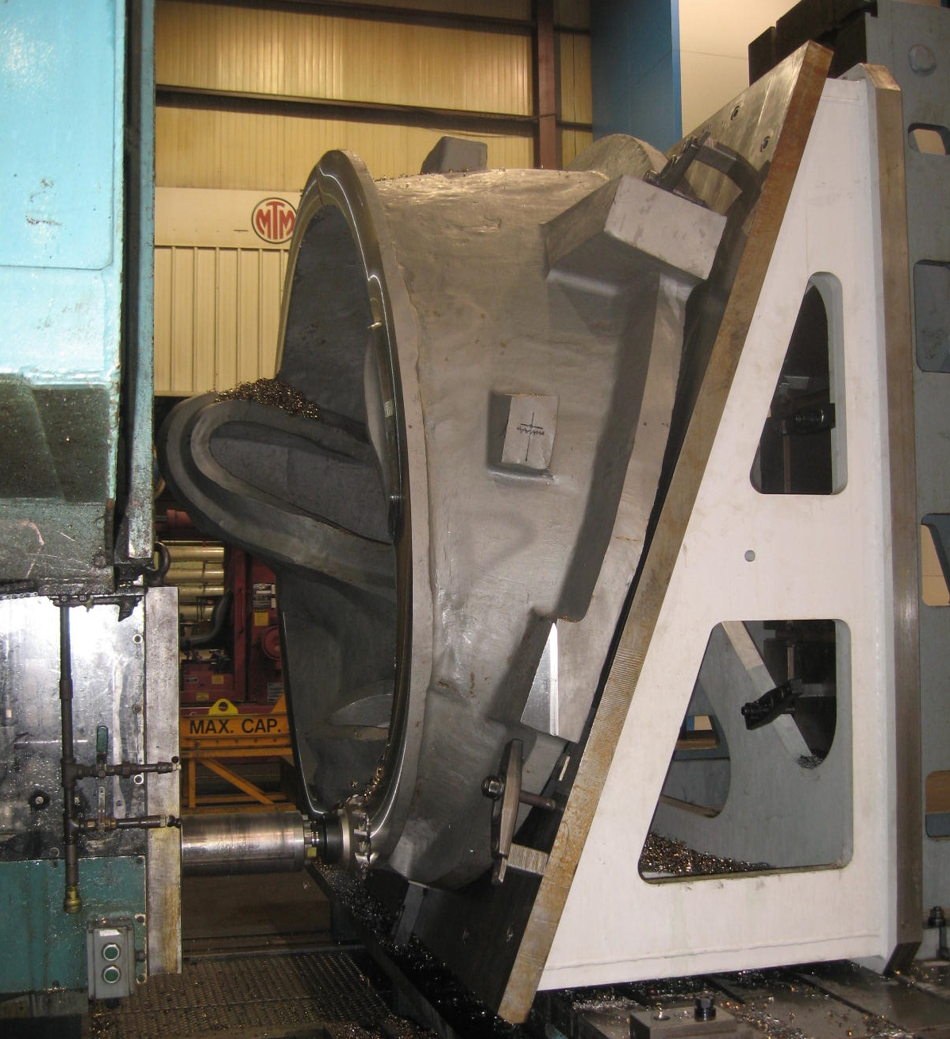
B-3 on the Lucas

Machining of B-3 commenced this week. MTM started the initial operation of B-3 on the Lucas T. There are 2 roughing operations done on this center (as well as arc removal), at which time they will move B-3 onto the 30’ Mitsu.
A-4
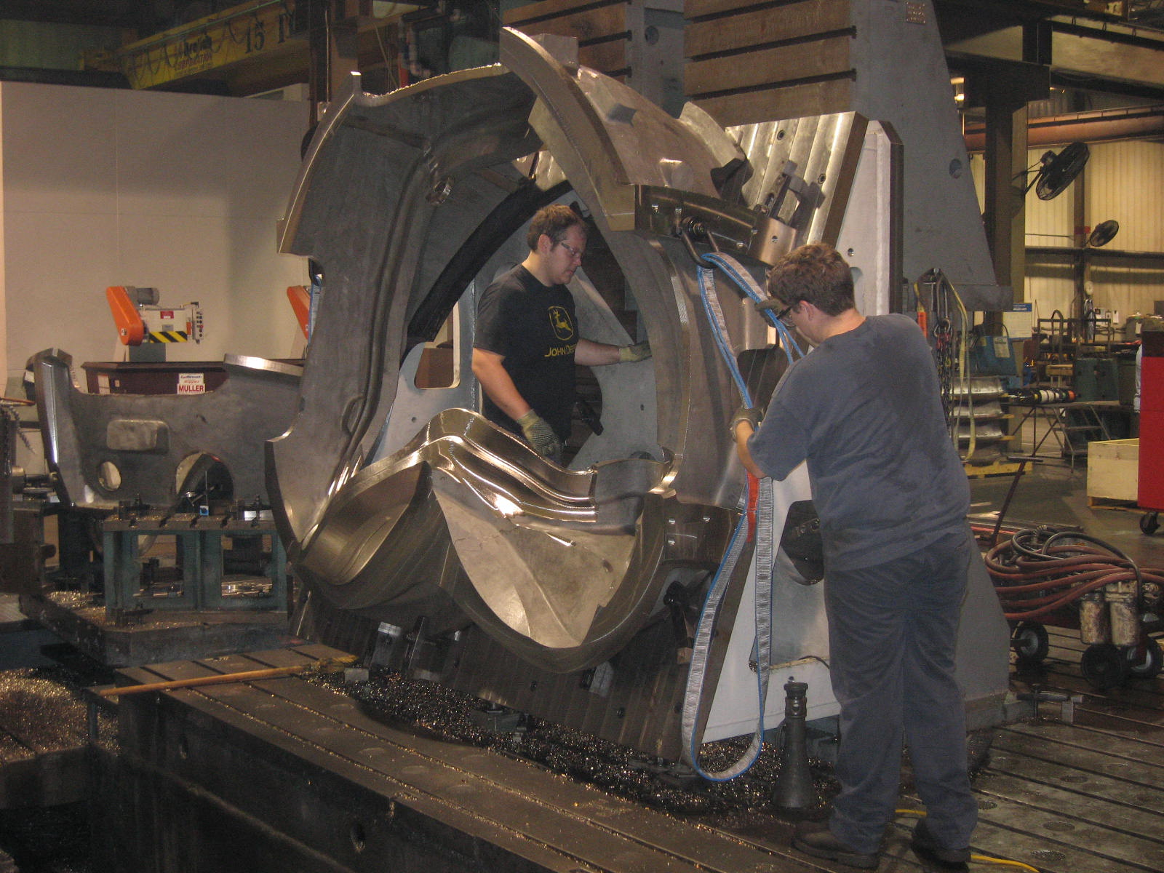
Removing A-4 from fixture
Major Tool finished the 2nd of the two resource leveling operations on the 30’ Mitsubishi. The casting was removed from the fixture and the casting has now been moved over to the 40’ center, where it will be placed in the queue along with B-2.

Technical Action Items

- (Major Tool) Processing A-3
Status: (Closed) Shipped

- (Major Tool) Machining B-1
Status: (Open) On 40’ Mitsu
- (Major Tool) Machining A-4
Status: (Open) Off 30’ Mitsu – in queue for 40’
- (Major Tool) Machining B-2
Status: (Open) Cutting poloidal break
- (Major Tool) Machining B-3
Status: (Open) On Lucas T
- (Major Tool) Machining B-4
Status: (Open) on hold
- (Major Tool) Machining B-5
Status: (Open) on hold
- (Major Tool) Machining B-6
Status: (Open) on hold

- (Major Tool) Machining A-5
Status: (Open) on hold
- (Major Tool) Machining A-6
Status: (Open) on hold
- (Major Tool) Machining C-6
Status: (Open) on hold

Quality Highlights

With the shipment of A-3 this week, the team has managed to finish up a few more of the remaining EIO action items on the list. MTM has promised that the Doc packages for A-1 & A-2 will be forthcoming shortly for EIO finalization.

The team needed to revise NC-20124 for the oversized hole bored in A-3 due to a measurement error. Larry Dudek of PPPL was informed and a revised version was shipped to PPPL for processing. The custom bushing was fabricated at MTM. Bushing fit was verified by Mike Griffith and Roy Sheppard, and the bushing will be shipped to PPPL along with A-3.

On 7/26, Roy Sheppard of EIO checked the surface permeability of B-4, B-5 & B-6. All of these castings had been aggressively cleaned and checked at the foundry prior to shipping. When the parts were received at MTM though, they were stored outside due to space consideration. At this time, all of the coils have recently been moved inside for storage. B-5 still had a large pool of rainwater trapped in 1 of the bends! All of the parts have rust over large areas of the castings. For the most part though, the rust seems to be a very light coating. Some areas though, particularly in pitted areas of the casting, looked to have a much thicker coating of rust (see photo below).

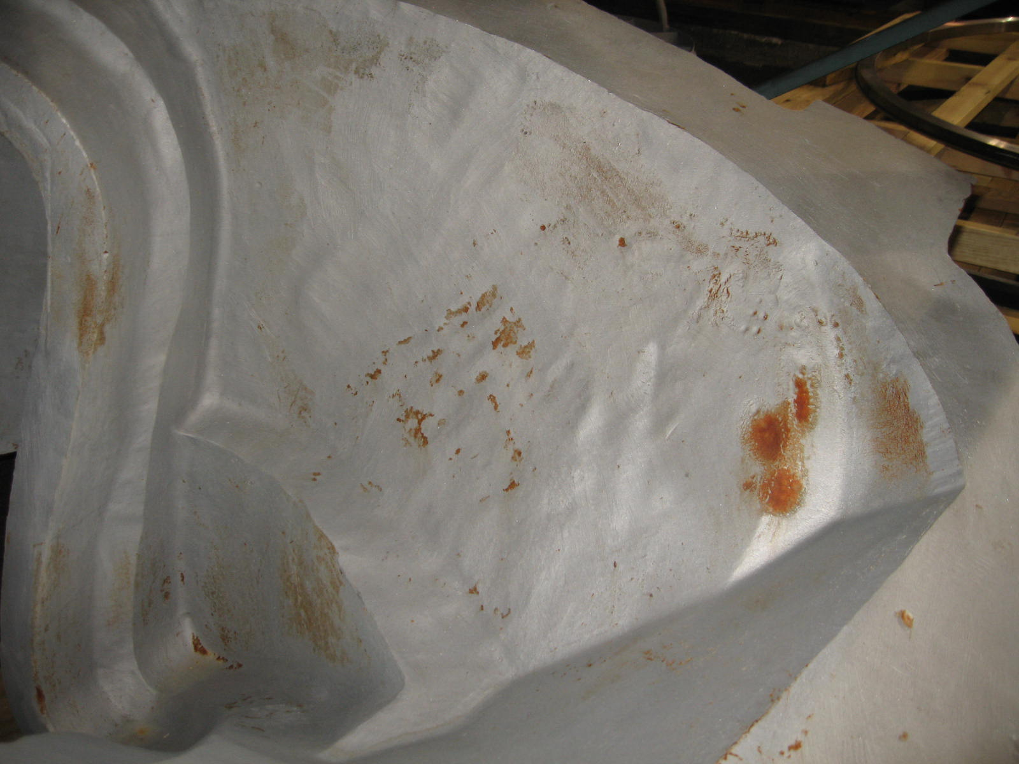
Some of the rusting evident on B-6

Aside from metallic transfer on B-4 & B-5 (probably from a forklift blade), Roy only found 1 small spot on C-5 that pulled the 1.02 Severn gauge. All of the other areas (light & heavy patina of rust) did not pull.

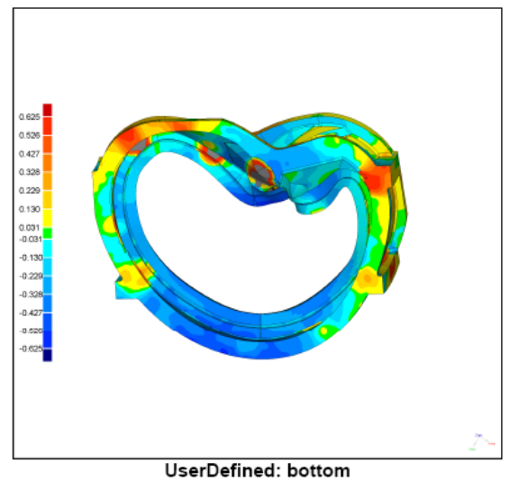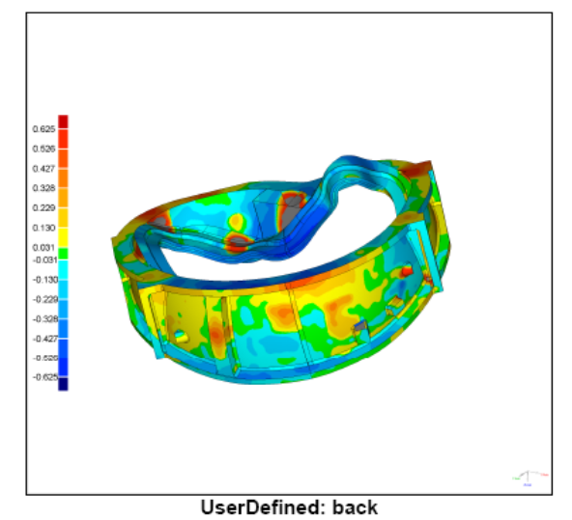
Slides from MTK Scan of A-3

Several meeting were held on Thursday, 7/27 to discuss the A-3 IDC. For the most part, A-3 proved to be the equal of A-2, for dimensional stability. The CMM data did not require best fit. A problem was found however in an as-cast area of the casting. An area of the casting appears to be raised above the general contour. This area was picked up in the CMM inspection at MTM & also appears to be shown in the scan from Metal Tek (grey area surrounded by red).

Analysis of the raised area by Tom Brown showed that this feature would cause an interference with the assembly of A to B. As mentioned in Technical Highlights, MTM ground the casting to eliminate the problem.
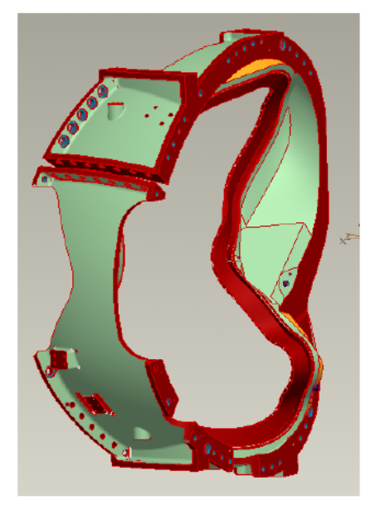
Slides showing A-B mounting interference

The team will be evaluating the balance of the castings and the scans to see if this feature appears on all of the A MCWF. Mike Griffith took a quick look at A-4 through A-6 and advised that they also seem to share this problem.

Upcoming QA Activities

- A-1 Doc package from MTM
- A-2 Doc packages from MTM
- Evaluation of raised area on A castings

QA Action Items

- Closed Items: (EIO Recommended)
  - Closed CA 1671 (for A6 test results below spec for elongation) transmitted 7/24.
  - Shipped replacement bearing plates and hardware to PPPL (2.3)
  - Shipped custom bushing to PPPL (2.4)

- Pending from EIO:
  - (EIO) Provide final documentation packages for completed MCWF’s.
    - A-1
Status: (Open) – MTK portion posted –awaiting MTM portion
    - A-2
Status: (Open) – MTK portion posted –awaiting MTM portion

  - (EIO, MTM) Document Corrective Action to close NC 19783 (A-1Tee hole counter-bore depths).
Status: (Open - No update) PPPL sent EIO/MTM direction on 6/20 to use 316 material regardless of the permeability. MTM has initiated manufacture of the bushings and will deliver by mid-August. NC will be closed on delivery.

  - (EIO, MTM) Provide Stellalloy bearing plates and replacement fasteners for MCWF’s C-1 through C-5. (Needed to close NCR’s 3618 & 3651)
Status: (Closed) Shipped with A-3.

  - (EIO, MTM) Document Corrective Action to close NC 20124 for oversized hole on A-3.
Status: (Closed) – Custom G-11 bushing shipped with A-3

  - (EIO, MTK) PPPL has requested permission to borrow MTK models to facilitate review of radiography shots. While the models are not contract deliverables, they have been extremely useful communication tools during inspection activities.
Status: (Open) – Request has been communicated to MTK. Opportunity to safely transport the models is being investigated, perhaps during a future visit of MTK or EIO to PPPL.

- Pending from PPPL
  - Revise CSPEC to incorporate the following changes:
    - CSPEC update addressing revised poloidal break inspection/tolerances. Poloidal break flange fit-up, 0.005” through and 0.015” at edges – edge defined as no more than 1/8” penetration.
Status: (Open) Draft Rev. 12 to EIO for comment – issue date target is 7/28.

    - CSPEC revision to update the inspection points.
Status: (Open) Draft Rev. 12 to EIO for comment – issue date target is 7/28.

    - Modify high stress area with Tee hole designators and location changes.
Status: (Open) Draft Rev. 12 to EIO for comment – issue date target is 7/28.

  - Review additional data for Type B technique mailed to PPPL last week.
Status: (Open) Mail not received as of 7/24/06. Emailed photos, received 7/17, and posted photos reviewed and PPPL questions sent to EIO 7/24.

  - MTM to obtain ingredients information for Sherwin penetrant (seen on A-1 PB insulator).
Status: (Open) EIO sent Sherwin info, which is now at ORNL for evaluation.

  - Review updated Documentation packages
    - C-4
Status: (Open) –Downloaded 7/24
    - C-5
Status: (Open) –Downloaded 7/24
  - NC20166, A-3 PT rejections, was discussed and, based on location and stresses, the project decided to accept all as-is.
  - NC-20124 – For oversized hole on A-3 – This NC had been closed. Reopened due to measurement error on hole size.

- Discussion Topics for Teleconference:
We were notified by Frank Malinowski that next week’s QA telecon (8/1) is cancelled. The meeting will resume on 8/8/06.

Nancy Horton

EIO Program Manager for NCSX

216-496-2314

