Energy Industries of Ohio (EIO) Team Weekly Status Report

Report covers the NCSX Modular Coil Winding Form Activities Under Production Contract S005242-F

Week ending August 4, 2006

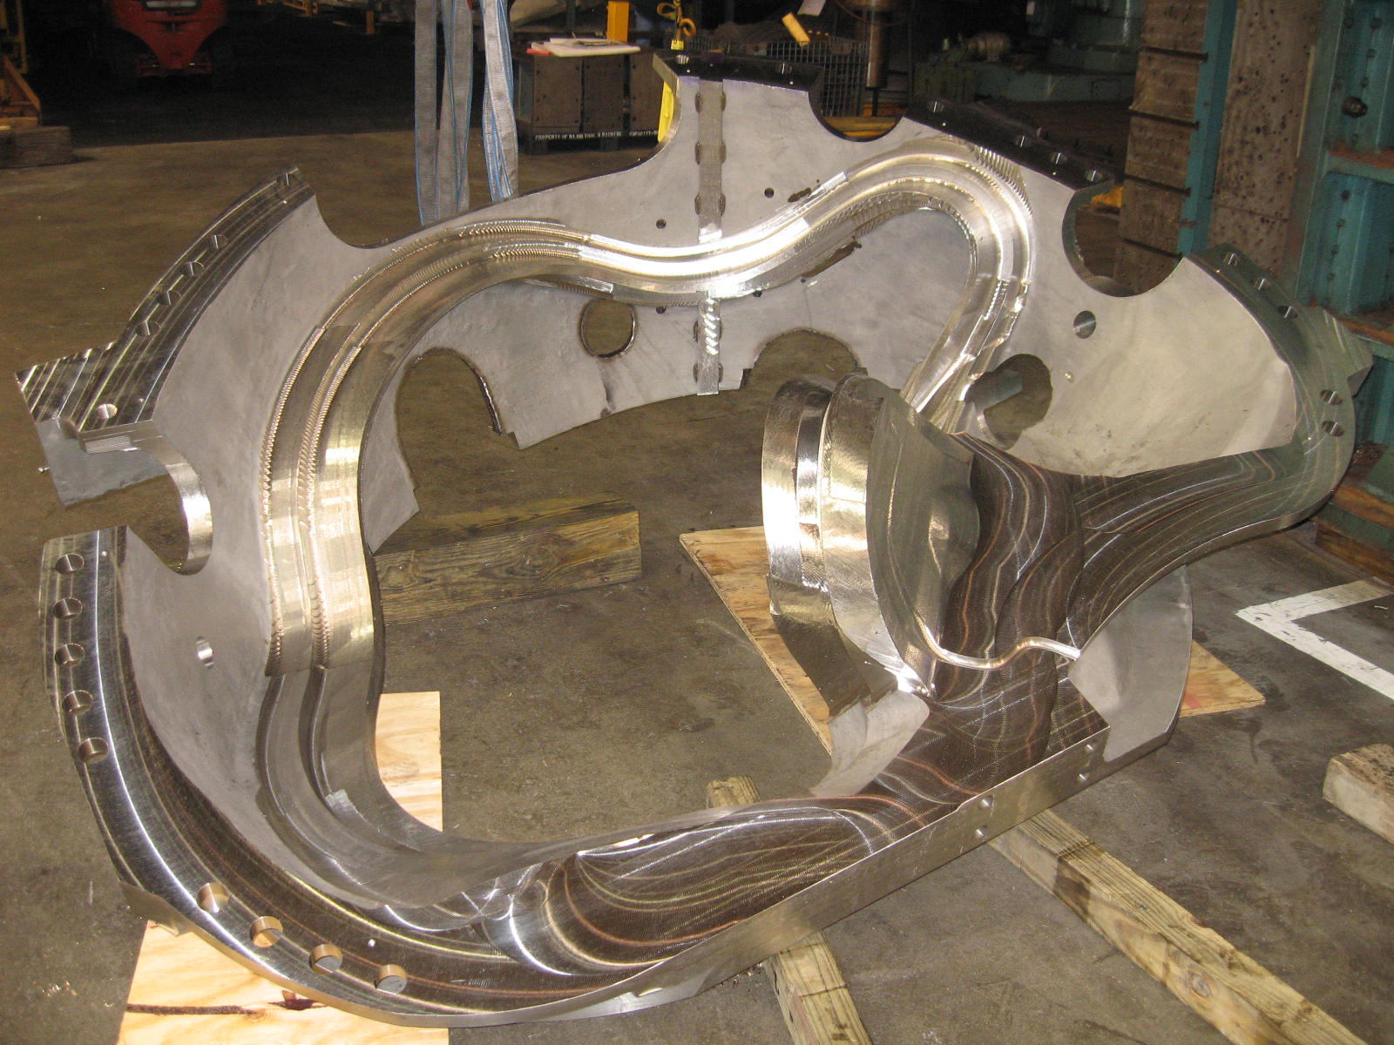
B-1 is “taking shape”

Administrative Highlights

As part of our end of the month contract reporting and in anticipation of our upcoming contract status meeting scheduled for 8/10 at PPPL, the team has spent the last two weeks reviewing our performance and assessing our remaining delivery projections. The good news is that despite a late start coming out of the gate and a couple of obstacles along the path, the overall outlook for the remainder of the contract is extremely favorable, with an on-time delivery of the first field period and full schedule recovery during the second field period. Our up-to-date risk mitigation strategy and details of our future performance plans will be shared in greater detail during the upcoming meeting. Joining me from the EIO team will be Roy Sheppard, Peter Djordjevich, Martin Mudry, Mike Griffith and Joel Manship.

FTP Postings this week
(found at: ftp.atc-inc.org:/PPPL/shared_info)
Location | File Name | Date
\Quality_Review | A_riser_pad_issue.doc | 8/1/06
\SOW_Spec_Drawings\B-changes | type_b_insp_points.zip | 8/1/06
\Quality_Review\A3_Doc | A3_interference_as_cast.pdf | 8/1/06
\Quality_Review\A3_Doc | GrindingofA3_jpg.zip | 8/1/06
\Quality_Review\A3_Doc | MTK_A-3_Doc_Pack-8-2-06.pdf | 8/2/06
\Quality_Review | b-undersized-pads-8-1-06.doc | 8/4/06
\Quality_Review\A1_Doc | A-1_Doc_MTM.pdf
\Quality_Review\A2_Doc | A-2_Doc_MTM.pdf
\Reports_Weekly-Monthly\Weekly | 06-07-28_eio_wk.doc | 7/30/06
\Reports_Weekly-Monthly\Monthly | Milestone_Schedule_for_Monthly_Report_8.1.06.xls | 8/6/06
**note – file names may be changed from the original for clarity

Administrative Action Items
- (EIO, MTK, PPPL) Pattern Storage after six castings have been delivered to MTM.

Status: (Open) Re-sequencing of machining the C coils means that the C pattern will need to be stored for an extended period and outdoor storage is not an option. A & B patterns are also ready for storage. We were informed this week that with rising oil prices, PPPL is concerned about the high cost for shipment of the patterns. Phil Heitzenroeder has asked EIO/MTK to investigate the cost for securing local storage in the St. Louis area to see if this might be a more economical option for housing the patterns until the program is complete. Barry Craig forwarded an estimate from a storage facility which included generic fees (by sq. foot) and labor rates. The team is trying to get a more specific idea, of the charges that would be seen for the 3 patterns.

- (EIO) Specification Rev 12 to EIO for comment

Status: (Open) Initial comments on wording & formatting problems were sent to Larry Sutton on 7/28. Type B inspection points were added to the PPPL ftp site late Friday, 7/28. These are still under review.

- (EIO) EIO Monthly Report for July

Status: (Closed) The monthly report was submitted on 8/2/06.

- (EIO, PPPL) EIO Contract Status Meeting at PPPL

Status: (Open) Meeting at PPPL has been scheduled for 8/10 and morning of 8/11 as needed. Hutch Neilson has been coordinating the agenda at PPPL with Nancy Horton of EIO.

- (PPPL) Disposition of Prototype Casting & Prototype Fixture from JP.

Status: (Newly Reopened) To be added to the agenda for the upcoming meeting, the EIO team has no further need for these items and is seeking disposition instructions from PPPL.

Technical Highlights

The configuration of the B MCWF has made this coil more challenging than either A or C. The B coil has the same tight racetrack as is seen on C as well as the large cutouts seen on A. The net result is that B, along with the difficulty in contouring, is also significantly less stable. The coil has required multiple setups & shimming to maintain the tight profile required.

The good news is, like the earlier MCWF, the learning curve is still applicable. The lessons garnered on B-1 have transferred over well to B-2 & B-3. These coils are progressing very well through the shop.
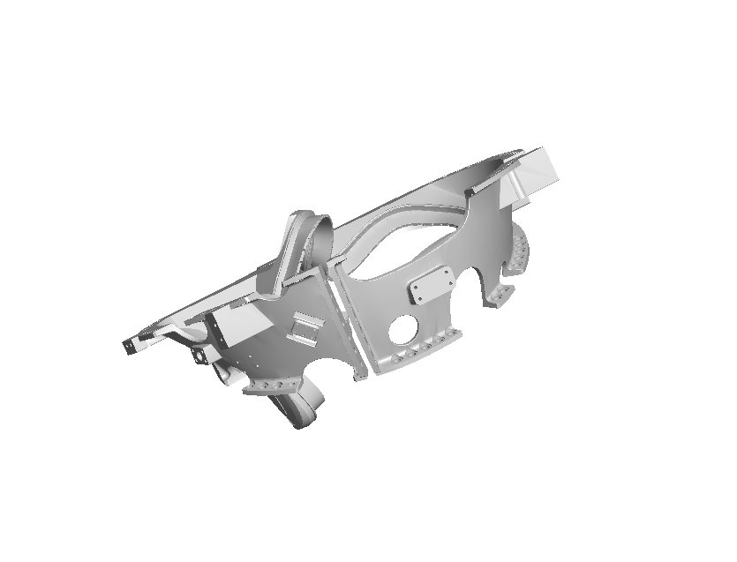
B Casting in Model Form
B-1

B-1 is finished on the 1st operation on the 40’ Mitsubishi. As depicted in the photo at the beginning of this report, the shop is setting up B-1 for the 2nd operation which is scheduled to commence over the weekend. At present, MTM has allowed 2 weeks for this op, but based on experience during the first set-up, they suspect that they will complete the operation sooner. Large areas of the 2nd side were machined in the initial setup. After completing 3-axis machining, the casting will move to the U-5

B-2

The shop completed the poloidal break cut this week. Although the casting still moved, MTM was able to successfully compensate for this, and the shim was tacked in place with little difficulty. The next operation will put the holes in the break (and shim) & cut in the lead block slots prior to indexing the casting to put in the thermocouple feature.

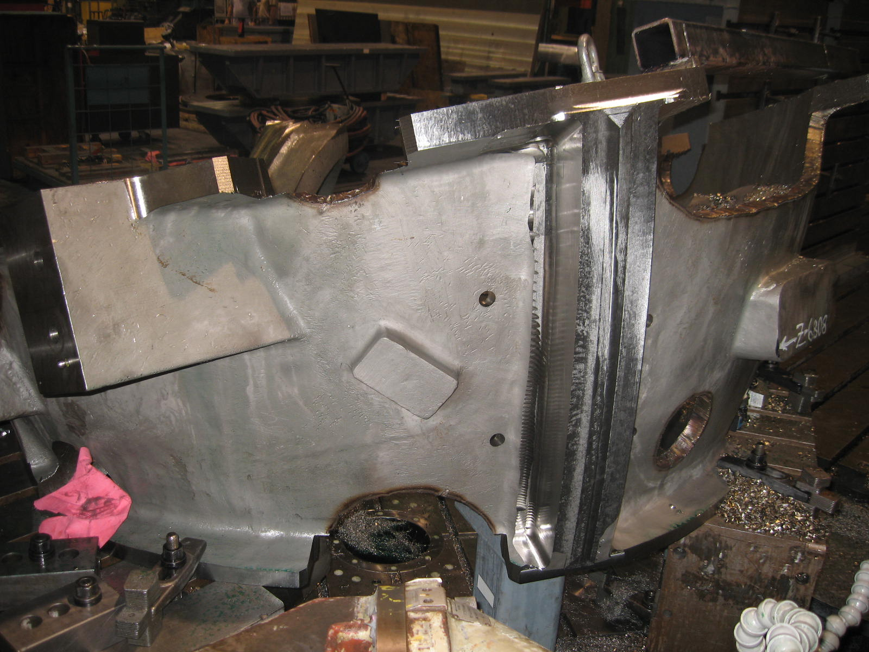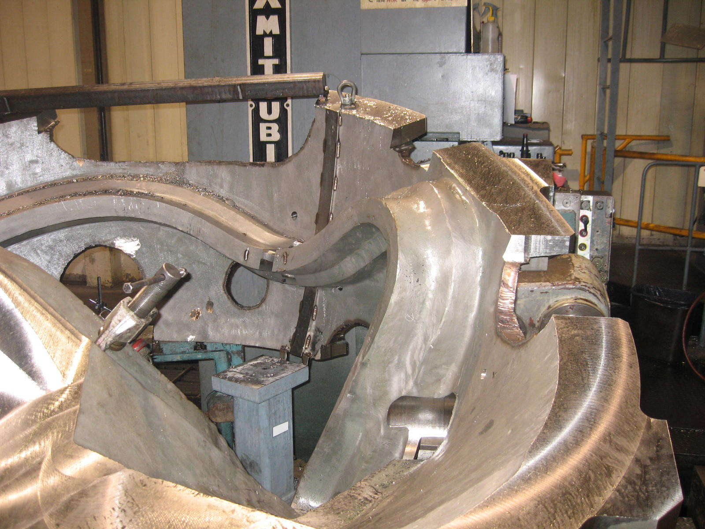
B-2 – break & shim welded – ready for drilling

B-3

Major Tool will be working on B-3 all weekend. Mike Griffith expects to finish up the 1st Lucas T operation (1 of 2) this weekend. After that, the coil will be swapped on the fixture with B-4. Initial B-4 operation should begin on Monday, 8/7.

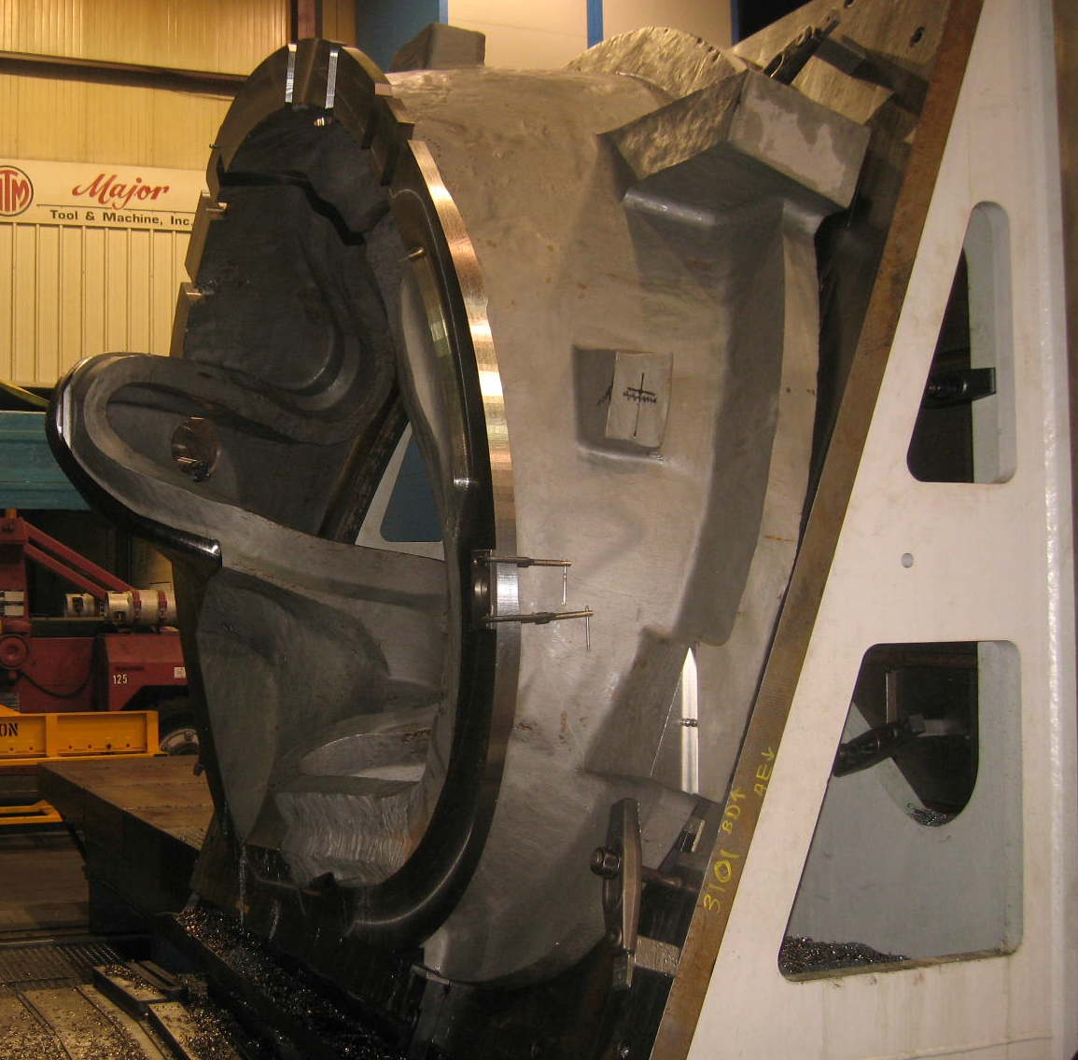
B-3 on 40-T

Technical Action Items

- (Major Tool) Machining B-1
Status: (Open) On 40’ Mitsu 2nd op
- (Major Tool) Machining A-4
Status: (Open) Off 30’ Mitsu – in queue for 40’
- (Major Tool) Machining B-2
Status: (Open) On 30’ Mitsu
- (Major Tool) Machining B-3
Status: (Open) On Lucas T
- (Major Tool) Machining B-4
Status: (Open) In queue for Lucas T
- (Major Tool) Machining B-5
Status: (Open) on hold
- (Major Tool) Machining B-6
Status: (Open) on hold

- (Major Tool) Machining A-5
Status: (Open) on hold
- (Major Tool) Machining A-6
Status: (Open) on hold
- (Major Tool) Machining C-6
Status: (Open) on hold

Quality Highlights

The EIO team took advantage of a mostly quiet week (QA meeting was cancelled and many PPPL team members were traveling) to work on the list of outstanding EIO QA action items. MTM has forwarded doc packages for A-1 & A-2 to EIO (2.1.1 & 2.2.2). The files have been posted for preliminary review. EIO will be implementing the changes to both of these packages, following suggestions by Frank Malinowski on the C-4 & C-5 packages. EIO has posted the complete MTK portion of A-3, but the MTM portion remains open pending resolution of open NCR’s (submitted to PPPL).

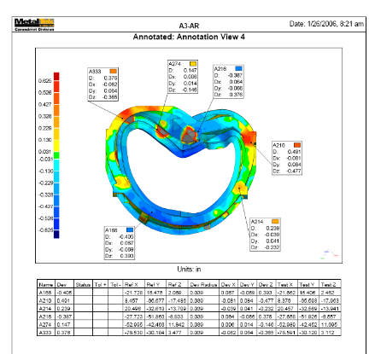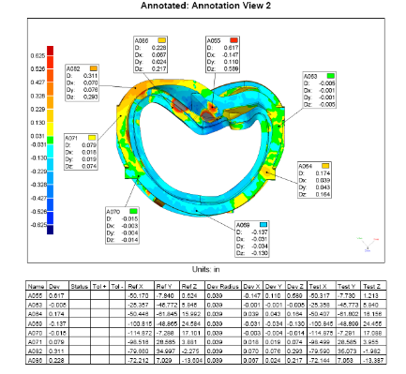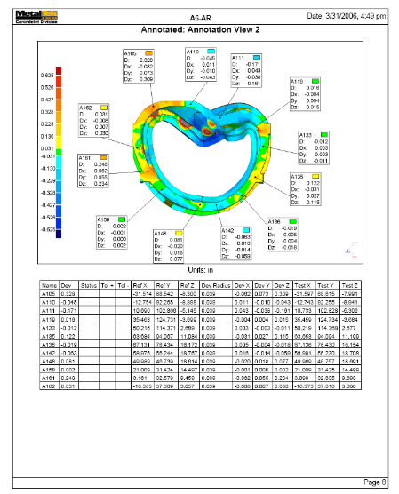
Slides from A-3, A5 & A-6

EIO received input from both Metal Tek & Major Tool on the issue reported on last week regarding the raised area seen on A-3. The area is of concern to PPPL because it will cause interference during assembly. Other scans were examined. Both A-5 & A6 had identical views from the scan. As can be seen above, the raised feature is evident in all of the scans.

Metal Tek has confirmed that there was a riser in this area. From a print review, the castings appear to be within stock allowances. Profile tolerance, thickness tolerance & riser allowances all add up to .750” over nominal. Since castings are compensated for best fit during machining, further allowable deviation can occur. A report was generated & forwarded to PPPL for comment.

A separate issue also developed last week while EIO was visiting MTM. Mike Griffith pointed out a problem the shop had noted on B-3.

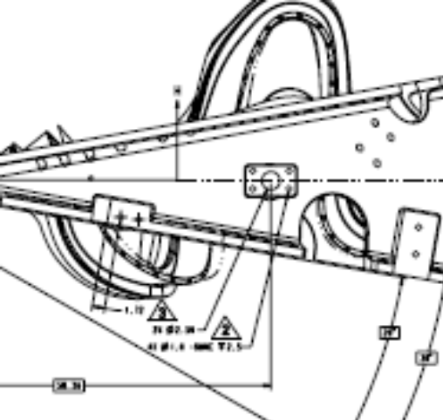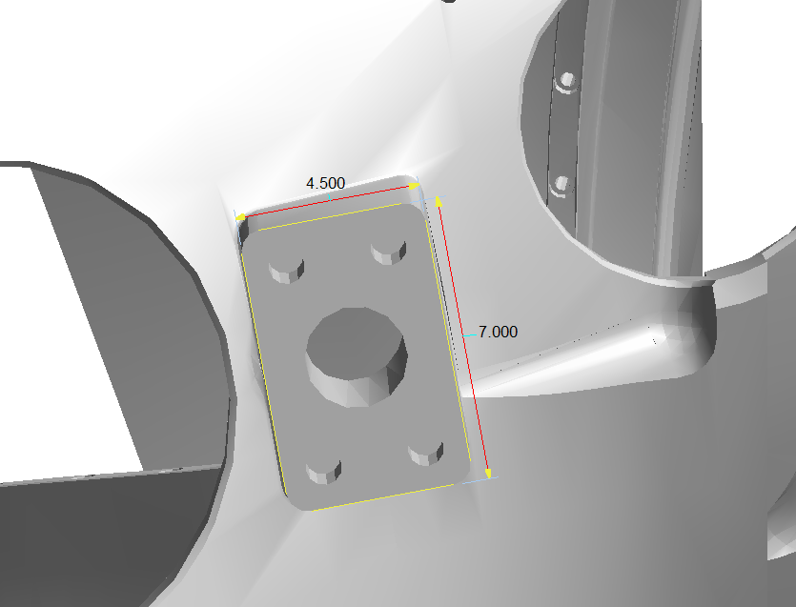

Pads on B MCWF - undersized

One of the small cast pads was undersized for the hole-pattern called out. These pads (2 per casting) get one 2.5” thru ø & four Ø1.0-8UNC tapped holes. Although the print does not dimension either the boss or the hole pattern, measuring the model gives you a hole pattern with the four 1" ø at 5" on center on the long leg & 2.5" on center on the short leg with a boss (pad) size of 4.5” x 7.0”

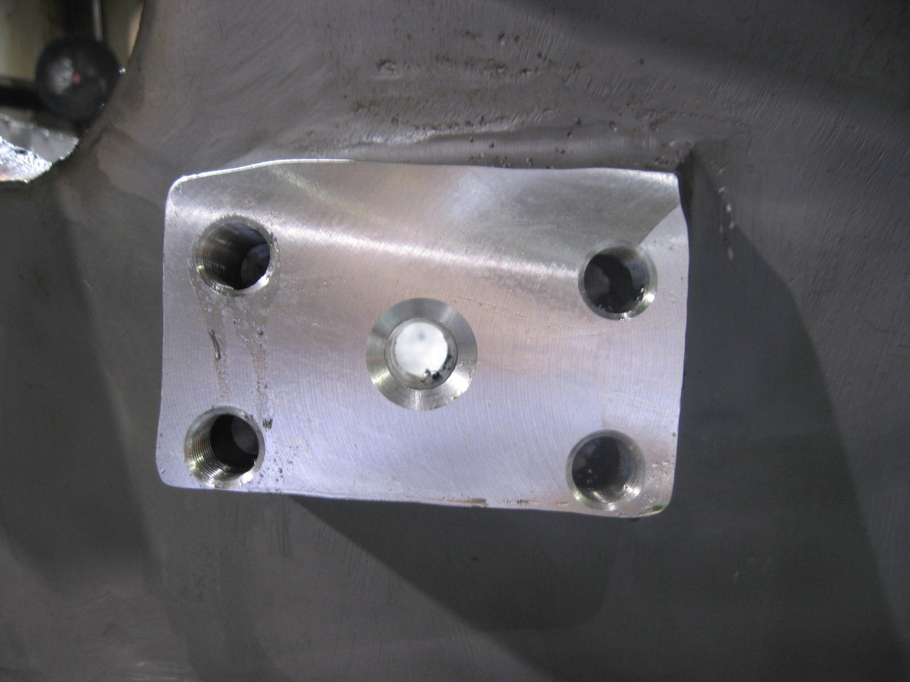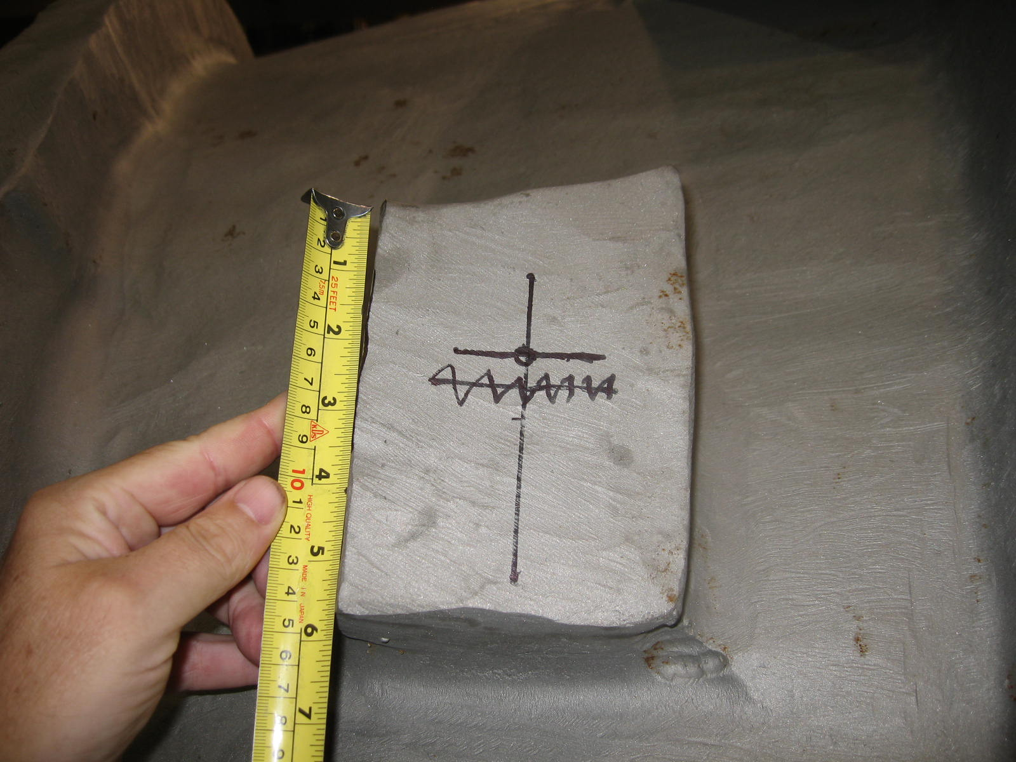

After examining the other B castings in storage a similar condition was found. EIO generated a report of the findings along with suggested remedies. The report was forwarded to PPPL for review & posted to the FTP site.

Upcoming QA Activities

- A-1 Doc package from EIO
- A-2 Doc packages from EIO
- Discussion on B pad issue

QA Action Items

- Closed Items: (EIO Recommended)

  - A-1 Tee hole bushings were received & are shipping to PPPL (2.2)
  - Type B inspection point file posted (4.2)

- Pending from EIO:

  - (EIO) Provide final documentation packages for completed MCWF’s.
    - A-1
Status: (Open) – MTM portion posted - under EIO review
    - A-2
Status: (Open) – MTM portion posted - under EIO review
    - A-3
Status:(Open) - MTK portion posted – MTM waiting for signed NCR’s to close.
  - (EIO, MTM) Document Corrective Action to close NC 19783 (A-1Tee hole counter-bore depths).
Status: (Closed) bushings received by MTM & are being shipped UPS to the lab
  - (EIO, MTK) PPPL has requested permission to borrow MTK models to facilitate review of radiography shots. While the models are not contract deliverables, they have been extremely useful communication tools during inspection activities.
Status: (Open - No update) – Request has been communicated to MTK. Opportunity to safely transport the models is being investigated, perhaps during a future visit of MTK or EIO to PPPL.

- Pending from PPPL

  - Revise CSPEC to incorporate the following changes:
    - CSPEC update addressing revised poloidal break inspection/tolerances. Poloidal break flange fit-up, 0.005” through and 0.015” at edges – edge defined as no more than 1/8” penetration.
Status: (Open) Draft Rev. 12 to EIO for comment – issue date target is 7/28.

    - CSPEC revision to update the inspection points.
Status: (Open) Draft Rev. 12 to EIO for comment – issue date target is 7/28.

    - Modify high stress area with Tee hole designators and location changes.
Status: (Open) Draft Rev. 12 to EIO for comment – issue date target is 7/28.

  - MTM to obtain ingredients information for Sherwin penetrant (seen on A-1 PB insulator).
Status: (Open) EIO sent Sherwin info, which is now at ORNL for evaluation.

  - Review updated Documentation packages
    - C-4
Status: (Open) –Downloaded 7/24
    - C-5
Status: (Open) –Downloaded 7/24

- Discussion Topics for Teleconference:

  - New Specification & Drawing Changes
    - Draft Rev. 12 of CSPEC including inspection points for type B

We are looking forward to visiting PPPL next week and seeing the castings as they are progressing through winding. If you have any questions or would like to add any topics to the agenda, please feel free to contact me.

Nancy Horton

EIO Program Manager for NCSX

216-496-2314

