Energy Industries of Ohio (EIO) Team Weekly Status Report

Report covers the NCSX Modular Coil Winding Form Activities Under Production Contract S005242-F

Week ending August 18, 2006

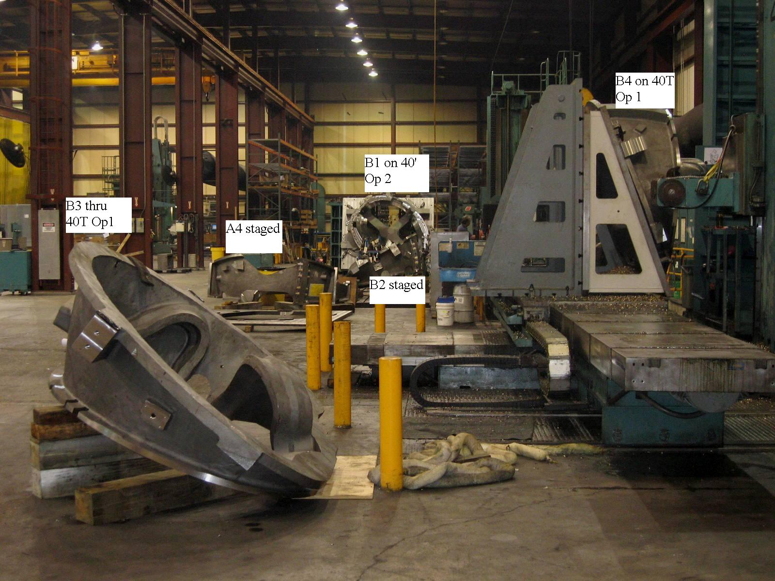

Castings staged & in process at MTM

Administrative Highlights

The above shot provides an interesting view of the castings in progress at MTM. As of this week, (with the addition of B-5 to the machining rotation this weekend), all but three of the team’s castings under the program have now been up on at least 1 center for a machining operation! The interchangeable design of the MTM fixtures, has made such quick “shuffling” feasible and has helped to get the most out of cut time on the shop floor.

Learning on B-1 continues to be the greatest challenge at present. Programs for the final set-up on the 40’ Mitsu proved insufficient and had to be reworked in order to successfully accomplish desired stock removal, thus delaying the move to the U5 until 8/19. Mike Griffith states: “As painful as it is to the Major Tool team, we all know that the extra efforts now will pay off over the next 5 B castings.” The good news came Sunday morning, 8/20. B-1 successfully completed the last operation on the 40’ Mitsu on Saturday morning and went up on the U5 as expected, thus enabling MTM to start cutting chips this weekend.

The movement of B-1 to the U-5 enabled B-2 to go up on the 40’ Mitsu, where machining is also now underway. Finally, B-4 completed its first operation on the 40T Lucas on Saturday, at which time B-5 was set-up for machining commencing on Sunday (details below under Tech Highlights).

Meanwhile this week, EIO’s Roy Sheppard returned to PPPL on Thursday 8/17, with Joe Edwards and Brian Bachman of Metal Tek. A primary purpose of the trip was to lend our SLA models of the castings to the lab. Among other things, these models were used by the team as an aide in setting up the RT techniques for each coil form. PPPL intends to make a digital version of the models to help quickly locate RT shots during their reviews.

While at the lab, the visitor’s met in the Director’s office with Rich Hawryluk, Deputy Director, and Phil Heitzenroeder. Rich expressed appreciation for Metal Tek’s role in finalizing the casting portion of the NCSX on time and within budget, noting that in fact, the last casting was delivered 1 month ahead of our initial schedule! Also discussed were upcoming projects such as ITER & QPS, along with the latest status of B-1. The visit concluded with a full tour of the coil shop, conducted by Jim Chrzanowski. Jim also provided photos from our previous visit, (one of which is included below) which were posted to the EIO FTP site. Thanks again to all for the hospitality and complementary feedback.

FTP Postings this week
(found at: ftp.atc-inc.org:/PPPL/shared_info)
Location | File Name | Date
\Quality_Review\A-3_Doc | A-3_MTM_Doc_pack-8-18-06.pdf | 8/19/06
\Photos | EIO_PPPL_8-10-06.zip | 8/19/06
\Reports_Weekly-Monthly/Weekly/ | 06-08-11_eio_wk.doc | 8/13/06
**note – file names may be changed from the original for clarity

Administrative Action Items
- (MTK, PPPL) Pattern Storage after six castings have been delivered to MTM.

Status: (Open) EIO gave PPPL a ROM quote from MTK’s pattern storage house at the 8/10 meeting. Price seemed acceptable by both PPPL & DOE. EIO has asked MTK to direct the Storage House to submit a formal quote directly to PPPL/Larry Sutton.
- (PPPL) Specification Rev 12 to EIO for comment

Status: (Open - No update) Draft was discussed at 8/10 meeting and spec revisions were reviewed and accepted. PPPL will issue final specification to EIO via contract mod.

- (PPPL) Disposition of Prototype Casting from MTK & Prototype Fixture from JP.

Status: (Open - No update) Discussed at meeting on 8/10. MTM to provide an estimate of scrap value of the prototype casting. PPPL will likely scrap in place. Per direction from Larry Sutton, MTM to ship the Remmele fixture back to PPPL with B-1 casting.

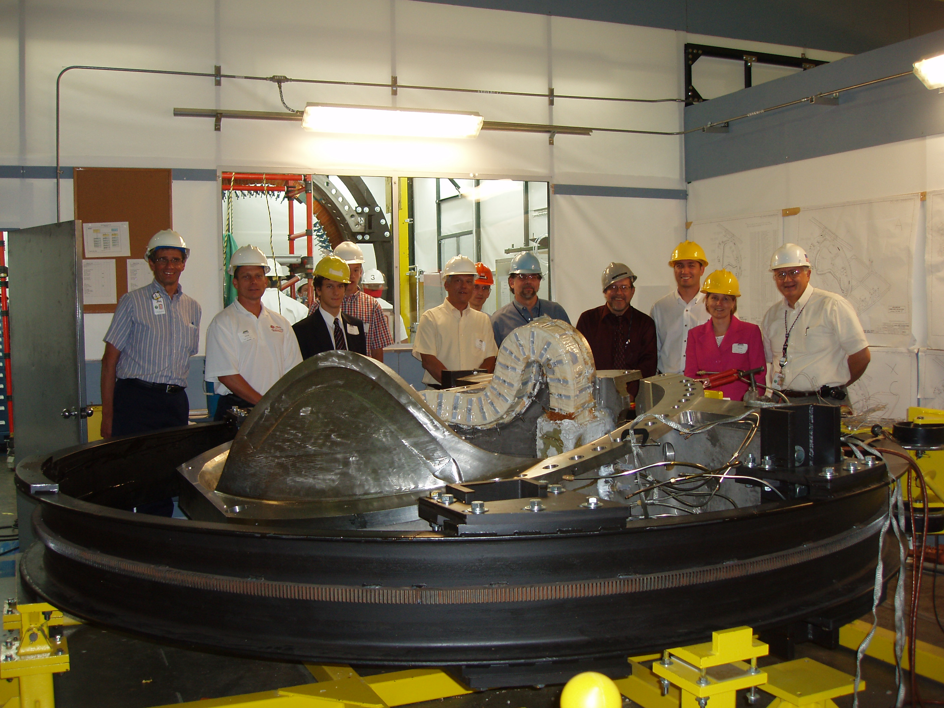

The team at the lab - 8/10

Technical Highlights

B-1

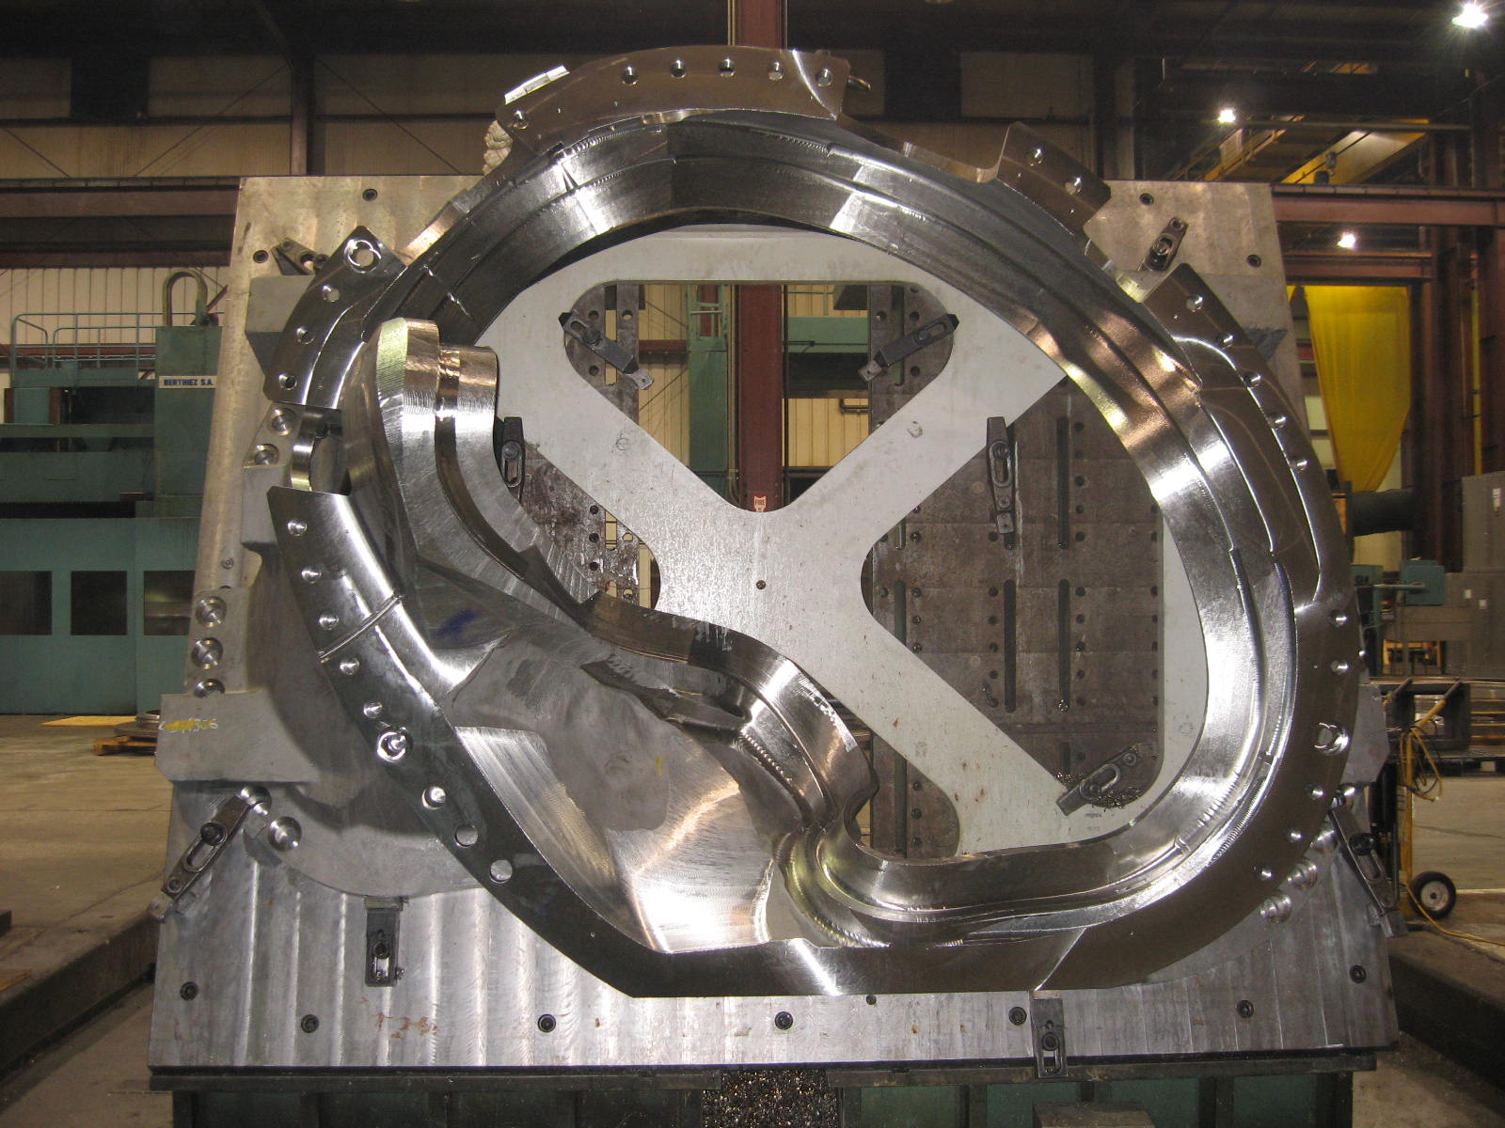
B-1 on 40’ Mitsu with challenge spot highlighted
As noted above, Mike Griffith reports that “B1 has certainly proved to be as challenging as we had always expected it to be.” The casting was not ready to move to the U5 on Monday, as planned, and remained on the 40’ Mitsubishi this week while several of the original machining programs for (what was thought to be) the final set-up were revamped. MTM brought in extra programmers early this week (including Brian Bowling, who played an active role during programming of the C and A castings) and by mid week new plans had been developed and machining resumed. One outcome: part of the new programming requires an additional setup to reach all areas of the casting and achieve a consistent stock allowance.
Lessons learned on the C castings (more heavily stocked) & the A castings (less so) are supporting the decision to delay moving B1 to the finishing operations on the U5. Leaving a consistent amount of stock to be removed during the final machining operations has proven to pay off in terms of the dimensional accuracy of the coils. As always, there is a learning curve on the initial coil form. B-2 thru B-6 will benefit from the extra time taken to “fine tune” the programs.
The photos below provide close-ups of the challenge spots on the B style castings, (as highlighted in yellow above). Ultimately, these areas required the new programming and additional setup.
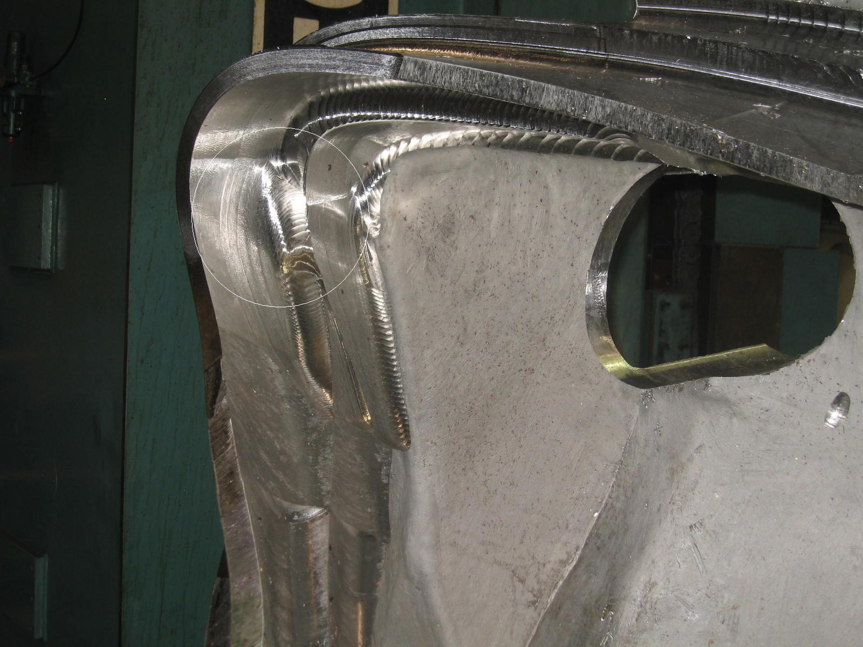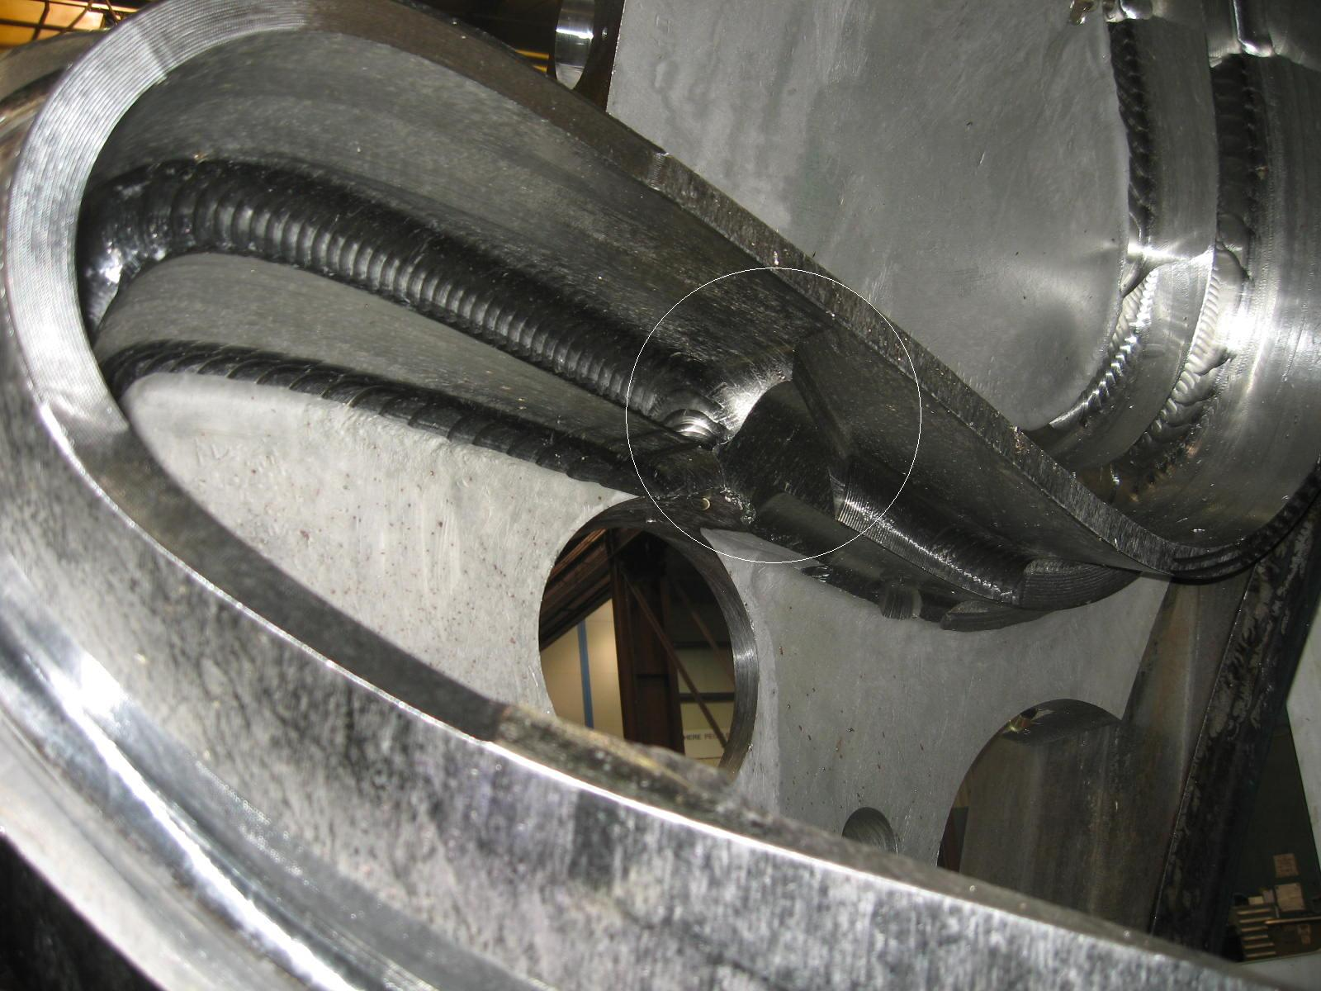
By Saturday morning at 9:30, B-1 had finished the last set-up on the 40’ Mitsu and was moved to the U-5 for the first set-up, where machining commenced late Saturday afternoon for one shift, with the plan to resume during second shift on Sunday, 8/20.

B-2
As soon as the 40’ Mitsu became free on 8/19, B-2 was set-up for machining. It is expected that programming changes during B-1 will facilitate the machining of this part on the Mitsu.

B-3
B-3 remains staged for the 2nd Lucas operation, following B-5 as MTM pushes 3 castings through the initial Lucas op.

B-4
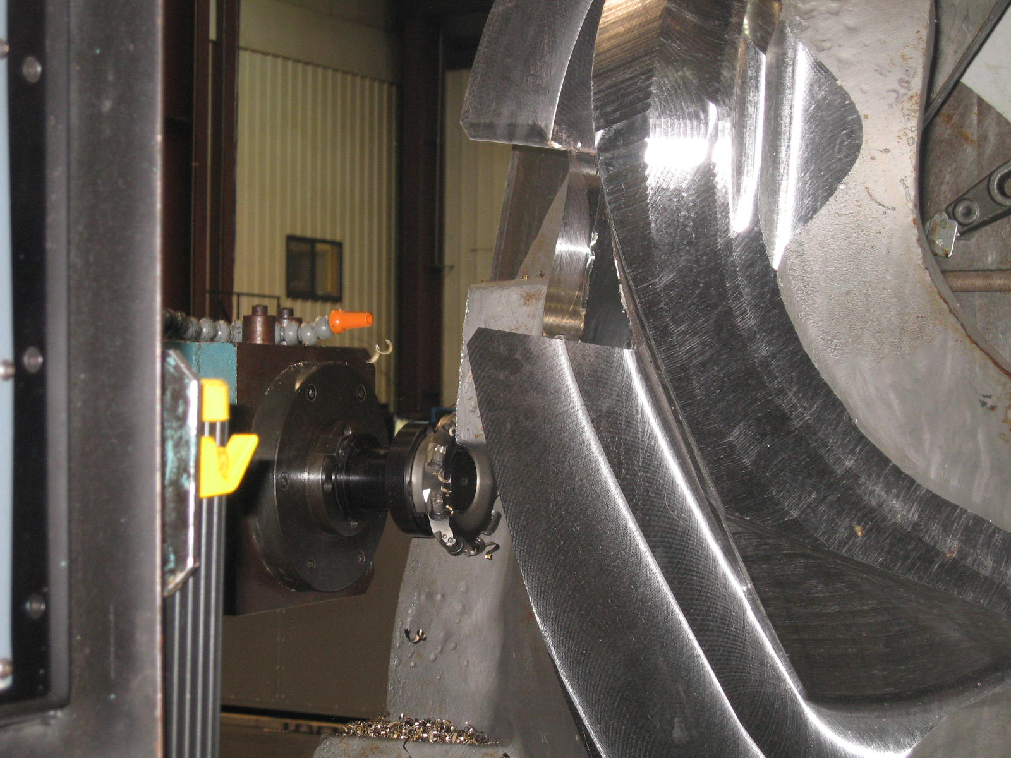
B-4 on the Lucas T

B-4 completed the 2nd Lucas operation on Saturday, 819. The coil was quickly moved off the center so that B-5 could be setup.

B-5
MTM decided to put B-5 into the rotation this week due to fixture constraints and a desire to maximize machining hours for the program. The previous “duet” has now become a “trio” as B-3 thru B-5 follow each other across the Lucas!

Technical Action Items

- (Major Tool) Machining B-1
Status: (Open) First Op on U-5
- (Major Tool) Machining A-4
Status: (Open) On hold
- (Major Tool) Machining B-2
Status: (Open) First op on 40’ Mitsu
- (Major Tool) Machining B-3
Status: (Open) On queue for 2nd Lucas op
- (Major Tool) Machining B-4
Status: (Open) Completed 1st op on Lucas, in queue for 2nd op
- (Major Tool) Machining B-5
Status: (Open) On 1st op of Lucas
- (Major Tool) Machining B-6
Status: (Open) on hold

- (Major Tool) Machining A-5
Status: (Open) on hold
- (Major Tool) Machining A-6
Status: (Open) on hold
- (Major Tool) Machining C-6
Status: (Open) on hold
Quality Highlights

Pads
Over the last several weeks various pad issues have been discussed in the weekly reports, QA telecons, meetings, emails and off-line conversations. Although these are all separate issues, at times they have seemed to get interwoven and juxtaposed. In an attempt to clarify the various issues, we have listed each below. We hope to confirm our understanding of the agreed upon resolutions and outstanding actions at this week’s QA telecon, following which appropriate items will be added to the QA Action list.

Issue 1 - Type B vacuum pad supports on B-3 and B-6 are undersized for current tapped hole pattern

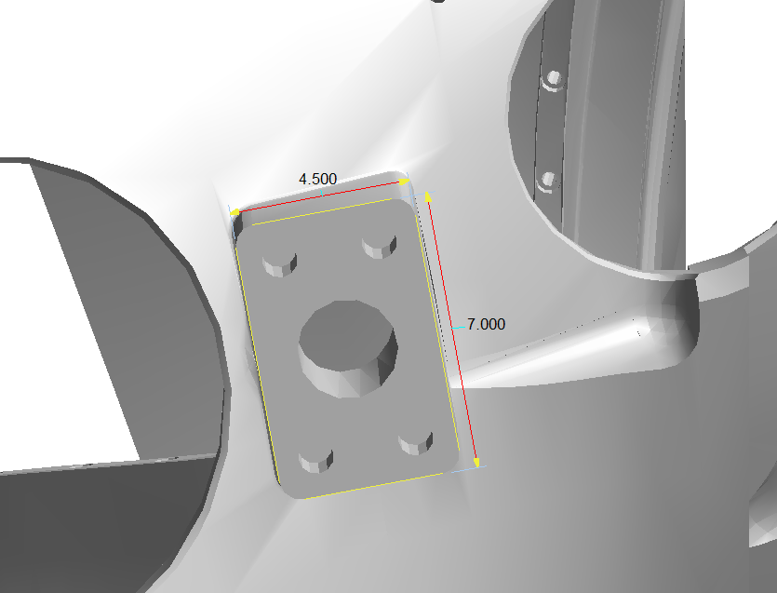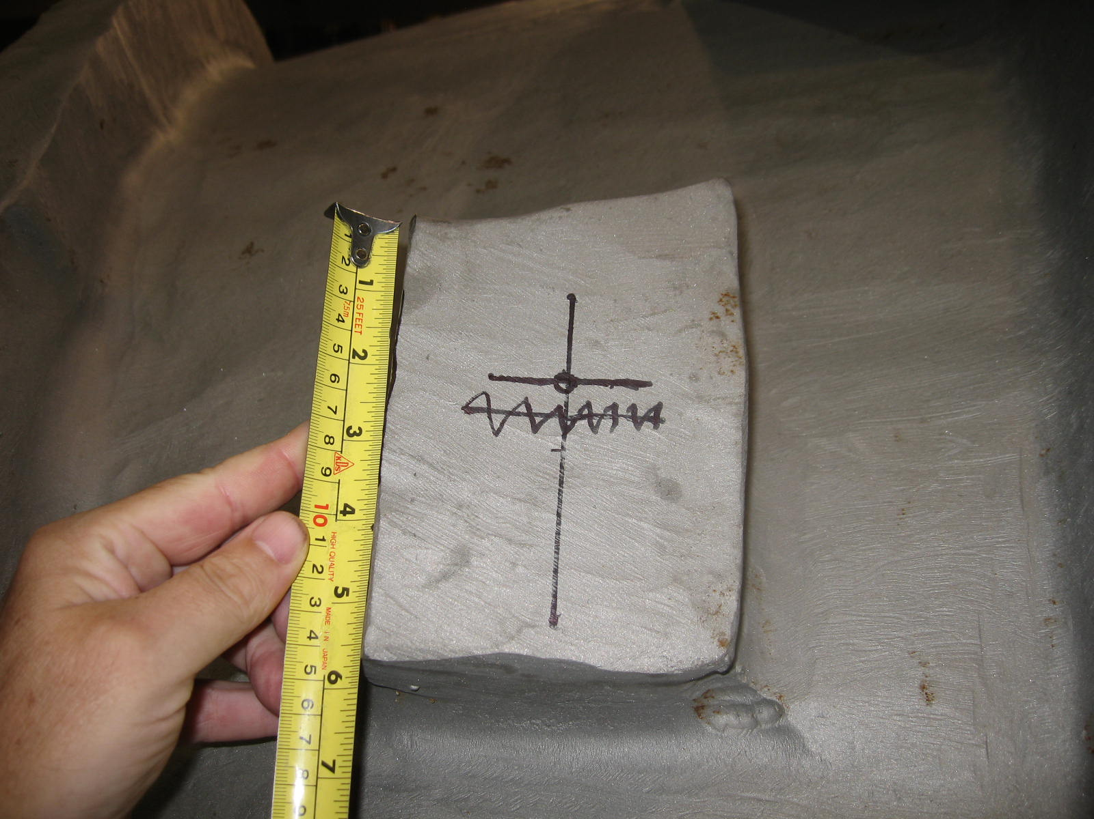

Castings Effected: primarily B-3 & B-6 which had corners ground off

Agreed Resolution: PPPL issued direction to EIO/MTM via e-mail to leave out the tapped hole feature.

Outstanding Action: Possible NCR from MTK for over-ground pad

Issue 2 - B-2 Casting lead block issue: 3 tapped holes will not fit on pad
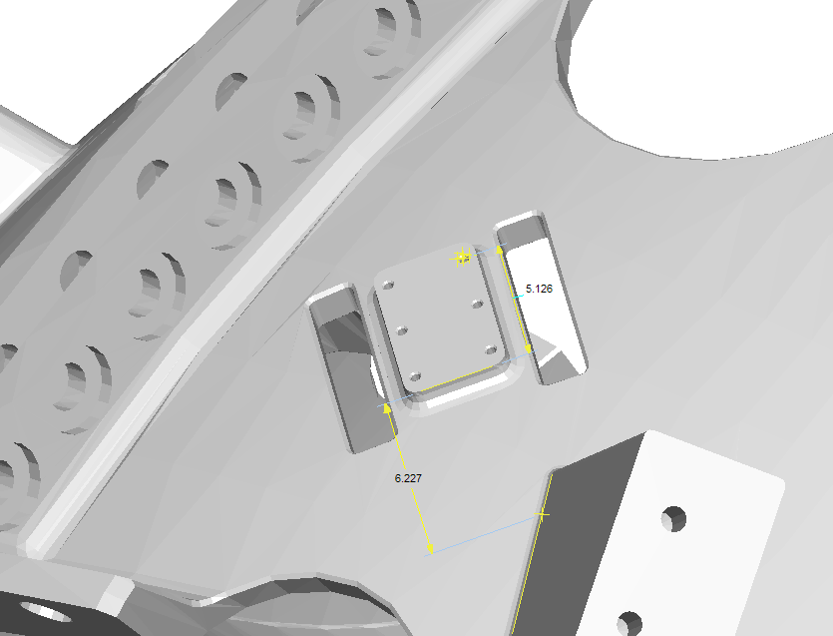

Castings Effected: B-2 (for now)

Agreed Resolution: MTM will submit a deviation request to grind off portion of pad & tack weld in a Stellalloy block

Outstanding Action: Deviation request from MTM

Issue 3 - PPPL proposed addition of tapped holes on circular boss.

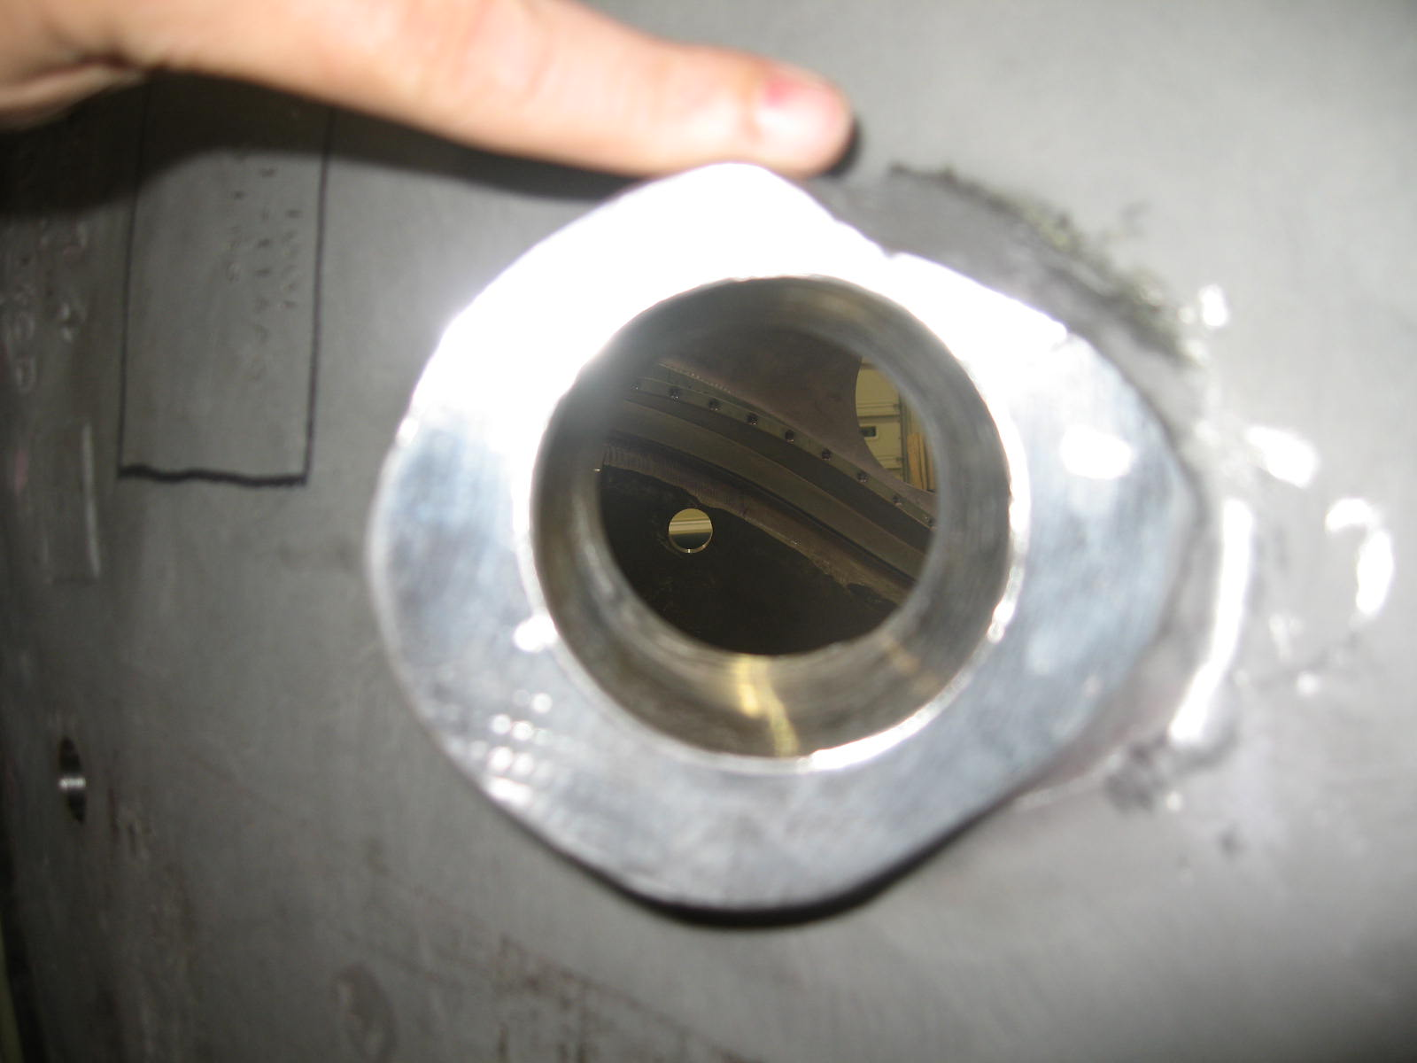

PPPL had inquired about adding in tapped holes around the large hole on the circular boss - This boss is used as a vacuum vessel support. There is insufficient annular ring around the central hole to allow the new feature.

Castings effected: all A style castings

Agreed Resolution: PPPL has determined that they can accomplish their requirement by welding on studs. The issue will be handled internally at PPPL.

Outstanding Action: None, since the proposed tapped holes are not on the drawing.

Issue 4 - Riser pad remnant causing wing interference during assembly

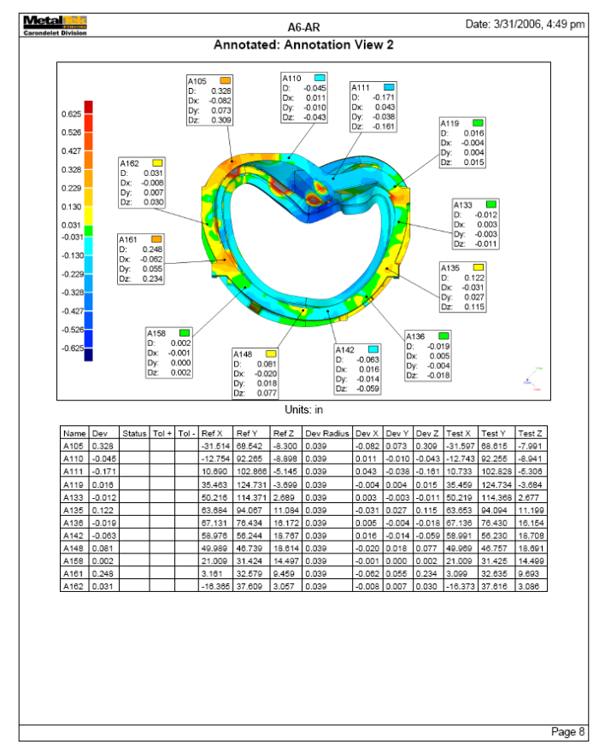

Castings effected: Possibly all A style (note: pads appear to conform to spec on A-3, A-5 & A-6, but may still cause interference)

Agreed Resolution: Dave Williamson will add points to the inspection area. Rev 12 of spec will be updated by PPPL prior to issuance. MTM will grind/machine the area in question on A-4 through A-6. PPPL will perform any required grinding on A-1 and A-2.

Outstanding Action(s): Incorporation of additional inspection points into the spec (PPPL/ORNL). Cost/Schedule Impact Proposal from MTM to grind/machine the area in question on A-3 thru A-6 (MTM/EIO).

Upcoming QA Activities

- A-1 Doc package from EIO
- A-2 Doc package from EIO
- A-3 Doc package from EIO
- B-2 lead block NCR

QA Action Items

- Closed Items: (EIO Recommended)
1.1 SLA models delivered to PPPL (2.5)

- Pending from EIO:

  - (EIO) Provide final documentation packages for completed MCWF’s.
    - A-1
Status: (Open - No update) – MTM portion posted - Complete package in process at EIO
    - A-2
Status: (Open - No update) – MTM portion posted - Complete package in process at EIO
    - A-3
Status: (Open) - MTM portion posted on 8/19 - Complete package is now in process at EIO

  - (EIO, MTM) Document Corrective Action to close NC 19783 (A-1Tee hole counter-bore depths).
Status: (??) Bushings hand delivered to PPPL on 8/10. Mike Griffith signed the NCR on 6/1/06, certifying action was implemented (bushings were ordered for delivery as specified). Not clear if additional signature is required to note that the bushings were delivered. Need direction from PPPL.

  - (EIO, MTM) Provide Stellalloy bearing plates and replacement fasteners for MCWF’s C-1 through C-5. (Needed to close NCR’s 3618 & 3651)
Status: (??) Hardware delivered with A-3. Pete Djordjevich will sign and return, if necessary to close. Need direction from PPPL.

  - (EIO, MTM) Document Corrective Action to close NC 20124 for oversized hole on A-3.
Status: (Open) – MTM shipped custom G-11 bushing with A-3. NCR signed & returned with A-3 Doc package on 8/18.

  - (EIO, MTK) PPPL has requested permission to borrow MTK models to facilitate review of radiography shots. While the models are not contract deliverables, they have been extremely useful communication tools during inspection activities.
Status: (Closed) –Models hand carried in to PPPL on 8/17

- Pending from PPPL

  - Revise CSPEC to incorporate the following changes:
    - CSPEC update addressing revised poloidal break inspection/tolerances. Poloidal break flange fit-up, 0.005” through and 0.015” at edges – edge defined as no more than 1/8” penetration.
Status: (Open) EIO sent in preliminary comments discussing errors in the wording most likely do to editing. Spec revisions were reviewed by EIO/MTM and during the meeting on 8/10, the changes were agreed upon.

    - CSPEC revision to update the inspection points.
Status: (Open) EIO sent in preliminary comments discussing errors in the wording most likely do to editing. Spec revisions were reviewed by EIO/MTM and during the meeting on 8/10, the changes were agreed upon.
    - Modify high stress area with Tee hole designators and location changes.
Status: (Open) EIO sent in preliminary comments discussing errors in the wording most likely do to editing. Spec revisions were reviewed by EIO/MTM and during the meeting on 8/10, the changes were agreed upon.
  - MTM to obtain ingredients information for Sherwin penetrant (seen on A-1 PB insulator).
Status: (Open) EIO sent Sherwin info, which is now at ORNL for evaluation.

  - Review updated Documentation packages
    - C-4
Status: (Open) –Downloaded 7/24 - Comments provided to EIO on 8/9.
    - C-5
Status: (Open) – Downloaded 7/24 - Comments provided to EIO on 8/9.

With operations running up to 24/7 on this program, often we seem to have significant “updates” occurring over the weekend. Such was certainly the case this week. Projections about B-1 in last week’s report did not play out as expected and consequently much of the week was devoted to trouble shooting in response to the challenges. During our weekly review held on Friday morning, 8/18, we could only speculate about whether castings in progress would reach desired milestones over the weekend, thus enabling the grand transition that would follow. I was delighted to get the phone call early Sunday morning confirming that reprogramming for B-1 had been successful and that all subsequent moves had taken place as planned. This makes for a very nice way to end the weekend and start the new week!

Nancy Horton

EIO Program Manager for NCSX

216-496-2314

