Energy Industries of Ohio (EIO) Team Weekly Status Report*

Report covers the NCSX Modular Coil Winding Form Activities Under Production Contract S005242-F

Week ending September 22, 2006

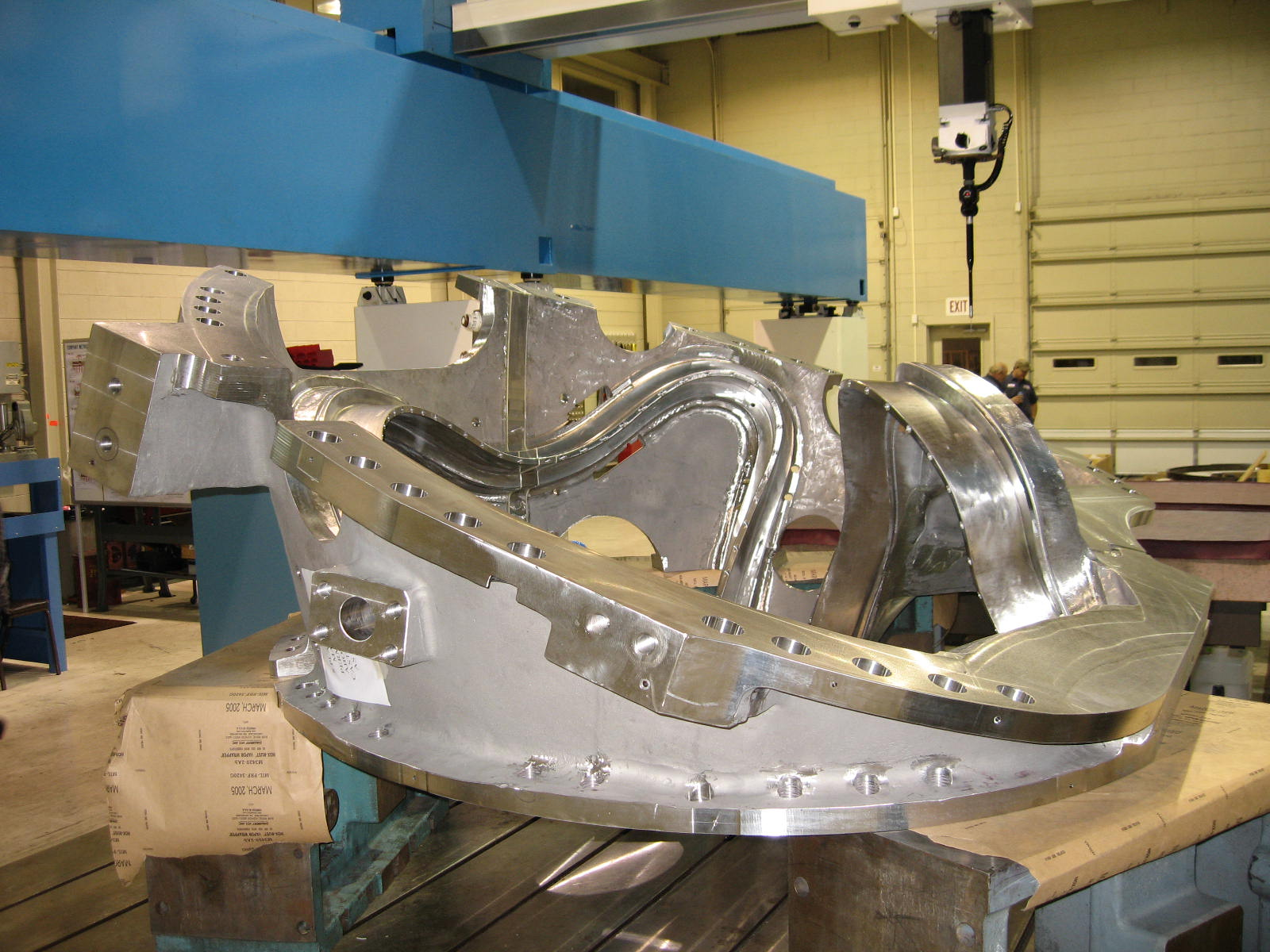
B-1 Completing CMM Inspection

Administrative Highlights

This was a critical week at MTM with machining progressing through the weekend. As of 9/24, new updates and reports of progress were still coming in and have been integrated into the report below.

In keeping with this momentum, timely reporting of technical activities and resolution of the resulting administrative actions arising during machining was priority #1 this week, as we endeavored to keep B-1 moving through final inspection activities and facilitate the transition of B-2 from the 40’ Mitsu to the U5. By the week’s end, several key accomplishments were achieved.

First, CMM inspection on B-1 had wrapped up, with Verisurf data review scheduled to continue through the weekend. If all goes well, a Monday (9/25) morning submission to PPPL is planned. The part has continued to move through the remaining inspection activities (Radiography, Resistance & Electrical Tests, Magnetic Permeability, etc) with expectation of completion by Sunday evening.

Next, B-2 completed machining on the 40’ Mitsu late week, and after some deburr and hand work to address a non-conformance, was set-up for machining on the U5 by week’s end. B-3, also on the critical path, completed its last operation on the 30’ Mitsu on Saturday, thus freeing that machine in time for final repair work on B-1. Finally, repair of the 40’ Mitsu was underway with the expectation that the gear replacement would be complete by the end of next week (see Technical and QA Highlights for details).

EIO also attended to other administrative activities including a response to PPPL’s request for end of the fiscal year input related to our contract “costs.” Since we are under a fixed price contract with milestone payments, rather than progress payments, they were looking for calculations for work in progress (not billable), primarily based on our input in the monthly report, as compared to our invoices to date. After receiving this clarification from Larry Sutton and Kim Buturla of Accounting, EIO provided the figures, including the estimated cumulative costs through September 30, 2006.

The team also continued our review of the latest contract amendment and specification revision. The QA meeting on Tuesday served as a forum for reviewing questions and comments with NCSX personnel to ensure all changes were understood. We verified that additional inspection points were added (they’re in the revised postings of inspection points and listed in the updated table in the Rev. 14 spec). It was noted that there are still some lingering discussions that have not yet been addressed in the spec. For example, still under discussion is whether some tolerances have to be formally updated in the drawings to address risers in wing locations, etc. In the case of the change to mounting holes on VV pads, which deviate from the spec, those will be handled as a PPPL requested deviation and no drawing change is expected. PPPL advised that any changes in process but not incorporated into the spec, should still be addressed for any impact as part of our response to Spec Rev 14. Based on the input, we are now in the process of preparing our formal comments/response for PPPL.

FTP Postings this week
(found at: ftp.atc-inc.org:/PPPL/shared_info)
Location | File Name | Date
\Reports_Weekly-Monthly\Weekly | 06-09-15_eio_wk.doc | 9/17/06
\Quality_Review\Open_NCR-CA-RFD | NC20487_B1PoloidalBreakGap.zip | 9/24/06
\Quality_Review\Open_NCR-CA-RFD | NC20338_REV1_B2_leadblock.rtf | 9/24/06
\Quality_Review\Open_NCR-CA-RFD | NC20483_b-2_LPIresults.zip | 9/24/06

Administrative Action Items
- (PPPL) Disposition of Prototype Casting from MTK & Prototype Fixture from JP.

Status: (Open) Discussed at meeting on 8/10. MTM to provide an estimate of scrap value of the prototype casting. PPPL will likely scrap in place. MTK may provide a quote. Remmele fixture to be shipped back to PPPL with B-1 casting, which should occur early the week of 9/25.

- (EIO, MTM) Execution of Amendment 15 to EIO Contract, which includes Specification Rev 14.

Status: (Open) On 9/8 PPPL issued a newly proposed Amendment No. 15 to EIO Subcontract, which EIO re-issued to Major Tool on 9/12. In accordance with the changes clause and as discussed during our meetings with PPPL, we are currently evaluating the revisions for any potential impact to price or schedule. Response is due by 10/6.

- (EIO, MTM) Preparation of Monthly Report

Status: (New) EIO/MTM will commence our assessment of progress in the upcoming week for submission of the report near the beginning of October.

Technical Highlights

B-1
As noted above, CMM inspection of B-1 was accomplished this week. By late Friday, 9/25, the Verisurf data review was underway; initial analysis indicated that a best fit of the CMM data would most likely be required. This activity is being conducted over the weekend. Meanwhile, after CMM, the part went into x-ray on Saturday. As noted under Administrative Highlights, all inspections except the IDC (but including magnetic permeability which was being performed by MTM on this part) will be complete by Sunday evening. Mike Griffith reported Sunday that the part has been moved to the 30’ Mitsu for welding of the holes and finishing the set-up. These activities are expected to take place during second shift Sunday for completion by Monday morning. IGS data is expected to be released on Monday, with the final IDC to be performed over the course of the day (with PPPL/EIO in attendance). Release of the part for shipment is anticipated for Tuesday 9/26.

B-2

B-2 completed the last operation on the 40’ Mitsu mid week and moved to deburring for some of the finished machine features of the part. By Thursday, the Lead Block area was reworked and all of the threaded inserts had been installed and welded in place. B-2 is now on the U5 undergoing machining throughout the weekend.

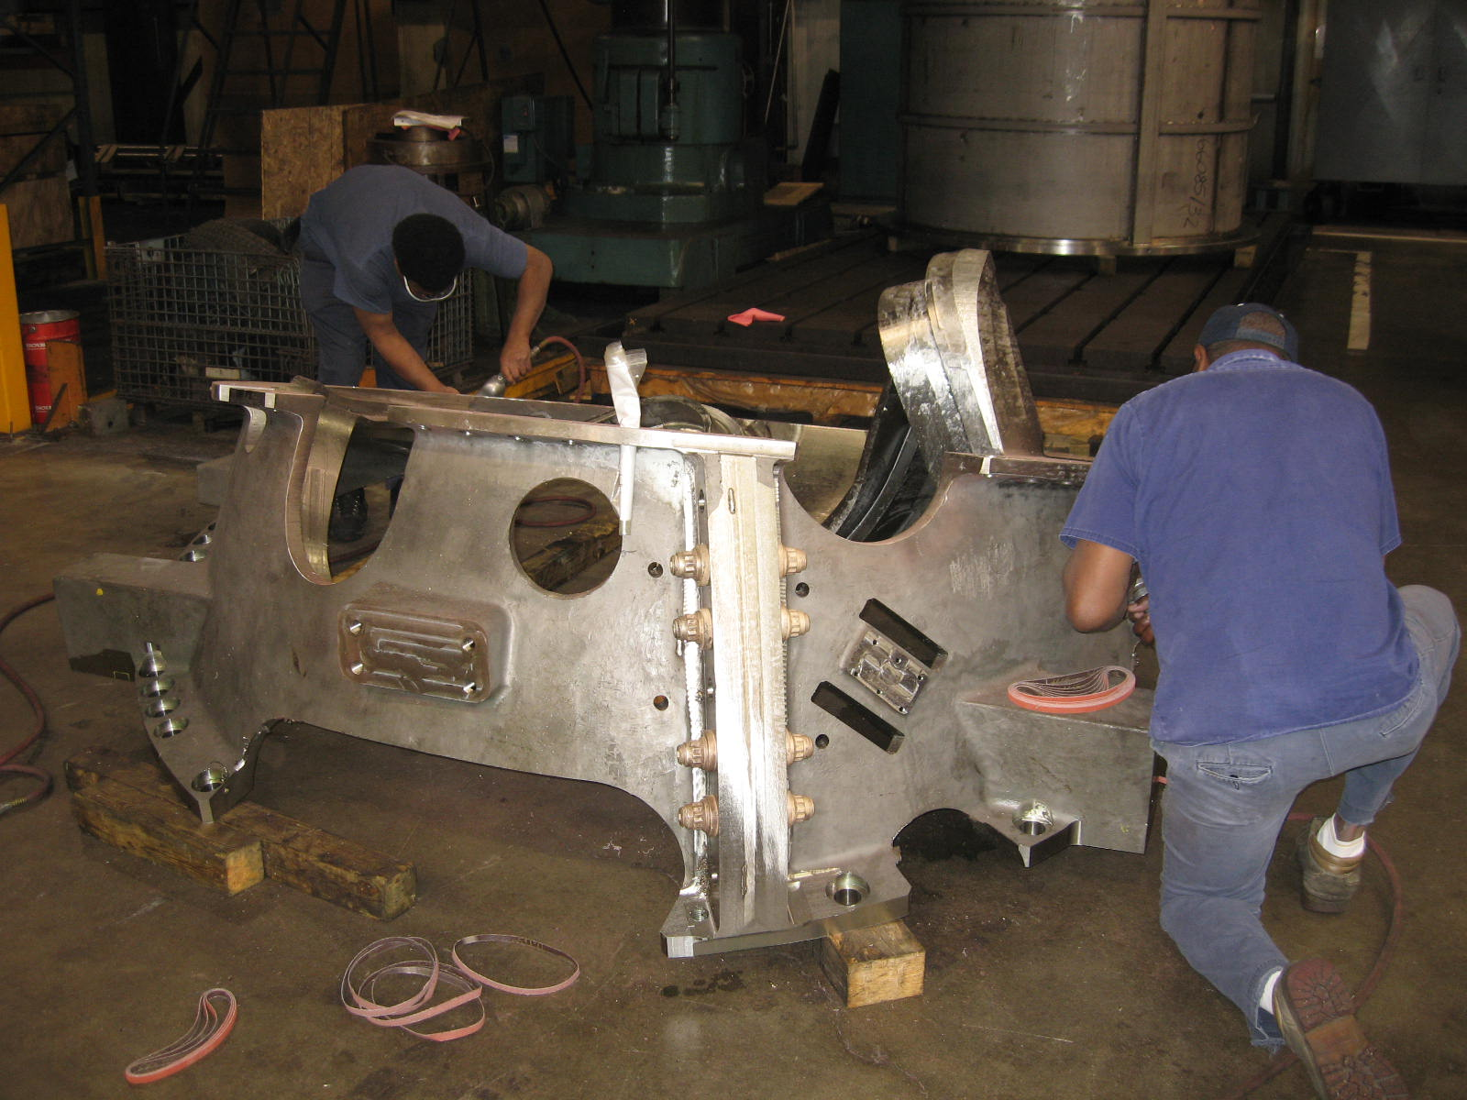
B-2 at Deburr

B-3

MTM continued machining B-3 on the 30’ Mitsu this week. As anticipated last week, they have now successfully completed the machining of the poloidal break and by Friday morning, the lead block area and thermocouple were the only remaining items to be machined on this operation. By Sunday (9/24) Mike had reported that these actions had been accomplished and the part was off the 30’ Mitsu, allowing B-1 to be set-up on this station.

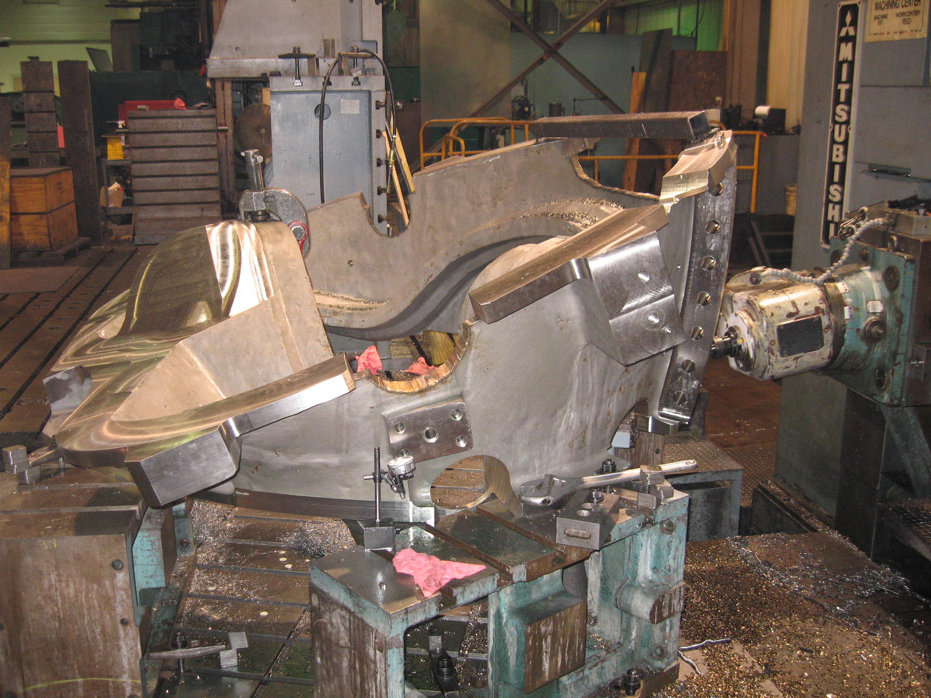
B-3 on 30’ Mitsu

B-4

B-4 completed the 2nd of 2 operations on the 40T Lucas this week. B4 is now scheduled for set-up on the 30’ Mitsu mid to late next week, following completion of B-1.

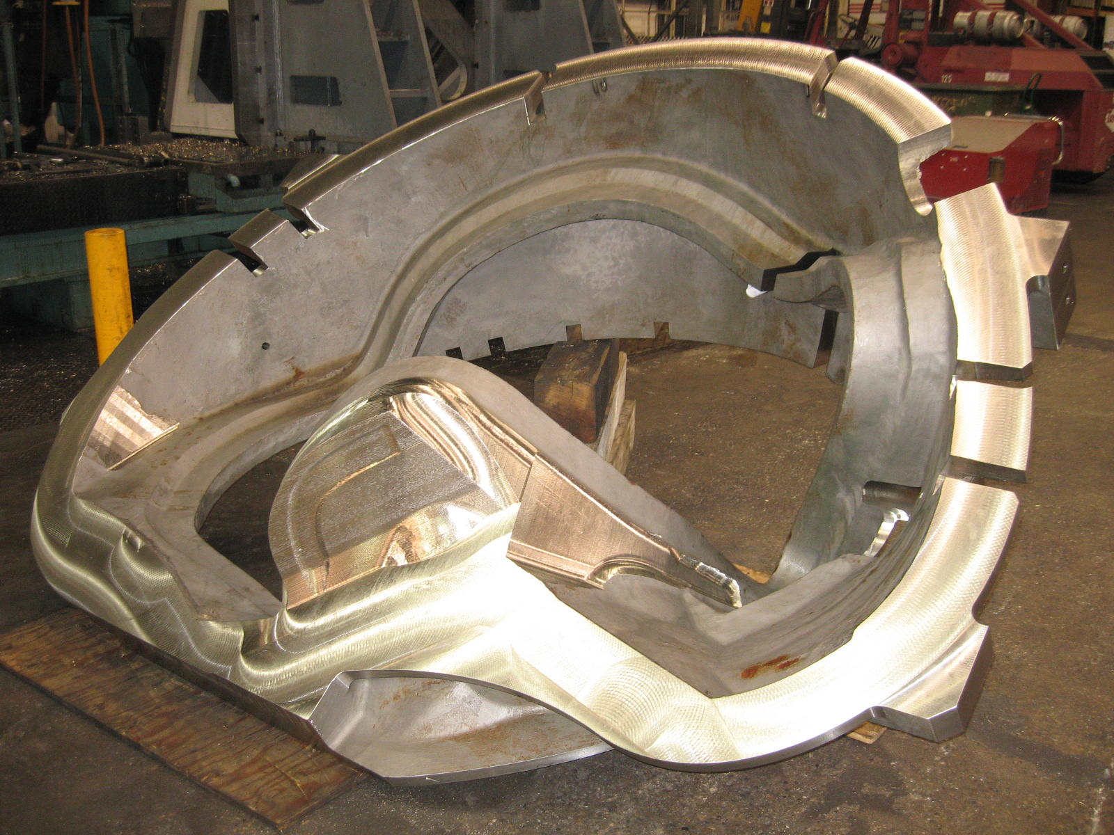

B-4 After machining on 40T Lucas

A-4

MTM reconsidered their plans to machine A-4 on the 40’ Mitsu prior to replacing the damaged gear. While it was possible to complete the remaining operations on the machine in its current status, it was not optimal, and so even though the part has been set-up on the 40 Mitsu, it will now wait until after the machine has been repaired before commencing. According to Mike Griffith, as of 9/25, MTM Maintenance was already in possession of the machine with plans to continue gear replacement activities through the weekend. The expected completion of the repairs is the end of next week, at which time machining of A-4 will commence.

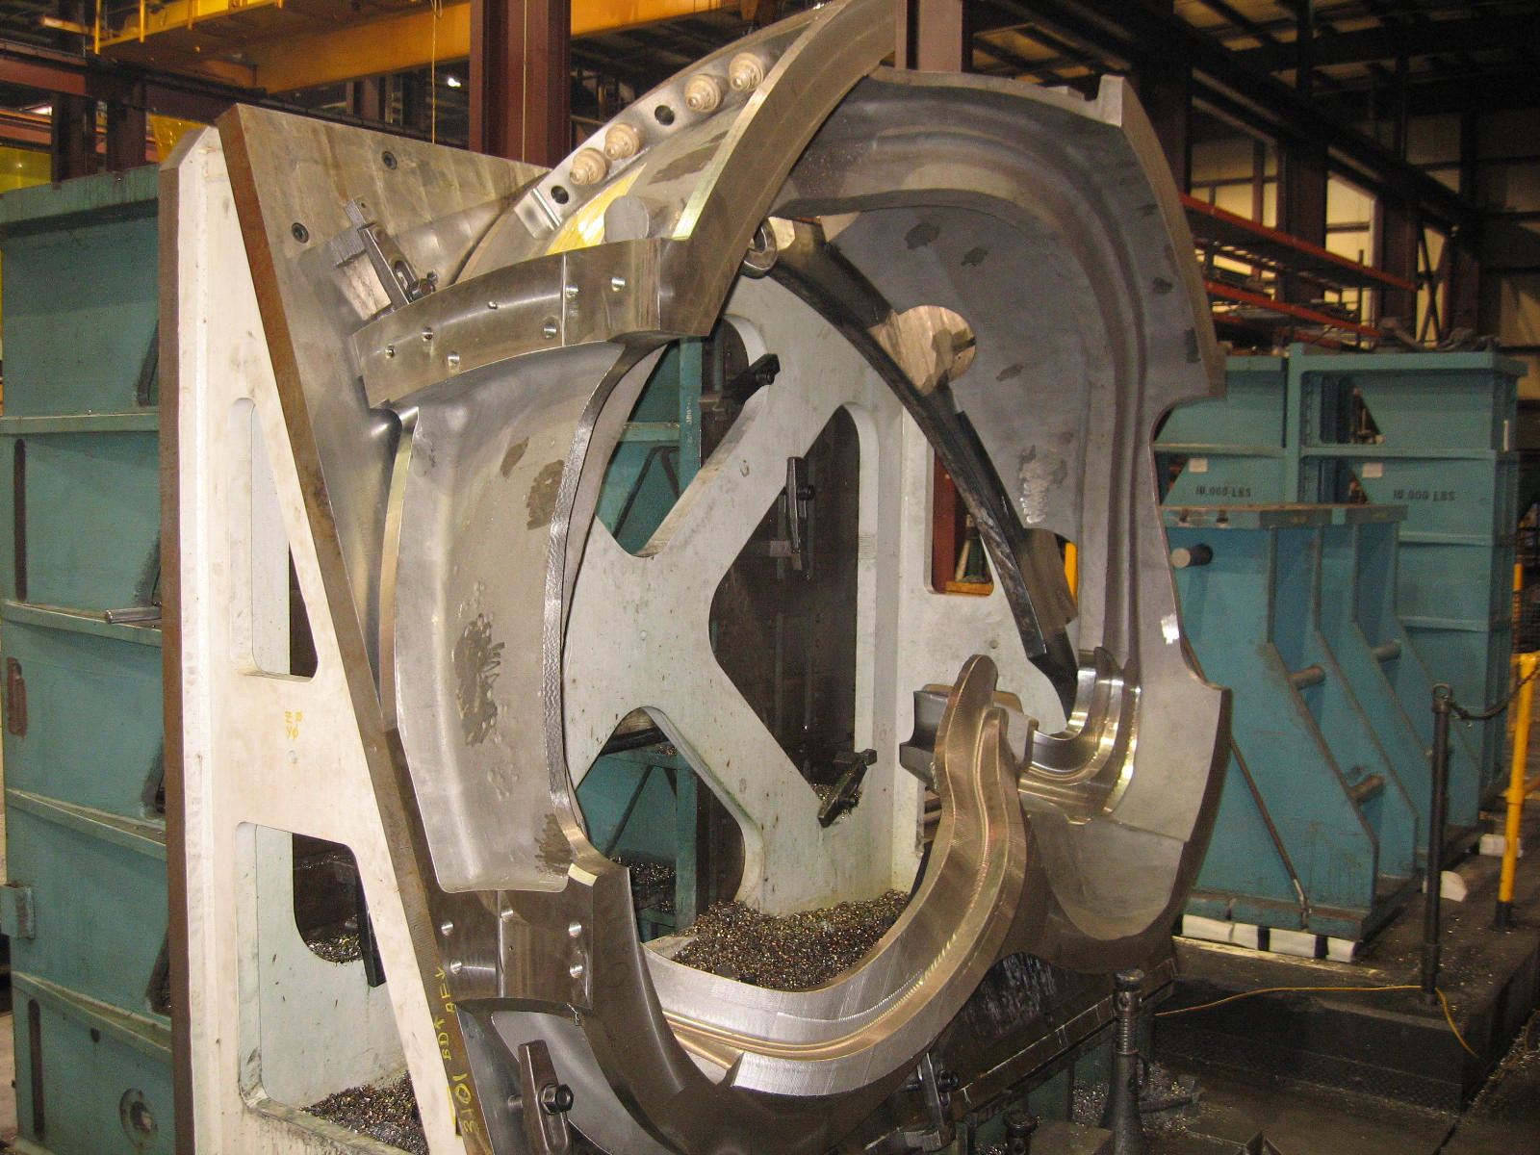
A-4 Ready for Op 1 on 40’ Mitsu

B-5
B-5 moved back into the mix again this week. As of Friday morning, operation 2 of 2 was underway on the 40T Lucas. Machining will continue through next week.

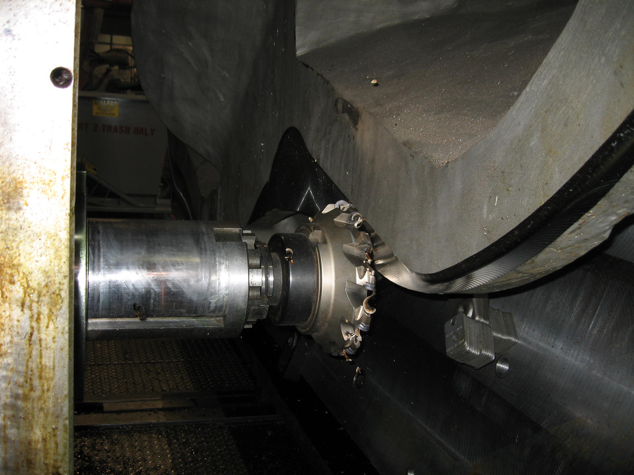
B-5 on 40T Lucas

Technical Action Items
- (Major Tool) Machining B-1
Status: (Open) Off CMM, Verisurf Data Review in Progress
- (Major Tool) Machining A-4
Status: (Open) Set-up on the 40’ Mitsu
- (Major Tool) Machining B-2
Status: (Open) Commencing Machining on the U5
- (Major Tool) Machining B-3
Status: (Open) Completed 30’ Mitsu Ops
- (Major Tool) Machining B-4
Status: (Open) Completed 2nd Lucas operation
- (Major Tool) Machining B-5
Status: (Open) Op 2 of 2 commenced on Lucas
- (Major Tool) Machining B-6
Status: (Open) Off line

- (Major Tool) Machining A-5
Status: (Open) Finished initial Lucas op
- (Major Tool) Machining A-6
Status: (Open) Off line
- (Major Tool) Machining C-6
Status: (Open) Off line

Quality Highlights
Both B-1 and B-2 castings have been in the “hot seat” this week as various non-conformances were identified and the team worked to quickly resolve and dispose of them. As highlighted in last week’s report, the results of the Liquid Penetrant tests for B-1 were submitted to EIO on 9/17 and forwarded to PPPL on 9/18. While there were 22 spots that failed the inspection, after a thorough review, only two of the spots merited further analysis. Based on the visual appearance, defects 4 and 13 were specifically tested for magnetic permeability. On Wednesday morning, 9/20, Mike Griffith reported that both areas had passed the permeability check.

On Monday afternoon (9/18) EIO also submitted an NC summarizing the gap in the poloidal break after the assembly of B-1. The blending MTM performed on the gap mismatch did not produce the results that had been anticipated. A telecon was held late Tuesday to determine the most appropriate disposition. Due to the shape of the gap, it was determined that mesh sheets of a fiberglass filler used by PPPL in other areas, would be the most effective solution. Jim Chrzanowski will bring the sheets with him when he travels to MTM on Monday.

During the same telecon, the remedy for the lead block slots was also agreed upon and by late Thursday, MTM confirmed that the Lead Block detail for B1 was off by the amount that had been previously calculated/reported. This will be reworked after CMM and RT have been completed (planned for Sunday 9/24, evening). The Lead Block area on B2 was reworked, matching the configuration submitted and discussed at the telecon. All of the threaded inserts have since been installed and welded in place.

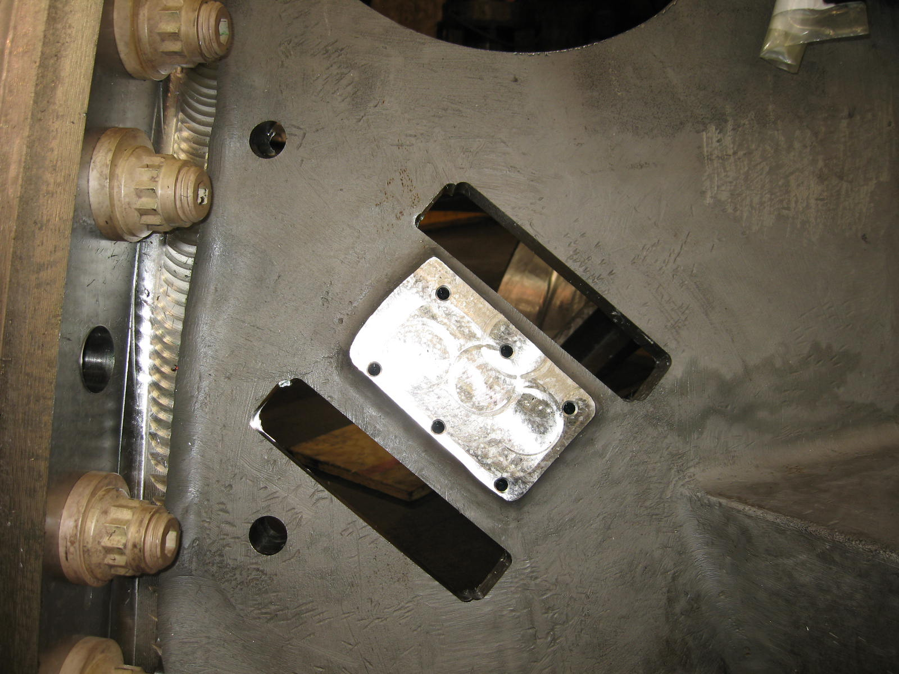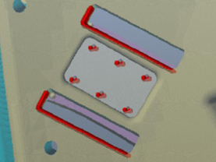
B-2 Lead Block Slots after machining,
compared to the proposed configuration

Upcoming QA Activities
- CMM & IDC Inspection Reports for B-1

QA Action Items

- Closed Items: (EIO Recommended)
  - NC20338, which was superseded by NC 20475 (see 2.1 below)

- Pending from EIO:

  - (EIO, MTM) to document completion of MTM NC20338 corrective action (B-2 lead pad deviation).
Status: (Closed) –This NC has been superseded by NC 20475. Documentation was submitted to PPPL on 9/19.

  - (EIO) Address NC discrepancies in A-1 Documentation Package.
Status: (Open) Under review at EIO.

  - (EIO, MTM) Provide documentation of completion of corrective action for NC20449 (mis-drilled holes on B-2).
Status: (New)

  - (EIO, MTM) Provide documentation of completion of corrective action for NCR NC 20475 for Lead Block Deviations on B-1 & B-2.
Status: (New)

  - (EIO, MTM) MTM Corrective actions for recent series of events on Type B castings including:
- Gear damage
- Mis-drilled holes
- Set-up instruction/misinterpretation in Lead areas
- Shearing of Head bolts
Status: (Open) EIO had requested root cause analysis and as part of their standard practice, MTM was already in the process of evaluating all of the circumstances leading up to these events with the goal of ensuring that a full understanding of the cause and appropriate corrective actions are implemented. The outcome will be documented and shared with PPPL.

- Pending from PPPL

  - Review Final Documentation Packages

    - A-1
Status: (Open) – NC comments sent to EIO.
    - A-2
Status: (No Change) –
    - A-3
Status: (No Change) –
    - B-1 (posted 9/1)
Status: (No Change) –

  - Disposition EIO CA 090606(NCR) for B-3 & B-6 Vacuum Vessel support pads deviations.
Status: (No Change) In process –RFD initiated

  - Issue, and provide copy to EIO, Request For Deviation (RFD) for change to mounting holes on VV pads on B-Type castings.
Status: (New)

  - Disposition NCR NC 20483 for rejectable B-1 PT indications.
Status: (New)

  - Disposition NCR NC 20487 for B-1 Poloidal Break Gap requirements exceeded.
Status: (New)

- Discussion Topics for Teleconference:
Frank Malinowski has notified us that there will not be a telecon next week (9/26). It is however likely that a telecon may be scheduled to review the IDC and approve the shipping release for B-1.

The challenges with B-1 are a daily reminder that this part is still a “prototype” and as such, continues to be a learning experience. With B-2 following so closely on the heels of B-1, it too is experiencing its own learning curve as the team seeks to implement the most efficient and effective methods known at the time, without benefit of conducting process analysis on a fully machined part. In light of this realization, the continued successful progress is quite encouraging and I look forward to reporting the shipment of B-1 in the upcoming week! If you have any questions or comments about this week’s report, I can be reached at 216-496-2314.

Nancy Horton

EIO Program Manager for NCSX

