Energy Industries of Ohio (EIO) Team Weekly Status Report

Report covers the NCSX Modular Coil Winding Form Activities Under Production Contract S005242-F

Week ending October 20, 2006

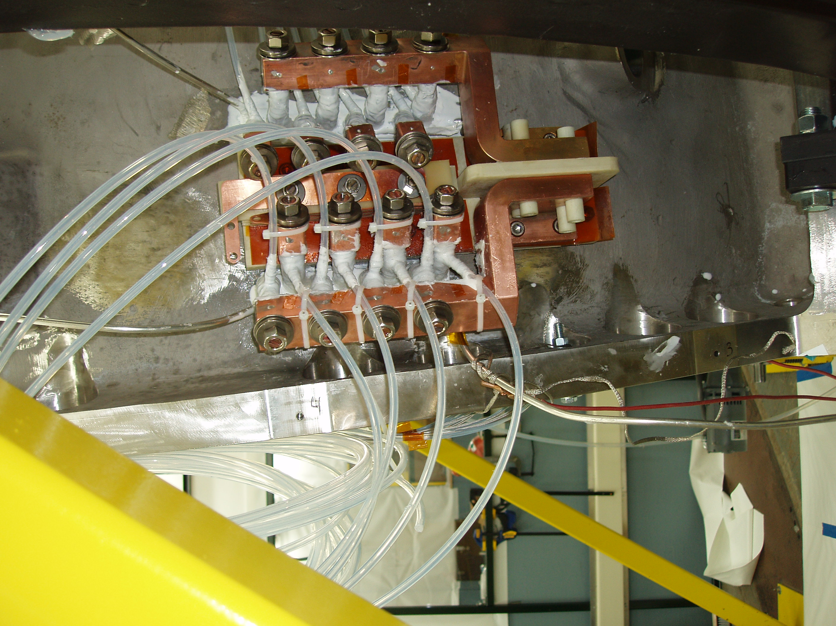

Lead Block Assembly on A-1

Administrative Highlights

Throughout our numerous weekly reports, we’ve detailed many of the unique challenges the team has faced in tooling, casting & machining MCWFs, and the creative solutions implemented by the NCSX team to address these situations. The photo above illustrates a post delivery design challenge faced by the lab. During processing, it was revealed that the close proximity of the leadblock assembly to the flange will make the assembly operation…”interesting!” After consideration of the dilemma, on A-2 and beyond, the counterbore clearance holes have been replaced with threaded holes, easing assembly.

FTP Postings this week
(found at: ftp.atc-inc.org:/PPPL/shared_info)
Location | File Name | Date
\Reports_Weekly-Monthly\Weekly | 06-10-13_eio_wk.doc | 10/15/06
\Quality_Review | CauseandCorrectiveActions.pdf | 10/20/06
\Quality_Review\Open_NCR-CA-RFD | NC20632_B2-LPI.zip | 10/20/06
\Quality_Review | A4LeadPadandB3VacuumPad.pdf | 10/20/06
\Quality-Meeting_notes | PPPLQualityNotes10-16-06plus.doc | 10/20/06

Administrative Action Items
- (PPPL) Disposition of Prototype Casting from MTK & Prototype Fixture from JP.

Status: (Open - No update) Remmele fixture shipped back to PPPL with B-1 casting. Action item remains open pending determination about scrapping the prototype.

- (EIO, MTM) Execution of Amendment 15 to EIO Contract, which includes Specification Rev 14.

Status: (Open - No update) EIO submitted a response to PPPL on 10/8, addressing changes under Amendment 15 (as specified in the changes clause). While the overall contract price and schedule were not impacted, there is an impact to several of the interim deliveries. Additional input was provided to PPPL on 10/9.

- (EIO, MTM) Submission of the Monthly Report for October.

Status: (New) EIO and MTM will begin data analysis for the upcoming monthly report submission, early next week.

Technical Highlights
B-2

B-2 is making good progress in the inspection process. The break was assembled successfully over the past weekend and final inspections began this week. MTM forwarded the LPI inspection report to EIO on 10/18. After review, the report was forwarded to PPPL on 10/20 (see QA Highlights).

The CMM scan of B-2 is also well underway. As of Friday morning, (10/20) inspection of the E side was completed, and the part was flipped over and D side data collection had begun. All data collection is expected to wrap up over the weekend including the best fit analysis and data output, enabling a final in-house review Monday (10/23) morning. Following this plan, the data package would be submitted to PPPL midday Monday, with shipping release anticipated well ahead of the previously projected ship date of 10/27.

A-4

A-4 finished up the 40’ Mitsu operations late Wednesday (10/18) and was moved over to the U-5 for final machining. Setup was complete on Friday morning, at which time machining on the U5 began. Typically, 5-axis machining on the A style MCWF has taken less than 2 weeks.

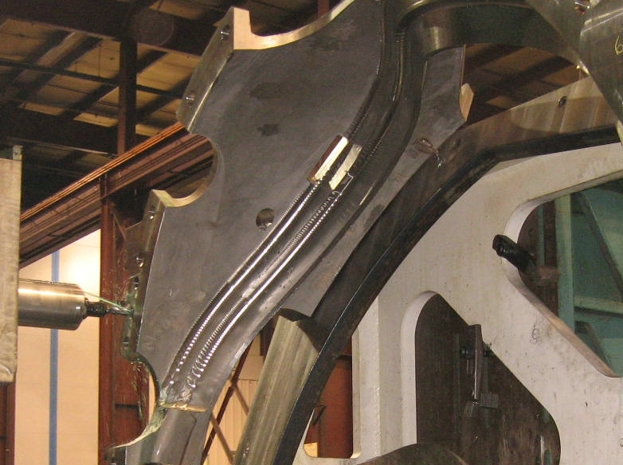
A-4 on final Mitsu op prior to U-5

B-3

As part of the on-going effort to reduce leadtimes on the 40’ Mitsu, the shop continued running B-3 on the 40T Lucas throughout the early part of this week. The operations run on the 40T for B3 should reduce the overall cycle time on the Mitsu from four weeks to closer to three. When A-4 moved off of the 40’ Mitsu late Thursday (10/19) B3 was removed from the 40T and set-up on the 40’ Mitsu to commence 1st operation setup/machining with the 3 axis.

B-4

B-4 is now set up on the 40T Lucas. The casting is undergoing the same resource leveling operations performed on B-3.

B-5

B-5 was setup on the 30’ Mitsubishi earlier this week. Mike anticipates that the 30’ operations will be complete by the end of next week. At that point, B-5 will be moved over to the Lucas, to wait its turn for resource leveling machining.

Technical Action Items

- (Major Tool) Finalizing B-2
Status: (Open) In CMM inspection

- (Major Tool) Machining A-4
Status: (Open) On U-5 – 1st op
- (Major Tool) Machining B-3
Status: (Open) On 40’ Mitsubishi
- (Major Tool) Machining B-4
Status: (Open) On Lucas
- (Major Tool) Machining B-5
Status: (Open) On 30’ Mitsubishi
- (Major Tool) Machining A-5
Status: (Open) Off line

- (Major Tool) Machining A-6
Status: (Open) Off line
- (Major Tool) Machining B-6
Status: (Open) Off line
- (Major Tool) Machining C-6
Status: (Open) Off line

Quality Highlights
On Wednesday, 10/18, EIO received formal acknowledgement that document packages for MCWFs A1 and A2 had been accepted. There are now only two other documentation packages in review (A-3 and B-1), and the submittal/acceptance process is well-aligned with the shipment of the parts. Chuck Ruud, Mike Griffith, Roy Sheppard and Frank Malinowski are to be commended for their dedicated and collaborative effort to successfully establish and implement this important (albeit time consuming) process for capturing the full history of each winding form.

During this week’s QA meeting on 10/17, the team discussed CA 090606 (documenting the non-conformance and corrective action) for B-3 & B-6 Vacuum Vessel support pad deviations. As mentioned previously, there is only room on 1 of the B-3 pads & 1 of the B-6 pads for 3 of 4 tapped holes. Mike Griffith also noted that in order to fit in 3 holes he would need to shift the pattern down on the boss to keep the 3rd hole from breaking out. As the large center hole is already in place, this would mean that hole locations relative to the center hole would deviate from the drawing. After the meeting, Mike took the photos shown below detailing the shift in hole pattern required ( ¼” ) and submitted that to PPPL for review.

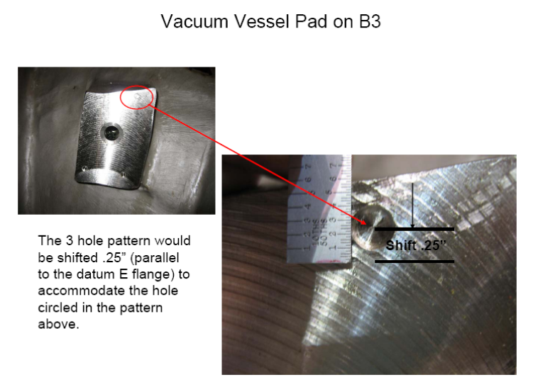

On 10/18, Phil Heitzenroeder wrote back to the team, that though the true position of the central thru-hole should remain to print, the tapped holes should be shifted as needed to best fit the feature. Phil further requested that details of any such offset for A or B castings should be forwarded to PPPL on a per occurrence basis.

On 10/17, Mike also sent in a slide showing a potential problem he noted on A-4. (see picture below)

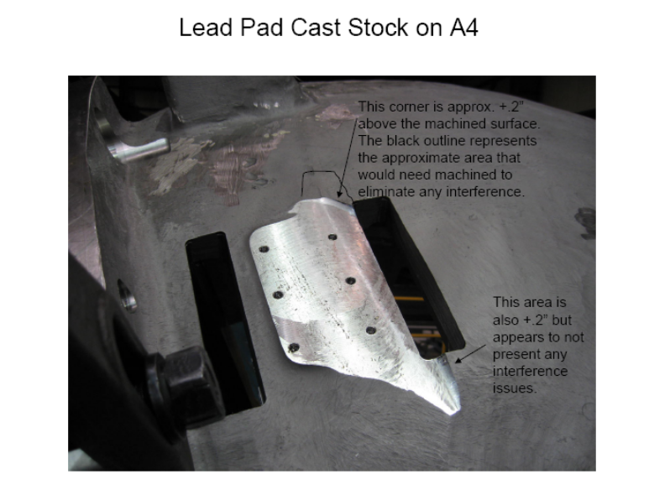
After finish machining of the leadblock pad, a .20” step remained below the casting wall in 2 places. The area outlined in black in the above photo appeared the most problematic as it looked like it could interfere with the leadblock hardware.

A quick review by PPPL ensued, and they agreed with MTM. Mike was requested to grind this step flush to allow the G-11 plate to sit securely. Phil added that on A-1 thru A-3, a similar situation had been noted and ground by the lab. Roy Sheppard will be traveling to MTM next Wednesday and will check on the condition of the lead block bosses on A-5 & A-6.

As noted in Technical Highlights, the LPI report for B-2 was submitted on Friday, 10/20. B-2 has the fewest rejectable spots to date and all of the spots appear well within acceptable range established on other parts. Consequently, proposed disposition is to accept the indications as-is. PPPL review is in progress.

Upcoming QA Activities
- Review of LPI info submitted – B-2
- Final documentation & review B-2
- Signed Shipping Release for B-2
- Commence B-2 Doc package

QA Action Items

- Closed Items:
  - A-1 & A-2 Document packages have been accepted by PPPL (see 3.1.1 & 3.1.2)
  - Report on recent problems at MTM sent in to PPPL (see 2.1)

- Pending from EIO:
  - (EIO, MTM) Share results of investigation and corrective actions taken regarding recent errors.
- Gear damage
- Mis-drilled holes
- Set-up instruction misinterpretation in Lead areas
- Shearing of Head bolts
- Status: (Closed) Report sent to PPPL & posted to FTP on 10/17

  - (EIO, MTM) Provide documentation of completion of corrective action for EIO CA 090606(NCR) for B-3 & B-6 Vacuum Vessel support pads deviations.
Status: (Open) “CA now signed off pending completion of B-3 & B-6.” Mike notes that the center hole IS FIXED in location but the tapped hole pattern IS being shifted. On B3 (and B6) one hole cannot be drilled (corner missing). Info on hole pattern shifts will be provided to NCSX so that any impacts on the interfacing hardware can be addressed (EIO asked MTM to provide this in advance of drilling). The pattern offsets are expected to be as much as ¼”. The CA will remain open until after B6 is completed.

- Pending from PPPL
  - Review Final Documentation Packages
    - A-1
Status: (Closed) – Formal approval received from PPPL on 10/18.
    - A-2
Status: (Closed) – Formal approval received from PPPL on 10/18.
    - A-3
Status: (No Change) –
    - B-1
Status: (No Change) -

  - Document (RFD/Dwg Change/Spec Change?) Rapid Response guidance provided regarding clearance for counter-bored flange holes.
Status: (Open) Documentation method still under discussion.. Mike G. notes that the guidance they’ve been given is adequate. NCSX is still working out how to formally implement this on the drawings.
  - Spec/Drawing Revision to eliminate use of Thred Guard.
Status: (Open) NCSX has to change the drawings to eliminate the notes on the drawings.

- Discussion Topics For Next Telecon
- B-2 Data Review and Final Inspection Results

Nancy Horton

EIO Program Manager for NCSX

216-296-2314

