Energy Industries of Ohio (EIO) Team Weekly Status Report

Report covers the NCSX Modular Coil Winding Form Activities Under Production Contract S005242-F

Week ending November 3, 2006

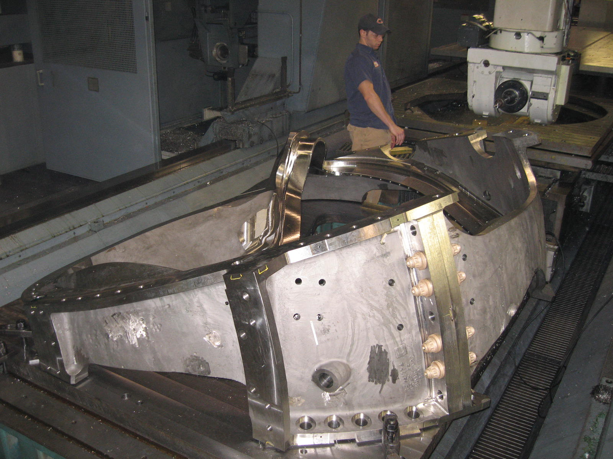

Final U-5 op on A-4

Administrative Highlights

MTM completed machining operations on A-4 this week & the part was moved off the U5 to begin hand operations over the weekend. During the week, MTM machined 4 coils on 3 centers: in addition to A-4, B-3 is making steady progress on the 40’ Mitsu, while MTM alternates machining of B-4 & B-5 on the 40T Lucas.

On Friday, 11/3, PPPL provided feedback on the B-1 casting that answered an inquiry generated by EIO/MTM back in July. Referring back to EIO’s visit to MTM on 7/25; during discussions of a problem in the B-1 leadblock, a possible interference issue on the B leadblock area was noted. It did not appear that there was sufficient clearance to fit the connector assembly (common to all 3 styles) on the block without running into the cast leg. Over the next couple weeks, this problem was discussed in several QA meetings and was detailed in the QA Highlights of the 8/11 Weekly report. A report was also posted to the EIO FTP site (see Quality_Review\ B-Leadblock\lead_block_assembly-8-8-06.doc).

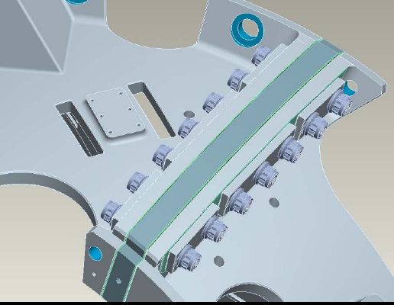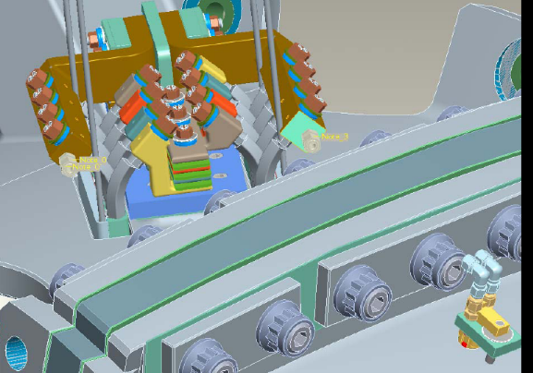

B Lead block assembly issues – 8/11 Weekly Report

At the time, one solution was to have ORNL investigate the possibility of redesigning a unique leadblock interface for the B style MCWF. Late Friday, Dave Williamson provided input to the team (see QA highlights). This matter has been added back to the QA action item list for further analysis.

In fact, there are several new (or returning) topics for discussion during our upcoming weekly QA telecon (included under QA Action Items - Section 4). From a contract administration perspective, it is worth repeating that this forum continues to serve as an efficient and effective approach for exchanging information, answering questions and resolving challenges.

FTP Postings this week
(found at: ftp.atc-inc.org:/PPPL/shared_info)
Location | File Name | Date
\Reports_Weekly-Monthly\Weekly | 06-10-27_eio_wk.doc | 11/4/06
\Quality_Review\Closed_NCR-CA-RFD\NC | Signed_off-NC20676_B2IDC.pdf
\Quality_Review\Closed_NCR-CA-RFD\NC | Signed_off-NC20670_B2Visuals.pdf
\Quality_Review\Closed_NCR-CA-RFD\NC | Signed_off-NC20632_B2PTI.pdf
\Quality_Review\Closed_NCR-CA-RFD\NC | Signed_Off-NC20676-IDC-Rev_103106.pdf
\Quality-Meeting_notes | PPPLQualityNotes10-30-06-plus.doc
\Quality_Review\A3_Doc | S5242l10-31-06A-3Acceptance.pdf
\Quality_Review | b1_block_interference_cad.ppt

Administrative Action Items

- (EIO, MTM) Execution of Amendment 15 to EIO Contract, which includes Specification Rev 14.

Status: (Open) EIO submitted a response to PPPL on 10/8, addressing changes under Amendment 15 (as specified in the changes clause). Larry Sutton advised this week that the resulting Amendment 16 is currently in process.
- (EIO, MTM) Submission of Monthly Report for October

Status: (Open) To be submitted on 11/6

Technical Highlights

A-4

As of Friday morning, A4 was on setup 3 of 3 on the U5 (see opening photo). MTM intended to move the part off the machine later in the day and hand deburring activities were scheduled to commence on Friday evening. Deburring will continue throughout the weekend, with the goal of moving A-4 into assembly & final testing early next week.

B-3

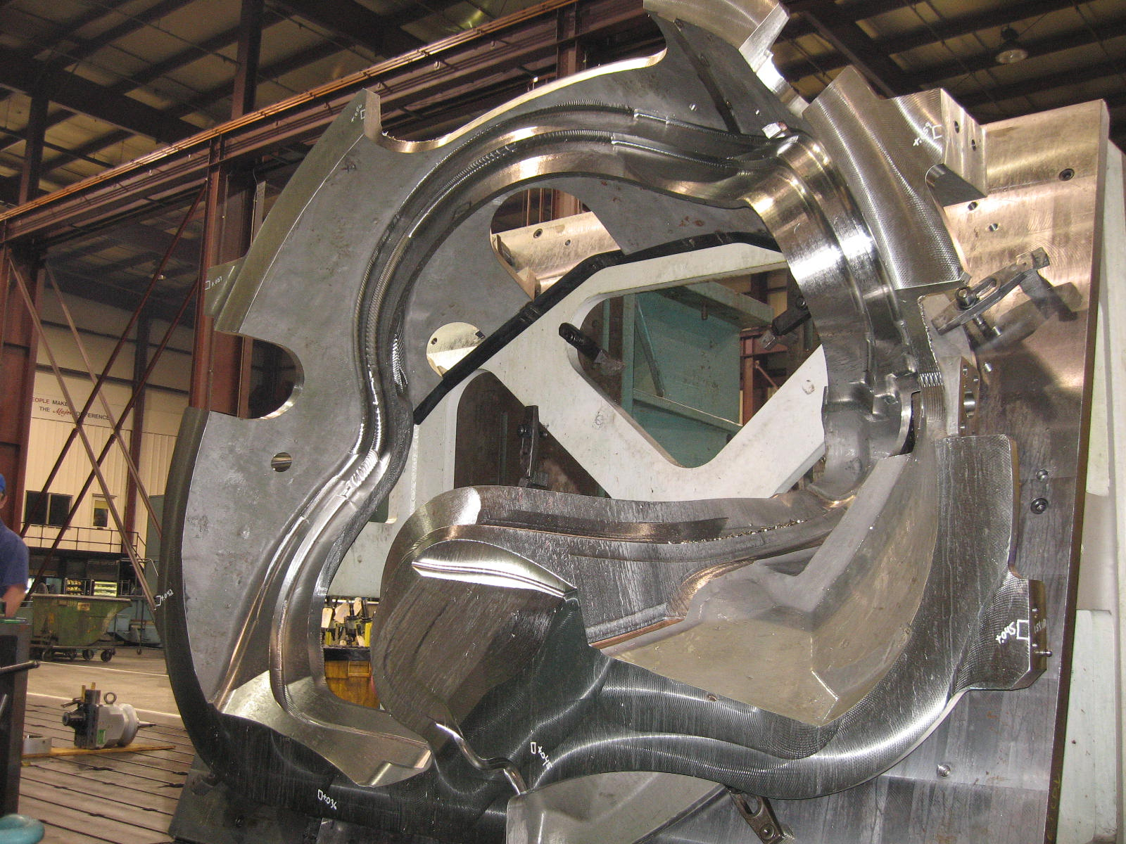
B-3 on 40’ Mitsu

MTM continued machining B-3 this week in the 1st of 2 operations on the 40’ Mitsubishi. The part is expected to begin the 2nd operation over this weekend. B-3 is targeted to finish Mitsu operations by 11/14.

B-4 & B-5

As was done on the initial Lucas operations, MTM is now running B-4 & B-5 across the Lucas in tandem through the resource leveling operation. MTM completed the 1st side of B-4 earlier this week. The casting was taken off the fixture & B-5 was setup. B-5 is now undergoing the same ops performed on B-4. This op is scheduled to continue throughout the weekend into early next week. At that point B-4 will be setup on the 2nd side. This follow-up operation is scheduled to be finished by the time B-3 comes off the 40’ Mitsu.
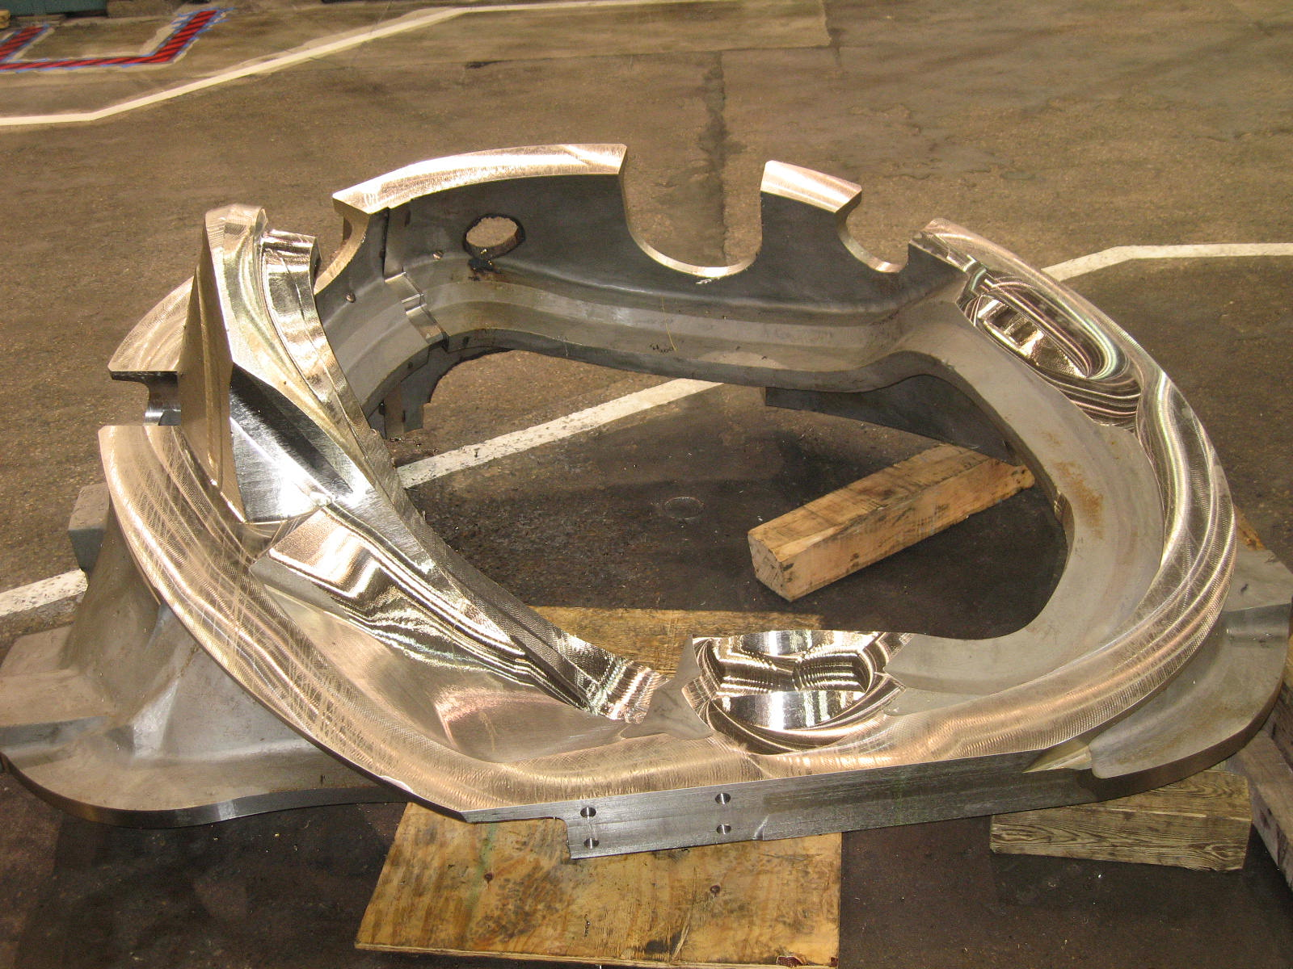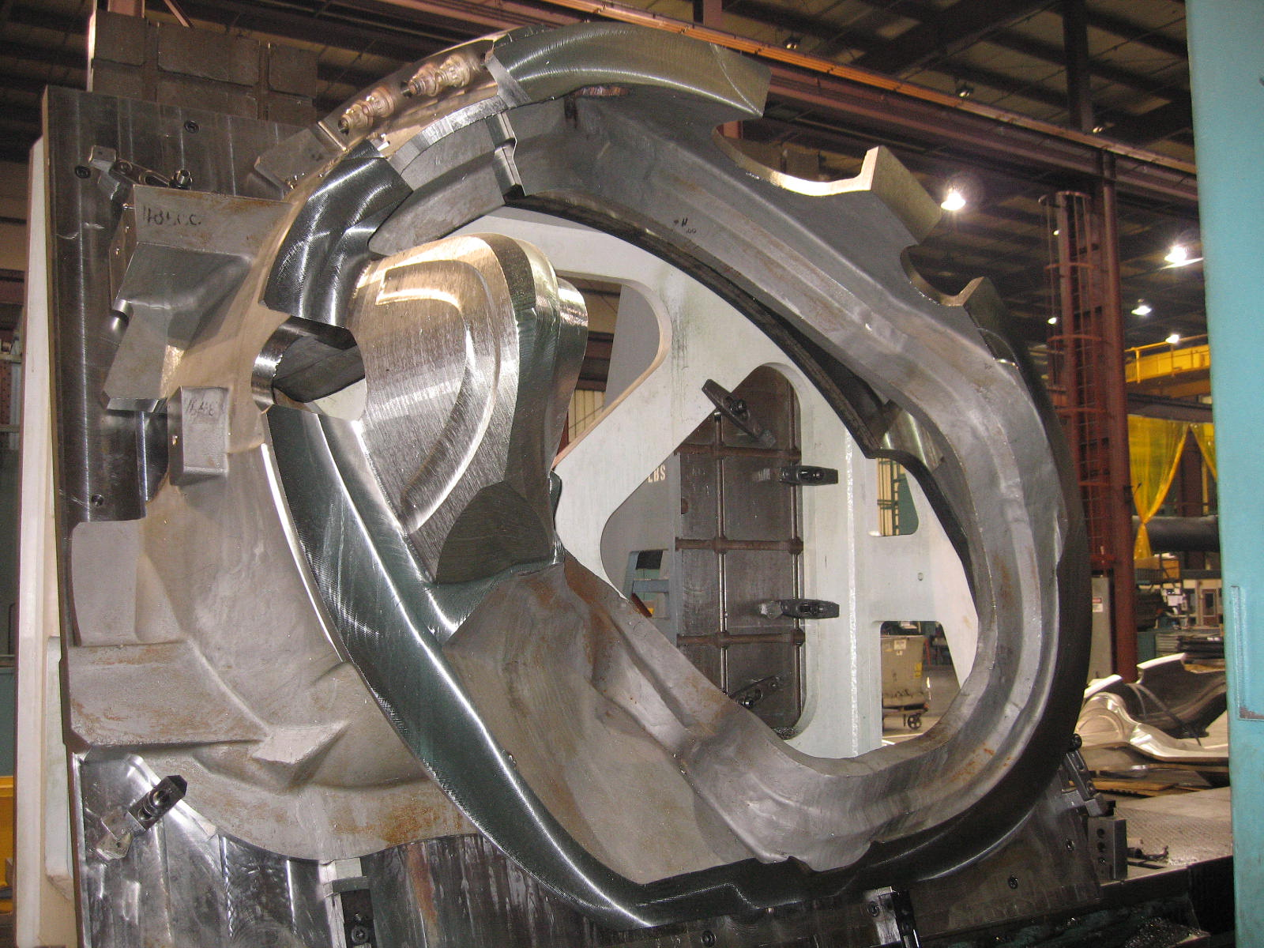
B-4 through the 1st Lucas op B-5 on the Lucas

Technical Action Items

- (Major Tool) Machining A-4
Status: (Open) In hand deburr

- (Major Tool) Machining B-3
Status: (Open) On 40’ Mitsubishi
- (Major Tool) Machining B-4
Status: (Open) Staged for 2nd Lucas op
- (Major Tool) Machining B-5
Status: (Open) On 1st Lucas op
- (Major Tool) Machining A-5
Status: (Open) Off line

- (Major Tool) Machining A-6
Status: (Open) Off line
- (Major Tool) Machining B-6
Status: (Open) Off line
- (Major Tool) Machining C-6
Status: (Open) Off line

Quality Highlights

EIO received approval of the A-3 Doc package this week from PPPL. The B-1 package had page numbers inserted & was reposted. This leaves only 1 outstanding Doc package owed to PPPL for the recently delivered B-2. Based on feedback and comments resulting in the approved doc packages, EIO is now compiling all of the MTK portions of the Doc packages, ensuring all needed paperwork is in hand. To date, A-4, A-5 & A-6 have been completed. These “partial” Doc packages will be posted to the FTP site next week.

During the preparation of the shipping release for B-2, the topic of the thin wall found on B-1 was reopened, as we discussed the applicability of CA 1538 to all of the B castings. While it had been agreed that the thin wall condition was not a concern for PPPL, the question of whether B-2 through B-6 had thin areas similar to areas found by Scanco on B-1 was still never fully answered. EIO started a review of all of the B scans (from both Scanco & Metal Tek on 10/27 and completed the review on 10/31.

The results confirm that the thin wall condition was replicated, although not necessarily to the degree on B-1.
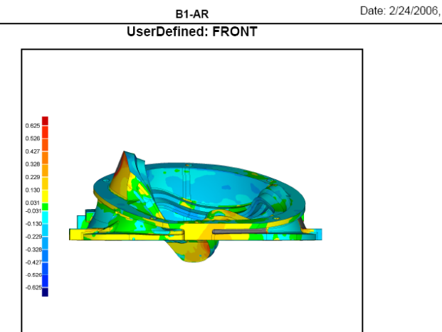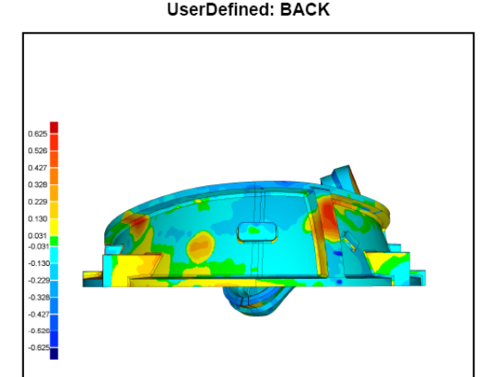

Scans from B-1 of thin walled area

The above scan is from Metal Tek. It confirms Scanco’s earlier readings. By subtracting the deviations from nominal on both sides (using the color gradients) one can roughly determine if the wall thickness is under the minimum 1.50” per the model. Of the 6 MCWF’s, B-1 probably has the largest area of thin wall - It is thin on both sides (back & front).

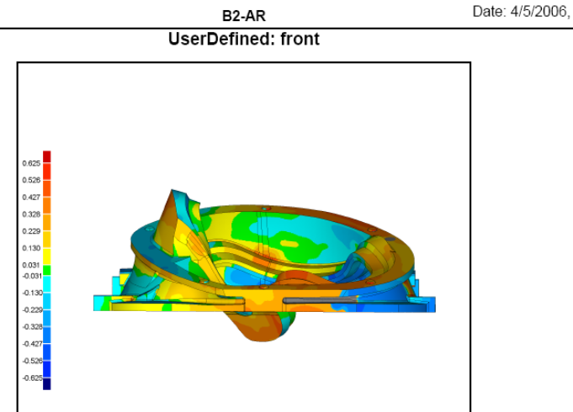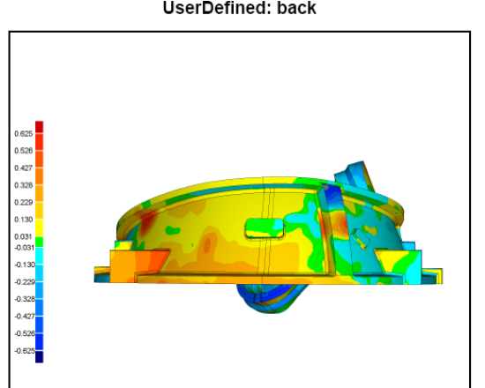

B-2 appears to be the best of the lot. However there is 1 small area adjacent to the racetrack that is low (dark blue above left). Although the area on the opposite side is high, if you roughly add & subtract the color gradients from a nominal designed wall of 1.5 you could have a minimal wall thickness of 1.4”. The others B castings are a bit worse than B-2 with some low spots on both sides. In light of these findings and per CA-1538, there is an outstanding action to submit a formal RFD to accept the condition (see 2.3, 2.4 & 4.2 below).

As mentioned in the administrative highlights, the problem with leadblock connector pad interference on the B coils came back to the forefront on Friday afternoon. Dave Williamson of ORNL prepared a quick PPT detailing the interference points (b1_block_interference_cad.ppt). A copy of this report has been posted to the FTP site for team review. This will be a subject for discussion on Tuesday’s QA telecon (see 4.4).
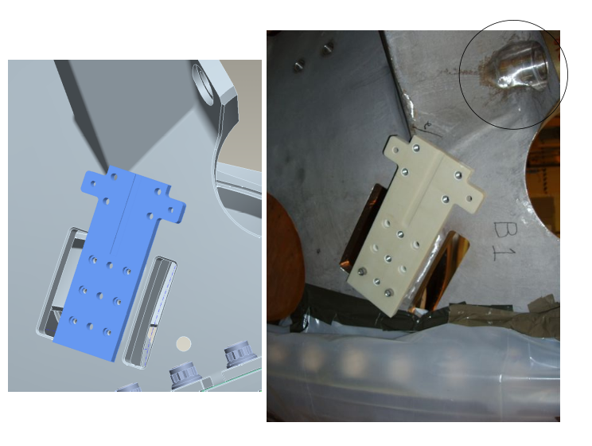
Slides from PPT contrasting model with casting
Upcoming QA Activities
- Review of thin wall on B castings
- Finalize B-2 doc package

QA Action Items
- Closed Items:

  - Documentation package for A-3 was approved.
  - Review of thin walled areas on B coils completed
  - NC 20676 has been signed to certify completion of CA (see 2.2)

- Pending from EIO:

  - (EIO, MTM) Provide documentation of completion of corrective action for EIO CA 090606(NCR) for B-3 & B-6 Vacuum Vessel support pads deviations.
Status: (Open - No update) MTM confirms that the center hole position is fixed but the tapped hole pattern is being shifted as needed (applies to all Type B castings). EIO/MTM will provide proposed shifted locations prior to drilling. On B3 & B6 it’s likely that one hole cannot be drilled (corner missing). The CA will remain open until after B6 is completed.

  - (EIO, MTM) Document Corrective Action on NC 20676 for discrepant radii at base of racetrack on B-2 (step 130)
Status: (Closed) MTM has completed rework of radii. MTM signed CA of NCR was submitted to PPPL on 11/5.

  - (EIO) EIO to confirm that B-2 thru B-6 do or do not have the thin wall conditions seen on B-1
Status: (Closed) Some of these coil forms have areas below the nominal wall thickness of 1.50”. An RFD will be generated ( 2.4)
  - (EIO) Section 4 of CA-1538 for B-1 thin wall areas, required that an RFD be written if a similar situation occurred in B-2 thru B-6.
Status: (New) EIO examination of scans shows that this condition does exist on some of these coils. Pete Djordjevich is in the process of writing an RFD.

- Pending from PPPL

  - Review Final Documentation Packages
    - B-1
Status: (Open) – PPPL comments/questions to be addressed by EIO/MTM:
- Shouldn’t there be rework steps where rework was performed? Mike says they’re included, but will point them out.
- Mike will provide searchable files with the dimensional NCs.
- B1 documentation needs page numbers – Roy will do.

  - Document, likely by Drawing Change, the Rapid Response guidance provided regarding clearance for counter-bored flange holes.
Status: (No Change) Documentation approach not yet resolved. David will prepare an ECN to cover both 3.2 and 3.3; this ECN will require eventual changes to the drawings. In the interim, the drawings will be stamped indicating that the changes are pending. The target date for the drawing updates are the end of February.
  - Spec/Drawing Revision to eliminate use of Thred Guard.
Status: (No Change) ECN to be issued (see 3.2)

- Discussion Topics For Next Telecon

  - Discussion of the CMM inspection challenges on B-2 and actions taken by MTM to avoid this problem in the future, as mentioned in the Weekly QA notes. Mike G needs to talk to Ed who did the scanning, but he’s been out sick. Will discuss next week.

  - Follow-up on last week’s discussion of CA 1538 from Metal Tek detailed variations from the cast model on the Scanco scan for B-1. Part 4 of the NCSX response dealt with the thin wall condition evidenced on this casting. NCSX concurred with EIO to use the B-1 casting as is. If this problem proved to repeat on subsequent B castings, it was agreed that an RFD should be processed. As noted above, the thin wall did repeat to varying degrees, so an RFD is required. EIO will prepare the RFD if it is agreed that this is the appropriate approach.

  - MTM RT film for high stress areas.
B-2 film is coming separately to Larry. PPPL asks: Have steps been taken to ensure that film, report, and envelopes are tied to the MCWF by S/N? Mike will check if this info is now included and will change the router if necessary. Permanent imprint on film preferred; permanent marker second best.

  - Discussion of interference of the leadblock connector pad with the cast leg – cause of interference & potential “fix(s)”
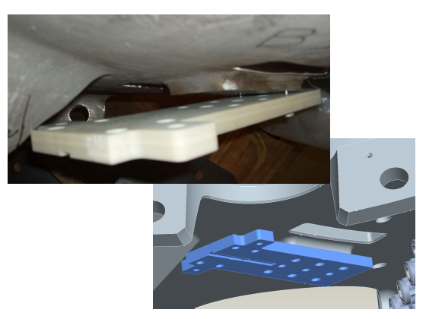
  - B-2 Poloidal Break protrusion.
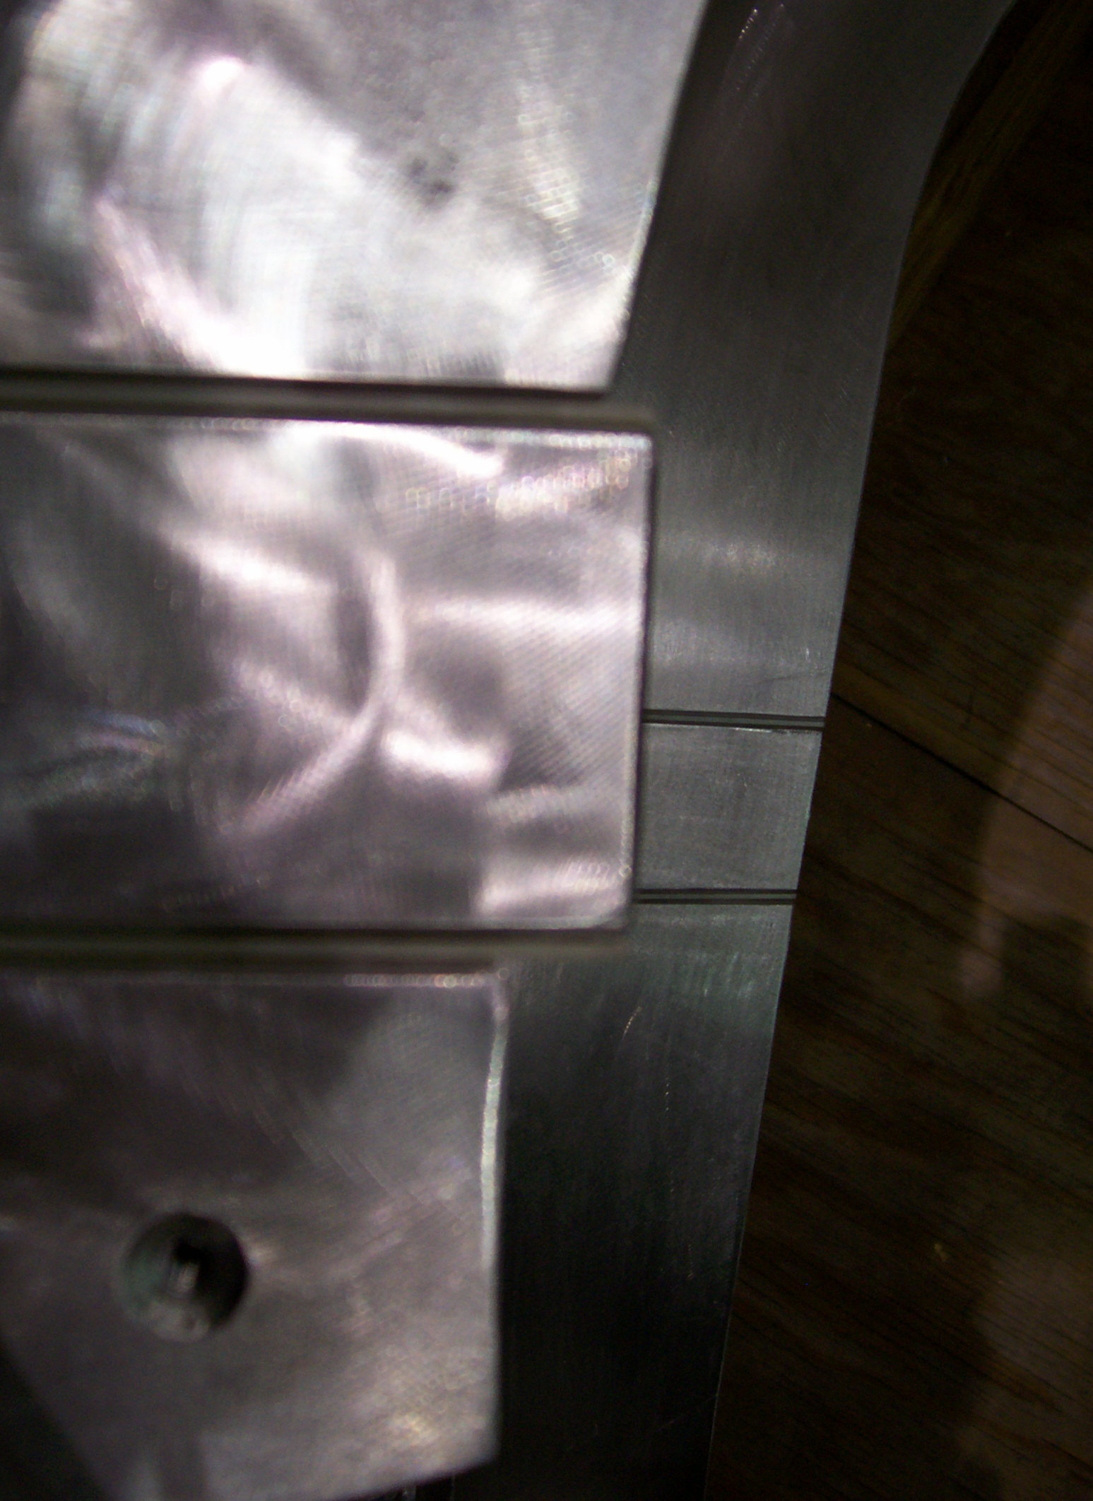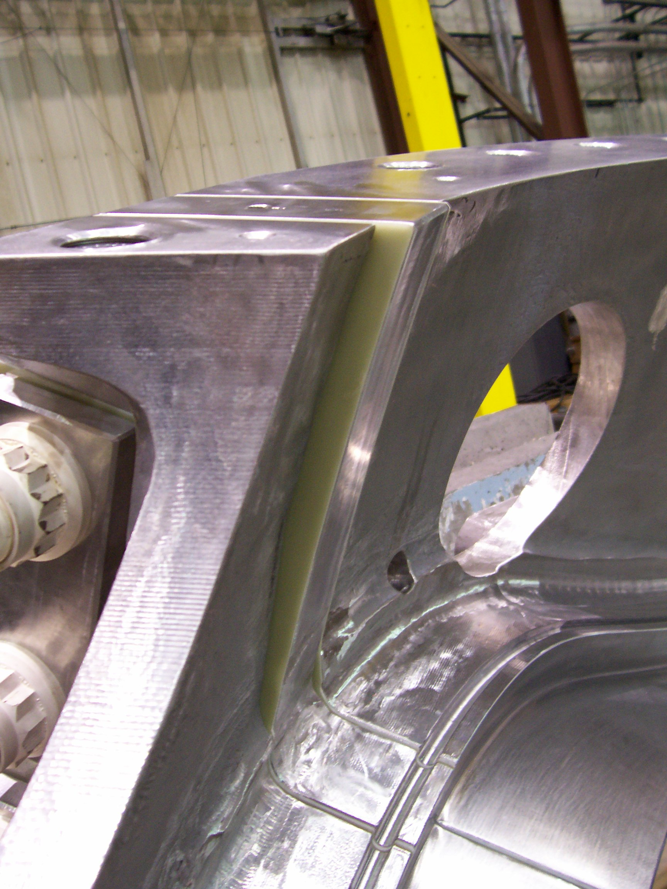

Looking forward to a lively QA telecon this week! If you have any questions or comments, please feel free to give me a call.

Nancy Horton

EIO Program Manager for NCSX

216-296-2314

