Energy Industries of Ohio (EIO) Team Weekly Status Report

Report covers the NCSX Modular Coil Winding Form Activities Under Production Contract S005242-F

Week ending November 17, 2006

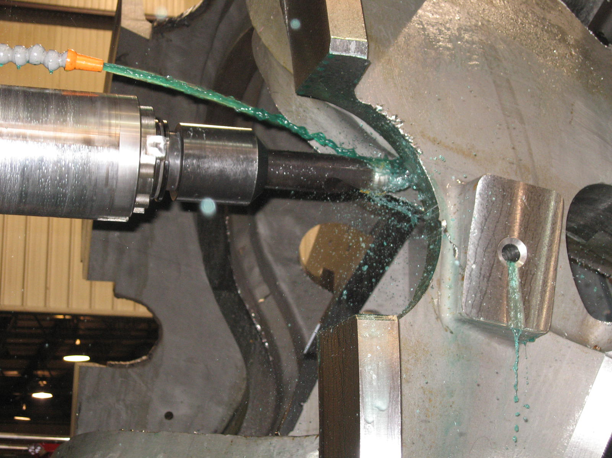

B-5 on 40T

Administrative Highlights

The EIO team successfully completed and delivered our eleventh casting this week. On Monday, 11/13, we commenced the week with the submission of CMM data and other final inspection results for A-4. Peter Djordjevich was at Major Tool to review the casting and the associated data results first hand, conducting the usual mag perm inspection. By Tuesday morning, all NC’s had been submitted and the team was able to discuss the input during our weekly QA telecon. While most of the issues were resolved on the spot, a follow-up call was conducted to complete the approval process. Upon receiving the green light, the shipping release was prepared and submitted to PPPL and approval was received shortly after. The part left Major Tool on Thursday, 11/16 and was received at PPPL on Friday, 11/17.

Also this week, reps from MTM, MTK and EIO had a chance to catch up with one another and meet up with members of PPPL and ORNL at the ITER Vendor Fair held in Oak Ridge on 11/15. The forum presented a nice opportunity for networking along with insight about the US’ contributions to ITER, planned program management approach to technical tasks, and upcoming and long-range procurement plans.

FTP Postings this week
(found at: ftp.atc-inc.org:/PPPL/shared_info)
Location | File Name | Date
\Reports_Weekly-Monthly\Weekly | 06-11-10_eio_wk.doc | 1112/06
\Quality_Review\B4_Doc | b4_MTK_Doc-11-13-06.pdf | 11/13/06
\Quality_Review\Open_NCR-CA-RFD | NC20741_A-4-RT-rejections.zip | 11/13/06
\Quality_Review | A-B-radius_check-idc.zip | 11/13/06
\Quality_Review\A4_Doc | A-4-MTM_IGS.zip | 11/13/06
\Quality_Review\A4_Doc | A-4_Verisurf_Reports.zip | 11/13/06
\Quality_Review\A4_Doc | A-4_RT_photos.zip | 11/13/06
\Quality-Meeting_notes | PPPLQualityNotes11-13-06-plus.doc | 11/18/06
\Quality_Review | ECN-5185-flange_hole-cntrbore_clear.pdf | 11/18/06
\Quality_Review\A4_Doc | A4.ppt | 11/18/06
\Quality_Review\A4_Doc | A4_inspection.ppt | 11/18/06
\Quality_Review\A4_Doc | a4_idc_step20_notes.xls | 11/18/06
\Quality_Review\Open_NCR-CA-RFD | NC20733_PT_summary.zip | 11/18/06
\Quality_Review\Open_NCR-CA-RFD | NC20759_IDC.zip | 11/18/06
\Quality_Review\Open_NCR-CA-RFD | NC20761_visual_summary.zip | 11/18/06

Administrative Action Items

- (EIO, MTM) Execution of Amendment 15 to EIO Contract, which includes Specification Rev 14.

Status: (Open) EIO submitted a response to PPPL on 10/8, addressing changes under Amendment 15 (as specified in the changes clause). Larry Sutton advised that they are continuing to process the resulting Amendment 16. New projection is around 11/22.

- (EIO, PPPL) Disposition of Patterns

Status: (Newly Re-Opened) PPPL re-opened the issue of pattern shipment/storage with EIO via e-mail on 11/13/06. EIO has responded with a request for clarification about the new disposition instruction being proposed.

Technical Highlights
A-4

A-4 was shipped this Thursday, bringing our total to 11 castings delivered to PPPL. Pete Djordjevich traveled to MTM on Monday, 11/13 to witness the final inspection of the coil form (see QA highlights).

B-3

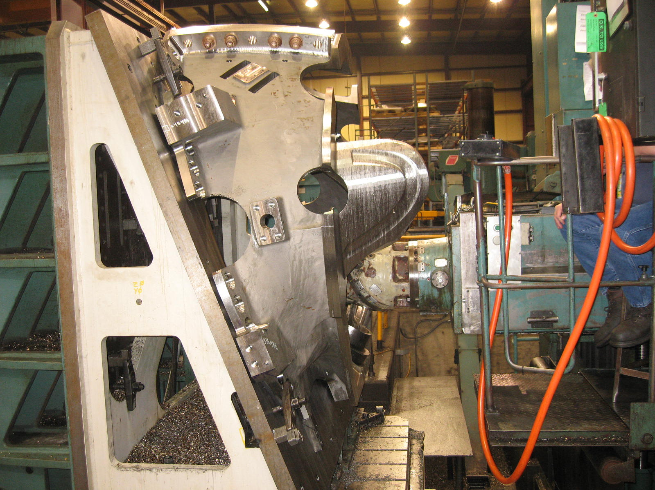
B-3 on Mitsu

As of Friday, a.m. B-3 was close to completing the 3-axis machining operations on the 40’ Mitsubishi. MTM plans on finishing the op this weekend. Upon completion, B-3 will be setup on the U-5 and 5-axis machining should begin Monday, 11/20.

B-4
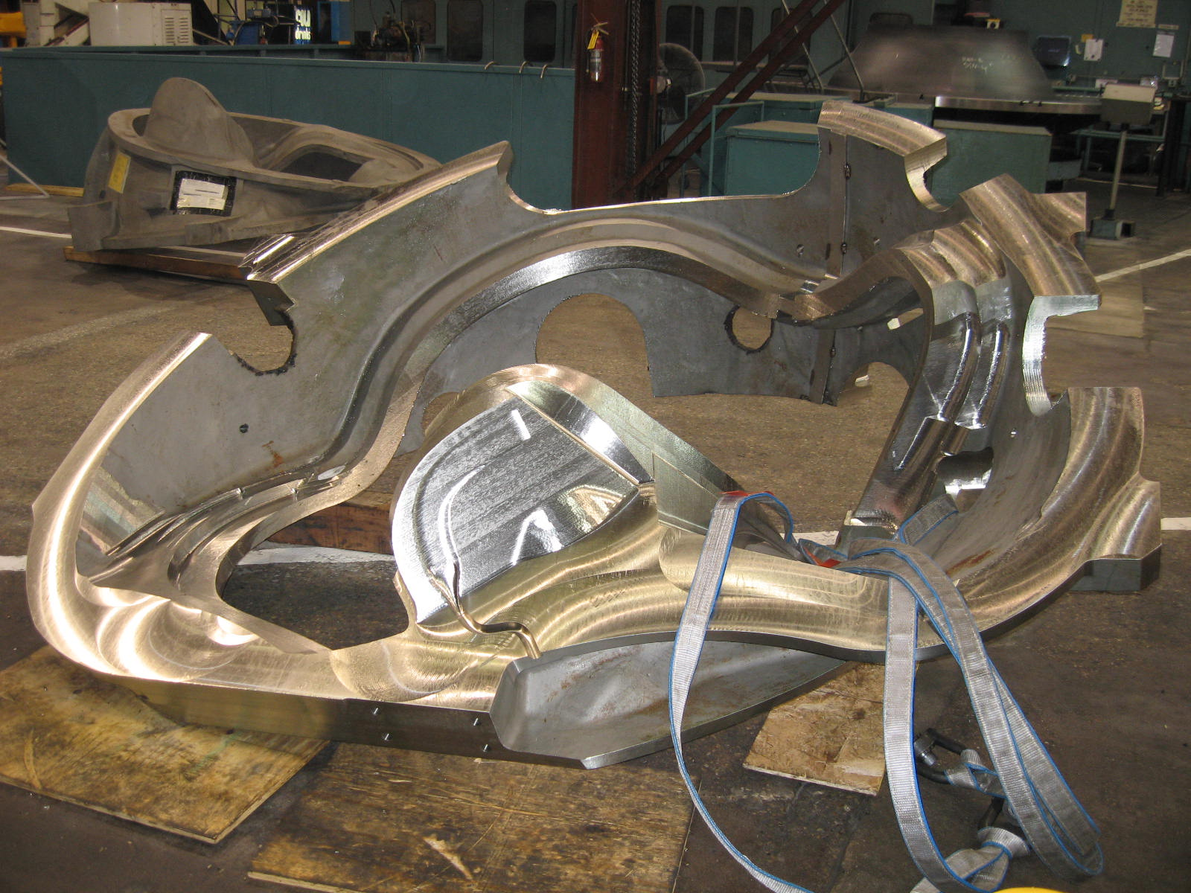
B-4 – staged for Mitsu

MTM completed the 2nd (and final) resource leveling op on the Lucas earlier this week. B-4 was moved off the Lucas & is now staged by the 40’ Mitsubishi. The part should move onto the Mitsu this weekend & commence 3-axis operations. This is the 1st B MCWF to receive the full resource leveling operation on the Lucas. The team is eager to see how much time this will save on the 40’ Mitsu operations.

B-5
B5 was moved onto the 40T Lucas earlier in the week for resource leveling operation 2 of 2. This part is expected to finish up early next week at which time A6 will be placed on the machine for its initial roughing operations. B-5 is currently scheduled to follow B-4 on to the 40’ Mitsubishi.

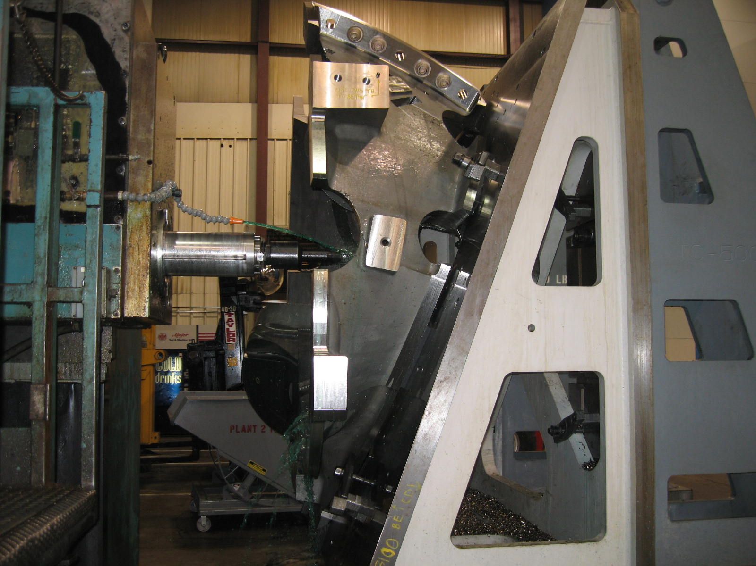
B-5 on 40T

Technical Action Items

- (Major Tool) Machining A-4
Status: (Closed) Shipped 11/16
- (Major Tool) Machining B-3
Status: (Open) Final Mitsu ops
- (Major Tool) Machining B-4
Status: (Open) Staged for 40’ Mitsu
- (Major Tool) Machining B-5
Status: (Open) On 40T 2nd op
- (Major Tool) Machining A-5
Status: (Open) Offline

- (Major Tool) Machining A-6
Status: (Open) On deck for roughing
- (Major Tool) Machining B-6
Status: (Open) Offline
- (Major Tool) Machining C-6
Status: (Open) Offline

Quality Highlights

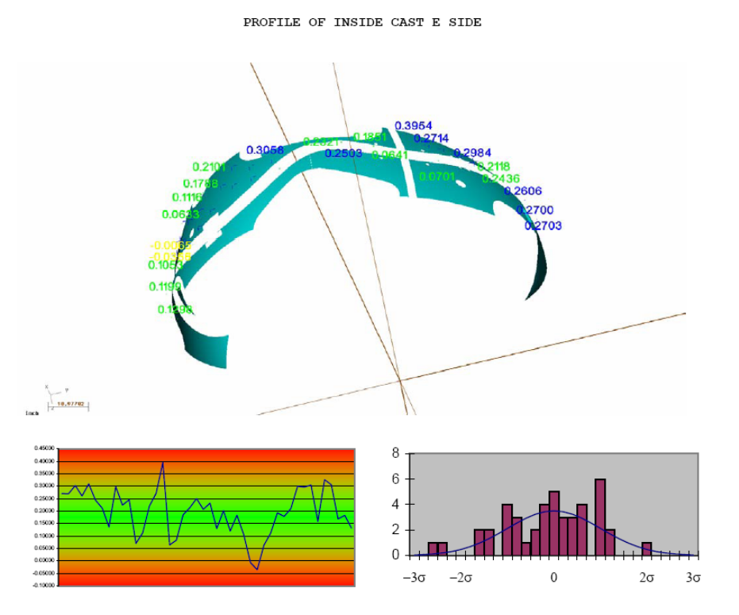
Verisurf data from A-4

The QA meeting this week focused almost exclusively on resolving open NC’s on A-4, so that the coil form could be released for shipment. An initial telecon to briefly discuss the RT failures on A-4, in particular the RT failure noted earlier during PT inspection was held on 11/13, while Pete Djordjevich of EIO was at MTM. This discussion was carried over into the Tuesday a.m. QA call, which also touched on the dimensional and visual inspection data. A 3rd and final telecon was held later that morning at which time it was agreed to release A-4 for shipment.

QA Action Items

- Closed Items:

  - NC 20676, for discrepant radii at base of the “T” on B-2 (step 130), is Closed.
  - Sent IDC to PPPL for radius check on A & B castings (see 2.2)
  - ECN 5185b transmitted to EIO for flange holes & B leadblock (3.3)
- Pending from EIO:

  - (EIO, MTM) Provide documentation of completion of corrective action for EIO CA 090606(NCR) for B-3 & B-6 Vacuum Vessel support pads deviations.
Status: (Open - No update) MTM confirms that the center hole position is fixed but the tapped hole pattern is being shifted as needed (applies to all Type B castings). EIO/MTM will provide proposed shifted locations prior to drilling. On B3 & B6 it’s likely that one hole cannot be drilled (corner missing). The CA will remain open until after B6 is completed.

  - (EIO, MTM) MTM will send IDC’s with Tee radius check added.
Status: (Closed). In-process IDC for A & B sent to PPPL for review.

- Pending from PPPL

  - Issue ECN for the elimination of Thred Gard use on Drawings SE141-101, 102, 103.
Status: (Open) ECN 5197 was generated and is in the processing cycle. A copy of it will be sent to EIO later this week.

  - PPPL to process EIO RFD for Type B Thin Wall conditions.
Status: (New) EIO RFD 110806 was regenerated as NCSX RFD-14-026 and is in the approval cycle. Note that EIO is holding final submission of B-2 data package until RFD is approved since this RFD will be placed in Doc packages B-2 thru B-6. ECN 5185 covers the required drawing note changes. RFD will be sent today.

  - PPPL issued ECN 5185 which addresses clearance for counter-bored flange holes & clearance/notching for support post/G11 lead block plate interference.
Status: (Closed) A copy was transmitted to EIO on 11/13.

  - Waiting for signed copies of A-4 NC all which were dispositioned during QA meetings on 11/14.
3.4.1 NC 20733 for penetrant inspection failures
3.4.2 NC 20741 for RT failures
3.4.3 NC 20759 for dimensional OT
3.4.4 NC 20761 for visual inspection

- Discussion Topics For Next Telecon -

  - PPPL QA note 3.2 states that ECN 5185 covers RFD 110806 for thin walls on B castings (see highlight on 3.2 above). If so, the change is not readily apparent in the ECN.

Nancy Horton

EIO Program Manager for NCSX

216-296-2314

