PRINCETON UNIVERSITY: PLASMA PHYSICS LABORATORY
To: | Distribution | Date: | October 24, 2003
From: | Frank Malinowski / Mike Viola | QA
Subject: | Visit to Major Tool & Machine, Inc. 10/20-22/03

Key Personnel involved: Mike Manuel—MTM Program Manager
Joel Manship—MTM Sales & Marketing
Doug McCorkle—MTM Manufacturing/Quality Planning
Dennis Knaub—MTM Vice President of Quality Assurance
Mike Viola—PPPL Engineering
Frank Malinowski—PPPL Quality Assurance
Also met: Jim Flanagan—Vice President of Engineering, Mike Trosen—Lead Weld Engineer, the forming press operator, and the subcontracted model maker (fabricating the plate gages).

On Monday afternoon, 10/20, Tuesday 10/21, and briefly Wednesday morning 10/22, Mike Viola and Frank Malinowski of PPPL visited Major Tool and Machine Co. (MTM) to get more familiar with their processing controls and quality program and also to observe processing of the NSTX Prototype Vacuum Vessel Section (PVVS). When discussing this visit with MTM, we had planned for Mike Viola to observe PVVS shop operations, especially welding, and for Frank Malinowski to meet with the QA Manager and walk through how a job travels through the shop. It should be noted that until now there has been no contact with MTM QA. The visit did not occur as planned. We saw very good progress with all of the die/punch sets completed. Two plates were formed with no indication of any fabrication defects. The first plate will be used for weld process development and tests and the second will be the first plate for the actual PVVS. MTM was not ready for plate welding and so we only saw test pieces. We did not get the QA walk-through of MTM’s processing system and were not able to discuss traditional QA system components such as calibration, audits, supplier qualification, or document control. We did, however, gain significant insight into MTM’s processing system and identified concerns with it. Most significant is the lack of QA involvement in process planning and oversight. While MTM described a system that worked without these traditional QA activities, each example shown to demonstrate this had problems that PPPL & MTM both readily recognized.

On Monday afternoon, Mike Manuel, Doug McCorkle, and Joel Manship gave us a tour of the three shop buildings. This included a look at the first formed plate and the die and punch sets for the subsequent plates. MTM had a presentation planned for Tuesday, but also had scheduled pressing of the second panel so that we could witness it. We returned on Wednesday to get a map of the MTM processing steps and during that visit looked at progress on the first production plate.
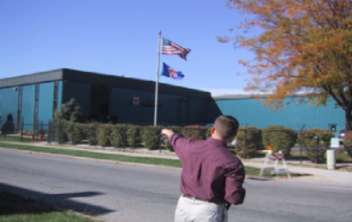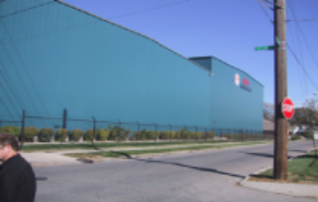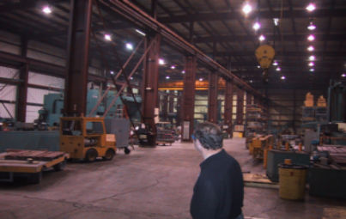

MTM is a large facility with over 200 employees; of which we were told approximately 12 are QC Inspectors. They have many large 4 and 5 axis machines, an extensive overhead crane system and apparently do a large amount of press forming. We saw many die sets stored around the facility and a large number stored outside. (The Kirksite dies are stored outside so as to protect them from any hazards such as fire or other damage.) Most of MTM’s work is with Inconel, much of it done for turbines. The shop areas were clean and well organized. There was a traveler apparent with each item we saw on the floor.

The NCSX components were located in various areas of the facility. Most of the plates had been prepared and were located in one area staged for forming. Our die sets were located in several areas since they were in different staged of fabrication.
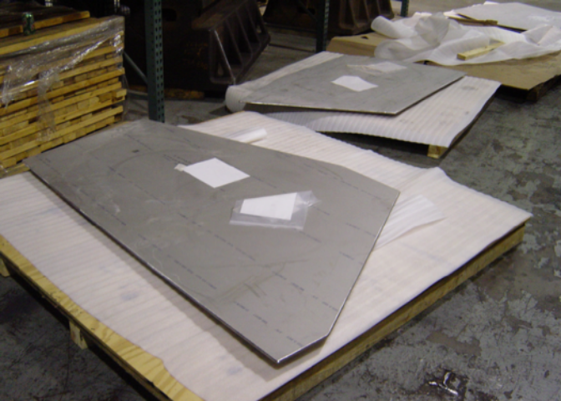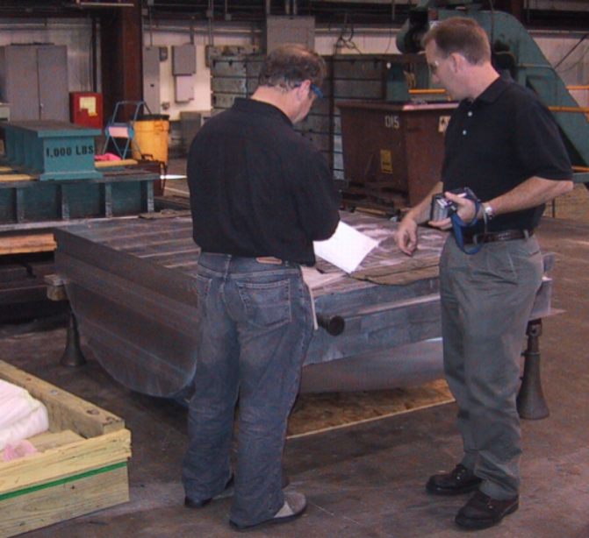

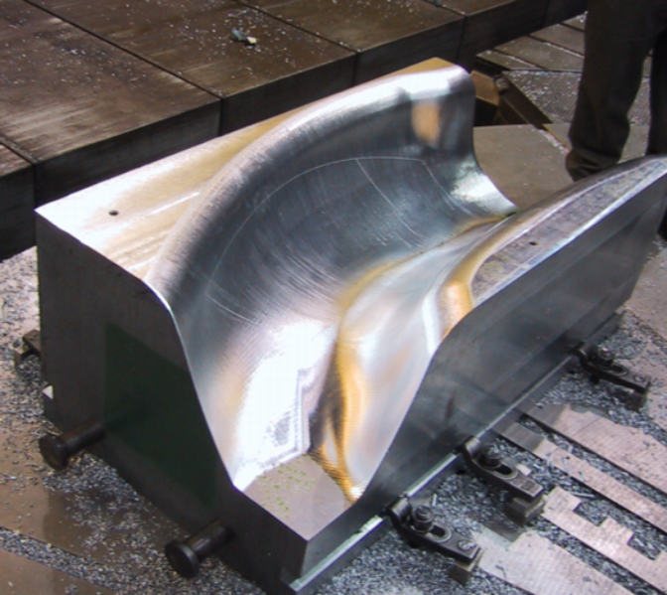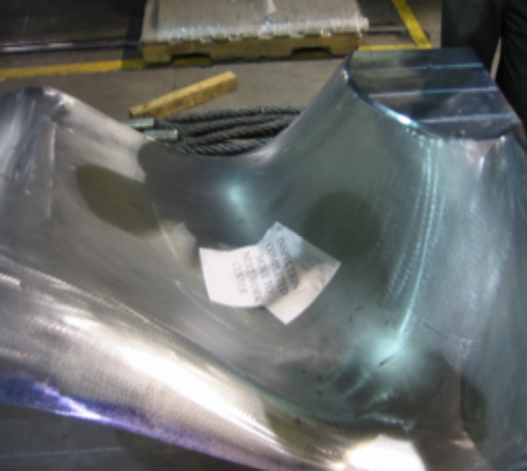

The location of each die set is controlled by the card system, which directs the flow of material and is further explained below. Most of the dies were complete. In fact, the final die of the set of 5 for the PVVS was completed on the day we left. We saw this die being measured on the CMM Monday. Once it was measured, it was sprayed with blueing, which was gently sanded off to remove the coarse mill marks and provide a smoother surface. There are several scribed lines (bottom left) which are machined into the die surface to provide trim location for the plate forming. There are also inside scribes which showed the inside final trimmed edge of the shape.

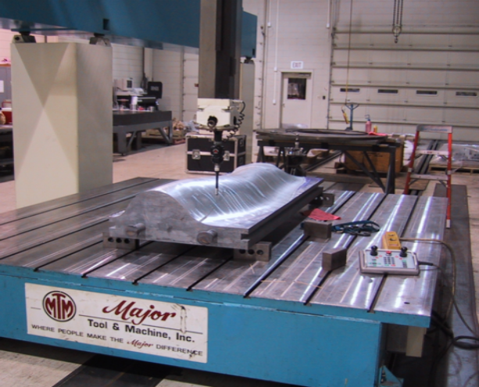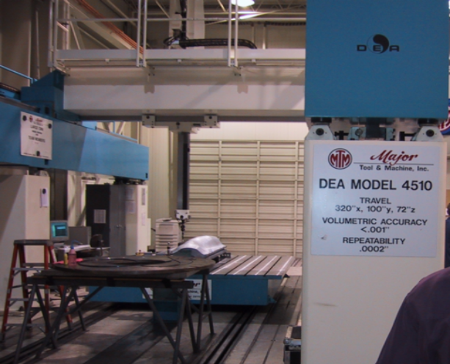

The dies were fabricated with an allowable tolerance of .002” of the model and verified on the CMM (above). The gages were made following the convex die shape. They are verified using feeler gages to match within .020” of the die. The panels were formed to match within .080” of the gage. We saw the first formed panel on a table, trimmed and with a gage on it. The gage was fitted to the panel and the panel was marked on a 6” inside grid showing indicating the deviation for the die set. There was a 1” pattern along the outside edge where the welds would occur. The deviation was generally less than .060”. We saw one completed gage and another being fabricated by outside pattern makers. The gages are formed from a composite of aluminum wafer board and plywood, connected with an epoxy/sawdust composite.
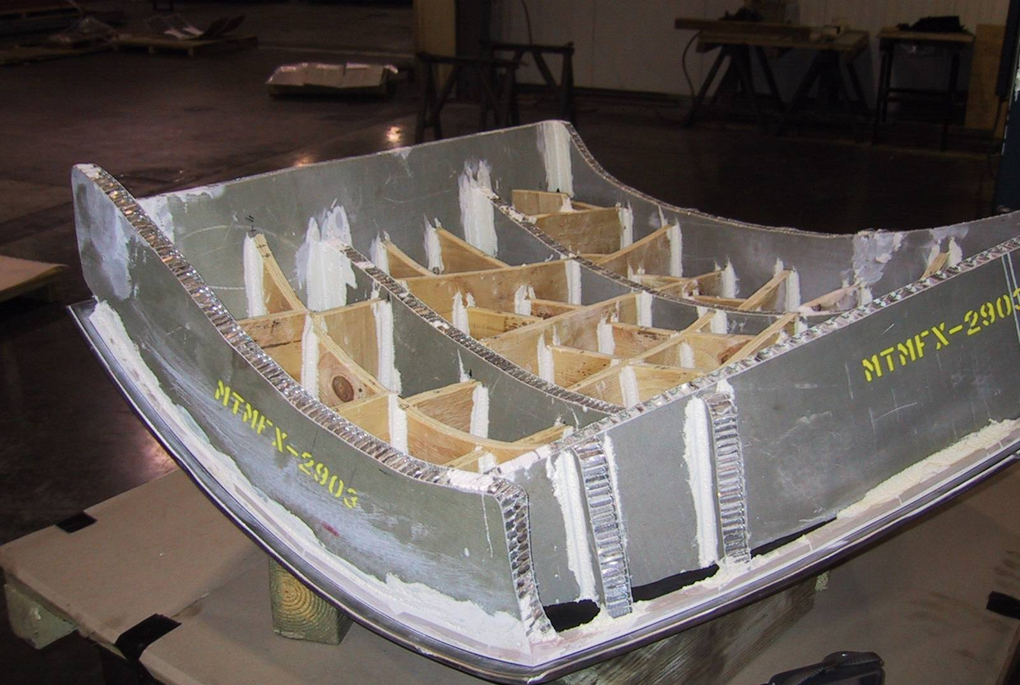
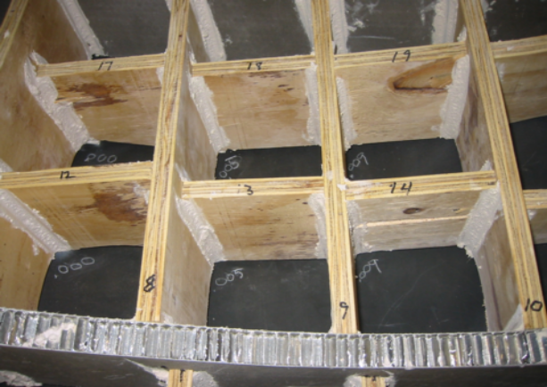

On Tuesday we observed the first production panel being formed. It was laid flat on the die and positioned by the forming press operator (Roger) who has a good feel for the way the material will be pushed into the die. The spring back appeared to be quite a bit after the die was reopened. Then the panel was notched in the wrinkled areas as you can see from the trimmings and pressed again. This brought it to within only a couple of inches of the desired shape. When we returned on Wednesday morning we saw the plate trimmed and formed close to the desired shape, judging from the gap between the plate and the gage. Roger easily recognized that the panel was work hardened and recommended that it be sent for solution annealing at this point.

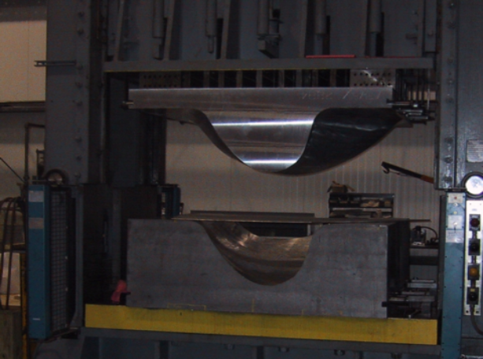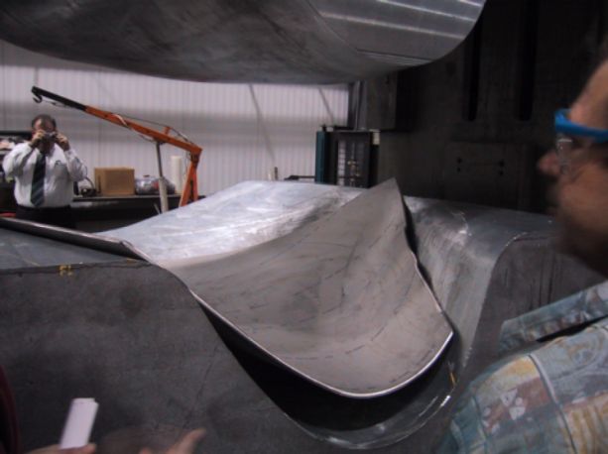
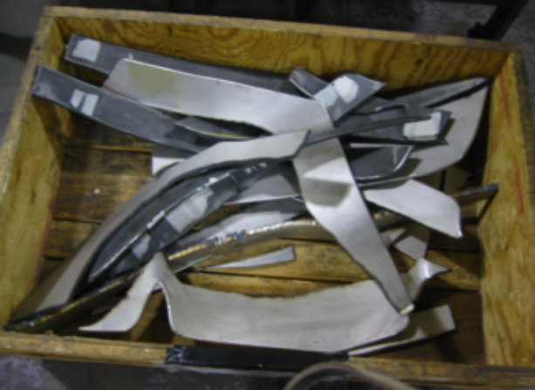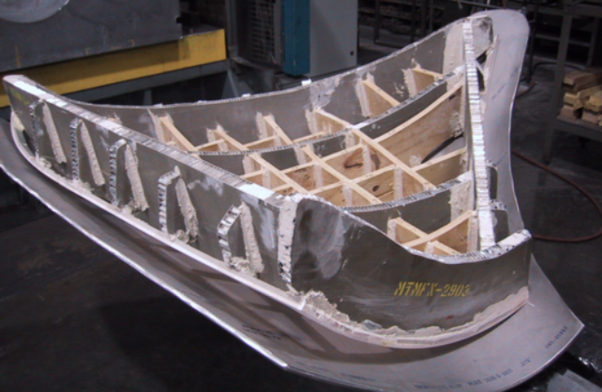

We were also shown the area where forming and welding studies were taking place regarding the port extension manufacture. They had rolled a section of Inconel and performed a plasma weld along the seam. The result was quite impressive. They questioned if the weld bead on the inside and outside was allowed and provided a sample to bring back to PPPL.
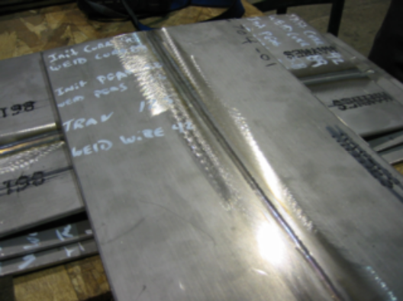
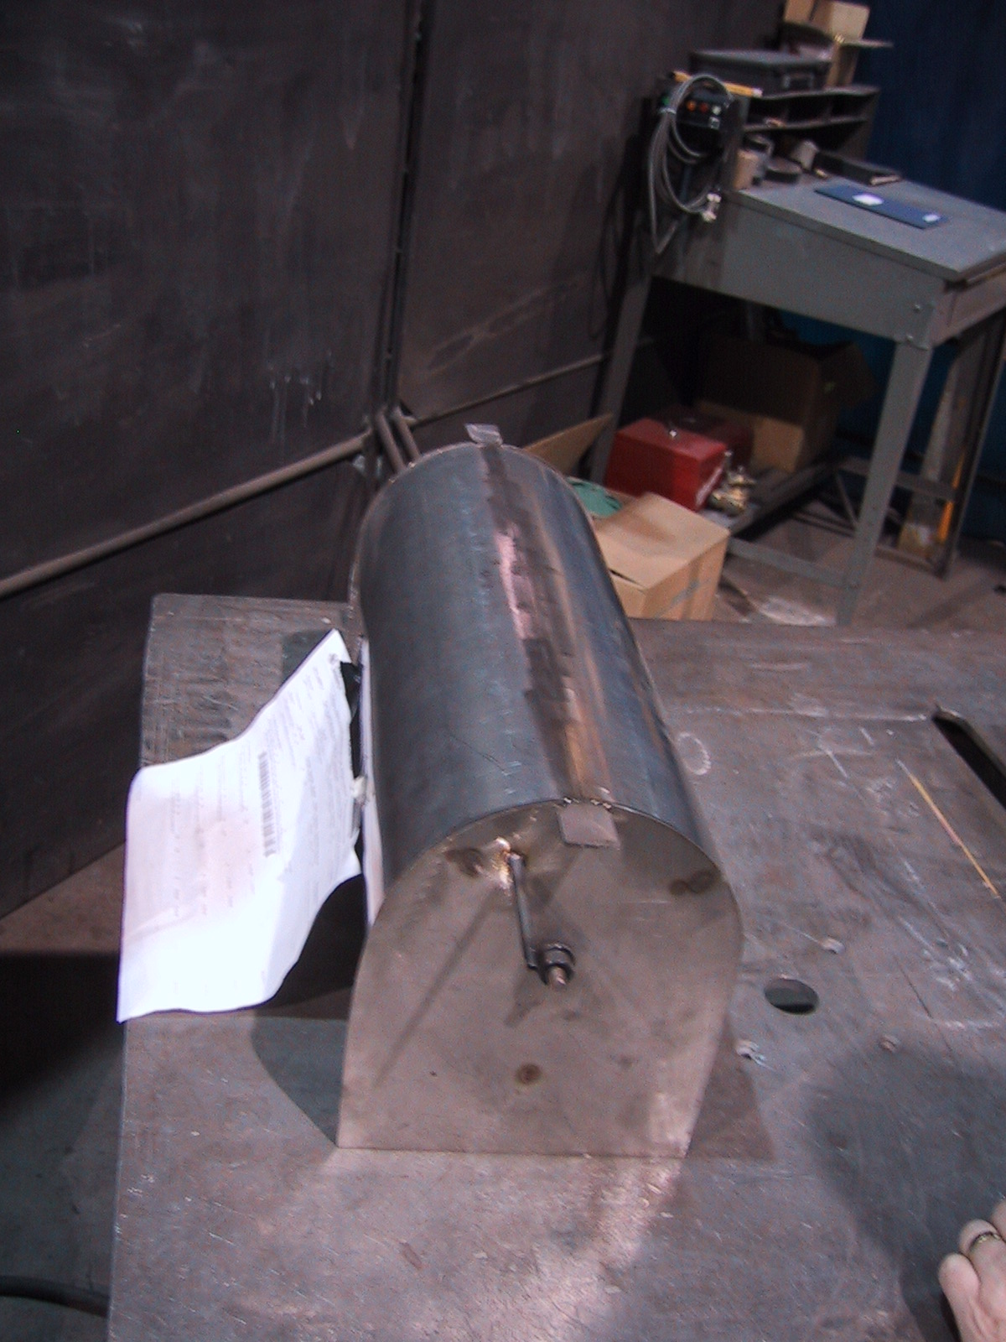

Tuesday’s presentation included updates to and progress reflected in the MTM Visual Manufacturing ERP system. As this progressed we questioned the lack of QA presence and were told “we can get him if you want him here”. Efforts to reach the VP of QA, Dennis Knaub, were not successful, so we continued the discussions. After lunch Dennis joined us as we went to see the forming of the first production plate (related above).

Prior to his arrival, we questioned the QA checks that had been done to date and were told there was no formal QA involvement so far. The first required QA step would be participation of the Vice President of QA in a meeting to release work to the shop. Throughout processing QA (QC?) Inspectors would be called on for designated inspections. Then at job completion the VP of QA would review the documentation package for completeness. We questioned the lack of an individual, other than the preparer, to check the plan for inclusion of all customer requirements as well as the lack of non-production personnel monitoring implementation of the plan. Doug did say that he, as a matter of professionalism, checks on his plan implementation, but that such checks are not part of the system.

MTM explained their team system. The shop is organized into regular teams, designated by color, that focus on different types of orders. A customized (Mike and Doug are usually on different teams) Customer Focused Team (CFT) was formed for the NSTX PVVS. The roles are Mike Manuel - Program Manager, Doug McCorkle – Manufacturing/Quality Engineering, and Joel Manship (Sales) as customer communication liaison (my term).

In the Manufacturing/Quality Engineering position, Doug develops the “Cards” that define individual tasks in the Visual Manufacturing ERP system. These cards are printed and serve as travelers. The cards identify the processing to be done, associated procedures, and any special instructions. They are also used to document hours spent and track schedule progress. Unlike many traveler systems, only a step or group of related steps appear on any one printed traveler. When each traveler is completed its bar code is scanned, another page is printed showing the next sequence of processing, and the completed page is discarded.

These cards form the manufacturing plan or MIT/QA Plan. The cards each have a status that can be F-Firm (in the schedule), R-Released, and C-Complete, among others. MTM explained that prior to release of a card, there had to be a pre-release and then a release meeting. QA is the final sign-off for the release. Many of the cards for the PVVS were released, which is consistent with the level of work we saw in the shop. Cards for inspections are linked to the Inspection Data Checklist (IDC), which is a list of inspection requirements.

We were shown a card for cleaning that had been updated to include reference to the custom procedure MTM had developed for NCSX. We asked if the procedure was attached to the card, either electronically or physically to the printed copy. When they explained that the technician had to go to the Team Leader and get a print-out of the card we expressed concern that such a cumbersome step might be skipped during a busy period when the technician felt comfortable doing the washing. We were assured that each employee understood that their job was “on the line” if they were to complete a card without all the documentation. Our reactions that a system that makes obtaining the procedure effortless is more likely to result in the procedure being followed were not well received.

Later, at our request, MTM showed a card for the completed receipt inspections of the plates. The link to the resulting documentation was inadvertently omitted when the card was generated, so there was no documentation in the system. They explained that all of the receipt inspection cards were duplicates of the first, so none would have the documentation. We expressed the opinion that an independent QA review of the cards might have spotted the omission, but we expressed an even greater concern that the inspector(s) had completed the cards without pointing out the lack of documentation. We linked this concern to one involving the washing procedure.

Since we understood the release meeting to be the only QA review of planning, we asked to see an example of documentation from a release meeting for the PVVS. After a long time searching, Mike Manuel returned with a release meeting sign-off sheet that had a notation QA refused to sign this release. This was the only release meeting documentation they could find although many cards showed as released in the Visual Manufacturing system. They explained that this was unusual and somewhat related to the desire to show us actual forming. However, some of these steps were for receipt inspections were done in previous weeks, yet they had not been formally released through a meeting with QA sign-off. Nothing in the system, including the VP of QA watching the forming with us, stopped processing in the absence of formal release.

The MTM team acknowledged that these were “holes in the system” and promised to provide us with corrective action for them. It was also stated that our identification of the problems would be helpful to QA in getting changes that they’d been seeking.

The VP of QA witnessed the panel forming with us and stayed for some of the subsequent discussion. During this time I expressed our concerns about lack of QA involvement in the planning and lack of process oversight by QA. His reaction was defensive. He spoke of his degrees and employment history. It came out that he had not reviewed the PPPL procurement documents (purchase order, Statement of Work, and Specifications), but had only seen our drawings. When asked to review our requirements prior to authorizing release of the processing cards, he said he typically only used the drawings. In addressing the process oversight, he mentioned the inspection steps in the plan. He reiterated that his main role in the processing was a documentation review at the end of the job. He then suddenly said he knew what would allay our concerns and so there would be no problem. When asked what he proposed, he repeated that he knew what was needed and it would be no problem. He stayed with us as we regrouped in the conference room after watching the forming, but then excused himself after several minutes.

We are left impressed with the progress made to date and pleased that the first two panels were formed without any of the possible difficulties, such as wrinkling. However we are also concerned about the lack of QA involvement in the process. Much is left to the Manufacturing/Quality Planning individual without independent support or review. While we are impressed with Doug McCorkle’s work and attitude, he needs support. We are anxious to see MTM’s corrective actions.

Distribution:
Phil Heitzenroeder
Wayne Reiersen
Paul Goranson
Brad Nelson
Larry Sutton
Hutch Heilson

Bob Keilbach
Tom Brown
Mike Cole
J.W. Anderson
J. Malsbury

