NCSX

Structural Design Analysis Report
Station 3 Lift Fixture,
Lifting Clevis & Link Pin

NCSX-CALC-18-003-00

May 2, 2008

Prepared By:

___________________________________
Mark Smith, PPPL Mechanical Engineering

Prepared By:

_________________________________________
Srinivas Avasarala, PPPL Mechanical Engineering

Reviewed By:

________________________________________
Tom Brown, PPPL WBS Tooling Constructability

Reviewed By:

_______________________________________
Mike Viola, PPPL WBS Field Period Assembly

Checked By:

________________________________
Art Brooks, PPPL Engineering Analyst

PPPL Calculation Form
Page 1 of 1
No. ENG-033 Rev 2
Attachment 1
PROCEDURE
PRINCETON PLASMA PHYSICS LABORATORY
PPPL
PPPL Calculation Form
TCR-ENG-033. R2-002

Calculation # NCSX-CALC-18-003-00 Revision # ______ WP #, if any _____________
(ENG-032)

Purpose of Calculation: (Define why the calculation is being performed.)

Refer to Objective section within the attached report.

References (List any source of design information including computer program titles and revision levels.)

Refer to the Methods and References sections of the attached report.

Assumptions (Identify all assumptions made as part of this calculation.)

Refer to the Methods sections of the attached report.

Calculation (Calculation is either documented here or attached.)

Refer to the attached report.

Conclusion (Specify whether or not the purpose of the calculation was accomplished.)

Yes, the purpose was accomplished. Refer to the Executive Summary in the attached report.

Cognizant Engineer’s printed name, signature, and date

_____________________________________________________________________

I have reviewed this calculation and to my professional satisfaction, it is properly performed and correct.

Checker’s printed name, signature, and data

Printed copies of this document are considered UNCONTROLLED / Information Only copies.
The official document is at http://www.pppl.gov/eshis/PPPL_docs.shtml.
The ES&H and Infrastructure Support Department maintains the signed original.

Executive Summary
Structural analyses provided estimates for the stresses anticipated during proof testing of the station 3 lift fixture, lifting clevis and link pin. The lift fixture was analyzed for three proof test configurations. The first configuration, which accounts for the maximum in service load, is from lift point 1, and requires a proof load of 22.5 kips. Proof loads of 12.6 kips and 17.1 kips are required for lift points 2 and 3 respectively. Finite element analyses show peak Von Mises stresses of (19.9-22.8), 6.63, 6.18 ksi for lift points 1, 2, and 3 with corresponding safety factors of 1.6, 5.4, and 5.8 respectively. The desire was to maximize the usefulness of the lifting clevis and link pin, by proof testing them at 125% of the actuator’s load rating. However, the analysis revealed the link pin is not strong enough to support this load safely. Consequently, the lift clevis and link pin were analyzed for a capacity rating of 18 kips, which requires a proof load of 22.5 kips. At this load the clevis safety factor is 3.2, failure mode tensile. The link pin safety factors for contact stress and Von Mises stress are 1.8 and 1.7 respectively. During actual in service use, (applied load 18 kips) these values are 2.0 and 2.2. The load on the weld is 804 lbf/in. Using a ½ fillet weld as specified on the drawing provides a safety factor of 6.9.

Table of Contents
PPPL Calculation Form ii
Executive Summary iii
List of Figures v
List of Tables v
List of Equations v
Objective 1
Background 1
Methods 2
Lift Fixture Structural Analysis 4
Lift Clevis and Link Pin Analysis 8
Results Discussion 11
Summary 13
References 14
Appendix 15

List of Figures
Figure 1. Station 3: Lift Point Layout in Maximum Load Configuration [1]. 3
Figure 2. Lift Point 1: ProMechanica FEM. 5
Figure 3. Lift Point 1: ProMechanica FEA Results. 5
Figure 4. Lift Point 1: Ansys Workbench FEM. 6
Figure 5. Lift Point 1: Ansys Workbench FEA Results. 6
Figure 6. Lift Point 2: Ansys Workbench FEM & Analysis Results. 7
Figure 7. Lift Point 3: Ansys Workbench FEM & Analysis Results. 7
Figure 8. Clevis & Link Pin Model. 8
Figure 9. Station 3 Lift Clevis Geometry. 9
Figure 10. Station 3 Link Pin Geometry. 9
Figure 11. Lug & Pin Connection Failure Modes [8]. 10
Figure 12. Non-Linear FEA Results @ 40 kips. 12
Figure 13. Non-Linear FEA Results @ 22.5 kips. 12
Figure 14. ASME Reference Geometry [2]. 15
Figure 15. Pin Shear & Bending Model. 16
Figure 16. Contact Stress Model. 17
Figure 17. Weld Load Model. 17

List of Tables
Table 1. Material Properties. 3
Table 2. Station 3 Lift Point Proof Loads, Unit Vectors, & Safety Factors. 4
Table 3. Clevis Allowable Laods. 10
Table 4. Analytical Results Summary. 10

List of Equations
Equation 1. Allowable Pin Tensile Strength: [2] eq (3-45). 15
Equation 2. Effective Width Criteria: [2] eq (3-46). 15
Equation 3. Effective Width: [2] eq (3-47). 15
Equation 4. Allowable Single Plane Fracture Strength: [2] eq (3-48). 15
Equation 5. Allowable Double Plane Shear Strength: [2] eq (3-49). 15
Equation 6. Total Area of Shear Planes: [2] eq (3-50 & C3-2). 15
Equation 7. Allowable Bearing Stress: [2] eq (3-51). 15
Equation 8. Pin Moment interval [a b]. 16
Equation 9. Pin Shear interval [b c]. 16
Equation 10. Pin Moment interval [b c]: 16
Equation 11. Pin Normal Stress from Bending. 16
Equation 12. Pin Combined Stress: Von Mises [2]. 16
Equation 13. Contact Stress Half Width [6]. 17
Equation 14. Contact Stress Maximum Pressure [6 ]. 17
Equation 15. Weld Load [7]. 17

Objective

The objective of this analysis was to validate the design adequacy of the station 3 lift fixture, lifting clevis and link pin. This validation consisted of determining factors of safety for the respective components when proof tested. Furthermore, the stress distributions for the lifting clevis and link pin were investigated at load rating levels of an adjacent rigging component—an actuator. The aim was to determine whether the clevis and pin load rating could be matched to the actuator.

Background

Proof testing is required for all in house fabricated lifting components which include the station 3 lift fixture, lifting clevis and link pin. Safety standards require proof testing at 125% of the maximum anticipated in service load. Previous estimated weight for the half period (HP) and lift fixture structure is 24 kips [1]. Furthermore, simulation of station 3 field period assembly (FPA) revealed maximum in service loads of 18 kips, 10.08 kips, and 13.68 kips, for lift fixture lift points 1, 2, and 3 respectively, refer to figure 1 [1]. Therefore, the required proof test loads for the lift fixture are 22.5 kips, 12.6 kips and 17.1 kips, for lift points 1, 2, and 3 respectively.
The lifting clevis and link pin require a minimum proof testing of 22.5 kips (125% of 18 kips, the maximum anticipated in-service loading.) However, these components are used in conjunction with an actuator rated from the manufacturer at 50 kips. For additional safety, PPPL has limited the actuator to a maximum load of 32 kips. Since versatility is gained when the lift components match in load rating, it is desirable to use the clevis and pin at the actuator rated value. Therefore, stress levels were investigated for proof testing at 40 kips (125% of 32 kips).

Methods

The material properties used for this analysis are listed in table 1. For this analysis it was assumed that the material properties and characteristics are homogenous and uniform throughout the volumes of the components. Computed Aided Design (CAD) models were created using ProEngineer software. Finite element models (FEM) were created and finite element analyses (FEA) were performed using ProMechanica (ProM) and Ansys Workbench (AWB) software. Furthermore, analytical analysis was performed in Excel based on classical strength of materials equations. Refer to the references section for the resource list and to the appendix for the equations used.

Note: ASME BTH-1-2005 Design of Below the Hook Lifting Devices [2] provides the following comments for evaluation of FEA results used in conjunction with BTH-1-2005.

BTH-1-2005 is based on classical strength of material methods. These methods effectively compute average stresses acting on structural / mechanical elements. The effects of stress concentrations are not normally required for static strength of a lifter, but are most important when determining fatigue life.
Peak stresses due to discontinuities do not affect the ultimate strength of a structural element unless the material is brittle. The types of steel on which this Standard is based are all ductile materials. Thus, static strength may reasonably be computed based on average stresses.
Linear FEA will typically show peak stresses that indicate failure. This is particularly true when evaluating static strength. While the use of such methods is not prohibited, modeling of the device and interpretation of the results demands suitable expertise to assure the requirements of this standard are met without creating unnecessarily conservative limits for static strength and fatigue life.

Therefore, the NCSX structural standards [3] were used as a basis for evaluating FEA results. For A36 structural steel with yield strength 36 ksi:
Design Tresca Stress Value (S_{m}):
S_{m} equals the lesser of : (2/3)Yield Strength = 24 ksi
(1/2)Ultimate Strength = 29 ksi.
Stress Allowable Primary Stress + Bending Stress Condition: < 1.5S_{m} = 36 ksi.

Allowable Bearing Stress < Yield Strength = 36 ksi.

For HS steel with yield strength 130 ksi:

Design Tresca Stress Value (S_{m}):
S_{m} equals the lesser of : (2/3)Yield Strength = 87 ksi
(1/2)Ultimate Strength = 75 ksi.
Stress Allowable Primary Stress + Bending Stress Condition: < 1.5S_{m} = 113 ksi.

Allowable Bearing Stress < Yield Strength = 130 ksi.

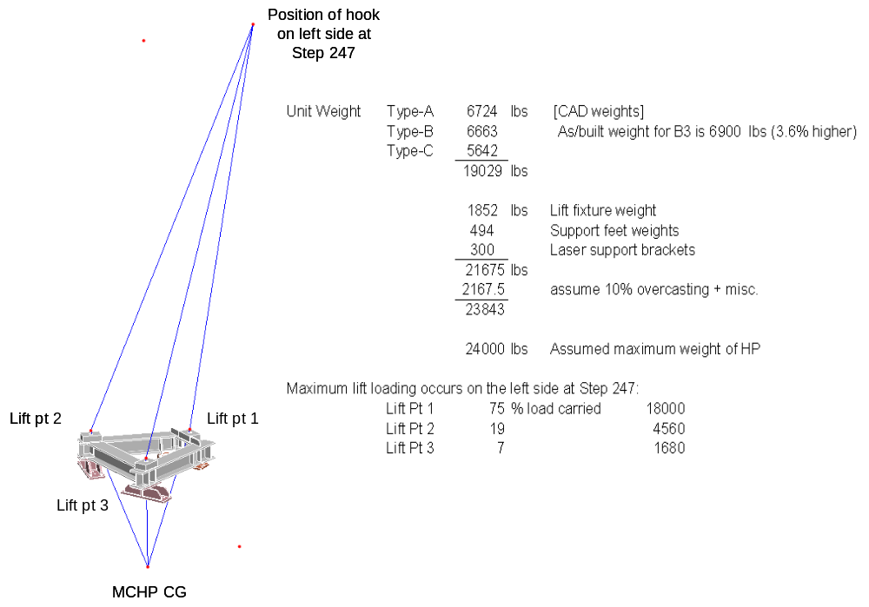

Figure 1. Station 3: Lift Point Layout in Maximum Load Configuration [1].

Table 1. Material Properties.

Structural Steel A36
Elastic Modulus: | E = 29.0 E3 ksi
Tension Yield Strength: | S_{ty} = 36 ksi
Tension Ultimate Strength: | S_{tu} = 58 ksi
Lift Link Pin: SAE J429 Grade 8
Elastic Modulus: | 29.0 E3 ksi
Tension Yield Strength: | 130 ksi
Tension Ultimate Strength: | 150 ksi

Lift Fixture Structural Analysis

A FEM of the lift fixture was created and a linear FEA performed using both ProM and AWB software platforms. A ProMechanism simulation of the station 3 field period assembly (FPA) facilitated vector estimates of the maximum in service loads [1, 4, 5]. FEA was performed at the loads of 22.5 kips, 12.6 kips and 17.1 kips with corresponding unit vectors for lift points 1, 2, and 3 respectively. Refer to table 2 for lift point proof loads and unit vectors. Figures 2 and 3 depict the FEA results obtained from ProM, for lift point 1; figures 4 and 5 represent the results from AWB. The ProM results show a peak Von Mises stress of 22.8 ksi The AWB results show a peak Von Mises stress of 19.9 ksi. Note, both initial FEM’s in ProM and AWB revealed peak stresses on the order of 16 ksi. However, by increasing the nodal count in the region of the peak stress, localized mesh refinement was achieved which resulted in the higher final results. FEA was performed at lift points 2 and 3 using only the AWB platform, figures 6 and 7 display the model and results. FEA for the lift point 2 configuration resulted in a peak Von Mises stress of 6.63 ksi while the lift point 3 configuration resulted in 6.18 ksi. All peak stresses are below the design Tresca stress value S_{m}, which is below the stress allowable. The corresponding safety factors for configurations 1, 2 and 3 are 1.6, 5.4, 5.8 respectively.

Table 2. Station 3 Lift Point Proof Loads, Unit Vectors, & Safety Factors.

Lift Points: Proof Loads & Unit Vectors. |  |  |  |  |  | Safety Factors
Lift Point # | Load Ratio | Magnitude (lbf) | ex | ey | ez
1 | 0.75 | 22500 | -0.15738 | 0.987364 | 0.018506 | 1.6
2 | 0.42 | 12600 | -0.24121 | 0.967269 | 0.078798 | 5.4
3 | 0.57 | 17100 | -0.00966 | 0.993034 | 0.11743 | 5.8

. Material Properties.

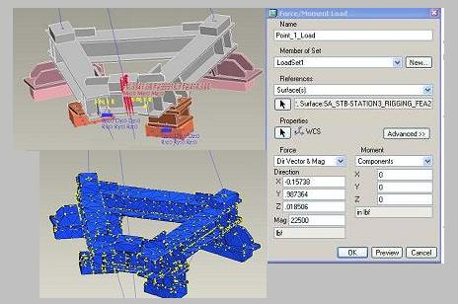
Figure 2. Lift Point 1: ProMechanica FEM.

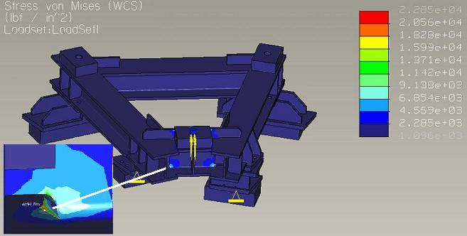
Figure 3. Lift Point 1: ProMechanica FEA Results.

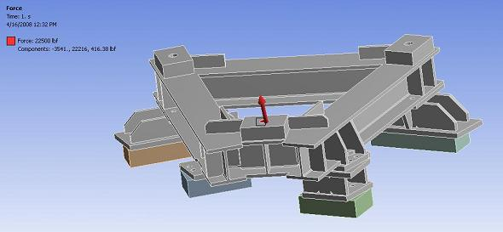
Figure 4. Lift Point 1: Ansys Workbench FEM.

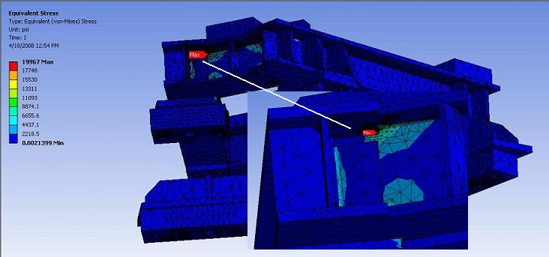
Figure 5. Lift Point 1: Ansys Workbench FEA Results.

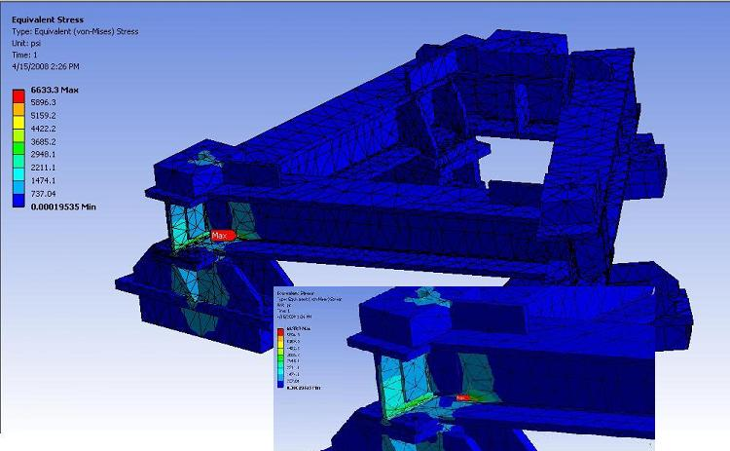

Figure 6. Lift Point 2: Ansys Workbench FEM & Analysis Results.

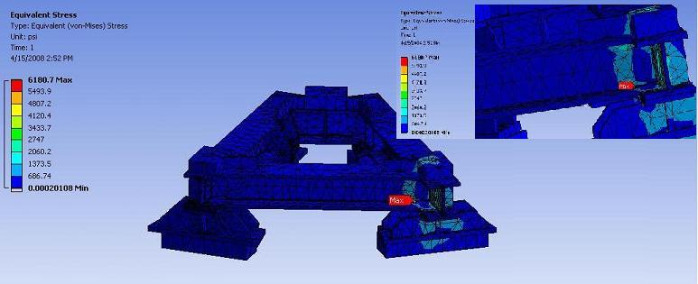

Figure 7. Lift Point 3: Ansys Workbench FEM & Analysis Results.

Lift Clevis and Link Pin Analysis

Analytical calculations and non-linear FEA were performed for the lift clevis and link pin, first based on the actuator load rating and then based on the maximum expected in-service loading. Figure 8 depicts the CAD model of the clevis and pin. Note, figure 8 contains a shackle pin. This is a commercial item load rated per the manufacturer. Therefore, it was not analyzed, but was included for visual reference only. Figure 9 provides the clevis geometry and figure 10 the link pin. Four failure modes are possible for the clevis: tension, splitting, shear, and dishing, refer to figure 11 [8]. There are two failure modes for the link pin: shear and bending. Per ASME [2], analysis for the dishing failure mode, figure 11d, is accounted for in the standard. Table 3 lists the allowable loads calculated for the clevis determined via ASME [2] guidelines. Table 4 provides a summary of the analytical results, (safety factors based on yield) and figures 12 and 13 depict the results of the FEA.

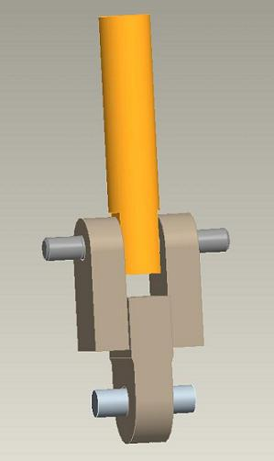
Shackle Pin
Link Pin
Clevis
Actuator
Shackle Pin
Link Pin
Clevis
Actuator

Figure 8. Clevis & Link Pin Model.

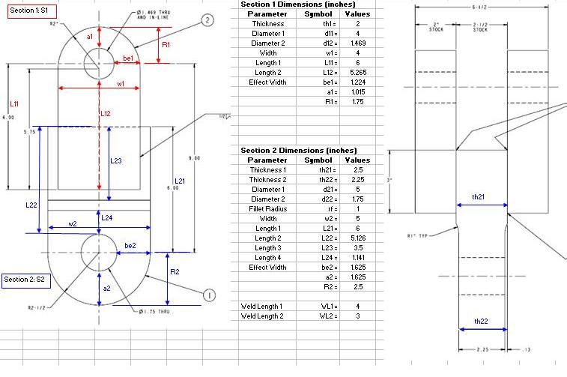
Figure 9. Station 3 Lift Clevis Geometry.

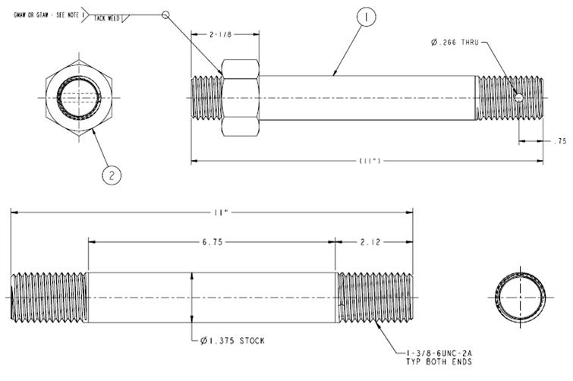
Figure 10. Station 3 Link Pin Geometry.

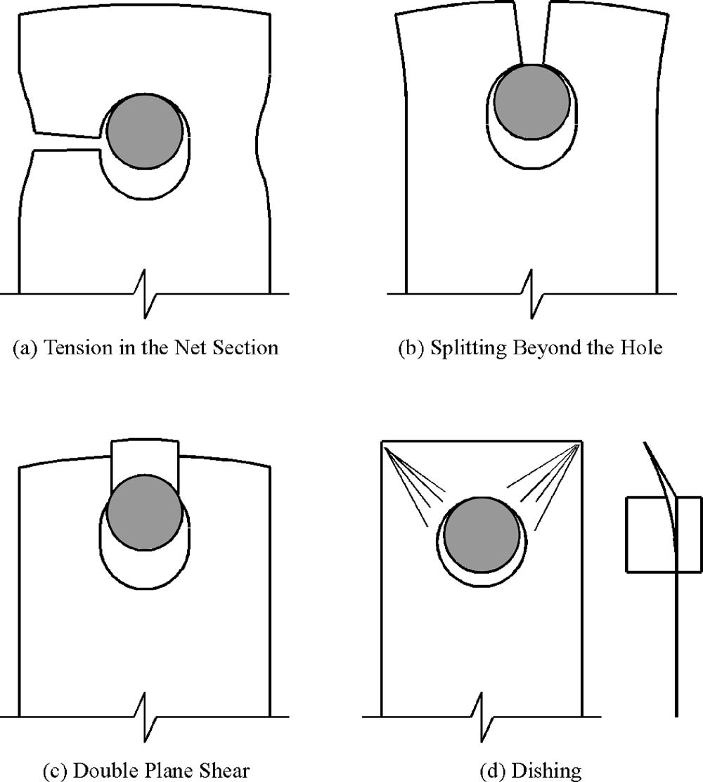

Figure 11. Lug & Pin Connection Failure Modes [8].

Table 6. Clevis Allowable Laods.

CAD Model Parameters: Section 1a/b
Pt1 | 118320 |  |  | lbf |  | Allowable Tensile Strength through Pin Hole
Pb1 | 85153 |  |  | lbf |  | Allowable Single Plane Fracture Strength beyond Pin Hole
Av1 | 4.816 |  |  | in^2 |  | Total Area of Shear Planes beyond Hole. *NOTE: curved edges
Pv1 | 81463 |  |  | lbf |  | Allowable Double Plane Shear Strength beyond Pin Hole.
CAD Model Parameters: Section 2
Pt2 | 176719 |  |  | lbf |  | Allowable Tensile Strength through Pin Hole.
Pb2 | 141997 |  |  | lbf |  | Allowable Single Plane Fracture Strength beyond Pin Hole
Av2 | 8.354 |  |  | in^2 |  | Total Area of Shear Planes beyond Hole. *NOTE: curved edges
Pv2 | 141317 |  |  | lbf |  | Allowable Double Plane Shear Strength beyond Pin Hole.

Table 8. Analytical Results Summary.

Component | Stress Type | Appplied Loading |  |  | Safety Factor at
 |  | 40 kips | 22.5 kips | 18 kips | 22.5 kips | 18 kips
Clevis Section S1a/b | Tensile Stress Net (psi) | 4085 | 3077 | 1838 | 11.7 | 19.6
 | Max Tensile Stress (psi) | 14297 | 8042 | 6434 | 4.5 | 5.6
 | Shear Stress (psi) | 4153 | 2336 | 1869 | 15.4 | 19.3
 | Bearing Stress (psi) | 7273 | 4091 | 3273 | 8.8 | 11.0
Clevis Section S2 | Tensile Stress Net (psi) | 5470 | 3077 | 2462 | 11.7 | 14.6
 | Max Tensile Stress (psi) | 19692 | 11077 | 8862 | 3.2 | 4.1
 | Shear Stress (psi) | 4788 | 2693 | 2155 | 13.4 | 16.7
 | Bearing Stress (psi) | 10907 | 6135 | 4908 | 5.9 | 7.3
Weld (S.F. @ 1/2 inch) | load (lbf/in) | 1429 | 804 | 643 | 6.9 | 8.7
Link Pin-Clevis | Bearing Stress (psi) | 7273 | 4091 | 3273 | 31.8 | 39.7
 | Contact Stress (psi) | 69181 | 51885 | 46408 | 2.5 | 2.8
Link Pin-Actuator | Bearing Stress (psi) | 12929 | 7273 | 5818 | 17.9 | 22.3
 | Contact Stress (psi) | 94945 | 71209 | 63691 | 1.8 | 2.0
Link Pin | Shear Stress (psi) | 13469 | 7576 | 6061 | 17.2 | 21.4
 | Von Mises (psi) | 132241 | 74386 | 59508 | 1.7 | 2.2

Results Discussion

Often, lifting components are forged or cast parts. Subsequently, a higher confidence is retained when material property assumptions are applied to these parts, i.e. homogenous, uniform etc. In contrast, material properties in weld heat affected zones can not be assumed with high confidence. The lifting clevis, made from A36 structural steel, is a welded item as specified by drawing se185-317. Consequently, the previous material property assumptions for the clevis are limited.
The desire was to maximize the usefulness of the lifting clevis and link pin by proof testing them at 40 kips, (125% of the actuator’s PPPL load rating of 32 kips.) Examining the computed clevis load limits, table 3, it is clear the clevis has sufficient strength to carry this load safely. However, the analysis revealed the Von Mises stress exceeded the link pin yield strength. A non-linear FEA was performed on the link pin which revealed lower Von Mises stresses when compared to the previous results, see figure 12. However note, the FEA results still show significant stress levels in the pin. The classical methods of analysis are more conservative, but reliable. In addition, the ASME standard [2] is based these methods. Therefore, the lift clevis and link pin were analyzed for a lower rated capacity. This rating is based on the maximum anticipated in-service load of 18 kips, which requires a proof load of 22.5 kips. Table 4 lists the analytical results and figure 13 depicts the FEA results. The strength limiting area on the clevis is section S2, failing via maximum tensile stress, safety factor of 3.2. The link pin safety factors for contact stress and Von Mises stress are 1.8 and 1.7 respectively. During actual in service use, (applied load 18 kips) these values are 2.0 and 2.2. The load on the weld is 804 lbf/in. Using a ½ fillet weld as specified on the drawing provides a safety factor of 6.9.

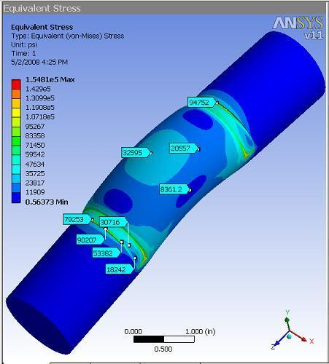

Figure 12. Non-Linear FEA Results @ 40 kips.

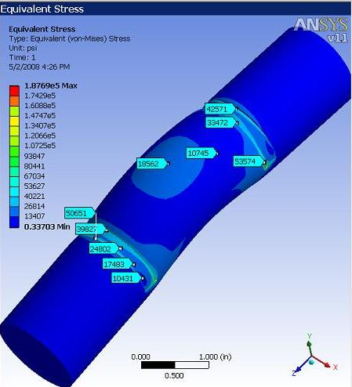

Figure 13. Non-Linear FEA Results @ 22.5 kips.

Summary
Structural analyses provided estimates for the stresses anticipated during proof testing of the station 3 lift fixture, lifting clevis and link pin. The lift fixture was analyzed for three proof test configurations. The first configuration, which accounts for the maximum in service load, is from lift point 1, and requires a proof load of 22.5 kips. Proof loads of 12.6 kips and 17.1 kips are required for lift points 2 and 3 respectively. Finite element analyses show peak Von Mises stresses of (19.9-22.8), 6.63, 6.18 ksi for lift points 1, 2, and 3 with corresponding safety factors of 1.6, 5.4, and 5.8 respectively.

The desire was to maximize the usefulness of the lifting clevis and link pin, by proof testing them at 125% of the actuator’s load rating. However, the analysis revealed the link pin is not strong enough to support this load safely. Consequently, the lift clevis and link pin were analyzed for a capacity rating of 18 kips, which requires a proof load of 22.5 kips. At this load the clevis safety factor is 3.2, failure mode tensile. The link pin safety factors for contact stress and Von Mises stress are 1.8 and 1.7 respectively. During actual in service use, (applied load 18 kips) these values are 2.0 and 2.2. The load on the weld is 804 lbf/in. Using a ½ fillet weld as specified on the drawing provides a safety factor of 6.9.

References
1. Brown, T. Analysis performed on the FPA station 3 lift fixture for its FDR

NCSX-CALC-18-002-00. 10 Dec. 2007.
2. ASME. BTH-1-2205 Design of Below the Hook Lifting Devices. 2006.
3. Zatz, I. J., NCSX Structural Design Criteria NCSX-CRIT-CRYO-00. 2004.
4. Brown, T. Excel File: trace00_path5tom3r13right.xls.
5. ProMechanism Simulation Files: stb-fpa_mech_leftside.asm, stb-fpa_mech_rightside.asm.
6. Shigley. Machine Design 7th ed. 2004.
7. Blodgett, O, W. Design of Welded Structures. 1966.
8. Duerr, D. Pinned Connection Strength and Behavior. 2006. Journal of Structural Engineering. Feb. p 182-194.

Appendix

Refer to figure 14 for applying equations 1-7.
Equation 1. Allowable Pin Tensile Strength: [2] eq (3-45).
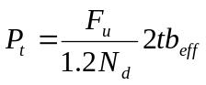

Equation 2. Effective Width Criteria: [2] eq (3-46).
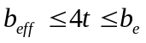

Equation 3. Effective Width: [2] eq (3-47).
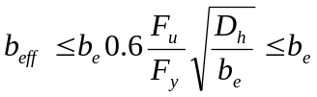

Equation 4. Allowable Single Plane Fracture Strength: [2] eq (3-48).
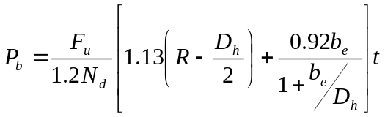

Equation 5. Allowable Double Plane Shear Strength: [2] eq (3-49).
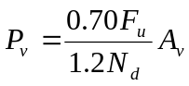
Equation 6. Total Area of Shear Planes: [2] eq (3-50 & C3-2).
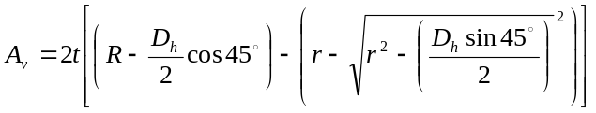

Equation 7. Allowable Bearing Stress: [2] eq (3-51).

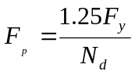

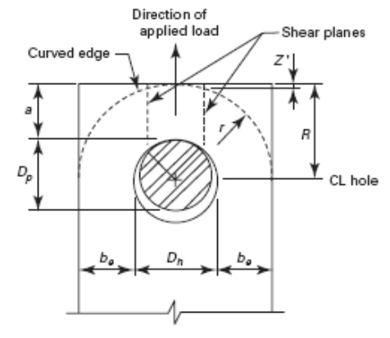
Figure 15. ASME Reference Geometry [2].

Refer to figure 15 for applying equations 8-12.

x₁ x₂
y
Actuator
Clevis
1.125 in
1.25 in
a
b
c
1 in
T/2
T/2
Link Pin
x₁ = [a b]
+M
+V
+P
T/2
a
1 in
x₂ = [b c]
+M
+V
+P
T/2
1.125 in
b
Figure 17. Pin Shear & Bending Model.

Equation 8. Pin Moment interval [a b].
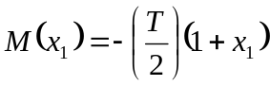
Equation 9. Pin Shear interval [b c].
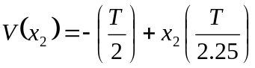
Equation 10. Pin Moment interval [b c]:
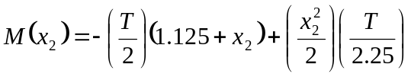
Equation 11. Pin Normal Stress from Bending.
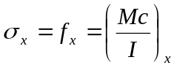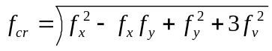
Equation 12. Pin Combined Stress: Von Mises [2].
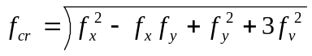

Refer to figure 16 for applying equations 13 and 14 and figure 17 for equation 15.

L
F
F
2b
d1
d2

Figure 20. Contact Stress Model.

Equation 13. Contact Stress Half Width [6].
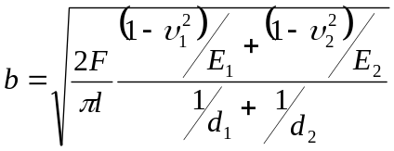

Equation 14. Contact Stress Maximum Pressure [6 ].
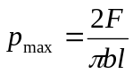

d
b
x
x

Figure 22. Weld Load Model.

Equation 15. Weld Load [7].


