I. Executive Summary

The purpose of this analysis is to examine the heat transfer characteristics of the vacuum vessel during and after an operational pulse. Each pulse radiates heat to the surface of the vacuum vessel, raising its temperature. The heat is subsequently dissipated by cooling tubes attached to the outer surface of the vessel. This local analysis proves that the tube spacing and the temperature of the cooling fluid (in this case Helium) are sufficient to meet the required cooling temperature and thermal stress criteria.

II. Assumptions
- All material properties are constant. (evaluated at room temperature)
- The Surface of the outer Grafoil pads is fixed at a constant temperature. (The helium thermal hydraulics will be the subject of a DAC by Goranson, and is assumed to be adequate to produce a constant temperature boundary condition in the tubes.)
- Heat from the pulse is imposed as a uniform heat generation over the Inconel (vessel shell) volume.
- Heat loss to the cryostat is considered by applying a negative heat generation term over the Inconel (vessel shell) volume.
- Radiation exchange with other surroundings is negligible.
- Steady state conditions are used to evaluate the stress distribution at the largest temperature gradient profile.

III. Analysis Methodology and Inputs

For this study, the maximum allowable steady state temperature in the vessel is 313 K or 40 ºC. This corresponds to a maximum steady state delta T of 20 ºC. The maximum thermal stress in the Inconel plate shall be a factor of 3 less than the yield for the material (S.F. > 3). The model is a representative section of the vessel and is not a section of the actual vessel.

Software and data files
The model is constructed in Ansys 7.0 and all of the preprocessing and post processing is done within the Ansys environment.

Drawings and models
No drawings have been referenced in this study. All models have been created from scratch as Ansys files. The chosen geometry is a flat plate of Inconel with a cooling tube connection (pad) placed in the middle of the model and four satellite pads placed at each corner of the plate.
Material Properties
Two materials are used in this analysis (Grafoil and Inconel 625). The material properties for Grafoil were obtained from its parent company of the product, Graftech Inc. The material properties for Inconel 625 were obtained from the MatWeb online materials database. The material properties for the two materials are shown below in Table 1.

Table 1: Material property data
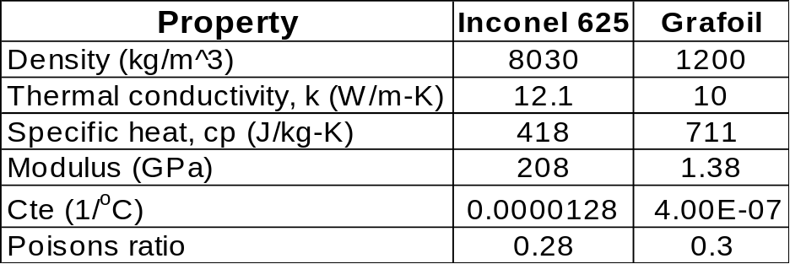

Model Setup
The model used in this analysis is shown below in Figure 1. It is a 3d representation of a section of the vacuum vessel and consists of a flat piece of the vacuum vessel material (Inconel 625) and 5 attached Grafoil cooling pads. The outer grafoil pads are ¼ representations of the center pad. This is due to the symmetry of the model in which the minimum amount of material was modeled to arrive at the heat transfer configuration. The model could have been further broken down into quarter symmetry by modeling only two pads. But, using a five pad model was easier to error check the heat distribution pattern and the processing time for the larger redundant model was not significant. The attachment points (pads) are separated in a somewhat “checkerboard-like” pattern where the horizontal distance between pads is 8 inches and the vertical spacing is 10 inches.

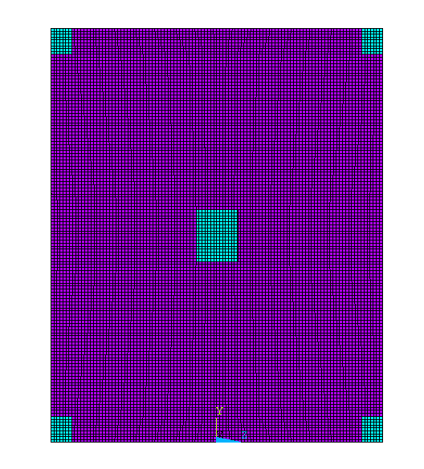
10 in.
8 in.
5 in.
Pad Dimensions are 1.25” X 1”
Pad thickness = 1/16”
Inconel thickness = 3/8”
4 in.

Figure 1: Sketch of the Ansys Model.

The model has been meshed with Solid 45 elements for the structural analysis and Solid 70 elements for the thermal analysis. The mesh consists of 5 elements through the thickness of the Inconel using a length of 0.075 in and two elements through the thickness of the grafoil pad with a length of 0.03125 in. This results in 74,132 elements for the entire model. A detailed view of the element configuration is shown in Figure 2.

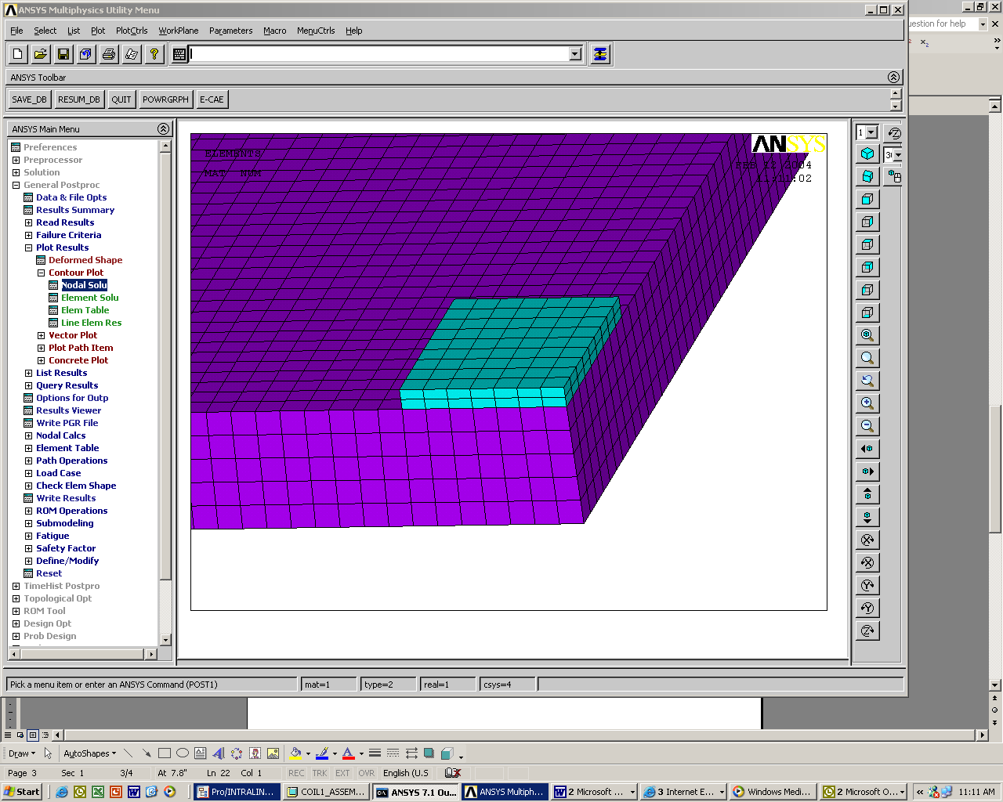
Figure 2: Elements through the thickness of the two materials.

Thermal Analysis Setup

A transient thermal analysis is performed on the Inconel/Grafoil model. Initially, all components are fixed at 294 K. The heat from the magnetic pulse is imposed as a volumetric heat generation term (g = 3.87 E7 W/m³) and is applied to the model for 1.2 sec. This represents both the highest total heat load to the vessel (12 MW) and the longest planned pulse and corresponds to a 13 K rise in temperature. Cooling to the cryostat is also considered and is applied to the vessel as a negative heat generation term (g = -12,200 W/m³) throughout the analysis, which corresponds to a value of 116 W/m^2. Using a fixed heat removal rate is conservative since this rate will go up as the temperature in the vessel rises. Both heat generation values were provide by Paul Goranson. Finally, the cooling tubes are idealized as fixed temperature pads.
The temperature on the top of the pads is held at 294 K (room temp) during operation. After the initial pulse, the model is allowed to cool for 15 minutes by means of the cooling pads and the heat loss to the cryostat. This cycle of pulse/cooldown is repeated 10 times for a total of 150 minutes to check the affect of ratcheting temperatures in the vessel.

Structural Analysis Setup

The structural analysis portion of the study uses the temperature nodal values (at t = 150 minutes) from the thermal analysis as the loading condition. Two static cases are considered each using slightly different displacement constraints. The first case fixes one corner of the model in place and keeps the remaining 3 corners as roller constraints that are fixed in the normal direction of the plate. Thus, the model is able to expand outward and upward away from the corners.

The second case fixes all to the vertical areas on the 4 sides of the slab in all directions. This forces the Inconel into compression and produces a more conservative and less realistic stress distribution.

IV. Results

The temperature distribution after the initial pulse is shown below in Figure 3. All temperature plots are expressed in units of degrees Kelvin.

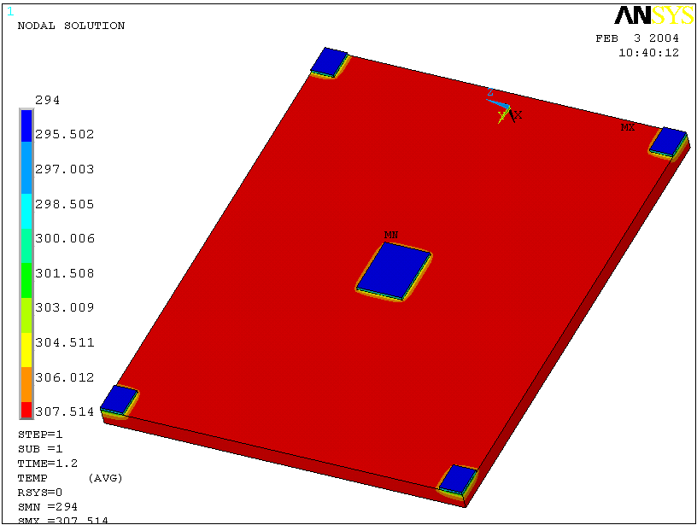
Figure 3: Temperature distribution after the first pulse (t = 1.2 sec)

The temperature distribution after the first 15 minute cool down and the last cool down period (t = 9000 sec) are shown below in Figures 4 and 5 respectively.

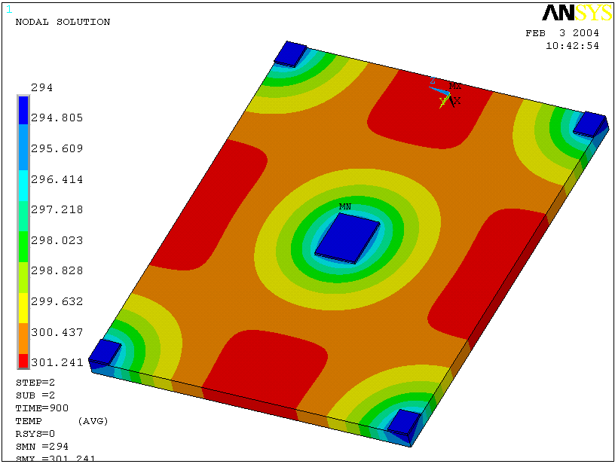
Figure 4: Temperature distribution after the first cool down period (t = 15 mins)

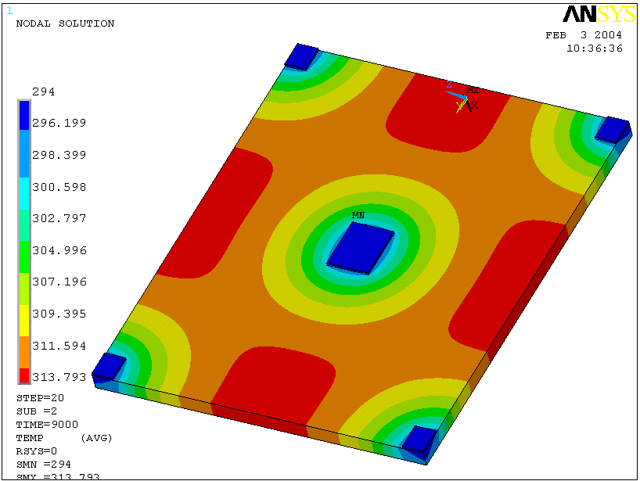
Node studied in ratcheting graph
(Figure 6)
Figure 5: Temperature distribution after the last cool down period (t =2.5 hr)
The ratcheting temperature distribution of a node in the “hot zone” (shown above in Figure 5) is shown in Figure 6.

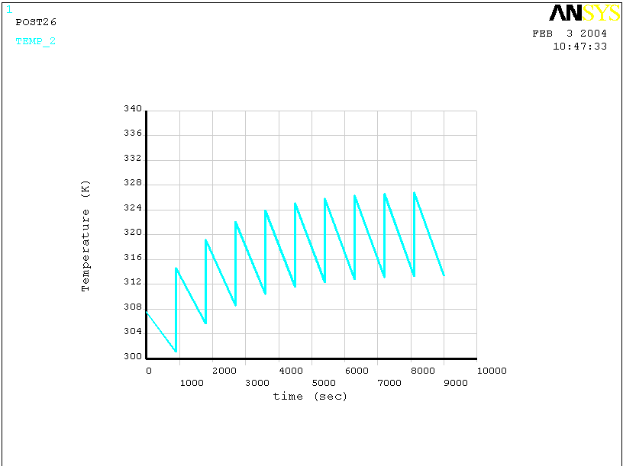
Figure 6: Ratcheting node temperature distribution.

The Von Mises stress distribution is shown in Figure 6. The edge areas are constrained in all directions in this plot. This accounts for the compression of the middle of the model as the material is unable to move past the boundaries. The contour bars of each of the stress plots are in units of Pa. The max stress is 0.569 E8 Pa, which corresponds to 8,520 psi.

The stress distribution for the fixed corners is shown in Figure 8. The max stress is 0.192 E8 Pa (2,785 psi) and is located near the cooling pad/Inconel interface. This is expected as this region experiences the max temperature gradient.

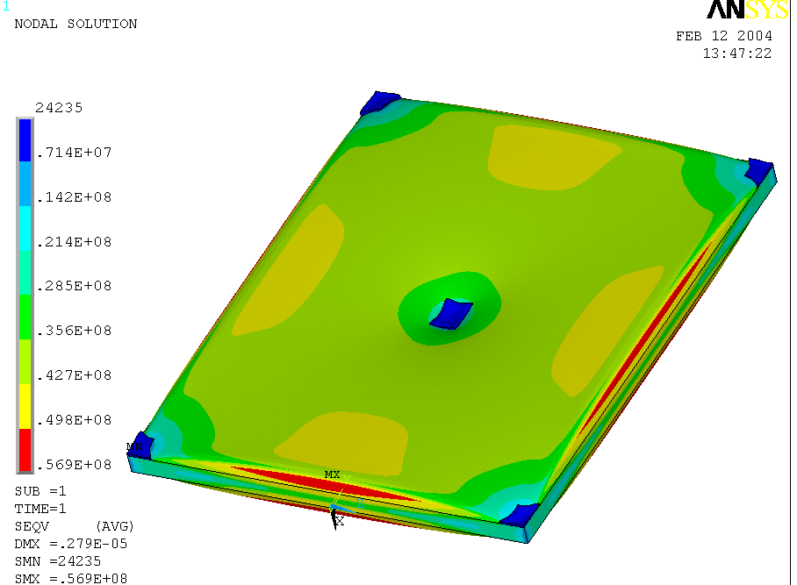
Figure 7: Von Mises Stress Distribution with all edges fixed.

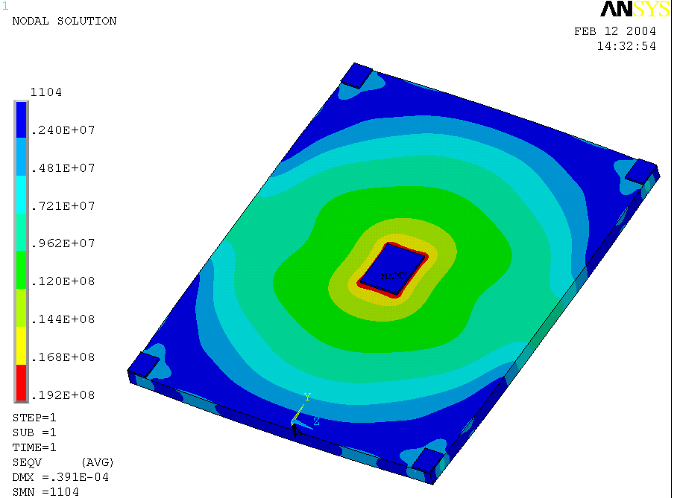
Figure 8: Von Mises Stress Distribution restrained by one fixed corner and three roller connections at the other corners.

V. Summary and Recommendations

The temperatures shown in Figures 3-5 are all under or equal to the 313 K maximum steady state temperature imposed on this analysis. The temperatures during the pulse do exceed 313 K but the temperatures after each 15 minute cool down are less than 313 K. It is these steady state temperatures that are of concern. The ratcheting of nodal temperatures begins to level off after the forth cycle (t = 3600 sec) with the cooling temperatures leveling out at about 314 K.

The stress levels are all well under the maximum yield for Inconel (approx 60,000 psi, 4.14E8 Pa) by a factor of around 10. Note, the max stresses in Figure 7 are slightly higher than 4.14E7 Pa, but they are located around the edges of the plate where an artificial restraint is imposed. Thus, thermal stress in the vacuum vessel is not an area for concern. Additionally, the maximum shear stress in the model is around eight times less than the corresponding directional stress further demonstrating the capable performance of the vacuum vessel in response to thermal loading.

Based on this analysis, the current configuration of cooling tubes (staggered, 10 inches vertical and 8 inches horizontal) maintains the temperature of the vacuum vessel under 313 K and does constitute a stress risk. Further, this study considered the longest operational pulse and thus the maximum heat that the vessel will experience. For shorter pulses (around 0.5 sec, the temperature gradient will drop to less than half of the 1.2 sec pulse. Thermal stress is also not an issue as the safety factor (10) is much greater than the factor of three imposed by the study.

Appendix A: Hand Calculation Check by P. Goranson

Overview
At steady state operation, between shots, the vessel plate temperature ratchets to a temperature varying from 294 K at the cooling bracket to 313 K at points midway between brackets. This gradient results in thermal stresses due to internal restraint of the material. The ANSYS model predicts these stresses to be on the order of 2785 psi near the boundary of the cooling bracket/pad.

Checks
The inputs to the ANSYS were checked for accuracy. The Inconel material properties were checked against values found in the Machine Design Material Selector and values for the Grafoil were obtained from the Vendor’s (UCAR) web site. The temperature assumptions were taken from NCSX-CALC-123-03, NCSX Vacuum Vessel Heating/Cooling Distribution System Thermo-hydraulics Analysis.

Hand Analysis

Reference: Roark Sixth Edition
Stresses due to internal constraint
Page 722. Case 12
Disk heated about center, temperature a function of distance from center only.

Assumptions:
The vessel plate may be represented by a flat circular disk, 8 inches in diameter, the mean distance between brackets. The plate curvature is slight and flatness should be a valid approximation. The heated region is small compared to the plate size and the radius drops out in the solution, so the circular section is not a concern.
The heat gradient is linear. This is not true for the real plate, however, a fitted linear gradient approximates the temperature distribution and should not give results within a partial order of magnitude.

Radial stress

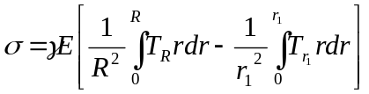, where T is the temperature gradient from the cold center to a radius r out in the disc, and R is the disk radius.
The integral solution is:
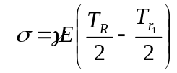
At small r₁ the delta temperature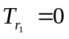, therefore:
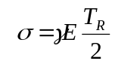
Let Young’s Modulus E = 28e+6 psi
T_{R} = 19
Coefficient of expansion 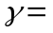7e-6 in/in-F
Results
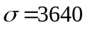psi

It is interesting to note that Case 10, which is the same disk with a comparatively small central circular portion at a delta temperature, results in the same maximum stress, i.e. 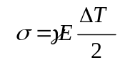
This confirms that small heat affected zones in flat plates have similar stresses.

Conclusions
The ANSYS analysis probably does not give totally accurate stress since it assumes a finite flat plate rather than a curved continuous one. Also, the results are dependant on the edge conditions assumed, the simple supports giving a stress of 2785 psi (Figure 8) at the bracket and the fixed edges 5100 psi. The 8000 psi stress found at the fixed edges are an artifact of over constraining the model and resulting externally induced stress, not representative of the actual geometry.

The hand calculated stress of 3640 psi gives close enough correlation in both location and magnitude to give confidence that the ANSYS model is sufficiently accurate, particularly in light of the resulting large safety factor

Graftech, Inc., Cleveland, Ohio, Technical Bulletin Number 208, Revised September 18, 2000.
MatWeb online database, properties from Special Metals, Inc., Publication SMC-027 Oct. 2003.

