PPPL-NCSX Memorandum

To: Michael Kalish (PPPL)
From: Leonard Myatt (Myatt Consulting, Inc.)
Date: April 16, 2005
Subject: Stress Analysis of the TF Coil Lead Region

1.0 Executive Summary

Detailed analysis of the TF coil high-stress region is well documented in an earlier project memo. That study focuses on the region where the winding pack (WP) transitions between fully supported by the wedge castings and unsupported. This memo addresses the stress field in yet another very important region; the conductor lead break-out region.

The local terminal support structure and conductor geometries are imported into ANSYS from a PPPL solid model (courtesy of J. Rushinski). Loads, boundary conditions (BCs), constraints, material properties and contact surface elements are added. Since the geometry in this region is very complicated, conservative simplifying approximations are employed to produce an efficient and manageable model. Conservative approximations include zero friction and no load-sharing between the conductor and the honeycomb insulation matrix. The methodology and nonlinear contact analysis results are presented.

The analysis indicates that large bending stresses resulting from eccentricities in the poloidal load path at the terminal anchor are beyond allowable stress limits. This will require a re-design of this area.

2.0 Assumptions and Notable Concerns

2.1 In this conservative frictionless contact analysis, significant forces develop where the conductors enter and exit the insulating block (clamp region). Real-world friction will reduce these high forces. However, the design team should be aware that the 90˚ bend and clamp region are ultimately responsible for supporting up to 4400 lb.

3.0 Analysis

Solid models of the terminal support structure are shown in Fig. 3.0-1. This region contains layer to layer transitions, the lead break-outs and the accompanying insulating support block. The critical stress area is where the conductor makes a 90˚ bend at the terminals as it supports the large tensile loads which develop from two sources:

- Differential thermal contraction (which puts the Cu conductor into poloidal tension and the epoxy/glass insulation into poloidal compression), and
- EM forces which produce poloidal tension in the conductor and insulation

Fig. 3.0-2 shows the 3D ANSYS model which is designed specifically to determine the maximum stresses in the insulating block. The model is developed by importing the reference geometry through IGES files. It is limited to a short section of terminal conductors and the insulating block. Loads, boundary conditions (BCs), constraints, material properties and contact surface elements are added to simulate the in-service loading of these components. The white arrows signify the poloidal tension applied to the conductor from the two sources listed above. These forces are determined quantitatively by the stress results from two models.

Fig. 3.0-3 is a plot of the stress in the terminal region of the detailed/smeared hybrid model. The legend lists “STEP=9999” which signifies that the stresses are not from a particular load step, but a result of some load case operation. As the author of [Error: Reference source not found], I know that this stress is a result of the subtraction of [cooldown stresses] from [cooldown + 0.5T EM stresses]. In addition, while the plot shows stress intensity contours (SINT), I also know that the stress in this region is almost entirely due to poloidal tension. So, the ~20 MPa stress in the terminal region from the 0.5 T operating condition is carried by the conductor as an axial tensile load. Each conductor unit cell (conductor and insulation) has a cross-sectional area of 0.0270 m by 0.0205 m or 554 mm². Multiplying this area by 20 MPa yields a poloidal force of 11.1 kN (or 2500 lb).

Fig. 3.0-4 is a plot of the vertical stresses in the terminal region of a quarter-pancake detailed model (also presented in [Error: Reference source not found]) from thermal contraction effects only. The outer layer shows a tensile stress of about 19 MPa. Reaction forces sum to 3678 N for this half-wide conductor or 7356 N for a full-wide conductor (1650 lb).

So, the outer layer conductors in the terminal region carry a poloidal tensile load of ~18.5 kN from 0.5T and 85K cooldown effects. This defines the design-basis mechanical loading applied to the model.

General surface to surface contact elements are placed between the conductor and insulating block. Fig. 3.0-5 shows the target elements which line the slots in the terminal support block. This provides the most conservative load path between the conductor and the terminal anchor. Friction effects are ignored along with any load sharing between the conductor and insulation matrix, which makes this a relatively conservative stress analysis.
Fig. 3.0-1 Recent Terminal Design Models (courtesy J. Rushinski)
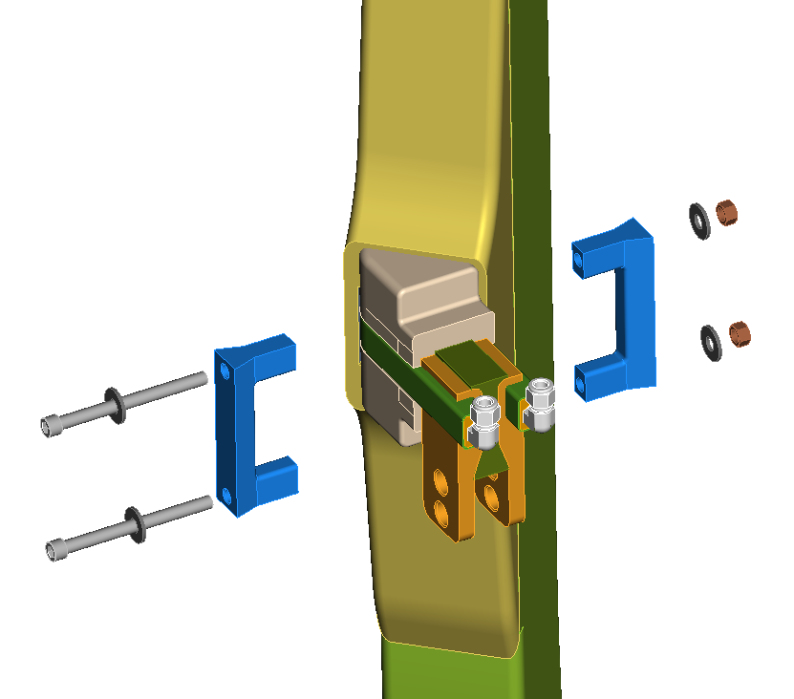
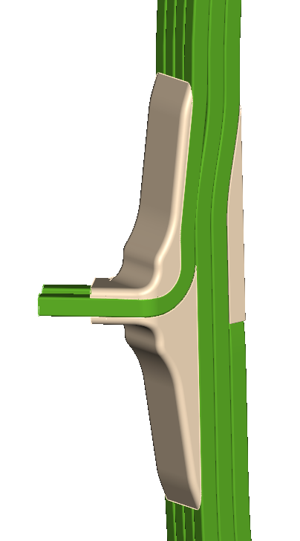
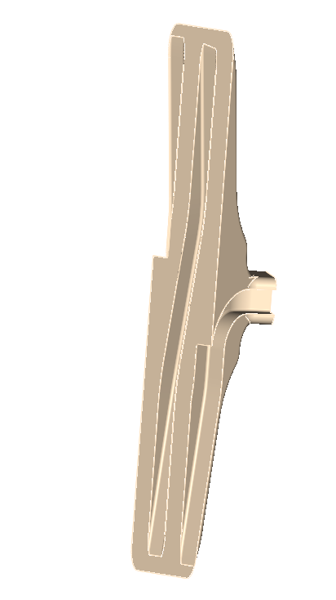
Fig. 3.0-2 ANSYS Model
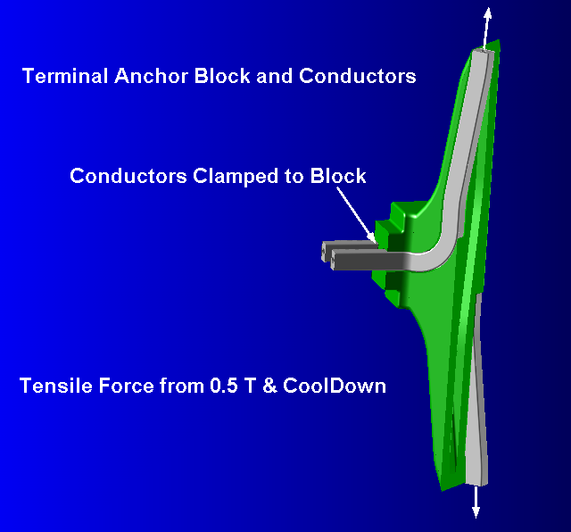

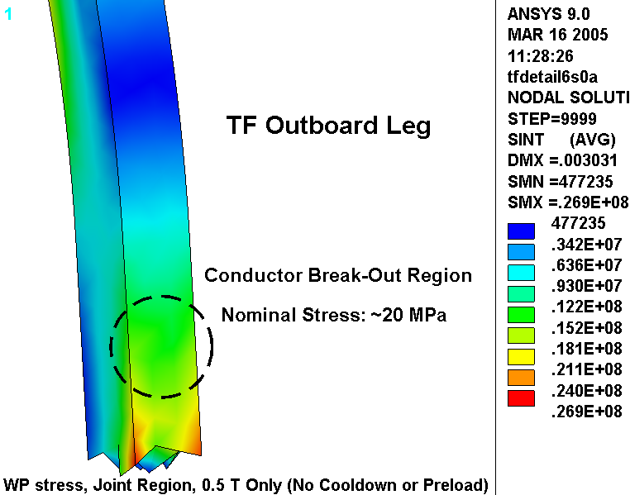
Fig. 3.0-3 Stress in Smeared WP in Terminal Region
(0.5 T, hybrid model [Error: Reference source not found])

Fig. 3.0-4 Vertical stress in Outboard Leg and Half-Conductor Force Sum
(85K, half-pancake model [Error: Reference source not found])
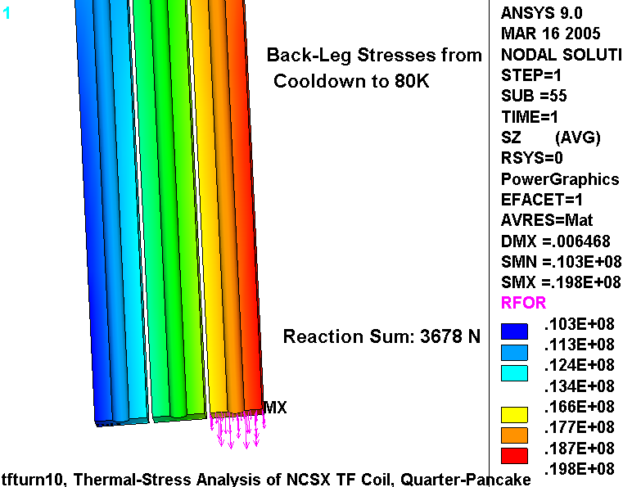
The conductor break-out region will need to support this 3678 x 2 or 7400 N (1650 lb) unbalanced poloidal load produced by the conductor termination.

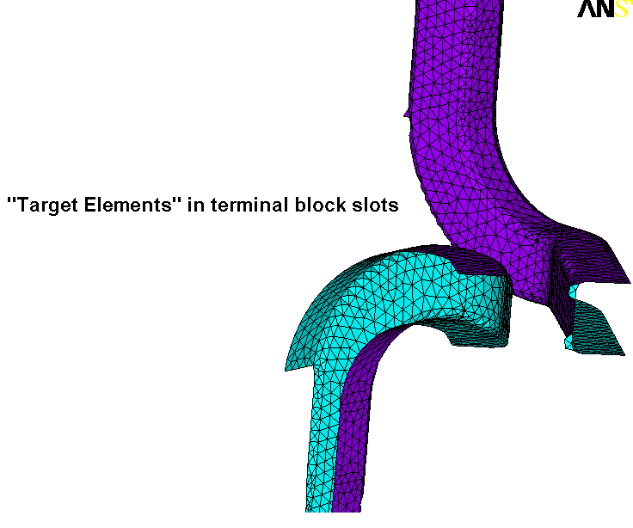
Fig. 3.0-5 Target Elements on the surface of the terminal support block slots

4.0 Results

The results of the PPPL terminal model analysis are summarized below in a series of stress and displacement contour plots and compared to the limits of the project’s structural design criteria document.

Fig. 4.0-1 is a plot of the stress intensity in the terminal support block as a result of the design-basis mechanical load. Notice that the front face of the block is cut away, exposing the inside skin of the solid G11 block. This is a visualization tool since the block is indeed modeled as a solid. It does, however, provide a way of viewing the high-stress regions of the near and far slots from the outside and inside, respectively. The legend indicates that these supporting radii carry a highly localized maximum stress of 90 MPa and a much broader nominal stress of 50-60 MPa. This should be compared to a maximum tension/compression allowable stress of 130 MPa [Error: Reference source not found].

Fig. 4.0-2 is two similar plots of the displacement magnitude superimposed on a greatly exaggerated deformed structure. They are included because they show the tendency for one conductor to pull away from the slot and the other to move into the slot. In reality, the EM loads might produce some mutual attraction which works in favor of keeping the wayward conductor seated. And of course, the ground wrap will provide some mechanical restraint preventing such a tendency. It is worth noting that the magnitudes of these displacements (~1 mm) are probably overestimated by this conservative analysis approach.

Fig. 4.0-3 is a plot of the stress distribution in the conductor bend region as a result of this design-basis tensile loading. Although the tensile force is only sufficient to produce 47 MPa away from the bend (see Fig. 4.0-4), these stresses are amplified at the 90˚ bend to ~300 MPa. Recall that design-basis load is composed of two parts; 1650 lb comes from thermal contraction effects and 2500 lb comes from the 0.5 T operating condition. This means that the 13000 0.5 T cycles produce a stress history as follows:

σ(CoolDown+0.0T) = (307 MPa)(1650/(1650+2500) = 122 MPa
σ(CoolDown+0.5T) = 307 MPa

This stress history has a mean stress (σ_{mean}) of 215 MPa with an alternating stress (σ_{alt}) of ±92 MPa. This produces an equivalent alternating stress (σ_{eq}) of:

σ_{eq} (tension) = σ_{alt} / {1 - σ_{mean}/σ_{ut}} = 92/{1-215/360} = 230 MPa (33 ksi)

This equivalent alternating stress level would produce a failure in very few (<<1000) cycles, according to the design-basis Cu fatigue curve included here as Fig. 4.0-9. Similarly, the most limiting monotonic stress requirement (Primary Membrane + Bending<1.5S_{m}) is also not met:

σ(P_{M}+ P_{B}) <307 MPa (Fig. 4.0-3) > 270 MPa (1.5S_{m})

This would indicate that while the analysis can be used to qualify the stresses in the G11 insulating block, it is not able to qualify the local stresses in the conductor.
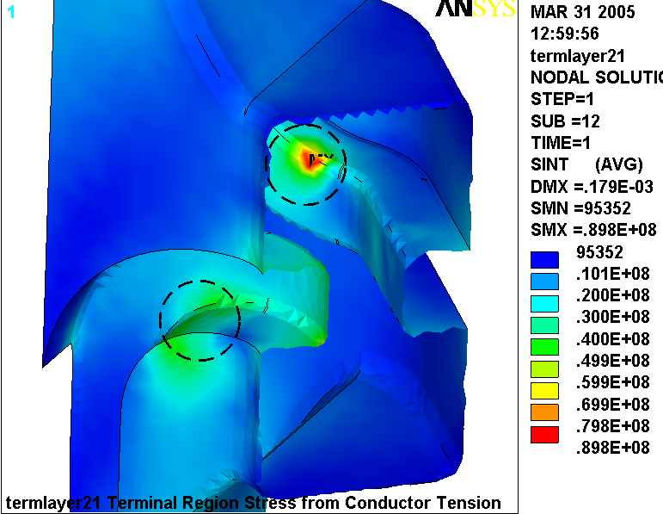
Fig. 4.0-1 Stress Intensity in Terminal Support Block from Design-Basis Loading

Notes:
- 90 MPa local peak (likely due to anomaly in contact elements based on size, location and asymmetry with respect to opposite slot)
- 50-60 MPa away from the local peak

Fig. 4.0-2 Displacement Modulus [m] from Design-Basis Loading
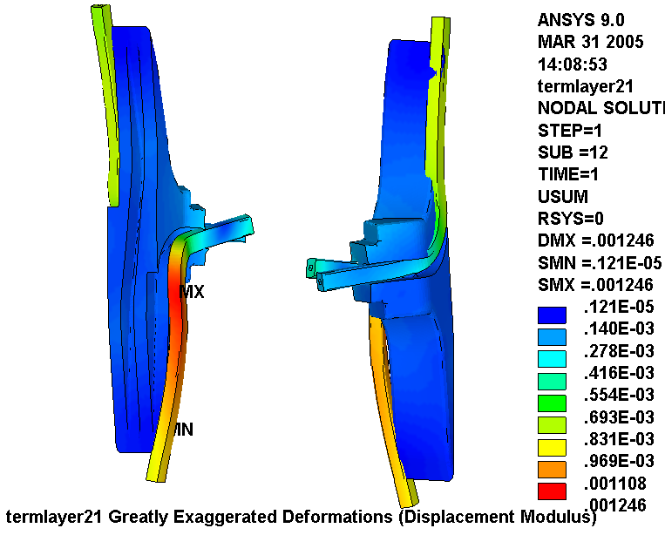
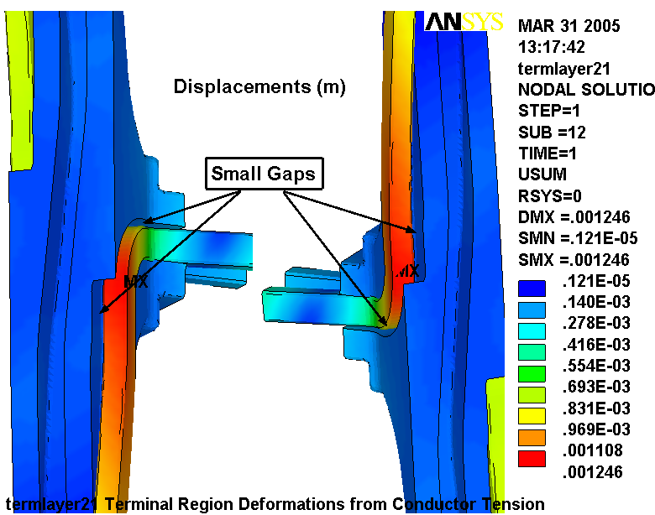
Fig. 4.0-3 Stress Intensity in Cu Conductor from Design-Basis Loading
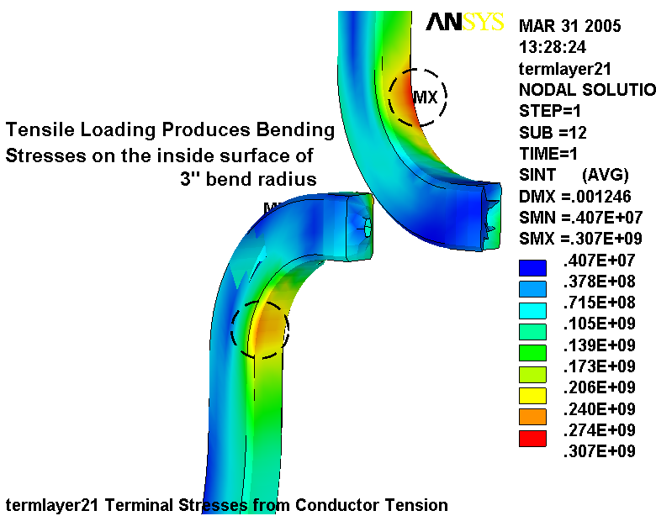
Fig. 4.0-4 Far-Field Tensile Stress [Pa] from Design-Basis Loading
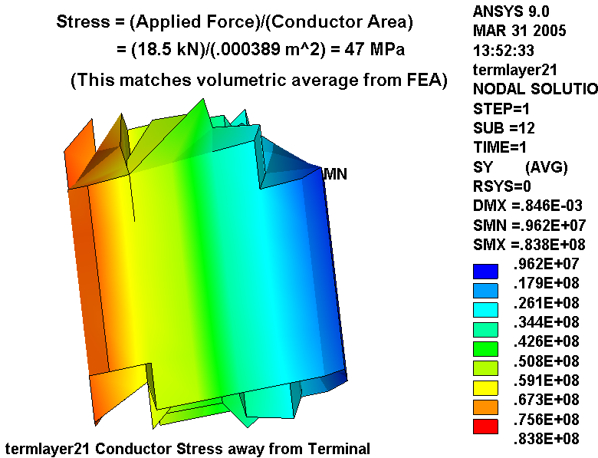
A number of variations of this model are used to make certain that the results are correct. Fig. 4.0-5 is a plot of the stress in the bend region when some lateral restraints and contact element “tuning parameters” are applied. The plot shows a maximum stress of 300 MPa in the 90˚ bend region, which is essentially the same result as reported earlier.
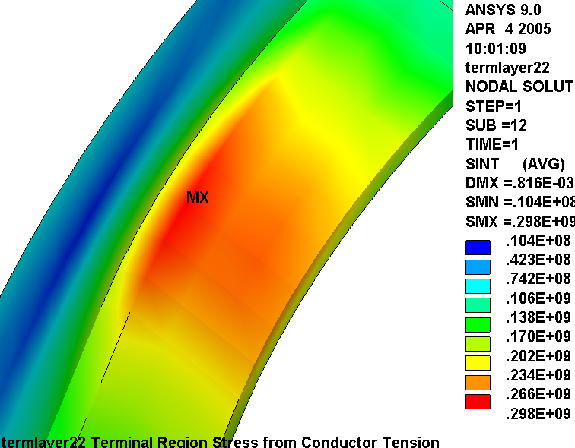
Fig. 4.0-5 Stress in Bend region after adding lateral BCs and setting Contact Element keyopt(5)=3

Fig. 4.0-6 is a plot of the stress in the bend region when the gaps stiffness is softened (to account for the unmodeled turn-wrap insulation) and the solid elements have an enhanced strain formulation. The plot shows a maximum stress of 330 MPa in the 90˚ bend region, which is again in-line with previous model results.
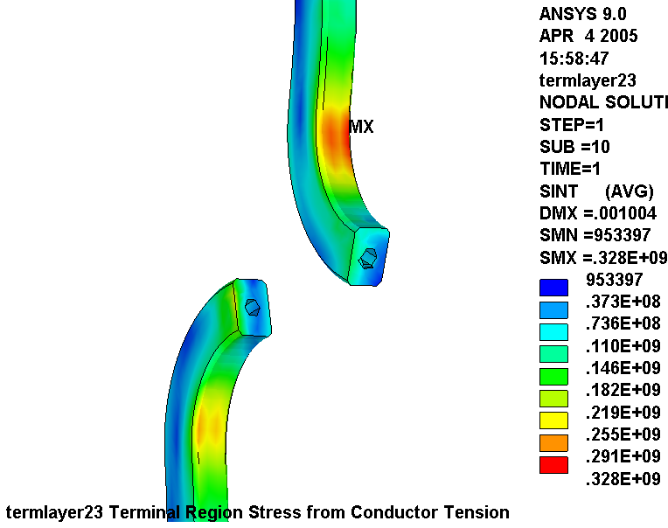
Fig. 4.0-6 Bend Region Stress with Softer gaps, Enhanced strain formulation Solids (keyopt(2)=2)

Curious if insulating block deflections were responsible for the high stresses in the conductor bend radius, the material of the block is changed to SS. Fig. 4.0-7 is a plot of the conductor stresses for this stiff anchor model. Maximum stress results are still around 300 MPa.
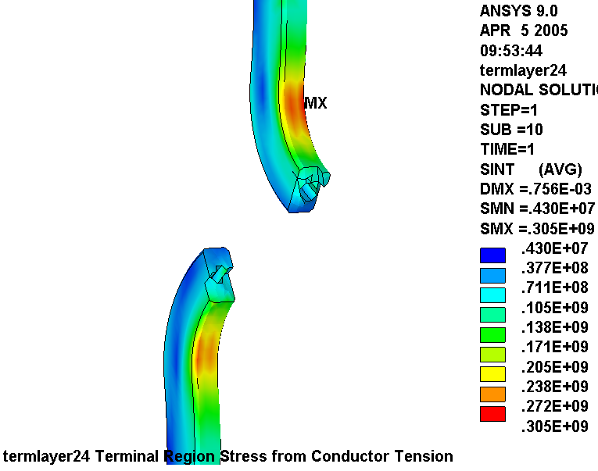

Fig.4.0-7 Bend Region Stress with a SS Terminal Block

In an effort to confirm that the surface-to-surface contact elements are working properly, the model is run without any contact elements (just tied together where the leads penetrate the outside surface of the G11 block). Fig. 4.0-8 shows that without support around the bend radius, the stress increases to 520 MPa. Clearly, the contact elements are working and providing some local support to the conductor.

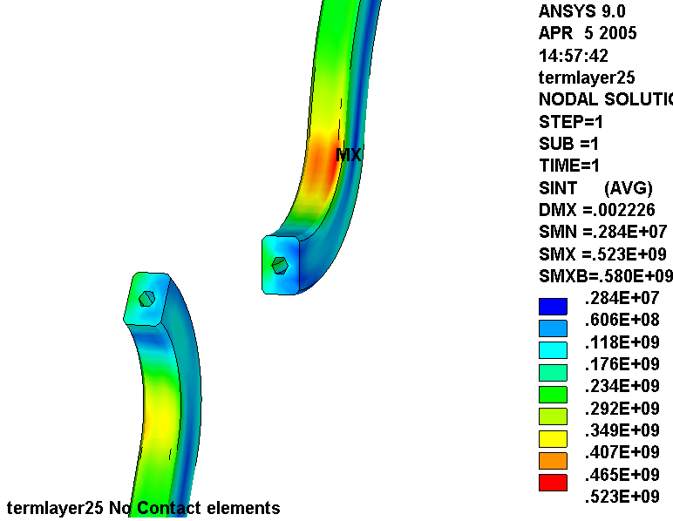
Fig. 4.0-8 Cu Stress with no contact element support, SS Terminal Block

Fig. 4.0-9 Source of Proposed Design-Basis Cu Fatigue Curve
(From http://ncsx.pppl.gov/NCSX_Engineering/Materials/CopperProperties/PB92172766.pdf) Notice that the σ/2 curve is more limiting than the N/20 curve.
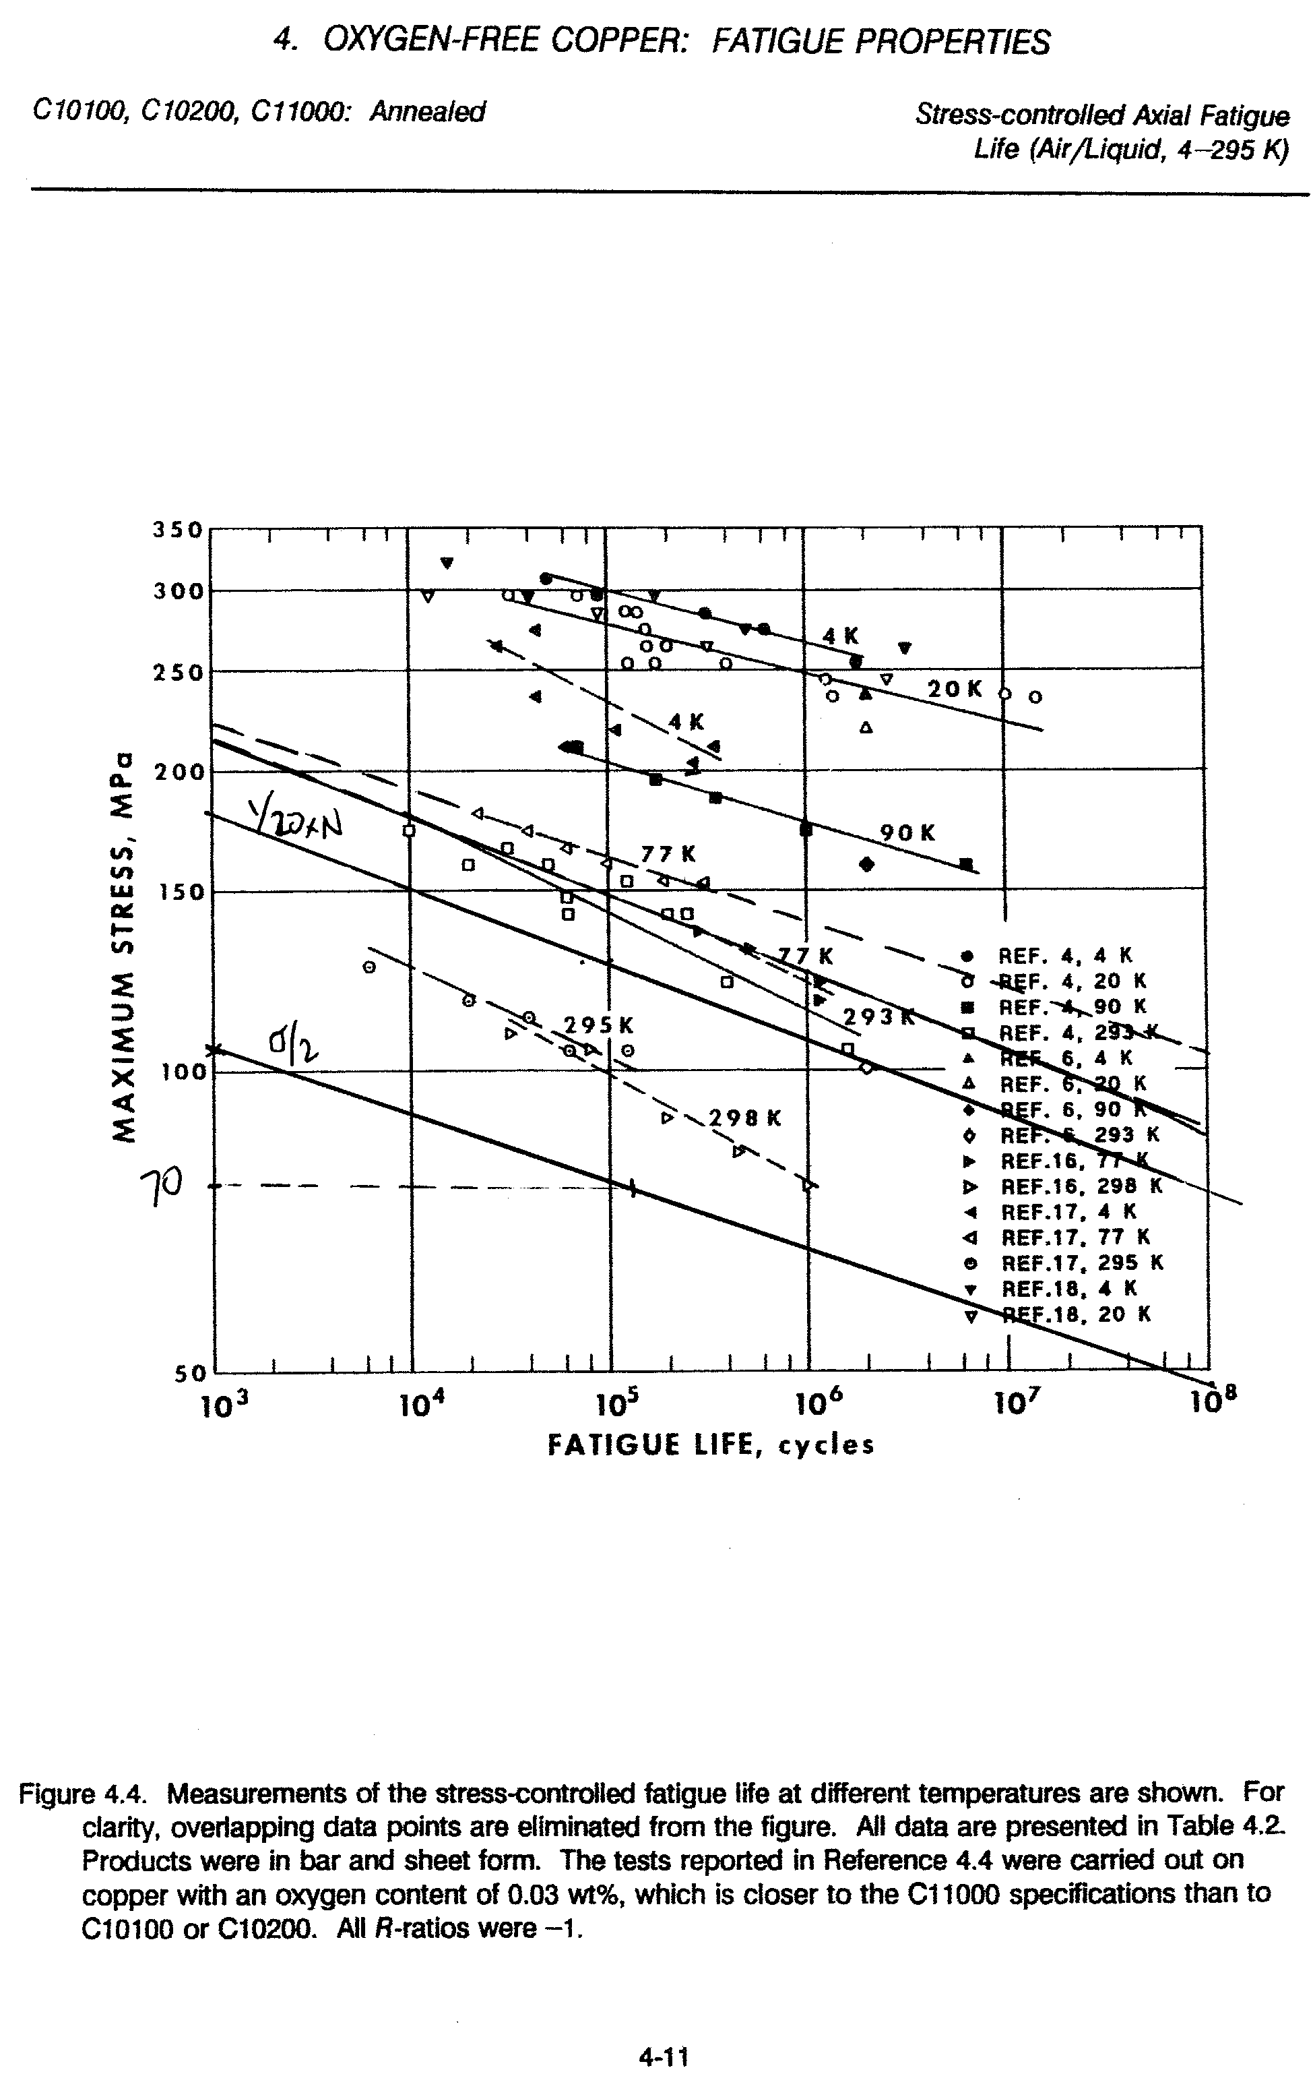
4.1 Idealized Bar on Disk Model

Still not fully understanding the source of the high stress in the terminal’s 90˚ bend region, a very simple 3D model is constructed to test the effects of contact element parameters, boundary conditions and constraint equations. Fig. 4.1-1 shows the stress in a solid Cu bar being pulled on a G11-like disk. The load is roughly comparable to our 4150 design-basis force, and the model is in English units (so stresses are in psi). The maximum stress is 17 ksi (120 MPa) and essentially matches a hand calculation of a thick-walled cylinder subjected to an internal pressure (notice the uniform nodal force vectors at the Cu ring ID representing the contact force magnitude). Notice that the BCs force the Cu bar to remain parallel to the cut plane (roller BCs).

Fig. 4.1-1 Stresses in an idealized Cu Bar Pulled around a G11 Disk
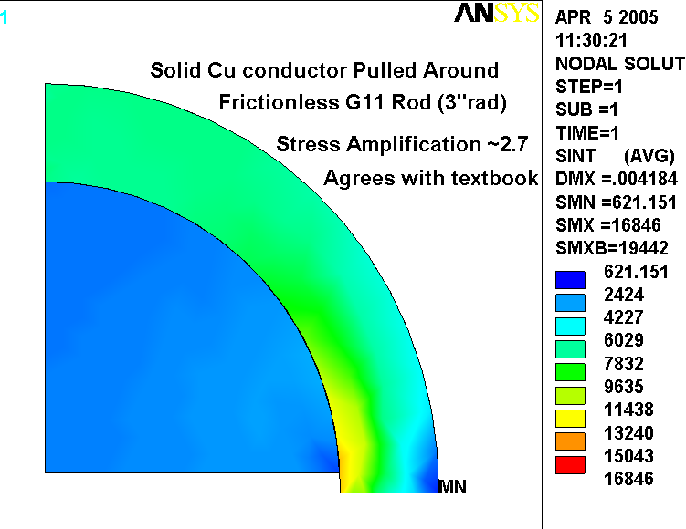
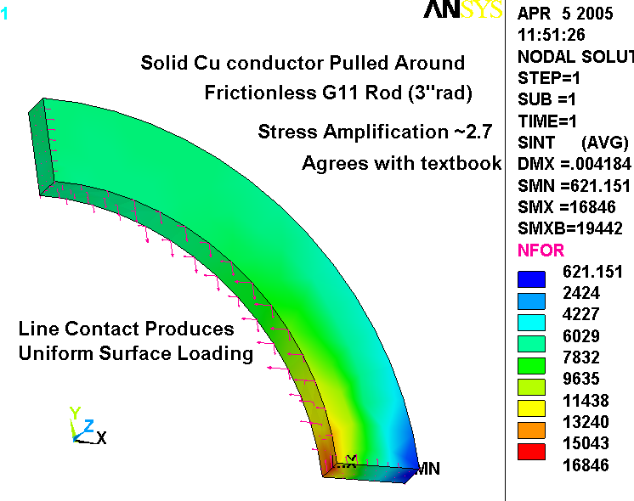
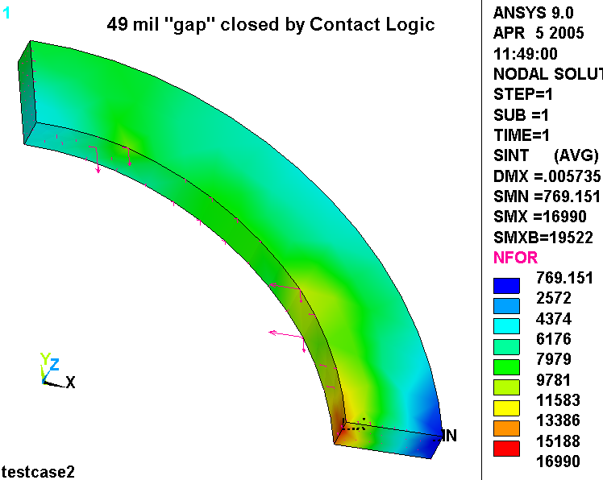
The idealized model is intentionally assembled with a 49 mil gap between the Cu bar and the G11 disk and the gap. This poses a situation which is similar to the more complex model shown in Fig. 3.0-2. The gap is artificially closed by invoking the appropriate contact element key option. Stresses are as shown in Fig. 4.1-2. Although the nodal force vectors are not as uniform as they were in the zero gap case (Fig. 4.1-1), the stresses are similar enough to prove that the high stresses do not come from mishandling the model’s initial gaps.

Fig. 4.1-2 Stresses in idealized Cu Bar Pulled around Disk, 49 mil gap “closed” with KEYOPT
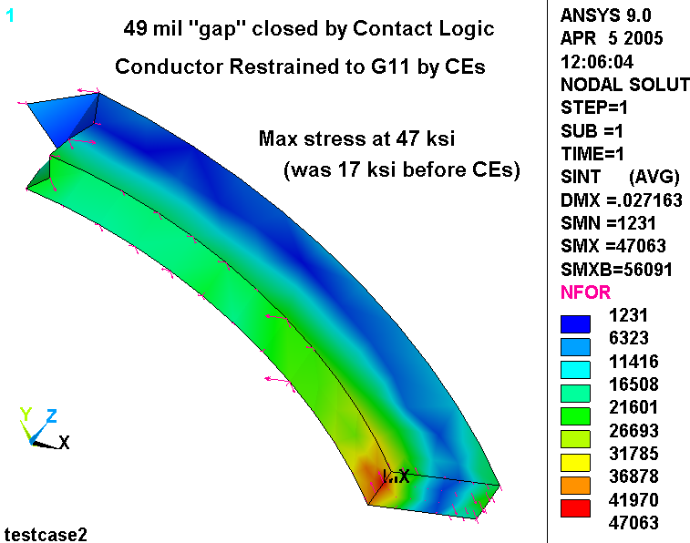
When the roller boundary conditions used idealized model are substantially reduced and constraint equations are added to the problem formulation, the bending stress in the Cu bar increases substantially, as shown in Fig. 4.1-3. This provides the first clue that the high stresses in the Cu are due to a bending component from non-rigid end conditions.

Fig. 4.1-3 Tie Conductor to G11 with Constraint Equations and limited UX=0 BCs

4.2 Precise Insulated Conductor Contact Model

It turns out that one of the problems with the PPPL model is that the gap between the conductor and G11 insulating block is not a uniform 49 mil consistent with a turn wrap thickness. The uncertainty of the effects of this anomaly on the maximum stress has inspired a more precise contact model (see Fig. 4.2-1), albeit more simplistic in other geometric respects. The model is loaded with the same poloidal tension discussed earlier. Stress plots are included as Figs. 4.2-2 through

Fig. 4.2-1 Idealized Conductor and Block Model
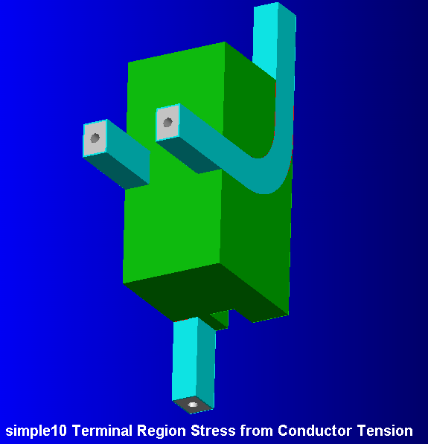
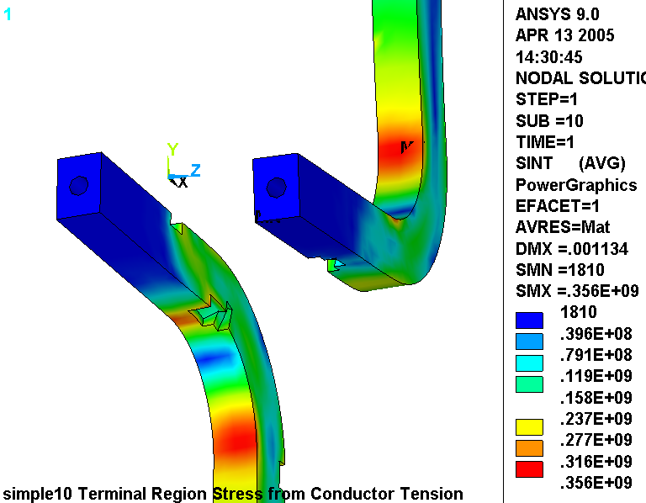
Fig. 4.2-2 Stress from mesh refinement study
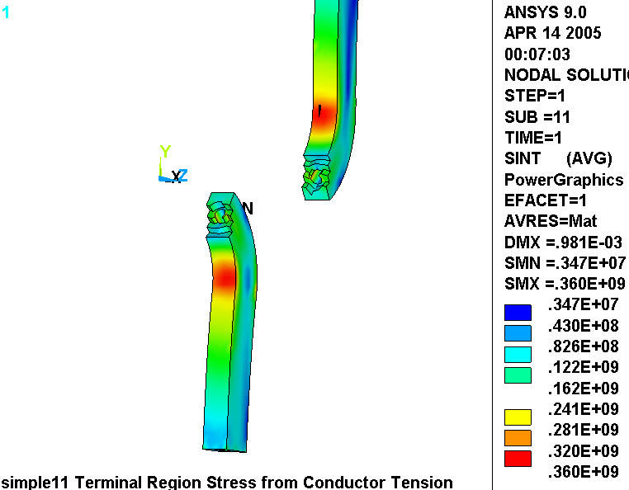

Fig. 4.2-3 Stress in the G11 Block
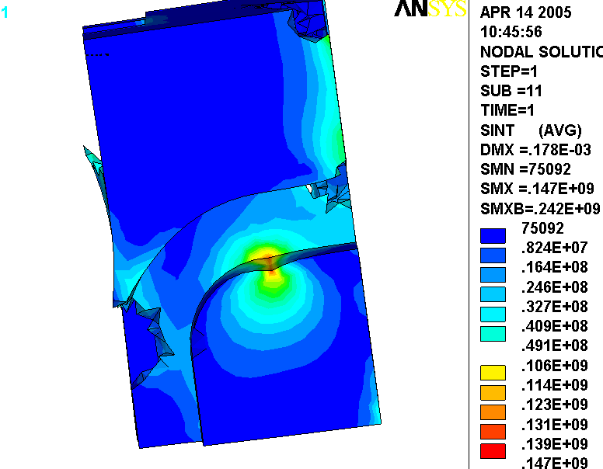
5.0 A Fix

One solution to the stress problem is to beef-up the terminal’s 90˚ bend region with the addition of a larger part. This involves brazing a foot, lug, tab, terminal block (you name it) onto the body of the conductor. The poloidal force which must be carried by the conductor/terminal block braze is still the 4150 lb (2500 lb from EM forces and ~1600 lb from thermal contraction differential effects) described above.

When Cu parts are brazed together, they are heated locally to a temperature which anneals the base metal. Dead-soft Cu has a room temperature yield stress of 64 MPa or 9.3 ksi (NIST Monograph 177), with minimal increase at cryogenic temperatures. Therefore, the average section stress produced by the primary (EM) load (2500 lb) must be kept below 2/3x64 or 43 MPa. With a cross-sectional area of about 0.6 in², the average conductor stress is 29 MPa, which meets the requirement. In addition, pure tensile stresses are difficult to achieve, and local bending could push the material beyond the 1.5S_{m} (64 MPa) stress limit. The project should develop a design which minimizes bending stresses at the terminal anchor. The braze joint itself must also be qualified.

Leonard Myatt, “Stress Analysis of the 3x4 Slip-Plane TF Coil with Cast SS Wedges,”03/07/05.
ANSYS Release 9.0, UP20041104, INTEL NT, ANSYS, Inc., Canonsburg, PA.
NCSX Structural Design Criteria, NCSX-CRIT-CRYO-00, 11/29/04, http://ncsx.pppl.gov/NCSX_Engineering/Design_Criteria/StructuralCryo/NCSX-CRIT-CRYO-00-Signed.pdf

