PPPL-NCSX Memorandum

To: Michael Kalish (PPPL)
From: Leonard Myatt (Myatt Consulting, Inc.)
Date: May 16, 2005
Subject: Stress Analysis of the 3x4 Slip-Plane TF Coil with Cast SS Wedges

1.0 Executive Summary

This memo presents the results of numerous ANSYS stress analyses documenting the evolution of the NCSX TF coil and support system. The latest design of record is based on a 3x4 conductor winding pack (WP), turn-wrap insulation with a Kapton slip-plane, a two-thickness ground wrap (3/8” beyond wedges, 1/8” bonded to wedges), and cast SS wedges on the inboard legs.

Stresses in the reference wedge TF coil system design are evaluated by two bracketing analyses; the first assumes that the coil is bonded to the wedge castings, while the second assumes that the bond has failed and the WP is held by the wedge casting by frictionless contact surfaces. The analyses indicate that the design satisfies all of the salient design criteria with the exception of the through-thickness tensile stresses which develop in the insulation from EM loads in the bonded configuration. Carrying primary loads as a tensile stress is a violation of the design criteria. However, when the bond is assumed to fail, the tensile stresses are relieved and all of the coil structure then satisfies the design criteria with reasonable margin.

Although the entire history of the TF coil analysis is presented, the reader can concentrate on the last results section (4.7) to review the details of the present configuration. Sections 2.0 (Assumptions and Notable Concerns) and 5.0 (Summary & Commentary) also provide concise and important text.
2.0 Assumptions and Notable Concerns

2.1 It is assumed that the critical loading is characterized by a 0.5 T toroidal field, 85K operating temperature and a 4000 lb/bracket radial preload. Reference [Error: Reference source not found] provides reason to believe this is true. (Analyzing other EM load conditions would require the addition of other field sources, which would likely complicate the model beyond all reasonable computational resources.)

2.2 It is assumed that the mechanical properties of the wedge castings will be comparable to 304SS. However, the 85K elastic modulus is assumed to be 159 GPa, which is more consistent with the MCWF casting data (ref. T. Kozub).

2.3 It is assumed that the Cu conductor is at least quarter-hard [in the upper and lower transition regions].
3.0 Analysis

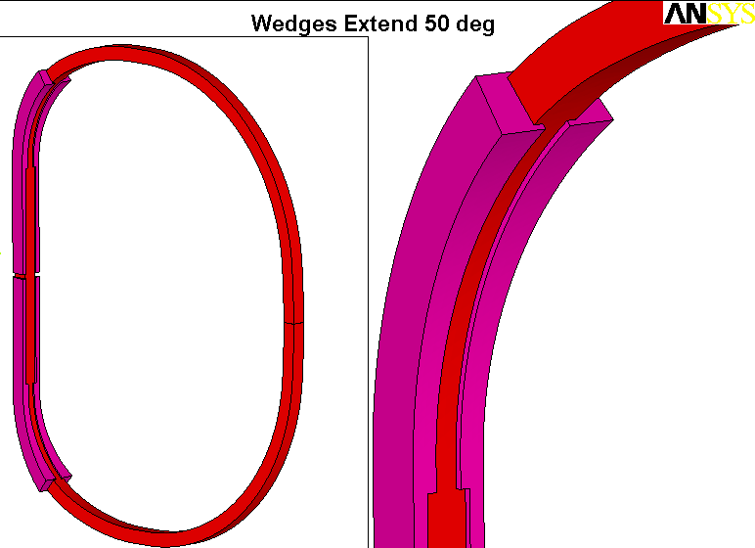
The analysis is based on the parametric model shown in Fig. 3.0-1. Although the reference wedge design has a 30˚ transition region, this particular plot shows them extending 50˚ from the ends of the straight-leg for greater support of the TF’s centering loads. Results for various angular extensions and a more advanced design are presented.

Fig. 3.0-1 Single TF Coil model for 0.5 T Loading (Extent of Wedges can be varied)

4.0 Results

Results are illustrated by a series of plots with accompanying text. The evolution of the design is carried for a historical record, but a detailed stress evaluation is only presented for the design of record.

Fig. 4.0-1 is a plot of the element centroid force vectors acting on the smeared TF winding pack. The ANSYS plot title lists the forces summation, and shows the large centering load (368 kN or 83 kips). The vertical and out of plane forces “should” sum to zero from symmetry. In the finite element world, 100 parts in 400,000 or 0.025% is zero.

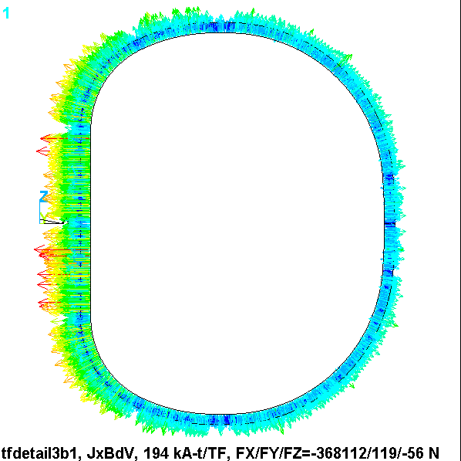
Fig. 4.0-1 Element Centroid Force Vectors (N) in Smeared WP

Fig. 4.0-2 is a plot of the flux density in the smeared WP. Again, the ANSYS plot title lists some interesting result. A hand calculation puts the peak field at 1.74 T, while the analysis reports 1.94 T. Back when the WP spanned the full toroidal width of the wedged inboard leg, the hand-calc was reasonably accurate. Here, the narrower WP produces some peaking, which shows up here as an 11% effect.

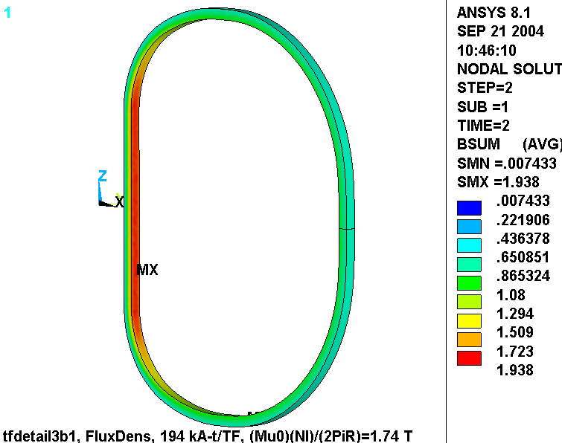
Fig. 4.0-2 Flux Density (T) in Smeared WP

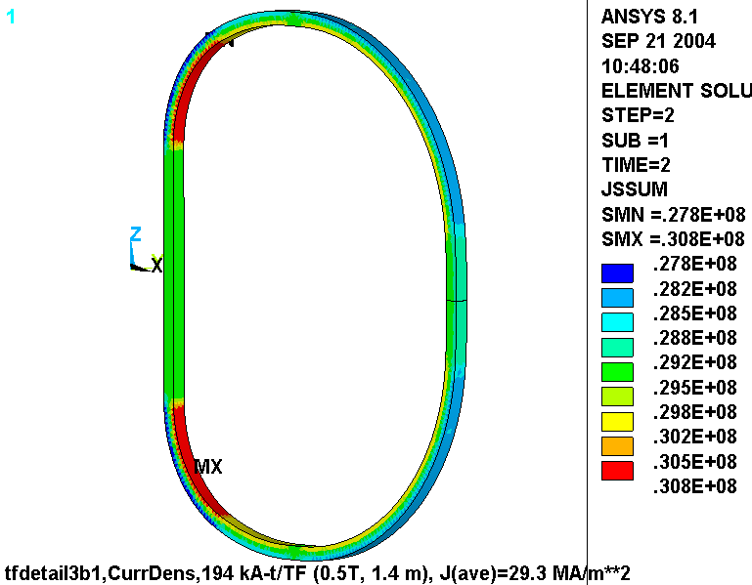
Fig. 4.0-3 is a plot of the current density distribution in the smeared WP. Although this should be a uniform 29.3 MA/m³ over the entire coil volume, the legend shows a variation of ±5%. This is very difficult to avoid with a smeared WP. However, the variation is small and should not impact the accuracy of the stress calculation be very much.

Fig. 4.0-3 Current Density (A/m²) in Smeared WP

The primary design variable is the amount (in degrees) that the wedges are extended beyond the straight region. The impact of this design variable on WP stress is explored with the model, and the results are illustrated in Fig. 4.0-4. The plot shows the maximum WP stress intensity as a function of Wedge Angular Extent. Two curves are plotted; one for so-called NODAL results, and another for so-called ETABLE results. Clearly, the WP stress decreases as the wedges are extended further around the corner.

These curves are based on linear analyses where the WPs are bonded to the wedges. One additional analysis is performed where the interface between the WP and the wedges are simulated more accurately with contact elements. This analysis is represented by the triangular markers for a 30˚ wedge configuration. Notice that the NODAL results are actually slightly less than that of the bonded results. This is because more realistic interface produces a softer transition from the clamped (supported) structure to the unclamped (free) WP.
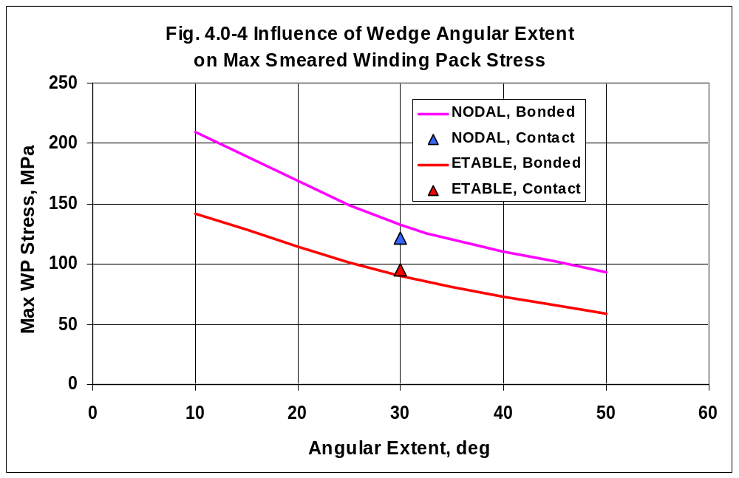

4.1 Wedges Extend 10˚

Fig. 4.1-1 shows nodal and ETABLE stress intensity plots from the 10˚ wedge analysis. In this case, the wedges provide minimal support and result in a rather large (210 MPa) bending stress right at the structural discontinuity.

4.2 Wedges Extend 30˚

Fig. 4.2-1 shows nodal and ETABLE stress intensity plots from the 30˚ wedge analysis. Here, the wedges provide more support and result in a moderate (133 MPa) bending stress which again appears right at the structural discontinuity.

4.3 Wedges Extend 50˚

Fig. 4.3-1 shows nodal and ETABLE stress intensity plots from the 50˚ wedge analysis. These extensive wedges provide great support and result in a very small (93 MPa) bending stress in the WP. Clearly, the TF WP would benefit from such a wedge design if they can fit within the other geometric limitations of the magnet support structure.

4.4 Wedges Extend 30˚, Contact WP-Wedge Interfaces

Figs. 4.4-1 and 4.4-2 show ETABLE and NODAL stress intensity plots from the 30˚ wedge analysis which includes frictionless and low friction contact interfaces between WP and wedges. The results are compared to the fully bonded result, and indicate a slight reduction in the maximum value. It is also interesting to note that the assumed friction coefficient (0.0 or 0.3) has little impact on the peak WP stress. This slight decrease in the maximum NODAL stress is due to a softening of the transition between supported and unsupported WP.

Fig. 4.4-3 is a plot of the TF coil deformations. There are a couple notable results shown in this figure.

- The outboard leg moves in 4.4 mm. This value is compared to other analyses later in the memo.
- There is a slight asymmetry in the vertical deflection values as the upper (unbonded) structure allows more motion than the lower (bonded) structure.

Fig. 4.4-4 shows plots of the stress intensity in these 30˚ wedges for the μ=0 and μ=0.3 cases. It is nice to see that the case with friction produces slightly lower stresses since some of the centering load gets carried as friction on the sidewalls of the WP instead of impinging on the thin lip of the wedge.

Fig. 4.4-5 is a plot of the vertical deflections in the wedges and WP when μ=0 and the wedge is vertically unsupported by displacement boundary conditions (BCs). Notice that the wedge moves upward by 8.2 mm. Now clearly, there will be some friction in the real magnet system. However, the structure demonstrates a characteristic to have relative motion which may result in parts “walking.” This characteristic is quantified in Fig. 4.4-6 which indicates that when the wedges are held at the equatorial plane then the force required to anchor them is about 7600 lb_{f}.

Therefore, modifying the design such that upper and lower wedges are mechanically joined would ensure that the parts don’t “walk.”

Fig. 4.1-1 Stresses in Smeared WP, Upper (“ETAB”), Lower (nodal), Wedges Extend 10˚
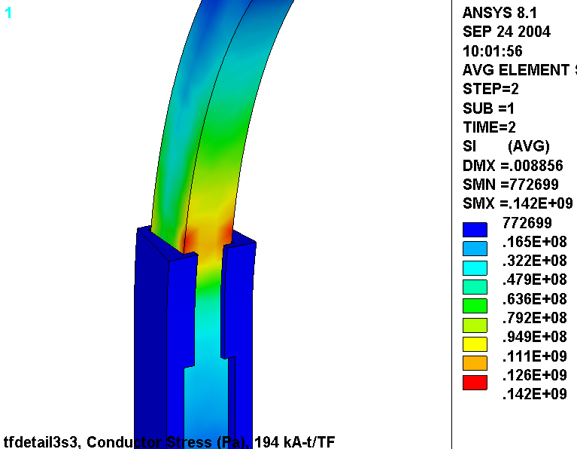
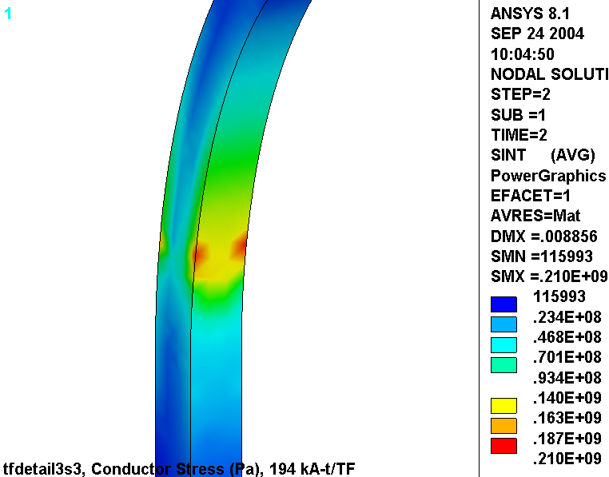
Fig. 4.2-1 Stresses in Smeared WP, Upper (“ETAB”), Lower (nodal), Wedges Extend 30˚
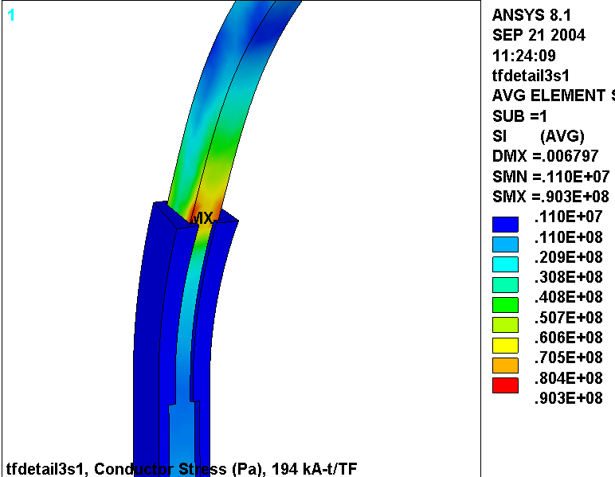
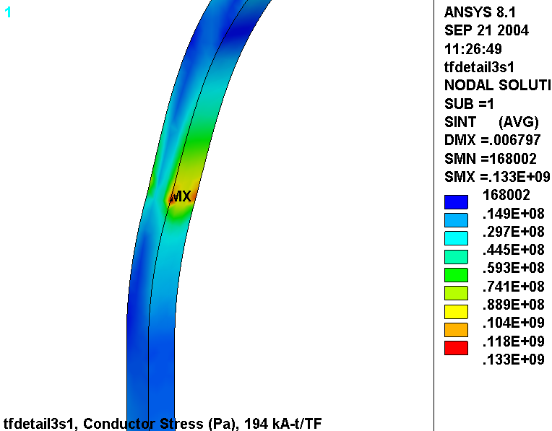
Fig. 4.3-1 Stresses in Smeared WP, Upper (“ETAB”), Lower (nodal), Wedges Extend 50˚
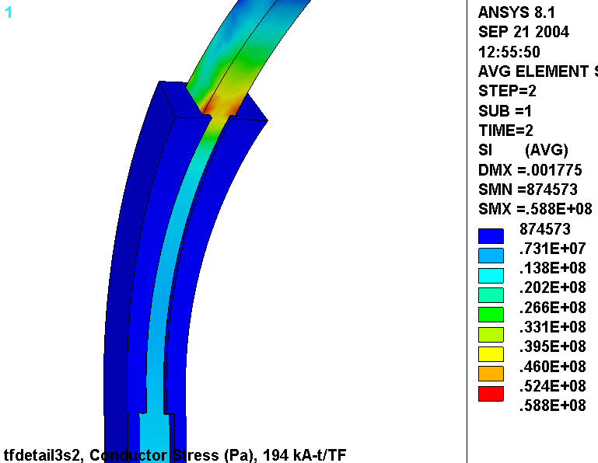
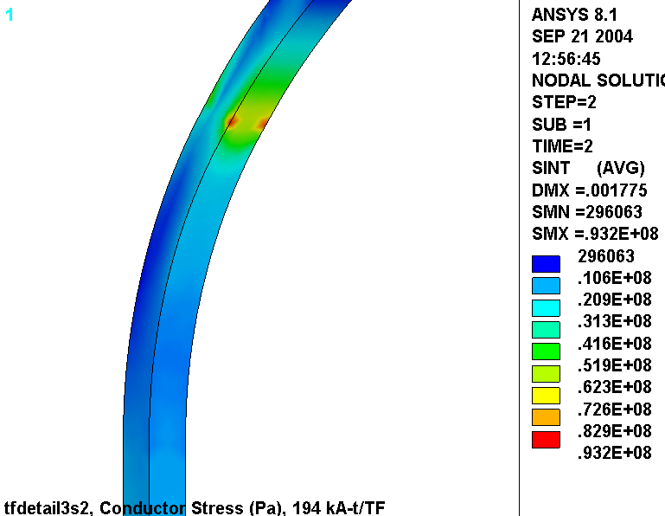
Fig. 4.4-1 “ETAB” Stresses in Smeared WP
Upper: μ=0.0, Lower: μ=0.3, Wedges Extend 30˚
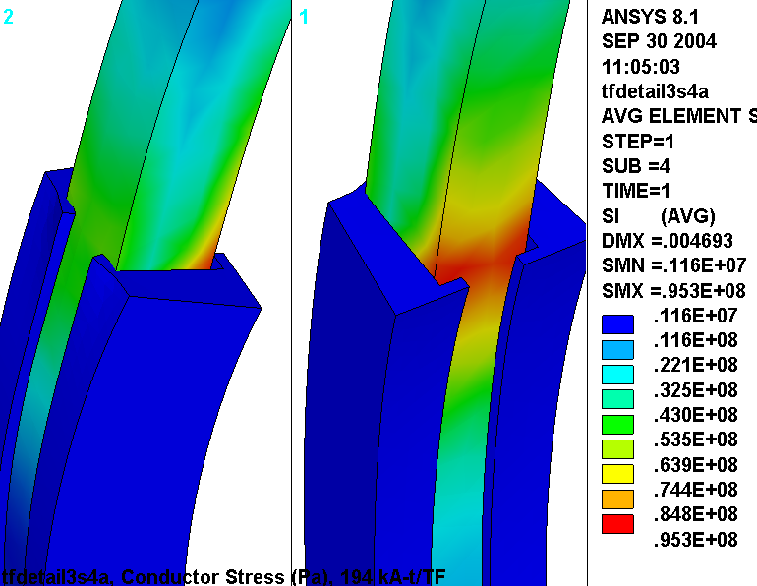
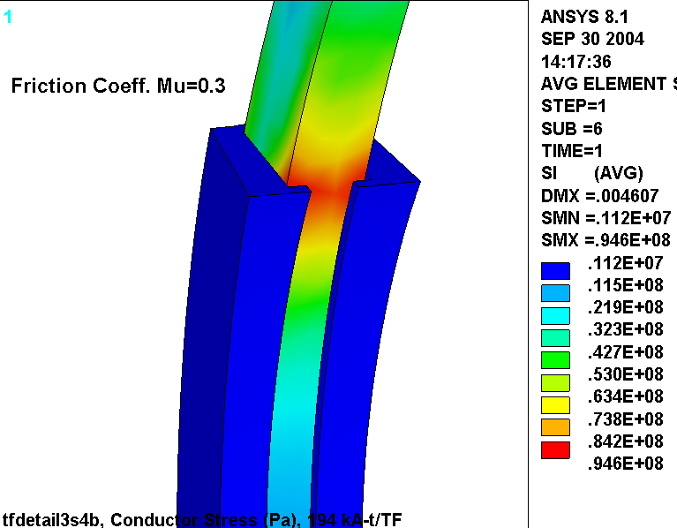
Fig. 4.4-2 “NODAL” Stresses in Smeared WP, Upper: μ=0.0, Lower: μ=0.3, Wedges Extend 30˚
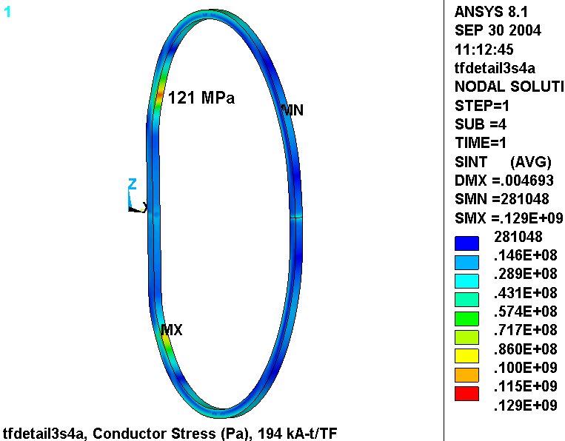
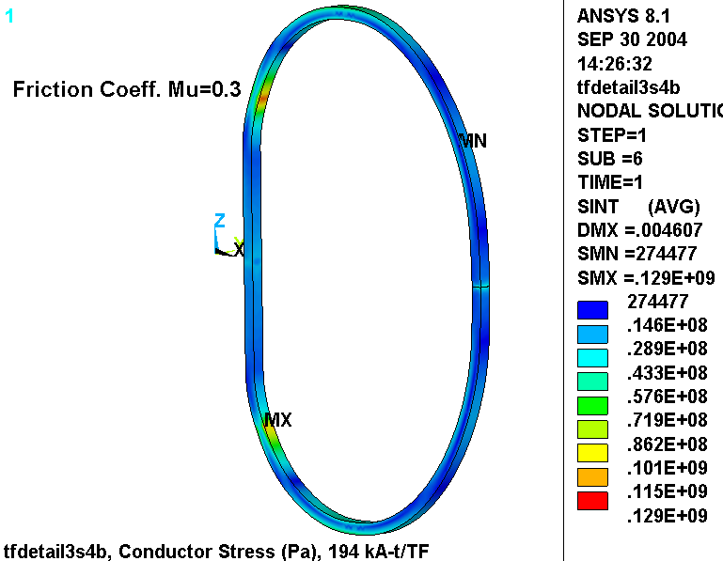
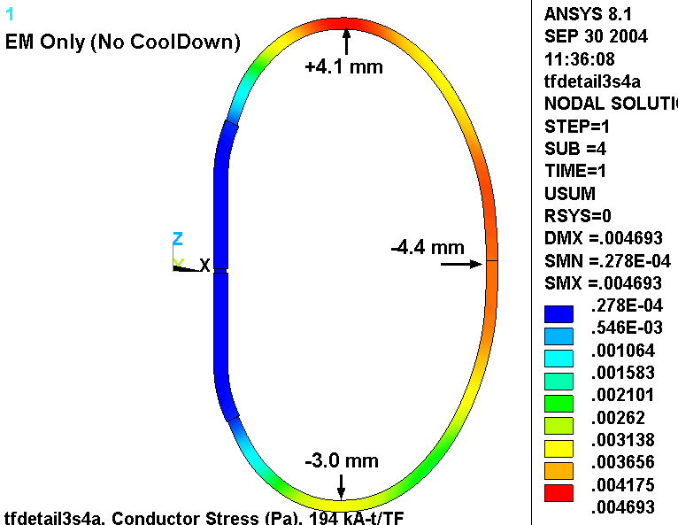
Fig. 4.4-3 Deformations in Smeared WP, μ=0, Wedges Extend 30˚ (μ=0.3 almost identical)

Fig. 4.4-4 Wedging Structure Stresses
Upper: Contact, Lower: Bonded, Wedges Extend 30˚ (upper: μ=0, lower: μ=0.3)
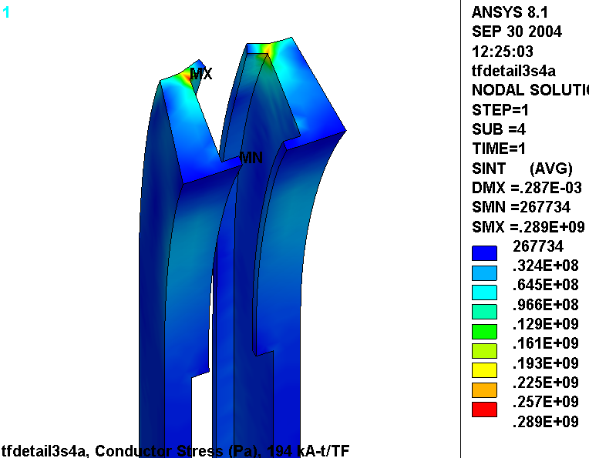
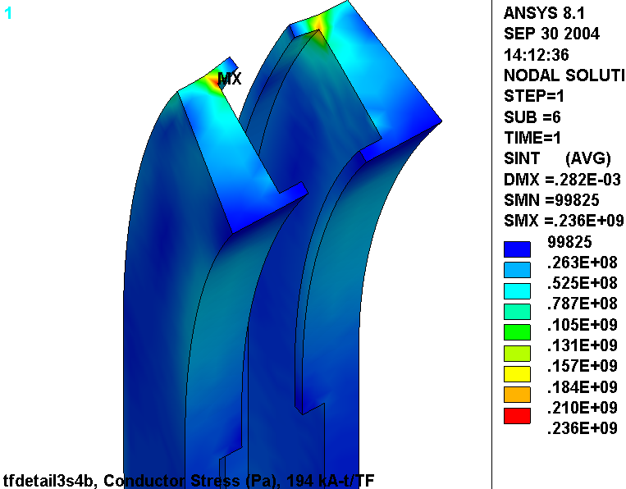
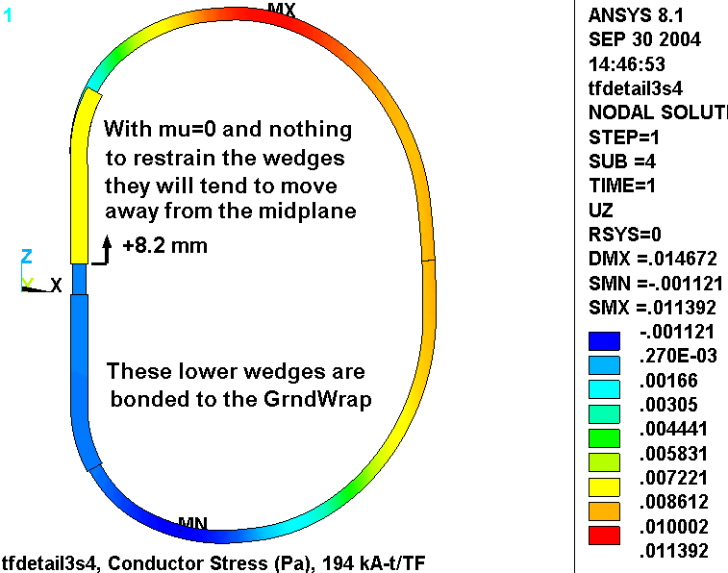
Fig. 4.4-5 Vertical Deformations, Upper Wedging Structure Not Secured by BCs or Friction
Fig. 4.4-6 Vertical Stress and Reaction Vectors, Upper Wedging Structure Secured by BCs
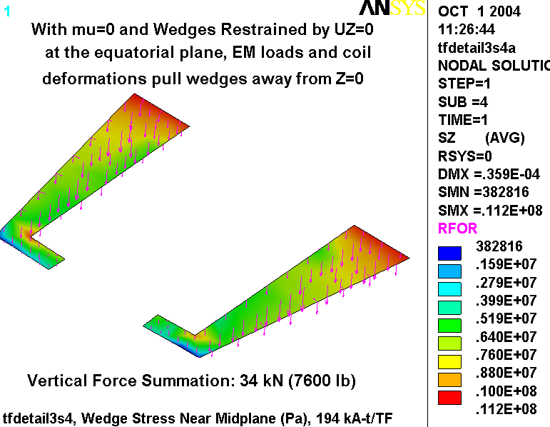
4.5 Extended TF Wedge Casting and Hybrid WP Model

The design studies presented above have highlighted some insightful characteristics of the original wedge design.

- Fig. 4.0-4 shows that extending the wedges >30˚ drops the WP stresses substantially.
- Fig. 4.4-4 shows that the low-field side lip should be thickened.
- Fig. 4.4-5 & 4.4-6 show that the wedges should be one piece (top to bottom).

All of these observations are rolled into an improved wedge design as shown in Fig. 4.5-1 (upper), while Fig. 4.5-1 (lower) shows the new 3x4 conductor array. The ANSYS model is modified to account for these design revisions as illustrated in Figs. 4.5-2 and 4.5-3. These plots show that in addition to incorporating these design changes, the model is taken to the next level of complexity; it now includes a hybrid of smeared and detailed regions to represent the WP. In the upper transition region, at the extreme of the wedge structure, the WP constituents are modeled explicitly. That is, each 0.966” x 0.709” conductor in the 3x4 array is surrounded by 49 mil turn insulation. The entire WP (smeared and detailed) is encapsulated in a 0.12” thick ground wrap.

This model provides component-level stress results in the high-stress region, and representative stiffness characteristics in the lower stress regions. It should be noted that the cooling channel is simplistically modeled as a square cross-section instead of circular for meshing efficiency.

Fig. 4.5-1 Revised TF Wedges (upper) and WP Array (lower)
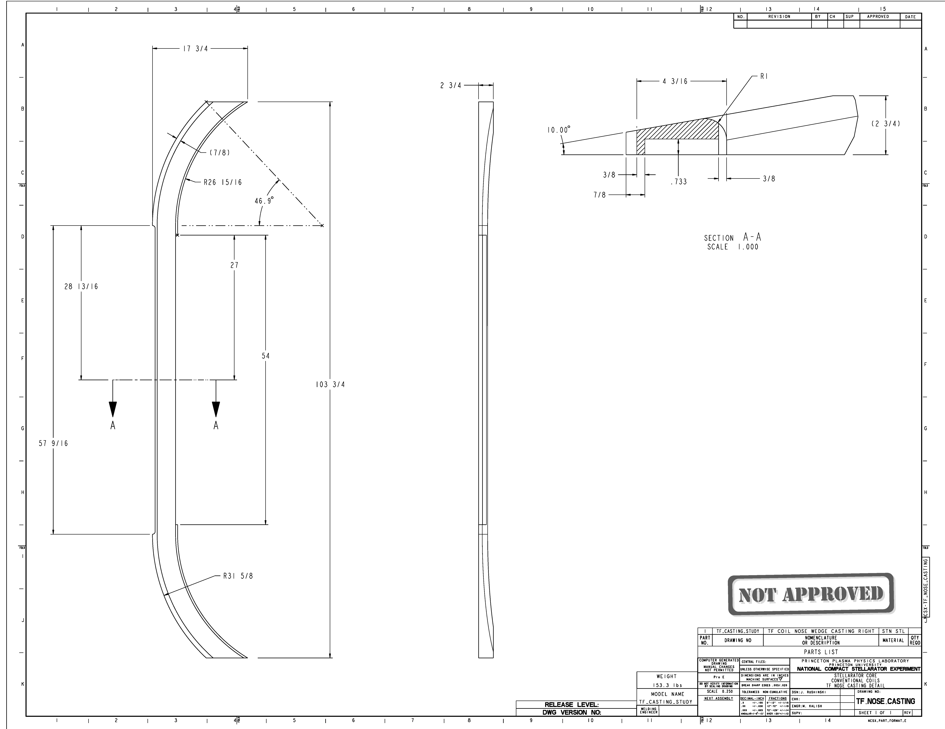
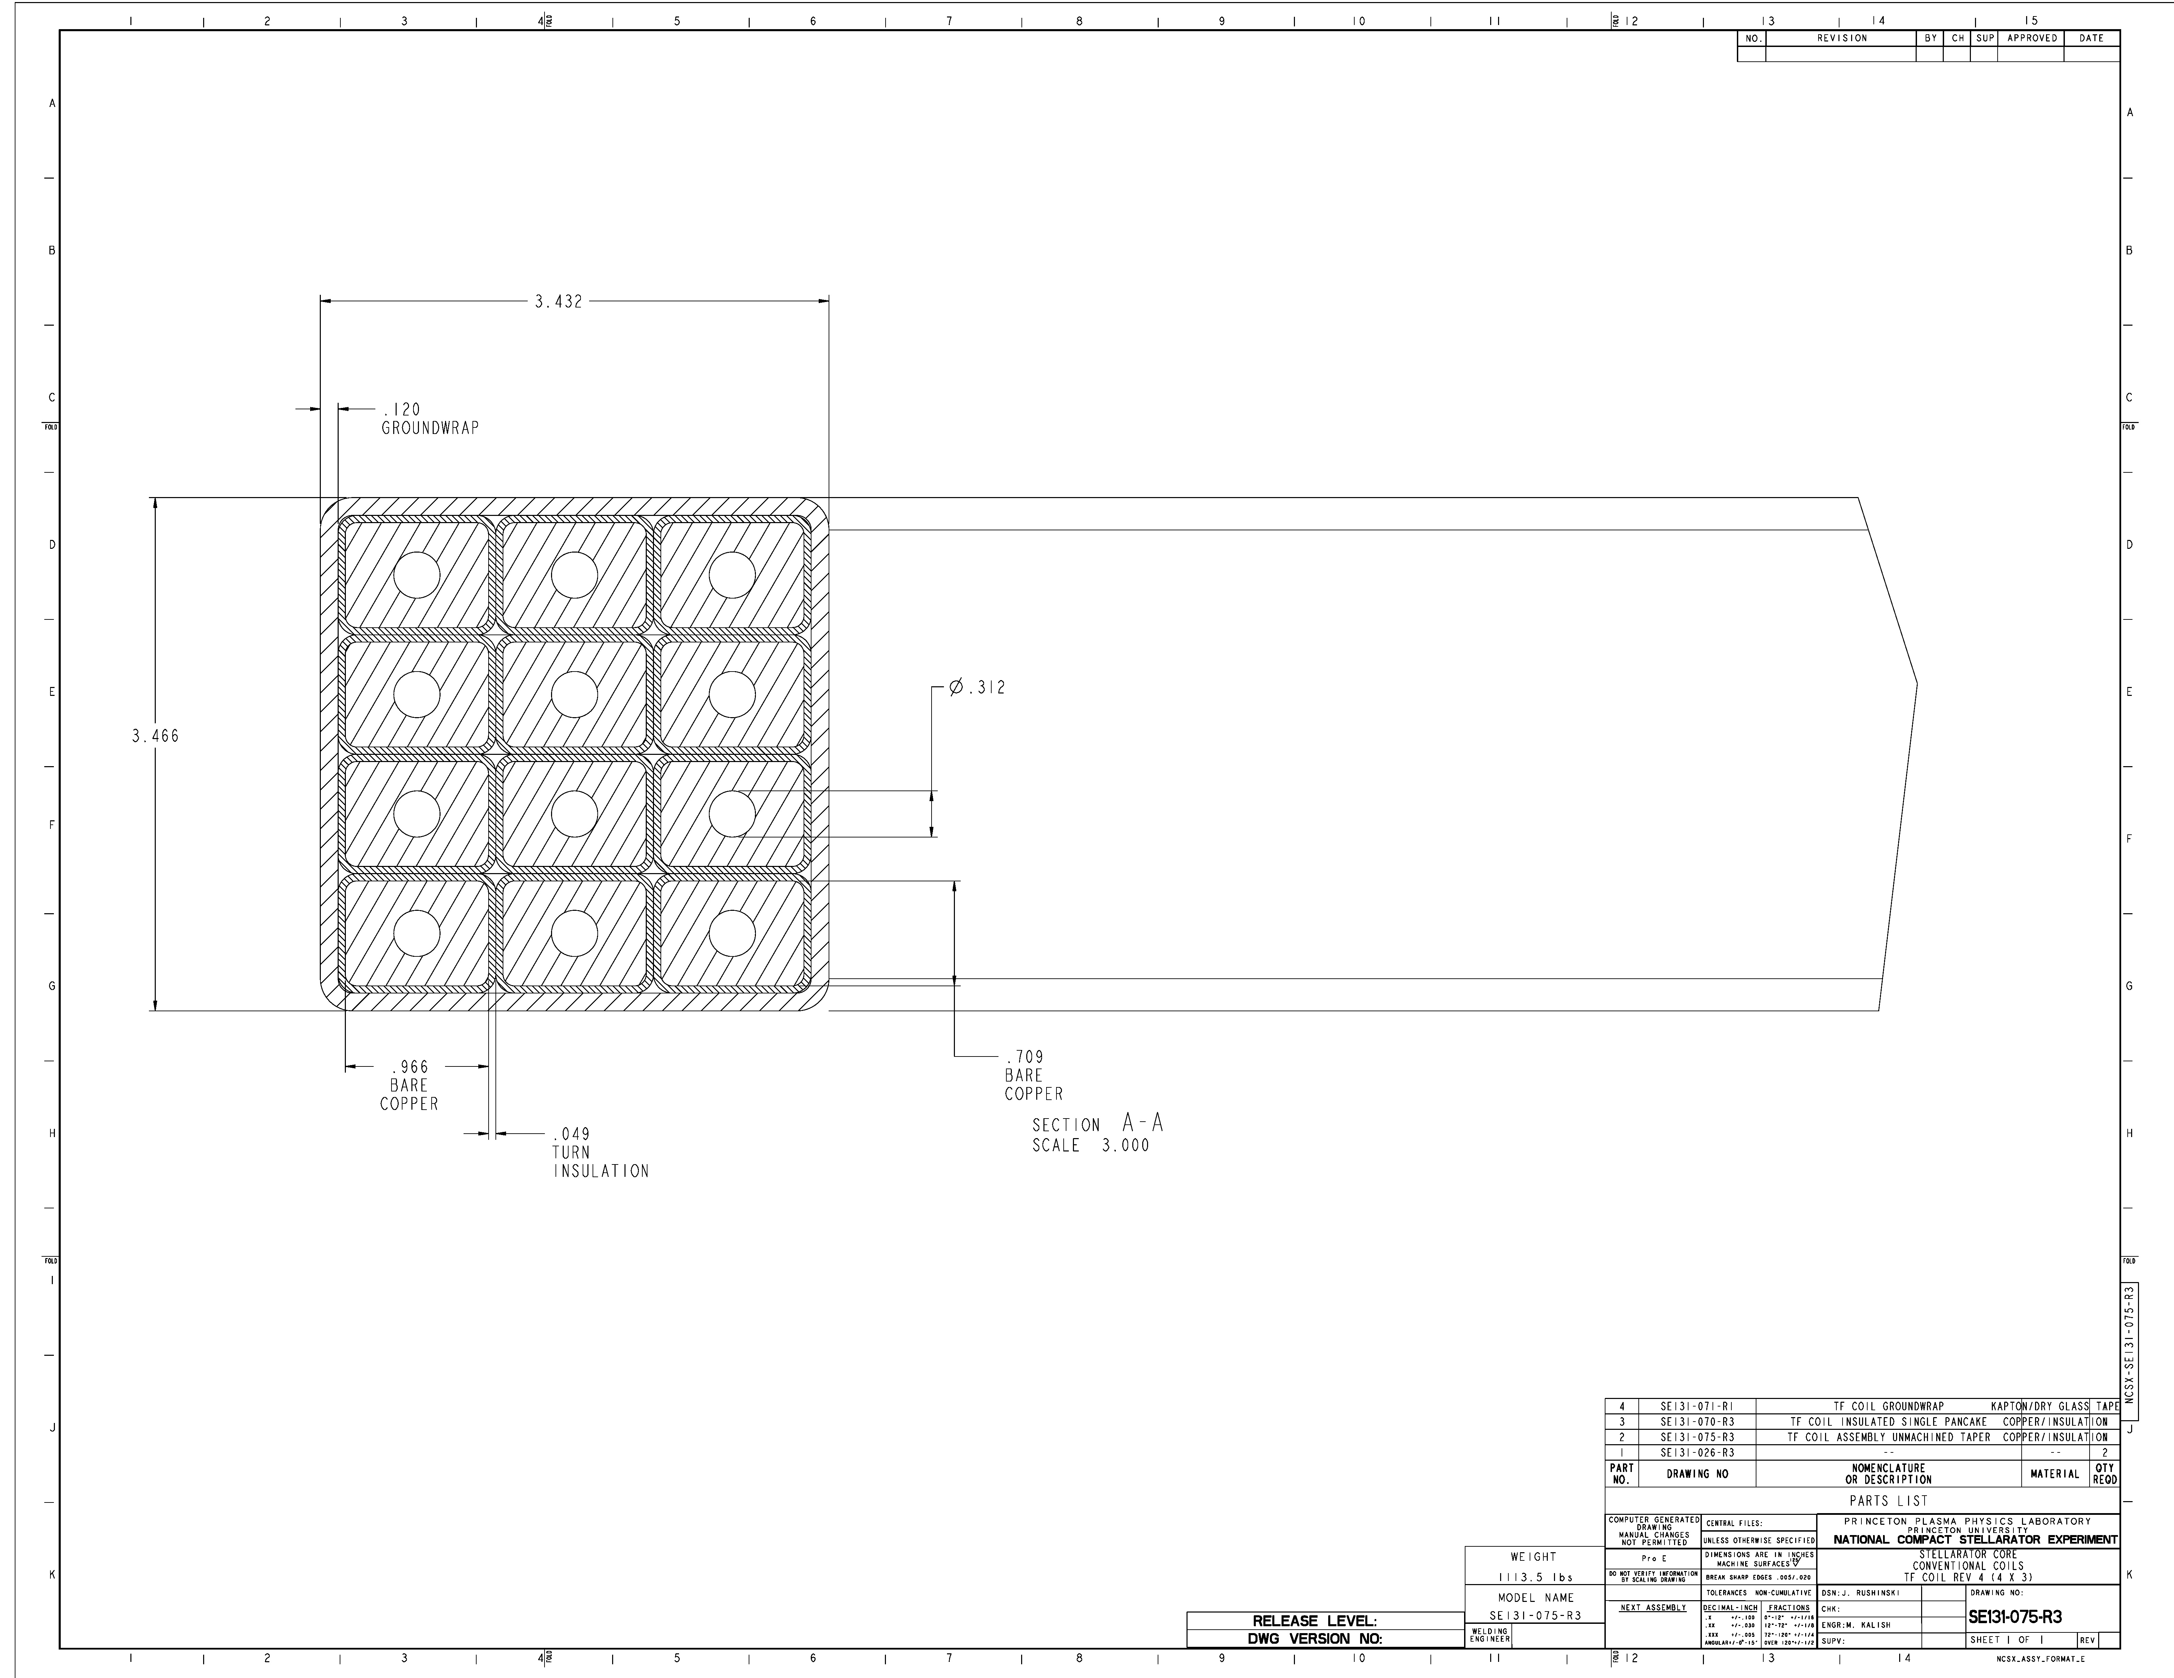
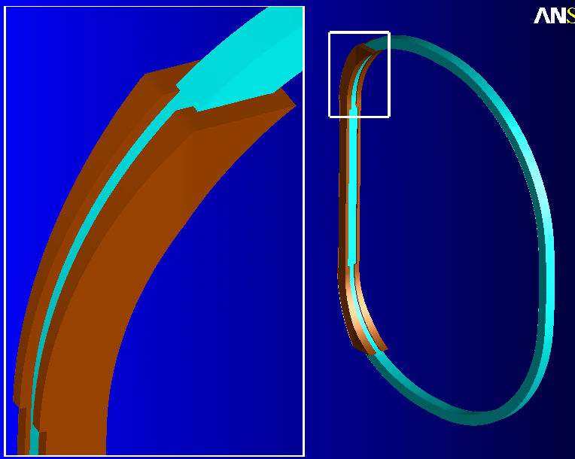
Fig. 4.5-2 Hybrid ANSYS model of TF and Redesigned Wedges
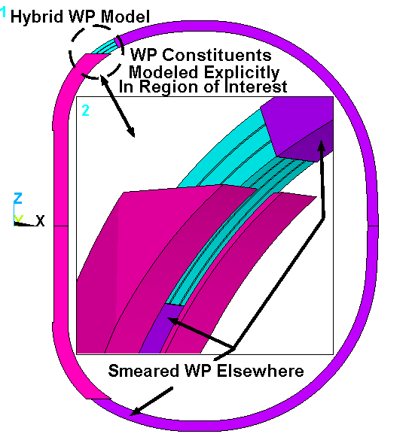
Generalized surface-to-surface contact element separate the inside faces of the Wedges from the outside faces of the Winding Pack in the upper half of the model. For solution expedience, these parts (WP and Wedges) are glued together in the lower half of the model. (This is one reason for any up-down asymmetries noted in the following results. The other reason, of course, is that only the upper transition has a detailed region.)

Fig. 4.5-3 Close-up of Wedges and Detailed Region Cross-Section
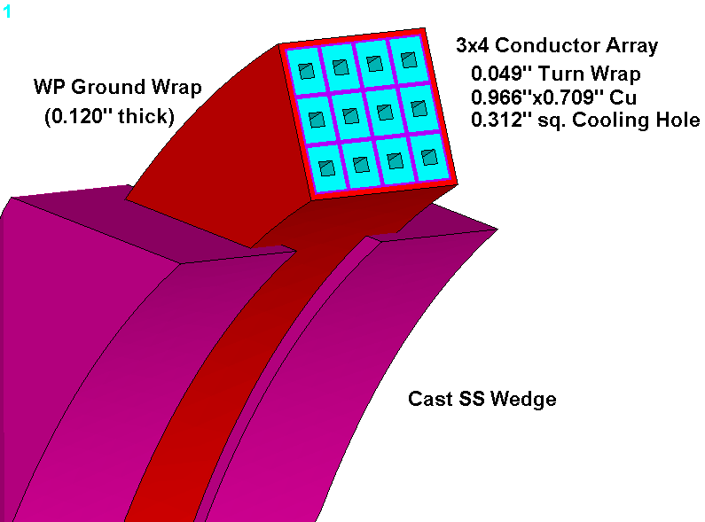
Fig. 4.5-4 is a plot of the stress intensity in the smeared WP and discrete Cu conductors resulting from this 0.5 T operating condition. As expected, the highest stresses occur in about the middle of the detailed WP region, with a maximum [nodal] value of 94 MPa. This agrees remarkably well with the smeared results reported in Fig. 4.0-4 for a 50˚ wedge extension.

This analysis is similar to one documented in an earlier memo for the original 6x2 conductor array. There, the maximum conductor stress is reported to be 134 MPa from this 0.5 T load condition. Clearly, the strength of the narrower WP plus wedges provides better support than the original array by itself. Consequently, the local membrane and membrane + bending stresses are lower in the new 3x4 conductor array.

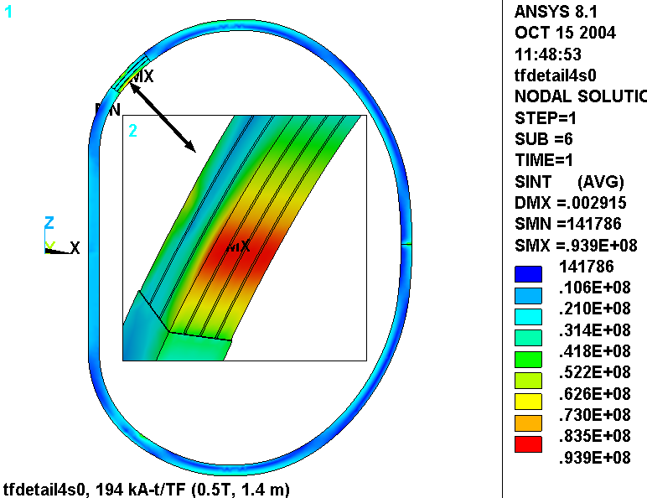

Fig. 4.5-4 Nodal Stress Intensity [Pa], Smeared WP and Discrete Cu Conductors

Fig. 4.5-5 is a plot of the ETAB stress intensity in the hybrid WP. They are plotted along with the wedges to show the location of the maximum conductor stress relative to the end of the structure. Recall that the ETAB results tend to be somewhat lower than nodal results. However, it is used here so that the wedges can get contoured as blue (since their stresses are not stored as ETAB values) for illustration purposes.
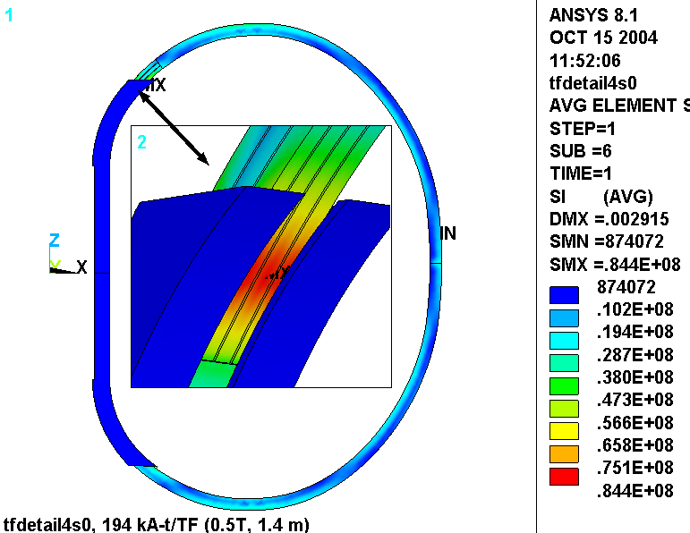

Fig. 4.5-5 ETAB Stress Intensity [Pa], Smeared WP and Discrete Cu Conductor

Fig. 4.5-6 is a plot of the flat-wise (normal to the plane of the glass) insulation stress. The most significant result is the magnitude and extent of the compressive stress as represented by the blue contour island. This stress occurs as a result of the hard contact at the end of the wedge. The legend indicates a maximum stress of 40 MPa, which is really quite low relative to a typical G10/G11 design stress (460 MPa from [Error: Reference source not found]).
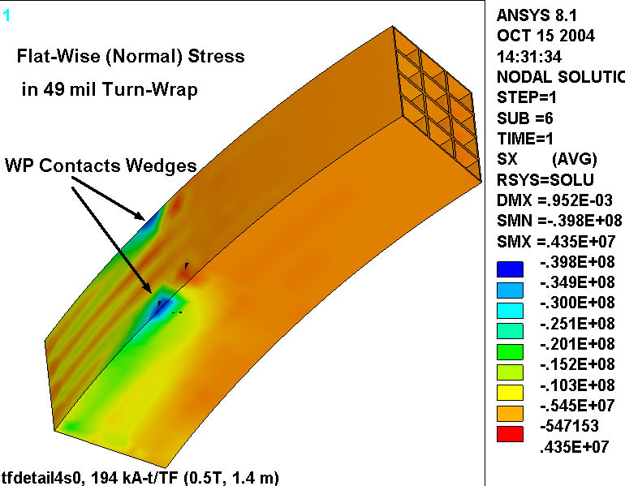

Fig. 4.5-6 Flat-Wise Insulation Stress [Pa]

Fig. 4.5-7 is a plot of the stress in the wedges and Cu conductors from this 0.5 T operating case. The greatly exaggerated deformed shape illustrates how the WP contacts the end of the wedges and tends to tear at the tips. This result is very similar to the previous configuration (as in Fig. 4.4-4), albeit at a slightly lower stress level.

- I think that the design would benefit from a generous radius around these sharp edges. It would move the contact point away from the very end of the wedges and into a region of more material. (An analysis to demonstrate this is TBD.)

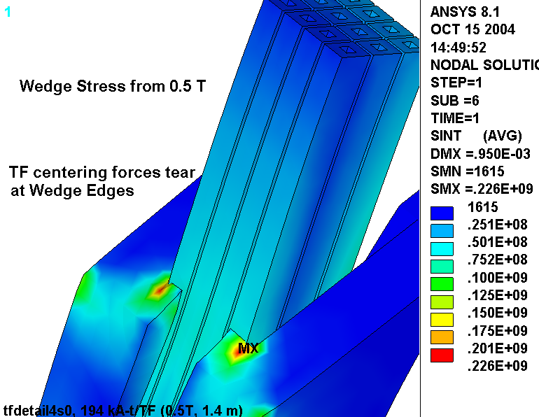
Fig. 4.5-7 Stress Intensity [Pa] in Wedges and Cu conductors

Fig. 4.5-8 is a plot of the deformations in the WP and wedges from this 0.5 T reference load case. In general, the deformations are down relative to those of the nominal 30˚ extension design (Fig. 4.4-3). This is due to the generally stiffer wedge configuration, which looks more like a 50˚ design. Also, there is an up-down asymmetry which is primarily due the softness of the unbonded WP/Wedge interface on top compared to the bonded interface on the bottom. Look closely at the wedge tips and notice a gap between the wedge and the WP at the upper tip, and the absence of said gap at the lower tip.

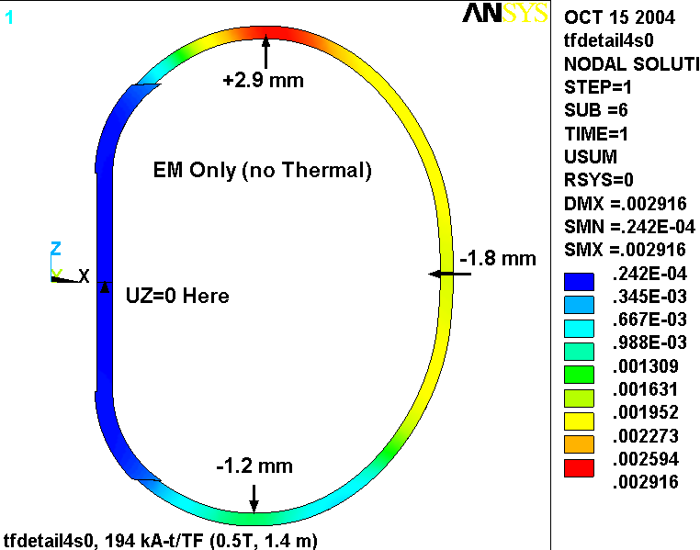
Fig. 4.5-8 Displacements from 0.5 T Loading
Add Radius Detail to Wedges

As shown below in Fig. 4.5-9, the wedge casting design is modified slightly to eliminate the sharp tab highlighted by the stress plot of Fig. 4.5-7. This detail is intended to reduce the peak stress, which generally only impacts fatigue life. At the same time, eliminating the near knife-edge profile will most assuredly reduces some high stresses in the steel and insulation which are too localized to be captured by this model.
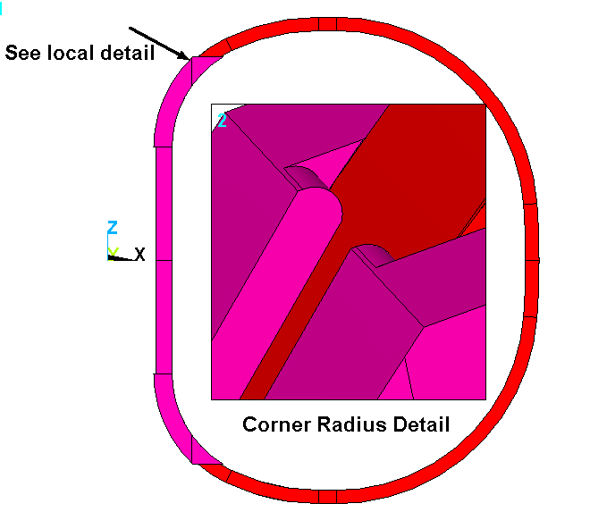

Fig. 4.5-9 Wedge Tip Radius Detail
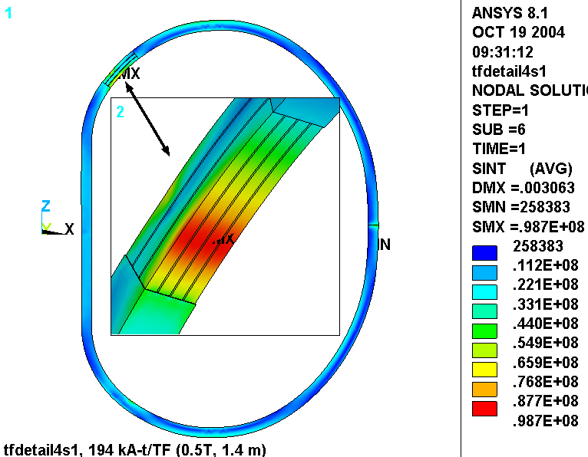
Fig. 4.5-10 is a plot of the stress intensity in the smeared WP and detailed Cu conductor array for this 0.5 T operating condition. The maximum has drifted up slightly from 94 to 99 MPa as a result of this radius detail. In reality, variations in the FE mesh from one model to the next are probably more responsible for this minor change than the addition of the 0.5” radius.

Fig. 4.5-10 Nodal Stress Intensity [Pa], Smeared WP and Discrete Cu Conductors

Fig. 4.5-11 is a plot of the stress intensity in the wedges and Cu conductor. The circled helps locate the 158 MPa peak stress. Recall that without a radius, the model reported a peak stress of 226 MPa. This ~160 MPa stress level is consistent with or below the stresses in the Modular Coil Winding Form (MCWF), which is also a cast SS part.

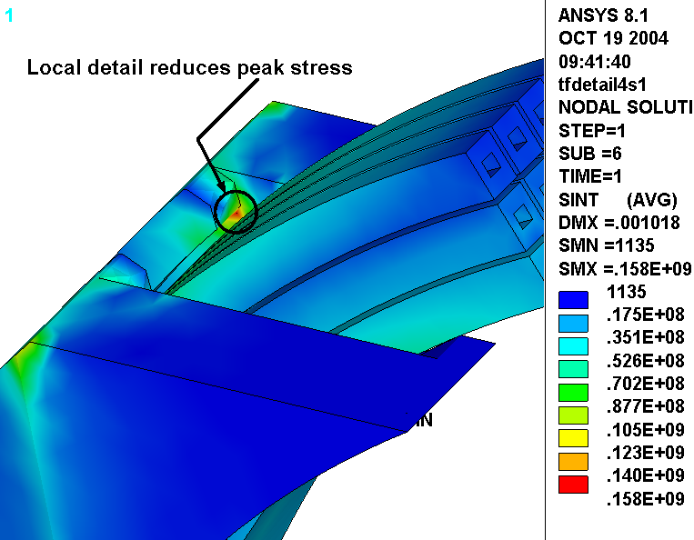
Fig. 4.5-11 Stress Intensity [Pa] in Wedges and Cu conductors

The addition of a radius to the wedge tip produces a slightly stiffer contact point at the ground wrap. Fig. 4.5-11 shows the normal stress distribution in the ground wrap and turn wrap insulation in the detailed WP region. The legend indicates that the peak contact stress has increased from 40 MPa (Fig. 4.5-7) to 50 MPa as a result of the stiffer contact point. However, this is still well below the nominal design stress for a glass-filled epoxy in flat-wise compression (460 MPa from [Error: Reference source not found]).

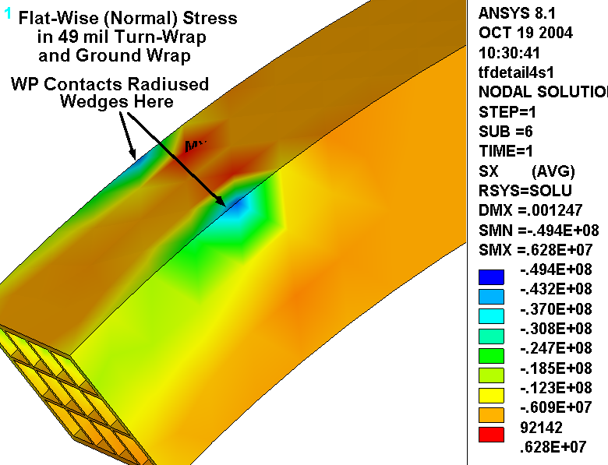

Fig. 4.5-11 Flat-Wise Insulation Stress [Pa]

4.6 Revised Insulation: Kapton Slip-Plane and 3/8” Thick GW

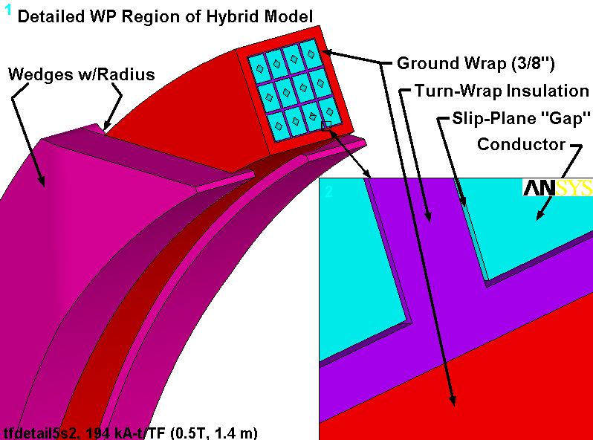
The design presented in Sect. 4.5 has evolved and is reanalyzed; the GW thickness has increased from 0.12” to 0.375”and the out-dated smeared orthotropic WP properties have been changed to reflect the new conductor and insulation slip-plane. In addition, the 4000 lb_{f}/bracket radial preload has been included in the loading. Other than these changes, the model is so similar to that of the previous section that Figs. 4.5-1, 4.5-2, 4.5-3 and 4.5-9 still apply (with the exception of the GW thickness and related dimensional changes). Fig. 4.6-1 is added here to document the slip-plane. This section presents the results from the latest stress analysis.

Fig. 4.6-1 View of Hybrid Model Showing Wedges, Detailed WP and Close-Up of Slip-Plane
Fig. 4.6-2 is a plot of the radial deflections from this 0.5 T + 4000 lb/bracket Radial Preload operating condition. Thermal contraction effects are intentionally omitted to avoid complicating the results with less interesting deflections. The annotated plot indicates that the upper wedges are connected to the WP through general surface-to-surface contact elements while the lower wedges are bonded (for computational efficiency). Vectors are used to represent the contact pressure developed locally by the preload structure. The radial component of each pressure patch integrates to about 4000 lb.

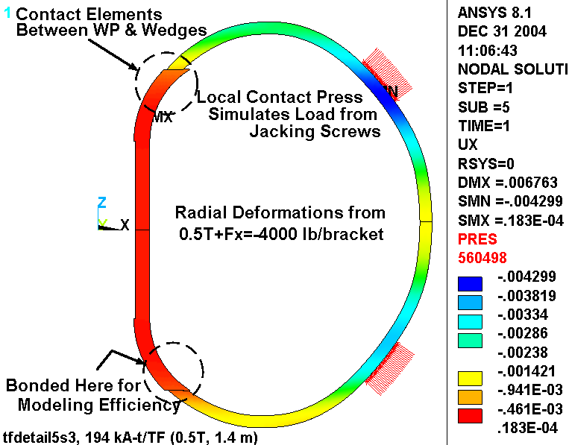
The 4.3 mm max deformation is about 1 mm more than the hybrid model shows for the 0.5 T only load case by itself, indicating the effects of the radial preload.

Fig. 4.6-2 Radial Deflections (m) in Hybrid Model from 0.5 T + 4000 lb/bracket Radial Preload
Cu Stresses

Fig. 4.6-3 is a plot of the stress intensity in the Cu conductor and local smeared WP. Elements at the detailed/smeared discontinuity are unselected as they would contaminate the stress legend with non-physical high stresses. It is a generally accepted practice to look away from the boundaries of a sub-model where artificial discontinuities in displacements, material properties and stiffness produce meaningless results. This hybrid model is essentially a submodel embedded in a full model.

Here, the maximum stress in the discrete Cu turn is 155 MPa (without thermal stresses). It appears in the edge turns which carry the brunt of the centering force as the WP contacts the wedge’s inner lip. It is worth noting that this is predominantly a compressive stress, which tends to be less dangerous (in fatigue and crack-growth) than a tensile stress of comparable magnitude.

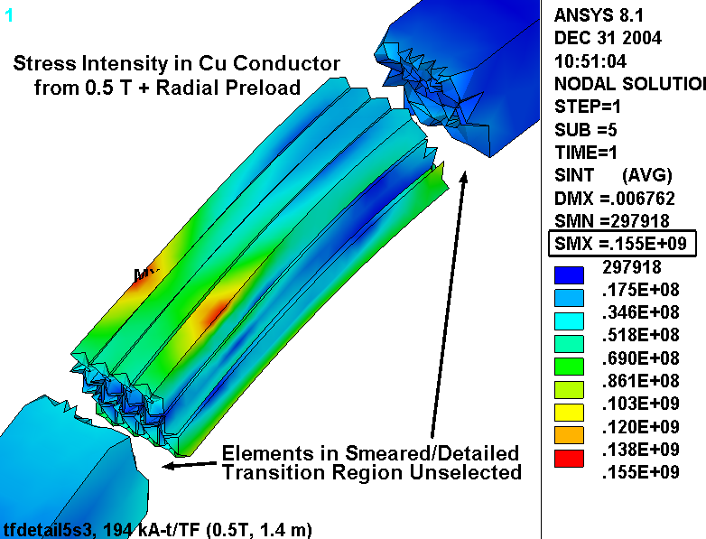
Fig. 4.6-4 is a plot of the stress intensity distribution in the max stress turn cross-section. The contours show a maximum stress at the top of the turn, a very low stress in the middle of the turn, and a slight increase in stress at the bottom of the turn. This is presented graphically in Fig. 4.6-5 which plots the TOTAL stress intensity as a function of distance across the turn (top to bottom). Of course the stress intensity is always positive, which explains the odd V-shaped curve. The plot also shows the average section or MEMBRANE stress (53 MPa) and the linearized MEM+BEND stress. It is interesting to note that the maximum TOTAL and MEM+BEND values are essentially the same (155 MPa), indicating that the local MEM+BEND allowable applies to the maximum conductor stress. In many structures, there is a sizable peak stress component that lowers the stress which must meet the MEM+BEND stress category.
Fig. 4.6-3 Stress Intensity (Pa) in Hybrid Model from 0.5 T + 4000 lb/bracket Radial Preload
Fig. 4.6-4 Stress Intensity (Pa) Max Stress Turn X-Section, 0.5 T + 4000 lb/bracket Radial Preload
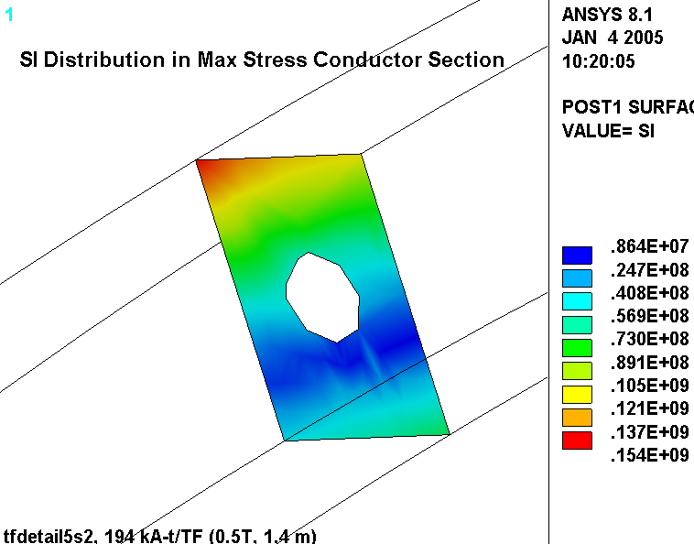
Fig. 4.6-5 Linearized Stresses (Pa) Across Max Stress Turn, 0.5 T + 4000 lb/bracket Radial Preload
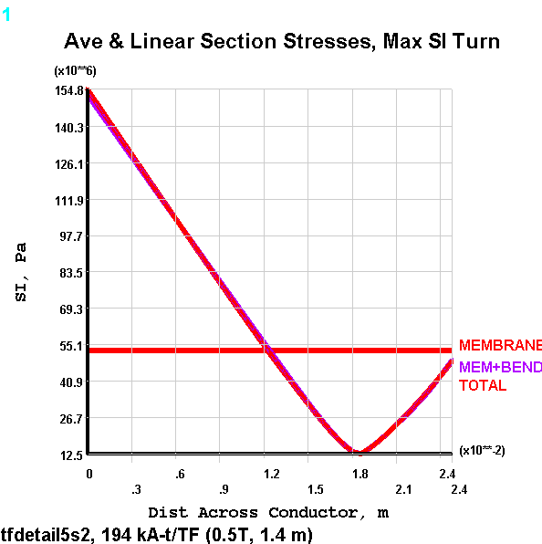
Fig. 4.6-6 is a plot of the 1st principal stress in just the Cu conductors (still excluding thermal contraction effects). It shows that the highest tensile stress occurs on the plasma-side of the WP and has a maximum value of 138 MPa.

The stress distribution in the cross-section of the max σ₁ turn is shown in Fig. 4.6-7. Of course the distribution is inverted relative to the compression-driven turn of Fig. 4.6-4. However, the trend is similar; max tension on the bottom, decaying to a small value on top. This is illustrated by the line plot of Fig. 4.6-8 which again shows little difference between the TOTAL stress and the linearized MEM+BEND stress (138 MPa). Here, the section average (MEMBRANE) is ~72 MPa.
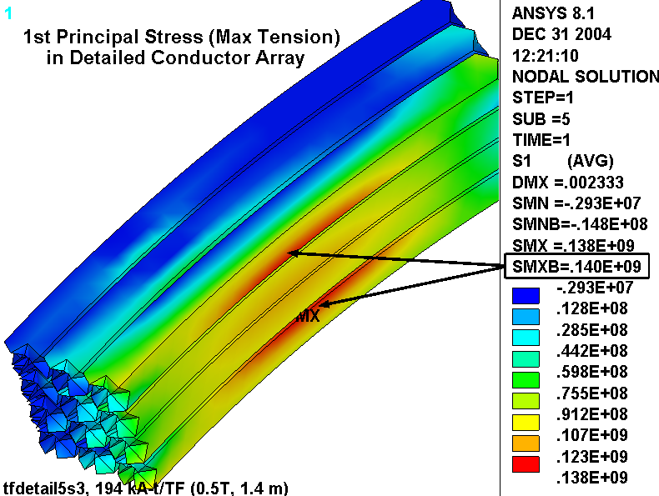
Fig. 4.6-6 Stress Intensity (Pa) in Hybrid Model from 0.5 T + 4000 lb/bracket Radial Preload
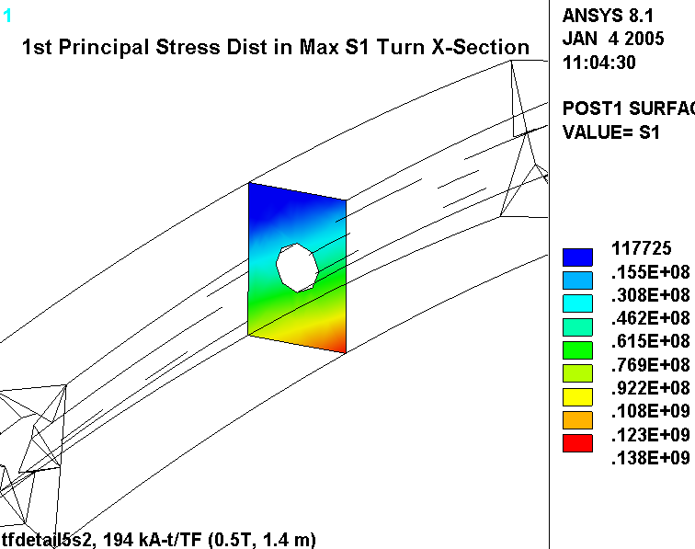
Fig. 4.6-7 Stress (Pa) in High σ₁ Turn X-Section, 0.5 T + 4000 lb/bracket Radial Preload

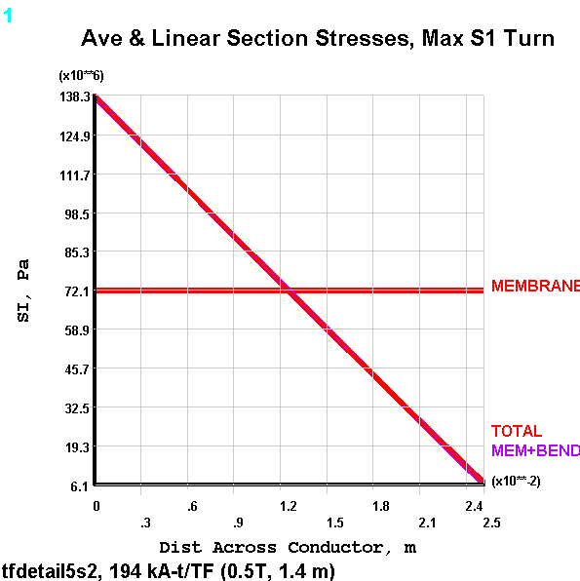
Fig. 4.6-8 Linearized Stresses (Pa) Across High σ₁ Turn, 0.5 T + 4000 lb/bracket Radial Preload
When cooldown effects are added to the analysis (85K), the low-α insulation holds back the contraction of the high-α Cu and increases the tensile stress in the conductors. This is shown in Fig. 4.6-9 which plots the 1st principal stress in the Cu turns for this 0.5 T, 85K, 4000 lb/bracket preload case. Incidentally, a plot of the stress intensity indicates the same result (max stress value and location), indicating that the maximum stress intensity is entirely determined by the 1st principal stress.
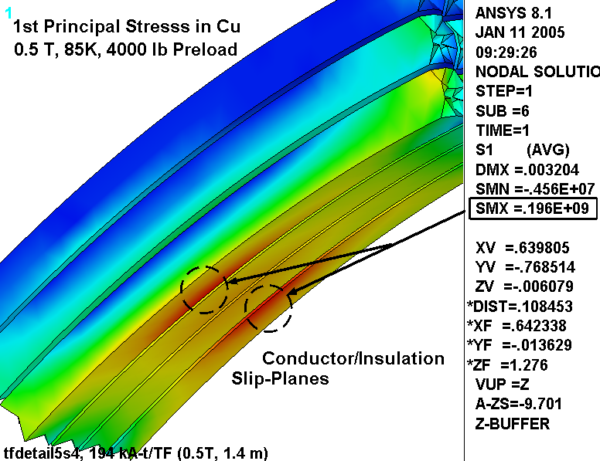

Fig. 4.6-9 Stress Intensity (Pa) in Hybrid Model from 85K, 0.5 T + 4000 lb/bracket Radial Preload
The projects structural design criteria indicates that alternating stresses from cyclic events which occur greater than 10,000 times must be accounted for in a fatigue analysis. In this case, the maximum TF conductor stress range is expected to occur 13000 times when the TF coil goes from zero current to 16.2 kA and back to zero (0.5 T operating current). The stress plots shown above include the 4000 lb/bracket radial preload and thermal contraction effects, which do not change with coil current. Therefore, the maximum alternating stress is best obtained by subtracting the stresses from 0.5 TF only (no preload or thermal contraction effect).

Fig. 4.6-10 shows the stresses in the TF conductor under this circumstance: TF at 0.5 T, zero preload, room temperature (RT). In this case, the maximum stress intensity also occurs on the high-field-side turns and is reported to be 102 MPa. A 1st principal stress plot would show that this is a tensile stress.
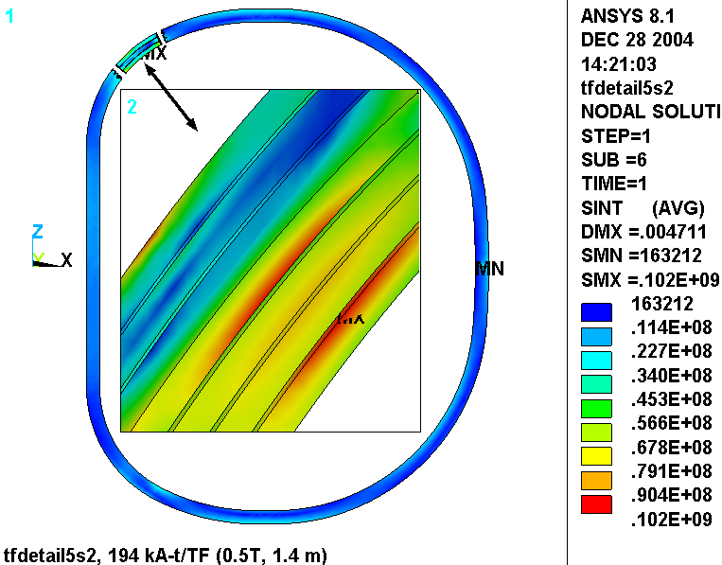

Fig. 4.6-10 Stress Intensity (Pa) in Detailed Conductor from TF at 0.5 T (RT and no radial preload)
Fig. 4.6-11 is a plot of the EM force vectors acting on half of the winding pack. It is used to illustrate the primary forces which must satisfy the primary stress requirement. The vertical force is carried as a tensile stress in the winding pack. A simplistic and conservative calculation would be to assume that the entire vertical force is carried by the conductor cross-section in the inboard leg (~0.0047 m²). This ignores the tensile capacity of the insulation and the outboard leg as a load path. The general primary stress is then calculated as:

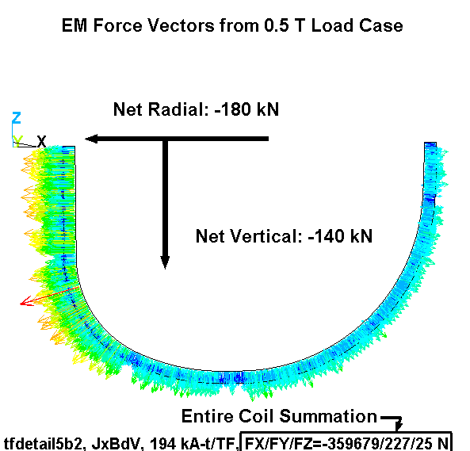
σ_{PM} = F/A = 140 kN/0.0047 m² = 30 MPa
Fig. 4.6-11 Force Vectors on Coil Half, 0.5 T EM Loading

Cu Monotonic Stress Evaluation

The design Tresca stress value (S_{m}) for our Cu TF conductor is based on a material with a specified room temperature minimum yield stress (σ_{y}) of 36 ksi (250 MPa) and a minimum ultimate tensile strength (σ_{ut}) of 42 ksi (280 MPa). These values correspond to a material with about 25% cold-work (CW).

Fig. 4.6-12 shows that for 25% CW Cu the yield stress will increase by about 14% (to 41 ksi or 290 MPa) and Fig. 4.6-13 shows that the tensile strength will increase by about 28% (to 52 ksi or 360 MPa) when cooled to 77K. Defined as the minimum of 2/3σ_{y} or ½σ_{ut} at operating temperature, S_{m} is determined to be 26 ksi (180 MPa) for this 80K coil. It’s worth noting that both of these NIST Monograph 177 figures put the 77K yield and ultimate at higher levels (330 MPa & 385 MPa, respectively), which is a source of some conservatism. The RT starting values of 250 MPa and 280 MPa indeed seem to be minimum properties.

The critical elements of the monotonic stress evaluation [Error: Reference source not found] are now in-hand:

- General Primary Membrane (P_{M}): 30 MPa (from σ_{PM} calculated above) < 180 MPa (1.0S_{m})
- Local Primary Membrane (P_{L}): 72 MPa (from Fig. 4.6-8) < 270 MPa (1.5S_{m})
- Primary Membrane + Bending (P_{M}+P_{B}): 155 MPa (from Fig. 4.6-5) < 270 MPa (1.5S_{m})
- Primary Membrane + Bending (P_{M}+P_{B}): 196 MPa (from Fig. 4.6-9) < 270 MPa (1.5S_{m})
- Total Primary + Secondary (P_{L}+P_{B}+Q): 196 MPa (from Fig. 4.6-9) < 540 MPa (3.0S_{m})

Note that the maximum stress of 196 MPa is categorized two different ways; once as P_{M}+P_{B} and again as P_{L}+P_{B}+Q. Although the incremental increase from 155 MPa to 196 MPa is due to thermal effects (typically thought of as a secondary Q stress), this thermal operating condition could be classified as a primary loading. There are no thermal gradients and it is a steady load. It has the characteristics of a primary load with the exception that it is self-limiting. We will conservatively assume that there is no Q-stress in the TF coil.

Fig. 4.6-12 Temperature Effects on Tensile Yield for 25% CD Conductor
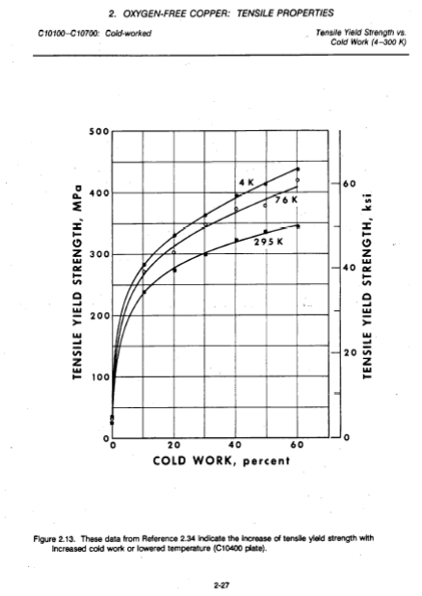
(From http://ncsx.pppl.gov/NCSX_Engineering/Materials/CopperProperties/PB92172766.pdf)

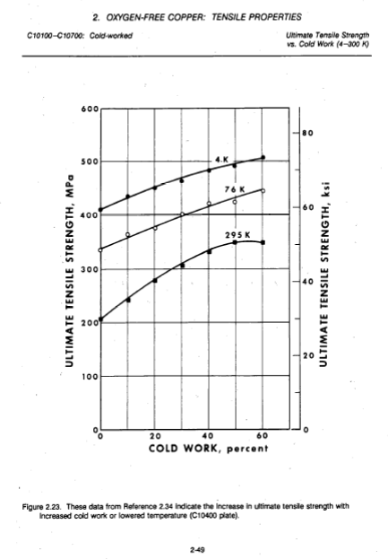
Fig. 4.6-13 Temperature Effects on Tensile Ultimate Strength for 25% CD Conductor
(From http://ncsx.pppl.gov/NCSX_Engineering/Materials/CopperProperties/PB92172766.pdf)

Cu Fatigue Evaluation

The critical elements of the fatigue analysis [Error: Reference source not found] are also now in-hand, but some data manipulation is required.

On the tension side of the WP, the 0.5 T operating condition produces a stress range from 94 MPa (196 MPa – 102 MPa) to 196 MPa. This is equivalent to a mean stress (σ_{mean}) of 145 MPa with an alternating stress (σ_{alt}) of ±51 MPa.

Since the proposed design-basis fatigue curve (Fig. 4.6-13) does not include mean stress effects, an equivalent alternating stress (σ_{eq}) for each side of the WP must be calculated [Error: Reference source not found]:

σ_{eq} (tension) = σ_{alt} / {1 - σ_{mean}/σ_{ut}} = 51/{1-94/360} = 69 MPa

With an alternating stress of ~70 MPa, the number 0.5 T TF cycles to failure (from the design-basis fatigue curve) is 130k. With a design life of 13k cycles, this stress cycle has a Usage Factor of 13k/130k or 0.1.

Of course there are other operating conditions which contribute to the total fatigue damage, such as 1.7 T Ohmic and 2.0 T High-β. However, the simplistic global model analysis of these operating conditions indicates that the stresses are off by a factor of two relative to the 0.5 T case. Stresses at this level have an allowable number of cycles >10⁷ and will add very little to the conductor’s cumulative usage factor (117k/10M=0.012). In fact, one could conservatively assume that all 130k design cycles are 0.5 T pulses and still demonstrate a Cumulative Usage Factor (CUF) of 1.0 (130k/130k), which predicts a conductor failure on the last cycle of the machine’s design life.

Cumulative Usage Factor: 0.10 + 0.01 = 0.11 < 1.0
Fig. 4.6-14 Source of Proposed Design-Basis Cu Fatigue Curve
(From http://ncsx.pppl.gov/NCSX_Engineering/Materials/CopperProperties/PB92172766.pdf) Notice that the σ/2 curve is more limiting than the N/20 curve.
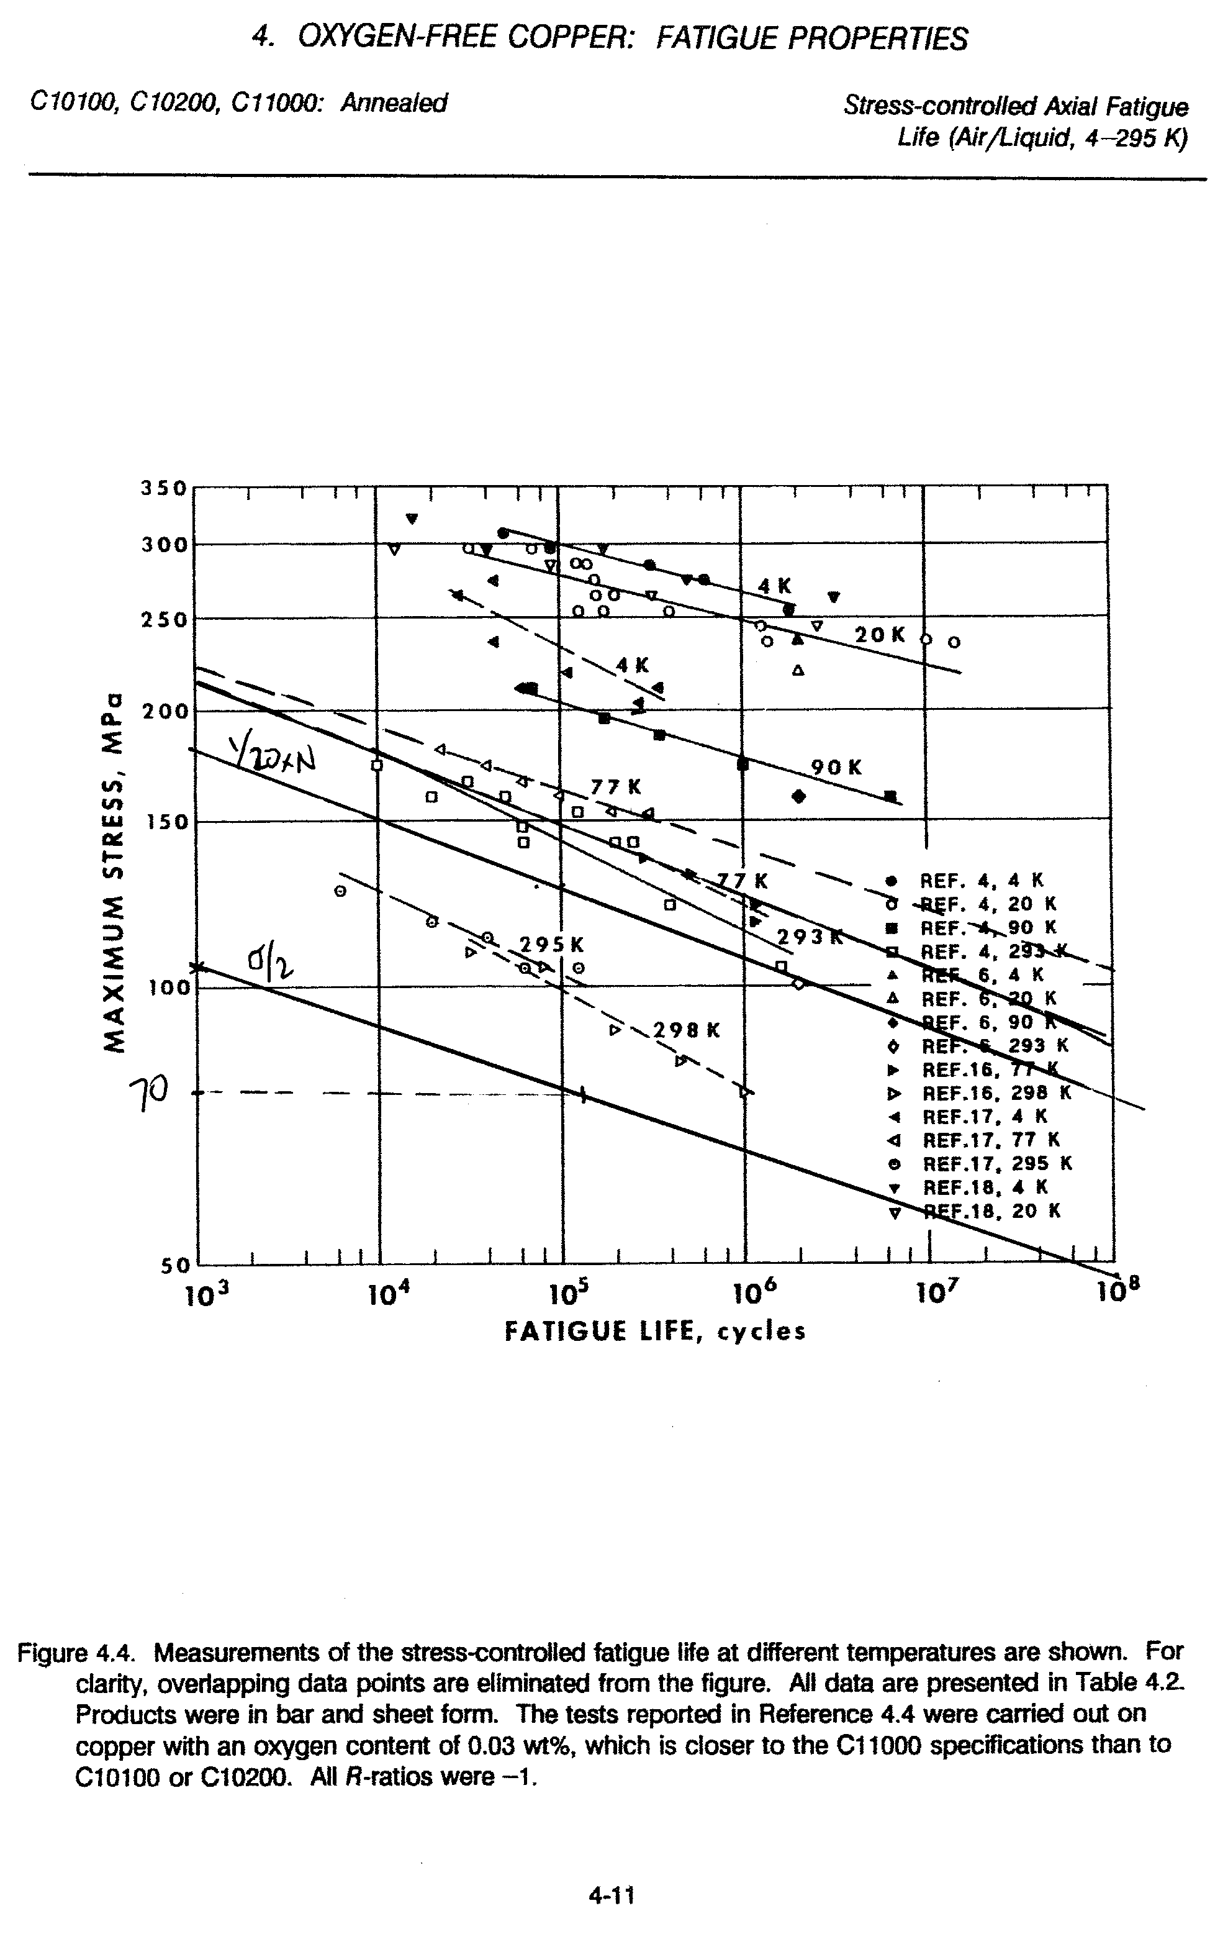
Insulation Stresses

Normal and in-plane stresses in the insulation are highlighted in two contour plots. Fig. 4.6-15 is a plot of the local X (flat-wise, normal) stress in the GW and turn-wrap insulation. The source of the highly localized stress is of course where the WP contacts the ¾” wide tips of the cast wedges. (Fig. 4.5-7 shows this nicely except with the insulation removed.) The plot legend indicates a maximum compressive stress (SMN) of -120 MPa.
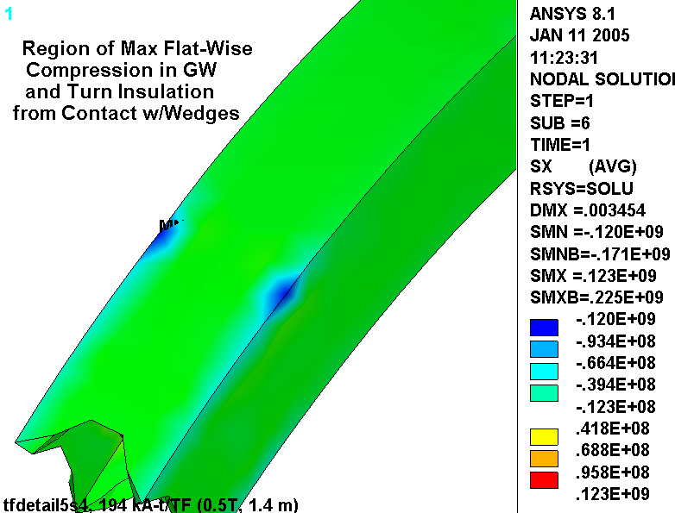
Fig. 4.6-15 Normal Stresses (Pa) in Insulation from 0.5 T, 85K + 4000 lb/bracket Radial Preload
Fig. 4.6-16 is a plot of the local Y & Z (in-plane) stress in the GW and turn-wrap insulation. Local in-plane components are combined by SRSS to produce this result, so the sign is lost. This detail is unimportant as the in-plane stress allowable is based on ±0.5% strain.
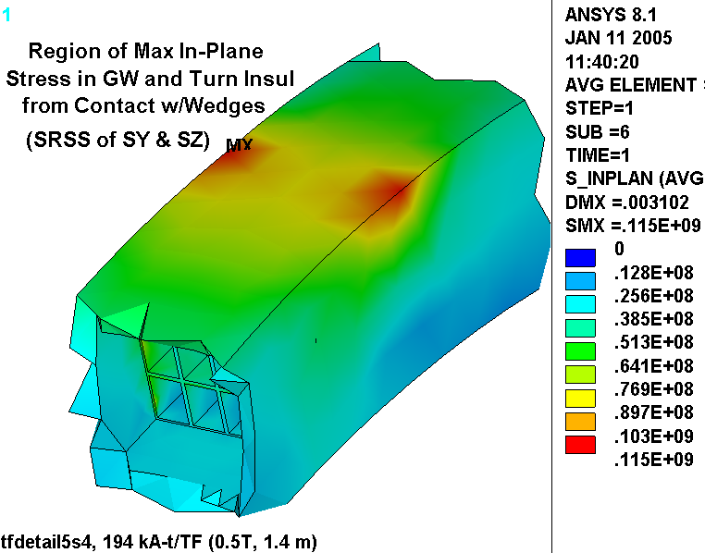

Fig. 4.6-16 In-Plane Stresses in Insulation from 0.5 T, 85K + 4000 lb/bracket Radial Preload
Insulation Stress Evaluation

The project’s design criteria document [Error: Reference source not found] presents an extensive outline for qualifying insulation stress. Requirements are paraphrased below:

- Flatwise (through-thickness) compressive stress shall be limited by 2/3 of the ultimate stress.
- Compressive fatigue allowable stress shall be equal to the lesser of 2/3 of the ultimate compressive fatigue stress measured at the lifetime number of cycles or the ultimate compressive fatigue stress at temperature at 5x the lifetime cycles.
- Normal to the adhesive bonds between metal and composite, no primary tensile strain is allowed. Secondary strain will be limited to 1/5 of the ultimate tensile strain of the adjacent insulation. In the absence of specific data, the allowable tensile strain is 0.02% in the insulation adjacent to the bond.
- The maximum tensile or compressive strain permitted in the plane of the insulation material is either +0.5% or -0.5%.
- The shear-stress allowable, S_{s}, for either static or fatigue conditions is given by:

S_{s} = 2/3 τ_{o} + c₂ S_{c}(n)
Where,

τ_{o} is the experimentally determined minimum intrinsic shear strength with no compressive load (the lower of the bond shear strength or the composite interlaminar shear strength).

c₂ is an experimentally determined factor representing the slope of the dependence of shear strength on compressive stress.

S_{c}(n) is the local normal compressive stress.

Aside: Allowable Stress Levels at 77K (close enough to the 85K operating temperature)

There is an ITER insulation design document which contains test data and recommended design values for a number of insulations systems. The NCSX system has a Kapton wrap followed by a VPI’d S2 glass. The ITER document does not list this specific system, but does have a “very similar product,” according to Paul Fabian of CTD, Inc.; CTD112/Prepreg S-2 glass with interleaved Kapton, hereafter referred to as Prepreg/Kapton.

- Under flatwise compression, G-10/11CR has an ultimate strength of about 700 MPa, while the TGDM Pre-Preg/Kapton system has a 200,000 cycle fatigue strength of 600 MPa[Error: Reference source not found]. The stress limit used here is conservatively based on the lower value: 2/3 x 600 or 400 MPa.

- The first insulating layer is Kapton, which will essentially ensure a poor bond between the insulation and the Cu. Therefore, no significant through-thickness tensile stresses are likely to develop. The model simulates this by assuming a slip plane capable of carrying compression only. Ref. [Error: Reference source not found] allows a tensile strain of <0.02%, or (0.0002)(19 GPa)=3.8 MPa.

- The ultimate in-plane tensile strength of G-10/11CR is anisotropic, with values of ~460 MPa in the Warp direction and ~800 MPa in the Fill direction (from [Error: Reference source not found]). We will assume that the lesser of these two values applies: 460 MPa and multiply by 2/3 to get an allowable of 310 MPa. When no insulation-specific data is available, the in-plane tensile allowable is based on the +0.5% strain limit, which is 0.005 x 26 GPa or 130 MPa. It is worth noting that this value is conservative by about a factor of two relative to the G-10/11CR value.

- The ultimate in-plane compressive strength of G-10/11CR is also anisotropic, with values of ~550 MPa in the Fill direction and ~800 MPa in the Fill direction (from [Error: Reference source not found]). We will assume that the lesser of these two values applies: 550 MPa and multiply by 2/3 to get an allowable of 360 MPa. When no insulation-specific data is available, the in-plane compression allowable is based on the -0.5% strain limit, which is -0.005 x 26 GPa or -130 MPa. It is worth noting that this value is conservative by almost a factor of three relative to the G-10/11CR value.

- The ITER document recommends values of τ_{o} and c₂ for Prepreg/Kapton insulations of 40 MPa and 0.32 (non-etched Kapton) respectively, when the coil is subject to a fatigue environment.

The critical elements of the Insulation stress analysis are now in-hand:

- Flat-Wise Compression: -120 MPa (from Fig. 4.6-15) < 400 MPa
- In-Plane Tension & Compression: 115 MPa (from Fig. 4.6-16) < 130 MPa
- Through-Thickness Tensile Stress: See Below.
- Shear/Compression: See Below.

A detailed analysis of the shear/compression stresses in the winding pack insulation requires some postprocessing operations which are consistent with the design criteria captured in the equation:

S_{s} = 2/3 τ_{o} + c₂ S_{c}(n)

Recall that τ_{o} is set at 40 MPa and c₂ is set at 0.32 (assuming non-etched Kapton). The normal stress, S_{c}, must be determined on an element by element basis. The resulting allowable shear stress, S_{s}, is then compared to the local shear stress (τ), also on an element by element basis.

Table 4.6-1 contains a summary of the insulation shear/compression stress analysis which is outlined above. Results are reported for coil detailed winding pack (WP) turn insulation. Recall that the analysis postprocessing determines the fraction (or percentage) of material which “passes” the criteria. Clearly, the goal is to achieve 100%. A small fraction of the turn wrap insulation elements fail the normal stress criteria while all of them pass the shear stress criteria.
The tabulated results indicate that shear (τ) and normal (⊥) stresses now pass the criteria in essentially all of the detailed winding pack insulation. This is illustrated by a normal stress plot where compressive stresses are contoured red and tensile stresses above the allowable are contoured grey (Fig. 4.6-17). The embedded title shows the results of a volumetric summation of elements which pass the shear and normal stress requirements; 99.8%.

Table 4.6-1 Insulation Shear Stress Evaluation Results
Detailed WP Material which Passes Criteria (%)
Loading | WP(⊥) | WP(τ) | WP(⊥ + τ)
0.5 T + Radial Preload at RT | 99.8 | 100 | 99.8

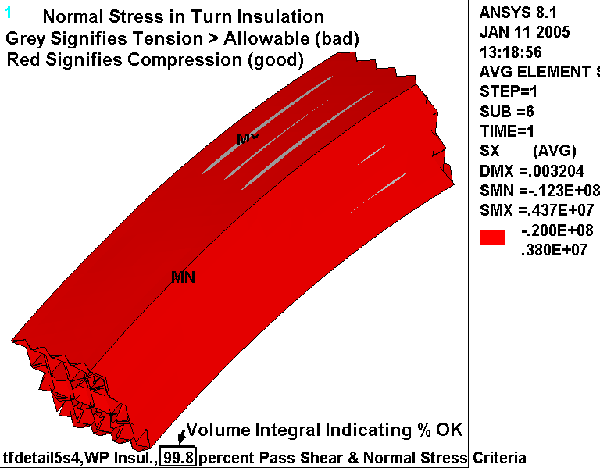
Fig. 4.6-17 Normal Stresses in Turn Insulation from 0.5T EM, 85K & Radial Preload

SS Wedge Casting Stresses

The maximum stress in the SS wedges occurs as a result of the radial force (EM + Preload) pushing against the ¾” lips. This contact force concentrates at the extremes of the wedges, as indicated by the peak in the stress field shown in Fig. 4.6-18. Left and right wedges are shown but do not indicate symmetric results: 343 MPa & 267 MPa. This can only be a result of some lack of symmetry in the contact element convergence as the model and loading are exactly symmetric. It is also worth noting that these stresses include a significant contact stress component, which generally must satisfy its own allowable stress.

Fig. 4.6-19 is a similar set of plots representing the 1st principal stress in this same region. This time, the maximum tensile stress in each wedge is identical; 203 MPa.

Fig. 4.6-20 is a plot of the 1st principle stress in the cast wedge as a result of the 0.5 T operating condition. This stress provides the stress range aspect of the cyclic load, while Fig. 4.6-19 provides the maximum stress.

The 0.75” wide by 1” deep lip must carry most of the radial load from the coil (EM + Preload) as a shear stress. (Some of the radial load will be carried by friction from toroidal compression on the sidewalls.) Let’s assume that the radial load is carried over the top 2.5” of the lip (a seemingly very conservative assumption considering the ~25” lip length). The radial load from the 0.5 T operating condition is 360 kN per coil (see the embedded plot title of Fig. 4.6-11). The radial preload is 4000 lb/bracket x 2 brackets per coil. Therefore, the average shear stress in the wedge lip (τ_{WL}) is:

τ_{WL} = {(360 kN x 0.2248 lb/N x 1000 N/kN) + 8000 lb} / (1” wide x 2” long x 4 lips/coil) = 11 ksi

SS Wedge Casting Stress Evaluation

It is assumed that the wedge casting material will be comparable to 304SS. The NCSX web site lists 304 minimum RT yield and ultimate stress values of 30 ksi and 75 ksi, respectively. It is expected that the yield stress will increase by about 100% and the ultimate strength will increase by about 150% at the LN2 operating condition [Error: Reference source not found], which puts these values at 60 ksi and 190 ksi. The design stress, S_{m}, based on these values is 2/3σ_{y} or 40 ksi (270 MPa).

The Structural Design Criteria [Error: Reference source not found] requires that the average shear stress must be less than 0.6S_{m}, or 24 ksi (160 MPa). This is well below the 11 ksi (76 MPa) shear stress calculated above, and indicates that the shear in the lips is acceptable.

The most limiting monotonic stress criterion is P_{L}+P_{B}<1.5S_{m} = (1.5x270 MPa) = 400 MPa. Even if we conservatively categorize the largest stress (343 MPa) as P_{L}+P_{B}, the criterion is satisfied. (Some portion of this number is a contact stress or peak stress which is not normally included in P_{L}+P_{B}.)

Fig. 4.6-18 Stress Intensity (Pa) in SS Wedges from 0.5T EM, 85K & Radial Preload
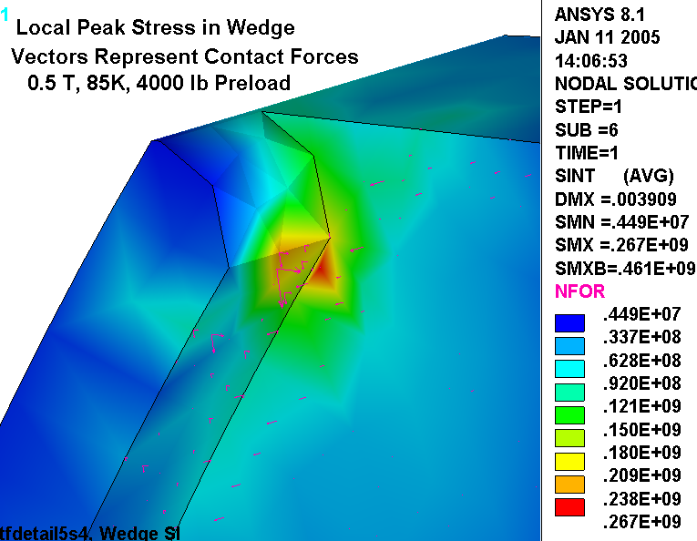
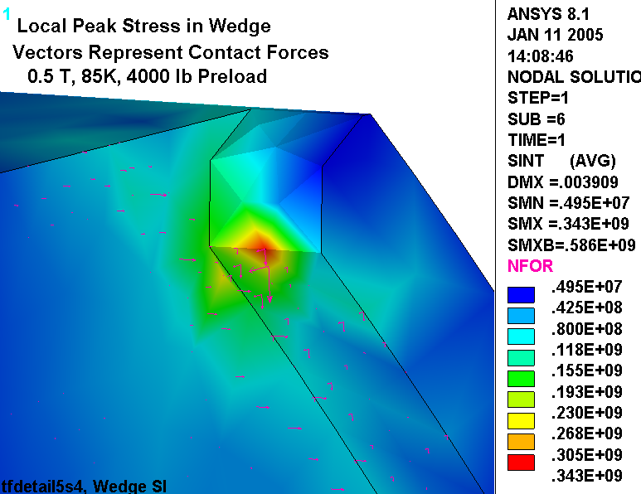
Fig. 4.6-19 1st Principal Stress (Pa) in SS Wedges from 0.5T EM, 85K & Radial Preload
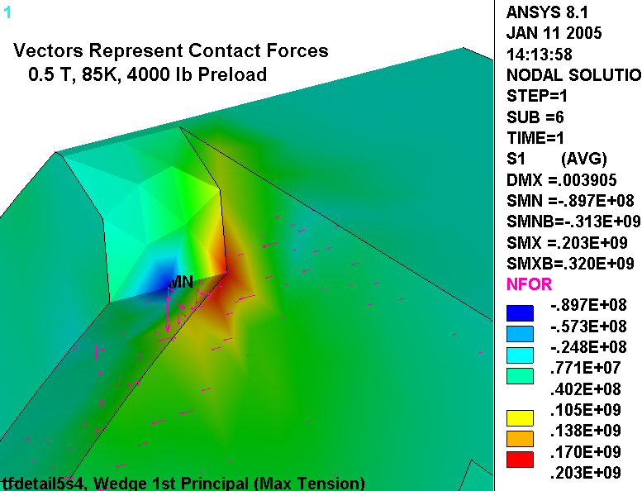
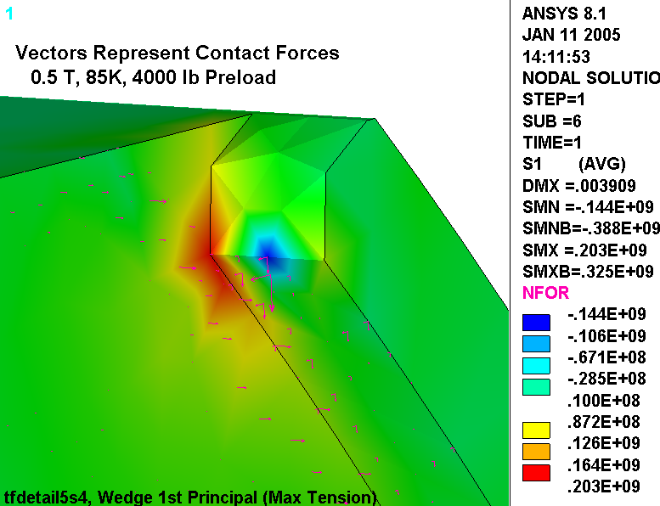
Fig. 4.6-20 1st Principal (above) & Stress Intensity (below) in SS Wedges from 0.5T EM
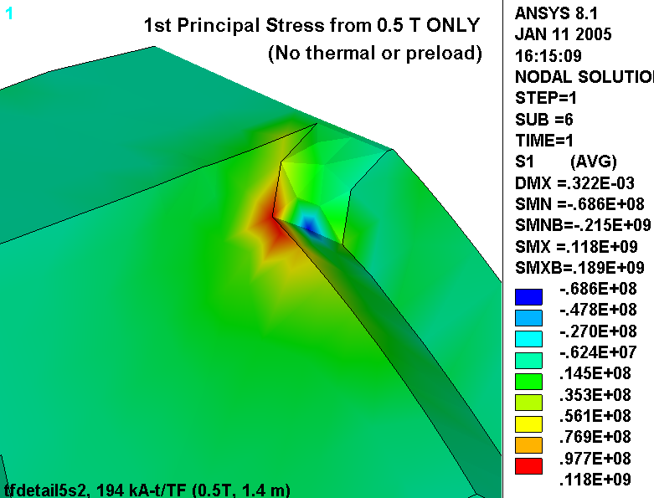
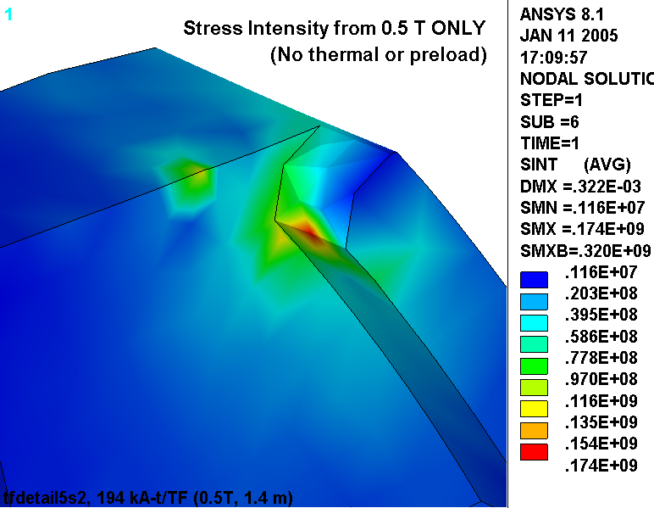
The castings are subjected to a cyclic loading, just like the Cu conductor. The model results are used to determine a maximum stress cycle to be used in a fatigue analysis.

Max 1st Principal Stress

Fig. 4.6-19 indicates that the maximum 1st principal stress (σ₁) is 203 MPa. Fig. 4.6-20 indicates that the σ₁ stress range is 118 MPa. This defines the mean and alternating components of the σ₁ stress cycle: σ_{mean} = {203 +(203 -118)}/2 = 144 MPa with an alternating stress (σ_{alt}) of ±59 MPa.

A design-basis fatigue curve for the 304 cast material is presented in Fig. 4.6-21. It is developed from notched and annealed 304L material with a fully-reversing (R=-1) stress. The notched data is conservative but consistent with the discontinuity at the base of the wedge lip (unless a fillet is added to the drawing). As with the Cu conductor, an equivalent alternating stress must be determined based on the following:

σ_{eq} (tension) = σ_{alt} / {1 - σ_{mean}/σ_{ut}} = 59/{1-144/1300} = 66 MPa (10 ksi)

With an alternating stress of 66 MPa (10 ksi) the number 0.5 T TF cycles to failure (from the σ/2 design-basis fatigue curve) is >10⁵, possibly 1M although this is an extrapolation. With a design life of 13k cycles, this stress cycle has a Usage Factor of 13k/>100k or <0.13. As with the Cu fatigue analysis, other stress cycles exist, but produce stresses which are down by a factor of two from this level. Consequently, the other stress cycles contribute negligibly to the Cumulative Usage Factor of the wedges, which is well below 1.0.

Max Tresca Stress

Fig. 4.6-18 indicates that the maximum stress intensity (σ₁) is 343 MPa. Fig. 4.6-20 indicates that the stress intensity range is 174 MPa. This defines the mean and alternating components of the SI stress cycle: σ_{mean} = {343 + (343 -174)}/2 = 256 MPa with an alternating stress (σ_{alt}) of ±87 MPa. An equivalent alternating stress must be determined based on the following:

σ_{eq} (tension) = σ_{alt} / {1 - σ_{mean}/σ_{ut}} = 87/{1-256/1300} = 110 MPa (16 ksi)

With an alternating stress of 110 MPa (16 ksi) the number 0.5 T TF cycles to failure (from the σ/2 design-basis fatigue curve) is still >10⁵ possibly 300k although this is a slight extrapolation. With a design life of 13k cycles, this stress cycle has a Usage Factor of 13k/>100k or <0.13. Again, other stress cycles exist, but produce stresses which are down by a factor of two from this level. Consequently, the other stress cycles contribute negligibly to the Cumulative Usage Factor of the wedges, which is well below 1.0.
Fig. 4.6-21 Proposed Design-Basis Fatigue Curve for 304SS Cast Wedges (σ/2 curve)
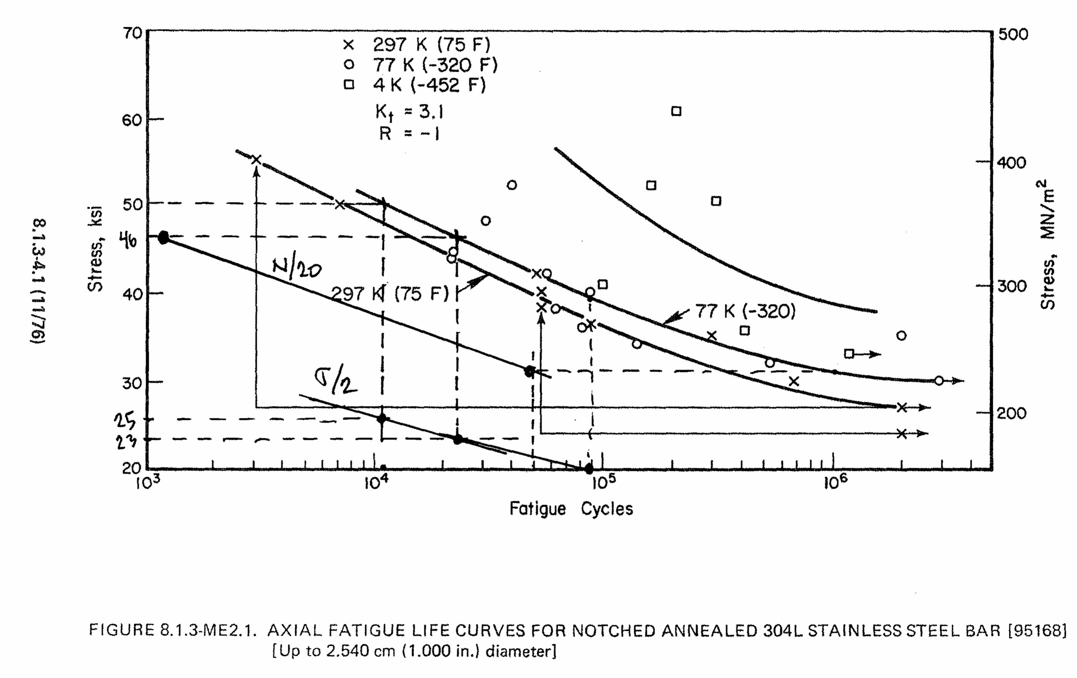

4.7 Design Revision: WP/Wedges Bond, GW thickness 1/8” & 3/8”, Preload Applied at Wedges

The latest design modification includes the following:

- The thickness of the GW is reduced in the region of the wedge castings from 3/8” to 1/8”.
- The location of the radial preload is moved from the back leg to the wedge castings.
- The WP is bonded to the wedge castings along their entire interface.

These changes are reflected in the hybrid model plot of Fig. 4.7-1 shown below. This design is evaluated with two different analyses. In the first analysis (4.7.1), the wedges are bonded to the coil GW. Stresses in the Cu conductor, insulation and wedge castings are determined for two load cases: 85K + Preload and 85K + Preload + 0.5 T EM loads, and compared to the project’s structural design requirements. In the second analysis (4.7.2), a worst-case deterioration in the structure is postulated, where the bond between the wedges and GW is replaced by a slip-plane. Again, two load cases are analyzed and results are compared to design allowable values. All analyses are performed in SI units, with displacements in meter [m] and stresses in Pascal [Pa].

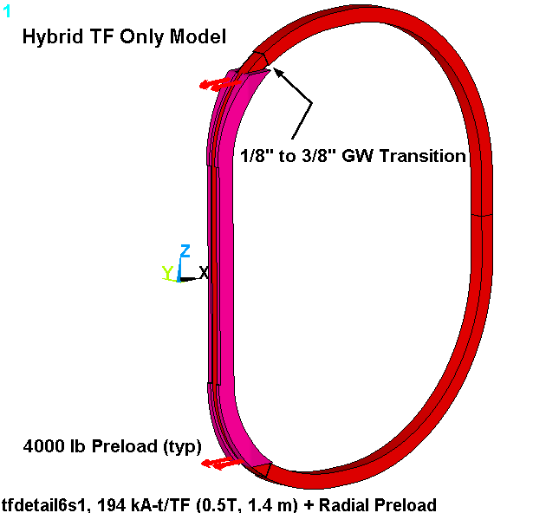
Fig. 4.7-1 Hybrid Model with Varying GW thickness and Radial Preload Application Points
4.7.1 Wedges Fully Bonded to WP Ground Wrap (ANSYS Results File: tfdetail6s1.*)

The graphical results and stress evaluation contained in this section correspond to the so-called bonded configuration. In this case, the wedge and WP ground wrap volumes are “glued” together before they are meshes. This forces perfect structural continuity between these parts.

Fig. 4.7.1-1 shows plots of the displacement modulus from 85K + Preload (upper plot) and with the addition of 0.5 T EM loading (lower plot) along with undeformed geometry. The coil is supported at the equator for modeling convenience, and has no influence on stresses or relative displacements. When the coil is cooled to 85K, then the outboard leg moves in about 8 mm. When the coil is energized to 0.5 T, the upper and lower arcs in the transition region straighten slightly producing a more oval-shaped coil and pull the outboard leg inward an additional 2.2 mm.

Figs. 4.7.1-2 through 4.7.1-4 show the stress intensity distribution in the Cu conductor from 85K + Preload, 0.5 T EM only, and the combined effects of 85K + Preload + 0.5 T EM. They provide the local primary and peak stress history, which are subsequently used in a series of stress qualification calculations.

Fig. 4.7.1-5 show plots of the turn and GW insulation flat-wise stress from this design-basis loading (85K + Preload + 0.5 T EM). They show that the maximum compressive stresses occur on the low-field side of the WP where the coil presses against the lips of the wedge castings. The worst tensile stress is only visible by the small red spot in the turn insulation on the high-field side of the WP.

Fig. 4.7.1-6 is a plot of the in-plane stress component in the turn-wrap and GW insulation. The maximum stress occurs on the low-field side of the WP, and is predominantly due to toroidal compression. The sign of the stress is lost when the two local in-plane components are combined by SRSS.

Fig. 4.7.1-7 show flat-wise stress plots of the turn and GW insulations and the results of the shear/compression stress evaluation. The plots contour all normal stresses less than 3.8 MPa (i.e., compressive stresses and tensile stresses < 3.8 MPa) as red. Grey values indicate local tensile stresses greater than 3.8 MPa. The grey signifies “danger” regions where normal stresses exceed the allowable for the insulating material. If we ignore the grey areas at the ends of the detailed region (stresses contaminated by the material discontinuity), then we see small areas on the toroidal faces where the wedging pressure becomes tensile, and on the high-field side where the WP is held out (radially) because of the bond to the casting. Both plots capture the results of a numerical integration and report the percentage of insulation which passes the shear/compression criteria: ~100% of the turn wrap and 92% of the ground-wrap.

Fig. 4.7.1-8 is a plot of the stress intensity in the equatorial region of the wedge castings. This area is away from local stress concentrations and geometric discontinuities, and could be considered a place which must pass the Primary Stress requirement. The average primary stress here is about 20 MPa, while the primary plus secondary stress average is about 30 MPa.

Figs. 4.7.1-9 and 4.7.1-10 are plots of the stress intensity in the wedges from all loads and EM only, respectively. These are used to perform a fatigue analysis of the castings. The maximum stress occurs at the tip of the wedged surface.
Fig. 4.7.1-1 Displacements, Bonded Configuration, 85K+Preload (upper) and with 0.5T EM (lower)
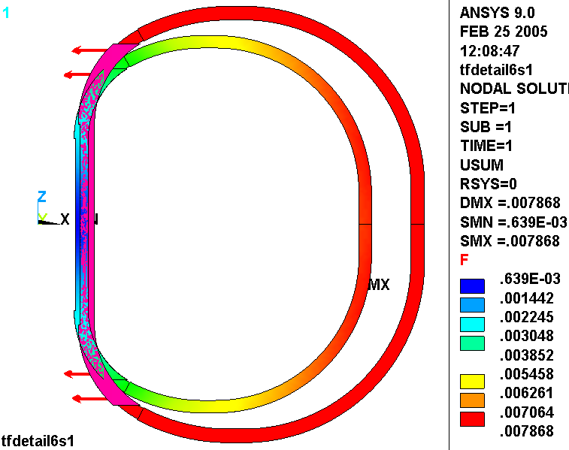
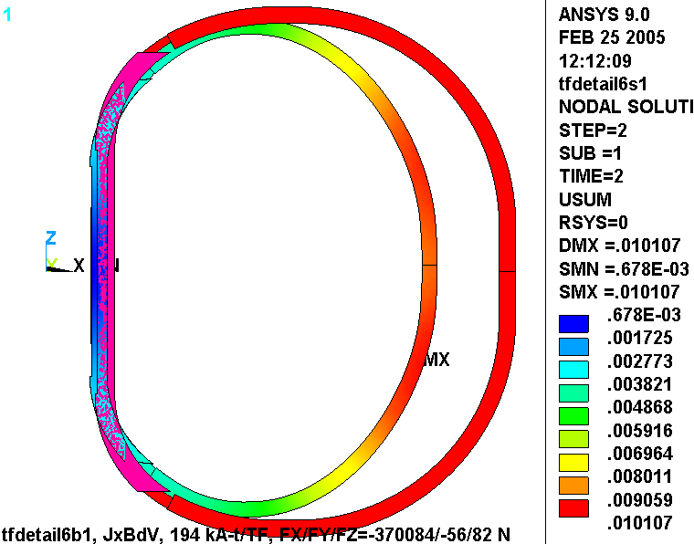
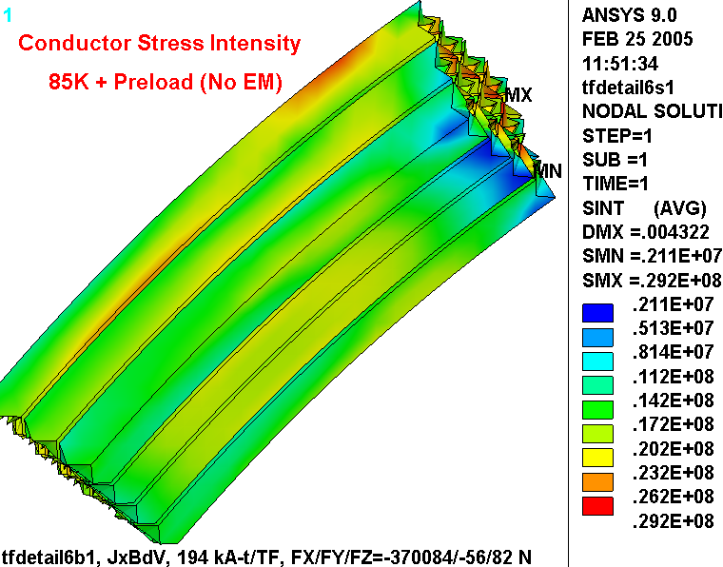
Fig. 4.7.1-2 Cu Conductor Stress (Pa), 85K + 4000 lb/bracket Radial Preload

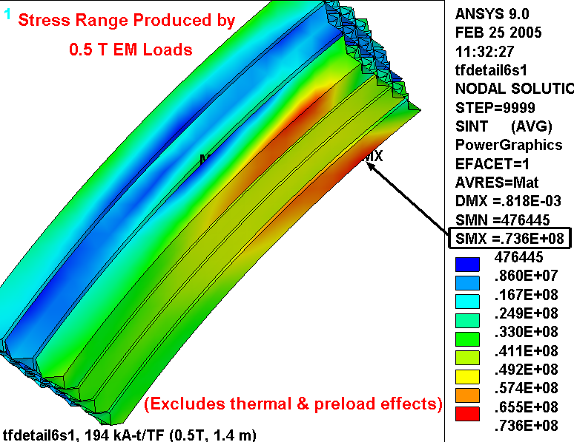
Fig. 4.7.1-3 Cu Conductor Stress (Pa), 0.5 T EM Loading

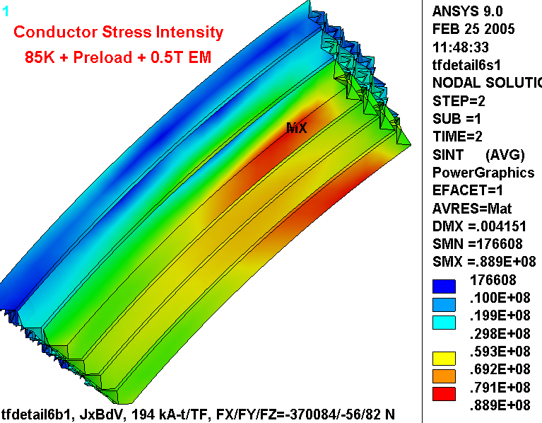
Fig. 4.7.1-4 Cu Conductor Stress (Pa), 85K + Radial Preload + 0.5 T Loading

Fig. 4.7.1-5 Turn (upper) and GW (lower) Flat-Wise Stress (Pa), 85K + Preload + 0.5T EM
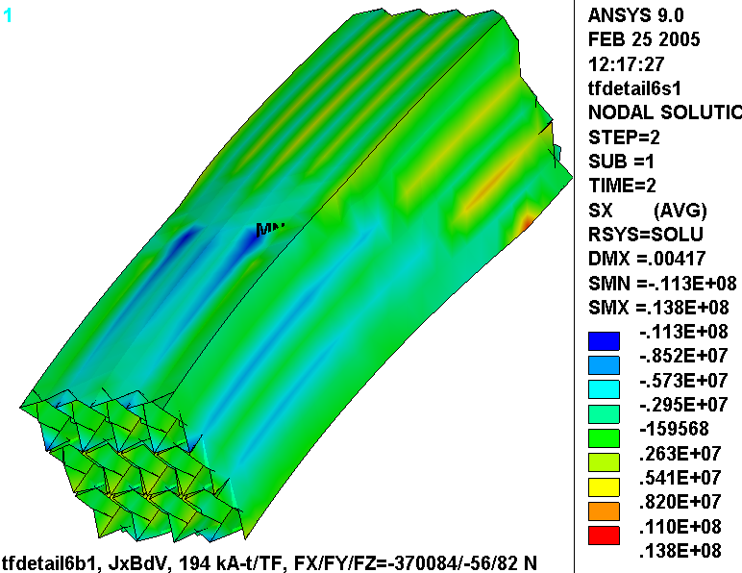
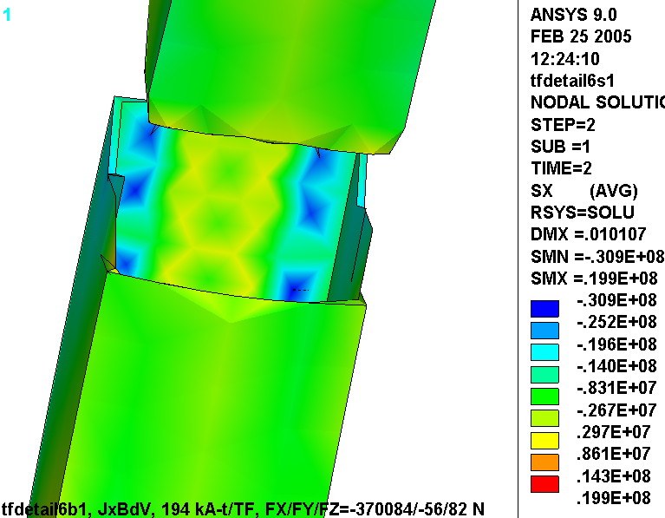
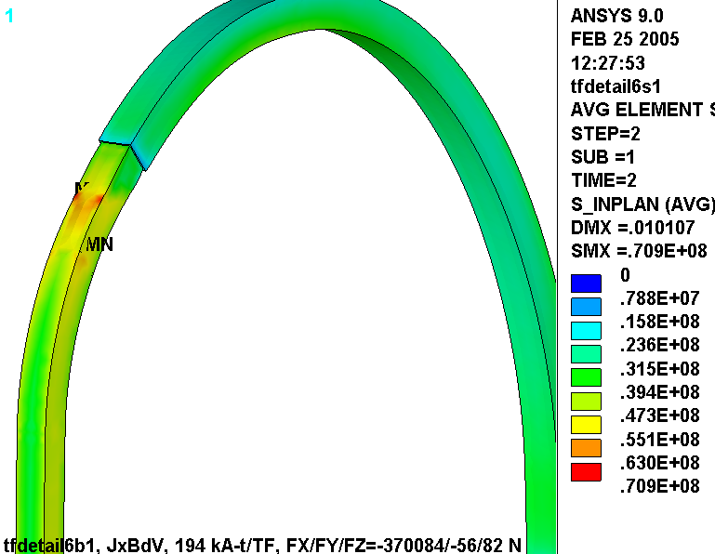
Fig. 4.7.1-6 In-Plane Turn (hidden) and GW Insulation Stress (Pa), 85K+Preload+0.5T EM Loading

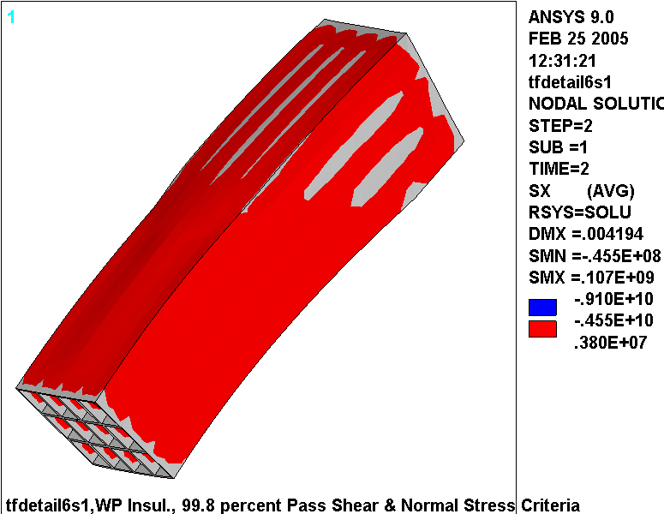
Fig. 4.7.1-7 Shear/Compression Insulation Stress Evaluation, 85K + Preload + 0.5T EM Load
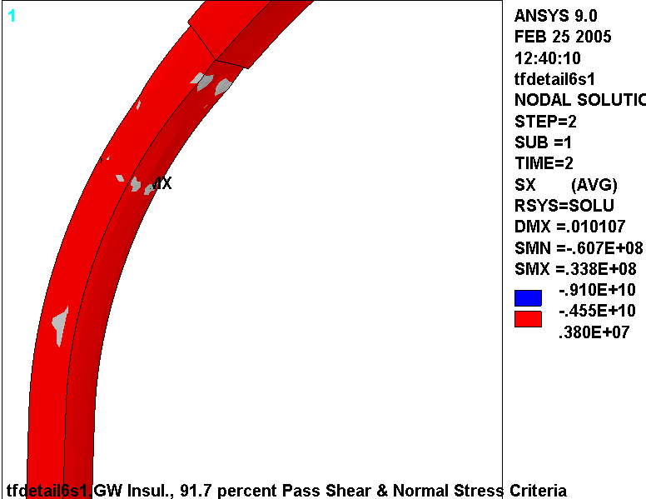
Fig. 4.7.1-8 Stress in Wedge Casting Mid-length, 0.5T only (upper) & 85K+Preload+0.5 T (lower)
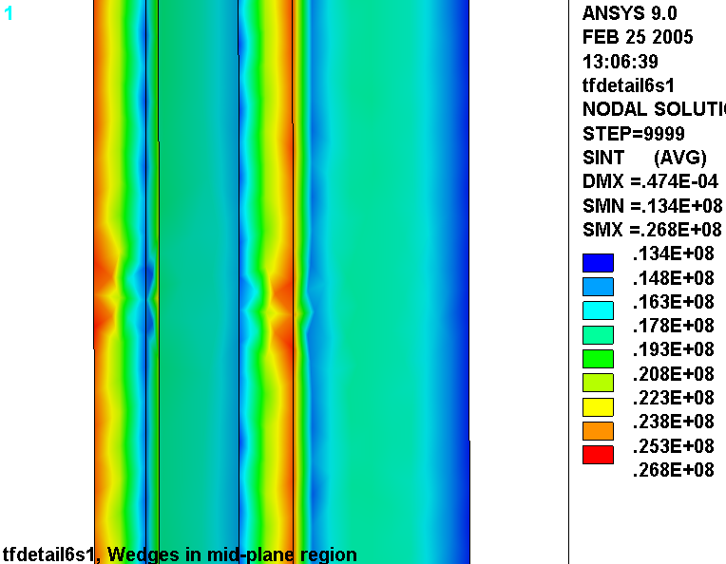
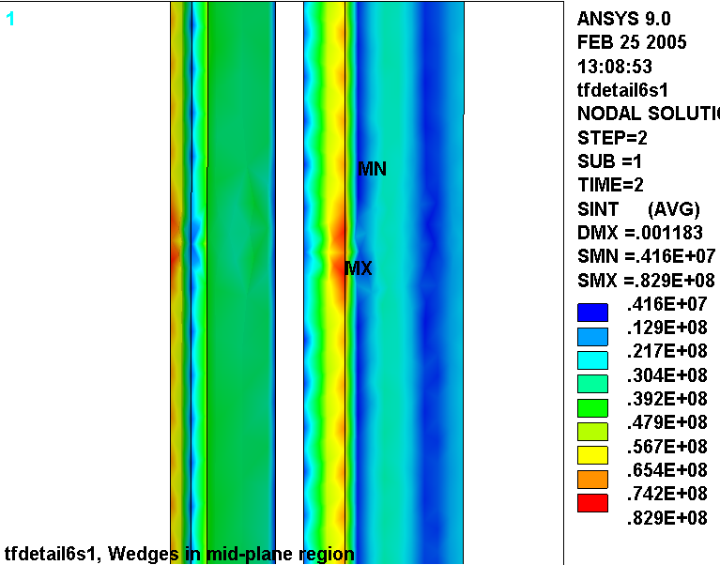
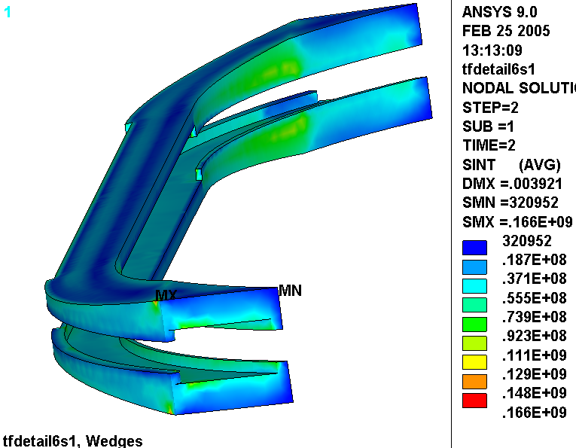
Fig. 4.7.1-9 Stress Intensity (Pa) in Bonded Wedge Casting (85K, Preload & 0.5 T EM)

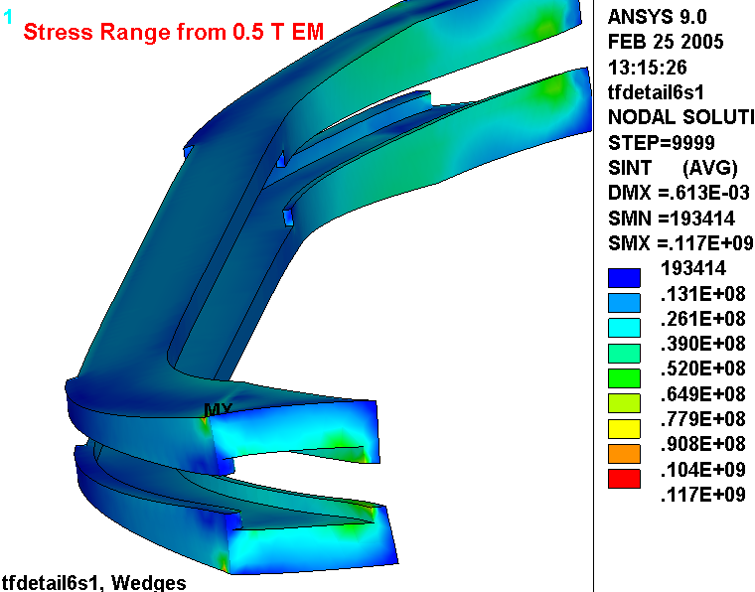
Fig. 4.7.1-10 Stress Intensity (Pa) in Bonded Wedge Casting (0.5 T EM Only)

Stress Summary, Bonded Configuration

Cu Stress

- General Primary Membrane (P_{M} < 1.0S_{m}):

σ(P_{M}) = F_{Z}/A_{Cu} = 140 kN/0.0047 m² (Fig. 4.6-11) = 30 MPa <180 MPa (1.0S_{m})

- Primary Membrane + Bending (P_{M}+P_{B} < 1.5S_{m}):

σ(P_{M}+ P_{B}) <89 MPa (Fig. 4.7.1-4) < 270 MPa (1.5S_{m})

- Fatigue (Cumulative Usage Factor, CUF < 1.0)

σ(min) = 15 MPa, σ(max) = 89 MPa, σ(mean) = (15+89)/2 = 52 MPa
σ(alt) = (89-15)/2 = 37 MPa
σ_{eq}(alt) = σ_{alt} /{1 - σ_{mean}/σ_{ut}} = 37/{1-52/360} = 43 MPa

Entering the proposed design-basis fatigue curve (Fig. 4.6-14) with an alternating stress of 43 MPa yields an allowable number of cycles >50x10⁶. So, the Usage Factor produced by this 0.5 T load case is the actual number of 0.5 T stress cycles (13k) divided by the allowable number of 0.5 T stress cycles (50x10⁶) or 0.0003. As discussed in section 5.6, the remaining 117k cycles produce about half the stress of this 0.5 T operating condition, which implies an allowable number of cycles >>50x10⁶. However, even if these other stress cycles were comparable to the 0.5 T case, the conductor CUF would be 130k/50x10⁶ or 0.003, which satisfies the CUF <1.0 requirement.

Insulation Stress

The critical results of the insulation stress analysis are represented in various plots and compared to requirements below:

- Flat-Wise Compression: -31 MPa (from Fig. 4.7.1-5) < 400 MPa
- In-Plane Tension & Compression: 71 MPa (from Fig. 4.7.1-6) < 130 MPa
- Through-Thickness Tensile Stress: 34 MPa (from Fig. 4.7.1-7) > 3.8 MPa
- Shear/Compression: 100% of Turn (Fig. 4.7.1-7) & 92% of GW (Fig. 4.7.1-7) Pass

The physical phenomenon which produces the relatively large local tensile stress reported here (34 MPa) will likely result in a local bond or interlaminar insulation failure at the tips of the wedge casting. The design should include some local detail that encourages a bond failure and not cracks in the epoxy-glass insulation. The following section (4.7.2) analyzes the completely debonded wedge-coil configuration, which is the worst-case deteriorated state of this bonded configuration.
Wedge Castings

- General Primary Membrane (P_{M} < 1.0S_{m}):

σ(P_{M}) = ~20 MPa (Fig. 4.7.1-8) <270 MPa (1.0S_{m})

- Primary Membrane + Bending (P_{M}+P_{B} < 1.5S_{m}):

σ(P_{M}+ P_{B}) = 166 MPa (Fig. 4.7.1-9) < 400 MPa (1.5S_{m})

- Fatigue (Cumulative Usage Factor, CUF < 1.0)

σ(min) = 49 MPa, σ(max) = 166 MPa, σ(mean) = (49+166)/2 = 108 MPa
σ(alt) = (166-49)/2 = 59 MPa
σ_{eq}(alt) = σ_{alt} /{1 - σ_{mean}/σ_{ut}} = 59/{1-108/1300} = 64 MPa

Entering the proposed design-basis fatigue curve (Fig. 4.6-14) with an alternating stress of 64 MPa (9 ksi) yields an allowable number of cycles of ~10⁶ (although this is an extrapolation of the data). So, the Usage Factor produced by this 0.5 T load case is the actual number of 0.5 T stress cycles (13k) divided by the allowable number of 0.5 T stress cycles (10⁶) or 0.013. As discussed in section 5.6, the remaining 117k cycles produce about half the stress of this 0.5 T operating condition, which implies an allowable number of cycles >10⁶. However, even if these other stress cycles were comparable to the 0.5 T case, the conductor CUF would be 130k/10⁶ or 0.13, which satisfies the CUF <1.0 requirement.

4.7.2 Wedges De-Bonded from the WP Ground Wrap (ANSYS Results File: tfdetail6s0.*)

The graphical results and stress evaluation contained in this section correspond to a condition where the reference WP/GW bond has deteriorated to the point of no remaining bond. In this case, the wedge and WP ground wrap volumes are in contact through (conservative) frictionless contact interfaces. This is considered an extreme case relative to the reference bonded configuration, but could occur as a result of cyclic thermal and EM stress cycles.

Fig. 4.7.2-1 shows plots of the displacement modulus from 85K + Preload (upper plot) and with the addition of 0.5 T EM loading (lower plot) along with the undeformed geometry. The coil is supported at the equator for modeling convenience, and has no influence on stresses or relative displacements. When the coil is cooled to 85K, then the outboard leg moves in about 8 mm. When the coil is energized to 0.5 T, the upper and lower arcs in the transition region straighten slightly producing a more oval-shaped coil and pull the outboard leg inward an additional 2.9 mm. This is slightly more than the 2.2 mm bonded result, indicating the slightly more flexible nature of the unbonded condition.

Figs. 4.7.2-2 through 4.7.2-4 show the stress intensity distribution in the Cu conductor from 85K + Preload, 0.5 T EM only, and the combined effects of 85K + Preload + 0.5 T EM. They provide the local primary and peak stress history, which are subsequently used in a series of stress qualification calculations.

Fig. 4.7.2-5 show plots of the turn and GW insulation flat-wise stress from this design-basis loading (85K + Preload + 0.5 T EM). They show that the maximum compressive stresses occur on the low-field side of the WP where the coil presses against the lips of the wedge castings.

Fig. 4.7.2-6 is a plot of the in-plane stress component in the turn-wrap and GW insulation. The maximum stress occurs on the low-field side of the WP, and is predominantly due to toroidal compression. The sign of the stress is lost when the two local in-plane components are combined by SRSS.

Fig. 4.7.2-7 show flat-wise stress plots of the turn and GW insulations and the results of the shear/compression stress evaluation. The plots contour all normal stresses less than 3.8 MPa (i.e., compressive stresses and tensile stresses < 3.8 MPa) as red. Grey values indicate local tensile stresses greater than 3.8 MPa. The grey signifies “danger” regions where normal stresses exceed the allowable for the insulating material. If we ignore the grey areas at the ends of the detailed region (stresses contaminated by the material discontinuity), then we see small areas on the toroidal faces where the wedging pressure becomes tensile, and on the high-field side where the WP is held out (radially) because of the bond to the casting. Both plots capture the results of a numerical integration and report the percentage of insulation which passes the shear/compression criteria: ~100% of the turn wrap and 92% of the ground-wrap.

Fig. 4.7.2-8 is a plot of the stress intensity in the equatorial region of the wedge castings. This area is away from local stress concentrations and geometric discontinuities, and could be considered a place which must pass the Primary Stress requirement. The average primary stress here (EM only, no thermal) is about 20 MPa, and is similar to the primary plus secondary stress (includes thermal contraction stresses.

Fig. 4.7.2-9 shows plots of the stress intensity in the wedges from 85K + preload, and 85K + preload + 0.5 T EM loads. The similarities are of course due to thermal contraction effects, which are present in both load cases. The relatively low-α of the WP cross-section holds apart the wedge lips, causing a local bending stress. This is somewhat artificial because of the way the smeared α is determined for the WP. At 85K, gaps open up between the turn wrap insulation and the Cu conductor, which makes the WP α contract more like the low α of in-plane S-glass. In reality, the wedge lips will close these gaps with minimal resistance and little stress will develop. This anomaly in the model is of little consequence since the most critical stress history is produced by the 0.5 T load cycle.

Fig. 4.7.2-10 is a plot of the stress range produced by the 0.5 T operating condition. Notice that the high stresses in the wedge lips are subtracted out as they do not change much when the coil is energized. The stress on the low-field-side lip, which carries the centering load from the coil, now appears as the maximum value.

These stress plots are used to perform a fatigue analysis of the castings.
Fig. 4.7.2-1 Displacements, 85K+Preload (upper) and with 0.5T EM (lower)
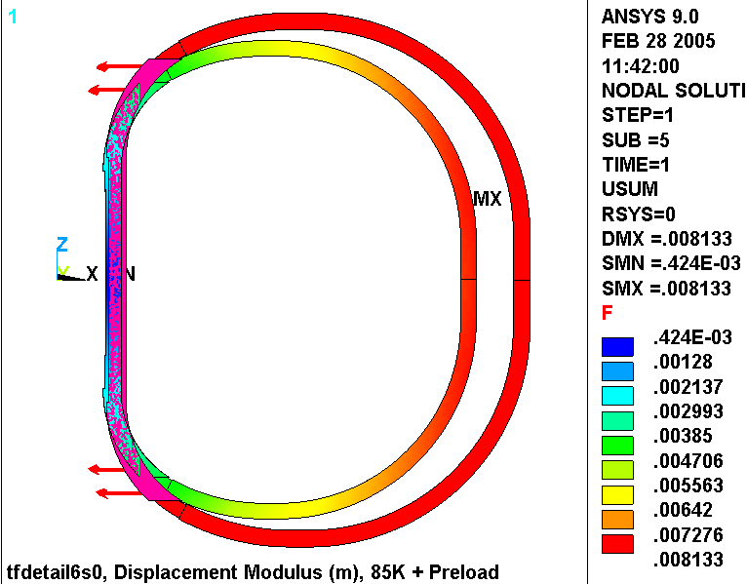
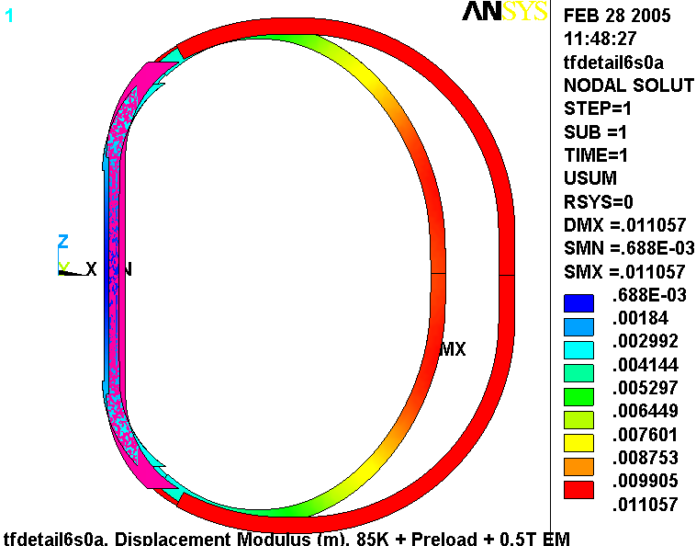
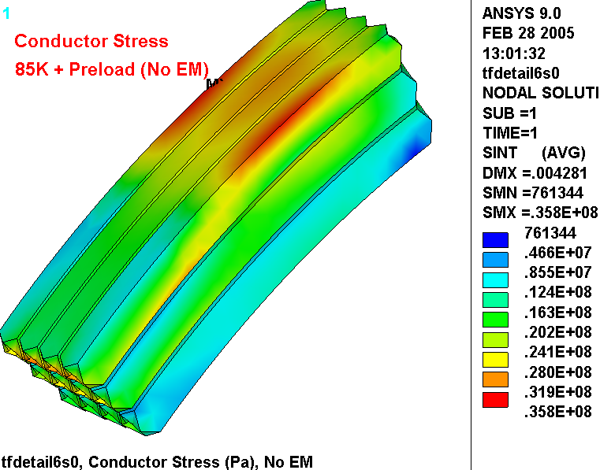
Fig. 4.7.2-2 Cu Conductor Stress (Pa), 85K + 4000 lb/bracket Radial Preload

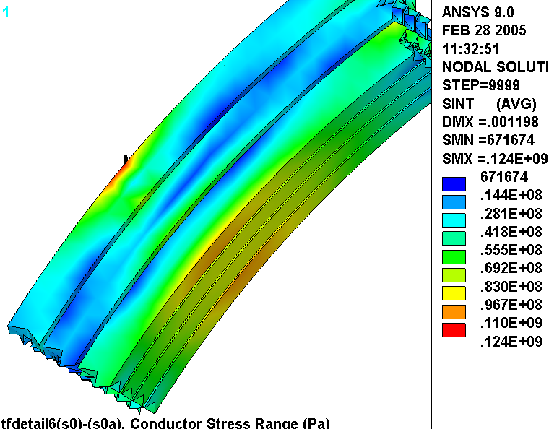
Fig. 4.7.2-3 Cu Conductor Stress Range (Pa) from 0.5 T EM Loading

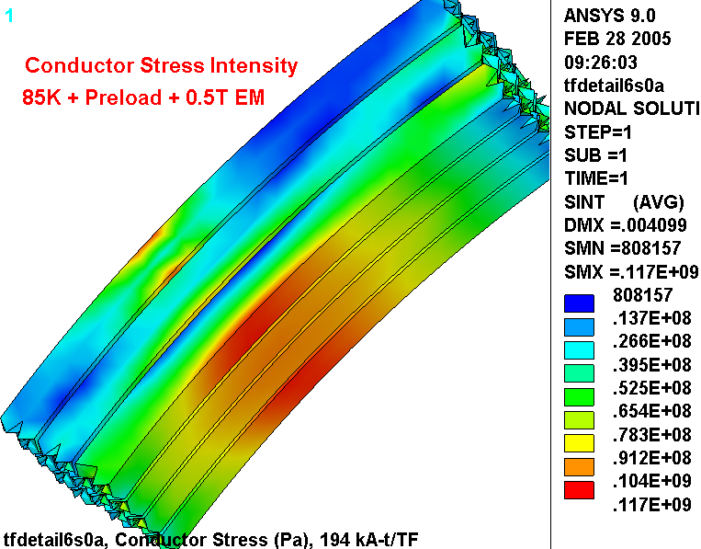
Fig. 4.7.2-4 Cu Conductor Stress (Pa), 85K + Radial Preload + 0.5 T Loading

Note: In other analyses, TIME=1 signifies the load case which corresponds to 85K+Preload, while TIME=2 signifies the load case which corresponds to 85K+Preload+0.5T. However, in this unbonded model, two separate runs are made and so both of these load cases are referred to as TIME=1. The best means of tracking the two different analyses is by jobname, which is listed in the plot legend; tfdetail6s0 simulates 85K+Preload, while tfdetail6s0a simulates 85K+Preload+0.5T.

Fig. 4.7.2-5 Turn (upper) and GW (lower) Flat-Wise Stress (Pa), 85K + Preload + 0.5T EM
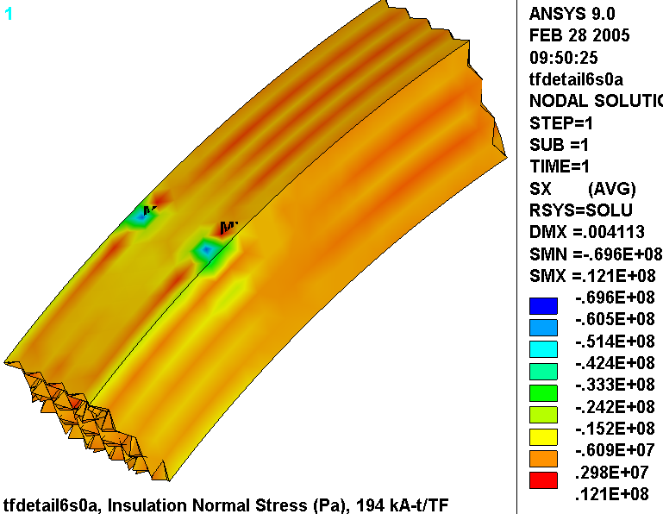
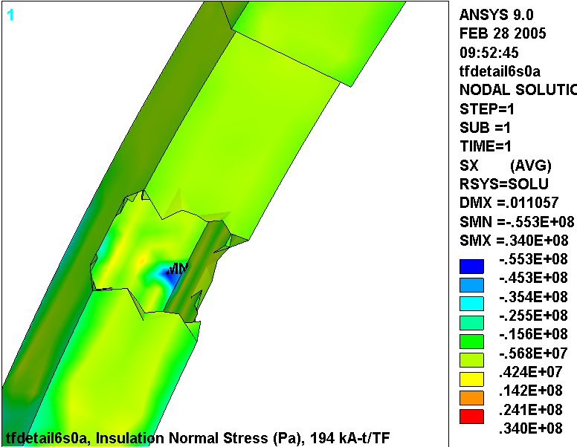
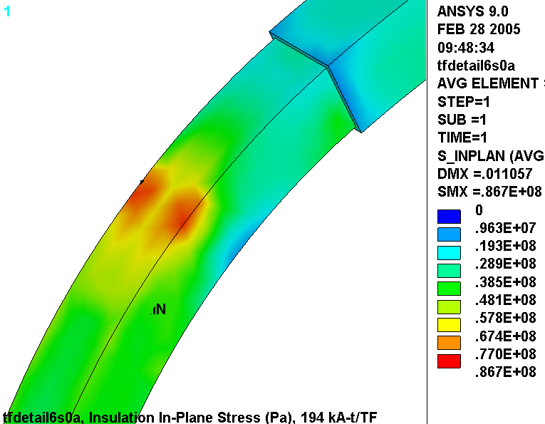
Fig. 4.7.2-6 In-Plane Turn (hidden) and GW Insulation Stress (Pa), 85K+Preload+0.5T EM Loading

Fig. 4.7.2-7 Shear/Compression Insulation Stress Evaluation, 85K + Preload + 0.5T EM Load
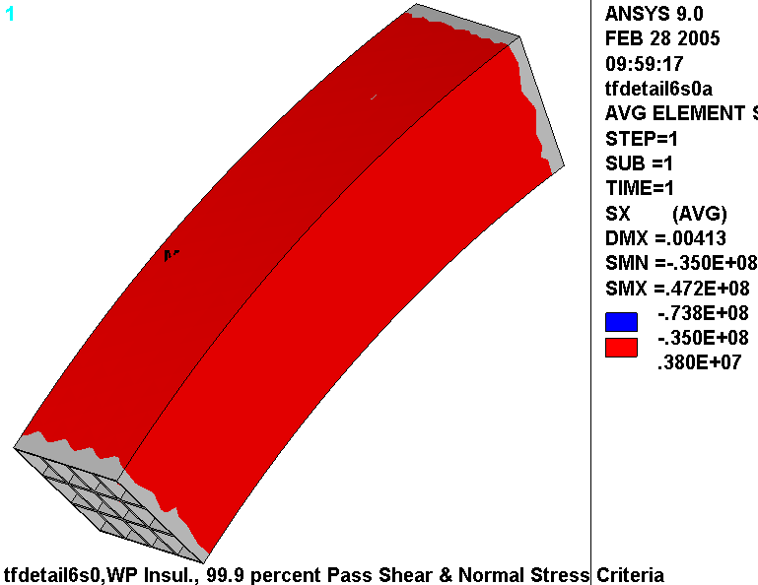
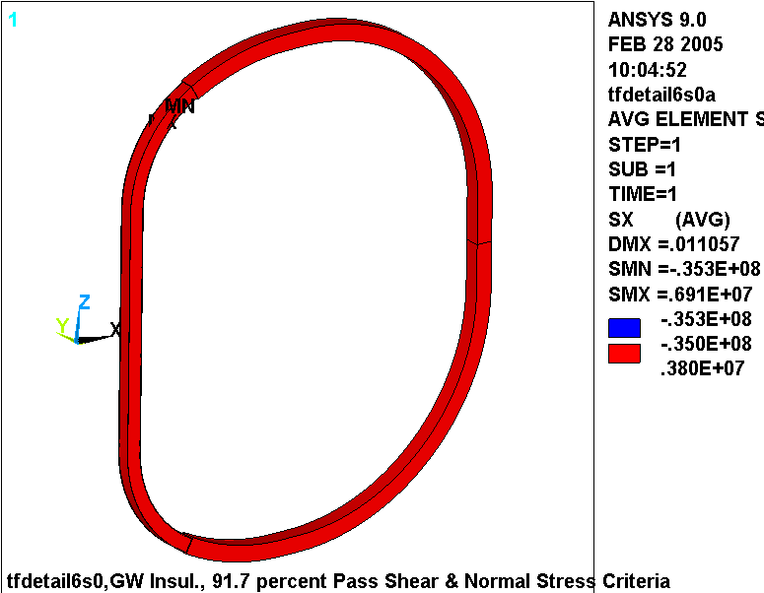
Fig. 4.7.2-8 Stress in Wedge Casting Mid-length, 0.5T only (upper) & 85K+Preload+0.5 T (lower)
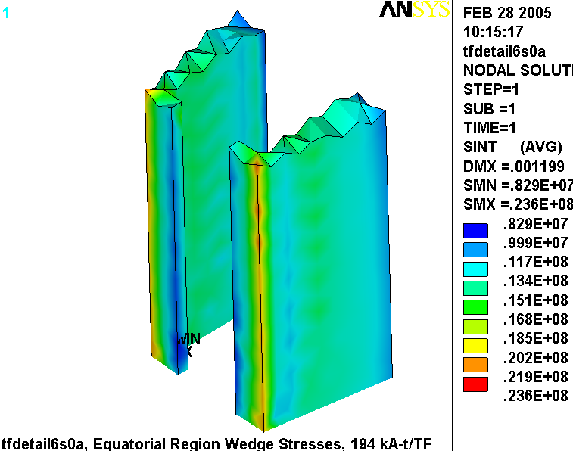
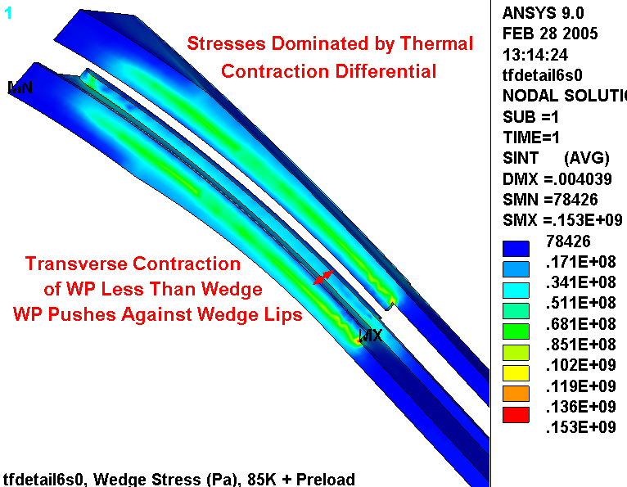
Fig. 4.7.2-9 Stress Intensity (Pa) in Wedge Casting (top: 85K+Preload, bottom: 85K+Preload+0.5T)

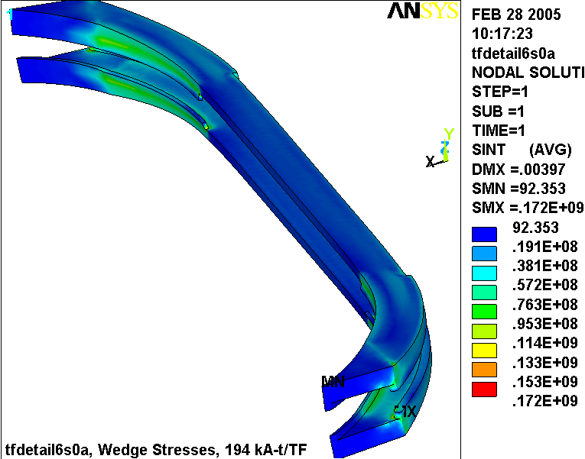
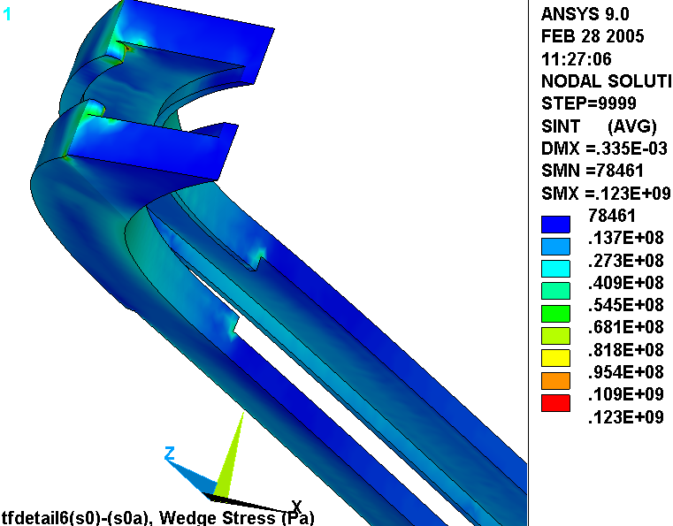
Fig. 4.7.2-10 Stress Intensity Range (Pa) in Wedge Casting (0.5 T EM Only)

Notice how the large stresses in high-field-side lip are eliminated by this stress differential. These 85K thermal stresses are present in both load cases. Here, the stress difference subtracts away their effects leaving only stresses from EM loads. This is equivalent to running the model with EM loads at room temperature and zero preload.
Stress Summary, De-Bonded Configuration

Cu Stress

- General Primary Membrane (P_{M} < 1.0S_{m}):

σ(P_{M}) = F_{Z}/A_{Cu} = 140 kN/0.0047 m² (Fig. 4.6-11) = 30 MPa <180 MPa (1.0S_{m})

- Primary Membrane + Bending (P_{M}+P_{B} < 1.5S_{m}):

σ(P_{M}+ P_{B}) <117 MPa (Fig. 4.7.2-4) < 270 MPa (1.5S_{m})

- Fatigue (Cumulative Usage Factor, CUF < 1.0)

σ(min) = 117-124 = -7 MPa, σ(max) = 117 MPa, σ(mean) = (117+(-7))/2 = 55 MPa
σ(alt) = (117-(-7))/2 = 62 MPa
σ_{eq}(alt) = σ_{alt} /{1 - σ_{mean}/σ_{ut}} = 62/{1-55/360} = 73 MPa

Entering the proposed design-basis fatigue curve (Fig. 4.6-14) with an alternating stress of 73 MPa yields an allowable number of cycles ~10⁵. So, the Usage Factor produced by this 0.5 T load case is the actual number of 0.5 T stress cycles (13k) divided by the allowable number of 0.5 T stress cycles (10⁵) or 0.13. As discussed in section 5.6, the remaining 117k cycles produce about half the stress of this 0.5 T operating condition, which implies an allowable number of cycles >10⁶. So, the Usage Factor produced by these other load cases is the actual number of stress cycles (117k) divided by the allowable number stress cycles (10⁶) or 0.12. This puts the CUF at 0.13 + 0.12 or 0.25, which satisfies the CUF <1.0 requirement.

Note: The use of softer Cu for coil manufacturing purposes, with minimum room temperature yield and ultimate stresses of 26 ksi and 36 ksi, respectively, has the following effect:

- S_{m} = 150 MPa
- σ(P_{M}) = 30 MPa <150 MPa (1.0S_{m})
- σ(P_{M}+ P_{B}) = 117 MPa < 225 MPa (1.5S_{m})
- CUF < 1.0; σ_{eq}(alt) = σ_{alt} /{1 - σ_{mean}/σ_{ut}} = 62/{1-55/340} = 74 MPa (No impact)

Insulation Stress

The critical results of the insulation stress analysis are represented in various plots and compared to requirements below:

- Flat-Wise Compression: -70 MPa (from Fig. 4.7.2-5) < 400 MPa
- In-Plane Tension & Compression: 87 MPa (from Fig. 4.7.2-6) < 130 MPa
- Through-Thickness Tensile Stress: 6.9 MPa (from Fig. 4.7.2-7) > 3.8 MPa
- Shear/Compression: 100% of Turn (Fig. 4.7.2-7) & 92% of GW (Fig. 4.7.2-7) Pass

It should be noted that the small through-thickness tensile stress is a result of how the orthotropic material gets modeled (rather than any actual phenomenon). Fig. 4.7.2-11 is a plot of the normal stresses in the 3/8” GW at the outboard leg equator. It shows that the tensile stresses develop at the corners where there is an abrupt change in the local element coordinate system. This is unlike the actual GW lay-up, which wraps around the corner making a smooth and continuous transition. The abrupt change in element orientation puts the through-thickness properties next to in-plane properties. The material property discontinuity (particularly the CTE) produces these erroneous tensile stresses.

Wedge Castings

- General Primary Membrane (P_{M} < 1.0S_{m}):

σ(P_{M}) = ~20 MPa (Fig. 4.7.2-8) <270 MPa (1.0S_{m})

- Primary Membrane + Bending (P_{M}+P_{B} < 1.5S_{m}):

σ(P_{M}+ P_{B}) = 172 MPa (Fig. 4.7.2-9) < 400 MPa (1.5S_{m})

- Fatigue (Cumulative Usage Factor, CUF < 1.0)

σ(min) = 49 MPa, σ(max) = 172 MPa, σ(mean) = (49+172)/2 = 111 MPa
σ(alt) = (172-49)/2 = 62 MPa
σ_{eq}(alt) = σ_{alt} /{1 - σ_{mean}/σ_{ut}} = 62/{1-111/1300} = 68 MPa

Entering the proposed design-basis fatigue curve (Fig. 4.6-14) with an alternating stress of 68 MPa (10 ksi) yields an allowable number of cycles of ~10⁶ (although this is an extrapolation of the data). So, the Usage Factor produced by this 0.5 T load case is the actual number of 0.5 T stress cycles (13k) divided by the allowable number of 0.5 T stress cycles (10⁶) or 0.013. As discussed in section 5.6, the remaining 117k cycles produce about half the stress of this 0.5 T operating condition, which implies an allowable number of cycles >10⁶. However, even if these other stress cycles were comparable to the 0.5 T case, the conductor CUF would be 130k/10⁶ or 0.13, which satisfies the CUF <1.0 requirement.

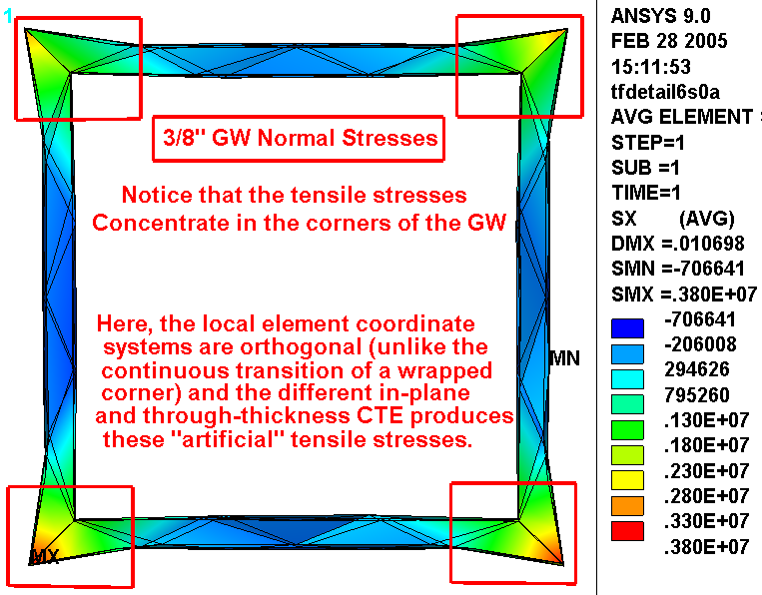
Fig. 4.7.2-11 Explanation of small Tensile Normal Stresses in GW
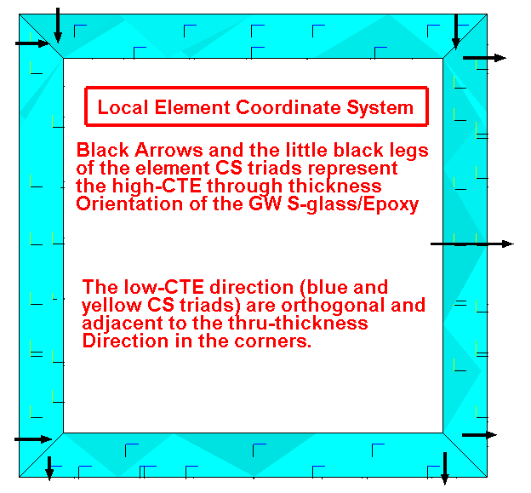
4.7.3 Large-Scale Displacements in the Slip-Plane WP from Cooldown

The goal of the hybrid model is to capture the stresses in the high-stress region of the WP, with particular attention on the EM load cycle. There is some uncertainty whether this model is sufficient to capture the effects of the more global deformations likely to occur in the slip-plane insulation system. For example, what happens to the coil structure when long lengths of the insulation and conductor are free to move relative to each other? Answering this question requires a little thought process and a model, which goes as follows.

Imagine the high-α_{Cu} turns within the low-α_{Ins.} epoxy/glass insulation honeycomb. If the ends of the conductor are simply terminated (no break-out or clamps), then when the coil is cooled-down by ΔT, the Cu will contract along the conductor axis inside the insulation. If the coil was an N-turn solenoid with mean radius R_{m}, then the contractions would integrate to some significant dimension (δ) as there are no abrupt changes in curvature to interrupt the relative movement:

δ = N2πR_{m} (ΔT)( Δα)

The TF coil, on the other hand, is not a constant radius structure, and the migration of the free-ends of the conductor will be restricted at changes in curvature such as at the ends of the inboard leg.

But a more important mechanism that restricts the shrinkage of the Cu conductor into the insulation superstructure is the termination at the back-leg break-outs. The right-angle bends and local reinforcement resist this tendency for the turn to contract into the insulation. If we accept this as true, then the large-scale relative motion of turn and insulation must be limited to some complex force and stress distribution within a single pancake, as if all relative displacements must be zero at one poloidal point in the coil. The logical poloidal location is the transition region of the outboard leg.

Taking the thought-process one step further, up-down symmetry would dictate that there would not be any difference between the deformations of the upper and lower coil halves. On step further, what happens to the left half of the turn must also happen to the right half.

All this discussion allows reducing the entire TF coil to a representative model with one quarter of a pancake, as shown in Fig. 4.7.3-1. Now, a detailed model of a quarter-pancake with contact elements at each conductor-insulation slip-plane is computationally manageable.
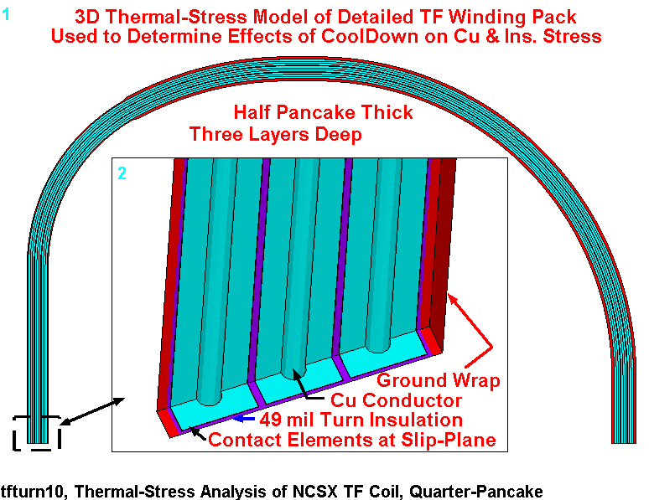
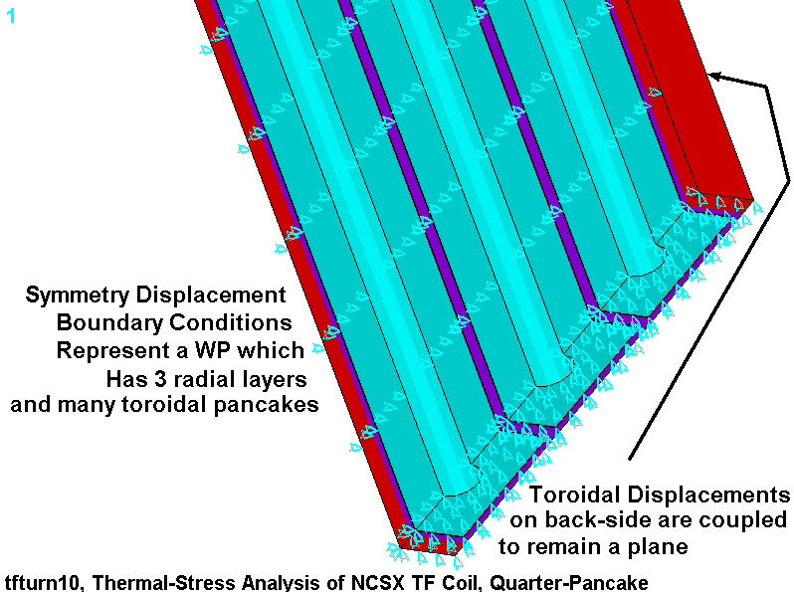
Fig. 4.7.3-1 Representative Quarter-Pancake Thermal Contraction TF Coil Model

The model is a poloidal extension of the detailed region of the hybrid model. The conductor cross-section, 49 mil turn insulation and ground wrap are modeled around the entire upper half of the coil. General surface to surface contact elements separate the Cu conductors from the epoxy-glass insulation. Symmetry boundary conditions are used to simulate a toroidally wide winding pack, although this is likely representative of the middle two pancakes in the actual 4-pancake coil. The behavior of the end pancakes could vary ever so slightly from this model, although not substantially.

The quarter-turn model is cooled to 85K (215˚ below RT). Initial load increments are very small (0.1% of the total load, or 0.215˚). The ANSYS auto time stepping algorithm increases this value as the contact elements “settle down” and behave more consistently. However, before this occurs, the load increment is reduced to 0.01% of the total load or 0.0215˚. By the end of the nonlinear analysis, the load increment is increased to 10% or 21.5˚, allowing the analysis to complete in a mere 8 hours.

There are a number of plots which help illustrate the essential behavior of this structure. Results are discussed below, and compared to hybrid model results wherever appropriate.

Fig. 4.7.3-2 is a plot of the stress intensity in the Cu conductors at the final 85K operating condition. Although plotting stress intensity (σ₁-σ₃) loses the sign of the stress, an interactive plot of the 1st principle stress indicated that this stress is almost entirely due to the tensile stress, σ₁. This is consistent with what must occur as the low-α glass resists the contraction of the high-α Cu. Specifically, the plot shows a peak of 24 MPa, and a local average tensile stress of ~16 MPa. This result is indeed, very similar to that of the hybrid model shown in Fig. 4.7.3-3, which plots σ₁ in the Cu turns. Notice that the stresses in the 1st and 4th pancakes are slightly higher, but generally similar to those of Fig. 4.7.3-2. In fact, a volumetric integration of σ₁ puts the average stress at 16 MPa (tension).

Fig. 4.7.3-4 is a plot of the stress intensity in the epoxy-glass insulation. The plot shows a peak stress of about 60 MPa occurring in the plasma-side ground-wrap. Away from the peak, the insulation stress field is a more uniform 40-50 MPa. An interactive σ₃ plot showed that this stress is essentially all poloidal compression, to balance the poloidal tension in the Cu.

Fig. 4.7.3-5 is a plot of the 3rd principal stress in the GW of the hybrid model in the region of the 1/8” to 3/8” transition. Notice that the plasma-side compressive stress is also 40-50 MPa, while the low-field side has a nominal stress of 25 MPa (compression). This consistency leads one to believe that the hybrid model is doing a reasonable job at capturing the thermal stresses produced by this dissimilar α winding pack.

The quarter-turn model is able to capture one characteristic that the hybrid model simply cannot: relative motion around the entire coil. Fig. 4.7.3-6 is a plot of the poloidal displacement in the transition region of the model. Subtracting color contours of adjacent materials produces the slip magnitude: ~0.6 mm. The exaggerated deformed shape also represents this relative displacement. It is worth noting that while the Cu moves to the right relative to the insulation in this location, the relative motion reverses in the horizontal arc and returns to zero at the equator (as required by displacement BCs). Real-world friction should reduce the magnitude of this relative motion.

In summary, the quarter-turn detailed model produces predominantly poloidal stresses in the insulation and conductor that are consistent with the hybrid model results. In addition, it determines an upper bound on the relative motion between these two “independent” coil elements at ~0.6 mm. Real-world friction and localized bonding should reduce this figure.
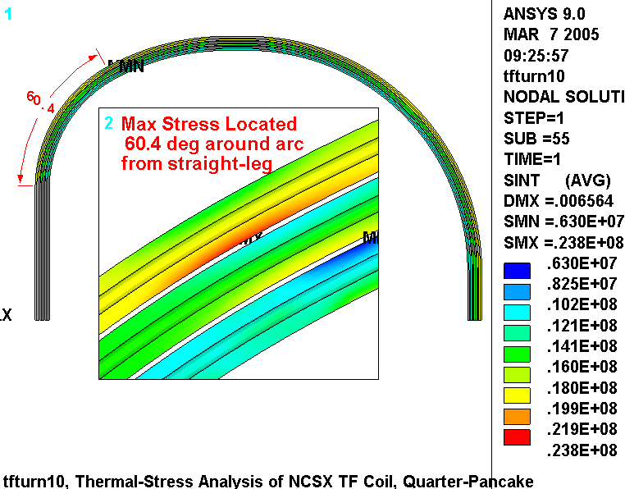
Fig. 4.7.3-2 Stress Intensity in Cu resulting from 85K Cool-Down Loading

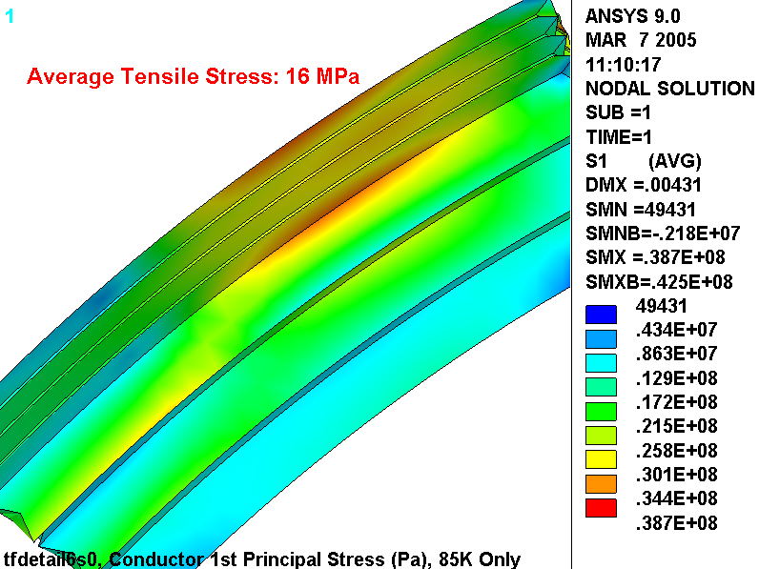
Fig. 4.7.3-3 Stress Intensity in Cu resulting from 85K + Preload (hybrid model)

Fig. 4.7.3-4 Stress Intensity in Epoxy/Glass resulting from 85K Cool-Down Loading
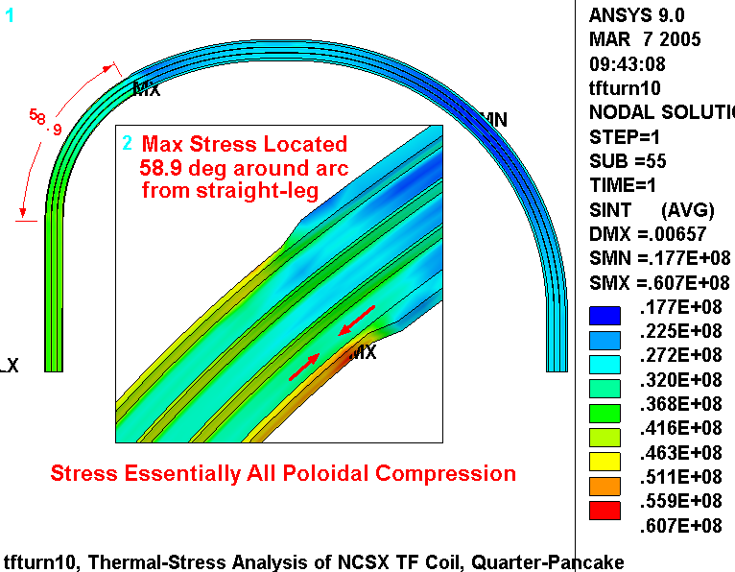
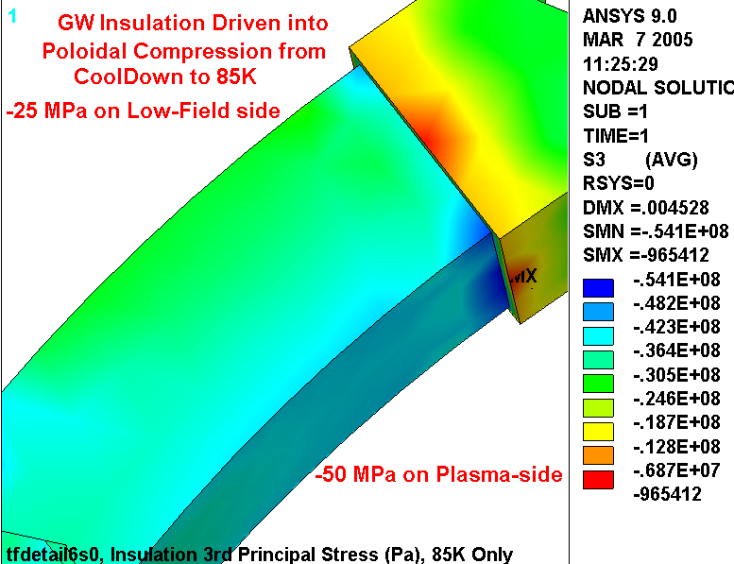
Fig. 4.7.3-5 3rd Principal Stress in Epoxy/Glass Ground Wrap of Hybrid Model, 85K + Preload

Fig. 4.7.3-6 Poloidal Displacements Showing
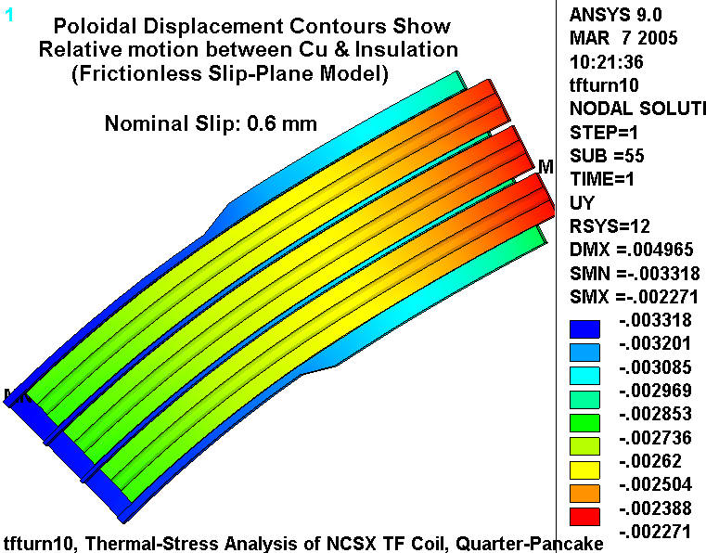
Conductor/Insulation Relative Motion in the Transition Region

5.0 Summary & Commentary

The latest TF coil design has been analyzed in detail using a hybrid (detailed-smeared) finite element model (i.e., a detailed model of a portion of the coil pack embedded within a global smeared-properties model). This TF coil configuration consists of the following:

- A 3x4 array of 0.966”x0.709” Cu conductors.
- Turn insulation composed of S-2 glass over Kapton which builds to 49 mils.
- Winding pack ground wrap composed of multi-layer S-2 glass which builds to 0.375” away from the wedges and 1/8” under the wedges.
- TF wedge (castings) made from 304-like material.

The analysis shows the following:

- The latest casting design passes all relevant design criteria:
  - Local lip shear stress: 76 MPa < 160 MPa
  - Primary Membrane plus Bending (P_{M}+P_{B}): 172 MPa < 400 MPa
  - Fatigue life: CUF = 0.13 < 1.0
- The highest conductor stress occurs at the ends of the wedges. EM and radial preload forces result in a bending stress with a significant tensile component on the high-field-side of the WP. This tensile stress is increased by differential contraction (α) effects upon cool-down. However, all relevant design criteria are satisfied with reasonable margin:
  - Primary Membrane plus Bending (P_{M}+P_{B}): 117 MPa < 270 MPa
  - Fatigue life: CUF = 0.25 < 1.0
- The highest insulation stress occurs at the ends of the wedges. However, all relevant design criteria are satisfied:
  - Flat-Wise Compression: 70 MPa < 400 MPa
  - In-Plane Tension & Compression: 87 MPa < 130 MPa
  - Through-Thickness Tensile Stress: 92% of Material < 3.8 MPa (due to modeling anomaly discussed above).
  - Shear/Compression: 100% of Material Satisfies Criteria.

It is worth noting that the analysis is based on assumed wedge casting properties (moduli, yield, ultimate and fatigue). The assumptions are thought to be conservative, but should be confirmed.

The work is illustrated by numerous stress plots, and the evolution of the design is carried along for historical purposes. Also, the ANSYS input file is attached and could be used by knowledgeable PPPL employees in future analyses.

6.0 Attachments

6.1 ANSYS Input File

/batch
rn=0
!/filnam,tfdetail6b%rn%
!/show,tfdetail6b%rn%,grp
!resume
*if,1,eq,1,:1000
/prep7
/com
/com Electromagnetic structural analysis of the NCSX TF Coil System
/com Geometry defined by: se131-075-R3, TF Nose Casting
/com
/com Model composed of smeared and detailed WP regions with Turn-Insulation Contact
/com Solve the Conduction and field problem, then solve the structural problem
/com (Because of bug in SOLID98: WP changed to 92 after EM and ldread in the EM forces)
/com
/com TF coils currents defined by: 0.5T load case
/com
/com Change conductor to 3x4 array based on 0.966" x 0.709" with gap element surrounding each
/com SS Cast Wedges with contact elements at WP interface (Z>0)
/com
/com This model is developed from tfdetail5.dat.
/com First change: the insulation thickness under the Wedges can be made thinner
/com than the insulation away from the wedge.
/com
/com Run History
/com
/com 60: 0.5 T, detailed WP,0.5" radius to top of wedge, 1/8" & 3/8" GW
/com 60: Stress Run with unbonded upper WP/Wedge Interface (conservative)
/com 61: Bonded (k_nl=0)
/com

/com
/com Selection of Detailed WP Region
/com
k_detail=12 ! 0: just smeared WP model, >0: detailed WP in this sector of model (11-16)
fr1=0.6 ! start of detailed sector (can be 0.0)
fr2=1.0 ! end of detailed sector (can be 1.0)

/com Interface Conditions set by k_nl:
/com 0: UY=0 at (+/-)arc/2, Bonded WP/Wedge
/com 1: UY=0 at (+/-)arc/2, Flex-Flex Contact at WP/Wedge
/com 2: Flex-Rigid Contact at (+/-)arc/2, Flex-Flex Contact at WP/Wedge
k_nl=1

/com Misc Parameters
k_dens=4 ! number of elements across WP
k=0.0254 ! english to si conversion factor
pi=acos(-1) ! pi
mu0=4*pi*1e-7 ! Mu0
*afun,deg ! use degrees in trig functions
t=0.0001 ! a tiny length
th=0.01 ! a tiny angle
dtr=pi/180 ! degrees to radians
rtd=1/dtr ! radians to degrees
b0=0.5 ! nominal flux density
r0=1.4 ! major radius
ntf=18 ! number of tf coils
n_lay=3 ! number of radial layers
n_pan=4 ! number of pancakes
i_tf=5e6*b0*r0/ntf ! total current per tf coil
i_con=i_tf/(n_lay*n_pan) ! TF conductor current
arc=360/ntf ! angular extent of 1 tf coil
emsym,ntf ! electromagnetic symmetry about Z
dtmp=-215 ! differential temperature (WRT room temp)

/com
/com element types
/com
et,1,98,1 ! structure only
et,2,98,1 ! conductor and structure

/com
/com graphics keys
/com
/pnum,mat,1
/num,1
/dist
/focus
/vup,1,z
/view,1,,-1

/com
/com tf conductor, ignoring radii (in local CS vernacular)
/com
dr_con=0.966*k ! Conductor build in thickness (0.434*k)
dz_con=0.709*k ! Conductor build in height (1.50*k)
di_con=0.312*k ! inside diameter of cooling channel

/com
/com Insulation
/com
t_tw=0.049*k ! turn wrap insulation thk
t_pan=0.0*k ! pancake insulation thk (was 0.030", can be 0.0)
t_lay=0.0*k ! layer insulation thk (can be 0.0)
t_gw1=0.125*k ! ground wrap thickness under wedges
t_gw2=0.375*k ! ground wrap thickness away from wedges
t_gap=t_tw/10 ! height of gap in outboard leg for current application

/com
/com WP Build
/com
dr_wp=n_lay*(dr_con+2*t_tw)+(n_lay-1)*t_lay ! radial build of WP
dz_wp=n_pan*(dz_con+2*t_tw)+(n_pan-1)*t_pan ! toroidal build of WP
dr_iwp1=dr_wp+2*t_gw1 ! radial build of ground-wrapped WP
dz_iwp1=dz_wp+2*t_gw1 ! toroidal build of ground-wrapped WP
dr_iwp2=dr_wp+2*t_gw2 ! radial build of ground-wrapped WP
dz_iwp2=dz_wp+2*t_gw2 ! toroidal build of ground-wrapped WP
cel=sqrt(dr_wp**2+dz_wp**2)/k_dens ! characteristic element size

/com
/com Centers of sweep and inside radii
/com
x_off=12.494*k ! distance from machine axis to Insulated WP inner edge
x11=r0 ! x position of local 11
z11=0.0 ! z position of local 11
ri11=r0-x_off-dr_iwp1 ! inside radius of coil in local 11
/com
x12=43.234*k ! x position of local 12
z12=28.785*k ! z position of local 12
ri12=27.308*k ! inside radius of coil in local 12
/com
x13=54.805*k ! x position of local 13
z13=7.155*k ! z position of local 13
ri13=51.044*k ! inside radius of coil in local 13
/com
x14=54.805*k ! x position of local 14
z14=0.000*k ! z position of local 14
ri14=ri13+z13 ! inside radius of coil in local 14
/com
x15=59.287*k ! x position of local 15
z15=10.894*k ! z position of local 15
ri15=47.335*k ! inside radius of coil in local 15
/com
x16=x15 ! x position of local 16
z16=z15 ! z position of local 16
ri16=ri15 ! inside radius of coil in local 16
/com
x17=x15 ! x position of local 17
z17=-z15 ! z position of local 17
ri17=ri15 ! inside radius of coil in local 17
/com
x18=x15 ! x position of local 18
z18=-z15 ! z position of local 18
ri18=ri15 ! inside radius of coil in local 18
/com
x19=x13 ! x position of local 19
z19=-z13 ! z position of local 19
ri19=ri13 ! inside radius of coil in local 19
/com
x20=x12 ! x position of local 20
z20=-z12 ! z position of local 20
ri20=ri12 ! inside radius of coil in local 20

/com
/com Swept Angles (and straight-lengths)
/com
dy11=2*z12
dy12=abs(atan((z12-z13)/(x13-x12)))
dy13=90-dy12
dy14=4.482*k ! length of section 14
dy15=90
dy16=2*z15
dy17=dy15
dy18=dy14
dy19=dy13
dy20=dy12

/com
/com material properties
/com
/com Smeared TF WP (Conductor, slip-plane and turn insulation)
mp, kxx,2,1
mp,murx,2,1
mp,rsvx,2,2e-8
mp, ex,2,62.8e9
mp, ey,2,101.8e9
mp, ez,2,59.7e9
mp,alpx,2,7.8e-6
mp,alpy,2,13.7e-6
mp,alpz,2,7.9e-6
mp,nuxy,2,0.316
mp,nuyz,2,0.316
mp,nuxz,2,0.463
mp, gxy,2,1.7e9
mp, gyz,2,1.7e9 ! required to get beam bending right
mp, gxz,2,1.7e9 ! required to get beam bending right

/com
/com S-2 Ground Wrap insulation (X is through thickness)
/com
mp,murx,3,1
mp, ex,3,21e9
mp, ey,3,28e9
mp, ez,3,28e9
mp,alpx,3,22e-6
mp,alpy,3,7.9e-6
mp,alpz,3,7.9e-6
mp, gxy,3,6.9e9
mp, gyz,3,9.6e9
mp, gxz,3,6.9e9
mp,nuxy,3,0.2
mp,nuyz,3,0.2
mp,nuxz,3,0.2
mp,dens,3,1800
mp, kxx,3,1

/com
/com Cu Conductor (at 77K)
/com
mp,murx,12,1
mp, ex,12,136e9
mp,alpx,12,14e-6
mp,nuxy,12,0.34
mp, kxx,12,1
mp,rsvx,12,2e-8

/com
/com Turn Wrap insulation, S-glass & Kapton (X is through thickness)
/com
mp,murx,13,1
mp, ex,13,19e9
mp, ey,13,26e9
mp, ez,13,26e9
mp,alpx,13,21e-6
mp,alpy,13,7.9e-6
mp,alpz,13,7.9e-6
mp, gxy,13,4.2e9
mp, gyz,13,6.0e9
mp, gxz,13,4.2e9
mp,nuxy,13,0.2
mp,nuyz,13,0.2
mp,nuxz,13,0.2
mp,dens,13,9000
mp, kxx,13,1

/com
/com S-glass Layer to Layer insulation (X is through thickness)
/com
mp,murx,14,1
mp, ex,14,21e9
mp, ey,14,28e9
mp, ez,14,28e9
mp,alpx,14,22e-6
mp,alpy,14,7.9e-6
mp,alpz,14,7.9e-6
mp, gxy,14,6.9e9
mp, gyz,14,9.6e9
mp, gxz,14,6.9e9
mp,nuxy,14,0.21
mp,nuyz,14,0.21
mp,nuxz,14,0.21
mp, kxx,14,1

/com
/com S-glass Pancake to Pancake insulation (local z is through thickness)
/com
mp,murx,15,1
mp, ex,15,21e9
mp, ey,15,28e9
mp, ez,15,28e9
mp,alpx,15,22e-6
mp,alpy,15,7.9e-6
mp,alpz,15,7.9e-6
mp, gxy,15,6.9e9
mp, gyz,15,9.6e9
mp, gxz,15,6.9e9
mp,nuxy,15,0.21
mp,nuyz,15,0.21
mp,nuxz,15,0.21
mp, kxx,15,1

/com
/com Cast SS Wedges
/com
mp,murx,16,1
mp, ex,16,159e9 ! taken from MCWF RT Tensile Test Data
mp,alpx,16,13e-6
mp, kxx,16,1

/com
/com coordinate systems
/com
/com Local 11
csys
wpcsys
wpoff,x11,,z11
wprot,,-90
wprot,180
cswpla,11
/com Local 12
csys
wpcsys
wpoff,x12,,z12
wprot,,-90
wprot,180
cswpla,12,1
/com Local 13
csys
wpcsys
wpoff,x13,,z13
wprot,,-90
wprot,180
wprot,dy12
cswpla,13,1
/com Local 14
csys
wpcsys
wpoff,x14,,z14
wprot,,-90
wprot,180
wprot,90
cswpla,14
/com Local 15
dy1215=90
csys
wpcsys
wpoff,x15,,z15
wprot,,-90
wprot,180
wprot,90
cswpla,15,1
/com Local 16
csys
wpcsys
wpoff,x16,,z16
wprot,,-90
wprot,180
wprot,90+dy15
cswpla,16!,1
/com Local 17
csys
wpcsys
wpoff,x17,,z17
wprot,,-90
wprot,180
wprot,180!+dy16/2
cswpla,17,1
/com Local 18
csys
wpcsys
wpoff,x18,,z18
wprot,,-90
wprot,180
wprot,180+90
cswpla,18
/com Local 19
csys
wpcsys
wpoff,x19,,z19
wprot,,-90
wprot,180
wprot,180+90
cswpla,19,1
/com Local 20
csys
wpcsys
wpoff,x20,,z20
wprot,,-90
wprot,180
wprot,180+90+dy19
cswpla,20,1

/com
/com Smeared Winding Pack
/com

/com Straight Leg
csys,11
wpcsys
block,ri11,ri11+dr_iwp1,-dy11/2,,-dz_iwp1/2,dz_iwp1/2
block,ri11+t_gw1,ri11+dr_iwp1-t_gw1,-dy11/2,,-dz_wp/2,dz_wp/2
vovlap,all
block,ri11,ri11+dr_iwp1,,dy11/2,-dz_iwp1/2,dz_iwp1/2
block,ri11+t_gw1,ri11+dr_iwp1-t_gw1,,dy11/2,-dz_wp/2,dz_wp/2
vovlap,all

/com Local 12 Arc
csys,12
wpcsys
ksel,s,loc,y
*get,ri12,kp,,mnloc,x
vsel,none
cylind,ri12,ri12+dr_iwp1,-dz_iwp1/2,dz_iwp1/2,,dy12
cylind,ri12+t_gw1,ri12+dr_iwp1-t_gw1,-dz_wp/2,dz_wp/2,,dy12
vovlap,all

/com Local 13 Arc
csys,13
wpcsys
ksel,s,loc,y
*get,ri13a,kp,,mnloc,x
ri13=ri13a-(t_gw2-t_gw1)
vsel,none
cylind,ri13,ri13+dr_iwp2,-dz_iwp2/2,dz_iwp2/2,,dy13
cylind,ri13+t_gw2,ri13+dr_iwp2-t_gw2,-dz_wp/2,dz_wp/2,,dy13
vovlap,all

/com Top Straight 14
csys,14
wpcsys
ksel,s,loc,x,0.99*ri14,1.01*ri14
*get,ri14,kp,,mnloc,x
vsel,none
block,ri14,ri14+dr_iwp2,,dy14,-dz_iwp2/2,dz_iwp2/2
block,ri14+t_gw2,ri14+dr_iwp2-t_gw2,,dy14,-dz_wp/2,dz_wp/2
vovlap,all

/com Local 15 Arc
csys,15
wpcsys
ksel,s,loc,y
*get,ri15,kp,,mnloc,x
vsel,none
cylind,ri15,ri15+dr_iwp2,-dz_iwp2/2,dz_iwp2/2,,dy15
cylind,ri15+t_gw2,ri15+dr_iwp2-t_gw2,-dz_wp/2,dz_wp/2,,dy15
vovlap,all

/com Local 16 Straight
csys,16
wpcsys
ksel,s,loc,y
*get,ri16,kp,,mnloc,x
vsel,none
block,ri16,ri16+dr_iwp2,,dy16,-dz_iwp2/2,dz_iwp2/2
block,ri16+t_gw2,ri16+dr_iwp2-t_gw2,,dy16,-dz_wp/2,dz_wp/2
vovlap,all

/com Local 17 Arc
csys,17
wpcsys
ksel,s,loc,y
*get,ri17,kp,,mnloc,x
vsel,none
cylind,ri17,ri17+dr_iwp2,-dz_iwp2/2,dz_iwp2/2,,dy17
cylind,ri17+t_gw2,ri17+dr_iwp2-t_gw2,-dz_wp/2,dz_wp/2,,dy17
vovlap,all

/com Bot Straight
csys,18
wpcsys
ksel,s,loc,y
ksel,r,loc,x,,12
*get,ri18,kp,,mnloc,x
vsel,none
block,ri18,ri18+dr_iwp2,,dy18,-dz_iwp2/2,dz_iwp2/2
block,ri18+t_gw2,ri18+dr_iwp2-t_gw2,,dy18,-dz_wp/2,dz_wp/2
vovlap,all

/com Local 19 Arc
csys,19
wpcsys
ksel,s,loc,y
*get,ri19,kp,,mnloc,x
vsel,none
cylind,ri19,ri19+dr_iwp2,-dz_iwp2/2,dz_iwp2/2,,dy19
cylind,ri19+t_gw2,ri19+dr_iwp2-t_gw2,-dz_wp/2,dz_wp/2,,dy19
vovlap,all

/com Local 20 Arc
csys,20
wpcsys
ksel,s,loc,y
*get,ri20tmp,kp,,mnloc,x
ri20=ri20tmp+(t_gw2-t_gw1)
vsel,none
cylind,ri20,ri20+dr_iwp1,-dz_iwp1/2,dz_iwp1/2,,dy20
cylind,ri20+t_gw1,ri20+dr_iwp1-t_gw1,-dz_wp/2,dz_wp/2,,dy20
vovlap,all

*if,k_detail,gt,0,then
/com
/com Slice-up smeared region (fr1,fr2) to make zone of detailed mesh
/com
*if,k_detail,le,12,then
m=1
*else
m=2
*endif
csys,k_detail
vsel,s,loc,y,,dy%k_detail%
allsel,below,volu
cm,temp,volu
wpcsys
wprot,fr1*dy%k_detail%,90
rectng,,2*ri%k_detail%,-dz_iwp%m%,dz_iwp%m%
wpcsys
wprot,fr2*dy%k_detail%,90
rectng,,2*ri%k_detail%,-dz_iwp%m%,dz_iwp%m%
vsba,temp,all

/com
/com Add detailed WP
/com
/com Build Cross-section at origin first
/com
csys
wpcsys
asel,none
rectng,-dr_con/2,dr_con/2,-dz_con/2,dz_con/2
rectng,-dr_con/2-t_tw,dr_con/2+t_tw,-dz_con/2-t_tw,dz_con/2+t_tw
*if,t_lay,gt,0,then
rectng,dr_con/2+t_tw,dr_con/2+t_tw+t_lay,-dz_con/2-t_tw,dz_con/2+t_tw+t_pan
*endif
*if,t_pan,gt,0,then
rectng,-dr_con/2-t_tw,dr_con/2+t_tw+t_lay,dz_con/2+t_tw,dz_con/2+t_tw+t_pan
*endif
aovlap,all
cm,temp,area
/com Subtract the center hole
pcirc,,di_con/2
asba,temp,all
allsel,below,area
cm,temp,area
/com Miter Turn Wrap Insulation
l,kp(-dr_con/2-t_tw,-dz_con/2-t_tw,0),kp(-dr_con/2,-dz_con/2,0)
l,kp(-dr_con/2-t_tw,+dz_con/2+t_tw,0),kp(-dr_con/2,+dz_con/2,0)
l,kp(dr_con/2+t_tw,+dz_con/2+t_tw,0),kp(dr_con/2,+dz_con/2,0)
l,kp(dr_con/2+t_tw,-dz_con/2-t_tw,0),kp(dr_con/2,-dz_con/2,0)
asbl,temp,all
cm,unit,area
!*if,k_nl,eq,1,then
/com Make a gap between the conductor and insulation
asel,none
rectng,-dr_con/2-t_gap,dr_con/2+t_gap,-dz_con/2-t_gap,dz_con/2+t_gap
cm,temp,area
rectng,-dr_con/2,dr_con/2,-dz_con/2,dz_con/2
asba,temp,all
cmsel,a,unit
asba,unit,all
cm,unit,area
!*endif

/com
/com Overall dimensions
/com
cmsel,s,unit
allsel,below,area
csys
*get,xmx,kp,,mxloc,x
*get,ymx,kp,,mxloc,y
*get,xmn,kp,,mnloc,x
*get,ymn,kp,,mnloc,y
dr_cell=xmx-xmn
dz_cell=ymx-ymn

/com
/com Build array of conductors
/com
agen,n_lay,all,,,dr_cell
agen,n_pan,all,,,,dz_cell
!allsel
btol,t_gap/10
aglue,all

/com
/com Nix extra insulation layers
/com
!asel,all
allsel,below,area
*if,t_lay,gt,0,then
*get,xmx,kp,,mxloc,x
ksel,s,loc,x,xmx-t_lay-t,xmx+t
lslk,,1
asll,,1
adele,all,,,1
*endif
*if,t_pan,gt,0,then
*get,ymx,kp,,mxloc,y
ksel,s,loc,y,ymx-t_pan-t,ymx+t
lslk,,1
asll,,1
adele,all,,,1
*endif

/com
/com Glue Detailed WP areas together
/com
vsel,all
allsel,below,volu
asel,invert
cm,tf%k_detail%,area
allsel,below,area
aglue,all
numcmp,area
asll,,a
cm,tf%k_detail%,area
*get,xmx,kp,,mxloc,x
*get,ymx,kp,,mxloc,y
*get,xmn,kp,,mnloc,x
*get,ymn,kp,,mnloc,y
dr_coil=xmx-xmn ! should match dr_wp
dz_coil=ymx-ymn ! should match dz_wp

/com
/com Move Detailed WP area set to correct location
/com
cmsel,s,tf%k_detail%
allsel,below,area
agen,2,all,,,(x11-ri11-dr_iwp%m%/2)-(xmx+xmn)/2,-(ymx+ymn)/2,,,,1

/com
/com Nix the smeared WP volume where the detailed WP will be placed
/com
csys,k_detail
ksel,s,loc,x,ri%k_detail%+t_gw%m%/2,ri%k_detail%+dr_iwp%m%-t_gw%m%/2
ksel,r,loc,y,-t+fr1*dy%k_detail%,fr2*dy%k_detail%+t
ksel,r,loc,z,-dz_wp/2-t,+dz_wp/2+t
lslk,,1
asll,,1
vsla,,1
vdele,all,,,1

/com
/com Put the detailed X-section in the desired location and extrude the volume
/com
/com Make some keypoints for VROTAT
allsel
*get,kmx,kp,,num,max
csys,%k_detail%
k,kmx+1,,,-1
k,kmx+2,,,+1
cmsel,s,tf%k_detail%

*if,k_detail,eq,11,then
csys,11
agen,2,all,,,,fr1*dy11/2,,,,1
vsel,none
vext,all,,,,dy11*(fr2-fr1)/2

*elseif,k_detail,eq,12
csys,11
agen,2,all,,,,dy11/2,,,,1
csys,12
agen,2,all,,,,fr1*dy12,,,,1
vrotate,all,,,,,,kmx+1,kmx+2,dy12*(fr2-fr1)

*elseif,k_detail,eq,13
csys,11
agen,2,all,,,,dy11/2,,,,1
csys,12
agen,2,all,,,,dy12,,,,1
csys,13
agen,2,all,,,,fr1*dy13,,,,1
vrotate,all,,,,,,kmx+1,kmx+2,dy13*(fr2-fr1)

*elseif,k_detail,eq,14
csys,11
agen,2,all,,,,dy11/2,,,,1
csys,12
agen,2,all,,,,dy12,,,,1
csys,13
agen,2,all,,,,dy13,,,,1
csys,14
agen,2,all,,,,fr1*dy14,,,,1
vext,all,,,,dy14*(fr2-fr1)

*elseif,k_detail,eq,15
csys,11
agen,2,all,,,,dy11/2,,,,1
csys,12
agen,2,all,,,,dy12,,,,1
csys,13
agen,2,all,,,,dy13,,,,1
csys,14
agen,2,all,,,,dy14,,,,1
csys,15
agen,2,all,,,,fr1*dy15,,,,1
vrotate,all,,,,,,kmx+1,kmx+2,dy15*(fr2-fr1)

*elseif,k_detail,eq,16
csys,11
agen,2,all,,,,dy11/2,,,,1
csys,12
agen,2,all,,,,dy12,,,,1
csys,13
agen,2,all,,,,dy13,,,,1
csys,14
agen,2,all,,,,dy14,,,,1
csys,15
agen,2,all,,,,dy15,,,,1
csys,16
agen,2,all,,,,fr1*dy16,,,,1
vrotate,all,,,,,,kmx+1,kmx+2,dy16*(fr2-fr1)
*endif
/com
/com End the Detailed WP Logic
/com
*endif

/com
/com Glue Up WPs
/com
allsel
vglue,all
cm,wp,volu

/com
/com Add the SS Case
/com
th_case=60 ! angular extent of wedges in dewedged region
dz_case=103.75*k ! vertical height of wedges
dy_case=2.75*k ! max toroidal thickness of wedge
r_case=0.5*k ! radius top of case
vsel,none
/com Straight Region
csys,11
wpcsys
block,ri11-0.375*k,ri11+dr_iwp1+(7/8)*k,,dy11/2,dz_iwp1/2-0.733*k,2*dz_iwp1
cm,case,volu
block,ri11,ri11+dr_iwp1,,dy11/2,,dz_iwp1/2
block,,ri11,,27*k,,dz_iwp1/2
vsbv,case,all
cm,case1,volu
/com Arc Region
csys,12
wpcsys
vsel,none
cylind,ri12-0.375*k,ri12+dr_iwp1+(7/8)*k,dz_iwp1/2-0.733*k,2*dz_iwp1,,th_case
cm,case,volu
cylind,ri12,ri12+dr_iwp1,,dz_iwp1/2,,th_case
vsbv,case,all
cmsel,a,case1
cm,case,volu
csys,11
wpcsys
block,ri11+dr_iwp1+(3/8)*k,12,,(28.785)*k,,12
csys
wpcsys
block,,12,,12,dz_case/2,12
block,,12,dz_iwp1/2-0.733*k+dy_case,12,,12
wprot,arc/2
block,,12,,12,,12
vsbv,case,all
vglue,all
cm,case,volu
allsel,below,volu

/com Add a radius to the Low-Field Side of the wedge lip (trig very approximate)
csys,12
ksel,r,loc,x,ri12+dr_iwp1-t,ri12+dr_iwp1+t
*get,th12mx,kp,,mxloc,y
ksel,r,loc,y,th12mx-t,th12mx+t
csys
*get,x12mx,kp,,mxloc,x
*get,z12mx,kp,,mxloc,z
local,112,1,x12mx-1.05*(r_case+r_case*(1/sin(th12mx))),,z12mx-r_case/1.05
!local,112,1,x12mx-r_case*cos(th12mx)-(r_case+r_case*(sin(th12mx)))*tan(th12mx),,z12mx-r_case
wpcsys
wprot,,-90
wprot,th12mx
cylind,1.02*r_case,3*r_case,,dz_iwp1/2,-90-th12mx,0
vsbv,case,all

/com
/com Reflect other wedges
/com
csys
VSYMM,Y,all
VSYMM,Z,all
vglue,all

/com
/com Treat WP/Wedge Interface
/com
*if,k_nl,eq,0,then
allsel
vglue,all
*else
csys
vsel,s,loc,z,-12,t
!vglue,all
*endif

/com
/com Slit Outboard Leg for Volt BC
/com
csys
wpcsys
allsel
cm,tf,volu
block,r0,3*r0,-dz_wp,dz_wp,,t_gap
btol,t_gap/2
vsbv,tf,all

/com
/com Set Attributes of Smeared WP
/com
*do,j,11,20
*if,j,le,12,or,j,ge,20,then
mm=1
*else
mm=2
*endif
*if,j,eq,k_detail,cycle
csys,j
ksel,s,loc,x,ri%j%+t_gw%mm%-t,ri%j%+dr_iwp%mm%-t_gw%mm%+t
*if,j,eq,11,then
ksel,r,loc,y,-dy%j%/2-t,dy%j%/2+t
*else
ksel,r,loc,y,-t,dy%j%+t
*endif
lslk,,1
asll,,1
vsla,,1
vatt,2,,2,j
*enddo

/com
/com Set attributes for smeared volumes of partially detailed region
/com
*if,k_detail,gt,0,then
csys,k_detail
ksel,s,loc,x,ri%k_detail%+t_gw%m%-t,ri%k_detail%+dr_iwp%m%-t_gw%m%+t
*if,k_detail,eq,11,then
ksel,r,loc,y,-dy11/2-t,dy11/2+t
*else
ksel,r,loc,y,-t,dy%k_detail%+t
*endif
ksel,r,loc,z,-dz_wp/2-t,dz_wp/2+t
lslk,,1
asll,,1
vsla,,1
cm,v%k_detail%,volu
*if,fr1,ne,0,or,fr2,ne,1,then
allsel,below,volu
*if,k_detail,eq,11,then
ksel,r,loc,y,fr1*dy11/2-t,fr2*dy11/2+t
*else
ksel,r,loc,y,fr1*dy%k_detail%-t,fr2*dy%k_detail%+t
*endif
lslk,,1
asll,,1
vsla,,1
vsel,invert
cmsel,r,v%k_detail%
*endif
vatt,2,,2,k_detail
*endif

/com
/com Attributes of Detailed WP
/com
*if,k_detail,gt,0,then
csys,k_detail
*do,np,1,n_pan
*do,nl,1,n_lay

/com Conductor
ksel,s,loc,x,ri%k_detail%+t_gw%m%+t_tw+(nl-1)*dr_cell-t,ri%k_detail%+t_gw%m%+t_tw+dr_con+(nl-1)*dr_cell+t
ksel,r,loc,z,-dz_wp/2+t_tw+(np-1)*dz_cell-t,-dz_wp/2+t_tw+dz_con+(np-1)*dz_cell+t
ksel,r,loc,y,fr1*dy%k_detail%-t,fr2*dy%k_detail%+t
lslk,,1
asll,,1
vsla,,1
vatt,12,,2,k_detail

/com Turn Insulation
ksel,s,loc,x,ri%k_detail%+t_gw%m%+(nl-1)*dr_cell-t,ri%k_detail%+t_gw%m%+2*t_tw+dr_con+(nl-1)*dr_cell+t
ksel,r,loc,z,-dz_wp/2+(np-1)*dz_cell-t,-dz_wp/2+2*t_tw+dz_con+(np-1)*dz_cell+t
ksel,r,loc,y,fr1*dy%k_detail%-t,fr2*dy%k_detail%+t
lslk,,1
asll,,1
vsla,,1
vsel,u,mat,,12
vatt,13,,1,k_detail

*if,t_lay,ne,0,then
*if,nl,ne,n_lay,then
/com Layer Insulation (not checked since not really necessary for this coil)
ksel,s,loc,x,ri%k_detail%+t_gw%m%+(nl+0)*dr_cell-t_lay-t,ri%k_detail%+t_gw%m%+(nl+0)*dr_cell+t
ksel,r,loc,z,-dz_wp/2+(np-1)*dz_cell-t,-dz_wp/2+(np+0)*dz_cell+t
ksel,r,loc,y,fr1*dy%k_detail%-t,fr2*dy%k_detail%+t
lslk,,1
asll,,1
vsla,,1
vatt,14,,1,k_detail
*endif
*endif

*if,t_pan,ne,0,then
*if,np,ne,n_pan,then
/com Pancake Insulation
ksel,s,loc,x,ri%k_detail%+t_gw%m%+(nl-1)*dr_cell-t,ri%k_detail%+t_gw%m%+(nl+0)*dr_cell+t
ksel,r,loc,z,-dz_wp/2+(np+0)*dz_cell-t_pan-t,-dz_wp/2+(np+0)*dz_cell+t
ksel,r,loc,y,fr1*dy%k_detail%-t,fr2*dy%k_detail%+t
lslk,,1
asll,,1
vsla,,1
vatt,15,,1,k_detail
*endif
*endif
*enddo
*enddo
*endif

/com
/com Attributes of SS Wedges
/com
csys,1
asel,s,loc,y,+arc/2
asel,a,loc,y,-arc/2
vsla
vatt,16,,1

/com Attributes of GW
vsel,s,mat,,0
vatt,3,,1

/com
/com Mesh the detailed WP Volumes
/com
MSHAPE,1,3D
*if,k_detail,gt,0,then
vsel,s,mat,,12
type,2
esize,dr_con/2
vmesh,all
vsel,s,mat,,13,15
esize,dr_con/2
vmesh,all
*endif

/com
/com Mesh the smeared WP Volumes
/com
vsel,s,mat,,2
esize,cel
vmesh,all
/com Insulation (could be improved)
vsel,s,mat,,3
vmesh,all
/com Wedges then reflect to get three others
vsel,s,mat,,16
esize,cel/2
vmesh,all

/com
/com Fix GW Insulation Esys
/com
local,23,,,,,90
*do,j,11,20
*if,j,le,12,or,j,ge,20,then
mm=1
*else
mm=2
*endif
csys,j
/com Inner Band
nsel,s,loc,x,ri%j%-100*t,ri%j%+t_gw%mm%+10*t
*if,j,eq,11,then
nsel,r,loc,y,-dy%j%/2-t,dy%j%/2+t
*else
nsel,r,loc,y,-t,dy%j%+t
*endif
esln,,1
esel,r,mat,,3
emodif,all,esys,j
emodif,all,real,11
/com Outer Band
nsel,s,loc,x,ri%j%+dr_iwp%mm%-t_gw%mm%-10*t,ri%j%+dr_iwp%mm%+100*t
*if,j,eq,11,then
nsel,r,loc,y,-dy%j%/2-t,dy%j%/2+t
*else
nsel,r,loc,y,-t,dy%j%+t
*endif
esln,,1
esel,r,mat,,3
emodif,all,esys,j
emodif,all,real,12
/com Sides
*if,j,eq,11,cycle
nsel,s,loc,x,ri%j%-10*t,ri%j%+dr_iwp%mm%+10*t
nsel,r,loc,y,-t,dy%j%+t
esln,,1
esel,u,esys,,j
esel,r,mat,,3
emodif,all,esys,23
emodif,all,real,13
*enddo
/com Sides of Inboard Leg
esel,s,mat,,3
nsle
csys,11
nsel,r,loc,y,-dy11/2,dy11/2
nsel,r,loc,x,ri11-t,ri11+dr_iwp%mm%+t
esln,,1
esel,r,type,,1,2
esel,u,real,,11,12
emodif,all,esys,23
emodif,all,real,13

/com
/com Fix the R-Z plane Turn Insulation ESYS
/com
*if,k_detail,gt,0,then
csys,k_detail
*do,np,1,n_pan
nsel,s,loc,x,ri%k_detail%+t_gw%m%/2,ri%k_detail%+dr_iwp%m%+t_gw%m%/2 ! CHECK THIS +t_gw/2 sign
nsel,r,loc,z,-dz_wp/2+(np-1)*dz_cell-t,-dz_wp/2+(np-1)*dz_cell+t_tw+t
nsel,r,loc,y,-t,dy%k_detail%+t
esln,,1
esel,u,mat,,2
emodif,all,esys,23
nsel,s,loc,x,ri%k_detail%+t_gw%m%/2,ri%k_detail%+dr_iwp%m%+t_gw%m%/2
nsel,r,loc,z,-dz_wp/2+dz_con+t_tw+(np-1)*dz_cell-t,-dz_wp/2+dz_con+2*t_tw+(np-1)*dz_cell+t
nsel,r,loc,y,-t,dy%k_detail%+t
esln,,1
esel,u,mat,,2
emodif,all,esys,23
*enddo
*endif

/com
/com Couple Volts and Apply Current to TF WP
/com
esel,s,mat,,2
nsle
csys
nsel,r,loc,x,r0,12
nsel,r,loc,z
cp,next,volt,all
*get,n_tf,node,,num,min
f,n_tf,amps,i_tf
/com Ground other end
esel,s,mat,,2
nsle
csys
nsel,r,loc,x,r0,12
nsel,r,loc,z,t_gap
d,all,volt

/com Nix MAG
esel,s,type,,1,2
nsle
d,all,mag
d,all,temp,dtmp

allsel
/psym,csys
kni_tf=nint(i_tf/1000)
/title,tfdetail6b%rn%, TF EM/ST, %kni_tf% kA-t/TF (%b0%T, %r0% m)
esel,s,mat,,2
nsle
eplo
allsel
eplo
save
fini

/solu
tref,0
/com Solve for the conduction problem
allsel
solve
/com Solve for the fields
esel,s,mat,,2,12,10
nsle
biot,new
allsel
solve
fini

/post1
esel,s,mat,,2
nsle
/psym,esys,1
/type,1,0
eplo
esel,s,real,,11,12
esel,r,mat,,3
nsle
eplo
esel,s,real,,13
nsle
/view
eplo
esel,s,real,,14
nsle
eplo

/type
/view,1,,-1
/psym,esys

esel,s,mat,,2,12,10
nsle
rsys,0
ETABLE,js,JS,SUM
etab,fx,fmag,x
etab,fy,fmag,y
etab,fz,fmag,z
ssum
*get,fx,ssum,,item,fx
*get,fy,ssum,,item,fy
*get,fz,ssum,,item,fz
nfx=nint(fx)
nfy=nint(fy)
nfz=nint(fz)
mjave=0.1*nint(i_tf/(dr_wp*dz_wp)/1e5)
csys
nsel,r,loc,z,-cel,+cel
nsel,r,loc,x,,r0
*get,xhf,node,,mxloc,x
bmx=0.01*nint(100*mu0*i_tf*ntf/(2*pi*xhf))
nsle
/com Contour Plots
plns,volt
/title,tfdetail6b%rn%, CurDen, %kni_tf% kA-t/TF (%b0%T, %r0% m), J(ave)=%mjave% MA/m**2
PLETAB,JS,AVG
/title,tfdetail6b%rn%, FluxDens, %kni_tf% kA-t/TF, (Mu0)(NI)/(2PiR)=%bmx% T
plns,b,sum
/title,tfdetail6b%rn%, JxBdV, %kni_tf% kA-t/TF, FX/FY/FZ=%nfx%/%nfy%/%nfz% N
PLVECT,FMAG, , , ,VECT,ELEM,ON,0

allsel
save
fini

:1000
srn=rn
/filnam,tfdetail6s%srn%a
/show,tfdetail6s%srn%a,grp
resume,tfdetail6s%srn%,db
!dtmp=-215
*if,1,eq,1,:2002

/prep7
shpp,off
et,1,92 ! Structure
et,2,92 ! Conductor

esel,s,type,,1,2
nsle
bfunif,temp,dtmp

/com
/com Revised Smeared Props (no GW)
/com
mp, kxx,2,1
mp,murx,2,1
mp,rsvx,2,2e-8
mp, ex,2,62.8e9
mp, ey,2,101.8e9
mp, ez,2,59.7e9
mp,alpx,2,7.8e-6
mp,alpy,2,13.7e-6
mp,alpz,2,7.9e-6
mp,nuxy,2,0.316
mp,nuyz,2,0.316
mp,nuxz,2,0.463
mp, gxy,2,1.7e9
mp, gyz,2,1.7e9 ! required to get beam bending right
mp, gxz,2,1.7e9 ! required to get beam bending right

/com Apply Wedged Face BCs
*if,k_nl,ne,2,then
/com Simply set toroidal displacements to zero at wedged surfaces
csys,1
esel,all !s,mat,,16
nsle
*get,thmn,node,,mnloc,y
*get,thmx,node,,mxloc,y
nsel,u,loc,y,thmn+0.01,thmx-0.01
nrotate,all
d,all,uy
*else
/com Generate Rigid Contact surfaces (with real constant 100)
et,100,170
csys
wpcsys
wprot,-arc/2
wprot,,90
asel,none
rectng,0.25,0.75,-1.25,+1.25
aatt,10,100,100
tshap,quad8
esize,2*r0
arev,all
amesh,all
csys
wpcsys
wprot,+arc/2
wprot,,90
asel,none
rectng,0.25,0.75,-1.25,+1.25
aatt,10,101,100
tshap,quad8
esize,2*r0
amesh,all
/com Fix Rigid surface displacements
esel,s,type,,100
nsle
d,all,ux,,,,,uy,uz

/com Generate Flex Contact surfaces (with real constant 10 & 11)
et,101,174!,,,,,3
keyopt,101, 9,2
keyopt,101,10,1
!r,10,,,-1e5 !1e-3
!r,11,,,-1e5 !1e-3
esel,s,mat,,3
nsle
nsel,ext
csys,1
nsel,u,loc,y,-arc/2+t,arc
mat,10
real,100
type,101
esurf
nsle
nsel,u,loc,y,-arc,arc/2-t
mat,10
real,101
type,101
esurf
*endif

/com
/com Treat WP/Wedge Interface
/com
*if,k_nl,ne,0,then
/com Interface elements between WP and Upper wedges (bond lower wedges)
/com Select -Y areas associated with WP
esel,s,mat,,16
nsle
csys
*get,zmx16,node,,mxloc,z
esel,s,mat,,2,3
!esel,a,mat,,12
nsel,ext
nsel,r,loc,y,-dz_iwp1/2,t
nsel,r,loc,x,,r0
!nsel,r,loc,z,,1.05*zmx16 ! contact on only upper half
nsel,r,loc,z,-1.05*zmx16,1.05*zmx16 ! contact along entire height
cm,nynwp,node ! negative y-nodes on WP
nsle
nsel,ext
nsel,r,loc,y,t,dz_iwp1/2
nsel,r,loc,x,,r0
!nsel,r,loc,z,,1.05*zmx16 ! contact on only upper half
nsel,r,loc,z,-1.05*zmx16,1.05*zmx16 ! contact along entire height
cm,pynwp,node ! positive y-nodes on WP
esel,s,mat,,16
nsle
!nsel,r,loc,z,-t,12 ! contact on only upper half
nsel,r,loc,z,-12,12 ! contact on entire height
esln,,1
nsel,r,loc,y,-12,t
esln,,1
nsel,ext
cm,nynw,node ! negative y-nodes on Wedge
esel,s,mat,,16
nsle
!nsel,r,loc,z,-t,12 ! contact on only upper half
nsel,r,loc,z,-12,12 ! contact on entire height
esln,,1
nsel,r,loc,y,-t,12
esln,,1
nsel,ext
cm,pynw,node ! negative y-nodes on Wedge
allsel
/COM, CONTACT PAIR CREATION - START
CM,_NODECM,NODE
CM,_ELEMCM,ELEM
CM,_KPCM,KP
CM,_LINECM,LINE
CM,_AREACM,AREA
CM,_VOLUCM,VOLU
/GSAV,cwz,gsav,,temp
MP,MU,2,mu_cont
MAT,2
R,3
REAL,3
ET,3,170
ET,4,174
KEYOPT,4,5,1
KEYOPT,4,10,1
R,3,
RMORE,
RMORE,,0
RMORE,0
! Generate the target surface
NSEL,S,,,NYNWP
CM,_TARGET,NODE
TYPE,3
ESLN,S,0
ESURF
CMSEL,S,_ELEMCM
! Generate the contact surface
NSEL,S,,,NYNW
CM,_CONTACT,NODE
TYPE,4
ESLN,S,0
ESURF
!* Create Companion Pair - Start
R,4
REAL,4
ET,5,170
ET,6,174
KEYOPT,6,5,1
KEYOPT,6,10,1
R,4,
RMORE,
RMORE,,0
RMORE,0
TYPE,5
ESEL,S,TYPE,,4
NSLE,S
ESLN,S,0
ESURF
TYPE,6
ESEL,S,TYPE,,3
NSLE,S
ESLN,S,0
ESURF
!* Create Companion Pair - End
ALLSEL
ESEL,ALL
ESEL,S,TYPE,,3
ESEL,A,TYPE,,4
ESEL,R,REAL,,3
/PSYMB,ESYS,1
/PNUM,TYPE,1
/NUM,1
!EPLOT
ESEL,ALL
ESEL,S,TYPE,,3
ESEL,A,TYPE,,4
ESEL,R,REAL,,3
ESEL,A,TYPE,,5
ESEL,A,TYPE,,6
CMSEL,A,_NODECM
CMDEL,_NODECM
CMSEL,A,_ELEMCM
CMDEL,_ELEMCM
CMSEL,S,_KPCM
CMDEL,_KPCM
CMSEL,S,_LINECM
CMDEL,_LINECM
CMSEL,S,_AREACM
CMDEL,_AREACM
CMSEL,S,_VOLUCM
CMDEL,_VOLUCM
/GRES,cwz,gsav
CMDEL,_TARGET
CMDEL,_CONTACT
/COM, CONTACT PAIR CREATION - END
/COM, CONTACT PAIR CREATION - START
CM,_NODECM,NODE
CM,_ELEMCM,ELEM
CM,_KPCM,KP
CM,_LINECM,LINE
CM,_AREACM,AREA
CM,_VOLUCM,VOLU
/GSAV,cwz,gsav,,temp
MP,MU,2,mu_cont
MAT,2
R,5
REAL,5
ET,7,170
ET,8,174
KEYOPT,8,5,1
KEYOPT,8,10,1
R,5,
RMORE,
RMORE,,0
RMORE,0
! Generate the target surface
NSEL,S,,,PYNWP
CM,_TARGET,NODE
TYPE,7
ESLN,S,0
ESURF
CMSEL,S,_ELEMCM
! Generate the contact surface
NSEL,S,,,PYNW
CM,_CONTACT,NODE
TYPE,8
ESLN,S,0
ESURF
!* Create Companion Pair - Start
R,6
REAL,6
ET,9,170
ET,10,174
KEYOPT,10,5,1
KEYOPT,10,10,1
R,6,
RMORE,
RMORE,,0
RMORE,0
TYPE,9
ESEL,S,TYPE,,8
NSLE,S
ESLN,S,0
ESURF
TYPE,10
ESEL,S,TYPE,,7
NSLE,S
ESLN,S,0
ESURF
!* Create Companion Pair - End
ALLSEL
ESEL,ALL
ESEL,S,TYPE,,7
ESEL,A,TYPE,,8
ESEL,R,REAL,,5
/PSYMB,ESYS,1
/PNUM,TYPE,1
/NUM,1
!EPLOT
ESEL,ALL
ESEL,S,TYPE,,7
ESEL,A,TYPE,,8
ESEL,R,REAL,,5
ESEL,A,TYPE,,9
ESEL,A,TYPE,,10
CMSEL,A,_NODECM
CMDEL,_NODECM
CMSEL,A,_ELEMCM
CMDEL,_ELEMCM
CMSEL,S,_KPCM
CMDEL,_KPCM
CMSEL,S,_LINECM
CMDEL,_LINECM
CMSEL,S,_AREACM
CMDEL,_AREACM
CMSEL,S,_VOLUCM
CMDEL,_VOLUCM
/GRES,cwz,gsav
CMDEL,_TARGET
CMDEL,_CONTACT
/COM, CONTACT PAIR CREATION - END
*endif

/com
/com Add Contact elements around conductors
/com
csys,k_detail
ET,11,170
ET,12,174
KEYOPT,12,5,1

*do,np,1,n_pan
*do,nl,1,n_lay
esel,s,mat,,12
nsle
nsel,ext
nsel,r,loc,x,ri%k_detail%+t_gw%m%+t_tw+(nl-1)*dr_cell-t,ri%k_detail%+t_gw%m%+t_tw+(nl-1)*dr_cell+dr_con+t
nsel,r,loc,z,-dz_wp/2+t_tw+(np-1)*dz_cell-t,-dz_wp/2+t_tw+(np-1)*dz_cell+dz_con+t
nsel,r,loc,y,fr1*dy%k_detail%+t,fr2*dy%k_detail%-t
cm,nm12l%nl%p%np%,node
type,11 $real,nl+10*np $mat,nl+10*np
esurf
esel,s,mat,,13
nsle
nsel,ext
nsel,r,loc,x,ri%k_detail%+t_gw%m%+t_tw-t_gap+(nl-1)*dr_cell-t,ri%k_detail%+t_gw%m%+t_tw+(nl-1)*dr_cell+dr_con+t_gap+t
nsel,r,loc,z,-dz_wp/2-t_gap+t_tw+(np-1)*dz_cell-t,-dz_wp/2+t_tw+t_gap+(np-1)*dz_cell+dz_con+t
nsel,r,loc,y,fr1*dy%k_detail%+t,fr2*dy%k_detail%-t
cm,nm13l%nl%p%np%,node
type,12 $real,nl+10*np $mat,nl+10*np
esurf
*enddo
*enddo

/com Restrain TF Coil in Z at bottom
allsel
csys
*get,zmn,node,,mnloc,z
nsel,s,loc,z,zmn-t,zmn+t
*get,xmn_bot,node,,mnloc,x
*get,xmx_bot,node,,mxloc,x
xav_bot=(xmn_bot+xmx_bot)/2
nsel,r,loc,x,xav_bot-cel/2,xav_bot+cel/2
nsel,r,loc,y,-cel/2,cel/2
cm,n_bottom,node
!d,all,uz

/com Restrain WP & Wedges at equator
esel,s,mat,,3,16,13
nsle
csys
nsel,r,loc,z
nsel,r,loc,x,,r0
d,all,uz

/com Stick Wedges at Z=0 (or use friction)
*if,mu_cont,eq,0,then
esel,s,mat,,16
nsle
csys
nsel,r,loc,z,,12
esln,,1
*get,z016,node,,mnloc,z
nsel,r,loc,z,z016
!d,all,uz
*endif

/com Apply Coupling at Equatorial Slit
csys,1
nsel,s,loc,x,r0,3*r0
nsel,r,loc,z,-t,2*t_gap
cpint,ux,2*t_gap
cpint,uy,2*t_gap
cpint,uz,2*t_gap

/com UY=0 at Y=0 nodes, Based on Symmetry
csys
esel,all
nsle
nsel,r,loc,y
d,all,uy
cm,n_cl,node

/com Grab some nodes to displace to engage NL interface
nsel,r,loc,x,r0,12
nsel,u,loc,z,-2*t_gap,2*t_gap
*get,x_nforc,node,,mxloc,x
nsel,r,loc,x,x_nforc-t,x_nforc+t
cm,nforc,node

allsel
save
fini

:2002
/solu
*if,1,eq,1,:2003

allsel
nsubst,4,100,2
autots,on
kbc,0
nropt,full,,off
lnsrch,on

/com
/com SET TEMP TO DTMP
/com
esel,s,type,,1,2
nsle
bfunif,temp,dtmp

/com
/com Radial Preload
/com
f_preload=4000/0.2248 ! Radial preload per TF Attachment (2 per coil)
*if,1,eq,2,then
/com
/com Old Method: Add Surface Pressure on back leg
/com
z_preload=52*k ! max vertical location of applied preload
dth_preload=20 ! local angular extent of preload
r_ulback=1.31525 ! Back-Side radius of upper and lower arcs
nsel,none
cm,npre1,node
esel,s,mat,,3
nsle
csys,1
nsel,r,loc,x,r0,12
nsel,r,loc,z,-z_preload,z_preload
cm,temp1,node
/com Upper Arc
csys,15
nsel,r,loc,x,r_ulback-0.001,r_ulback+0.001
nsel,r,loc,y,,90
*get,thmnpre,node,,mnloc,y
nsel,r,loc,y,thmnpre,thmnpre+dth_preload
cmsel,a,npre1
cm,npre1,node
/com Lower Arc
cmsel,s,temp1
csys,17
nsel,r,loc,x,r_ulback-0.001,r_ulback+0.001
nsel,r,loc,y,,90
*get,thmxpre,node,,mxloc,y
nsel,r,loc,y,thmxpre-dth_preload,thmxpre
cmsel,a,npre1
cm,npre1,node
/com Apply a surface Pressure to these nodes
cmsel,s,npre1
esln
sf,all,pres,31.5*f_preload ! scale factor gets correct radial load from applied pressure
*else
/com
/com New Method: Apply Negative Radial Force on Wedges
/com
/com Upper Bolts
esel,s,mat,,16
nsle
nsel,ext
csys,12
nsel,r,loc,x,ri12+dr_iwp1+7/8*k-t,ri12+dr_iwp1+7/8*k+t
*get,thmx_pre,node,,mxloc,y
nsel,r,loc,y,thmx_pre-(180/pi)*(3*k/(ri12+dr_iwp1+7/8*k)),thmx_pre-(180/pi)*(2*k/(ri12+dr_iwp1+7/8*k))
cm,temp,node
csys
*get,ymx,node,,mxloc,y
nsel,r,loc,y,ymx-2*k,ymx-1*k
cm,bolt1,node
cmsel,s,temp
nsel,r,loc,y,-ymx+1*k,-ymx+2*k
cm,bolt2,node
cmsel,a,bolt1
*get,num_un,node,,count
f,all,fx,-f_preload/num_un
/com Lower Bolts
esel,s,mat,,16
nsle
nsel,ext
csys,20
nsel,r,loc,x,ri20+dr_iwp1+7/8*k-t,ri20+dr_iwp1+7/8*k+t
*get,thmn_pre,node,,mnloc,y
nsel,r,loc,y,thmn_pre+(180/pi)*(2*k/(ri20+dr_iwp1+7/8*k)),thmn_pre+(180/pi)*(3*k/(ri20+dr_iwp1+7/8*k))
cm,temp,node
csys
*get,ymx,node,,mxloc,y
nsel,r,loc,y,ymx-2*k,ymx-1*k
cm,bolt3,node
cmsel,s,temp
nsel,r,loc,y,-ymx+1*k,-ymx+2*k
cm,bolt4,node
cmsel,a,bolt3
*get,num_ln,node,,count
f,all,fx,-f_preload/num_ln
*endif

allsel
!solve

/com
/com Pull In EM Loads
/com
:2003
antype,,new
allsel
ldread,forc,2,,,,tfdetail6b%rn%,rst
solve
fini

:2003
/auto
/post1
*do,j,1,1
!set,j
save
/auto
/view,1,,-1
/title,tfdetail6s%srn%, Conductor Stress (Pa), %kni_tf% kA-t/TF
esel,s,mat,,2,12,10
nsle
plns,s,int
/title,tfdetail6s%srn%, UX (m), %kni_tf% kA-t/TF, FX/FY/FZ=%nfx%/%nfy%/%nfz% N
plns,u,x

/title,tfdetail6s%srn%, %kni_tf% kA-t/TF (%b0%T, %r0% m)

/com
/com WP Insulation Stress Evaluation
/com
/com constants for TPX Epoxy/S-2 glass Insulation
/com
*dim,insul,,6 ! GW(Normal),GW(Shear),GW(Norm+Shear),WP(Normal),WP(Shear),WP(Norm+Shear)
rsys,solu
bs=40e6 ! Bond Strength (t0)
cf=0.32 ! Friction Coefficient (c2)
sn_small=3.8e6 ! threshold for allowing small tensile stress (0.02% strain in 19 GPa Insul)
/com GW
esel,s,mat,,3
cm,gw,elem
etable,volgw,volu
ssum
*get,vgw,ssum,,item,volgw
etable,sx,s,x
etable,sy,s,y
etable,sz,s,z
etable,sxy,s,xy
etable,sxz,s,xz
smult,sxy2,sxy,sxy
smult,sxz2,sxz,sxz
sadd,sxy2xz2,sxy2,sxz2
sexp,sxyxz,sxy2xz2,,0.5
*if,k_detail,gt,0,then
/com WP Insulation
esel,s,mat,,13,15
cm,wp,elem
etable,volwp,volu
ssum
*get,vwp,ssum,,item,volwp
esel,s,mat,,13,14
etable,sx,s,x
etable,sy,s,y
etable,sz,s,z
esel,s,mat,,15
etable,sx,s,z
etable,sy,s,y
etable,sz,s,x
esel,s,mat,,13,15
etable,sxy,s,xy
etable,sxz,s,xz
smult,sxy2,sxy,sxy
smult,sxz2,sxz,sxz
sadd,sxy2xz2,sxy2,sxz2
sexp,sxyxz,sxy2xz2,,0.5
*endif

/com
/com Process GWI
/com
cmsel,s,gw
/com Shear Allowable based on bs and cf
sadd,shallgw,sx,,-cf,,2*bs/3
/com Shear Margin = Shear Allowable - Local Shear
sadd,smgw,shallgw,sxyxz,1,-1
/com Elements with local shear margin
esel,r,etab,smgw,.001,1e12
cm,oktgw,elem
ssum
*get,voktgw,ssum,,item,volgw
/com Elements with positive shear margin, and Local normal stress less than Limit
cmsel,s,gw
esel,r,etab,sx,-1e12,sn_small
cm,okngw,elem
ssum
*get,vokngw,ssum,,item,volgw
cmsel,s,oktgw
esel,r,etab,sx,-1e12,sn_small
cm,oktngw,elem
ssum
*get,voktngw,ssum,,item,volgw

/com
/com Process WPI
/com
*if,k_detail,gt,0,then
cmsel,s,wp
/com Shear Allowable based on bs and cf
sadd,shallwp,sx,,-cf,,2*bs/3
/com Shear Margin = Shear Allowable - Local Shear
sadd,smwp,shallwp,sxyxz,1,-1
/com Elements with positive shear margin
esel,r,etab,smwp,.001,1e12
cm,oktwp,elem
ssum
*get,voktwp,ssum,,item,volwp
/com WPI Elements with positive shear margin, and Negative normal
cmsel,s,wp
esel,r,etab,sx,-1e12,sn_small
cm,oknwp,elem
ssum
*get,voknwp,ssum,,item,volwp
cmsel,s,oktwp
esel,r,etab,sx,-1e12,sn_small
cm,oktnwp,elem
ssum
*get,voktnwp,ssum,,item,volwp
*endif

/com
/com Plot commands for GWI
/com
cmsel,s,okngw
nsle
pfrac=0.1*nint(1000*(vokngw/vgw))
insul(1)=pfrac
/title,tfdetail6s%srn%,GW Insul., %pfrac% percent Pass Normal Stress Criteria
plet,sx,avg
cmsel,s,gw
cmsel,u,okngw
nsle
ffrac=0.1*nint(1000*(1-vokngw/vgw))
/title,tfdetail6s%srn%,GW Insul., %ffrac% percent Fail Normal Stress Criteria
plet,sx,avg

cmsel,s,oktgw
nsle
pfrac=0.1*nint(1000*(voktgw/vgw))
insul(2)=pfrac
/title,tfdetail6s%srn%,GW Insul., %pfrac% percent Pass Shear Stress Criteria
plet,sxyxz,avg
cmsel,s,gw
cmsel,u,oktgw
nsle
ffrac=0.1*nint(1000*(1-voktgw/vgw))
/title,tfdetail6s%srn%,GW Insul., %ffrac% percent Fail Shear Stress Criteria
plet,sxyxz,avg

cmsel,s,oktngw
nsle
pfrac=0.1*nint(1000*(voktngw/vgw))
insul(3)=pfrac
/title,tfdetail6s%srn%,GW Insul., %pfrac% percent Pass Shear & Normal Stress Criteria
!/edge,1,1
!eplo
plet,sx,avg
cmsel,s,gw
cmsel,u,oktngw
nsle
ffrac=0.1*nint(1000*(1-voktngw/vgw))
/title,tfdetail6s%srn%,GW Insul., %ffrac% percent Fail Shear & Normal Stress Criteria
plet,sx,avg
!eplo
!/edge

/com
/com Plot commands for WPI
/com
*if,k_detail,gt,0,then
cmsel,s,oknwp
nsle
pfrac=0.1*nint(1000*(voknwp/vwp))
insul(4)=pfrac
/title,tfdetail6s%srn%,WP Insul., %pfrac% percent Pass Normal Stress Criteria
plet,sx,avg
cmsel,s,wp
cmsel,u,oknwp
nsle
ffrac=0.1*nint(1000*(1-voknwp/vwp))
/title,tfdetail6s%srn%,WP Insul., %ffrac% percent Fail Normal Stress Criteria
plet,sx,avg

cmsel,s,oktwp
nsle
pfrac=0.1*nint(1000*(voktwp/vwp))
insul(5)=pfrac
/title,tfdetail6s%srn%,WP Insul., %pfrac% percent Pass Shear Stress Criteria
plet,sxyxz,avg
cmsel,s,wp
cmsel,u,oktwp
nsle
ffrac=0.1*nint(1000*(1-voktwp/vwp))
/title,tfdetail6s%srn%,WP Insul., %ffrac% percent Fail Shear Stress Criteria
plet,sxyxz,avg

cmsel,s,oktnwp
nsle
pfrac=0.1*nint(1000*(voktnwp/vwp))
insul(6)=pfrac
/title,tfdetail6s%srn%,WP Insul., %pfrac% percent Pass Shear & Normal Stress Criteria
!/edge,1,1
!eplo
plet,sx,avg
cmsel,s,wp
cmsel,u,oktnwp
nsle
ffrac=0.1*nint(1000*(1-voktnwp/vwp))
/title,tfdetail6s%srn%,WP Insul., %ffrac% percent Fail Shear & Normal Stress Criteria
!eplo
!/edge
plet,sx,avg

esel,s,mat,,13,15
nsle
smult,sy2,sy,sy
smult,sz2,sz,sz
sadd,sy2z2,sy2,sz2
sexp,s_inpln,sy2z2,,0.5

/title,tfdetail6s%srn%,WP Insul., Normal Stresses
plet,sx,avg
/title,tfdetail6s%srn%,WP Insul., In-Plane Stresses
plet,s_inpln,avg
allsel
/title,tfdetail6s%srn%, %kni_tf% kA-t/TF (%b0%T, %r0% m)
/type

*endif

/com Write the Insulation Stress Criteria Review (% Passing Criteria)
*vwrite,
('GrWrp(Norm) GrWrp(Tau) GrWrp(N+T) WP(Norm) WP(Tau) WP(N+T)')
*vwrite,insul(1),insul(2),insul(3),insul(4),insul(5),insul(6)
(1p6e12.4)

*enddo

fini
/exit,all
/eof

/com In-Plane Stresses
esel,s,mat,,3,13,10
nsle
rsys,solu
etab,sy,s,y
etab,sz,s,z
smult,sy2,sy,sy
smult,sz2,sz,sz
sadd,sy2sz2,sy2,sz2
sexp,s_InPlane,sy2sz2,,0.5
plet,s_InPlane,avg

ANSYS Release 9.0, UP20041104, INTEL NT, ANSYS, Inc., Canonsburg, PA.
Leonard Myatt, “Detailed Electromagnetic-Structural Analysis of the NCSX TF Coils,” 03/17/04.
Leonard Myatt, “Calculating Smeared Properties of the TF Winding Pack for Use in Global Models,” January 3, 2005.
NCSX Structural Design Criteria, NCSX-CRIT-CRYO-00, 11/29/04, http://ncsx.pppl.gov/NCSX_Engineering/Design_Criteria/StructuralCryo/NCSX-CRIT-CRYO-00-Signed.pdf
Leonard Myatt, “Deformations in the NCSX TF Coil from all Field Sources and a Simplistic Linear Model,” 01/03/05.
Annex to Design Requirements and Guidelines Level 1 (DRG1), Structural Material Database, Article 3. Non-Metallic Materials Database & Specifications – Electrical Insulation Materials, N 11 FDR 26 01-07-04 R 0.1.
M. B. Kasen, et. al., “Mechanical, Electrical, and Thermal Characterization of G-10CR and G-11CR Glass-Cloth/Epoxy Laminates Between Room Temperature and 4K,” NBS, Boulder, CO, Advances in Cryogenic Engineering Materials, Vol. 26, 1980.
http://ncsx.pppl.gov/NCSX_Engineering/Materials/StainlessSteel/302_305data.pdf
Handbook on Materials for Superconducting Machinery, Metals and Ceramics Information Center, Battelle (MCIC-HB-04), Columbus OH, January, 1977.

