PPPL-NCSX Memorandum

To: Project Engineer (PPPL)
From: Leonard Myatt (Myatt Consulting, Inc.)
Date: January 13, 2005
Subject: Radial Preload Requirements for TF Coil Structural Continuity, 3x4 TF Array + Wedges

1.0 Executive Summary

The radial preload requirement for the original toroidal field coil (2 toroidal turns x 6 radial turns) has been fully documented in an earlier memo. However, recently the project has elected to pursue a narrower configuration (3 toroidal turns x 4 radial turns with a smaller conductor) used in conjunction with cast SS wedges in order to eliminate machining the WP inboard leg.

A 3D coupled electromagnetic-structural ANSYS model of this latest NCSX TF and Modular Coil (MC) systems is assembled and used to determine Lorentz forces, deformations and, to some extent stresses within the TF magnet from one particularly limiting equilibrium current set. The analysis focuses on the Modular Coil Fields at S3 state, when TF currents are low and MC currents are high but negative in some or all coils. Field analyses using current-sticks has shown that some of the TF coils have a positive net radial force. This analysis is designed to check those earlier results [Error: Reference source not found] and draw a more detailed picture of the deflections and radial preload requirement.

A simulation which includes frictional contact between wedged faces of just two of the six coils indicates that with a 4000 lb/bracket preload, the threshold friction coefficient is 0.24. A second analysis with updated TF coil pack smeared orthotropic properties and more realistic boundary conditions (BCs) indicate a threshold friction coefficient of 0.10. This dramatic drop in the minimum friction coefficient requirement is consistent with the revised boundary conditions and suggests plenty of margin in the 4000 lb/bracket preload. Even halving the preload to 2000 lb only increases the minimum surface friction coefficient to 0.19, which should be easy to achieve.

If relying on friction alone (as a “belt”) causes some trepidation, then adding a mechanical fastener capable of transmitting ~1000 lb of shear at the extremes of the wedged interfaces, would proved some margin (and the “suspenders”) to the structure.
2.0 Assumptions and Notable Concerns

2.1 The stability of the TF coil system under light TF operating currents will rely on a mechanical preload and friction at the wedged surfaces to hold back the TF coils with a positive radial Lorentz force. An assumed friction coefficient of 0.3 is used in the analysis, which should be relatively easy to achieve. Most materials have friction coefficients greater than 0.3, and achieving a low friction surface usually takes some special effort. The subject coil currents indicate that the minimum friction coefficient requirement to a mere 0.1 when a 4000 lb/bracket preload is applied. Halving the radial preload results in a doubling of the minimum friction coefficient to 0.19.

2.2 The coil currents used here are chosen because they produce positive radial forces on some TF coils, tending to eject them from the coil system. It is assumed that A. Brooks’ design-space search has identified the worst-case condition for producing slippage between coils.

2.3 The computational demands of modeling six contact surfaces for this 120˚ field period model are too great for the resources available to Myatt Consulting, Inc. However, the EM analysis of [Error: Reference source not found] shows that a single contact surface in the middle of the six-coil model is the most likely place for slippage based on poloidal torque summations.
3.0 Analysis

The analysis is based on the 3D model shown in Fig. 3.0-1. There are six TF coils and six MCs which make up one 120˚ “field period.” Smeared TF coil winding packs (WP) are bonded to cast SS wedged. General surface to surface contact elements allow for contact, separation and sliding at the θ=0 symmetry plane. All other wedges are bonded to their neighbor.

The electromagnetic (EM) model is loaded by applying the following currents: NI(TF)=-18.43 kA-t, NI(MC1)=820kA-t, NI(MC2)=830 kA-t and NI(MC3)=730 kA-t. The structural model is loaded by importing the Lorentz forces calculated by the EM model and the applied radial preload (located at ±52” about the equatorial plane). The model is very similar to the one described in [Error: Reference source not found] with the changes to the TF coils and support wedges described in [Error: Reference source not found]. Salient drawings are included here as Attachment 6.1.

Deformations and stresses are postprocessed in order to assess the stability of the wedged surfaces (i.e., conditions which produce stick-slip behavior).
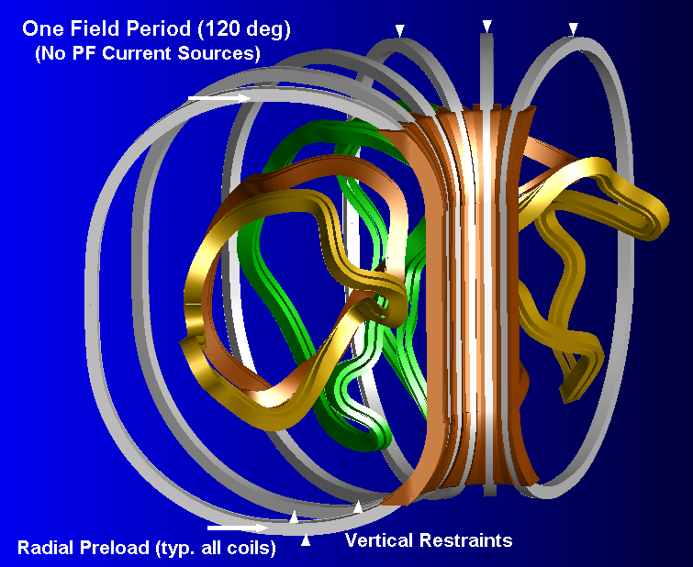
Fig. 3.0-1 Isometric View, One Field Period of TF & Modular Coils
4.0 Results

The results of the new TF WP with SS wedges and a 4000 lb per bracket preload are presented below.

Fig. 4.0-1 is a plot of the deformed coil & wedges, which shows local contact at the upper and lower extremes and a 5 mil gap at the equator.

Fig. 4.0-2 is a plot of the relative motion at the θ=0, TF3/4 contact surface. The contour values represent the amount of tangential relative motion and indicate a maximum of 39 μm or 1.5 mils. This maximum occurs in the red regions mid-way between the Z=0 equatorial plane and the two extremes of the interface. It is worth noting that this is about half of the relative motion found in the previous analysis of the larger WP without SS wedges [Error: Reference source not found]. Sliding at the extremes of the interface is nil, as represented by the “MN” symbol which correspond to a slip of 10⁻¹⁴ m.

The ANSYS plot title also lists some interesting results about the status of the contact elements: 2.1% are stuck, 1.7% are sliding, and 96% are open. In addition, of the contact elements which are closed (i.e., in contact and sliding or stuck) the average ratio of friction force to normal force is 0.24. This result is based on a very conservative calculation which goes as follows:

- Determine the resultant frictional force for each contact element, F_S = (F_Y² + F_Z²)^{0.5}.
- Divide F_S by the normal force (F_N) for each contact element, MUJ = F_S/F_N.
- Determine the average friction coefficient, Σ(MUJ)/(No. of closed contact elements).

Another approach is to uses global force summations from the ETABLE sum shown in Fig. 4.0-3, which goes as follows:

- Calculate the resultant frictional force Fs (sliding or stuck) from all contact elements above the equator.
  - Fs = (Σ(F_Y)²+ Σ(F_Z)²)^{0.5} = (1360² + 3940²)^{0.5} = 4170 N
- Calculate the total contact force from all contact elements above the equator.
  - Fn = 55540 N
- Divide Fs by Fn to determine the average friction coefficient required to maintain equilibrium.
  - μ_{min} = (4170/55540) = 0.075

This global force ratio of 0.075 is substantially smaller than the local average fiction coefficient value of 0.24 because some of the Fy and Fz forces have opposite signs which reduce the net frictional force. One could think of it this way: Eliminate macro-level slip by assuring a wedge surface friction coefficient of 0.24 or greater. Eliminate global-level slip by assuring a wedge surface friction coefficient of 0.08 or greater. It is worth noting that the assumed friction coefficient used in the analysis (0.3) is from conservative engineering judgment based on a survey of numerous materials with sliding contact (Marks’ Handbook). Increasing the preload will reduced the minimum required friction coefficient if 0.24 is a concern. Also, any mechanical fasteners at the extremes of the wedged interfaces would supplement or eliminate this frictional component. This mechanical device must restrain 4170 N (~1000 lb) in shear to carry the differential loads developed at this limiting operating condition.
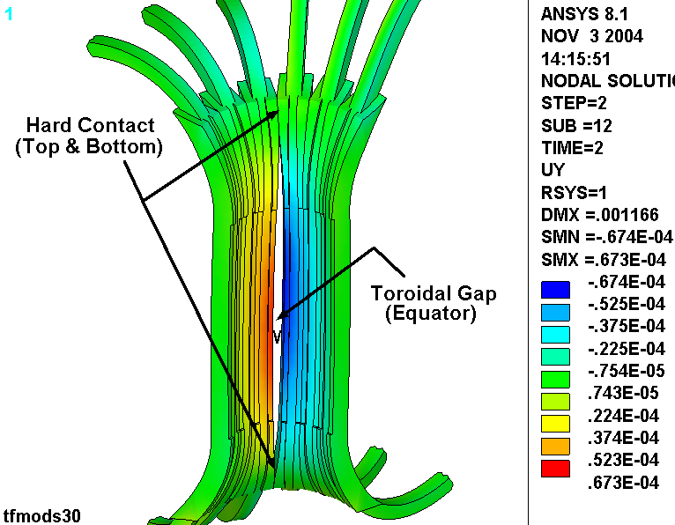
Fig. 4.0-1 Toroidal Displacement Contours [m] Superimposed on Exaggerated Deformed Shape

Fig. 4.0-2 Relative Motion at TF3/4 Interface
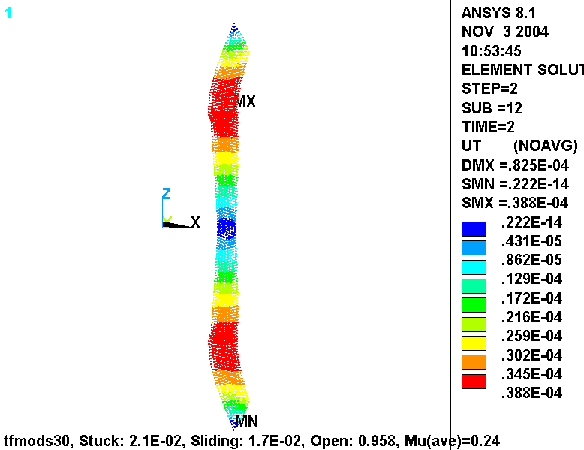
TFCs & MCs from 0.048T S3 Field State, 4000 lb/bracket Preload (μ=0.3 Friction at TF3/4 surface)

Fig. 4.0-3 Summation of Various ETABLE Components from Upper Half Contact Elements
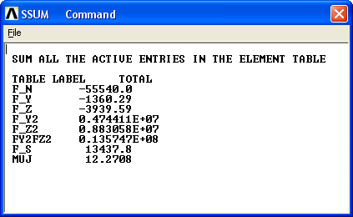
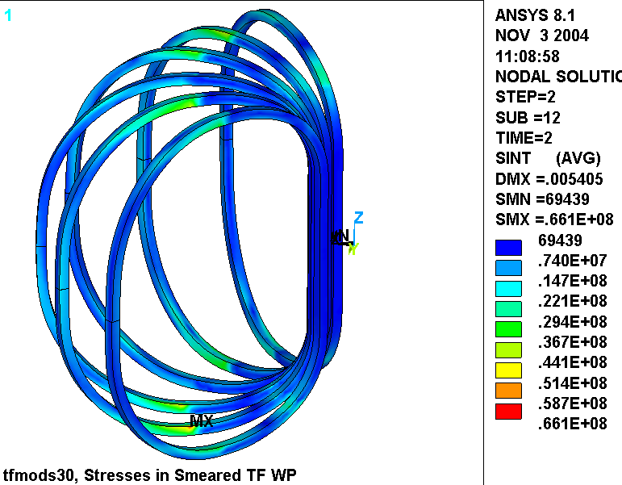
Fig. 4.0-4 is included to show the stress intensity in the smeared WP as a result of this particular coil current set plus the 4000 lb/bracket mechanical preload operating condition. The plot shows that the highest stresses appear at the lateral displacement boundary conditions, which make the 66 MPa value suspect. Away from these lateral constraints, the plot indicates larger regions at a stress level of 25 MPa (in the transition regions of all TF coils). Even with the understanding that these are smeared stresses which must be “marked-up” to determine the stress in the Cu conductor, the magnitude is low enough to not be a concern (Local Primary Membrane limit: 270 MPa).

Fig. 4.0-4 Stress Intensity in the Smeared TF WP
TFCs & MCs from 0.048T S3 Field State, 4000 lb/bracket Preload (μ=0.3 Friction at TF3/4 surface)
4.1 Preload Analysis with Revised Smeared Properties

The results presented in Sect. 4.0 are based on out-dated smeared winding pack properties. A recent change in the TF conductor insulation system, from fully-bonded to a Kapton-glass slip-plane, has triggered a revision to the smeared properties used in all global analyses. Since it is not clear what effect, if any, this change will have on the radial preload requirements, the six-coil model is revised and rerun.

It should be noted that the earlier version of the model (such as reported in 4.0) uses isotropic properties for the smeared WP. In this revised model, the orthotropic properties from [Error: Reference source not found] are applied. This requires defining a series of local coordinates (~10 per coil) for each WP segment (straights in the inboard leg and arcs elsewhere), which requires a fairly tedious effort. Conversely, all of these local systems can be approximated by a single toroidal system. Of course, the TF coils are not precisely toroidal (their minor radius is not a single value). However, the simplification is so trivial and the results are so close to “right” that the approach is applied here (see Fig. 4.1-1).

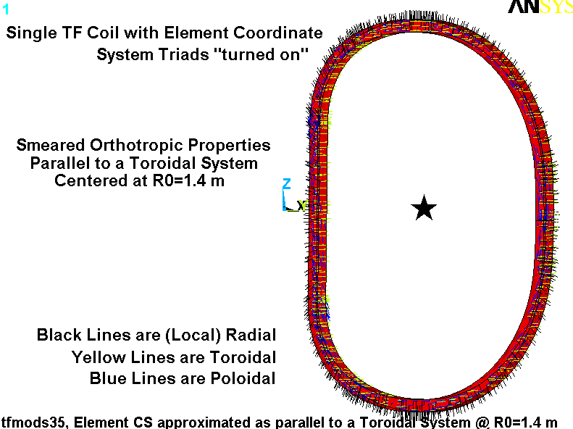
Fig. 4.1-1 Orthotropic WP Properties Parallel to Toroidal System Illustrated by Element CS Triads

Some difficulties in convergence have lead to another change: instead of supporting the –Y coils from the top and +Y coils from the bottom (as shown in Fig. 3.0-1), all coils are supported from the bottom. (It is very likely that this was the source of the convergence problem. It also produces some asymmetries that are non-physical and would not be present in the actual coil.)

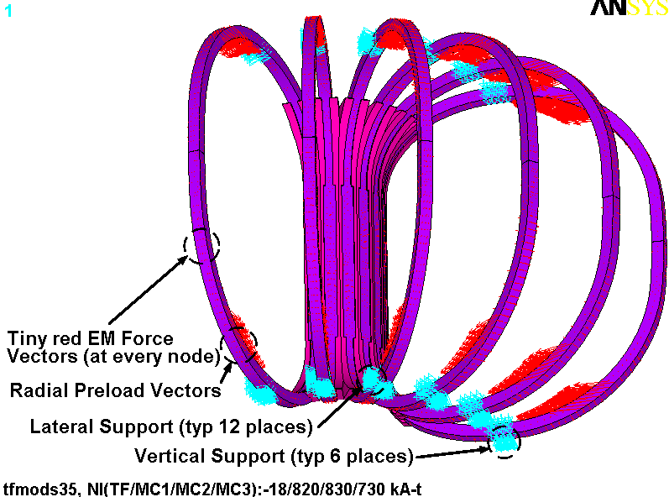
Fig. 4.1-2 shows a plot with these vertical displacement constraints highlighted, as well as the radial preload vectors, EM vectors, and lateral support points. The embedded ANSYS plot title also lists the coil currents associated with this EM loading.

Fig. 4.1-2 Force and Displacement Boundary Conditions

Fig. 4.1-3 is a plot of the radial deformations superimposed on a greatly exaggerated deformed shape plot from the radial preload condition. Ignore the embedded plot title which indicates that coil currents are present (“STEP=1” contains preload forces only). The plot shows how the coil sets contact each other at the extremes of the interface while producing a small gap in between. The back leg moves in by ~1.4 mm.
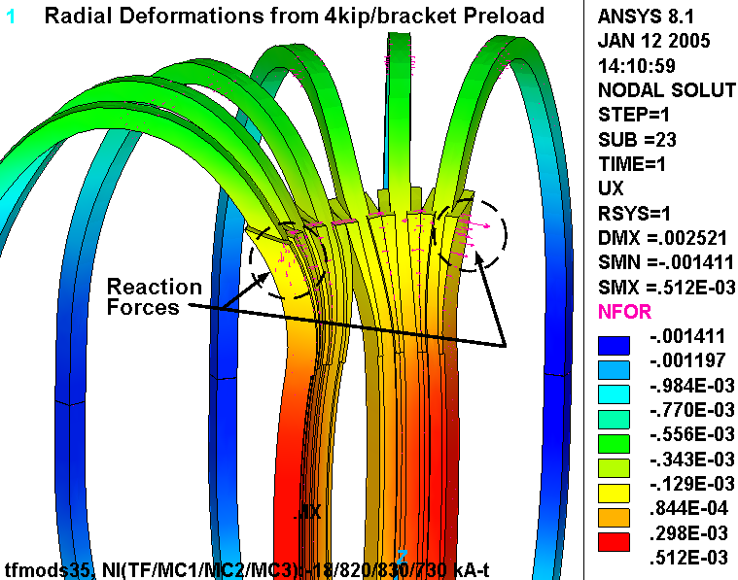

Fig. 4.1-3 Gaps, Contact and Radial Deformations (Smeared Properties of Slip-Plane Insulation)
(4000 lb/bracket Preload Load Case)

Fig. 4.1-4 is a similar plot of the radial deformations superimposed on a greatly exaggerated deformed shape plot. But in this case, the reference EM forces (coil amp-turns embedded in plot title) are included along with the radial preload (STEP=2). A close-up of the contact surface shows perfect radial displacement continuity (no color jump which signifies a stuck condition).

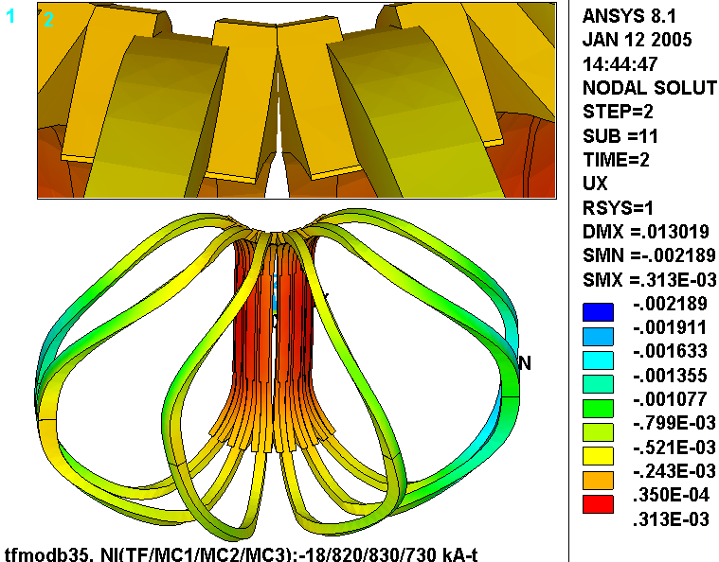

Fig. 4.1-4 Gaps, Contact and Radial Deformations (Smeared Properties of Slip-Plane Insulation)
TFCs & MCs from 0.048T S3 Field State, 4000 lb/bracket Preload (μ=0.3 Friction at TF3/4 surface)

The condition of the contact surface is quantified by a survey of the gap element “status.” Fig. 4.1-5 is a plot of the relative motion across each gap element. Dots signify no relative motion, while lines are vector-like and indicate the magnitude and direction of the relative motion. Notice that the relative motion at the extremes is represented by blue dots (relative displacements of order 10⁻⁸ m). Somewhat above the equatorial plane, the relative motion is a maximum at 0.06 mm. The embedded plot title lists other salient results:

- 5.9% of the gaps are “Stuck” (closed and not sliding)
- 0.5% of the gaps are “Sliding” (closed and sliding)
- 93.7% of the gaps are “Open”
- The ratio of shear force to normal force gives an effective friction coefficient, Mu(ave)=0.1

It is interesting to note that the average friction coefficient has dropped from 0.24 (Fig. 4.0-2) to 0.1, and is consistent with the 0.075 hand-calculation shown in sect. 4.0. The best physical explanation must be tied to the vertical constraint difference between the two models. The previous analysis (4.0) has boundary conditions which produce relative shear forces even when only in-plane radial preload forces are applied. In this later analysis, the BCs cannot induce such frictional shear forces. Consequently, the frictional requirement goes down and the 4000 lb/bracket may be higher than it needs to be.

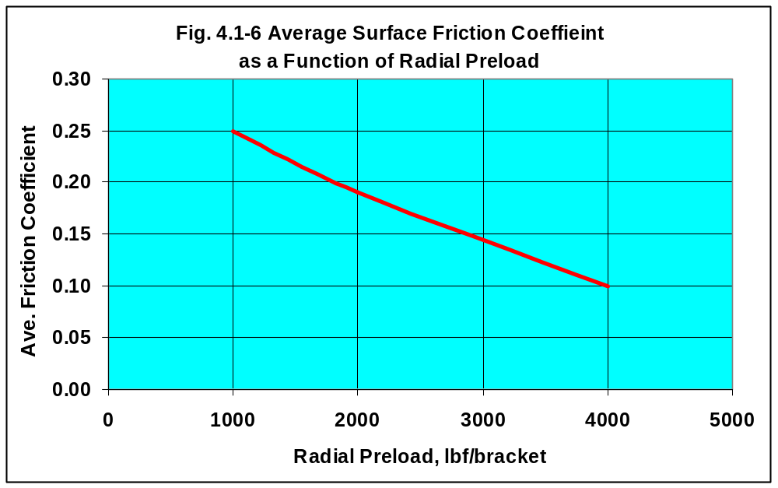
A couple additional analyses are made in order to gain a better understanding of the relationship between radial preload (F_{PL}) and average surface friction coefficient (μ_{ave}). Fig. 4.1-6 summarizes this result with a simple line plot. As the preload is reduced from 4000 lb_{f}/bracket, the average friction coefficient required to maintain a “stuck” wedge contact interface increases. Notice that when the preload is reduced to 2000 lb_{f} then the friction coefficient increases to 0.19.

Fig. 4.1-5 Relative Motion at TF3/4 Interface (Smeared Properties of Slip-Plane Insulation)
TFCs & MCs from 0.048T S3 Field State, 4000 lb/bracket Preload (μ=0.3 Friction at TF3/4 surface)

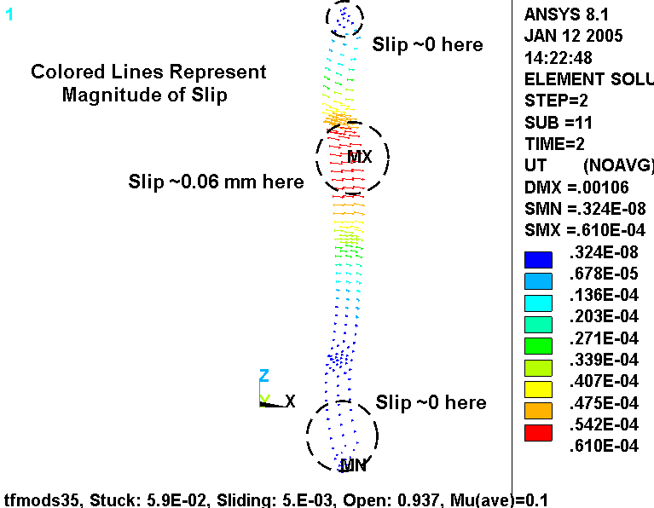
This plot demonstrates that the 4000 lb/bracket radial preload is sufficient to maintain a stuck interface (albeit limited to small patches at the extremes) even though there is a net radial force on one (or more) of the TF coils.
5.0 Summary & Commentary

At certain times during the current pulse, the net EM load on some of the TF coils is a positive radial force. Therefore, the project is obliged to provide some inward radial preload in order to ensure a structurally stable TF coil system.

The analysis shows that when the radial preload is 4000 lb/bracket (two per TF coil), then a friction coefficient of >0.10 at the wedge-to-wedge contact surface will maintain a no-slip condition. Analyses at lower preload levels suggest that a 2000 lb/bracket preload would also work, and results in a modest increase in the minimum friction coefficient to 0.19. In general engineering terms, these are both relatively low values, and should be easy to achieve with possibly no design effort. As added insurance against progressive relative motion, a mechanical device could be designed to transmit ~1000 lb of shear force at the extremes of the wedged interfaces.

6.0 Attachments

6.1 Drawings

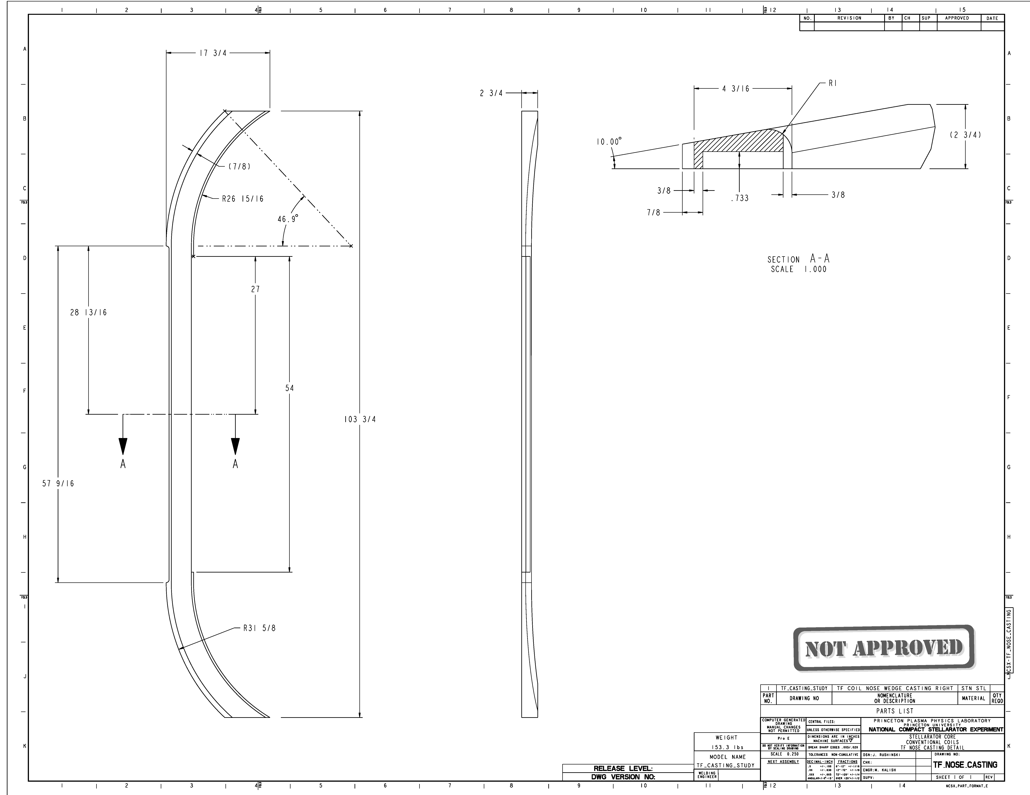
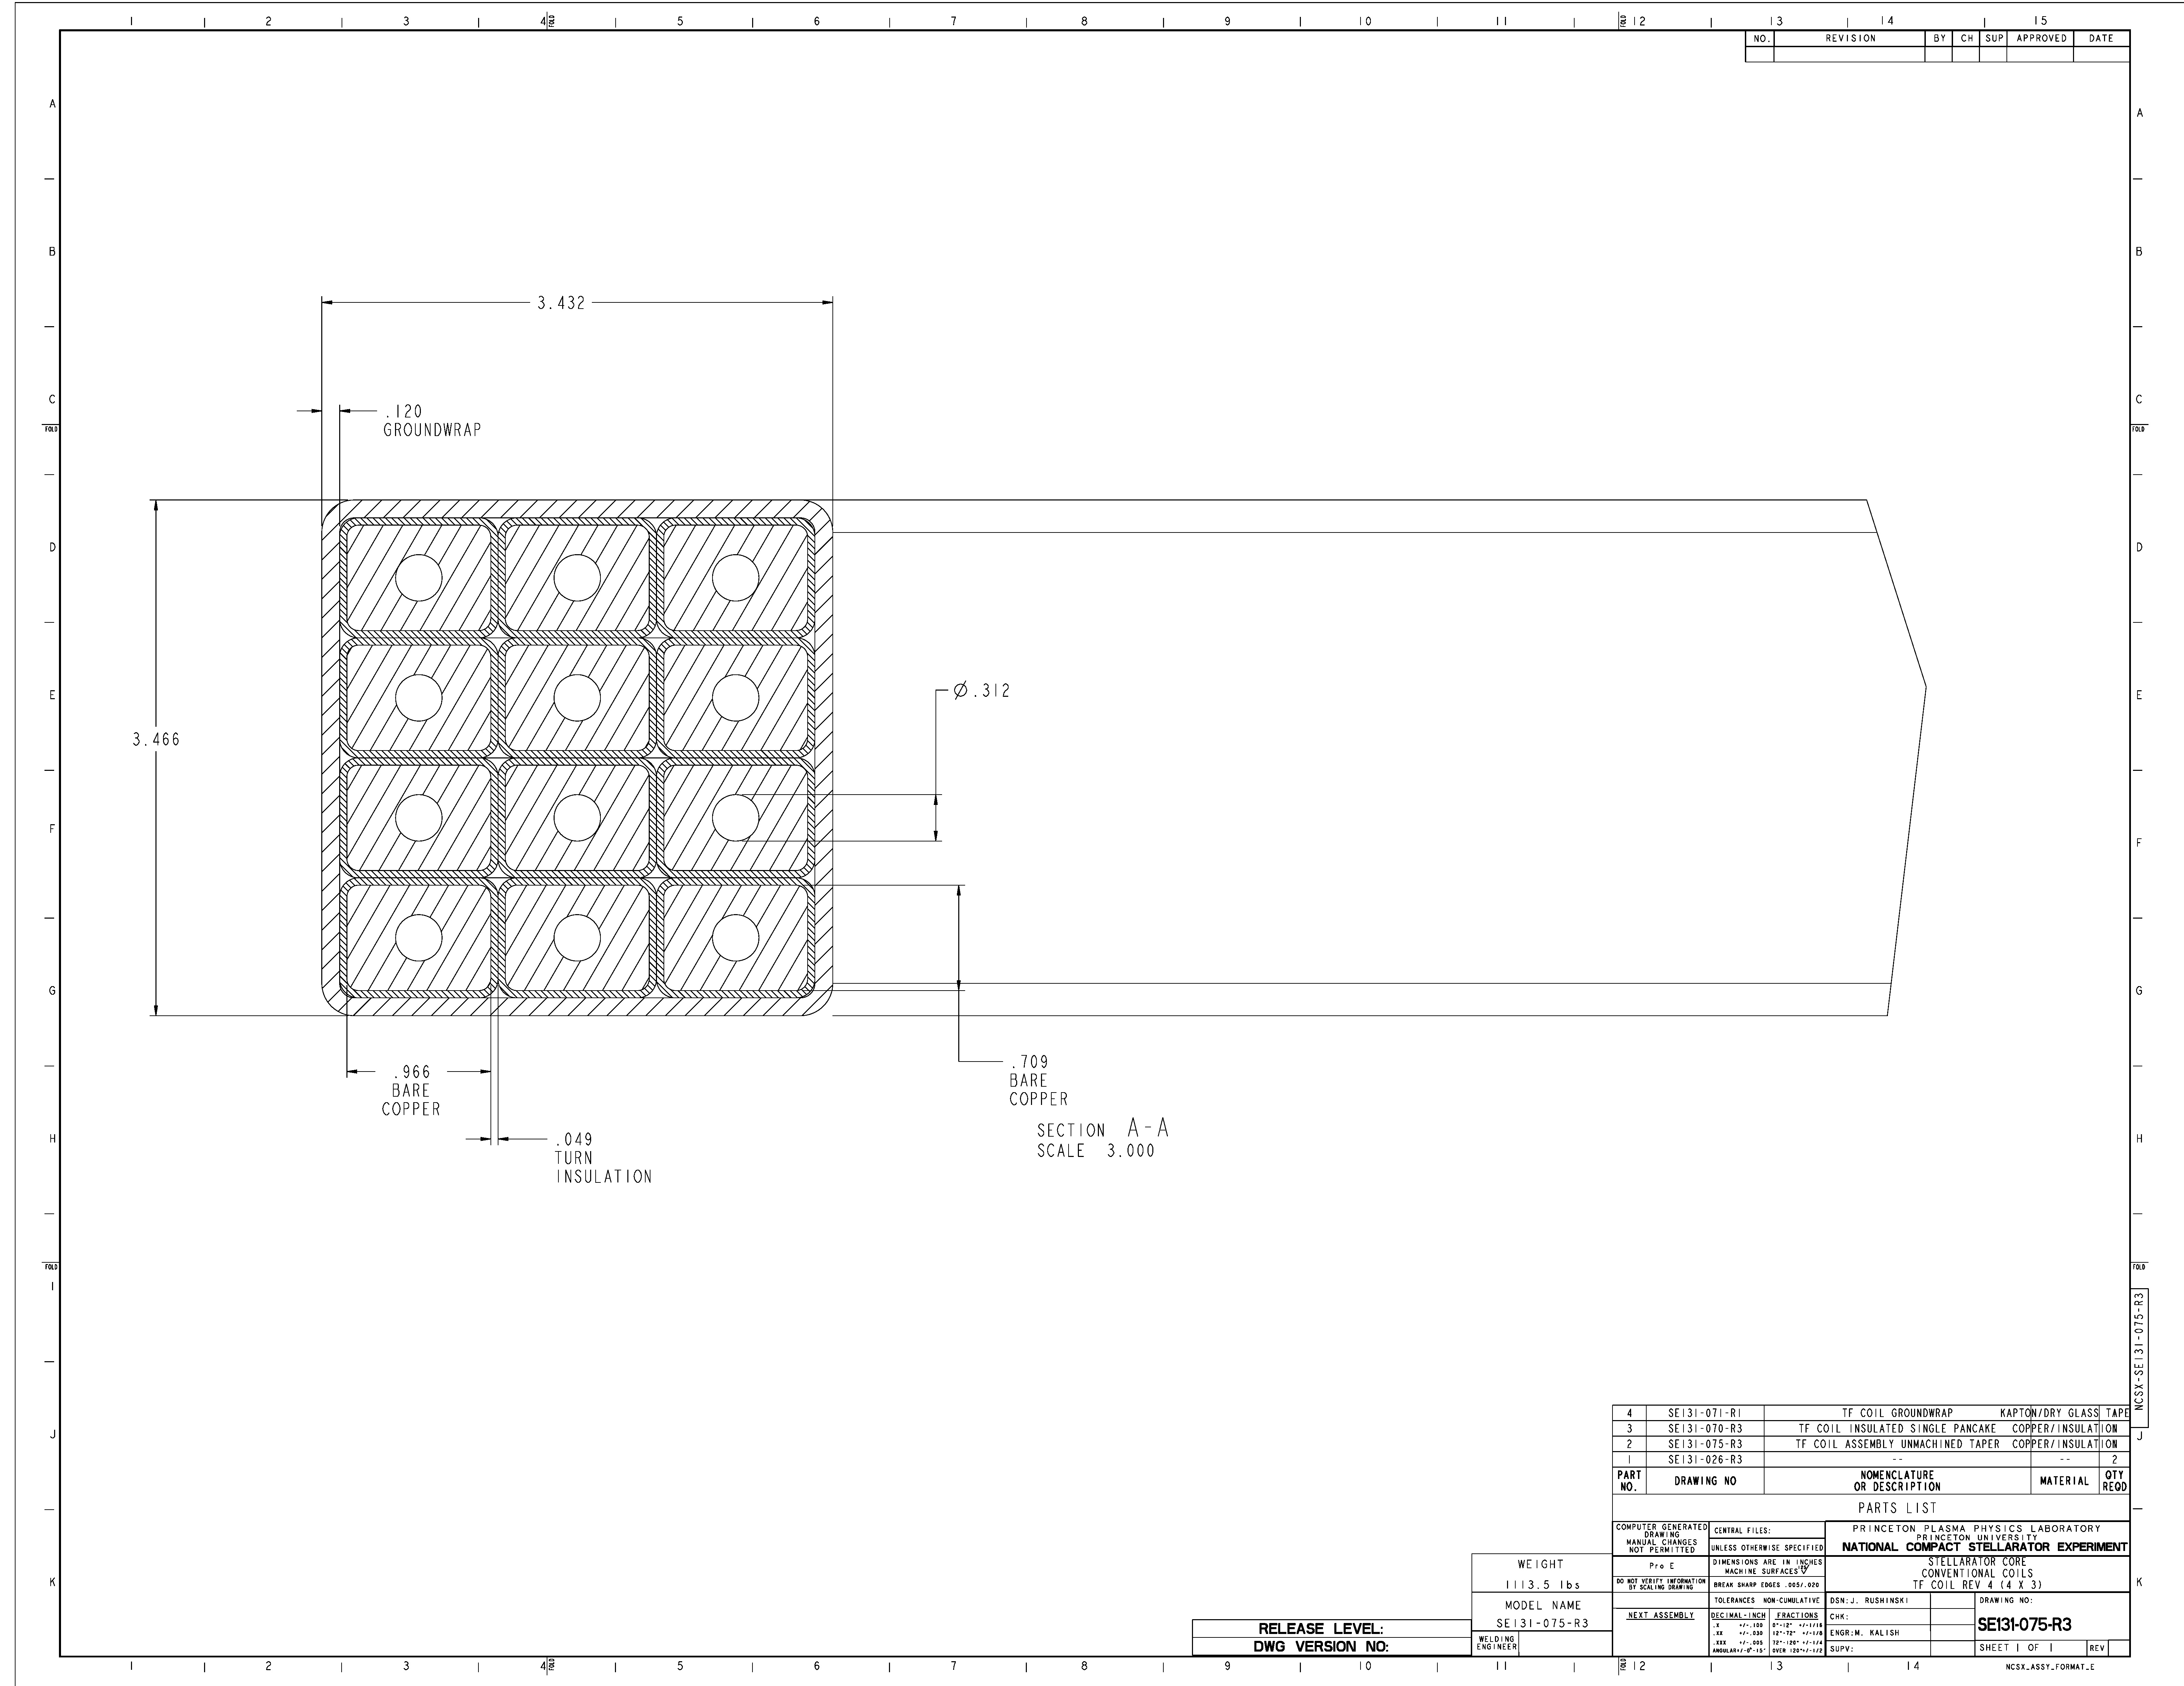
6.2 ANSYS Input File

/batch
rn=5
!/filnam,tfmodb3%rn%
!/show,tfmodb3%rn%,grp
resume,tfmodb3%rn%,db
*if,1,eq,1,:2000
/prep7
/com
/com Electromagnetic analysis of the NCSX TF and Modular Coil System
/com Structural analysis of the TF Coil System (No OOP structure...just inboard wedging and BCs)
/com Derived from tfmod2.dat, Coils made as smeared without ground wrap or sidewall insulation.
/com This coarser model designed to run with wedging contact elements to determine potential for stick-slip
/com Geometry defined by new 3x4 conductor pack and wedges
/com Solve the Conduction and field problem, then solve the structural problem
/com
/com
/com Model by Leonard Myatt, Myatt Consulting, Inc.
/com leonard.myatt@myattconsulting.com, 508-520-4590
/com
/com
/com Run History
/com
/com 30: TF Only...looks OK
/com 31: EM Only: TF & MC currents from Art Brooks (TF:+25.4 kA-t, M1/M2/M3:-850/+850/-850 kA-t)
/com 32: EM Only: TF & MC currents from Art Brooks (TF:-18.43 kA-t, M1/M2/M3:+820/+830/+730 kA-t)
/com Revise Smeared Properties & 3/8" GW thickness
/com 33: TF & MC currents from Art Brooks (TF:-18.43 kA-t, M1/M2/M3:+820/+830/+730 kA-t), k_dens=3
/com 34: TF & MC currents from Art Brooks (TF:-18.43 kA-t, M1/M2/M3:+820/+830/+730 kA-t), k_dens=2
/com 35: TF & MC currents from Art Brooks (TF:-18.43 kA-t, M1/M2/M3:+820/+830/+730 kA-t), k_dens=1, UZ=0 @ Z=0
/com 35: TF & MC currents from Art Brooks (TF:-18.43 kA-t, M1/M2/M3:+820/+830/+730 kA-t), nix toln & ftol on real
/com 35: TF & MC currents from Art Brooks (TF:-18.43 kA-t, M1/M2/M3:+820/+830/+730 kA-t), Key2=1 Lagrange Mult.
/com 35: TF & MC currents from Art Brooks (TF:-18.43 kA-t, M1/M2/M3:+820/+830/+730 kA-t), Key2=2, k_dens=1
/com
/com
/com Contact and Mesh Density Parameters
k_nl=1 ! 0: Wedged surfaces held to UY=0, 1: Generate Flex-Rigid Contact Interface
k_dens=1 ! number of elements across WP (3 is good, smaller can cause meshing problems)
mu_sw=0.3 ! sidewall-to-sidewall friction coefficient

/com Misc Parameters
k=0.0254 ! english to si conversion factor
pi=acos(-1) ! pi
mu0=4*pi*1e-7 ! Mu0
*afun,deg ! use degrees in trig functions
t=0.0001 ! a tiny length
th=0.1 ! a tiny angle

/com Nominal Performance Parameters
f_preload=4000/0.2248 ! applied radial preload per TF Bracket x 2 brackets per coil
z_preload=52*k ! vertical location of applied preload
b0=0.5 ! nominal flux density (one way of specifying TF current)
r0=1.4 ! major radius
ntf=18 ! number of tf coils
nsym=3 ! toroidal symmetry
arc=360/ntf ! angular extent of 1 tf coil
emsym,nsym ! electromagnetic symmetry about Z
dtmp=0!-215 ! differential temperature (WRT room temp)

/com
/com Coil Currents
/com
n_lay=3 ! number of radial layers
n_pan=4 ! number of pancakes
ntf=18 ! number of tf coils
i_tf=-18.43e3 !5e6*b0*r0/ntf ! total current in each smeared tf winding pack, A-turns/coil
i_mc1=820e3/20 ! conductor current in MC1, Amps
i_mc2=830e3/20 ! conductor current in MC2, Amps
i_mc3=730e3/18 ! conductor current in MC3, Amps

/com
/com element types
/com
et,1,98,2 ! Wedges (UX, UY, UZ)
et,2, 5,1 ! Modular Coil WP (TEMP, VOLT, MAG)
et,3,98,1 ! TF WP (TEMP, VOLT, MAG)

/com
/com graphics keys
/com
/pnum,mat,1
/num,1
/dist
/focus
/vup,1,z
/view,1,,-1

/com
/com tf conductor, ignoring radii (in local CS vernacular)
/com
dr_con=0.966*k ! Conductor build in thickness (0.434*k)
dz_con=0.709*k ! Conductor build in height (1.50*k)
dri_con=0.312*k ! inside thickness of cooling channel
dzi_con=0.312*k ! inside height of cooling channel
a_con=dr_con*dz_con-dri_con*dzi_con ! conductor metal area

/com
/com Insulation
/com
t_tw=0.049*k ! turn wrap insulation thk
t_pan=0.0*k ! pancake insulation thk (was 0.030", can be 0.0)
t_lay=0.0*k ! layer insulation thk (can be 0.0)
t_gw=0.375*k ! module over-wrap thickness
t_gap=t_gw/10 ! height of gap in outboard leg for current application

/com
/com WP Build
/com
dr_wp=n_lay*(dr_con+2*t_tw)+(n_lay-1)*t_lay ! radial build of WP
dz_wp=n_pan*(dz_con+2*t_tw)+(n_pan-1)*t_pan ! toroidal build of WP
dr_iwp=dr_wp+2*t_gw ! radial build of ground-wrapped WP
dz_iwp=dz_wp+2*t_gw ! toroidal build of ground-wrapped WP
cel=sqrt(dr_wp**2+dz_wp**2)/k_dens ! characteristic element size

/com
/com Centers of sweep and inside radii
/com
x11=r0 ! x position of local 11
z11=0.0 ! z position of local 11
ri11=r0-(12.494*k+dr_iwp) ! inside radius of coil in local 11
/com
x12=43.239*k ! x position of local 12
z12=28.785*k ! z position of local 12
ri12=27.314*k-(t_gw-k/8) ! inside radius of coil in local 12
/com
x13=53.629*k ! x position of local 13
z13=7.141*k ! z position of local 13
ri13=51.323*k-(t_gw-k/8) ! inside radius of coil in local 13
/com
x14=53.629*k ! x position of local 14
z14=0.000*k ! z position of local 14
ri14=ri13+z13-(t_gw-k/8) ! inside radius of coil in local 14
/com
x15=58.111*k ! x position of local 15
z15=10.850*k ! z position of local 15
ri15=47.614*k-(t_gw-k/8) ! inside radius of coil in local 15
/com
ri16=199.614*k-(t_gw-k/8) ! inside radius of coil in local 16
x16=(97.051+12.494-203.046)*k! x position of local 16
z16=0.000*k ! z position of local 16
/com
x17=58.111*k ! x position of local 17
z17=-10.850*k ! z position of local 17
ri17=ri15 ! inside radius of coil in local 17
/com
x18=58.111*k ! x position of local 18
z18=0.000*k ! z position of local 18
ri18=ri14 ! inside radius of coil in local 18
/com
x19=53.629*k ! x position of local 19
z19=-7.141*k ! z position of local 19
ri19=ri13 ! inside radius of coil in local 19
/com
x20=43.239*k ! x position of local 20
z20=-28.785*k ! z position of local 20
ri20=27.314*k-(t_gw-k/8) ! inside radius of coil in local 20

/com
/com Swept Angles (and straight-lengths)
/com
dy11=2*z12
dy12=abs(atan((z12-z13)/(x13-x12)))
dy13=90-dy12
dy14=4.482*k ! length of section 14
dy15=90-abs(atan((z15-z16)/(x15-x16)))
dy16=2*abs(atan((z15-z16)/(x15-x16)))
dy17=dy15
dy18=dy14
dy19=dy13
dy20=dy12

/com
/com material properties (Toroidal System: X is radial, Y is toroidal and Z is poloidal)
/com
local,103,3,,,,,,,1.4
/com TF Coils
mp, kxx,2,1
mp,murx,2,1
mp,rsvx,2,1
mp, ex,2,42.3e9
mp, ey,2,41.2e9
mp, ez,2,76.6e9
mp,alpx,2,9.5e-6
mp,alpy,2,9.6e-6
mp,alpz,2,13.0e-6
mp,nuxy,2,0.319
mp,nuyz,2,0.284
mp,nuxz,2,0.284
mp, gxy,2,2.1e9
mp, gyz,2,2.1e9 ! required to get beam bending right
mp, gxz,2,2.1e9 ! required to get beam bending right

/com
/com Side Wall insulation (Y is through thickness)
/com
mp,murx,3,1
mp, ey,3,21e9
mp, ex,3,28e9
mp, ez,3,28e9
mp,alpy,3,22e-6
mp,alpx,3,7.9e-6
mp,alpz,3,7.9e-6
mp, gxy,3,6.9e9
mp, gyz,3,6.9e9
mp, gxz,3,9.6e9
mp,nuxy,3,0.21
mp,nuyz,3,0.21
mp,nuxz,3,0.21
mp,dens,3,1800
mp, kxx,3,1

/com
/com Cast SS Wedges
/com
mp,murx,16,1
mp, ex,16,159e9
mp,alpx,16,13e-6
mp, kxx,16,1

/com
/com coordinate systems
/com
/com Local 11
csys
wpcsys
wpoff,x11,,z11
wprot,,-90
wprot,180
cswpla,11
/com Local 12
csys
wpcsys
wpoff,x12,,z12
wprot,,-90
wprot,180
cswpla,12,1
/com Local 13
csys
wpcsys
wpoff,x13,,z13
wprot,,-90
wprot,180
wprot,dy12
cswpla,13,1
/com Local 14
csys
wpcsys
wpoff,x14,,z14
wprot,,-90
wprot,180
wprot,90
cswpla,14
/com Local 15
dy1215=90
csys
wpcsys
wpoff,x15,,z15
wprot,,-90
wprot,180
wprot,90
cswpla,15,1
/com Local 16
csys
wpcsys
wpoff,x16,,z16
wprot,,-90
wprot,180
wprot,90+dy15
cswpla,16,1
/com Local 17
csys
wpcsys
wpoff,x17,,z17
wprot,,-90
wprot,180
wprot,180+dy16/2
cswpla,17,1
/com Local 18
csys
wpcsys
wpoff,x18,,z18
wprot,,-90
wprot,180
wprot,180+90
cswpla,18
/com Local 19
csys
wpcsys
wpoff,x19,,z19
wprot,,-90
wprot,180
wprot,180+90
cswpla,19,1
/com Local 20
csys
wpcsys
wpoff,x20,,z20
wprot,,-90
wprot,180
wprot,180+90+dy19
cswpla,20,1

/com
/com Smeared Winding Pack
/com

/com Straight Leg
csys,11
wpcsys
block,ri11,ri11+dr_iwp,-dy11/2,,-dz_iwp/2,dz_iwp/2
block,ri11,ri11+dr_iwp,,dy11/2,-dz_iwp/2,dz_iwp/2

/com Local 12,13 Arc
*do,j,12,13
csys,j
wpcsys
ksel,s,loc,x,0.99*ri%j%,1.01*ri%j%
*get,ri%j%,kp,,mnloc,x
vsel,none
cylind,ri%j%,ri%j%+dr_iwp,-dz_iwp/2,dz_iwp/2,,dy%j%
*enddo

/com Top Straight
csys,14
wpcsys
ksel,s,loc,x,0.99*ri14,1.01*ri14
*get,ri14,kp,,mnloc,x
vsel,none
block,ri14,ri14+dr_iwp,,dy14,-dz_iwp/2,dz_iwp/2

/com Local 15,16,17 Arc
*do,j,15,17
csys,j
wpcsys
ksel,s,loc,x,0.99*ri%j%,1.01*ri%j%
*get,ri%j%,kp,,mnloc,x
vsel,none
cylind,ri%j%,ri%j%+dr_iwp,-dz_iwp/2,dz_iwp/2,,dy%j%
*enddo

/com Bot Straight
csys,18
wpcsys
ksel,s,loc,x,0.99*ri18,1.01*ri18
*get,ri18,kp,,mnloc,x
vsel,none
block,ri18,ri18+dr_iwp,,dy18,-dz_iwp/2,dz_iwp/2

/com Local 19,20 Arc
*do,j,20,19,-1
csys,j
wpcsys
ksel,s,loc,x,0.99*ri%j%,1.01*ri%j%
*get,ri%j%,kp,,mnloc,x
vsel,none
cylind,ri%j%,ri%j%+dr_iwp,-dz_iwp/2,dz_iwp/2,,dy%j%
*enddo

/com
/com Glue Up WPs
/com
allsel
vglue,all
cm,wp,volu

/com
/com Add the SS Case
/com
th_case=60 ! angular extent of wedges in dewedged region
dz_case=103.75*k ! vertical height of wedges
dy_case=2.75*k ! max toroidal thickness of wedge
r_case=0!.5*k ! radius top of case
vsel,none
/com Straight Region
csys,11
wpcsys
block,ri11-0.375*k,ri11+dr_iwp+(7/8)*k,,dy11/2,dz_iwp/2-0.733*k,2*dz_iwp
cm,case,volu
block,ri11,ri11+dr_iwp,,dy11/2,,dz_iwp/2
block,,ri11,,27*k,,dz_iwp/2
vsbv,case,all
cm,case1,volu
/com Arc Region
csys,12
wpcsys
vsel,none
cylind,ri12-0.375*k,ri12+dr_iwp+(7/8)*k,dz_iwp/2-0.733*k,2*dz_iwp,,th_case
cm,case,volu
cylind,ri12,ri12+dr_iwp,,dz_iwp/2,,th_case
vsbv,case,all
cmsel,a,case1
cm,case,volu
csys,11
wpcsys
!block,ri11+dr_iwp+(3/8)*k,12,,(28+13/16)*k,,12
block,ri11+dr_iwp+(3/8)*k,12,,z12,,12
csys
wpcsys
block,,12,,12,dz_case/2,12
block,,12,dz_iwp/2-0.733*k+dy_case,12,,12
wprot,arc/2
block,,12,,12,,12
vsbv,case,all
vglue,all
cm,case,volu
allsel,below,volu

/com Add a radius to the Low-Field Side of the wedge lip (trig very approximate)
*if,r_case,ne,0,then
csys,12
ksel,r,loc,x,ri12+dr_iwp-t,ri12+dr_iwp+t
*get,th12mx,kp,,mxloc,y
ksel,r,loc,y,th12mx-t,th12mx+t
csys
*get,x12mx,kp,,mxloc,x
*get,z12mx,kp,,mxloc,z
local,112,1,x12mx-1.05*(r_case+r_case*(1/sin(th12mx))),,z12mx-r_case
!local,112,1,x12mx-r_case*cos(th12mx)-(r_case+r_case*(sin(th12mx)))*tan(th12mx),,z12mx-r_case
wpcsys
wprot,,-90
wprot,th12mx
cylind,r_case,3*r_case,,dz_iwp/2,-90-th12mx,0
vsbv,case,all
*endif

/com
/com Reflect other wedges
/com
csys
VSYMM,Y,all
VSYMM,Z,all

/com
/com Treat WP/Wedge Interface
/com
allsel
vglue,all

/com
/com Slit Outboard Leg for Volt BC
/com
csys
wpcsys
allsel
cm,tf,volu
block,r0,3*r0,-dz_wp,dz_wp,,t_gap
btol,t_gap/2
vsbv,tf,all

/com
/com Cut Model in half for reflection later
/com
allsel
csys
wpcsys
cm,tfcoil1,volu
block,,10,-10,,-10,10
vsbv,tfcoil1,all

/com
/com Set Attributes
/com
*do,j,11,20
csys,j
ksel,s,loc,x,ri%j%-t,ri%j%+dr_iwp+t
*if,j,eq,11,then
ksel,r,loc,y,-dy%j%/2-t,dy%j%/2+t
*else
ksel,r,loc,y,-t,dy%j%+t
*endif
lslk,,1
asll,,1
vsla,,1
vatt,2,,3,j
*enddo
vsel,s,mat,,2
vsel,invert
vatt,16,,1

/com
/com Mesh the smeared WP Volumes
/com
MSHAPE,1,3D
esize,cel
allsel
vmesh,all

/com
/com Reflect other half
/com
allsel
*get,dn1,node,,num,max
csys
nsym,y,dn1,all
esym, ,dn1,all
numm,node

/com
/com Make all TF Coils
/com
allsel
*get,dn2,node,,num,max
csys,1
ngen,ntf/nsym,dn2,all,,,,360/ntf
egen,ntf/nsym,dn2,all
*get,thmn,node,,mnloc,y
*get,thmx,node,,mxloc,y
modmesh,detach
ngen,2,,all,,,,-(thmn+thmx)/2
*get,thmn,node,,mnloc,y
*get,thmx,node,,mxloc,y

/com
/com Couple & Ground Volts and Apply Current to TF WP
/com
*do,j,1,ntf/nsym
esel,s,mat,,2
nsle
csys,1
nsel,r,loc,x,r0,12
nsel,r,loc,z
nsel,r,loc,y,-(360/nsym/2)+(360/ntf)*(j-1),-(360/nsym/2)+(360/ntf)*(j-0)
cp,next,volt,all
*get,n_tf%j%,node,,num,min
f,n_tf%j%,amps,i_tf
/com Ground other end
esel,s,mat,,2
nsle
csys,1
nsel,r,loc,x,r0,12
nsel,r,loc,z,t_gap
nsel,r,loc,y,-(360/nsym/2)+(360/ntf)*(j-1),-(360/nsym/2)+(360/ntf)*(j-0)
d,all,volt
*enddo

/com
/com Modular Coil Model
/com
/input,modcoils1,cdb ! pull in PDR modular coils from HM Fan's file-1.7t.db

n_mcoils=3 ! number of Modular Coil Pairs
tpmc1=10 ! turns per MC1 winding pack, 2 WP per coil, 4 in-hand
tpmc2=10 ! turns per MC2 winding pack, 2 WP per coil, 4 in-hand
tpmc3=9 ! turns per MC3 winding pack, 2 WP per coil, 4 in-hand

/com Node numbers for current application
n_m11=13599
n_m12=13609
n_m13=13619
n_m14=15619
n_m21=21639
n_m22=21649
n_m23=21659
n_m24=23659
n_m31=29679
n_m32=29689
n_m33=29699
n_m34=31699

/com Make nodal components out of Modular Coil Current Nodes
*do,jj,1,n_mcoils
nsel,none
*do,j,1,4
nsel,a,node,,n_m%jj%%j%
*enddo
cm,n_m%jj%,node
*enddo

/com
/com Modular Coil Currents
/com
cmsel,s,n_m1 $f,all,amps,i_mc1*tpmc1 ! MC1
cmsel,s,n_m2 $f,all,amps,i_mc2*tpmc2 ! MC2
cmsel,s,n_m3 $f,all,amps,i_mc3*tpmc3 ! MC3

/com Nix MAG DOF
esel,s,type,,2,3
nsle
d,all,mag
/com Set TEMP
esel,s,type,,1,3,2
nsle
d,all,temp,dtmp
allsel
bfunif,temp,dtmp

allsel
/psym,csys
nit=nint(i_tf/1000)
nim1=nint(i_mc1*tpmc1*2/1000)
nim2=nint(i_mc2*tpmc2*2/1000)
nim3=nint(i_mc3*tpmc3*2/1000)

/title,tfmodb3%rn%, NI(TF/MC1/MC2/MC3):%nit%/%nim1%/%nim2%/%nim3% kA-t
allsel
/edge,1,1
eplo
esel,s,mat,,2
esel,a,mat,,103,105
nsle
eplo
/edge
allsel
save
fini

/solu
tref,0
/com Solve for the conduction problem
allsel
esel,u,type,,1
*if,i_mc1+i_mc2+i_mc3,eq,0,then
esel,u,mat,,103,105 ! Nix MCs
*endif
nsle
solve

/com Solve for the fields
esel,s,mat,,2
nsle
*if,i_mc1+i_mc2+i_mc3,ne,0,then
esel,a,mat,,103,105
*endif
nsle
biot,new
allsel
solve
fini

:1000
/post1
/auto
/title,tfmodb3%rn%, NI(TF/MC1/MC2/MC3):%nit%/%nim1%/%nim2%/%nim3% kA-t
esel,s,mat,,2
esel,a,mat,,103,105
nsle
/view,1,1
/edge,1,1
eplo
/edge
/com Modular Coil Fields
esel,s,mat,,103,105
nsle
plns,b,sum
/com TF Coil Fields
esel,s,mat,,2
nsle
plns,b,sum
/com TF Coil Forces
*dim,f_t,,6,ntf/nsym

*do,j,1,ntf/nsym
th%j%=-(360/nsym/2)+arc/2+(360/ntf)*(j-1)
local,1000+j,,,,,th%j%
/psym,csys
esel,s,mat,,2
nsle
csys,1
nsel,r,loc,y,th%j%-arc/2,th%j%+arc/2
esln,,1
rsys,1000+j
etab,fx,fmag,x
etab,fy,fmag,y
etab,fz,fmag,z
csys,1000+j
etab,xc,cent,x
etab,yc,cent,y
etab,zc,cent,z
sadd,eccx,xc,,-1,,r0
!sadd,eccx,xc,,-1,,1.48736 ! Art's Centroid
/com Calculate Torques from each coil
/com Tx
smult,tx1,fy,zc,-1
smult,tx2,fz,yc,+1
sadd,tx,tx1,tx2
/com Ty
smult,ty1,fx,zc,+1
smult,ty2,fz,eccx,+1
sadd,ty,ty1,ty2
/com Tz
smult,tz1,fy,xc,+1
smult,tz2,fx,yc,-1
sadd,tz,tz1,tz2
ssum
*get,fx,ssum,,item,fx
*get,fy,ssum,,item,fy
*get,fz,ssum,,item,fz
*get,tx,ssum,,item,tx
*get,ty,ssum,,item,ty
*get,tz,ssum,,item,tz
f_t(j,1)=fx
f_t(j,2)=fy
f_t(j,3)=fz
f_t(j,4)=tx
f_t(j,5)=ty
f_t(j,6)=tz
nfx=nint(fx)
nfy=nint(fy)
nfz=nint(fz)
kfx=0.01*nint(fx/10)
kfy=0.01*nint(fy/10)
kfz=0.01*nint(fz/10)
thj=th%j%
/title,tfmodb3%rn%, TF#%j% (%thj% deg), Local FX/FY/FZ=%kfx%/%kfy%/%kfz% kN
/title,tfmodb3%rn%, TF#%j% (%thj% deg), Local FX/FY/FZ=%nfx%/%nfy%/%nfz% N
/view,1,,1
plns,b,sum
*enddo

*vwrite,
(' F(radial) F(OOP) F(Vertical) T(radial) T(R0) T(Vertical)')
*vwrite,f_t(1,1),f_t(1,2),f_t(1,3),f_t(1,4),f_t(1,5),f_t(1,6)
(1p6e12.4)

allsel
save
fini
!/exit,nosa
!/eof

:2000
srn=7
/filnam,tfmods3%srn%
/show,tfmods3%srn%,grp

/com 30: 4000 lb preload, Art's 08/03 currents, 2 load steps (just like previous, non-wedged, analysis)
/com 32:
/com 33: 4000 lb preload, new smeared props, Not Converged
/com 34: 4000 lb preload, new smeared props
/com 35: 4000 lb preload, new smeared props
/com 36: 2000 lb preload, new smeared props
/com 37: 1000 lb preload, new smeared props
/com
/prep7
shpp,off
dtmp=0
k_nl=1 ! 0: Wedged surfaces held to UY=0, 1: Generate Flex-Rigid Contact Interface
mu_sw=0.3 ! sidewall-to-sidewall friction coefficient
f_preload=1000/0.2248 ! applied radial preload per TF Bracket x 2 brackets per coil

/com Change to structural elements
et,1,92
et,3,92

/com Delete MC elements
esel,s,type,,2
nsle
edele,all
ndele,all
etdele,2

/com TF Coils (close to a simple toroidal system)
local,103,3,,,,,,,1.4
mp, kxx,2,1
mp,murx,2,1
mp,rsvx,2,1
mp, ex,2,42.3e9
mp, ey,2,41.2e9
mp, ez,2,76.6e9
mp,alpx,2,9.5e-6
mp,alpy,2,9.6e-6
mp,alpz,2,13.0e-6
mp,nuxy,2,0.319
mp,nuyz,2,0.284
mp,nuxz,2,0.284
mp, gxy,2,2.1e9
mp, gyz,2,2.1e9 ! required to get beam bending right
mp, gxz,2,2.1e9 ! required to get beam bending right
esel,s,mat,,2
emodif,all,esys,103
csys

/com Apply Temps to TF Coil
esel,all
nsle
bfunif,temp,dtmp

/com Apply Wedged Face BCs
*if,k_nl,eq,0,then
/com Couple adjacent nodes and cyclically couple wedged surfaces at theta edges
csys,1
nsel,s,loc,x,,r0
cpintf,ux
cpintf,uy
cpintf,uz
allsel
nsel,u,loc,y,thmn+th,thmx-th
nrotate,all
/com Cyclic Coupling at inboard legs
cpcyc,ux,0.1*k,1,,thmx-thmn,,1
cpcyc,uy,0.1*k,1,,thmx-thmn,,1
cpcyc,uz,0.1*k,1,,thmx-thmn,,1
*else
/com Generate Node-Node Contact surfaces between Wedged Surfaces for nonlinear analyses
!et,11,178,,,1,1,0 ! contact elements
!et,11,178,,1,1,1,0 ! Lagrange Mult.
et,11,178,,2,1,1,0 !
mp,mu,11,mu_sw
mat,11
type,11
*do,j,1,ntf/nsym-1
/gopr
csys,1000+j
wpcsys
wprot,+arc/2
cswpla,2000+j
nsel,s,loc,y,-t,t
csys,1
*get,thmn%j%,node,,mnloc,y
*get,thmx%j%,node,,mxloc,y
th%j%=(thmn%j%+thmx%j%)/2
esel,s,mat,,3
!*if,j,ge,ntf/nsym/2-1,and,j,le,ntf/nsym/2+1,then
*if,j,ge,ntf/nsym/2,and,j,le,ntf/nsym/2,then
real,10+j
r,10+j,,0,2,,,-sin(th%j%)
rmore,cos(th%j%),,!2,2 ! 9 & 10 are scale factors on toln & ftol
eint,,,low
*else
cpintf,ux
cpintf,uy
cpintf,uz
*endif
*enddo
/com Cyclic Coupling at inboard legs
csys,1
nsel,s,loc,x,,r0
allsel
nsel,u,loc,y,thmn+th,thmx-th
nrotate,all
/com Cyclic Coupling at inboard legs
cpcyc,ux,0.1*k,1,,thmx-thmn,,1
cpcyc,uy,0.1*k,1,,thmx-thmn,,1
cpcyc,uz,0.1*k,1,,thmx-thmn,,1
*endif

/com Restrain TF Coil in Z
*do,j,1,ntf/nsym
csys,1000+j
nsel,s,loc,y,-cel/2,cel/2
*if,j,le,ntf/nsym/2,then
*get,zgrnd,node,,mnloc,z
*else
!*get,zgrnd,node,,mxloc,z
*get,zgrnd,node,,mnloc,z
*endif
nsel,r,loc,z,zgrnd-t,zgrnd+t
*get,xmn_bot,node,,mnloc,x
*get,xmx_bot,node,,mxloc,x
xav_bot=(xmn_bot+xmx_bot)/2
nsel,r,loc,x,xav_bot-cel/2,xav_bot+cel/2
d,all,uz
*enddo

/com Apply Coupling at Equatorial Slit
csys,1
nsel,s,loc,x,r0,2*r0
nsel,r,loc,z,-t,2*t_gap
cpint,ux,2*t_gap
cpint,uy,2*t_gap
cpint,uz,2*t_gap

/com
/com Apply Radial Preload and lateral constraint
/com
*do,j,1,ntf/nsym
csys,1000+j
esel,all
nsel,ext
nsel,r,loc,y,-dz_iwp,dz_iwp
nsel,r,loc,x,r0,12
nsel,r,loc,z,z_preload-cel,z_preload+cel
*get,nnodes,node,,count
nrotate,all
f,all,fx,-f_preload/nnodes
nsle
nsel,ext
nsel,r,loc,y,-dz_iwp,dz_iwp
nsel,r,loc,x,r0,12
nsel,r,loc,z,-z_preload-cel,-z_preload+cel
*get,nnodes,node,,count
nrotate,all
f,all,fx,-f_preload/nnodes
/com Lateral Constraints
allsel
nsel,ext
nsel,r,loc,y,-dz_iwp/2-t,dz_iwp/2+t
nsel,r,loc,x,r0-0.1,r0+0.1
nsel,u,loc,y,-dz_iwp/2+t,dz_iwp/2-t
nrotate,all
d,all,uy
*enddo

allsel
save
fini

/solu
allsel

/com Solve the preload problem
*if,k_nl,eq,0,then
solve
*else
nsubst,10000,200000,4
autots,on
kbc,0
nropt,unsym ! bombs on "Insufficient memory error during solution" with -m 128/64
!eqslv,pcg ! PCG solver fails to solve problems with Lagrange multiplier method.
eqslv,sparse
!nropt,full,,off
!lnsrch,on
solve
*endif
fcum,add
ldread,forc,2,,,,tfmodb3%rn%,rst
nsubst,100,200000,4
solve

fini
:3000
/show,tfmods3%srn%,grp
/post1
set,last
/auto
/psym,csys
/cont,,,auto
/title,tfmods3%srn%, Stress Analysis
/view,1,,-1
pldi
esel,s,mat,,2
nsle
plns,s,int
rsys,1
plns,u,x

*if,k_nl,eq,1,then
/com Ratio of Shear Force to Notmal Force
esel,s,type,,11
*get,nce,elem,,count
etab,f_n,smisc,1
etab,f_y,smisc,2
etab,f_z,smisc,3
smult,f_y2,f_y,f_y
smult,f_z2,f_z,f_z
sadd,fy2fz2,f_y2,f_z2
sexp,f_s,fy2fz2,,0.5
sexp,muj,f_s,f_n,,-1
esel,r,etab,muj,0.99*mu_sw,1.01*mu_sw
*get,nsce,elem,,count
f_sl=0.001*nint(1000*nsce/nce)
esel,s,type,,11
esel,r,etab,f_n,0
*get,noce,elem,,count
f_op=0.001*nint(1000*noce/nce)
esel,s,type,,11
esel,r,etab,muj,0.01*mu_sw,0.99*mu_sw
*get,nstkce,elem,,count
f_stk=0.001*nint(1000*nstkce/nce)
esel,s,type,,11
esel,r,etab,muj,0.01*mu_sw,1.01*mu_sw
*get,ncntce,elem,,count
ssum
*get,mursum,ssum,,item,muj
muav=0.01*nint(100*mursum/ncntce)
/title,tfmods3%srn%, Stuck: %f_stk%, Sliding: %f_sl%, Open: %f_op%, Mu(ave)=%muav%
esel,s,type,,11
nsle
plet,muj

/com Max Slip
esel,s,type,,11
etab,uty,nmisc,6
etab,utz,nmisc,7
smult,uty2,uty,uty
smult,utz2,utz,utz
sadd,uty2utz2,uty2,utz2
sexp,ut,uty2utz2,,.5
plet,ut
*endif

allsel
/cont
fini
/exit,all
/eof

Leonard Myatt, “Effects of Modular Coil Fields at S3 State on TF Coil Structural Continuity,” 08/16/2004.
ANSYS Release 8.1, UP20040329, INTEL NT, ANSYS, Inc., Canonsburg, PA.
A. Brooks, Excel file: TF Centering Forces with Modular Coils.xls, ~06/30/04.
Leonard Myatt, “Calculating Smeared Properties of the TF Winding Pack for Use in Global Models,” 12/03/2005.

