PPPL-NCSX Memorandum

To: Project Engineer (PPPL)
From: Leonard Myatt (Myatt Consulting, Inc.)
Date: January 3, 2005
Subject: Calculating Smeared Properties of the TF Winding Pack for Use in Global Models

1.0 Executive Summary

A change to the TF coil conductor and winding pack (WP) turn array has lead to an update of the smeared material properties for use in global models. This memo presents an analysis of this latest configuration, which includes the recent addition of a conductor-to-turn-wrap slip-plane (Kapton-wrap).

A parametric, text-based ANSYS input file is developed to represent the coil cross-section. Loads and boundary conditions are applied to simulate unit loads that lead to elastic moduli (E_{x}, E_{y}, E_{z}), Poisson’s Ratios (ν_{xy}, ν_{yz}, ν_{xz}), shear moduli (G_{xy}, G_{yz}, G_{xz}) and coefficients of thermal expansion (CTEs α_{x}, α_{y}, α_{z}). The model is exercised with the latest dimensions (e.g. 0.966” x 0.709” conductor, a 49 mil Kapton-glass turn-wrap insulation, and a 0.120” thick glass ground wrap). In addition, the model is used to produces smeared properties for thicker ground wraps (GW), as this may be helpful to the no-case TF coil configuration. However, the attached input file can easily be rerun with different dimensions and the revised properties gleaned from the titles of automated result plots.

A concern over the adequacy of these developed properties to capture the behavior of gross bending leads to the development of two “beam” models:

- A detailed model of the TF WP with all of its conductors, slip-planes, insulation and GW.
- A homogeneous model of the TF WP with orthotropic properties.

The analysis of the detailed beam provides a benchmark of what bending deformations aught to be like. The analysis of the homogeneous beam with orthotropic properties is expected to produce similar results. However, the smeared model highlights a shortcoming in the smeared property calculation; the high transverse shear modulus is more appropriate for short beam shear and not the larger-scale bending deformations expected in our TF coil. Fortunately, applying the lower in-plane shear modulus in all three shear directions leads to deformations which are fairly consistent with the results predicted by the detailed model. All ANSYS input files are attached, along with text and figures to illustrate this point.
2.0 Assumptions and Notable Concerns

2.1 The analyses assume a zero-friction Cu-insulation interface. The real presence of friction (or partial and poor bonding) would effectively stiffen the moduli, pushing them closer to the earlier monolithic results. Therefore, the zero-friction assumption should yield conservative results (i.e., somewhat larger than expected deformations) when used in global model analyses.

2.2 The orthotropic properties used for the Kapton-S2 glass layer are not necessarily based on the exact lay-up of our TF turn insulation and epoxy. However, they seem to be the next-best thing short of a costly and time-consuming test program. (See Attachment 6.2)
3.0 Analysis

The 3D structural ANSYS model is based on the TF coil conductor and winding pack shown in Attachment 6.1. The 0.966” x 0.709” Cu conductor has a 0.312” diameter cooling channel, and is wound into a three radial layer by four toroidal pancake array. Each turn is insulated with a single half-lap Kapton layer (3.5 mils with adhesive) and three half-laps of S-2 glass (7 mils each), for a total thickness of 2x3.5+6x7 or 49 mils. The entire WP is covered by a multiple layer glass wrap with a total thickness of 0.12” (in this model plot), although this is increased to 3/8” to add a case-like characteristic to the structure.

A representative 3D model is shown in Fig. 3.0-1. The local blow-up exposes an important model feature; the Cu turns are separated from the turn insulation by a small (10 μm) gap and series of simple gap elements (CONTAC52). The node-to-node contact formulation requires that the contact surfaces are normal to the line element, or defined by unit vectors (NX, NY, NZ). Since controlling the location of each node pair is not a simple task, the later approach is applied. The somewhat skewed view also shows the depth of the model.

The constituent material properties are tabulated in Attachment 6.2. These properties are taken from various NBS, ITER and NCSX test data, as detailed in the referenced document. Unit loads are applied to the model to capture the essential behaviors leading to orthotropic moduli, CTEs and Poisson’s ratios. These results are discussed in the following section.
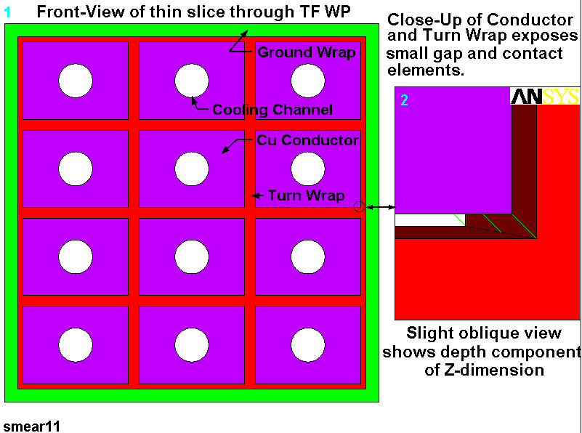
Fig. 3.0-1 Annotated Model Plot (x points right, y points up and z is out of the page)
4.0 Results

The results of the analyses are summarized in Table 4.0-1 and illustrated by a series of representative plots. For efficiency, only the plots of the 0.25” thick ground wrap are presented.

Table 4.0-1 Smeared Material Property Summary for Various GW Thicknesses
Material Property  Model and Global CS | 0.12” GW | 0.25” GW | 0.375” GW | 0.500” GW
E_{y} (E_{t}), [GPa] | 51.0 | 45.1 | 41.2 | 38.3
E_{x} (E_{r}), [GPa] | 53.2 | 46.6 | 42.3 | 39.1
E_{z} (E_{p}), [GPa] | 91.9 | 83.3 | 76.6 | 71.0
ν_{xy} (ν_{rt}), [N/A] | 0.390 | 0.342 | 0.310 | 0.285
ν_{yx} (ν_{tr}), [N/A] | 0.435 | 0.366 | 0.328 | 0.301
AVE[ν_{xz}, ν_{yz})] (ν_{rp}), [N/A] | 0.304 | 0.294 | 0.284 | 0.275
α_{x} (α_{r}), [μ/K] | 8.1 | 8.8 | 9.5 | 9.9
α_{y} (α_{t}) , [μ/K] | 8.3 | 9.1 | 9.6 | 10.1
α_{z} (α_{p}) , [μ/K] | 13.4 | 13.2 | 13.0 | 12.7
G_{zx} (G_{pr}), [GPa] | 33.1 | 29.7 | 27.1 | 24.9
G_{zy} (G_{pt}), [GPa] | 33.0 | 29.7 | 27.1 | 24.9
G_{xy} (G_{rt}), [GPa] | 2.1 | 2.1 | 2.2 | 2.3
G_{yx} (G_{tr}), [GPa] | 1.4 | 1.5 | 1.7 | 1.8
Use G_{xy}=G_{yz}=G_{xz} (Note 2) | 1.8 | 1.8 | 2.1 | ~2.1
Notes:
- The model Coordinate System (CS) x, y & z correspond to a Global Toroidal Coordinate System r (radial), t (toroidal) & p (poloidal).
- The transverse shear moduli are not appropriate for use in global models where beam-bending is more characteristic than short-beam shear. An average of the in-plane shear values is more appropriate in all three shear directions.

Fig. 3.0-1 is a plot of the deformed WP as a result of an imposed toroidal compression (δ_{y}) of 1 mm. The effective modulus is calculated by dividing the average surface stress (i.e., the total y-directed force divided by the y-normal area) by the toroidal strain (i.e., δ_{y}/h). Rearranging terms;

E = (F h)/(A_{y} δ_{y}) = (25334 N x 0.094691 m)/(0.093777 m x 0.0006223 m x 0.001 m) = 41.1 GPa

Where,

h is the toroidal height of the winding pack, and
A_{y} is the product of the radial width (w) and the poloidal thickness (dz) of the model.

The Poisson’s ratio calculation requires the orthogonal (x-directed) strain in addition to the parallel (y-directed) strain noted above. This x-strain is simply 2δ_{x}/w. So,

ν_{xy} = -εx/εy = -(2x0.0001684 m/0.093777 m)/(-0.001 m/0.094691 m) = 0.34

Of course all of these calculations are incorporated into the input file using ANSYS Parametric Design Language (APDL) which automates the process. Calculated results are also pulled into the plot titles for ease of documentation, as shown in Fig. 4.0-1.
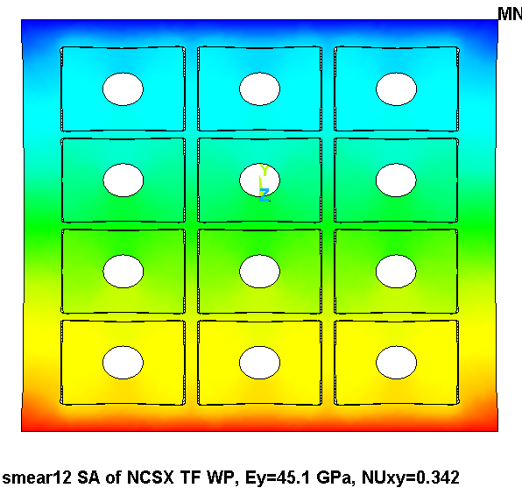
Fig. 4.0-1 Toroidal Deflection Contours from Imposed Deformation
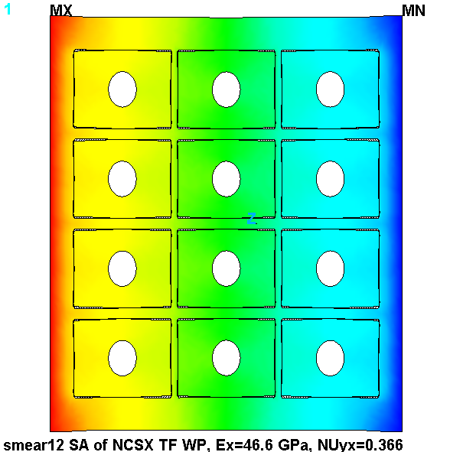
Fig. 4.0-2 is a plot of the deformed WP from a radially-oriented loading. The loading is similar to the previous case. However, since there is a little less insulation in this orientation, the effective modulus is somewhat higher (see results in plot title). The calculations are also similar to above, and so they are omitted.

Fig. 4.0-2 Radial Deflection Contours from Imposed Deformation
Fig. 4.0-3 is a plot of the deformed WP from a vertically-oriented (poloidal) loading. In this case, the load is carried by a series of parallel springs (k=AE/L) with the Cu providing the largest effective stiffness. A rule of mixtures hand calculation would confirm this, although it has been done too many times to justify repeating it here. The ANSYS plot title captures the expected result, and indicates an average modulus of 83 GPa and a Poisson’s ratio close to 0.3.

It is worth noting that although axial compression is applied here (even though axial tension is the more likely TF coil loading) the result would be the same for the tensile case. Poisson contractions from tensile stresses are a second or third-order effect in the stiffness calculation.
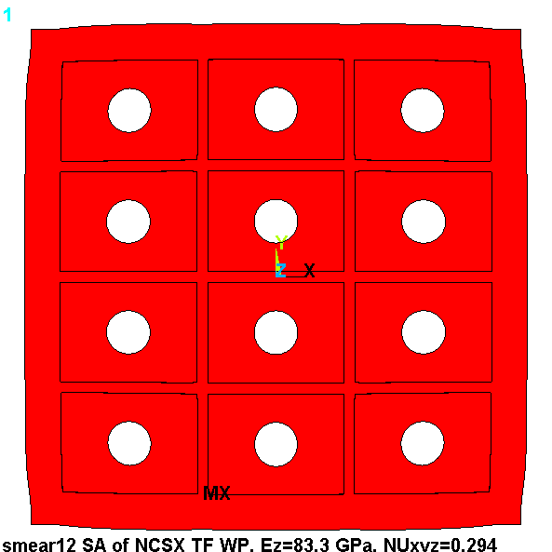

Fig. 4.0-3 Vertical Deflection Contours from Imposed Deformation
Fig. 4.0-4 is a plot of the local radial deformations from a 295K-80K cooldown. An average X, Y and Z displacements are calculated, divided by the appropriate dimension and ΔT. Results are again captured in the plot title. Notice that the axial (α_{z}) is close to but less than the value of pure Cu (14 μ/K). The Cu value is diluted by the lower α glass-filled epoxy (in the plane of the glass weave). Conversely, the two in-plane contractions are dominated by the low in-plane α of the glass weave.

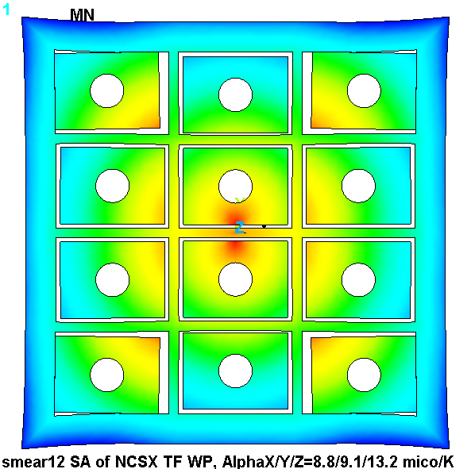
Fig. 4.0-4 Deformations from Cooldown
The average transverse shear modulus (G) is calculated in a manor similar to the elastic modulus. In this case the average shear stress (τ) is divided by the average shear strain (γ);

G = τ/γ

Fig. 4.0-5 is a plot of the deformed winding pack which is loaded by an x-directed shear relative to the stationary bottom plane. The total force required to achieve the 0.1 mm imposed deflection is divided by the shear area to get the shear stress. The imposed deflection is divided by the thickness of the model to get the shear strain. The numerical result is captured in the plot title. This G_{zx} value is believable because in this shear direction, the Cu carries essentially all of the stress. If the WP were totally Cu, then the shear modulus would come out to 51 GPa. The ratio of Cu area to total WP area leads to a shear modulus of 27 GPa, indicating that the insulation contributes slightly to this transverse modulus value.

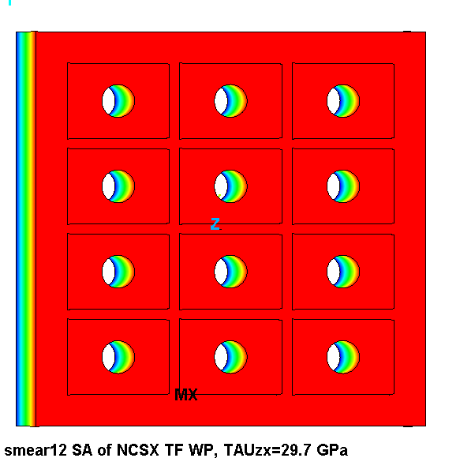
The “other” transverse shear direction G_{zy} is predictably similar, and therefore omitted from this pictorial summary.

Fig. 4.0-5 Deformations from X-Directed Shear

The in-plane shear stress presents a substantially different mechanical condition. Here, the shear stress must be carried almost entirely by the web of epoxy and glass, and is

Fig. 4.0-6 is a plot of the G_{xy} shear deformation. Again, forces are summed, turned into stress and divided by the average shear strain. The result is a very low shear modulus as indicated by the 1.9 GPa value listed in the plot title.

Again, the complementary G_{yx} shear is too similar to bother presenting. The slightly lower value is reported in Table 4.0-1; a value lower than this G_{yx} shear modulus is consistent with shearing more (four) layers.
Fig. 4.0-6 Deformations from In-Plane (G_{xy}) Shear
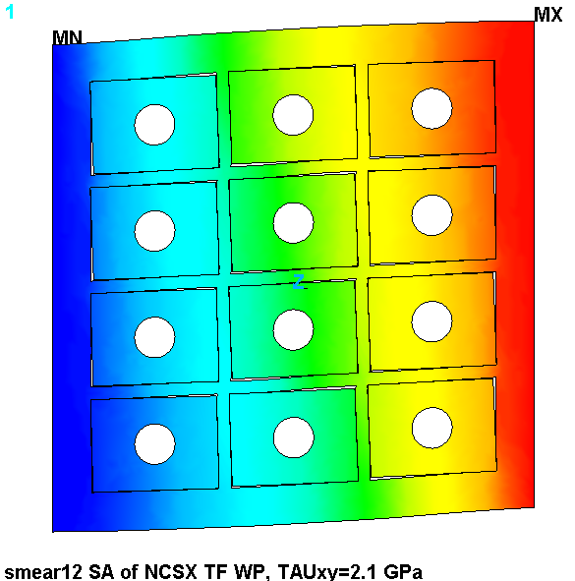
4.1 Smeared Properties Test

It seems reasonable enough to assume that most of the unidirectional loadings from section 4.0 will produce comparable structural characteristics in a homogeneous medium with smeared orthotropic properties. But it is not obvious that the smeared structure will behave similar to the actual structure when a more complex loading is imposed (i.e., beam-like bending).

A 3D model of the detailed 3x4 TF coil WP is developed as a means of benchmarking the adequacy of the proposed idealized model to such a loading. Fig. 4.1-1 shows a 60/2 cm length of the TF WP supported like a fixed-fixed beam with a uniform vertical load. Quarter-symmetry boundary conditions apply which cuts the beam length and width in half. The deformed structure plot shows that individual turns are modeled along with turn wrap and ground wrap insulation. Less visible are the frictionless gap elements which create a slip-plane between the conductor surface and the 49 mil turn insulation. In this plot, the winding pack ground wrap is 0.25” thick. However, a model with a 3/8” GW is also developed and used.

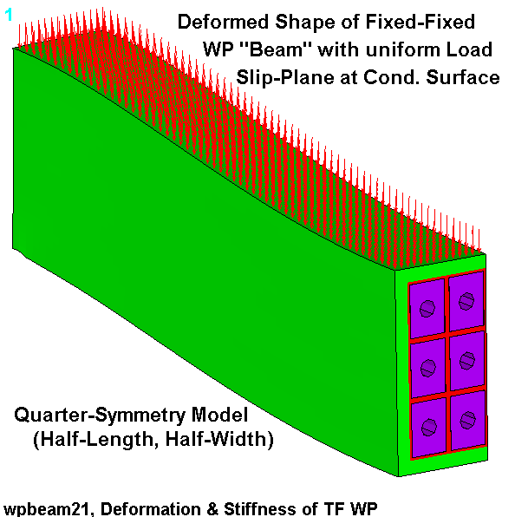
Fig. 4.1-1 Deformed Shape of Detailed TF WP “Beam” with Uniform Loading
A homogeneous model with dimensions, boundary conditions and loading identical to those of the detailed WP beam is developed and shown in Fig. 4.1-2. Of course the material properties for this model are taken from section 4.0. The linear model runs in a flash, and shows a disconcerting result when compared to the nonlinear model it is expected to emulate; the deformations are low by nearly a factor of five. Line plots of the vertical displacement as a function of distance along the beam half-length are shown in Fig. 4.1-3. The blue line corresponds to the results from the smeared WP with orthotropic properties taken directly from Table 4.0-1 (1/4” GW). The black lines correspond to results from the detailed WP beam with slip-planes at the conductor surface. The red lines correspond to results from the smeared model with the suggested isotropic shear modulus and all other orthotropic properties taken from Table 4.0-1.

The plot highlights the reason behind the concern which centers on the differences between shear deformations and bending deformations. Although the high cross-WP shear modulus calculated in section 4.0 (29.7 GPa) might be correct for short beam shear, it is totally inappropriate for modeling gross beam bending. When the lower (1.8 GPa) in-plane shear modulus is also applied to the transverse component, the deformations follow the detailed beam much more closely. It seems unlikely that any combination of material properties will make the smeared beam behave precisely like the detailed WP with all of its slip-planes. However, it would also seem as if adopting the lower in-plane shear modulus for all three shear orientations is the most reasonable compromise.
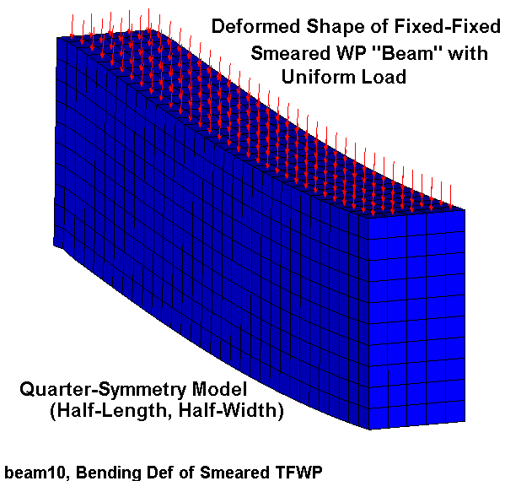
Fig. 4.1-2 Deformed Shape of Smeared TF WP “Beam” with Uniform Loading
This plot shows how WP “beam” deformations are determined more by gross bending than short-beam shear. This necessitates the use of the lower in-plane shear modulus in all three shear directions.

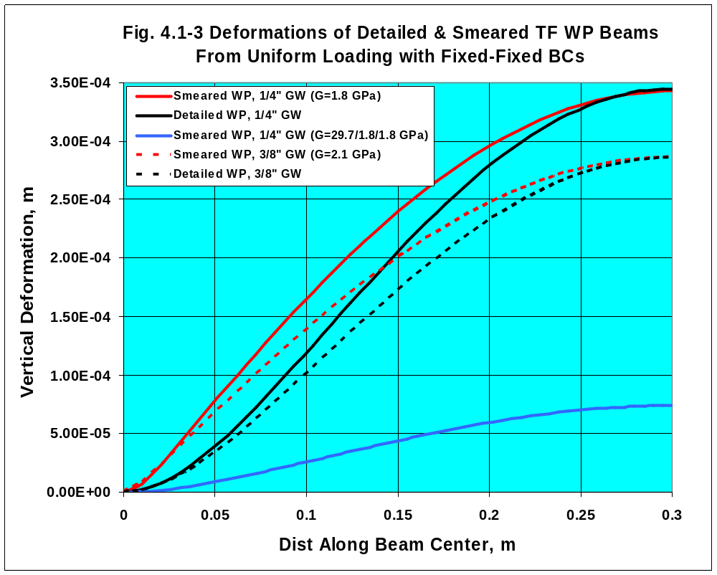
Notice that two different ground wrap thicknesses are presented: ¼” (solid lines) and 3/8” (dashed lines). Clearly, the thicker GW increases the overall bending stiffness of the WP (as indicated by a 17% reduction in the maximum deflection).
5.0 Summary & Commentary

A parametric 3D ANSYS model of the NCSX TF coil cross-section has been developed and used to determine equivalent smeared material properties for global models. The text-based ANSYS input file (Attachment 6.3) is sufficiently well annotated to allow most any knowledgeable ANSYS user to change dimensions, material properties, number of layers (N) and pancakes (M)…or even add layer or pancake insulation (presently zero), and recalculate all salient smeared properties in fairly short order. The resulting output must be used appropriately in a global model, taking care to transform this local coordinate system. The most likely transformation is presented as a footnote to the tabulated results (x=radial, y=toroidal, and z=poloidal).

A closer review of the smeared properties and the structural characteristics of the TF coil indicate that the transverse shear modulus calculated by the unit-thickness model is not representative of bending deformations. A more accurate approach is to use the lower in-plane shear modulus in all three directions to capture the bending behavior of the sparsely-supported TF coil.

6.0 Attachments

6.1 Drawings
6.2 Material Properties
6.3 ANSYS Input File, Smeared Properties
6.4 ANSYS Input File, Detailed WP Beam
6.5 ANSYS Input File, Smeared WP Beam

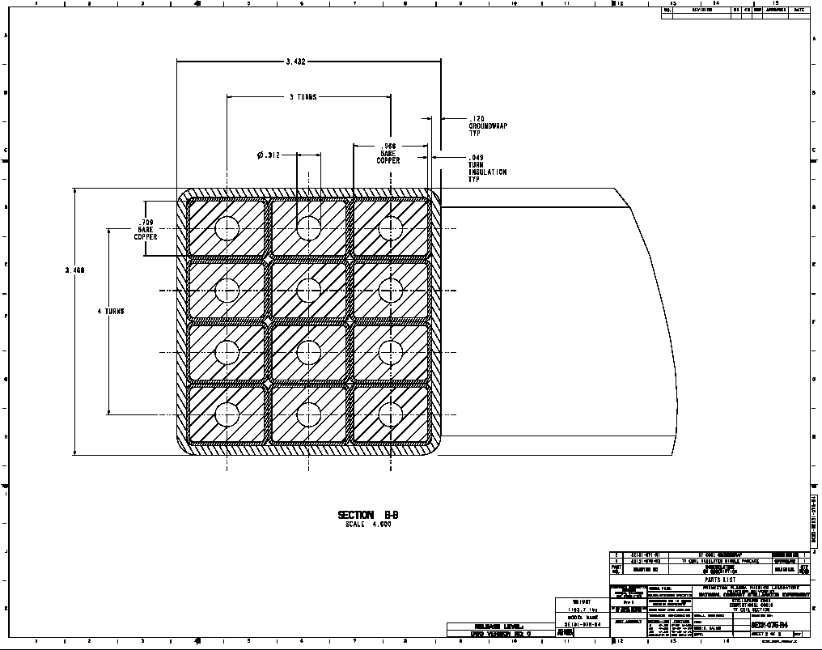
6.1 Drawings
6.2 Material Properties (Taken from an earlier project memo)

Table 1.0 Material Property Data Base for use in (80K) Structural Analyses
Material | Ex  [GPa] | Ey  [GPa] | Ez  [GPa] | αx  [μ/K] | αy  [μ/K] | αz  [μ/K] | Gxy  [GPa] | Gxz  [GPa] | Gyz  [GPa] | υ_{xy}  [-] | υ_{yz}  [-] | υ_{xz}  [-]
316LN SS Annealed | 209 |  |  | 13 |  |  | 81 |  |  | 0.283
MCWF Casting | Tensile w/SG |  |  | CD w/SG |  |  |  |  |  | Tensile w/SG
OFHC Cu | 136 |  |  | 14 |  |  | 51 |  |  | 0.34
VPI S-Glass | 21 | 28 |  | 22 | 7.9 |  | 6.9 |  | 9.6 | 0.2
VPI S-Glass + Kapton (courtesy R.P.Reed) | 19 | 26 |  | 21 | 7.9 |  | 4.2 |  | 6.0 | 0.2
Prepreg S-Glass | 22 | 30 |  | 28 | 7.4 |  | 5.3 (6.2) |  | 10 | 0.2
Prepreg S-Glass + Kapton | 21 | 22 |  | 27 | 7.5 |  | 3.8 |  | 6.2 | 0.2
VPI’d MC Conductor | 37 (TBD:2x5Test) |  | 78 | CD w/SG |  | CD | Ultrasonic | Twist Test
Notes:
1. Orthotropic material coordinate system:
- x is the through-thickness direction
- y is in the direction of the wrap (i.e., around the conductor perimeter)
- z is parallel to the conductor axis
2. Cells filled in yellow signify FE-based values.
3. Cells filled in blue signify low-risk assumed values of comparable materials.
4. SG = Strain Gages, CD = Cool Down

6.3 ANSYS Input File, Smeared Properties

/batch
rn=1
/filnam,smear1%rn%ey
/show,smear1%rn%,grp

/prep7
/com
/com This input file is used to determine the smeared moduli
/com and the coefficient of thermal expansion (CTE) of
/com a detailed conductor pack (including GW).
/com Look at the end of the ANSYS output listing to find the calculated
/com equivalent Es and alphas.
/com
/com mat,1 is not used
/com mat,2 is the conductor
/com mat,3 is the turn wrap
/com mat,4 is layer insulation
/com mat,5 is pancake insulation

/com
/com Run History
/com Run with 1e9 gap stiffness
/com 11: 0.120" GW, all load cases
/com 12: 0.250" GW, all load cases
/com 13: 0.375" GW, all load cases
/com 14: 0.500" GW, all load cases

/com Misc Parameters
k_nl=1 ! invoke contact analysis
k_dens=1 ! integer number, 1:nominal, 2:4x more elements
k=0.0254 ! english to si conversion factor
pi=acos(-1) ! pi
*afun,deg ! use degrees in trig functions
t=0.0001 ! a tiny length
th=0.1 ! a tiny angle
dtr=pi/180 ! degrees to radians
rtd=1/dtr ! radians to degrees
n_lay=3 ! number of radial layers
n_pan=4 ! number of pancakes
dtmp=-215 ! differential temperature (WRT room temp)

/com
/com graphics keys
/com
/pnum,mat,1
/num,1

/com
/com Element types
/com
et,1,82 ! U, higher order stress element

/com
/com Material properties
/com
tref,295

/com
/com tf conductor, ignoring radii (in local CS vernacular)
/com
dr_con=0.966*k ! Conductor build in thickness (0.434*k)
dz_con=0.709*k ! Conductor build in height (1.50*k)
di_con=0.312*k ! inside dia of cooling channel

/com
/com Insulation
/com
t_tw=0.049*k ! turn wrap insulation thk
t_pan=0.0*k ! pancake insulation thk (was 0.030", can be 0.0)
t_lay=0.0*k ! layer insulation thk (can be 0.0)
t_gw=0.12*k ! module over-wrap thickness (0.12" ref)
t_gap=1e-5 ! Conductor/TW gap

/com
/com WP Build
/com
dr_wp=n_lay*(dr_con+2*t_tw)+(n_lay-1)*t_lay ! radial build of WP
dz_wp=n_pan*(dz_con+2*t_tw)+(n_pan-1)*t_pan ! toroidal build of WP
dr_iwp=dr_wp+2*t_gw ! radial build of ground-wrapped WP
dz_iwp=dz_wp+2*t_gw ! toroidal build of ground-wrapped WP
cel=sqrt(dr_wp**2+dz_wp**2)/k_dens ! characteristic element size

/com
/com Cu Conductor (at 77K)
/com
mp, ex,2,136e9
mp,alpx,2,14e-6
mp,nuxy,2,0.34

/com
/com Turn Wrap insulation, S-glass & Kapton (X is through thickness)
/com
mp, ex,3,19e9
mp, ey,3,26e9
mp, ez,3,26e9
mp,alpx,3,21e-6
mp,alpy,3,7.9e-6
mp,alpz,3,7.9e-6
mp, gxy,3,4.2e9
mp, gyz,3,6.0e9
mp, gxz,3,4.2e9
mp,nuxy,3,0.2
mp,nuyz,3,0.2
mp,nuxz,3,0.2

/com
/com Layer to Layer insulation, S-glass (X is through thickness)
/com
mp, ex,4,21e9
mp, ey,4,28e9
mp, ez,4,28e9
mp,alpx,4,22e-6
mp,alpy,4,7.9e-6
mp,alpz,4,7.9e-6
mp, gxy,4,6.9e9
mp, gyz,4,9.6e9
mp, gxz,4,6.9e9
mp,nuxy,4,0.21
mp,nuyz,4,0.21
mp,nuxz,4,0.21

/com
/com Pancake to Pancake insulation, S-glass (local x is through thickness)
/com
mp, ex,5,21e9
mp, ey,5,28e9
mp, ez,5,28e9
mp,alpx,5,22e-6
mp,alpy,5,7.9e-6
mp,alpz,5,7.9e-6
mp, gxy,5,6.9e9
mp, gyz,5,9.6e9
mp, gxz,5,6.9e9
mp,nuxy,5,0.21
mp,nuyz,5,0.21
mp,nuxz,5,0.21

/com
/com Ground Wrap, S-glass
/com
mp, ex,6,21e9
mp, ey,6,28e9
mp, ez,6,28e9
mp,alpx,6,22e-6
mp,alpy,6,7.9e-6
mp,alpz,6,7.9e-6
mp, gxy,6,6.9e9
mp, gyz,6,9.6e9
mp, gxz,6,6.9e9
mp,nuxy,6,0.21
mp,nuyz,6,0.21
mp,nuxz,6,0.21

/com
/com Detailed WP
/com
csys
wpcsys
asel,none
rectng,-dr_con/2,dr_con/2,-dz_con/2,dz_con/2
rectng,-dr_con/2-t_tw,dr_con/2+t_tw,-dz_con/2-t_tw,dz_con/2+t_tw
*if,t_lay,gt,0,then
rectng,dr_con/2+t_tw,dr_con/2+t_tw+t_lay,-dz_con/2-t_tw,dz_con/2+t_tw+t_pan
*endif
*if,t_pan,gt,0,then
rectng,-dr_con/2-t_tw,dr_con/2+t_tw+t_lay,dz_con/2+t_tw,dz_con/2+t_tw+t_pan
*endif
aovlap,all
cm,temp,area
/com Subtract the center hole
pcirc,,di_con/2
asba,temp,all
allsel,below,area
cm,temp,area
/com Miter Turn Wrap Insulation
l,kp(-dr_con/2-t_tw,-dz_con/2-t_tw,0),kp(-dr_con/2,-dz_con/2,0)
l,kp(-dr_con/2-t_tw,+dz_con/2+t_tw,0),kp(-dr_con/2,+dz_con/2,0)
l,kp(dr_con/2+t_tw,+dz_con/2+t_tw,0),kp(dr_con/2,+dz_con/2,0)
l,kp(dr_con/2+t_tw,-dz_con/2-t_tw,0),kp(dr_con/2,-dz_con/2,0)
asbl,temp,all
cm,unit,area
*if,k_nl,eq,1,then
/com Make a gap between the conductor and insulation
asel,none
rectng,-dr_con/2-t_gap,dr_con/2+t_gap,-dz_con/2-t_gap,dz_con/2+t_gap
cm,temp,area
rectng,-dr_con/2,dr_con/2,-dz_con/2,dz_con/2
asba,temp,all
cmsel,a,unit
asba,unit,all
cm,unit,area
*endif

/com
/com Overall dimensions
/com
cmsel,s,unit
allsel,below,area
csys
*get,xmx,kp,,mxloc,x
*get,ymx,kp,,mxloc,y
*get,xmn,kp,,mnloc,x
*get,ymn,kp,,mnloc,y
dr_cell=xmx-xmn
dz_cell=ymx-ymn

/com
/com Build array of conductors
/com
agen,n_lay,all,,,dr_cell
agen,n_pan,all,,,,dz_cell
allsel
btol,t_gap/10
aglue,all

/com
/com Nix extra insulation layers
/com
asel,all
allsel,below,area
*if,t_lay,gt,0,then
*get,xmx,kp,,mxloc,x
ksel,s,loc,x,xmx-t_lay-t,xmx+t
lslk,,1
asll,,1
adele,all,,,1
*endif
*if,t_pan,gt,0,then
*get,ymx,kp,,mxloc,y
ksel,s,loc,y,ymx-t_pan-t,ymx+t
lslk,,1
asll,,1
adele,all,,,1
*endif

/com
/com Move to the center and glue on a layer of GW
/com
allsel
csys
*get,xmx,kp,,mxloc,x
*get,ymx,kp,,mxloc,y
*get,xmn,kp,,mnloc,x
*get,ymn,kp,,mnloc,y
agen,2,all,,,-(xmx+xmn)/2,-(ymx+ymn)/2,,0,,1
*get,xmx_wp,kp,,mxloc,x
*get,ymx_wp,kp,,mxloc,y
*get,xmn_wp,kp,,mnloc,x
*get,ymn_wp,kp,,mnloc,y

*get,kmx,kp,,num,max
k,kmx+1,xmx_wp+t_gw,ymx_wp+t_gw
k,kmx+2,xmn_wp-t_gw,ymx_wp+t_gw
k,kmx+3,xmn_wp-t_gw,ymn_wp-t_gw
k,kmx+4,xmx_wp+t_gw,ymn_wp-t_gw

a,kp(xmx_wp,ymx_wp,0),kmx+1,kmx+2,kp(xmn_wp,ymx_wp,0)
a,kp(xmn_wp,ymx_wp,0),kmx+2,kmx+3,kp(xmn_wp,ymn_wp,0)
a,kp(xmn_wp,ymn_wp,0),kmx+3,kmx+4,kp(xmx_wp,ymn_wp,0)
a,kp(xmx_wp,ymn_wp,0),kmx+4,kmx+1,kp(xmx_wp,ymx_wp,0)
aglue,all
*get,xmx_iwp,kp,,mxloc,x
*get,ymx_iwp,kp,,mxloc,y
*get,xmn_iwp,kp,,mnloc,x
*get,ymn_iwp,kp,,mnloc,y

/com
/com Make a series of local csys and set material attributes
/com
*do,j,1,n_pan
*do,jj,1,n_lay
local,100+10*j+jj,,xmn_wp+(jj-1/2)*dr_cell-t_lay/2,ymn_wp+(j-1/2)*dz_cell-t_pan/2
/com Conductor Attribute
asel,s,loc,x
asel,r,loc,y
aatt,2
/com Turn Wrap Attribute
asel,s,loc,x,-dr_cell/2+t_lay,dr_cell/2-t_lay
asel,r,loc,y,-dz_cell/2+t_pan,dz_cell/2-t_pan
asel,u,mat,,2
aatt,3
/com Layer Insulation Attribute
*if,t_lay,gt,0,then
asel,s,loc,x,dr_cell/2-t_lay,dr_cell/2
asel,r,loc,y,-dz_cell/2+t_pan,dz_cell/2-t_pan
aatt,4
*endif
/com Pancake Insulation Attribute
*if,t_pan,gt,0,then
asel,s,loc,x,-dr_cell/2,dr_cell/2
asel,r,loc,y,dz_cell/2-t_pan,dz_cell/2
aatt,5
*endif
*enddo
*enddo
/com GW attribute
asel,s,mat,,0
aatt,6

/com
/com Mesh Areas
/com

/com Turn Wrap
cel=t_tw/2
asel,s,mat,,3
allsel,below,area
lsel,r,length,,,sqrt(2)*t_tw
lesiz,all,,,2,,1
asel,s,mat,,2,3
allsel,below,area
lsel,r,length,,dz_con,dz_con+2*t_tw
lesiz,all,,,nint(dz_con/cel/2),,1
allsel,below,area
lsel,r,length,,dr_con,dr_con+2*t_tw
lesiz,all,,,nint(dr_con/cel/2),,1
asel,s,mat,,3
allsel,below,area
amesh,all

/com Conductor
asel,s,mat,,2
esize,2*cel
amesh,all
/com Layer & Pancake Insulation
*if,t_pan+t_lay,gt,0,then
asel,s,mat,,4,5
allsel,below,area
amesh,all
*endif

/com Ground Wrap
asel,s,mat,,6
allsel,below,area
lsel,r,length,,,sqrt(2)*t_gw
nec_gw=nint(sqrt(2)*t_gw/cel/2)
lesiz,all,,,nec_gw,,1
allsel,below,area
lsel,r,length,,dr_iwp-t,dr_iwp+t
lesiz,all,,,nint(dr_iwp/cel/2),,1
allsel,below,area
lsel,r,length,,dz_iwp-t,dz_iwp+t
lesiz,all,,,nint(dz_iwp/cel/2),,1
allsel,below,area
amesh,all

/com
/com Fix ESYS for orthotropic insulation
/com
local,11,,,,, 0 ! local X = global X
local,12,,,,,90 ! local X = global Y
/com Turn, Layer & Pancake
*do,j,1,n_pan
*do,jj,1,n_lay
csys,100+10*j+jj
asel,s,loc,y,dz_con/2,dz_con/2+t_tw+t_pan
asel,r,loc,x,-dr_cell/2,dr_cell/2
allsel,below,area
emodif,all,esys,12
asel,s,loc,y,-(dz_con/2+t_tw+t_pan),-dz_con/2
asel,r,loc,x,-dr_cell/2,dr_cell/2
allsel,below,area
emodif,all,esys,12
*enddo
*enddo

/com GW
csys
asel,s,loc,y,ymx_wp,ymx_iwp
allsel,below,area
emodif,all,esys,12
asel,s,loc,y,ymn_iwp,ymn_wp
allsel,below,area
emodif,all,esys,12
/com Turn all non-12 insulation into 11
esel,s,mat,,3,6
esel,u,esys,,12
emodif,all,esys,11

/com
/com Extrude to cel long in Z
/com
esel,all
nsle
*get,e_strt,elem,,num,min
*get,e_stop,elem,,num,max
*get,nmx,node,,num,max
*get,nmn,node,,num,min
dn2=nmx-nmn+1
csys
ngen,2,dn2,all,,,,,cel
/com
/com Make the elements
/com
modmesh,detach
et,11,95
type,11
*do,j,e_strt,e_stop,1
*if,esel(j),ne,1,cycle
*get,ni,elem,j,node,1
*get,nj,elem,j,node,2
*get,nk,elem,j,node,3
*get,nl,elem,j,node,4
*get,m_num,elem,j,attr,mat
*get,e_sys,elem,j,attr,esys
mat,m_num $esys,e_sys
edele,j $en,j,ni,nj,nk,nl,ni+dn2,nj+dn2,nk+dn2,nl+dn2
*enddo
esel,all
nsle
nsel,invert
ndele,all
allsel
emid,add
/title,smear1%rn% Making Smeared Properties of NCSX TF WP
aplo
eplo
/psym,esys,1
/edge,1,1
esel,u,mat,,2
nsle
eplo
/psym,esys
/edge

/com
/com Make Gap elements
/com
et,12,52
r,1,1e9,0,1,,,1 ! +X
r,2,1e9,0,1 ! +Y
rmore,1
r,3,1e9,0,1,,,-1 ! -X
r,4,1e9,0,1 ! -Y
rmore,-1
r,5,1e9,0,1,,,1 ! +X+Y
rmore,1
r,6,1e9,0,1,,,-1 ! -X+Y
rmore,1
r,7,1e9,0,1,,,-1 ! -X-Y
rmore,-1
r,8,1e9,0,1,,,1 ! +X-Y
rmore,-1
esel,s,mat,,2,3
nsle
type,12
eintf,5*t_gap,,high
/com Fix the Gap Normals around each conductor
*do,j,1,n_pan
*do,jj,1,n_lay
csys,100+10*j+jj
esel,s,type,,12
nsle
nsel,r,loc,y,dz_con/2-t,dz_con/2+t_gap+t
nsel,r,loc,x,-dr_con/2,dr_con/2
esln,,1
emodif,all,real,2
esel,s,type,,12
nsle
nsel,r,loc,y,-dz_con/2-t_gap-t,-dz_con/2+t
nsel,r,loc,x,-dr_con/2,dr_con/2
esln,,1
emodif,all,real,4
esel,s,type,,12
nsle
nsel,r,loc,x,-dr_con/2-t_gap-t,-dr_con/2+t
nsel,r,loc,y,-dz_con/2,dz_con/2
esln,,1
emodif,all,real,3
/com Fix the corner gaps
esel,s,type,,12
nsle
nsel,r,loc,y,dz_con/2-t,dz_con/2+t_gap+t
nsel,r,loc,x,dr_con/2-t,dr_con/2+t_gap+t
esln,,1
emodif,all,real,5
esel,s,type,,12
nsle
nsel,r,loc,y,-dz_con/2-t_gap-t,-dz_con/2+t
nsel,r,loc,x,-dr_con/2-t_gap-t,-dr_con/2+t
esln,,1
emodif,all,real,7
esel,s,type,,12
nsle
nsel,r,loc,x,-dr_con/2-t_gap-t,-dr_con/2+t
nsel,r,loc,y,dz_con/2-t,dz_con/2+t_gap+t
esln,,1
emodif,all,real,6
esel,s,type,,12
nsle
nsel,r,loc,x,dr_con/2-t,dr_con/2+t_gap+t
nsel,r,loc,y,-dz_con/2-t_gap-t,-dz_con/2+t
esln,,1
emodif,all,real,8
*enddo
*enddo

/com WP Dims
allsel
csys
*get,xmn,node,,mnloc,x
*get,xmx,node,,mxloc,x
*get,ymn,node,,mnloc,y
*get,ymx,node,,mxloc,y
*get,zmx,node,,mxloc,z
*get,zmn,node,,mnloc,z

fini

/solu
allsel
bfunif,temp,295
/com
/com Ey BCs
/com
nsel,s,loc,y,ymn-t,ymn+t
d,all,uy
cm,y_grnd,node
nsel,s,loc,y,ymx-t,ymx+t
cm,y_forc,node
d,all,uy,-0.001
nsel,s,loc,z
d,all,uz
esel,all
nsle
nsel,r,loc,z,zmx
cp,next,uz,all
nsel,s,loc,x
d,all,ux
allsel
!autots,on
!nsubst,10,1000,2
solve
fini
/com
/com Ey Postprocessing
/com
/post1
allsel
cmsel,s,y_forc
fsum
*get,fy,fsum,,item,fy
ay=(xmx-xmn)*(zmx-zmn)
csys
*get,u_y,node,node(xmx,ymx,0),u,y
yy_strain=u_y/(ymx-ymn)
ey=abs(0.1*nint((1e-8)*(fy/ay)/yy_strain))
nsel,s,loc,x,xmx
esln
nsle
etab,ux,u,x
etab,volu,volu
smult,uxv,ux,volu
ssum
*get,uxvtot,ssum,,item,uxv
*get,vtot,ssum,,item,volu
u_x=uxvtot/vtot
xy_strain=u_x/(xmx)
nu_xy=0.001*nint(-1000*xy_strain/yy_strain)
/title,smear1%rn% SA of NCSX TF WP, Ey=%ey% GPa, NUxy=%nu_xy%
allsel
plns,u,y
save
fini

/filnam,smear1%rn%ex
/solu
/com
/com Ex BCs
/com
allsel
ddele,all,uy
ddele,all,ux
nsel,s,loc,x,xmn-t,xmn+t
d,all,ux
cm,x_grnd,node
nsel,s,loc,x,xmx-t,xmx+t
cm,x_forc,node
d,all,ux,-0.001
nsel,s,loc,y
d,all,uy
allsel
!autots,on
!nsubst,10,1000,2
solve
fini

/com
/com Ex Postprocessing
/com
/post1
allsel
cmsel,s,x_forc
fsum
*get,fx,fsum,,item,fx
ax=(ymx-ymn)*(zmx-zmn)
csys
*get,u_x,node,node(xmx,ymx,0),u,x
xx_strain=u_x/(xmx-xmn)
ex=abs(0.1*nint((1e-8)*(fx/ax)/xx_strain))
nsel,s,loc,y,ymx
esln
nsle
etab,uy,u,y
etab,volu,volu
smult,uyv,uy,volu
ssum
*get,uyvtot,ssum,,item,uyv
*get,vtot,ssum,,item,volu
u_y=uyvtot/vtot
yx_strain=u_y/(ymx)
nu_yx=0.001*nint(-1000*yx_strain/xx_strain)
/title,smear1%rn% SA of NCSX TF WP, Ex=%ex% GPa, NUyx=%nu_yx%
allsel
plns,u,y
save
fini

/filnam,smear1%rn%ez
/solu
/com
/com Ez BCs
/com
allsel
ddele,all,uy
ddele,all,ux
nsel,s,loc,x
d,all,ux
nsel,s,loc,y
d,all,uy
cpdele,all
nsel,s,loc,z
cm,z_grnd,node
nsel,s,loc,z,zmx-t,zmx+t
cm,z_forc,node
d,all,uz,-0.00001
allsel
solve
fini
/com
/com Ez Postprocessing
/com
/post1
allsel
cmsel,s,z_forc
fsum
*get,fz,fsum,,item,fz
az=(ymx-ymn)*(xmx-xmn)
csys
*get,u_z,node,node(xmx,ymx,zmx),u,z
zz_strain=u_z/(zmx-zmn)
ez=abs(0.1*nint((1e-8)*(fz/az)/zz_strain))
nsel,s,loc,y,ymx
esln
nsle
etab,uy,u,y
etab,volu,volu
smult,uyv,uy,volu
ssum
*get,uyvtot,ssum,,item,uyv
*get,vtot,ssum,,item,volu
u_y=uyvtot/vtot
yz_strain=u_y/(ymx)
nsel,s,loc,x,xmx
esln
nsle
etab,ux,u,x
etab,volu,volu
smult,uxv,ux,volu
ssum
*get,uxvtot,ssum,,item,uxv
*get,vtot,ssum,,item,volu
u_x=uxvtot/vtot
xz_strain=u_x/(xmx)
ave_strain=(yz_strain+xz_strain)/2

nu_xyz=0.001*nint(-1000*ave_strain/zz_strain)
/title,smear1%rn% SA of NCSX TF WP, Ez=%ez% GPa, NUxyz=%nu_xyz%
allsel
plns,u,z
save
fini

/filnam,smear1%rn%alpha
/solu
/com
/com Alpha BCs
/com
allsel
cpdele,all
nsel,s,loc,z,zmx
ddele,all,uz
cp,next,uz,all
allsel
bfunif,temp,80
solve
fini
/com
/com Alpha Postprocessing
/com
/post1
allsel
csys
*get,u_z,node,node(xmx,ymx,zmx),u,z
z_strain=u_z/(zmx-zmn)
alphaz=abs(0.1*nint((1e7)*z_strain/215))
nsel,s,loc,y,ymx
esln
nsle
etab,uy,u,y
etab,volu,volu
smult,uyv,uy,volu
ssum
*get,uyvtot,ssum,,item,uyv
*get,vtot,ssum,,item,volu
u_y=uyvtot/vtot
y_strain=u_y/ymx
alphay=abs(0.1*nint((1e7)*y_strain/215))

nsel,s,loc,x,xmx
esln
nsle
etab,ux,u,x
etab,volu,volu
smult,uxv,ux,volu
ssum
*get,uxvtot,ssum,,item,uxv
*get,vtot,ssum,,item,volu
u_x=uxvtot/vtot
x_strain=u_x/xmx
alphax=abs(0.1*nint((1e7)*x_strain/215))

/title,smear1%rn% SA of NCSX TF WP, AlphaX/Y/Z=%alphax%/%alphay%/%alphaz% mico/K
allsel
plns,u,x
plns,u,y
plns,u,z
save
fini

/filnam,smear1%rn%tauzx
/solu
/com
/com TauZX BCs
/com
allsel
ddele,all,ux
nsel,s,loc,y
d,all,uy
nsel,s,loc,z,zmx
d,all,ux,0.00001
nsel,s,loc,z
d,all,ux
allsel
bfunif,temp,295
solve
fini

/com
/com TauZX Postprocessing
/com
/post1
allsel
csys
nsel,s,loc,z
fsum
*get,fx,fsum,,item,fx
tauzx=fx/az
allsel
*get,u_zx,node,node(xmx,ymx,zmx),u,x
gammazx=u_zx/(zmx-zmn)
gzx=0.1*nint(1e-8*tauzx/gammazx)
/title,smear1%rn% SA of NCSX TF WP, TAUzx=%gzx% GPa
plns,u,x
save
fini

/filnam,smear1%rn%tauzy
/solu
/com
/com TAUzy BCs
/com
allsel
ddele,all,uy
ddele,all,ux
nsel,s,loc,x
d,all,ux
nsel,s,loc,z,zmx
d,all,uy,0.00001
nsel,s,loc,z
d,all,uy
allsel
bfunif,temp,295
solve
fini

/com
/com TAUzy Postprocessing
/com
/post1
allsel
csys
nsel,s,loc,z
fsum
*get,fy,fsum,,item,fy
tauzy=fy/az
allsel
*get,u_zy,node,node(xmx,ymx,zmx),u,y
gammazy=u_zy/(zmx-zmn)
gzy=0.1*nint(1e-8*tauzy/gammazy)
/title,smear1%rn% SA of NCSX TF WP, TAUzy=%gzy% GPa
plns,u,y
save
fini

/filnam,smear1%rn%tauxy
/solu
/com
/com TAUxy BCs
/com
allsel
ddele,all,uy
ddele,all,ux
ddele,all,uz
nsel,s,loc,x,xmn-t,xmn+t
cm,n_grnd,node
d,all,uy
d,all,ux
nsel,s,loc,x,xmx-t,xmx+t
d,all,uy,0.001
d,all,ux
nsel,s,loc,z,zmn
d,all,uz
nsel,s,loc,x
nsel,r,loc,y
d,all,ux

allsel
bfunif,temp,295
solve
fini

/com
/com TAUxy Postprocessing
/com
/post1
allsel
csys
cmsel,s,n_grnd
fsum
*get,fy,fsum,,item,fy
tauxy=fy/ax
allsel
*get,u_xy,node,node(xmx,ymx,zmx),u,y
gammaxy=u_xy/(xmx-xmn)
gxy=0.1*nint(1e-8*tauxy/gammaxy)
/title,smear1%rn% SA of NCSX TF WP, TAUxy=%gxy% GPa
plns,u,y
save
fini

/filnam,smear1%rn%tauyx
/solu
/com
/com TAUyx BCs
/com
allsel
ddele,all,uy
ddele,all,ux
ddele,all,uz
nsel,s,loc,y,ymn-t,ymn+t
cm,n_grnd,node
d,all,uy
d,all,ux
nsel,s,loc,y,ymx-t,ymx+t
d,all,ux,0.001
d,all,uy
nsel,s,loc,z,zmn
d,all,uz
nsel,s,loc,x
nsel,r,loc,y
d,all,uy

allsel
bfunif,temp,295
solve
fini

/com
/com TAUyx Postprocessing
/com
/post1
allsel
csys
cmsel,s,n_grnd
fsum
*get,fx,fsum,,item,fx
tauyx=fx/ay
allsel
*get,u_yx,node,node(xmx,ymx,zmx),u,x
gammayx=u_yx/(ymx-ymn)
gyx=0.1*nint(1e-8*tauyx/gammayx)
/title,smear1%rn% SA of NCSX TF WP, TAUyx=%gyx% GPa
plns,u,x
save
fini

/exit,nosa
/eof
6.4 ANSYS Input File, Detailed WP Beam

/batch
rn=1
/filnam,wpbeam2%rn%
/show,wpbeam2%rn%,grp
!resume
!*if,1,eq,1,:1000
/prep7
/com
/com Structural model of 3x4 NCSX TF WP as a beam for stiffness calc with a slip-plane.
/com
/com Run History
/com
/com 20: unbonded, 1/4" GW, Uniform Loading on Fixed-Fixed beam (questionable gap behavior)
/com 21: adopt contact elements from smear1.dat

/com
/com Misc Parameters
/com
load_dir=1 ! 1: X, 2: Y
em_pres=1e6 ! magnetic pressure loading
k_nl=1 ! 0: Bonded, 1: N-N contact
k_dens=1 ! 1: nominal mesh size, >1 smaller mesh size, <1 bigger mesh size
l_tot=0.30 ! beam length
mu_cont=0.0 ! Contact friction coeffient
k=0.0254 ! english to si conversion factor
pi=acos(-1) ! pi
mu0=4*pi*1e-7 ! Mu0
*afun,deg ! use degrees in trig functions
t=0.0001 ! a tiny length
n_lay=3 ! number of radial layers
n_pan=4 ! number of pancakes
dtmp=0!-215 ! differential temperature (WRT room temp)

/com
/com element types
/com
et,1,45 ! structure only
et,2,42 ! planar element
et,12,52 ! gap elements
r,1,1e9,0,1,,,1 ! +X
r,2,1e9,0,1 ! +Y
rmore,1
r,3,1e9,0,1,,,-1 ! -X
r,4,1e9,0,1 ! -Y
rmore,-1
r,5,1e9,0,1,,,1 ! +X+Y
rmore,1
r,6,1e9,0,1,,,-1 ! -X+Y
rmore,1
r,7,1e9,0,1,,,-1 ! -X-Y
rmore,-1
r,8,1e9,0,1,,,1 ! +X-Y
rmore,-1

/com
/com graphics keys
/com
/pnum,mat,1
/num,1
/dist
/focus
/vup,1,x
/view,1,,-1

/com
/com tf conductor, ignoring radii (in local CS vernacular)
/com
dr_con=0.966*k ! Conductor build in thickness
dz_con=0.709*k ! Conductor build in height
di_con=0.312*k ! inside diameter of cooling channel

/com
/com Insulation
/com
t_tw=0.049*k ! turn wrap insulation thk
t_pan=0.0*k ! pancake insulation thk (can be 0.0)
t_lay=0.0*k ! layer insulation thk (can be 0.0)
t_gw=0.25*k ! module over-wrap thickness
t_gap=1e-5 ! Conductor/TW gap

/com
/com WP Build
/com
dr_wp=n_lay*(dr_con+2*t_tw)+(n_lay-1)*t_lay ! radial build of WP
dz_wp=n_pan*(dz_con+2*t_tw)+(n_pan-1)*t_pan ! toroidal build of WP
dr_iwp=dr_wp+2*t_gw ! radial build of ground-wrapped WP
dz_iwp=dz_wp+2*t_gw ! toroidal build of ground-wrapped WP
cel=sqrt(dr_wp**2+dz_wp**2)/k_dens ! characteristic element size

/com
/com material properties
/com
/com
/com Cu Conductor (at 77K)
/com
mp, ex,2,136e9
mp,alpx,2,14e-6
mp,nuxy,2,0.34

/com
/com Turn Wrap insulation, S-glass & Kapton (X is through thickness)
/com
mp, ex,3,19e9
mp, ey,3,26e9
mp, ez,3,26e9
mp,alpx,3,21e-6
mp,alpy,3,7.9e-6
mp,alpz,3,7.9e-6
mp, gxy,3,4.2e9
mp, gyz,3,6.0e9
mp, gxz,3,4.2e9
mp,nuxy,3,0.2
mp,nuyz,3,0.2
mp,nuxz,3,0.2

/com
/com Layer to Layer insulation, S-glass (X is through thickness)
/com
mp, ex,4,21e9
mp, ey,4,28e9
mp, ez,4,28e9
mp,alpx,4,22e-6
mp,alpy,4,7.9e-6
mp,alpz,4,7.9e-6
mp, gxy,4,6.9e9
mp, gyz,4,9.6e9
mp, gxz,4,6.9e9
mp,nuxy,4,0.21
mp,nuyz,4,0.21
mp,nuxz,4,0.21

/com
/com Pancake to Pancake insulation, S-glass (local x is through thickness)
/com
mp, ex,5,21e9
mp, ey,5,28e9
mp, ez,5,28e9
mp,alpx,5,22e-6
mp,alpy,5,7.9e-6
mp,alpz,5,7.9e-6
mp, gxy,5,6.9e9
mp, gyz,5,9.6e9
mp, gxz,5,6.9e9
mp,nuxy,5,0.21
mp,nuyz,5,0.21
mp,nuxz,5,0.21

/com
/com Ground Wrap, S-glass
/com
mp, ex,6,21e9
mp, ey,6,28e9
mp, ez,6,28e9
mp,alpx,6,22e-6
mp,alpy,6,7.9e-6
mp,alpz,6,7.9e-6
mp, gxy,6,6.9e9
mp, gyz,6,9.6e9
mp, gxz,6,6.9e9
mp,nuxy,6,0.21
mp,nuyz,6,0.21
mp,nuxz,6,0.21

/com
/com Gaps
/com
mp,mu,10,mu_cont

/com
/com Detailed WP
/com
csys
wpcsys
asel,none
rectng,-dr_con/2,dr_con/2,-dz_con/2,dz_con/2
rectng,-dr_con/2-t_tw,dr_con/2+t_tw,-dz_con/2-t_tw,dz_con/2+t_tw
*if,t_lay,gt,0,then
rectng,dr_con/2+t_tw,dr_con/2+t_tw+t_lay,-dz_con/2-t_tw,dz_con/2+t_tw+t_pan
*endif
*if,t_pan,gt,0,then
rectng,-dr_con/2-t_tw,dr_con/2+t_tw+t_lay,dz_con/2+t_tw,dz_con/2+t_tw+t_pan
*endif
aovlap,all
cm,temp,area
/com Subtract the center hole
pcirc,,di_con/2
asba,temp,all
allsel,below,area
cm,temp,area
/com Miter Turn Wrap Insulation
l,kp(-dr_con/2-t_tw,-dz_con/2-t_tw,0),kp(-dr_con/2,-dz_con/2,0)
l,kp(-dr_con/2-t_tw,+dz_con/2+t_tw,0),kp(-dr_con/2,+dz_con/2,0)
l,kp(dr_con/2+t_tw,+dz_con/2+t_tw,0),kp(dr_con/2,+dz_con/2,0)
l,kp(dr_con/2+t_tw,-dz_con/2-t_tw,0),kp(dr_con/2,-dz_con/2,0)
asbl,temp,all
cm,unit,area
*if,k_nl,eq,1,then
/com Make a gap between the conductor and insulation
asel,none
rectng,-dr_con/2-t_gap,dr_con/2+t_gap,-dz_con/2-t_gap,dz_con/2+t_gap
cm,temp,area
rectng,-dr_con/2,dr_con/2,-dz_con/2,dz_con/2
asba,temp,all
cmsel,a,unit
asba,unit,all
cm,unit,area
*endif

/com
/com Overall dimensions
/com
cmsel,s,unit
allsel,below,area
csys
*get,xmx,kp,,mxloc,x
*get,ymx,kp,,mxloc,y
*get,xmn,kp,,mnloc,x
*get,ymn,kp,,mnloc,y
dr_cell=xmx-xmn
dz_cell=ymx-ymn

/com
/com Build array of conductors
/com
agen,n_lay,all,,,dr_cell
agen,n_pan,all,,,,dz_cell
allsel
btol,t_gap/10
aglue,all

/com
/com Nix extra insulation layers
/com
asel,all
allsel,below,area
*if,t_lay,gt,0,then
*get,xmx,kp,,mxloc,x
ksel,s,loc,x,xmx-t_lay-t,xmx+t
lslk,,1
asll,,1
adele,all,,,1
*endif
*if,t_pan,gt,0,then
*get,ymx,kp,,mxloc,y
ksel,s,loc,y,ymx-t_pan-t,ymx+t
lslk,,1
asll,,1
adele,all,,,1
*endif

/com
/com Move to the center and glue on a layer of GW
/com
allsel
csys
*get,xmx,kp,,mxloc,x
*get,ymx,kp,,mxloc,y
*get,xmn,kp,,mnloc,x
*get,ymn,kp,,mnloc,y
agen,2,all,,,-(xmx+xmn)/2,-(ymx+ymn)/2,,0,,1
*get,xmx_wp,kp,,mxloc,x
*get,ymx_wp,kp,,mxloc,y
*get,xmn_wp,kp,,mnloc,x
*get,ymn_wp,kp,,mnloc,y

*get,kmx,kp,,num,max
k,kmx+1,xmx_wp+t_gw,ymx_wp+t_gw
k,kmx+2,xmn_wp-t_gw,ymx_wp+t_gw
k,kmx+3,xmn_wp-t_gw,ymn_wp-t_gw
k,kmx+4,xmx_wp+t_gw,ymn_wp-t_gw

a,kp(xmx_wp,ymx_wp,0),kmx+1,kmx+2,kp(xmn_wp,ymx_wp,0)
a,kp(xmn_wp,ymx_wp,0),kmx+2,kmx+3,kp(xmn_wp,ymn_wp,0)
a,kp(xmn_wp,ymn_wp,0),kmx+3,kmx+4,kp(xmx_wp,ymn_wp,0)
a,kp(xmx_wp,ymn_wp,0),kmx+4,kmx+1,kp(xmx_wp,ymx_wp,0)
aglue,all
*get,xmx_iwp,kp,,mxloc,x
*get,ymx_iwp,kp,,mxloc,y
*get,xmn_iwp,kp,,mnloc,x
*get,ymn_iwp,kp,,mnloc,y

/com
/com Overlay Lines at Symmetry Planes
/com
allsel
cm,wp,area
*get,kmx,kp,,num,max
csys
k,kmx+1,-dr_iwp/2
k,kmx+2,+dr_iwp/2
l,kmx+1,kmx+2
k,kmx+3,,-dz_iwp/2
k,kmx+4,,+dz_iwp/2
!l,kmx+3,kmx+4 ! forget about symmetry this way
asbl,wp,all

/com
/com Make a series of local csys and set material attributes
/com
*do,j,1,n_pan
*do,jj,1,n_lay
local,100+10*j+jj,,xmn_wp+(jj-1/2)*dr_cell-t_lay/2,ymn_wp+(j-1/2)*dz_cell-t_pan/2
/com Conductor Attribute
asel,s,loc,x
asel,r,loc,y
aatt,2
/com Turn Wrap Attribute
asel,s,loc,x,-dr_cell/2+t_lay,dr_cell/2-t_lay
asel,r,loc,y,-dz_cell/2+t_pan,dz_cell/2-t_pan
asel,u,mat,,2
aatt,3
/com Layer Insulation Attribute
*if,t_lay,gt,0,then
asel,s,loc,x,dr_cell/2-t_lay,dr_cell/2
asel,r,loc,y,-dz_cell/2+t_pan,dz_cell/2-t_pan
aatt,4
*endif
/com Pancake Insulation Attribute
*if,t_pan,gt,0,then
asel,s,loc,x,-dr_cell/2,dr_cell/2
asel,r,loc,y,dz_cell/2-t_pan,dz_cell/2
aatt,5
*endif
*enddo
*enddo
/com GW attribute
asel,s,mat,,0
aatt,6

/com
/com Mesh Areas
/com

/com Turn Wrap
cel=sqrt(2)*t_tw
asel,s,mat,,3
allsel,below,area
lsel,r,length,,,sqrt(2)*t_tw
lesiz,all,,,1,,1
asel,s,mat,,2,3
allsel,below,area
lsel,r,length,,dz_con,dz_con+2*t_tw
lesiz,all,,,nint(dz_con/cel/2),,1
allsel,below,area
lsel,r,length,,dr_con,dr_con+2*t_tw
lesiz,all,,,nint(dr_con/cel/2),,1
asel,s,mat,,3
allsel,below,area
amesh,all

/com Conductor
asel,s,mat,,2
esize,2*cel
amesh,all
/com Layer & Pancake Insulation
*if,t_pan+t_lay,gt,0,then
asel,s,mat,,4,5
allsel,below,area
amesh,all
*endif

/com Ground Wrap
asel,s,mat,,6
allsel,below,area
lsel,r,length,,,sqrt(2)*t_gw
nec_gw=nint(sqrt(2)*t_gw/cel/2)
lesiz,all,,,nec_gw,,1
allsel,below,area
lsel,r,length,,dr_iwp-t,dr_iwp+t
lesiz,all,,,nint(dr_iwp/cel/2),,1
allsel,below,area
lsel,r,length,,dz_iwp-t,dz_iwp+t
lesiz,all,,,nint(dz_iwp/cel/2),,1
allsel,below,area
amesh,all

/com
/com Fix ESYS for orthotropic insulation
/com
local,11,,,,, 0 ! local X = global X
local,12,,,,,90 ! local X = global Y
/com Turn, Layer & Pancake
*do,j,1,n_pan
*do,jj,1,n_lay
csys,100+10*j+jj
asel,s,loc,y,dz_con/2,dz_con/2+t_tw+t_pan
asel,r,loc,x,-dr_cell/2,dr_cell/2
allsel,below,area
emodif,all,esys,12
asel,s,loc,y,-(dz_con/2+t_tw+t_pan),-dz_con/2
asel,r,loc,x,-dr_cell/2,dr_cell/2
allsel,below,area
emodif,all,esys,12
*enddo
*enddo

/com GW
csys
asel,s,loc,y,ymx_wp,ymx_iwp
allsel,below,area
emodif,all,esys,12
asel,s,loc,y,ymn_iwp,ymn_wp
allsel,below,area
emodif,all,esys,12
/com Turn all non-12 insulation into 11
esel,s,mat,,3,6
esel,u,esys,,12
emodif,all,esys,11

/com
/com Extrude in Z
/com
allsel
modmesh,detach
*get,e_strt,elem,,num,min
*get,e_stop,elem,,num,max
*get,nmx,node,,num,max
*get,nmn,node,,num,min
dn2=nmx-nmn+1
nez=nint(l_tot/cel)
nez=nint(l_tot/cel/3)

/com
/com Generate nodes
/com
allsel
ngen,nez+1,dn2,all,,,,,l_tot/nez

/com
/com Make the elements
/com
modmesh,detach
type,1
*do,j,e_strt,e_stop,1
*if,esel(j),ne,1,cycle
*get,ni,elem,j,node,1
*get,nj,elem,j,node,2
*get,nk,elem,j,node,3
*get,nl,elem,j,node,4
*get,m_num,elem,j,attr,mat
*get,esys_num,elem,j,attr,esys
mat,m_num $esys,esys_num $edele,j $en,j,ni,nj,nk,nl,ni+dn2,nj+dn2,nk+dn2,nl+dn2
*enddo
egen,nez,dn2,all

/com
/com Deal with the conductor/insulator interfaces
/com
*if,k_nl,eq,0,then
allsel
numm,node
*else
/com Create Contact Interface (i-node on conductor, j-node on insulation)
allsel
mat,10 $type,12 $real,1
eintf,2*t_gap,,high

/com Fix the Gap Normals around each conductor
*do,j,1,n_pan
*do,jj,1,n_lay
csys,100+10*j+jj
esel,s,type,,12
nsle
nsel,r,loc,y,dz_con/2-t,dz_con/2+t_gap+t
nsel,r,loc,x,-dr_con/2,dr_con/2
esln,,1
emodif,all,real,2
esel,s,type,,12
nsle
nsel,r,loc,y,-dz_con/2-t_gap-t,-dz_con/2+t
nsel,r,loc,x,-dr_con/2,dr_con/2
esln,,1
emodif,all,real,4
esel,s,type,,12
nsle
nsel,r,loc,x,-dr_con/2-t_gap-t,-dr_con/2+t
nsel,r,loc,y,-dz_con/2,dz_con/2
esln,,1
emodif,all,real,3
/com Fix the corner gaps
esel,s,type,,12
nsle
nsel,r,loc,y,dz_con/2-t,dz_con/2+t_gap+t
nsel,r,loc,x,dr_con/2-t,dr_con/2+t_gap+t
esln,,1
emodif,all,real,5
esel,s,type,,12
nsle
nsel,r,loc,y,-dz_con/2-t_gap-t,-dz_con/2+t
nsel,r,loc,x,-dr_con/2-t_gap-t,-dr_con/2+t
esln,,1
emodif,all,real,7
esel,s,type,,12
nsle
nsel,r,loc,x,-dr_con/2-t_gap-t,-dr_con/2+t
nsel,r,loc,y,dz_con/2-t,dz_con/2+t_gap+t
esln,,1
emodif,all,real,6
esel,s,type,,12
nsle
nsel,r,loc,x,dr_con/2-t,dr_con/2+t_gap+t
nsel,r,loc,y,-dz_con/2-t_gap-t,-dz_con/2+t
esln,,1
emodif,all,real,8
*enddo
*enddo

/com
/com Make a symmetric model
/com
csys
*if,load_dir,eq,1,then
nsel,s,loc,y,-12,t
esln,,1
edele,all
esel,all
nsle
nsel,invert
ndele,all
nsel,s,loc,y
d,all,uy
*elseif,load_dir,eq,2
nsel,s,loc,x,-12,t
esln,,1
edele,all
esel,all
nsle
nsel,invert
ndele,all
nsel,s,loc,x
d,all,ux
*endif

/com
/com BCs
/com
csys
nsel,s,loc,z
d,all,uz
allsel
nsel,s,loc,z,l_tot
cp,next,uz,all

/com
/com Apply a Load & Restrain Load Direction
csys
*if,load_dir,eq,1,then
esel,all
nsel,s,loc,x,dr_iwp/2
sf,all,pres,em_pres
nsel,s,loc,x,-dr_iwp/2
nsel,r,loc,z,,l_tot/nez+t
d,all,ux
*elseif,load_dir,eq,2
esel,all
nsel,s,loc,y,dz_iwp/2
sf,all,pres,em_pres
nsel,s,loc,y,-dz_iwp/2
nsel,r,loc,z,,l_tot/nez+t
d,all,uy
*endif

/title,wpbeam2%rn%, Bending Def of TFWP
allsel
eplo
allsel
save
fini
:100
/solu
tref,0
bfunif,temp,dtmp
*if,k_nl,ne,0,then
autots,on
nsubst,2000,4000,2
nropt,auto
*endif
solve
fini

:1000
/auto
/post1

/auto
/view,1,1,1,1
/title,wpbeam2%rn%, Deformed Shape
esel,s,mat,,2
nsle
plns,s,int

/com
/com WP Insulation Stress Evaluation
/com
/com constants for TPX Epoxy/S-2 glass Insulation
/com
*dim,insul,,6 ! GW(Normal),GW(Shear),GW(Norm+Shear),WP(Normal),WP(Shear),WP(Norm+Shear)
rsys,solu
bs=40e6 ! Bond Strength (t0)
cf=0.51 ! Friction Coefficient (c2)
sn_small=4.4e6 ! threshold for allowing small tensile stress (0.02% strain in 22 GPa Insul)
/com GW
esel,s,mat,,6
cm,gw,elem
etable,volgw,volu
ssum
*get,vgw,ssum,,item,volgw
etable,sx,s,x
etable,sy,s,y
etable,sz,s,z
etable,sxy,s,xy
etable,sxz,s,xz
smult,sxy2,sxy,sxy
smult,sxz2,sxz,sxz
sadd,sxy2xz2,sxy2,sxz2
sexp,sxyxz,sxy2xz2,,0.5

/com WP Insulation
esel,s,mat,,3,5
cm,wp,elem
etable,volwp,volu
ssum
*get,vwp,ssum,,item,volwp
esel,s,mat,,3,4
etable,sx,s,x
etable,sy,s,y
etable,sz,s,z
esel,s,mat,,5
etable,sx,s,z
etable,sy,s,y
etable,sz,s,x
esel,s,mat,,3,5
etable,sxy,s,xy
etable,sxz,s,xz
smult,sxy2,sxy,sxy
smult,sxz2,sxz,sxz
sadd,sxy2xz2,sxy2,sxz2
sexp,sxyxz,sxy2xz2,,0.5

/com
/com Process GWI
/com
cmsel,s,gw
/com Shear Allowable based on bs and cf
sadd,shallgw,sx,,-cf,,2*bs/3
/com Shear Margin = Shear Allowable - Local Shear
sadd,smgw,shallgw,sxyxz,1,-1
/com Elements with local shear margin
esel,r,etab,smgw,.001,1e12
cm,oktgw,elem
ssum
*get,voktgw,ssum,,item,volgw
/com Elements with positive shear margin, and Local normal stress less than Limit
cmsel,s,gw
esel,r,etab,sx,-1e12,sn_small
cm,okngw,elem
ssum
*get,vokngw,ssum,,item,volgw
cmsel,s,oktgw
esel,r,etab,sx,-1e12,sn_small
cm,oktngw,elem
ssum
*get,voktngw,ssum,,item,volgw

/com
/com Process WPI
/com
cmsel,s,wp
/com Shear Allowable based on bs and cf
sadd,shallwp,sx,,-cf,,2*bs/3
/com Shear Margin = Shear Allowable - Local Shear
sadd,smwp,shallwp,sxyxz,1,-1
/com Elements with positive shear margin
esel,r,etab,smwp,.001,1e12
cm,oktwp,elem
ssum
*get,voktwp,ssum,,item,volwp
/com WPI Elements with positive shear margin, and Negative normal
cmsel,s,wp
esel,r,etab,sx,-1e12,sn_small
cm,oknwp,elem
ssum
*get,voknwp,ssum,,item,volwp
cmsel,s,oktwp
esel,r,etab,sx,-1e12,sn_small
cm,oktnwp,elem
ssum
*get,voktnwp,ssum,,item,volwp

/com
/com Plot commands for GWI
/com
cmsel,s,okngw
nsle
pfrac=0.1*nint(1000*(vokngw/vgw))
insul(1)=pfrac
/title,wpbeam2%rn%,GW Insul., %pfrac% percent Pass Normal Stress Criteria
plet,sx,avg
cmsel,s,gw
cmsel,u,okngw
nsle
ffrac=0.1*nint(1000*(1-vokngw/vgw))
/title,wpbeam2%rn%,GW Insul., %ffrac% percent Fail Normal Stress Criteria
plet,sx,avg

cmsel,s,oktgw
nsle
pfrac=0.1*nint(1000*(voktgw/vgw))
insul(2)=pfrac
/title,wpbeam2%rn%,GW Insul., %pfrac% percent Pass Shear Stress Criteria
plet,sxyxz,avg
cmsel,s,gw
cmsel,u,oktgw
nsle
ffrac=0.1*nint(1000*(1-voktgw/vgw))
/title,wpbeam2%rn%,GW Insul., %ffrac% percent Fail Shear Stress Criteria
plet,sxyxz,avg

cmsel,s,oktngw
nsle
pfrac=0.1*nint(1000*(voktngw/vgw))
insul(3)=pfrac
/title,wpbeam2%rn%,GW Insul., %pfrac% percent Pass Shear & Normal Stress Criteria
!/edge,1,1
!eplo
plet,sx,avg
cmsel,s,gw
cmsel,u,oktngw
nsle
ffrac=0.1*nint(1000*(1-voktngw/vgw))
/title,wpbeam2%rn%,GW Insul., %ffrac% percent Fail Shear & Normal Stress Criteria
plet,sx,avg
!eplo
!/edge

/com
/com Plot commands for WPI
/com
cmsel,s,oknwp
nsle
pfrac=0.1*nint(1000*(voknwp/vwp))
insul(4)=pfrac
/title,wpbeam2%rn%,WP Insul., %pfrac% percent Pass Normal Stress Criteria
plet,sx,avg
cmsel,s,wp
cmsel,u,oknwp
nsle
ffrac=0.1*nint(1000*(1-voknwp/vwp))
/title,wpbeam2%rn%,WP Insul., %ffrac% percent Fail Normal Stress Criteria
plet,sx,avg

cmsel,s,oktwp
nsle
pfrac=0.1*nint(1000*(voktwp/vwp))
insul(5)=pfrac
/title,wpbeam2%rn%,WP Insul., %pfrac% percent Pass Shear Stress Criteria
plet,sxyxz,avg
cmsel,s,wp
cmsel,u,oktwp
nsle
ffrac=0.1*nint(1000*(1-voktwp/vwp))
/title,wpbeam2%rn%,WP Insul., %ffrac% percent Fail Shear Stress Criteria
plet,sxyxz,avg

cmsel,s,oktnwp
nsle
pfrac=0.1*nint(1000*(voktnwp/vwp))
insul(6)=pfrac
/title,wpbeam2%rn%,WP Insul., %pfrac% percent Pass Shear & Normal Stress Criteria
!/edge,1,1
!eplo
plet,sx,avg
cmsel,s,wp
cmsel,u,oktnwp
nsle
ffrac=0.1*nint(1000*(1-voktnwp/vwp))
/title,wpbeam2%rn%,WP Insul., %ffrac% percent Fail Shear & Normal Stress Criteria
!eplo
!/edge
plet,sx,avg

esel,s,mat,,3,5
nsle
smult,sy2,sy,sy
smult,sz2,sz,sz
sadd,sy2z2,sy2,sz2
sexp,s_inpln,sy2z2,,0.5

/title,wpbeam2%rn%,WP Insul., Normal Stresses
plet,sx,avg
/title,wpbeam2%rn%,WP Insul., In-Plane Stresses
plet,s_inpln,avg
allsel
/title,wpbeam2%rn%, Deformation & Stiffness of TF WP
/type

/com
/com Deformation
/com
allsel
PATH,p1,2,30,nez+1,
PPATH,1,0,0,0,0,0,
PPATH,2,0,0,0,l_tot,0,
PDEF,U,U,sum,AVG
PLPATH,U
PRPATH,U

/com Write the Insulation Stress Criteria Review (% Passing Criteria)
*vwrite,
('GrWrp(Norm) GrWrp(Tau) GrWrp(N+T) WP(Norm) WP(Tau) WP(N+T)')
*vwrite,insul(1),insul(2),insul(3),insul(4),insul(5),insul(6)
(1p6e12.4)

fini
/exit,all
/eof

6.5 ANSYS Input File, Smeared WP Beam

/batch
rn=0
/filnam,beam1%rn%
/show,beam1%rn%,grp
!resume
!*if,1,eq,1,:1000
/prep7
/com
/com Structural model of quarter-Symmetry Fixed-Fixed Beam to benchmark smeared properties
/com of the NCSX TF WP with a slip-plane.
/com
/com Run History
/com
/com 10: Cross-Plane Shear adjusted to match detailed model deformations
/com 11: All properties as calculated by smear1.dat (too stiff in bending)

/com
/com Misc Parameters
/com
l_tot=0.30 ! beam length
em_pres=1e6 ! magnetic pressure loading
k=0.0254 ! english to si conversion factor

/com
/com graphics keys
/com
/pnum,mat,1
/num,1
/dist
/focus
/vup,1,x
/view,1,,-1

/com
/com tf conductor, ignoring radii (in local CS vernacular)
/com
n_lay=3 ! number of radial layers
n_pan=4 ! number of pancakes
dr_con=0.966*k ! Conductor build in thickness
dz_con=0.709*k ! Conductor build in height
di_con=0.312*k ! inside diameter of cooling channel

/com
/com Insulation
/com
t_tw=0.049*k ! turn wrap insulation thk
t_pan=0.0*k ! pancake insulation thk (can be 0.0)
t_lay=0.0*k ! layer insulation thk (can be 0.0)
t_gw=0.25*k ! module over-wrap thickness
t_gap=1e-5 ! Conductor/TW gap

/com
/com WP Build
/com
dr_wp=n_lay*(dr_con+2*t_tw)+(n_lay-1)*t_lay ! radial build of WP
dz_wp=n_pan*(dz_con+2*t_tw)+(n_pan-1)*t_pan ! toroidal build of WP
dr_iwp=dr_wp+2*t_gw ! radial build of ground-wrapped WP
dz_iwp=dz_wp+2*t_gw ! toroidal build of ground-wrapped WP

/com
/com Smeared Material Properties
/com

mp, ex,1,46.6e9
mp, ey,1,45.1e9
mp, ez,1,83.3e9
mp,alpx,1,8.8e-6
mp,alpy,1,9.1e-6
mp,alpz,1,13.2e-6
mp,nuxy,1,0.354
mp,nuyz,1,0.294
mp,nuxz,1,0.294
mp,gxy,1,1.8e9
mp,gyz,1,1.8e9 ! required to get beam bending right
mp,gxz,1,1.8e9 ! required to get beam bending right

/com
/com element types
/com
et,1,45 ! structure only

/com
/com Homogeneous WP
/com
cel=dr_iwp/2/5
csys
wpcsys
block,-dr_iwp/2,dr_iwp/2,,dz_iwp/2,,l_tot
lsel,s,length,,dz_iwp/2
lesize,all,,,nint(dz_iwp/2/cel),,1
lsel,s,length,,dr_iwp
lesize,all,,,nint(dr_iwp/cel),,1
lsel,s,length,,l_tot
lesize,all,,,nint(l_tot/cel),,1
allsel
vmesh,all

/com
/com Symmetric BCs
/com
nsel,s,loc,y
d,all,uy
nsel,s,loc,z
d,all,uz
allsel
nsel,s,loc,z,l_tot
cp,next,uz,all
nsel,s,loc,x,-dr_iwp/2
nsel,r,loc,z,,!cel
d,all,ux

/com
/com Apply a Surface Load
csys
esel,all
nsel,s,loc,x,dr_iwp/2
sf,all,pres,em_pres

/title,beam1%rn%, Bending Def of Smeared TFWP
allsel
eplo
allsel
save
fini
:100
/solu
tref,0
bfunif,temp,dtmp
solve
fini

:1000
/auto
/post1

/auto
/view,1,1,1,1
/title,beam1%rn%, Deformed Shape
esel,s,mat,,2
nsle
pldi
plns,s,int

/com
/com Deformation
/com
allsel
PATH,p1,2,30,58,
PPATH,1,0,0,0,0,0,
PPATH,2,0,0,0,l_tot,0,
PDEF,U,U,sum,AVG
PLPATH,U
PRPATH,U

fini
/exit,all
/eof

ANSYS Release 8.1, UP20040329, INTEL NT, ANSYS, Inc., Canonsburg, PA.
Leonard Myatt (Myatt Consulting, Inc.), “Material Property Data Base to be used for NCSX Analyses,” June 30, 2004.

