PPPL-NCSX Memorandum

To: NCSX Project Files (PPPL)
From: Leonard Myatt (Myatt Consulting, Inc.)
Date: June 22, 2004
Subject: Coupled Electromagnetic-Structural Analysis of Deformed NCSX Field Sources

1.0 Executive Summary

This memo describes an ANSYS electromagnetic-structural analysis of the NCSX coil systems. The 3D model is fully developed in an earlier project memo, and so the text is intentionally brief.

The objective of the analysis is to determine the TF coil displacements from the worst-case EM loading. Equilibrium ID #7 appears to be this case. Displacements are presented in plot form for visualization purposes, but also as text files for ease of use by others (but no attached to this memo).

2.0 Analysis

The stress analysis of the NCSX TF & PF coil systems is based on the finite element ANSYS model shown in Fig. 2.0-1. The coupled electromagnetic-structural model is an accumulation of a number of references:

- The coil support structure (shown in red) is a defeatured version of the PPPL solid model.
- Coil geometries (TF, PF, Modular and Plasma) are from a PPPL ANSYS database.
- Coil currents for various operating scenarios are from the NCSX Technical Data site.
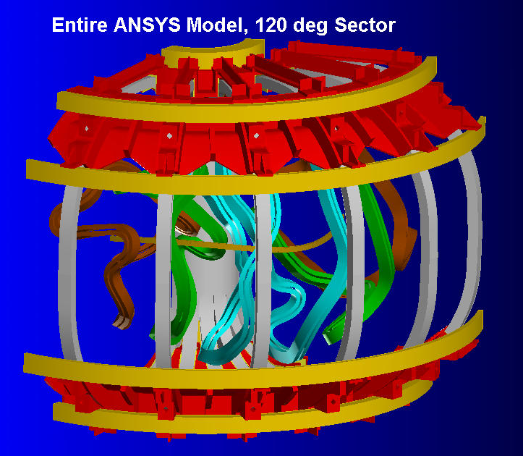
- Smear material properties for PF & TF winding packs.
Fig. 2.0-1: NCSX Magnet System 120˚ Sector
These inputs are manipulated into a text-based ANSYS batch file (included here as Attachment 4.1) which facilitates changes such as material properties, boundary conditions, coil currents and postprocessing with minimal user-input. The model is well developed in [] and the interested reader is referred there for details relating to boundary conditions, load application and material properties. All of these modeling details are available by way of the attached text-based ANSYS input file. However, some knowledge of the ANSYS language might be required to decipher the coding.

A series of figures are included here to illustrate the TF coil support. Fig. 2.0-2 shows how shims are placed between the coil pack and the support structure. Fig. 2.0-3 shows how the displacement continuity between the misaligned WPs and shims are handled with constraint equations. Fig. 2.0-4 shows how the TF coils are supported from below. Fig. 2.0-5 shows how the TF support structure is fixed in space as if attached to an infinitely rigid Modular Coil shell.

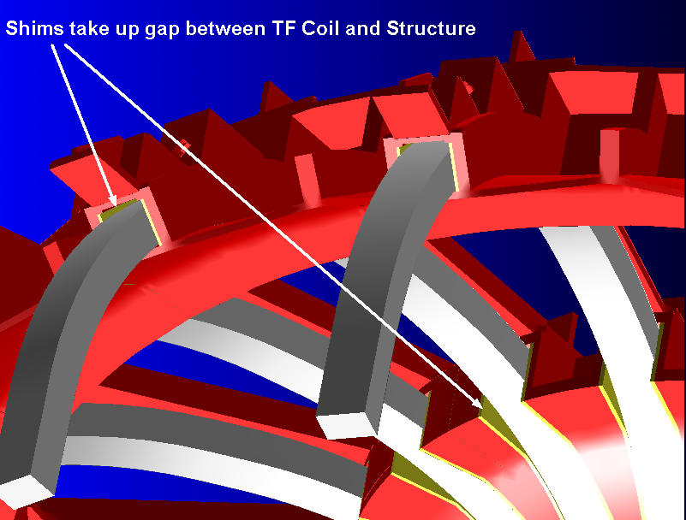
Fig. 2.0-2 TF Winding-Pack and Support Structure Lateral Continuity

Fig. 2.0-3 TF Coil-Shim Constraint Equation Symbols
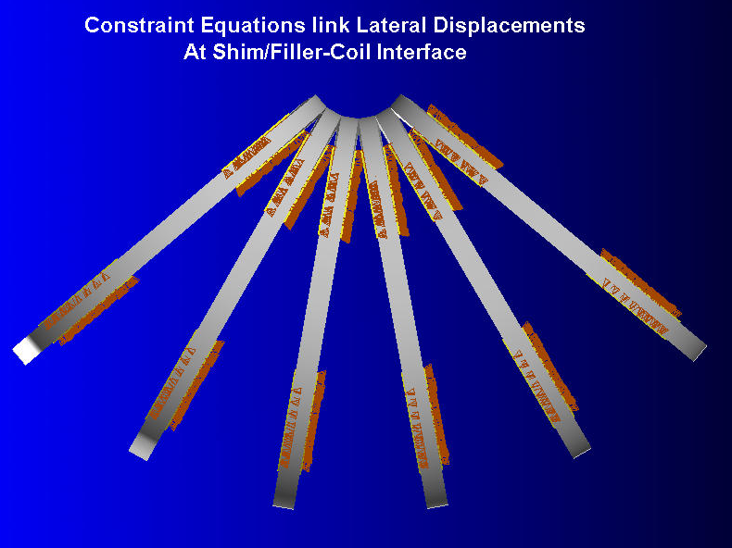
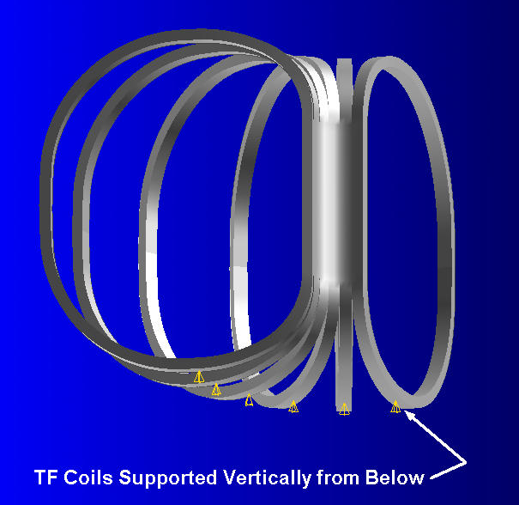
Fig. 2.0-4 TF Coil Vertical Displacement Constraints

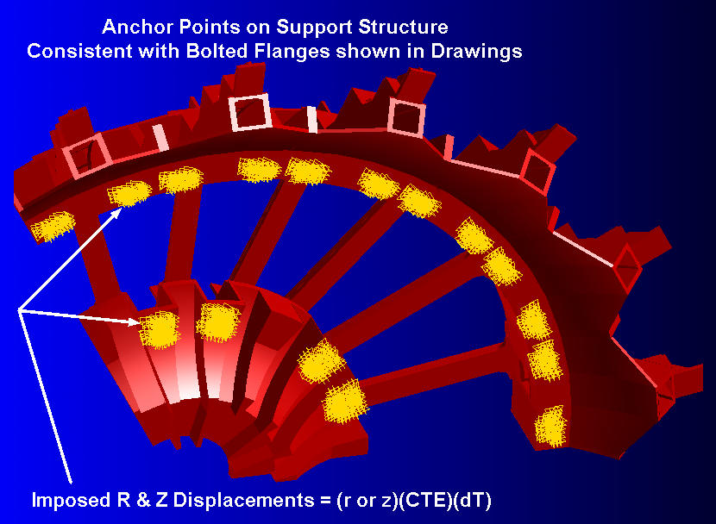
Fig. 2.0-5 Coil Support Structure Anchored to Modular Coil Shell at Bolted Flanges

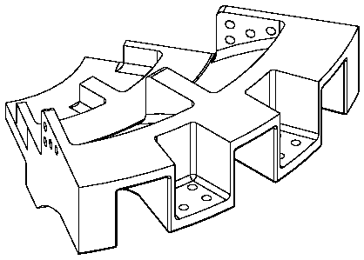 | 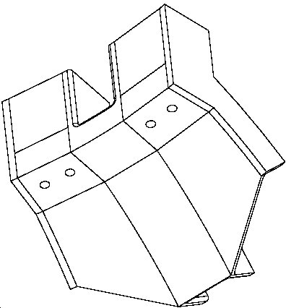
Inboard Structure and Bolt Location | Outboard Structure and Bolt Location
3.0 Analysis

The finite element model described above is used to simulate what is believed to be the most limiting Load Case (LC) from deflection-induced field errors. Equilibrium ID 7 has the TF at full current plus Modular Coils at close to their full current [Error: Reference source not found]. Although it is not part of the reference scenarios [Error: Reference source not found], this equilibrium operating condition probably produces the largest out of place loads and displacements on the TF coils. The coil currents associated with this Load Case (and number of turns per coil, N) are listed in Table 3.0-1. Load Case 1 represents cool down to 80K only.

The focus of this analysis is TF coil displacements. Contours of the displacement modulus are shown in Figs. 3.0-1 and 3.0-2 which correspond to Load Cases 1 & 6, respectively. The difference numeric between these two sets of displacements can be thought of as the EM-induced displacements. In fact, these displacements would be most applicable to field error calculations as the precise location of the TF coils in their cold position may be difficult to get just right. Displacement data is made available in ASCII text form at TF coil element centers for ease of input to other field error programs.

Table 3.0-1 Summary of Total Currents for Limiting Load Case
Load Case>> | 1 | 6
Equilibrium ID>> | N/A | 7
Time, s | 0 | N/A
M1 (N=20) | 0 | 695 kA-t
M2 (N=20) | 0 | 706 kA-t
M3 (N=18) | 0 | 621 kA-t
PF1 (N=72) | 0 | 0
PF2 (N=72) | 0 | 0
PF3 (N=72) | 0 | 160 kA-t
PF4 (N=80) | 0 | -192 kA-t
PF5 (N=24) | 0 | 24.2 kA-t
PF6 (N=14) | 0 | 10.7 kA-t
TF (N=12) | 0 | 194 kA-t
Plasma (N=1) | 0 | 0
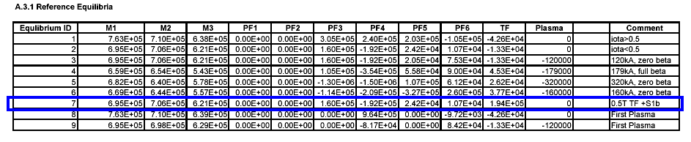

Fig. 3.0-1 TF Coil Displacements from Cool Down Only
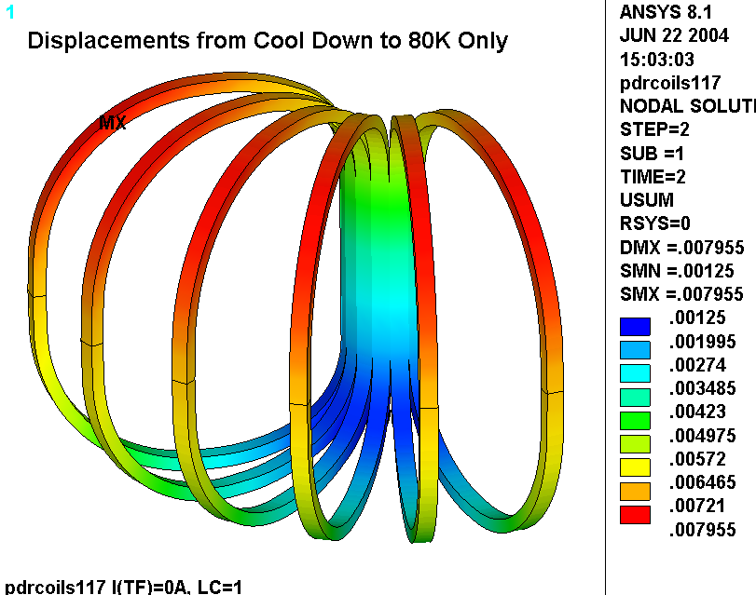
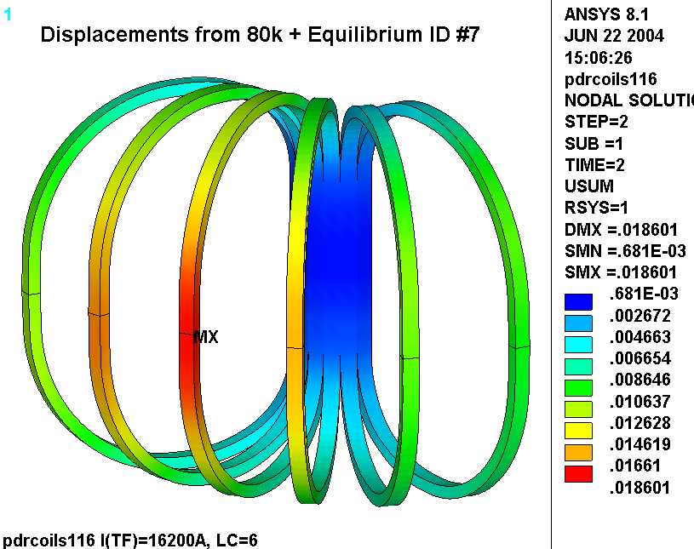
Fig. 3.0-2 TF Coil Displacements from Cool Down + Equilibrium ID #7 EM Loads

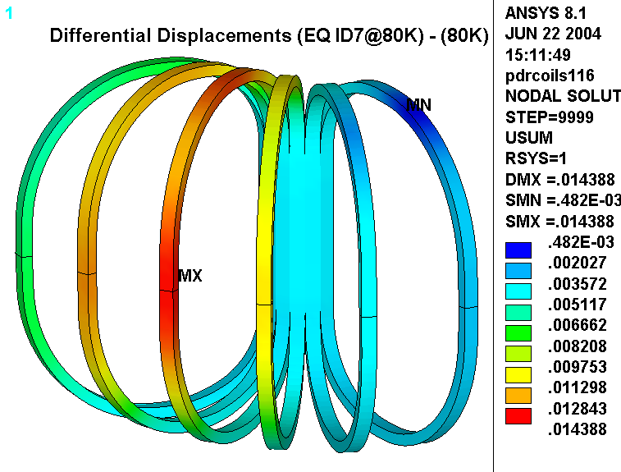
Fig. 3.0-3 TF Coil Displacement Differential (Cool Down + Eq ID #7) – (Cool Down)

4.0 Attachments

4.1 Batch Input File (06/22/04)

/BATCH
rn=17
/filnam,pdrcoils1%rn%
/show,pdrcoils1%rn%,grp
!resume
!*if,1,eq,1,:1000
/PREP7

/com
/com EM-STRUC Analysis of the NCSX PDR TF/PF Coil System
/com
/com
/com Run History
/com 10: TF Only, 16.2kA, 0.5T, Isotropic resistivity produces best results
/com 11: timepoint=1 (0.5 T TF Only), with CEs on TF sides
/com 12: timepoint=2 (1.7T Ohmic Scenario, t=0.0)
/com 13: timepoint=3 (2T High Beta Scenario, t=0.0)
/com 14: timepoint=4 (320kA Ohmic Scenario, t=0.206)
/com 15: TBD: timepoint=5 (320kA Ohmic Scenario, t=0.506)
/com Set all alpha values to 10e-6
/com 16: timepoint=1 (0.5 T TF Only, 85K), tunif=-215, tref=0, hold PF5/6 by CE
/com 17: timepoint=1 reft=300, bf=85, d,all,temp,85, hold PF5/6 w/CE (Structure stress not right)
/com 18: Just Cold, tref=0, bfunif=-215, d,all,temp,-215, hold PF5/6 w/CE, cnvtol,f,big
/com 19: timepoint=1 tref=0, bfunif=-215, d,all,temp,-215, hold PF4/5/6 w/CE, cnvtol,f,big

/com 11: Just Cold (0.5e-4 T TF), now with CEs on TF sides...looks OK

/com Now with CEs on TF sides

/com 12: TP=1 (85K and 0.5 T TF)...looks OK
/com 13: TP=2
/com 14: TP=3
/com 15: TP=4
/com 16: TP=5

/com Incorporate the CS into the structural model

/com 111: TP=1
/com 112: TP=2
/com 113: TP=3
/com 114: TP=4
/com 115: TP=5

/com
/com June 2004, Analyze another load case to determine TF coil deformations for Art's field error study
/com
/com 116: Equilibrium ID #7 has high TF and MC currents
/com 117: Thermal Only

/com
/com Field Analysis based on coil definitions in HM Fan's file-1.7t.db (saved as pdrcoils1.db)
/com
!resume,pdrcoils1,db,,1 ! pull in PF/TF/MC/Plasma Current Sources and merge parameters
!resume,pdrcoils2,db,,1 ! pull in PF/TF/MC/Plasma Currents (Cheat: PF4 moved 1.12 cm to Struc Surface)
resume,pdrcoils3,db,,1 ! pull in CS/PF/TF/MC/Plasma Currents (Add spacers between coils in CS)

/com
/com Misc Parameters
/com
time_pt=1 ! Coil Currents for this time point (see array listed below)
t=1e-3 ! tiny
k=0.0254 ! m/in
emsym,3 ! number of circular symmetry sections about Global Z
r0=1.4 ! Major Radius
tmp=-215 ! Operating Temp
t_ref=0 ! Reference Temperature
alpha_struc=10e-6 ! Thermal expansion coefficient of Structure (should be 13e-6 for SS at 85K)
tref,t_ref ! Or use MP command
!tunif,tmp ! Steve says do not use tunif
save
/pbc,mag
/pbc,temp
/pbc,volt
/pbc,ce

/com
/com Element Types
/com
et,1,5,0 ! U,TEMP,VOLT,MAG (PF4/5/6 and TF)
et,2,36 ! Plasma Current Source Primitive
et,3,5,1 ! TEMP,VOLT,MAG (CS, M and R0 ring)

/com
/com Merge TF Coil nodes in the inboard leg
/com
esel,s,mat,,2
nsle
csys,1
nsel,r,loc,x,,r0
numm,node

/com
/com Material Properties
/com
allsel
mpdele,all,all
/com All PF Coils
!mp,reft,1,t_ref
mp, kxx,1,1
mp,murx,1,1
mp,rsvx,1,1
mp,alpx,1,10e-6 ! roughly (no reference or calc)
/com Chang Jun, "ANSYS Modeling to obtain Equivalent Moduli of Elasticity of
/com PF & TF Coils of NCSX," 06/27/03
mp, ex,1,62.27E9!,54.44E9
mp, ey,1,93.10E9!,85.10E9
mp, ez,1,64.03E9!,56.59E9
mp, Gxy,1,35.27E9!,32.01E9
mp, Gyz,1,35.27E9!,32.01E9
mp, Gxz,1,20.69E9!,18.31E9
mp,nuxy,1, 0.306!,0.310
mp,nuyz,1, 0.213!,0.209
mp,nuxz,1, 0.339!,0.340

/com TF Coils
!mp,reft,2,t_ref
mp, kxx,2,1
mp,murx,2,1
mp,rsvx,2,1
mp,alpx,2,10e-6 ! roughly (no reference or calc)
/com Chang Jun, "ANSYS Modeling to obtain Equivalent Moduli of Elasticity of
/com TF Coils of NCSX," 07/15/03
mp, ex,2,111.6E9!, 93.3E9
mp, ey,2,129.5E9!,119.0E9
mp, ez,2,125.1E9!,113.9E9
mp, Gxy,2, 48.6E9!, 44.4E9
mp, Gyz,2, 48.6E9!, 44.4E9
mp, Gxz,2, 41.8E9!, 37.5E9
mp,nuxy,2, 0.323!, 0.329
mp,nuyz,2, 0.277!, 0.273
mp,nuxz,2, 0.277!, 0.273
/com M1 Coils
!mp,reft,3,t_ref
mp, kxx,3,1
mp,murx,3,1
mp,rsvx,3,1
/com M2 Coils
!mp,reft,4,t_ref
mp, kxx,4,1
mp,murx,4,1
mp,rsvx,4,1
/com M3 Coils
!mp,reft,5,t_ref
mp, kxx,5,1
mp,murx,5,1
mp,rsvx,5,1
/com R0 Field Elements
!mp,reft,7,t_ref
mp, kxx,7,1
mp,murx,7,1
mp,rsvx,7,1

/com CS Coil-Coil shims (G-10)
!mp,reft,9,t_ref
mp,murx,9,1
mp, ex,9,25e9
mp,alpx,9,10e-6
mp,nuxy,9,.21
/com Coil Support Structure (Stainless Steel)
!mp,reft,10,t_ref
mp,murx,10,1
mp, ex,10,205e9
mp,alpx,10,alpha_struc
mp,nuxy,10,0.265
mp, gxy,10,81e9
/com TF Coil-Case side shims (G-10)
!mp,reft,11,t_ref
mp,murx,11,1
mp, ex,11,25e9
mp,alpx,11,10e-6
mp,nuxy,11,.21

/com
/com Current Nodes
/com
n_pfcoils=6 ! number of PF Coil Pairs
n_tfcoils=6 ! number of PF Coils
n_mcoils=3 ! number of Modular Coil Pairs
/com PF Coil Current Nodes
n_pf1u=1
n_pf1l=1488
n_pf2u=1110
n_pf2l=1593
n_pf3u=1299
n_pf3l=2346
n_pf4u=190
n_pf4l=1782
n_pf5u=450
n_pf5l=1922
n_pf6u=846
n_pf6l=2126
/com TF Coil Current Nodes
n_tf1=3641
n_tf2=4730
n_tf3=5819
n_tf4=6908
n_tf5=7997
n_tf6=9086
/com Modular Coil Current Nodes
n_m11=13599
n_m12=13609
n_m13=13619
n_m14=15619
n_m21=21639
n_m22=21649
n_m23=21659
n_m24=23659
n_m31=29679
n_m32=29689
n_m33=29699
n_m34=31699
/com Make nodal components out of Modular Coil Current Nodes
*do,jj,1,n_mcoils
nsel,none
*do,j,1,4
nsel,a,node,,n_m%jj%%j%
*enddo
cm,n_m%jj%,node
*enddo

/com
/com Define Coil Currents
/com
*dim,i_coils,array,6,12 ! Time,M1,M2,M3,PF1,PF2,PF3,PF4,PF5,PF6,TF,Plasma
/com Proposed Worst 6 Cases (from Wayne's TDS_XL_C08R00_c3.pdf)
i_coils(1,1)=1,2,3,4,5,6
i_coils(1,2)=0,38141,40908,34200,34200,695e3/20
i_coils(1,3)=0,35504,41561,32057,32057,706e3/20
i_coils(1,4)=0,35453,40598,32184,32184,621e3/18
i_coils(1,5)=0,-25123,-15274,11354,21858,0
i_coils(1,6)=0,-25123,-15274,11354,21858,0
i_coils(1,7)=0,-9698,-5857,-11802,-5975,160e3/72
i_coils(1,8)=0,-7752,-9362,-13936,-9441,-192e3/80
i_coils(1,9)=0,8284,1080,4563,4634,24.2e3/24
i_coils(1,10)=0,-8997,-24,5068,5705,10.7e3/14
!i_coils(1,11)=16200,-3548,-1301,2191,2191,194.4e3/12
i_coils(1,11)=0,-3548,-1301,2191,2191,194.4e3/12
i_coils(1,12)=0,0,0,-320775,-320775,0

/com
/com Modular Coils (two WP per coil, so two F commands per coil)
/com PDR analysis has 2x as much current as it should have
/com
tpmc1=10*1 ! turns per MC1 winding pack, 4 in-hand
tpmc2=10*1 ! turns per MC2 winding pack, 4 in-hand
tpmc3=9*1 ! turns per MC3 winding pack, 4 in-hand

*do,j,1,n_mcoils
cmsel,s,n_m%j%
f,all,amps,(tpmc%j%)*i_coils(time_pt,j+1)
*enddo

/com PF Coils
tppf1=72 ! turns per PF1 winding
tppf2=72 ! turns per PF2 winding
tppf3=72 ! turns per PF3 winding
tppf4=80 ! turns per PF4 winding
tppf5=24 ! turns per PF5 winding
tppf6=14 ! turns per PF6 winding
*do,j,1,n_pfcoils
nsel,s,node,,n_pf%j%u
nsel,a,node,,n_pf%j%l
f,all,amps,(tppf%j%)*i_coils(time_pt,j+4)
*enddo

/com TF Coils
tptf=12
*do,j,1,n_tfcoils
nsel,s,node,,n_tf%j%
f,all,amps,tptf*i_coils(time_pt,11)
*enddo

/com Plasma Current in Type,2 Real,1
r,1,2,i_coils(time_pt,12),0.03,0.05

/com
/com Make a ring of elements on the Plasma Axis
/com
*if,time_pt,eq,1,then
csys
wpcsys
vsel,none
esel,none
nsel,none
cylind,r0-0.005,r0+0.005,-0.005,0.005,-60,60
vatt,7
esize,0.1
type,3
mp,murx,7,1
vmesh,all
d,all,mag
d,all,temp
d,all,volt
*endif

itf=i_coils(time_pt,11)
tme=i_coils(time_pt,1)
/title,pdrcoils1%rn% I(TF)=%itf%A, LC=%time_pt%
allsel
save
fini

/com
/com Pull in Structural Solid
/com
vsel,none
asel,none
lsel,none
ksel,none
/AUX15
IOPTN,IGES,NODEFEAT
IOPTN,MERGE,YES
IOPTN,SOLID,YES
IOPTN,SMALL,YES
IOPTN,GTOLER, DEFA
IGESIN,'inboard_beams_steps_inter_1coiltop_LM10_asm','igs',' '
fini

/prep7
/com Make structural element
*get,etmx,etyp,,num,max
et,etmx+1,92
et,etmx+2,200,5
/com Mesh Structure
cel=2*k
esize,cel
/com Mesh Inner Volume Faces
csys,1
asel,s,loc,x,,r0
asel,r,loc,z,.5,12
allsel,below,area
*get,thmn_inface,kp,,mnloc,y
*get,thmx_inface,kp,,mxloc,y
asel,r,loc,y,thmn_inface-0.1,thmn_inface+0.1
cm,a1_inface,area
asll,,1
asel,r,loc,y,thmx_inface-0.1,thmx_inface+0.1
cm,a2_inface,area
cmsel,s,a1_inface
type,etmx+2
amesh,all
asll,,1
mshcopy,area,a1_inface,a2_inface,1,,(thmx_inface-thmn_inface),,t
/com Mesh Outer Volume Faces
csys,1
asel,s,loc,x,r0,12
asel,r,loc,z,.5,12
allsel,below,area
*get,thmn_outface,kp,,mnloc,y
*get,thmx_outface,kp,,mxloc,y
asel,r,loc,y,thmn_outface-0.1,thmn_outface+0.1
cm,a1_outface,area
asll,,1
asel,r,loc,y,thmx_outface-0.1,thmx_outface+0.1
cm,a2_outface,area
cmsel,s,a1_outface
type,etmx+2
amesh,all
asll,,1
mshcopy,area,a1_outface,a2_outface,1,,(thmx_outface-thmn_outface),,t
/com Mesh all volumes
allsel
type,etmx+1
vmesh,all

/com Generate the other upper structural set
csys,1
vsel,u,mat,,7
VGEN,2,all,,,,60,,,0
/com Reflect to get the bottom structure
csys
vsymm,z,all

/com Merge Adjacent Nodes
/com Outboard Interface
esel,s,type,,etmx+1
nsle
cm,struc_node,node
nsel,none
cm,merge_node,node
*do,j,1,5
cmsel,s,struc_node
csys
wpcsys
wprot,(j-1)*20-40
cswpla,200
nsel,r,loc,y,-0.10*k,0.10*k
nsel,r,loc,x,r0,12
cmsel,a,merge_node
cm,merge_node,node
*enddo
cmsel,s,merge_node
numm,node,0.050*k*1.25
/com Inboard Interface
esel,s,type,,etmx+1
nsle
csys
nsel,r,loc,y,-0.10*k,0.10*k
nsel,r,loc,x,,r0
numm,node,0.050*k*1.25
nsle
numcmp,node

/com Write Structural Coupling for Cyclic Symmetry
allsel
*get,ncp,cp,,num,max
modmesh,detach
esel,s,type,,1
esel,a,type,,etmx+1
nsle
csys,1
nrotate,all
esel,s,type,,etmx+1
nsle
nsel,r,loc,y,-60.1,-59.9
cm,neg60,node
nsle
nsel,r,loc,y,59.9,60.1
cm,pos60,node
esel,s,mat,,1,2
nsle
nsel,r,loc,y,-60.005,-59.995
cmsel,a,neg60
cm,neg60,node
nsle
nsel,r,loc,y,59.995,60.005
cmsel,a,pos60
cm,pos60,node

/com The cpcyc commands take too long unless the wedge face nodes are the only ones selected
esel,s,mat,,1,2
esel,r,type,,1,3,2
nsle
cmsel,r,pos60
cm,ncoils1,node
esel,s,mat,,1,2
esel,r,type,,1,3,2
nsle
cmsel,r,neg60
cmsel,a,ncoils1
cpcyc,ux,0.1*k,1,,120,,1
cpcyc,uy,0.1*k,1,,120,,1
cpcyc,uz,0.1*k,1,,120,,1
esel,s,mat,,10
esel,r,type,,4
nsle
cmsel,r,pos60
cm,nstruc1,node
esel,s,mat,,10
esel,r,type,,4
nsle
cmsel,r,neg60
cmsel,a,nstruc1
cpcyc,ux,0.1*k,1,,120,,1
cpcyc,uy,0.1*k,1,,120,,1
cpcyc,uz,0.1*k,1,,120,,1

/com
/com Couple UX/UY/UZ at TF outboard equator
/com
esel,s,mat,,2
nsle
csys,1
nsel,r,loc,z
nsel,r,loc,x,r0,12
cpint,ux
cpint,uy
cpint,uz

/com
/com Constrain sides of WP to TF Case Side-Wall Shims
/com
dz_tfcoil=0.135
dz_tfcase=0.153
*do,j,1,6
csys,1
esel,s,mat,,2,11,9
nsle
nsel,r,loc,y,-60+(j-1)*20,-60+(j-0)*20
nsel,u,loc,z,-0.75,0.75
esln,,1
csys,13+8*(j-1)
nsel,u,loc,z,-dz_tfcoil/3,dz_tfcoil/3
nrotate,all
nsle
cm,n_temp,node
cm,e_temp,elem
esel,r,mat,,11
cm,e_keep,elem
esln,,1
esel,r,mat,,2
nsle
nsel,u,loc,z,-dz_tfcoil/4,dz_tfcoil/4
cm,n_keep,node
cmsel,s,n_keep
cmsel,s,e_keep
ceint,,uz
*enddo

/com
/com Constrain midplane of WP (only good for TF On Load Case)
/com
*if,time_pt,eq,1,then
*do,j,1,6
csys,1
esel,s,mat,,2
nsle
csys,13+8*(j-1)
nsel,r,loc,z,-dz_tfcoil/3,dz_tfcoil/3
!nrotate,all
!d,all,uz
*enddo
*endif

/com
/com Couple the Ring Coils to their supports
/com
esel,s,mat,,1
esel,r,type,,1,3,2
nsle
csys,1
nrotate,all
/com CS Radii
esel,s,mat,,9
nsle
csys,1
*get,ro_cs,node,,mxloc,x
*get,ri_cs,node,,mnloc,x

/com PF4
/com
zsup_pf4=1.4478
esel,s,mat,,1
esel,r,type,,1
nsle
csys,1
nsel,r,loc,x,ro_cs+0.001,r0 ! PF4 must be inboard of R0
esln,,1
cm,pf4_elem,elem ! all PF4 elements
nsel,r,loc,z,,12
esln,,1
cm,pf4u_elem,elem ! PF4Upper elements
nrotate,all
*get,zbot_pf4,node,,mnloc,z
*get,ro_pf4,node,,mxloc,x
*get,ri_pf4,node,,mnloc,x
esel,invert
cmsel,r,pf4_elem
cm,pf4l_elem,elem ! PF4Lower elements
nrotate,all
/com Set Up Constraints on PF4U
esel,s,mat,,10
nsle
nsel,r,loc,z,zsup_pf4-t,zsup_pf4+t
nsel,r,loc,x,ri_pf4-cel/4,ro_pf4+cel/4
nrotate,all
cmsel,s,pf4u_elem
ceint,,uz
ceint,,uy
/com Set Up Constraints on PF4L
esel,s,mat,,10
nsle
nsel,r,loc,z,-zsup_pf4-t,-zsup_pf4+t
nsel,r,loc,x,ri_pf4-cel/4,ro_pf4+cel/4
cmsel,s,pf4l_elem
ceint,,uz
ceint,,uy

/com
/com PF5
/com
esel,s,mat,,1
esel,r,type,,1
nsle
csys,1
nsel,u,loc,x,,r0
*get,ri_pf5,node,,mnloc,x
nsel,r,loc,x,ri_pf5-t,ri_pf5+t
nsel,r,loc,z,,12
*get,zbot_pf5,node,,mnloc,z
nsle
nsel,r,loc,x,ri_pf5-t,12

nsel,r,loc,z,zbot_pf5-t,,zbot_pf5+t
*get,ro_pf5,node,,mxloc,x
nsle
nsel,r,loc,x,ri_pf5-t,ro_pf5+t
esln,,1
nrotate,all
cm,pf5_elem,elem
nsel,r,loc,z,,12
esln,,1
cm,pf5u_elem,elem
esel,invert
cmsel,r,pf5_elem
cm,pf5l_elem,elem
/com Set Up Constraints on PF5U
esel,s,mat,,10
nsle
nsel,r,loc,z,zbot_pf5-t,zbot_pf5+t
nsel,r,loc,x,ri_pf5,ro_pf5
nrotate,all
cmsel,s,pf5u_elem
ceint,,uz
ceint,,uy
/com Set Up Constraints on PF5L
esel,s,mat,,10
nsle
nsel,r,loc,z,-zbot_pf5-t,-zbot_pf5+t
nsel,r,loc,x,ri_pf5,ro_pf5
nrotate,all
cmsel,s,pf5l_elem
ceint,,uz
ceint,,uy

/com
/com PF6
/com
esel,s,mat,,1
esel,r,type,,1
cmsel,u,pf4_elem
cmsel,u,pf5_elem
nsle
csys,1
nsel,u,loc,x,,ro_cs+0.001
esln,,1
cm,pf6_elem,elem
nsle
csys,1
nrotate,all
*get,ri_pf6,node,,mnloc,x
*get,ro_pf6,node,,mxloc,x
*get,zbot_pf6,node,,mxloc,z
nsel,r,loc,z,,12
esln,,1
cm,pf6u_elem,elem
esel,invert
cmsel,r,pf6_elem
cm,pf6l_elem,elem
/com Set Up Constraints on PF6U
esel,s,mat,,10
nsle
nsel,r,loc,z,zbot_pf6-t,zbot_pf6+t
nsel,r,loc,x,ri_pf6,ro_pf6
cmsel,s,pf6u_elem
ceint,,uz
ceint,,uy
/com Set Up Constraints on PF6L
esel,s,mat,,10
nsle
nsel,r,loc,z,-zbot_pf6-t,-zbot_pf6+t
nsel,r,loc,x,ri_pf6,ro_pf6
cmsel,s,pf6l_elem
ceint,,uz
ceint,,uy

/com
/com Make a component out of the CS (call it PF3 for logic reasons)
/com
esel,s,type,,1
nsle
csys,1
nsel,r,loc,x,ri_cs-0.001,ro_cs+0.001
esln,,1
cm,cs_elem,elem
cm,pf3_elem,elem
nsel,r,loc,z,,12
esln,,1
cm,pf3u_elem,elem
esel,invert
cmsel,r,pf3_elem
cm,pf3l_elem,elem

/com
/com Restrain The TF Coil in the Global Z
/com
*do,j,1,6
esel,s,mat,,2
nsle
csys,13+8*(j-1)
nsel,r,loc,z
csys,1
*get,zmn2%j%,node,,mnloc,z
nsel,r,loc,z,zmn2%j%-t,zmn2%j%+t
*get,thn2%j%,node,,mnloc,y
*get,r2%j%,node,,mnloc,x
nsel,r,node,,node(r2%j%,thn2%j%,zmn2%j%)
csys,1
nrotate,all
d,all,uz
*enddo

/com
/com Restrain the CS in Z and theta at the bottom
/com
cmsel,s,cs_elem
nsle
*get,zmn_cs,node,,mnloc,z
nsel,r,loc,z,zmn_cs
nsel,r,loc,y
d,all,uy,,,,,uz

/com
/com Restrain the TF Structure in Z & theta (Function of Temperature)
/com
/com At the inner shelf/flange/flats
/com
zin_struc=1.38938 ! Elevation of flat
r1in_struc=0.90 ! outer radius of flat
r2in_struc=1.05 ! inner radius of flat
thin_struc=60 ! angular frequency of supports
dthin_struc=26 ! angular extent of supports
nxdthin_struc=12 ! angular extent of nixed supports
nsel,none
cm,nin_struc,node
*do,j,1,2
esel,s,mat,,10
nsle
csys,1
nsel,r,loc,z,-zin_struc-t,zin_struc+t
nsel,r,loc,x,r1in_struc,r2in_struc
nsel,r,loc,y,(j-1)*thin_struc-30-dthin_struc/2,(j-1)*thin_struc-30+dthin_struc/2
nsel,u,loc,y,(j-1)*thin_struc-30-nxdthin_struc/2,(j-1)*thin_struc-30+nxdthin_struc/2
cmsel,a,nin_struc
cm,nin_struc,node
*enddo
cmsel,s,nin_struc
nrotate,all
d,all,uy!,,,,,uz
*get,nstrt,node,,num,min
*get,nstop,node,,num,max
*do,j,nstrt,nstop,1
*get,nselj,node,j,nsel
*if,nselj,ne,1,cycle
d,j,ux,nx(j)*alpha_struc*(tmp-t_ref)
d,j,uz,nz(j)*alpha_struc*(tmp-t_ref)
*enddo
/com
/com At the outer shelf/flange/flats
/com
zout_struc=1.246691 ! Elevation of flat
r1out_struc=1.98 ! outer radius of flat
r2out_struc=2.05 ! inner radius of flat
thout_struc=20 ! angular frequency of supports
dthout_struc=16 ! angular extent of supports
nxdthout_struc=7.5 ! angular extent of nixed supports

nsel,none
cm,nout_struc,node
*do,j,1,6
esel,s,mat,,10
nsle
csys,1
nsel,r,loc,z,-zout_struc-t,zout_struc+t
nsel,r,loc,x,r1out_struc,r2out_struc
nsel,r,loc,y,(j-1)*thout_struc-50-dthout_struc/2,(j-1)*thout_struc-50+dthout_struc/2
nsel,u,loc,y,(j-1)*thout_struc-50-nxdthout_struc/2,(j-1)*thout_struc-50+nxdthout_struc/2
cmsel,a,nout_struc
cm,nout_struc,node
*enddo
cmsel,s,nout_struc
nrotate,all
d,all,uy!,,,,,uz
*get,nstrt,node,,num,min
*get,nstop,node,,num,max
*do,j,nstrt,nstop,1
*get,nselj,node,j,nsel
*if,nselj,ne,1,cycle
d,j,ux,nx(j)*alpha_struc*(tmp-t_ref)
d,j,uz,nz(j)*alpha_struc*(tmp-t_ref)
*enddo

/com
/com Nix CEs
/com
!esel,all
!nsle
!cedele,all

/com Nix 200 elements
esel,s,type,,etmx+2
!edele,all

/com
/com Mag BCs
/com
esel,s,type,,1,3,2
nsle
d,all,mag

/com
/com Thermal BCs
/com
/com CS Temp
cmsel,s,cs_elem
nsle
d,all,temp,tmp
/com PF4 Temp
cmsel,s,pf4_elem
nsle
d,all,temp,tmp
/com PF5 Temp
cmsel,s,pf5_elem
nsle
d,all,temp,tmp
/com PF6 Temp
cmsel,s,pf6_elem
nsle
d,all,temp,tmp
/com TF Temp
esel,s,mat,,2
nsle
d,all,temp,tmp
/com Mod Coils
esel,s,mat,,3,5
nsle
d,all,temp,tmp

/com Oh, Just do it to all TEMP nodes
esel,s,type,,1,3,2
nsle
d,all,temp,tmp

/com Structure Temp
allsel
bfunif,temp,tmp

allsel
save
fini
:100
/solu
cnvtol,f,1e8,0.99 ! do not let the program try to converge on F
/com Solve Conduction Problem
allsel
solve

/com Solve for the fields on these nodes...
esel,s,mat,,1,2 ! PFs and TFs
esel,a,mat,,3,5 ! M1/2/3
esel,a,mat,,7 ! R0
esel,r,type,,1,3,2
nsle
/com ...from these elements
esel,s,mat,,1,5
esel,r,type,,1,3
esel,a,type,,2
biot,new

/com Solve for the Stresses
allsel
solve
fini
:1000
/post1
/dev,font,1,Arial,700,0,-19,0,0,,,
/view,1,1,1,1
/vup,1,z
/auto
!set,last
/title,pdrcoils1%rn% I(TF)=%itf%A, LC=%time_pt%
esel,s,mat,,2
nsle
plns,volt
plns,b,sum
plns,s,eqv
plns,u,z
plns,u,sum
esel,s,mat,,1,5
esel,r,type,,1,3,2
nsle
plns,volt
esel,s,type,,1,4,3
nsle
plns,u,sum
esel,s,mat,,10,11
nsle
plns,s,eqv
esel,s,mat,,2
nsle
csys,1
nsel,r,loc,x,,r0
nsel,r,loc,z,-.25,.25
esln,,1
/view
/type,1,0
/title,pdrcoils1%rn% I(TF)=%itf%A, LC=%time_pt%, TF Inboard Legs (+/-0.25 m) F=JxBdV
PLVECT,FMAG, , , ,VECT,ELEM,ON,0
/title,pdrcoils1%rn% I(TF)=%itf%A, LC=%time_pt%, TF Inboard Legs (+/-0.25 m) von Mises
/view,1,1,,1
/type
plns,s,eqv

/title,pdrcoils1%rn% I(TF)=%itf%A, LC=%time_pt%, CS von Mises
cmsel,s,cs_elem
nsle
rsys,1
plns,s,eqv
plns,s,z
plns,s,y
rsys

/com Sum forces on Ring coils
esel,s,mat,,10
nsle
csys,1
*get,thmn,node,,mnloc,y
*get,thmx,node,,mxloc,y
zsym=nint(360/(thmx-thmn))
*do,j,3,6
rsys,1
cmsel,s,pf%j%_elem
etab,fz,f,z
cmsel,s,pf%j%u_elem
ssum
*get,fz%j%u,ssum,,item,fz
fu=nint(zsym*fz%j%u/1000)
cmsel,s,pf%j%l_elem
ssum
*get,fz%j%l,ssum,,item,fz
fl=nint(zsym*fz%j%l/1000)

cmsel,s,pf%j%_elem
esel,u,mat,,9
nsle
/type,1,0
/title,pdrcoils1%rn% I(TF)=%itf%A, LC=%time_pt%, Fz(PF%j%U/L)=%fu%/%fl% kN
PLVECT,FMAG, , , ,VECT,ELEM,ON,0
/type
/title,pdrcoils1%rn% I(TF)=%itf%A, LC=%time_pt%, PF%j% von Mises, Fz(U/L)=%fu%/%fl%kN
plns,s,eqv
*enddo

/title,pdrcoils1%rn% I(TF)=%itf%A, LC=%time_pt%, Force Density (N/mm**3)
/com Force Density
/triad,off
esel,s,type,,1,3,2
esel,u,mat,,9
nsle
etab,fmag,fmag,sum
etab,volu,volu
SEXP,fd,FMAG,VOLU,1,-1,
sadd,mfd,fd,,1e-6
/view,1,-1,1,.25
esel,s,mat,,1
esel,r,type,,1,3,2
nsle
plet,mfd,avg
esel,s,mat,,2
nsle
/view,1,1,0.4,.25
plet,mfd,avg
esel,s,mat,,3,5
nsle
/view,1,1
plet,mfd,avg

allsel
/title,pdrcoils1%rn% I(TF)=%itf%A, LC=%time_pt%

:1001
/com List element centroids and their displacements
ETABLE,ERASE
*get,ls,active,,set,lstp
/stitle,1,pdrcoils1%rn%, Load Step %ls%
esel,s,mat,,2
nsle
*get,e_strt,elem,,num,min
*get,e_stop,elem,,num,max
*get,e_num,elem,,count
*dim,e_cent,,e_num,7
csys
rsys
etab,u_x,u,x
etab,u_y,u,y
etab,u_z,u,z
count=0
*do,j,e_strt,e_stop
*if,esel(j),ne,1,cycle
count=count+1
e_cent(count,1)=count
*get,ejx,elem,j,cent,x
*get,ejy,elem,j,cent,y
*get,ejz,elem,j,cent,z
*get,uxj,elem,j,etab,u_x
*get,uyj,elem,j,etab,u_y
*get,uzj,elem,j,etab,u_z
e_cent(count,2)=ejx
e_cent(count,3)=ejy
e_cent(count,4)=ejz
e_cent(count,5)=uxj
e_cent(count,6)=uyj
e_cent(count,7)=uzj
*enddo

/output,tflocdisp%rn%_tp%time_pt%,lis
*vwrite,
(' Element # X Y Z UX UY UZ')
*vwrite,e_cent(1,1),e_cent(1,2),e_cent(1,3),e_cent(1,4),e_cent(1,5),e_cent(1,6),e_cent(1,7)
(1p7e13.5)

/type
fini
/exit,all
/eof

ANSYS Release 8.1, UP20040329, INTEL NT, ANSYS, Inc., Canonsburg, PA.
Leonard Myatt, “Electromagnetic Stress Analysis of the NCSX TF and PF Coil Systems,” 09/24/03.
T. Brown, sjdr130-003-c4-fea_asm.igs (Structural members, 09/02/03), se151-019.igs (PF6 bracket, 09/10/03).
H.M. Fan, ANSYS database from ftp://ftp.pppl.gov/pub/hmfan/ncsx-pftf/file-1.7T.db
http://ncsx.pppl.gov/NCSX_Engineering/Requirements/Specs/GRD/Rev1/TDS_XL_C08R00_c3.pdf
Chang Jun, "ANSYS Modeling to obtain Equivalent Moduli of Elasticity of PF & TF Coils of NCSX," 06/27/03
Chang Jun, "ANSYS Modeling to obtain Equivalent Moduli of Elasticity of TF Coils of NCSX," 07/15/03

