NCSX
Design Basis Analysis

Stress Analysis of the 3x4 Slip-Plane TF Coil with Cast SS Wedges

NCSX-CALC-131-003-00

12 January 2005

Prepared by:

_______________________________________
L. Myatt, Engineering Analyst

I have reviewed this calculation and, to my professional satisfaction, it is properly performed and correct. I concur with analysis methodology and inputs and with the reasonableness of the results and their interpretation.

Reviewed by:

_______________________________________
- Brooks, Engineering Analyst

Controlled Document
THIS IS AN UNCONTROLLED DOCUMENT ONCE PRINTED.
Check the NCSX Engineering Web prior to use to assure that this document is current.

1.0 Executive Summary

This memo presents the results of numerous ANSYS stress analyses documenting the evolution of the NCSX TF coil and support system. The latest design of record is based on a 3x4 conductor winding pack (WP), turn-wrap insulation with a Kapton slip-plane, a 3/8” ground wrap, and cast SS wedges in the inboard region.

The reference wedge design satisfies all of the salient design criteria as long as subtle design changes are adopted (radii to reduce local stress concentrations).

The Cu conductor and insulation also satisfy monotonic, fatigue and shear/compression requirements with reasonable margin.

Although the entire history of the TF coil analysis is presented, the reader can concentrate on the last results section (4.6) to review the details of the present configuration. Sections 2.0 (Assumptions and Notable Concerns) and 5.0 (Summary & Commentary) also provide concise and important text.
2.0 Assumptions and Notable Concerns

2.1 It is assumed that the critical loading is characterized by a 0.5 T toroidal field, 85K operating temperature and a 4000 lb/bracket radial preload. Reference [Error: Reference source not found] provides reason to believe this is true. (Analyzing other EM load conditions would require the addition of other field sources, which would likely complicate the model beyond all reasonable computational resources.)

2.2 It is assumed that the mechanical properties of the wedge castings will be comparable to 304SS.

2.3 It is assumed that the Cu conductor is at least quarter-hard [in the upper and lower transition regions].
3.0 Analysis

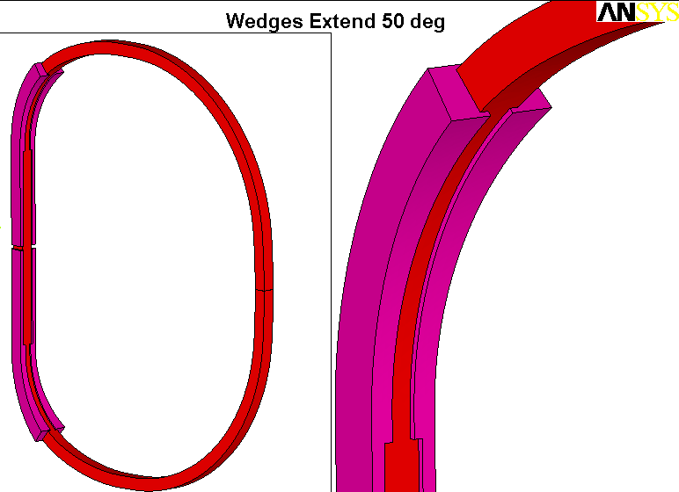
The analysis is based on the parametric model shown in Fig. 3.0-1. Although the reference wedge design has a 30˚ transition region, this particular plot shows them extending 50˚ from the ends of the straight-leg for greater support of the TF’s centering loads. Results for various angular extensions and a more advanced design are presented.

Fig. 3.0-1 Single TF Coil model for 0.5 T Loading (Extent of Wedges can be varied)

4.0 Results

Results are illustrated by a series of plots with accompanying text. The evolution of the design is carried for a historical record, but a detailed stress evaluation is only presented for the design of record.

Fig. 4.0-1 is a plot of the element centroid force vectors acting on the smeared TF winding pack. The ANSYS plot title lists the forces summation, and shows the large centering load (368 kN or 83 kips). The vertical and out of plane forces “should” sum to zero from symmetry. In the finite element world, 100 parts in 400,000 or 0.025% is zero.

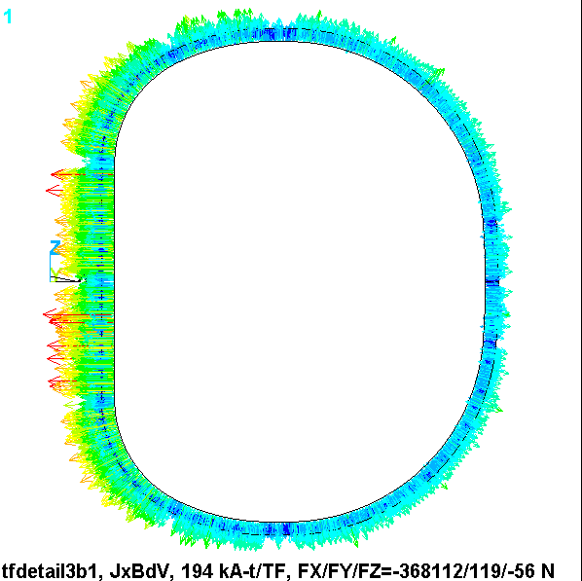
Fig. 4.0-1 Element Centroid Force Vectors (N) in Smeared WP

Fig. 4.0-2 is a plot of the flux density in the smeared WP. Again, the ANSYS plot title lists some interesting result. A hand calculation puts the peak field at 1.74 T, while the analysis reports 1.94 T. Back when the WP spanned the full toroidal width of the wedged inboard leg, the hand-calc was reasonably accurate. Here, the narrower WP produces some peaking, which shows up here as an 11% effect.

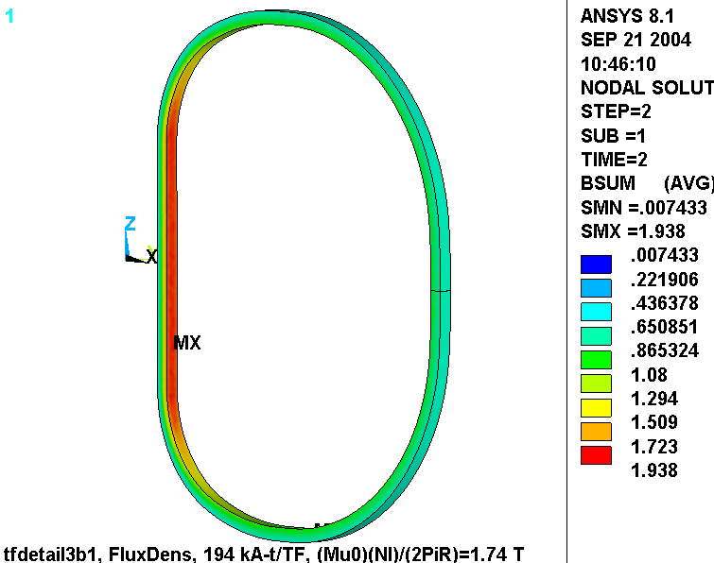
Fig. 4.0-2 Flux Density (T) in Smeared WP

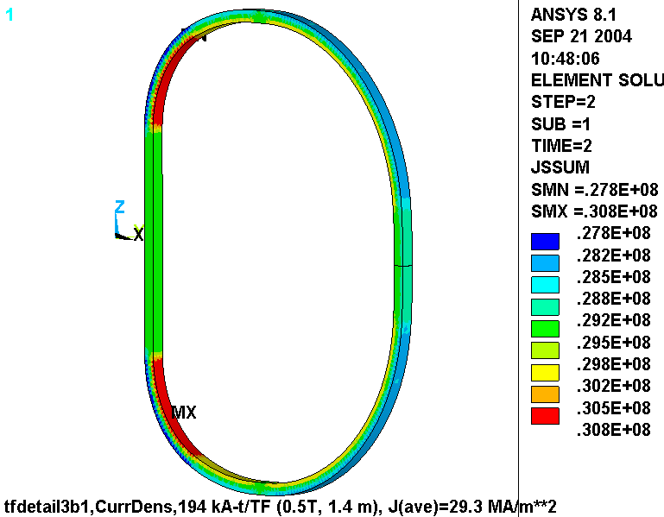
Fig. 4.0-3 is a plot of the current density distribution in the smeared WP. Although this should be a uniform 29.3 MA/m³ over the entire coil volume, the legend shows a variation of ±5%. This is very difficult to avoid with a smeared WP. However, the variation is small and should not impact the accuracy of the stress calculation be very much.

Fig. 4.0-3 Current Density (A/m²) in Smeared WP

The primary design variable is the amount (in degrees) that the wedges are extended beyond the straight region. The impact of this design variable on WP stress is explored with the model, and the results are illustrated in Fig. 4.0-4. The plot shows the maximum WP stress intensity as a function of Wedge Angular Extent. Two curves are plotted; one for so-called NODAL results, and another for so-called ETABLE results. Clearly, the WP stress decreases as the wedges are extended further around the corner.

These curves are based on linear analyses where the WPs are bonded to the wedges. One additional analysis is performed where the interface between the WP and the wedges are simulated more accurately with contact elements. This analysis is represented by the triangular markers for a 30˚ wedge configuration. Notice that the NODAL results are actually slightly less than that of the bonded results. This is because more realistic interface produces a softer transition from the clamped (supported) structure to the unclamped (free) WP.
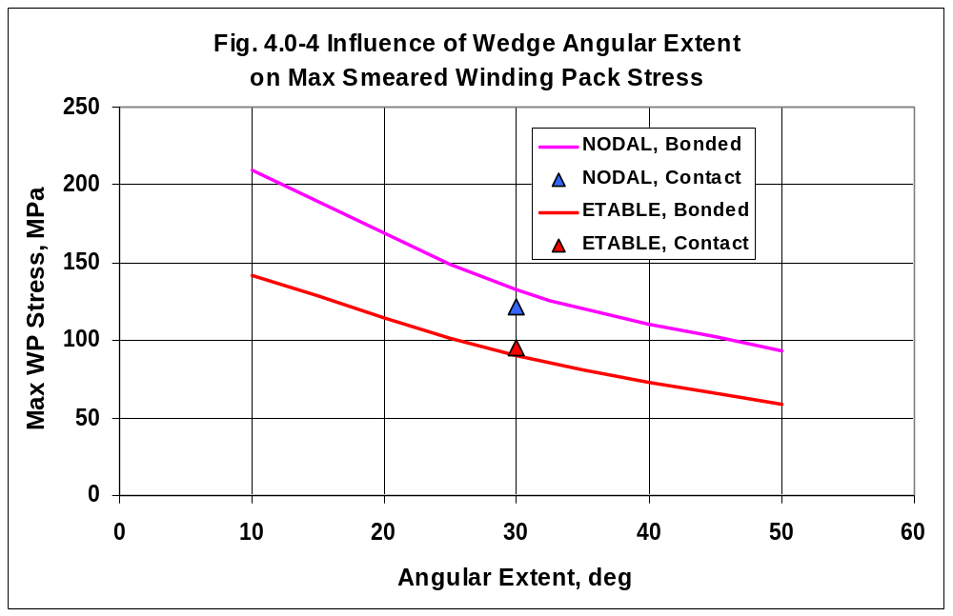

4.1 Wedges Extend 10˚

Fig. 4.1-1 shows nodal and ETABLE stress intensity plots from the 10˚ wedge analysis. In this case, the wedges provide minimal support and result in a rather large (210 MPa) bending stress right at the structural discontinuity.

4.2 Wedges Extend 30˚

Fig. 4.2-1 shows nodal and ETABLE stress intensity plots from the 30˚ wedge analysis. Here, the wedges provide more support and result in a moderate (133 MPa) bending stress which again appears right at the structural discontinuity.

4.3 Wedges Extend 50˚

Fig. 4.3-1 shows nodal and ETABLE stress intensity plots from the 50˚ wedge analysis. These extensive wedges provide great support and result in a very small (93 MPa) bending stress in the WP. Clearly, the TF WP would benefit from such a wedge design if they can fit within the other geometric limitations of the magnet support structure.

4.4 Wedges Extend 30˚, Contact WP-Wedge Interfaces

Figs. 4.4-1 and 4.4-2 show ETABLE and NODAL stress intensity plots from the 30˚ wedge analysis which includes frictionless and low friction contact interfaces between WP and wedges. The results are compared to the fully bonded result, and indicate a slight reduction in the maximum value. It is also interesting to note that the assumed friction coefficient (0.0 or 0.3) has little impact on the peak WP stress. This slight decrease in the maximum NODAL stress is due to a softening of the transition between supported and unsupported WP.

Fig. 4.4-3 is a plot of the TF coil deformations. There are a couple notable results shown in this figure.

- The outboard leg moves in 4.4 mm. This value is compared to other analyses later in the memo.
- There is a slight asymmetry in the vertical deflection values as the upper (unbonded) structure allows more motion than the lower (bonded) structure.

Fig. 4.4-4 shows plots of the stress intensity in these 30˚ wedges for the μ=0 and μ=0.3 cases. It is nice to see that the case with friction produces slightly lower stresses since some of the centering load gets carried as friction on the sidewalls of the WP instead of impinging on the thin lip of the wedge.

Fig. 4.4-5 is a plot of the vertical deflections in the wedges and WP when μ=0 and the wedge is vertically unsupported by displacement boundary conditions (BCs). Notice that the wedge moves upward by 8.2 mm. Now clearly, there will be some friction in the real magnet system. However, the structure demonstrates a characteristic to have relative motion which may result in parts “walking.” This characteristic is quantified in Fig. 4.4-6 which indicates that when the wedges are held at the equatorial plane then the force required to anchor them is about 7600 lb_{f}.

Therefore, modifying the design such that upper and lower wedges are mechanically joined would ensure that the parts don’t “walk.”

Fig. 4.1-1 Stresses in Smeared WP, Upper (“ETAB”), Lower (nodal), Wedges Extend 10˚
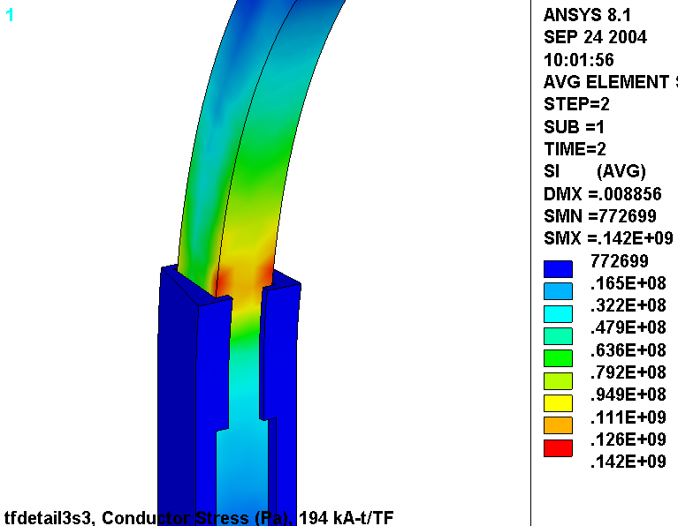
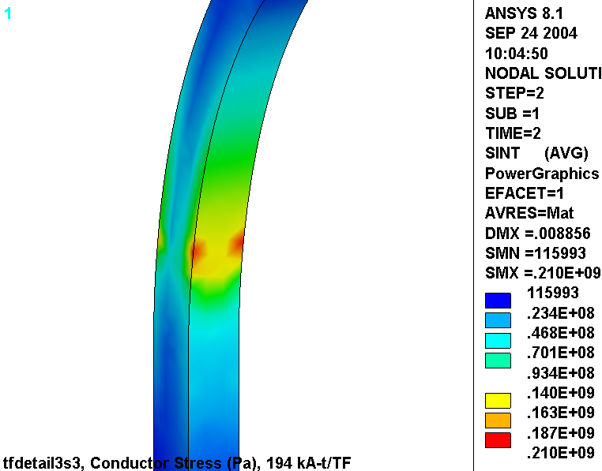
Fig. 4.2-1 Stresses in Smeared WP, Upper (“ETAB”), Lower (nodal), Wedges Extend 30˚
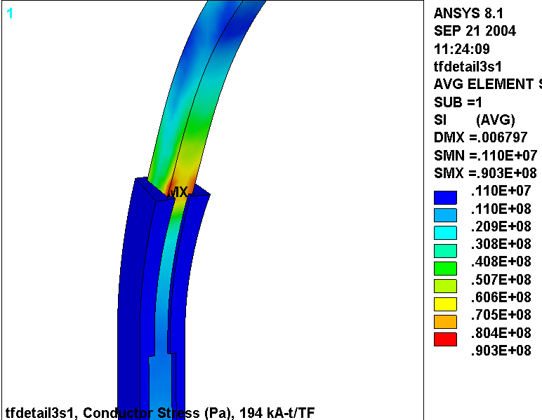
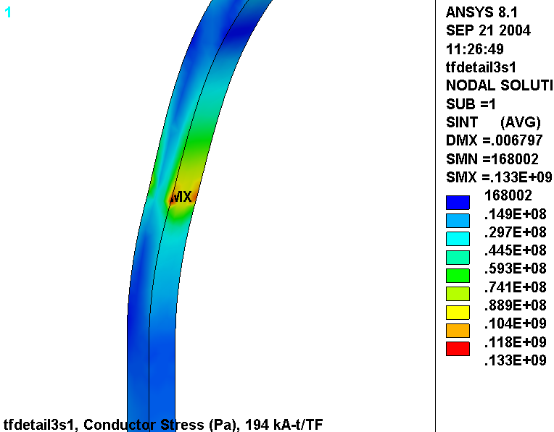
Fig. 4.3-1 Stresses in Smeared WP, Upper (“ETAB”), Lower (nodal), Wedges Extend 50˚
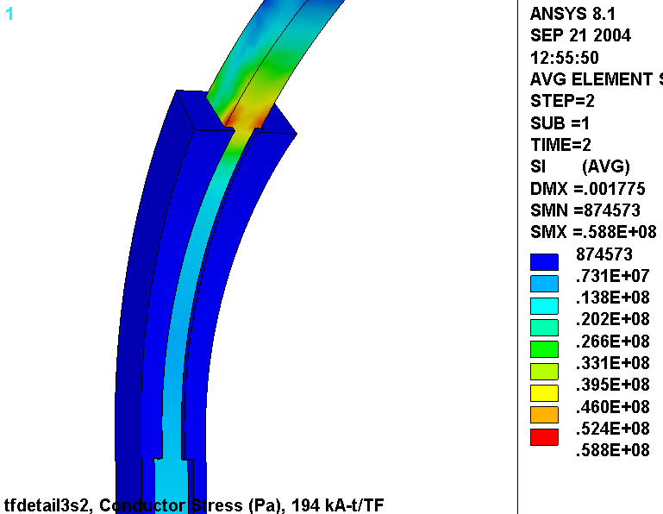
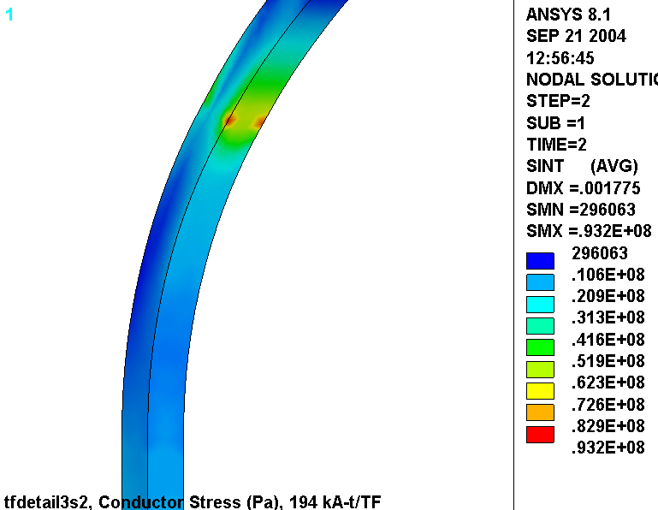
Fig. 4.4-1 “ETAB” Stresses in Smeared WP
Upper: μ=0.0, Lower: μ=0.3, Wedges Extend 30˚
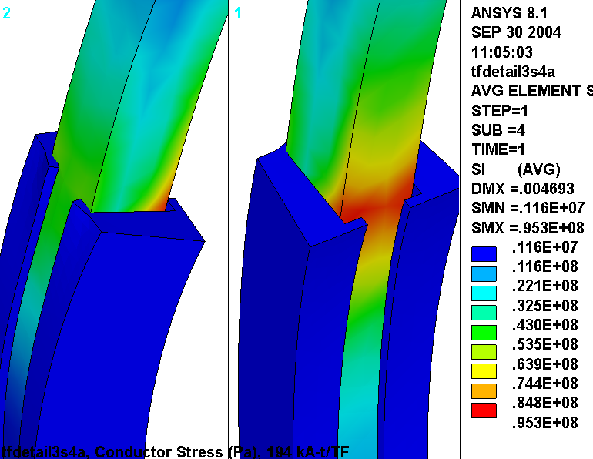
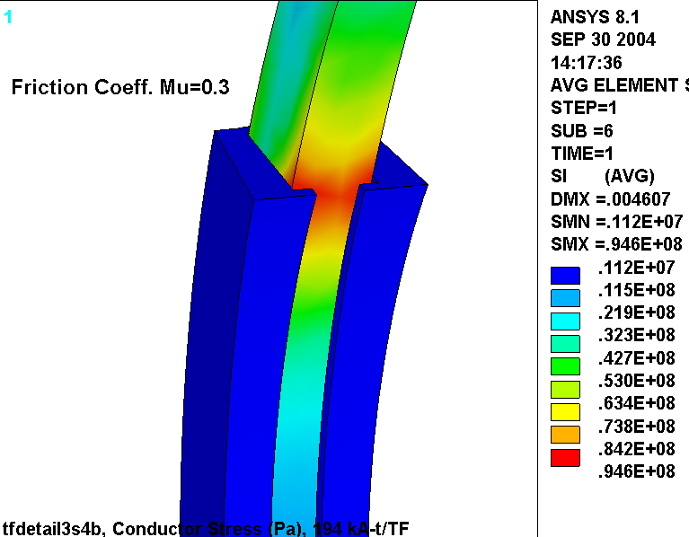
Fig. 4.4-2 “NODAL” Stresses in Smeared WP, Upper: μ=0.0, Lower: μ=0.3, Wedges Extend 30˚
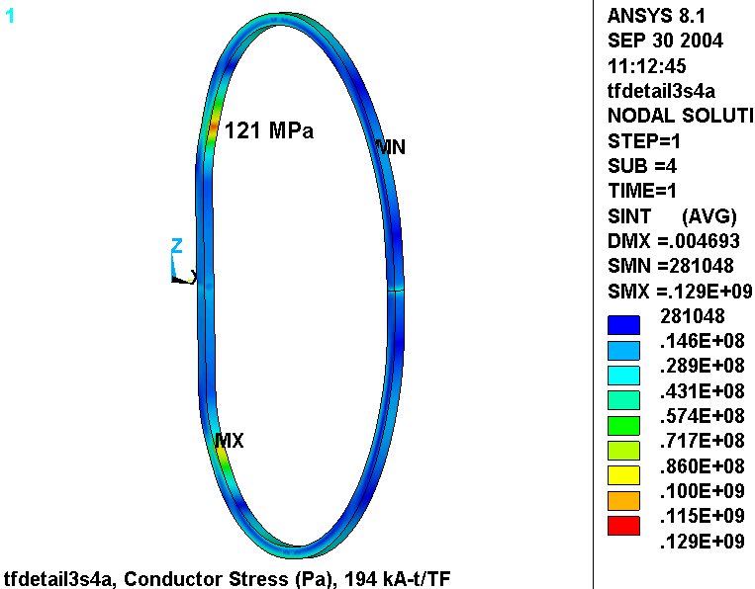
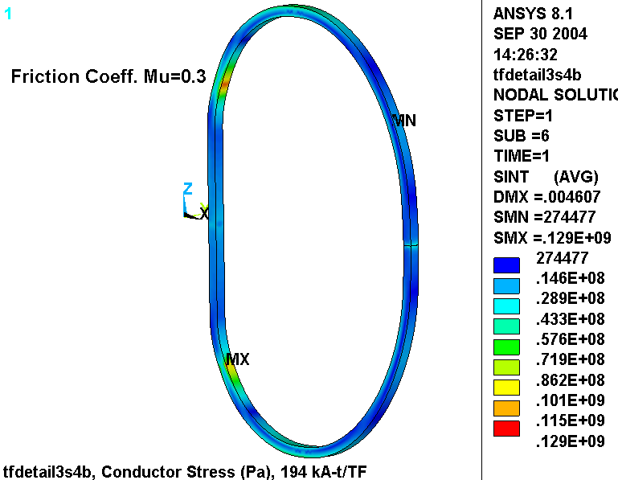
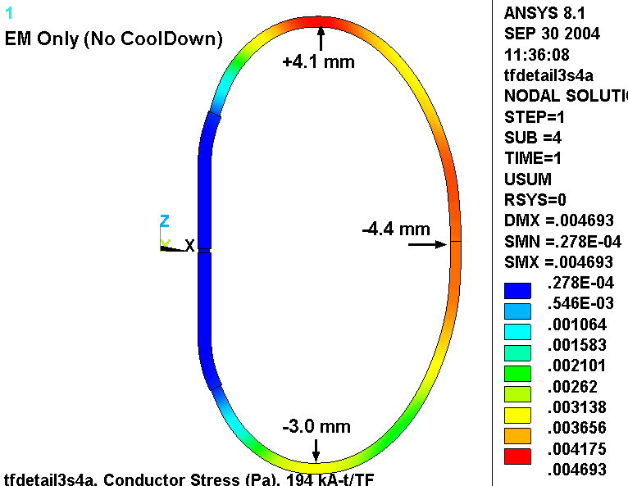
Fig. 4.4-3 Deformations in Smeared WP, μ=0, Wedges Extend 30˚ (μ=0.3 almost identical)

Fig. 4.4-4 Wedging Structure Stresses
Upper: Contact, Lower: Bonded, Wedges Extend 30˚ (upper: μ=0, lower: μ=0.3)
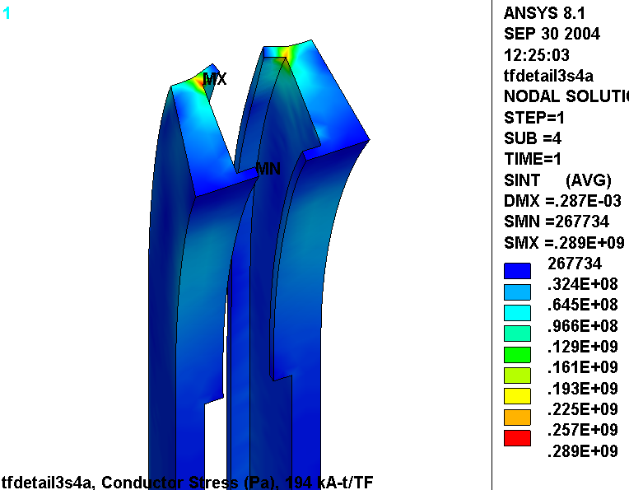
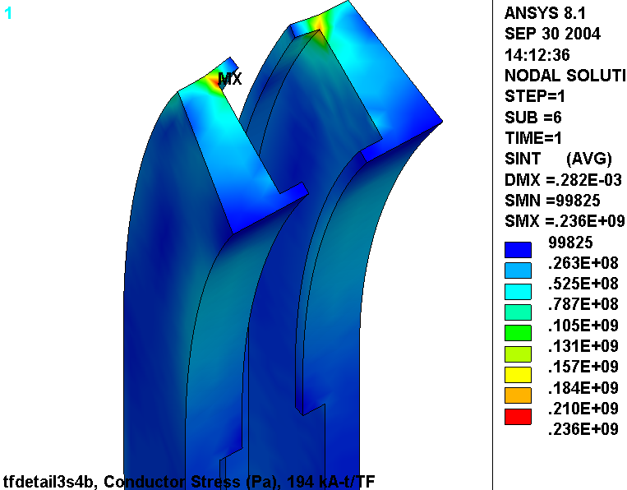
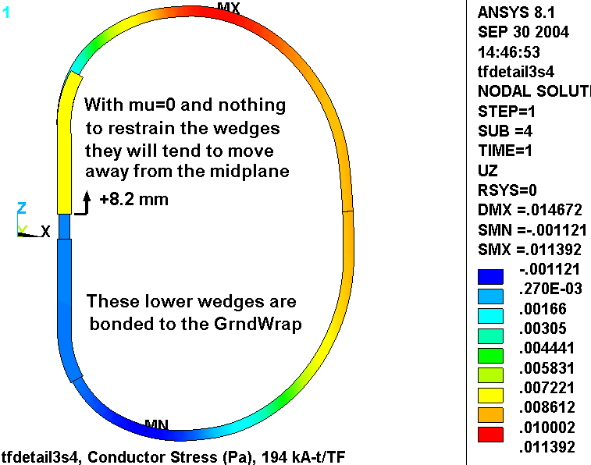
Fig. 4.4-5 Vertical Deformations, Upper Wedging Structure Not Secured by BCs or Friction
Fig. 4.4-6 Vertical Stress and Reaction Vectors, Upper Wedging Structure Secured by BCs
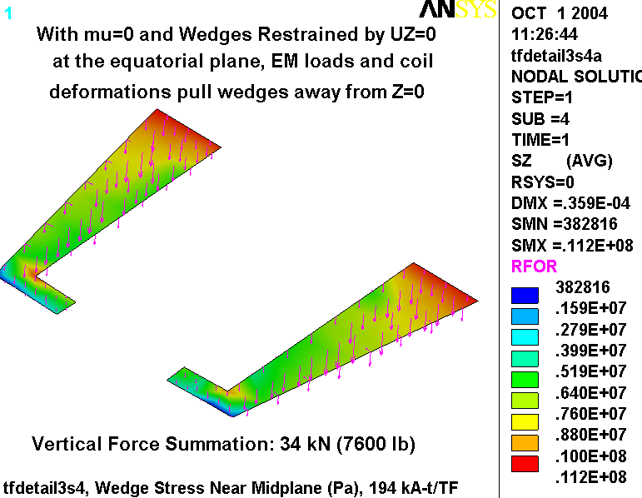
4.5 Extended TF Wedge Casting and Hybrid WP Model

The design studies presented above have highlighted some insightful characteristics of the original wedge design.

- Fig. 4.0-4 shows that extending the wedges >30˚ drops the WP stresses substantially.
- Fig. 4.4-4 shows that the low-field side lip should be thickened.
- Fig. 4.4-5 & 4.4-6 show that the wedges should be one piece (top to bottom).

All of these observations are rolled into an improved wedge design as shown in Fig. 4.5-1 (upper), while Fig. 4.5-1 (lower) shows the new 3x4 conductor array. The ANSYS model is modified to account for these design revisions as illustrated in Figs. 4.5-2 and 4.5-3. These plots show that in addition to incorporating these design changes, the model is taken to the next level of complexity; it now includes a hybrid of smeared and detailed regions to represent the WP. In the upper transition region, at the extreme of the wedge structure, the WP constituents are modeled explicitly. That is, each 0.966” x 0.709” conductor in the 3x4 array is surrounded by 49 mil turn insulation. The entire WP (smeared and detailed) is encapsulated in a 0.12” thick ground wrap.

This model provides component-level stress results in the high-stress region, and representative stiffness characteristics in the lower stress regions. It should be noted that the cooling channel is simplistically modeled as a square cross-section instead of circular for meshing efficiency.

Fig. 4.5-1 Revised TF Wedges (upper) and WP Array (lower)
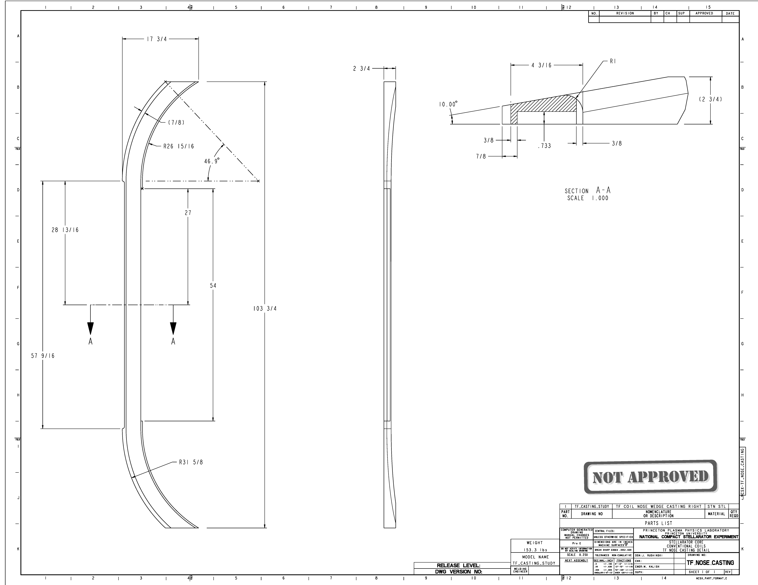
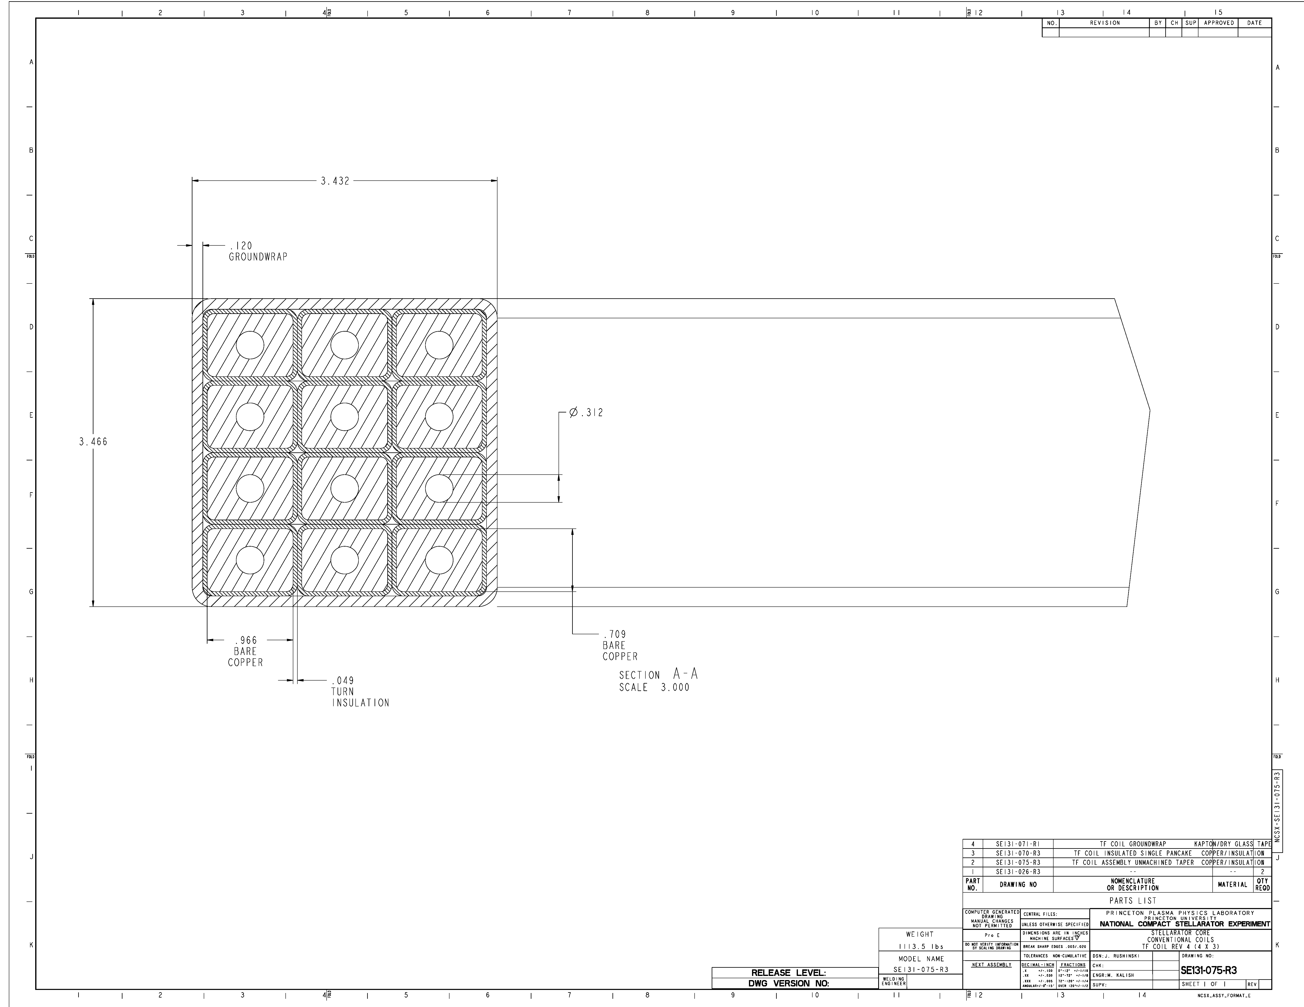
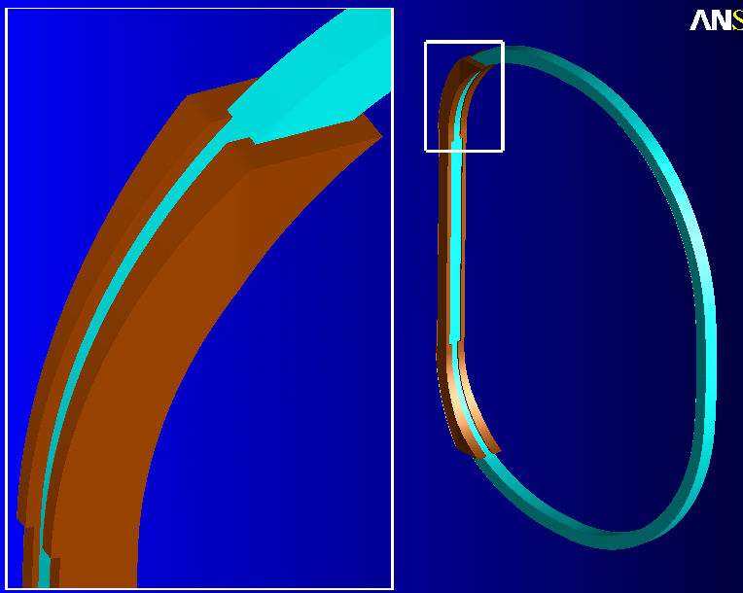
Fig. 4.5-2 Hybrid ANSYS model of TF and Redesigned Wedges
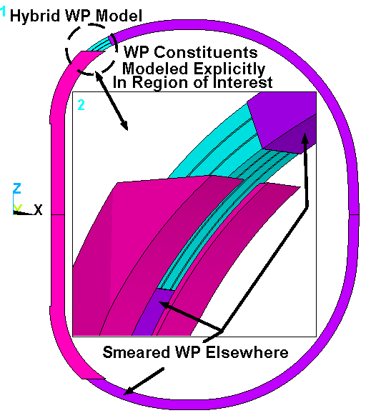
Generalized surface-to-surface contact element separate the inside faces of the Wedges from the outside faces of the Winding Pack in the upper half of the model. For solution expedience, these parts (WP and Wedges) are glued together in the lower half of the model. (This is one reason for any up-down asymmetries noted in the following results. The other reason, of course, is that only the upper transition has a detailed region.)

Fig. 4.5-3 Close-up of Wedges and Detailed Region Cross-Section
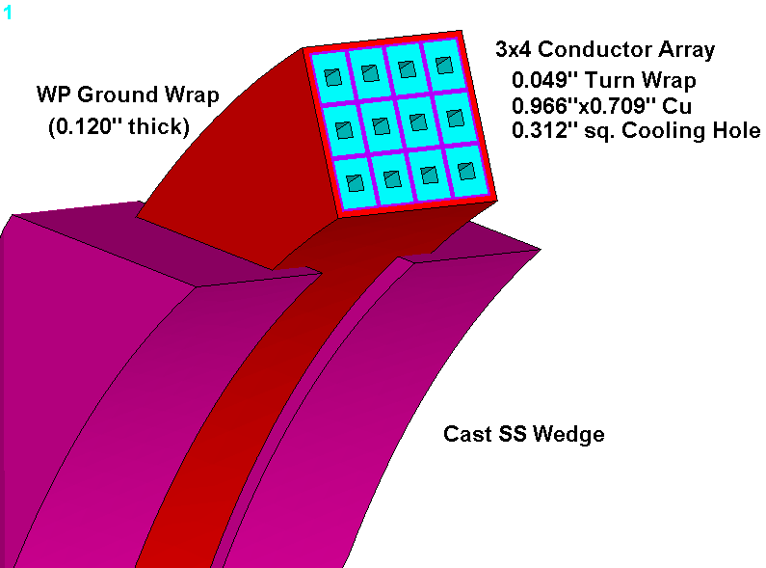
Fig. 4.5-4 is a plot of the stress intensity in the smeared WP and discrete Cu conductors resulting from this 0.5 T operating condition. As expected, the highest stresses occur in about the middle of the detailed WP region, with a maximum [nodal] value of 94 MPa. This agrees remarkably well with the smeared results reported in Fig. 4.0-4 for a 50˚ wedge extension.

This analysis is similar to one documented in an earlier memo for the original 6x2 conductor array. There, the maximum conductor stress is reported to be 134 MPa from this 0.5 T load condition. Clearly, the strength of the narrower WP plus wedges provides better support than the original array by itself. Consequently, the local membrane and membrane + bending stresses are lower in the new 3x4 conductor array.

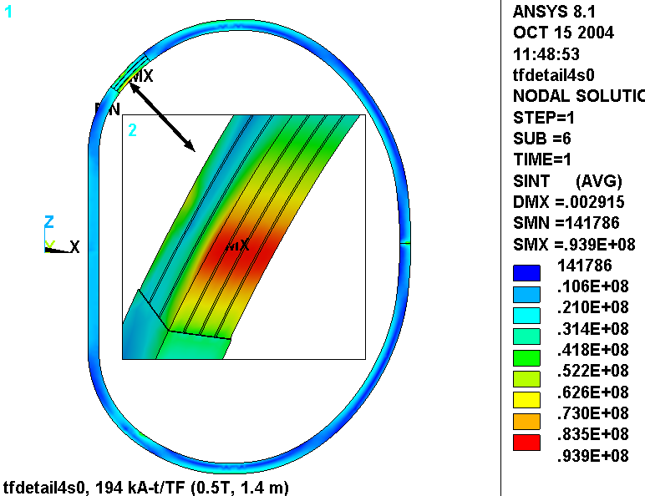

Fig. 4.5-4 Nodal Stress Intensity [Pa], Smeared WP and Discrete Cu Conductors

Fig. 4.5-5 is a plot of the ETAB stress intensity in the hybrid WP. They are plotted along with the wedges to show the location of the maximum conductor stress relative to the end of the structure. Recall that the ETAB results tend to be somewhat lower than nodal results. However, it is used here so that the wedges can get contoured as blue (since their stresses are not stored as ETAB values) for illustration purposes.
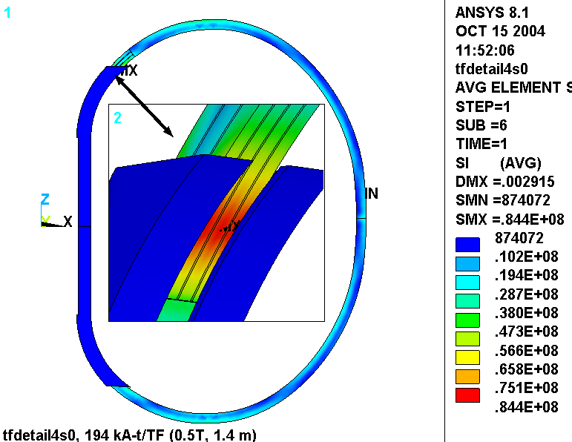

Fig. 4.5-5 ETAB Stress Intensity [Pa], Smeared WP and Discrete Cu Conductor

Fig. 4.5-6 is a plot of the flat-wise (normal to the plane of the glass) insulation stress. The most significant result is the magnitude and extent of the compressive stress as represented by the blue contour island. This stress occurs as a result of the hard contact at the end of the wedge. The legend indicates a maximum stress of 40 MPa, which is really quite low relative to a typical G10/G11 design stress (460 MPa from [Error: Reference source not found]).
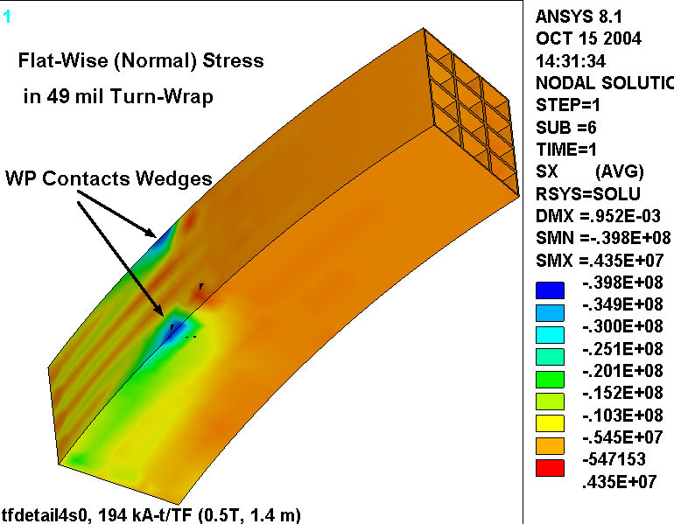

Fig. 4.5-6 Flat-Wise Insulation Stress [Pa]

Fig. 4.5-7 is a plot of the stress in the wedges and Cu conductors from this 0.5 T operating case. The greatly exaggerated deformed shape illustrates how the WP contacts the end of the wedges and tends to tear at the tips. This result is very similar to the previous configuration (as in Fig. 4.4-4), albeit at a slightly lower stress level.

- I think that the design would benefit from a generous radius around these sharp edges. It would move the contact point away from the very end of the wedges and into a region of more material. (An analysis to demonstrate this is TBD.)

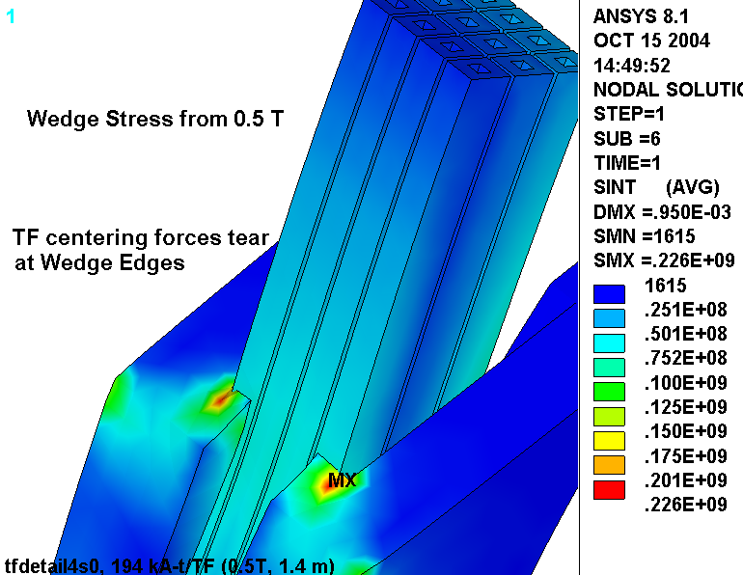
Fig. 4.5-7 Stress Intensity [Pa] in Wedges and Cu conductors

Fig. 4.5-8 is a plot of the deformations in the WP and wedges from this 0.5 T reference load case. In general, the deformations are down relative to those of the nominal 30˚ extension design (Fig. 4.4-3). This is due to the generally stiffer wedge configuration, which looks more like a 50˚ design. Also, there is an up-down asymmetry which is primarily due the softness of the unbonded WP/Wedge interface on top compared to the bonded interface on the bottom. Look closely at the wedge tips and notice a gap between the wedge and the WP at the upper tip, and the absence of said gap at the lower tip.

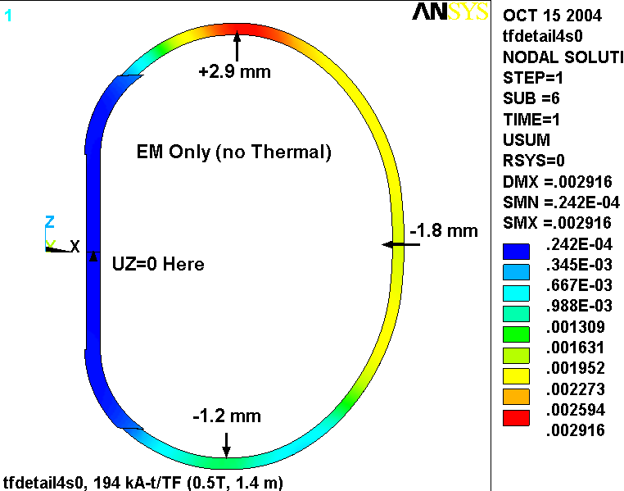
Fig. 4.5-8 Displacements from 0.5 T Loading
Add Radius Detail to Wedges

As shown below in Fig. 4.5-9, the wedge casting design is modified slightly to eliminate the sharp tab highlighted by the stress plot of Fig. 4.5-7. This detail is intended to reduce the peak stress, which generally only impacts fatigue life. At the same time, eliminating the near knife-edge profile will most assuredly reduces some high stresses in the steel and insulation which are too localized to be captured by this model.
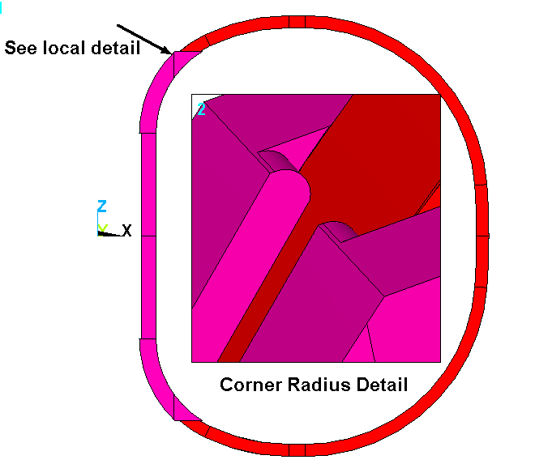

Fig. 4.5-9 Wedge Tip Radius Detail
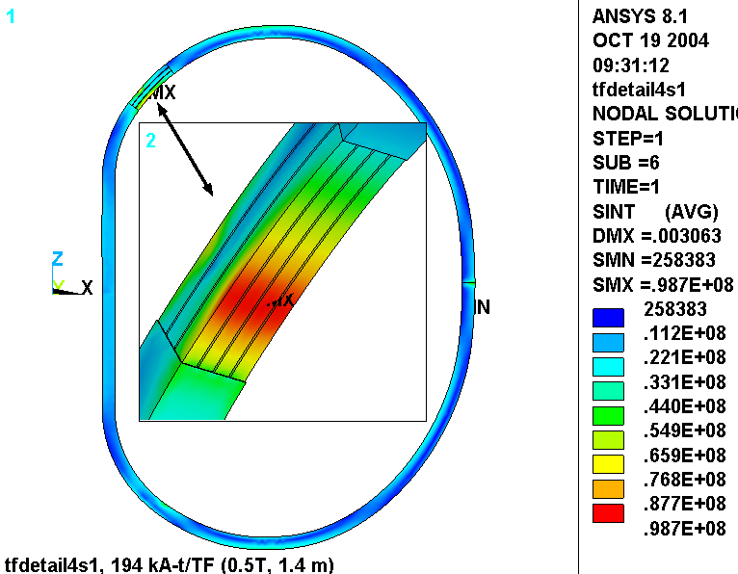
Fig. 4.5-10 is a plot of the stress intensity in the smeared WP and detailed Cu conductor array for this 0.5 T operating condition. The maximum has drifted up slightly from 94 to 99 MPa as a result of this radius detail. In reality, variations in the FE mesh from one model to the next are probably more responsible for this minor change than the addition of the 0.5” radius.

Fig. 4.5-10 Nodal Stress Intensity [Pa], Smeared WP and Discrete Cu Conductors

Fig. 4.5-11 is a plot of the stress intensity in the wedges and Cu conductor. The circled helps locate the 158 MPa peak stress. Recall that without a radius, the model reported a peak stress of 226 MPa. This ~160 MPa stress level is consistent with or below the stresses in the Modular Coil Winding Form (MCWF), which is also a cast SS part.

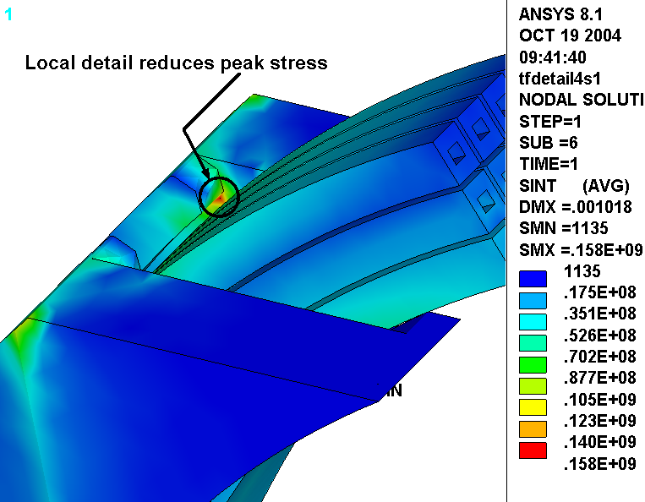
Fig. 4.5-11 Stress Intensity [Pa] in Wedges and Cu conductors

The addition of a radius to the wedge tip produces a slightly stiffer contact point at the ground wrap. Fig. 4.5-11 shows the normal stress distribution in the ground wrap and turn wrap insulation in the detailed WP region. The legend indicates that the peak contact stress has increased from 40 MPa (Fig. 4.5-7) to 50 MPa as a result of the stiffer contact point. However, this is still well below the nominal design stress for a glass-filled epoxy in flat-wise compression (460 MPa from [Error: Reference source not found]).

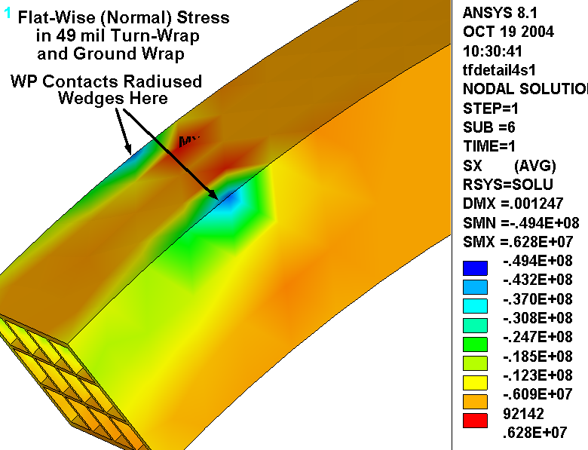

Fig. 4.5-11 Flat-Wise Insulation Stress [Pa]

4.6 Revised Insulation: Kapton Slip-Plane and 3/8” Thick GW

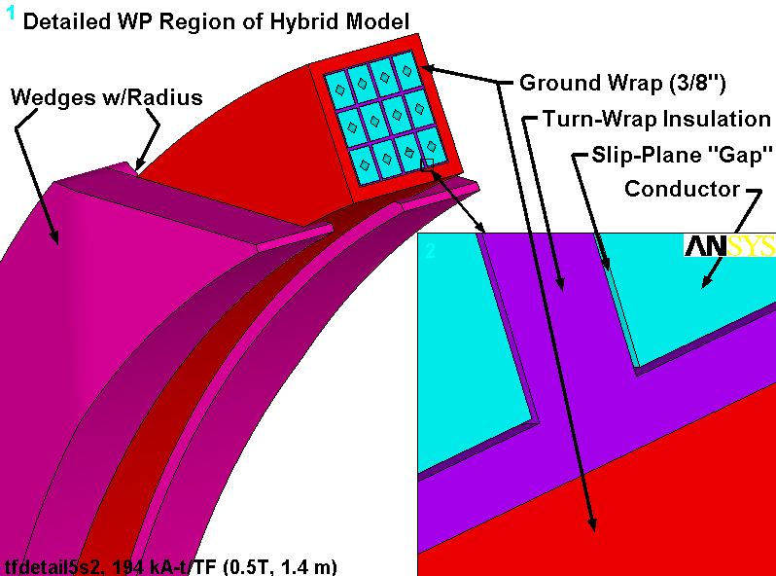
The design presented in Sect. 4.5 has evolved and is reanalyzed; the GW thickness has increased from 0.12” to 0.375”and the out-dated smeared orthotropic WP properties have been changed to reflect the new conductor and insulation slip-plane. In addition, the 4000 lb_{f}/bracket radial preload has been included in the loading. Other than these changes, the model is so similar to that of the previous section that Figs. 4.5-1, 4.5-2, 4.5-3 and 4.5-9 still apply (with the exception of the GW thickness and related dimensional changes). Fig. 4.6-1 is added here to document the slip-plane. This section presents the results from the latest stress analysis.

Fig. 4.6-1 View of Hybrid Model Showing Wedges, Detailed WP and Close-Up of Slip-Plane
Fig. 4.6-2 is a plot of the radial deflections from this 0.5 T + 4000 lb/bracket Radial Preload operating condition. Thermal contraction effects are intentionally omitted to avoid complicating the results with less interesting deflections. The annotated plot indicates that the upper wedges are connected to the WP through general surface-to-surface contact elements while the lower wedges are bonded (for computational efficiency). Vectors are used to represent the contact pressure developed locally by the preload structure. The radial component of each pressure patch integrates to about 4000 lb.

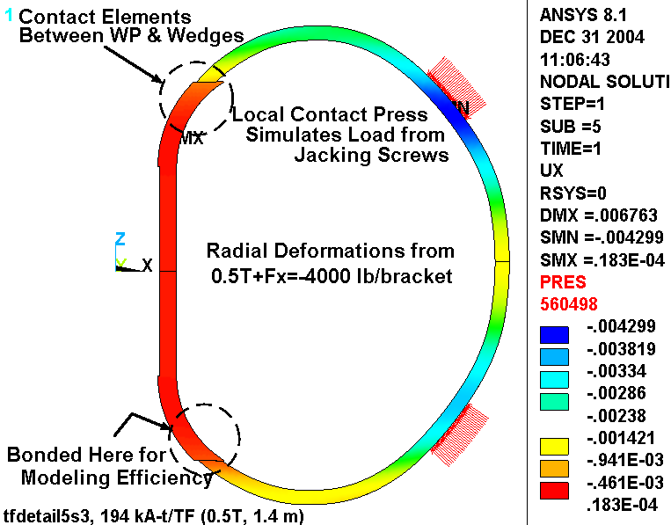
The 4.3 mm max deformation is about 1 mm more than the hybrid model shows for the 0.5 T only load case by itself, indicating the effects of the radial preload.

Fig. 4.6-2 Radial Deflections (m) in Hybrid Model from 0.5 T + 4000 lb/bracket Radial Preload
Cu Stresses

Fig. 4.6-3 is a plot of the stress intensity in the Cu conductor and local smeared WP. Elements at the detailed/smeared discontinuity are unselected as they would contaminate the stress legend with non-physical high stresses. It is a generally accepted practice to look away from the boundaries of a sub-model where artificial discontinuities in displacements, material properties and stiffness produce meaningless results. This hybrid model is essentially a submodel embedded in a full model.

Here, the maximum stress in the discrete Cu turn is 155 MPa (without thermal stresses). It appears in the edge turns which carry the brunt of the centering force as the WP contacts the wedge’s inner lip. It is worth noting that this is predominantly a compressive stress, which tends to be less dangerous (in fatigue and crack-growth) than a tensile stress of comparable magnitude.

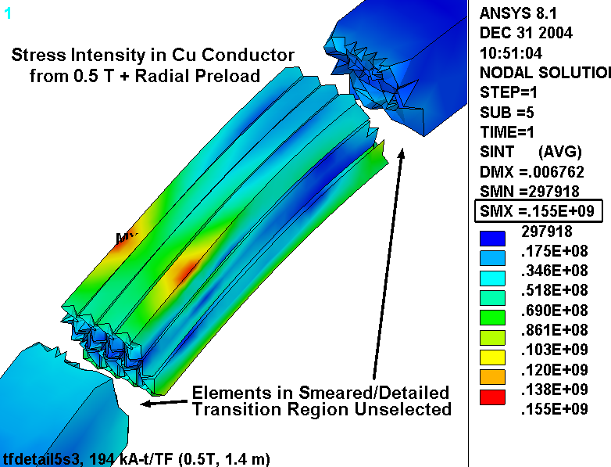
Fig. 4.6-4 is a plot of the stress intensity distribution in the max stress turn cross-section. The contours show a maximum stress at the top of the turn, a very low stress in the middle of the turn, and a slight increase in stress at the bottom of the turn. This is presented graphically in Fig. 4.6-5 which plots the TOTAL stress intensity as a function of distance across the turn (top to bottom). Of course the stress intensity is always positive, which explains the odd V-shaped curve. The plot also shows the average section or MEMBRANE stress (53 MPa) and the linearized MEM+BEND stress. It is interesting to note that the maximum TOTAL and MEM+BEND values are essentially the same (155 MPa), indicating that the local MEM+BEND allowable applies to the maximum conductor stress. In many structures, there is a sizable peak stress component that lowers the stress which must meet the MEM+BEND stress category.
Fig. 4.6-3 Stress Intensity (Pa) in Hybrid Model from 0.5 T + 4000 lb/bracket Radial Preload
Fig. 4.6-4 Stress Intensity (Pa) Max Stress Turn X-Section, 0.5 T + 4000 lb/bracket Radial Preload
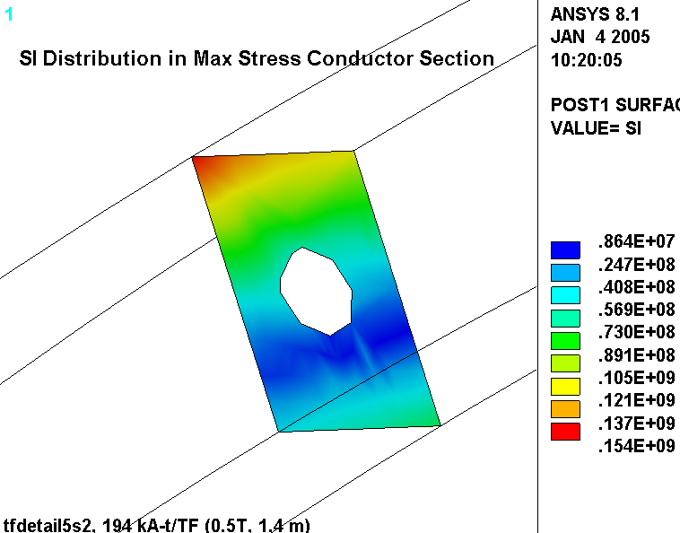
Fig. 4.6-5 Linearized Stresses (Pa) Across Max Stress Turn, 0.5 T + 4000 lb/bracket Radial Preload
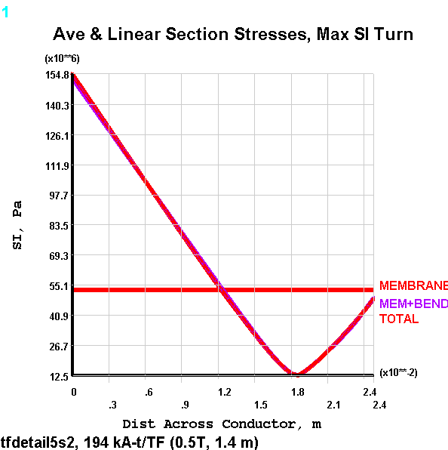
Fig. 4.6-6 is a plot of the 1st principal stress in just the Cu conductors (still excluding thermal contraction effects). It shows that the highest tensile stress occurs on the plasma-side of the WP and has a maximum value of 138 MPa.

The stress distribution in the cross-section of the max σ₁ turn is shown in Fig. 4.6-7. Of course the distribution is inverted relative to the compression-driven turn of Fig. 4.6-4. However, the trend is similar; max tension on the bottom, decaying to a small value on top. This is illustrated by the line plot of Fig. 4.6-8 which again shows little difference between the TOTAL stress and the linearized MEM+BEND stress (138 MPa). Here, the section average (MEMBRANE) is ~72 MPa.
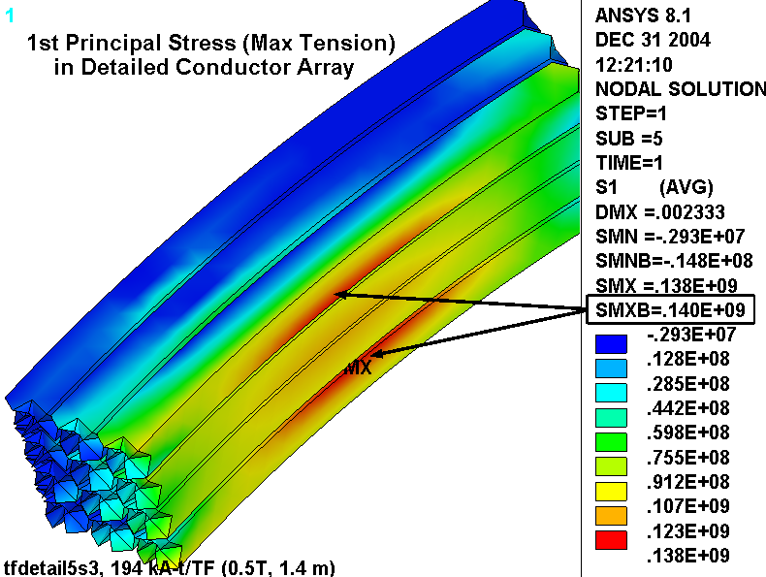
Fig. 4.6-6 Stress Intensity (Pa) in Hybrid Model from 0.5 T + 4000 lb/bracket Radial Preload
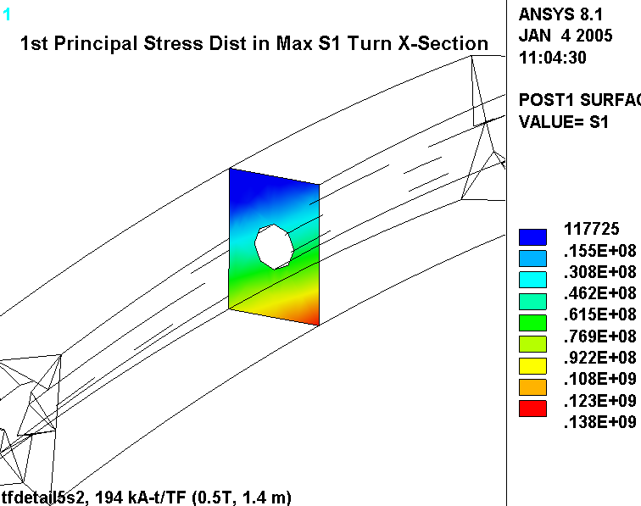
Fig. 4.6-7 Stress (Pa) in High σ₁ Turn X-Section, 0.5 T + 4000 lb/bracket Radial Preload

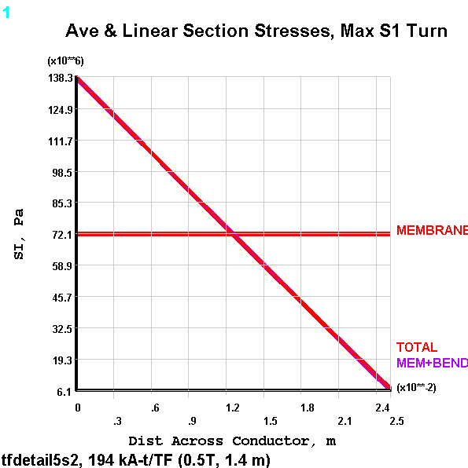
Fig. 4.6-8 Linearized Stresses (Pa) Across High σ₁ Turn, 0.5 T + 4000 lb/bracket Radial Preload
When cooldown effects are added to the analysis (85K), the low-α insulation holds back the contraction of the high-α Cu and increases the tensile stress in the conductors. This is shown in Fig. 4.6-9 which plots the 1st principal stress in the Cu turns for this 0.5 T, 85K, 4000 lb/bracket preload case. Incidentally, a plot of the stress intensity indicates the same result (max stress value and location), indicating that the maximum stress intensity is entirely determined by the 1st principal stress.
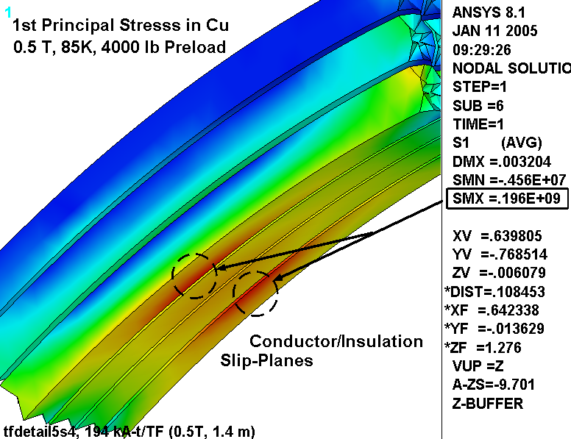

Fig. 4.6-9 Stress Intensity (Pa) in Hybrid Model from 85K, 0.5 T + 4000 lb/bracket Radial Preload
The projects structural design criteria indicates that alternating stresses from cyclic events which occur greater than 10,000 times must be accounted for in a fatigue analysis. In this case, the maximum TF conductor stress range is expected to occur 13000 times when the TF coil goes from zero current to 16.2 kA and back to zero (0.5 T operating current). The stress plots shown above include the 4000 lb/bracket radial preload and thermal contraction effects, which do not change with coil current. Therefore, the maximum alternating stress is best obtained by subtracting the stresses from 0.5 TF only (no preload or thermal contraction effect).

Fig. 4.6-10 shows the stresses in the TF conductor under this circumstance: TF at 0.5 T, zero preload, room temperature (RT). In this case, the maximum stress intensity also occurs on the high-field-side turns and is reported to be 102 MPa. A 1st principal stress plot would show that this is a tensile stress.
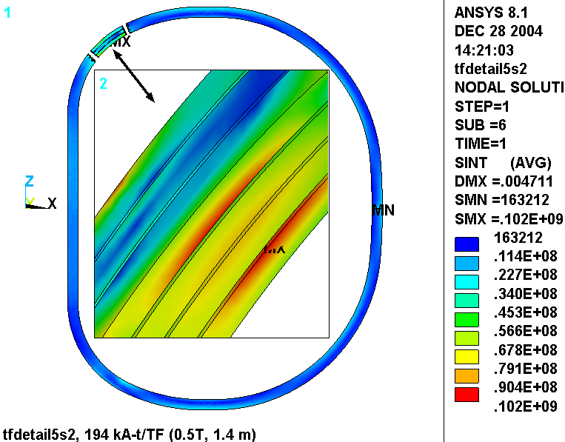

Fig. 4.6-10 Stress Intensity (Pa) in Detailed Conductor from TF at 0.5 T (RT and no radial preload)
Fig. 4.6-11 is a plot of the EM force vectors acting on half of the winding pack. It is used to illustrate the primary forces which must satisfy the primary stress requirement. The vertical force is carried as a tensile stress in the winding pack. A simplistic and conservative calculation would be to assume that the entire vertical force is carried by the conductor cross-section in the inboard leg (~0.0047 m²). This ignores the tensile capacity of the insulation and the outboard leg as a load path. The general primary stress is then calculated as:

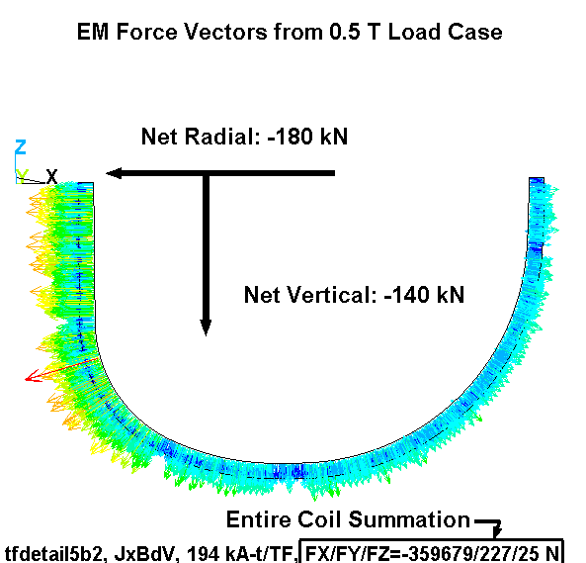
σ_{PM} = F/A = 140 kN/0.0047 m² = 30 MPa
Fig. 4.6-11 Force Vectors on Coil Half, 0.5 T EM Loading

Cu Monotonic Stress Evaluation

The design Tresca stress value (S_{m}) for our Cu TF conductor is based on a material with a specified room temperature minimum yield stress (σ_{y}) of 36 ksi (250 MPa) and a minimum ultimate tensile strength (σ_{ut}) of 42 ksi (280 MPa). These values correspond to a material with about 25% cold-work (CW).

Fig. 4.6-12 shows that for 25% CW Cu the yield stress will increase by about 14% (to 41 ksi or 290 MPa) and Fig. 4.6-13 shows that the tensile strength will increase by about 28% (to 52 ksi or 360 MPa) when cooled to 77K. Defined as the minimum of 2/3σ_{y} or ½σ_{ut} at operating temperature, S_{m} is determined to be 26 ksi (180 MPa) for this 80K coil. It’s worth noting that both of these NIST Monograph 177 figures put the 77K yield and ultimate at higher levels (330 MPa & 385 MPa, respectively), which is a source of some conservatism. The RT starting values of 250 MPa and 280 MPa indeed seem to be minimum properties.

The critical elements of the monotonic stress evaluation [Error: Reference source not found] are now in-hand:

- General Primary Membrane (P_{M}): 30 MPa (from σ_{PM} calculated above) < 180 MPa (1.0S_{m})
- Local Primary Membrane (P_{L}): 72 MPa (from Fig. 4.6-8) < 270 MPa (1.5S_{m})
- Primary Membrane + Bending (P_{M}+P_{B}): 155 MPa (from Fig. 4.6-5) < 270 MPa (1.5S_{m})
- Primary Membrane + Bending (P_{M}+P_{B}): 196 MPa (from Fig. 4.6-9) < 270 MPa (1.5S_{m})
- Total Primary + Secondary (P_{L}+P_{B}+Q): 196 MPa (from Fig. 4.6-9) < 540 MPa (3.0S_{m})

Note that the maximum stress of 196 MPa is categorized two different ways; once as P_{M}+P_{B} and again as P_{L}+P_{B}+Q. Although the incremental increase from 155 MPa to 196 MPa is due to thermal effects (typically thought of as a secondary Q stress), this thermal operating condition could be classified as a primary loading. There are no thermal gradients and it is a steady load. It has the characteristics of a primary load with the exception that it is self-limiting. We will conservatively assume that there is no Q-stress in the TF coil.

Fig. 4.6-12 Temperature Effects on Tensile Yield for 25% CD Conductor
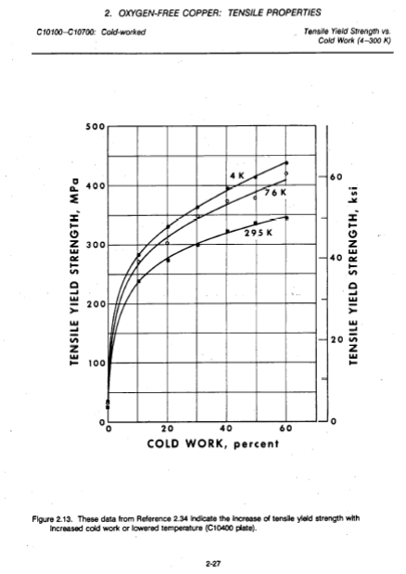
(From http://ncsx.pppl.gov/NCSX_Engineering/Materials/CopperProperties/PB92172766.pdf)

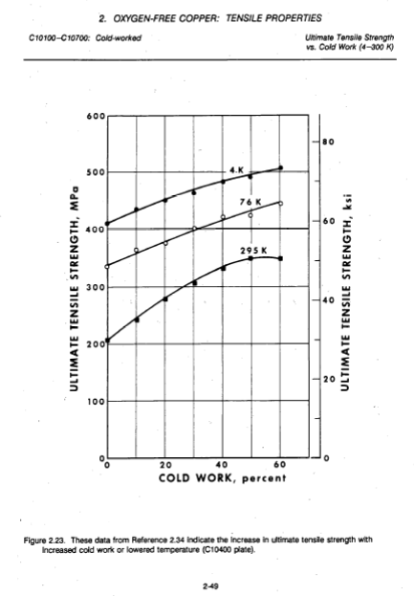
Fig. 4.6-13 Temperature Effects on Tensile Ultimate Strength for 25% CD Conductor
(From http://ncsx.pppl.gov/NCSX_Engineering/Materials/CopperProperties/PB92172766.pdf)

Cu Fatigue Evaluation

The critical elements of the fatigue analysis [Error: Reference source not found] are also now in-hand, but some data manipulation is required.

On the tension side of the WP, the 0.5 T operating condition produces a stress range from 94 MPa (196 MPa – 102 MPa) to 196 MPa. This is equivalent to a mean stress (σ_{mean}) of 145 MPa with an alternating stress (σ_{alt}) of ±51 MPa.

Since the proposed design-basis fatigue curve (Fig. 4.6-13) does not include mean stress effects, an equivalent alternating stress (σ_{eq}) for each side of the WP must be calculated [Error: Reference source not found]:

σ_{eq} (tension) = σ_{alt} / {1 - σ_{mean}/σ_{ut}} = 51/{1-94/360} = 69 MPa

With an alternating stress of ~70 MPa, the number 0.5 T TF cycles to failure (from the design-basis fatigue curve) is 130k. With a design life of 13k cycles, this stress cycle has a Usage Factor of 13k/130k or 0.1.

Of course there are other operating conditions which contribute to the total fatigue damage, such as 1.7 T Ohmic and 2.0 T High-β. However, the simplistic global model analysis of these operating conditions indicates that the stresses are off by a factor of two relative to the 0.5 T case. Stresses at this level have an allowable number of cycles >10⁷ and will add very little to the conductor’s cumulative usage factor (117k/10M=0.012). In fact, one could conservatively assume that all 130k design cycles are 0.5 T pulses and still demonstrate a Cumulative Usage Factor (CUF) of 1.0 (130k/130k), which predicts a conductor failure on the last cycle of the machine’s design life.

Cumulative Usage Factor: 0.10 + 0.01 = 0.11 < 1.0
Fig. 4.6-14 Source of Proposed Design-Basis Cu Fatigue Curve
(From http://ncsx.pppl.gov/NCSX_Engineering/Materials/CopperProperties/PB92172766.pdf) Notice that the σ/2 curve is more limiting than the N/20 curve.
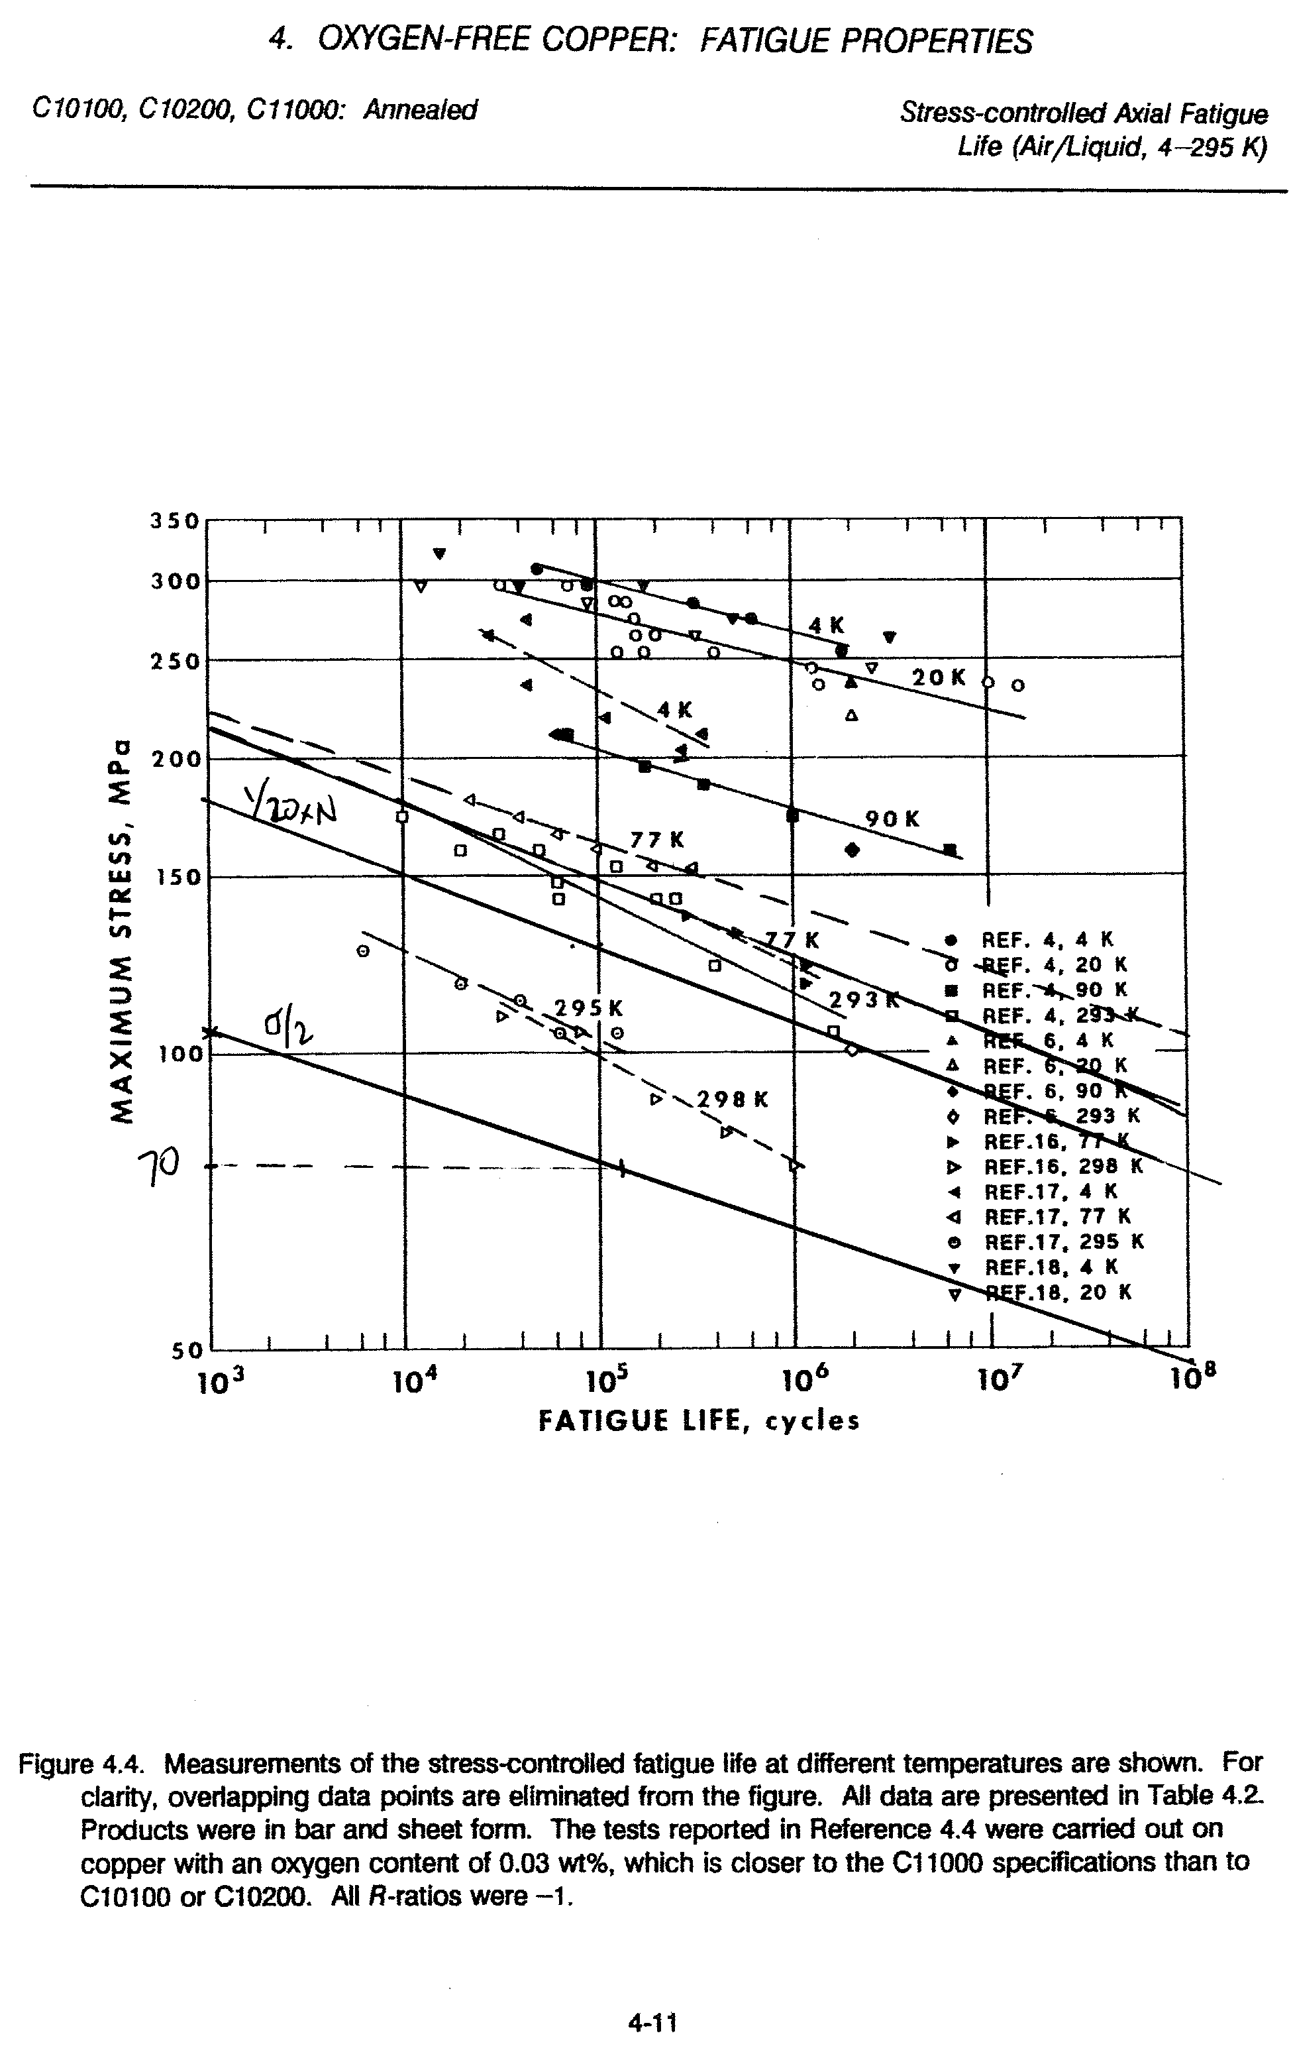
Insulation Stresses

Normal and in-plane stresses in the insulation are highlighted in two contour plots. Fig. 4.6-15 is a plot of the local X (flat-wise, normal) stress in the GW and turn-wrap insulation. The source of the highly localized stress is of course where the WP contacts the ¾” wide tips of the cast wedges. (Fig. 4.5-7 shows this nicely except with the insulation removed.) The plot legend indicates a maximum compressive stress (SMN) of -120 MPa.
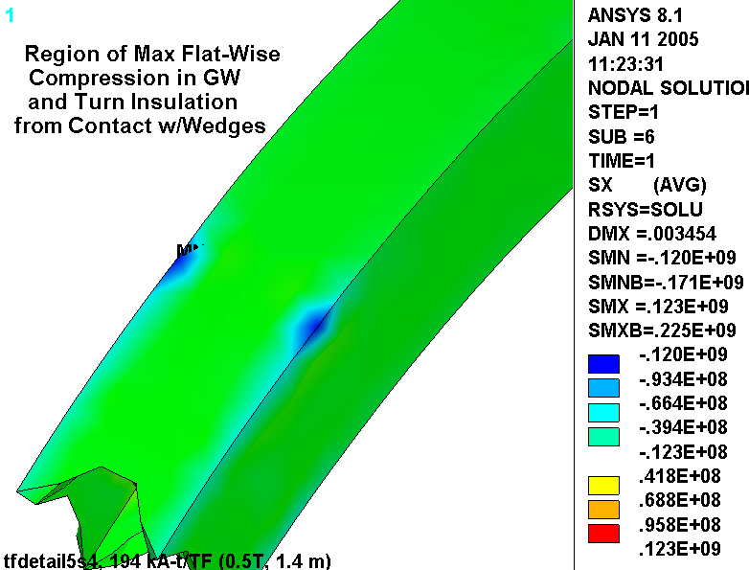
Fig. 4.6-15 Normal Stresses (Pa) in Insulation from 0.5 T, 85K + 4000 lb/bracket Radial Preload
Fig. 4.6-16 is a plot of the local Y & Z (in-plane) stress in the GW and turn-wrap insulation. Local in-plane components are combined by SRSS to produce this result, so the sign is lost. This detail is unimportant as the in-plane stress allowable is based on ±0.5% strain.
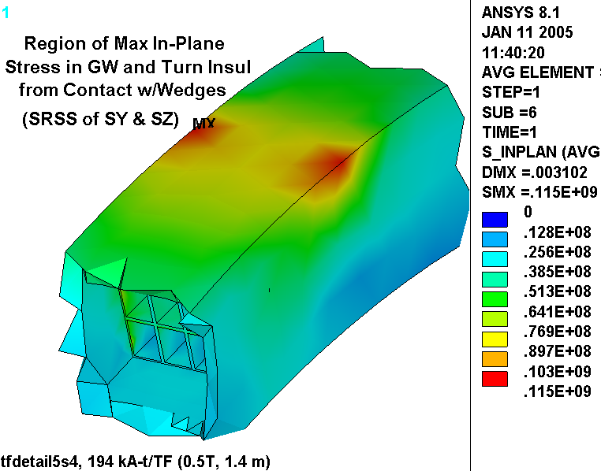

Fig. 4.6-16 In-Plane Stresses in Insulation from 0.5 T, 85K + 4000 lb/bracket Radial Preload
Insulation Stress Evaluation

The project’s design criteria document [Error: Reference source not found] presents an extensive outline for qualifying insulation stress. Requirements are paraphrased below:

- Flatwise (through-thickness) compressive stress shall be limited by 2/3 of the ultimate stress.
- Compressive fatigue allowable stress shall be equal to the lesser of 2/3 of the ultimate compressive fatigue stress measured at the lifetime number of cycles or the ultimate compressive fatigue stress at temperature at 5x the lifetime cycles.
- Normal to the adhesive bonds between metal and composite, no primary tensile strain is allowed. Secondary strain will be limited to 1/5 of the ultimate tensile strain of the adjacent insulation. In the absence of specific data, the allowable tensile strain is 0.02% in the insulation adjacent to the bond.
- The maximum tensile or compressive strain permitted in the plane of the insulation material is either +0.5% or -0.5%.
- The shear-stress allowable, S_{s}, for either static or fatigue conditions is given by:

S_{s} = 2/3 τ_{o} + c₂ S_{c}(n)
Where,

τ_{o} is the experimentally determined minimum intrinsic shear strength with no compressive load (the lower of the bond shear strength or the composite interlaminar shear strength).

c₂ is an experimentally determined factor representing the slope of the dependence of shear strength on compressive stress.

S_{c}(n) is the local normal compressive stress.

Aside: Allowable Stress Levels at 77K (close enough to the 85K operating temperature)

There is an ITER insulation design document which contains test data and recommended design values for a number of insulations systems. The NCSX system has a Kapton wrap followed by a VPI’d S2 glass. The ITER document does not list this specific system, but does have a “very similar product,” according to Paul Fabian of CTD, Inc.; CTD112/Prepreg S-2 glass with interleaved Kapton, hereafter referred to as Prepreg/Kapton.

- Under flatwise compression, G-10/11CR has an ultimate strength of about 700 MPa, while the TGDM Pre-Preg/Kapton system has a 200,000 cycle fatigue strength of 600 MPa[Error: Reference source not found]. The stress limit used here is conservatively based on the lower value: 2/3 x 600 or 400 MPa.

- The first insulating layer is Kapton, which will essentially ensure a poor bond between the insulation and the Cu. Therefore, no significant through-thickness tensile stresses are likely to develop. The model simulates this by assuming a slip plane capable of carrying compression only. Ref. [Error: Reference source not found] allows a tensile strain of <0.02%, or (0.0002)(19 GPa)=3.8 MPa.

- The ultimate in-plane tensile strength of G-10/11CR is anisotropic, with values of ~460 MPa in the Warp direction and ~800 MPa in the Fill direction (from [Error: Reference source not found]). We will assume that the lesser of these two values applies: 460 MPa and multiply by 2/3 to get an allowable of 310 MPa. When no insulation-specific data is available, the in-plane tensile allowable is based on the +0.5% strain limit, which is 0.005 x 26 GPa or 130 MPa. It is worth noting that this value is conservative by about a factor of two relative to the G-10/11CR value.

- The ultimate in-plane compressive strength of G-10/11CR is also anisotropic, with values of ~550 MPa in the Fill direction and ~800 MPa in the Fill direction (from [Error: Reference source not found]). We will assume that the lesser of these two values applies: 550 MPa and multiply by 2/3 to get an allowable of 360 MPa. When no insulation-specific data is available, the in-plane compression allowable is based on the -0.5% strain limit, which is -0.005 x 26 GPa or -130 MPa. It is worth noting that this value is conservative by almost a factor of three relative to the G-10/11CR value.

- The ITER document recommends values of τ_{o} and c₂ for Prepreg/Kapton insulations of 40 MPa and 0.32 (non-etched Kapton) respectively, when the coil is subject to a fatigue environment.

The critical elements of the Insulation stress analysis are now in-hand:

- Flat-Wise Compression: -120 MPa (from Fig. 4.6-15) < 400 MPa
- In-Plane Tension & Compression: 115 MPa (from Fig. 4.6-16) < 130 MPa
- Through-Thickness Tensile Stress: See Below.
- Shear/Compression: See Below.

A detailed analysis of the shear/compression stresses in the winding pack insulation requires some postprocessing operations which are consistent with the design criteria captured in the equation:

S_{s} = 2/3 τ_{o} + c₂ S_{c}(n)

Recall that τ_{o} is set at 40 MPa and c₂ is set at 0.32 (assuming non-etched Kapton). The normal stress, S_{c}, must be determined on an element by element basis. The resulting allowable shear stress, S_{s}, is then compared to the local shear stress (τ), also on an element by element basis.

Table 4.6-1 contains a summary of the insulation shear/compression stress analysis which is outlined above. Results are reported for coil detailed winding pack (WP) turn insulation. Recall that the analysis postprocessing determines the fraction (or percentage) of material which “passes” the criteria. Clearly, the goal is to achieve 100%. A small fraction of the turn wrap insulation elements fail the normal stress criteria while all of them pass the shear stress criteria.
The tabulated results indicate that shear (τ) and normal (⊥) stresses now pass the criteria in essentially all of the detailed winding pack insulation. This is illustrated by a normal stress plot where compressive stresses are contoured red and tensile stresses above the allowable are contoured grey (Fig. 4.6-17). The embedded title shows the results of a volumetric summation of elements which pass the shear and normal stress requirements; 99.8%.

Table 4.6-1 Insulation Shear Stress Evaluation Results
Detailed WP Material which Passes Criteria (%)
Loading | WP(⊥) | WP(τ) | WP(⊥ + τ)
0.5 T + Radial Preload at RT | 99.8 | 100 | 99.8

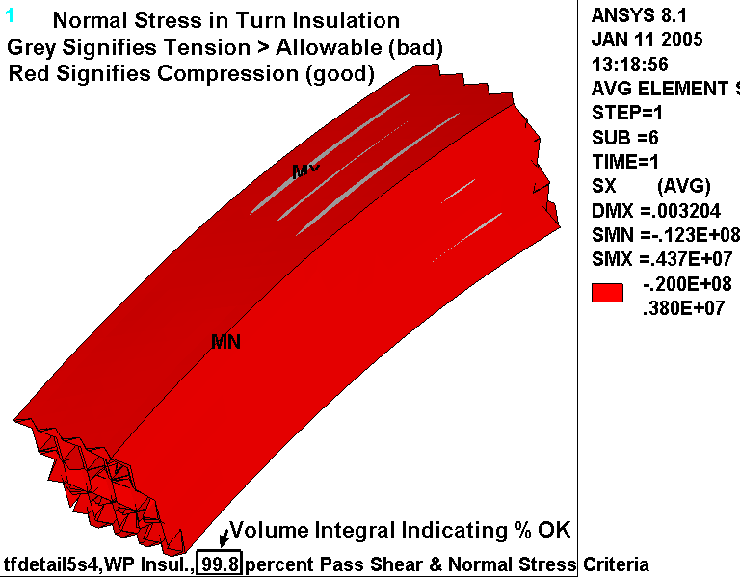
Fig. 4.6-17 Normal Stresses in Turn Insulation from 0.5T EM, 85K & Radial Preload

SS Wedge Casting Stresses

The maximum stress in the SS wedges occurs as a result of the radial force (EM + Preload) pushing against the ¾” lips. This contact force concentrates at the extremes of the wedges, as indicated by the peak in the stress field shown in Fig. 4.6-18. Left and right wedges are shown but do not indicate symmetric results: 343 MPa & 267 MPa. This can only be a result of some lack of symmetry in the contact element convergence as the model and loading are exactly symmetric. It is also worth noting that these stresses include a significant contact stress component, which generally must satisfy its own allowable stress.

Fig. 4.6-19 is a similar set of plots representing the 1st principal stress in this same region. This time, the maximum tensile stress in each wedge is identical; 203 MPa.

Fig. 4.6-20 is a plot of the 1st principle stress in the cast wedge as a result of the 0.5 T operating condition. This stress provides the stress range aspect of the cyclic load, while Fig. 4.6-19 provides the maximum stress.

The 0.75” wide by 1” deep lip must carry most of the radial load from the coil (EM + Preload) as a shear stress. (Some of the radial load will be carried by friction from toroidal compression on the sidewalls.) Let’s assume that the radial load is carried over the top 2.5” of the lip (a seemingly very conservative assumption considering the ~25” lip length). The radial load from the 0.5 T operating condition is 360 kN per coil (see the embedded plot title of Fig. 4.6-11). The radial preload is 4000 lb/bracket x 2 brackets per coil. Therefore, the average shear stress in the wedge lip (τ_{WL}) is:

τ_{WL} = {(360 kN x 0.2248 lb/N x 1000 N/kN) + 8000 lb} / (1” wide x 2” long x 4 lips/coil) = 11 ksi

SS Wedge Casting Stress Evaluation

It is assumed that the wedge casting material will be comparable to 304SS. The NCSX web site lists 304 minimum RT yield and ultimate stress values of 30 ksi and 75 ksi, respectively. It is expected that the yield stress will increase by about 100% and the ultimate strength will increase by about 150% at the LN2 operating condition [Error: Reference source not found], which puts these values at 60 ksi and 190 ksi. The design stress, S_{m}, based on these values is 2/3σ_{y} or 40 ksi (270 MPa).

The Structural Design Criteria [Error: Reference source not found] requires that the average shear stress must be less than 0.6S_{m}, or 24 ksi (160 MPa). This is well below the 11 ksi (76 MPa) shear stress calculated above, and indicates that the shear in the lips is acceptable.

The most limiting monotonic stress criterion is P_{L}+P_{B}<1.5S_{m} = (1.5x160 MPa) = 400 MPa. Even if we conservatively categorize the largest stress (343 MPa) as P_{L}+P_{B}, the criterion is satisfied. (Some portion of this number is a contact stress or peak stress which is not normally included in P_{L}+P_{B}.)

Fig. 4.6-18 Stress Intensity (Pa) in SS Wedges from 0.5T EM, 85K & Radial Preload
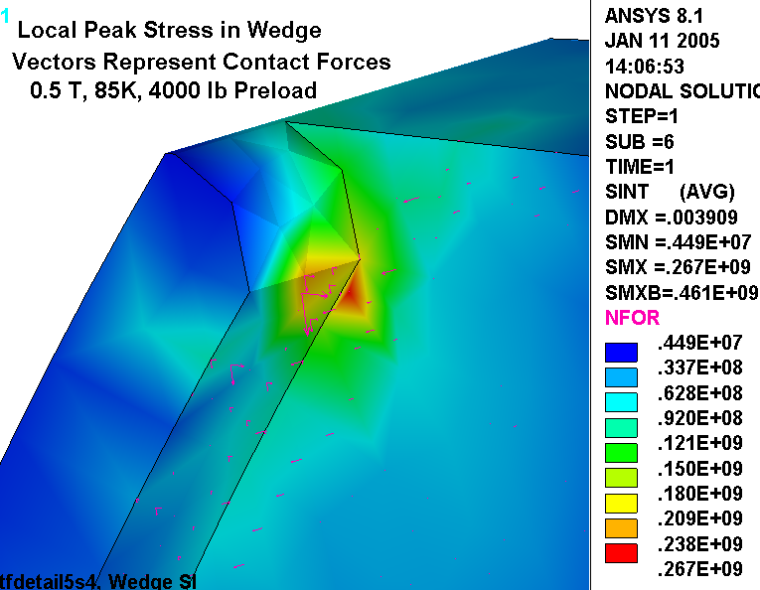
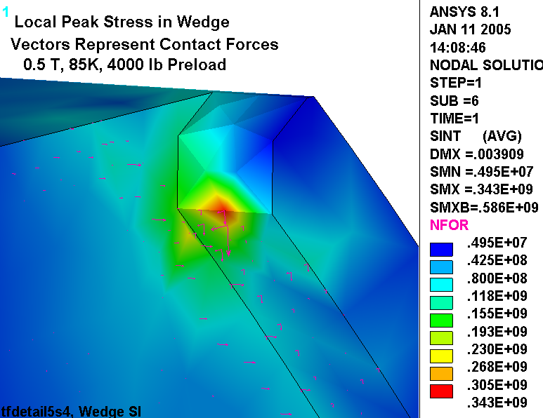
Fig. 4.6-19 1st Principal Stress (Pa) in SS Wedges from 0.5T EM, 85K & Radial Preload
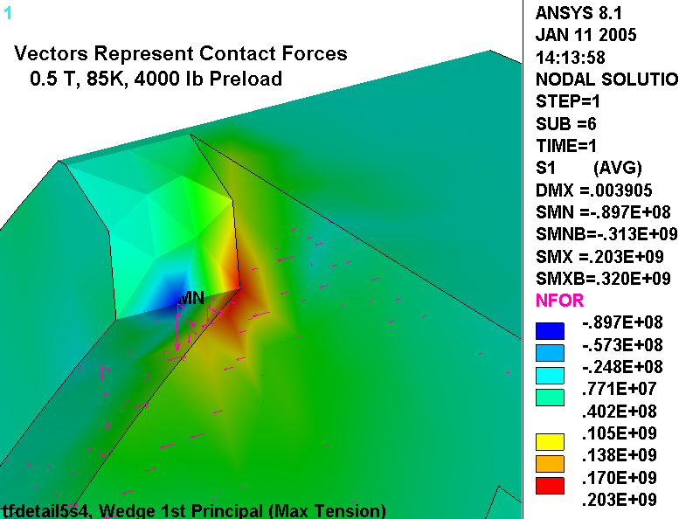
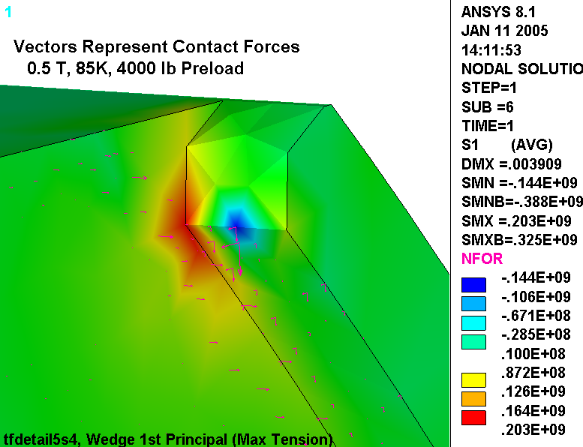
Fig. 4.6-20 1st Principal (above) & Stress Intensity (below) in SS Wedges from 0.5T EM
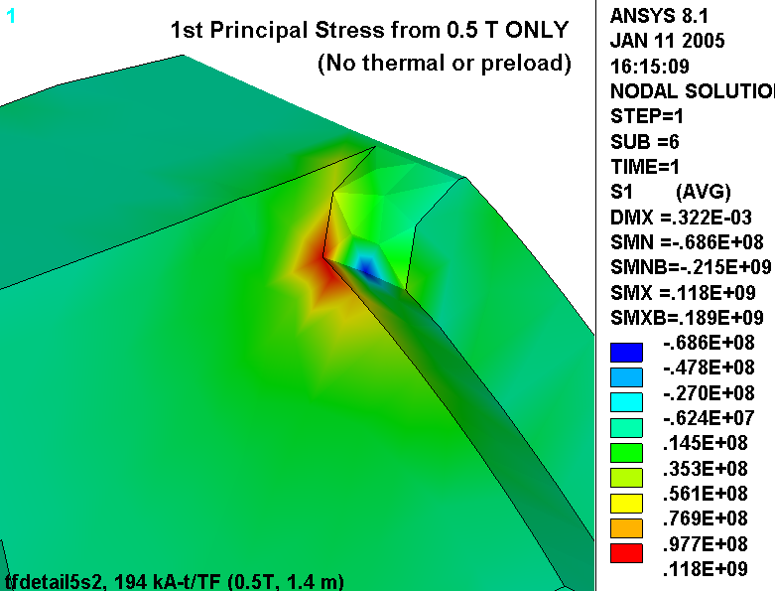
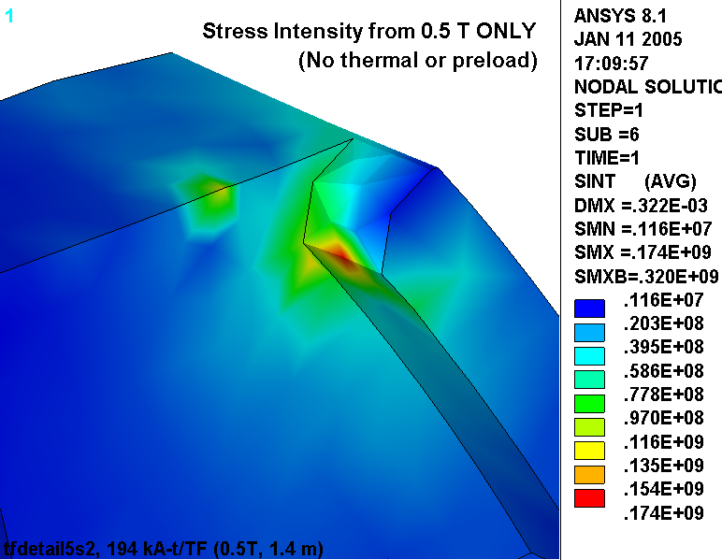
The castings are subjected to a cyclic loading, just like the Cu conductor. The model results are used to determine a maximum stress cycle to be used in a fatigue analysis.

Max 1st Principal Stress

Fig. 4.6-19 indicates that the maximum 1st principal stress (σ₁) is 203 MPa. Fig. 4.6-20 indicates that the σ₁ stress range is 118 MPa. This defines the mean and alternating components of the σ₁ stress cycle: σ_{mean} = {203 +(203 -118)}/2 = 144 MPa with an alternating stress (σ_{alt}) of ±59 MPa.

A design-basis fatigue curve for the 304 cast material is presented in Fig. 4.6-21. It is developed from notched and annealed 304L material with a fully-reversing (R=-1) stress. The notched data is conservative but consistent with the discontinuity at the base of the wedge lip (unless a fillet is added to the drawing). As with the Cu conductor, an equivalent alternating stress must be determined based on the following:

σ_{eq} (tension) = σ_{alt} / {1 - σ_{mean}/σ_{ut}} = 59/{1-144/1300} = 66 MPa (10 ksi)

With an alternating stress of 66 MPa (10 ksi) the number 0.5 T TF cycles to failure (from the σ/2 design-basis fatigue curve) is >10⁵, possibly 1M although this is an extrapolation. With a design life of 13k cycles, this stress cycle has a Usage Factor of 13k/>100k or <0.13. As with the Cu fatigue analysis, other stress cycles exist, but produce stresses which are down by a factor of two from this level. Consequently, the other stress cycles contribute negligibly to the Cumulative Usage Factor of the wedges, which is well below 1.0.

Max Tresca Stress

Fig. 4.6-18 indicates that the maximum stress intensity (σ₁) is 343 MPa. Fig. 4.6-20 indicates that the stress intensity range is 174 MPa. This defines the mean and alternating components of the SI stress cycle: σ_{mean} = {343 + (343 -174)}/2 = 256 MPa with an alternating stress (σ_{alt}) of ±87 MPa. An equivalent alternating stress must be determined based on the following:

σ_{eq} (tension) = σ_{alt} / {1 - σ_{mean}/σ_{ut}} = 87/{1-256/1300} = 110 MPa (16 ksi)

With an alternating stress of 110 MPa (16 ksi) the number 0.5 T TF cycles to failure (from the σ/2 design-basis fatigue curve) is still >10⁵ possibly 300k although this is a slight extrapolation. With a design life of 13k cycles, this stress cycle has a Usage Factor of 13k/>100k or <0.13. Again, other stress cycles exist, but produce stresses which are down by a factor of two from this level. Consequently, the other stress cycles contribute negligibly to the Cumulative Usage Factor of the wedges, which is well below 1.0.

Fig. 4.6-21 Proposed Design-Basis Fatigue Curve for 304SS Cast Wedges (σ/2 curve)
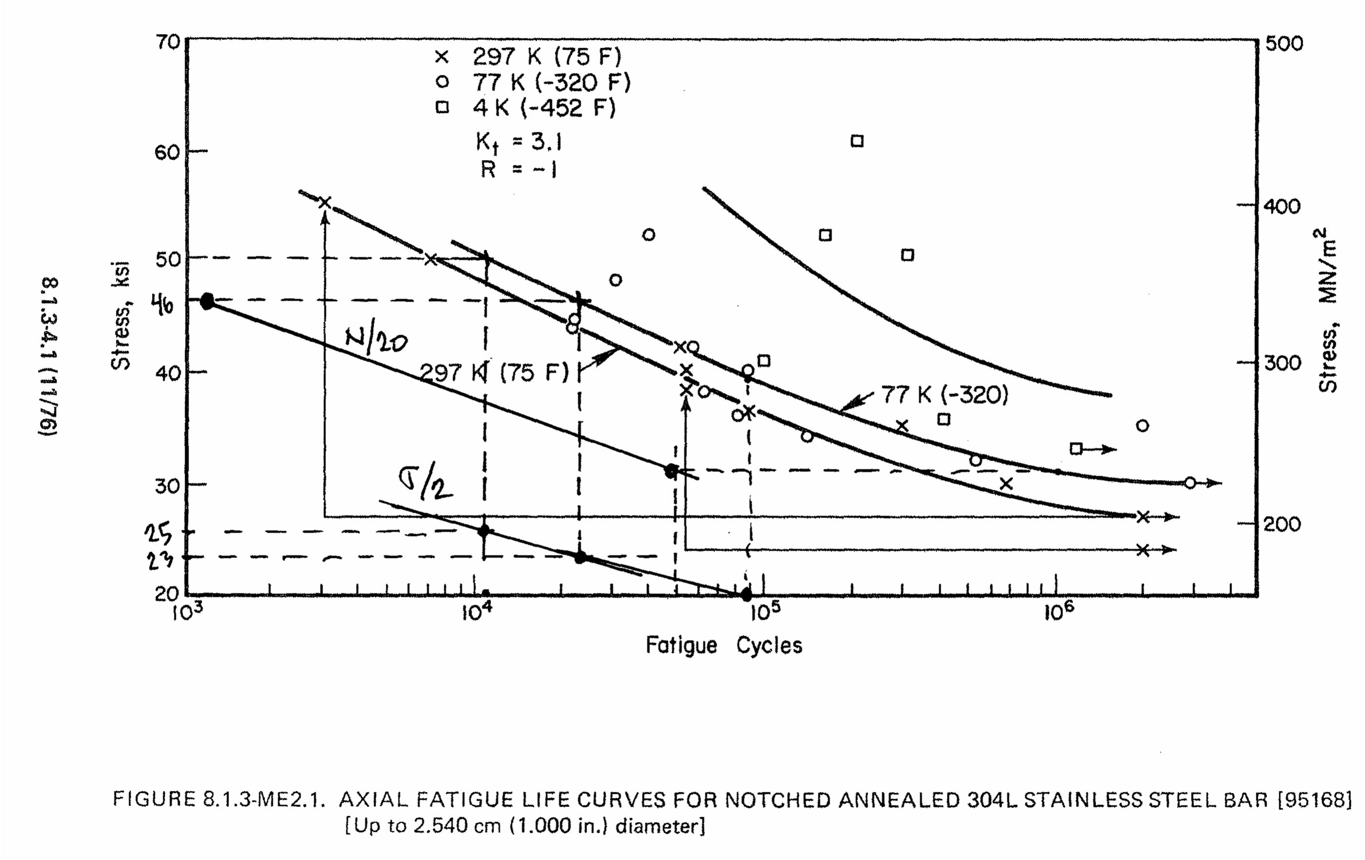
5.0 Summary & Commentary

The latest TF coil design has been analyzed in detail using a hybrid (detailed-smeared) finite element model (i.e., a detailed model of a portion of the coil pack embedded within a global smeared-properties model). This TF coil configuration consists of the following:

- A 3x4 array of 0.966”x0.709” Cu conductors.
- Turn insulation composed of S-2 glass over Kapton which builds to 49 mils.
- Winding pack ground wrap composed of multi-layer S-2 glass which builds to 0.375”.
- TF nose castings (wedges) made from 304-like material.

The analysis shows the following:

- The latest casting design (Fig. 4.5-1) passes all relevant design criteria:
  - Local lip shear stress: 76 MPa < 160 MPa
  - Primary Membrane plus Bending (P_{M}+P_{B}): 343 MPa < 400 MPa
  - Fatigue life: CUF = 0.11 < 1.0
  - Improvements such as eliminating the knife-edge at the ends of the casting (by adding a large radius as shown in Fig. 4.5-9) and adding a small (1/8”) radius at the root of the low-field-side lip (particularly within 6” of the ends) are necessary to reduce the local stresses in the WP insulation and casting peak stress. This is particularly important to a cyclically-operated machine.
- The highest conductor stress occurs at the ends of the wedges. EM and radial preload forces result in a bending stress with a significant tensile component on the high-field-side of the WP. This tensile stress is increased by differential contraction (α) effects upon cool-down. However, all relevant design criteria are satisfied with reasonable margin:
  - Primary Membrane plus Bending (P_{M}+P_{B}): 196 MPa < 270 MPa
  - Fatigue life: CUF = 0.11 < 1.0
- The highest insulation stress occurs at the ends of the wedges. However, all relevant design criteria are satisfied:
  - Flat-Wise Compression: 120 MPa < 400 MPa
  - In-Plane Tension & Compression: 115 MPa < 130 MPa
  - Through-Thickness Tensile Stress: 99.8% of Material < 3.8 MPa.
  - Shear/Compression: 100% of Material Satisfies Criteria.

It is worth noting that the analysis is based on assumed wedge casting properties (moduli, yield, ultimate and fatigue). The assumptions are thought to be conservative, but should be confirmed.

The work is illustrated by numerous stress plots, and the evolution of the design is carried along for historical purposes. Also, the ANSYS input file is attached and could be used by knowledgeable PPPL employees in future analyses.

6.0 Attachments

6.1 ANSYS Input File

/batch
!rn=3
!/filnam,tfdetail5b%rn%
!/show,tfdetail5b%rn%,grp
!/filnam,tfdetail5s3
!resume
*if,1,eq,1,:1000
/prep7
/com
/com Electromagnetic structural analysis of the NCSX TF Coil System
/com Geometry defined by: se131-075-R3, TF Nose Casting
/com
/com Model composed of smeared and detailed WP regions with Turn-Insulation Contact
/com Solve the Conduction and field problem, then solve the structural problem
/com (Because of bug in SOLID98: WP changed to 92 after EM and ldread in the EM forces)
/com
/com TF coils currents defined by: 0.5T load case
/com
/com Change conductor to 3x4 array based on 0.966" x 0.709"
/com SS Cast Wedges with contact elements at WP interface
/com
/com
/com Run History
/com
/com 50: 0.5 T, detailed WP,0.5" radius to top of wedge
/com 51: add gap elements around detailed conductors
/com 52: 0.5 T, detailed WP,0.5" radius to top of wedge, 3/8" GW
/com 53: As in 52 but with radial preload
/com
/com
/com Selection of Detailed WP Region
/com
k_detail=12 ! 0: just smeared WP model, >0: detailed WP in this sector of model (11-16)
fr1=0.6 ! start of detailed sector (can be 0.0)
fr2=1.0 ! end of detailed sector (can be 1.0)

/com Interface Conditions set by k_nl:
/com 0: UY=0 at (+/-)arc/2, Bonded WP/Wedge
/com 1: UY=0 at (+/-)arc/2, Flex-Flex Contact at WP/Wedge
/com 2: Flex-Rigid Contact at (+/-)arc/2, Flex-Flex Contact at WP/Wedge
k_nl=1

/com Misc Parameters
k_dens=4 ! number of elements across WP
k=0.0254 ! english to si conversion factor
pi=acos(-1) ! pi
mu0=4*pi*1e-7 ! Mu0
*afun,deg ! use degrees in trig functions
t=0.0001 ! a tiny length
th=0.1 ! a tiny angle
dtr=pi/180 ! degrees to radians
rtd=1/dtr ! radians to degrees
b0=0.5 ! nominal flux density
r0=1.4 ! major radius
ntf=18 ! number of tf coils
n_lay=3 ! number of radial layers
n_pan=4 ! number of pancakes
i_tf=5e6*b0*r0/ntf ! total current per tf coil
i_con=i_tf/(n_lay*n_pan) ! TF conductor current
arc=360/ntf ! angular extent of 1 tf coil
emsym,ntf ! electromagnetic symmetry about Z
dtmp=-215 ! differential temperature (WRT room temp)

/com
/com element types
/com
et,1,98,1 ! structure only
et,2,98,1 ! conductor and structure

/com
/com graphics keys
/com
/pnum,mat,1
/num,1
/dist
/focus
/vup,1,z
/view,1,,-1

/com
/com tf conductor, ignoring radii (in local CS vernacular)
/com
dr_con=0.966*k ! Conductor build in thickness (0.434*k)
dz_con=0.709*k ! Conductor build in height (1.50*k)
di_con=0.312*k ! inside diameter of cooling channel

/com
/com Insulation
/com
t_tw=0.049*k ! turn wrap insulation thk
t_pan=0.0*k ! pancake insulation thk (was 0.030", can be 0.0)
t_lay=0.0*k ! layer insulation thk (can be 0.0)
t_gw=0.375*k ! module over-wrap thickness
t_gap=t_tw/10 ! height of gap in outboard leg for current application

/com
/com WP Build
/com
dr_wp=n_lay*(dr_con+2*t_tw)+(n_lay-1)*t_lay ! radial build of WP
dz_wp=n_pan*(dz_con+2*t_tw)+(n_pan-1)*t_pan ! toroidal build of WP
dr_iwp=dr_wp+2*t_gw ! radial build of ground-wrapped WP
dz_iwp=dz_wp+2*t_gw ! toroidal build of ground-wrapped WP
cel=sqrt(dr_wp**2+dz_wp**2)/k_dens ! characteristic element size

/com
/com Centers of sweep and inside radii
/com
x11=r0 ! x position of local 11
z11=0.0 ! z position of local 11
ri11=r0-(12.494*k+dr_iwp)!-(t_gw-k/8) ! inside radius of coil in local 11
/com
x12=43.239*k ! x position of local 12
z12=28.785*k ! z position of local 12
ri12=27.314*k-(t_gw-k/8) ! inside radius of coil in local 12
/com
x13=53.629*k ! x position of local 13
z13=7.141*k ! z position of local 13
ri13=51.323*k-(t_gw-k/8) ! inside radius of coil in local 13
/com
x14=53.629*k ! x position of local 14
z14=0.000*k ! z position of local 14
ri14=ri13+z13-(t_gw-k/8) ! inside radius of coil in local 14
/com
x15=58.111*k ! x position of local 15
z15=10.850*k ! z position of local 15
ri15=47.614*k-(t_gw-k/8) ! inside radius of coil in local 15
/com
ri16=199.614*k-(t_gw-k/8) ! inside radius of coil in local 16
x16=(97.051+12.494-203.046)*k! x position of local 16
z16=0.000*k ! z position of local 16
/com
x17=58.111*k ! x position of local 17
z17=-10.850*k ! z position of local 17
ri17=ri15 ! inside radius of coil in local 17
/com
x18=58.111*k ! x position of local 18
z18=0.000*k ! z position of local 18
ri18=ri14 ! inside radius of coil in local 18
/com
x19=53.629*k ! x position of local 19
z19=-7.141*k ! z position of local 19
ri19=ri13 ! inside radius of coil in local 19
/com
x20=43.239*k ! x position of local 20
z20=-28.785*k ! z position of local 20
ri20=ri12 ! inside radius of coil in local 20

/com
/com Swept Angles (and straight-lengths)
/com
dy11=2*z12
dy12=abs(atan((z12-z13)/(x13-x12)))
dy13=90-dy12
dy14=4.482*k ! length of section 14
dy15=90-abs(atan((z15-z16)/(x15-x16)))
dy16=2*abs(atan((z15-z16)/(x15-x16)))
dy17=dy15
dy18=dy14
dy19=dy13
dy20=dy12

/com
/com material properties
/com
/com Smeared TF WP
mp, kxx,2,1
mp,murx,2,1
mp,rsvx,2,2e-8
mp, ex,2,42.3e9
mp, ey,2,41.2e9
mp, ez,2,76.6e9
mp,alpx,2,9.5e-6
mp,alpy,2,9.6e-6
mp,alpz,2,13.0e-6
mp,nuxy,2,0.319
mp,nuyz,2,0.284
mp,nuxz,2,0.284
mp, gxy,2,2.1e9
mp, gyz,2,2.1e9 ! required to get beam bending right
mp, gxz,2,2.1e9 ! required to get beam bending right

/com
/com S-2 Ground Wrap insulation (X is through thickness)
/com
mp,murx,3,1
mp, ex,3,21e9
mp, ey,3,28e9
mp, ez,3,28e9
mp,alpx,3,22e-6
mp,alpy,3,7.9e-6
mp,alpz,3,7.9e-6
mp, gxy,3,6.9e9
mp, gyz,3,9.6e9
mp, gxz,3,6.9e9
mp,nuxy,3,0.21
mp,nuyz,3,0.21
mp,nuxz,3,0.21
mp,dens,3,1800
mp, kxx,3,1

/com
/com Cu Conductor (at 77K)
/com
mp,murx,12,1
mp, ex,12,136e9
mp,alpx,12,14e-6
mp,nuxy,12,0.34
mp, kxx,12,1
mp,rsvx,12,2e-8

/com
/com Turn Wrap insulation, S-glass & Kapton (X is through thickness)
/com
mp,murx,13,1
mp, ex,13,19e9
mp, ey,13,26e9
mp, ez,13,26e9
mp,alpx,13,21e-6
mp,alpy,13,7.9e-6
mp,alpz,13,7.9e-6
mp, gxy,13,4.2e9
mp, gyz,13,6.0e9
mp, gxz,13,4.2e9
mp,nuxy,13,0.2
mp,nuyz,13,0.2
mp,nuxz,13,0.2
mp,dens,13,9000
mp, kxx,13,1

/com
/com S-glass Layer to Layer insulation (X is through thickness)
/com
mp,murx,14,1
mp, ex,14,21e9
mp, ey,14,28e9
mp, ez,14,28e9
mp,alpx,14,22e-6
mp,alpy,14,7.9e-6
mp,alpz,14,7.9e-6
mp, gxy,14,6.9e9
mp, gyz,14,9.6e9
mp, gxz,14,6.9e9
mp,nuxy,14,0.21
mp,nuyz,14,0.21
mp,nuxz,14,0.21
mp, kxx,14,1

/com
/com S-glass Pancake to Pancake insulation (local z is through thickness)
/com
mp,murx,15,1
mp, ex,15,21e9
mp, ey,15,28e9
mp, ez,15,28e9
mp,alpx,15,22e-6
mp,alpy,15,7.9e-6
mp,alpz,15,7.9e-6
mp, gxy,15,6.9e9
mp, gyz,15,9.6e9
mp, gxz,15,6.9e9
mp,nuxy,15,0.21
mp,nuyz,15,0.21
mp,nuxz,15,0.21
mp, kxx,15,1

/com
/com Cast SS Wedges
/com
mp,murx,16,1
mp, ex,16,159e9
mp,alpx,16,13e-6
mp, kxx,16,1

/com
/com coordinate systems
/com
/com Local 11
csys
wpcsys
wpoff,x11,,z11
wprot,,-90
wprot,180
cswpla,11
/com Local 12
csys
wpcsys
wpoff,x12,,z12
wprot,,-90
wprot,180
cswpla,12,1
/com Local 13
csys
wpcsys
wpoff,x13,,z13
wprot,,-90
wprot,180
wprot,dy12
cswpla,13,1
/com Local 14
csys
wpcsys
wpoff,x14,,z14
wprot,,-90
wprot,180
wprot,90
cswpla,14
/com Local 15
dy1215=90
csys
wpcsys
wpoff,x15,,z15
wprot,,-90
wprot,180
wprot,90
cswpla,15,1
/com Local 16
csys
wpcsys
wpoff,x16,,z16
wprot,,-90
wprot,180
wprot,90+dy15
cswpla,16,1
/com Local 17
csys
wpcsys
wpoff,x17,,z17
wprot,,-90
wprot,180
wprot,180+dy16/2
cswpla,17,1
/com Local 18
csys
wpcsys
wpoff,x18,,z18
wprot,,-90
wprot,180
wprot,180+90
cswpla,18
/com Local 19
csys
wpcsys
wpoff,x19,,z19
wprot,,-90
wprot,180
wprot,180+90
cswpla,19,1
/com Local 20
csys
wpcsys
wpoff,x20,,z20
wprot,,-90
wprot,180
wprot,180+90+dy19
cswpla,20,1

/com
/com Smeared Winding Pack
/com

/com Straight Leg
csys,11
wpcsys
block,ri11,ri11+dr_iwp,-dy11/2,,-dz_iwp/2,dz_iwp/2
block,ri11+t_gw,ri11+dr_iwp-t_gw,-dy11/2,,-dz_wp/2,dz_wp/2
vovlap,all
block,ri11,ri11+dr_iwp,,dy11/2,-dz_iwp/2,dz_iwp/2
block,ri11+t_gw,ri11+dr_iwp-t_gw,,dy11/2,-dz_wp/2,dz_wp/2
vovlap,all

/com Local 12,13 Arc
*do,j,12,13
csys,j
wpcsys
ksel,s,loc,x,0.99*ri%j%,1.01*ri%j%
*get,ri%j%,kp,,mnloc,x
vsel,none
cylind,ri%j%,ri%j%+dr_iwp,-dz_iwp/2,dz_iwp/2,,dy%j%
cylind,ri%j%+t_gw,ri%j%+dr_iwp-t_gw,-dz_wp/2,dz_wp/2,,dy%j%
vovlap,all
*enddo

/com Top Straight
csys,14
wpcsys
ksel,s,loc,x,0.99*ri14,1.01*ri14
*get,ri14,kp,,mnloc,x
vsel,none
block,ri14,ri14+dr_iwp,,dy14,-dz_iwp/2,dz_iwp/2
block,ri14+t_gw,ri14+dr_iwp-t_gw,,dy14,-dz_wp/2,dz_wp/2
vovlap,all

/com Local 15,16,17 Arc
*do,j,15,17
csys,j
wpcsys
ksel,s,loc,x,0.99*ri%j%,1.01*ri%j%
*get,ri%j%,kp,,mnloc,x
vsel,none
cylind,ri%j%,ri%j%+dr_iwp,-dz_iwp/2,dz_iwp/2,,dy%j%
cylind,ri%j%+t_gw,ri%j%+dr_iwp-t_gw,-dz_wp/2,dz_wp/2,,dy%j%
vovlap,all
*enddo

/com Bot Straight
csys,18
wpcsys
ksel,s,loc,x,0.99*ri18,1.01*ri18
*get,ri18,kp,,mnloc,x
vsel,none
block,ri18,ri18+dr_iwp,,dy18,-dz_iwp/2,dz_iwp/2
block,ri18+t_gw,ri18+dr_iwp-t_gw,,dy18,-dz_wp/2,dz_wp/2
vovlap,all

/com Local 19,20 Arc
*do,j,20,19,-1
csys,j
wpcsys
ksel,s,loc,x,0.99*ri%j%,1.01*ri%j%
*get,ri%j%,kp,,mnloc,x
vsel,none
cylind,ri%j%,ri%j%+dr_iwp,-dz_iwp/2,dz_iwp/2,,dy%j%
cylind,ri%j%+t_gw,ri%j%+dr_iwp-t_gw,-dz_wp/2,dz_wp/2,,dy%j%
vovlap,all
*enddo

*if,k_detail,gt,0,then
/com
/com Slice-up smeared region (fr1,fr2) to make zone of detailed mesh
/com
csys,k_detail
vsel,s,loc,y,,dy%k_detail%
allsel,below,volu
cm,temp,volu
wpcsys
wprot,fr1*dy%k_detail%,90
rectng,,2*ri%k_detail%,-dz_iwp,dz_iwp
wpcsys
wprot,fr2*dy%k_detail%,90
rectng,,2*ri%k_detail%,-dz_iwp,dz_iwp
vsba,temp,all

/com
/com Add detailed WP
/com
/com Build Cross-section at origin first
/com
csys
wpcsys
asel,none
rectng,-dr_con/2,dr_con/2,-dz_con/2,dz_con/2
rectng,-dr_con/2-t_tw,dr_con/2+t_tw,-dz_con/2-t_tw,dz_con/2+t_tw
*if,t_lay,gt,0,then
rectng,dr_con/2+t_tw,dr_con/2+t_tw+t_lay,-dz_con/2-t_tw,dz_con/2+t_tw+t_pan
*endif
*if,t_pan,gt,0,then
rectng,-dr_con/2-t_tw,dr_con/2+t_tw+t_lay,dz_con/2+t_tw,dz_con/2+t_tw+t_pan
*endif
aovlap,all
cm,temp,area
/com Subtract the center hole
pcirc,,di_con/2
asba,temp,all
allsel,below,area
cm,temp,area
/com Miter Turn Wrap Insulation
l,kp(-dr_con/2-t_tw,-dz_con/2-t_tw,0),kp(-dr_con/2,-dz_con/2,0)
l,kp(-dr_con/2-t_tw,+dz_con/2+t_tw,0),kp(-dr_con/2,+dz_con/2,0)
l,kp(dr_con/2+t_tw,+dz_con/2+t_tw,0),kp(dr_con/2,+dz_con/2,0)
l,kp(dr_con/2+t_tw,-dz_con/2-t_tw,0),kp(dr_con/2,-dz_con/2,0)
asbl,temp,all
cm,unit,area
*if,k_nl,eq,1,then
/com Make a gap between the conductor and insulation
asel,none
rectng,-dr_con/2-t_gap,dr_con/2+t_gap,-dz_con/2-t_gap,dz_con/2+t_gap
cm,temp,area
rectng,-dr_con/2,dr_con/2,-dz_con/2,dz_con/2
asba,temp,all
cmsel,a,unit
asba,unit,all
cm,unit,area
*endif

/com
/com Overall dimensions
/com
cmsel,s,unit
allsel,below,area
csys
*get,xmx,kp,,mxloc,x
*get,ymx,kp,,mxloc,y
*get,xmn,kp,,mnloc,x
*get,ymn,kp,,mnloc,y
dr_cell=xmx-xmn
dz_cell=ymx-ymn

/com
/com Build array of conductors
/com
agen,n_lay,all,,,dr_cell
agen,n_pan,all,,,,dz_cell
!allsel
btol,t_gap/10
aglue,all

/com
/com Nix extra insulation layers
/com
!asel,all
allsel,below,area
*if,t_lay,gt,0,then
*get,xmx,kp,,mxloc,x
ksel,s,loc,x,xmx-t_lay-t,xmx+t
lslk,,1
asll,,1
adele,all,,,1
*endif
*if,t_pan,gt,0,then
*get,ymx,kp,,mxloc,y
ksel,s,loc,y,ymx-t_pan-t,ymx+t
lslk,,1
asll,,1
adele,all,,,1
*endif

/com
/com Glue Detailed WP areas together
/com
vsel,all
allsel,below,volu
asel,invert
cm,tf%k_detail%,area
allsel,below,area
aglue,all
numcmp,area
asll,,a
cm,tf%k_detail%,area
*get,xmx,kp,,mxloc,x
*get,ymx,kp,,mxloc,y
*get,xmn,kp,,mnloc,x
*get,ymn,kp,,mnloc,y
dr_coil=xmx-xmn ! should match dr_wp
dz_coil=ymx-ymn ! should match dz_wp

/com
/com Move Detailed WP area set to correct location
/com
cmsel,s,tf%k_detail%
allsel,below,area
agen,2,all,,,(x11-ri11-dr_iwp/2)-(xmx+xmn)/2,-(ymx+ymn)/2,,,,1

/com
/com Nix the smeared WP volume where the detailed WP will be placed
/com
csys,k_detail
ksel,s,loc,x,ri%k_detail%+t_gw/2,ri%k_detail%+dr_iwp-t_gw/2
ksel,r,loc,y,-t+fr1*dy%k_detail%,fr2*dy%k_detail%+t
ksel,r,loc,z,-dz_wp/2-t,+dz_wp/2+t
lslk,,1
asll,,1
vsla,,1
vdele,all,,,1

/com
/com Put the detailed X-section in the desired location and extrude the volume
/com
/com Make some keypoints for VROTAT
allsel
*get,kmx,kp,,num,max
csys,%k_detail%
k,kmx+1,,,-1
k,kmx+2,,,+1
cmsel,s,tf%k_detail%

*if,k_detail,eq,11,then
csys,11
agen,2,all,,,,fr1*dy11/2,,,,1
vsel,none
vext,all,,,,dy11*(fr2-fr1)/2

*elseif,k_detail,eq,12
csys,11
agen,2,all,,,,dy11/2,,,,1
csys,12
agen,2,all,,,,fr1*dy12,,,,1
vrotate,all,,,,,,kmx+1,kmx+2,dy12*(fr2-fr1)

*elseif,k_detail,eq,13
csys,11
agen,2,all,,,,dy11/2,,,,1
csys,12
agen,2,all,,,,dy12,,,,1
csys,13
agen,2,all,,,,fr1*dy13,,,,1
vrotate,all,,,,,,kmx+1,kmx+2,dy13*(fr2-fr1)

*elseif,k_detail,eq,14
csys,11
agen,2,all,,,,dy11/2,,,,1
csys,12
agen,2,all,,,,dy12,,,,1
csys,13
agen,2,all,,,,dy13,,,,1
csys,14
agen,2,all,,,,fr1*dy14,,,,1
vext,all,,,,dy14*(fr2-fr1)

*elseif,k_detail,eq,15
csys,11
agen,2,all,,,,dy11/2,,,,1
csys,12
agen,2,all,,,,dy12,,,,1
csys,13
agen,2,all,,,,dy13,,,,1
csys,14
agen,2,all,,,,dy14,,,,1
csys,15
agen,2,all,,,,fr1*dy15,,,,1
vrotate,all,,,,,,kmx+1,kmx+2,dy15*(fr2-fr1)

*elseif,k_detail,eq,16
csys,11
agen,2,all,,,,dy11/2,,,,1
csys,12
agen,2,all,,,,dy12,,,,1
csys,13
agen,2,all,,,,dy13,,,,1
csys,14
agen,2,all,,,,dy14,,,,1
csys,15
agen,2,all,,,,dy15,,,,1
csys,16
agen,2,all,,,,fr1*dy16,,,,1
vrotate,all,,,,,,kmx+1,kmx+2,dy16*(fr2-fr1)
*endif
/com
/com End the Detailed WP Logic
/com
*endif

/com
/com Glue Up WPs
/com
allsel
vglue,all
cm,wp,volu

/com
/com Add the SS Case
/com
th_case=60 ! angular extent of wedges in dewedged region
dz_case=103.75*k ! vertical height of wedges
dy_case=2.75*k ! max toroidal thickness of wedge
r_case=0.5*k ! radius top of case
vsel,none
/com Straight Region
csys,11
wpcsys
block,ri11-0.375*k,ri11+dr_iwp+(7/8)*k,,dy11/2,dz_iwp/2-0.733*k,2*dz_iwp
cm,case,volu
block,ri11,ri11+dr_iwp,,dy11/2,,dz_iwp/2
block,,ri11,,27*k,,dz_iwp/2
vsbv,case,all
cm,case1,volu
/com Arc Region
csys,12
wpcsys
vsel,none
cylind,ri12-0.375*k,ri12+dr_iwp+(7/8)*k,dz_iwp/2-0.733*k,2*dz_iwp,,th_case
cm,case,volu
cylind,ri12,ri12+dr_iwp,,dz_iwp/2,,th_case
vsbv,case,all
cmsel,a,case1
cm,case,volu
csys,11
wpcsys
block,ri11+dr_iwp+(3/8)*k,12,,(28+13/16)*k,,12
csys
wpcsys
block,,12,,12,dz_case/2,12
block,,12,dz_iwp/2-0.733*k+dy_case,12,,12
wprot,arc/2
block,,12,,12,,12
vsbv,case,all
vglue,all
cm,case,volu
allsel,below,volu

/com Add a radius to the Low-Field Side of the wedge lip (trig very approximate)
csys,12
ksel,r,loc,x,ri12+dr_iwp-t,ri12+dr_iwp+t
*get,th12mx,kp,,mxloc,y
ksel,r,loc,y,th12mx-t,th12mx+t
csys
*get,x12mx,kp,,mxloc,x
*get,z12mx,kp,,mxloc,z
local,112,1,x12mx-1.05*(r_case+r_case*(1/sin(th12mx))),,z12mx-r_case
!local,112,1,x12mx-r_case*cos(th12mx)-(r_case+r_case*(sin(th12mx)))*tan(th12mx),,z12mx-r_case
wpcsys
wprot,,-90
wprot,th12mx
cylind,r_case,3*r_case,,dz_iwp/2,-90-th12mx,0
vsbv,case,all

/com
/com Reflect other wedges
/com
csys
VSYMM,Y,all
VSYMM,Z,all

/com
/com Treat WP/Wedge Interface
/com
*if,k_nl,eq,0,then
allsel
vglue,all
*else
csys
vsel,s,loc,z,-12,t
vglue,all
*endif

/com
/com Slit Outboard Leg for Volt BC
/com
csys
wpcsys
allsel
cm,tf,volu
block,r0,3*r0,-dz_wp,dz_wp,,t_gap
btol,t_gap/2
vsbv,tf,all

/com
/com Set Attributes of Smeared WP
/com
*do,j,11,20
*if,j,eq,k_detail,cycle
csys,j
ksel,s,loc,x,ri%j%+t_gw-t,ri%j%+dr_iwp-t_gw+t
*if,j,eq,11,then
ksel,r,loc,y,-dy%j%/2-t,dy%j%/2+t
*else
ksel,r,loc,y,-t,dy%j%+t
*endif
lslk,,1
asll,,1
vsla,,1
vatt,2,,2,j
*enddo

/com
/com Set attributes for smeared volumes of partially detailed region
/com
*if,k_detail,gt,0,then
csys,k_detail
ksel,s,loc,x,ri%k_detail%+t_gw-t,ri%k_detail%+dr_iwp-t_gw+t
*if,k_detail,eq,11,then
ksel,r,loc,y,-dy11/2-t,dy11/2+t
*else
ksel,r,loc,y,-t,dy%k_detail%+t
*endif
ksel,r,loc,z,-dz_wp/2-t,dz_wp/2+t
lslk,,1
asll,,1
vsla,,1
cm,v%k_detail%,volu
*if,fr1,ne,0,or,fr2,ne,1,then
allsel,below,volu
*if,k_detail,eq,11,then
ksel,r,loc,y,fr1*dy11/2-t,fr2*dy11/2+t
*else
ksel,r,loc,y,fr1*dy%k_detail%-t,fr2*dy%k_detail%+t
*endif
lslk,,1
asll,,1
vsla,,1
vsel,invert
cmsel,r,v%k_detail%
*endif
vatt,2,,2,k_detail
*endif

/com
/com Attributes of Detailed WP
/com
*if,k_detail,gt,0,then
csys,k_detail
*do,np,1,n_pan
*do,nl,1,n_lay

/com Conductor
ksel,s,loc,x,ri%k_detail%+t_gw+t_tw+(nl-1)*dr_cell-t,ri%k_detail%+t_gw+t_tw+dr_con+(nl-1)*dr_cell+t
ksel,r,loc,z,-dz_wp/2+t_tw+(np-1)*dz_cell-t,-dz_wp/2+t_tw+dz_con+(np-1)*dz_cell+t
ksel,r,loc,y,fr1*dy%k_detail%-t,fr2*dy%k_detail%+t
lslk,,1
asll,,1
vsla,,1
vatt,12,,2,k_detail

/com Turn Insulation
ksel,s,loc,x,ri%k_detail%+t_gw+(nl-1)*dr_cell-t,ri%k_detail%+t_gw+2*t_tw+dr_con+(nl-1)*dr_cell+t
ksel,r,loc,z,-dz_wp/2+(np-1)*dz_cell-t,-dz_wp/2+2*t_tw+dz_con+(np-1)*dz_cell+t
ksel,r,loc,y,fr1*dy%k_detail%-t,fr2*dy%k_detail%+t
lslk,,1
asll,,1
vsla,,1
vsel,u,mat,,12
vatt,13,,1,k_detail

*if,t_lay,ne,0,then
*if,nl,ne,n_lay,then
/com Layer Insulation (not checked since not really necessary for this coil)
ksel,s,loc,x,ri%k_detail%+t_gw+(nl+0)*dr_cell-t_lay-t,ri%k_detail%+t_gw+(nl+0)*dr_cell+t
ksel,r,loc,z,-dz_wp/2+(np-1)*dz_cell-t,-dz_wp/2+(np+0)*dz_cell+t
ksel,r,loc,y,fr1*dy%k_detail%-t,fr2*dy%k_detail%+t
lslk,,1
asll,,1
vsla,,1
vatt,14,,1,k_detail
*endif
*endif

*if,t_pan,ne,0,then
*if,np,ne,n_pan,then
/com Pancake Insulation
ksel,s,loc,x,ri%k_detail%+t_gw+(nl-1)*dr_cell-t,ri%k_detail%+t_gw+(nl+0)*dr_cell+t
ksel,r,loc,z,-dz_wp/2+(np+0)*dz_cell-t_pan-t,-dz_wp/2+(np+0)*dz_cell+t
ksel,r,loc,y,fr1*dy%k_detail%-t,fr2*dy%k_detail%+t
lslk,,1
asll,,1
vsla,,1
vatt,15,,1,k_detail
*endif
*endif
*enddo
*enddo
*endif

/com
/com Attributes of SS Wedges
/com
csys,1
asel,s,loc,y,+arc/2
asel,a,loc,y,-arc/2
vsla
vatt,16,,1

/com Attributes of GW
vsel,s,mat,,0
vatt,3,,1

/com
/com Mesh the detailed WP Volumes
/com
MSHAPE,1,3D
*if,k_detail,gt,0,then
vsel,s,mat,,12
type,2
esize,dr_con/2
vmesh,all
vsel,s,mat,,13,15
esize,dr_con/2
vmesh,all
*endif

/com
/com Mesh the smeared WP Volumes
/com
vsel,s,mat,,2
esize,cel
vmesh,all
/com Insulation (could be improved)
vsel,s,mat,,3
vmesh,all
/com Wedges then reflect to get three others
vsel,s,mat,,16
esize,cel/2
vmesh,all

/com
/com Fix GW Insulation Esys
/com
local,23,,,,,90
*do,j,11,20
csys,j
/com Inner Band
nsel,s,loc,x,ri%j%-100*t,ri%j%+t_gw+10*t
*if,j,eq,11,then
nsel,r,loc,y,-dy%j%/2-t,dy%j%/2+t
*else
nsel,r,loc,y,-t,dy%j%+t
*endif
esln,,1
esel,r,mat,,3
emodif,all,esys,j
emodif,all,real,11
/com Outer Band
nsel,s,loc,x,ri%j%+dr_iwp-t_gw-10*t,ri%j%+dr_iwp+100*t
*if,j,eq,11,then
nsel,r,loc,y,-dy%j%/2-t,dy%j%/2+t
*else
nsel,r,loc,y,-t,dy%j%+t
*endif
esln,,1
esel,r,mat,,3
emodif,all,esys,j
emodif,all,real,12
/com Sides
*if,j,eq,11,cycle
nsel,s,loc,x,ri%j%-10*t,ri%j%+dr_iwp+10*t
nsel,r,loc,y,-t,dy%j%+t
esln,,1
esel,u,esys,,j
esel,r,mat,,3
emodif,all,esys,23
emodif,all,real,13
*enddo
/com Sides of Inboard Leg
esel,s,mat,,3
nsle
csys,11
nsel,r,loc,y,-dy11/2,dy11/2
nsel,r,loc,x,ri11-t,ri11+dr_iwp+t
esln,,1
esel,r,type,,1,2
esel,u,real,,11,12
emodif,all,esys,23
emodif,all,real,13

/com
/com Fix the R-Z plane Turn Insulation ESYS
/com
*if,k_detail,gt,0,then
csys,k_detail
*do,np,1,n_pan
nsel,s,loc,x,ri%k_detail%+t_gw/2,ri%k_detail%+dr_iwp+t_gw/2 ! CHECK THIS +t_gw/2 sign
nsel,r,loc,z,-dz_wp/2+(np-1)*dz_cell-t,-dz_wp/2+(np-1)*dz_cell+t_tw+t
nsel,r,loc,y,-t,dy%k_detail%+t
esln,,1
esel,u,mat,,2
emodif,all,esys,23
nsel,s,loc,x,ri%k_detail%+t_gw/2,ri%k_detail%+dr_iwp+t_gw/2
nsel,r,loc,z,-dz_wp/2+dz_con+t_tw+(np-1)*dz_cell-t,-dz_wp/2+dz_con+2*t_tw+(np-1)*dz_cell+t
nsel,r,loc,y,-t,dy%k_detail%+t
esln,,1
esel,u,mat,,2
emodif,all,esys,23
*enddo
*endif

/com
/com Couple Volts and Apply Current to TF WP
/com
esel,s,mat,,2
nsle
csys
nsel,r,loc,x,r0,12
nsel,r,loc,z
cp,next,volt,all
*get,n_tf,node,,num,min
f,n_tf,amps,i_tf
/com Ground other end
esel,s,mat,,2
nsle
csys
nsel,r,loc,x,r0,12
nsel,r,loc,z,t_gap
d,all,volt

/com Nix MAG
esel,s,type,,1,2
nsle
d,all,mag
d,all,temp,dtmp

allsel
/psym,csys
kni_tf=nint(i_tf/1000)
/title,tfdetail5b%rn%, TF EM/ST, %kni_tf% kA-t/TF (%b0%T, %r0% m)
esel,s,mat,,2
nsle
eplo
allsel
eplo
save
fini

/solu
tref,0
/com Solve for the conduction problem
allsel
solve
/com Solve for the fields
esel,s,mat,,2,12,10
nsle
biot,new
allsel
solve
fini

/post1
esel,s,mat,,2
nsle
/psym,esys,1
/type,1,0
eplo
esel,s,real,,11,12
esel,r,mat,,3
nsle
eplo
esel,s,real,,13
nsle
/view
eplo
esel,s,real,,14
nsle
eplo

/type
/view,1,,-1
/psym,esys

esel,s,mat,,2,12,10
nsle
rsys,0
ETABLE,js,JS,SUM
etab,fx,fmag,x
etab,fy,fmag,y
etab,fz,fmag,z
ssum
*get,fx,ssum,,item,fx
*get,fy,ssum,,item,fy
*get,fz,ssum,,item,fz
nfx=nint(fx)
nfy=nint(fy)
nfz=nint(fz)
mjave=0.1*nint(i_tf/(dr_wp*dz_wp)/1e5)
csys
nsel,r,loc,z,-cel,+cel
nsel,r,loc,x,,r0
*get,xhf,node,,mxloc,x
bmx=0.01*nint(100*mu0*i_tf*ntf/(2*pi*xhf))
nsle
/com Contour Plots
plns,volt
/title,tfdetail5b%rn%, CurrDens, %kni_tf% kA-t/TF (%b0%T, %r0% m), J(ave)=%mjave% MA/m**2
PLETAB,JS,AVG
/title,tfdetail5b%rn%, FluxDens, %kni_tf% kA-t/TF, (Mu0)(NI)/(2PiR)=%bmx% T
plns,b,sum
/title,tfdetail5b%rn%, JxBdV, %kni_tf% kA-t/TF, FX/FY/FZ=%nfx%/%nfy%/%nfz% N
PLVECT,FMAG, , , ,VECT,ELEM,ON,0

allsel
save
fini
!/exit,nosa
!/eof

:1000
/filnam,tfdetail5s4
/show,tfdetail5s4,grp
resume,tfdetail5s3,db
dtmp=-215
srn=4
*if,1,eq,1,:2002

/prep7
shpp,off
et,1,92 ! Structure
et,2,92 ! Conductor

esel,s,type,,1,2
nsle
bfunif,temp,dtmp

/com Apply Wedged Face BCs
*if,k_nl,ne,2,then
/com Simply set toroidal displacements to zero at wedged surfaces
csys,1
esel,all !s,mat,,16
nsle
*get,thmn,node,,mnloc,y
*get,thmx,node,,mxloc,y
nsel,u,loc,y,thmn+th,thmx-th
nrotate,all
d,all,uy
*else
/com Generate Rigid Contact surfaces (with real constant 10)
et,10,170
csys
wpcsys
wprot,-arc/2
wprot,,90
asel,none
rectng,0.25,0.75,-1.25,+1.25
aatt,10,10,10
tshap,quad8
esize,2*r0
arev,all
amesh,all
csys
wpcsys
wprot,+arc/2
wprot,,90
asel,none
rectng,0.25,0.75,-1.25,+1.25
aatt,10,11,10
tshap,quad8
esize,2*r0
amesh,all
/com Fix Rigid surface displacements
esel,s,type,,10
nsle
d,all,ux,,,,,uy,uz

/com Generate Flex Contact surfaces (with real constant 10 & 11)
et,11,174!,,,,,3
keyopt,11, 9,2
keyopt,11,10,1
!r,10,,,-1e5 !1e-3
!r,11,,,-1e5 !1e-3
esel,s,mat,,3
nsle
nsel,ext
csys,1
nsel,u,loc,y,-arc/2+t,arc
mat,10
real,10
type,11
esurf
nsle
nsel,u,loc,y,-arc,arc/2-t
mat,10
real,11
type,11
esurf
*endif

/com
/com Treat WP/Wedge Interface
/com
*if,k_nl,ne,0,then
/com Interface elements between WP and Upper wedges (bond lower wedges)
/com Select -Y areas associated with WP
esel,s,mat,,16
nsle
csys
*get,zmx16,node,,mxloc,z
esel,s,mat,,2,3
esel,a,mat,,12
nsel,ext
nsel,r,loc,y,-dz_iwp/2,t
nsel,r,loc,x,,r0
nsel,r,loc,z,,1.05*zmx16
cm,nynwp,node ! negative y-nodes on WP
nsle
nsel,ext
nsel,r,loc,y,t,dz_iwp/2
nsel,r,loc,x,,r0
nsel,r,loc,z,,1.05*zmx16
cm,pynwp,node ! posative y-nodes on WP
esel,s,mat,,16
nsle
nsel,r,loc,z,-t,12
esln,,1
nsel,r,loc,y,-12,t
esln,,1
nsel,ext
cm,nynw,node ! negative y-nodes on Wedge
esel,s,mat,,16
nsle
nsel,r,loc,z,-t,12
esln,,1
nsel,r,loc,y,-t,12
esln,,1
nsel,ext
cm,pynw,node ! negative y-nodes on Wedge
allsel
/COM, CONTACT PAIR CREATION - START
CM,_NODECM,NODE
CM,_ELEMCM,ELEM
CM,_KPCM,KP
CM,_LINECM,LINE
CM,_AREACM,AREA
CM,_VOLUCM,VOLU
/GSAV,cwz,gsav,,temp
MP,MU,2,mu_cont
MAT,2
R,3
REAL,3
ET,3,170
ET,4,174
KEYOPT,4,9,1
KEYOPT,4,10,1
R,3,
RMORE,
RMORE,,0
RMORE,0
! Generate the target surface
NSEL,S,,,NYNWP
CM,_TARGET,NODE
TYPE,3
ESLN,S,0
ESURF
CMSEL,S,_ELEMCM
! Generate the contact surface
NSEL,S,,,NYNW
CM,_CONTACT,NODE
TYPE,4
ESLN,S,0
ESURF
!* Create Companion Pair - Start
R,4
REAL,4
ET,5,170
ET,6,174
KEYOPT,6,9,1
KEYOPT,6,10,1
R,4,
RMORE,
RMORE,,0
RMORE,0
TYPE,5
ESEL,S,TYPE,,4
NSLE,S
ESLN,S,0
ESURF
TYPE,6
ESEL,S,TYPE,,3
NSLE,S
ESLN,S,0
ESURF
!* Create Companion Pair - End
ALLSEL
ESEL,ALL
ESEL,S,TYPE,,3
ESEL,A,TYPE,,4
ESEL,R,REAL,,3
/PSYMB,ESYS,1
/PNUM,TYPE,1
/NUM,1
!EPLOT
ESEL,ALL
ESEL,S,TYPE,,3
ESEL,A,TYPE,,4
ESEL,R,REAL,,3
ESEL,A,TYPE,,5
ESEL,A,TYPE,,6
CMSEL,A,_NODECM
CMDEL,_NODECM
CMSEL,A,_ELEMCM
CMDEL,_ELEMCM
CMSEL,S,_KPCM
CMDEL,_KPCM
CMSEL,S,_LINECM
CMDEL,_LINECM
CMSEL,S,_AREACM
CMDEL,_AREACM
CMSEL,S,_VOLUCM
CMDEL,_VOLUCM
/GRES,cwz,gsav
CMDEL,_TARGET
CMDEL,_CONTACT
/COM, CONTACT PAIR CREATION - END
/COM, CONTACT PAIR CREATION - START
CM,_NODECM,NODE
CM,_ELEMCM,ELEM
CM,_KPCM,KP
CM,_LINECM,LINE
CM,_AREACM,AREA
CM,_VOLUCM,VOLU
/GSAV,cwz,gsav,,temp
MP,MU,2,mu_cont
MAT,2
R,5
REAL,5
ET,7,170
ET,8,174
KEYOPT,8,9,1
KEYOPT,8,10,1
R,5,
RMORE,
RMORE,,0
RMORE,0
! Generate the target surface
NSEL,S,,,PYNWP
CM,_TARGET,NODE
TYPE,7
ESLN,S,0
ESURF
CMSEL,S,_ELEMCM
! Generate the contact surface
NSEL,S,,,PYNW
CM,_CONTACT,NODE
TYPE,8
ESLN,S,0
ESURF
!* Create Companion Pair - Start
R,6
REAL,6
ET,9,170
ET,10,174
KEYOPT,10,9,1
KEYOPT,10,10,1
R,6,
RMORE,
RMORE,,0
RMORE,0
TYPE,9
ESEL,S,TYPE,,8
NSLE,S
ESLN,S,0
ESURF
TYPE,10
ESEL,S,TYPE,,7
NSLE,S
ESLN,S,0
ESURF
!* Create Companion Pair - End
ALLSEL
ESEL,ALL
ESEL,S,TYPE,,7
ESEL,A,TYPE,,8
ESEL,R,REAL,,5
/PSYMB,ESYS,1
/PNUM,TYPE,1
/NUM,1
!EPLOT
ESEL,ALL
ESEL,S,TYPE,,7
ESEL,A,TYPE,,8
ESEL,R,REAL,,5
ESEL,A,TYPE,,9
ESEL,A,TYPE,,10
CMSEL,A,_NODECM
CMDEL,_NODECM
CMSEL,A,_ELEMCM
CMDEL,_ELEMCM
CMSEL,S,_KPCM
CMDEL,_KPCM
CMSEL,S,_LINECM
CMDEL,_LINECM
CMSEL,S,_AREACM
CMDEL,_AREACM
CMSEL,S,_VOLUCM
CMDEL,_VOLUCM
/GRES,cwz,gsav
CMDEL,_TARGET
CMDEL,_CONTACT
/COM, CONTACT PAIR CREATION - END

/com
/com Add Contact elements around conductors
/com
csys,k_detail
*do,np,1,n_pan
*do,nl,1,n_lay
esel,s,mat,,12
nsle
nsel,ext
nsel,r,loc,x,ri%k_detail%+t_gw+t_tw+(nl-1)*dr_cell-t,ri%k_detail%+t_gw+t_tw+(nl-1)*dr_cell+dr_con+t
nsel,r,loc,z,-dz_wp/2+t_tw+(np-1)*dz_cell-t,-dz_wp/2+t_tw+(np-1)*dz_cell+dz_con+t
nsel,r,loc,y,fr1*dy%k_detail%+t,fr2*dy%k_detail%-t
cm,nm12l%nl%p%np%,node
type,9 $real,nl+10*np $mat,nl+10*np
esurf
esel,s,mat,,13
nsle
nsel,ext
nsel,r,loc,x,ri%k_detail%+t_gw+t_tw-t_gap+(nl-1)*dr_cell-t,ri%k_detail%+t_gw+t_tw+(nl-1)*dr_cell+dr_con+t_gap+t
nsel,r,loc,z,-dz_wp/2-t_gap+t_tw+(np-1)*dz_cell-t,-dz_wp/2+t_tw+t_gap+(np-1)*dz_cell+dz_con+t
nsel,r,loc,y,fr1*dy%k_detail%+t,fr2*dy%k_detail%-t
cm,nm13l%nl%p%np%,node
type,10 $real,nl+10*np $mat,nl+10*np
esurf
*enddo
*enddo

*endif

/com Restrain TF Coil in Z
allsel
csys
*get,zmn,node,,mnloc,z
nsel,s,loc,z,zmn-t,zmn+t
*get,xmn_bot,node,,mnloc,x
*get,xmx_bot,node,,mxloc,x
xav_bot=(xmn_bot+xmx_bot)/2
nsel,r,loc,x,xav_bot-cel/2,xav_bot+cel/2
nsel,r,loc,y,-cel/2,cel/2
cm,n_bottom,node
esel,all
nsle
nsel,r,loc,z
nsel,r,loc,x,,r0
cm,n_midplane,node
cmsel,s,n_midplane
d,all,uz
/com Stick Wedges at Z=0 (or use friction)
*if,mu_cont,eq,0,then
esel,s,mat,,16
nsle
csys
nsel,r,loc,z,,12
esln,,1
*get,z016,node,,mnloc,z
nsel,r,loc,z,z016
d,all,uz
*endif

/com Apply Coupling at Equatorial Slit
csys,1
nsel,s,loc,x,r0,2*r0
nsel,r,loc,z,-t,2*t_gap
cpint,ux,2*t_gap
cpint,uy,2*t_gap
cpint,uz,2*t_gap

/com UY=0 at Y=0 nodes, Based on Symmetry
csys
esel,all
nsle
nsel,r,loc,y
d,all,uy
cm,n_cl,node

/com Grab some nodes to displace to engage NL interface
nsel,r,loc,x,r0,12
nsel,u,loc,z,-2*t_gap,2*t_gap
*get,x_nforc,node,,mxloc,x
nsel,r,loc,x,x_nforc-t,x_nforc+t
cm,nforc,node

allsel
save
fini

/solu

*if,k_nl,eq,0,then
allsel
/com Cool Down
!solve
/com EM+CD
ldread,forc,2,,,,tfdetail5b%rn%,rst
solve
*else
allsel
nsubst,10,100,2
autots,on
kbc,0
!cmsel,s,nforc
!d,all,ux,-0.001
nropt,full,,off
lnsrch,on
!solve
ldread,forc,2,,,,tfdetail5b%rn%,rst
allsel
*endif

:2001
/solu
/com
/com Add Surface Pressure
/com

f_preload=4000/0.2248 ! applied radial preload per TF Bracket
z_preload=52*k ! max vertical location of applied preload
dth_preload=20 ! local angular extent of preload
r_ulback=1.2965 ! Back-Side radius of upper and lower arcs

nsel,none
cm,npre1,node
esel,s,mat,,3
nsle
csys,1
nsel,r,loc,x,r0,12
nsel,r,loc,z,-z_preload,z_preload
cm,temp1,node
/com Upper Arc
csys,15
nsel,r,loc,x,r_ulback-0.001,r_ulback+0.001
nsel,r,loc,y,,90
*get,thmnpre,node,,mnloc,y
nsel,r,loc,y,thmnpre,thmnpre+dth_preload
cmsel,a,npre1
cm,npre1,node
/com Lower Arc
cmsel,s,temp1
csys,17
nsel,r,loc,x,r_ulback-0.001,r_ulback+0.001
nsel,r,loc,y,,90
*get,thmxpre,node,,mxloc,y
nsel,r,loc,y,thmxpre-dth_preload,thmxpre
cmsel,a,npre1
cm,npre1,node
/com Apply a surface Pressure to these nodes
cmsel,s,npre1
esln
sf,all,pres,31.5*f_preload ! scale factor gets correct radial load from applied pressure
allsel
nsubst,5,100,2
solve

:2002
/solu
/com SET TEMP TO DTMP
esel,s,type,,1,2
nsle
bfunif,temp,dtmp
allsel
nsubst,10,100,2
solve
fini

:2003
/auto
/post1
*do,j,1,1
!set,j
save
/auto
/view,1,,-1
/title,tfdetail5s%srn%, Conductor Stress (Pa), %kni_tf% kA-t/TF
esel,s,mat,,2,12,10
nsle
plns,s,int
/title,tfdetail5s%srn%, UX (m), %kni_tf% kA-t/TF, FX/FY/FZ=%nfx%/%nfy%/%nfz% N
plns,u,x

/title,tfdetail5s%srn%, %kni_tf% kA-t/TF (%b0%T, %r0% m)

/com
/com WP Insulation Stress Evaluation
/com
/com constants for TPX Epoxy/S-2 glass Insulation
/com
*dim,insul,,6 ! GW(Normal),GW(Shear),GW(Norm+Shear),WP(Normal),WP(Shear),WP(Norm+Shear)
rsys,solu
bs=40e6 ! Bond Strength (t0)
cf=0.32 ! Friction Coefficient (c2)
sn_small=3.8e6 ! threshold for allowing small tensile stress (0.02% strain in 19 GPa Insul)
/com GW
esel,s,mat,,3
cm,gw,elem
etable,volgw,volu
ssum
*get,vgw,ssum,,item,volgw
etable,sx,s,x
etable,sy,s,y
etable,sz,s,z
etable,sxy,s,xy
etable,sxz,s,xz
smult,sxy2,sxy,sxy
smult,sxz2,sxz,sxz
sadd,sxy2xz2,sxy2,sxz2
sexp,sxyxz,sxy2xz2,,0.5
*if,k_detail,gt,0,then
/com WP Insulation
esel,s,mat,,13,15
cm,wp,elem
etable,volwp,volu
ssum
*get,vwp,ssum,,item,volwp
esel,s,mat,,13,14
etable,sx,s,x
etable,sy,s,y
etable,sz,s,z
esel,s,mat,,15
etable,sx,s,z
etable,sy,s,y
etable,sz,s,x
esel,s,mat,,13,15
etable,sxy,s,xy
etable,sxz,s,xz
smult,sxy2,sxy,sxy
smult,sxz2,sxz,sxz
sadd,sxy2xz2,sxy2,sxz2
sexp,sxyxz,sxy2xz2,,0.5
*endif

/com
/com Process GWI
/com
cmsel,s,gw
/com Shear Allowable based on bs and cf
sadd,shallgw,sx,,-cf,,2*bs/3
/com Shear Margin = Shear Allowable - Local Shear
sadd,smgw,shallgw,sxyxz,1,-1
/com Elements with local shear margin
esel,r,etab,smgw,.001,1e12
cm,oktgw,elem
ssum
*get,voktgw,ssum,,item,volgw
/com Elements with positive shear margin, and Local normal stress less than Limit
cmsel,s,gw
esel,r,etab,sx,-1e12,sn_small
cm,okngw,elem
ssum
*get,vokngw,ssum,,item,volgw
cmsel,s,oktgw
esel,r,etab,sx,-1e12,sn_small
cm,oktngw,elem
ssum
*get,voktngw,ssum,,item,volgw

/com
/com Process WPI
/com
*if,k_detail,gt,0,then
cmsel,s,wp
/com Shear Allowable based on bs and cf
sadd,shallwp,sx,,-cf,,2*bs/3
/com Shear Margin = Shear Allowable - Local Shear
sadd,smwp,shallwp,sxyxz,1,-1
/com Elements with positive shear margin
esel,r,etab,smwp,.001,1e12
cm,oktwp,elem
ssum
*get,voktwp,ssum,,item,volwp
/com WPI Elements with positive shear margin, and Negative normal
cmsel,s,wp
esel,r,etab,sx,-1e12,sn_small
cm,oknwp,elem
ssum
*get,voknwp,ssum,,item,volwp
cmsel,s,oktwp
esel,r,etab,sx,-1e12,sn_small
cm,oktnwp,elem
ssum
*get,voktnwp,ssum,,item,volwp
*endif

/com
/com Plot commands for GWI
/com
cmsel,s,okngw
nsle
pfrac=0.1*nint(1000*(vokngw/vgw))
insul(1)=pfrac
/title,tfdetail5s%srn%,GW Insul., %pfrac% percent Pass Normal Stress Criteria
plet,sx,avg
cmsel,s,gw
cmsel,u,okngw
nsle
ffrac=0.1*nint(1000*(1-vokngw/vgw))
/title,tfdetail5s%srn%,GW Insul., %ffrac% percent Fail Normal Stress Criteria
plet,sx,avg

cmsel,s,oktgw
nsle
pfrac=0.1*nint(1000*(voktgw/vgw))
insul(2)=pfrac
/title,tfdetail5s%srn%,GW Insul., %pfrac% percent Pass Shear Stress Criteria
plet,sxyxz,avg
cmsel,s,gw
cmsel,u,oktgw
nsle
ffrac=0.1*nint(1000*(1-voktgw/vgw))
/title,tfdetail5s%srn%,GW Insul., %ffrac% percent Fail Shear Stress Criteria
plet,sxyxz,avg

cmsel,s,oktngw
nsle
pfrac=0.1*nint(1000*(voktngw/vgw))
insul(3)=pfrac
/title,tfdetail5s%srn%,GW Insul., %pfrac% percent Pass Shear & Normal Stress Criteria
!/edge,1,1
!eplo
plet,sx,avg
cmsel,s,gw
cmsel,u,oktngw
nsle
ffrac=0.1*nint(1000*(1-voktngw/vgw))
/title,tfdetail5s%srn%,GW Insul., %ffrac% percent Fail Shear & Normal Stress Criteria
plet,sx,avg
!eplo
!/edge

/com
/com Plot commands for WPI
/com
*if,k_detail,gt,0,then
cmsel,s,oknwp
nsle
pfrac=0.1*nint(1000*(voknwp/vwp))
insul(4)=pfrac
/title,tfdetail5s%srn%,WP Insul., %pfrac% percent Pass Normal Stress Criteria
plet,sx,avg
cmsel,s,wp
cmsel,u,oknwp
nsle
ffrac=0.1*nint(1000*(1-voknwp/vwp))
/title,tfdetail5s%srn%,WP Insul., %ffrac% percent Fail Normal Stress Criteria
plet,sx,avg

cmsel,s,oktwp
nsle
pfrac=0.1*nint(1000*(voktwp/vwp))
insul(5)=pfrac
/title,tfdetail5s%srn%,WP Insul., %pfrac% percent Pass Shear Stress Criteria
plet,sxyxz,avg
cmsel,s,wp
cmsel,u,oktwp
nsle
ffrac=0.1*nint(1000*(1-voktwp/vwp))
/title,tfdetail5s%srn%,WP Insul., %ffrac% percent Fail Shear Stress Criteria
plet,sxyxz,avg

cmsel,s,oktnwp
nsle
pfrac=0.1*nint(1000*(voktnwp/vwp))
insul(6)=pfrac
/title,tfdetail5s%srn%,WP Insul., %pfrac% percent Pass Shear & Normal Stress Criteria
!/edge,1,1
!eplo
plet,sx,avg
cmsel,s,wp
cmsel,u,oktnwp
nsle
ffrac=0.1*nint(1000*(1-voktnwp/vwp))
/title,tfdetail5s%srn%,WP Insul., %ffrac% percent Fail Shear & Normal Stress Criteria
!eplo
!/edge
plet,sx,avg

esel,s,mat,,13,15
nsle
smult,sy2,sy,sy
smult,sz2,sz,sz
sadd,sy2z2,sy2,sz2
sexp,s_inpln,sy2z2,,0.5

/title,tfdetail5s%srn%,WP Insul., Normal Stresses
plet,sx,avg
/title,tfdetail5s%srn%,WP Insul., In-Plane Stresses
plet,s_inpln,avg
allsel
/title,tfdetail5s%srn%, %kni_tf% kA-t/TF (%b0%T, %r0% m)
/type

*endif

/com Write the Insulation Stress Criteria Review (% Passing Criteria)
*vwrite,
('GrWrp(Norm) GrWrp(Tau) GrWrp(N+T) WP(Norm) WP(Tau) WP(N+T)')
*vwrite,insul(1),insul(2),insul(3),insul(4),insul(5),insul(6)
(1p6e12.4)

*enddo

fini
/exit,all
/eof

/com In-Plane Stresses
esel,s,mat,,3,13,10
nsle
rsys,solu
etab,sy,s,y
etab,sz,s,z
smult,sy2,sy,sy
smult,sz2,sz,sz
sadd,sy2sz2,sy2,sz2
sexp,s_InPlane,sy2sz2,,0.5
plet,s_InPlane,avg

ANSYS Release 8.1, UP20040329, INTEL NT, ANSYS, Inc., Canonsburg, PA.
Leonard Myatt, “Detailed Electromagnetic-Structural Analysis of the NCSX TF Coils,” 03/17/04.
Leonard Myatt, “Calculating Smeared Properties of the TF Winding Pack for Use in Global Models,” January 3, 2005.
NCSX Structural Design Criteria, NCSX-CRIT-CRYO-00, 11/29/04, http://ncsx.pppl.gov/NCSX_Engineering/Design_Criteria/StructuralCryo/NCSX-CRIT-CRYO-00-Signed.pdf
Leonard Myatt, “Deformations in the NCSX TF Coil from all Field Sources and a Simplistic Linear Model,” 01/03/05.
Annex to Design Requirements and Guidelines Level 1 (DRG1), Structural Material Database, Article 3. Non-Metallic Materials Database & Specifications – Electrical Insulation Materials, N 11 FDR 26 01-07-04 R 0.1.
M. B. Kasen, et. al., “Mechanical, Electrical, and Thermal Characterization of G-10CR and G-11CR Glass-Cloth/Epoxy Laminates Between Room Temperature and 4K,” NBS, Boulder, CO, Advances in Cryogenic Engineering Materials, Vol. 26, 1980.
http://ncsx.pppl.gov/NCSX_Engineering/Materials/StainlessSteel/302_305data.pdf
Handbook on Materials for Superconducting Machinery, Metals and Ceramics Information Center, Battelle (MCIC-HB-04), Columbus OH, January, 1977.

