PPPL-NCSX Memorandum

To: Michael Kalish (PPPL)
From: Leonard Myatt (Myatt Consulting, Inc.)
Date: December 10, 2003
Subject: Insulation Shear Stresses in the Central Solenoid

1.0 Executive Summary

This memo describes a detailed electromagnetic-structural (EM-ST) ANSYS analysis of the NCSX Central Solenoid (CS). The model is designed to evaluate the stress in the insulation, although the Cu conductor stresses are also available. It is based on a previous analysis which establishes the CS Tie Rod preload requirements. That model uses smeared, orthotropic winding packs. The analysis presented here uses a detailed model of the winding pack. Preload, cool-down to 80K and a series of critical coil current scenarios are considered. The requirements of the NCSX design criteria document are applied to the coil pack stresses with particular attention to the insulation system. A more complete qualification of the Cu conductor will be handled in a future memo.

The analysis finds that the insulation system passes the shear and compressive stress requirements. However, differences in the thermal contraction rates of the various winding pack constituents lead to modest tensile stresses in the vertical ligaments of the insulation when the coil is cooled to 80K. With no provision to apply a radial preload, about one-third of the insulation system (predominantly the layer insulation) “fails” to meet the 0.02% strain limit (4.4 MPa) for secondary normal tensile stresses. A less conservative stress limit (10-20 MPa) based on through-thickness tensile test data could essentially eliminate this negative conclusion.

The analysis also shows that the Cu conductor passes static stress requirements, with the inner turns of PF1 representing the critical element.

Notables:
- The turn insulation is modeled as 42 mils based on a 28-July-03 drawing. A subsequent revision puts the turn insulation at 49 mils. Some results with the 49 mil dimension are presented and show that there is a negligible impact from the design change.
- The insulation stress limits are taken from the literature for similar glass-filled epoxy systems. The performance of the actual NCSX CS insulation system is required to confirmation these assumed stress limits.
- An epoxy-glass insulation with a thermal expansion rate comparable to the Cu conductor would improve the minor problems uncovered by this analysis.
- The Cu conduit undergoes a stress range of ~70 MPa from the 1.7 T Ohmic scenario (when the coil is driven to its maximum current condition). A fatigue evaluation is TBD.
2.0 Analysis

Analysis of the NCSX CS and preload structure is based on the design represented in the solid model pictures of Fig. 2.0-1. The six-coil assembly is clamped together between End Castings, also referred to here as Cover Plates, by a series of tie rods (9 in the present design). The details of the design are defined in the following sources:

- Coil geometries are the c08r00 Coil Set (see Attachment 4.1).
- Coil currents for various operating scenarios.
- Smear winding pack material properties with additions detailed in Attachment 4.2.
- CS Preload Cover Plate Structure ([Error: Reference source not found] calls for a minimum plate thickness of 4”).

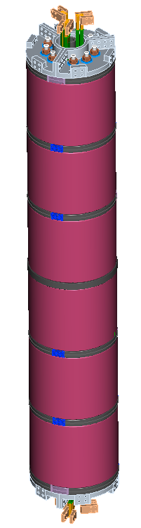
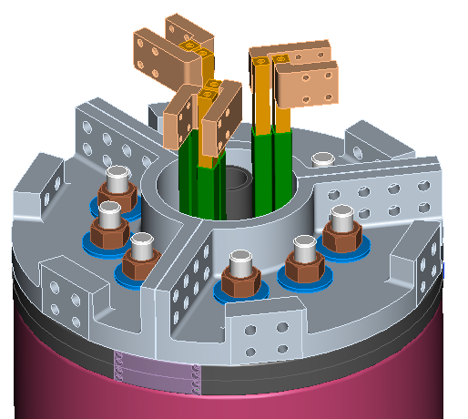

Fig. 2.0-1 Solid Model of NCSX CS (Courtesy of T. Brown, PPPL)

A 2D coupled-field electromagnetic-structural model of all poloidal field sources (PF1-PF6 plus a simplistic representation of the plasma) is shown in Fig. 2.0-2. However, only the CS is modeled with structural degrees of freedom.

Symmetry in the PF coil system allows the application of half-symmetry about the equatorial plane. This is achieved by the “natural” flux-normal boundary condition in the 2D vector potential formulation. The axis of symmetry is a flux-parallel boundary.

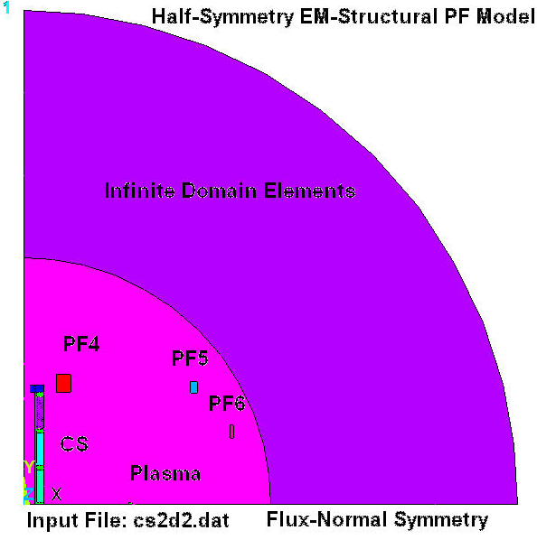
The entire magnet system is enveloped in free-space out to a radius which is 10% larger than the furthest point in PF6. Glued to that outer radius are so-called infinite domain elements which simulate the field effects of free-space between the finite element mesh and infinity. The scale in this figure obscures some of the detail required to model the structural aspects of the CS. Fig. 2.0-3 provides a closer look at these details.
Fig. 2.0-2: NCSX PF Magnet System Model
Fig. 2.0-3 is a plot of the structural elements of the CS assembly. In this particular model plot, the PF1 & PF2 winding packs are modeled with smeared orthotropic properties, while PF3 is modeled in detail. However, choosing which winding pack gets modeled in detail is easily controlled by changing the input parameter k_detail from 3 to 2 or 1. The basic elements of the winding pack are dimensioned in the PF1 drawing included as Attachment 4.3. The 0.787” square Cu conductor with a 0.354” diameter hole is wrapped with 42 mils of epoxy glass turn insulation. The helically-wound coil has 30 mils of layer-to-layer insulation, and each coil pack is covered with a 120 mil thick ground wrap.

Filler blocks are designed to fill the space between the coil’s top (and bottom) turns and the ground wrap. This provides a flat surface and uniform vertical stiffness without θ or r dependence. Here, the layer-to-layer vertical offset is one-half of a turn height. At other sections through the coil, the profile will be different. The parametric model can be used to simulate any cross-section, excluding the lead details, by varying theta_sec over the range of ±180 (degrees). Fig. 2.0-4 present close-up views of the detailed coil cross-sections for various theta_sec values.

Each coil is separated from its neighbor by a Cu-like spacer [Error: Reference source not found]. The stack is captured between Cover Plates. Consistent with [Error: Reference source not found] the Cover plates are 4” thick disk. Because of the axisymmetric approximation, the plates do not include the flanges used to bolt 120˚ sectors together as shown in Fig. 2.0-1.

A shell, with cross-sectional area equal to that of the (9) 1.125” dia. tie rods and located at a mean radius of 5.7”, is the tension element used to compress the CS assembly. An annular region in the End-Plate has a reduced elastic modulus to simulate the effects of (9) Tie Rod holes.

Vertical displacement constraints are imposed at the equatorial plane to provide the required structural symmetry.

This finite element model is used to simulate the most limiting Load Cases (LC) based on an array of NCSX operating scenarios [Error: Reference source not found]. A scan of these scenarios leads to a handful of time-points during which all coils are driven to their maximum current level. Of course there are two other important load conditions to consider before the coils are even powered-up. All six are listed below:

- Preload, 293K (RT, Room Temperature)
- Preload, 80K
- 1st Plasma Scenario, t=0.0 s (Biggest negative PF3 coil current)
- 1.7 T Ohmic Scenario, t=0.0 s (Biggest negative PF1,2&6 coil currents)
- 320 kA Ohmic Scenario, t=0.206 s (Biggest negative PF4 coil current and Plasma current)
- 320 kA Ohmic Scenario, t=0.506 s (Biggest positive PF1&2 coil and Plasma currents)

The coil currents associated with each of these select Load Cases (and number of turns per coil, N) are listed in Table 2.0-1. Positive and negative extremes are highlighted in the table. Notice that the selected load cases include times when PF1-4, PF6 and the plasma are driven to their maximum currents. PF5 misses its maximum current by <1% in this subset of operating scenarios.

The parametric ANSYS model is assembled into a text-based batch file (included here as Attachment 4.4) which facilitates this exploration of the design-space by simplifying changes to dimensions, material properties, detailed coil cross-section parameters and preload values with minimal user-input.
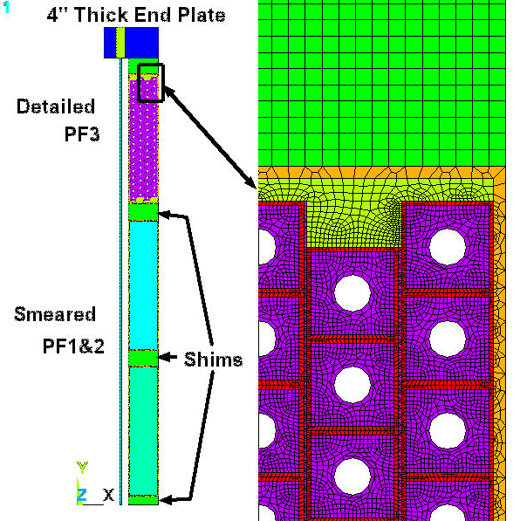
Fig. 2.0-3: Details of the 2D Model Structural Elements

Table 2.0-1 Summary of Coil Currents for Limiting Load Cases
Load Case>> | 1 | 2 | 3 | 4 | 5 | 6
Scenario>> | 293K Preload | 80K  Preload | 1st Plasma | 1.7T Ohmic | 320kA Ohmic | 320kA Ohmic
Time, s | 0 | 0 | 0.0 | 0.0 | 0.206 | 0.506
PF1 (N=72) | 0 | 0 | -12877 | -25123 | 11354 | 21858
PF2 (N=72) | 0 | 0 | -12877 | -25123 | 11354 | 21858
PF3 (N=72) | 0 | 0 | -12877 | -9698 | -11802 | -5975
PF4 (N=80) | 0 | 0 | -367 | -7752 | -13936 | -9441
PF5 (N=24) | 0 | 0 | 0 | 8284 | 4563 | 4634
PF6 (N=14) | 0 | 0 | -1223 | -8997 | 5068 | 5705
Plasma (N=1) | 0 | 0 | 0 | 0 | -320775 | -320775
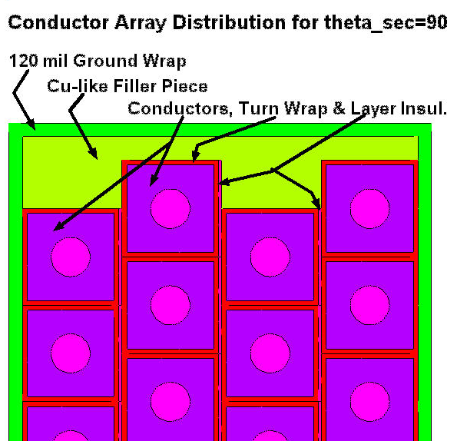
Fig. 2.0-4 Relative Vertical Position of Conductor Layers Controlled by Parameter theta_sec
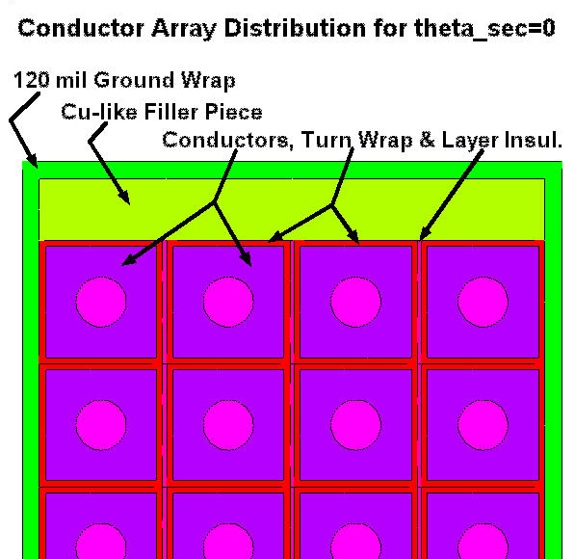
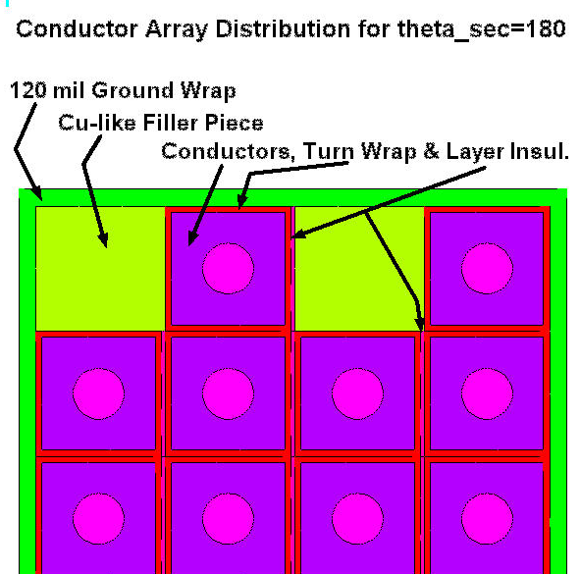
The conductor pattern in the cross-section of a spiral-wound coil changes as a function of the section angle (see the PF1 drawing in Sect. 4.3). At one angle, say 0˚, the conductors are aligned as in the upper-left model plot (theta_sec=0). At a section 90˚ from this aligned section, one layer will be a quarter-turn lower, the next layer will be a quarter-turn higher, and the conductor array will look like the model plot on the right (theta_sec=90). At a section 180˚ from the aligned section, the layers will be incremented up and down by a half-turn, and the conductor array will look like the model plot on the lower-left (theta_sec=180). Although a spiral wound coil is not quite axisymmetric, the effects of variations in the conductor array profile can be evaluated with models such as these shown above.
3.0 Results

The parametric 2D model is exercised for a variety of configurations (theta_sec values of 0, 90 and 180˚, and k_detail values or 1, 2 and 3) in order to determine the effects of these parameters on tie rod, conductor and insulation stresses.

Fig. 3.0-1 is a plot of the Tie Rod (shell) stress history when PF3 is modeled in detail and PF2 & PF3 are modeled as orthotropic smears (this is consistent with the model plot of Fig. 2.0-2). Three different yet nearly coincident curves are plotted and represent PF3 winding packs with varying layer positions (as shown in Fig. 2.0-4). Clearly, this result indicates that such a detail has essentially no impact on the Tie Rod stress.

An initial (Room Temperature) pre-stress of 260 MPa relaxes to ~200 MPa when the CS is cooled to 80K. Subsequently, through the full range of anticipated coil currents, the Tie Rod stress varies by ±9 MPa. This is roughly consistent with the results reported in [Error: Reference source not found]. Deviations are most likely due to the changes in the vertical CTE (crudely approximated as 15.1μ/K in the previous memo, but more accurately determined to be 14.6μ/K as shown here in sec. 4.2).

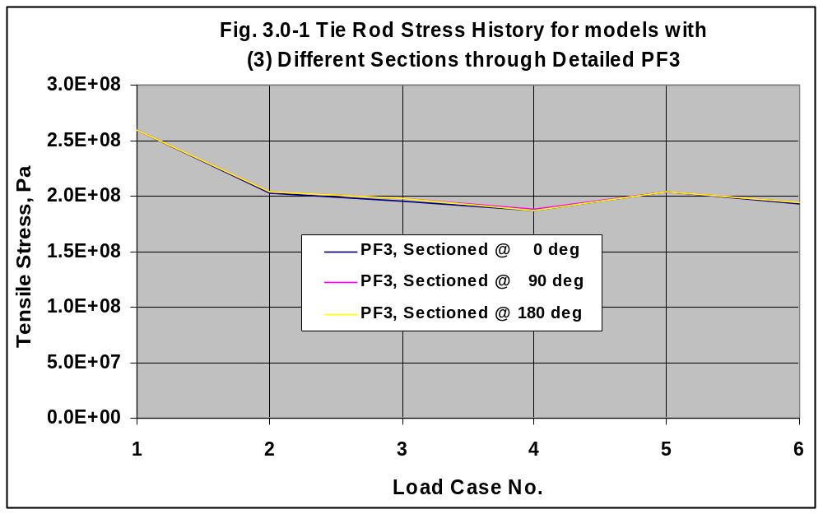

The stress history in the PF3 conductor is reported in Fig. 3.0-2. Again, three curves are included to represent the different layer positions controlled by the section angle parameter theta_sec. As with the Tie Rod stress, the closely-grouped curves indicate that the conductor stress is a very weak function of the layer-to-layer positioning, which varies with θ in a spiral-wound coil. The largest variation occurs at 80K (Load Case 2) and is a mere ±2 MPa.

If we now admit that the conductor array profile has a minor effect on the maximum stress in the conductor, then we can choose a single profile (like theta_sec=90, where the conductors are misaligned by half a turn) and report the stresses in all three PF coils. Fig. 3.0-3 is a plot of the maximum stress intensity in each coil for the six reference Load Cases. The plot repeats the PF3 result: small variations about 50 MPa. It also shows that the stresses in PF2 & PF1 peak at 91 and 94 MPa, respectively, for Load Case 4 (1.7T Ohmic, t=0.0 s) when their currents are a maximum. The detailed stress distribution in the PF1 conductor is shown in Fig. 3.0-4. It is worth noting that this stress level is almost double the stress predicted by the smeared winding packs of the global TF/PF model. However, these are peak stresses which are driven by the combination of a hoop stress (which is easily unsmeared) and a transverse stress in the vicinity of a hole (which is not easily unsmeared).

Recall that one of the design objectives is to ensure that the CS conductors remain in (vertical) compression during all operating conditions. Reference [Error: Reference source not found] recommends a RT preload which produces an average vertical winding pack stress of -12 MPa. This result is demonstrated here (except with a detailed PF3) as illustrated in Figs. 3.0-5 and 3.0-6. These are plots of the maximum vertical stress history in the PF1 and PF2 coils (respectively) when the PF3 coil is modeled in detail. Again, there are three curves per plot which represent the range of conductor array profiles expected in the spiral-wound coils. And as before, the curves are essentially coincident, indicating that the maximum vertical stress histories in the PF1 & PF2 coils are a very weak function of subtleties in the PF3 conductor array profile. Also notice that the -12 MPa RT pre-stress is sufficient to maintain the compressive stress requirement, albeit a mere -0.5 MPa for PF2 under Load Case 5.

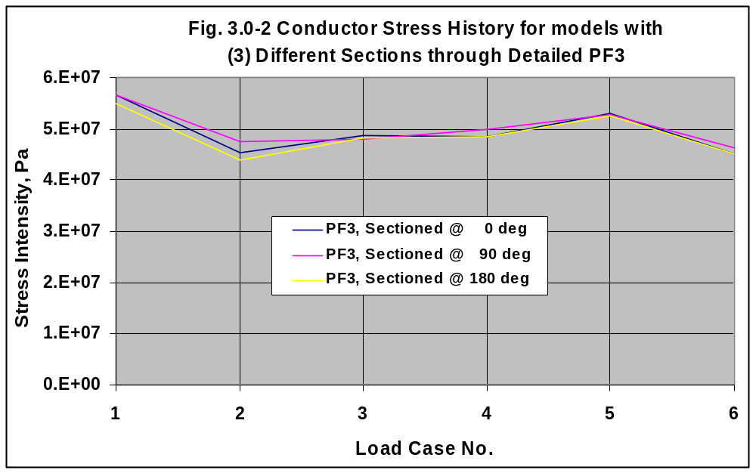
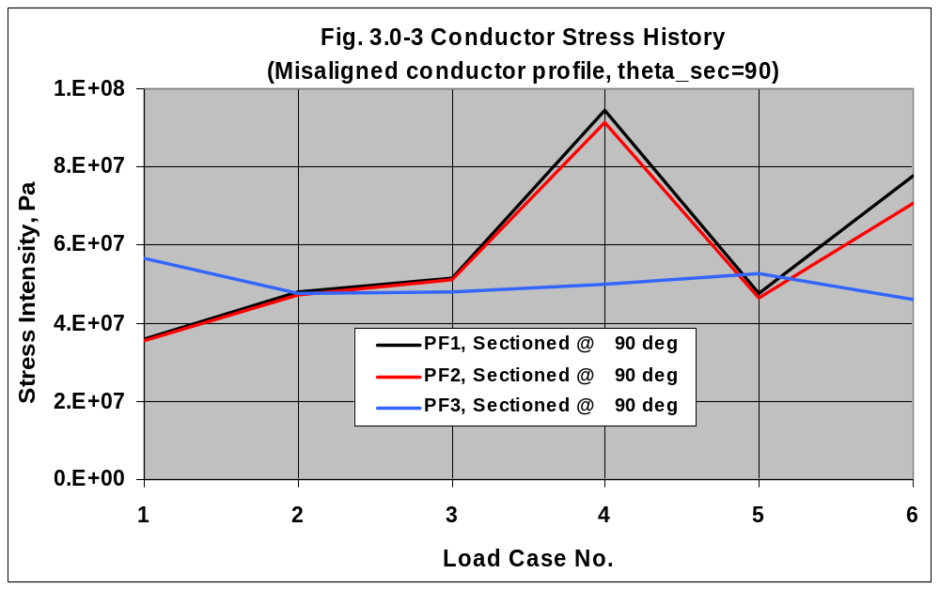
Fig. 3.0-4 Stress Intensity in PF1 Conductor, Load Case 4 (49 mil turn insulation)
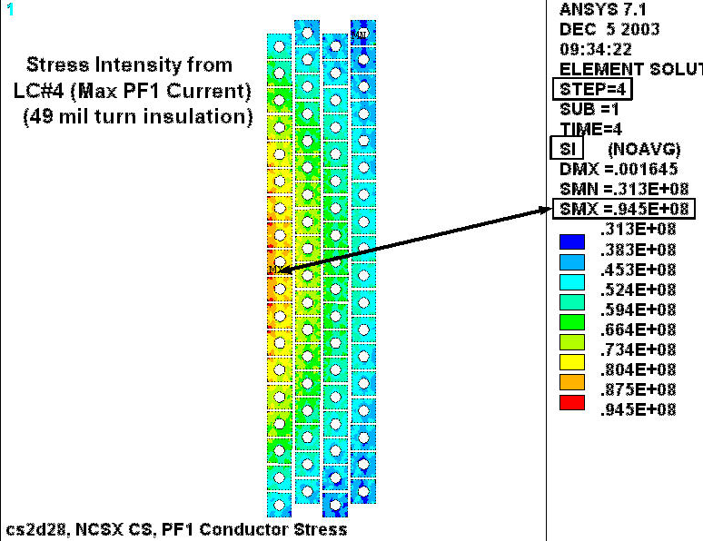
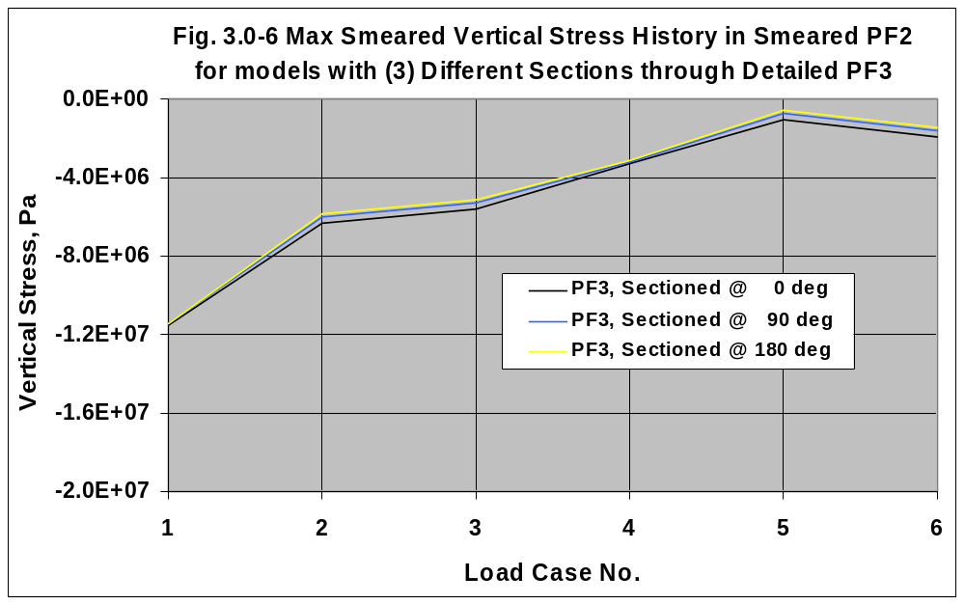
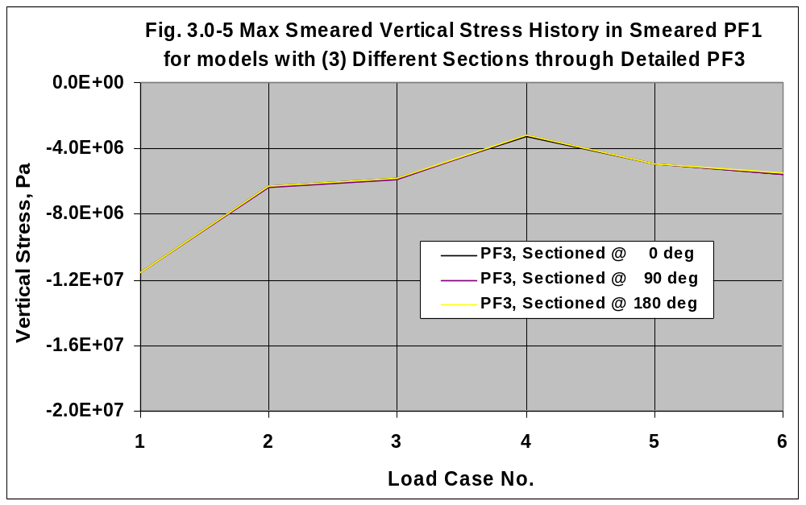
Aside: Insulation Design Criteria

Let us turn our attention to the primary concern of this analysis: insulation stresses. The relevant sections of the project’s design criteria document [Error: Reference source not found] are included here in Sec. 4.5 and paraphrased below:

- Flatwise (through-thickness) compressive stress shall be limited by 2/3 of the ultimate stress.
- Compressive fatigue allowable stress shall be equal to the lesser of 2/3 of the ultimate compressive fatigue stress measured at the lifetime number of cycles or the ultimate compressive fatigue stress at temperature at 5x the lifetime cycles.
- Normal to the adhesive bonds between metal and composite, no primary tensile strain is allowed. Secondary strain will be limited to 1/5 of the ultimate tensile strain of the adjacent insulation. In the absence of specific data, the allowable tensile strain is 0.02% in the insulation adjacent to the bond.
- The maximum tensile or compressive strain permitted in the plane of the insulation material is either +0.5% or -0.5%.
- The shear-stress allowable, S_{s}, for either static or fatigue conditions is given by:
S_{s} = 2/3 τ_{o} + c₂ S_{c}(n)
Where,

τ_{o} is the experimentally determined minimum intrinsic shear strength with no compressive load (the lower of the bond shear strength or the composite interlaminar shear strength).

c₂ is an experimentally determined factor representing the slope of the dependence of shear strength on compressive stress.

S_{c}(n) is the local normal compressive stress.

Aside: Allowable Stress Levels at 77K (close enough to 90K max CS operating temp. [Error: Reference source not found])

- The insulation system will probably behave like G-10/11CR (reference a discussion with I. Zatz, 12/03). Under flatwise compression, G-10/11CR has an ultimate strength of about 700 MPa. The stress limit is 2/3 x 700 or 460 MPa.

- In the absence of tensile test data normal to the plane of the glass, the allowable strain is 0.02%. With an elastic modulus of ~22 GPa, the allowable normal tensile stress is 0.0002 x 22 GPa or 4.4 MPa. Incidentally, CTD-101K as a neat resin has a tensile strength of ~100 MPa or more. Eventually, the tested CS insulation system might exhibit tensile strengths of this order, which would allow a design-basis stress of (100 MPa)/5 or 20 MPa instead of the 4.4 MPa value proposed here.

- The ultimate tensile strength of G-10/11CR is anisotropic, with values of ~460 MPa in the Warp direction and ~800 MPa in the Fill direction (from [Error: Reference source not found]). We will assume that the lesser of these two values applies: 460 MPa. However, the in-plane allowable is based on the +0.5% strain limit, which is 0.005 x 33 GPa or 165 MPa.

- The ultimate compressive strength of G-10/11CR is also anisotropic, with values of ~550 MPa in the Fill direction and ~800 MPa in the Fill direction (from [Error: Reference source not found]). We will assume that the lesser of these two values applies: 550 MPa. However, the in-plane allowable is based on the -0.5% strain limit, which is -0.005 x 33 GPa or -165 MPa.

- The shear strength of G-10/11CR is ~56 MPa (from [Error: Reference source not found]).

In the early ‘90s, R.P. Reed and his NIST associates performed many insulation stress tests at cryogenic temperatures. One particularly useful test shows the correlation between shear strength and normal compression in a glass-filled epoxy insulation specimen. Coincidentally, the epoxy resin they used is diglycidyl ether of bisphenol A (DGEBA), which is consistent with epoxy proposed for the NCSX Modular coil, and a good candidate for use in the NCSX CS (i.e., CTD-101K from Composite Technology Development, Inc., 2600 Campus Drive, Suite D, Lafayette, CO 80026).

Their test results are captured in two plots, which are scanned from the paper and included here as Fig. 3.0-7. The plots (and the reference) indicate that there is very little difference in performance between the 64% and 52% glass content specimens. The plots also show that the shear strength can be approximated by a linear curve with constants τ_{o} of 54 MPa and c₂ of 0.5. Incidentally, this value of τ_{o} is consistent with the G-10/11CR shear strength value of 56 MPa listed above.

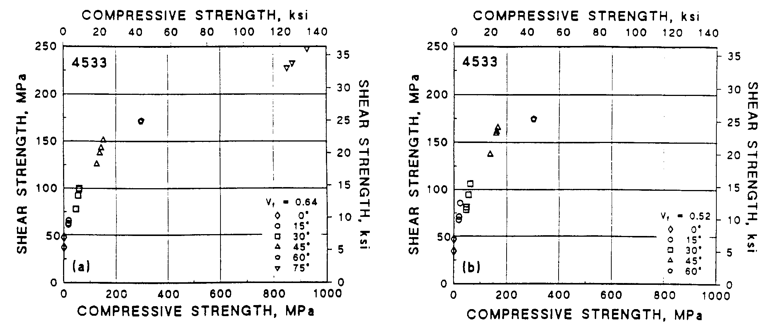
Fig. 3.0-7 Shear strength as a function of Compression at 76 K for Glass-Filled epoxy specimens with 64% (left) and 52% (right) fiberglass volume fraction (from [Error: Reference source not found]).
The analysis is now prepared to evaluate the stress in the insulation system.

Fig. 3.0-8 shows plots of the normal (flatwise) insulation stresses in PF1 from LC4. The dimensions make it difficult to find any details in the plot. However, the plot legends list the most important results: the maximum and minimum stress levels. The largest normal compressive stress is reported to be -34 MPa, which is well within the 460 MPa limit. On the other hand, the 30 MPa tensile stress level is greater than the 4.4 MPa limit. Tensile stresses are also addressed in the part of the memo devoted to the shear stress evaluation.
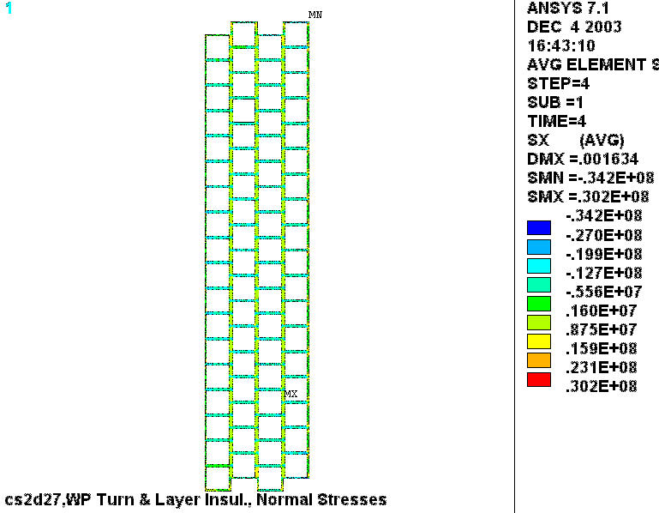
Fig. 3.0-8 PF1 Turn & Layer Insulation Normal Stresses from LC4

Fig. 3.0-9 shows a plot of the in-plane insulation stresses in PF1 from LC4. Again, the dimensions make it difficult to find any details in the plot, but the legend lists the maximum and minimum values: -103 MPa and +7.8 MPa. These stress levels are well within the ±165 MPa limit.

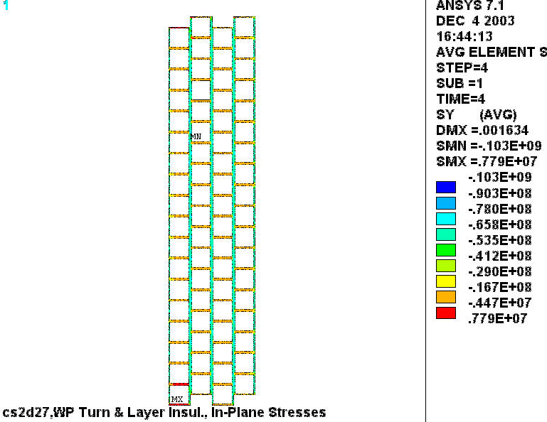
Fig. 3.0-9 PF1 Turn & Layer Insulation In-Plane Stresses from LC4
A detailed analysis of the shear/compression stresses in the winding pack insulation requires some postprocessing operations which are consistent with the design criteria captured in the equation:
S_{s} = 2/3 τ_{o} + c₂ S_{c}(n)
Recall that τ_{o} is set at 54 MPa and c₂ is set at 0.5. The normal stress, S_{c}, must be determined on an element by element basis. The resulting allowable shear stress, S_{s}, is then compared to the local shear stress (τ), also on an element by element basis. In order to quantify the results, the elements which pass the shear stress criteria form one subset while the elements which fail the criteria form another subset.

It is not sufficient to limit the shear stress evaluation to those elements which pass or fail the shear stress limit since the shear/compression characteristics shown in Fig. 3.0-7 imply a normal compressive stress. We also have the explicit requirement of limiting the local tensile stress to a small value, 4.4 MPa.

Fig. 3.0-10 is a plot of the percentage of winding pack insulation which passes the shear and “small secondary tension” stress criteria. At RT preload, 100% of the insulation passes the criteria. Upon cool down to 80K, the passing percentage drops to 65%. The plot shows two other important results:

- The fraction of insulation which passes the criteria is essentially unaffected by EM loading.
- The fraction of insulation which passes the criteria is essentially the same for all three coils.

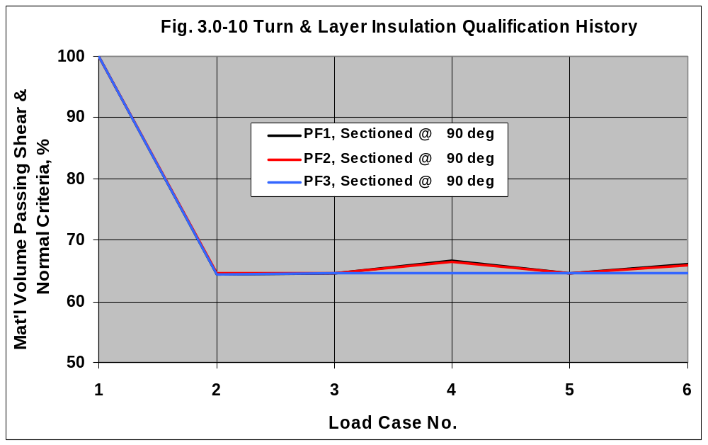
These observations point to the conclusion that thermal expansion mismatches within the winding pack constituents are responsible for the failure to meet the “small secondary tension” design criteria. It should be noted that all (100%) of the insulation pass the shear stress criteria, and that all of the failures come from normal tensile stresses which are greater than 4.4 MPa.
Fig. 3.0-11 is a plot of the elements which pass the shear stress and small tensile stress requirement. This particular plot is for PF1 insulation and Load Case 4. The ANSYS plot title lists the percentage of insulation which meets these requirements (66.7%). Clearly, the vertical compression from tie rods and EM loads produces a favorable shear and normal stress condition for all of the horizontal ligaments of the insulation system. However, there is no radial preload mechanism and the vertically-oriented insulation ligaments are vulnerable to the small tensile stress requirement. (Notice that the maximum normal stress listed in the legend is 4.4 MPa, consistent with the small tensile stress limit introduced above.)

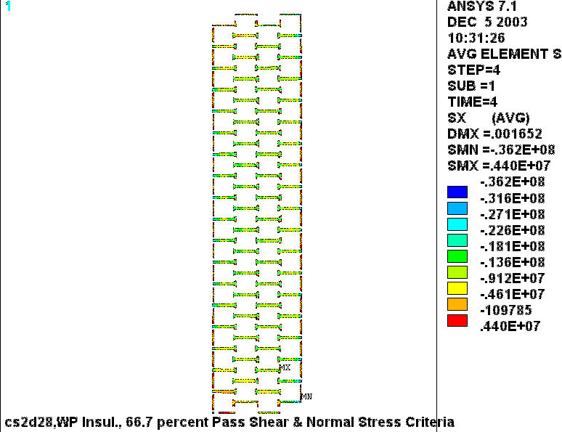
Fig. 3.0-11 Normal stresses in WP insulation which pass shear and normal stress requirements

Fig. 3.0-12 is a plot of the WP insulation elements which fail the shear and small normal tension requirements. Clearly, the failing elements are limited to the vertically-oriented turn and layer insulation. And although the plot legend indicates that the maximum normal tensile stress is 54 MPa, the predominant contour color is dark blue, indicating normal stress levels of 4-10 MPa.
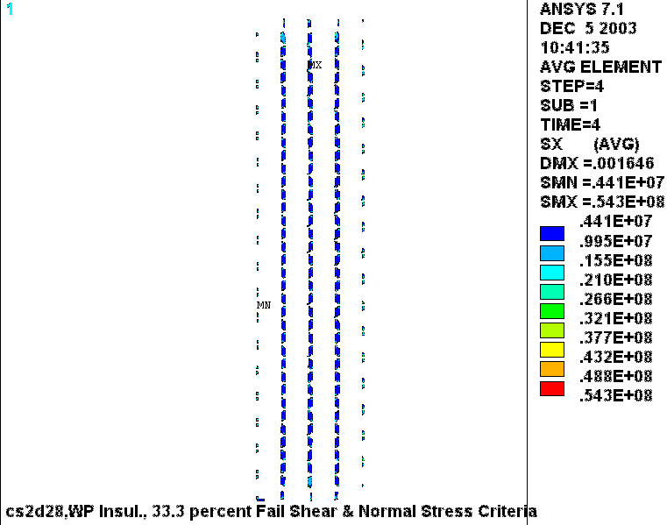
Fig. 3.0-12 Normal stresses in WP insulation which fail the 4.4 MPa normal stress requirements
The results illustrated in Fig. 3.0-12 are not completely obvious without a very close inspection of the model. Fig. 3.0-13 is a close-up of the grossly distorted winding pack when it is simply preloaded at 80K. Remember, we are looking for the mechanism which drives through-thickness tensile stresses in the layer and turn insulation. This figure shows that the horizontal ligaments of the turn insulation appear to bulge out from between the turns above and below. This is a result of the two mechanisms: (1) a Poisson effect from the vertical preload, and (2) the low CTE of the insulation in the plane of the glass (relative to the Cu conductor). It can be shown that the low CTE is the dominant component.

The bulging insulation produces relatively large local contact stresses in the adjacent insulation (see circled areas), which must be balanced by tensile stresses in the regions in between (see rectangular areas). This is consistent with the results reported above. The tensile stresses produced by these radial deformations are on the order of 8 MPa, which is about twice our nominal 4.4 MPa allowable tensile stress.

There is no obvious solution to this condition, with the exception of developing an epoxy-glass insulation system which has a better CTE match to Cu than the G-10/11 CR values assumed here.

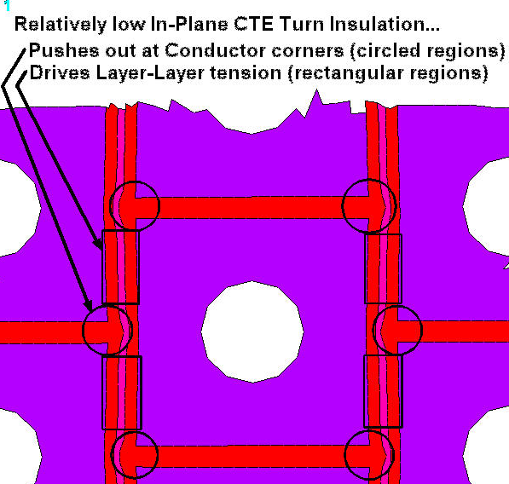
Fig. 3.0-13 Greatly-exaggerated displaced shape plot of a few winding pack turns at 80K
Fig. 3.0-14 is a plot of the insulation elements which fail the (shear and) small normal tension requirements when the small tensile stress limit is increased to 20 MPa. Notice that the failing elements are made up of small isolated regions which comprise a mere 3.1% of the insulation system. (A similar analysis with a 10 MPa small tensile limit results in excessive normal stresses in 5.7% of the insulation system with a similar spotty distribution.)

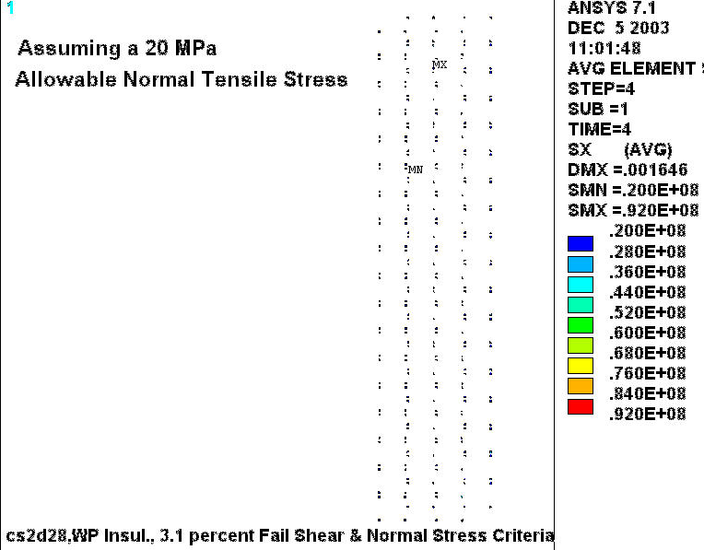
Fig. 3.0-14 Normal stresses in WP insulation which fail the 20 MPa normal stress requirements

3.1 Conductor Stress Results

Fig. 3.0-4 indicates that the maximum stress intensity in the conductor is ~95 MPa and occurs as a result of the high PF1 currents during the 1.7 T Ohmic Scenario. This information is not sufficient in order to qualify the stresses for the fatigue environment in which it must operate. For a fatigue evaluation, the stress range is also important.

Fig. 3.1-1 is a plot of the stress intensity in the conductor based on stress components obtained by subtracting LC2 (80K no EM) from LC4 (80K, max EM loads). This plot indicates that the 1.7T Ohmic scenario will drive a stress range of ~70 MPa on the inside surface of the conductor hole. This stress range is limited to the middle few turns of the inner layer.
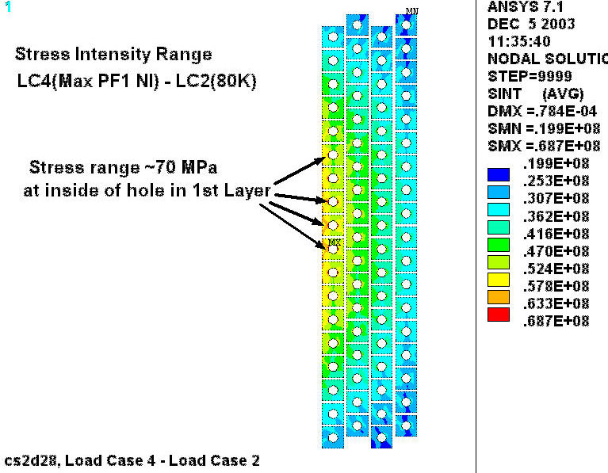

Fig. 3.1-1 Stress Intensity range produced by LC4 – LC2 Stress Difference

The primary stress in the Cu conductor is also an important element in the stress qualification process. Fig. 3.1-2 is a plot of the hoop stress in the highest-stressed turns from the maximum PF1 current Load Case (#4). It indicates a maximum stress of 97 MPa, with an integrated average stress of 65 MPa. A similar plot of the stress intensity in these highest-stressed turns indicates a maximum value of ~100 MPa and an average value of 80 MPa.

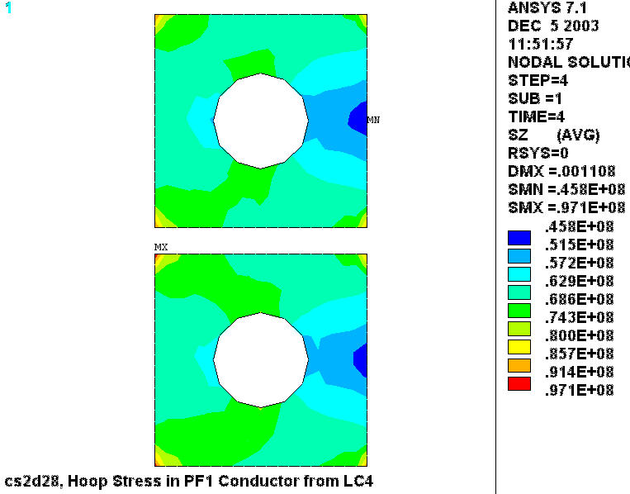
Fig. 3.1-2 Hoop stress in the high-stressed inner turns of PF1 from LC4

The CS conductor is OFHC Cu and assumed to be soft except for the cold-work introduced by the winding process. With an inner radius (R_{i}) of ~6.8” and a conductor thickness (t_{c}) of 0.787”, the inner turn winding strain (ε) is calculated to be (t_{c}/2)/ R_{i} or ~6%. OFHC Cu with a small (5-7%) amount of cold-working has an ultimate strength of ~350 MPa and a yield stress of ~160 MPa. This puts the design Tresca stress value (S_{m}) at 2/3 σ_{y} or ~110 MPa, which is consistent with values found in other project documents (like the PDR presentations).

The largest conductor-average hoop and Tresca stresses of 65 MPa and 80 MPa are indeed below the design limit of 110 MPa. This could be considered a rather conservative approach. One could argue that the average stress across the inner turn of the coil pack should be classified as a local primary stress, instead of a general primary stress, which pushes the allowable stress to the yield stress or 160 MPa. In either case, the conductor passes the project’s monotonic stress requirements.

A more complete evaluation of the Cu conductor, including a fatigue analysis, will be presented in a future memo.
4.0 Attachments

4.1 PF Coil Centers

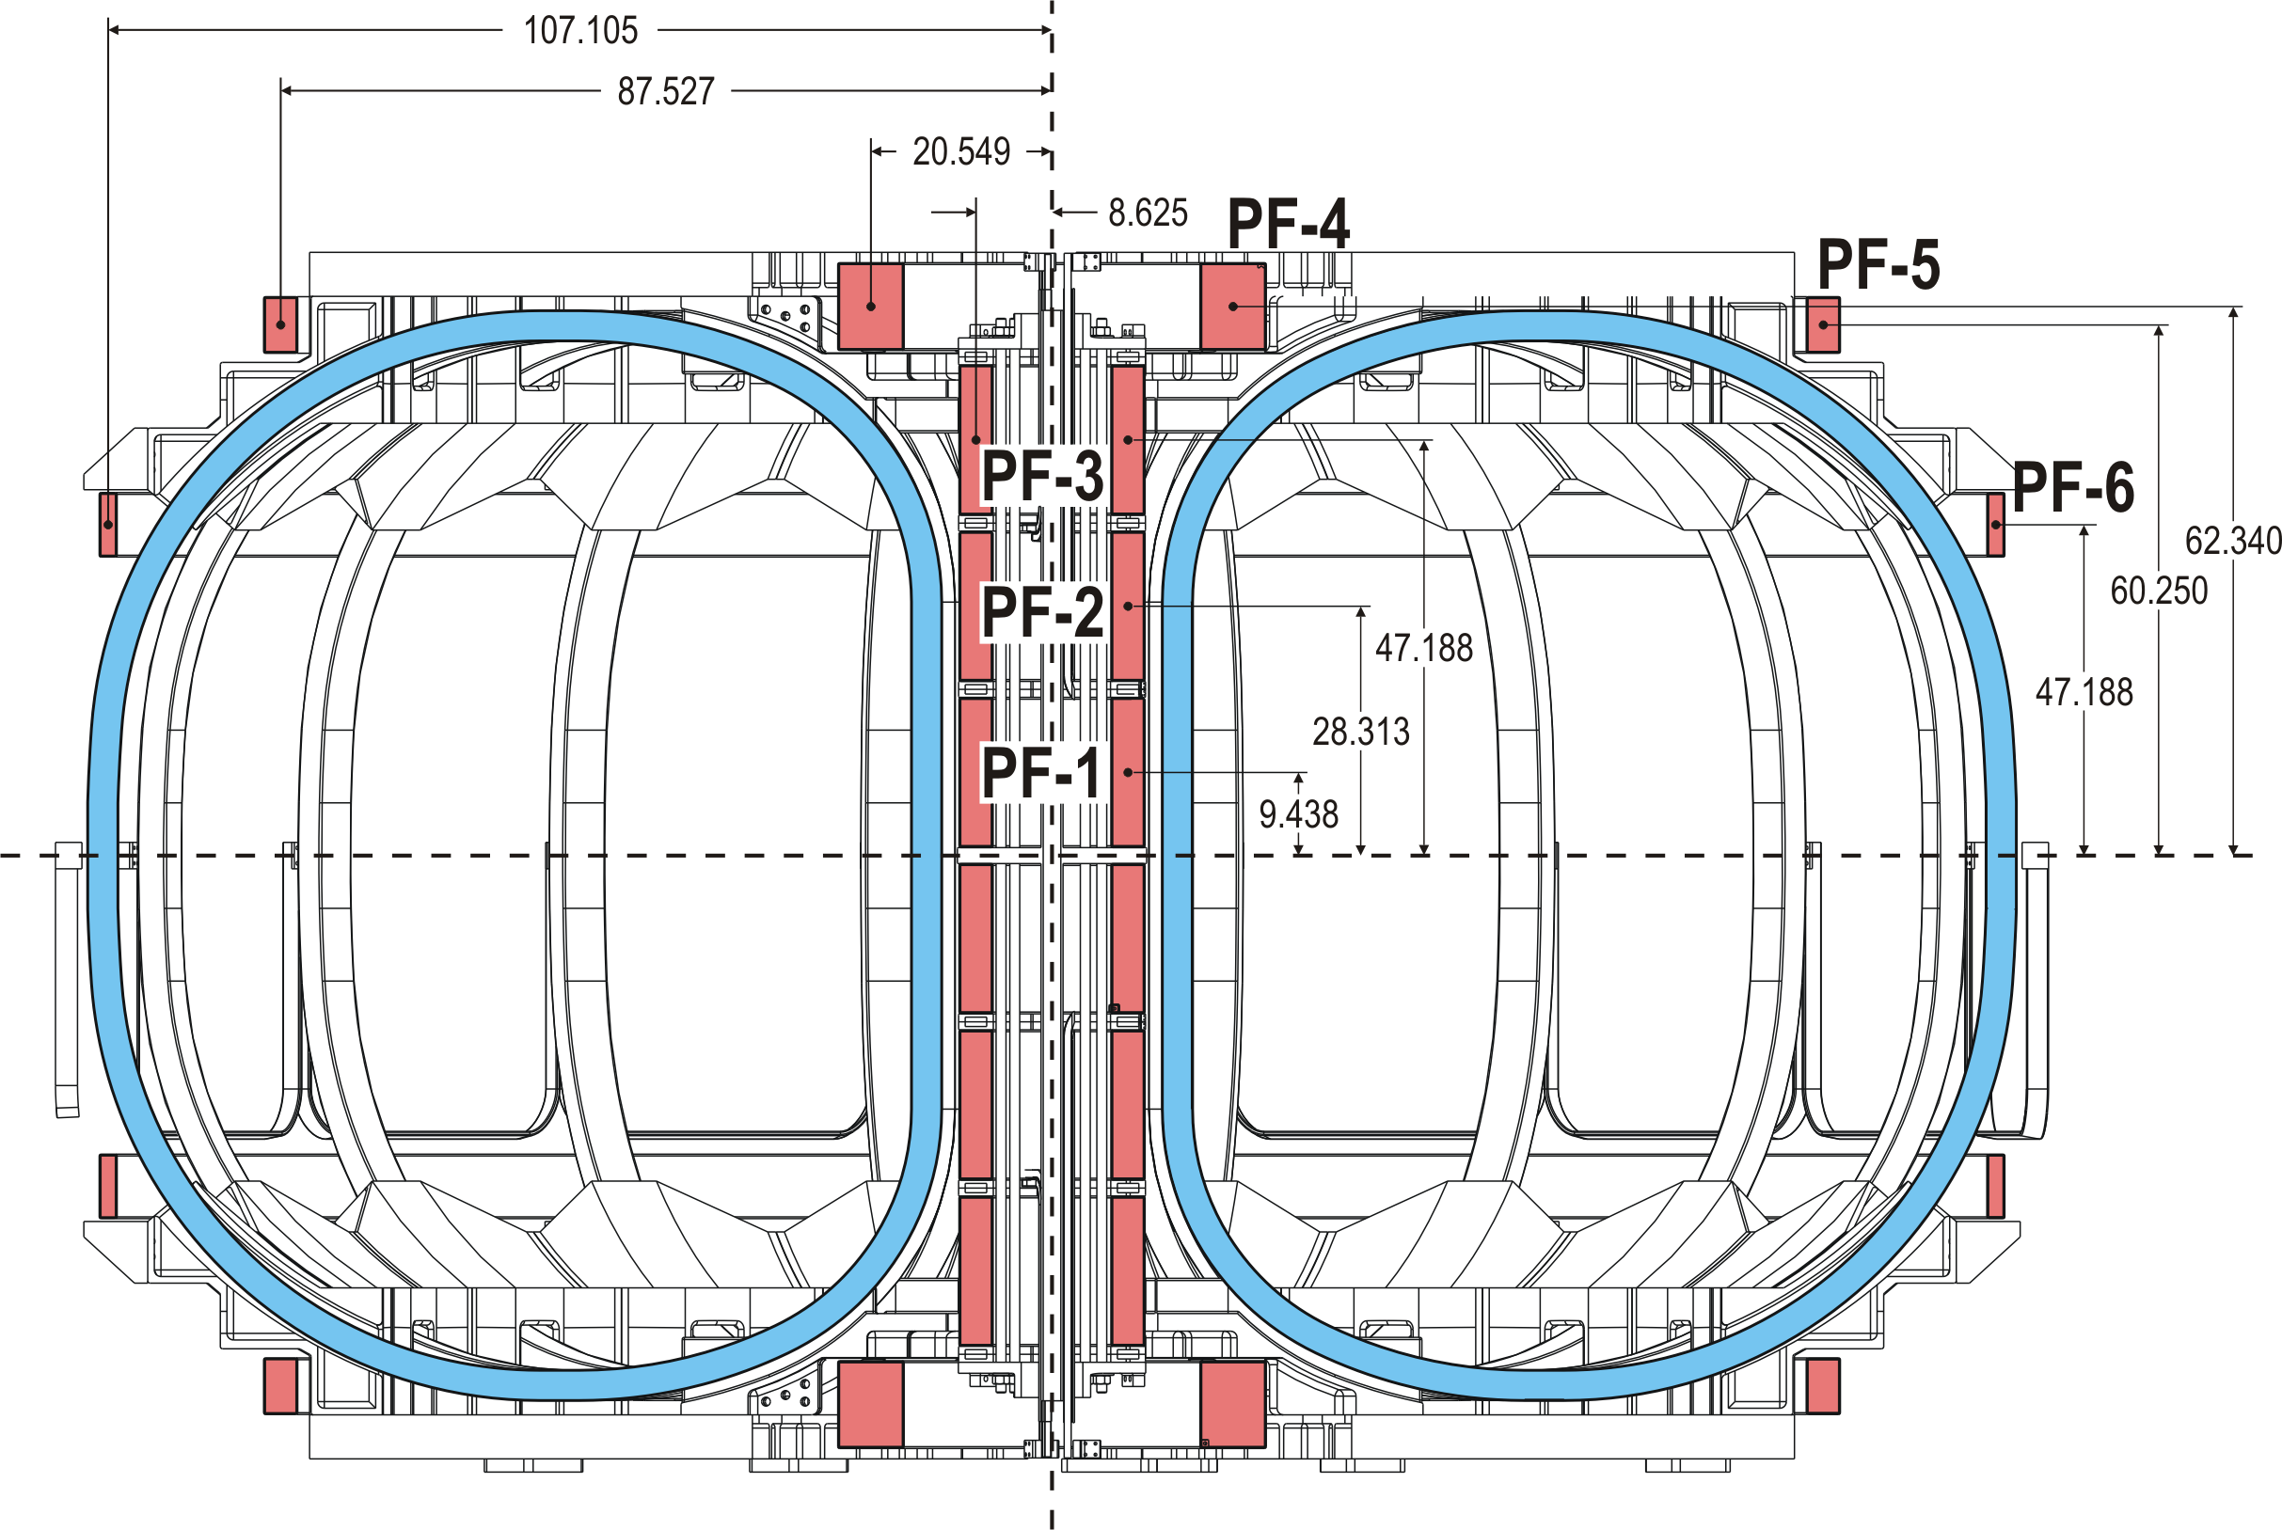
Fig. 4.1-1 Elevation View of Magnet System with PF Coil Centers (taken from October ‘03 PDR)

Note: The vertical distance to the center of PF6 is a typo (erroneously matching that of PF3). The proper dimension is 37.562”as given in a project spreadsheet.

4.2 Winding Pack Equivalent Properties

The smeared material properties presented in [Error: Reference source not found] includes all of the necessary mechanical (load-related) values. However, the analysis does not address coefficients of thermal expansion (CTE). This section performs one benchmark of the elastic modulus (E_{y}), and develops the three orthogonal CTE values.

4.2.1 Vertical Modulus (E_{y})

The vertical elastic moduli of the smeared and detailed winding packs are obtained by converting the model to a plane-stress formulation and imposing a uniform vertical displacement on the top of the cover. A purely vertical compression results, and the modulus of each winding pack is calculated based on the nominal stress and strain.

For the smeared winding pack, the vertical deflection (UY) and stress (SY) contour plots of Fig. 4.2.1-1 shown below lead to the following:

E_{y} = σ_{y}/ε_{y} = 46.67 MPa/0.0007276 = 64.1 GPa

Thankfully, this matches the input value used for the smeared WP: 64.03 GPa

The effective modulus of the detailed winding pack is calculated using the vertical deformations of Fig. 4.2.1-2 as follows:

E_{y} = σ_{y}/ε_{y} = 46.67 MPa/0.0007043 = 66.3 GPa

This is a mere 3.5% above the smeared value, which is close enough to serve as confirmation without requiring a change to the values of record [Error: Reference source not found].

Fig. 4.2.1-1 Vertical deflection and stress contour plots in Smeared WP from Imposed deformation
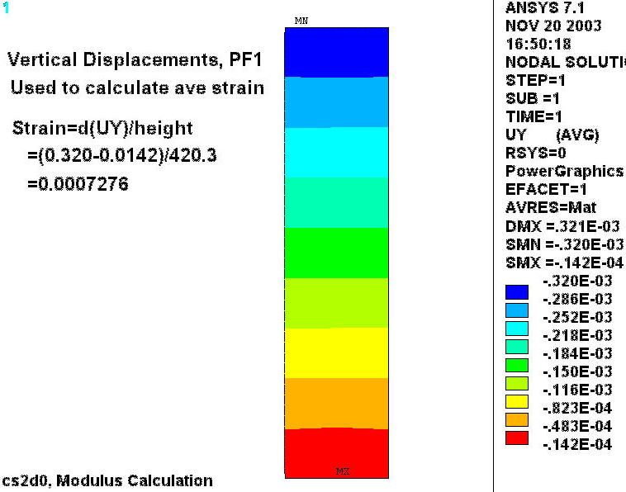
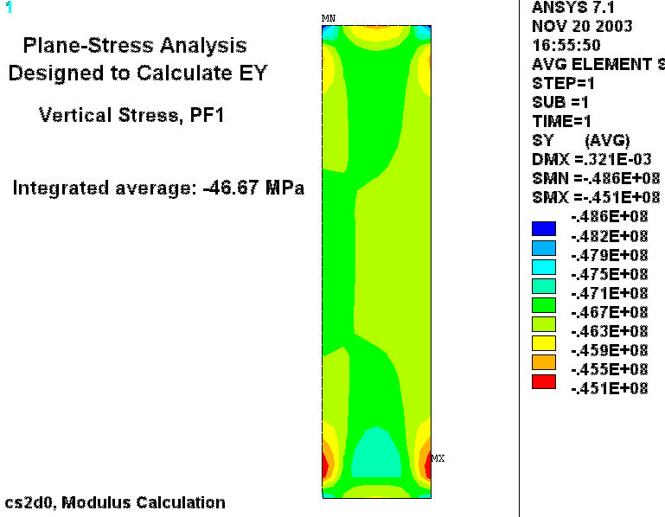
Fig. 4.2.1-2 Vertical deflection contour plot in Detailed WP from Imposed deformation
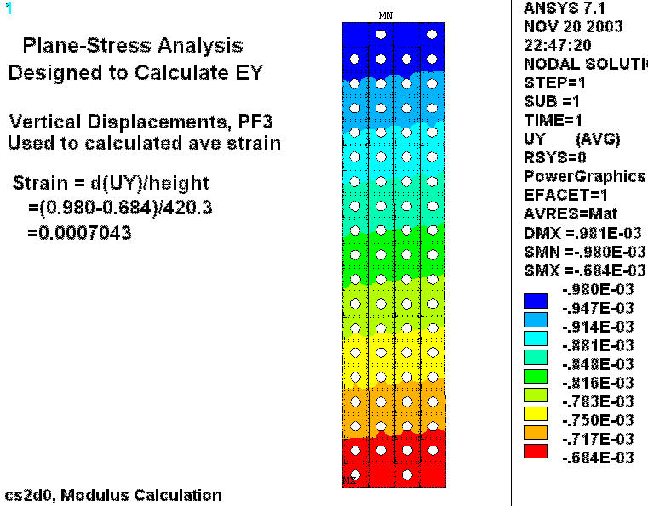

4.2.2 Coefficient of Thermal Expansion

The detailed winding pack model is also used to determine a more precise value for the orthotropic expansion coefficients. Fig. 4.2.2-1 is a plot of the radial deflections from a 293K-80K cool-down load case. This result allows calculating the radial (x) and out of plain (z) CTE.

CTE(x) = (UX_{OD}–UX_{ID})/(Radial Build)/(ΔT)=(0.782–0.494)/(90.78)/(293-80) = 14.9 μ/K

CTE(z) = {(UX_{OD}+UX_{ID})/2}/(Mean Radius)/(ΔT)=(0.782+0.494)/2/(219.1)/(293-80) = 13.7 μ/K

The vertical CTE requires a second contour plot: Fig. 4.2.2-2 is a plot of UY in the detailed WP cross-section from this 293-80K cool-down load case. Here, the vertical CTE is calculated as follows:

CTE(y) = (UY_{top}–UY_{bot})/(Vertical Build)/(ΔT)=(5.855–4.547)/(420.3)/(293-80) = 14.6 μ/K
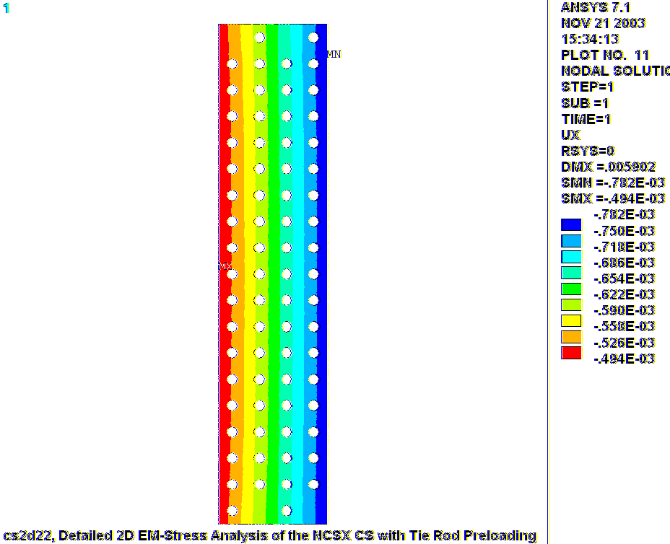
Fig. 4.2.2-1 Radial Deformations from Cool-Down from 293K to 80K
Fig. 4.2.2-2 Vertical Deformations from Cool-Down from 293K to 80K
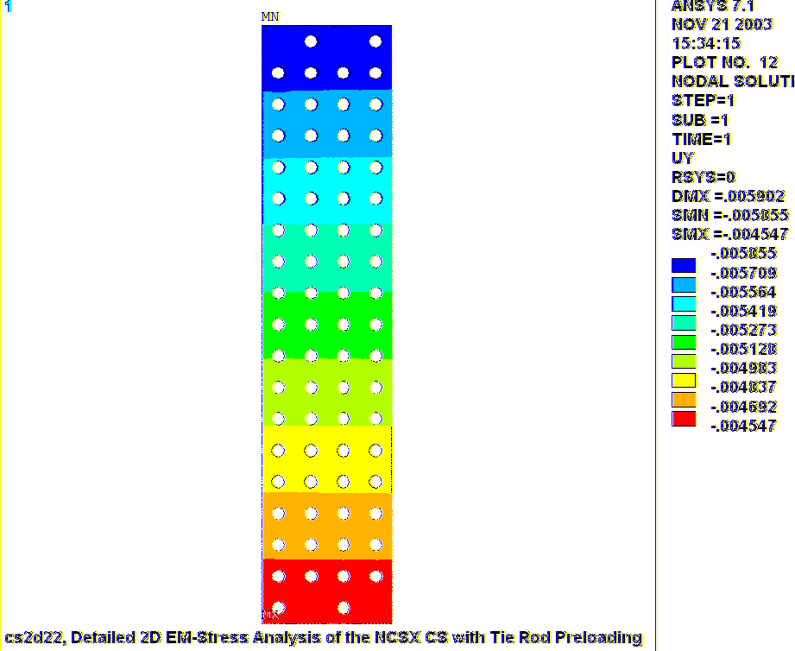
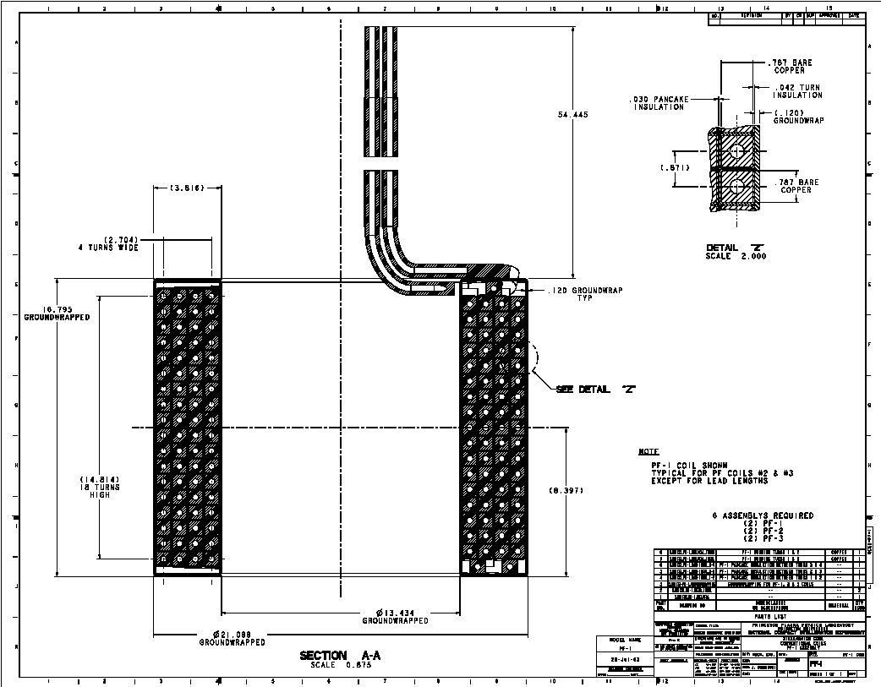
4.3 PF1-3 Design Drawing (from T. Brown, PF-1.pdf)

Note: A later version of this drawing shows that the turn wrap insulation thickness is 49 mils, compared to the 42 mils shown here.
4.4 ANSYS Batch File Listing (circa December 2, 2003)

/batch
rn=1 ! run number
k=0.0254 ! conversion (inches to meters)
t=1e-5 ! a tiny number
pi=acos(-1) ! pi

/filnam,cs2d2%rn% ! job name
/show,cs2d2%rn%,grp ! plot file
!resu
!*go,:1000
/prep7
/com
/com 2D Electromagnetic, half-symmetry structural analysis of the NCSX CS
/com Parameterized model allows specifying either smeared or
/com detailed X-sections (in a single PF coil)
/com
/com Developed by L. Myatt, Myatt Consulting, Inc., Norfolk, MA
/com leonard.myatt@myattconsulting.com
/com 508-520-4590
/com
/com Run Status
/com
/com 0: Very stiff cover (for EY calc), plane stress, impose vertic displacements
/com 1: Preload only: Poor vertical stress distribution. Better check alpha.
/com 2: Cool to 80K with very soft shims and GW for proper alpha calc.
/com 3: All load cases, Smeared PFs, MatProps as in cs2d1.dat: Tabulated results very similar to cs2d115.lis

/com Change one set of currents to get all max/min LCs for CS & PF4

/com 1: All Load Cases, detail PF3, theta_sec=180
/com 4: All Load Cases, detail PF3, theta_sec=90

/com
/com Select which PF (if any) to mesh in detail. 0 means no detailed PF (all smeared)
/com
k_detail=3

/com
/com The detailed WP conductor array can be modeled as:
/com aligned (theta_sec=0)
/com offset vertically by one conductor (theta_sec=180)
/com or any amount in between (0<theta_sec<180)
theta_sec=180

/com Misc Parameters
tp_strt=0 ! Starting time point number
tp_stop=5 ! Stopping time point number
t_ref=293 ! reference temperature
t0_sh=412 ! shell reference temperature

/com
/com Structure Parameters
/com
n_tr=9 ! number of Tie Rods
d_tr=1.125*k ! diameter of Tie Rods (Brown, 09/26/03)
br_tr=5.7*k ! bolt radius of Tie Rods
dz_cov=4*k ! effective cover thk
ri_cov=3.5*k ! cover IR
a_tr=n_tr*(pi/4)*d_tr**2 ! CSA of Tie Rods
a_ann=2*pi*br_tr*d_tr ! CSA of Hole Annulus
a_ratio=(a_ann-a_tr)/a_ann ! Metal to Annular area ratio
dr_sh=a_tr/(2*pi*br_tr) ! area-equivalent shell at Tie Rod Bolt Radius

/com
/com Conductor
/com
dr_con=0.787*k ! Conductor build in radius
dz_con=0.787*k ! Conductor build in height
ri_con=0.354/2*k ! inside radius of cooling channel hole
a_con=dr_con*dz_con-pi*ri_con**2 ! conductor metal area
/com
/com Insulation
/com
t_tw=0.042*k ! turn wrap insulation thk
t_pan=0.000*k ! pancake insulation thk (can be 0.0)
t_lay=0.030*k ! layer insulation thk (can be 0.0)
t_gw=0.12*k ! module over-wrap thickness
t_bz=0.0508 ! height of buffer zone (coil-cover shim)

/com
/com Unit Cell dimensions
/com
dr_cell=dr_con+2*t_tw+1*t_lay
dz_cell=dz_con+2*t_tw+1*t_pan

/com
/com Turn Count
/com
nr1=4 $nz1=18 ! PF1 turn-count
nr2=4 $nz2=18 ! PF2 turn-count
nr3=4 $nz3=18 ! PF3 turn-count
nr4=8 $nz4=10 ! PF4 turn-count
nr5=4 $nz5=6 ! PF5 turn-count
nr6=2 $nz6=7 ! PF6 turn-count
nr7=1 $nz7=1 ! Plasma turn-count

/com
/com PF & Plasma Geometry (Rc, Zc, dr, dz) from Brown's PDR Overview
/com
r0=1.40 ! major radius
num_pf=7 ! number of PF coils including plasma
*dim,pf_geo,,4,num_pf
pf_geo(1,1)= 8.625*k, 9.438*k,dr_cell*nr1-t_lay,dz_cell*(nz1+1) ! PF1
pf_geo(1,2)= 8.625*k,28.313*k,dr_cell*nr2-t_lay,dz_cell*(nz2+1) ! PF2
pf_geo(1,3)= 8.625*k,47.188*k,dr_cell*nr3-t_lay,dz_cell*(nz3+1) ! PF3
pf_geo(1,4)= 20.549*k,62.340*k,dr_cell*nr4-t_lay,dz_cell*(nz4+1) ! PF4
pf_geo(1,5)= 87.527*k,60.250*k,dr_cell*nr5-t_lay,dz_cell*(nz5+1) ! PF5
pf_geo(1,6)=107.105*k,37.562*k,dr_cell*nr6-t_lay,dz_cell*(nz6+1) ! PF6
pf_geo(1,7)= r0, 0.0, 0.04, 0.04 ! Plasma

num_tp=6 ! number of time points
*dim,i_coils,array,num_tp,num_pf+2 ! Time,PF1,PF2,PF3,PF4,PF5,PF6,Plasma
/com Coil Currents for Proposed Worst 4 Cases (from Wayne's TDS C08R00 Spreadsheet
/com RT Preload, 80K Preload, 1st Plasma (t=0 s), 1.7T Ohmic (t=0 s),320kA (t=0.206s),320kA (t=0.506s)
i_coils(1,1)=0,1,2,3,4,5 ! Time Points
i_coils(1,2)=t_ref,80,85,85,85,85 ! Temp Points
i_coils(1,3)=0,0,-12877,-25123,11354,21858 ! PF1
i_coils(1,4)=0,0,-12877,-25123,11354,21858 ! PF2
i_coils(1,5)=0,0,-12877,-9698,-11802,-5975 ! PF3
i_coils(1,6)=0,0,-367,-7752,-13936,-9441 ! PF4
i_coils(1,7)=0,0,0,8284,4563,4634 ! PF5
i_coils(1,8)=0,0,-1223,-8997,5068,5705 ! PF6
i_coils(1,9)=0,0,0,0,-320775,-320775 ! Plasma

/com
/com Graphics settings
/com
/GRAPHICS,FULL
/type,1,4
dtr=pi/180
mu_0=pi*4e-7
*afun,deg
/pnum,mat,1
/num,1
/type,1,4
local,21,,,,, 0 ! local csys with Y up
local,22,,,,,90 ! local csys with X up
csys

/com
/com element types
/com
/com Mag Only Elements
!et, 1, 53,0,,1 ! Az, higher order field element
!et, 2, 53,0,,1 ! Az, higher order field element
!et,11,110,,1,1 ! infinite boundary element, midside nodes, axisym
/com Coupled Field Elements
et,1,13,0,,1 ! Az, lower order field element
et,2,13,4,,1 ! Az, UX, UY, TEMP, lower order field element
et,3,13,3,,1 ! UX, UY
et,11,110,,,1 ! infinite boundary element

/com
/com material properties
/com
tref,t_ref
/com
/com All PF Coils, Chang Jun, "ANSYS Modeling to obtain Equivalent Moduli of Elasticity
/com of PF & TF Coils of NCSX," 06/27/03
/com
*do,j,10+1,10+num_pf
!mp,reft,j,t_ref
mp, kxx,j,1
mp,murx,j,1
alpha_pf=14e-6*(0.787/0.871)+25e-6*(2*0.042/0.871) ! very approximate
mp,alpx,j,14.9e-6 ! by this detailed WP model
mp,alpy,j,14.6e-6 ! by this detailed WP model
mp,alpz,j,13.7e-6 ! by this detailed WP model
mp, ex,j,62.27E9
mp, ez,j,93.10E9
mp, ey,j,64.03E9 ! by Chang Jun
!mp, ey,j,66.3E9 ! by this detailed WP model
mp, Gxz,j,35.27E9
mp, Gyz,j,35.27E9
mp, Gxy,j,20.69E9
mp,nuxz,j, 0.306
mp,nuyz,j, 0.310
mp,nuxy,j, 0.339
*enddo

/com
/com Equivalent SS Tension Shell
/com
mp,reft,1,t0_sh
mp,murx,1,1
mp, ex,1,193e2
mp, ey,1,193e9
mp, ez,1,193e2
mp,alpx,1,12.9e-6
mp,alpy,1,12.9e-6
mp,alpz,1,12.9e-6
mp, gxy,1,81e9
mp,nuxy,1,.285e-7
mp,nuyz,1,.285e-7
mp,nuxz,1,.285e-7
mp, kxx,1,1

/com
/com Cu Conductor
/com
mp,murx,2,1
mp, ex,2,137e9
mp,alpx,2,14e-6
mp,nuxy,2,0.34
mp, kxx,2,1

/com
/com Turn wrap insulation (X is through thickness)
/com
mp,murx,3,1
mp, ex,3,22e9
mp, ey,3,33e9
mp, ez,3,33e9
mp,alpx,3,25e-6
mp,alpy,3,8e-6
mp,alpz,3,8e-6
mp, gxy,3,11e9
mp,nuxy,3,0.26
mp,nuyz,3,0.26
mp,nuxz,3,0.26
mp, kxx,3,1

/com
/com Pancake to Pancake insulation (x is through thickness)
/com
mp,murx,4,1
mp, ex,4,22e9
mp, ey,4,33e9
mp, ez,4,33e9
mp,alpx,4,25e-6
mp,alpy,4,8e-6
mp,alpz,4,8e-6
mp, gxy,4,11e9
mp,nuxy,4,0.26
mp,nuyz,4,0.26
mp,nuxz,4,0.26
mp, kxx,4,1

/com
/com Layer to Layer insulation (X is through thickness)
/com
mp,murx,5,1
mp, ex,5,22e9
mp, ey,5,33e9
mp, ez,5,33e9
mp,alpx,5,25e-6
mp,alpy,5,8e-6
mp,alpz,5,8e-6
mp, gxy,5,11e9
mp,nuxy,5,0.26
mp,nuyz,5,0.26
mp,nuxz,5,0.26
mp, kxx,5,1

/com
/com InterCoil Shims, y is through thickness
/com
mp,murx,6,1
mp, ex,6,137e9
mp,alpx,6,14e-6
mp,nuxy,6,0.34
mp, kxx,6,1

/com
/com Ground wrap, X is through thickness
/com
mp,murx,7,1
mp, ex,7,22e9
mp, ey,7,3.3e9
mp, ez,7,3.3e9
mp,alpx,7,25e-6
mp,alpy,7,8e-6
mp,alpz,7,8e-6
mp, gxy,7,11e9
mp,nuxy,7,0.26e-1
mp,nuyz,7,0.26e-1
mp,nuxz,7,0.26e-1
mp, kxx,7,1

/com
/com Air
/com
mp,murx,8,1

/com
/com Upper and Lower filler pieces in detailed WP
/com
mp,murx,9,1
mp, ex,9,137e9
mp,alpx,9,14e-6
mp,nuxy,9,0.34
mp, kxx,9,1

/com
/com stainless steel cover
/com
mp,murx,10,1
mp, ex,10,193e9
mp,alpx,10,12.9e-6
mp,nuxy,10,0.285
mp, kxx,10,1

/com
/com Drilled-Out Annular region of Stainless steel cover
/com
mp,murx,20,1
mp, ex,20,a_ratio*193e9
mp,alpx,20,12.9e-6
mp,nuxy,20,0.285
mp, kxx,20,1

/com
/com Air
/com
mp,murx,101,1

/com
/com infinite boundary
mp,murx,111,1

/com
/com
/com
/com
/com Model Generation
/com
/com
/com

*if,k_detail,gt,0.5,then
/com
/com Detailed Unit Conductor cell, build at origin, and moved to appropriate location
/com
allsel
csys
wpcsys
rectng,-dr_con/2,dr_con/2,-dz_con/2,dz_con/2
rectng,-dr_con/2-t_tw,dr_con/2+t_tw,-dz_con/2-t_tw,dz_con/2+t_tw
pcirc,,ri_con
aovlap,all
*if,t_lay,gt,0,then
rectng,-dr_con/2-t_tw,dr_con/2+t_tw+t_lay,-dz_con/2-t_tw,dz_con/2+t_tw+t_pan
*endif
*if,t_pan,gt,0,then
rectng,-dr_con/2-t_tw,dr_con/2+t_tw+t_lay,-dz_con/2-t_tw,dz_con/2+t_tw+t_pan
*endif
aovlap,all
numcmp,area
cm,unit,area

/com
/com Overall dimensions
/com
csys
*get,xmx,kp,,mxloc,x
*get,ymx,kp,,mxloc,y
*get,xmn,kp,,mnloc,x
*get,ymn,kp,,mnloc,y
dr_cell=xmx-xmn
dz_cell=ymx-ymn

/com
/com Build array of conductors
/com
allsel
agen,2,all,,,,-(theta_sec/360)*dz_cell,,,,1
agen,nz%k_detail%,all,,,,dz_cell
agen,nr%k_detail%/2,all,,,2*dr_cell
agen,2,all,,,dr_cell,2*(theta_sec/360)*dz_cell

/com
/com Glue Detailed WP together
/com
allsel
aglue,all
allsel,below,area
numcmp,area
*get,xmx,kp,,mxloc,x
*get,ymx,kp,,mxloc,y
*get,xmn,kp,,mnloc,x
*get,ymn,kp,,mnloc,y
dr_coil=xmx-xmn
dz_coil=ymx-ymn

/com
/com Nix extra insulation layers
/com
*if,t_lay,gt,0,then
*get,xmx,kp,,mxloc,x
ksel,s,loc,x,xmx-t_lay-t,xmx+t
lslk,,1
asll,,1
adele,all,,,1
*endif
*if,t_pan,gt,0,then
*get,ymx,kp,,mxloc,y
ksel,s,loc,y,ymx-t_lay-t,ymx+t
lslk,,1
asll,,1
adele,all,,,1
*endif

/com
/com Move Detailed WP to correct location
/com
allsel
csys
*get,xmx,kp,,mxloc,x
*get,ymx,kp,,mxloc,y
*get,xmn,kp,,mnloc,x
*get,ymn,kp,,mnloc,y
dx=pf_geo(1,k_detail)-(xmx+xmn)/2
dy=pf_geo(2,k_detail)-(ymx+ymn)/2
agen,2,all,,,dx,dy,,,,1
*endif

/com
/com Make Smeared WPs of PF System
/com
/com create PF coils
*do,j,1,num_pf-1
blc5,pf_geo(1,j),pf_geo(2,j),pf_geo(3,j),pf_geo(4,j)
*if,j,le,3,then
blc5,pf_geo(1,j),pf_geo(2,j),pf_geo(3,j)+2*t_gw,pf_geo(4,j)+2*t_gw
*endif
*enddo
/com Plasma
blc5,pf_geo(1,num_pf),pf_geo(2,num_pf)+pf_geo(4,num_pf)/4,pf_geo(3,num_pf),pf_geo(4,num_pf)/2

/com
/com Make CS Intercoil Shims
/com
ri_cs=pf_geo(1,1)-pf_geo(3,1)/2-t_gw
ro_cs=pf_geo(1,1)+pf_geo(3,1)/2+t_gw
ksel,s,loc,x,ri_cs-t,ro_cs+t
*get,zmx_wp,kp,,mxloc,y
*get,zmn_wp,kp,,mnloc,y
csys
wpcsys
rectng,ri_cs,ro_cs,,zmx_wp+t_bz
!aovlap,all

/com
/com Cover and TieRod Annulus
/com
csys
wpcsys
asel,none
/com Cover
rectng,ri_cov,ro_cs,zmx_wp+t_bz,zmx_wp+t_bz+dz_cov+dz_ring
/com Reduced modulus annulus (because of holes)
rectng,br_tr-d_tr/2,br_tr+d_tr/2,zmx_wp+t_bz,zmx_wp+t_bz+dz_cov
/com Equivalent Shell annulus for coupling
rectng,br_tr-dr_sh/2,br_tr+dr_sh/2,zmx_wp+t_bz,zmx_wp+t_bz+dz_cov
zmx_cov=zmx_wp+t_bz+dz_cov

/com
/com Make Near Field Area
/com
allsel,all
csys,1
*get,rmx,kp,,mxloc,x
pcirc,1.1*rmx,,0,90
aovlap,all

/com
/com Surface elements
/com
allsel,all
csys,1
*get,rmx,kp,,mxloc,x
cyl4,,,rmx,0,2*rmx,90
aglue,all

/com Make an Eqivalent Shell Member and Mesh it
csys
wpcsys
asel,none
rectng,br_tr-dr_sh/2,br_tr+dr_sh/2,,zmx_cov
aatt,1,,3
esize,2*dr_sh
amesh,all

*if,k_detail,gt,0,then
/com
/com Fix the Attributes of the Detailed Coil Pack
/com
local,100,,dx,dy
ncount=0 ! counter to determine odd or even layer number
*do,n,1,nr%k_detail%
ncount=ncount+1
*if,ncount,eq,1,then
y_offset=-(theta_sec/360)*dz_cell
*elseif,ncount,eq,2
y_offset=+(theta_sec/360)*dz_cell
*endif
*do,m,1,nz%k_detail%
csys,100
wpcsys
wpoff,(n-1)*dr_cell,(m-1)*dz_cell+y_offset
cswpla,100*n+m
/com Fix the hole attributes
ksel,s,loc,x,-ri_con-t,ri_con+t
ksel,r,loc,y,-ri_con-t,ri_con+t
lslk,,1
asll,,1
aatt,8,,1
/com Fix the Conductor Attributes
ksel,s,loc,x,-dr_con/2-t,dr_con/2+t
ksel,r,loc,y,-dz_con/2-t,dz_con/2+t
lslk,,1
asll,,1
asel,u,mat,,1,10
aatt,2,,2
/com Fix the Turn Wrap Insulation Attributes
ksel,s,loc,x,-dr_con/2-t_tw-t,dr_con/2+t_tw+t
ksel,r,loc,y,-dz_con/2-t_tw-t,dz_con/2+t_tw+t
lslk,,1
asll,,1
asel,u,mat,,1,10
aatt,3,,2
/com Fix the Pancake Insulation Attributes
*if,t_pan,gt,0,then
ksel,s,loc,x,-dr_con/2-t_tw-t,dr_con/2+t_tw+t
ksel,r,loc,y,+dz_con/2+t_tw-t,dz_con/2+t_tw+t_pan+t
lslk,,1
asll,,1
asel,u,mat,,1,10
aatt,4,,2
*endif
/com Fix the Layer Insulation Attributes
*if,t_lay,gt,0,then
ksel,s,loc,x,dr_con/2+t_tw-t,dr_con/2+t_tw+t_lay+t
ksel,r,loc,y,-dz_con/2-t_tw-t,dz_con/2+t_tw+t
lslk,,1
asll,,1
asel,u,mat,,1,10
aatt,5,,2
*endif
*enddo
*if,ncount,eq,2,then
ncount=0
*endif
*enddo
/com
/com Fix the attributes of the upper and lower filler pieces
/com
csys
ksel,s,loc,x,pf_geo(1,k_detail)-pf_geo(3,k_detail)/2-t,pf_geo(1,k_detail)+pf_geo(3,k_detail)/2+t
ksel,r,loc,y,pf_geo(2,k_detail)-pf_geo(4,k_detail)/2-t,pf_geo(2,k_detail)+pf_geo(4,k_detail)/2+t
lslk,,1
asll,,1
asel,r,mat,,0
aatt,9,,2
*endif

/com
/com Mesh the Coils
/com
/com Mesh the detailed WP
*if,k_detail,gt,0,then
asel,s,mat,,3
allsel,below,area
cel=sqrt(t_tw**2+(t_lay+t_pan)**2)
lesize,all,,,sqrt(dr_con**2+dz_con**2)/cel
esize,cel
amesh,all
asel,s,mat,,4,5
esize,cel
amesh,all
asel,s,mat,,2
allsel,below,area
asll,,1
esize,2*cel
amesh,all
asel,s,mat,,9
amesh,all
*endif

/com Mesh the smeared CS WPs
esize,dr_con/2
*do,j,1,3
*if,j,eq,k_detail,cycle
csys
ksel,s,loc,x,pf_geo(1,j)-pf_geo(3,j)/2-t,pf_geo(1,j)+pf_geo(3,j)/2+t
ksel,r,loc,y,pf_geo(2,j)-pf_geo(4,j)/2-t,pf_geo(2,j)+pf_geo(4,j)/2+t
lslk,,1
asll,,1
aatt,j+10,,2
amesh,all
*enddo

/com
/com Mesh the Smeared Ring Coil WPs
/com
esize,1*dr_con
csys
*do,j,4,num_pf
*if,j,eq,k_detail,cycle
ksel,s,loc,x,pf_geo(1,j)-pf_geo(3,j)/2-t,pf_geo(1,j)+pf_geo(3,j)/2+t
ksel,r,loc,y,pf_geo(2,j)-pf_geo(4,j)/2-t,pf_geo(2,j)+pf_geo(4,j)/2+t
lslk,,1
asll,,1
aatt,j+10,,1
amesh,all
*enddo

/com
/com Mesh CS ground wraps and Shims
/com
csys
ksel,s,loc,x,ri_cs-t,ro_cs+t
ksel,r,loc,y,,zmx_cov-dz_cov+t
lslk,,1
asll,,1
asel,r,mat,,0
esize,(dr_con/2+2*cel)/3
aatt,6,,2 ! fix the Ground Wrap attribute later
amesh,all

/com
/com Mesh the cover
/com
csys
ksel,s,loc,y,zmx_cov-dz_cov-t,zmx_cov+dz_ring+t
ksel,r,loc,x,ri_cov-t,ro_cs+t
lslk,,1
asll,,1
esize,(dr_con/2+2*cel)/3
aatt,10,,2
amesh,all
/com Change the Annular space with holes to mat,20
csys
esel,s,mat,,10
nsle
nsel,r,loc,x,br_tr-d_tr/2,br_tr+d_tr/2
esln,,1
esel,r,mat,,10
emodif,all,mat,20

/com
/com Mesh the infinite boundary element
/com
allsel,all
csys,1
*get,rmx,kp,,mxloc,x
ksel,s,loc,x,0.99*rmx,1.01*rmx
lslk,,1
lesize,all,,2 ! divisions of this many degrees
ksel,s,loc,x,0.49*rmx,0.51*rmx
lslk,,1
lesize,all,,2 ! divisions of this many degrees
ksel,s,loc,x,0.99*rmx,1.01*rmx
lslk
asll
allsel,below,area
cm,far_air,area
esize,0.5*rmx
aatt,101,,11
amesh,all

/com
/com Mesh the Air
/com
csys
ksel,s,loc,x
ksel,r,loc,y,,0.51*rmx
lslk,,1
lesize,all,2*dr_con,,,!2
csys,1
ksel,s,loc,x,0.49*rmx,0.51*rmx
lslk,,1
asll
cmsel,u,far_air
allsel,below,area
esize,4*dr_con
aatt,8,,1
amesh,all

/com
/com fix the ground wrap (mat,7) esys
/com
local,11,,,,,90
*do,j,1,3
esel,s,mat,,6
nsle
csys
nsel,r,loc,y,pf_geo(2,j)-pf_geo(4,j)/2-t_gw-t,pf_geo(2,j)-pf_geo(4,1)/2+t ! for bottom GW length
esln,,1
emodif,all,mat,7
emodif,all,esys,11
esel,s,mat,,6
nsle
nsel,r,loc,y,pf_geo(2,j)+pf_geo(4,j)/2-t,pf_geo(2,j)+pf_geo(4,1)/2+t_gw+t ! for top GW length
esln,,1
emodif,all,mat,7
emodif,all,esys,11
esel,s,mat,,6
nsle
nsel,r,loc,y,pf_geo(2,j)-pf_geo(4,j)/2-t_gw-t,pf_geo(2,j)+pf_geo(4,1)/2+t_gw+t ! for side GW lengths
esln,,1
esel,u,esys,,11
emodif,all,mat,7
*enddo

/com
/com Fix the element CS for the mat,3 turn wrap
/com
*do,n,1,nr%k_detail%,1
*do,m,1,nz%k_detail%,1
/com Get all the turn wrap elements around this turn
esel,s,mat,,3
nsle
csys,100*n+m
nsel,r,loc,x,-dr_con/2-t_tw-t,dr_con/2+t_tw+t
nsel,r,loc,y,-dz_con/2-t_tw-t,dz_con/2+t_tw+t
esln,,1
nsel,u,loc,y,-dz_con/2+t,dz_con/2-t
esln,,1
emodif,all,esys,11
*if,t_pan,gt,0,then
/com Get the pancake insulation elements around this turn
esel,s,mat,,4
nsle
csys,100*n+m
nsel,r,loc,x,-dr_con/2-t_tw-t,dr_con/2+t
nsel,r,loc,y,+dz_con/2+t_tw-t,dz_con/2+t_tw+t_pan+t
esln,,1
emodif,all,esys,11
*endif
*enddo
*enddo

/com
/com Flag the infinite surface
/com
esel,s,type,,11
nsle
csys,1
*get,rmx,node,,mxloc,x
nsel,r,loc,x,0.999*rmx,1.001*rmx
sf,all,inf
csys

/com
/com CS BCs
/com
esel,s,type,,2,3
nsle
nsel,r,loc,y
d,all,uy

/com
/com Couple top of Shell to top of Cover
/com
esel,s,mat,,1,20,19
nsle
csys
nsel,r,loc,y,zmx_cov-t,zmx_cov+t
numm,node

allsel,all
/title,cs2d2%rn%, Detailed 2D EM-Stress Analysis of the NCSX CS with Tie Rod Preloading
/edge,1,1
eplo
/edge
save
finish

/solu
/com Loop through these time points
*do,jj,tp_strt,tp_stop
/gopr
time_pt=jj
tp=i_coils(time_pt+1,1)
tmp=i_coils(time_pt+1,2)

/com
/com Set the temperature
/com
bfunif,temp,tmp
esel,s,type,,2
nsle
d,all,temp,tmp

/com Apply Current densities
*do,j,1,num_pf
/gopr
*if,j,ne,k_detail,then
esel,s,mat,,10+j
js%j%=i_coils(time_pt+1,j+2)*nr%j%*nz%j%/(pf_geo(3,j)*pf_geo(4,j))
bfe,all,js,3,js%j%
*else
esel,s,mat,,2
bfe,all,js,3,i_coils(time_pt+1,j+2)/a_con
*endif
*enddo

allsel
magsolv
*enddo
fini

:1000
/post1
set,last
*get,nls,active,,set,lstp
*dim,symx_i,,nls,8 ! time, Sy(TR), Syave(PF1), Symax(PF1), Syave(PF2), Symax(PF2), Syave(PF3), Symax(PF3)
*dim,insul,,nls,7 ! time,GW(Normal),GW(Shear),GW(Norm+Shear),WP(Normal),WP(Shear),WP(Norm+Shear)
*do,jj,1,nls
/gopr
set,jj
*get,tm,active,,set,time
symx_i(jj,1)=tm
insul(jj,1)=tm

/auto
/dscal,1,1e-12
allsel,all
PLF2D,27,0,10,1
PLVECT,FMAG, , , ,VECT,ELEM,ON,0
esel,s,type,,2,3
nsle
/dscal
pldi
/edge
*do,jjj,1,3
*if,k_detail,ne,jjj,then
esel,s,mat,,jjj+10
nsle
etab,seq,s,eqv
etab,sy,s,y
etab,sxy,s,xy
etab,volu,volu
smult,syv,sy,volu
ssum
*get,syvtot,ssum,,item,syv
*get,vtot,ssum,,item,volu
symx_i(jj,2*jjj+1)=syvtot/vtot ! average coil vertical stress
syav=0.1*nint(1e-5*syvtot/vtot)
esort,etab,sy
*get,symx,sort,,max
eusort
symx_i(jj,2*jjj+2)=symx
/title,cs2d2%rn%, NCSX CS, PF%jjj%: SY(ave)=%syav% MPa
plet,sy,noav
plet,sxy,avg
!*get,symx_i(jj,jjj+2),plnsol,,max
plet,seq,avg
*endif
*enddo

/com Tie Rod
/title,cs2d2%rn%, NCSX CS, Tie Rod Stress
esel,s,mat,,1
nsle
plns,s,y
*get,symx_i(jj,2),plnsol,,max

*if,k_detail,gt,0,then
/com
/com Insulation Shear & Normal Stress Calculations
/com
/com constants for CTD-101K/S-2 glass AR at 4K, scaled by 60% for 30000 cycles
/com
rsys,solu
bs=54e6 ! Bond Strength (t0)
cf=0.49 ! Friction Coefficient (c2)
sn_small=4.4e6 ! threshold for allowing small tensile stress (0.02% strain in 22 GPa Insul)
/com GW
esel,s,mat,,7
cm,gw,elem
etable,volgw,volu
ssum
*get,vgw,ssum,,item,volgw
etable,sx,s,x
etable,sy,s,y
etable,sxy,s,xy
sabs,1
sadd,sxy,sxy
sabs
/com WP Insulation
esel,s,mat,,3,5
cm,wp,elem
etable,volwp,volu
ssum
*get,vwp,ssum,,item,volwp
etable,sx,s,x
etable,sy,s,y
etable,sxy,s,xy
sabs,1
sadd,sxy,sxy
sabs
/com
/com Process GWI
/com
cmsel,s,gw
/com Shear Allowable based on bs and cf
sadd,shallgw,sx,,-cf,,2*bs/3
/com Shear Margin = Shear Allowable - Local Shear
sadd,smgw,shallgw,sxy,1,-1
/com Elements with local shear margin
esel,r,etab,smgw,.001,1e12
cm,oktgw,elem
ssum
*get,voktgw,ssum,,item,volgw
/com Elements with positive shear margin, and Local normal stress less than Limit
cmsel,s,gw
esel,r,etab,sx,-1e12,sn_small
cm,okngw,elem
ssum
*get,vokngw,ssum,,item,volgw
cmsel,s,oktgw
esel,r,etab,sx,-1e12,sn_small
cm,oktngw,elem
ssum
*get,voktngw,ssum,,item,volgw

/com
/com Process WPI
/com
cmsel,s,wp
/com Shear Allowable based on bs and cf
sadd,shallwp,sx,,-cf,,2*bs/3
/com Shear Margin = Shear Allowable - Local Shear
sadd,smwp,shallwp,sxy,1,-1
/com Elements with positive shear margin
esel,r,etab,smwp,.001,1e12
cm,oktwp,elem
ssum
*get,voktwp,ssum,,item,volwp
/com WPI Elements with positive shear margin, and Negative normal
cmsel,s,wp
esel,r,etab,sx,-1e12,sn_small
cm,oknwp,elem
ssum
*get,voknwp,ssum,,item,volwp
cmsel,s,oktwp
esel,r,etab,sx,-1e12,sn_small
cm,oktnwp,elem
ssum
*get,voktnwp,ssum,,item,volwp

/com
/com Plot commands for GWI
/com
cmsel,s,okngw
nsle
pfrac=0.1*nint(1000*(vokngw/vgw))
insul(jj,2)=pfrac
/title,cs2d2%rn%,GW Insul., %pfrac% percent Pass Normal Stress Criteria
plet,sx,avg
cmsel,s,gw
cmsel,u,okngw
nsle
ffrac=0.1*nint(1000*(1-vokngw/vgw))
/title,cs2d2%rn%,GW Insul., %ffrac% percent Fail Normal Stress Criteria
plet,sx,avg

cmsel,s,oktgw
nsle
pfrac=0.1*nint(1000*(voktgw/vgw))
insul(jj,3)=pfrac
/title,cs2d2%rn%,GW Insul., %pfrac% percent Pass Shear Stress Criteria
plet,sxy,avg
cmsel,s,gw
cmsel,u,oktgw
nsle
ffrac=0.1*nint(1000*(1-voktgw/vgw))
/title,cs2d2%rn%,GW Insul., %ffrac% percent Fail Shear Stress Criteria
plet,sxy,avg

cmsel,s,oktngw
nsle
pfrac=0.1*nint(1000*(voktngw/vgw))
insul(jj,4)=pfrac
/title,cs2d2%rn%,GW Insul., %pfrac% percent Pass Shear & Normal Stress Criteria
!/edge,1,1
!eplo
plet,sx,avg
cmsel,s,gw
cmsel,u,oktngw
nsle
ffrac=0.1*nint(1000*(1-voktngw/vgw))
/title,cs2d2%rn%,GW Insul., %ffrac% percent Fail Shear & Normal Stress Criteria
plet,sx,avg
!eplo
!/edge

/com
/com Plot commands for WPI
/com
cmsel,s,oknwp
nsle
pfrac=0.1*nint(1000*(voknwp/vwp))
insul(jj,5)=pfrac
/title,cs2d2%rn%,WP Insul., %pfrac% percent Pass Normal Stress Criteria
plet,sx,avg
cmsel,s,wp
cmsel,u,oknwp
nsle
ffrac=0.1*nint(1000*(1-voknwp/vwp))
/title,cs2d2%rn%,WP Insul., %ffrac% percent Fail Normal Stress Criteria
plet,sx,avg

cmsel,s,oktwp
nsle
pfrac=0.1*nint(1000*(voktwp/vwp))
insul(jj,6)=pfrac
/title,cs2d2%rn%,WP Insul., %pfrac% percent Pass Shear Stress Criteria
plet,sxy,avg
cmsel,s,wp
cmsel,u,oktwp
nsle
ffrac=0.1*nint(1000*(1-voktwp/vwp))
/title,cs2d2%rn%,WP Insul., %ffrac% percent Fail Shear Stress Criteria
plet,sxy,avg

cmsel,s,oktnwp
nsle
pfrac=0.1*nint(1000*(voktnwp/vwp))
insul(jj,7)=pfrac
/title,cs2d2%rn%,WP Insul., %pfrac% percent Pass Shear & Normal Stress Criteria
!/edge,1,1
!eplo
plet,sx,avg
cmsel,s,wp
cmsel,u,oktnwp
nsle
ffrac=0.1*nint(1000*(1-voktnwp/vwp))
/title,cs2d2%rn%,WP Insul., %ffrac% percent Fail Shear & Normal Stress Criteria
!eplo
!/edge
plet,sx,avg
allsel
*endif
*enddo
/com Write the force/stress file
*vwrite,
(' Time S(TR) SYave(PF1) SYmax(PF1) SYave(PF2) SYmax(PF2) SYave(PF3) SYmax(PF3)')
*vwrite,symx_i(1,1),symx_i(1,2),symx_i(1,3),symx_i(1,4),symx_i(1,5),symx_i(1,6),symx_i(1,7),symx_i(1,8)
(1p8e12.4)
/com Write the Insulation Stress Criteria Review (% Passing Criteria)
*vwrite,
(' Time GrWrp(Norm) GrWrp(Tau) GrWrp(N+T) WP(Norm) WP(Tau) WP(N+T)')
*vwrite,insul(1,1),insul(1,2),insul(1,3),insul(1,4),insul(1,5),insul(1,6),insul(1,7)
(1p7e12.4)
allsel
fini
/exit,all
/eof
4.5 Relevant Design Criteria (Taken from [Error: Reference source not found])

I-5.2 Design Criteria

I-5.2.1 Mechanical Limits for Insulation Materials

The stress criteria defined herein may be locally exceeded by secondary stresses in an area whose characteristic length along the insulation plane is not more than the insulation thickness and where it can be demonstrated that cracking or surface debonding parallel to the insulation layer and limited to the local length will relieve the stresses without violating the integrity of the structure. In this situation, final verification must be obtained by mechanical/electrical testing of a representative winding pack section.

I-5.2.1.1 Compressive Stress Allowable

Static
The design allowable flatwise (through-thickness) compressive stress of continuous sheets of insulating material shall be limited by the following:

- 2/3 of the ultimate stress at temperature [NOTE: Reference 9 suggested a more conservative value of 1/3 ultimate stress]

Fatigue
The compressive stress fatigue allowable shall be equal to the lesser of:

- 2/3 of the ultimate compressive fatigue stress at temperature measured at the lifetime number of cycles [NOTE: Reference 9 suggested a more conservative value of 1/2 ultimate stress]

- the ultimate compressive fatigue stress at temperature at 5x the lifetime cycles, or when shear is present, the worst case combination of compression and shear using a representative test specimen configuration as discussed in Section I-5.2.1.3 [NOTE: Reference 9 suggests a more conservative 10x on cycles]

I-5.2.1.2 Tensile Strain Allowable Normal to Plane

In the direction normal to the adhesive bonds between metal and composite, no primary tensile strain is allowed. Secondary strain will be limited to 1/5 of the ultimate tensile strain. In the absence of specific data, the allowable working tensile strain is 0.02% in the insulation adjacent to the bond.

I-5.2.1.3 Shear Stress Allowable

The shear-stress allowable, Ss, for an insulating material is most strongly a function of the particular material and processing method chosen, the loading conditions, the temperature, and the radiation exposure level. The shear strength of insulating materials depends strongly on the applied compressive stress. Therefore, the following conditions must be met for either static or fatigue conditions:

S_{s} = [2/3 τ_{o} ]+ [c₂ x S_{c}(n)] [NOTE: Reference 9 suggested 1/3 for static and 1/2 for fatigue]

τ_{o} = the experimentally determined minimum intrinsic shear strength of the material with no compressive load at the temperature and radiation dose representative of the service condition. The strength will represent the lower of the bond shear strength or the composite interlaminar shear strength. This value is to be the minimum value from a sample lot of at least 6. For the sample lot to be valid, the process is to be developed such that the scatter of values shall not exceed +/- 10% from the mean value.

c₂ = an experimentally determined factor for the proposed insulating material based on combined shear and compression testing at the temperature and radiation dose level representative of the service conditions. The constant represents the slope of the dependence of shear strength on compressive stress.

S_{c}(n) = the applied normal compressive stress

The shear allowable must, in all cases, be verified by testing of irradiated test specimens of the materials selected subjected to a calibrated or equivalent in situ exposure. Adequate fatigue life must be demonstrated for five times the design life with combined shear and compression loading using representative samples. In cases where slippage is expected to occur, laboratory tests of the suitability of the wear characteristics of the chosen materials for at least five times the design life must be made, using representative test specimen configuration(s).

I-5.2.1.4 In-Plane Strain Allowable

The in-plane strains are usually secondary stresses, imposed by the coil structural material. In the absence of measured strain absorbing data for an insulation material, the maximum tensile or compressive strain permitted in the plane of the insulation material is either +0.5% or -0.5%. This strain limitation is imposed to preclude micro cracking in the through-thickness direction of the insulation sheets. The strain limits normal to the plane of the insulation are considered to be independent of the in-plane strain.

ANSYS Release 7.1, UP20030501, INTEL NT, ANSYS, Inc., Canonsburg, PA.
Leonard Myatt (Myatt Consulting, Inc.), “Sizing the NCSX Central Solenoid Tie Rods,” 11/05/03.
Irving Zatz, (PPPL) “NCSX Structural Design Criteria,” 5/13/02.
W. Reiersen, Excel file: TDS_XL_C08R00_C.xls
Chang Jun, "ANSYS Modeling to obtain Equivalent Moduli of Elasticity of PF & TF Coils of NCSX," 06/27/03
Leonard Myatt (Myatt Consulting, Inc.), “Electromagnetic Stress Analysis of the NCSX TF and PF Coil Systems,” 09/24/03.
M. B. Kasen, et. al., “Mechanical, Electrical, and Thermal Characterization of G-10CR and G-11CR Glass-Cloth/Epoxy Laminates Between Room Temperature and 4K,” NBS, Boulder, CO, Advances in Cryogenic Engineering Materials, Vol. 26, 1980.
E.S. Drexler, et. al., “Shear-Compressive Properties of Vacuum-Impregnated Insulation at 76K,” NIST, Boulder, Co, ICMC-Kiev, 1992.
Handbook on Materials for Superconducting Machinery, Metals and Ceramics Information Center, Battelle (MCIC-HB-04), Columbus OH, January, 1977.
http://www.pppl.gov/me/NCSX_Engineering/Technical_Data/c08r00/C08R00_C/CoilData_XL_C08R00.xls

