PPPL-NCSX Memorandum

To: Michael Kalish (PPPL)
From: Leonard Myatt (Myatt Consulting, Inc.)
Date: February 18, 2004
Subject: Detailed Electromagnetic-Structural Analysis of the NCSX PF4/5/6 Coils

1.0 Executive Summary

This memo describes a detailed electromagnetic-structural (EM-ST) analysis of the NCSX PF4/5/6 coils. It is an extension of the EM-ST analysis presented in an earlier project memo which uses smeared winding pack properties to make a first-order estimate of the stresses in PF and TF coils. In the analysis presented here, the detailed 3D ANSYS model includes a more precise representation of the PF winding packs by simulating the actual conductor cross-section, layer insulation, ground wrap and coil support collars. This level of detailed analysis has already been applied to the CS.

The model is presented and salient structural results are highlighted for the most critical load cases. The requirements of the NCSX design criteria document are applied to the coil pack stresses with particular attention to the insulation system. The analysis shows the following:

- A mismatch in the thermal expansion properties of the winding pack constituents results in a significant fraction (60-70%) of insulation which fails to meet the project’s shear/compression stress criteria.
- Electromagnetic forces are inconsequential, and tend to improve the above condition.
- This is similar to the results found in the CS [Error: Reference source not found], although there is no vertical pre-compression in the PF4/5/6 coils which would ameliorate this situation.
- Some R&D on the coil insulation system should be conducted to develop defendable shear/compression stress characteristics and limits.
- The in-plane and flat-wise stresses in the insulation are within the allowable stress levels.
- The coils are generally lightly-loaded and the primary stress in the Cu conductor is well within the allowable stress level. By inspection, a conductor failure by cyclic loading (fatigue) should not be a concern.
- Of the two restraint options being considered by the project, radially-free and radially-clamped, only the radially-clamped configuration can cause a problem. Both conditions must occur: (1) the radial stiffness of the support must be large (as opposed to soft by design), and (2) a large temperature differential between the PF coil and its support structure must be allowed to develop.
- If controlling the cooldown rate of the coils and support structure is an onerous operating restriction, then the PF supports must be radially soft, either by allowing slippage or by implementing a flexible structural. Such design details are beyond the scope of this memo.
2.0 Analysis

The stress analysis of the NCSX PF coils is based on the finite element ANSYS model shown in Fig. 2.0-1. The coupled field electromagnetic-structural model is an accumulation of a number of references:

- Coil geometries (TF, PF, Modular and Plasma) are from a PPPL ANSYS database, with PF coil dimensions confirmed by the PPPL drawing “PF System General Arrangement”.
- Coil currents for various operating scenarios are from a web-posted PPPL spreadsheet.
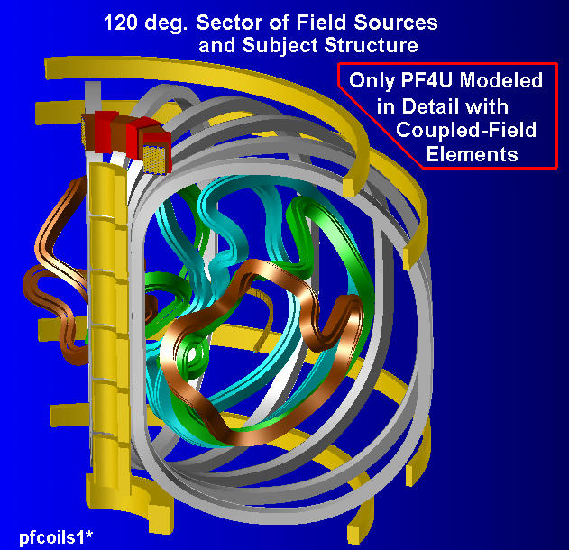
Fig. 2.0-1: NCSX Magnet System 120˚ Sector (PF4U modeled in detail)
These inputs are manipulated into a text-based ANSYS batch file (included here as Attachment 4.1) which facilitates changes to the model such as:

- selecting which coil gets modeled in detail (PF4U, PF5U or PF6U)
- coil restraint hardware dimensions
- material properties
- boundary conditions
- coil currents
- postprocessing

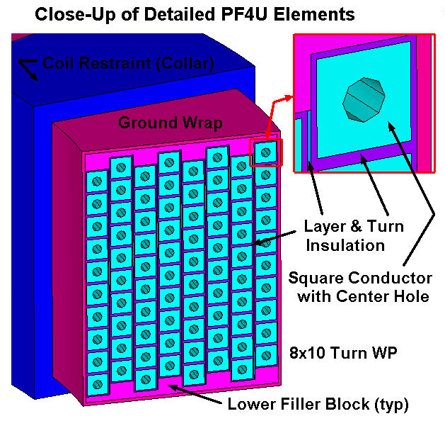
In this particular plot (Fig. 2.0-1) PF4U is modeled in detail while the other coils maintain a homogeneous mesh. A close-up of the PF4U model is shown in Fig. 2.0-2. Notice that all 8x10 conductor turns and their accompanying insulation are modeled explicitly. In this case, there is a vertical offset of one-half turn between layers. The input file provides for selecting either aligned conductors, or conductors offset vertically by one-half or one-whole turn. The detailed model of the CS also provided for this geometric subtlety, but the analysis showed that the alignment had little impact on the stresses of the winding pack constituents [Error: Reference source not found].
Fig. 2.0-2 Close-Up view of Detailed PF4U
There are a number of electromagnetic and structural considerations which must be addressed so that all of the parts of this multi-field model work together properly.

EM Symmetry:

Symmetry in the coil system, specifically the Modular coils, requires modeling 1/3rd of the entire magnet system. The ANSYS user is able to account for the unmodeled coils by telling the program that there is n-fold electromagnetic symmetry about the global Z axis. Here, the ANSYS command is EMSYM, 3.

Cyclic-Symmetry:

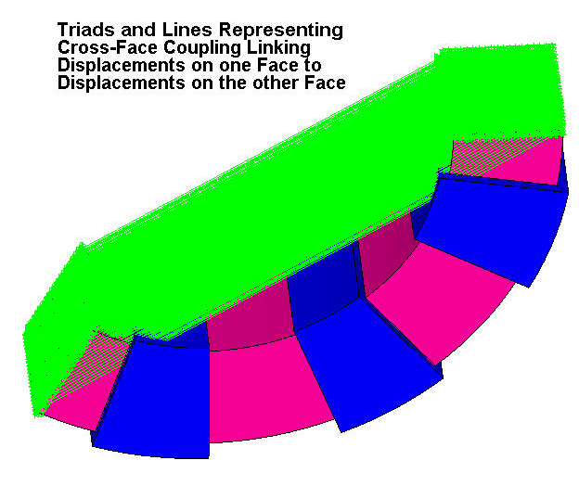
The nodal displacements (UX, UY and UZ) on each face of the 120˚ wedge must be identical. After forcing an identical mesh on these two faces, this so-called cross-face coupling is achieved by invoking the ANSYS command CPCYC,UX,,1,,120,,1 for each of the three displacement degrees of freedom (UX,UY,UZ). Fig. 2.0-3 shows a rather busy representation of the cyclic-symmetry constraints required for this 1/3rd model.
Fig. 2.0-3 Cyclic-Symmetry across the 120˚ Sector
PF Coil Collars to Super Structure Constraints:

The PF coils 4 through 6 are supported by the TF coil superstructure. There are two philosophies associated with the support of these coils: (1) provide vertical restraints at some TBD number of support points, or (2) provide vertical and radial restraints at some TBD number of support points.

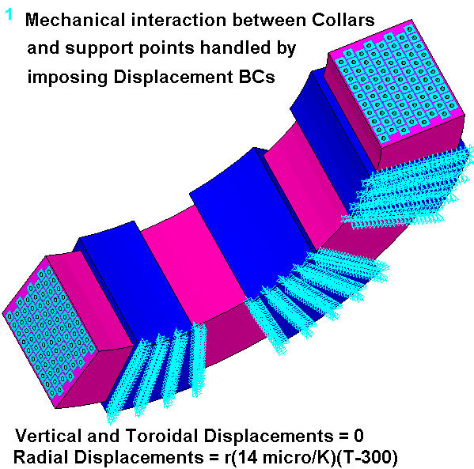
In the first case, the only interaction between the PF supports and the TF structure is that of the vertical EM force acting on the PF coils. The coil restraints (collars) must be sized to support these loads, particularly loads which tend to pull the coil away from the TF attachments. As shown in [Error: Reference source not found] the effect of the PF forces on the TF structure are relatively minor. This allows us to eliminate the TF structure and replace it with a displacement boundary condition at the interface with the PF collars. This is illustrated in Fig. 2.0-4, which shows a representative coil (PF4), attending support collars, and triads which represent the imposed displacement boundary conditions. The annotated plot indicates how the displacements of the collar nodes are set to zero in Z (vertically) and θ (toroidally), and assigned a non-zero value depending on the temperature (T) and radius (r). In this case, it is assumed that the collars are mounted to a structure which has the CTE of SS between 300K and 80K (13 μ/K). Note: The displacement boundary conditions (BCs) for PF5 & PF6 collars are imposed on all of the nodes, not just the bottom nodes as shown here for PF4.
Fig. 2.0-4 PF4, Support Collars and Displacement Boundary Conditions
In the second case, when the PF collars are designed to restrain vertical and radial motion (fully-clamped), the problem gets slightly more complicated. Here, the mechanical stiffness and thermal expansion characteristics of the TF superstructure will affect the stresses in the PF coils. However, if we assume that the large, robust TF structure shrinks with near infinite rigidity according to RαΔT where (R) is the radial distance to the support point, (α) is the coefficient of thermal expansion, and (ΔT) is the temperature differential between coil installation and operating conditions, then we are still be able to conservatively replace mechanical effects of the TF structure with these non-zero displacement boundary conditions.

PF Coil to Collar Interaction:

The PF coil is anchored to the TF support structure by a series of collars. Ideally, the horizontal elements of the collars (seat and cover) will be in contact with the winding packs after cooldown to 80K. Then, depending on the radial restraint design philosophy, there will either be a radial gap or contact between vertical elements of the collar and winding packs. This interface can be handled in either of two ways which trade accuracy and computer run-time.

One way to handle the support-to-WP interface is by coupling specific degrees of freedom (DOF) at specific surfaces. For example, if the coil currents of a particular time-point tend to pull the PF coil towards the machine equatorial plane (let’s call this a Centering condition), then all of the load will appear as compression across the “coil seat.” Coupling the UZ (vertical) DOF will accomplish this restraint in a linear analysis, which is computationally very efficient. Conversely, if the coil currents tend to push the PF coils away from the machine equatorial plane (let’s call this a Launching condition), then all of the load will appear as compression across the “coil cover” side of the winding pack.

Another way to handle the support-to-WP interface is by applying general surface-to-surface contact elements on the outside surfaces of the WP and the inside surfaces of the collars. This is clearly more realistic than selective coupling, but requires substantially more computer-time. Multi-field analyses in 3D demand special consideration in order to justify the transition from a two hour linear analysis to a 12+ hour nonlinear analysis, especially when multiple simulations are required. The parametric model is set up to simulate both modeling approaches. There is more discussion on this subject later in the memo.

Critical Time-Points:

In order to determine which time points present the most critical operating conditions for the PF4/5/6 coils, it is helpful to calculate the net vertical and radial forces acting on the coils. These calculations are efficiently performed using the 2D model introduced in [Error: Reference source not found]. “Critical operating points” are originally chosen based on the maximum (or minimum) coil currents. Curiously, this methodology is over-simplistic, but leads to an important discovery, as discussed below.

Table 2.0-1 lists the net vertical and radial coil forces during what are thought to be a few critical time points of the reference scenarios plus gravity for comparison. One might expect that the largest radial load would occur when the coil current is a maximum. This is indeed true for PF4. At t=0.206 s of the 320 kA Ohmic scenario, PF4 reaches its maximum current and carries its greatest radial force (of the four time points considered here).

Table 2.0-1 Magnetic Forces from Max Current Time Points
Time Point | PF4U  [kN] | PF5U  [kN] | PF6U  [kN]
Time Point | Vertical/Radial | Vertical/Radial | Vertical/Radial
1.7 T Ohmic, t=0.0 s (PF6 I_{min}) | -222/+725 | +85/+22 | -82/+53
2.0 T High-β, t=0.197 s (PF6 I_{max}) | -87/+820 | -11/+46 | +10/+36
320 kA Ohmic, t=0.206 s (PF4 I_{min}) | -201/+1984 | -10/+82 | +18/+19
1.7 T High-β, t=0.0 s (PF5 I_{max}) | -46/+118 | +68/+23 | -72/+51
Gravity (from 3D ANSYS model) | -9.8/0 | -14/0 | -9.6/0

By contrast, PF5 reaches its maximum current at t=0.0s of the 1.7 T High-β scenario. But its radial force is a mere 28% of the value occurring at t=0.206 s of the 320 kA Ohmic scenario. This is because at t=0.0s of the 1.7 T High-β scenario PF6 has a high current in the opposite direction. These neighboring coils carrying current in opposite direction repel each other. So the radial force acting on PF5 is actually reduced by the PF6 fields.

To find when the maximum bursting force on PF5 occurs, we should look for a point in all of the scenarios when the PF5 & PF6 currents have the same sign (so they will be attracted to each other), and PF5 is large. This occurs during the 320 kA Ohmic scenario, as evident by the +82 kN radial force listed in the table.

Conversely, to find the maximum bursting force on PF6, we should look through all of the scenarios for when PF5 & PF6 have opposing currents and the PF6 current is large. This occurs during the 1.7 T Ohmic scenario which produces a radial force of 53 kN on PF6.

The bold values in Table 2.0-1 show a more select set of worst-case operating conditions (ignoring coil faults). It looks like the analysis can focus on a single time point in each of the 1.7 T and 320 kA Ohmic scenarios for all three coils. However, even with this reduced set of cases to analyze, the number of 3D multi-field simulations is;

Number of Simulations = (2 time points per coil) x (3 coils) x (2 support configurations) = 12
This number can be reduce to eight by recognizing that the 320 kA Ohmic time point is more critical to PF4U than 1.7 T Ohmic, and the 1.7 T Ohmic time point is more critical to PF6U than the 320 kA Ohmic. The new subset of limiting load cases is highlighted by yellow cells in Table 2.0-1.

It would also be interesting to know the approximate magnitude of the stresses and deflections produced by these load cases. This not only provides a benchmark for the ANSYS results, but it also gives some insights into the relative magnitude of magnetic and thermal strains.

The radial forces (F_{r}) produced in the body of an electromagnet can be likened to the internal pressure (P) in a vessel. In fact, this force component is often referred to as magnetic pressure. In a thin-shell pressure vessel of radius r and thickness t, the predominant stress is hoop (σ_{h}) and is given by the well-know equation;
σ_{h} = Pr/t

In the case of a solenoid-shaped electromagnet of mean radius r and axial height dz, the radial force can be converted to a magnetic pressure (P_{m}) by dividing it by the mean cylindrical area (2πrdz). This leads to an equivalent hoop stress in the coil with radial thickness dr;

σ_{h} = P_{m}r/t = (F_{r}/2πrdz)(r)/dr

Notice that the r’s cancel, and the stress is simply F_{r}/(2πdrdz). Of course, the winding pack cross-section is not homogeneous, and so this represents the average stress, not the maximum stress. The hoop strain is then simply the hoop stress divided by the effective elastic modulus of the coil cross-section. And the radial deflection is simply the hoop strain multiplied by the coil radius.

Table 2.0-2 lists the salient input and results of these hand calculations. It also lists the thermal deflection of the assumed predominantly stainless steel support structure (α=13μ/K) produced by the temperature differential (ΔT) from 300K to 85K. Notice the following:

- The average hoop stresses in the PF coils from magnetic pressure loads are very small.
- Radial deflections from these stress levels are also very small (below assembly tolerances).
- Radial deflections associated with thermal contraction to 85K are much larger.

Table 2.0-2 Nominal Coil Hoop Stress and Radial Deflection
PF | Radial  Force, F_{r}  [kN] | Coil Dimensions  [m] |  |  | Ave. Hoop Stress, σ_{h}  F_{r}/(2πdrdz)  [MPa] | Ave. Hoop Modulus  E  [GPa] | Deflection  [mm]
PF | Radial  Force, F_{r}  [kN] | r | dr | dz | Ave. Hoop Stress, σ_{h}  F_{r}/(2πdrdz)  [MPa] | Ave. Hoop Modulus  E  [GPa] | Magnetic  (σ_{h}/E)r | Thermal  (αΔT)r
4 | 1984 | 0.522 | 0.1852 | 0.2473 | 7 | 93 | 0.04 | 1.5
5 | 82 | 2.223 | 0.0922 | 0.1574 | 1 | 93 | 0.02 | 6.2
6 | 53 | 2.720 | 0.0457 | 0.1798 | 1 | 93 | 0.03 | 7.6

Fig. 2.0-5 is a plot of radial displacement contours for PF4U when the coil system is 0.206 s into the 320 kA Ohmic scenario, but at room temperature. Notice that the model predicts an average radial magnetic deflection of 0.041 mm, which is within 5% of the hand-calculated value listed in Table 2.0-2.

There is one subtlety worth mentioning; Tables 2.0-1 and 2.0-2 list a radial magnetic force of 1984 kN. Recall that this value is determined from a 2D model of the PF coil system and plasma. Fig. 2.0-6 captures the magnetic force in the ANSYS plot title, which indicates a radial force of 2132 kN. The 3D model predicts a slightly higher radial force compared to the 2D model, which partially explains this minor difference between the hand-calculated and FE-calculated deflection results.

It is also interesting to note that the radial deflections from cooldown (60-300 mils for PF4-PF6) are about two orders of magnitude larger than the radial deflections from the energized coils (0.8-1.5 mils for PF4-PF6). Therefore, it will be far more important to ensure displacement-compatibility between the PF coils and their supporting superstructure during cooldown than it will be to protect the PF coils from the over-constraint of magnetic deflections.
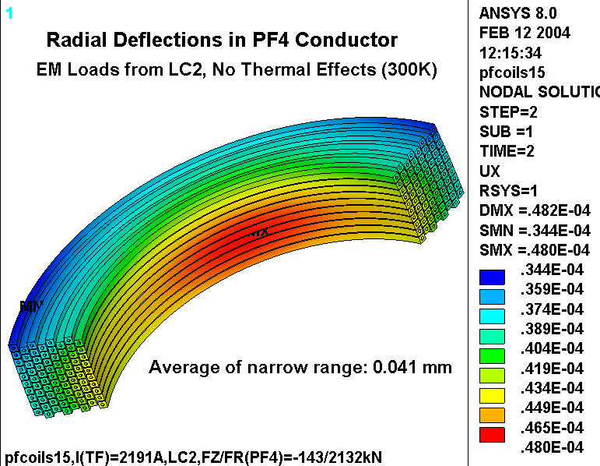
Fig. 2.0-5 Radial deflections, 320 kA Ohmic scenario at 0.206 s, No CTE effects

Figs. 2.0-6 and 2.0-7 are plots of the PF5U and PF6U ANSYS models. The detailed winding packs are shown along with the TF coils for perspective. Other field sources are excluded from the plot for clarity. Collar supports are conveniently located at every TF coil.

Fig. 2.0-6 Detailed PF5U Model Plot
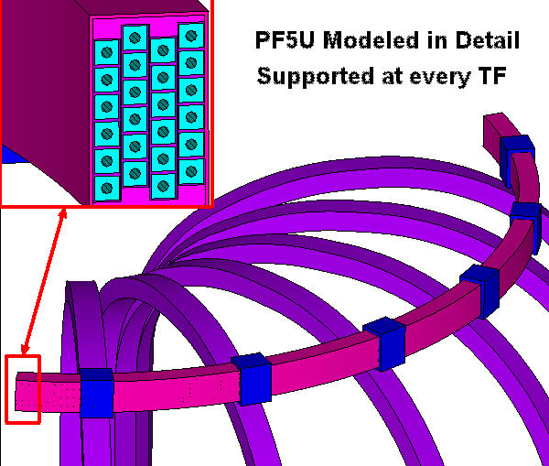
Fig. 2.0-7 Detailed PF6U Model Plot
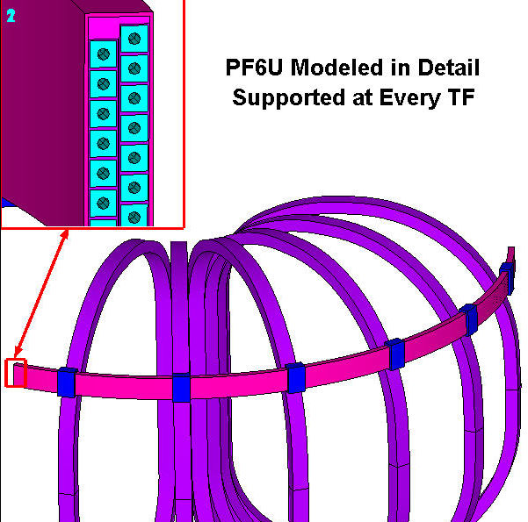

2.1 Assumptions

The following is a list of assumptions applied in the analysis. Those requiring confirmation or further action are noted.

- It is assumed that the coil support superstructure has thermal expansion characteristics consistent with stainless steel (α=13μ/K). That is, a toroidally continuous structure at radius R will contract δ from temperature changes with respect to the assembly temperature (ΔT) by: δ = RαΔT.
- It is assumed that the glass-filled epoxy insulation system has shear/compression constants τ_{o} of 54 MPa and c₂ of 0.5. Confirmation Required.
- It is assumed that the insulation system can support flat-wise tensile stresses up to 4.4 MPa. This has a significant impact on the results of the shear/compression stress evaluation, and should be evaluated more precisely with some insulation R&D program. Confirmation Required.

3.0 Analysis

The 3D finite element model described above is used to simulate the most limiting Load Cases (LC) based on an array of NCSX operating scenarios [Error: Reference source not found]. Detailed 2D and simplistic hand calculations presented above lead to these critical time-points. The coil currents associated with each of these Load Cases (and number of turns per coil, N) are listed in Table 3.0-1.

Table 3.0-1 Summary of Currents for Limiting Load Cases (taken from [Error: Reference source not found])
Load Case>> | 1 | 2
Scenario>> | 1.7T Ohmic | 320kA Ohmic
Time, s | 0.0 | 0.206
M1 (N=40) | 38141 | 34200
M2 (N=40) | 35504 | 32057
M3 (N=36) | 35453 | 32184
PF1 (N=72) | -25123 | 11354
PF2 (N=72) | -25123 | 11354
PF3 (N=72) | -9698 | -11802
PF4 (N=80) | -7752 | -13936
PF5 (N=24) | 8284 | 4563
PF6 (N=14) | -8997 | 5068
TF (N=12) | -3548 | 2191
Plasma (N=1) | 0 | -320775

Detailed stress results are presented in the following 3.x subsections. In summary, the analysis shows:

- When the coils are radially clamped to the structure and both are cooled to 85K, there is a potential for a radial interference of nil for PF4, 0.29 mm for PF5 and 0.34 mm for PF6.
- Of course this interference cannot occur, and so the radial constraint induces additional stresses in the coil. In the case of PF6, with the largest potential interference, the conductor stress increases a trivial amount from 48 MPa to 55 MPa.
- If the coils are rigidly clamped to the superstructure and allowed to be brought to 85K while the structure remains at 300K, then the potential interference is substantial and the conductor stresses exceed 600 MPa (in this elastic analysis). Clearly, the project must either minimize the temperature differential between the hard-mounted PF coils and the structure, or incorporate some radial compliance into the support design.
- Ground wrap and winding pack shear/compression stress evaluations (with assumed τ_{o} and c₂ constants) indicates that large fractions (60%-70%) of the WP insulation fail to meet the design criteria. The “failure” is almost completely due to the differential contraction rates within the winding pack constituents, and NOT electromagnetic loads which actually tend to stabilize the array.
- Increasing the flat-wise tensile stress allowable from 4.4 MPa to 10 MPa increases the fraction of insulation which passes the criteria to almost 90%.
- Flat-wise compression and in-plane insulation stresses are all within allowable limits.
- Cu conductor stresses from EM loads are trivial (a few MPa) and seemingly could not lead to a fatigue failure of the conductor.

3.1 Coil-Structure Thermal Contraction Mismatch

As mentioned earlier in the memo, there are two proposed coil clamping configurations being considered: (1) vertically restrained and radially free and (2) vertically restrained and radially fixed. Let’s begin by looking closely at the contractions of each coil.

Fig. 3.1-1 is a plot of the radial deflections in PF4 when the coil is cooled to 85K (no EM loads). The plot shows an average radial deflection of about -1.55 mm, which yields an effective hoop CTE of 13.8 μ/K. This is very similar to the contraction rate of the SS support structure (13 μ/K), and indicates that the PF coils will contract like their support structure as long as their transient temperatures are consistent.

The differential radial contraction across the winding pack can be used to calculate the across-WP CTE. Fig. 3.1-2 shows radial deflection contours for this 85K operating condition. Here, most of the winding pack constituents are included in the plot (conductor, turn-wrap, layer and ground-wrap…no filler blocks). In this case, the differential radial contraction is 0.7 mm, which yields an effective radial CTE of 17.6 μ/K. This is a larger than that of the SS structure and implies that a line-fit collar at room temperature will develop a small (0.19 mm) gap at 80K:

δ = (dr)(α_{r}-α_{SS})(ΔT) = (0.185m)(17.6μ/K-13μ/K)(300-80) = 0.19 mm

It is curious to note that the (0.19/2) mm gap which will open up on each side of the winding pack at 80K is larger than the 0.04 mm magnetic deflection caused by the energized coils. In this case, radial clamping will not influence the stresses of the energized coil.

A similar set of calculations are performed for PF5 and PF6. Table 3.1-1 lists the numerical values required for the calculation and resulting contraction rates. Notice that the hoop CTE is about the same for all three coils, while the radial CTE increases as the percentage of high-α (through-thickness) glass epoxy increases in the narrower coils.

Table 3.1-1 Thermal Contraction of the PF Coils (300-85K)
PF | Run # | δR_{ave}  [mm] | R_{ave}  [mm] | δdr  [mm] | dr  [mm] | Hoop CTE, α_{θ}  (δR_{ave}/R_{ave})/ΔT  [μ/K] | Radial CTE, α_{r}  (δdr/dr)/ΔT  [μ/K]
4 | 10 | -1.55 | 522 | -0.674 | 185.2 | 13.8 | ~17
5 | 19 | -6.56 | 2223 | -0.36 | 92.2 | 13.7 | ~18
6 | 18 | -7.98 | 2720 | -0.202 | 45.7 | 13.6 | ~21

Now that we have established the contraction rates for the PF coils, we can determine the amount of radial interference between the coil and support structure at 80K. As noted in Sect. 2.0, we assume that the contraction rate of the superstructure and attached collars is dominated by SS components. Another series of hand calculations are performed to determine this coil-structure radial interference. Results are summarized in Table 3.1-2 along with 3D model results.

The results of the free-radial thermal contraction analyses indicate that there will be essentially no radial interference between the PF4 inside surface and the structure at a uniform temperature of 80K. Although the average hoop CTE of the winding pack is somewhat larger than that of the support structure, the relatively wide PF4 winding pack has a fairly large radial CTE, which just about makes up for the difference.

The relatively small difference in hoop thermal contraction rates of the coils and the structure is more important with the larger diameter PF5 & PF6 coils. Here, the calculation shows a potential interference of about 0.3 mm (13 mils), which is still very small on the scale of these coils. Fig. 3.1-3 shows a radial displacement contour plot of PF6 and support collars at 85K. Although the coil-collar overlap is not visible at this scale, the color contours (and plot annotations) confirm the values listed in Table 3.1-2.

Again, it will be very important to ensure that the superstructure and coils cooldown together. If the coils were cooled before the structure, the radial interference could be ~7mm in PF5 & PF6.

Table 3.1-2 Potential Coil-Structure Interference from Cooldown to 80K
PF | Radial Deflection of Coil IR  {(dr/2)(α_{r})-(R_{ave})(α_{θ})}(ΔT)/1000  [mm] | Radial Deflection of Collar @ Coil IR  {(R_{ave}-dr/2)(α_{ss})}(ΔT)/1000  [mm] | Radial Interference  (Model Results)  [mm]
4 | -1.24 | -1.23 | 0.01 (0.03)
5 | -6.52 | -6.23 | 0.29 (0.29)
6 | -8.03 | -7.71 | 0.32 (0.34)

Fig. 3.1-1 Radial deflections from contraction to 85K, No EM effects
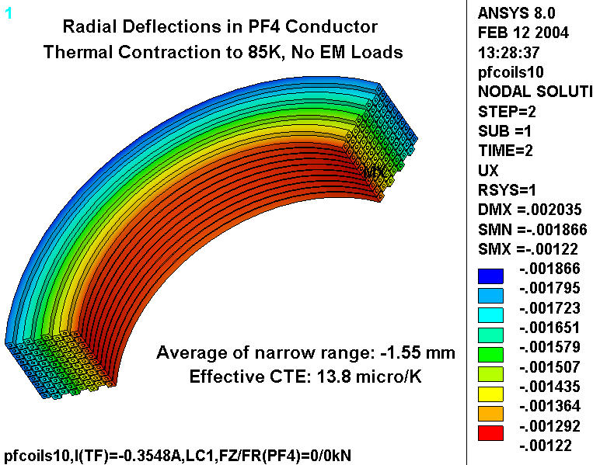
The average radial deflection is used to calculate an effective hoop-direction CTE:
α_{θ} = ε/ΔT = (1.55 mm/522 mm)/(300-85) = 13.8 μ/K
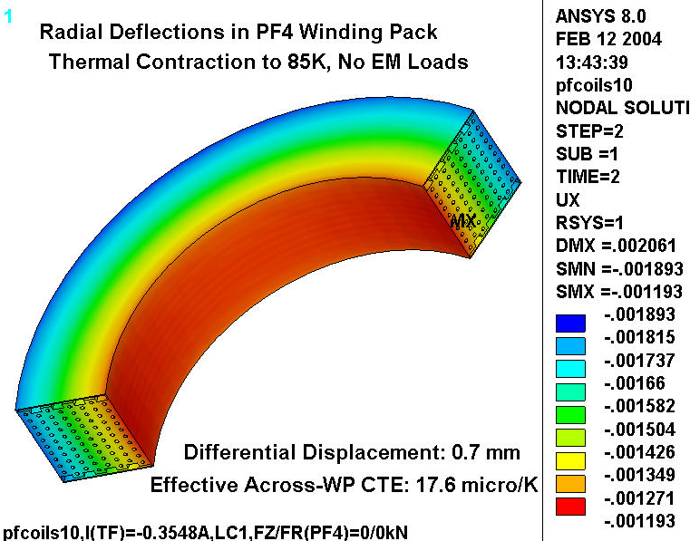
Fig. 3.1-2 Radial deflections from contraction to 85K, No EM effects

The differential radial deflection is used to calculate an effective radial (across-WP) CTE:
α_{r} = ε/ΔT = (0.700 mm/ 185.2mm)/(300-85) = 17.6 μ/K

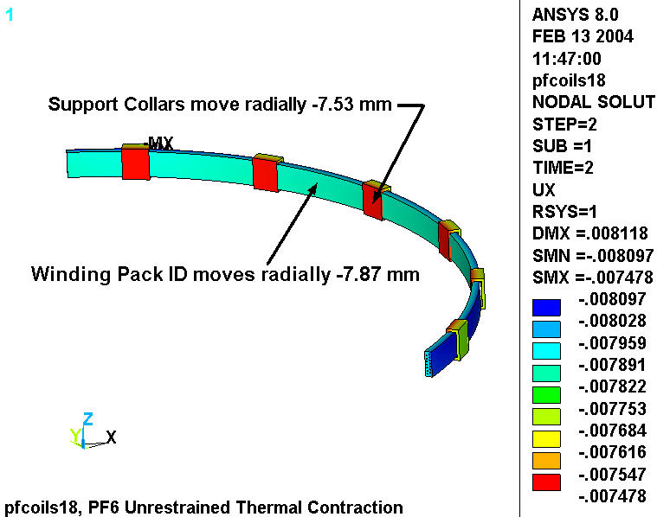
Fig. 3.1-3 Radial Deflection Contours, PF6 and Collar Supports at 85K

3.2 Stresses from Radial Clamping

The effects of radially clamping the PF coil to the TF superstructure is divided into two categories: (1) PF and superstructure at 85K, (2) PF at 85K and superstructure at 300K. Clearly, the minimum impact will be when both coil and superstructure are at the same temperature. However, from an operational perspective, it would be advantageous to allow for any coil-structure temperature combination. The following looks at these two cases.

(1) Coil and Superstructure at 85K

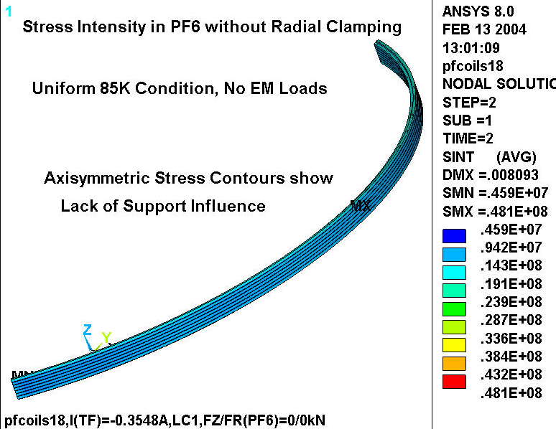
Table 3.1-2 shows the potential interference between coil and structure for all three coils when the system is a uniform 85K. Notice that the largest coil-structure radial interference occurs in PF6, with PF5 a close second. The interference at PF4, on the other hand, seems to be below reasonable assembly tolerances. For reference, Fig. 3.2-1 is included to show the stress in the Cu conductor when the winding pack is free in the radial direction (no radial clamping). The plot legend lists a maximum stress of 48 MPa. Of course this stress comes entirely from the differential contraction rates of the winding pack constituents.

Fig. 3.2-1 Stress Intensity in PF6 Cu Conductor from Uniform 85K Condition, No Radial Clamps
When the winding pack is supported radially at every TF coil, then the radial interference predicted earlier (0.34 mm) cannot occur. Instead, the coil must deform to match the supports. Fig. 3.2-2 is a plot of the stress in the Cu conductor when the winding pack is clamped to the supports in the radial direction. The plot legend lists a maximum stress of 55 MPa, a mere 7 MPa higher than the unclamped configuration shown in Fig. 3.2-1.

This indicates that the radially clamped support concept will have a minor impact on the coil stresses as long as the coil and structure are at the same temperature. A differential in temperature will exacerbate this effect, as shown below in the extreme case.
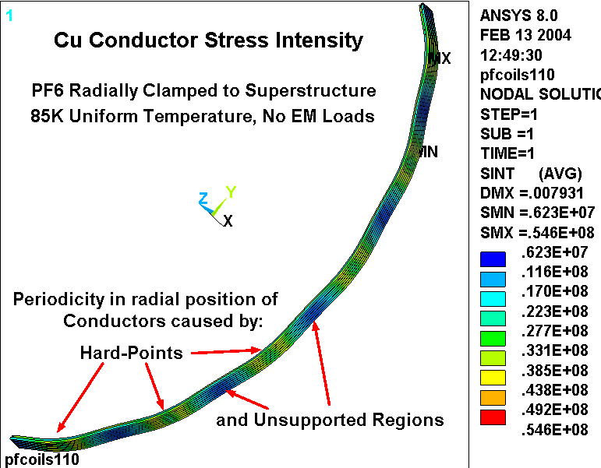
Fig. 3.2-2 Stress Intensity in PF6 Cu Conductor from Uniform 85K Condition, With Radial Clamps

(2) Coil at 85K, Superstructure at 300K

The likelihood of this operating condition is uncertain. However, it is worth determining the effects of a cold coil and a warm structure since it represents the worst possible impact of a radially clamped coil mounting configuration.

Fig. 3.2-3 is a plot of the stress intensity in the Cu conductors of PF4 when the coil is at 85K and the superstructure is at 300K. In this particular analysis there are three collars per 120˚ sector, or nine support coils per PF4. The plot indicates that the stresses would easily exceed 600 MPa between the support points. A maximum stress of 731 MPa is listed, but is too close to the imposed displacement boundary condition to believe. In either case, the Cu stresses are well above any reasonable allowable stress, which makes this an unallowable operating condition.

It is worth noting that these high stresses are a function of the support stiffness. A support concept which is radially soft by design, could provide for “radial clamping” with acceptable coil stresses. Developing such a support is beyond the scope of this effort.
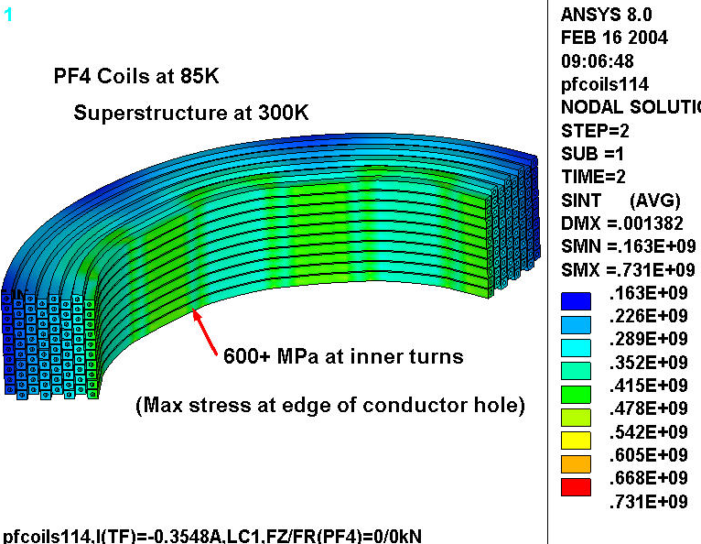

Fig. 3.2-3 Stress Intensity in PF4 Cu Conductor, 85K Coil, 300K Structure, Radially Clamped
Fig. 3.2-4 is a similar plot of the stresses in PF5 when the coil is at 85K and the support structure is at 300K. Here, the stresses are also very high (at 600 MPa, they are well beyond the Cu yield stress), indicating that such an operating condition would also be unacceptable for PF5.

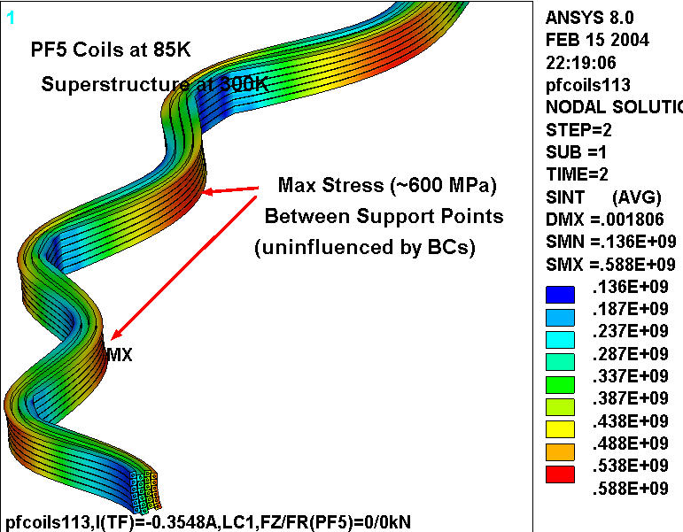
Fig. 3.2-4 Stress Intensity in PF5 Cu Conductor, 85K Coil, 300K Structure, Radially Clamped
Fig. 3.2-5 shows the same result for PF6, with even higher stresses. As with PF5, with the coil at 85K and the support structure at 300K, the Cu stress is around 600 MPa mid-way between coil support points.

This indicates that the radially clamped support concept will have a major and unacceptable impact on the coil stresses if the coil is allowed to cool completely while the structure resides at 300K.

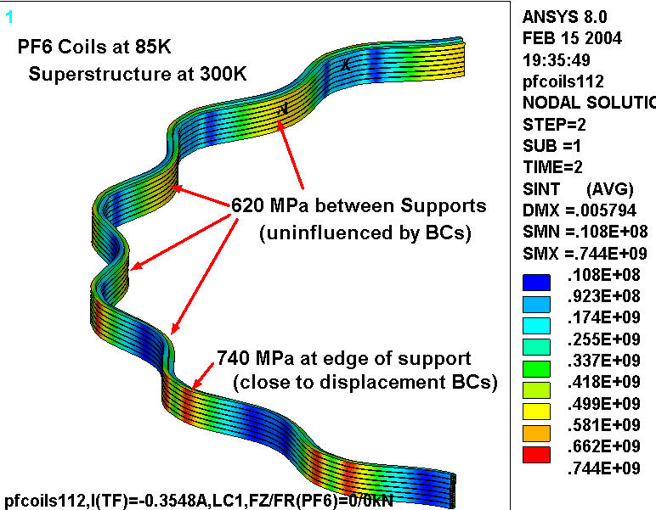
Fig. 3.2-5 Stress Intensity in PF6 Cu Conductor, 85K Coil, 300K Structure, Radially Clamped

3.3 Stresses from Normal Operation

This section investigates the stresses in the winding pack constituents as a result of the most limiting normal operating conditions: Load Cases 1 & 2. Results are evaluated on the basis of the NCSX’ design criteria [Error: Reference source not found].

Insulation Stresses

Evaluating insulation stresses is a rather involved calculation that requires knowing the shear and normal stresses throughout the entire winding pack, and then processing the components in a way which is consistent with the design criteria. The complexity arises because the allowable shear stress is not a constant, but a function of the local normal stress. This insulation evaluation process was fully developed in [Error: Reference source not found], and for the sake of consistency, the text from that memo is simply pasted here below (with the appropriate adjustments to reference and plot numbers).

Aside: Insulation Design Criteria

Let us turn our attention to insulation stresses. The relevant sections of the project’s design criteria document [Error: Reference source not found] are paraphrased below:

- Flatwise (through-thickness) compressive stress shall be limited by 2/3 of the ultimate stress.
- Compressive fatigue allowable stress shall be equal to the lesser of 2/3 of the ultimate compressive fatigue stress measured at the lifetime number of cycles or the ultimate compressive fatigue stress at temperature at 5x the lifetime cycles.
- Normal to the adhesive bonds between metal and composite, no primary tensile strain is allowed. Secondary strain will be limited to 1/5 of the ultimate tensile strain of the adjacent insulation. In the absence of specific data, the allowable tensile strain is 0.02% in the insulation adjacent to the bond.
- The maximum tensile or compressive strain permitted in the plane of the insulation material is either +0.5% or -0.5%.
- The shear-stress allowable, S_{s}, for either static or fatigue conditions is given by:
S_{s} = 2/3 τ_{o} + c₂ S_{c}(n)
Where,

τ_{o} is the experimentally determined minimum intrinsic shear strength with no compressive load (the lower of the bond shear strength or the composite interlaminar shear strength).

c₂ is an experimentally determined factor representing the slope of the dependence of shear strength on compressive stress.

S_{c}(n) is the local normal compressive stress.

Aside: Allowable Stress Levels at 77K (close enough to 85K operating temp. [Error: Reference source not found])

- The insulation system will probably behave like G-10/11CR (reference a discussion with I. Zatz, 12/03). Under flatwise compression, G-10/11CR has an ultimate strength of about 700 MPa. The stress limit is 2/3 x 700 or 460 MPa.

- In the absence of tensile test data normal to the plane of the glass, the allowable strain is 0.02%. With an elastic modulus of ~22 GPa, the allowable normal tensile stress is 0.0002 x 22 GPa or 4.4 MPa. Incidentally, CTD-101K as a neat resin has a tensile strength of ~100 MPa or more. Eventually, the tested CS insulation system might exhibit tensile strengths of this order, which would allow a design-basis stress of (100 MPa)/5 or 20 MPa instead of the 4.4 MPa value proposed here.

- The ultimate tensile strength of G-10/11CR is anisotropic, with values of ~460 MPa in the Warp direction and ~800 MPa in the Fill direction (from [Error: Reference source not found]). We will assume that the lesser of these two values applies: 460 MPa. However, the in-plane allowable is based on the +0.5% strain limit, which is 0.005 x 33 GPa or 165 MPa.

- The ultimate compressive strength of G-10/11CR is also anisotropic, with values of ~550 MPa in the Fill direction and ~800 MPa in the Fill direction (from [Error: Reference source not found]). We will assume that the lesser of these two values applies: 550 MPa. However, the in-plane allowable is based on the -0.5% strain limit, which is -0.005 x 33 GPa or -165 MPa.

- The shear strength of G-10/11CR is ~56 MPa (from [Error: Reference source not found]).

In the early ‘90s, R.P. Reed and his NIST associates performed many insulation stress tests at cryogenic temperatures. One particularly useful test shows the correlation between shear strength and normal compression in a glass-filled epoxy insulation specimen. Coincidentally, the epoxy resin they used is diglycidyl ether of bisphenol A (DGEBA), which is consistent with epoxy proposed for the NCSX Modular coil, and a good candidate for use in the NCSX CS (i.e., CTD-101K from Composite Technology Development, Inc., 2600 Campus Drive, Suite D, Lafayette, CO 80026).

Their test results are captured in two plots, which are scanned from the paper and included here as Fig. 3.3-1. The plots (and the reference) indicate that there is very little difference in performance between the 64% and 52% glass content specimens. The plots also show that the shear strength can be approximated by a linear curve with constants τ_{o} of 54 MPa and c₂ of 0.5. Incidentally, this value of τ_{o} is consistent with the G-10/11CR shear strength value of 56 MPa listed above.

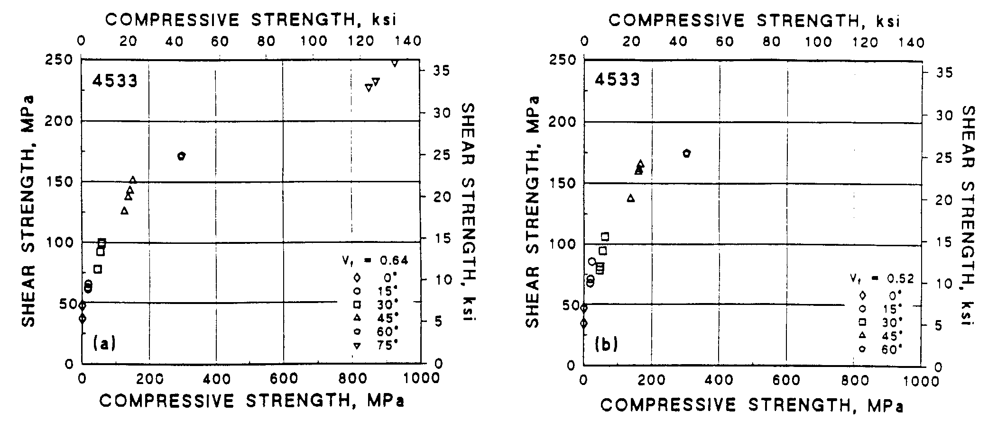
Fig. 3.3-1 Shear strength as a function of Compression at 76 K for Glass-Filled epoxy specimens with 64% (left) and 52% (right) fiberglass volume fraction (from [Error: Reference source not found]).

A detailed analysis of the shear/compression stresses in the winding pack insulation requires some postprocessing operations which are consistent with the design criteria captured in the equation:

S_{s} = 2/3 τ_{o} + c₂ S_{c}(n)

Recall that τ_{o} is set at 54 MPa and c₂ is set at 0.5. The normal stress, S_{c}, must be determined on an element by element basis. The resulting allowable shear stress, S_{s}, is then compared to the local shear stress (τ), also on an element by element basis. In order to quantify the results, the elements which pass the shear stress criteria form one subset while the elements which fail the criteria form another subset.

It is not sufficient to limit the shear stress evaluation to those elements which pass or fail the shear stress limit since the shear/compression characteristics shown in Fig. 3.3-1 imply a normal compressive stress. There is also the explicit requirement of limiting the local tensile stress to a small value, 4.4 MPa.

Table 3.3-1 contains a summary of the insulation shear stress analysis which is outlined above. The table is subdivided into three main regions, one for each of the subject coils. For each coil, there are various design and loading configurations, such as Radial Constraint, Coil & Structure Temperature, and Load Condition (0 represents thermal only). Results are reported for Ground Wrap and Turn & Layer insulation. Recall that the analysis postprocessing determines the fraction (or percentage) of material which “passes” the criteria. Clearly, the goal is to achieve 100%. Let’s review the results for each analysis.

Table 3.3-1 Insulation Shear Stress Evaluation Results, Material which Passes the Criteria (%)
Run | PF | Radial  Constraint | Temp  Coil/Structure  [K] | LC | Ground Wrap Insulation (GW) |  |  | Turn & Layer Insulation  (WP)
 |  |  |  |  | ⊥  % | τ  % | ⊥ & τ % | ⊥  % | τ  % | ⊥ & τ %
10 | 4 | free | 85/85 | 0 | 92.7 | 100.0 | 92.7 | 24.3 | 100.0 | 24.3
15 | 4 | free | 300/300 | 2 | 100.0 | 100.0 | 100.0 | 100.0 | 100.0 | 100.0
12 | 4 | free | 85/85 | 2 | 93.1 | 100.0 | 93.1 | 41.2 | 99.6 | 41.2
13 | 4 | clamped | 85/85 | 2 | 92.8 | 100.0 | 92.8 | 39.7 | 99.8 | 39.7
114 | 4 | clamped | 85/300 | 0 | 87.4 | 97.3 | 84.6 | 55.3 | 95.3 | 54.4
16 | 5 | free | 85/85 | 1 | 80.7 | 100.0 | 80.7 | 31.0 | 99.7 | 31.0
14 | 5 | free | 85/85 | 2 | 80.5 | 100.0 | 80.5 | 29.0 | 99.7 | 29.0
19 | 5 | free | 85/85 | 0 | 80.5 | 100.0 | 80.5 | 28.5 | 99.8 | 28.5
111 | 5 | clamped | 85/85 | 0 | 82.0 | 100.0 | 82.0 | 28.1 | 99.5 | 28.1
113 | 5 | clamped | 85/300 | 0 | 79.6 | 98.5 | 79.1 | 31.8 | 92.1 | 30.9
18 | 6 | free | 85/85 | 0 | 79.0 | 100.0 | 79.0 | 32.8 | 99.8 | 32.8
17 | 6 | free | 85/85 | 1 | 79.0 | 100.0 | 79.0 | 33.2 | 99.8 | 33.2
110 | 6 | clamped | 85/85 | 0 | 79.5 | 100.0 | 79.5 | 30.4 | 99.6 | 30.4
112 | 6 | clamped | 85/300 | 0 | 76.8 | 98.2 | 76.5 | 34.9 | 91.1 | 33.7

Insulation Stresses: PF4 Insulation Shear

Runs 10, 15 & 12 correspond to the “Radially Free” clamping configuration. In run #10, the coil and structure are simply cooled to 85K. This results in acceptable shear and normal stress levels in 93% of the GW insulation and 24% of the WP insulation. Notice that for both insulation components, it is the normal stress (⊥) which causes the problem, not the shear stress (τ). Run #12 shows the impact of applying LC2 coil currents to the cold coil and structure. In this case, the GW remains in reasonably good shape (93% OK), and the fraction of acceptable WP insulation increases slightly to 41%. This is because the energized coil produces some turn-to-turn compression in the winding pack, as represented by the EM force vectors shown in Fig. 3.3-2. In run#15, the coils remain energized to LC2 currents, but the coil is at RT (300K). In this case, 100% of the GW and WP insulation pass the stress criteria, which indicates that the flat-wise normal tensile stresses are predominantly caused by the differential thermal contraction rates of the WP constituents. This phenomenon was also seen (to a lesser degree) in the CS and was thoroughly discussed in [Error: Reference source not found]. The lack of axial pre-compression in the PF4/5/6 coils exacerbates this flat-wise tensile stress condition.

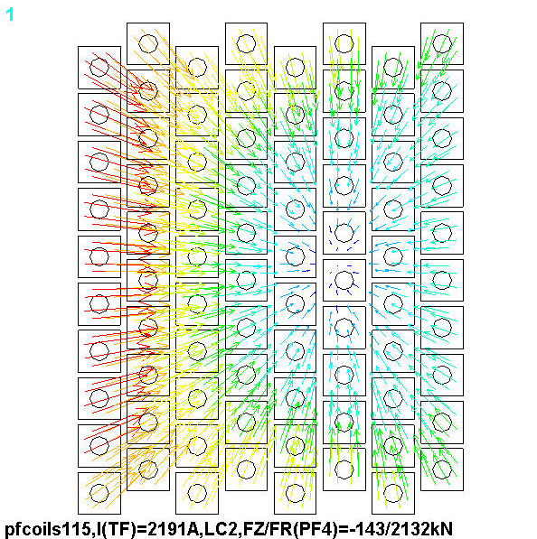
Runs 13 & 114 apply to the radially clamped configuration. Run #13 shows that this has a nearly imperceptible impact on insulation stresses compared to the Radially-Free configuration (Run #12), with 93% of the GW and 40% of the WP insulation passing the stress criteria at 85K and LC2 coil currents. Run number 114 represents an extreme case when the coil is at 85K and the structure is at 300K. Coil currents are off as the outward radial forces would only lessen the severity of this postulated operating condition. The results indicate that this has a slightly negative influence on GW stresses (85% OK) and a slightly positive influence on WP stresses (54% OK). These results are minor compared to the impact on conductor stresses shown in Fig. 3.2-3.
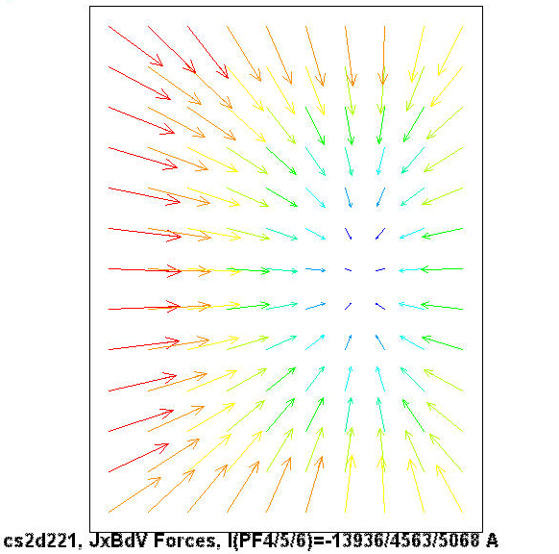
Fig. 3.3-2 Force Vectors, PF4, LC2 (from 2D model)
Insulation Stresses: PF5 Insulation Shear

Runs 16, 14 & 19 correspond to the “Radially Free” clamping configuration. Recall that for PF5, we are obliged to analyze the stresses from LC1 (Run #16) & LC2 (Run #14). The thermal-only load case (0) is added as a point of reference. The tabulated results show that about 80% of the GW and 30% of the WP insulation passes the shear stress criteria, independent of coil currents. This is consistent with the average stress results reported in Table 2.0-2 which shows that the coil has very light EM loads. Fig. 3.3-3 shows the EM force vectors in PF5 from LC1. As in PF4, the magnetic forces tend to hold the turn array together.

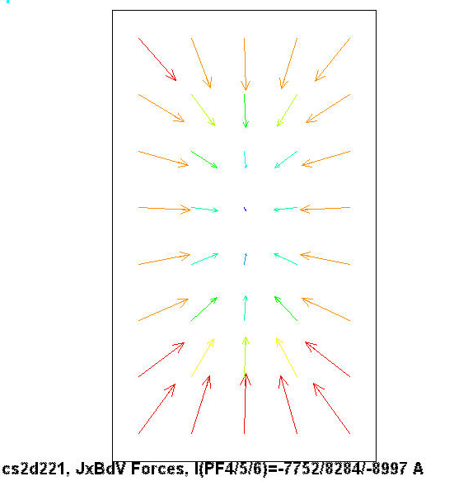
Runs 111 & 113 apply to the radially clamped configuration. Coil currents are off in both of these analyses. Run #111 has coil and structure at 85K, while run #113 has an 85K coil and a RT structure. This difference has almost no impact on the fraction of insulation which passes the stress criteria: 80% of the GW and 30% of the WP. In fact, this is about the same result as the radially free configuration. Of course, the greatest impact of “free” versus “clamped” appears in the conductor stress, as shown in Fig. 3.2-4.

Fig. 3.3-3 Force Vectors, PF5, LC1 (from 2D model)

Insulation Stresses: PF6 Insulation Shear

Runs 18 & 17 correspond to the “Radially Free” clamping configuration. Run #18 simulates an 85K coil and an 85K structure without coil currents. Run # 17 simulates this thermal condition but with the coils energized to LC1 currents. As with PF5, the results indicate that about 79% of the GW and 33% of the WP insulation pass the shear stress criteria, independent of coil currents. Again, the slight increase in WP acceptability can be attributed to the compressive forces developed from the energized coil, with force vectors shown in Fig. 3.3-4. Even without having a simulation to reference, all of the “failures” are certain to be attributable to thermal contraction effects.

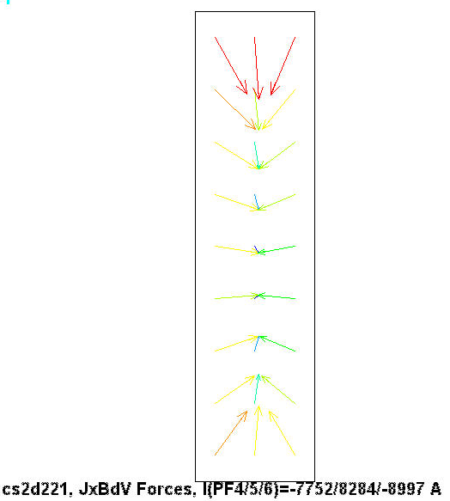
When the PF6 coil is clamped radially to the structure, the result is very similar to that of PF5; the fraction of insulation which passes the stress criteria is mildly affected. However, the stress in the conductor is greatly affected when the coil is allowed to cool to 85K and the structure is held at 300K (reference Fig. 3.2-5).
Fig. 3.3-4 Force Vectors, PF6, LC1 (from 2D model)
Table 3.3-1 indicates that none of the insulation components (neither GW nor WP) entirely pass the insulation shear and normal stress requirement. It shows that that:

- Tensile normal stresses (relative to the glass layers) are the source of the “failure.”
- Shear stresses are generally within the shear/compression stress limits.
- Essentially all of the criteria “failures” are because of the Cu/Epoxy/glass thermal contraction differences.
- Normal operating EM forces contribute almost nothing to the state of the insulation stress.
- The radial clamping configuration has a minimal impact on the volume of insulation which meets the shear/compression design criteria.

The EM force vector plots shown above support the general observation that EM forces tend to stabilize the conductor array, drawing them all towards the magnetic center of the winding pack.

These results are very sensitive to the assumed allowable tensile stress allowable. Lacking actual test data on our specific conductor and insulation system, we are obliged to assume 0.02% of the elastic modulus normal component [Error: Reference source not found], or 4.4 MPa. If this value increases to 10 MPa (because of test data or a less stringent requirement), then about 90% of the insulation passes the shear/compression stress criteria. This is represented pictorially by the radial stress contour plot of Fig. 3.3-5. (It is unclear why the normal stresses concentrate in the layer insulation at the ends of the 120˚ sector.)
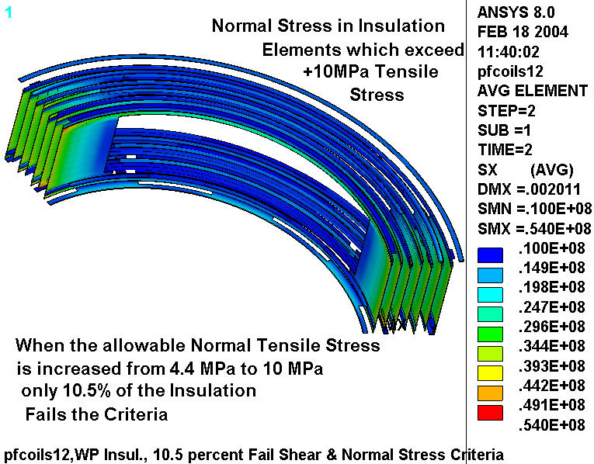
Fig. 3.3-5 Radial Stresses in WP insulation which exceed an arbitrary 10 MPa normal stress limit
Insulation Stresses: In-Plane & Flat-Wise

In addition to the shear stress requirements issued by the design criteria [Error: Reference source not found] and outlined above, the insulation must also pass flat-wise compression and in-plane tension and compression stress limits. Table 3.3-2 lists these stress components from the same set of analyses discussed above and shown in Table 3.3-1.

Recall that in-plane compression and tension stresses are limited to 165 MPa and the flat-wise compression is limited to 460 MPa. A review of these results indicates that these limiting load cases produce in-plane and flat-wise insulation stresses which are well within these design limits. Clearly, the most challenging stresses occur when 85K coils are radially clamped to RT supports. However, even this extreme condition does not produce a failure of these in-plane and flat-wise insulation stress criteria.

Table 3.3-2 Insulation In-Plane Tension & Compression and Flat-Wise Compression Stress Results
Run | PF | Radial  Constraint | Temp  Coil/Structure  [K] | LC | In-Plane  Compression/Tension  [MPa] | Flat-Wise Compression  [MPa]
10 | 4 | free | 85/85 | 0 | -42.9/+9.6 | -6.3
15 | 4 | free | 300/300 | 2 | -0.6/+3.4 | -3.0
12 | 4 | free | 85/85 | 2 | -42.5/+10.1 | -8.3
13 | 4 | clamped | 85/85 | 2 | -41.4/+10.8 | -8.3
114 | 4 | clamped | 85/300 | 0 | -93.9/+81.3 | -177
16 | 5 | free | 85/85 | 1 | -40.9/+10.6 | -7.4
14 | 5 | free | 85/85 | 2 | -41.1/+10.4 | -7.1
19 | 5 | free | 85/85 | 0 | -40.7/+10.3 | -7.1
111 | 5 | clamped | 85/85 | 0 | -39.0/+12.9 | -7.2
113 | 5 | clamped | 85/300 | 0 | -49.5/+103 | -81.8
18 | 6 | free | 85/85 | 0 | -39.6/+10.2 | -6.4
17 | 6 | free | 85/85 | 1 | -40.7/+10.5 | -6.6
110 | 6 | clamped | 85/85 | 0 | -36.6/+13.0 | -7.5
112 | 6 | clamped | 85/300 | 0 | -110/+140 | -99.5

Note: The results shown above list stresses to 0.X MPa. Although there is no reason to believe that the analysis is accurate to tenths on an MPa, the first digit to the right of the decimal is reported to show the small differences produced by these various load conditions.
Cu Conductor Stresses

Table 3.3-3 lists the stress intensity in the Cu conductor from the same series of load conditions shown in the insulation stress tables. An earlier project memo [Error: Reference source not found] presents the rational for establishing a design Tresca stress value (S_{m}) of 110 MPa. With the exception of the case of an 85K coil clamped to a 300K structure, all of the stresses listed in Table 3.3-3 are less than this 110 MPa allowable value. Notice that energizing the coils has little impact on the conductor stresses produced by 85K alone.

Clearly, the project cannot allow the PF4/5/6 coils to cool at substantially different rates than the support structure, if radial clamping is the preferred design option. There is still at least one solution to the radial clamped configuration: design a coil support which incorporates some radial flexibility into a non-sliding hanger. This gives the desired performance characteristics of no coil/support relative motion without a requirement on coil/structure temperature compatibility.

It is interesting to note that the previous smeared analysis of the PF coils [Error: Reference source not found] predicted an unsmeared PF4 Cu stress of about 12 MPa. This is only slightly below the 19 MPa stress reported here (Run #15) where thermal effects are eliminated. It should be noted that the earlier smeared analysis does not account for the vertical stress amplification produced by the center channel. Add to this, the 7 MPa predicted by the hand calculation shown in Table 2.0-2 (un-amplified for packing factor and transverse stress hole effects) and these 3D model results seem reasonable.

Table 3.3-3 Cu Conductor Stress Results
Run | PF | Radial  Constraint | Temp  Coil/Structure  [K] | LC | Conductor Stress Intensity  [MPa]
10 | 4 | free | 85/85 | 0 | 46.6
15 | 4 | free | 300/300 | 2 | 19.2
12 | 4 | free | 85/85 | 2 | 49.1
13 | 4 | clamped | 85/85 | 2 | 48.0
114 | 4 | clamped | 85/300 | 0 | 731
16 | 5 | free | 85/85 | 1 | 49.2
14 | 5 | free | 85/85 | 2 | 46.1
19 | 5 | free | 85/85 | 0 | 46.1
111 | 5 | clamped | 85/85 | 0 | 53.1
113 | 5 | clamped | 85/300 | 0 | 588
18 | 6 | free | 85/85 | 0 | 48.1
17 | 6 | free | 85/85 | 1 | 51.0
110 | 6 | clamped | 85/85 | 0 | 54.6
112 | 6 | clamped | 85/300 | 0 | 744

4.0 Attachments

4.1 Batch Input File (2/17/2004)

/BATCH
rn=13
/filnam,pfcoils1%rn%
/show,pfcoils1%rn%,grp
!resume
!*if,1,eq,1,:1000
/PREP7

/com
/com Detailed EM-STRUC Analysis of the NCSX PDR PF Coils
/com Resume pfcoils1.db which has smeared coil definitions (CS, PF, TF, Modular & Plasma)
/com Rebuild one PF coil in detail.
/com
/com Run History
/com
/com 10: TF Only, 16.2kA, 0.5T
/com 11: Time Point 5
/com
/com Fix Insulation orthotropy, alpha=13 at 85K
/com 12 : TP=4, temp=RT, use cnvtol,f, 1E15 stresses not correct
/com 12a: TP=4, temp=RT, nix cnvtol,f, never converged
/com 12b: ANSYS7.1 with cnvtol,f and pdrcoils1.db, BIOT calc works on all coil nodes so I killed the job
/com 12c: ANSYS8.0 with neqit=1, stopped after 1 iter, but with huge DISP & Stress
/com 12d: ANSYS8.0 with solid5,2 instead of solid45, use cnvtol,f,1e8,
/com 12e: solve 1st load step with all (even purely structural) elements selected, then Biot & Stress

/com NEED TO HAVE ALL ELEMENTS PRESENT EVEN THOUGH THE 1ST SOLVE IS JUST CONDUCTION)
/com General Contact with collars contacing on top & bottom
/com 13: PF4, LC4 (Max PF4 Current), RT, no radial constraint and no thermal (not converged, but working OK)
/com 14: Add friction to interfaces, PCG solver, 3 iterations (not converged, but working OK)

/com Start Again with production runs
/com
/com 10: PF4, LC=0, UZ/UY Coupling (Fmag<<0), UX Free, thermal Only
/com 11: PF4, LC=1, UZ/UY Coupling (Fmag<<0), UX Free
/com 12: PF4, LC=2, UZ/UY Coupling (Fmag<<0), UX Free
/com 13: PF4, LC=2, vertical and radial contact with and w/o friction (not converged)
/com 13: PF4, LC=2, UZ/UY Coupling, UX clamped by radial coupling at OD (wrong side)
/com 13: PF4, LC=2, UZ/UY Coupling, UX clamped by radial coupling at ID (borderline side)
/com 15: PF4, LC=2 w/o thermal, UZ/UY Coupling (Fmag<<0), UX Free
/com 114:PF4, LC=0, UZ/UY Coupling, Support UX fixed at RT, Coil at -215, thermal Only

/com 14: PF5, LC=2, UZ/UY Coupling (Fmag<<0), UX Free
/com 16: PF5, LC=1, UZ/UY Coupling (Fmag>>0), UX Free, 6 collars
/com 19: PF5, LC=0, UZ/UY Coupling (Fmag<<0), UX Free, thermal only
/com 111:PF5, LC=0, UZ/UY Coupling, UX CP at ID, thermal only
/com 113:PF5, LC=0, UZ/UY Coupling, Support UX fixed at RT, Coil at -215, thermal Only

/com 17: PF6, LC=1, UZ/UY Coupling (Fmag<<0), UX Free, 6 collars,
/com 18: PF6, LC=0, UZ/UY Coupling (Fmag<<0), UX Free, thermal only
/com 110:PF6, LC=0, UZ/UY Coupling (Fmag<<0), UX CP, thermal only
/com 112:PF6, LC=0, UZ/UY Coupling, Support UX fixed at RT, Coil at -215, thermal Only

/com
/com Field model based on coil definitions in HM Fan's file-1.7t.db (saved as pdrcoils1.db)
/com
resume,pfcoils1,db,,1 ! pull in PF/TF/MC/Plasma Current Sources (stif36 is type 2, stif96 is type 3)
/com
/com Misc Parameters
/com
time_pt=1 ! Coil Currents for this time point (see array listed below)
t=1e-5 ! tiny
k_intface=0 ! Collar-Coil Interface, 0:Selective Coupling and Imposed Displacements, 1:General Contact
k_radial=1 ! 0: No Radial Constraint, 1: Include radial constraint
mu_int=0.0 ! WP/Collar interface friction coefficient
k=0.0254 ! conversion (inches to meters)
pi=acos(-1) ! pi
*afun,deg
emsym,3 ! number of circular symmetry sections about Global Z
r0=1.4 ! Major Radius
tmp_cl=-215 ! Coil Differential Operating Temp
tmp_st=-215 ! Structure Differential Operating Temp
t_ref=0 ! Reference Temperature
alpha_struc=13e-6 ! Thermal expansion coefficient of Structure between RT and 85K
tref,t_ref ! Or use MP command

/com
/com Select which PF to mesh in detail and number of elements in theta
/com
k_detail=4 ! Which coil number (4,5,6)
nth=45 ! number of elements in theta (45 for PF4, 150 for PF5, 240 for PF6)

/com
/com The detailed WP conductor array can be modeled as:
/com aligned (theta_sec=0), offset by one conductor (theta_sec=180), or half of a conductor (theta_sec=90)
/com
theta_sec=90

/com
/com Conductor
/com
dr_con=0.787*k ! Conductor build in radius
dz_con=0.787*k ! Conductor build in height
ri_con=0.354/2*k ! inside radius of cooling channel hole
a_con=dr_con*dz_con-pi*ri_con**2 ! conductor metal area
/com
/com Insulation
/com
t_tw=0.049*k ! turn wrap insulation thk
t_pan=0.000*k ! pancake insulation thk (can be 0.0)
t_lay=(0.030+0.0)*k ! layer insulation thk (can be 0.0)
t_gw=0.12*k ! module over-wrap thickness
/com
/com Coil Support Collars
/com
t_collar=0.75*k ! case thickness
n_collar=3 ! number of collars
w_collar=0.127 ! width of collar

/com
/com Unit Cell dimensions
/com
dr_cell=dr_con+2*t_tw+1*t_lay
dz_cell=dz_con+2*t_tw+1*t_pan

/com
/com Turn Counts
/com
nr1=4 $nz1=18 ! PF1 turn-count
nr2=4 $nz2=18 ! PF2 turn-count
nr3=4 $nz3=18 ! PF3 turn-count
nr4=8 $nz4=10 ! PF4 turn-count
nr5=4 $nz5=6 ! PF5 turn-count
nr6=2 $nz6=7 ! PF6 turn-count
nr7=1 $nz7=1 ! Plasma turn-count
tpmc1=10*4 ! turns per MC1 winding
tpmc2=10*4 ! turns per MC2 winding
tpmc3=9*4 ! turns per MC3 winding
tptf=12 ! turns per TF coil

/com
/com PF & Plasma Geometry (Rc, Zc, dr, dz) from Brown's PDR Overview
/com These coil definitions are only used to regenerate the requested k_detail coil.
/com In general, the coils are already defined within the resumed *.db file
/com
r0=1.40 ! major radius
num_pf=7 ! number of PF coils including plasma
*dim,pf_geo,,4,num_pf
pf_geo(1,1)= 8.625*k, 9.438*k,dr_cell*nr1-t_lay,dz_cell*(nz1+1) ! PF1
pf_geo(1,2)= 8.625*k,28.313*k,dr_cell*nr2-t_lay,dz_cell*(nz2+1) ! PF2
pf_geo(1,3)= 8.625*k,47.188*k,dr_cell*nr3-t_lay,dz_cell*(nz3+1) ! PF3
pf_geo(1,4)= 20.549*k,62.340*k,dr_cell*nr4-t_lay,dz_cell*(nz4+1) ! PF4
pf_geo(1,5)= 87.527*k,60.250*k,dr_cell*nr5-t_lay,dz_cell*(nz5+1) ! PF5
pf_geo(1,6)=107.105*k,37.562*k,dr_cell*nr6-t_lay,dz_cell*(nz6+1) ! PF6
pf_geo(1,7)= r0, 0.0, 0.04, 0.04 ! Plasma

/com
/com Define Coil Currents
/com
*dim,i_coils,array,6,12 ! Time,M1,M2,M3,PF1,PF2,PF3,PF4,PF5,PF6,TF,Plasma
/com Proposed Worst 5 Cases (from Wayne's TDS C08R00 Spreadsheet, circa 09/15/03)
i_coils(1,1)=1,2
i_coils(1,2)=.38141,34200
i_coils(1,3)=.35504,32057
i_coils(1,4)=.35453,32184
i_coils(1,5)=-.25123,11354
i_coils(1,6)=-.25123,11354
i_coils(1,7)=-.9698,-11802
i_coils(1,8)=-.7752,-13936
i_coils(1,9)=.8284,4563
i_coils(1,10)=-.8997,5068
i_coils(1,11)=-.3548,2191
i_coils(1,12)=0,-320775

/com
/com BC flags
/com
/pbc,mag
/pbc,temp
/pbc,volt
/pbc,ce
/pbc,cp
/pbc,amps

/com
/com Element Types
/com
et,1,5,0 ! U,TEMP,VOLT,MAG (Only PF%k_detail%u)
et,2,36 ! Plasma Current Source Primitive
et,3,5,1 ! TEMP,VOLT,MAG (TF, CS, PF, M and R0 ring)

/com
/com Merge TF Coil nodes in the inboard leg
/com
esel,s,mat,,2
nsle
csys,1
nsel,r,loc,x,,r0
!numm,node ! not here where TFs are only field sources

/com
/com Material Properties
/com
allsel
mpdele,all,all
/com All PF Coils
!mp,reft,1,t_ref
mp, kxx,1,1
mp,murx,1,1
mp,rsvx,1,1
mp,alpx,1,10e-6 ! roughly (no reference or calc)
/com
/com PF Coils, Chang Jun, "ANSYS Modeling to obtain Equivalent Moduli of Elasticity of
/com PF & TF Coils of NCSX," 06/27/03
mp, ex,1,62.27E9!,54.44E9
mp, ey,1,93.10E9!,85.10E9
mp, ez,1,64.03E9!,56.59E9
mp, Gxy,1,35.27E9!,32.01E9
mp, Gyz,1,35.27E9!,32.01E9
mp, Gxz,1,20.69E9!,18.31E9
mp,nuxy,1, 0.306!,0.310
mp,nuyz,1, 0.213!,0.209
mp,nuxz,1, 0.339!,0.340

/com TF Coils
!mp,reft,2,t_ref
mp, kxx,2,1
mp,murx,2,1
mp,rsvx,2,1
mp,alpx,2,10e-6 ! roughly (no reference or calc)
/com Chang Jun, "ANSYS Modeling to obtain Equivalent Moduli of Elasticity of
/com TF Coils of NCSX," 07/15/03
mp, ex,2,111.6E9!, 93.3E9
mp, ey,2,129.5E9!,119.0E9
mp, ez,2,125.1E9!,113.9E9
mp, Gxy,2, 48.6E9!, 44.4E9
mp, Gyz,2, 48.6E9!, 44.4E9
mp, Gxz,2, 41.8E9!, 37.5E9
mp,nuxy,2, 0.323!, 0.329
mp,nuyz,2, 0.277!, 0.273
mp,nuxz,2, 0.277!, 0.273
/com M1 Coils
!mp,reft,3,t_ref
mp, kxx,3,1
mp,murx,3,1
mp,rsvx,3,1
/com M2 Coils
!mp,reft,4,t_ref
mp, kxx,4,1
mp,murx,4,1
mp,rsvx,4,1
/com M3 Coils
!mp,reft,5,t_ref
mp, kxx,5,1
mp,murx,5,1
mp,rsvx,5,1
/com R0 Field Elements
!mp,reft,7,t_ref
mp, kxx,7,1
mp,murx,7,1
mp,rsvx,7,1

/com Stainless Steel (at 77K)
!mp,reft,10,t_ref
mp,murx,10,1
mp, ex,10,193e9
mp,alpx,10,alpha_struc
mp,nuxy,10,0.285
!mp, gxy,10,76.7e9

/com
/com Cu Conductor (at 77K)
/com
mp,murx,12,1
mp, ex,12,136e9
mp,alpx,12,14e-6
mp,nuxy,12,0.34
mp, kxx,12,1
mp,rsvx,12,1

/com
/com Turn wrap insulation (X is through thickness)
/com
mp,murx,13,1
mp, ex,13,22e9
mp, ey,13,33e9
mp, ez,13,33e9
mp,alpx,13,30e-6
mp,alpy,13,10e-6
mp,alpz,13,10e-6
mp, gxy,13,8e9
mp, gyz,13,11e9
mp, gxz,13,8e9
mp,nuxy,13,0.21
mp,nuyz,13,0.21
mp,nuxz,13,0.21
mp, kxx,13,1

/com
/com Pancake to Pancake insulation (x is through thickness)
/com
mp,murx,14,1
mp, ex,14,22e9
mp, ey,14,33e9
mp, ez,14,33e9
mp,alpx,14,30e-6
mp,alpy,14,10e-6
mp,alpz,14,10e-6
mp, gxy,14,11e9
mp,nuxy,14,0.21
mp,nuyz,14,0.21
mp,nuxz,14,0.21
mp, kxx,14,1

/com
/com Layer to Layer insulation (X is through thickness)
/com
mp,murx,15,1
mp, ex,15,22e9
mp, ey,15,33e9
mp, ez,15,33e9
mp,alpx,15,30e-6
mp,alpy,15,10e-6
mp,alpz,15,10e-6
mp, gxy,15,8e9
mp, gyz,15,11e9
mp, gxz,15,8e9
mp,nuxy,15,0.21
mp,nuyz,15,0.21
mp,nuxz,15,0.21
mp, kxx,15,1

/com
/com Ground wrap, X is through thickness
/com
mp,murx,16,1
mp, ex,16,22e9
mp, ey,16,33e9
mp, ez,16,33e9
mp,alpx,16,30e-6
mp,alpy,16,10e-6
mp,alpz,16,10e-6
mp, gxy,16,8e9
mp, gyz,16,11e9
mp, gxz,16,8e9
mp,nuxy,16,0.21
mp,nuyz,16,0.21
mp,nuxz,16,0.21
mp, kxx,16,1

/com
/com Upper and Lower filler pieces in detailed WP
/com
mp,murx,19,1
mp, ex,19,136e9
mp,alpx,19,14e-6
mp,nuxy,19,0.34
mp, kxx,19,1

/com
/com Current Nodes
/com
n_pfcoils=6 ! number of PF Coil Pairs
n_tfcoils=6 ! number of TF Coils
n_mcoils=3 ! number of Modular Coil Pairs
/com PF Coil Current Nodes
n_pf1u=1
n_pf1l=1488
n_pf2u=1110
n_pf2l=1593
n_pf3u=1299
n_pf3l=2346
n_pf4u=190
n_pf4l=1782
n_pf5u=450
n_pf5l=1922
n_pf6u=846
n_pf6l=2126
/com TF Coil Current Nodes
n_tf1=3641
n_tf2=4730
n_tf3=5819
n_tf4=6908
n_tf5=7997
n_tf6=9086
/com Modular Coil Current Nodes
n_m11=13599
n_m12=13609
n_m13=13619
n_m14=15619
n_m21=21639
n_m22=21649
n_m23=21659
n_m24=23659
n_m31=29679
n_m32=29689
n_m33=29699
n_m34=31699

/com
/com Make nodal components out of Modular Coil Current Nodes
/com
*do,jj,1,n_mcoils
nsel,none
*do,j,1,4
nsel,a,node,,n_m%jj%%j%
*enddo
cm,n_m%jj%,node
*enddo

/com
/com Plasma Current in Type,2 Real,1
/com
r,1,2,i_coils(time_pt,12),0.03,0.05

/com
/com Make a ring of elements on the Plasma Axis
/com
!*if,time_pt,eq,1,then
*if,0,eq,1,then
csys
wpcsys
vsel,none
esel,none
nsel,none
cylind,r0-0.005,r0+0.005,-0.005,0.005,-60,60
vatt,7
esize,0.1
type,3
mp,murx,7,1
vmesh,all
d,all,mag
d,all,temp
d,all,volt
*endif

itf=i_coils(time_pt,11)
tme=i_coils(time_pt,1)
/title,pfcoils1%rn% I(TF)=%itf%A, LC=%time_pt%
allsel

/com Make 2D element for detailed coil X-section Mesh
*get,etmx,etyp,,num,max
et,etmx+1,200,6 ! quad element type

/com
/com Nix the k_detail smeared WP
/com
csys,1
xc=pf_geo(1,k_detail)
nsel,s,loc,x,pf_geo(1,k_detail)-pf_geo(3,k_detail),pf_geo(1,k_detail)+pf_geo(3,k_detail)
nsel,r,loc,z,pf_geo(2,k_detail)-pf_geo(4,k_detail),pf_geo(2,k_detail)+pf_geo(4,k_detail)
esln,,1
nsle
edele,all
ndele,all

/com
/com Make Detailed WP with Case, build at origin, and moved to appropriate location
/com
vsel,none
asel,none
lsel,none
ksel,none
csys
wpcsys
rectng,-dr_con/2,dr_con/2,-dz_con/2,dz_con/2
rectng,-dr_con/2-t_tw,dr_con/2+t_tw,-dz_con/2-t_tw,dz_con/2+t_tw
*if,t_lay,gt,0,then
rectng,-dr_con/2-t_tw,dr_con/2+t_tw+t_lay,-dz_con/2-t_tw,dz_con/2+t_tw+t_pan
*endif
*if,t_pan,gt,0,then
rectng,-dr_con/2-t_tw,dr_con/2+t_tw+t_lay,-dz_con/2-t_tw,dz_con/2+t_tw+t_pan
*endif
aovlap,all
cm,temp,area
/com Subtract the center hole
pcirc,,ri_con
asba,temp,all

allsel,below,area
/com Overlap lines to simplify coarse meshing
!l,kp(-dr_con/2,-dz_con/2,0),kp(dr_con/2,+dz_con/2,0)
!l,kp(-dr_con/2,+dz_con/2,0),kp(dr_con/2,-dz_con/2,0)
/com Miter Turn Wrap Insulation
l,kp(-dr_con/2-t_tw,-dz_con/2-t_tw,0),kp(-dr_con/2,-dz_con/2,0)
l,kp(-dr_con/2-t_tw,+dz_con/2+t_tw,0),kp(-dr_con/2,+dz_con/2,0)
l,kp(dr_con/2+t_tw,+dz_con/2+t_tw,0),kp(dr_con/2,+dz_con/2,0)
l,kp(dr_con/2+t_tw,-dz_con/2-t_tw,0),kp(dr_con/2,-dz_con/2,0)
asbl,temp,all
cm,unit,area

/com
/com Overall dimensions (should agree with previous definitions)
/com
cmsel,s,unit
allsel,below,area
csys
*get,xmx,kp,,mxloc,x
*get,ymx,kp,,mxloc,y
*get,xmn,kp,,mnloc,x
*get,ymn,kp,,mnloc,y
dr_cell=xmx-xmn
dz_cell=ymx-ymn

/com
/com Build array of conductors
/com
agen,2,all,,,,-(theta_sec/360)*dz_cell,,,,1
agen,nz%k_detail%,all,,,,dz_cell
agen,nr%k_detail%/2,all,,,2*dr_cell
agen,2,all,,,dr_cell,2*(theta_sec/360)*dz_cell
cm,pf%k_detail%,area

/com
/com Nix extra insulation layers
/com
*if,t_lay,gt,0,then
*get,xmx,kp,,mxloc,x
ksel,s,loc,x,xmx-t_lay-t,xmx+t
lslk,,1
asll,,1
adele,all,,,1
*endif
*if,t_pan,gt,0,then
*get,ymx,kp,,mxloc,y
ksel,s,loc,y,ymx-t_lay-t,ymx+t
lslk,,1
asll,,1
adele,all,,,1
*endif

/com
/com Glue Detailed WP together
/com
cmsel,s,pf%k_detail%
allsel,below,area
aglue,all
numcmp,area
*get,xmx,kp,,mxloc,x
*get,ymx,kp,,mxloc,y
*get,xmn,kp,,mnloc,x
*get,ymn,kp,,mnloc,y
dr_coil=xmx-xmn
dz_coil=ymx-ymn

/com
/com Make the Filler Blocks
/com
csys
wpcsys
wpoff,,-(theta_sec/360+0.5)*dz_cell
asel,none
rectng,-dr_con/2-t_tw,dr_con/2+t_tw+t_lay,,dz_cell*nz%k_detail%
agen,nr%k_detail%/2,all,,,2*dr_cell
agen,2,all,,,dr_cell,2*(theta_sec/360)*dz_cell
cm,tool,area
/com Slice of extra layer insulation at OD
wpcsys
rectng,xmx,2*xmx,ymn,ymx
asba,tool,all
/com Glue up the tool
aglue,all
cm,tool,area
/com Overlap with filler block material
rectng,xmn,xmx,-dz_cell,pf_geo(4,k_detail)-dz_cell
aovlap,all
/com delete the tool areas
asel,r,loc,y,(ymn+ymx)/2-dz_cell,(ymn+ymx)/2+dz_cell
adele,all,,,1

/com
/com Add Ground Wrap Insulation
/com
csys
wpcsys
asel,none
rectng,xmn-t_gw,xmx+t_gw,-dz_cell-t_gw,pf_geo(4,k_detail)-dz_cell+t_gw
cm,gw,area
rectng,xmn,xmx,-dz_cell,pf_geo(4,k_detail)-dz_cell
asba,gw,all
*get,xmx,kp,,mxloc,x
*get,ymx,kp,,mxloc,y
*get,xmn,kp,,mnloc,x
*get,ymn,kp,,mnloc,y
dr_pf%k_detail%=xmx-xmn
dz_pf%k_detail%=ymx-ymn

/com
/com Glue-Up WP and Ground Wrap
/com
asel,s,loc,z
asel,r,loc,x,xmn,xmx
asel,r,loc,y,ymn,ymx
allsel,below,area
cm,a_detail,area
aglue,all

/com
/com Add a steel Case
/com
asel,none
csys
wpcsys
rectng,xmn-t_collar,xmx+t_collar,ymn-t_collar,ymx+t_collar
cm,case,area
rectng,xmn,xmx,ymn,ymx
asba,case,all
*get,xmx,kp,,mxloc,x
*get,ymx,kp,,mxloc,y
*get,xmn,kp,,mnloc,x
*get,ymn,kp,,mnloc,y

/com
/com Fix the Attributes of the Detailed Coil Pack
/com
ncount=0 ! counter to determine odd or even layer number
*do,n,1,nr%k_detail%
ncount=ncount+1
*if,ncount,eq,1,then
y_offset=-(theta_sec/360)*dz_cell
*elseif,ncount,eq,2
y_offset=+(theta_sec/360)*dz_cell
*endif
*do,m,1,nz%k_detail%
csys
wpcsys
wpoff,(n-1)*dr_cell,(m-1)*dz_cell+y_offset
cswpla,100*n+m
/com Fix the Conductor Attributes
ksel,s,loc,x,-dr_con/2-t,dr_con/2+t
ksel,r,loc,y,-dz_con/2-t,dz_con/2+t
lslk,,1
asll,,1
!asel,u,mat,,12
aatt,12,,etmx+1
/com Fix the Turn Wrap Insulation Attributes
*if,t_tw,gt,0,then
ksel,s,loc,x,-dr_con/2-t_tw-t,dr_con/2+t_tw+t
ksel,r,loc,y,-dz_con/2-t_tw-t,dz_con/2+t_tw+t
lslk,,1
asll,,1
asel,u,mat,,12
aatt,13,,etmx+1
*endif
/com Fix the Pancake Insulation Attributes
*if,t_pan,gt,0,then
ksel,s,loc,x,-dr_con/2-t_tw-t,dr_con/2+t_tw+t
ksel,r,loc,y,+dz_con/2+t_tw-t,dz_con/2+t_tw+t_pan+t
lslk,,1
asll,,1
asel,u,mat,,1,20
aatt,14,,etmx+1
*endif
/com Fix the Layer Insulation Attributes
*if,t_lay,gt,0,then
ksel,s,loc,x,dr_con/2+t_tw-t,dr_con/2+t_tw+t_lay+t
ksel,r,loc,y,-dz_con/2-t_tw-t,dz_con/2+t_tw+t
lslk,,1
asll,,1
asel,u,mat,,1,20
aatt,15,,etmx+1
*endif
*enddo
*if,ncount,eq,2,then
ncount=0
*endif
*enddo

/com
/com Fix the attributes of the upper and lower filler pieces
/com
csys
ksel,s,loc,x,xmn+t_collar+t_gw-t,xmx-t_collar-t_gw+t
ksel,r,loc,y,ymn+t_collar+t_gw-t,ymx-t_collar-t_gw+t
lslk,,1
asll,,1
asel,u,mat,,12,15
aatt,19,,etmx+1

/com
/com Fix the attributes of the upper and lower filler pieces
/com
asel,s,mat,,12,19
allsel,below,area
asll
asel,u,mat,,12,19
aatt,16,,etmx+1

/com
/com Fix the attributes of the case
/com
asel,s,mat,,0
aatt,10,,etmx+1

/com
/com Force the number of element divisions before meshing
/com
asel,s,mat,,10,20
allsel,below,area
cm,l_detail,line
lsel,r,length,,dr_con/2,12
lesize,all,(dz_con+2*t_tw)/2
cm,l_done,line
lsel,s,length,,2*ri_con*pi/4
lesize,all,,,2
cmsel,a,l_done
cm,l_done,line
lsel,invert
cmsel,r,l_detail
lesize,all,(dr_con+dz_con)/2/2

/com
/com Mesh
/com
allsel
esize,t_tw+dz_con/2
!asel,s,mat,,10,20
!asel,u,mat,,13
amesh,all
!asel,s,mat,,13
!MSHKEY,0
!MSHAPE,1,2D
!amesh,all

/com
/com Move Detailed WP to correct location
/com
csys
asel,s,loc,z
asel,r,loc,x,xmn,xmx
asel,r,loc,y,ymn,ymx
allsel,below,area
cm,a_detail,area
local,100,1,,,,90,90
agen,2,all,,,,90,,,,1
csys
dr=pf_geo(1,k_detail)-(xmx+xmn)/2
dz=pf_geo(2,k_detail)-(ymx+ymn)/2
agen,2,all,,,dr,,dz,,,1

/com Rotate
esel,s,mat,,1
nsle
csys,1
*get,thmn,node,,mnloc,y
*get,thmx,node,,mxloc,y
thmn=nint(thmn)
thmx=nint(thmx)
asel,all
agen,2,all,,,,thmn,,,,1

/com
/com Extrude the detailed mesh in theta
/com
et,etmx+2,45 ! for non-magnetic elements
dth=(thmx-thmn)/nth ! angular increment per element
allsel,below,area
*get,e_strt,elem,,num,min
*get,e_stop,elem,,num,max
*get,nmx,node,,num,max
*get,nmn,node,,num,min
dn2=nmx-nmn+1
csys,1
ngen,nth+1,dn2,all,,,,dth
/com
/com Make the elements
/com
modmesh,detach
!type,1
*do,j,e_strt,e_stop,1
*if,esel(j),ne,1,cycle
*get,ni,elem,j,node,1
*get,nj,elem,j,node,2
*get,nk,elem,j,node,3
*get,nl,elem,j,node,4
*get,m_num,elem,j,attr,mat
*if,m_num,eq,12,then
mat,m_num $type,1 $edele,j $en,j,ni,nj,nk,nl,ni+dn2,nj+dn2,nk+dn2,nl+dn2
*else
mat,m_num $type,etmx+2 $edele,j $en,j,ni,nj,nk,nl,ni+dn2,nj+dn2,nk+dn2,nl+dn2
*endif
*enddo
egen,nth,dn2,all

/com
/com Nix Some of the case to make collars
/com
csys,1
*do,j,1,n_collar
esel,s,mat,,10
nsle
th_collar=(180/pi)*w_collar/pf_geo(1,k_detail)
nsel,r,loc,y,thmn+((thmx-thmn)/n_collar)*(j-0.5)-th_collar/2,thmn+((thmx-thmn)/n_collar)*(j-0.5)+th_collar/2
esln!,,1
emodif,all,mat,100
*enddo
esel,s,mat,,10
edele,all
esel,s,mat,,100
emodif,all,mat,10

/com
/com Fix the Element CS of the orthotropic turn wrap
/com
local,200,,,,,,,-90 ! X parallel to global Z
esel,s,mat,,13
nsle
cm,n_13,node
csys,1
*get,zmn13,node,,mnloc,z
*get,zmx13,node,,mxloc,z
*do,j,1,nz%k_detail%
/com Bottom-Up
cmsel,s,n_13
nsel,r,loc,z,zmn13+(j-1)*dz_cell-t,zmn13+(j-1)*dz_cell+t_tw+t
esln,,1
emodif,all,esys,200
cmsel,s,n_13
nsel,r,loc,z,zmn13+(j)*dz_cell-t_tw-t,zmn13+(j)*dz_cell+t
esln,,1
emodif,all,esys,200
/com Top-Down
cmsel,s,n_13
nsel,r,loc,z,zmx13-(j-1)*dz_cell-t_tw-t,zmx13-(j-1)*dz_cell+t
esln,,1
emodif,all,esys,200
cmsel,s,n_13
nsel,r,loc,z,zmx13-(j)*dz_cell-t,zmx13-(j)*dz_cell+t_tw+t
esln,,1
emodif,all,esys,200
*enddo
/com Fix the sides with radial faces
esel,s,mat,,13
esel,u,esys,,200
emodif,all,esys,11

/com
/com Fix the Ground Wrap esys
/com
esel,s,mat,,16
nsle
cm,n_16,node
csys,1
*get,zmn16,node,,mnloc,z
*get,zmx16,node,,mxloc,z
cmsel,s,n_16
nsel,r,loc,z,zmn16-t,zmn16+t_gw+t
esln,,1
emodif,all,esys,200
cmsel,s,n_16
nsel,r,loc,z,zmx16-t_gw-t,zmx16+t
esln,,1
emodif,all,esys,200
/com Fix the sides with radial faces
esel,s,mat,,16
esel,u,esys,,200
emodif,all,esys,11

/com
/com Write Structural Coupling for Cyclic Symmetry
/com
allsel
esel,s,type,,1
esel,a,type,,etmx+2
nsle
csys,1
nrotate,all
nsel,r,loc,y,thmn-0.1,thmn+0.1
cm,neg60,node
nsle
nsel,r,loc,y,thmx-0.1,thmx+0.1
cm,pos60,node
cmsel,a,neg60
cpcyc,ux,0.001*k,1,,thmx-thmn,,1
cpcyc,uy,0.001*k,1,,thmx-thmn,,1
cpcyc,uz,0.001*k,1,,thmx-thmn,,1

/com
/com WP to Collar Interface Logic
/com
/com Collar Nodes
esel,s,mat,,10
nsle
csys,1
nsel,r,loc,x,pf_geo(1,k_detail)-pf_geo(3,k_detail)/2-t_gw-t,pf_geo(1,k_detail)+pf_geo(3,k_detail)/2+t_gw+t
nsel,r,loc,z,pf_geo(2,k_detail)+pf_geo(4,k_detail)/2+t_gw-t,pf_geo(2,k_detail)+pf_geo(4,k_detail)/2+t_gw+t
cm,n_col_top,node
esel,s,mat,,10
nsle
csys,1
nsel,r,loc,x,pf_geo(1,k_detail)-pf_geo(3,k_detail)/2-t_gw-t,pf_geo(1,k_detail)+pf_geo(3,k_detail)/2+t_gw+t
nsel,r,loc,z,pf_geo(2,k_detail)-pf_geo(4,k_detail)/2-t_gw-t,pf_geo(2,k_detail)-pf_geo(4,k_detail)/2-t_gw+t
cm,n_col_bot,node
esel,s,mat,,10
nsle
csys,1
nsel,r,loc,x,pf_geo(1,k_detail)-pf_geo(3,k_detail)/2-t_gw-t,pf_geo(1,k_detail)-pf_geo(3,k_detail)/2-t_gw+t
nsel,r,loc,z,pf_geo(2,k_detail)-pf_geo(4,k_detail)/2-t_gw-t,pf_geo(2,k_detail)+pf_geo(4,k_detail)/2+t_gw+t
cm,n_col_in,node
esel,s,mat,,10
nsle
csys,1
nsel,r,loc,x,pf_geo(1,k_detail)+pf_geo(3,k_detail)/2+t_gw-t,pf_geo(1,k_detail)+pf_geo(3,k_detail)/2+t_gw+t
nsel,r,loc,z,pf_geo(2,k_detail)-pf_geo(4,k_detail)/2-t_gw-t,pf_geo(2,k_detail)+pf_geo(4,k_detail)/2+t_gw+t
cm,n_col_out,node
/com Ground Wrap Nodes
esel,s,mat,,16
nsle
csys,1
nsel,r,loc,x,pf_geo(1,k_detail)-pf_geo(3,k_detail)/2-t_gw-t,pf_geo(1,k_detail)+pf_geo(3,k_detail)/2+t_gw+t
nsel,r,loc,z,pf_geo(2,k_detail)+pf_geo(4,k_detail)/2+t_gw-t,pf_geo(2,k_detail)+pf_geo(4,k_detail)/2+t_gw+t
cm,n_gw_top,node
esel,s,mat,,16
nsle
csys,1
nsel,r,loc,x,pf_geo(1,k_detail)-pf_geo(3,k_detail)/2-t_gw-t,pf_geo(1,k_detail)+pf_geo(3,k_detail)/2+t_gw+t
nsel,r,loc,z,pf_geo(2,k_detail)-pf_geo(4,k_detail)/2-t_gw-t,pf_geo(2,k_detail)-pf_geo(4,k_detail)/2-t_gw+t
cm,n_gw_bot,node
esel,s,mat,,16
nsle
csys,1
nsel,r,loc,x,pf_geo(1,k_detail)-pf_geo(3,k_detail)/2-t_gw-t,pf_geo(1,k_detail)-pf_geo(3,k_detail)/2-t_gw+t
nsel,r,loc,z,pf_geo(2,k_detail)-pf_geo(4,k_detail)/2-t_gw-t,pf_geo(2,k_detail)+pf_geo(4,k_detail)/2+t_gw+t
cm,n_gw_in,node
esel,s,mat,,16
nsle
csys,1
nsel,r,loc,x,pf_geo(1,k_detail)+pf_geo(3,k_detail)/2+t_gw-t,pf_geo(1,k_detail)+pf_geo(3,k_detail)/2+t_gw+t
nsel,r,loc,z,pf_geo(2,k_detail)-pf_geo(4,k_detail)/2-t_gw-t,pf_geo(2,k_detail)+pf_geo(4,k_detail)/2+t_gw+t
cm,n_gw_out,node

*if,k_intface,eq,0,then
/com Set Up selective coupling for crude linear analysis
/com Top Surface
esel,s,type,,etmx+2
nsle
csys,1
nsel,r,loc,x,pf_geo(1,k_detail)-pf_geo(3,k_detail)/2-t_gw+t,pf_geo(1,k_detail)+pf_geo(3,k_detail)/2+t_gw-t
nsel,r,loc,z,pf_geo(2,k_detail)+pf_geo(4,k_detail)/2+t_gw-t,pf_geo(2,k_detail)+pf_geo(4,k_detail)/2+t_gw+t
!cpint,uz
!cpint,uy
/com Bot Surface
esel,s,type,,etmx+2
nsle
csys,1
nsel,r,loc,x,pf_geo(1,k_detail)-pf_geo(3,k_detail)/2-t_gw+t,pf_geo(1,k_detail)+pf_geo(3,k_detail)/2+t_gw-t
nsel,r,loc,z,pf_geo(2,k_detail)-pf_geo(4,k_detail)/2-t_gw-t,pf_geo(2,k_detail)-pf_geo(4,k_detail)/2-t_gw+t
cpint,uz
cpint,uy
*if,k_radial,eq,1,then
/com Outside Surface
esel,s,type,,etmx+2
nsle
csys,1
nsel,r,loc,x,pf_geo(1,k_detail)+pf_geo(3,k_detail)/2+t_gw-t,pf_geo(1,k_detail)+pf_geo(3,k_detail)/2+t_gw+t
nsel,r,loc,z,pf_geo(2,k_detail)-pf_geo(4,k_detail)/2-t_gw-t,pf_geo(2,k_detail)+pf_geo(4,k_detail)/2+t_gw+t
!cpint,ux
/com Inside Surface
esel,s,type,,etmx+2
nsle
csys,1
nsel,r,loc,x,pf_geo(1,k_detail)-pf_geo(3,k_detail)/2-t_gw-t,pf_geo(1,k_detail)-pf_geo(3,k_detail)/2-t_gw+t
nsel,r,loc,z,pf_geo(2,k_detail)-pf_geo(4,k_detail)/2-t_gw-t,pf_geo(2,k_detail)+pf_geo(4,k_detail)/2+t_gw+t
cpint,ux
*endif

*else
/com
/com Set Up Contact Elements between WP and Collar
/com Contact Surface: Top of WP
/com
/COM, (Top) CONTACT PAIR CREATION - START
CM,_NODECM,NODE
CM,_ELEMCM,ELEM
CM,_KPCM,KP
CM,_LINECM,LINE
CM,_AREACM,AREA
CM,_VOLUCM,VOLU
/GSAV,cwz,gsav,,temp
MP,MU,1,mu_int
MAT,1
R,3
REAL,3
ET,6,170
ET,7,174
KEYOPT,7,9,0
R,3,
RMORE,
RMORE,,0
RMORE,0
KEYOPT,7,1,3
! Generate the target surface
NSEL,S,,,N_COL_TOP
CM,_TARGET,NODE
TYPE,6
ESLN,S,0
ESURF,ALL
CMSEL,S,_ELEMCM
! Generate the contact surface
NSEL,S,,,N_GW_TOP
CM,_CONTACT,NODE
TYPE,7
ESLN,S,0
ESURF,ALL
ALLSEL
ESEL,ALL
ESEL,S,TYPE,,6
ESEL,A,TYPE,,7
ESEL,R,REAL,,3
/PSYMB,ESYS,1
/PNUM,TYPE,1
/NUM,1
EPLOT
ESEL,ALL
ESEL,S,TYPE,,6
ESEL,A,TYPE,,7
ESEL,R,REAL,,3
CMSEL,A,_NODECM
CMDEL,_NODECM
CMSEL,A,_ELEMCM
CMDEL,_ELEMCM
CMSEL,S,_KPCM
CMDEL,_KPCM
CMSEL,S,_LINECM
CMDEL,_LINECM
CMSEL,S,_AREACM
CMDEL,_AREACM
CMSEL,S,_VOLUCM
CMDEL,_VOLUCM
/GRES,cwz,gsav
CMDEL,_TARGET
CMDEL,_CONTACT
/COM, CONTACT PAIR CREATION - END
/COM, (Bottom) CONTACT PAIR CREATION - START
CM,_NODECM,NODE
CM,_ELEMCM,ELEM
CM,_KPCM,KP
CM,_LINECM,LINE
CM,_AREACM,AREA
CM,_VOLUCM,VOLU
/GSAV,cwz,gsav,,temp
MP,MU,1,mu_int
MAT,1
R,4
REAL,4
ET,8,170
ET,9,174
KEYOPT,9,9,0
R,4,
RMORE,
RMORE,,0
RMORE,0
KEYOPT,9,1,3
! Generate the target surface
NSEL,S,,,N_COL_BOT
CM,_TARGET,NODE
TYPE,8
ESLN,S,0
ESURF,ALL
CMSEL,S,_ELEMCM
! Generate the contact surface
NSEL,S,,,N_GW_BOT
CM,_CONTACT,NODE
TYPE,9
ESLN,S,0
ESURF,ALL
ALLSEL
ESEL,ALL
ESEL,S,TYPE,,8
ESEL,A,TYPE,,9
ESEL,R,REAL,,4
/PSYMB,ESYS,1
/PNUM,TYPE,1
/NUM,1
EPLOT
ESEL,ALL
ESEL,S,TYPE,,8
ESEL,A,TYPE,,9
ESEL,R,REAL,,4
CMSEL,A,_NODECM
CMDEL,_NODECM
CMSEL,A,_ELEMCM
CMDEL,_ELEMCM
CMSEL,S,_KPCM
CMDEL,_KPCM
CMSEL,S,_LINECM
CMDEL,_LINECM
CMSEL,S,_AREACM
CMDEL,_AREACM
CMSEL,S,_VOLUCM
CMDEL,_VOLUCM
/GRES,cwz,gsav
CMDEL,_TARGET
CMDEL,_CONTACT
/COM, CONTACT PAIR CREATION - END
*if,k_radial,eq,1,then
/COM, (Inside) CONTACT PAIR CREATION - START
CM,_NODECM,NODE
CM,_ELEMCM,ELEM
CM,_KPCM,KP
CM,_LINECM,LINE
CM,_AREACM,AREA
CM,_VOLUCM,VOLU
/GSAV,cwz,gsav,,temp
MP,MU,1,mu_int
MAT,1
R,5
REAL,5
ET,10,170
ET,11,174
KEYOPT,11,9,0
R,5,
RMORE,
RMORE,,0
RMORE,0
KEYOPT,11,1,3
! Generate the target surface
NSEL,S,,,N_COL_IN
CM,_TARGET,NODE
TYPE,10
ESLN,S,0
ESURF,ALL
CMSEL,S,_ELEMCM
! Generate the contact surface
NSEL,S,,,N_GW_IN
CM,_CONTACT,NODE
TYPE,11
ESLN,S,0
ESURF,ALL
ALLSEL
ESEL,ALL
ESEL,S,TYPE,,10
ESEL,A,TYPE,,11
ESEL,R,REAL,,5
/PSYMB,ESYS,1
/PNUM,TYPE,1
/NUM,1
EPLOT
ESEL,ALL
ESEL,S,TYPE,,10
ESEL,A,TYPE,,11
ESEL,R,REAL,,5
CMSEL,A,_NODECM
CMDEL,_NODECM
CMSEL,A,_ELEMCM
CMDEL,_ELEMCM
CMSEL,S,_KPCM
CMDEL,_KPCM
CMSEL,S,_LINECM
CMDEL,_LINECM
CMSEL,S,_AREACM
CMDEL,_AREACM
CMSEL,S,_VOLUCM
CMDEL,_VOLUCM
/GRES,cwz,gsav
CMDEL,_TARGET
CMDEL,_CONTACT
/COM, CONTACT PAIR CREATION - END
/COM, (Outside) CONTACT PAIR CREATION - START
CM,_NODECM,NODE
CM,_ELEMCM,ELEM
CM,_KPCM,KP
CM,_LINECM,LINE
CM,_AREACM,AREA
CM,_VOLUCM,VOLU
/GSAV,cwz,gsav,,temp
MP,MU,1,mu_int
MAT,1
R,6
REAL,6
ET,12,170
ET,13,174
KEYOPT,13,9,0
R,6,
RMORE,
RMORE,,0
RMORE,0
KEYOPT,13,1,3
! Generate the target surface
NSEL,S,,,N_COL_OUT
CM,_TARGET,NODE
TYPE,12
ESLN,S,0
ESURF,ALL
CMSEL,S,_ELEMCM
! Generate the contact surface
NSEL,S,,,N_GW_OUT
CM,_CONTACT,NODE
TYPE,13
ESLN,S,0
ESURF,ALL
ALLSEL
ESEL,ALL
ESEL,S,TYPE,,12
ESEL,A,TYPE,,13
ESEL,R,REAL,,6
/PSYMB,ESYS,1
/PNUM,TYPE,1
/NUM,1
EPLOT
ESEL,ALL
ESEL,S,TYPE,,12
ESEL,A,TYPE,,13
ESEL,R,REAL,,6
CMSEL,A,_NODECM
CMDEL,_NODECM
CMSEL,A,_ELEMCM
CMDEL,_ELEMCM
CMSEL,S,_KPCM
CMDEL,_KPCM
CMSEL,S,_LINECM
CMDEL,_LINECM
CMSEL,S,_AREACM
CMDEL,_AREACM
CMSEL,S,_VOLUCM
CMDEL,_VOLUCM
/GRES,cwz,gsav
CMDEL,_TARGET
CMDEL,_CONTACT
/COM, CONTACT PAIR CREATION - END
*endif ! radial clamp
*endif

/com
/com Specify Vertical, Toroidal and radial displacements on the bottom of the brackets
/com
esel,s,mat,,10
nsle
csys,1
*get,zmn10,node,,mnloc,z
nsel,r,loc,z,zmn10-t,zmn10+t
d,all,uz
d,all,uy
nsle ! all collar nodes
*get,nstrt,node,,num,min
*get,nstop,node,,num,max
*do,j,nstrt,nstop,1
*get,nselj,node,j,nsel
*if,nselj,ne,1,cycle
d,j,ux,nx(j)*alpha_struc*(tmp_st-t_ref)
*enddo

/com
/com Mag BCs
/com
esel,s,type,,1,3,2
nsle
d,all,mag

/com
/com Thermal BCs
/com
esel,s,type,,1,3,2
nsle
d,all,temp,tmp_cl

/com Structure Temp
allsel
*if,tmp_st,ne,tmp_cl,then
esel,u,mat,,10 ! don't include the collars for the special cold coil/warm structure case
nsle
*endif
bfunif,temp,tmp_cl

allsel
save
fini

/solu
!cnvtol,f,1e8,0.99 ! do not let the program try to converge on F
eqslv,pcg

/com
/com Modular Coils
/com Scale currents by tpmc*/2 because each WP has two nodes in the F-command
/com

*do,j,1,n_mcoils
cmsel,s,n_m%j%
f,all,amps,(tpmc%j%/2)*i_coils(time_pt,j+1)
*enddo

/com
/com PF Coils
/com
*do,j,1,n_pfcoils
tppf%j%=nr%j%*nz%j%
nsel,s,node,,n_pf%j%u
nsel,a,node,,n_pf%j%l
f,all,amps,(tppf%j%)*i_coils(time_pt,j+4)
*enddo

/com
/com Deatailed PF
/com
esel,s,mat,,12
nsle
csys,1
nsel,r,loc,y,thmx-0.1,thmx+0.1
d,all,volt
nsle
nsel,r,loc,y,thmn-0.1,thmn+0.1
cp,next,volt,all
*get,n_pf%k_detail%u,node,,num,min
f,n_pf%k_detail%u,amps,(tppf%k_detail%)*i_coils(time_pt,k_detail+4)

/com
/com TF Coils
/com
*do,j,1,n_tfcoils
nsel,s,node,,n_tf%j%
f,all,amps,tptf*i_coils(time_pt,11)
*enddo

/com
/com Solve Conduction Problem
/com (NEED TO HAVE ALL ELEMENTS PRESENT EVEN THOUGH THE 1ST SOLVE IS JUST CONDUCTION)
/com
allsel
solve

/com
/com Solve for the fields on these nodes...
/com
esel,s,mat,,12 ! Detailed Conductor
nsle
/com ...from these elements
esel,s,type,,1,3
biot,new

/com Solve for the Stresses
!nsubst,3,6,2
!esel,s,type,,1,5,4
!nsle
allsel
solve
fini

:1000
/post1
/view,1,-1,0,1
/vup,1,z
/auto
set,last
/title,pfcoils1%rn% I(TF)=%itf%A, LC=%time_pt%
esel,s,type,,1,5,4
nsle
pldi

esel,s,mat,,12
nsle
rsys,1
etab,fz,fmag,z
etab,fr,fmag,x
ssum
*get,fz,ssum,,item,fz
*get,fr,ssum,,item,fr
kfztot=nint(fz*360/(thmx-thmn)/1000)
kfrtot=nint(fr*360/(thmx-thmn)/1000)
/title,pfcoils1%rn%,I(TF)=%itf%A,LC%time_pt%,FZ/FR(PF%k_detail%)=%kfztot%/%kfrtot%kN
plns,volt
plns,b,sum
plns,s,int
plns,u,z

esel,s,mat,,10
nsle
pldi
plns,s,int

/com
/com Insulation Shear & Normal Stress Calculations
/com
/com constants for CTD-101K/S-2 glass
/com
*dim,insul,,7 ! LC,GW(Normal),GW(Shear),GW(Norm+Shear),WP(Normal),WP(Shear),WP(Norm+Shear)
insul(1)=time_pt
rsys,solu
bs=54e6 ! Bond Strength (t0)
cf=0.49 ! Friction Coefficient (c2)
sn_small=4.4e6 ! threshold for allowing small tensile stress (0.02% strain in 22 GPa Insul)
/com GW
esel,s,mat,,16
cm,gw,elem
etable,volgw,volu
ssum
*get,vgw,ssum,,item,volgw
etable,sx,s,x
etable,sy,s,y
etable,sz,s,z
etable,sxy,s,xy
etable,sxz,s,xz
smult,sxy2,sxy,sxy
smult,sxz2,sxz,sxz
sadd,sxy2xz2,sxy2,sxz2
sexp,sxyxz,sxy2xz2,,0.5
/com WP Insulation
esel,s,mat,,13,15
cm,wp,elem
etable,volwp,volu
ssum
*get,vwp,ssum,,item,volwp
etable,sx,s,x
etable,sy,s,y
etable,sz,s,z
etable,sxy,s,xy
etable,sxz,s,xz
smult,sxy2,sxy,sxy
smult,sxz2,sxz,sxz
sadd,sxy2xz2,sxy2,sxz2
sexp,sxyxz,sxy2xz2,,0.5

/com
/com Process GWI
/com
cmsel,s,gw
/com Shear Allowable based on bs and cf
sadd,shallgw,sx,,-cf,,2*bs/3
/com Shear Margin = Shear Allowable - Local Shear
sadd,smgw,shallgw,sxyxz,1,-1
/com Elements with local shear margin
esel,r,etab,smgw,.001,1e12
cm,oktgw,elem
ssum
*get,voktgw,ssum,,item,volgw
/com Elements with positive shear margin, and Local normal stress less than Limit
cmsel,s,gw
esel,r,etab,sx,-1e12,sn_small
cm,okngw,elem
ssum
*get,vokngw,ssum,,item,volgw
cmsel,s,oktgw
esel,r,etab,sx,-1e12,sn_small
cm,oktngw,elem
ssum
*get,voktngw,ssum,,item,volgw

/com
/com Process WPI
/com
cmsel,s,wp
/com Shear Allowable based on bs and cf
sadd,shallwp,sx,,-cf,,2*bs/3
/com Shear Margin = Shear Allowable - Local Shear
sadd,smwp,shallwp,sxyxz,1,-1
/com Elements with positive shear margin
esel,r,etab,smwp,.001,1e12
cm,oktwp,elem
ssum
*get,voktwp,ssum,,item,volwp
/com WPI Elements with positive shear margin, and Negative normal
cmsel,s,wp
esel,r,etab,sx,-1e12,sn_small
cm,oknwp,elem
ssum
*get,voknwp,ssum,,item,volwp
cmsel,s,oktwp
esel,r,etab,sx,-1e12,sn_small
cm,oktnwp,elem
ssum
*get,voktnwp,ssum,,item,volwp

/com
/com Plot commands for GWI
/com
cmsel,s,okngw
nsle
pfrac=0.1*nint(1000*(vokngw/vgw))
insul(2)=pfrac
/title,pfcoils1%rn%,GW Insul., %pfrac% percent Pass Normal Stress Criteria
plet,sx,avg
cmsel,s,gw
cmsel,u,okngw
nsle
ffrac=0.1*nint(1000*(1-vokngw/vgw))
/title,pfcoils1%rn%,GW Insul., %ffrac% percent Fail Normal Stress Criteria
plet,sx,avg

cmsel,s,oktgw
nsle
pfrac=0.1*nint(1000*(voktgw/vgw))
insul(3)=pfrac
/title,pfcoils1%rn%,GW Insul., %pfrac% percent Pass Shear Stress Criteria
plet,sxyxz,avg
cmsel,s,gw
cmsel,u,oktgw
nsle
ffrac=0.1*nint(1000*(1-voktgw/vgw))
/title,pfcoils1%rn%,GW Insul., %ffrac% percent Fail Shear Stress Criteria
plet,sxyxz,avg

cmsel,s,oktngw
nsle
pfrac=0.1*nint(1000*(voktngw/vgw))
insul(4)=pfrac
/title,pfcoils1%rn%,GW Insul., %pfrac% percent Pass Shear & Normal Stress Criteria
!/edge,1,1
!eplo
plet,sx,avg
cmsel,s,gw
cmsel,u,oktngw
nsle
ffrac=0.1*nint(1000*(1-voktngw/vgw))
/title,pfcoils1%rn%,GW Insul., %ffrac% percent Fail Shear & Normal Stress Criteria
plet,sx,avg

/com
/com Plot commands for WPI
/com
cmsel,s,oknwp
nsle
pfrac=0.1*nint(1000*(voknwp/vwp))
insul(5)=pfrac
/title,pfcoils1%rn%,WP Insul., %pfrac% percent Pass Normal Stress Criteria
plet,sx,avg
cmsel,s,wp
cmsel,u,oknwp
nsle
ffrac=0.1*nint(1000*(1-voknwp/vwp))
/title,pfcoils1%rn%,WP Insul., %ffrac% percent Fail Normal Stress Criteria
plet,sx,avg

cmsel,s,oktwp
nsle
pfrac=0.1*nint(1000*(voktwp/vwp))
insul(6)=pfrac
/title,pfcoils1%rn%,WP Insul., %pfrac% percent Pass Shear Stress Criteria
plet,sxyxz,avg
cmsel,s,wp
cmsel,u,oktwp
nsle
ffrac=0.1*nint(1000*(1-voktwp/vwp))
/title,pfcoils1%rn%,WP Insul., %ffrac% percent Fail Shear Stress Criteria
plet,sxyxz,avg
cmsel,s,oktnwp
nsle
pfrac=0.1*nint(1000*(voktnwp/vwp))
insul(7)=pfrac
/title,pfcoils1%rn%,WP Insul., %pfrac% percent Pass Shear & Normal Stress Criteria
!/edge,1,1
!eplo
plet,sx,avg
cmsel,s,wp
cmsel,u,oktnwp
nsle
ffrac=0.1*nint(1000*(1-voktnwp/vwp))
/title,pfcoils1%rn%,WP Insul., %ffrac% percent Fail Shear & Normal Stress Criteria
!eplo
!/edge
plet,sx,avg
esel,s,mat,,13,15
nsle
/title,pfcoils1%rn%,WP Insul., Normal Stresses
plet,sx,avg
/title,pfcoils1%rn%,WP Insul., In-Plane Stresses
plet,sy,avg
allsel
/title,pfcoils1%rn%,I(TF)=%itf%A,LC%time_pt%,FZ/FR(PF%k_detail%)=%kfztot%/%kfrtot%kN
/type
/com Write the Insulation Stress Criteria Review (% Passing Criteria)
*vwrite,
(' LC GrWrp(Norm) GrWrp(Tau) GrWrp(N+T) WP(Norm) WP(Tau) WP(N+T)')
*vwrite,insul(1),insul(2),insul(3),insul(4),insul(5),insul(6),insul(7)
(1p7e12.4)
fini
/exit,all
/eof
4.2 Design Drawings
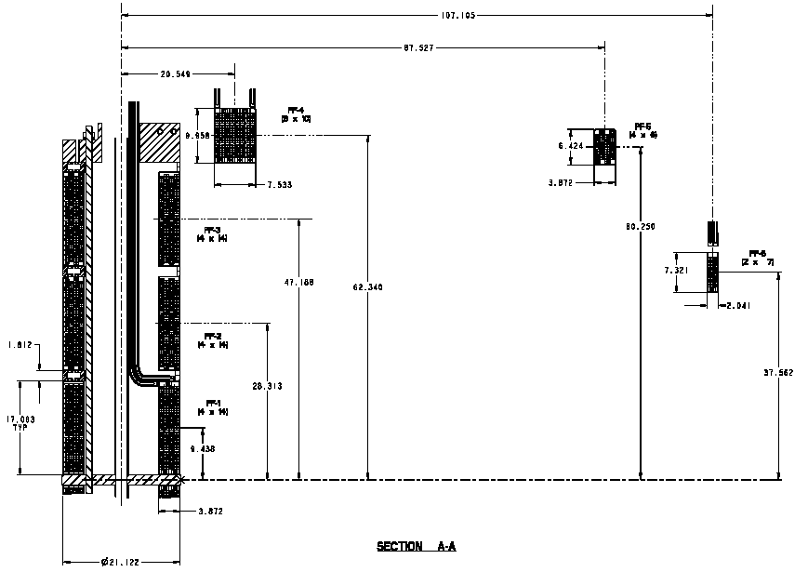
Fig. 4.2-1 PF System General Arrangement (PPPL drawing se-132-000)

Table 4.2-1 Coil Centers and Dimensions (taken from PPPL drawing se-132-000)
PF | Conductor Array  Radial x Vertical | Radial Center  [in.] | Vertical Center  [in.]
1 | 4x18 | 8.625 | 9.438
2 | 4x18 | 8.625 | 28.313
3 | 4x18 | 8.625 | 47.188
4 | 8x10 | 20.549 | 62.340
5 | 4x6 | 87.527 | 60.250
6 | 2x7 | 107.105 | 37.562

Fig. 4.2-2 Elevation View of PF Coil Layout
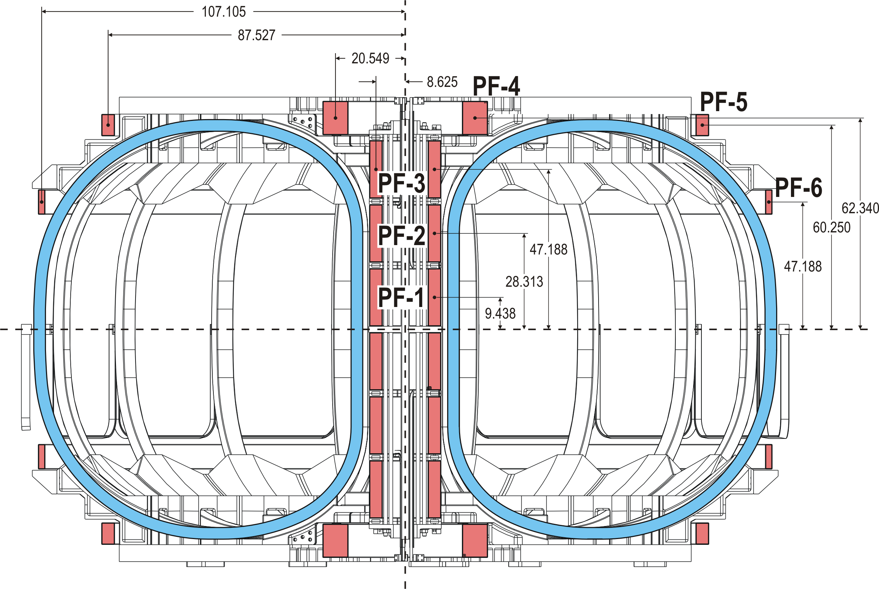
Note: PF6 vertical center mistakenly listed as 47.188” is really 37.562”
4.3 Current Scenarios (http://ncsx.pppl.gov/NCSX_Engineering/Requirements/Specs/GRD/Rev1/TDS_XL_C08R00_c3.pdf)
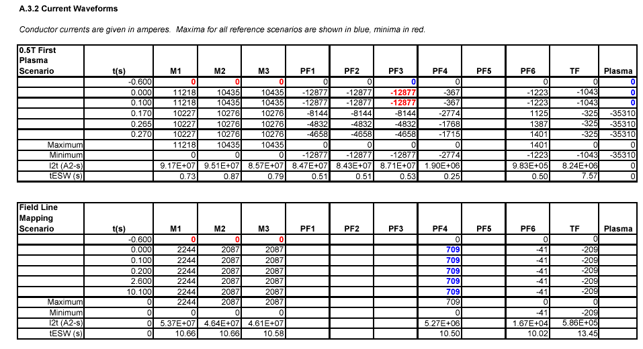
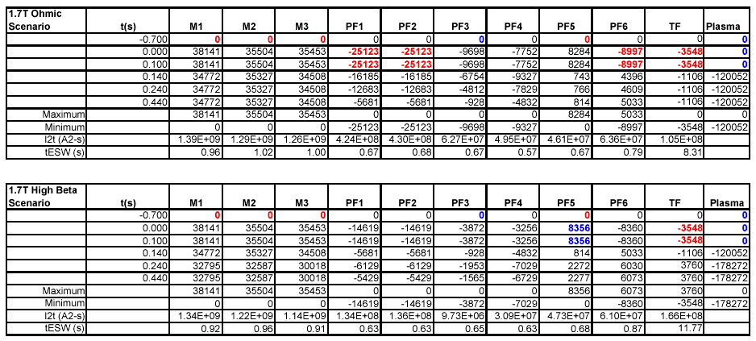
4.3 Current Scenarios, continued
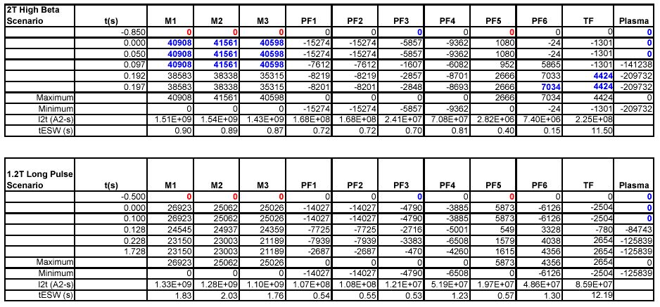

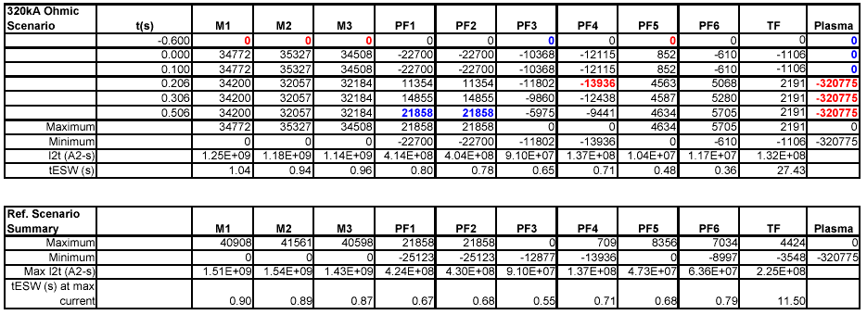

Leonard Myatt, “Electromagnetic Stress Analysis of the NCSX TF and PF Coil Systems,” 09/24/03.
ANSYS Release 8.0, UP20030930, INTEL NT, ANSYS, Inc., Canonsburg, PA.
Leonard Myatt, “Insulation Shear Stresses in the Central Solenoid,” 12/10/03.
Irving Zatz, (PPPL) “NCSX Structural Design Criteria,” 5/13/02.
H.M. Fan, ANSYS database from ftp://ftp.pppl.gov/pub/hmfan/ncsx-pftf/file-1.7T.db
PPPL drawing se132-000, PF System General Arrangement.
http://ncsx.pppl.gov/NCSX_Engineering/Requirements/Specs/GRD/Rev1/TDS_XL_C08R00_c3.pdf
Chang Jun, "ANSYS Modeling to obtain Equivalent Moduli of Elasticity of PF & TF Coils of NCSX," 06/27/03.
M. B. Kasen, et. al., “Mechanical, Electrical, and Thermal Characterization of G-10CR and G-11CR Glass-Cloth/Epoxy Laminates Between Room Temperature and 4K,” NBS, Boulder, CO, Advances in Cryogenic Engineering Materials, Vol. 26, 1980.
E.S. Drexler, et. al., “Shear-Compressive Properties of Vacuum-Impregnated Insulation at 76K,” NIST, Boulder, Co, ICMC-Kiev, 1992.

