NCSX
Design Basis Analysis

Modular Coil Eddy Currents Time Constant

NCSX-CALC-14-06

31 March 2008

Prepared by:

_______________________________________
Art Brooks, Engineering Analyst

I have reviewed this calculation and, to my professional satisfaction, it is properly performed and correct. I concur with analysis methodology and inputs and with the reasonableness of the results and their interpretation.

Reviewed by:

_______________________________________
David Williamson, ORNL

Controlled Document
THIS IS AN UNCONTROLLED DOCUMENT ONCE PRINTED.
Check the NCSX Engineering Web prior to use to assure that this document is current.

Initial results, 10 October 2002:

Figures 1-3 and Table-1 show a summary table along with some pictures of the SPARK analyses to-date on the Modular Coil Support Structure.

It appears we can get to a time constant of 17.0 ms using one poloidal break at the outboard mid-plane along with toroidal breaks at each of the flanges. If we don't insulate the construction joint, we pay only a small penalty raising the time constant to 17.7 ms.

Note however the modeling of the break at the flanges was done by splitting thru the entire structure at each radial plane. This produced multiple cuts in the Tee sections which cross the flanges.

Analysis Update, 16 October 2002:

Figures 4-9 show the results of an update to the SPARK Model of the Modular Coil Support Structure to remove the multiple cuts thru the tee section. The model now reflects the "wings" from each casting extending past the flanges and nesting into the adjoining casting. The wings and flanges are assumed electrically isolated except at the construction joint. ( see the exploded view, Fig. 5 ). The poloidal cut is also more representative of it's location in the ProE model.

The slowest time constant has increased only slightly from 17.7 ms previously reported to 18.5 ms. That number does not include the copper cladding which was considered separately.

A first estimate of the effect of the cladding was made by modeling it by itself. With only the one poloidal break in the Tee, the time constant is 26.9 ms for 2 mm cladding on each surface ( rho = .3e-8 W-m ). This would drive the overall time constant up. Cutting the cladding has very little impact unless the distance between cuts is smaller than the 12 cm height of the tee web. To reduce the time constant of the cladding to the point where it has negligible impact on the overall time contant, radial cuts in the cladding must be made approxiamtely every 6 cm or so.

The full SPARK model of the Modular Coil Support Structure did not lend itself to easily adding the cladding cut so finely, so a simplified model was made to understand how the time constants add (see figures). If the time constants of the separate structures were comparable, combining them resulted in an overall increase in time constant of 11%. If the cladding time constant is much less, the impact on the combined time constant is substantially reduced.

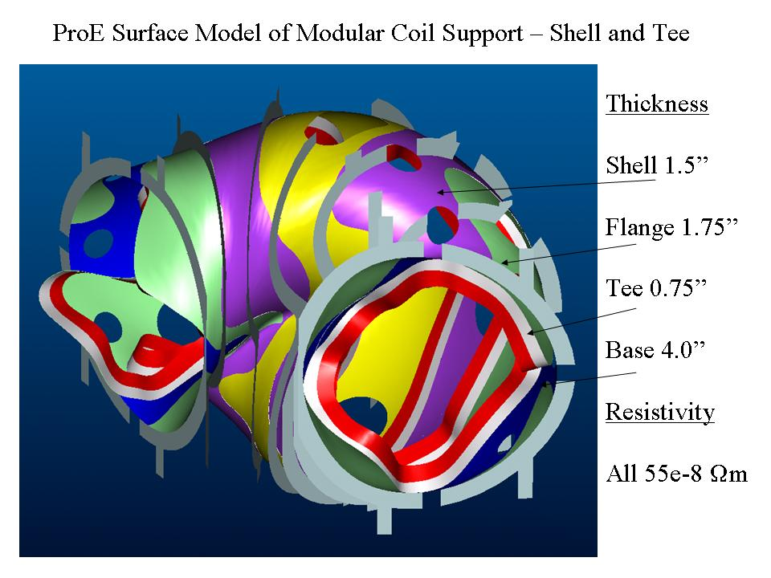
Fig. 1 – Pro/ENGINEER Model of Modular Coil Support Structure

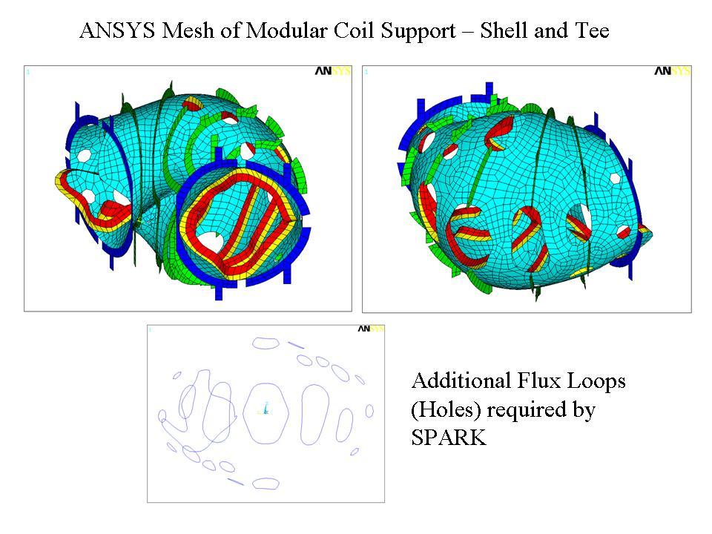
Fig. 2 – ANSYS Mesh of Support Structure

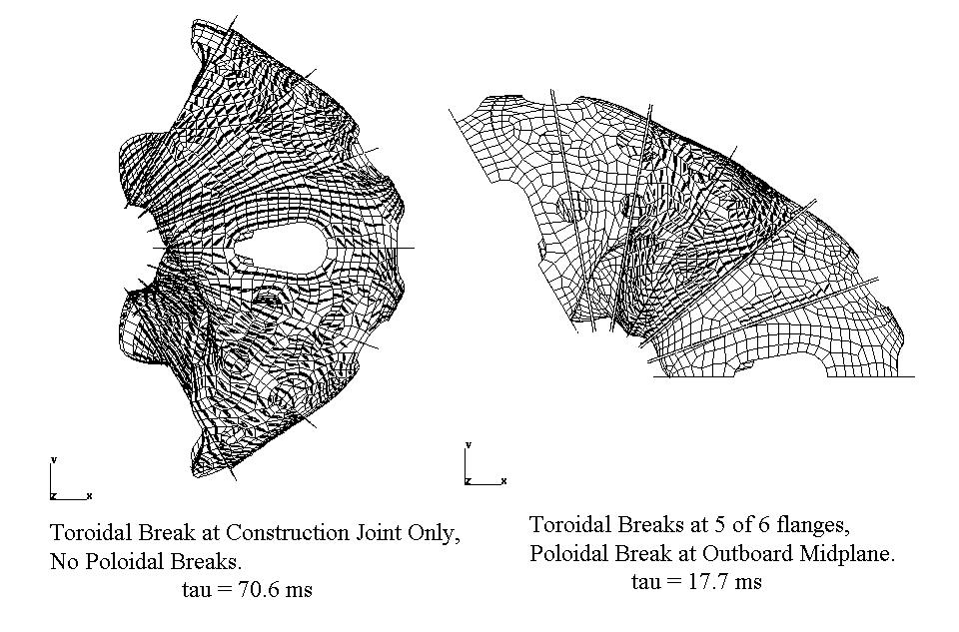
Fig. 3 – SPARK Eigenmodes for Two Configurations

Table 1 – SPARK Results Summary
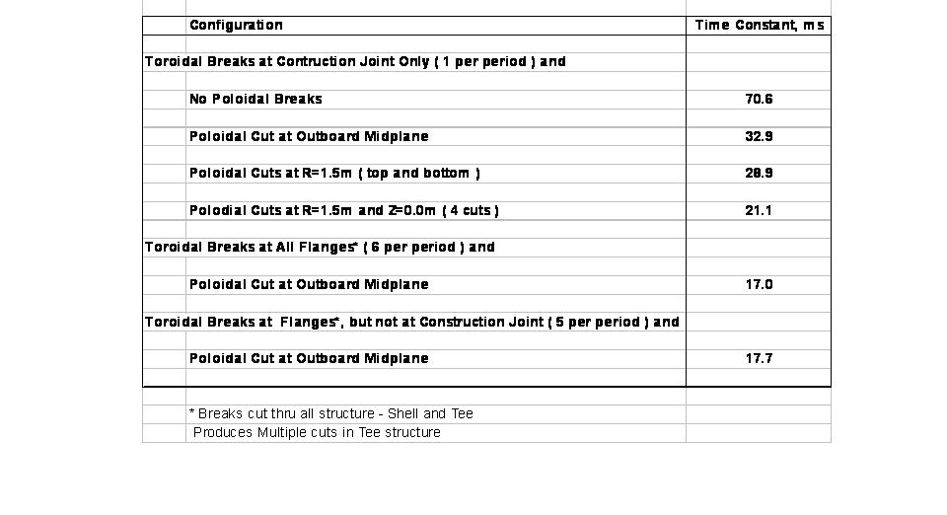

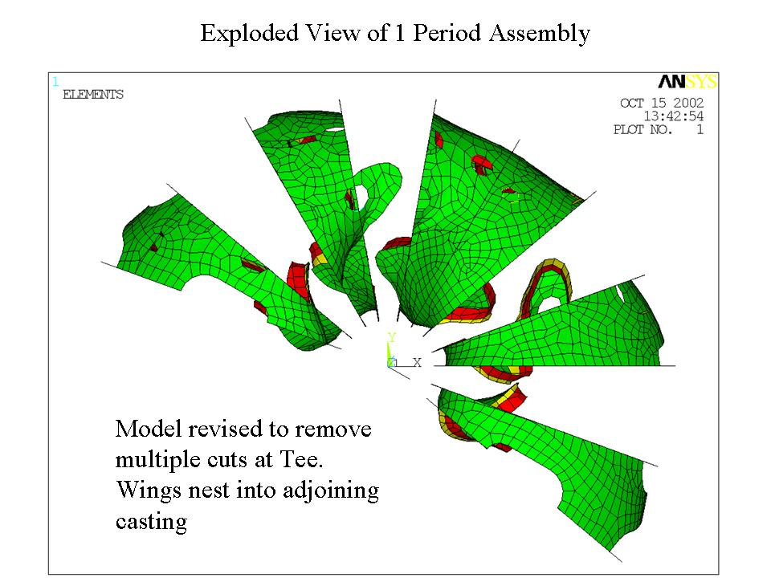
Fig. 4 – Exploded View of Field Period Assembly

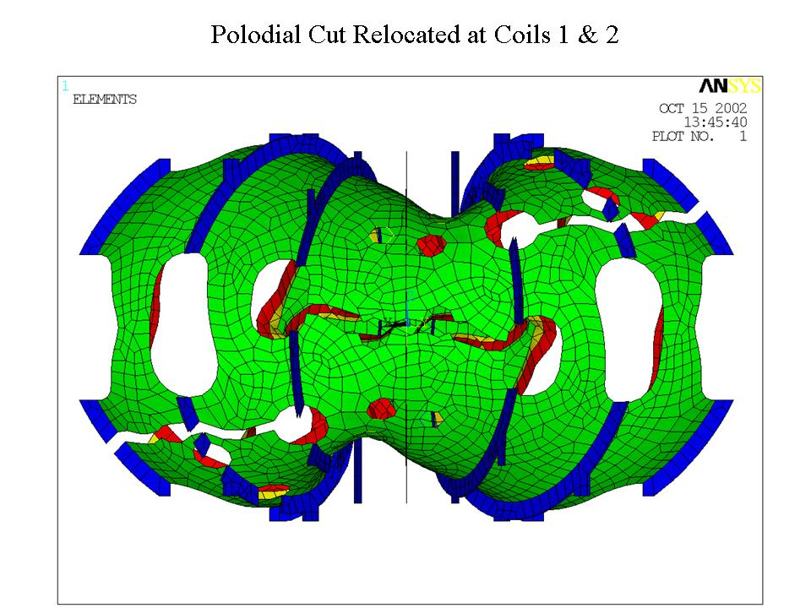
Fig. 5 – Poloidal Cut Between Coils 1 and 2

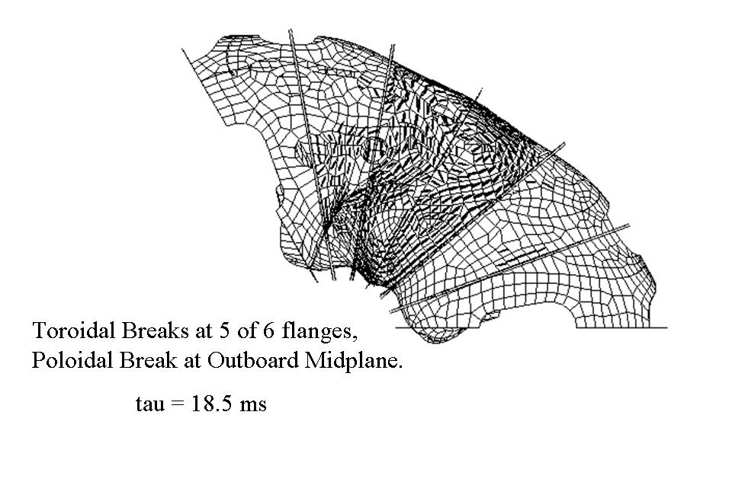
Fig. 6 – SPARK Eigenmode for Slowest Time Constant

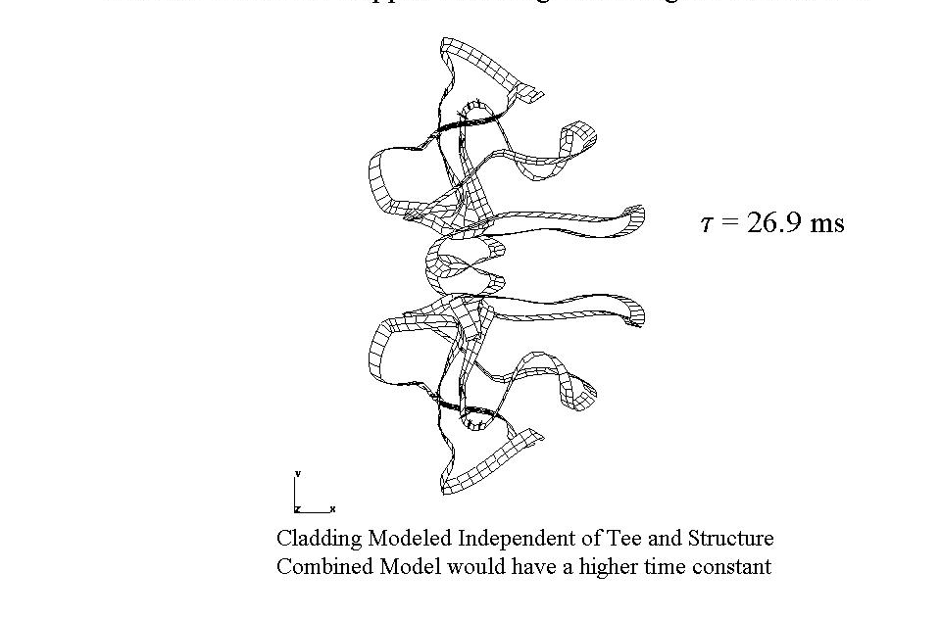
Fig. 7 – SPARK Model of Copper Cladding w/ Single Poloidal Cut

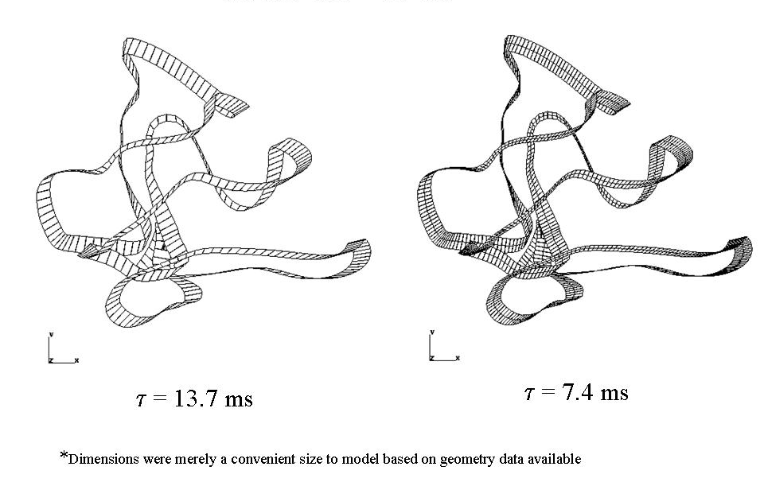
Fig. 8 – SPARK Model of Cladding w/ 5.8-cm Cuts

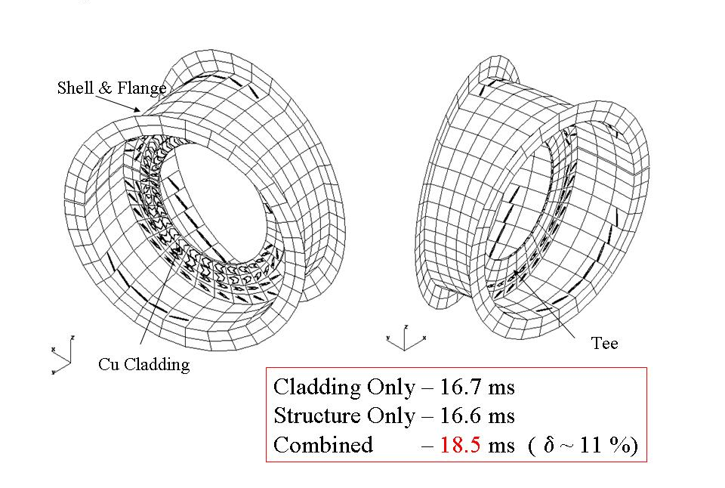
Fig. 9 – Simplified Eddy Current Model

