NCSX
Design Basis Analysis

Modular Coil Lead Thermal Analysis

NCSX-CALC-14-010-00

5-Sept 2008

Prepared by:

_______________________________________
K. Freudenberg, ORNL

I have reviewed this calculation and, to my professional satisfaction, it is properly performed and correct. I concur with analysis methodology and inputs and with the reasonableness of the results and their interpretation.

Reviewed by:

_______________________________________
D. Williamson, ORNL
Controlled Document
THIS IS AN UNCONTROLLED DOCUMENT ONCE PRINTED.
Check the NCSX Engineering Web prior to use to assure that this document is current.
Record of Revisions
Date | Revision | Description
September 5, 2008 | 0 | Initial Issue

Table Of Contents
I. Executive Summary 1
II. Assumptions 1
III. Analysis Methodology and Inputs 1
Software and data files 1
Drawings and models 2
Material properties 2
Model setup 2
Thermal analysis setup 4
IV. Results 5
V. Discussion 7
Appendix: Modular coil cooling Analysis: for reference only. 8

I. Executive Summary

The purpose of this analysis is to examine the heat transfer characteristics of a local model of the lead area of the modular coil during and after an operational pulse. Each pulse generates a tremendous amount of heat in the winding coils that must be removed by cooling tubes in the lead block such that the lead area return to a baseline cryogenic temperature of about 90 K (-183 C) within 15 minutes.

II. Assumptions
- Initially temperature of all components = 80 K (-193C)
- Heat from the pulse is imposed as a uniform volumetric heat generation (6.67 E7 W/m³ for 1 sec). on the Cu/epoxy winding pack.
- Heat transfer from/to the other copper jumpers is ignored since relatively thick pieces of G10 insulate them.
- Heat is also generated in the copper jumper and end copper connections. Heat generation terms of 5.84E6 W/m3 and 2.64E6 W/m3 are applied to the copper end connector and the copper jumper, respectively, for one second. This corresponds to 4.16 KAmps/turn at 2 Tesla for the winding. The heat gen applied to the copper pieces are estimated on the high side as they were calculated with the max area available, (no holes, radius included).
- Cooling from the fluid in the tubing is imposed as constant temperature of 80 K (-193 C) throughout the 15 minute cycle(s).
- Radiation exchange with other surroundings is negligible.
- Material properties are temperature dependent (see table below in material property section)

III. Analysis Methodology and Inputs

For this study, the maximum temperature of the coil must return to approximately the same starting temperature of 80 K after 15 minutes. Although, there is no definitive temperature limit defined, it is generally accepted that the temperature should reach steady state equilibrium of less than 95 K in the windings when considering ratcheting temperatures after each successive pulse. This ensures that the liquid Nitrogen in the cooling tubes will not see a large delta T across its outer boundary and thus boiling will not occur. To be conservative the same temperature limit is applied to the lead area. The model is a representative 3d section of the lead area consisting of cladding, copper blocks, winding and insulation for a half of a jumper connection.

Software and data files
The model is constructed in Ansys 11.0 and all of the preprocessing and post processing is done within the Ansys Workbench environment.

Drawings and models
ProE model SE142C-050 was used to create the ANSYS model s in this study.

Material properties
The temperature dependent material properties are listed in Table 1. For modeling and meshing purposes it is necessary to model the epoxy layer between the copper chill plates and the copper triangular piece as thicker than it is in reality. Otherwise, an extremely large mesh is produced. The glue is 0.05” thick in the model and is approximately 0.02”. Thus, the conductivity has been multiplied by 2.5 to account for this scaling factor.

Table 1: Material property data
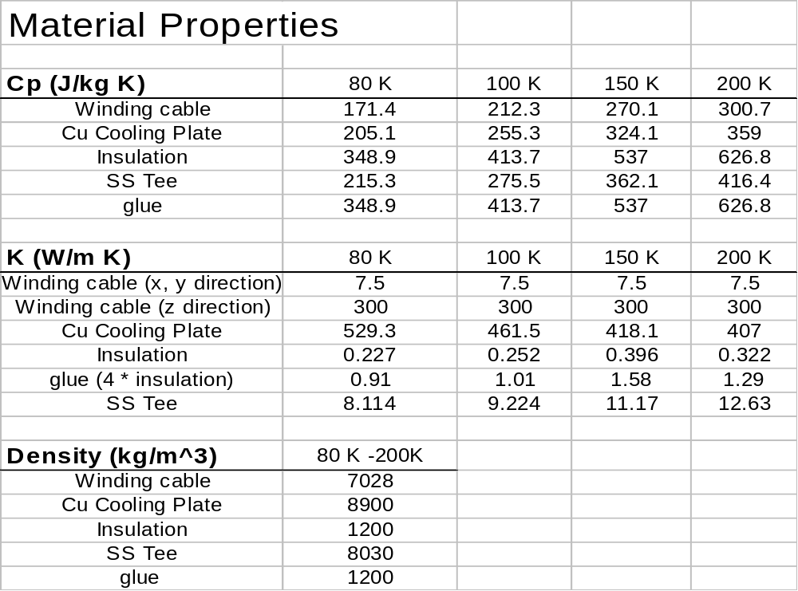

Model setup

- The Cad models and the real world lead region pictures are also shown in Figure 1 for reference. Only half of the lead terminal area is modeled as it is symmetric about its central axis. A detailed view of the elements and model are shown below in Figure 2. There is some question as to the thickness of the epoxy layers in the lead region. The manufacturing plan is to have the copper cladding touch the copper triangular piece with little to no gap between the to of them. There is most likely a slight gap between the two pieces that the epoxy would be pumped into during potting. To be conservative this gap is estimated at a rather large0.02". The other interface where uncertainty arises is the contact between the winding insulation and the vertical copper piece. Here, the thermal contact resistance is estimated at a conservative 10e-4 m^2-K/W. (ref Fundamentals of Heat and Mass Transfer, 4th ed, 1996 pg 81).

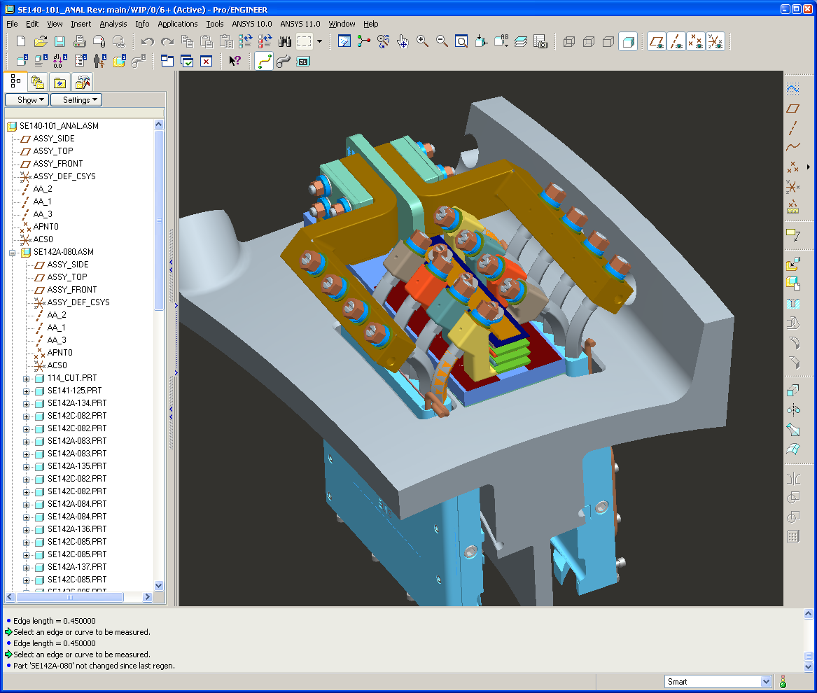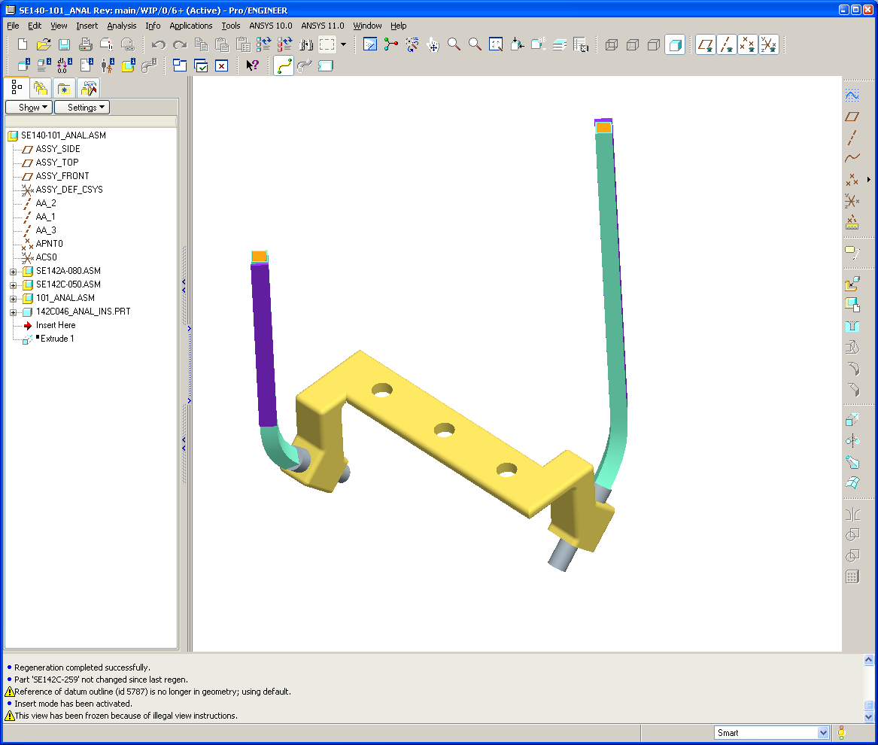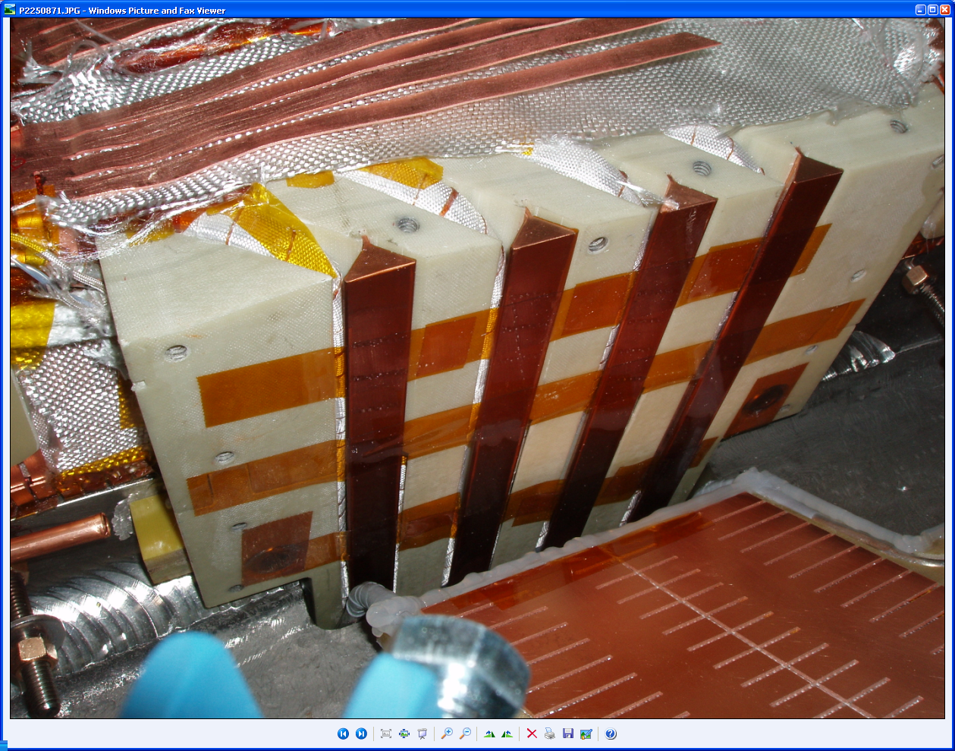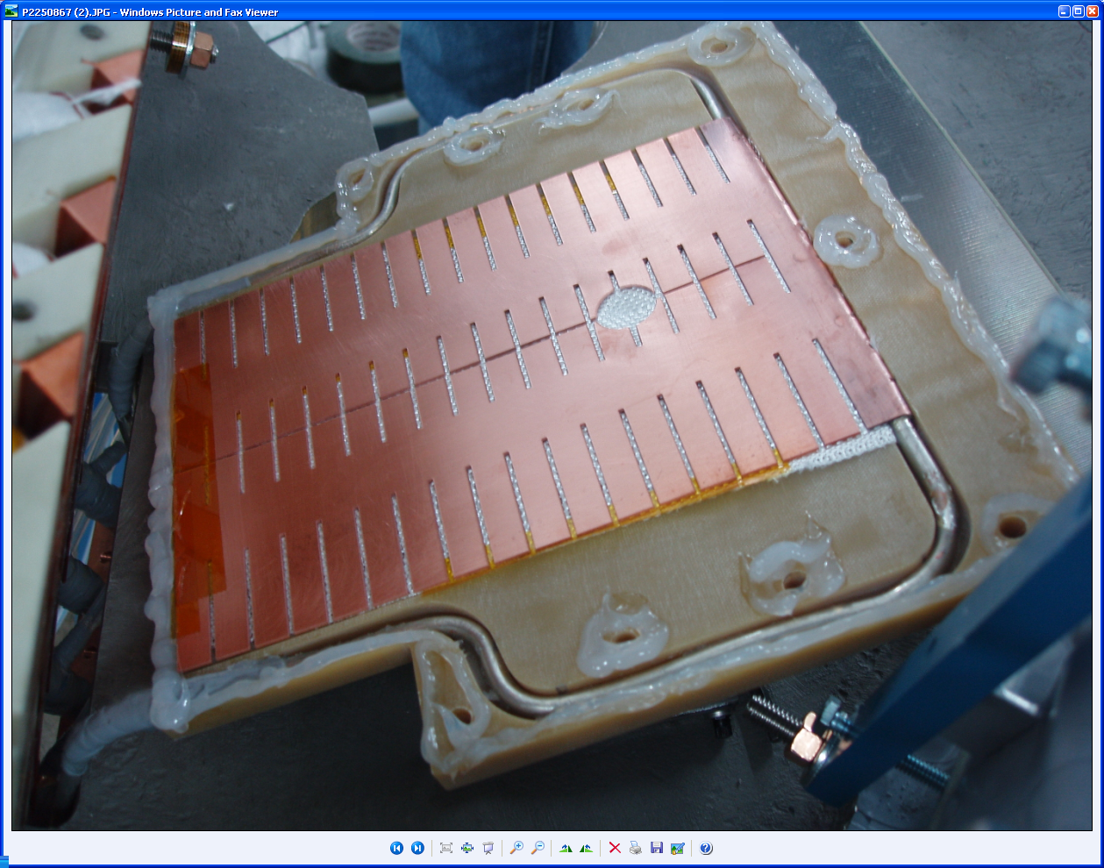
Cad Model of Leads
Actual Built lead area
Single jumper isolated in CAD
Cladding and Cooling Tube
Figure 1: Cad and real world views of lead area

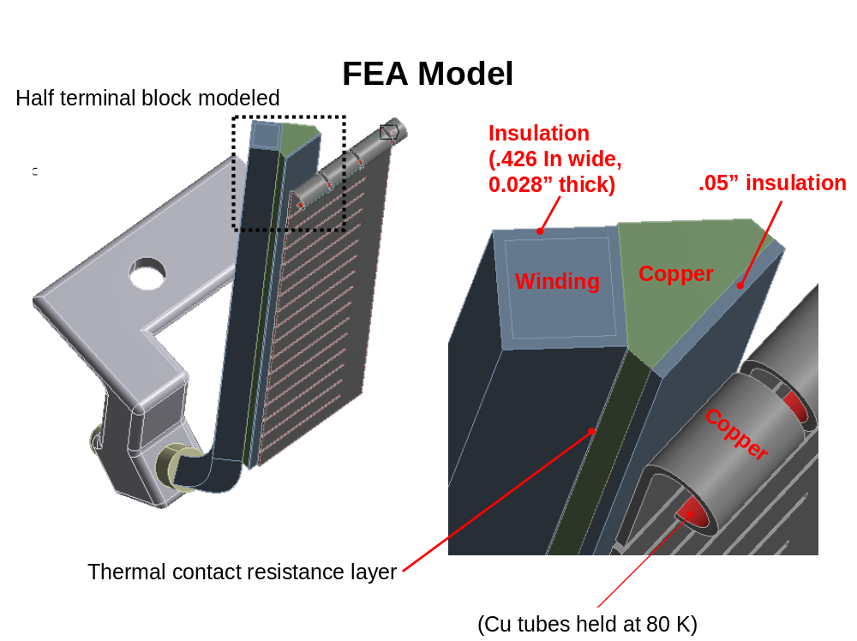
Figure 2: FEA Model and Mesh

Thermal analysis setup

A transient thermal analysis was run on the representative lead section shown above. Initially, all temperatures are set to -193 C (80 K), cryogenic conditions. The heat generation term of 6.67E7 W/m³ is applied to the winding cables for one second and then the model is allowed to cool by means of a constant temperature of -193 C (80 K) applied to the cooling tube pad area on the cladding, indicted in Figure 2, for 15 minutes. The process is then repeated with the final nodal set temperature from the previous 15 minute cycle used as the beginning temperature set of the next cycle. This process is carried out for 10 cycles so that a steady state equilibrium can be reached and the effect of ratcheting is known.

IV. Results

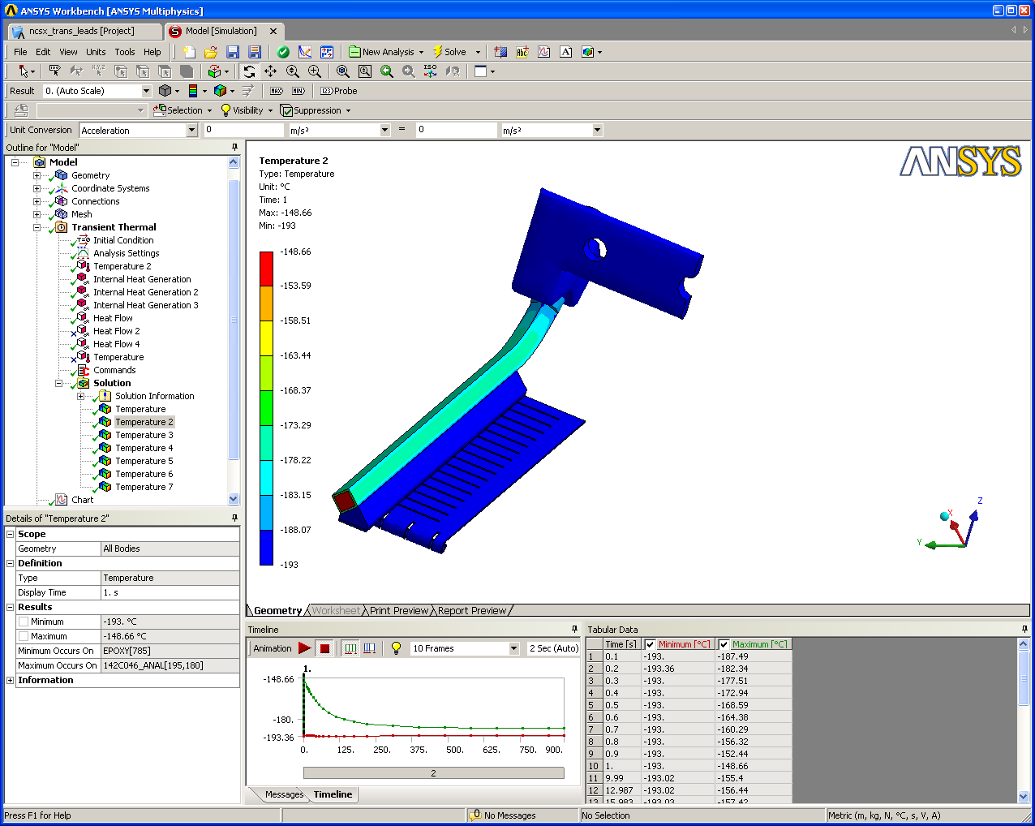
Conductor sees a 44 K rise
Terminal block rises by 3.6 degrees
Figure 3: Model temperature distribution after 1 second.

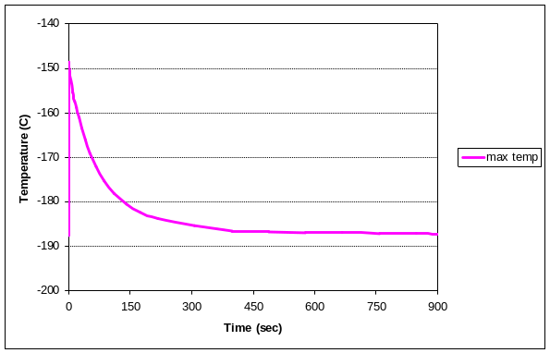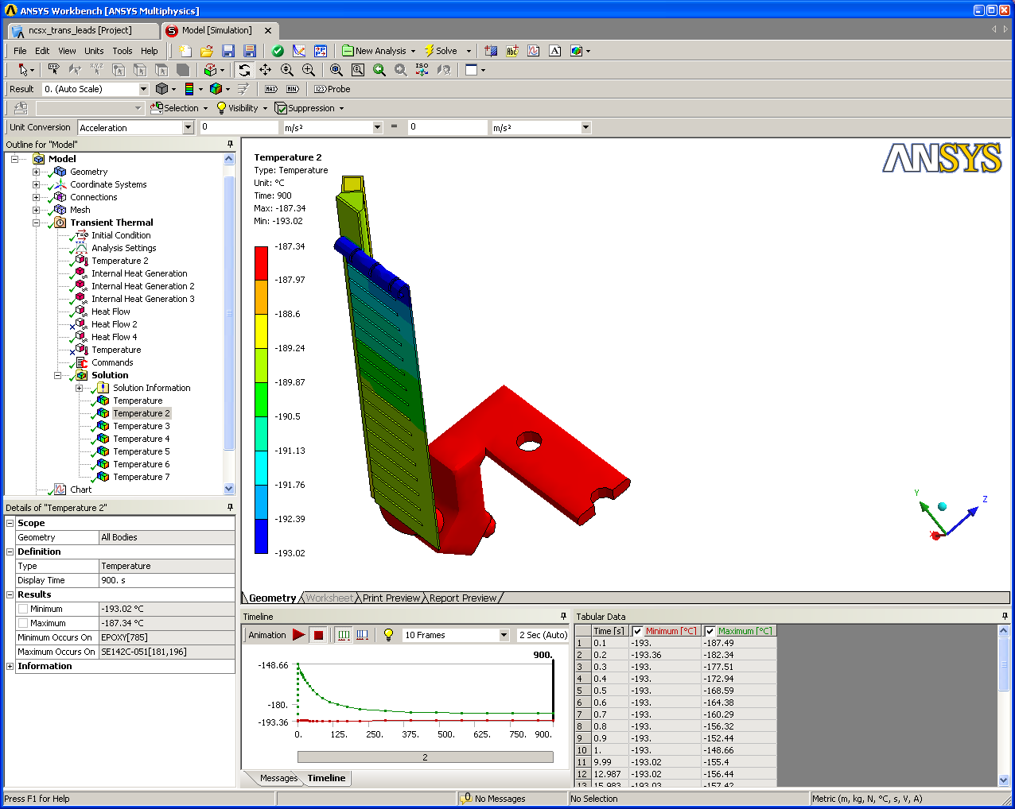
After 15 mins the model cools to -187.3 C (delta T of 5.7 degrees)
Figure 4: Model temperature and profile distribution after 15 minutes.

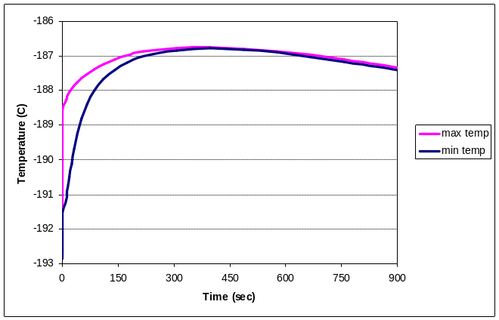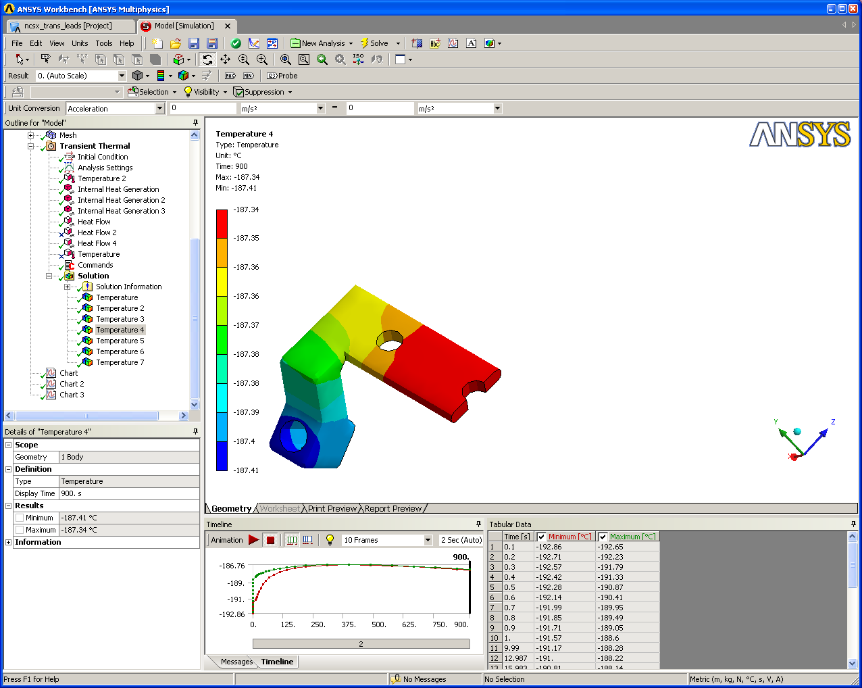
Temperature rise less than 7 degrees for the jumper but there is very little cooling from conduction here.
Figure 5: Jumper temperature and profile distribution after 15 minutes.

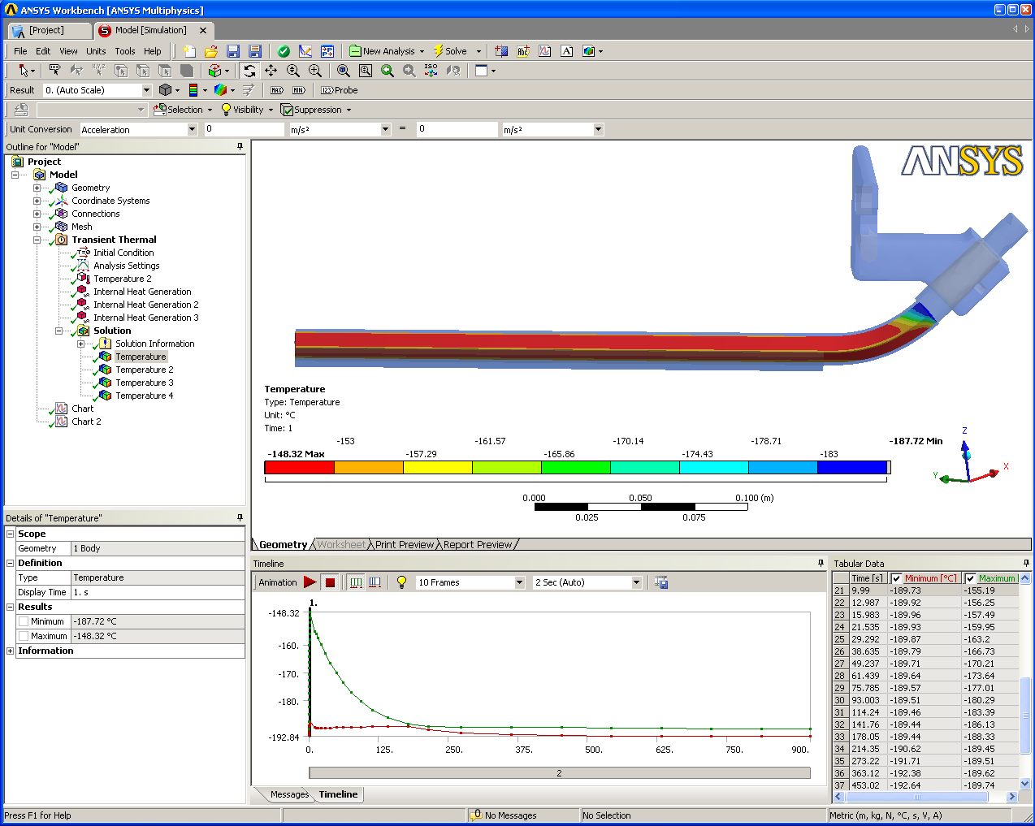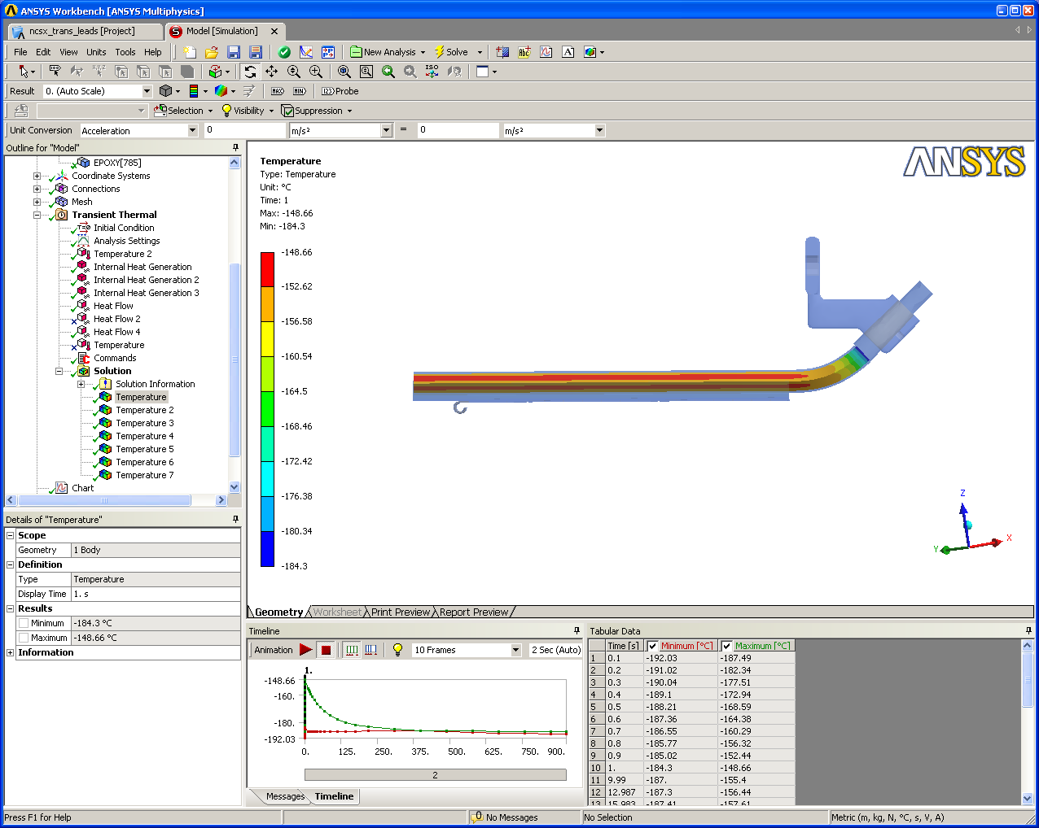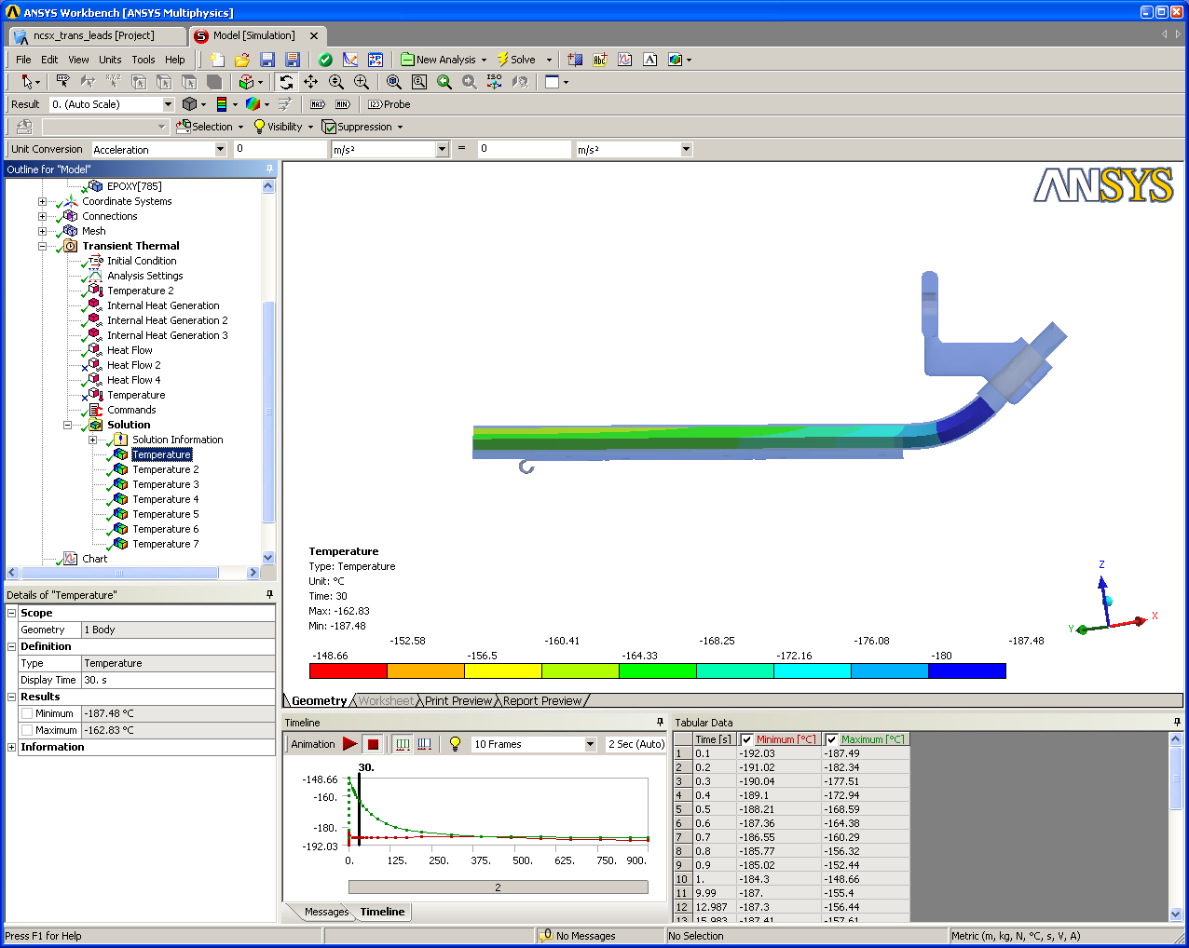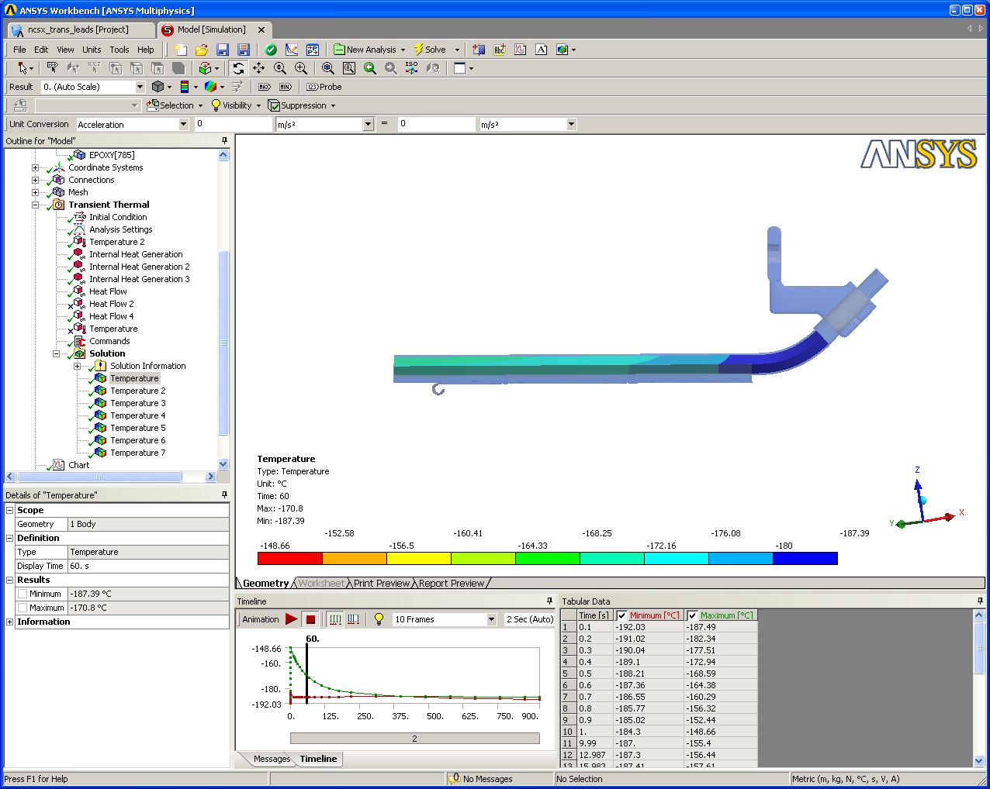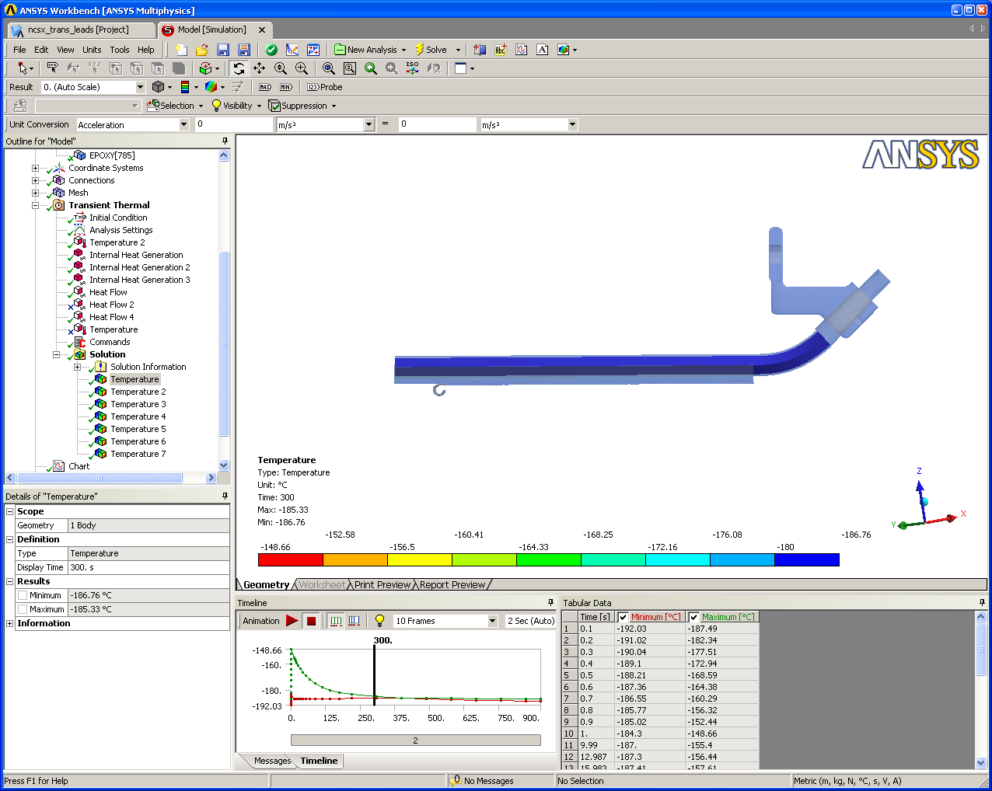
T = 1 sec
T = 30 sec
T = 60 sec
T = 300 sec
Figure 6: Winding distribution doing the first pulse and cool down.
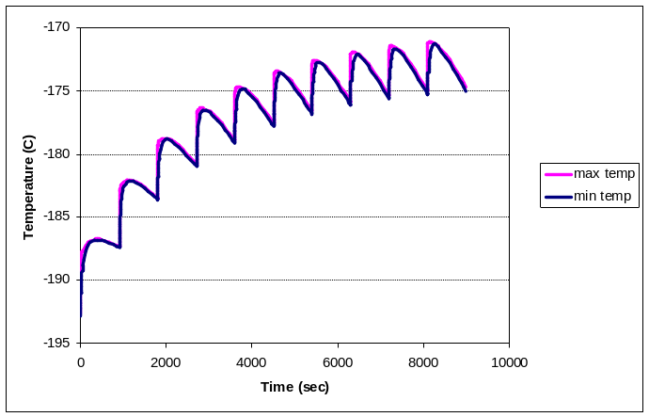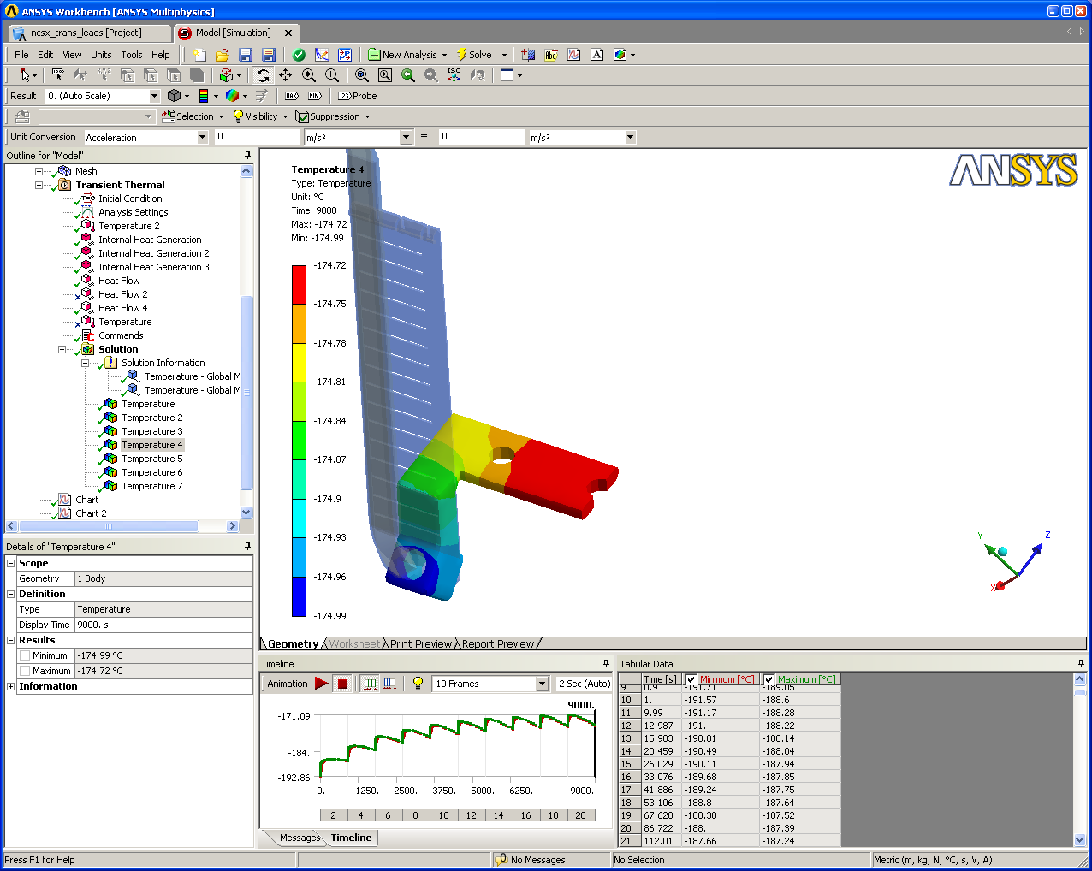
The Ratchet is about 20 degrees after the 10th cycle.
The curve is beginning to level off after the 8th cycle.
Figure 7: Ratcheting of lead jumper

V. Discussion

- Questionable contact between copper strip and winding cable shown in picture. A conservative contact resistance was used to model this interface.
- A conservative epoxy thickness was also used between the claddings and the triangular copper strips, who may in fact be pressing against each other in reality with little to no epoxy separating them.
- The entire model cools to within 5 degrees after the first shot but the terminal only cools by 0.5 degrees from its peak value after the shot.
- The ratchet is only 20 degrees for the terminal after 10 cycles and begins to reach equilibrium after about the 8th cycle.
- In order to eliminate the heat ratcheting we would have to actively cool the leads by dripping LN2 over them or by allowing convection (forced or natural) around the lead region. However, any amount of convective cooling coefficient would help.
- Given that the modular coil itself (shown in the Appendix) ratchets by 12 degrees, the lead area may be acceptable as currently designed as it only ratchets by 20 degrees.
- A future effort would be to include the cooling from the windings if the temperature rise is deemed unacceptable. This could be done by extending the winding form in this model, then mapping the cool down to the end of it.

Appendix: Modular coil cooling Analysis: for reference only.

The results from the earlier modular coil analysis are shown below in Figures 8-10.

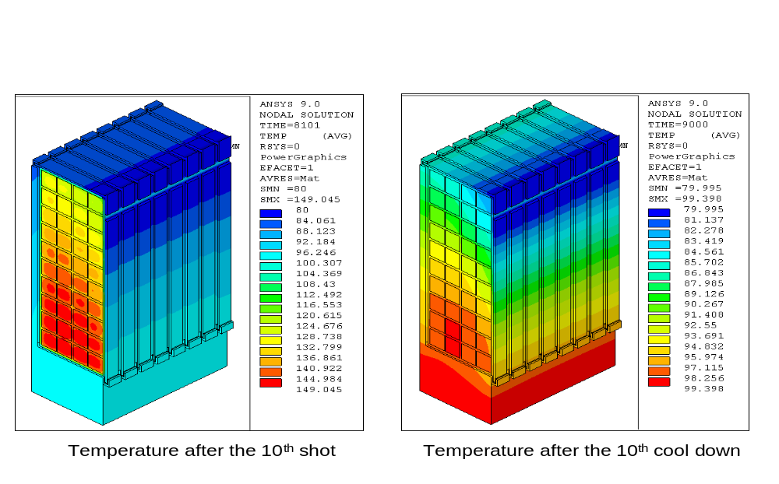
Figure 8: Temperatures during the 10th shot for a 15 minute cool down period
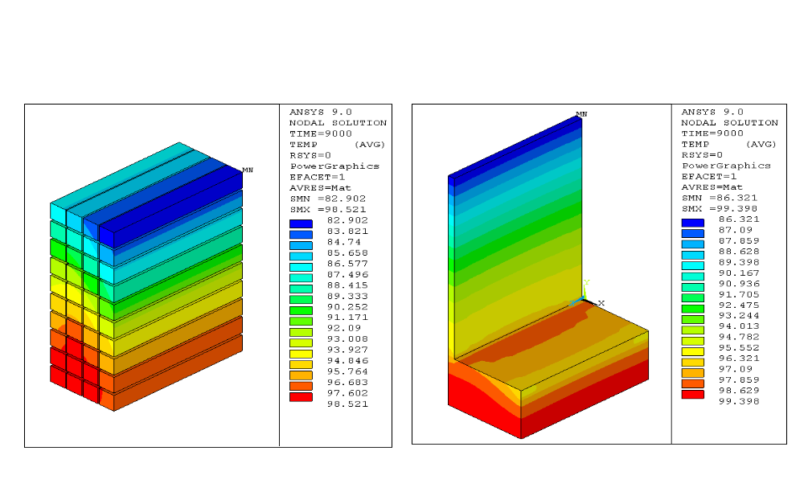
Figure 9: After 10th cycle fro a 15 minute cool down period (winding and tee isolated)

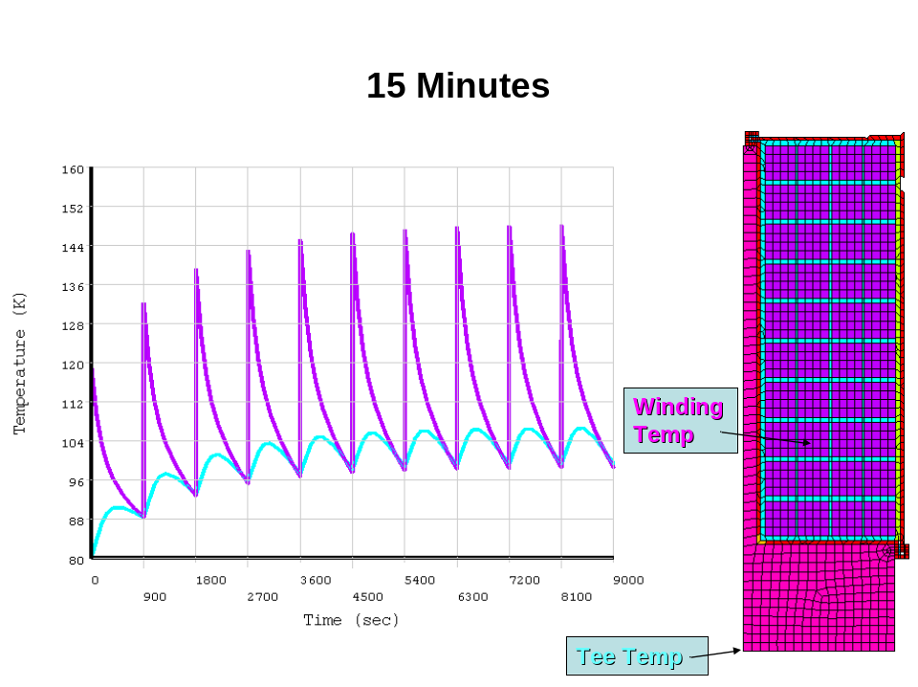
Figure 10: Temperatures ratcheting for a 15 minute cool down period

