NCSX Fueling and Vacuum
SC Project Review of NCSX, April 8-10, 2008
Pumping Systems
W. Blanchard
WBS 21 and 22 Manager

- Differentially pumped RGA
Design Features
- Two legacy 1500 l/s TMPs
- System monitored, controlled
and interlocked using a PLC
Requirements
- Minimum effective pumping
speed of 1300 l/s
Interfaces
- Design consists of one
pumping duct off of one NB
transition piece and a vertical
24” duct
VACUUM PUMPING SYSTEM
SC Project Review of NCSX, April 8-10, 2008
W. Blanchard - page 2
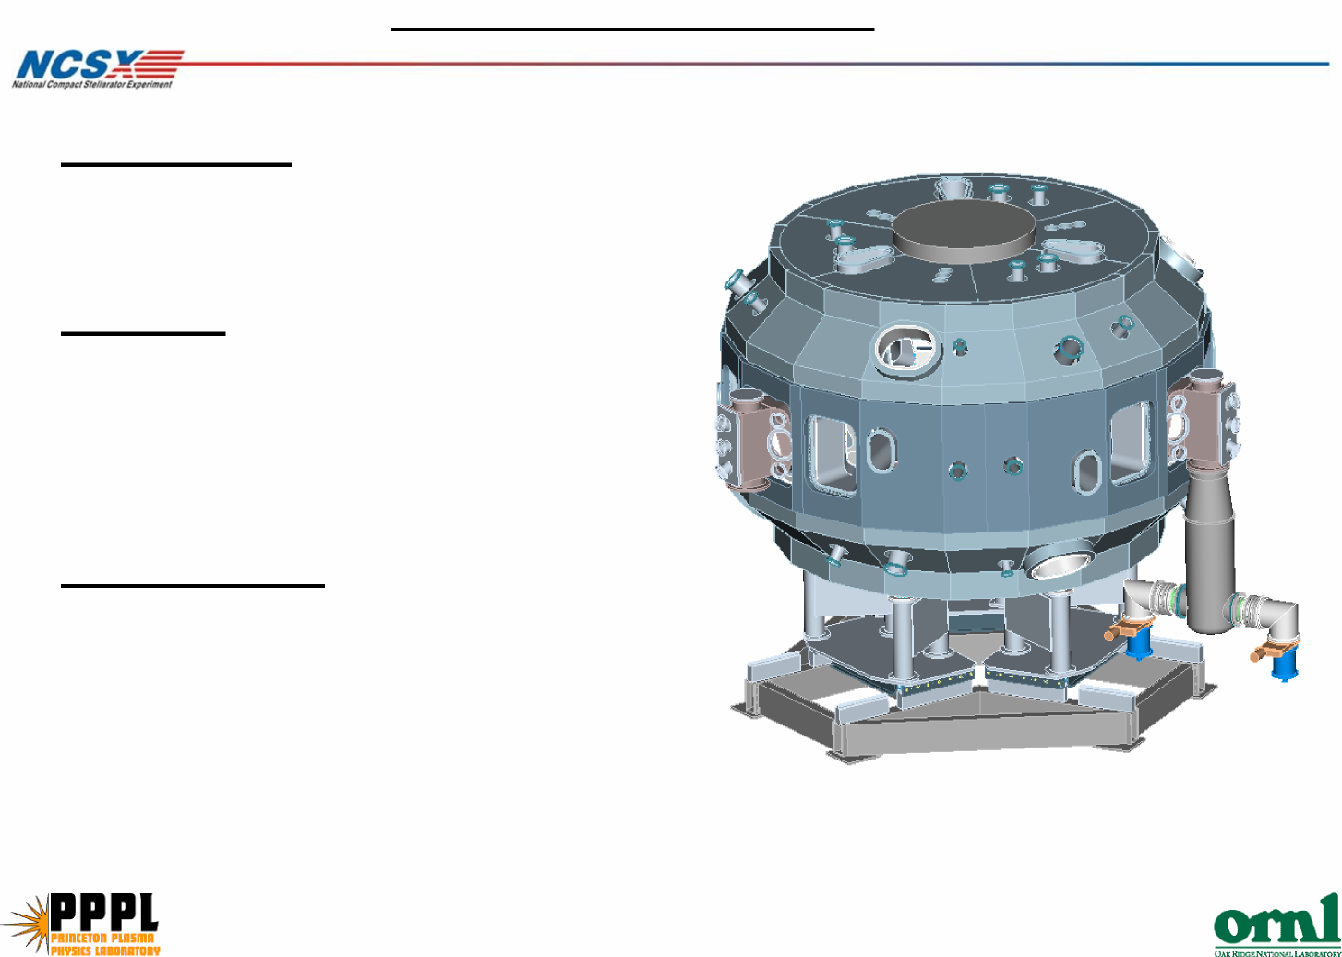

 |  | $ |  |  |  |  |  |  | Hours
Task ID
Title I and II Design
Preliminary Design / Management / Admin
 | Engr Work Planning & Design |  | 180
 | Design Hardware |  |  |  |  | 80
 | Design PLC Controls |  |  |  |  |  |  |  |  |  |  | 336
 | Testing Equipment |  |  |  |  | 88
 | Drafting Support (Electrical) |  |  |  |  |  |  | 160
 | Drafting Support (Mechanical) |  |  |  |  |  |  | 20
Final Design / Management / Admin
 | Engr Work Planning & Design |  | 220
 | Mechanical Design |  |  |  |  | 88
 | Design PLC Controls |  |  |  |  |  |  |  |  |  |  | 336
 | Electrical Design |  |  |  |  |  |  |  |  |  |  | 64
 | Electrical Design/Drafting |  |  |  |  |  |  |  |  | 272
 | Drafting Support (Mechanical) |  |  |  |  |  |  |  |  | 60
Subtotal Title I & II Design |  |  | 400 | 0 |  | 256 | 0 | 180 |  | 332 |  | 736 | 0 |  | 0 |  | 0
Title III
 | Engr Work Planning & Design |  | 120
 | Maint/Repair Mech Pumps |  |  |  |  | 80
 | Repair/Cal. Instrumentation |  |  |  |  | 80
 | Electrical Installation |  |  |  |  |  | 668
 | Fabricate/Install Hardware |  |  |  |  | 120 | 520
 | Fabricate/Install PLC Controls |  |  |  |  |  |  |  |  |  |  | 352
 | Integrated System Testing |  | 40 |  |  |  |  |  |  |  |  | 80
 | Materials and Supplies | $ 118,000
Subtotal Title III |  | $ 118,000 | 160 |  | 0 | 280 | 1188 |  | 0 |  | 0 | 432 |  | 0 |  | 0 |  | 0

Cost Estimate
SC Project Review of NCSX, April 8-10, 2008
W. Blanchard - page 3
* Based on NSTX costs for system which is similar to the proposed NCSX design * Input from engineers and personnel familiar with various parts of the project

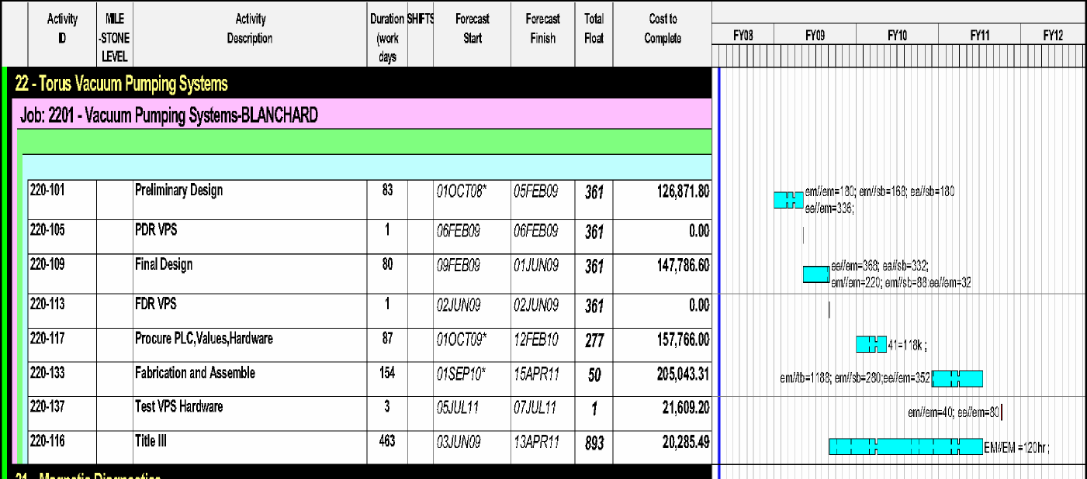
Project Schedule
SC Project Review of NCSX, April 8-10, 2008
W. Blanchard - page 4
'Design in FY09, procurements in FY10 and fabrication/installation in FY11

Uncertainty of the Estimate
 |  |  | High | Medium | Low | Uncertainty | Comments/Other Considerations
 |  |  |  |  |  | Range (%)
 | Design Maturity |  |  |  | X |  | There have been no design reviews therefore the design is not fixed.
 |  |  |  |  |  | -1 5%/+25%
 | Design Complexity |  |  |  | X |  | Anticipated to only require standard components
 | Other Comments:

Risk Assessment: Low
SC Project Review of NCSX, April 8-10, 2008
W. Blanchard - page 5
Risk:
* Equipment or component failure
Mitigation:
* All components outside of coils and cryostat and easily accessible * Standard equipment and hardware
* Replacement parts for major components in-house

- Pulse valve controlled from central computing
- System monitored, controlled and interlocked using a PLC
Interfaces
- Injectors located at the three upper P12 port covers
Design Features
- Includes gas delivery manifold, pumpout system and gauging
Requirements
- Three gas injection systems with each injector having a maximum flow rate >50 T-l/s
FUELING SYSTEM
SC Project Review of NCSX, April 8-10, 2008
W. Blanchard - page 6
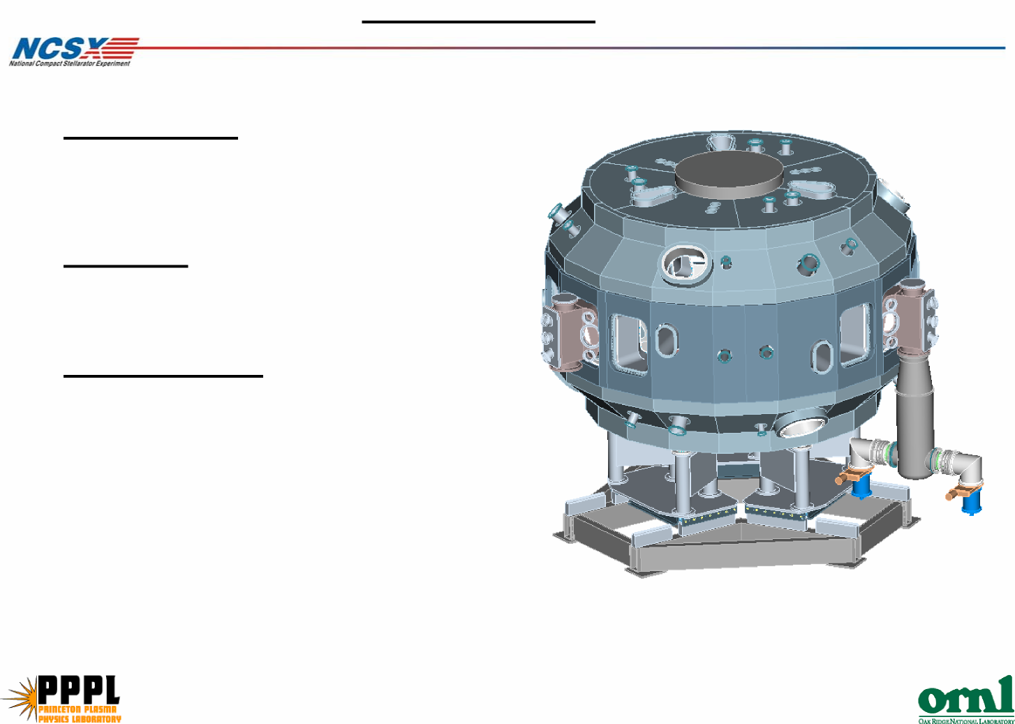

$
Task ID
Hours
Cost Estimate
* Based on NSTX costs for system which is similar to the proposed NCSX design * Input from engineers and personnel familiar with various parts of the project
80 0 120 528 0 272 0 0
40 80
192
288
120 240
40
136 0 144 0 236 560 0 0
68
144
Materials and Supplies $ 38,000
Subtotal Title III $ 38,000
Integrated System Testing
Install PLC Controls
Fabricate & Install Hardware (Electrical)
Fabricate & Install Hardware
Engr Work Planning & Design
Title III
Subtotal Title I & II Design
Drafting Support (Mechanical)
Drafting Support (Electrical)
Design PLC Controls
Design Gas handling Hardware
Final Design / Management / Admin Engr Work Planning & Design
Drafting Support
Design PLC Controls
Design Gas handling Hardware
Title I and II Design
Preliminary Design / Management / Admin
Engr Work Planning & Design
FUELING SYSTEM
SC Project Review of NCSX, April 8-10, 2008
W. Blanchard - page 7
48
88
24
96
48
448
112
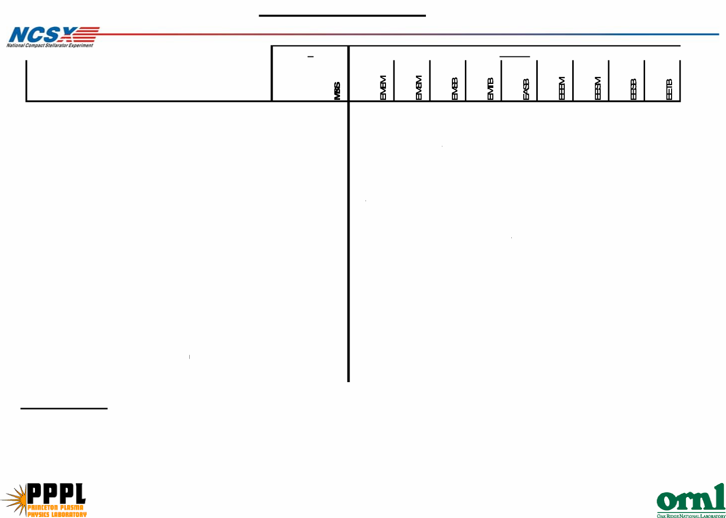

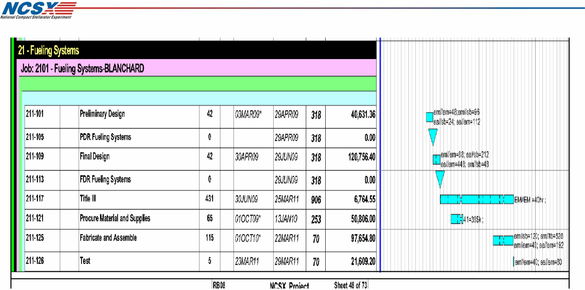
Project Schedule
SC Project Review of NCSX, April 8-10, 2008
W. Blanchard - page 8
Design in FY09, procurements in FY10 and fabrication/installation in FY11

Uncertainty of the Estimate
 |  |  | High | Medium | Low | Uncertainty | Comments/Other Considerations
 |  |  |  |  |  | Range (%)
 | Design Maturity |  |  |  | X |  | There have been no design reviews therefore the design is not fixed.
 |  |  |  |  |  | -1 5%/+25%
 | Design Complexity |  |  |  | X |  | Anticipated to only require standard components
 | Other Comments:

Risk Assessment: Low
SC Project Review of NCSX, April 8-10, 2008
W. Blanchard - page 9
Risk:
* Equipment or component failure
Mitigation:
* All components outside of coils and cryostat and easily replaceable * Standard equipment and hardware

