Design Integration
SC Project Review of NCSX, April 8-10, 2008

T. Brown
Design Integration Job Manager

Design Integration
Responsibilities include:
SC Project Review of NCSX, April 8-10, 2008
T. Brown - page 2

- Configuration development and integration support for all
design and construction activities.
- Administering the CAD database of project models and
drawings. Reviewing and promoting CAD models and
drawings. Establishing Intralink procedures and
privileges.
- Providing support to the metrology and dimensional
control efforts by analyzing metrology data in conjunction
with CAD models of the parts and assemblies

Configuration development and integration support
of design activities.
DI activates are used:
- In support of ORNL in developing the device core component details
- Development of the test cell general arrangement, and
- The machine assembly design and assembly sequence plan
SC Project Review of NCSX, April 8-10, 2008
T. Brown - page 3
Permanent
machine
supports
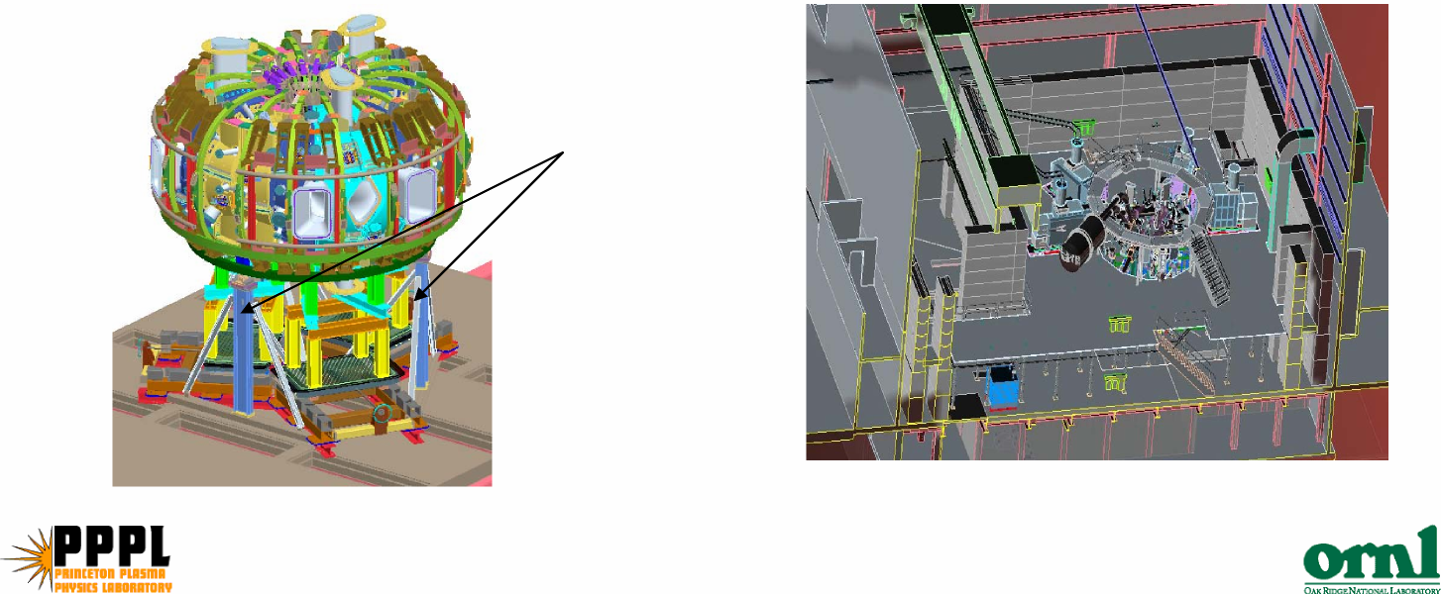

Detailed assembly steps for Stations 2, 3, 5 and 6 have
been developed and forms the basis for the assembly
estimates generated by Mike and Erik.
SC Project Review of NCSX, April 8-10, 2008
T. Brown - page 4
Rev 10 of the assembly sequence plan issued
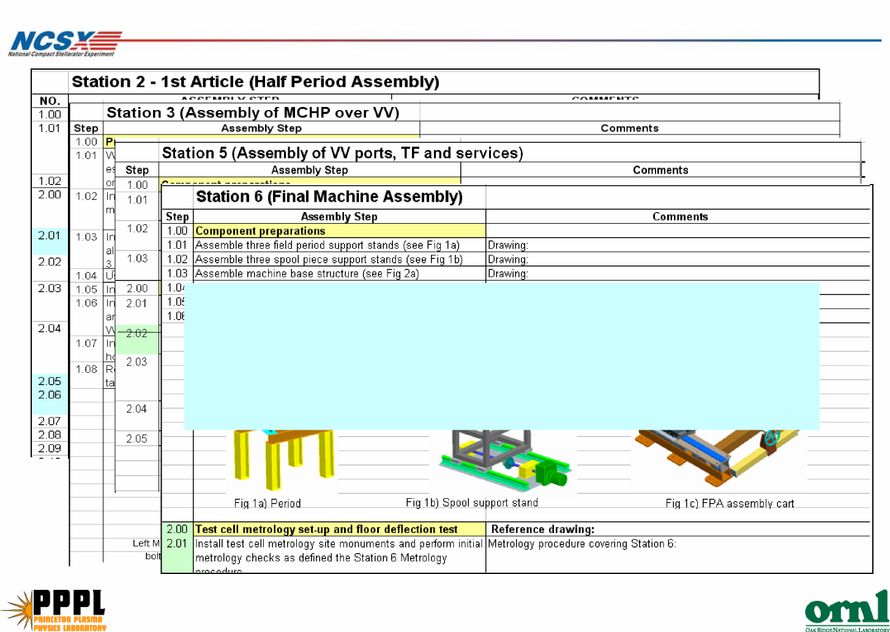

Administering the CAD database of project
models and drawings

A centralized 3D modeling of the device core and
SC Project Review of NCSX, April 8-10, 2008
T. Brown - page 5

facility is maintained using Pro/Intralink.
- The CAD database is accessible to all design staff here at
PPPL and at ORNL.
- The CAD modeling and data management system allows
timely development and view of physical details and
interfaces.
- Insertion of As-Built component conditions allows
assembly simulation models to be run to view critical
interfacing areas to aid machine assembly activities.

Assembly simulation clearance studies

Station 3 assembly Final machine assembly
SC Project Review of NCSX, April 8-10, 2008
T. Brown - page 6

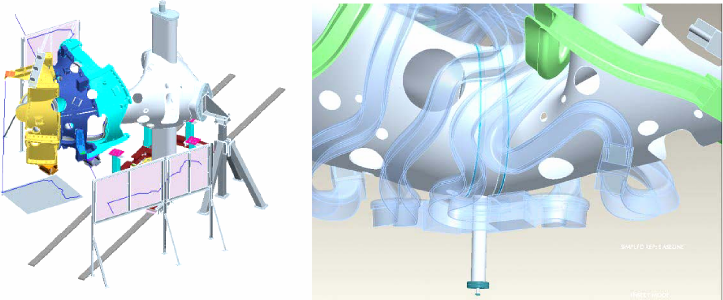

SC Project Review of NCSX, April 8-10, 2008
T. Brown - page 7
1.53”
- analyzing metrology data in conjunction with CAD models of the
parts and assemblies
- Continue to review component interfaces
Continue to review interfaces and support the
metrology and dimensional control efforts
Added lead stems to
improve assembly features
and schedule
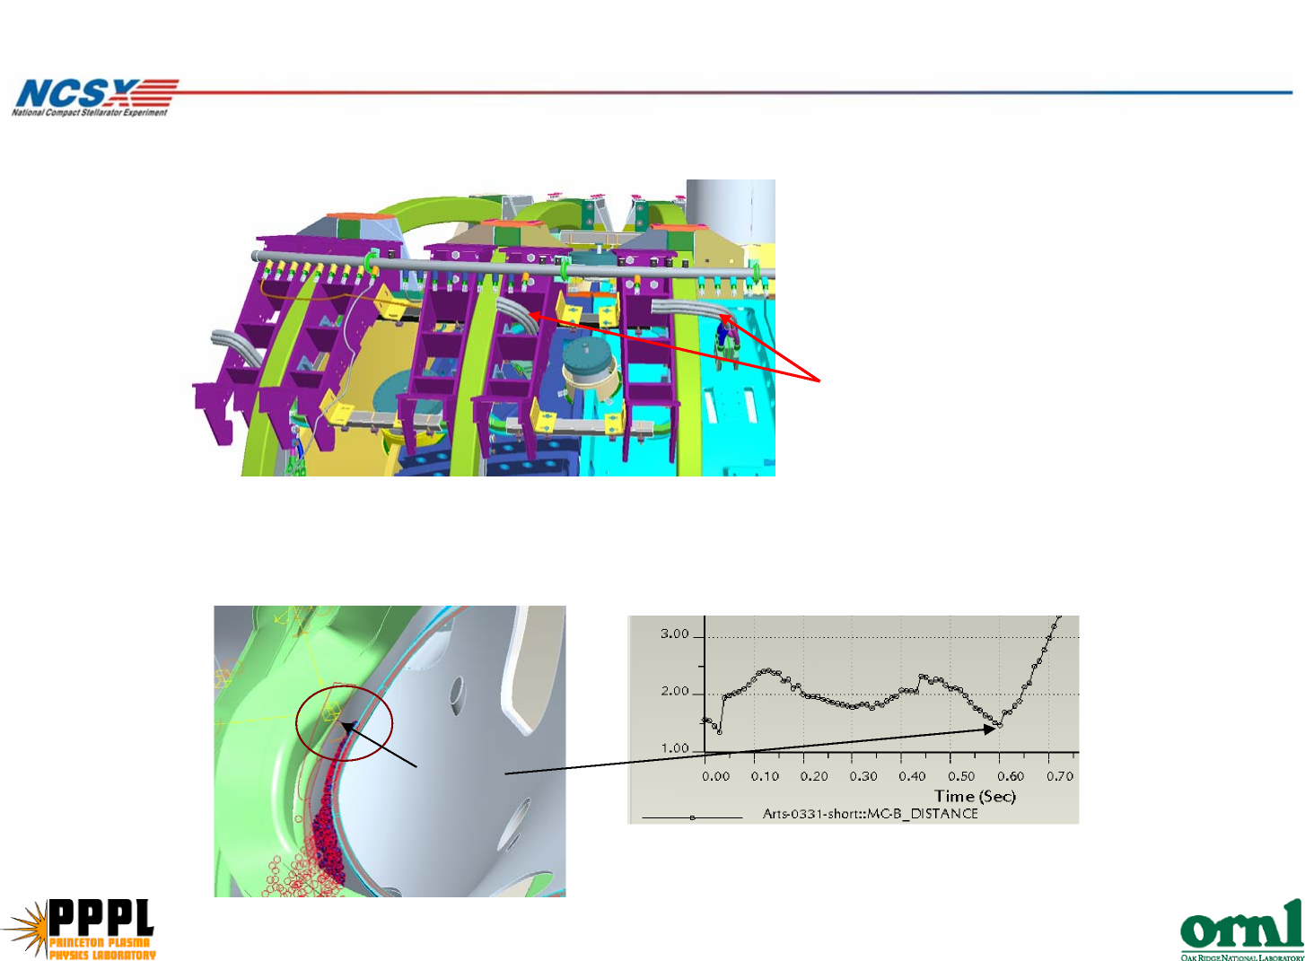

Manpower Staffing
SC Project Review of NCSX, April 8-10, 2008
T. Brown - page 8

