PPPL ENGINEERING CHANGE NOTICE (ECN) ECN # 5128R3

COGNIZANT INDIVIDUAL: D. Williamson

ECN TITLE: MCWF Type-A and -B Modifications

ASSOCIATED ECP: None

CC/WP/Job:9450-1***-1403 AREA OR PROJECT: NCSX

LIMITATION OF SCOPE - NOTE: A Work Planning Form is NOT required if the total change to be accomplished (ENG-032):
- Is not large or complex or does not represent a new installation into a usable space
- Does not have a significant ES&H impact
- Does not involve tritium or other radioactive contaminated or activated equipment
- Does not impact multiple projects, systems, or groups
OR does not change the scope or intent of the original design.

Responsible Line Manager CONCURRENCE: __________________________________
(Signature indicates that no Work Planning form is required.)

If non-concurrence or associated with a work planning form, enter the WP Number:

DRAWING(S) AFFECTED NUMBER: | NEW  Revision | TITLE
SE140-129 | 0 | Type-ABC Flange Hole Layout
SE141-114 | 7 | Production Winding Form Type-A
SE141-115 | 8 | Production Winding Form Type-B
SE141-058 | 3 | Type-B Poloidal Break Shim Asm
SE141-048 | 3 | Type-A Poloidal Break Shim Asm

DESCRIPTION OF CHANGE: (State Drawing No., Zone/Group, or List Attachments)
1) Revise Type-A flange holes from clearance to tapped holes per RFD-14-018.
Ref drawings SE141-114, sheets 4, 5.
2) Revise Type-B flange holes per memo, "Flange Hole Proposal for B Casting",
from MTM, 6/9/06. Ref drawing SE141-115, sheets 4,5.
3) Revise Type-A TC2 hole size and location per RFD-14-017. Ref SE141-114, sheet 9.
4) Revise Type-A TC1 hole size and location per memo, "MCWF Type A - New location
for TC1 thermocouple", from MTM 4/18/06
5) Revise Type-B TC1/2 hole size and location per email from MTM, 6/9/06.
Ref SE141-115, sheet 9.
6) Revise Type-B leads interface features, SE141-115, sheet7, quad B-4,
to match lead block geometry.
7) Revise Type-B port geom to match MTM's NC. Ref Se141-115, sheet 8, quad C-1.
DESCRIPTION OF CHANGE (continued):
8) Revise .25-20UNC hole chamfer on -114, sht4, B4, -115, sht4,E1, -115, sht5, F7
9) Correct no. of .25-20UNC holes on -114, sht5, B3
10) Remove conflicting dimensions from poloidal break detail. Ref -114, sht 6, quad F7.
11) Revise size, location of VPI bleed hole shown on -115, sht-5.
12) Add "tee hole" to poloidal break shims. Ref SE141-048, SE141-058.
13) Removed tapped holes from Type-B tee in high-stress region. Ref SE141-115, sht2
14) Flange hole numbers added, ref -114, sht4-5, -115, sht 4-5.

REASON FOR CHANGE:

Major Tool noted casting interference at the bolt locations as shown in the attached figures for the Type A castings The interference is similar to what was noted on the Type-C winding forms, but more severe. NCSX reviewed the layout for Type-A and -B coils and changed some holes from clearance holes to tapped holes as shown in the attached figure.

In order to facilitate the drilling of the thermocouple holes, MTM proposed to increase the diameter of the hole for all except the last inch of depth. In addition, the location of the inboard thermocouple was changed to eliminate a setup.

Port geometry was changed very slightly in order to use a common setup for nearby external features on the part.

A Project-initiated modification to improve the lead block positioning resulted in a
slight reorientation (2.2° horizontal change at the top and 0.114” vertical change) of the Type-B lead slots as shown in the figure (Ref RFD-14-022).

Tapped holes in the flanges (.25-20UNC) have an incorrect chamfer callout on the drawing, though the model is correct.

Bleed holes were not called out on -115, and one of them is the wrong size. The hole axis represented in the model may exit the casting at a bad spot, depending on the amount of stock present. Dimensions and note should allow some flexibility in hole location while meeting the requirements.

Tapped holes have been removed from a portion of the Type-B tee to improve stress.

ENGINEERING CHANGE PROPOSAL: DATE:

COGNIZANT INDIVIDUAL MAKING THE CHANGE: D. Williamson

RESONSIBLE LINE MANAGER: B. Nelson

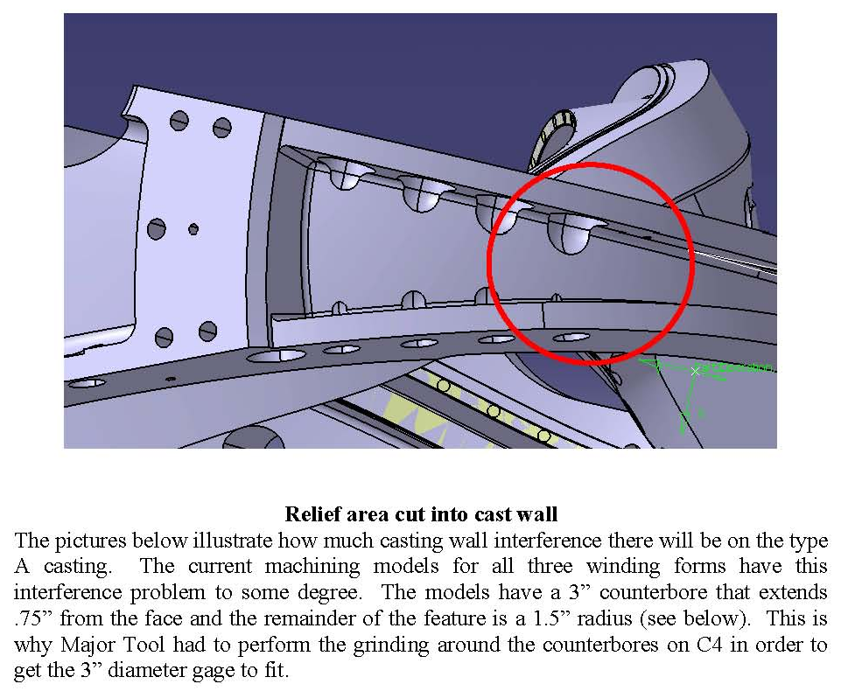

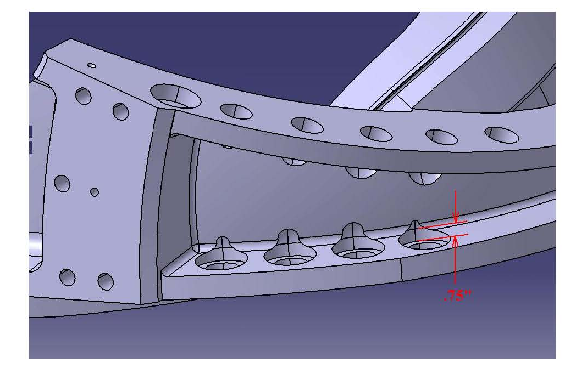
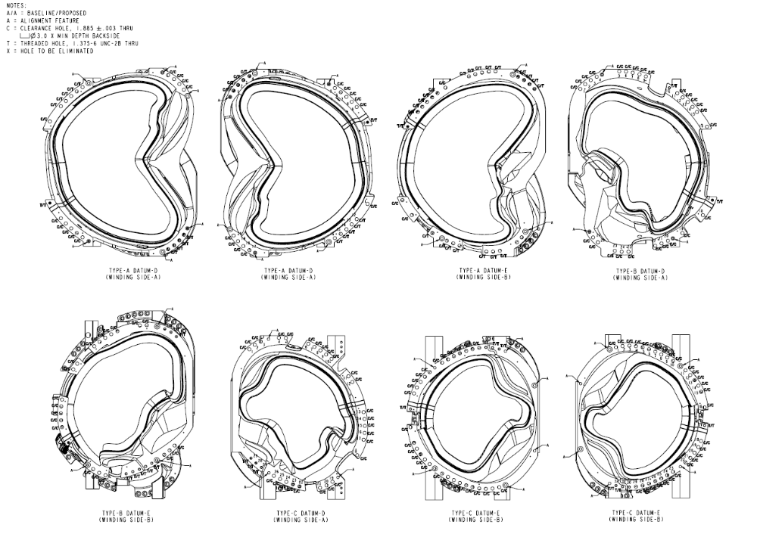
Ref drawing SE140-129 (to be released)
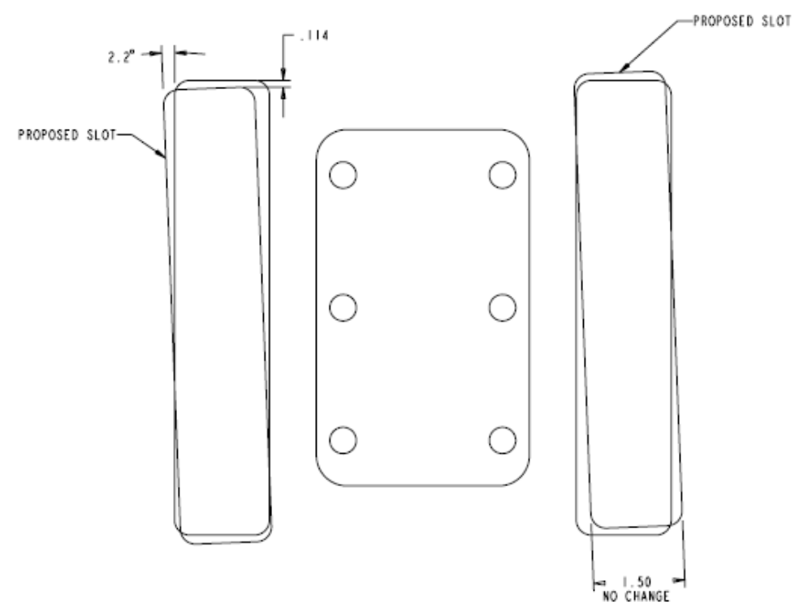
Type-B leads area (Ref SE141-115, sht7, B4)
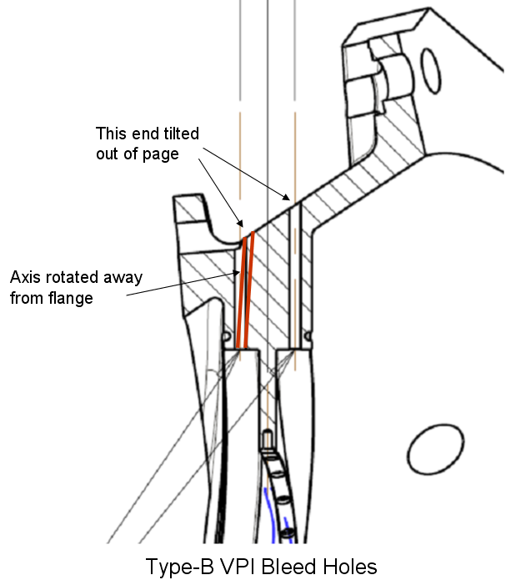
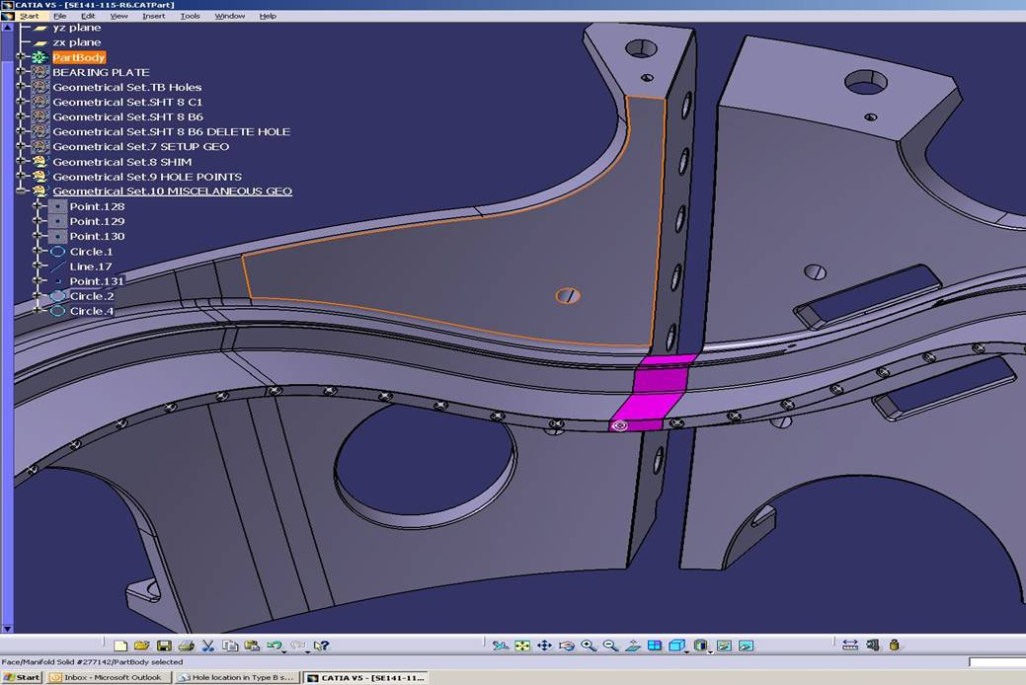
Type-B Tee Hole in Shim

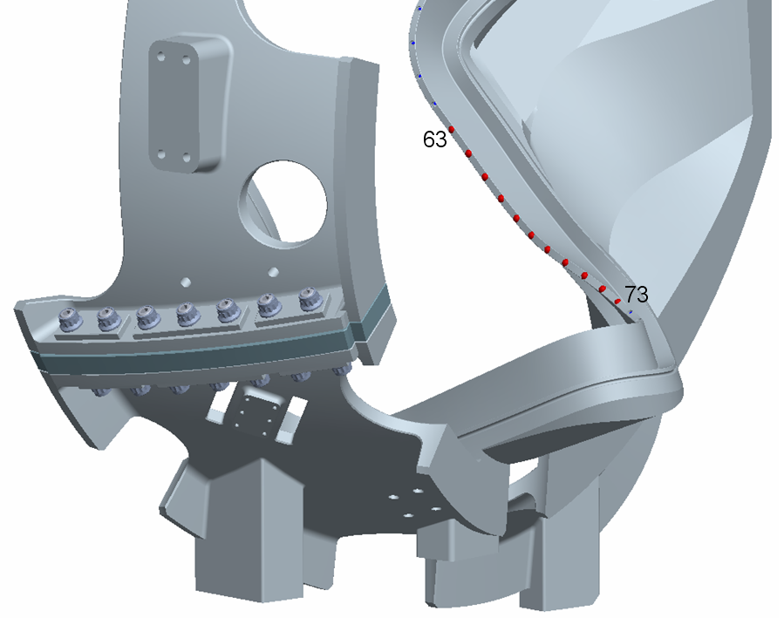

Type-B Tee Holes Changed to "Spot-Face Only"

