NCSX Facility Interface – Meeting Summary – 7/18/03

Attendance: Tom Brown, Raki Ramakrishnan, Larry Dudek, Geoff Gettelfinger, George Steill, Rick VanKirk, Joe Brsesti, Frank Jones, Joe Rushinski
Mike Kalish, Mike, Viols, Wayne Reiersen

An integration meeting was held to discuss the arrangement of the coil leads; interface with the power supply termination points and cryogenic interfaces/details. Slides presented were distributed as an attachment to the email sent with this meeting summary.

- The reference machine orientation is shown in Figure 1 with the day one NB pair located on the NE side of the test cell. The machine is centered over bus and water tunnels that run north and south. It was agreed that the routing of all leads (PF, TF, modular coils, etc.) would be routed to one of three termination points in the bus tunnel areas (C6, C7 and E7 shown in yellow) as specified by Raki. Interconnections would be made inside the cryostat where appropriate to minimize the number of cryogenic connections passing through the cryostat.
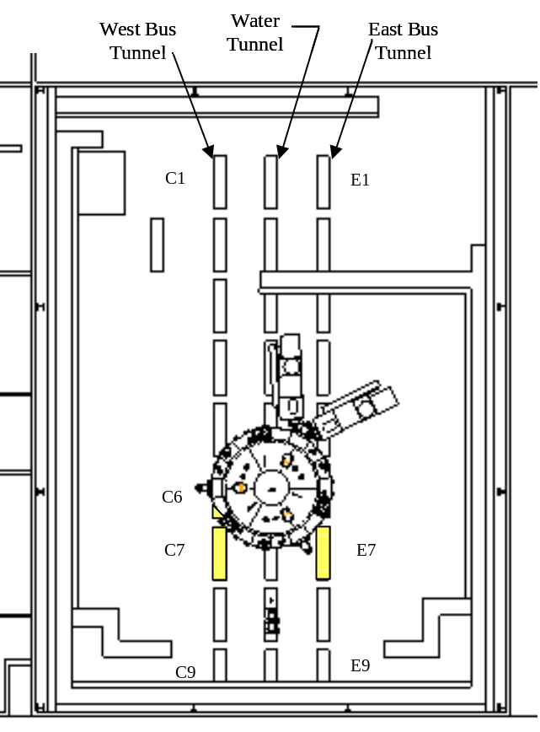
Figure 1. Test Cell Plan View

- Action: George Steill / Rick Vankirk will define the power termination geometry and George will add models to ProE facility assembly model.
- The TF lead routing the on the machine was discussed with considerations for locating the TF connections along the back leg of the TF at the midplane of the machine (or near the lower outboard PF coil) with the requirement of maintaining stellarator symmetry and limiting interference with diagnostic ports. Figure 2 below shows a full period section of the device core.

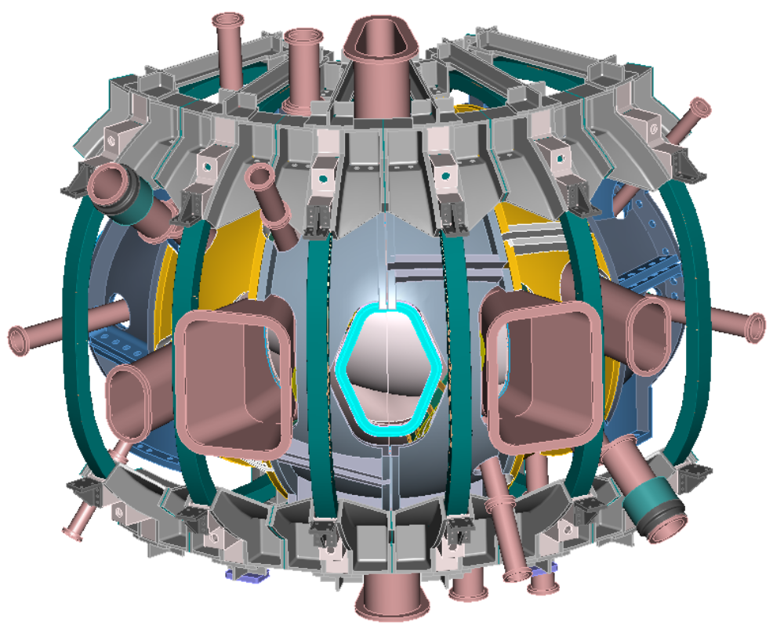
Figure 2. Core Full Period

After the meeting I put together three TF lead routing options, shown in Figures 3 thru 5, that I believe matches the general line of discussions carried on in the meeting. The routing shown in Figure 5 flips both the coils and leads which makes the period connections more difficult. I recommend that we follow the arrangement shown in Figure 3 and let Joe Rushinski, who is developing the TF magnet details, determine if he can define a lead arrangement that fits within the region of the TF back leg that meets access requirements for the ports and insulation. Mike Cole and I will also review the results of the models in the overall arrangement. If Joe finds that space is limited he would then precede with the arrangement scheme shown in Figure 4 which places the TF connection above and below the horizontal midplane where greater space is available. Instead of alternating the TF coils as shown in the schematic they could be ordered with three leads in the lower position and coils symmetrically rotated. The first pass for lead routing also assumes that standard copper bars would be used instead of coax cable. Brad, Wayne (others) need to concur with this approach. Also the baseline TF design moving to the PDR review is assumed to incorporate wedged TF coils. A conceptual design of a bucked TF arrangement using a bucking cylinder is in existence but in earlier reviews this approach was thought to be more costly when compared to a wedged approach. Mike Viola, Mike Kalish, Phil Heitzenroeder and others may need to again review this decision before the final TF system details are developed for its PDR.

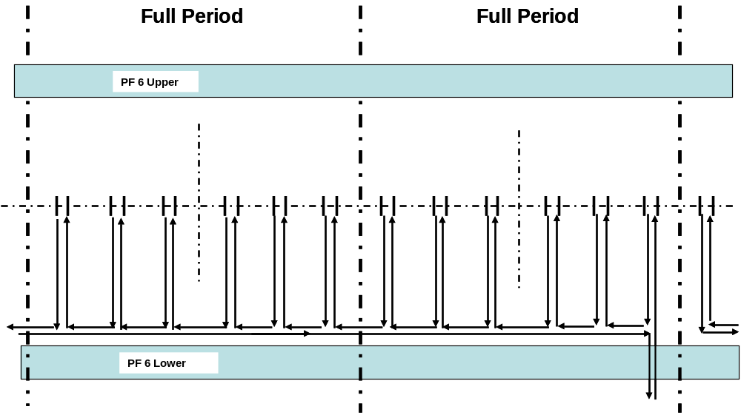
Figure 3. TF lead routing to center of TF along the back leg

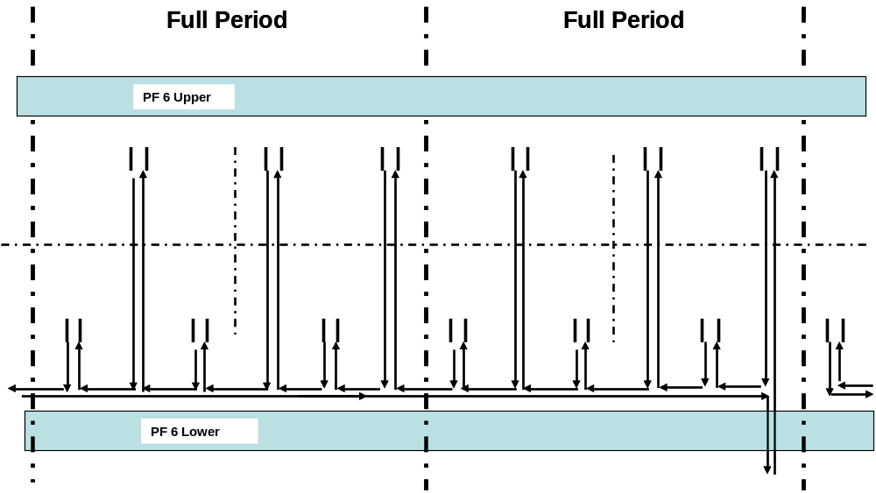
Figure 4. TF lead routing off-center of TF along the back leg

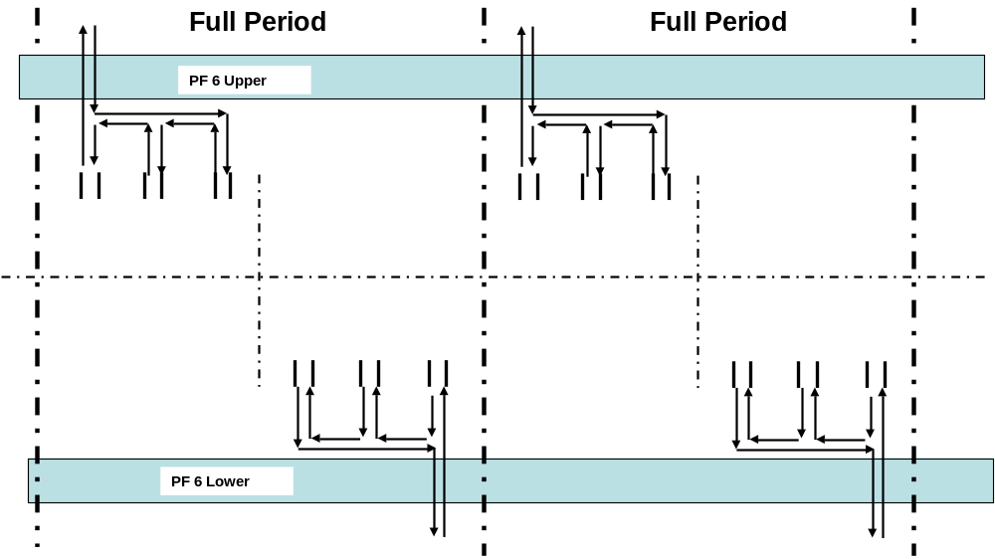

Figure 5. TF lead routing off-center of TF along the back leg with symmetrically placed connections

- It was suggested that Joe Rushinski also route the PF leads to one of three termination points after he developed the PF winding details. Incorporating coax leads on the PF bus runs must be finalized. Further decisions with Brad Nelson are needed.

- Action: Mike Viola to follow up with discussions with Brad to identify a cryogenic coax lead. Wayne and Brad - should Joe Rushinski be tasked to route the PF and TF leads on the device core to the termination point in the test cell?

