NCSX

Data Management Plan

NCSX-PLAN-DMP

Revision 0 - Draft B

05 August 2002

Prepared By: _______________________________________
T Brown, NCSX Design Integration

Approved by: ______________________________________
G.H. Neilson, NCSX Project Manager

Approved by: ______________________________________
W. Reiersen, NCSX Project Engineering Manager

Approved by: ______________________________________

Approved by: ______________________________________

Controlled Document
This is a controlled document. Check the NCSX Engineering Web prior to use to assure that this document is current.

Record of Revisions

Revision | Date | Description of Changes
Rev. 0 Draft A | 7/25/02 | Initial draft
Rev. 0 Draft B | 8/5/02 | Incorporated comments. Revised order to some sections and added additional sections. Changed to an “All Electronic” drawing system using Acrobat PDF sign-off.

Table of Contents

- INTRODUCTON………………………………………………………………… 4

2 DATA STORAGE AND CHANGE CONTROL PROCESS………………….. 4
  - Release Scheme………………………………………………………………….. 5
  - Release Procedure……………………………………………………………….. 6
  - Released Fabrication Drawings………………………………………………….. 8
  - Data Base User Access……………………………………………………….. … 8
  - Creating an Object Baseline……………………………………………………... 8

3 CAD DRAWING SYSTEM……………………………………………………… 9
3.1 Drawing Numbers………………………………………………….………...…..10
3.1.1 Standard Numbers…………………………………………………….…….……10
3.1.2 Sketch Numbers……………………………………………………………….…10
    - Prototype Numbers………………………………………………………………10

- INTERFACE CONTROL DRAWNGS…………………………………………11

5 ENGINEERING CHANGE NOTICE (ECN)…………………………………..11

INTRODUCTON

This document has been prepared for the National Compact Stellarator Experiment (NCSX) Project to describe the process by which drawings under configuration control (CAD models, drawings, specifications and interface control drawings) will be stored and managed.

Note: This plan only addresses drawings => it does not address any other controlled documents. Not all interfaces are shown on drawings => this only addresses interfaces shown on drawings. If this is cover all documents, it needs to be expanded significantly to address each document.

2 DATA STORAGE AND CHANGE CONTROL PROCESS

The Pro/INTRALINK data management tool will be used in the storage of data and in the overall change control process put in place to govern changes to models and drawings placed under configuration control. Pro/INTRALINK provides communication between the Commonspace (or server) and the workspace database, as illustrated in Figure 2.0.1.

Figure 2.0.1 Pro/INTRALINK Communications

This only shows drawings – what about other documents as you claim above?

Models, drawings as well as all documents (have we committed to cover all documents in INTRALINK???) placed under configuration control will be stored in a folder structure within the central database called the Commonspace, which is the collection point for all design activities, accessible to all users. The Commonspace format for the NCSX project (shown in Figure 2.0.2) will follow the project defined WBS structure. Each folder will have subfolders breaking down the second and third level WBS areas.

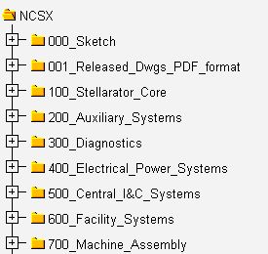

What about the GRD and other global requirements documents => WBS 8??? NEED TO ADD A FOLDER FOR TOP LEVEL DOCUMENTS AND PLACE IT UNDER 800_Project Oversight and Support
Figure 2.0.2. NCSX Common Space Folders

The Data Management process for the NCSX project can be shown in Figure 2.0.3 illustrating the main features of Pro/INTRALINK and its tie to Configuration Management (CM). Models, drawings and documents placed under configuration control will be processed in accordance to the procedures set up in the Configuration Management Plan (NCSX-PLAN-CMP). Within INTRALINK a Release scheme that establishes the progression of an object (model, drawing or Spec) through the design process will be defined; Baselines that provide status accounting in compliance with CM will be set; Release procedures used for authorization to promote objects to higher Release levels will be defined, and Roles will be established to define user data access.

2.1 Release Scheme

Within the Pro/INTRALINK environment a defined set of release levels have been defined that a drawing or model will progress through. What about documents? Six release levels have been established: Work in Progress, Conceptual Design, Preliminary Design, Prototype, Final Design, and Fabrication. What about As-Built? It is not necessary that an object pass though each release level. It will be at the discretion of the WBS manager and/or the CM release process that will determine if the full release scheme is followed or a subgroup for the WBS section under his/her responsibility. Will WBS Manager have full authority to declare a release level – I would think that the design review process has something to say about certain release level approvals; e.g., fabrication. AS BOB SAYS, WE NEED TO SAY SOMETHIN ABOUT OTHER DOCUMENTS. Each INTRALINK folder will have a predefined set of release procedures that identifies who can approve an object to allow it to pass to the next release level; typically the Section Project engineering manager and sub level WBS managers will make approvals. Once a design is placed under configuration control it will follow the established change control procedures and the INTRALINK release environment.

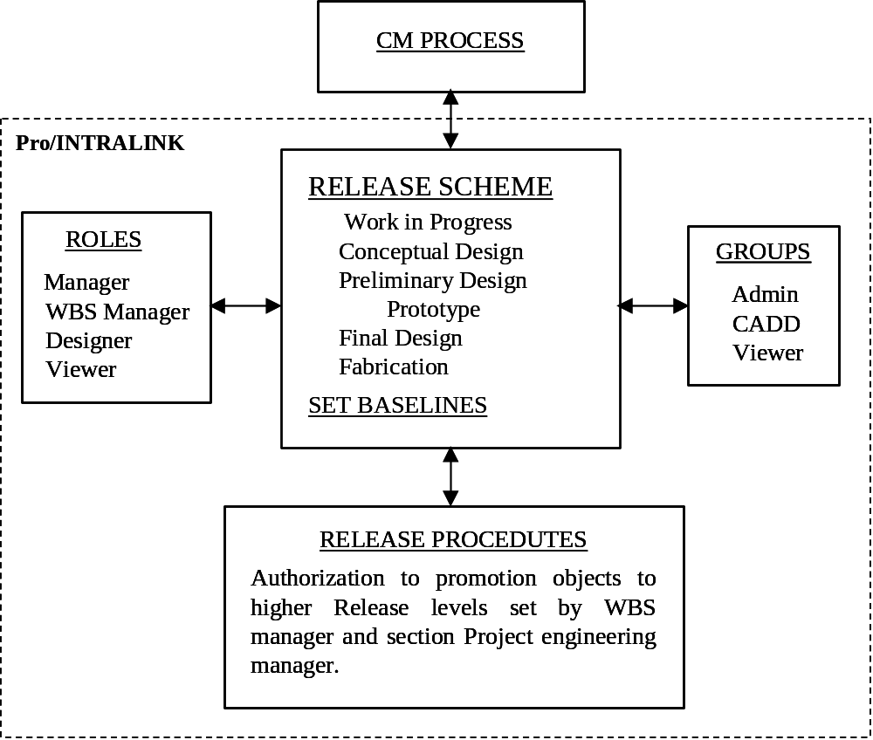

Figure 2.0.3 NCSX Data Management Work Process

2.2 Release Procedure

Release procedures specify an approval process that occurs when an object is promoted or demoted to a designated Release Level (see Table 2.2.0). As work progresses and a designated milestone is reached an authorized user can move a drawing, model, or other object from one release level of INTRALINK to another by promoting it. Likewise an object can be moved back to a lower level by demoting it. When a user tries to move an object the associated release procedure is initiated. A release procedure request is sent to those users who have been designated as reviewers for the procedure. For the NCSX project the promotion process can be completed with approvals made by the Section Project engineer and sub level managers, based on a predefined set of release procedures established for each WBS area. A detailed set of instructions that defines the promotion process is described in the Pro/INTRALINK user guide set up for the NCSX project.

Work in Progress
Conceptual Design
Preliminary Design
Prototype
Final Design
Fabrication

Table 2.2.0 Release Levels

A typical release sequence is as follows:

- All new models and drawings will start in the Work in Progress release level from which they can be promoted to a higher level. It is not necessary that a progression is the next release level. Also if a change is needed to be made in a model or drawing previously released (say for Preliminary Design) it must be “demoted” and placed in the Work in Progress Release level where modifications are made and then again promoted to a higher Release level.

- Models and drawings used for the conceptual design review are all frozen at the Conceptual Design release level. Copies of these models are now in the conceptual design folder, where they will be first demoted to Work in Progress Release level if there is a need to modify them for future promotion to the Preliminary Design Release.

- Upon successful completion of the Preliminary Design Review, all models will be promoted to the Preliminary Design release level. Again if changes are to be made in some of the Preliminary Design modes/drawings those needing modifications will be demoted to the Work in Progress Release level.

- If prototype components must be fabricated, copies of the detailed design models and drawings will be certified for construction as prototypes and released to the prototype release level. A prototype number will be placed on these objects, see Sec. 3.1.3. Prototype drawings are a branch of the design process and do not necessarily represent the final design, but since they may be included in procurement packages, they must have revision capability. Once a prototype model or drawing is approved they will be moved into the Fabrication release level (skipping Final Design) where revisions are tracked.

- For standard objects (not becoming a prototype) after the successful completion of the Final Design Review the models and drawings will be promoted to the Final Design release level.

Once again you only address drawings – if this is truly to be a complete Data Management Plan, then you need to address each and every type of document. I also wonder about this plan’s relationship to the Documents and Records Plan (DOC) that identifies each type of document, the approval levels, etc.

I AGREE. THIS NEEDS SOME FURTHER REVIEW AND EXPANDED TO ADD NON DRAWING DOCUMENTS THAT FALL UNDER CONFIGURATON CONTROL.

As procurement packages are assembled, models and drawings will be released to the Fabrication level. Only at this level will revisions be tracked.

2.3 Released Fabrication Drawing

When a drawing (or model) is ready to be released for fabrication the responsible designer/drafter/engineer shall make an Adobe PDF file for obtaining signatures. The Adobe PDF file will be routed for signatures following the sign-off procedure for the WBS group that the drawing was released in. My understanding that there is security getting the signature, but not so clear that someone can’t “erase” that signature once it is posted => Bryan Pappas is determining what constraints there are. BEING WORKED ON. Typically a drawing release sigh-off procedure will call for signatures by the drawing originator, a drawing checker and the WBS manager(s). The approved drawing signatures will be electronically added to the PDF file using the Adobe signing process. After the WBS manager signs he will send the Adobe PDF file to the PPPL Drafting supervisor. The Drafting supervisor will add his signature to the PDF drawing (indicating that PPPL drawing standards are met) and add the stamp “Released for Fabrication/Installation”. He will then enter the drawing in the Released Drawing folder in INTRALINK (the NCSX subfolder is 001_Released_Dwgs_PDF_Format). Write access to this area will be restricted. Release drawings developed at ORNL will be sent to the PPPL Drafting supervisor for placement in the NCSX released drawing folder.

The electronic CAD version of the release drawing will be stored in INTRALINK in the appropriate subfolder based on the WBS level where it originated.

2.4 Data Base User Access

User “Roles” will be established to define what a user is able to do with a specific folder and with the objects stored within a folder. Actions can include: view only, object check out, deleting an object, creating folders, etc. Five Roles will be established for the NCSX project listed here in descending order of capabilities. These include: Manager, WBS manage, Designer, View Only, and No Access. The established Roles for these users are detailed in Table 2.4.1.

2.5 Creating an Object Baseline

To accommodate the configuration management process of status accounting that provides precise identification of performance baselines and status of all changes to those baselines the mythology provided in Pro/INTRALINK will be used to set baselines at intermediate points of the Release Schedule. A baseline is a fixed configuration of objects that can be created at anytime within Pro/INTRALINK. It is planned that objects (models/drawings, etc.) will be frozen at the start of each design review and those version numbers saved. At intermediate points of the Release Level Baselines will also be created for status accounting IN COMPLIANCE WITH THE CM PROCESS. Baselines are created in the Commonspace as well as during a Check In or Promotion operation. When created a unique name must be supplied. A number of operations can be performed on a baseline in Commonspace: create, view, modify, move to a different folder location, rename, check out objects to workspace and interrogate. Baseline parameters can be set as: read only; read and add; read, add and delete.

I would try to find another word than “baseline” as it has technical, cost, and schedule ramifications. We surely don’t need a fourth baseline here. When you talk about baselines in CM, there is certain configuration control discipline attached and I am not sure that you want or will have that control on drawings before they come under CM after the final design review.

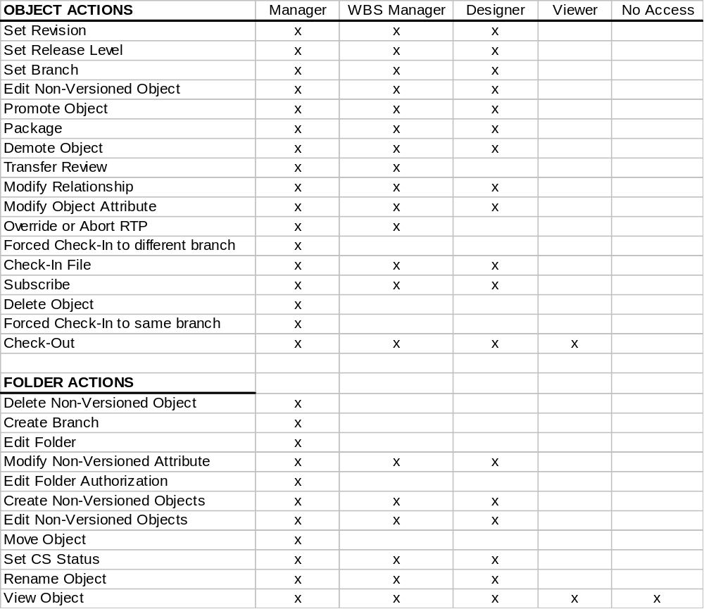

Table 2.4.1 NCSX Roles Set in Pro/INTRALINK

3 CAD DRAWING SYSTEM

All models and drawings will exist in electronic form. Pro/Engineer is the preferred CADD package used on the NCSX project. All mechanical 3D models and 2D drawings of the device core or interfacing components will be generated in Pro/Engineer to facilitate the building of a unified assembly. If a variance to this rule is required to develop a component as a 2D drawing in another CAD package then there will be a Pro/Engineer model that accurately defines the component envelope and placed in the full Pro/Engineer assembly model. Mechanical models and drawings of the test cell, ancillary equipment and services will be generated using Pro/Engineer as the first choice system, again to maintain uniformity of the overall NCSX database. Electrical drawings (2D) will be generated using AutoCAD or Pro/Engineer (if appropriate) or other Project-approved software package.

Drawing Numbers

3.1.1 Standard Numbers

NCSX drawing numbers will take a form that follows the NCSX WBS structure. A typical number might be S17E112-011; where S is the NCSX project designation, 17 defines the concept number (the CDR in this example), E the sheet size, a three level WBS breakdown (112) follows, then the drawing number (001). After leaving the conceptual design phase of the project the concept number designation (17 in this example) will be dropped, so that going forward the drawing number will be shortened to, SE112-011 in this example.

Assigning drawing numbers will be the responsibility of the WBS manager in charge of a WBS design activity. Using the WBS drawing tree structure and Pro/INTRALINK an engineer or designer can go into the database “Commonspace” and take the next available number within the NCSX folder he is working in when a drawing is started (saving the part to Commonspace as the design progresses); or a temporary name can be used while developing a drawing and then changing it to the next available number before saving to Commonspace. Pro/INTRALINK allows one and only one name within the database so there can be no duplications.

As a rule, in developing mechanical drawings, drawing numbers –000 thru –010 is saved for top-level assemblies. Drawing numbers –011 thru –999 will be used for parts, assemblies or drawings with no preference to order (the next number is taken).

3.1.2 Sketch Numbers

Preliminary sketch numbers that are assigned to a model or drawing shall be based on the NCSX WBS structure and take the following form: S B 112- XXXXXX. Where the first letter (S) designates the NCSX project; the letter “B” is the last initial of the user name (first and second initials can also be used); 112 define the first three WBS levels and –XXXXX can be a number or alphanumeric description of the object. A sketch file directory (000_sketch) has been established to allow all engineers/designers/drafters participating in the NCSX project to store sketch files.

3.1.3 Prototype Numbers

Prototype models and drawings will have a special designation in the drawing number with the letter “P” added at the end of the standard number. This will allow the models and drawing of components that are to be fabricated as prototypes to take the same number as the baseline model except for the added letter “P” at the end.

    - As Built Drawing Numbers

AD AB BEHIND THE STANDARD NUMBER…………………

4 INTERFACE CONTROL DRAWINGS

Physical interface definitions between two WBS system components will be defined in an Interface Control Drawing (ICD). The interface may define either a physical boundary, mating surface geometry or attachment details that exist between two adjoining WBS components. An Interface Control drawing folder will be set up in INTRALINK that will contain two subfolders. One subfolder will contain PDF files of ICD’s and the other will contain the CAD drawing files. For Pro/Engineer users the ICD parts and/or assemblies will remain their respective WBS folders. One WBS system manager will take the responsibility of generating the ICD. The drawing number placed on the ICD will be a number generated by the generating WBS group. No special number is assigned. After the ICD is completed a pdf file will be generated and routed to both interfacing WBS managers and the section Project Engineer for approval. Once approved a Baseline will be created, when using Pro/Engineer, in order to save the Release Level and object Version number for objects used in the ICD drawing.

5 ENGNEERING CHANGE NOTICE (ECN)

Drawing changes will be made in a manner that follows the PPPL Engineering Procedure ENG-010, “Control of Drawings, Software, and Firmware” with one alteration. When an ECN is pending on a particular drawing the Drafting supervisor will extract the effected drawing from the NCSX INTRALINK drawing released folder and add an Acrobat stamp that states “ECN Pending” along with the ECN number and any summary description added to the drop-down note. Once the Acrobat stamp is added the Drafting supervisor will place the drawing back into the released drawing folder. This process allows all viewers of drawings in the Released Drawing folder to be made aware that an ECN is pending on a particular drawing. After the ECN changes have been completed a pdf file will be made of the revised drawing and placed in the Release Drawing folder and the drawing with the ECN Acrobat stamp removed.

THIS DOES NOT ADDRESS ANY DOCUMENTS EXCEPT DRAWINGS.
.

