NCSX

Specification
For the
Modular Coil Assembly Fixture (WBS 18)

NCSX-CSPEC-18-01-00

Draft A

23 February 2005

Prepared by: __________________________________________________________________________
T. G. Brown, Field Period Assembly (WBS 18) Manager

Concur: ______________________________________________________________________________
M. Viola, Technical Representative for Field Period Assembly (WBS 18) Procurements

Concur: ______________________________________________________________________________
F. Malinowski, Quality Assurance

Concur: ______________________________________________________________________________
B. Nelson, Project Engineer for Stellarator Core Systems (WBS 1)

Concur: ______________________________________________________________________________
W. Reiersen, Engineering Manager

Controlled Document
This is a controlled document. Check the NCSX Engineering Web prior to use to assure that this document is current.
Record of Revisions

Revision | Date | ECP | Description of Change
Rev. 0 | 02/01/2005 | - | Initial issue
TABLE OF CONTENTS
1 INTRODUCTION AND SCOPE 3
1.1 Introduction 3
1.2 Scope 3
1.3 Definitions 3
2 Applicable Documents 3
3 Subsystem Requirements 3
3.1 Performance Requirements 3
3.2 Fit-up and Assembly Space Allocation. 3
3.3 Motion Controllers Requirements. 3
3.4 Design and Construction 3
3.5 Transportability 3
3.6 Nameplates and Product Marking 3
3.7 Environmental, Safety, and Health (ES&H) Requirements 3
4 Quality Assurance Provisions 3
4.1 General 3
4.2 Quality Conformance Inspections / Verifications 3
5 MODELS AND DRAWINGS 3
Appendix A 3

INTRODUCTION AND SCOPE

Introduction
The National Compact Stellarator Experiment (NCSX) is an experimental research facility that is to be constructed at the Department of Energy’s Princeton Plasma Physics Laboratory (PPPL). Its mission is to acquire the physics knowledge needed to evaluate compact stellarators as a fusion concept and to advance the understanding of 3D plasma physics for fusion and basic science. Operation of NCSX is scheduled to begin in 2009. A primary component of the facility is a stellarator core, which contains a highly shaped vacuum vessel surrounded by equally highly shaped modular coil half periods. Figure 1.1-1 shows one period of the vacuum vessel and the two modular coil assembly half periods that will surround it. To place the half period modular coil assembly over the vacuum vessel requires the detailed design and fabrication of an external assembly fixture that will manipulate the MC half period over the vacuum vessel without contact between the MC and the insulation surface that is attached to the vacuum vessel.
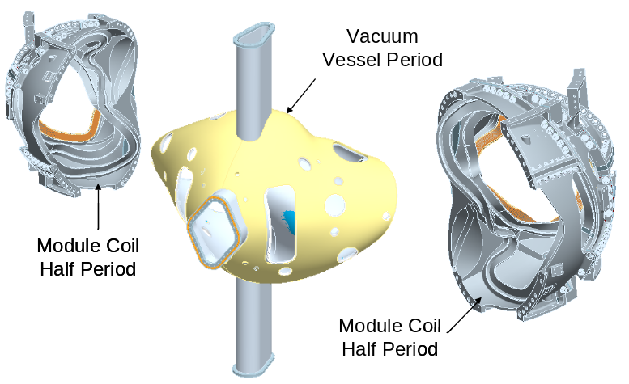

Figure 1.1-1 Vacuum Vessel and Module Coil Half Period Assemblies

Scope
This specification provides the requirements and specifications for the detail design and fabrication of the Modular Coil Assembly Fixture.

Definitions
AISC – American Institute of Steel Construction
PPPL – Princeton Plasma Physics Laboratory
NCSX – National Compact Stellarator Experiment
MC – Modular Coil
MCAF – Modular Coil Assembly Fixture
MCHP – Module Coil Half Period
VV – Vacuum Vessel

Applicable Documents
Design and fabrication of structural steel components shall be performed in accordance with the requirements of the following codes:
- AISC “Steel Construction Allowable Stress Design”, latest addition
- AWS D1.1 ”Structural Welding Code – Steel”, latest edition
- Rigging activities must comply with PPPL procedure ENG-021, “Hoisting and Rigging Program”.
- Seismic Requirements for NCSX “NCSX-CRIT-SEIS-00”

Subsystem Requirements
Background
The MCAF shown in Appendix A, Figure A-1 represents a Reference design for assembling the modular coil over the vacuum vessel. The Modular Coil Assembly Fixture consists of a turning fixture, a base guide rail, vacuum vessel support, all turning fixture / MC interface components and gantry crane used to off load the right hand module coil once it has been positioned. The turning fixture is designed around five sub-assemblies that support the modular coil within the modular coil center of gravity. It provides six degrees of freedom in motion and adjustment accuracy to properly position a half period modular coil assembly over the vacuum vessel within designated positional tolerances. It is believed that the mechanisms defined in the turning fixture have the capability to meet the assembly tolerances. The load transfer from the turning fixture to the gantry crane can be done without degrading the position of the modular coil. The MCAF Reference design was developed to evaluate the feasibility of designing an assembly fixture and to help in developing this design Specification.

3.1 Performance Requirements
    - The MCAF must be designed to support the expected 25,000 lb maximum weight of the MCHP while operating over the full cycle path with standard structural design margins as defined in AISC (Steel Construction Allowable Stress Design) and considering seismic effects.
    - Except for the last 0.54” of motion a 1.0” minimum clearance exists between the VV outer insulating surface and the MCHP. In the last 0.54”of motion there exists 0.48” of clearance between the VV outer insulating surface and the MCHP and 0.43” clearance between two MCHP adjacent surfaces. These values take into account VV and MCHP fabrication tolerances.
The MCAF shall provide movement of the MCHP over the VV without allowing contact between the inner surfaces of the MC and the VV insulation outer surfaces or between mating surfaces of adjoining MC’s.
    - To meet the clearances defined in paragraph 3.1.2, the MCAF must provide six degrees of freedom and pass the MCHP over the VV in a path prescribed in Table 3.1-1 based on the Reference Design coordinate system and axes show in Figure 3.1.1 and Figure 3.1-2 or some equivalent transformation.
    - The MCAF shall be designed with the ability to control the location of three spherical seats located on the MC type “A” flange in its final position to within +/- .020". The spherical seat locations relative to their control axis in the Reference Design are shown in Figure 3.1-2. (Can this be relaxed if one of the MCHPs is “floating” rather than bringing both to hard positions?)
    - The MCAF must be capable of being stopped and then restarted at any point in the cycle.
    - There shall be no movement of the modular coil or any of the MCAF subcomponents when the modular coil is at a stop position.
    - Anti-backlash devices shall be used on all machine components wherever reversible load conditions exists.
    - The surface(s) to which jacks are mounted must be smooth and perpendicular to the guides. (Do not understand this requirement, this is a function of the detailed design?)
    - Motors shall be used to drive all MCAF subcomponents with in-line encoders installed to provide positioning feedback (?) and accuracy.
    - Motors shall provide variable speeds with forward and reverse travel. Adding brakes to the motors may be necessary. Both 208 single phase (?) and 480 three-phase house power will be supplied.
    - Shear couplings are required to protect any reducer or motor from excessive torques. Consideration must be given to keep parts from moving in the event of a sheared coupling; motor torque feedback is desirable.
    - Safety elements shall be installed to prevent any motion during loss of power and the system must be stable under an abrupt stop condition. Travel stops (i.e., limit switches) shall be used to stop the motors.
    - After one modular coil half period is placed over the VV a secondary support system must be used to support the MCHP to allow the MCAF to be retracted for use in assembling the second MCHP. A gantry crane was designed for this purpose in the Reference design (see Figure 1-A).
    - The secondary support system shall be designed with sufficient stiffness to limit the vertical deflection to less than .050” when supporting the module coil half period. (relative to the unloaded position?)
    - Any secondary support system must be constructed with some bolted members to allow for ease of shipment.
    - The attachment system between the secondary support and MCHP shall be so designed to restrict any rotation or out of plane movement of the MCHP that will result in its contact with the insulating surfaces that surrounds the vacuum vessel.
    - Within the design of the secondary support system a method that allows +/- 2.0” movement of the MCHP(?) in one direction while holding the MCHP must be provided. A separate roller system is provided on the gantry crane of the Reference design to provide motion in the “Y” direction, as defined in Figure A-3 of Appendix A. Should there be a way to tweak all the other directions of motion?
    - The MCAF must be attached in such a way that provides sufficient clearances to easily release the MCHP from the MCAF and remove the MCAF.
    - The MCAF must be capable of being lifted by a crane to allow it to be positioned on either side of the VV for assembling a second MCHP.
    - All systems must be designed for seismic conditions assuming a dynamic magnification factor of 0.11.
Table 3.1-1 The Reference MCAF motion based on a 248-step servo
table that drives six motors (for details see Sec. 5.0)
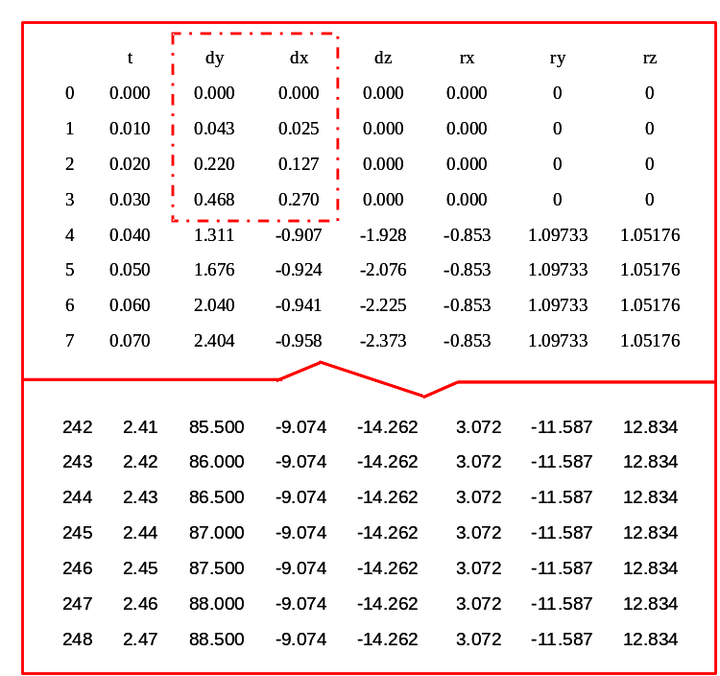

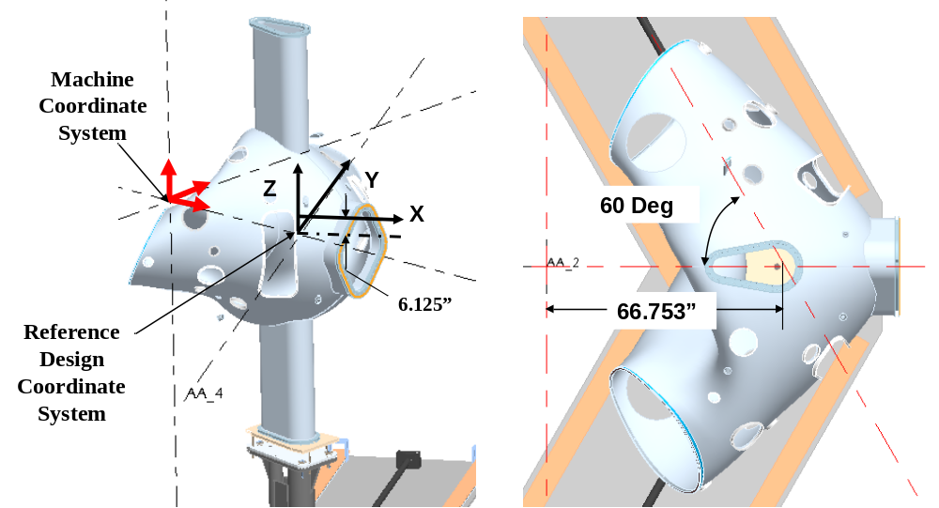
Figure 3.1-1 Modular Coil Assembly Fixture Coordinate System

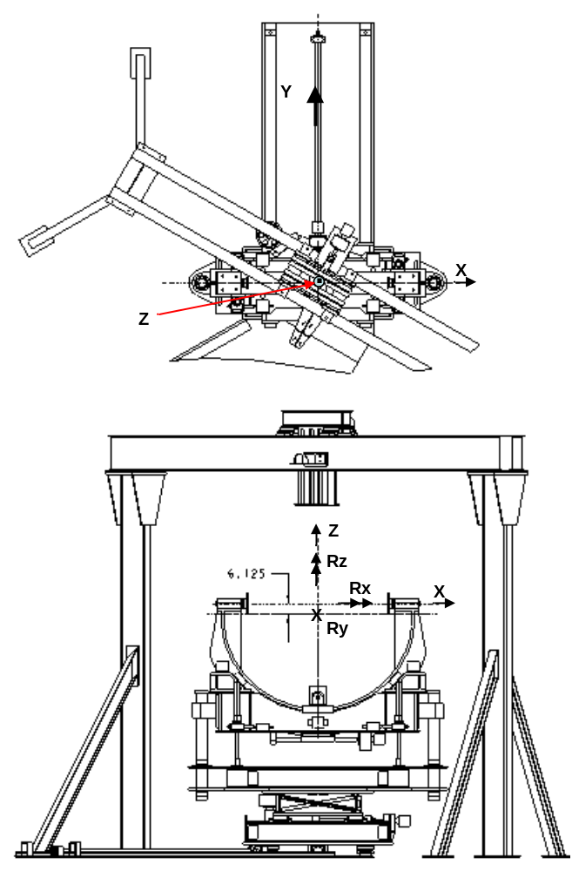

Figure 3.1-2 Reference design axis location with motion indicated

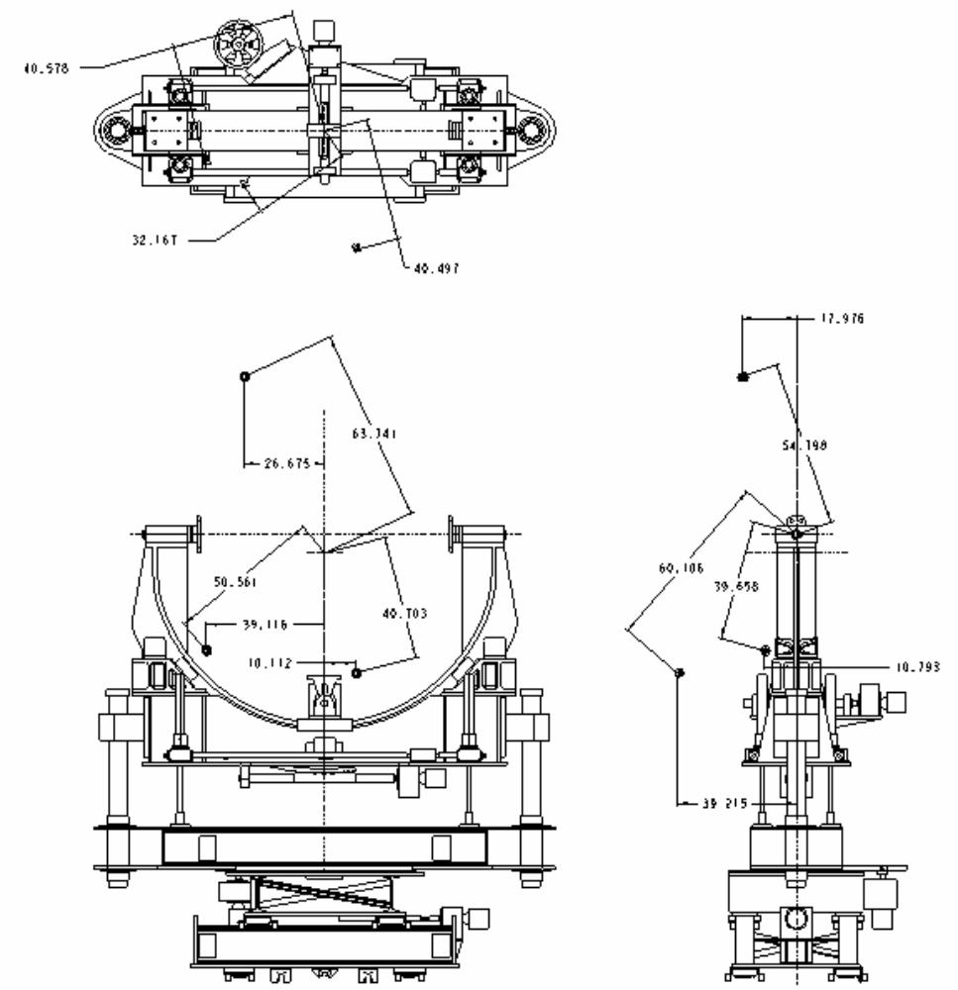

Figure 3.1-3 Spherical Seat Locations for Reference Design

3.2 Fit-up and Assembly Space Allocation.
    - A support interface must be established between the turning fixture and the modular coil half period. In the Reference design this occurs between pins bolted on the inner and outer midsections of the Type B module coil and bushings on the Turning Fixture pivot-rotating component. The support interface must provide adjustment to accommodate tolerances among the various parts.
    - The Reference Turning Fixture will position the modular coil assembly beneath the gantry crane where a bolted interface can be made between a support fitting mounted on the module coil assembly and a roller system assembly plate. A modified or alternate design approach also will require an interface with the secondary support system.
    - The secondary support structure or the gantry structure in the Reference design must be sized to allow access to apply bolts at the mating surface of adjoining module coil assemblies. The minimum clearance for bolt spacing is shown in Figure 3.2-1 for the Reference design.
    - Within the NCSX assembly area a space of 22’ x 35’ has been allocated to perform the modular coil assembly operation. The MCAF must be designed to operate within this space.
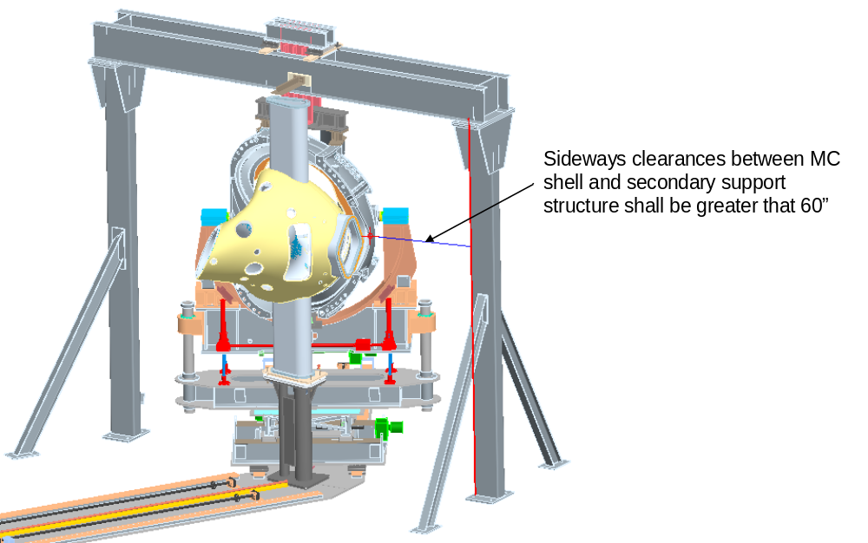

Figure 3.2-1 Secondary Structure Sideways Clearance Space

3.3 Motion Controllers Requirements.
3.3.1 The motion controller must provide at least seven axes of control. For the Reference Design this includes six axes on the Turning Fixture and one axis on the gantry crane. Should there be (are there) additional adjustment axes on the gantry connection? (not motorized, just adjustable)
3.3.2 An initial setup sequence (procedure) shall be provided to establish and position the starting point.
3.3.3 The MCAF and its control system must be designed so that the path of motion is repeatable.
3.3.4 The motion controller must be capable of being re-programmed.
3.3.5 Motor torque monitoring or feedback is desirable if not cost prohibitive.
3.3.6 A jog mode for each axis (TBD” per step) with continuous position monitoring.
3.3.7 An input channel for emergency stop (normally closed).
3.3.8. Provide four input channels, for soft stop (normally open).
3.3.9. Provide one output indicator that identifies any fault conditions (yellow) and one output indicator to identify any stop conditions (red).

3.4 Design and Construction

3.4.1 Workmanship
3.4.1.1 During MCAF fabrication and finishing, particular attention shall be given to freedom from burrs and sharp edges; accuracy of dimensioning radii of weld fillets; making of parts; thoroughness of cleaning; quality of brazing, welding, riveting, painting, and wiring; alignment of parts; and tightness and torquing of fasteners.
3.4.1.2 All welding shall be done by qualified personnel using written and qualified welding procedures in accordance with AWS D.1.

3.5 Transportability
All MCAF components shall be transportable by commercial carrier via highway, air, sea, or railway.

3.6 Nameplates and Product Marking

3.6.1 Labels
Equipment and any parts of that equipment to be used by personnel shall be identified with appropriate labels. Labels shall indicate clearly and concisely the function and purpose of the item being labeled. Hierarchical labeling shall be used to facilitate component location on control panels. The terminology used for equipment, procedures, and training materials shall be the same for each case. Label design shall be consistent to promote simplicity and avoid clutter. The use of abbreviations and acronyms shall be minimized. Permanent labels shall be attached to the specific component or equipment in such a manner that environmental conditions or usage by personnel will not remove or destroy the label. Temporary labels shall be used only when necessary and shall not obscure other information or equipment. If a temporary label is to designate a device that is out of service, the label shall be applied so that it prevents the use of that device. Labeling shall be legible and conform to human visual capabilities and limitations in regard to physical characteristics.

3.7 Environmental, Safety, and Health (ES&H) Requirements

3.7.1 General Safety
- When utilized within its intended use and within specified environments, the safe operation, test, handling, maintenance and storage of the subsystem hardware and software shall be provided.
- The subsystem shall not present any uncontrolled safety or health hazard to user personnel.
- The subsystem shall detect abnormal operating conditions and safeguard the NCSX system and personnel.
- The subsystem must comply with applicable requirements of PPPL procedure ENG-021, “Hoisting and Rigging Program”.

3.7.2 Personnel Safety
The subsystem shall meet all applicable OSHA requirements in accordance with 29CFR1910 and 29CFR1926.

3.7.3 Flammability
The use of flammable and combustible materials shall be minimized.

4 Quality Assurance Provisions

4.1 General
The responsibility for performing all tests and verifications rests with the supplier. PPPL reserves the right to witness or separately perform all tests specified or otherwise inspect any or all tests and inspections.

4.2 Quality Conformance Inspections / Verifications
4.2.1 An operational test shall be conducted at the supplier’s facility or other suitable location. The supplier shall provide a test plan that will demonstrate, with a load approximating the 25,000 lb. weight:
4.2.1.1 The six degrees of motion and movement control of 3.1.2 & 3.1.3
4.2.1.2 The spherical seat movement control of 3.1.4
4.2.1.3 The load test at 125% of rated capacity to qualify the Gantry Crane as a lifting device.
4.2.1.4 The stopping control of 3.1.5 & 3.1.6.
4.2.1.5 The deflection restriction of 3.1.13 and rotation restriction of 3.1.14.
4.2.2 All welds must be inspected by qualified.
4.2.7.1 Visual weld inspection shall be done by inspectors certified in accordance with AWS QC1.
4.2.7.2 Nondestructive examination shall be performed by personnel certified in accordance with ASNT-SNT-TC-1A
4.2.3 The design features of 3.1.7, 3.1.8, 3.1.9, 3.1.10, 3.1.11, 3.1.12, 3.1.15, 3.1.16, 3.1.17, 3.1.18, 3.1.19 & 3.1.20 shall be addressed in the design review.

5 MODELS AND DRAWINGS
Table 5-1 provides a list of files for the Reference Design and the module coil winding form. These files have been placed in a Zip file titled MCAF-050201 and posted on the PPPL NCSX manufacturing Web site under the directory MCAF. The URL for this site is: ftp://ftp.pppl.gov/pub/ncsx/manuf/MCAF/ Pro/Engineer models will be made available upon request.

Table 5-1
MCAF-050201 Zip File Listing

File Name | Description | File Type
se185-000_asm | Reference design FPAF Step file | step
se185-000 | Reference design FPAF basic geometry | pdf, dxf
se185-003 | Reference design FPAF base guide rail assembly | pdf, dxf
se185-004 | Reference design FPAF linear motion structure | pdf, dxf
se185-005 | Reference design FPAF cradle component | pdf, dxf
se185-006 | Reference design FPAF pivot and rotation component | pdf, dxf
se185-007 | Reference design FPAF linear turntable structure | pdf, dxf
se185-008 | Reference design FPAF vertical guide component | pdf, dxf
se185-067 | Reference design FPAF gantry crane | pdf, dxf
MCAF Rev servo table - 050201 | Reference design Turning Fixture servo table | Excel
se141-114-r1 | Modular Coil production winding form Type "A" | pdf
se141-115-r2 | Modular Coil production winding form Type "B" | pdf
se141-116-r3 | Modular Coil production winding form Type "C" | pdf

Appendix A
Modular Coil Assembly Fixture Reference Design

The Modular Coil Assembly Fixture Reference Design (shown in Figure A-1) consists of a turning fixture, a base guide rail, vacuum vessel support, all turning fixture / MC interface components and gantry crane used to off load the right hand module coil once it has been positioned. Also shown is the vacuum vessel and the vacuum vessel support stand which is not a part of this Specification document.
The design philosophy used in laying out the modular coil assembly fixture was to provide six degrees of freedom in motion and adjustment accuracy to properly position a half period modular coil assembly within its designated positional tolerance. The turning fixture is designed around five sub-assemblies that support the modular coil within the modular coil center of gravity. Figure A-2 shows the breakdown of the turning fixture sub-components. The mechanisms defined in the turning fixture design are expected to have the capability to meet the assembly tolerances. The interface between the MCHP and gantry crane has been designed to allow a weight transfer to take place without any MCHP positional degradation other than a vertical deflection of the gantry crane.
The extent of motion of the various turning fixture subcomponents is defined in the isometric view of Figure A-3.

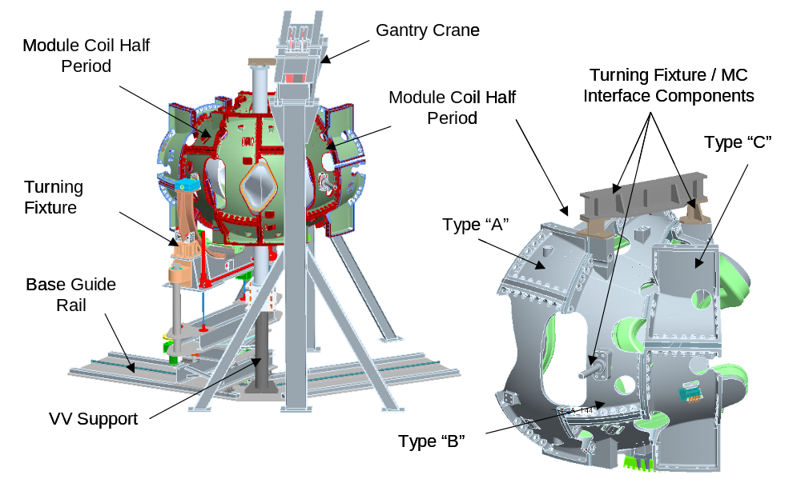
Figure A-1 Module Coil Assembly Fixture Reference Design

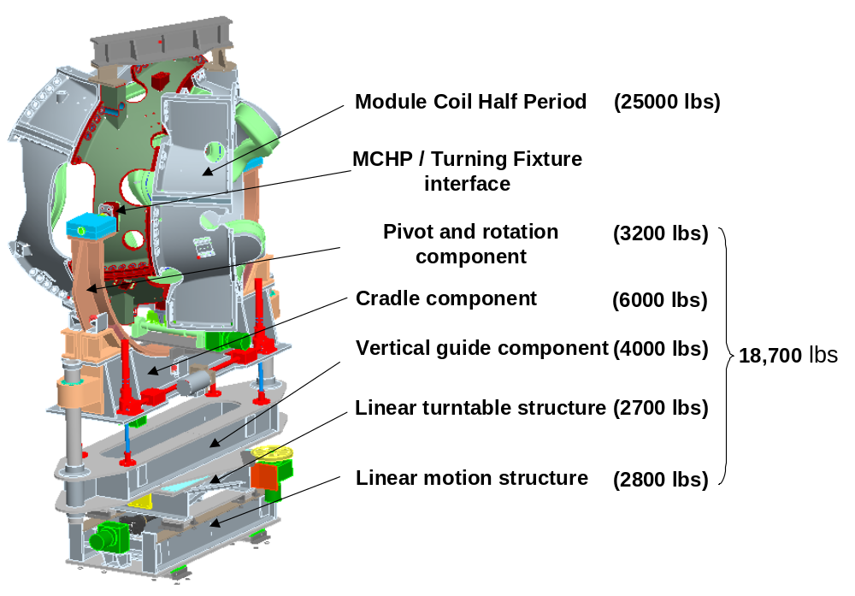
Figure A-2 Reference Design Turning Fixture Component details

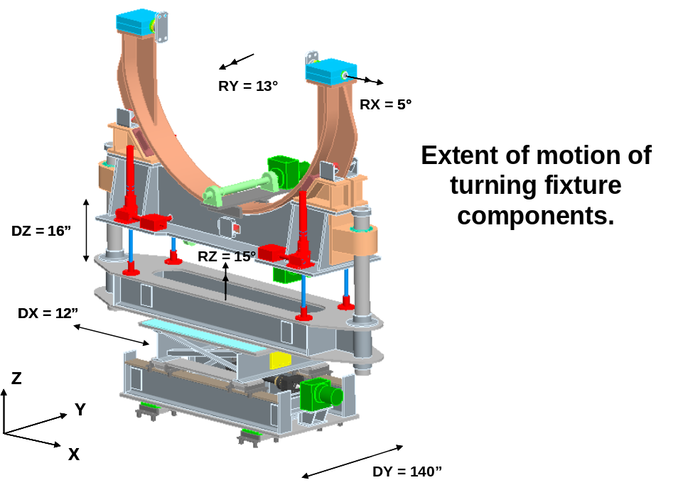
Figure A-3 Reference Design Turning Fixture Component Motion Designation

