NCSX

Specification
For the
Modular Coil Assembly Fixture (WBS 18)

NCSX-CSPEC-18-01-00

Draft B

2 May 2005

Prepared by: __________________________________________________________________________
T. G. Brown, Field Period Assembly (WBS 18) Manager

Concur: ______________________________________________________________________________
M. Viola, Technical Representative for Field Period Assembly (WBS 18) Procurements

Concur: ______________________________________________________________________________
F. Malinowski, Quality Assurance

Concur: ______________________________________________________________________________
B. Nelson, Project Engineer for Stellarator Core Systems (WBS 1)

Concur: ______________________________________________________________________________
W. Reiersen, Engineering Manager

Controlled Document
This is a controlled document. Check the NCSX Engineering Web prior to use to assure that this document is current.
Record of Revisions

Revision | Date | ECP | Description of Change
Rev. 0 | 02/01/2005 | - | Initial issue
TABLE OF CONTENTS
1 INTRODUCTION AND SCOPE 1
1.1 Introduction 1
1.2 Scope 1
1.3 Definitions 1
2 Applicable Documents 2
3 Subsystem Requirements 2
3.1 Performance Requirements 2
3.2 Fit-up and Assembly Space Allocation. 5
3.3 Motion Controllers Requirements. 6
3.4 Design and Construction 6
3.5 Shipping 6
3.6 Nameplates and Product Marking 6
3.7 Environmental, Safety, and Health (ES&H) Requirements 7
4 Quality Assurance Provisions 7
4.1 General 7
4.2 Quality Conformance Inspections / Verifications 7
5 MODELS AND DRAWINGS 8
Appendix A 9

INTRODUCTION AND SCOPE

Introduction
The National Compact Stellarator Experiment (NCSX) is an experimental research facility that is to be constructed at the Department of Energy’s Princeton Plasma Physics Laboratory (PPPL). Its mission is to acquire the physics knowledge needed to evaluate compact stellarators as a fusion concept and to advance the understanding of 3D plasma physics for fusion and basic science. Operation of NCSX is scheduled to begin in 2009. A primary component of the facility is a stellarator core, which contains a highly shaped vacuum vessel surrounded by equally highly shaped modular coil half periods. Figure 1.1-1 shows one period of the vacuum vessel and the two modular coil assembly half periods that will surround it. To place the half period modular coil assembly over the vacuum vessel requires the detailed design and fabrication of an external assembly fixture that will manipulate the MC half period over the vacuum vessel without contact between the MC and the insulation surface that is attached to the vacuum vessel.
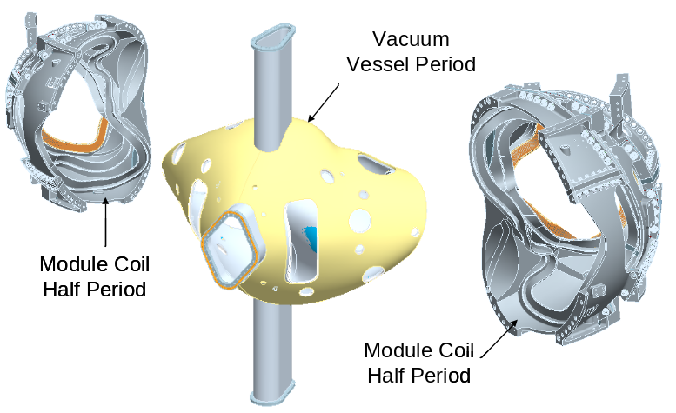

Figure 1.1-1 Vacuum Vessel and Module Coil Half Period Assemblies

Scope
This specification provides the requirements and specifications for the detail design and fabrication of the Modular Coil Assembly Fixture.

Definitions
AISC – American Institute of Steel Construction
PPPL – Princeton Plasma Physics Laboratory
NCSX – National Compact Stellarator Experiment
MC – Modular Coil
MCAF – Modular Coil Assembly Fixture
MCHP – Module Coil Half Period
VV – Vacuum Vessel

Applicable Documents
Design and fabrication of structural steel components shall be performed in accordance with the requirements of the following codes:
- AISC: Steel Construction Allowable Stress Design, latest addition
- AWS D1.1: Structural Welding Code – Steel, latest edition
- AWS D1.6: Structural Welding Code - Stainless Steel
- ASME Boiler and Pressure Vessel Code - Section IX
- Rigging activities must comply with PPPL procedure ENG-021, “Hoisting and Rigging Program”.
- Seismic Requirements for NCSX “NCSX-CRIT-SEIS-00”

Subsystem Requirements
Background
The MCAF shown in Appendix A, Figure A-1 represents a Reference design for assembling the modular coil over the vacuum vessel. The Modular Coil Assembly Fixture consists of a turning fixture, a base guide rail, vacuum vessel support, a turning fixture and gantry crane used to off load the right hand module coil once it has been positioned. The turning fixture is designed around five sub-assemblies that support the modular coil within the modular coil center of gravity. It provides six degrees of freedom in motion and adjustment accuracy to properly position a half period modular coil assembly over the vacuum vessel within designated positional tolerances. It is believed that the mechanisms defined in the turning fixture have the capability to meet the assembly tolerances. The MCAF Reference design was developed to evaluate the feasibility of designing an assembly fixture and to help in developing this design Specification.

3.1 Performance Requirements
    - The MCAF must be designed to support the expected 25,000 lb maximum weight of the MCHP while operating over the full cycle path with standard structural design margins as defined in AISC (Steel Construction Allowable Stress Design).
    - Except for the last 0.54” of motion a 1.0” minimum clearance exists between the VV outer insulating surface and the MCHP. In the last 0.54”of motion there exists 0.48” of clearance between the VV outer insulating surface and the MCHP and 0.43” clearance between two MCHP adjacent surfaces. These values take into account VV and MCHP fabrication tolerances.
The MCAF shall provide movement of the MCHP over the VV without allowing contact between the inner surfaces of the MC and the VV insulation outer surfaces or between mating surfaces of adjoining MC’s.
    - To meet the clearances defined in paragraph 3.1.2, the MCAF must provide six degrees of freedom and pass the MCHP over the VV in a path prescribed in Table 3.1-1 based on the Reference Design coordinate system and axes show in Figure 3.1.1 or some equivalent transformation. The maximum extent of motion required for the Reference Design is: 16” – dx, 120” – dy, 20” – dz, 6° – rx, 16° – ry, 17° – rz (see Appendix A, Fig. A-6).
    - The MCAF shall be designed with the ability to control the location of three spherical seats located on the MC type “A” flange in its final position to within +/- .025". The spherical seat locations relative to their control axis in the Reference Design are shown in Figure 3.1-2.
    - The MCAF must be capable of being stopped and then restarted at any point in the cycle.
    - There shall be no movement of the modular coil or any of the MCAF subcomponents when the modular coil is at a stop position.
    - Anti-backlash devices shall be used on all machine components wherever reversible load conditions exists.
    - Motors shall be used to drive all MCAF subcomponents with in-line encoders installed to provide positioning feedback and accuracy.
    - Motors shall provide variable speeds with forward and reverse travel. Adding brakes to the motors may be necessary. Both 120 single phase and 208 three-phase house power will be supplied.
Table 3.1-1 The Reference MCAF motion based on a 248-step servo
table that drives six motors (for details see Sec. 5.0)

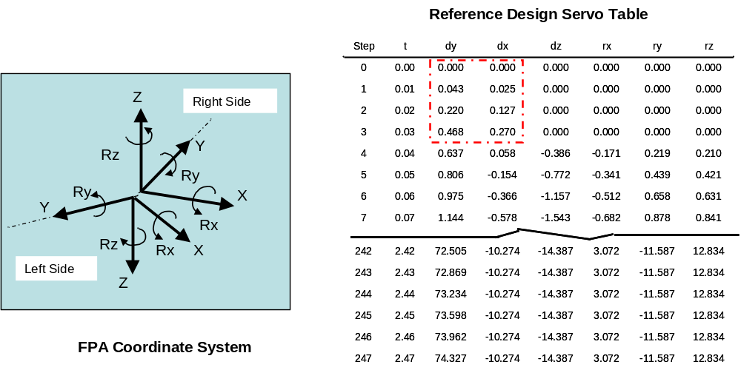

    - Shear couplings are required to protect any reducer or motor from excessive torques. Safety conditions must be taken into account so that there is no movement of the MCHP if the coupling is sheared. Limit switches can be used to handle an over-travel condition but additional capabilities (such as motor torque feedback) need to be added to cover any off-normal binding condition.
    - Safety elements shall be installed to prevent any motion during loss of power and the system must be stable under an abrupt stop condition. Limit switches shall be used to stop the motors in the event of an over-travel condition..
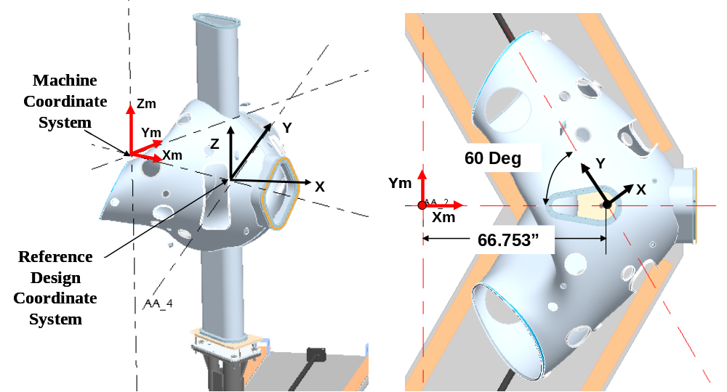
Figure 3.1-1 Modular Coil Assembly Fixture Coordinate System

    - After one modular coil half period is placed over the vacuum vessel a secondary support system must be used to support the MCHP to allow the MCAF (or Turning Fixture in the Reference Design) to be retracted and moved to the left side of the vacuum vessel for use in assembling the second MCHP. A gantry crane was designed for this purpose in the Reference design (see Figure 1-A).
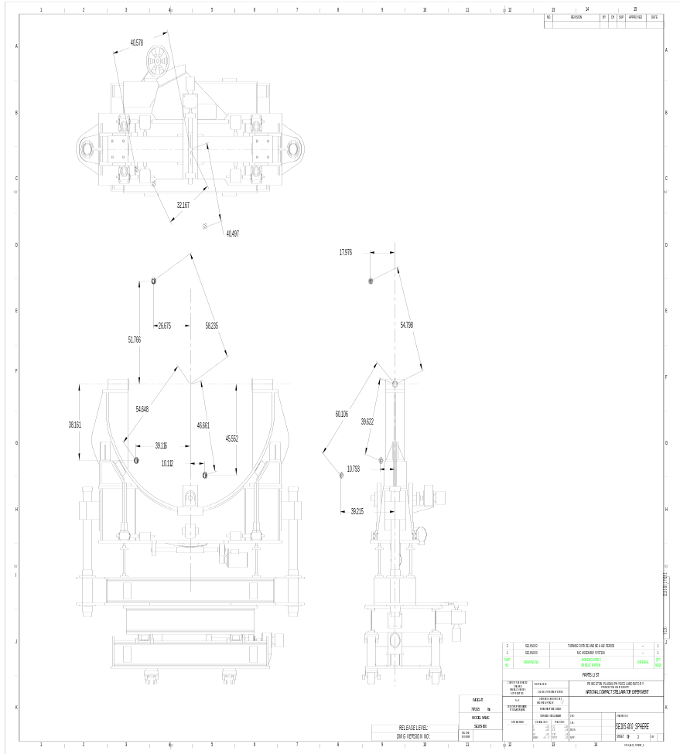
Figure 3.1-3 Spherical Seat Locations for Reference Design

    - The MCHP must be attached to the MCAF in such a way to allow easy release of the MCHP for the process of repositioning the MCAF to the left side of the vacuum vessel.
    - The secondary support system shall be designed with sufficient stiffness to limit the vertical deflection to less than .050” when supporting the module coil half period (relative to the unloaded position). Local disk springs are required at the bolted interface to the MCHP to allow an additional .050” deflection to aid the final seating of the MCHP’s (see Appendix A, Figure A-3 for the approach used in the Reference design).
    - Any secondary support system must be constructed with some bolted members to allow for ease of shipment.
    - Within the design of the secondary support system a method that allows +/- 1.5” movement of the MCHP in one direction while holding the MCHP must be provided. Positional allowances must be provided to align the secondary support system. A separate roller system is provided on the gantry crane of the Reference design to provide motion in the “Y” direction, as defined in Figure A-3 of Appendix A.
    - The MCAF must be capable of being lifted by a crane to allow it to be positioned on either side of the VV for assembling a second MCHP.
    - All rigid components mounted to the floor must be designed for conditions assuming a static seismic criteria factor of 0.108. This criterion relates to a single “g” force factor applied to the center of gravity of the component in question. This applies to the gantry crane and to the MCAF when it is located at the end of the guide rail in a “collapsed” position. No seismic criteria will be specified during the time period when the turning fixture is in operation. We will cover this condition under our internal Job Hazard Analysis documentation that will define safety procedures to mitigate risks.
    - The Turning Fixture must be designed so that it cannot tip over during operation under a sudden stop condition.

3.2 Fit-up and Assembly Space Allocation.
    - A support interface must be established between the turning fixture and the modular coil half period. In the Reference design this occurs between pins bolted on the inner and outer midsections of the Type B module coil and bushings on the Turning Fixture pivot-rotating component. The support interface must provide adjustment to accommodate tolerances among the various parts.
    - The Reference Turning Fixture will position the modular coil assembly beneath the gantry crane where a bolted interface can be made between a support fitting mounted on the module coil assembly and a roller system assembly plate. A modified or alternate design approach also will require an interface with the secondary support system.
    - The secondary support structure or the gantry structure in the Reference design must be sized to allow access to apply bolts at the mating surface of adjoining module coil assemblies. The minimum clearance for bolt spacing is shown in Figure 3.2-1 for the Reference design.
    - Within the NCSX assembly area a space of 22’ x 35’ has been allocated to perform the modular coil assembly operation. The MCAF must be designed to operate within this space.
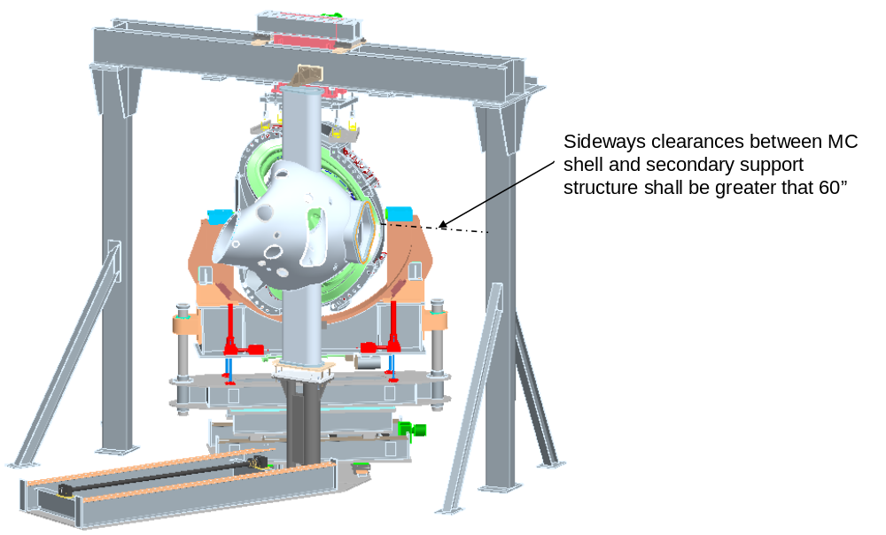

Figure 3.2-1 Secondary Structure Sideways Clearance Space

3.3 Motion Controllers Requirements.
3.3.1 The motion controller must provide at least seven axes of control. For the Reference Design this includes six axes on the Turning Fixture and one axis on the gantry crane.
3.3.2 An initial setup sequence (procedure) shall be provided to establish and position the starting point.
3.3.3 The MCAF and its control system must be designed so that the path of motion is repeatable.
3.3.4 The motion controller must be capable of being re-programmed.
3.3.5 Motor torque monitoring or feedback is desirable if not cost prohibitive.
3.3.6 Control must be provided so that power to the motors are turned off and the breaks engaged before the limit of the mechanical travel are reached.
3.3.7 A jog mode for each axis (TBD” per step) with continuous position monitoring.
3.3.8 An input channel for emergency stop (normally closed).
3.3.9 Provide four input channels, for soft stop (normally open).
3.3.10 Provide one output indicator that identifies any fault conditions (yellow) and one output indicator to identify any stop conditions (red).

3.4 Design and Construction

3.4.1 The MCAF shall be designed to the latest edition of AISC “Steel Construction Allowable Stress Design”.

3.4.2 Workmanship
3.4.2.1 During MCAF fabrication and finishing, particular attention shall be given to freedom from burrs and sharp edges; accuracy of dimensioning radii of weld fillets; making of parts; thoroughness of cleaning; quality of brazing, welding, riveting, painting, and wiring; alignment of parts; and tightness and torquing of fasteners.
3.4.2.2 All welding shall be done by qualified personnel using written and qualified welding procedures in accordance with AWS D.1.

3.5 Shipping
Supplier is responsible for arranging shipment and for the safe arrival of the MCAF at PPPL in Princeton, New Jersey, USA. Subcontractor’s name, shipper, purchase order number, contents and gross weight shall be marked on the shipping container.

3.6 Nameplates and Product Marking

3.6.1 Labels
Equipment and any parts of that equipment to be used by personnel shall be identified with appropriate labels. Labels shall indicate clearly and concisely the function and purpose of the item being labeled. Hierarchical labeling shall be used to facilitate component location on control panels. The terminology used for equipment, procedures, and training materials shall be the same for each case. Label design shall be consistent to promote simplicity and avoid clutter. The use of abbreviations and acronyms shall be minimized. Permanent labels shall be attached to the specific component or equipment in such a manner that environmental conditions or usage by personnel will not remove or destroy the label. Temporary labels shall be used only when necessary and shall not obscure other information or equipment. If a temporary label is to designate a device that is out of service, the label shall be applied so that it prevents the use of that device. Labeling shall be legible and conform to human visual capabilities and limitations in regard to physical characteristics.

3.7 Environmental, Safety, and Health (ES&H) Requirements

3.7.1 General Safety
- When utilized within its intended use and within specified environments, the safe operation, test, handling, maintenance and storage of the subsystem hardware and software shall be provided.
- The subsystem shall not present any uncontrolled safety or health hazard to user personnel.
- The subsystem shall detect abnormal operating conditions and safeguard the NCSX system and personnel.
- The subsystem must comply with applicable requirements of PPPL procedure ENG-021, “Hoisting and Rigging Program”.

3.7.2 Personnel Safety
The subsystem shall meet all applicable OSHA requirements in accordance with 29CFR1910 and 29CFR1926.

3.7.3 Flammability
The use of flammable and combustible materials shall be minimized.

4 Quality Assurance Provisions

4.1 General
The responsibility for performing all tests and verifications rests with the supplier. PPPL reserves the right to witness or separately perform all tests specified or otherwise inspect any or all tests and inspections.

4.2 Quality Conformance Inspections / Verifications
4.2.1 An operational test shall be conducted at the supplier’s facility or other suitable location. The supplier shall provide a test plan that will demonstrate, with a load approximating the 25,000 lb. weight:
4.2.1.1 The six degrees of motion and movement control of 3.1.3
4.2.1.2 The spherical seat movement control of 3.1.4
4.2.1.3 The load test at 125% of rated capacity to qualify the Gantry Crane as a lifting device.
4.2.1.4 The stopping control of 3.1.5 & 3.1.6.
4.2.1.5 The deflection restriction of 3.1.13.
4.2.2 All welds must be inspected by qualified.
4.2.7.1 Visual weld inspection shall be done by inspectors certified in accordance with AWS QC1.
4.2.7.2 Nondestructive examination shall be performed by personnel certified in accordance with ASNT-SNT-TC-1A
4.2.3 The design features of 3.1.7, 3.1.8, 3.1.9, 3.1.10, 3.1.11, 3.1.12, 3.1.13, 3.1.15, 3.1.16, 3.1.17, 3.1.18 & 3.1.19 shall be addressed in the design review.

5 MODELS AND DRAWINGS
Table 5-1 provides a list of files for the Reference Design and the module coil winding form. These files have been placed in a Zip file titled MCAF-050201 and posted on the PPPL NCSX manufacturing Web site under the directory MCAF. The URL for this site is: ftp://ftp.pppl.gov/pub/ncsx/manuf/MCAF/ Pro/Engineer models will be made available upon request.

Table 5-1
MCAF-050201 Zip File Listing

File Name | Description | File Type
se185-000_asm | Reference design FPAF Step file | step
se185-000 | Reference design FPAF basic geometry | pdf, dxf
se185-003 | Reference design FPAF base guide rail assembly | pdf, dxf
se185-004 | Reference design FPAF linear motion structure | pdf, dxf
se185-005 | Reference design FPAF cradle component | pdf, dxf
se185-006 | Reference design FPAF pivot and rotation component | pdf, dxf
se185-007 | Reference design FPAF linear turntable structure | pdf, dxf
se185-008 | Reference design FPAF vertical guide component | pdf, dxf
se185-067 | Reference design FPAF gantry crane | pdf, dxf
MCAF Rev servo table - 050201 | Reference design Turning Fixture servo table | Excel
se141-114-r1 | Modular Coil production winding form Type "A" | pdf
se141-115-r2 | Modular Coil production winding form Type "B" | pdf
se141-116-r3 | Modular Coil production winding form Type "C" | pdf

Appendix A
Modular Coil Assembly Fixture Reference Design

The Modular Coil Assembly Fixture Reference Design (shown in Figure A-1) consists of a turning fixture, a base guide rail, vacuum vessel support and gantry crane used to off load the right hand module coil once it has been positioned. The design philosophy used in laying out the modular coil assembly fixture was to provide six degrees of freedom in motion and adjustment accuracy to properly position two modular coil half periods (MCHP’s) over the vacuum vessel (from each end) and precisely join them at their interface. An I-beam is added to the left side of the base structure to raise the placement position of the Turning Fixture. This enables jack screws providing z-direction motion to be sized to provide the minimum vertical lift needed to raise the MCHP from either the right or left side of the vacuum vessel. It should be noted that the vacuum vessel shell geometry forces the MCHP to move from a low-to-higher position on the right side and from a high-to-lower position on the left side.
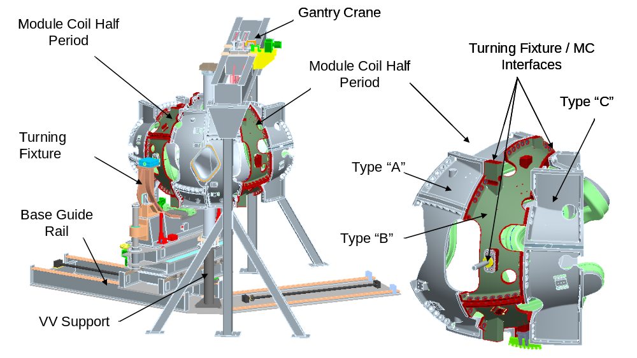
Figure A-1 Module Coil Assembly Fixture Reference Design
Coordinate System: With an I-beam on the left side of the base guide rail the coordinate system that defines the MCHP path on the right side can simply be rotated about the Machine Coordinate System x-axis, allowing one servo table drive system to operate both the left and right side. Figure A-2 shows the relationship between the left and right coordinate systems and the Reference Design 247 step servo table. The servo table is set up to “disassemble” a MCHP over the vacuum vessel. We have defined the starting position on the servo table (Step 0 – all values are at 0) as the position where the MCHP is located when the left and right sides are bolted together (their final position). Step 3 is the position where the MCHP is beneath the gantry crane ~ 0.54” from the final position (Step 0). The phantom box in the servo table indicates that only motion in the y and x direction occurs during Steps 1 thru 3, allowing the MCHP to move perpendicular to the interface parting plane between the left and right hand MCHP’s. Step 247 defines the position where the MCHP Type-A MC will start to pass over the vacuum vessel (moving toward the gantry crane, see Figure A-1). Additional steps beyond Step 247, that will move the MCHP to a position at the end of the guide rail, have not been added to the servo table at this time.

Figure A-2 Turning Fixture Reference Axis

Gantry Crane: The Reference design gantry crane serves two purposes: 1) it supports the right side MCHP when it is ~ 1/2” from the final position (moving from step 247 to step 3 in the Ref servo table listed in Figure 1.3-1); and 2) it provides support to a linear mechanism that moves the right side MCHP into its final position (~ 1/2” of linear motion). Because of the geometry of the Type-A MC the MCHP’s would interfere with each other if we were to simply place the right side in its final position and then manipulate the left side to reach its final position. With the right side supported off the gantry crane, the left side can be moved to its final position (reusing the turning fixture); then the right side can be moved to its final position using the local mechanism that is mounted off the gantry crane. The Reference design gantry crane has been updated to better define the MCHP attachment method and to identify service access for attaching the MCHP to the crane and bolting the MCHP’s together. Figure A-3 highlights the arrangement of the gantry crane showing the MCHP support system.

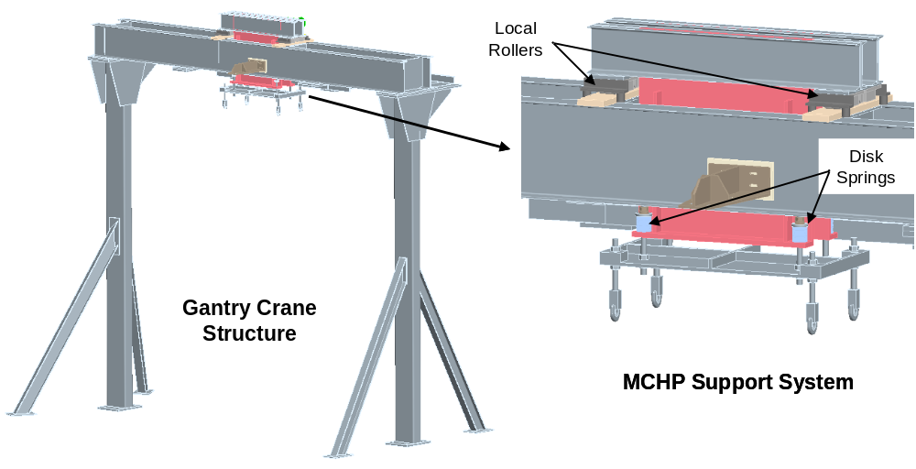

Figure A-3 MCAF Gantry Crane

MCHP / Gantry Crane Attachment Method: When the MCHP is transferred from the turning fixture to the gantry crane there can be no interference with the vacuum vessel insulation system due to deflections of the gantry crane. Contrary to this “stiffness” requirement there is a desire to have some degree of “float” in the support of the right side MCHP support (off the gantry crane) in an effort to aid the seating of the two MCHP’s as the gantry crane mechanism moves the right MCHP to its final position, engaging the left side MCHP. Figure A-4 shows the approach used in the Reference design for interfacing the gantry crane with the MCHP. The MCHP is supported off four links that span the CG of the MCHP. Relatively stiff disk springs have been added to provide some additional “float” to the support system to increase the allowable deflection of the gantry crane/disk spring system to ~ 0.10”.

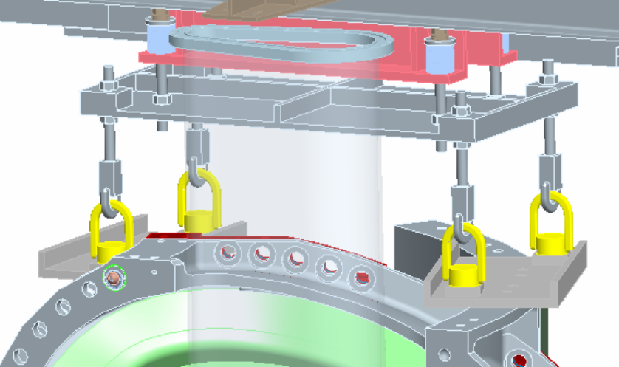

Figure A-4 Gantry Crane / MCHP Interface

Turning Fixture: The Turning fixture consists of five sub-assemblies that are designed to support and move a MCHP with six degrees of freedom about the MCHP center of gravity. Figure A-5 shows the breakdown of the turning fixture sub-components. The maximum extent of motion of the various turning fixture components is defined in the isometric view of Figure A-6.

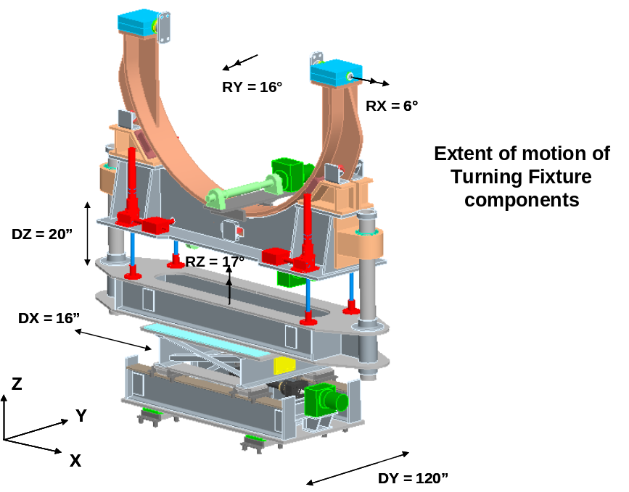
Figure A-6. Reference Design Turning Fixture Component Motion Designation

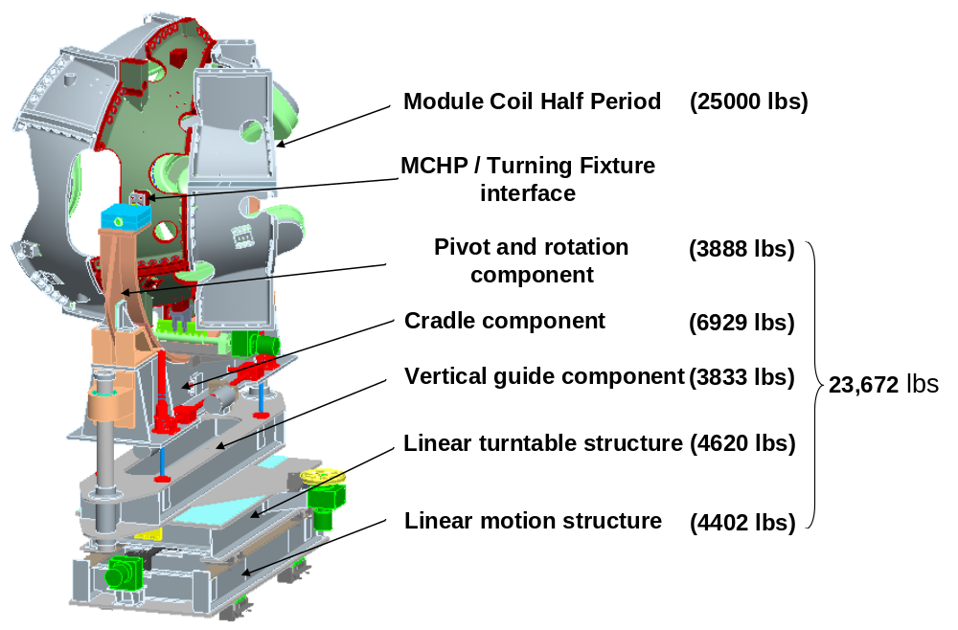
Figure A-5. Reference Design Turning Fixture Component details

