NCSX

Field Period Assembly (FPA)
Manufacturing/Assembly, Inspection, Test and Quality Assurance Plan

NCSX-MIT/QA-183-01-00

August 29, 2005

Author: _______________________________________ Date: __________________
Mike Viola- Field Period Assembly (FPA) Facility Manager

Reviewed By: _________________________________ Date: __________________
Judy Malsbury- NCSX QA Representative

Reviewed By: _________________________________ Date: __________________
Jerry Levine- PPPL Safety Representative

Reviewed By: _________________________________ Date: __________________
Tom Brown- WBS Manager for FPA (WBS14)

Reviewed By: _________________________________ Date: __________________
Brad Nelson-Project Engineer for Stellerator Systems
(WBS 1) Manager

Approved By: _________________________________ Date: __________________
Larry Dudek- RLM for Modular Coil Mfg.Facility

Controlled Document
THIS IS AN UNCONTROLLED DOCUMENT ONCE PRINTED.
Check the NCSX Engineering Web prior to use to assure that this document is current.

RECORD OF CHANGE

Revision | Date | Description of Change
00 |  | Initial release

TABLE OF CONTENTS

1 Introduction and Scope 1
1.1 Introduction 1
1.2 Scope 1
2 Applicable Documents 2
2.1 Laboratory Procedures 2
2.2 NCSX Project Documents 2
2.3 Field Period Assembly Procedures 2
2.4 Manufacturing and Assembly Travelers 3
2.5 Assembly Drawings: 3
2.6 Permits 3
3 Safety Requirements: 4
3.1 Integrated Safety Management: 4
3.2 Job Hazard Analysis: 4
3.3 Personal Protective Equipment: 4
3.4 Radiation Controlled Area: 4
3.5 Food and Beverage 4
4 Training Requirements 4
4.1 General Training Requirements 5
4.2 Specialized Training Requirements 5
4.3 Training Matrix 5
5 General Notes for Field Period Assembly: 6
5.1 General Operating Plan: 6
5.2 Care: 6
5.3 Housekeeping: 6
5.4 Markers and Pencils: 6
5.5 Chips and Filings: 6
5.6 Critical Lifts: 6
6 Materials and Parts 6
7 Assembly Process 7
8 ASSEMBLY STEPS AND SEQUENCE 9
8.1 Vacuum Vessel Assembly 9
8.2 Assembly of the Modular Coils 12
8.3 Vacuum Vessel Support Hardware 16
8.4 Assembly of the Ports 16
8.5 Assembly of the TF Coils 18
8.6 Assembly of External Trim Coils 21
8.7 Vacuum Vessel Final Support Adjustment. 22
8.8 Field Period Transportation to NCSX Test Cell 23
9 Documentation Requirements: 24
9.1 Document Control: 24
9.2 Field Package: 24
9.3 Traveler: 24
9.4 Final Document Storage: 24
10 Quality Assurance/Quality Control Requirements 25
10.1 Mission Statement: -FPA QA/QC Plan 25
10.2 Inspection/Surveillance and Audit: 25
10.3 Inspection and Test Procedures: 25
10.4 Document Traceability and Records: 25
10.5 Equipment/Material Identification and Status 25
10.6 Nonconformance’s & Corrective Actions: 26
10.7 Calibration of Test and Measuring Equipment: 26
10.8 Release for Station Transfer: 26
10.9 Process History: 26

Introduction and Scope

Introduction

The National Compact Stellerator Experiment (NCSX) will be assembled and built at Princeton Plasma Physics Laboratory. The NCSX is comprised of several major components which must be preassembled into three 120° field period assemblies. Each field period assembly consists of one VVSA which has many diagnostic loops and cooling tubes attached, six modular coil assemblies, Once the modular coils are installed, each of the port extensions are welded into place onto the VVSA and finally the 6 TF coils are installed.

The TFTR test cell, shown in Error: Reference source not found, is approximately 114 ft wide by 150 ft. long. The modular coil area will occupy the North side of the building. The Field Period Assembly will be located around the modular coil area in the east and south side of the building. PPPL will coordinate the cleanup and installation of fixtures that will be used for Field Period Assembly. Utilities such as instrument air, power and data ports will be installed or upgraded based on the needs of each fixture, but at the present time the utilities appear adequate. Data ports will be installed as needed, primarily to collect the metrology data that will be generated during the assembly processes. The building crane will be shared with the modular coil assembly.

Scope

This document addresses the manufacturing, inspection, test and Quality Assurance (QA) plan to complete and deliver the field period assemblies to the NCSX Project. This document includes the following Sections:
2 Applicable Documents
3 Safety Requirements
5 General notes for fabrication of Modular Coils.
6 Materials and Parts
7 Fabrication Process
9 Documentation Requirements
10 Quality Assurance/Quality Control Requirements

This document along with the “Facility Operations Plan” [NCSX-PLAN-MFOP-01] will govern the processes by which the modular coils will be fabricated.

This document meets the requirements of the NCSX Quality Assurance Plan [NCSX-PLAN-QAP].

Applicable Documents
Identified below are the primary laboratory and project documents that that will be needed to complete the production of the Modular coils.

Laboratory Procedures

Procedure Number (Latest Version) | Title
ESH-004 | Job Hazard Analysis
ES&H 5008 | PPPL Environmental, Safety and Health Manual
ESH-008 | Access to Radiological Areas (RCA’s)
ENG-014 | Hydrostatic and Pneumatic Testing
ENG-021 | Hoisting & Rigging Procedure
EM-002 | General Welding & Brazing Requirements

NCSX Project Documents

Document No. | Title
NCSX-CSPEC-142-03 | Modular Coil Assembly Specification
NCSX-CSPEC-141-02 | Modular Coil Castings Specification
NCSX-CSPEC-142-04 | Modular Coil Conductor Specification
NCSX-CSPEC-121-02 | VVSA Specification
NEPA No. 1283 | Modular Coil Development and Production
NCSX-PLAN-FCP-00 | Manufacturing Facility Operations Plan
WP-1138 | Manufacturing of Production Coils

Field Period Assembly Procedures

Document No. | Title
NCSX-PROC- FPA -001 | FPA -Material Receipt
NCSX-PROC- FPA -002 | FPA -Station No. 1 Activities
NCSX-PROC- FPA -003 | FPA -Station No. 2 Activities
NCSX-PROC- FPA -004 | FPA -Station No. 3 Activities
NCSX-PROC- FPA -005 | FPA -Station No. 4 Activities
NCSX-PROC- FPA -006 | FPA -Station No. 5 Activities
D-L-NCSX-983 | Lifting Modular Coil Castings
D-L-NCSX-984 | Lifting Mod Coil Casting & Windings

Manufacturing and Assembly Travelers

NCSX-TRAV-MCF-001…. Mod Coil Fabrication Traveler

NCSX-TRAV- FPA-001…. Field Period Assembly Traveler

Assembly Drawings:

Drawing No. | Drawing Description
TBD
TBD

Permits

D-site work permits:

Required whenever work is being performed at D-site. It identifies the type of work and procedures being used.

Confined space permits:

Required whenever a person is entering a confined space. It identifies any restrictions, requirements and personnel who are authorized for entry. The PPPL Industrial Hygienist (IH) representative issues the permit. [Requires a “safety watch”] (Example: Autoclave entrances when the dome is in position)

Flame/Fire Permit:

Required whenever open flame activities such as welding, soldering, grinding, etc. are being performed. The permit is issued by PPPL’s Emergency Service Unit (ESU) and requires a fire watch.

Safety Requirements:

Integrated Safety Management:

All work will be performed in accordance with PPPL safety policies ES&H 5008 and “Integrated Safety Management” (ISM) policy.

Job Hazard Analysis:

JHA’s will be generated for each workstation, identifying existing or potential workplace hazards and to evaluate the risk of worker injury or illness associated with job tasks. (Reference document ESH-004 “Job Hazard Analysis”) The IH representative will review the JHA’s for accuracy as well as completeness. It will be reviewed with all activity participants at the Pre-Job briefings.

Personal Protective Equipment:

The PPPL Industrial Hygiene and Construction Safety representatives will work together with the Manufacturing Facility Managers to identify the necessary and correct personal protective equipment (PPE’s) needed to ensure a healthy and safe work environment for the work force.

Radiation Controlled Area:

The modular coil manufacturing facility is located in a Radiation Controlled Area (RCA). As a result, all personnel entering or working in the area must be radiation qualified, or be escorted by a qualified escort.

Food and Beverage

No food, gum, or beverage will be allowed in the manufacturing facility.

Training Requirements
Training of personnel working in the NCSX Manufacturing Facility is key to successfully completing the manufacturing of the modular coils. There are two categories of training requirements, general and specialized.

General Training Requirements
General training includes all laboratory-training requirements that are required to enter or work in the NCSX Manufacturing Facility. Examples of this training includes:

- General Employee Training [GET]
- Integrated Safety Management [ISM]
- Radiation Safety Training

Specialized Training Requirements
Specialized training includes specific training or certification required to complete tasks during the fabrication of the modular coils. Examples include:

- Weld or braze certifications
- Confined space
- Winding Facility Operations Plan [WFOP]

Training Matrix
The training matrix below identifies the type of training required for individuals working on the Field Period Assembly.

Training Matrix
 | Station 1 VVSA loops and tubes | Station 2  Modular Coil Assembly | Station 3  Modular Coil & port installation | Station 4 TF Install | Station 5 Storage & Transport prep. | Riggers & Crane Operators | Field Supervisors | QC  Represent
Confined Space |  |  |  |  |  |  | X | X
General Employee (GET) | X | X | X | X | X | X | X | X
Radiation Safety | X | X | X | X | X | X | X | X
Hazard Communications | X | X | X | X | X |  | X | X
Hazard Awareness (JHA) | X | X | X | X | X | X | X | X
Lockout/Tagout | X | X | X | X | X |  | X | X
Basic Electrical | X | X | X | X | X |  | X | X
Ladder Safety | X | X | X | X | X |  | X | X
Fall Protection |  |  | X | X | X | X
Stud Welding | X
Rigging &/or crane operator training |  |  |  |  |  | X
Mechanical Arm training- Romer (operators only) | X | X | X | X

General Notes for Field Period Assembly:

General Operating Plan:

Document “NCSX-PLAN-MFOP-01” describes the general operating plan that will be used for the manufacturing and assembly facility.

Care:

Certain coil parts are extremely fragile and special care must be taken to assure that they are not damaged. The most fragile areas are the coil terminals and the cooling tubes.

Housekeeping:

Good Housekeeping is an essential element to the success of the manufacturing of the modular coils. It is required that all stations be maintained in as clean a state as is reasonable for the specific activities being performed.

Markers and Pencils:

The use of lead pencils or non-approved markers is prohibited in the fabrication stations. “Sharpie” permanent markers are the only markers that may be used without prior approval by the Field Supervisor.

Chips and Filings:

Extreme care must be taken when using files, grinders, etc. that could generate metal chips or filings. Surrounding areas must be protected from these activities.

Critical Lifts:

All lifting of modular coil castings and/or completed coils will be considered a “Critical” lift that requires the presence of a lift engineer. Note: The lift engineer may later identify the lift as repetitive, in which case his presence would not be required.

Materials and Parts

General Description | Material | Reference Document/Product No.
TBD
TBD

Assembly Process

This section of the MIT/QA plan outlines the processes that are to be performed and procedures required to complete the Field Period Assembly. Procedures for performing the activities are covered by the Field Period Assembly procedures. Each station will have a separate procedure detailing the manufacturing processes; use of travelers; inspection points and test plan for that station.

Material Receipt
Material Receipt
  - VVSA receipt & inspection
  - Cooling Tubes receipt & inspection
  - Misc. hardware inspection guidelines
Procedure No.
NCSX-PROC- FPA -QA

- VVSA Preparation
  - Locate diagnostic loops
  - Install templates
  - Install Diag Loops
  - Locate cooling tubes
  - Install tube clamp studs
  - Perform measurements
Station No. V1
VVSA loops and tubes
Procedure No.
NCSX-PROC- FPA -001

Station No. V2
MC Assembly
Procedure No.
NCSX-PROC- FPA -002
- MC Assembly
  - Align and assembly 3 MC sets

- Install MC Assembly and port extension
  - Align and Install VVSA
  - Install first 3 MC sets
  - Install Second 3 MC sets
  - Align and bolt together
  - Align and Weld Port extension

Station No. V3
Install MC and port extension
Procedure No.
NCSX-PROC- FPA -003

Station No. V4
TF HP Assembly
4,0 TF HP Assembly
  - Assemble two 3 TF coil sets

Procedure No.
NCSX-PROC- FPA -002

Station No. V5
Install TF and Trim Coil
- Assemble and Install TF Coils and Trim Coils
  - Assemble two 3 TF coil sets
  - Install Field Period
  - Install one 3 coil set onto TF fixture
  - Roll Coils on
  - Install second 3 coil set onto TF fixture
  - Roll Coils on
  - Install Trim Coils

Procedure No.
NCSX-PROC- FPA -004

Station No. V6
Final Prep for transport

6.0 Final Prep for Transport
  - Perform Final Measurements
  - Install transportation supports
  - Load on truck

Procedure No.
NCSX-PROC- FPA -005

Send to NCSX Test Cell

Figure 1- Field Period Assembly Plan Outline

The Field Period Assembly area will make use of the crane primarily for picking up major components such as the Vacuum Vessel, Modular Coil, TF Coil and the completed Field Period Assembly. When components arrive from the vendor they will be inspected for damage, lifted off the truck and placed in an area designated for receiving inspection. All necessary documentation will be reviewed and any additional testing will be performed. When the component has passed the receiving inspection test it will be lifted to the appropriate fixture in the assembly area.

ASSEMBLY STEPS AND SEQUENCE

Vacuum Vessel Assembly (Stage 1)
The Field Period Assembly will begin with the assembly of the vacuum vessel. The vacuum vessel will be assembled to the vacuum vessel support fixture, as shown in Figure 8.1. The lower vertical port flange is bolted to the mating flange on the vacuum vessel support fixture. A column located in the center of the vessel will supply stability during the assembly.

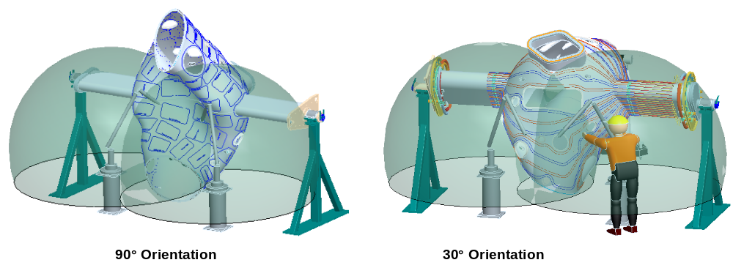
Figure 8.1 Vacuum Vessel Support

The following components will be assembled to the outside of the vessel.

Magnetic loops / saddle coils
Saddle loops will be installed on all three vacuum vessel Field Periods with varying numbers on each. One vacuum vessel Period Assembly supports 142 magnetic loops, with 135 of the loops located on a single Half Period. The remaining two vessel Period assemblies will support 13 magnetic loops. Sixteen saddle loops will also be installed on each of the three spool pieces. The technique for installing the saddle coils is to place a thin copper template that mimics the size and shape of a particular saddle loop over the surface of the vacuum vessel. The template will have a number of edge marks that will be used to match up with pre-inscribed marks placed on the surface of the vessel by the Romer or Leica metrology measurement system. Each copper loop will be pressed down against the vessel to conform to the vessel surface and will be centered between the locating marks. A number of template hold-down methods are being evaluated. The mineral insulated (MI) cable for the sensors will be wrapped around the edge of the template. Leads from the coils will be routed to the vertical ports and terminated in a junction box on the ports. The MI cable will be held in place by wrapping the cable with thin tabs and spot welded to the vessel. Measurements of the coils will be made using a Faro arm or laser tracker and recorded for future information. The measurement tolerance for locating these coils is +/- .030.

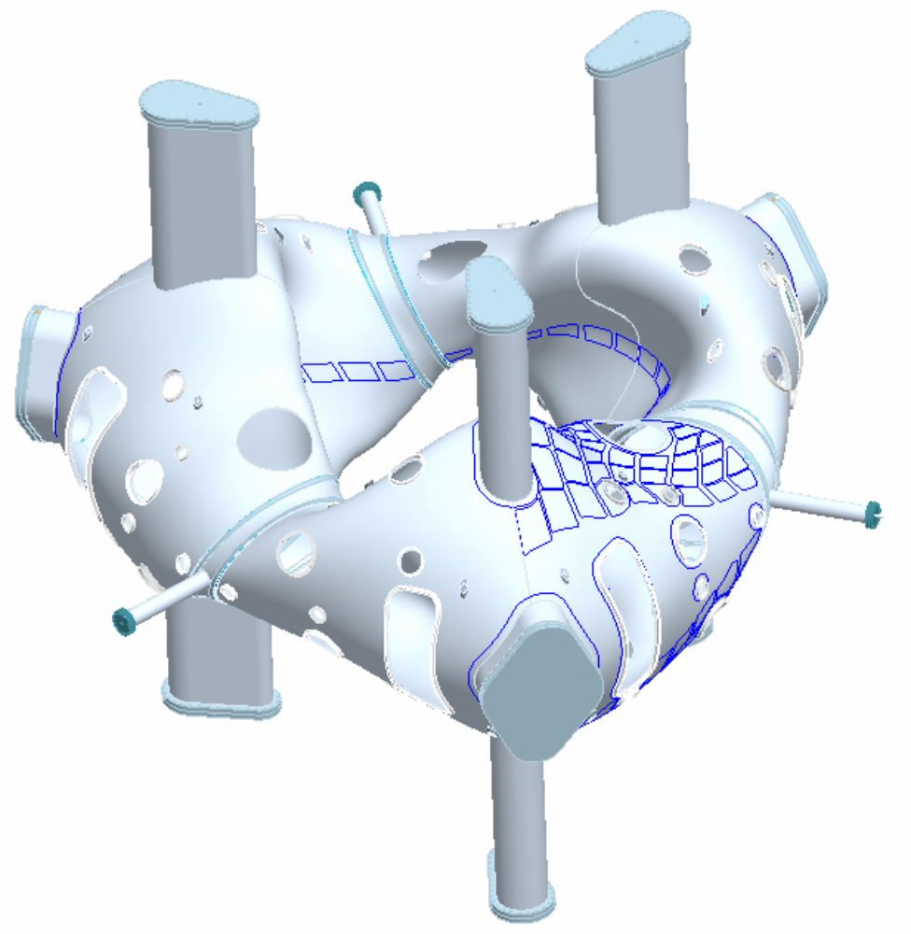

Figure 8.2 Magnetic Loop Arrangement

Cooling / heating trace lines
A total of 64 cooling/heating trace lines will be attached to the outside surface of each vacuum vessel Field Period with 600 studs at approximately 8” spacing, shown in Figure 8.3. The cooling tubes are 0.375” O.D. x .035” wall thickness flexible tubing made of Inconel 600????????. The tubes will be attached to the vessel by stud welding “J” clamps. A 1/16-inch gap is designed between the vessel and the cooling tubes. This gap provides clearance for the installation of the saddle coils. Stycast, a thermally conducting epoxy, will be placed between the vessel and tubes. The location of the tubes is not as critical as previous components.

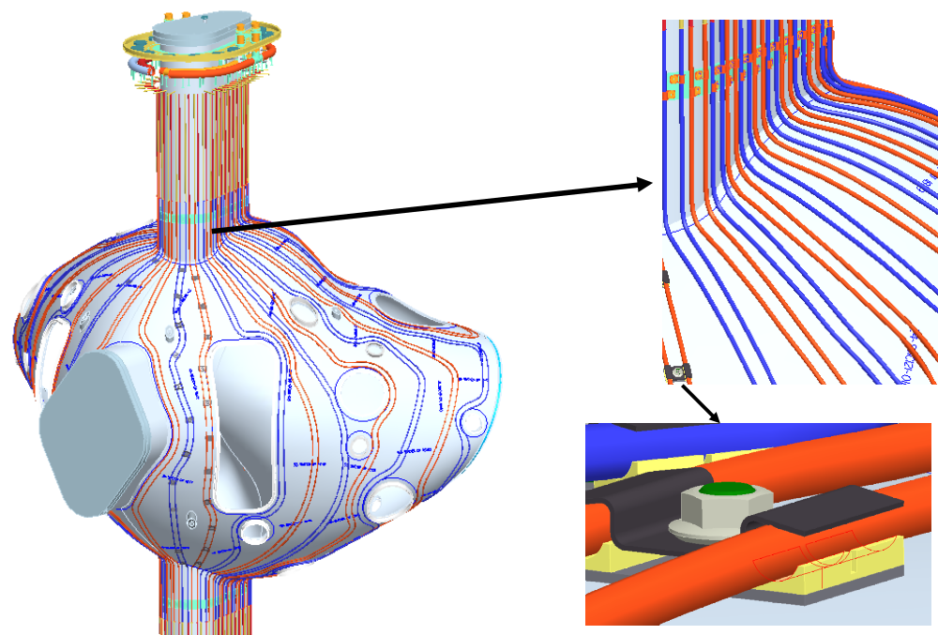

Figure 8.3 Cooling / heating line tracing installed on vacuum vessel

Modular Coil Half Period Assembly (Stage 2)
The assembly of the modular coils will consist of four steps. Step 1 is to review the dimensional inspection information generated during the manufacture of each coil. Step 2 is to assemble coil segments M1, M2 and M3 together to form the half period coil subassembly, using shims as required to obtain the best relational fit between the three coils. Step 3 is to dimensionally inspect the coil sub-assemblies. Step 4 is to assemble the left and right half period sub assemblies over the vacuum vessel.

Step 1
Inspection data from each coil will be collected, including the relationship between the winding geometry, flange geometry, and tooling ball monuments. The location of these features relative to the global machine assembly will be calculated based on the optimum position of each coil in the assembly. This information must be processed to determine the best fit of the coils in the final assembly, and to size the shims needed for the next step.

Step 2
The modular coils will first be assembled into segments consisting of the three coils using the fixture shown in Figure 2. This procedure will start with M1. The M1 coil segment will be placed in the fixture and measured to verify location. A shim, which has been sized based on dimensional data taken during the fabrication of the M1 coil and the next coil segment, M2, will be placed on the flange. The M2 segment will be lowered into place and insulated bolts will be matched reamed with the flange holes. The bolt and nut assembly will be torqued to specification. Dimensional inspection data will be taken to verify the location of the coil. The M3 coil will be assembled next using the same procedure as done for the M2 coil. After the three shell segments have been assembled, cryolite batt insulation will be placed between the windings.

Step 3
After the 3-coil subassembly is completed, it must be re-inspected. The purpose of this inspection is to verify the assembly of the half period coil subassembly and to compare this information with a second half period assembly to size the shim needed at the Field Period Assembly.
TBD
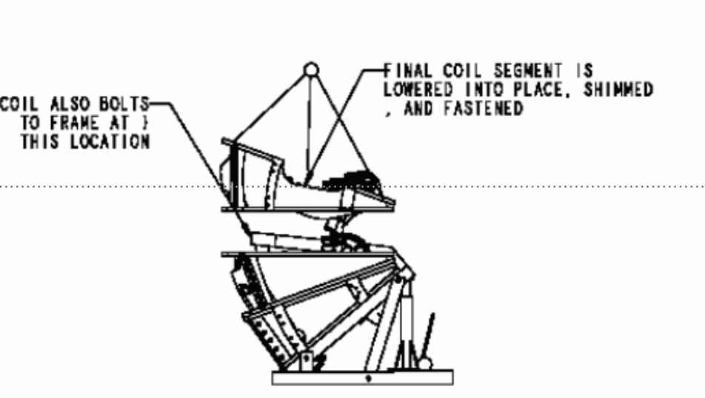
Figure 2 Modular Coil Subassembly with fixture

Step 4
After a pair of 3-coil assemblies are completed and inspected, they will be assembled over the vacuum vessel. The half period modular coil subassembly and fixture will first be placed next to the vacuum vessel and fixture shown in Figure 3.

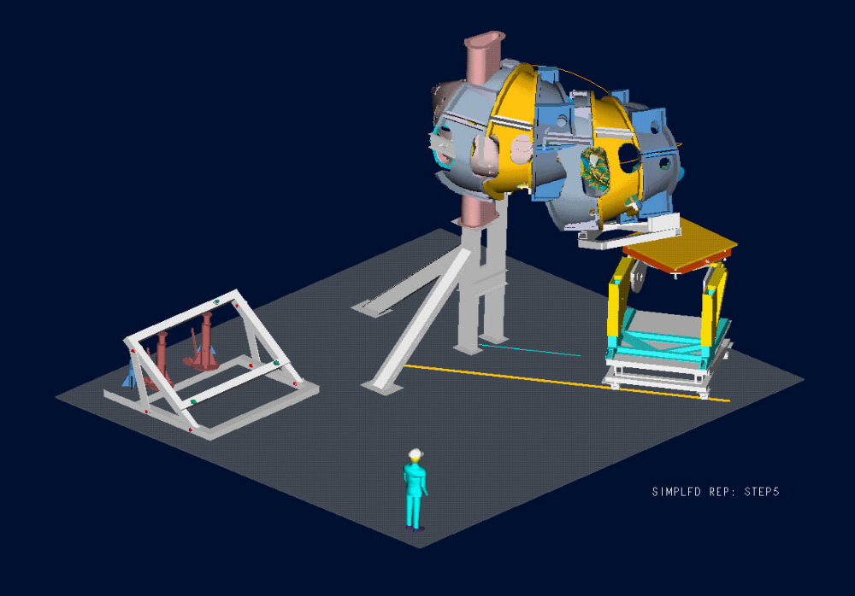
TBD
Figure 3 Modular coil subassembly on fixture for assembly over vacuum vessel

The half period modular coil subassembly and fixture will be guided by tracks that have been positioned on the floor. As the fixture and subassembly follows the tracks the fixture will change the location of the coils by moving vertically, pivoting on the horizontal axis, and rotating the table about a vertical axis. By slowly advancing the fixture and adjusting the location of the coils the half period segment will fit over the vessel until the coils have been positioned correctly.
Measurements of the coil location will be made during the assembly to verify the location of the coils during all moves. When the half period subassembly is correctly positioned the load will be temporally transferred from the fixture to a support frame as shown in Figure 4. The support frame allows the handling / positioning fixture to be removed from under the 3-coil subassembly.
After the handling fixture is removed, the half period subassembly will be supported from the floor as shown in Figure 5. The temporary support frame is also removed.
A shim that fits between the two half periods will be placed on the installed half period subassembly. The second half period subassembly will be installed in a similar manner as the first. When the second half period subassembly has been installed insulated bolts/nuts will be matched reamed with the first half period subassembly and torqued to the required specification.
The modular coils will be inspected to verify the final location of the coils.
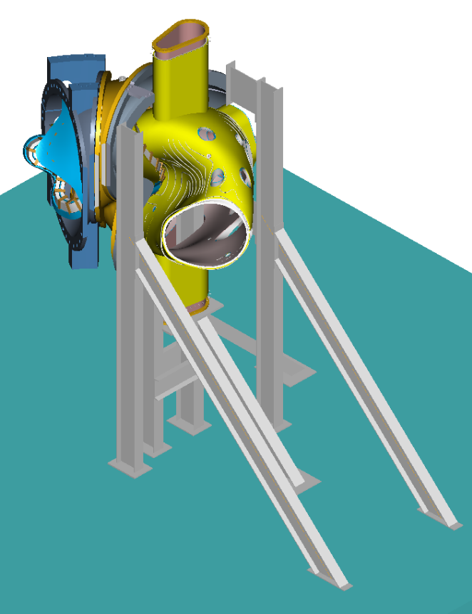
TBD
Figure 4 Load transfer fixture

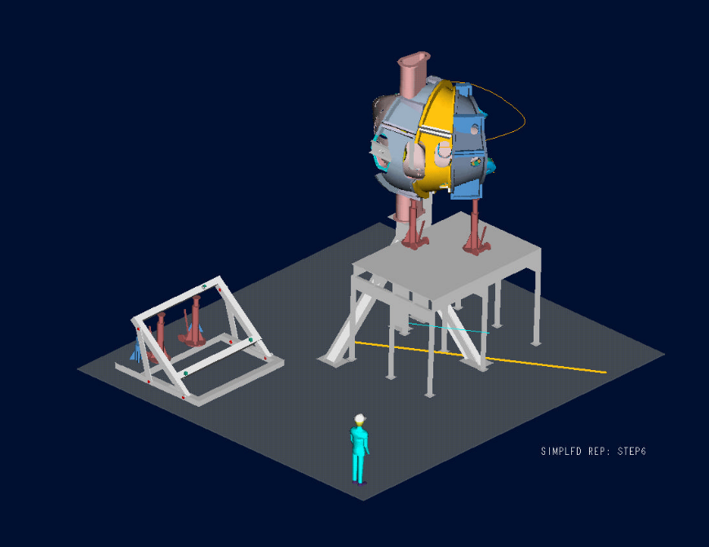
TBD
Figure 5 Modular coil load transfer fixture

Vacuum Vessel Support Hardware
The vacuum vessel support hardware can now be installed between the vacuum vessel and the shell. A clevis subassembly will be fitted thru access ports in the shell and screwed into bosses that are in the vessel, as shown in Figure 6. Threaded rod can be inserted into the clevis from the outside of the shell. Belleville washers and a nut will be attached to the threaded rod and tightened against the shell until the vacuum vessel is snug. The vessel will not be fully supported by this hardware until the ports have been installed and welded to the vessel.

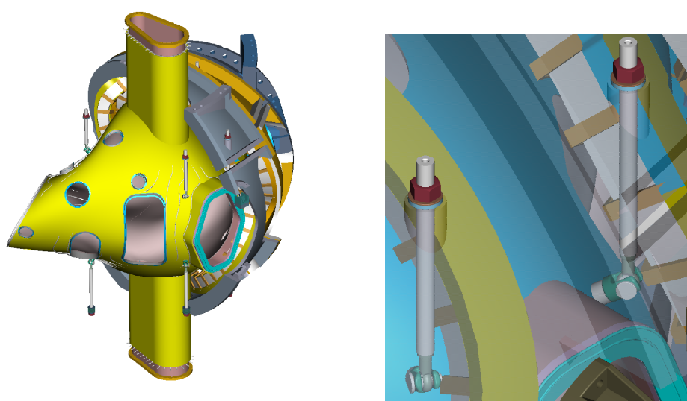
Figure 6 Vacuum vessel support hardware

Assembly of the Ports
The vacuum vessel ports are the last major items to be assembled to the Field Period Assembly. Before installing the ports the Field Period Assembly will have the components assembled as shown in Figure 12. A typical port configuration is shown in Figure 7. A backing ring is shown welded to the port. The backing ring will help position the port over the stub in the vacuum vessel (Figure 7). An assembly fixture will be used to maintain alignment of the ports relative to the global reference frame. All of the ports will be positioned on the vessel and aligned using the alignment fixture. As each port is positioned a tack weld will hold the port stable. After all ports have been assembled each joint will be finished with a full penetration weld. Blank off flanges will be installed on the ports and on the open ends of the vacuum vessel. The vacuum vessel will be baked above the normal bake out temperature (150ºC) to 165ºC and cycled several times. A vacuum leak test will be performed to verify all the welds are leak tight. In addition to the vacuum leak test, a dimensional verification of the port locations will be performed. All fixtures shall be removed and the inspection shall be made with the ports in a “free condition”.

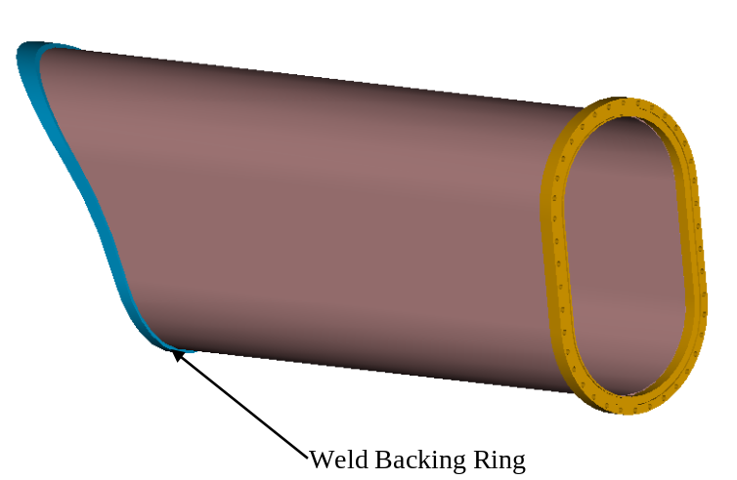
Figure 7 Typical Vacuum Vessel Port Extension ready for welding

Assembly of the TF Coils
The completed half period TF coil subassembly is shown in Figure 8. The subassembly consists of 3 TF coils with a cast top and bottom support structure. The assembly of the TF coil subassembly is shown in Figure 9. This subassembly step is required prior to assembling the TF coils over the modular coil shell. The TF coils will be positioned slightly offset in the radial direction (~1/4 in) from their final position. This provides clearance during the final machine assembly, when the three Field Periods are installed on the base structure.
The assembly trajectory of the TF Coil half period subassembly is much simpler than the modular coil assembly. The TF Coil half period subassembly can be simply rotated over the modular coils. The fixtures for the assembly are shown in Figure 10.
Before the TF Coil can be assembled, the supports for the Modular Coils must be positioned to allow free access over the Modular Coil. One end of the modular coils is supported from the ground. This allows the opposite half shell subassembly to be cantilevered from the fixed half shell subassembly. With no supports preventing the installation of the TF Coil half period the coils are simply rotated into position. Shims are sized and then placed between the TF Coil and the Modular coils. The two sub-assemblies are then bolted together. Supports are then placed under the TF Coil support and the procedure is repeated for the opposite side.

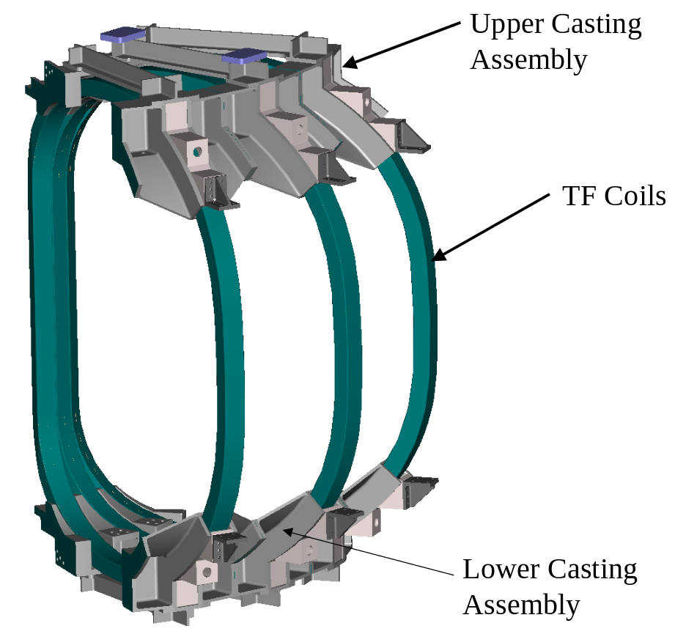
Figure 8 TF coil half-field period subassembly

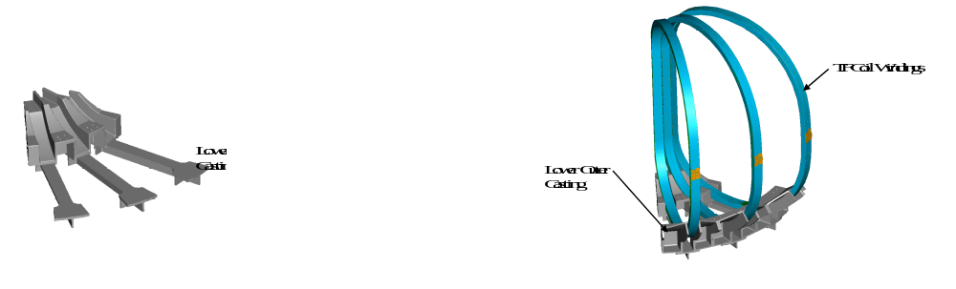
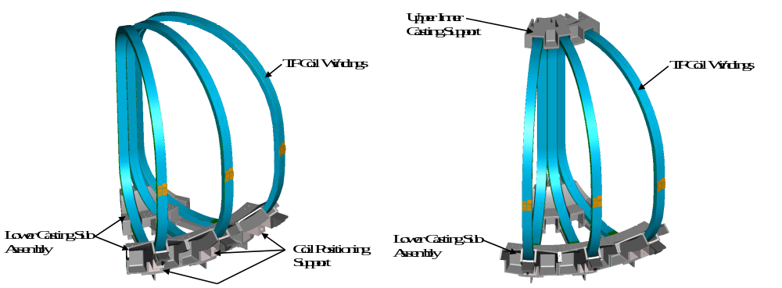
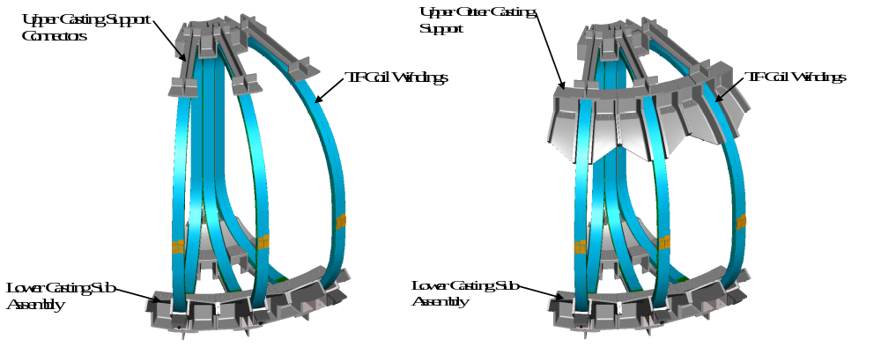
Figure 9 Assembly sequence of TF half-field period subassembly

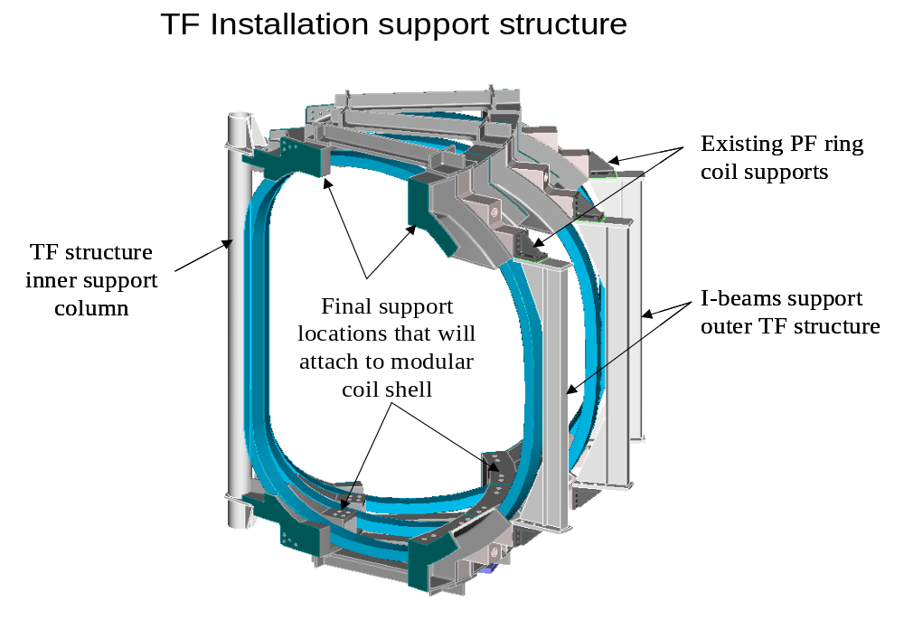
Figure 10 TF Coil installation support fixture

Assembly of External Trim Coils
After the assembly of the TF coils, the External Trim Coils will be attached to the Field Period Assembly. The External Trim Coils are shown in Figure 11. The external trim coils consist of three upper, three lower, and two outer coils. The upper and lower coils are attached to the frame of the TF coil support structure. The outer trim coil is mounted on the outside of the TF coil (Figure 12). At the machine assembly level an additional outer trim coil will be added between each Field Period Assembly. The complete assembly of all the external trim coils is shown in Error: Reference source not found.

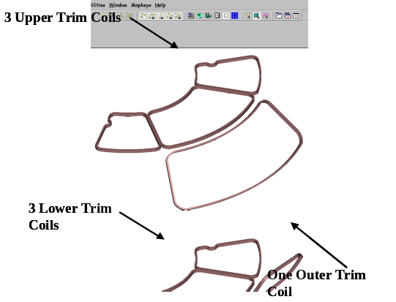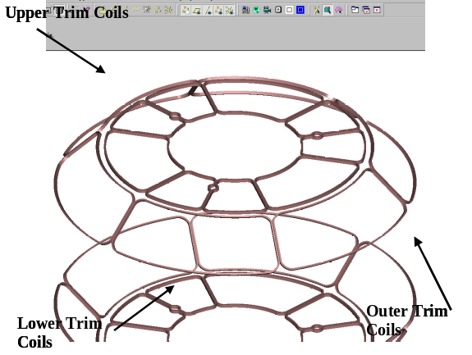
Figure 11 External trim coils

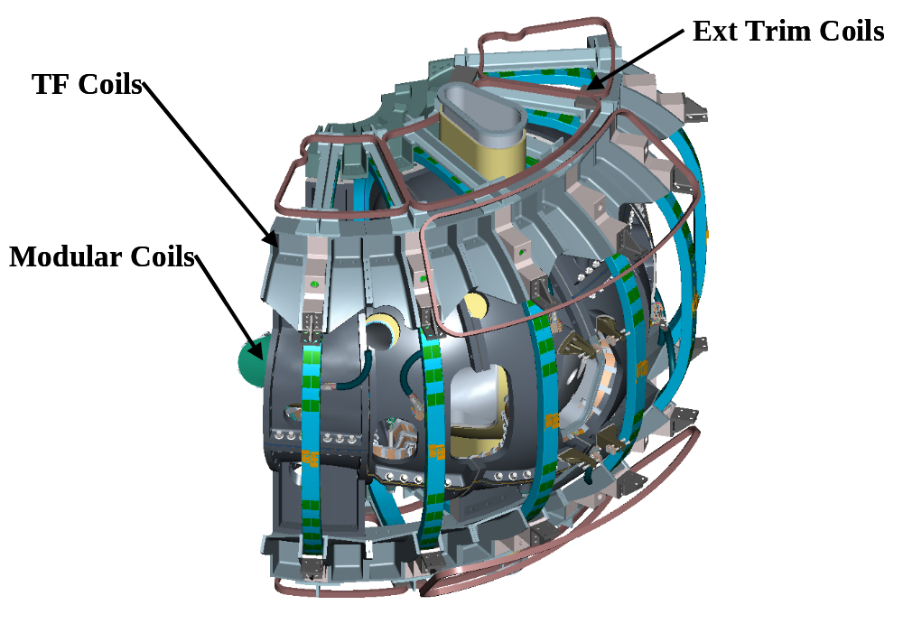
Figure 12 Field period with trim coils installed

Vacuum Vessel Final Support Adjustment.
Before completing the Field Period Assembly, the vacuum vessel has to be supported from the shell. The support hardware that was installed after the modular coils is now tightened until the vessel is barely lifted off the support fixture. The vessel is now free and can move inside the shell assembly. Temporary blocking will be installed between the shell and the vessel during transport from the assembly area to the NCSX test cell. The completed field period assembly is shown in Figure 13.

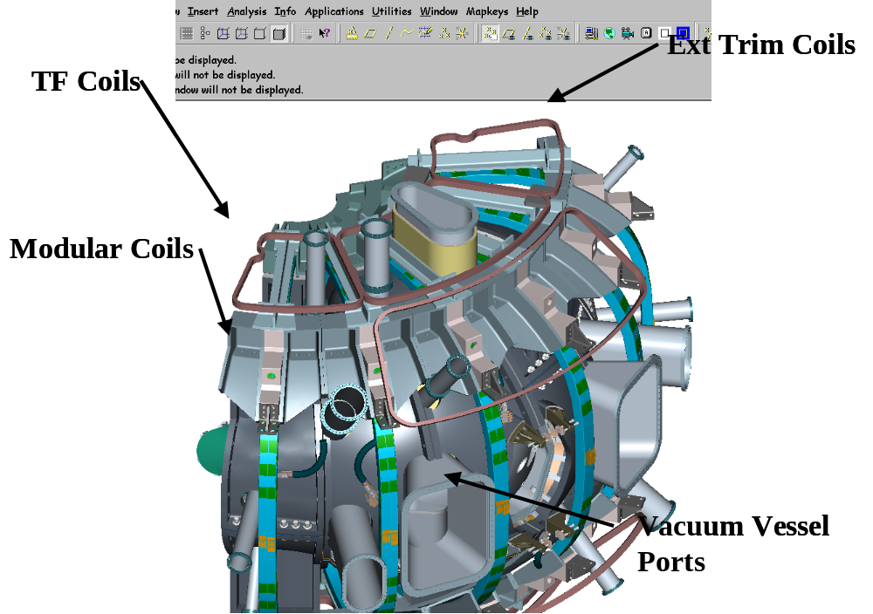
Figure 13 Field period assembly with trim coils

Field Period Transportation to NCSX Test Cell
When a Field Period Assembly is completed it will be lifted from the fixture in the assembly area and set on a truck for shipment as shown in Figure 14. The Field Period Assembly will be driven a short distance on site to the NCSX test cell.
The crane is not expected to be used for day-to-day assembly. Local fixtures will be used for assembly. Typical lifts and the weights are shown in Table 1. After a lift has been performed the crane will be released for other operations needed in the TFTR Test Cell.

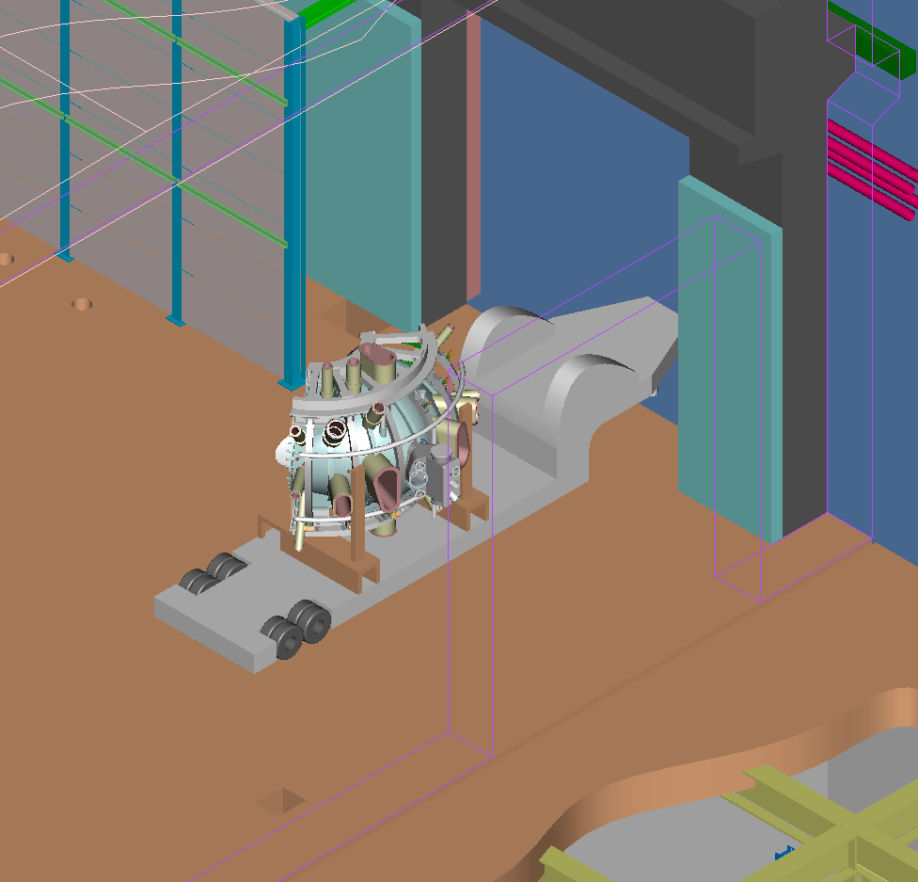
Figure 14 TFTR Loading Station

Table 1 Typical components to be lifted and weights
Description | Weight
Vacuum Vessel | 6,400 lbs
M1 Coil | 7,100 lbs
M2 Coil | 6,700 lbs
M3 Coil | 7,100 lbs
Half period Modular Coil | 21,000 lbs x 2
Half period TF Coil | 11,000 lbs x 2
Field Period Assembly | 70,400 lbs

Documentation Requirements:

Document Control:

All NCSX associated documents providing instruction for manufacturing the modular coils will be maintained under NCSX Project document control.

Field Package:

Each field period will have a “Field Package” that will include all related documentation associated with the FPA. Documentation in this package will include Travelers, inspection & test reports, data sheets, photographs, etc.

Traveler:

A “Traveler” will be used to document the completion of the various assembly phases of the field period from station to station. The traveler will be used in conjunction with the manufacturing procedures as a signoff/approval form noting that critical manufacturing steps have been completed. Authorized personnel associated with the manufacturing, inspection and test processes will perform the signoff’s. In addition, it will provide witness points as well as reference for test results, and measurements.

Traveler Completion:

The Lead Technician or Field Supervisor will document all critical completions on the traveler. This will be completed using the signer’s initials or pre-approved stamps identifying the signer.

The “Travelers” will be filled out in a timely fashion once a particular activity has been completed.

Authorized Signoff’s for Manufacturing Completions:

The manufacturing procedures will identify what level of signoff is required for a particular step. The following disciplines are the authorized signatures for the in-process Travelers.

-Station Lead Technicians
-Field Supervisors
-Quality Control Representative
-Manufacturing Facility Manager

Final Document Storage:

All documents (hard copy) associated with the manufacturing will be stored in the PPPL Operations center for the lifetime of the NCSX Project.

Quality Assurance/Quality Control Requirements

Mission Statement: -FPA QA/QC Plan

To observe and obtain any required information as may be necessary to assure that the assembly of the field periods is being performed in accordance with the Manufacturing Facility Operations Plan, the NCSX field period assembly Procedures and other applicable documents. [See section 2 for document numbers]

Inspection/Surveillance and Audit:

Authorized representatives of the NCSX project will perform inspection and surveillances all during the manufacturing of modular coils. These representatives will include the Field Supervisors; lead technicians as well as the Quality Control (QC) representatives.

All measurements and tests will be performed by the field crews and engineering and do not require, unless outlined in the procedures, the presence of a QC representative.

Independent Audits may be performed by the Quality Assurance Division to ensure that approved manufacturing processes and quality of product is being observed.

Inspection and Test Procedures:

Inspections and tests shall be performed in accordance with written/approved procedures referencing criteria for acceptance or rejection. Adequate records shall be maintained and available for NCSX Project reviews.

Document Traceability and Records:

The FPA team shall maintain a system of documentation whereby objective evidence of required operations, inspections, examinations, and tests is systematically compiled, indexed and stored. Such objective evidence will include “travelers”; and material test, certification, inspection, examination, test and discrepancy reports; which shall be complete and legible and validated by responsible personnel and shall be traceable to subject items.

Equipment/Material Identification and Status

Material and equipment identification shall be maintained throughout the program and be traceable to the records. Status of acceptability shall be readily discernible through the use of tags, stamps, serial numbers or other positive means.

Nonconformance’s & Corrective Actions:

Nonconforming items shall be positively identified, and, where possible, segregated to prevent use. The FPA Team shall document each non-conformance in accordance with PPPL procedure QA-005 “Control of Nonconformance’s”.

Calibration of Test and Measuring Equipment:

Inspections and tests shall be performed using properly calibrated measuring and test equipment in accordance with PPPL procedure ENG-002 “Control of Measurement Test Equipment & Calibration”.

Release for Station Transfer:

Prior to releasing a modular coil from one station to the next it is required that the all-responsible individuals sign the release indicating that all processes at that station have been satisfactorily completed. The release (on the Traveler) will include signatures from the Station Lead Technician, Field Supervisor and the QC representative.

Process History:

The FPA team shall provide a Process History for the modular coils that includes a compilation of documents, detailing the objective evidence of the acceptability of the work performed. The Process History shall include as a minimum, but not be limited to the following:

Material Certifications:

The FPA Team shall compile inspection reports, test data, and/or certifications from vendors, showing relevant chemical, mechanical and electrical properties of materials used, where applicable, as well as documents showing adherence to in-process requirements. Material certifications from sub-tier suppliers shall also be submitted. {Certifications for the insulation, epoxy, conductor as well as chill plates and lead materials are required as a minimum}

Inspection/ Test Documents:

Original or copies of filled in and completed process planning and control documents (travelers, etc.), which verify controlled execution of the required work. Each modular coil will have its own set of process planning and control documents.

Inspection Reports:

Copies of the original reports of all required inspections and examinations, properly and will validated by authorized personnel.

Test Reports:

Copies of the original test data sheets or reports of all required tests, both in-process and acceptance, properly validated by authorized personnel.

