Vacuum Vessel Installation Fixture Design Summary

Reference 1: NCSX Vacuum Vessel assembly tooling study.
Reference 2: NCSX Vacuum Vessel operating deflections

A number of configurations have been considered for supporting the vacuum vessel period sub-assembly in order to install magnetic loops and vessel heating/cooling tubes. The project is migrating toward insulating the vacuum vessel using insulation beads “pored-in” after final machine assembly instead of using an insulation blanket mounted off the vacuum vessel; so installing blanket insulation is no longer an assembly concern at this time. The heating tubes sit 1/8" off the VV and the diagnostic loops lie on the VV surface (see Figure 1). Initially a Rogowski coil was to be located near the large vertical port running in a poloidal direction stitched to the surface of the (now removed) insulation blanket. Options for attaching the Rogowski coil to the heating/cooling tubes through insulated connections or moving it to a location inside the modular coils are under consideration.

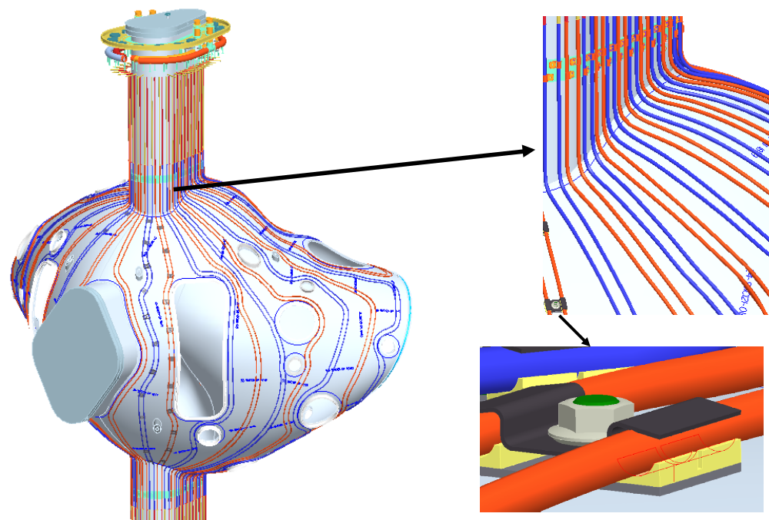

Figure 1.0 Heating / Cooling Tube Arrangement

Component Installation Fixture Design Requirements

The vacuum vessel installation fixture shall provide a cost-effective (economical) system to install the magnetic loops and the vacuum vessel heating/cooling tubes while meeting individual installation requirements.

The heating/cooling tubes are planned to be pre-fabricated and their installation is not expected to impose any specific requirements on the vacuum vessel installation fixture other then providing accessibility to comfortably assemble and attach the tubes.

The magnetic loops need to be installed and their final position accurately measured using the Romer CMM. A number of metrology pucks will be temporarily attached to the vacuum vessel surface to act as reference features for alignment. The accuracy to which the magnetic loops can be measured is dependent on the Romer CMM system and its alignment as well as the overall deflection characteristic of the vacuum vessel while supported in the assembly fixture.

Vacuum Vessel Installation Fixture Options

Figure 2 shows a vertical port trunnion arrangement that allows the vacuum vessel to be moved to different positions for easy assess for personnel to install components and perform positional measurements of the diagnostic loops. The Romer CMM will need to be positioned in four “quadrants” for it to gain access to all loops. The silhouette area is shown to indicate the reach of the Romer arm. Alternate support arrangements (shown in Figure3) have also been considered. Platforms are needed if the vacuum vessel were located in a vertical position as the distance of the vertical port ends measures 13 ½’. If supported on the NB flange the vessel will need to be moved from a local platform support (as shown) to the floor to gain access to the inside region of the vessel. If the vessel is supported off the parting flange it also will need to be raised up to gain access to the underside region.
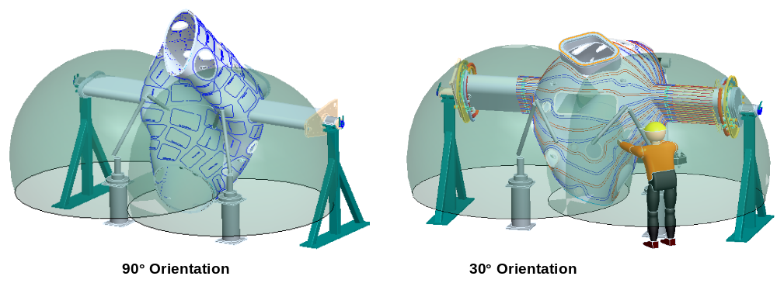

Figure 2 Vertical port trunnion support arrangement

To identify the merits of the different support arrangements from the standpoint of shell deflections due to gravity loads an FEA model (without ports) was created. The deflection results are summarized in Table 1, with the complete write-up provided in Reference 1. The relative displacement defines the relative surface deflection on the shell.
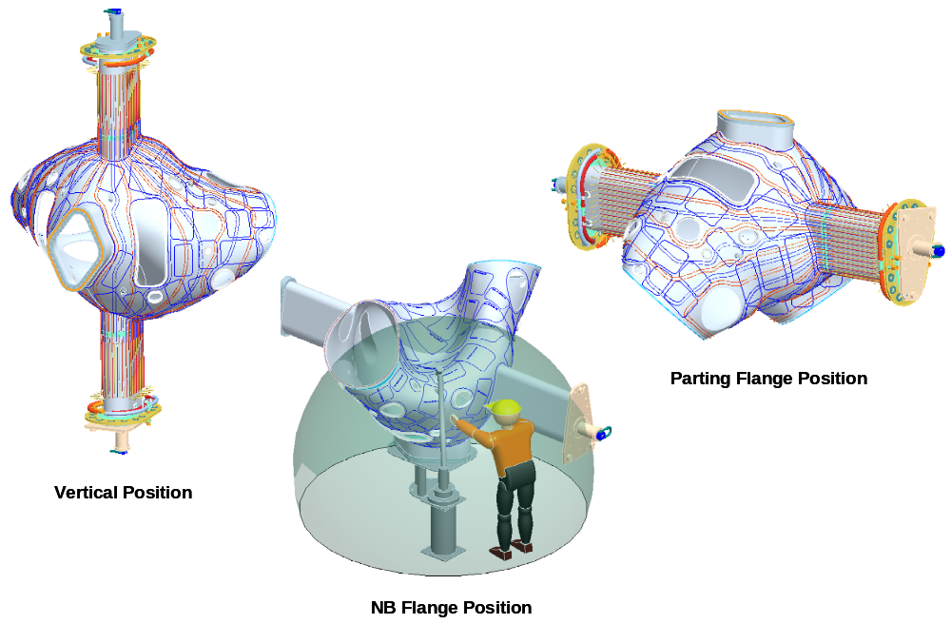

Figure 3 Alternate Support Arrangements

Table 1 Vacuum Vessel Shell Deflection

Support | Shell Deflection | Relative
Arrangement | Range (in) | Displacement
Trunnion Support | 0.050 - 0.061 | 0.011
Vertical Support | 0.001 - 0.035 | 0.034
NB end Support | 0.002 - 0.012 | 0.010
Parting Plane Support | 0.000 - 0.005 | 0.005

The arrangement providing the smallest amount of relative shell deflection resulted when the vessel was supported at the end parting plans. The analysis assumed that a cover plate is attached to the vessel at the parting plans and the unit supported off the floor. Welded cover plates are at the vessel parting plane when the vessel is delivered from the vendor. The deflection shown for the vertical support arrangement primarily resulted from an unsupported upper vertical port. This could be reduced if the upper flange was externally supported.

Vacuum Vessel Deflections under Atmospheric and Gravity Loading:

Reference 2 provides an extract from Fred Dahlgren’s vacuum vessel analysis write-up highlighting the pertinent pages showing displacement contours for the vacuum vessel when operating with atmospheric and gravity loading. Surface deflections range from 0.0015” to 0.045” over the major portion of the vessel shell. Shell deflections in the area around port 2 and port 9 ranges from .048” to .094”.
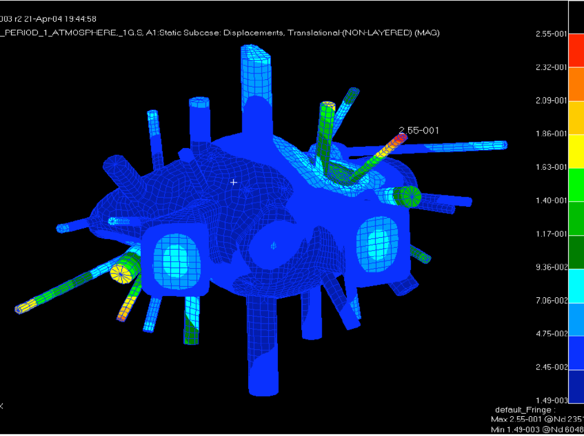

Figure 4 Vacuum Vessel displacement contours for atmospheric + gravity loads

