NCSX
Design Basis Analysis

Analysis of the Modular Coil Winding Form Assembly Fixture

NCSX-CALC186-002-00

Draft C

5 October 2006

Prepared by:

_______________________________________
Fred Dahlgren, PPPL

I have reviewed this calculation and, to my professional satisfaction, it is properly performed and correct. I concur with analysis methodology and inputs and with the reasonableness of the results and their interpretation.

Reviewed by:

_______________________________________
Tom Brown,PPPL

Controlled Document
THIS IS AN UNCONTROLLED DOCUMENT ONCE PRINTED.
Check the NCSX Engineering Web prior to use to assure that this document is current.

Analysis of the MCWF Frame Assembly Fixture

Executive Summary:

A stress analysis of the MCWF assembly support frame was performed to assess the adequacy of the design for two (A-A) & three (A-B-C) module sub-assembly loading in the 20 and 40 degree positions which were deemed the most severe loading conditions. The loading of the frame tends to be more uniform in the 20 degree position. The loading results from the A-B-C sub-assembly in the 40 degree position resulted in 14.1ksi Tresca stress. The peak stress for the 20 degree A-B-C load was the highest overall with a peak Tresca stress of 18.1 ksi. Deflections of the frame were greatest at the center of the lower cross member of the pivoting frame section for the 40 degree position with a maximum displacement of 0.028” (for the revised 0.5” thick box section). For the 20 degree position (w/revised lower cross beam) the maximum deflection occurs in the mounting gussets and peaks at 0.034” in the upper corner gussets. The peak Tresca stresses for the 20 degree position A-B-C assembly (probably not used in this position for A-B-C) occur at the mounting bolt perimeters of the corner gussets and at the stanchion pivot pin hole perimeters, but do not exceed the allowable 24 ksi stress for A36 steel (assuming a 2/3rd yield allowable criteria). A supplementary analysis which takes into account the maximum loading with all hardware attached to the A-B-C sub-assembly (~23,550 lbs.) produced a peak stress of 18.1 ksi which is still comfortably below the 2/3rd allowable.

Analysis Methodology:

The analysis was performed using MSC/Nastran, a general purpose finite element analysis computer program. The FEA model was generated from the dimensional information contained in the Pro-E CAD models referenced below. The centers of gravity were located from the Pro-E model SE185-113 for the various sub-assemblies and frame positions. A review of the various sub-assembly configurations revealed that the section A-A & A-B-C combinations produced the most severe loading conditions and there were therefore selected for the 20 & 40 degree analysis. In all four separate models were run. The database and Nastran input files are referenced below.

Project Reference Documents:

Pro-E models/drawings:

SE185-111
SE185-112
SE185-113
SE185-116
SE185-118

Nastran FEA Models:

FEA Database Nastran Input file
mcwf-frame20a.db mcwf-frame20a.bdf
mcwf-frame20abc.db mcwf-frame20abc.bdf
mcwf-frame40a.db - mcwf-frame40a.bdf
mcwf-frame40abc.db - mcwf-frame40abc.bdf
Modular Coil Winding Form Frame Assembly Fixture Analysis

Introduction:

A structural FE analysis was performed to determine the adequacy of the Modular Coil Winding Form (MCWF) Frame Assembly fixture design. The assembly fixture is a weldment comprised of several standard 6” x 6” x 3/8th thick A36 box beam sections for the base with ½” thick welded stanchions (“sandwich plates” per dwg. SE185-113) and two pivot frame weldments. The ½” thick stanchions on the base frame accommodate and support the articulating pivot frame members attached with removable pivot pins. These pivot frames support one, two, or three Modular Coil/shell segments oriented at either 20 or 40 degrees from the horizontal plane. The full frame assembly is shown in Figure 1 in the 40 degree configuration, and in figure 2 with the pivot frame in the 20 degree position.

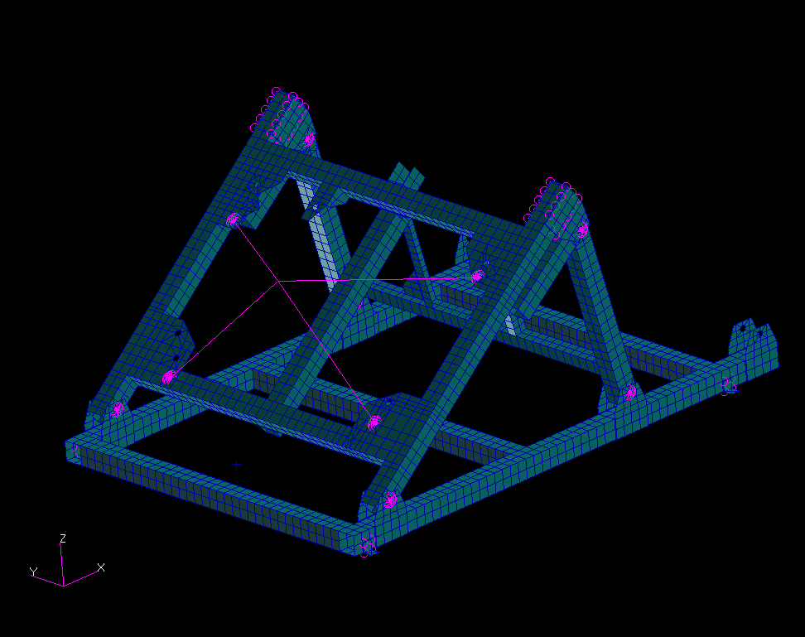
12,266 lbs Acting @ the A-A sub-ass’y.C.G

Figure 1. MCWF Frame Assembly Fixture (Shown in the 40 degree position)

Assumptions:

The analysis assumes that the MCWF segments are stiff enough (relative to the frame structure) that they can be adequately represented by rigid elements attached to the C.G. as defined by the Pro-E models referenced above, and that the loads are properly distributed to the mounting points on the frame by this mechanism. It also assumes that the frame attaches to a floor which is an infinitely rigid structure.

FEA Model Description:

The frame box sections are modeled with simple quadrilateral and triangular plate elements (CQUAD4/CTRIA3-Nastran plate elements) with both bending and membrane stiffness. To avoid having to model the complex Modular Coil with the winding form, it was represented by four rigid elements ( shown in figures 1 & 2 as magenta lines), attached to the articulating frame at the four bolted attachment points and at the acting center of gravity of the MCWF assembly. The rigid elements imply an infinitely stiff MCWF structure which (when compared to the supporting frame assembly) is a reasonable approximation. The frame itself is constrained in the vertical direction at the lower nodes of the base frame and at the centers of the welded angle hold-downs which are also constrained in the other 5 DOFs, representing an anchor bolt attachment to a rigid concrete floor. The pivot pin attachments are represented by multipoint constraints (MPCs in Nastran), which structurally tie the pivot frame pin hole perimeters to the hole perimeters of the stanchions (the pins are therefore also assumed to be infinitely stiff relative to the frame members). The loading for the maximum A-A MCWF segments of 12,266 lbs was applied vertically down at the grid point representing the C.G. of the A-A assembly and connected to the four rigid elements. The most extreme loading is the A-B-C sub-assembly which weighs 18,271 lbs.
12,266 lbs Acting @ the A-A sub-ass’y.C.G.
Four rigid elements representing the MCWF (as infinitely stiff).
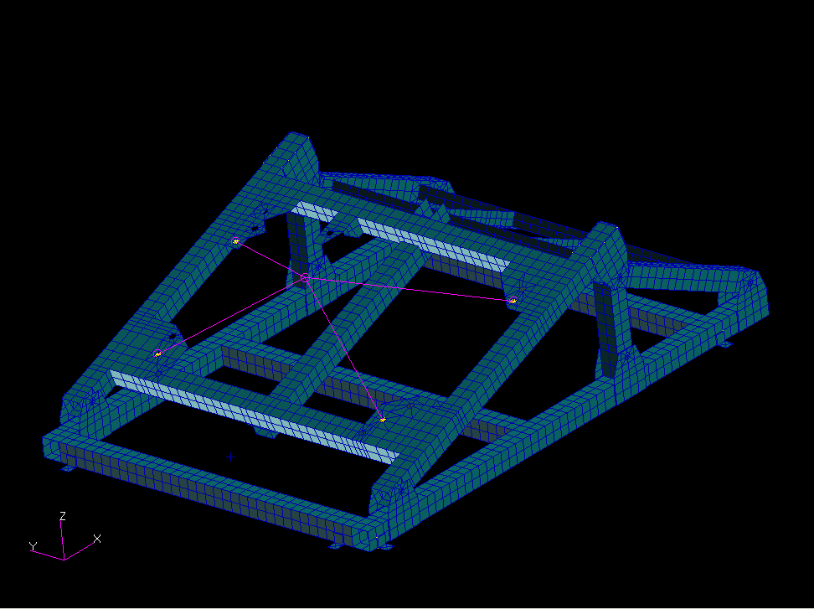
Figure 2. MCWF Frame Assembly Fixture (Shown in the 20 degree position)
12,266 lbs Acting @ the A-A sub-ass’y.C.G
Discussion and Results:

20 Degree Position:

Results for the A-A assembly load case are shown in figures 3 and 4. the maximum displacements of 0.027” occur at the lower cross beam and corner brackets . The peak Tresca stress is 13.7 ksi at the lower support pin hole perimeters in the base frame stanchions. Note these results were from the model with the 3/8” thick wall lower cross beam.

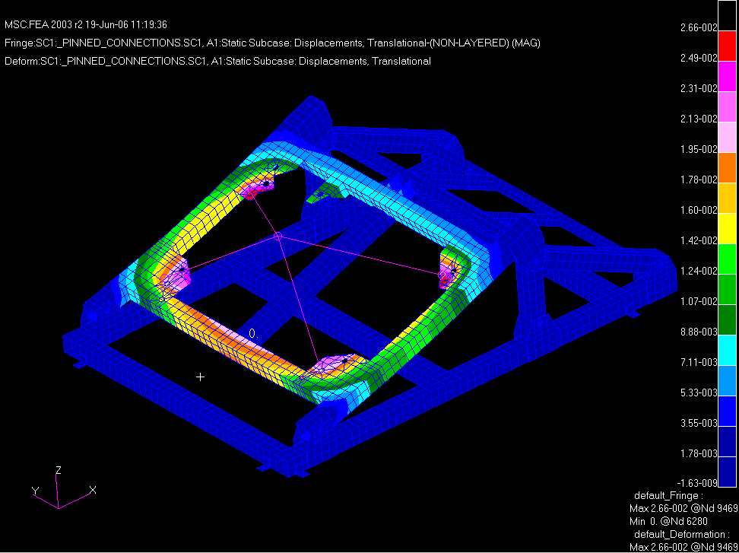

Figure 3 Displacements (SRSS) for A-A loading in 20-degree position

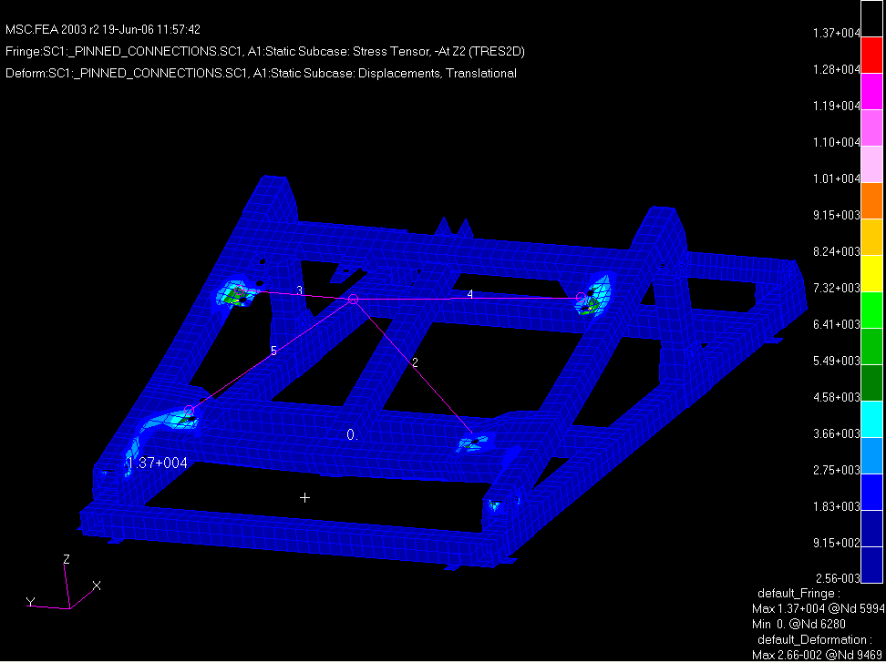

Figure 4. Tresca stress contours for A-A assembly loads @ 20 degrees
The displacement contours for the A-B-C assembly in the 20-degree position are shown in figure 5. The peak (SRSS) displacement is 0.034” at the upper corner gussets . The Tresca stress contours for this load case are shown in figure 6a. The peak stress of 18.1 ksi is at the stanchion pin hole perimeters. Note these model results include the thicker (0.5” thick) lower cross beam. Figure 6b shows the peak Tresca stress in the pin is at 21.9 ksi although this is likely an overly high result due to model limitations. Note that the red color of the plate elements representing the box frame and stanchions is just the default fill color when plotting the solid element pin stresses using the Patran post processor.

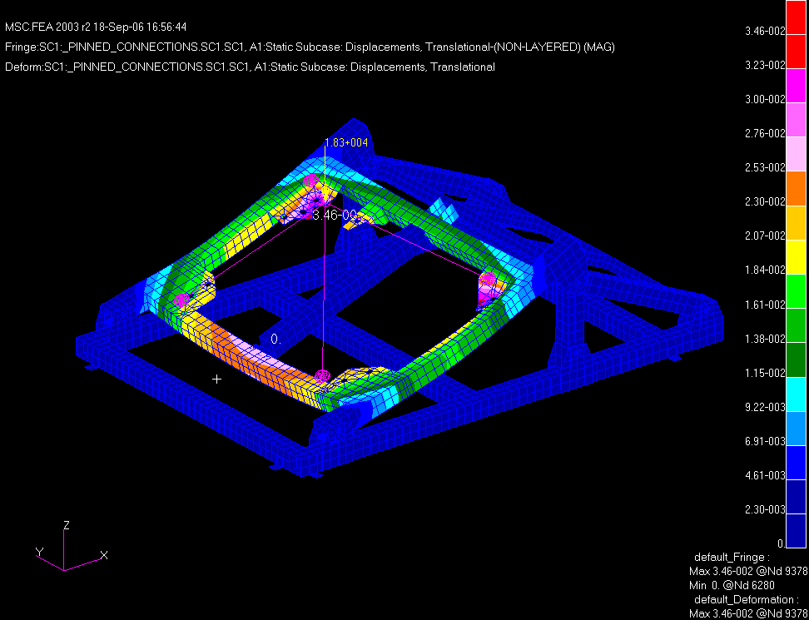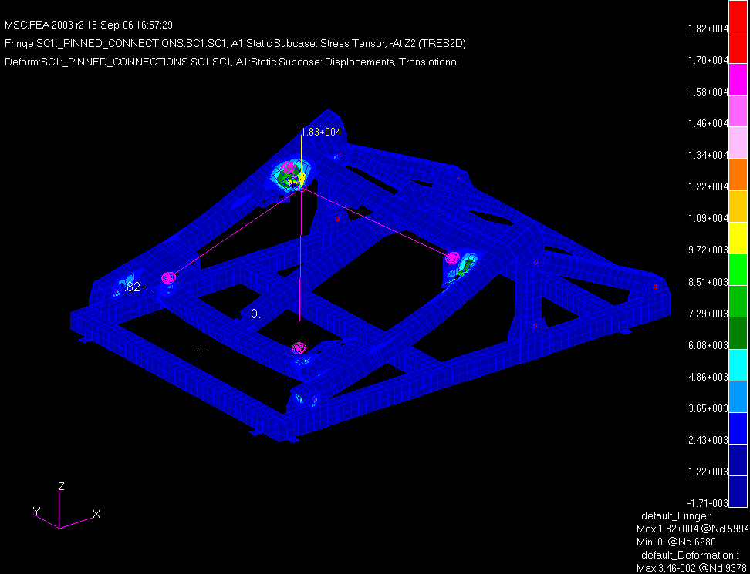

Figure 5. Displacement contours for A-B-C 20 degree loading
Figure 6a. Tresca stress contours for A-B-C
20 degree loading

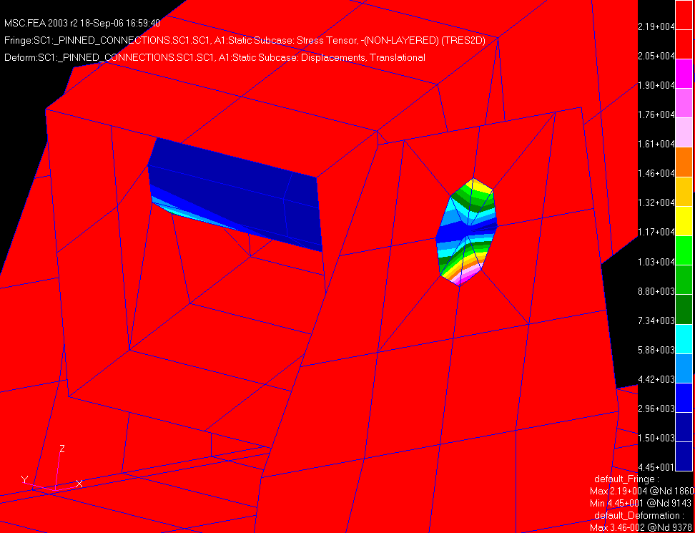

Figure 6b. Tresca stress contours in the support pin for the A-B-C 20-degree loading
40-Degree position:

It was determined that the A-A sub-assembly, with winding forms, shims, bolts, and coils, was the largest loading for a two segment setup, with a load of 12,266 lbs. acting at the C.G.s shown in figures 1 & 2. The peak load estimated for a full A-B-C half-period sub-assembly was 18,271 lbs. The C.G.s for this configuration are shown in figure 7. Figure 8 shows the various thicknesses of the final structure.

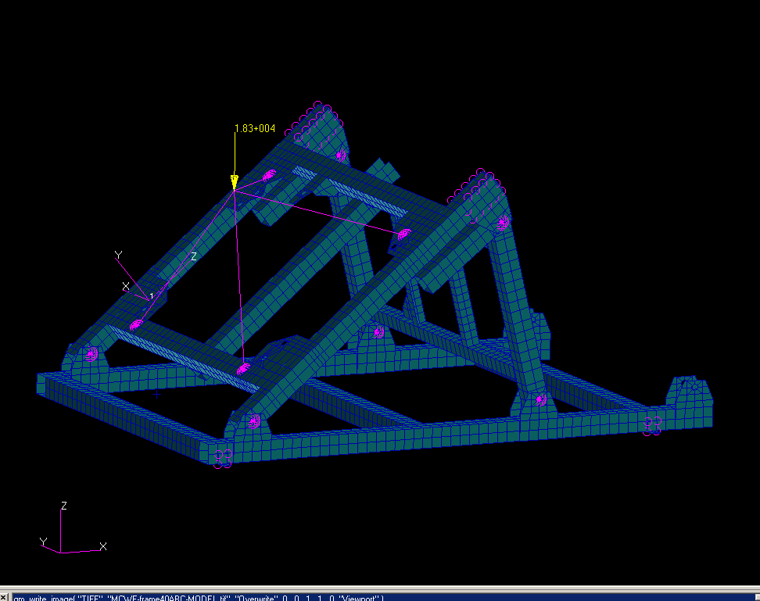
Four rigid elements represent the MCWF as an infinitely stiff structure

Figure 7. FEA model of the MCWF support frame at the 40-degree angle for ABC

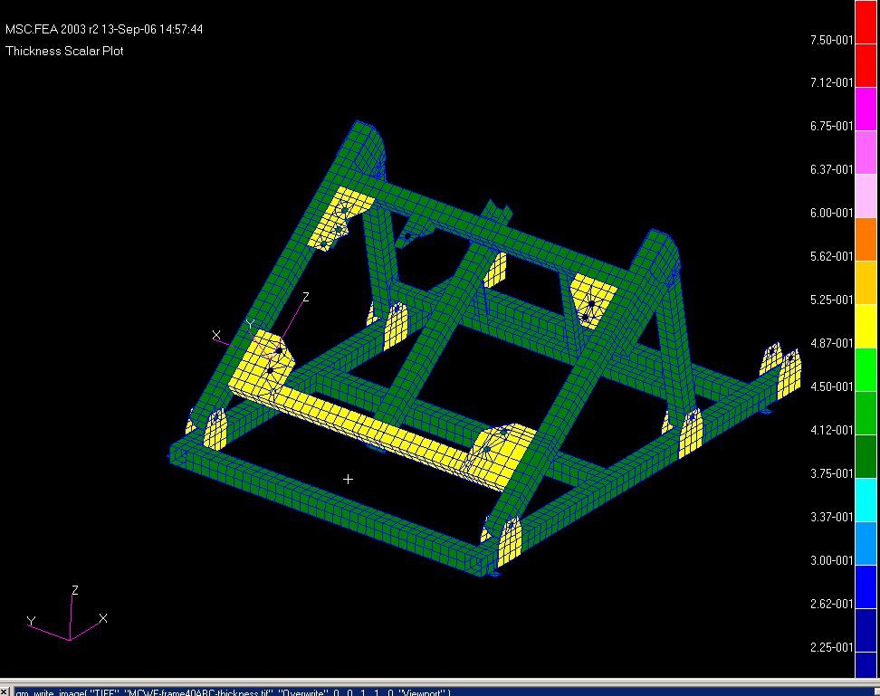
Yellow areas are 0.5” thick & Green areas are .375” thick.
Figure 8. A contour plot of the thickness for various members of the frame
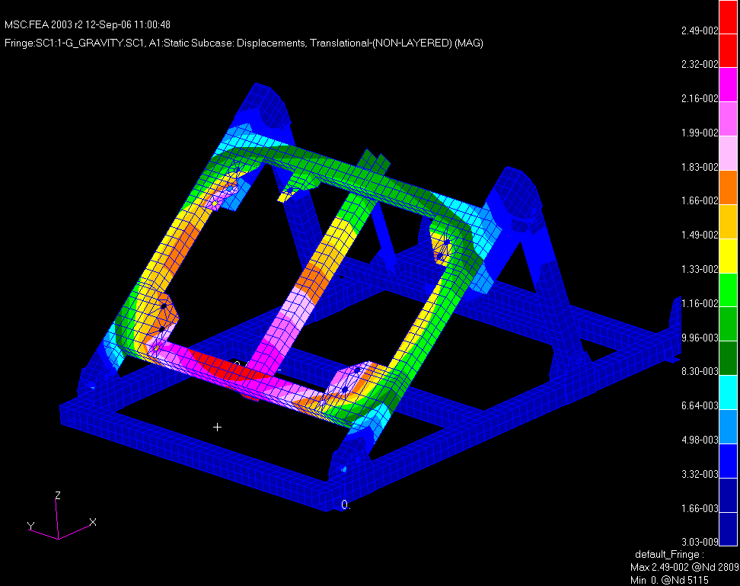
Figure 9. Displacements (SRSS) for the A-A assembly loading at 40 degrees.

Displacement contours for the A-A assembly are shown in figure 9 above. The maximum deflection of the frame occurs at the lower cross brace and is seen to be 0.025” The contours of the Tresca stress are shown below in figure 10. The peak stress in the frame is 17.4 ksi peaking at the lower stanchions (item 10 “sandwich” plates on SE185-113) . The allowable stress for A36 using a 2/3rd yield criteria is 24 ksi.

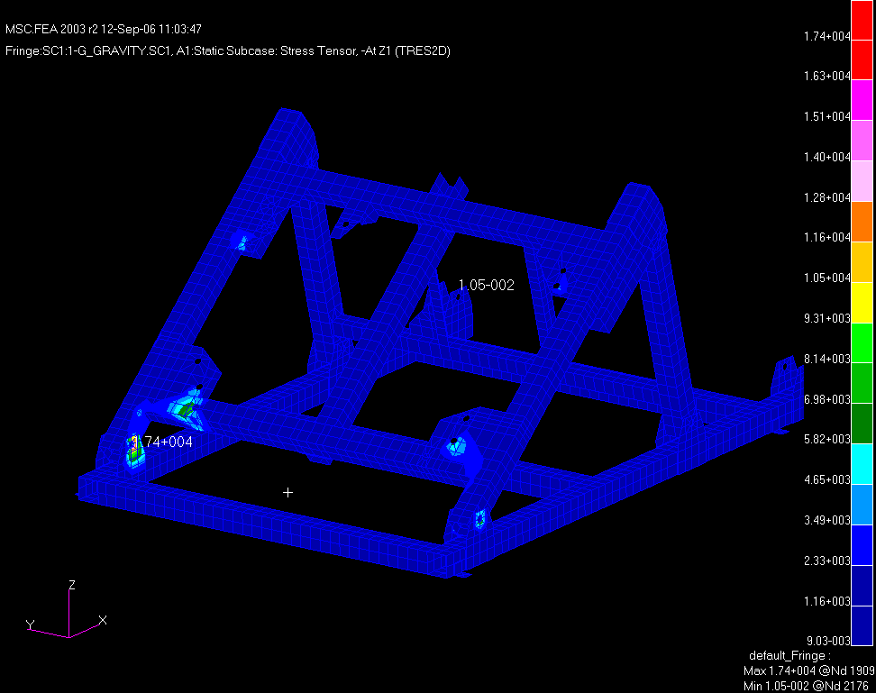

Figure 10. Tresca stress contours on Z1 surface for the A-A segment load
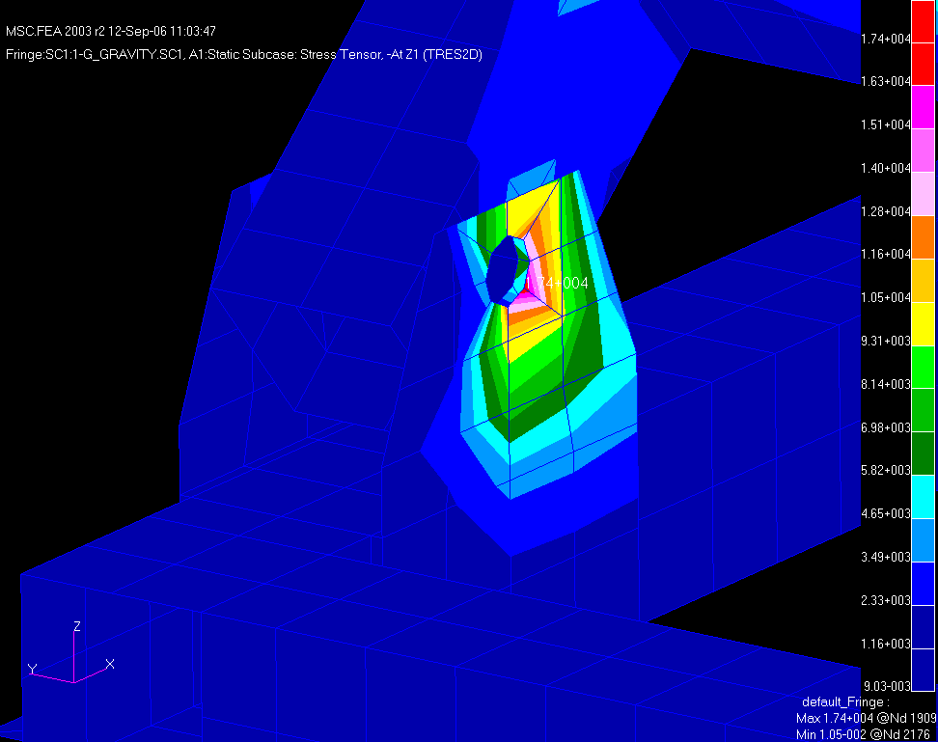

Figure 11. Tresca stress contour – Z1 surface for A-A segment loading – Peak stress @ pinned joint stanchions

Initial analysis of the A-B-C sub-assembly shown in figure 6 in the 40-degree position yielded fairly high stresses in the lower cross member of the pivot frame. Maximum displacement of the frame was just over 0.034” at the cross member center. Due to flexing of the cross member the lateral box sections experience torsional flexing which tended to put higher stresses (from bending) into the pinned joint and stanchions. To alleviate this condition a heavier wall box section (0.5” vs. 0.375”), for the lower cross member has been recommended. Figure 8 above shows the thicker section. Displacement results with the thinner and thicker cross member are shown in figures 12 & 13 below. Figure 12 is a contour plot of the displacement for the thinner cross member indicating a peak of 0.034” an the center of the cross member. Figure 13 shows a peak displacement of 0.028” with the heavier wall.

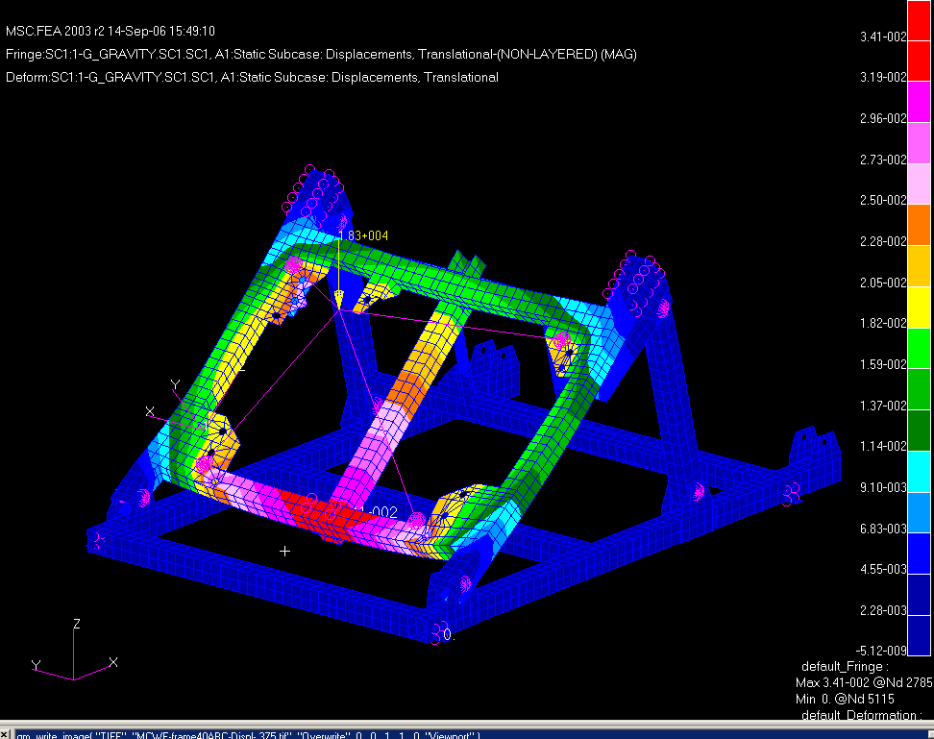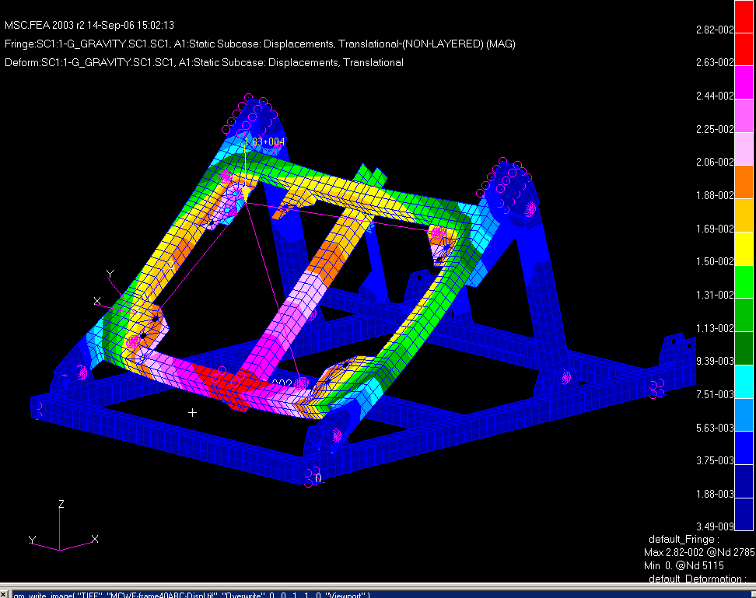
Figure 12 Displacements (SRSS) 0.375 thick wall Figure 13 Displacements (SRSS) – 0.500” thick wall
Figure 14 shows the Tresca stress contours for the 40-degree A-B-C MCWF subassembly with the thicker (0.500”) lower cross member. The peak stress is 14.1 ksi at the upper corner gussets and at the stanchion around the mounting bolt hole perimeters. Figures 15 & 16 show the Tresca stress contours at these locations. The peak stress in the lower cross brace is 7.5 ksi at the lower mounting bolt hole perimeters.

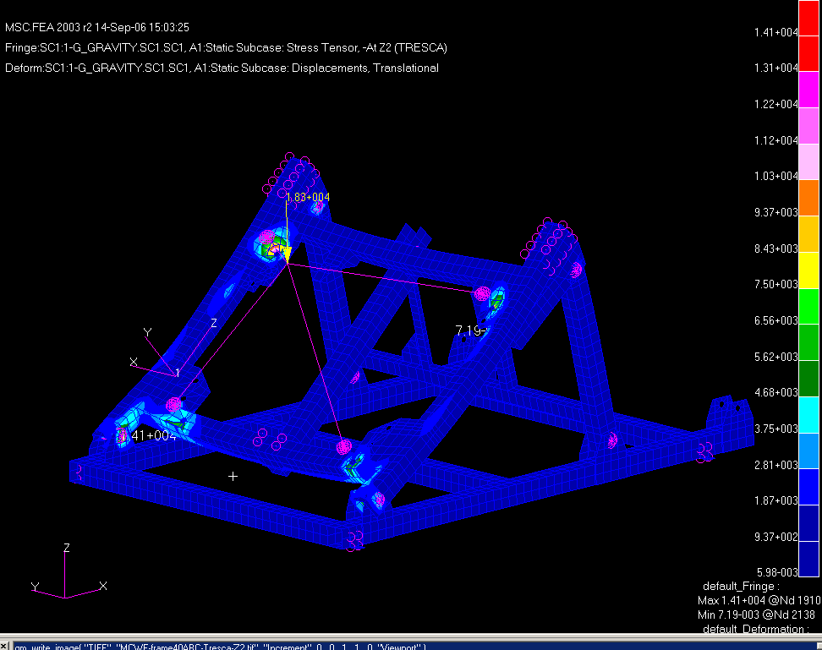
Peak Tresca stress @ bolt perimeters 14.1 ksi
Figure 14. Tresca stress contours for the 40-degree A-B-C MCWF sub-assembly (18,271 lb. load)

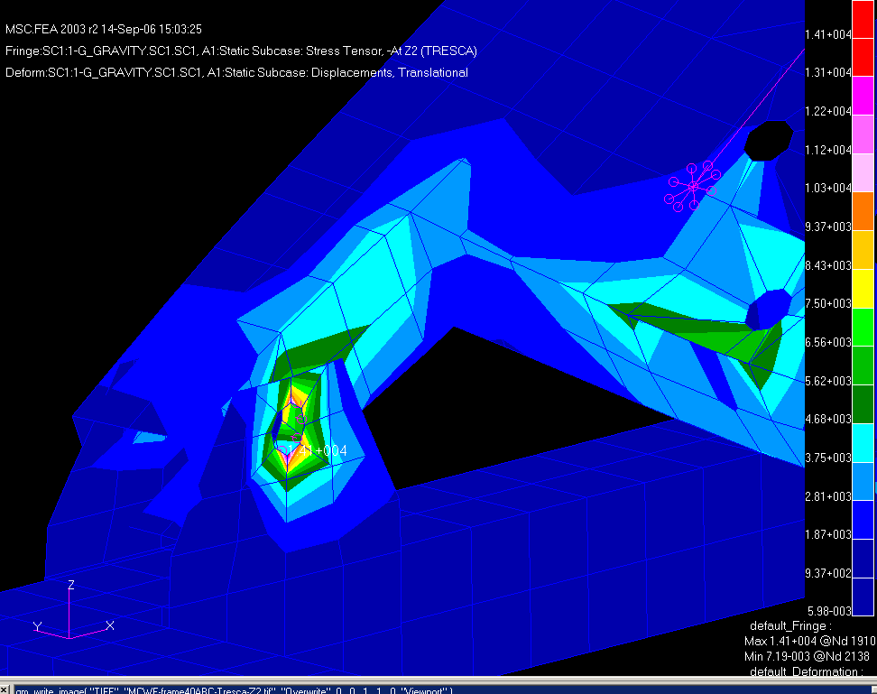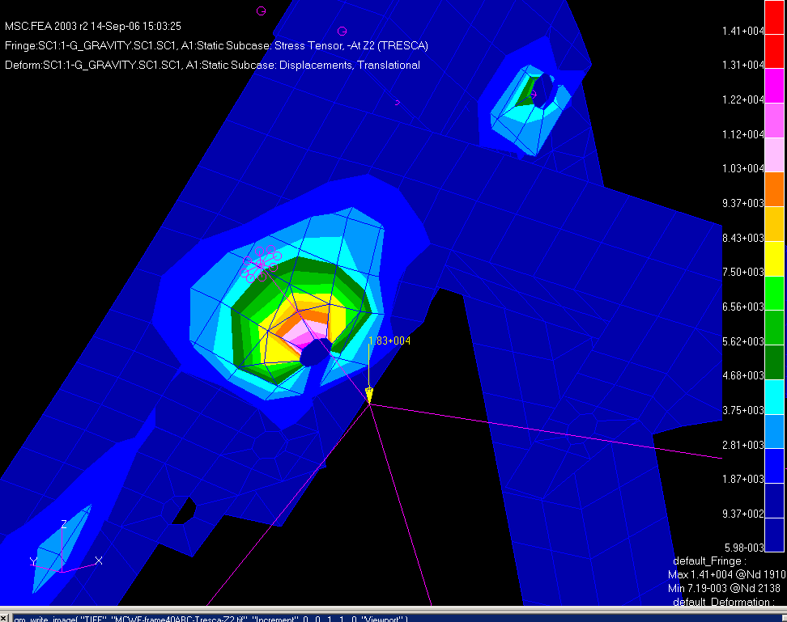

Figure 15 Tresca stress contours @ stanchion & cross member
Figure 16 Tresca stress contours @ upper gusset

Lateral stiffness:

To quantify the lateral stiffness of the frame a 100 lb lateral (Y-Dir.) load was applied to the model at the upper corner of the pivot frame in the 40 degree position as shown in Figure 17. The peak lateral deflection (in the Y-Dir.) was 0.00326”.

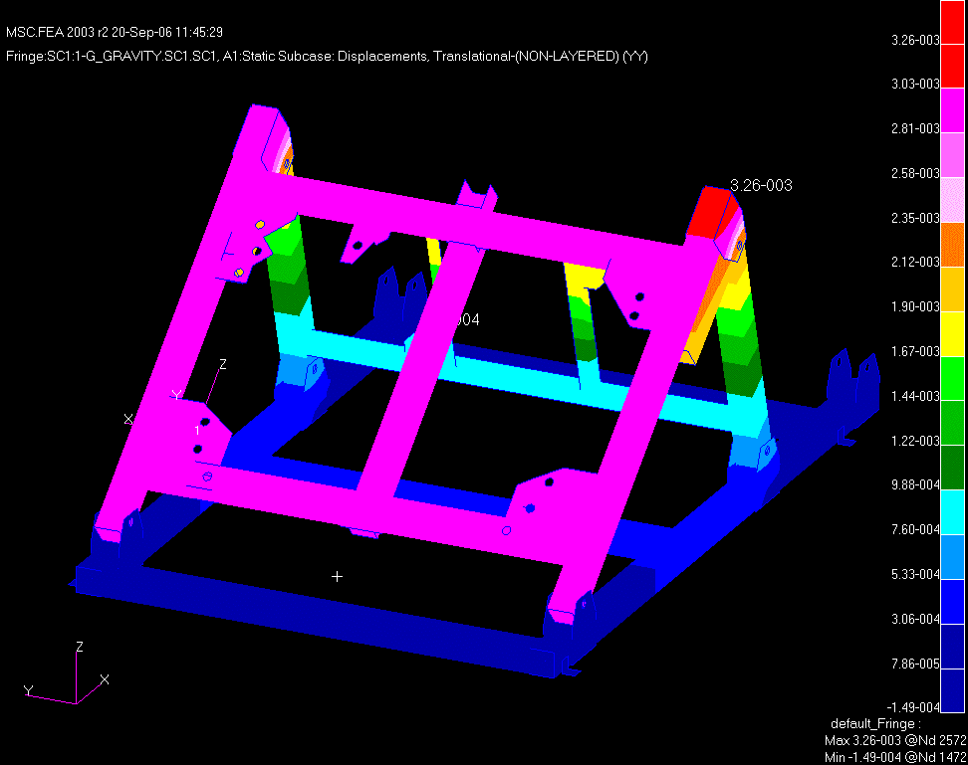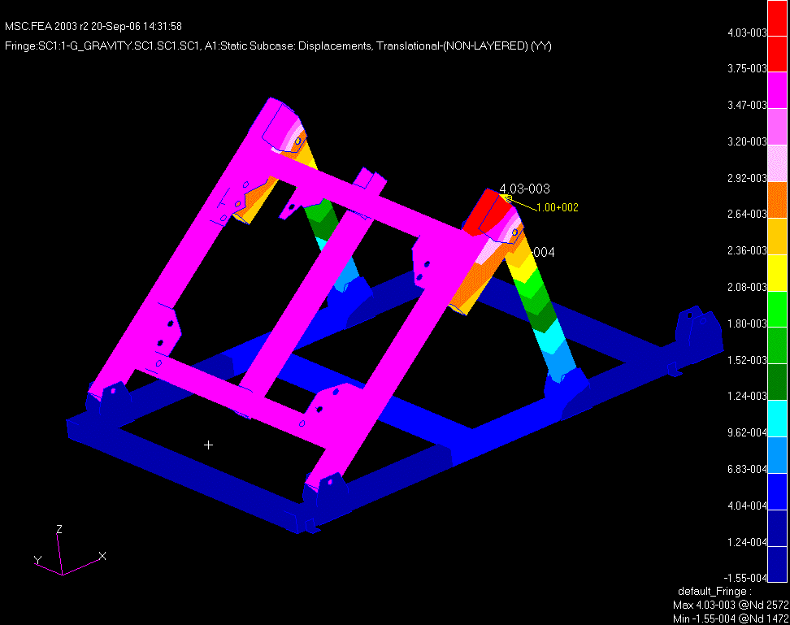
100 lbs.
Figure 17. Current bracing w/100lb lateral load Figure 18. No bracing w/100lb lateral load

The stiffening effect of the current lateral bracing was determined by removing the two horizontal angle beams, the two vertical angle stringers, and the reinforcing gussets, and re-running the 100 lb lateral load case. The resulting peak displacement (shown in Figure 18) was 0.00403” or ~ 20% higher than the reinforced frame. A third model with the current horizontal angles and a diagonal 6 x 4 x 3/8” channel reinforcement replacing the vertical stringers and gussets was run (see Figure 19), and yielded a maximum lateral displacement of 0.00212”.

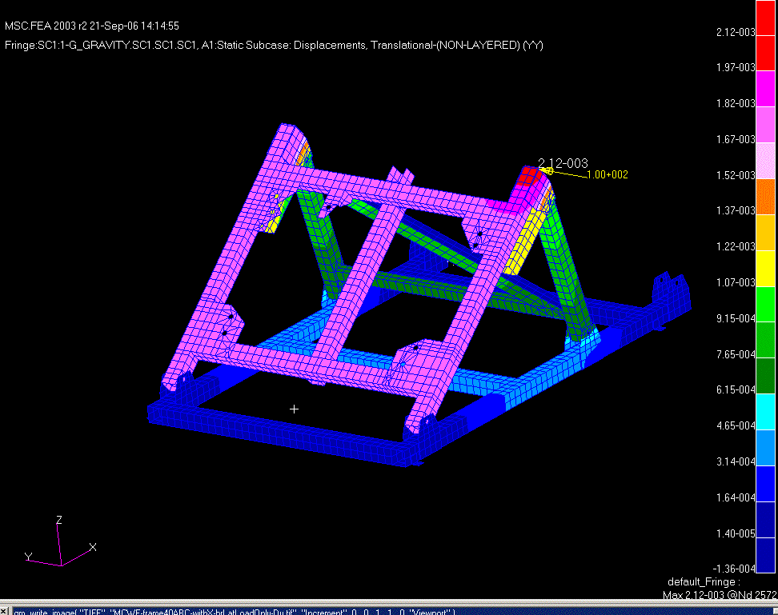
Figure 19. Diagonal channel cross bracing w/100lb lateral load

Conclusions:

A stress analysis of the MCWF assembly support frame was performed to assess the adequacy of the design for two (A-A) & three (A-B-C) module sub-assembly loadings in the 20 and 40 degree positions which were deemed the most severe loading conditions. The loading of the frame tends to be more uniform in the 20 degree position. The gravity loading results from the A-B-C sub-assembly in the 40 degree position resulted in 14.1ksi Tresca stress. The peak stress for the 20 degree A-B-C load was the highest overall with a peak Tresca stress of 18.1 ksi. Deflections of the frame under gravity loading were greatest at the center of the lower cross member of the pivoting frame section for the 40 degree position with a maximum displacement of 0.028” (for the revised 0.5” thick box section). For the 20 degree position (w/revised lower cross beam) the maximum deflection occurs in the mounting gussets and peaks at 0.034” in the upper 1/2” thick corner gussets. The peak Tresca stresses for the 20 degree position A-B-C assembly occur at the mounting bolt perimeters of the corner gussets and at the stanchion pivot pin hole perimeters, but do not exceed the allowable 24 ksi stress for A36 steel (assuming a 2/3rd yield allowable criteria). The current bracing provides a ~20% greater lateral stiffness than the frame without bracing. A ~35% improvement in lateral stiffness was seen by using a 3/8” thick 6 x 4 A36 channel diagonal cross brace.
Supplementary

Additional analysis were run to assure the design adequacy for the heavier loading when hardware is added to the A-B-C sub-assembly. The total gravity load under these conditions is 23,550 lbs. Since the additional hardware is assumed to be nearly uniformly distributed, the C.G. of the sub-assembly was assumed to not vary significantly from the prior analysis. Figure 20 is a contour plot of the SRSS displacements for the 40 degree position A-B-C sub-assembly. The maximum displacement is 0.036” at the lower cross-member. Recall the earlier run with 18.3 kip loading was 0.028” with the 0.5” cross-member so the 28% increase in deflection scales linearly with the increased load as expected.

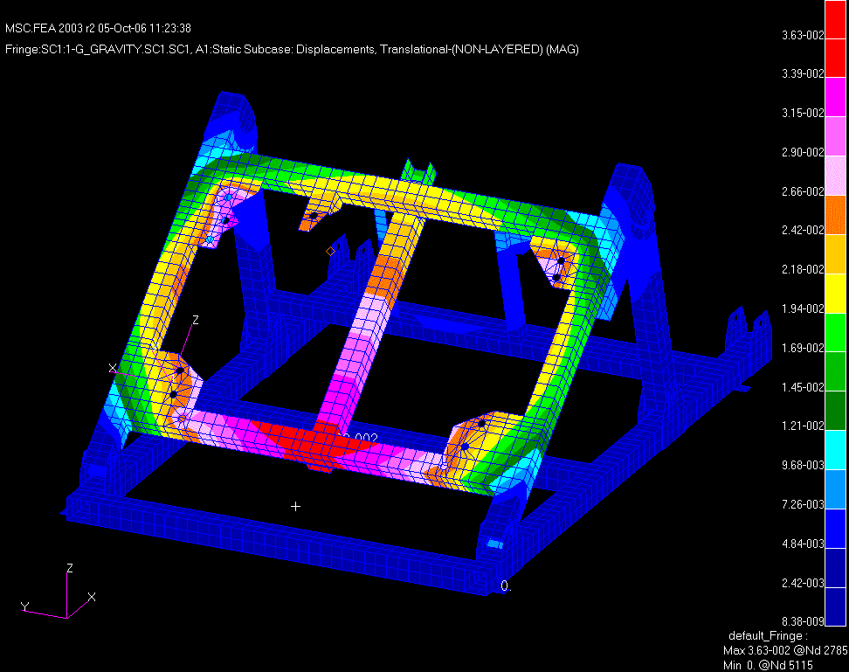

Figure 20. Displacements (SRSS) with a 23,550 lb loading

The Tresca stress contours for this loading condition are shown in figure 21a and indicate a peak stress of 18.1 ksi at the stanchion pivot pin hole perimeters (~28% increase over 14.1 ksi for the baseline loading).

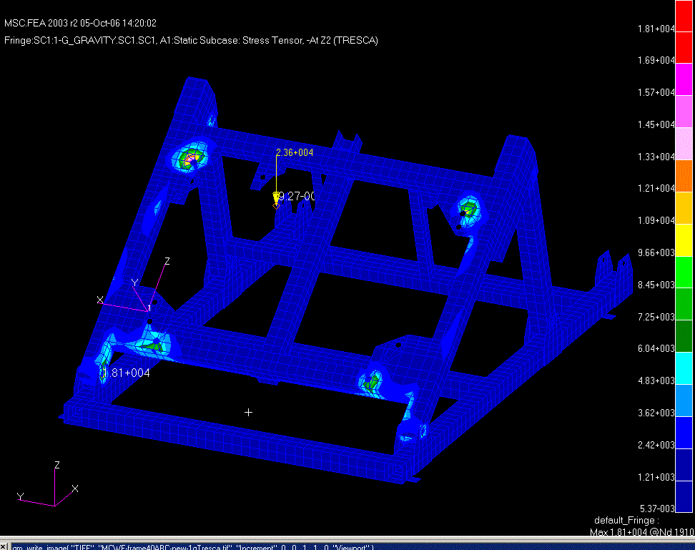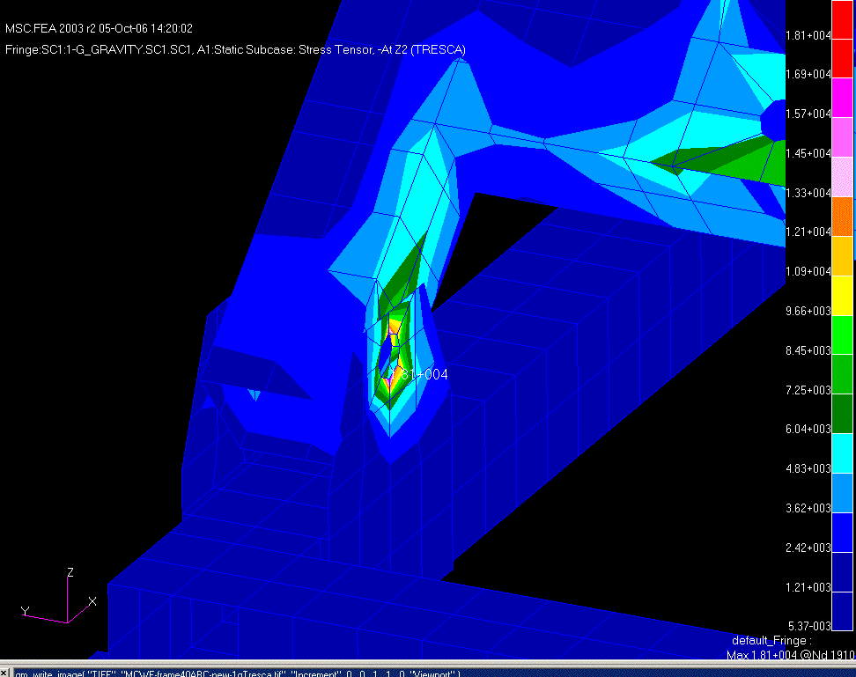
Peak Tresca stress 18.1ksi

Figure 21a & 21b. Tresca stress contours for a 23,550 lb. gravity loading
Figure 22 below is contour plot of the Tresca stresses in the (now extended) pivot pin for the 20 degree position (not a required position for the A-B-C sub-assembly but added for comparrison with figure 6b in the above analysis). The 1st run with a 23,550 lb load indicated a very highly localized stress > 30ksi at the pin interior ends due to modeling only a truncated length of the pivot pin. When the ends of the pins were extended this loacalized stress was reduced to the peak of 19.1 ksi as seen in figure 22.

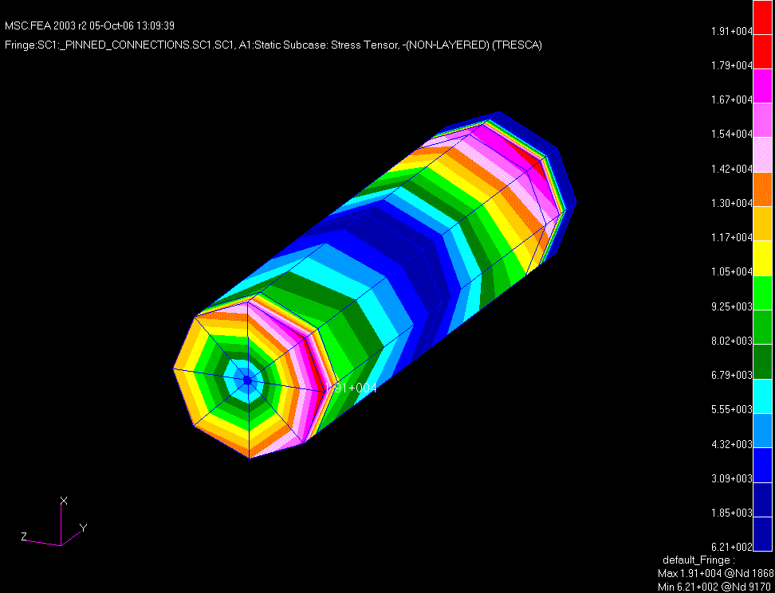
Peak Tresca stress @ pivot pin ends 19.1 ksi

Figure 22. Tresca stress in the pivot pin with extended ends

Supplementary conclusions:

For the A-B-C sub-assembly with loading for additional hardware, the stresses and dispacements increase linearly by ~28%. The peak stress intensity for the worst case loading at 40 degrees is 18.1 ksi which is still well below the 24ksi allowable for A36 steel.

