NCSX

Field Period Assembly (FPA) Manufacturing/Assembly, Inspection, Test and Quality Assurance Plan
NCSX-MIT/QA-185-01-00
February 28, 2006

Author: ________________________________________________________________
Mike Viola - Field Period Assembly (FPA) Facility Manager

Reviewed by:

Jim Chrzanowski Judy Malsbury
NCSX Manufacturing Facility Manager NCSX QA Representative

Jerry Levine Brent Stratton
PPPL Safety Representative Dimensional Control Coordinator

Steve Raftopoulos John Edwards
Lead Metrology Engineer FPA Field Supervisor

Tom Brown Brad Nelson
WBS 186 Manager Stellarator Core Design RLM

_________________________________________
Wayne Reiersen
NCSX Engineering Manager

Approved By: ___________________________________________________________
Larry Dudek
RLM for the NCSX Manufacturing Facility
Controlled Document
THIS IS AN UNCONTROLLED DOCUMENT ONCE PRINTED.
- Check the NCSX Engineering Web prior to use to assure thatFinal Prep for Transport
  - Perform Final Measurements
  - Install transportation supports
  - Load on truck
  - Locate cooling tubes
  - Install tube clamp studs
  - Perform measurements
  - nsion

document is current.
Record of Revisions

Revision | Date | Description of Change
0-dD | 1/16/2006 | Complete re-write and reformatting.
0-dE | 2/28/2006 | More Formatting and editorial comments
0-dF | 2/28/2006 | Comment incorporation and alignment with existing MC MIT/QA again

Table of Contents

1 Introduction and Scope 1
1.1 Introduction 1
1.2 Scope 1
2 Applicable Documents 1
2.1 Governing Documents 2
2.2 Training Requirements Error! Bookmark not defined.
3 Field Period Assembly Processes 3
3.1 Overall Field Period Assembly Process Outline 3
3.2 Field Period Assembly Stations and Procedures 5
3.2.1 Station 1 – Vacuum Vessel Preparation 5
3.2.1.1 Station 1 Assembly Activities 5
3.2.1.2 Station 1 Tooling and Fixtures 6
3.2.2 Station 2 – Modular Coil Half-Period Assembly 6
3.2.3 Station 3 – Modular Coil Installation 6
3.2.4 Station 4 – Final Field Period Assembly 6
3.2.5 Station 5 – TF Half-period Assembly 7
4 Documentation Requirements 7
4.1 Document Control 7
4.2 Field Assembly Station Field Packages 7
4.3 Assembly/Injstallation Procedure Sign-Off’s 7
4.3.1 Procedure Completion 7
4.3.2 Authorized Signoff’s for Manufacturing Completions 7
4.4 Final Document Storage 8
5 Quality Assurance/Quality Control Requirements Error! Bookmark not defined.
5.1 Inspection/Surveillance and Audit Error! Bookmark not defined.
5.2 Inspection and Test by Field Crews and Engineering Error! Bookmark not defined.
5.3 Equipment/Material Identification and Status Error! Bookmark not defined.
5.4 Non-conformance & Corrective Actions Error! Bookmark not defined.
5.5 Release for Station Transfer Error! Bookmark not defined.
5.6 Process History Error! Bookmark not defined.
5.6.1 Material Certifications Error! Bookmark not defined.
5.6.2 Inspection/ Test Documents Error! Bookmark not defined.
5.6.3 Inspection Reports Error! Bookmark not defined.
5.6.4 Test Reports Error! Bookmark not defined.
6 Specification Verification Activities Check list 8

List of Figures

Figure 4-1 Field Period Assembly Process Outline 4
Figure 4-2 FPA Area Layout (Need new layout of just FPA stations) 5
Figure 4-3 Vacuum Vessel Support 6

Introduction and Scope

Introduction

The National Compact Stellarator Experiment (NCSX) will be assembled and built at Princeton Plasma Physics Laboratory. The stellarator core will be preassembled into three 120° field period assemblies in the TFTR Test Cell. There will be five (5) stations to accomplish this task. Once completed, the Field Period Assemblies (FPA) will be moved into the NCSX test cell.

Scope

This document addresses the manufacturing, inspection, test and Quality Assurance (QA) plan to complete and deliver three (3) Field Period Assemblies for the NCSX Project to the NCSX test cell.

Applicable Documents

Four plans have been prepared which cover the Field Period Assembly (FPA) activities. These are the NCSX Manufacturing Operations Plan (NCSX-PLAN-MFOP-01), the Field Period Assembly Sequence Plan (NCSX-PLAN-SEQ-FPA1), the NCSX Field Period Assembly Station 1 Dimensional Control Plan (NCSX-PLAN-FPA1DC-00), and this document, the NCSX Field Period Assembly Manufacturing, Inspection, Test, and Quality Assurance Plan (NCSX-PLAN-MIT/QA-185-01)

The Manufacturing Facility Operations Plan describes how the activities within the NCSX Manufacturing Facility will meet PPPL Integrated Safety Management (ISM) requirements specified in laboratory policies, programs, and procedures. It also provides an overview of the general processes that occur in the facility, including general facility operating guidelines, safety controls, and reviews.

The Field Period Sequence Plan provides guidance to convey the designer’s intentions as to how the Field Period Assembly is to be performed. Field period procedures will be developed from the sequence plan, in combination with this MIT/QA plan, which explains how to perform the tasks at each of the 5 assembly stations.

This document specifically addresses FPA activities, providing:
- A description of the field period assembly sequence including a process outline;
- A description of each station including tooling and fixtures; and
- A listing of governing specifications, assembly drawings, models, data files, and procedures for each station.

Identified below are the primary documents that that will be needed to complete the FPA.

NCSX Project Documents for FPA
Document No. | Title
NCSX-CSPEC-141-03 | VVSA Specification
NEPA No. 1261 | Construction and operation of NCSX
WP-1224 | Field Period Assembly work Plan
NCSX-PLAN-MFOP-01 | NCSX Manufacturing Facility Operations Plan
NCSX-PLAN-FPA1DC-00 | NCSX Field Period Assembly Station 1 Dimensional Control Plan

Field Period Assembly Manufacturing Procedures
Document No. | Title
D-NCSX- FPA -QA1 | Material Receipt
D-NCSX- FPA -001 | FPA Assembly – VVSA diagnostic loops, cooling tubes, and misc. I&C Activities
D-NCSX- FPA -002 | FPA Assembly – MC Assembly and alignment
D-NCSX- FPA -003 | FPA Assembly – Install MC Assembly and port extension
D-NCSX- FPA -004 | FPA Assembly – Install TF and Trim Coils
D-NCSX- FPA -005 | FPA Assembly – Final verification and prep for transport to NCSX test cell

Drawings

Drawings for each field period assembly and station will be provided by the NCSX project. Only signed and “Approved For Fabrication” stamped drawings may be used. A complete list of field period drawings is listed in the filed period assembly specification.

Training Requirements

Training of personnel working on the FPA is critical to successfully completing the assembly of the FPA. There are two categories of training requirements, general and specialized.

General Training Requirements

General training includes all laboratory-training requirements that are required to enter or work in the Manufacturing Facility. Examples of this training include:
- General Employee Training [GET]
- Integrated Safety Management [ISM]
- Radiation Safety Training

Specialized Training Requirements

Specialized training includes specific training or certification required to complete tasks during the assembly of the FPA. Examples include:
- Weld or braze certifications
- Confined space
- NCSX Manufacturing Facility Operations Plan [MFOP]

Training Matrix

An NCSX Manufacturing training matrix exists for the FPA stations which is posted on the NCSX Web site.

Field Period Assembly Processes

Overall Field Period Assembly Process Outline

This section outlines the processes that are to be performed and procedures required to complete field period assembly. Figure 4-1 provides a pictorial of the general layout with the NCSX manufacturing facility. The FPA activities will take place along the North wall and in the South West corner. The Modular Coil activities take place along the East wall and on the center 102 foot elevation.
Figure 4-1 FPA Area Layout

2 provides an outline of the overall field period assembly process and provides a layout of the Field Period Assembly layout within the NCSX Manufacturing Facility.
Send to NCSX Test Cell
Assemble and Install TF Coils and Trim Coils
Assemble two 3 TF coil sets
Install Field Period
Install one 3 coil set onto TF fixture
Roll Coils on
Install second 3 coil set onto TF fixture
Roll Coils on
Install Trim Coils

Material Receipt
VVSA receipt & inspection
Cooling Tubes receipt & inspection
Misc. hardware inspection guidelines
MC Assembly
Mechanically Align and assemble 3 MC set
Magnetically align two 3 coil sets

Final Prep for Transport
Perform Final Measurements
Install transportation supports
Load on truck
VVSA Preparation
Locate diagnostic loops
Install templates
Install Diag Loops
Locate cooling tubes
Install tube clamp studs
Perform measurements
Install MC Assembly and port extension
Align and Install VVSA
Install first 3 MC sets
Install Second 3 MC sets
Align and bolt together
Align and Weld Port extension
Procedure No.
D-NCSX- FPA -004
Procedure No.
D-NCSX- FPA -003
Procedure No.
D-NCSX- FPA -005
Procedure No.
D-NCSX- FPA -001
Procedure No.
D-NCSX- FPA -002
Procedure No.
D-NCSX- FPA -QA1
Station No. V4 Install TF and Trim Coils
Material Receipt
Station No. V2
MC Assembly
Station No. V3
Install MC and port extension
Station No. V5
Final Prep for transport
Station No. V1
VVSA loops and tubes
Figure 4-2 Field Period Assembly Process Outline

Field Period Assembly Stations and Procedures

Each Field Period procedure will be generated from an approved sequence plan generated to

Station 1 – Vacuum Vessel Preparation

Station 1 Assembly Activities
The Field Period Assembly will begin with the VVSA receipt Inspection, followed by the diagnostic loop and cooling tube installation. The Diagnostic loops will be installed using small tabs spot welded to the vessel surface and then the cooling tubes will be installed with studs welded to the surface and clamps applied. The Assembly Sequence Plan (NCSX-PLAN-SEQ-FPA1), Station 1 Dimensional Control Plan (NCSX-PLAN–PA1DC), and top-level assembly drawing (SE121-004 TBD) provides guidance from the designer and dimensional control coordinator on how the components being handled in Station 1 were designed to be assembled and what dimensional control checks are needed.
The Field Period Assembly Manager will utilize these plans and the top-level assembly drawing as a basis for developing the FPA Station 1 Detailed Installation/Assembly Procedure (D-NCSX-FPA-001). This detailed procedure and any related detailed drawings shall govern each step in the assembly sequence for Station 1.
Confirmation of specification verification activities are shown in Appendix A to this MIT/QA Plan

Station 1 Tooling and Fixtures
This station is comprised of two trunions (See ) that will support the VVSA in a rotisserie style. This station will be built by the PPPL Tech Shop using drawing SE184-001.
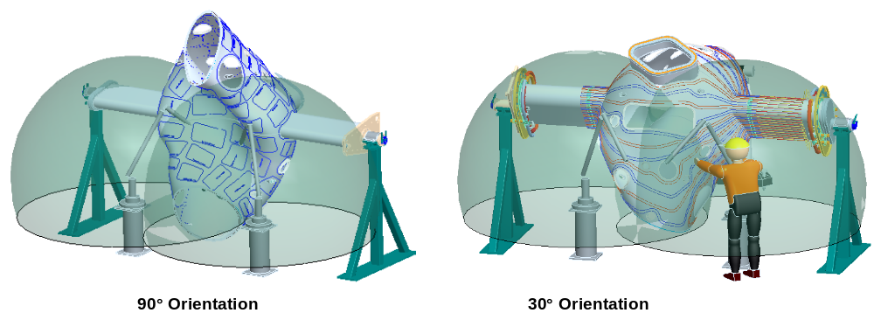
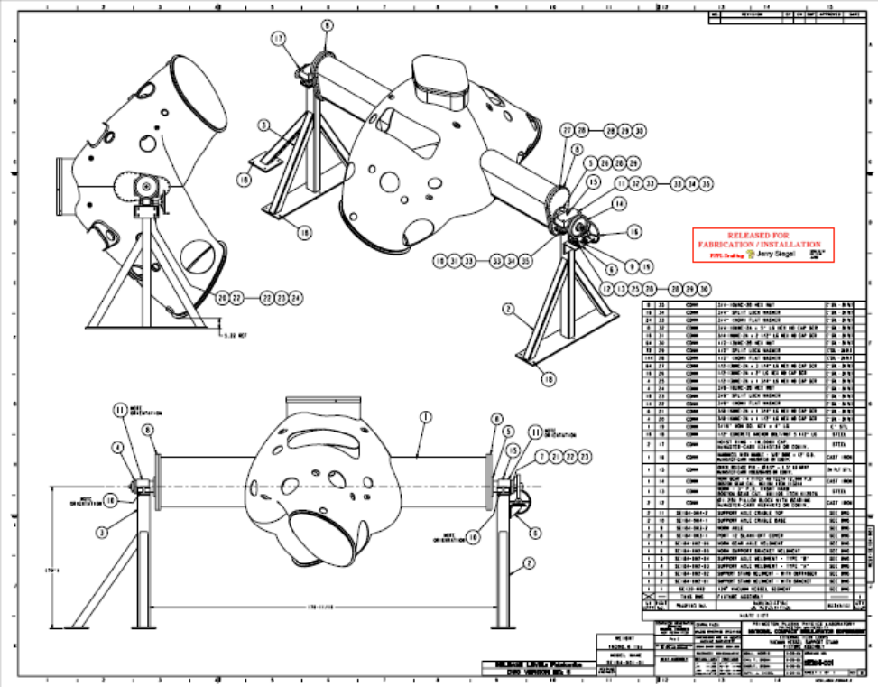
Figure 4-1 Vacuum Vessel Support

Magnetic loops / saddle coils
The Field Period Assembly plan is to install 130 magnetic loops and/or saddle coils on the first period. If the magnetic analysis indicates the need for more coils these coils will be added to the second and third period assembly. The plan today is to install saddle coils on the first period and add additional coils if needed.
The technique for installing the saddle coils is to place a template over the surface of the vacuum vessel. The template will have holes to mark the location on the vessel where studs will be attached. The mineral insulated (MI) cable for the sensors will be wrapped around the studs on the vessel. Leads from the
s will be routed to the vertical ports and terminated in a junction box on the ports. The MI cable will be held in place by wrapping the cable with thin tabs and spot welded to the vessel.
Measurements of the coils will be made using a Faro arm or laser tracker and recorded for future information. The measurement tolerance for locating these coils is +- .030.

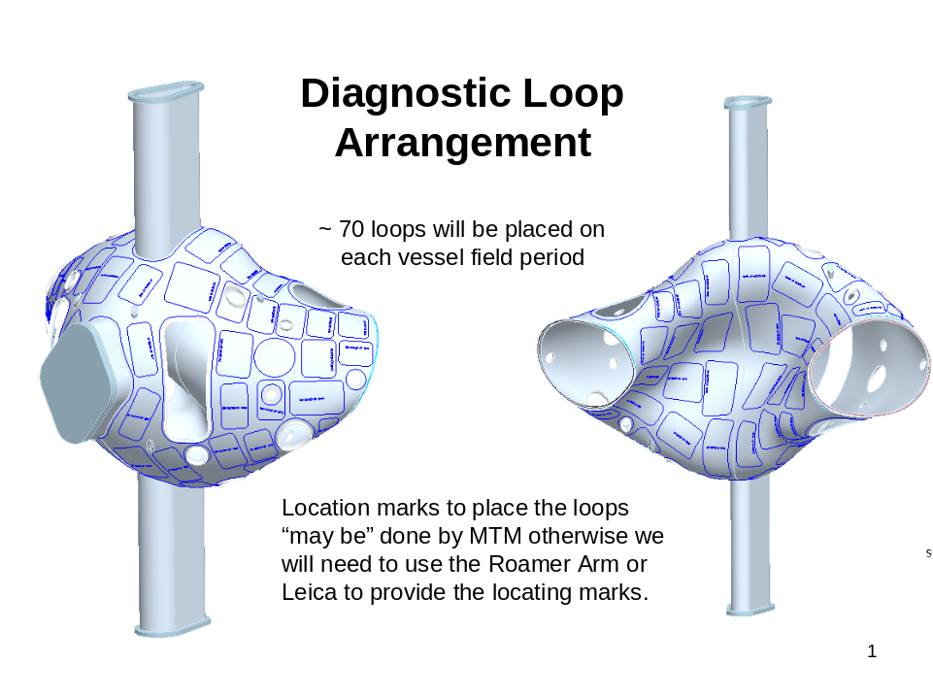

Cooling / heating trace lines
Cooling/heating trace lines will be added to each period as shown in Figure 2. These cooling/heating tubes will be attached to the vessel by stud welding “J” clamps to the vessel. A 1/16-inch gap is designed between the vessel and the cooling tubes. This gap provides clearance for the installation of the saddle coils.
Stycast, a thermally conducting epoxy, will be placed between the vessel and tubes. A total of 32 tubes will be attached to the outside surface. The location of the tubes is not as critical as previous components. The cooling tubes are 0.375” O.D. x .035” wall thickness and made of Inconel 600 and will be preformed before assembly.
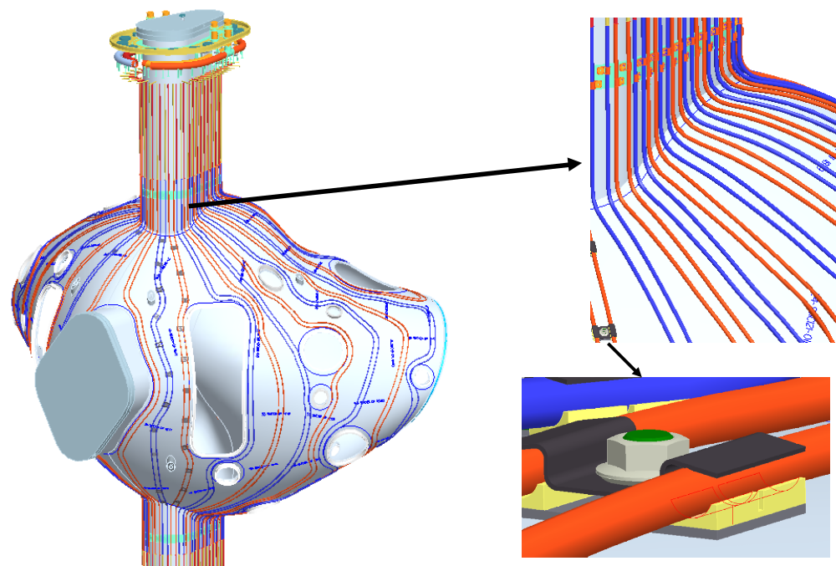

Figure 2 Cooling / heating line tracing installed on vacuum vessel

Vessel support hardware
The next step would be to install the vacuum vessel support hardware that suspends the vessel from the modular coil shell. This hardware cannot be installed at this time because of the limited clearance during the assembly of the modular coils over the vacuum vessel. The installation of the vacuum vessel support hardware will be discussed after the installation of the shell.

Station 2 – Modular Coil Half-Period Assembly
This station is comprised of a tilting platform that will allow the modular coils to be aligned and bolted together. Preliminary Details follow.

Assembly of the Modular Coils
The assembly of the modular coils will consist of four steps. Step 1 is to review the dimensional inspection information generated during the manufacture of each coil. Step 2 is to assemble coil segments M1, M2 and M3 together to form the half period coil subassembly, using shims as required to obtain the best relational fit between the three coils. Step 3 is to dimensionally inspect the coil sub-assemblies. Step 4 is to assemble the left and right half period sub assemblies over the vacuum vessel.

Step 1
Inspection data from each coil will be collected, including the relationship between the winding geometry, flange geometry, and tooling ball monuments. The location of these features relative to the global machine assembly will be calculated based on the optimum position of each coil in the assembly. This information must be processed to determine the best fit of the coils in the final assembly, and to size the shims needed for the next step.

Step 2
The modular coils will first be assembled into segments consisting of the three coils using the fixture shown in Figure 3. This procedure will start with M1. The M1 coil segment will be placed in the fixture and measured to verify location. A shim, which has been sized based on dimensional data taken during the fabrication of the M1 coil and the next coil segment, M2, will be placed on the flange. The M2 segment will be lowered into place and insulated bolts will be matched reamed with the flange holes. The bolt and nut assembly will be torqued to specification. Dimensional inspection data will be taken to verify the location of the coil. The M3 coil will be assembled next using the same procedure as done for the M2 coil. After the three shell segments have been assembled, cryolite batt insulation will be placed between the windings.

Step 3
After the 3-coil subassembly is completed, it must be re-inspected. The purpose of this inspection is to verify the assembly of the half period coil subassembly and to compare this information with a second half period assembly to size the shim needed at the Field Period Assembly.
TBD
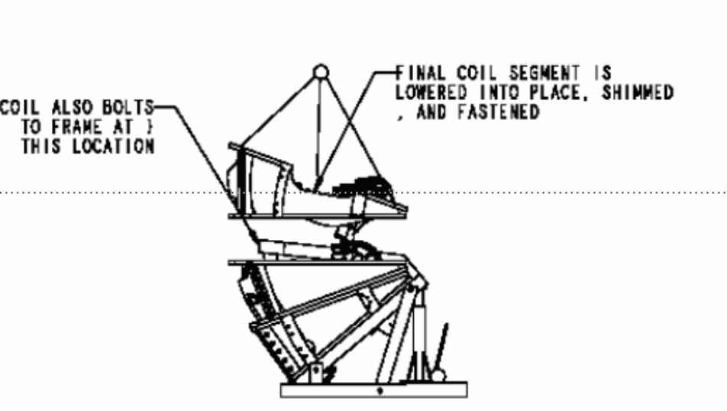
Figure 3 Modular Coil Subassembly with fixture

Step 4
After a pair of 3-coil assemblies are completed and inspected, they will be assembled over the vacuum vessel. The half period modular coil subassembly and fixture will first be placed next to the vacuum vessel and fixture shown in Figure 4.

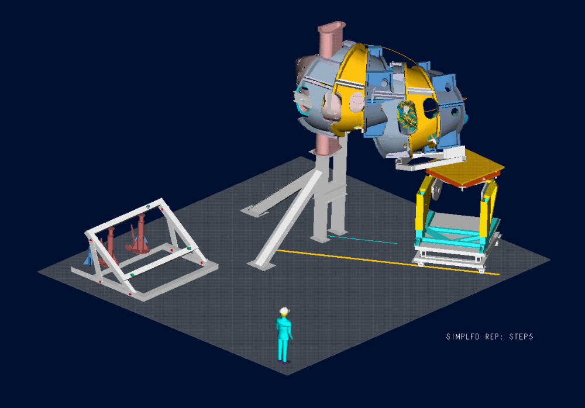
TBD
Figure 4 Modular coil subassembly on fixture for assembly over vacuum vessel

The half period modular coil subassembly and fixture will be guided by tracks that have been positioned on the floor. As the fixture and subassembly follows the tracks the fixture will change the location of the coils by moving vertically, pivoting on the horizontal axis, and rotating the table about a vertical axis. By slowly advancing the fixture and adjusting the location of the coils the half period segment will fit over the vessel until the coils have been positioned correctly.
Measurements of the coil location will be made during the assembly to verify the location of the coils during all moves. When the half period subassembly is correctly positioned the load will be temporally transferred from the fixture to a support frame as shown in Figure 5. The support frame allows the handling / positioning fixture to be removed from under the 3-coil subassembly.
After the handling fixture is removed, the half period subassembly will be supported from the floor as shown in Figure 6. The temporary support frame is also removed.
A shim that fits between the two half periods will be placed on the installed half period subassembly. The second half period subassembly will be installed in a similar manner as the first. When the second half period subassembly has been installed insulated bolts/nuts will be matched reamed with the first half period subassembly and torqued to the required specification.
The modular coils will be inspected to verify the final location of the coils.
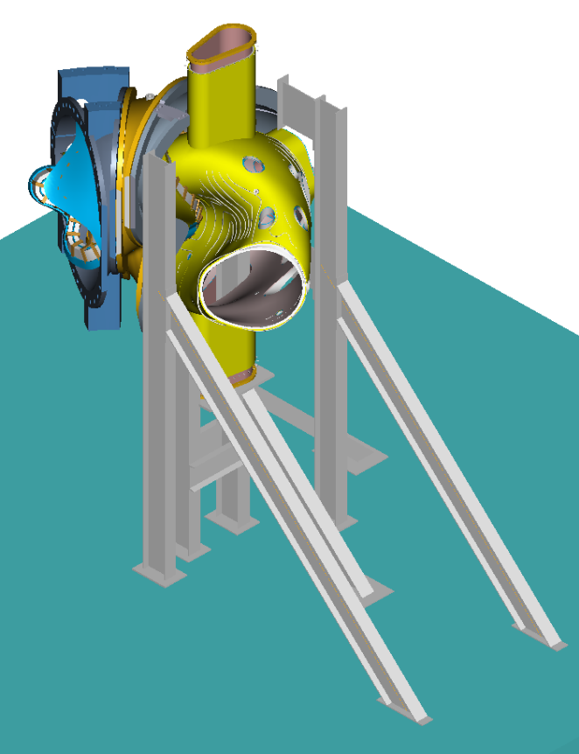
TBD
Figure 5 Load transfer fixture

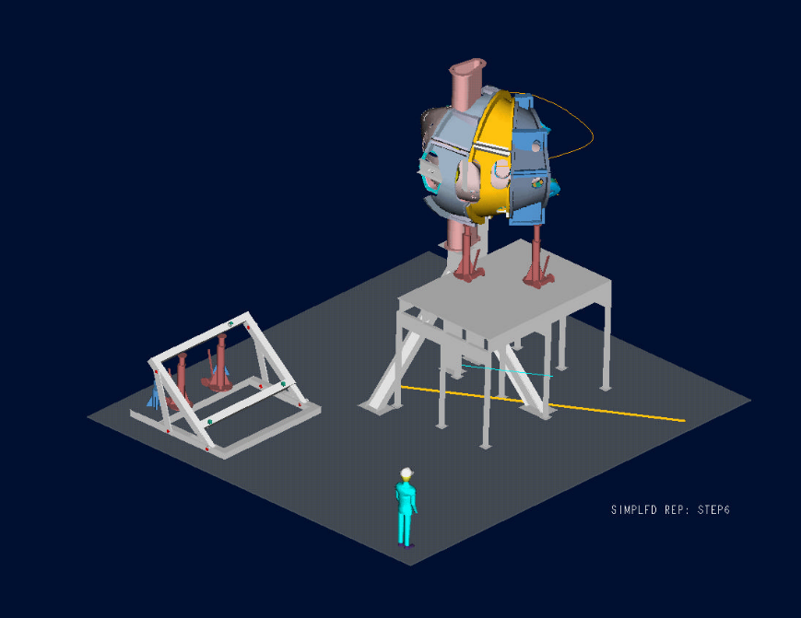
TBD
Figure 6 Modular coil load transfer fixture

Station 3 – Modular Coil Installation
This station is comprised of a support that will hold the vacuum vessel vertical and allow the modular coils to be rotated (screwed) onto each end of the VVSA, one at a time. Then the ports will be aligned and welded on. From this point forward, the Assembly will be called the Field Period Assembly. Preliminary Details follow.

Vacuum Vessel Support Hardware
The vacuum vessel support hardware can now be installed between the vacuum vessel and the shell. A clevis subassembly will be fitted thru access ports in the shell and screwed into bosses that are in the vessel, as shown in Figure 7. Threaded rod can be inserted into the clevis from the outside of the shell. Belleville washers and a nut will be attached to the threaded rod and tightened against the shell until the vacuum vessel is snug. The vessel will not be fully supported by this hardware until the ports have been installed and welded to the vessel.

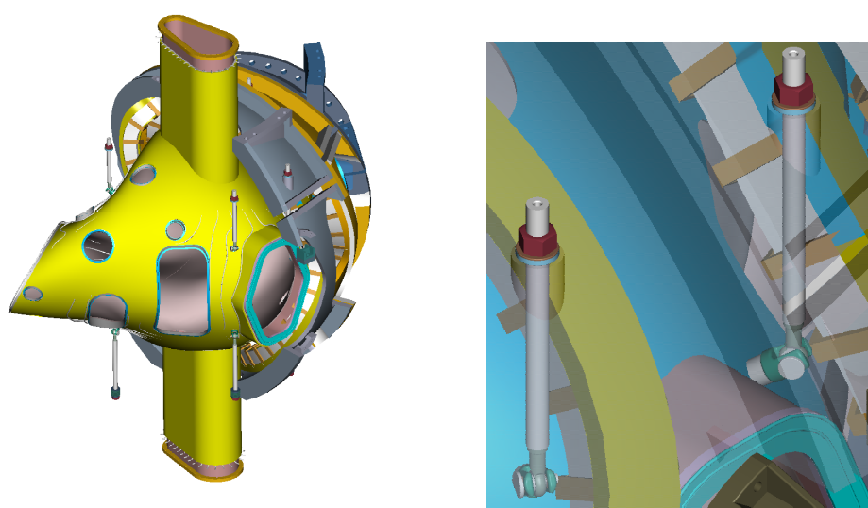
Figure 7 Vacuum vessel support hardware

Assembly of the Ports
The vacuum vessel ports are the last major items to be assembled to the Field Period Assembly. Before installing the ports the Field Period Assembly will have the components assembled as shown in Figure 13. A typical port configuration is shown in Figure 8. A backing ring is shown welded to the port. The backing ring will help position the port over the stub in the vacuum vessel (Figure 8). An assembly fixture will be used to maintain alignment of the ports relative to the global reference frame. All of the ports will be positioned on the vessel and aligned using the alignment fixture. As each port is positioned a tack weld will hold the port stable. After all ports have been assembled each joint will be finished with a full penetration weld. Blank off flanges will be installed on the ports and on the open ends of the vacuum vessel. The vacuum vessel will be baked above the normal bake out temperature (150ºC) to 165ºC and cycled several times. A vacuum leak test will be performed to verify all the welds are leak tight. In addition to the vacuum leak test, a dimensional verification of the port locations will be performed. All fixtures shall be removed and the inspection shall be made with the ports in a “free condition”.

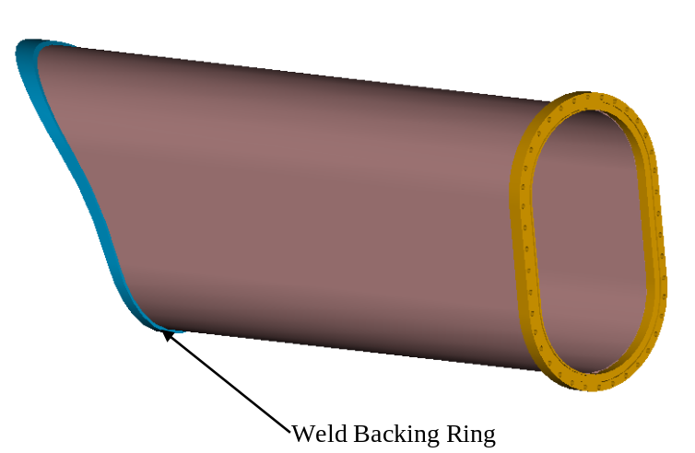
Figure 8 Typical Vacuum Vessel Port Extension ready for welding

Station 4 – Final Field Period Assembly
This station is comprised of a support for the Field Period Assembly and a large column that will be used to support the TF Coils and rotate them onto the Field Period. Preliminary Details follow:

Assembly of the TF Coils
The completed half period TF coil subassembly is shown in Figure 9. The subassembly consists of 3 TF coils with a cast top and bottom support structure. The assembly of the TF coil subassembly is shown in Figure 10. This subassembly step is required prior to assembling the TF coils over the modular coil shell. The TF coils will be positioned slightly offset in the radial direction (~1/4 in) from their final position. This provides clearance during the final machine assembly, when the three Field Periods are installed on the base structure.
The assembly trajectory of the TF Coil half period subassembly is much simpler than the modular coil assembly. The TF Coil half period subassembly can be simply rotated over the modular coils. The fixtures for the assembly are shown in Figure 11.
Before the TF Coil can be assembled, the supports for the Modular Coils must be positioned to allow free access over the Modular Coil. One end of the modular coils is supported from the ground. This allows the opposite half shell subassembly to be cantilevered from the fixed half shell subassembly. With no supports preventing the installation of the TF Coil half period the coils are simply rotated into position. Shims are sized and then placed between the TF Coil and the Modular coils. The two sub-assemblies are then bolted together. Supports are then placed under the TF Coil support and the procedure is repeated for the opposite side.

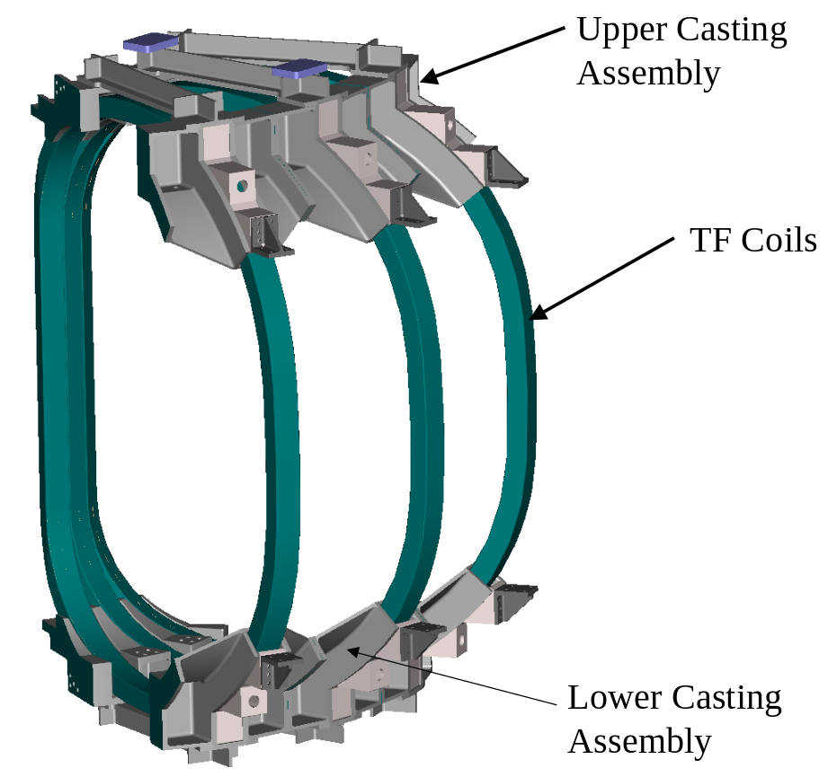
Figure 9 TF coil half-field period subassembly

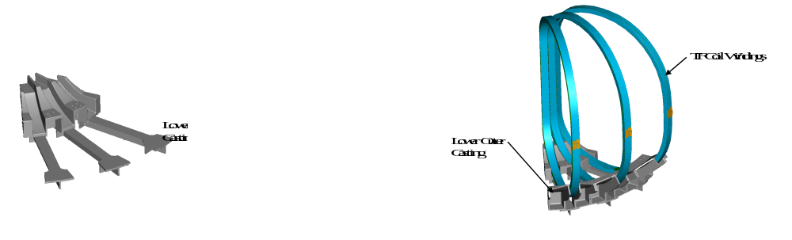
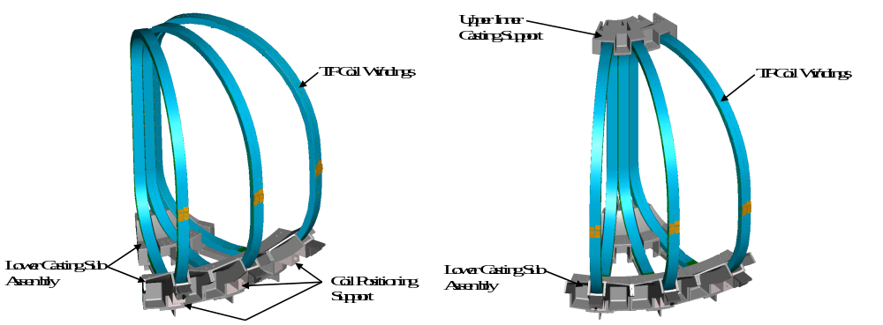
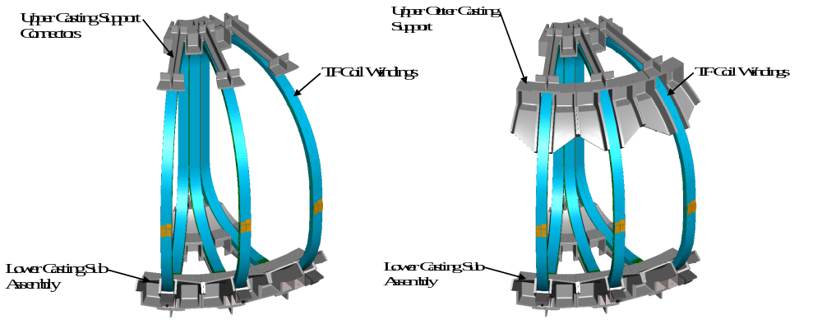
Figure 10 Assembly sequence of TF half-field period subassembly

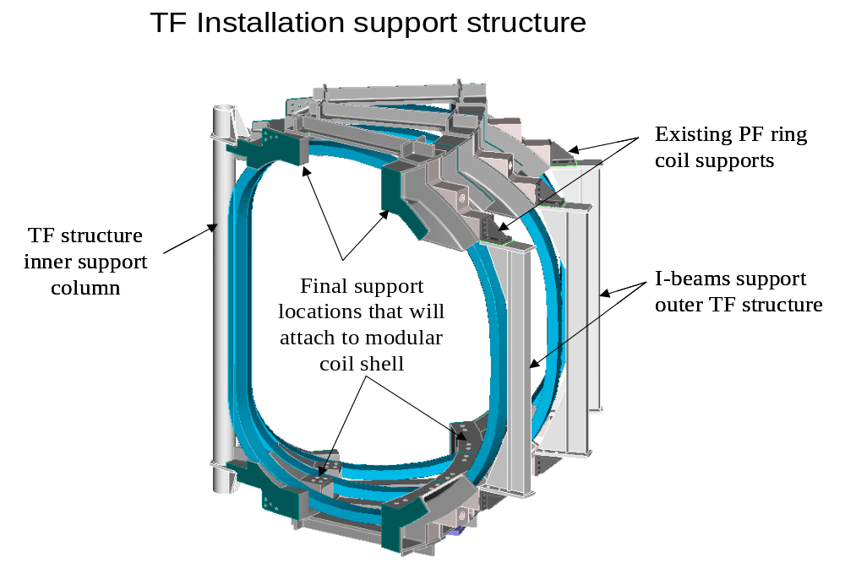
Figure 11 TF Coil installation support fixture

Assembly of External Trim Coils
After the assembly of the TF coils, the External Trim Coils will be attached to the Field Period Assembly. The External Trim Coils are shown in Figure 12. The external trim coils consist of three upper, three lower, and two outer coils. The upper and lower coils are attached to the frame of the TF coil support structure. The outer trim coil is mounted on the outside of the TF coil (Figure 13). At the machine assembly level an additional outer trim coil will be added between each Field Period Assembly. The complete assembly of all the external trim coils is shown in Error: Reference source not found.

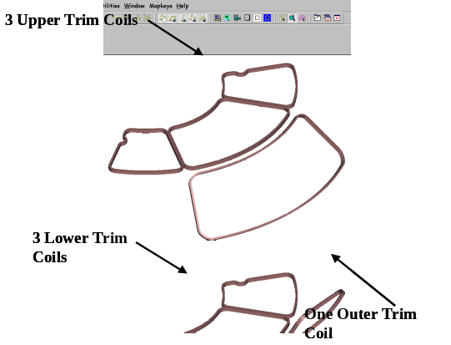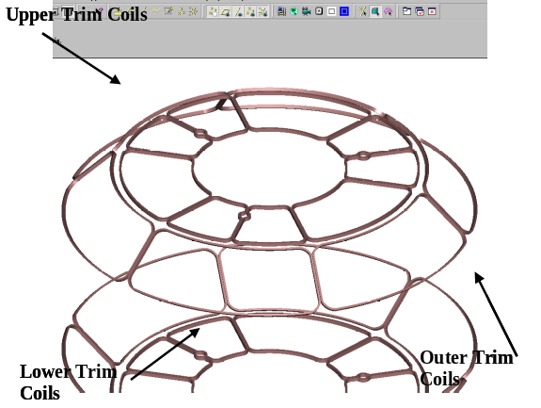
Figure 12 External trim coils

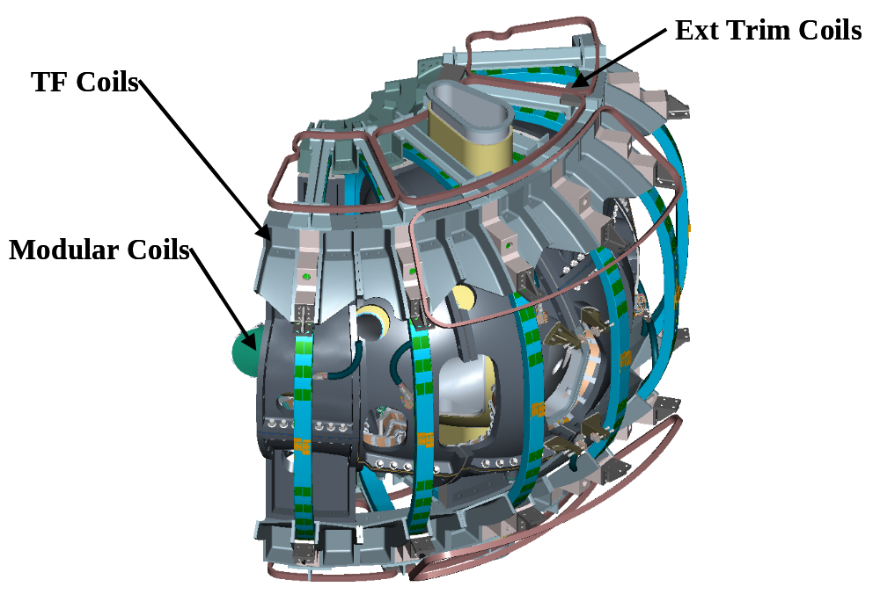
Figure 13 Field period with trim coils installed

Vacuum Vessel Final Support Adjustment.
Before completing the Field Period Assembly, the vacuum vessel has to be supported from the shell. The support hardware that was installed after the modular coils is now tightened until the vessel is barely lifted off the support fixture. The vessel is now free and can move inside the shell assembly. Temporary blocking will be installed between the shell and the vessel during transport from the assembly area to the NCSX test cell. The completed field period assembly is shown in Figure 14.

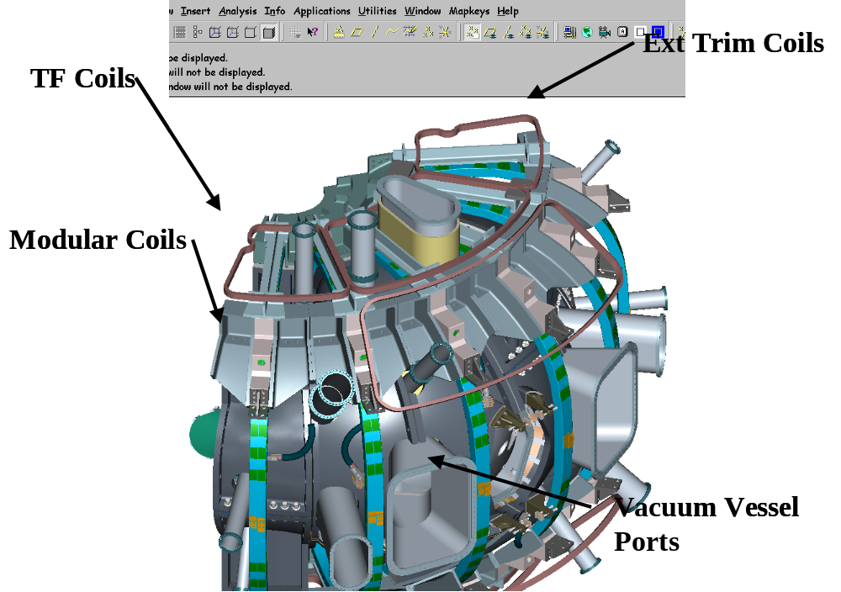
Figure 14 Field period assembly with trim coils

Station 5 – TF Half-period Assembly
This station is space set aside for minor intermediate operations or storage both between stations and in preparation for transportation to the NCSX Test Cell. Preliminary Details follow.

Field Period Transportation to NCSX Test Cell
When a Field Period Assembly is completed it will be lifted from the fixture in the assembly area and set on a truck for shipment as shown in Figure 15. The Field Period Assembly will be driven a short distance on site to the NCSX test cell.
The crane is not expected to be used for day-to-day assembly. Local fixtures will be used for assembly. Typical lifts and the weights are shown in Table 1. After a lift has been performed the crane will be released for other operations needed in the TFTR Test Cell.

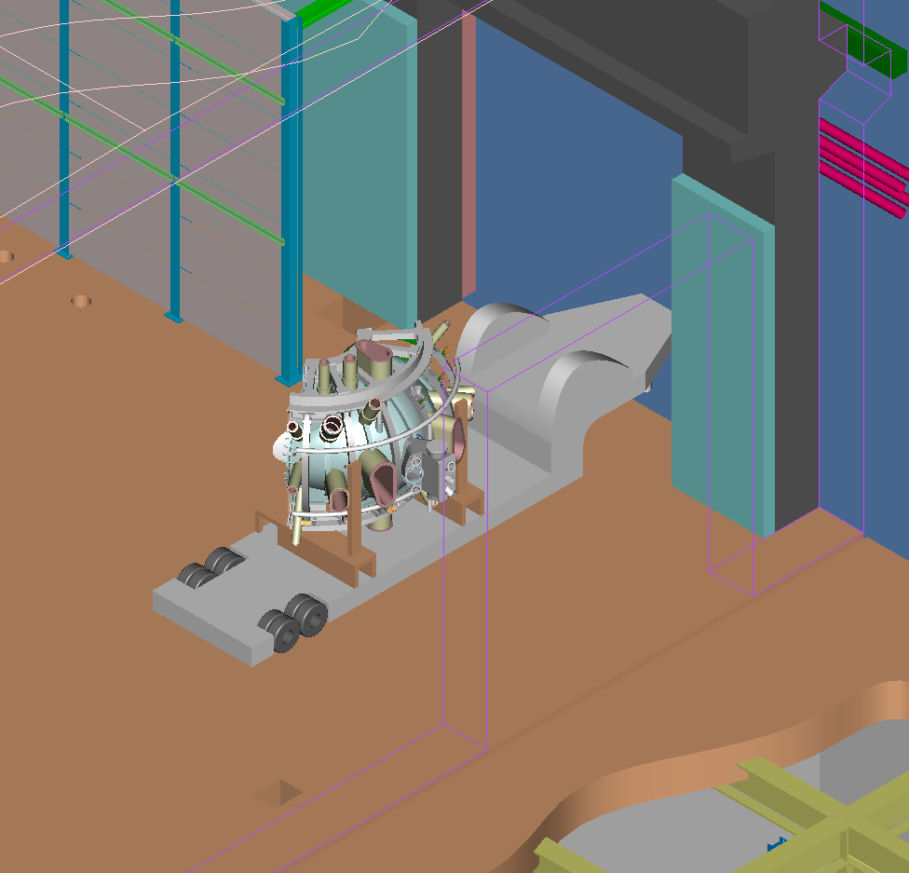
Figure 15 TFTR Loading Station

Table 1 Typical components to be lifted and weights
Description | Weight
Vacuum Vessel | 6,400 lbs
M1 Coil | 7,100 lbs
M2 Coil | 6,700 lbs
M3 Coil | 7,100 lbs
Half period Modular Coil | 21,000 lbs x 2
Half period TF Coil | 11,000 lbs x 2
Field Period Assembly | 70,400 lbs

Documentation Requirements

Document Control
All NCSX associated documents providing instruction for assembling the field period assembly (e.g. plans and procedures) will be maintained under NCSX Project document control.

Field Assembly Station Field Packages
Each field period assembly station shall have a “Station Field Package” that shall be maintained by the field period assembly team. This package shall include all process procedures, inspection reports, photographs, test results, and measurements used to document completion of major activities associated with the activities in each station to assemble the field period assembly. It shall also include ECNs, non–conformance reports (NCR), or other exceptions to or changes in requirements. All documents shall be complete, legible and validated by responsible personnel.

Assembly/Installation Procedures
Field Period Procedures shall include:
- The critical steps and criteria established by the sequence plan.
- Reference the specification applicable to the procedure
- The list of drawings applicable to the procedure
- Procedure sign-offs for critical steps in the procedure
- The verification list of criteria to determine the successful completion of the procedure.

Assembly/Installation Procedure Sign-Off’s
Assembly/Installation procedures will be used as a signoff/approval document noting that critical manufacturing steps have been completed. Authorized personnel associated with the manufacturing, inspection and test processes will perform the signoff’s. In addition, it will provide witness points as well as reference for test results, and measurements.

Procedure Completion
The Lead Technician or Field Supervisor will document all critical completions on the procedure. This will be completed using the signer’s initials or full signature.
The procedures will be filled out in a timely fashion once a particular activity has been completed.

Authorized Signoff’s for Manufacturing Completions
The manufacturing procedures will identify what level of signoff is required for a particular step. The following disciplines are the authorized signatures for the in-process procedures.
- Station Lead Technicians
- Field Supervisors
- Quality Control Representative
- Manufacturing Facility Manager
The Lead Tech and Field Supervisor are signing that the procedural aspects of the assembly stage are completed. The FPA Manager is signing that the Documentation package is complete and ready for verification. The QA representative is signing that he has reviewed the documentation package, verified that it is complete and verified that it meets all specification requirements and tests referenced in the procedure.

Final Document Storage
All documents (hard copy) associated with the manufacturing will be stored in the PPPL Operations center, electronic documents will be stored on the NCSX Web site for the lifetime of the NCSX MIE Project, after which the files will be turned over to the Operations Center.

Quality Assurance/Quality Control Requirements

Inspection/Surveillance and Audit:
Field Supervisors; lead technicians and Quality Control (QC) representatives will perform FPA inspection and surveillances as required by FPA procedures.
Independent Audits may be performed by the Quality Assurance Division to ensure that approved manufacturing processes and quality of product is being observed.

Inspection and Test Procedures:
Inspections, measurements, and tests will be performed by the field crews and engineering. Where required by procedure, a QC representative shall be present during inspections, measurements, or tests.
Inspections and tests shall be performed:
- In accordance with written/approved procedures referencing criteria for acceptance or rejection.
- Using properly calibrated measuring and test equipment in accordance with PPPL procedure ENG-002 “Control of Measurement Test Equipment & Calibration”.
Adequate records to reproduce the inspection shall be maintained and available for NCSX Project reviews.

Equipment/Material Identification and Status
Material and equipment identification shall be maintained throughout the program and be traceable to the records. Status of acceptability shall be readily discernible through the use of tags, stamps, travelers, serial numbers or other positive means.

Non-conformance & Corrective Actions:
Nonconforming items shall be positively identified, and, where possible, segregated to prevent use. The Manufacturing Team shall document each non-conformance in accordance with PPPL procedure QA-005 “Control of Non-conformances”.

Release for Station Transfer:
Prior to releasing a VVSA or FPA from one station to the next, the Station Lead Technician, Field Supervisor, FPA Manager and the QC representative will review and approve the release indicating that all processes at that station have been satisfactorily completed.

Process History:
The FPA team shall provide a Process History for the VVSA or FPA that includes a compilation of documents, detailing the objective evidence of the acceptability of the work performed. Process History shall be stored in the Operations Center after assembly is completed. The Process History shall include as a minimum, but not be limited to the following:

Material Certifications:
The FPA Team shall compile inspection reports, test data, and/or certifications from vendors, showing relevant chemical, mechanical and electrical properties of materials used, where applicable, as detailed in applicable procedures, as well as documents showing adherence to in-process requirements. Material certifications from sub-tier suppliers shall also be submitted.

Completed Procedures:
Original or copies of filled in and completed process planning and control documents (procedures, etc.), which verify controlled execution of the required work. Each FPA will have its own set of process planning and control documents.

Inspection Reports:
Copies of the original reports from all required inspections and examinations, that are properly validated by authorized personnel.

Test Reports:
Copies of the original test data sheets or reports of all required tests, both in-process and acceptance, that are properly validated by authorized personnel.

