Our initial review of the casting and comparison to MTM NC18297 identified the following items related to nonconformances:

- IDC #70 is listed on the NCR, but shown as acceptable on the IDC. Is there a nonconformance in this area?
- IDC #90, #180, #210, & #230 are all listed on the IDC as rejected, but do not appear on NC18297.
- IDC #140 & #160 identify out of tolerance conditions at the base of the tee (distance from potting groove to inside of shell too small). This prevents clamp studs from being welded where needed and so these areas are now being reworked at PPPL. These areas must meet the model/drawing requirements on subsequent castings.
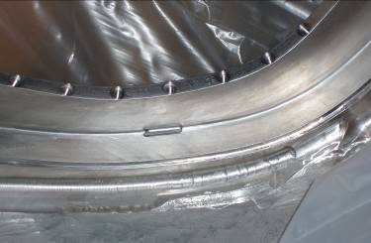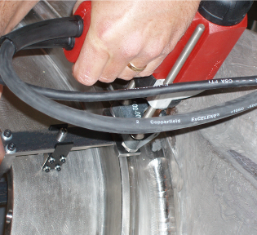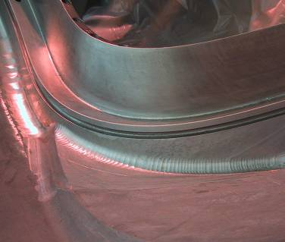
- IDC #250 shows a flange face out of tolerance by .032”. Last Friday we all questioned this, based on the CMM data file, and Kevin was to verify this reported value.
- IDC #300 covers the diameter of the spherical alignment features. These cannot be accepted as-is on future castings. They are now being reworked at PPPL.
- As previously discussed, the poloidal break features (IDC # 510-540) need to be inspected on subsequent castings. On C-1 the mating flanges are significantly undersized. PPPL is currently analyzing the effect of the reduced flange thickness.
- IDC#1040 reports all surface finishes and gives a range of 31-500 micro-inches. Please report the two areas (125 & 250) separately. Also The 500 micro-inch areas around the base of the tee cannot be accepted as-is on future castings. PPPL is reworking those areas on C-1.
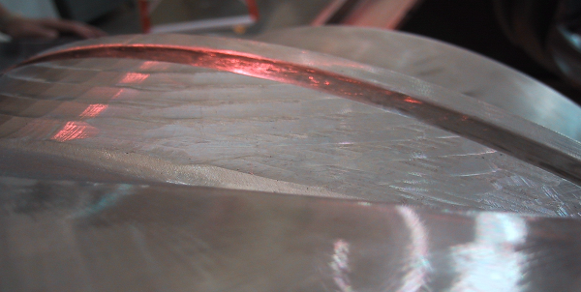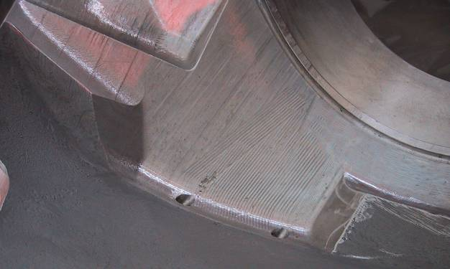
- The poloidal break shim does not conform to the shape of the casting or to the model. PPPL will issue an NCR for this condition. Future shims should conform to the model.
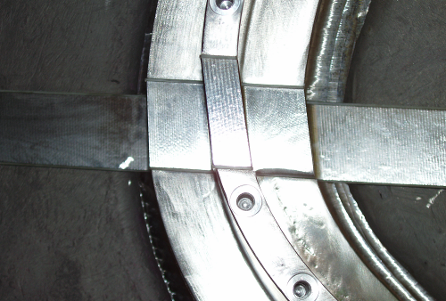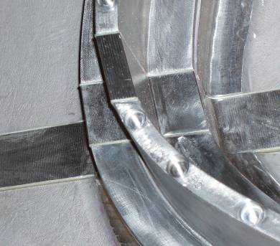
- The poloidal break fasteners have certification stating they are A286, but later pages identify the material as 4340 steel. The magnetic permeability of the nuts and studs is higher than any of our gages can read. PPPL will issue an NCR for this condition. The fasteners need to be replaced with fasteners compliant to the UNS S66286 designation.
- Back spot facing of one flange was done in large cuts, rather than just a spot face around each flange hole. This resulted in loss of thickness on a large area of the flange. PPPL needs to understand if this is necessary or if local spot facing, as was done for the other flange, can be done.
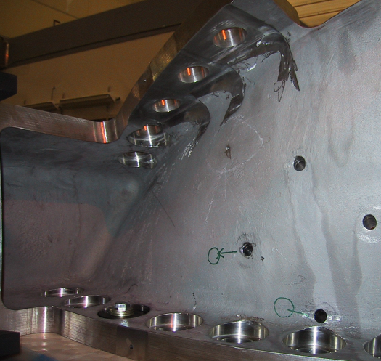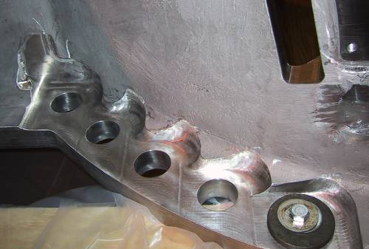
- There is a large flange counterbore/through-hole interference (Sheet 1, D-4) where back spotface is inadequate. The model does not have this problem. PPPL is reworking this area.
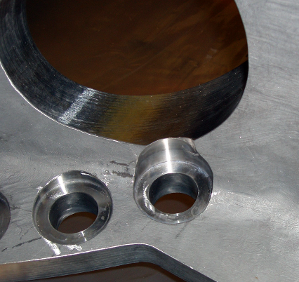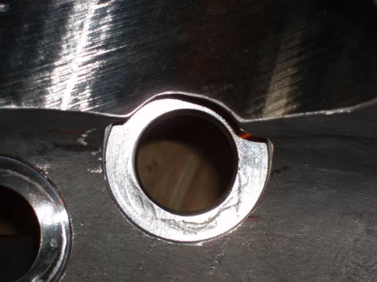

- A cooling tube hole (sht.3, C-6 & sht. 9, C-7) appears to have been drilled at the wrong angle. It intersects with the base of the tee on the casting, but not on the model.
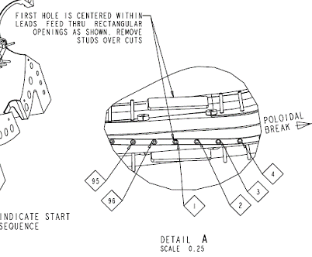
- Web holes are mis-numbered. PPPL is renumbering. Numbering on future castings should comply with that shown on email guidance provided 9/7/2005.

