DESIGN INTEGRATION / ASSEMBLY TOOLING CLOSEOUT REPORT

NATIONAL COMPACT STELLATOR EXPERIMENT
(NCSX)

T. Brown

September 2008
- Document Overview

This document covers the closeout of assembly tooling and design integration. Assembly tooling in this period of the project involves planned activities to support the final stages of field period assembly (Stations 3 and 5) and final machine assembly, Station 6. As part of the design integration closeout activity a final review of the NCSX device was made to document configuration and interface issues and to identify design activities that would be needed “if” and when the NCSX project were reactivated. Special emphases were placed on documenting the cryostat design, which was still in the design process prior to closeout, as it has significant integration impacts on interfacing components. Where cryostat-interfacing subsystems were still in design and time allowed changes, subsystems were altered to allow proper interface with the cryostat. When design changes were too involved, the expected cryostat imposed subsystem changes have been documented. It must be noted that changes made as part of configuration development process within the design integration activity have not been formally reviewed by the project; however, system components changes have been reviewed by the effected WBS managers. Specific components highlighted in the design integration section include the cryostat, magnetic systems electrical services, the neutral beam transition duct, diagnostic ports and the pumping duct. To complete the review, auxiliary systems and facilities issues brought about through the integration of the device core with the updated cryostat have also been documented.

2.0 Assembly Tooling

Figure 2-1. Station 5 assembly tooling

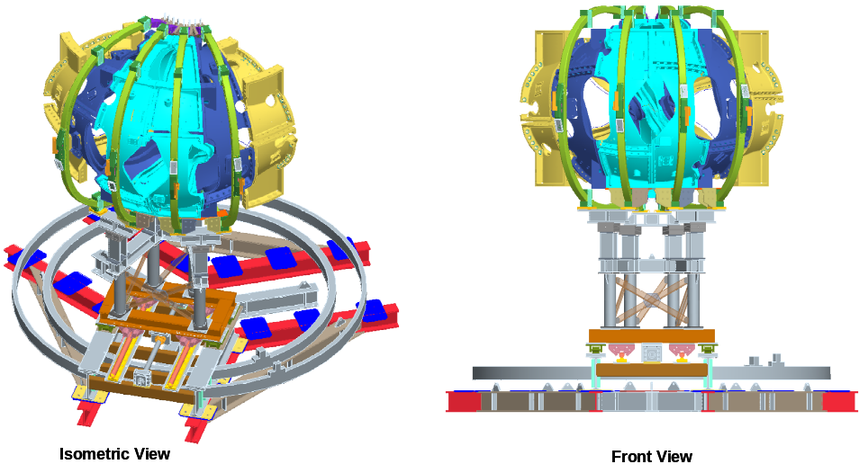

Figure 2-2. Station 6 assembly tooling

3.0 Design Integration

A conceptual design of the cryostat was developed in April of 2003 to form the bases of the NCSX final design review of the vacuum vessel subassembly and modular coil winding forms. The original cryostat had a simple frame and panel design in a topology that provided the build for urethane insulation space and openings for the myriad of vacuum vessel ports that dominated its interface. It incorporated rubber “Gortiflex” boots to seal between vessel port extensions and the cryostat. Figure 3-1 shows the progression of the cryostat over the project life in different spurts of activity, even showing an arrangement looking for a better approach in March of 2007, with “bags” of loose insulation bridging upper and lower disks of urethane foam. The dominant driver in the cryostat design is the need to provide sealed penetrations to all the ports that pass through it coupled with the need to gain access to its interior for inspections and repair.

Figure 3-1. Cryostat history

The insulation system for the vacuum vessel transitioned from microtherm insulation wrapped on the vessel in 2003 to the 2008 insulation filled (Nanogel beads) system occupying the space between the vacuum vessel and modular coil. A general arrangement of this system is illustrated in Figure 3-2 showing a section cut at the port 12 vertical port. What is shown is Nanogel beads captured between the modular coil shell and the outer surface of the vacuum vessel and locally contained by a duct that surrounds port 12. A fill/sight tube penetrates the collar that surrounds the port. The cryostat is shown to the right in this figure, acting as a boundary to the Nanogel.

Section 3.6 of this closeout document will describe a Design Integration evolved cryostat configuration that follows the topology of the original 2003 cryostat but incorporates the characteristics of the Nanogel bead insulation system. Before the cryostat details are presented, needed changes to interfacing components will be discussed.

3.1 Vacuum Vessel Port Interface

The vacuum vessel has an array of ports that are arranged to penetrate the void space in the modular coil system forming an arrangement that easily could mimic the quills of a porcupine. Large horizontal ports were sized to meet the requirements for near parallel neutral beam injection at the center port of a field period with an adjacent port contoured to allow viewing access for the MSE/CHERS diagnostic system. To maintain machine stellarator symmetry the MSE/CHERS configured port shape was also placed on the opposite side of the NB port. The general arrangement of the baseline vacuum vessel ports with port extensions that will penetrate the cryostat is shown in Figure 3-3.

The challenge in designing the cryostat is in defining a configuration that provides the space for the vacuum vessel ports; the port seals, the base machine support, service penetrations and at the same time allows “reasonable” access into it for inspection and maintenance of the device core components. In reviewing the device core / cryostat interfaces it became apparent that changes were needed with some of the interfacing components.
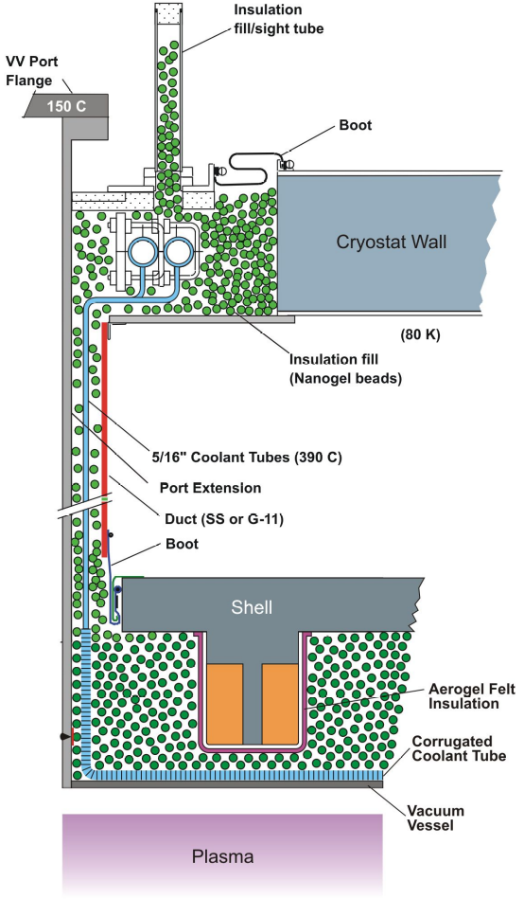

Figure 3-2. Insulation filled (Nanogel beads) system

The lack of clearances between the collar that surrounds port 12 and the adjacent vertical port (shown in Figure 3-4) makes is very difficult to define a feasible port cryostat seal. Developing “reasonable” machine access is also compromised with the large number of varying angled ports that penetrate the upper and lower cryostat surfaces. To solve the port 12/adjacent port interface issue plus improve machine access, four upper and lower angled ports within the period were changed to re-interant horizontal ports (see Figure 3-5) that interface with the slanted section of the cryostat. The diameters of the horizontal section of these ports were increased to provide greater area to insert diagnostic components. This change in port geometry was reviewed by the diagnostic group head (Brent Stratton) who indicated that the proposed change should be feasible, although a final project review and approval is required. Only the ports adjacent to the port 12 collars needed to be altered but to improve the “reasonable” access nature of the cryostat design, changing the geometry of all the upper/lower angled ports allowed large non-penetrated access panels to be formed. Only the large port 4 diagnostics ports were retained as vertical ports in each of the three field periods.
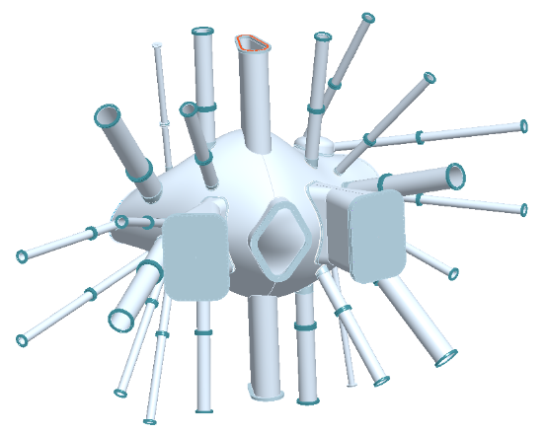

Figure 3-3. Baseline vacuum vessel port arrangement

  - Electrical Lead Service Routing Through the Cryostat

The electrical lead routing on the device core was arranged to match the DC pick-up connection points in the NCSX test cell floor as show in the test cell plan view of Figure 3-6. All PF leads are routed to the E side of the test cell, all modular coil leads routed to the SW side and all TF and trim coils leads are routed to the NW side. The lead routing on the device core was in works prior to the project termination. Figure 3-7 shows the status of the design integration model prior to project termination. The lead arrangement model was developed in sufficient detail to determine the path and space requirements for the modular coil (MC) and TF cables. This work was done in conjunction with the responsible ORNL WBS group. Future detail effort would be needed to add the PF and the smaller trim coil leads along with the support hangers that would be attached to the magnet structure. The PF lead routing was not added to the model due to close out constraints; however it was agreed by Art Brooks that field errors would not be a problem in clocking the PF coils such that their leads are concentrated on the east side of the test cell to minimize the run length to the PF lead chase. As shown in the Figure 3-7 the MC leads would be routed just outside the PF6 ring coil (upper and lower) and the TF leads routed above (or below) the horizontal ports. The MC leads will head toward the MC lead supply chase shown to the left of the figure. The lower MC leads head to the lead chase on the left side but the model details of turning the corner and moving into the chase was not completed. The details of the cryostat lead chase will be covered in Section 3.6.
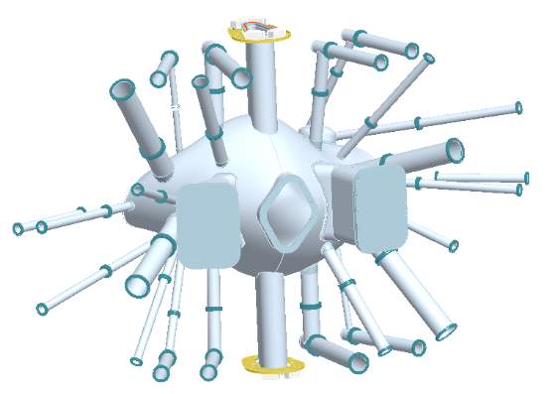

Figure 3-5. Proposed altered vacuum vessel port arrangement

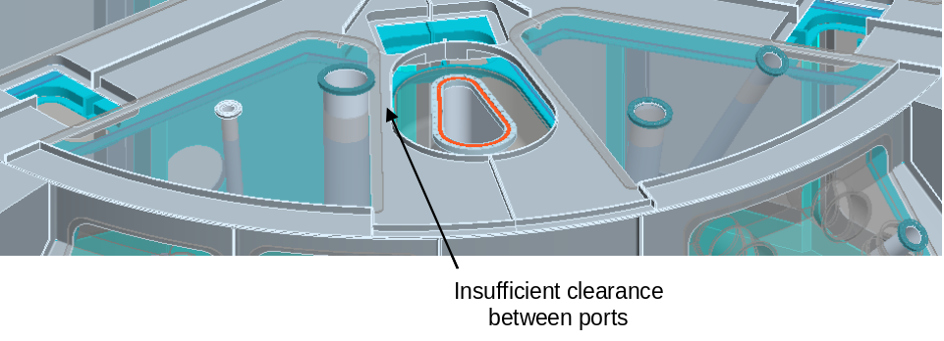
Figure 3-4. Lack of clearance space between port 12 and the adjacent port

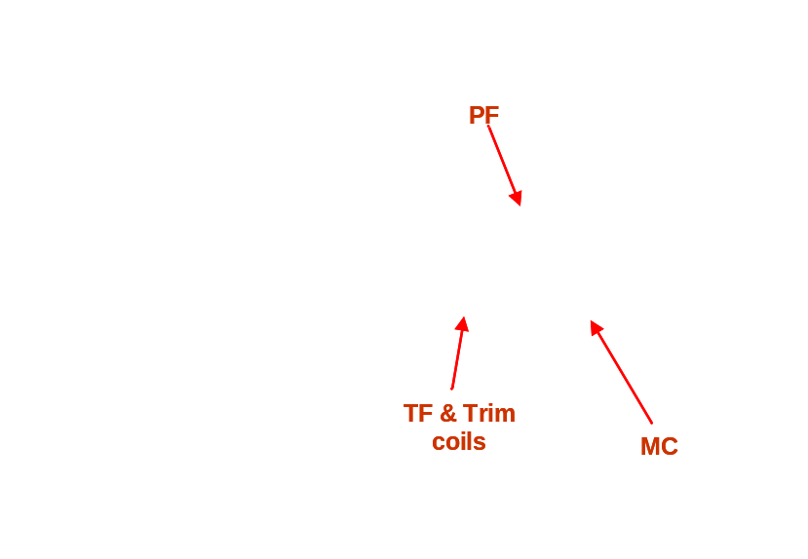

Figure 3-6. DC systems test cell penetrations

3.4 Neutral Beam Transition Duct
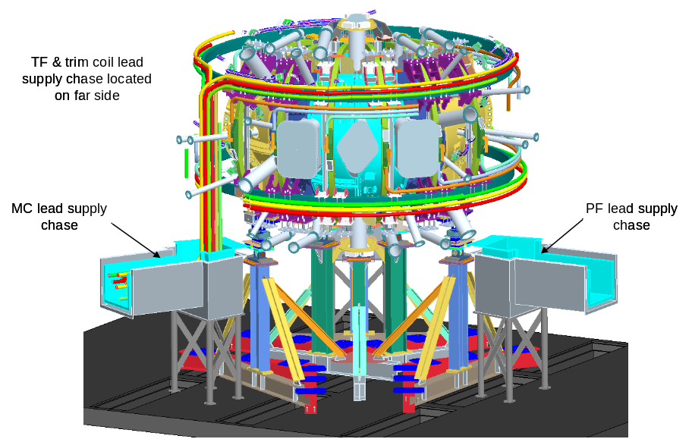

Figure 3-7. Electrical lead routing of core components

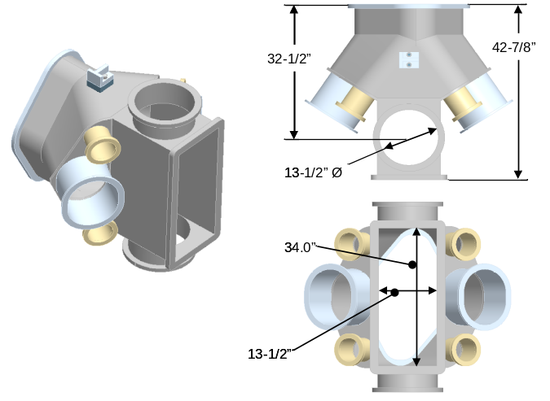

Figure 3-8. Reference NB transition duct

The neutral beam transition duct reference design shown in Figure 3-8 was configured early in the NCSX design process to accommodate two neutral beams and provide manned access between the beam ports. When the design recently entered the detailed schedule phase an internal review found that industry standards had become more stringent, now pointing to a minimum manhole sixe of 15” x 23”. With the baseline transition duct width of 13-1/2” and a need to improve its interface with the cryostat, the transition duct geometry was revised to the arrangement shown in Figure 3-9. The NB port structure front plate was changed to a flat surface (instead of angled) to improve the seal interface with the cryostat and the side ports now interface in the corner in order to increase the center port opening for improved manned access. The manned access opening width was increased to 18” (from 13.5”), also allowing the duct opening used for pumping to increase to 15” from 13.5”. The center of the pumping duct did move out approximately 6” to accommodate required clearances to the cryostat. Bill Blanchard (pumping system WBS head) felt that given the transition duct size changes there would be a net win on pumping conductance.

The NB transition duct boot seal also was found to be in need of alteration to improve its cryostat interface plus eliminate some inaccessible attachment bolts. Figure 3-10 below shows a series of figures that illustrate the current seal interface with the modular coil. The seal is shown attached to the outside surface of the vacuum vessel neutral beam stub section which will be located within the confines of the modular coils at the A-A fit-up joint. This implies that the NB transition duct insulation boot would need to be attached to the vacuum vessel prior to the Station 3 assembly where the modular coil half period (MCHP) is rotated over the VV. Upon completing the Station 3 assembly, the bolts of the seal boot would be inaccessible.
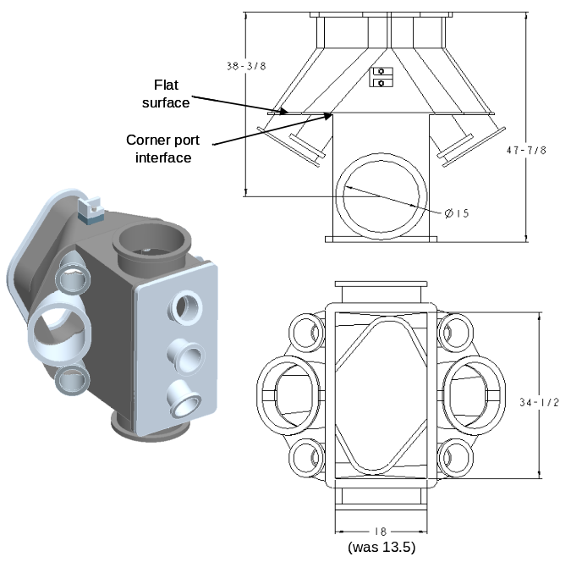
Figure 3-9. Revised NB transition duct

A new arrangement is being proposed for the transition duct seal to gain bolt access and provide insulation for the transition duct in a configuration that can incorporate a Nanogel bead insulation system that interfaces with the cryostat. Figure 3-11 shows the general arrangement for this modified seal. The exploded view in the upper left of this figure shows the components of the transition duct system; the transition duct, the lateral support members and the newly configured boot seal. The boot seal will be attached to the outside of the A-A modular coil joint surfaces using a bolting scheme that is accessible from inside the seal. Sealing to the MC outer surface will be more difficult than sealing to the edge of the vacuum vessel but it appears feasible. Once the seal is installed the NB transition duct would be installed inside it as shown in the exploded view on the right of Figure 3-11 and shown fully engaged in the lower set of figures. The end of the boot seal will need to be attached to the transition duct at one edge and to the cryostat at the other edge. Sealing to the transition duct is needed to close off the Nanongel beads of the MC / VV cavity. It should be noted that rather than filling the cavity around the transition duct with Nanogel beads, the duct can be wrapped with Pyrogel blanket as called out in the baseline arrangement. Finalizing the details would be worked out under WBS 12. The seal to the transition duct is not shown but it could be as simple as adding an additional member welded to the outside of the transition duct to form a sealing surface for the transition duct seal. Changing the geometry of the transition duct to a flat end improves this sealing feature. The lateral support structure can be added after the transition duct is attached to the VV and before the horizontal port section of the cryostat is installed (to be discussed later). The VV lateral support may need to be reworked to eliminate a local interference near the end of the fitting, shown in Figure 3-12. Using the reference design cloth boot construction the local interference will not be a problem. There may be advantages to use a combination of the cloth boot in conjunction with formed fiberglass section, at least at the ends where it interfaces with the cryostat.
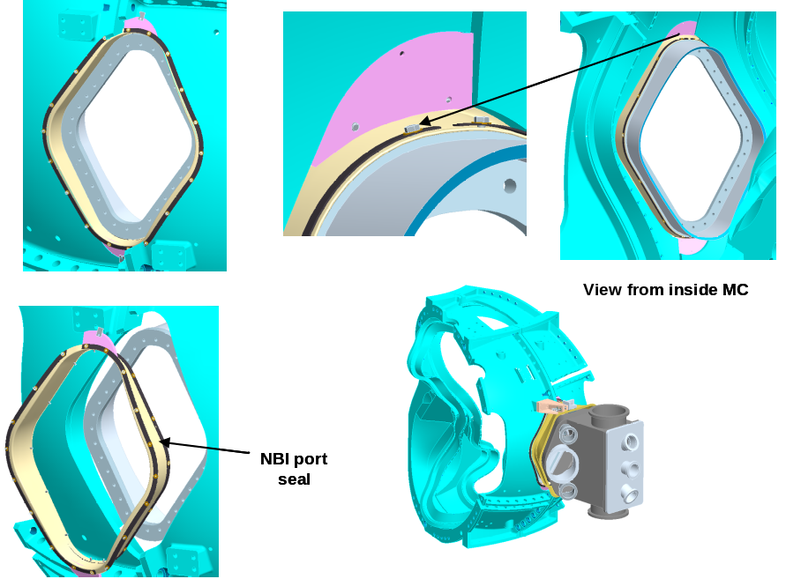

Figure 3-10. NB transition duct reference design insulation seal

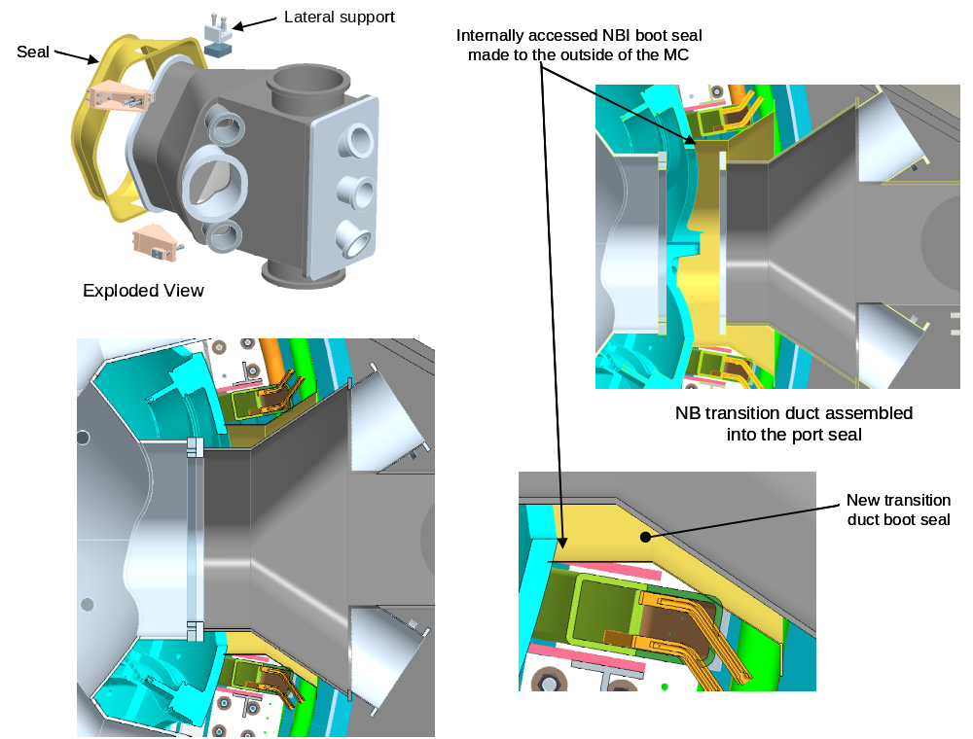

Figure 3-11. Revised NB transition duct insulation seal arrangement

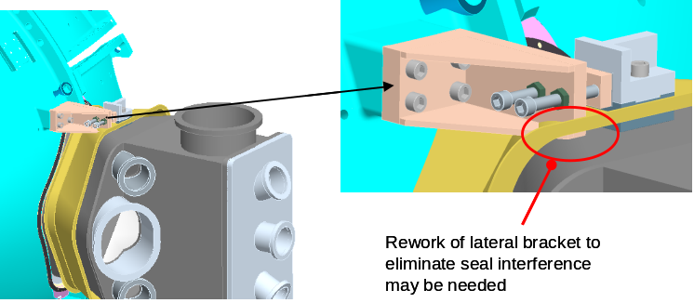

Figure 3-12. Rework lateral support bracket needed

3.5 Port 4 (MSE/CHERS) diagnostic port

Figure 3-13 shows the proposed upgrade of the baseline Port 4 boot/insulation scheme to an arrangement that interfaces with an upgraded cryostat. The left most figure of 3-13 shows the baseline configuration where the port is wrapped in Pyrogel blanket insulation. The blanket section at the end of the port is actually fully wrapped around the back side of the port flange, although it is shown horizontal and extending into the TF lead on the upper end. It was shown this way for the purpose of model simplification. The front of the port is shown with the flange fully covered in insulation, although Paul Goranson (WBS 12 manager) stated that the stainless steel flange needs to be open to air as it can not endure the VV bake out temperature. Unfortunately the port flange of Port 4 falls inside the cryostat as indicated in the far left picture of Figure 3-13. In hindsight we should have added a straight section to the hour-glass port, extending out through the cryostat. Instead of this the cryostat was revised to accommodate the current port configuration. The center picture of Figure 3-13 shows the revised Port 4 boot/insulation arrangement with an interface with the cold section of the cryostat. The arrangement can be seen in more detail in the isometric and exploded views of Figure 3-14, showing some of the component details of the cryostat. The cryostat details will be presented in Section 3.6. The picture to the far left of Figure 3-13 shows the clearance space between the back of the flange and an adjacent TF coil. There is 1-1/4” gap between the coil lead insulation and flange and a 0.060” gap to a diagnostic loop box. The diagnostic loop box will need to be moved. It might also be prudent to grind a chamfer on the TF lead insulation to gain some additional space.
Figure 3-13. Port 4 revised insulation scheme

Figure 3-14. Isometric views of the revised Port 4 insulation scheme

3.6 Cryostat Configuration Upgrade

Now that the changes in the cryostat interfacing components have been discussed the details of the Design Integration revised cryostat configuration can be presented. The cryostat topology remains the same as the baseline design except for three-magnet chase “chimneys” added to collect the MC, TF, PF and trim coil leads. The cryostat was changed to a double wall fiberglass construction enclosing a Nanogel bead filled insulation system; a configuration that lends itself to encapsulating the vacuum vessels complex port arrangement and affording access for inspection and maintenance. Figure 3-15 shows the arrangement of the cryostat design. Before looking at the specific details of the configuration some insight into its design intent is warranted. The NCSX cryostat must be gas-tight to internal positive pressure yet provide penetrations to the vast array of vacuum vessel ports and magnet services as well as allow access for maintenance with “relative” ease. As presented in the information provided earlier in this close out document some of the VV angled ports were altered to enhance cryostat access and the magnet leads were collected to match the interface with the test cell DC pick-up points. These alterations were done in part to improve access into the cryostat. Another conforming cryostat access constraint is the three large horizontal ports (NBI and Port 4) that consume most of the cryostat access along the midplane region. Given the restrictions imposed by the ports and the planned lead routing, the cryostat configuration was set to define a “semi-permanent” structural region that would normally remain in tact as designated “access” panels are removed to gain access to the cryostats interior. Figure 3-16 shows an arrangement where panels have been removed. For expedience the cryostat structure at the top is identical with the base structure that was configured to accommodate the machine support structure. With further refinement (and a project restart) the top cryostat structure would be altered to increase the extent of open space by eliminating the machine support panel sections, as indicated in the figure, leaving in place panel sections only used to seal around the three port 12 vertical ports. Additional designated access panels would also be added as a project follow-up activity.

Figure 3-15. Cryostat arrangement

Figure 3-16. Primary access passage into cryostat interior

The cryostat is constructed from individual panels allowing it to be completely assembled or disassembled, although normal servicing is through designated access panels. To maintain a gas tight seal surface “fat” Teflon tape with pressure sensitive adhesive on one side would be attached to one surface of the mechanically fastened panels. The panels were sized and arranged to eliminate “triple” corner points to minimize interface-sealing problems. A backing seal member was also added to the lower angled panels that would be part of the semi-permanent cryostat structure.

The inner cryostat shell (shown in Figure 3-17) will be at nitrogen temperatures and is supported at the base of the three lead chase chimneys and at each of the six machine supports. It is expected that the upper flat surfaces will need some local “spring loaded” supports tied to the machine structure at the top.
Figure 3-17. Semi-permanent cold cryostat structure

Figure 3-18 shows the six machine support locations in an isometric cut-away view. Also shown in this figure is a section cut through one support and the lead chase where the cryostat layers are illustrated. The inner layer shell will be hard mounted to the machine support and move with it as it cools down. Since the outer surface will be at room temperature and does not move a flexible boot type seal is needed to seal the lower cryostat surface. The cold inner surface support at the base of the lead chase is provided through a cold-to-warn support structure, although not detailed at this time.

Looking beneath the cryostat in the isometric cut-away view and exploded view, Figure 3-19 shows the assembled lower cryostat arrangement and interfacing machine supports as well as the components that are used to assemble the cryostat base. Since the cryostat will be assembled after the full machine is in place on the machine supports the cryostat must be installed in subsections, surrounding the base support structure. The exploded isometric view of Figure 3-19 shows the make up of the individual cryostat panels. Again panel members would be mechanically fastened together with pressure sensitive Teflon tape adhesive on one side of the interfacing surfaces.

Figure 3-18. Cryostat interface with machine support

The interfacing details of the cryostat midsection have been presented earlier in this report with the rework of the neutral beam and the port 4 diagnostic ports. Because of the close proximity of the three large diagnostic ports individual removable panels around each port could not be configured. A single panel structure surrounding all three large ports was needed with a recessed pocket added to accommodate the recessed port 4 diagnostic port. The design intent in laying out the midplane panel was to define a relatively simple shape that provided the needed port cut-outs yet left sufficient panel edges to provide sealing surfaces. The inner and outer midsection members can be easily installed without interference with the port components or the neutral beam transition side ports. Figure 3-20 shows various views of the midplane region highlighting the midsection cryostat arrangement along with individual panel details. Figure 3-21 shows the cold surface midplane panel member as it surrounds the three midplane ports along with a local panel insulation seal cover.

Figure 3-19. View beneath the cryostat showing subdivided panel members

Figure 3-20. Midplane cryostat panel member details

The final cryostat panel assembly to be discussed is the angled section that is configured to meet the interface requirements of the ports that pass through the cryostat above and below the midplane ports. The inner shell arrangement is highlighted in Figure 3-22. The angled sections are supported from the lead chase chimneys and constructed from pre-assembled panels mechanically fastened together with Teflon tape interfaces. The cut-outs in the panels were sized to accept the ports with enough room to spare to allow the fully assembled angle section to be installed as one unit. It was envisioned that this would simply the cryostat assembly and when the full cryostat was completed the panel construction would allow individual panels to be removed if required for maintenance of the device core components. To complete the assembly a flexible boot system would be installed around the ports that pass through the individual panel openings.

Figure 3-22 Cryostat inner shell angled section

To round out the cryostat installation scenario Figure 3-23 provides a pictorial view of the anticipated assembly sequence that would be followed in assembling the cryostat.
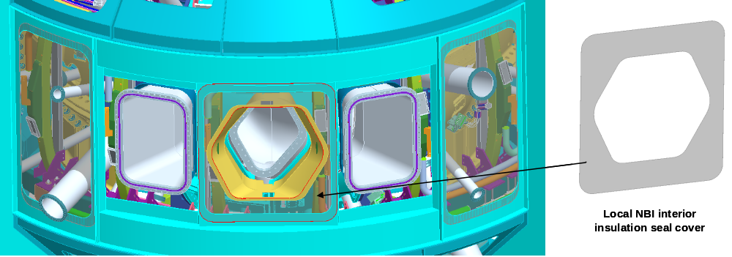

Figure 3-21. Cold surface midplane panel member

Figure 3-23. Cryostat assembly sequence

4.0 Auxiliary Systems and Facility Induced Cryostat Upgrades

To round out this close out report the facility and auxiliary systems are reviewed from the standpoint of identifying required updates brought about by the proposed changes in the cryostat.

  - Vacuum Pumping System

As discussed in Section 3 the neutral beam duct was revised to accommodate the cryostat and to increase the manned access port. In the changes made to the pumping duct the interface point was moved out approximately 6” to accommodate cryostat clearances. Since the transition duct is sandwiched between two neutral beam systems (shown in the isometric view of Figure 4-1) there was a limitation on how far the transition duct could be moved out. To maintain clearance to the cryostat shell outer flange the local transition duct connecting the port at the base of the NB transition duct to the larger diameter vertical pumping duct needed to be reshaped as shown in the side view of Figure 4-1. To improve access to the turbo pumps the connecting ducts were also changed to a 90 degree angled interface from the original 180 degree interface of the baseline design (see Figure 4-1 front view).

Figure 4-1. Pumping System Arrangement

4.2 Neutral Beam System

The neutral beam system was modeled very early in the NCSX project to establish design consistency between the vacuum vessel, the NB transition duct and requirements of near parallel beam injection. The neutral beam models have not been altered, however a misalignment was found at the interface between the NB and the transition duct port. The area of misalignment is shown in Figure 4-2; minimum effort will be needed to rectify the condition.
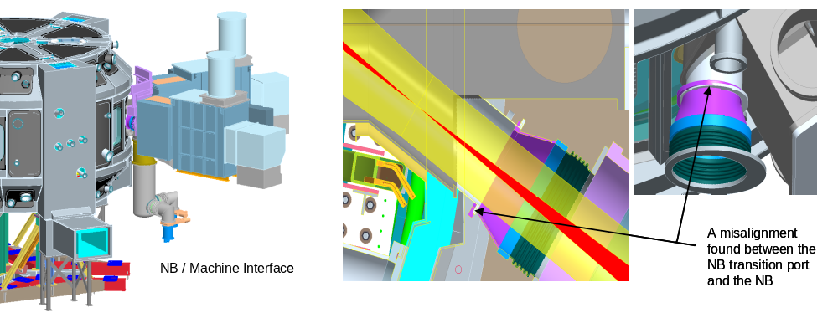
Figure 4-2. Neutral Beam Interface

4.3 Facility Issues

The NCSX facility arrangement was defined in conjunction with the machine core components and has been updated in sink with the design release stages set by the project schedule. At the time of the project shut down order the facility models and subsequent drawings were entering a normal upgrade stage to bring them into compliance with maturing machine core components details; most significant being the cryostat. With the greatest impact on the facility models being the cryostat, models only dealing with this interface are reviewed in this closeout document. Figure 4-3 illustrates an overall view of the test cell floor with the updated cryostat in place. The first floor platforms that surround the device core are completely module in construction and can be easily removed or altered. A similar modular platform construction is currently in place in the PPPL labs NSTX facility. If you remove the test cell walls and the platform surface the general arrangement of the major services near the machine core is shown in Figure 4-4. In light of the device core model changes, updating the close-in facility / machine model arrangement would be needed to reconfigure some local services, auxiliary support equipment and diagnostic services to best meet their operational requirements.

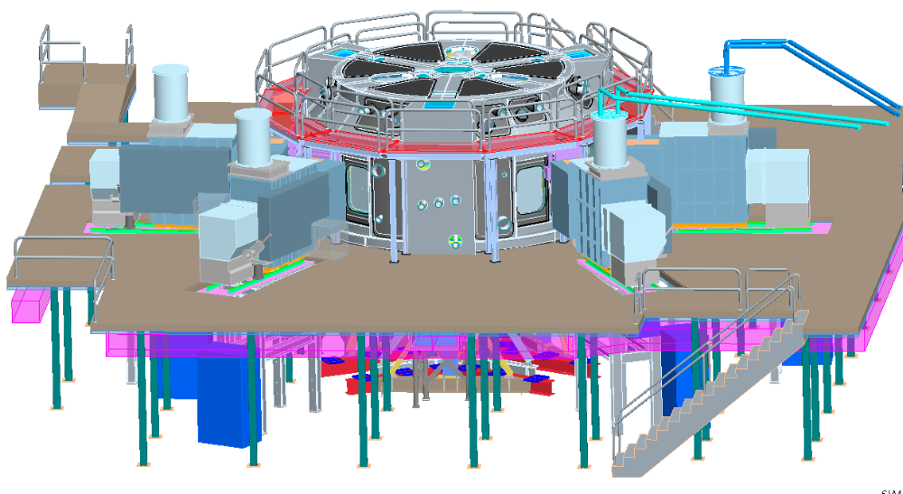
Figure 4-3. NCSX test cell arrangement

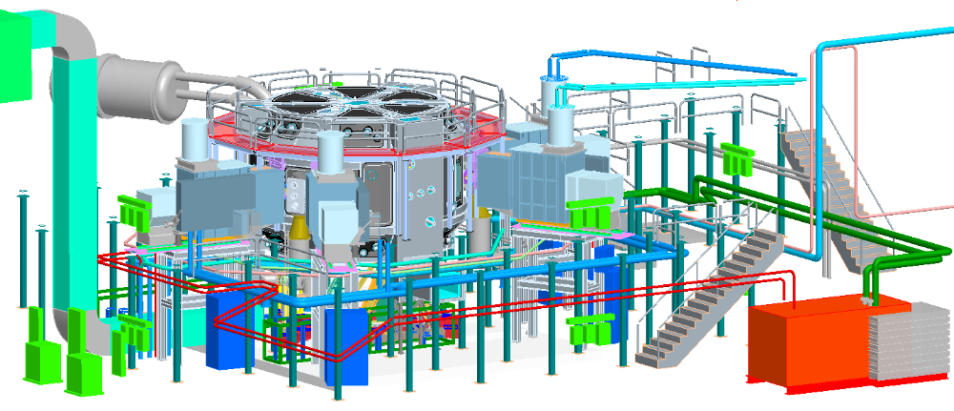

Figure 4-4. Full service arrangement around machine core

The following sequence of figures are presented to highlight the areas of the facility model that would need to be upgraded it the NCSX project was restarted. Figure 4-5 highlights the expected changes that would occur below the test cell first floor; details primary involving modifying services routings and positional adjustment in some of the service components. Figure 4-6 highlights expected updates needed in the catwalk and first floor platform. It was noted that some of the catwalk supports are located inside the neutral beams and they will need to be repositioned. Additional cutouts are needed in the platform to accommodate the pumping duct and the lead chases of the cryostat. Also the height and general arrangement of the platform and catwalk will need to be revisited in order to maximize the utility of servicing the cryostat interfacing machine ports.
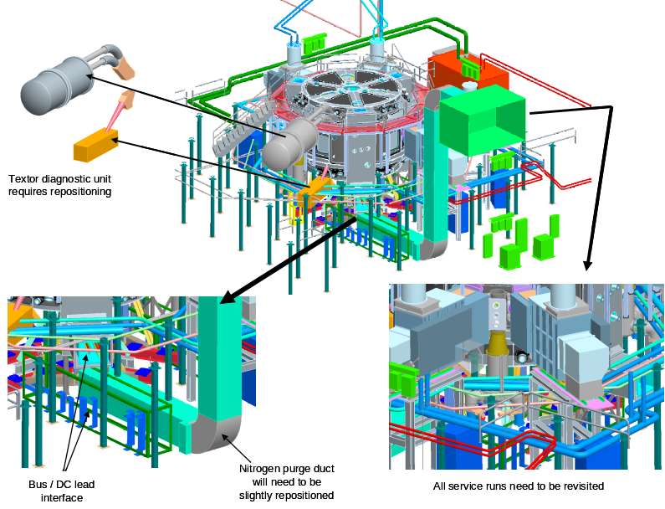

Figure 4-5. Highlighted changes to first floor services

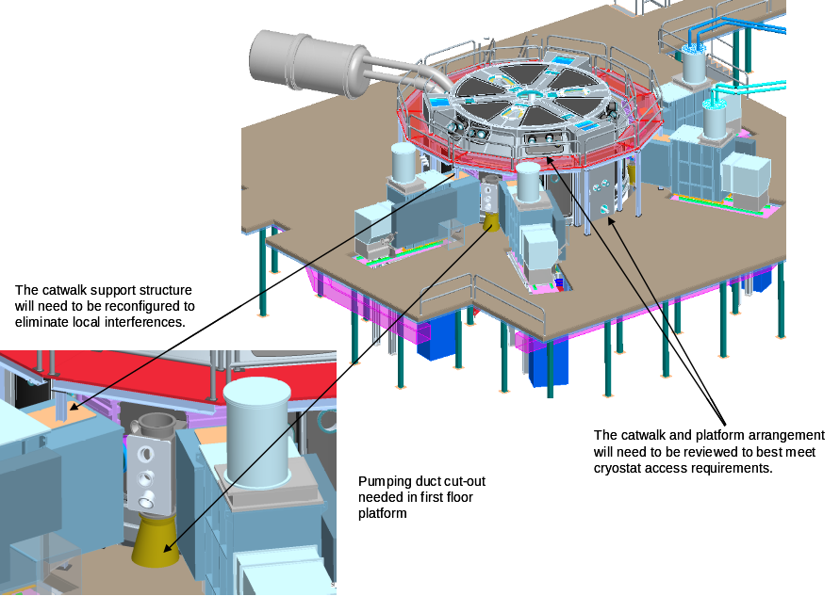

Figure 4-6. Highlighted changes needed to the facility above the platform

