5.01 How many thermocouples and gages?
Am I terminating them or is Erik?
Are they the correct length or am I lengthening them?
For the MC’s there are 40 thermocouples per FP and 30 strain gages on one HP. I spoke with George Labik and he said that there should enough blanks on the horse collar to run all the MC I&C. So this effort will be done on Station 5. I assume that length will be correct.

Per discussion with Paul Goranson, all PF, TF coils and the N2 header will have thermocouples; one at each end of the LN2 header and one at the LN2 inlet and outlet of each coil. Erik will handle this in Station 6.

5.03, 5.04, 5.07, 5.08 … – figure references seem off. Please put arrows to what you are referring to. Will do…….

5.09 What is involved with installing the MC lead stem?
How many bolts – how big – how is it supported – what tests etc.?
The details are not done here but concept envisioned is the magnet structure will placed to pass over the lead stem and provide support for it. If the lead stem is concentric cooper tubes (maybe 3” OD) there should be little net load. I would assume you will need four bolts per lead.

5.11 What’s a TC bracket? How many bolts – how big – how is it supported – what tests etc.?
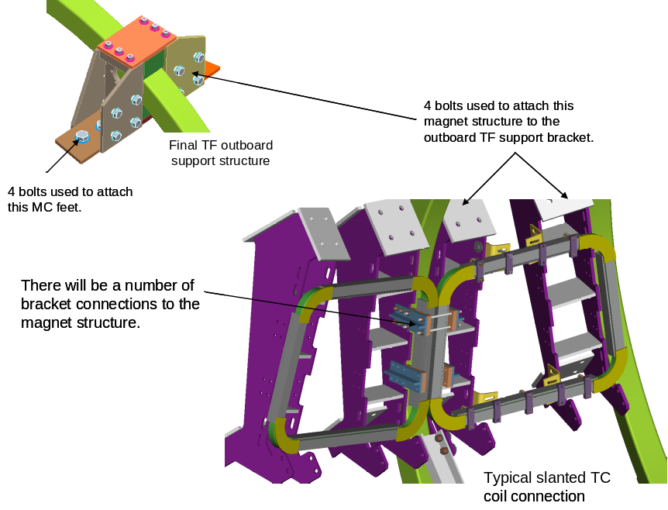

The design is still progressing. There will be a number of brackets used to secure the TC’s to the magnet structure.

5.13 repeat of 5.12?? I’ll fix this. Step 5.12 was used to initially install some small brackes on the “A” TF support brackets before placing the Port 12 TC’s on them. 5.13 involves the actual bolting down the TC.

6.02 How many? You will only be installing four slanted TC’s (2 upper and 2 lower) and one large somewhat horizontal TC around each Port 12.

6.03 How many? broken comment I’ll fix this. It should say that there is no room to install the channel structure at the “A” MC. You will be attaching some kind of strut to the MC.

7.02 How many MC strain gages and thermocouples? Who is terminating them? See first comment.

7.03 How many grounds how many? Who is terminating them? Raki told me that there would be about 50 per period (maybe ½” diameter). I assume that you will install half of them and route them to a area and bundle them. Erik will continue to add grounds and then route them to a single ground point in the the cryostat.

11.01 Don’t see the PF structure covered: “Install the PF coil support structure that surround the TF coils. In doing this the MC leads and coolant lines need to be routed to the outside of the PF structure. PF structure is only partially installed at the Type-C MC's.” I couldn’t find this quote Mike. However, I have changed terminology somewhat. I have started to call TF support brackets; structure that is bolted to the MC feet that centers the TF coil and which the “magnet” structure is bolted to. The magnet structure supports the PF windings, the slanted trim coils and probably all the leads and services.

