NCSX

Station 5 Structural Analysis
Hoist & Base Support

Document #
March 6, 2008

Prepared By: ____Mark Smith______________
Prepared By: ____________________________
Prepared By: ____________________________

Reviewed By: ____________________________

Executive Summary

Table of Contents
List of Figures iv
List of Tables iv
List of Equations iv
Introduction 1
Purpose 1
Scope 1
Methodology 2
Hoist Structural Integrity 2
Hoist Structure & Cabling Pin Connection 2
Hoist-Modular Coil Bolted Connection 6
Station 5 Structural Support Integrity 8
Buckling Analysis 8
Results & Discussion 13
Conclusion 14
References 15
Appendix 16

List of Figures
Figure 1. FEA #1 Results Convergence and Deformation. 2
Figure 2. FEA #1 Results Pin Connection . 3
Figure 3. FEA #2 Results Von Mises Stress. 4
Figure 4. FEA #2 Results Displacements. 5
Figure 5. (a) FEM Loads & Constraints, (b) FEM Mesh. 9
Figure 6. Buckling Analysis (a) Mesh Parameters, (b) Mesh Image. 11
Figure 7. Torque-Preload Curve Typical Nut Factor: K=0.15. 19
Figure 8. Torque-Preload Curve Typical Nut Factor: K =0.20. 19

List of Tables
Table 1. Reactions from FP Model 30608. 10
Table 2. Bolt Specifications and Preload 17
Table 3. Bolt Thread Specifications [4] 18
Table 4. Maximum Torque Specifications for Preload 18

List of Equations
Equation 1. Critical Buckling Load. 10
Equation 2. Critcial Buckling Stress. 10

Introduction

Purpose

The purpose of this study was to investigate the structural integrity of the station 5 field period assembly hoist (FPAH), the hoist to machine bolted connections, and the station 5 support base. The objective was to ensure the devices will operate within allowable limits.

Scope

The analysis of the hoist encompassed the following:

- Validation of the hoist design structural integrity.
- Determination of required bolt preloads and corresponding torque.
- Validation of bolted connection integrity for the hoist-machine interface.

The analysis of the support base consisted of the following:

- Buckling Analysis
- Determination of Bearing Stress.
- Support Base Reactions Under Impact Loading.

Methodology

Hoist Structural Integrity

Hoist Structure & Cabling Pin Connection
Results from FEA
Analytical Results
Lug Calculations

A finite element model (FEM) was created from ProEngineer (ProE) files and used for analysis in the Mechanica platform of the ProE environment.

FEA #1 ms_22708_v1_sta5_hoist_fea2 : Main Structural Beam Initial Design
FEM consisted of channels and webs bonded via contacting surface area.
No Secondary Beam or cross plates included in this model.
Mesh settings all default except detailed fillet modeling enabled.
Analysis settings: Multi-pass Adaptive, polynomial degree 9, convergence 5% on local displacement, strain energy, global stress.

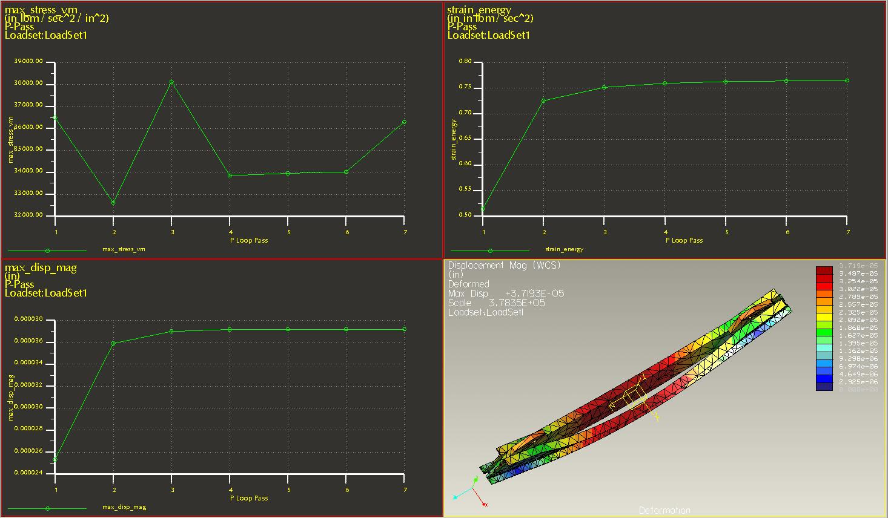

Figure 1. FEA #1 Results Convergence and Deformation.

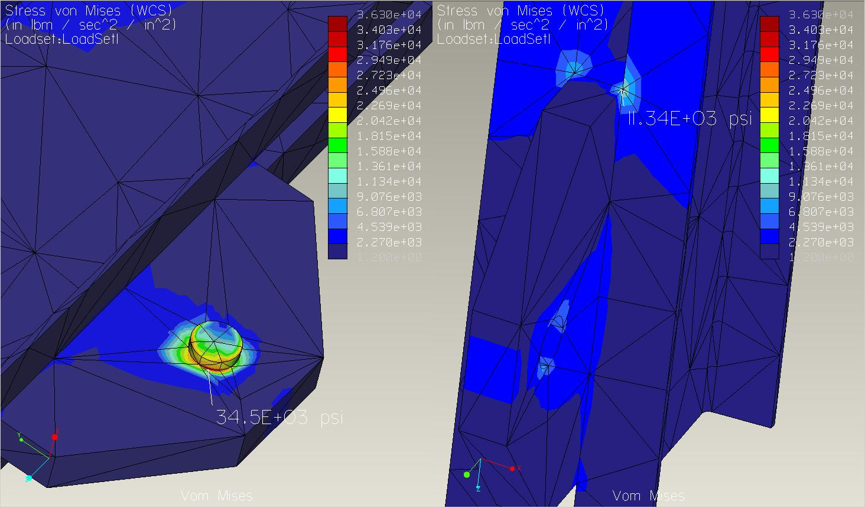
Figure 2. FEA #1 Results Pin Connection .

FEA #2 ms_22708_v1_sta5_hoist_fea1 : Entire Hoist.
CAD model: ms-22708_v1_sta5_hoist_fea.asm
FEA: ms_fea2_3708_entire_hoist.rwd
FEM consisted of channels and webs bonded via contacting surface area.
Attempted to simulate welds on secondary Beam using a Mate offset of 0.0050 inch.
But, the offset did not stop the surface bonding. Thus, the bond was achieved through both the fillets and surface contact area.
Cross plates offset 0.020 inch, bond achieved through fillet to simulate welds.
Mesh settings all default except detailed fillet modeling enabled.
Analysis settings: Multi-pass Adaptive, polynomial degree 6, convergence 10% on local displacement, strain energy, global stress.

Refer to figures 3 & 4 for the analysis results.
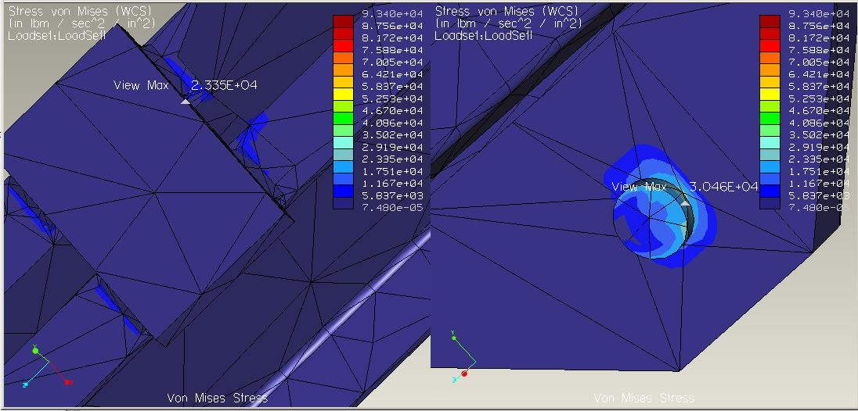
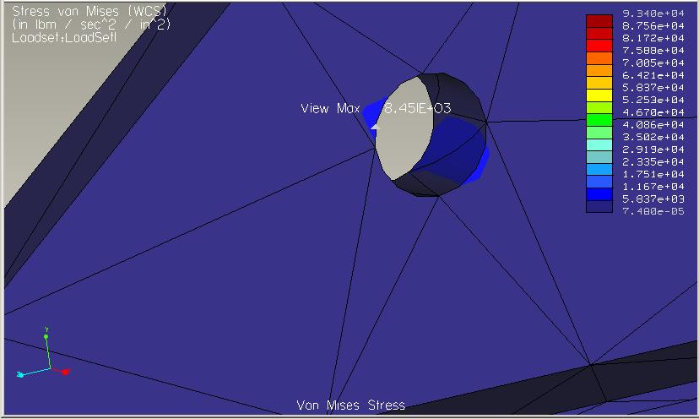

Figure 3. FEA #2 Results Von Mises Stress.

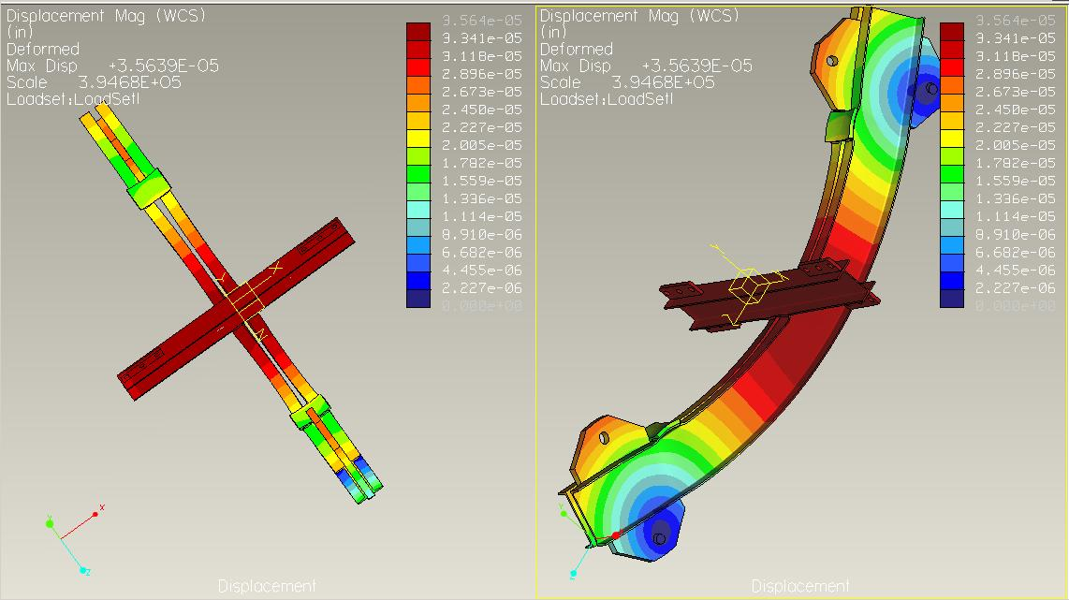

Figure 4. FEA #2 Results Displacements.

Analytical Calculation for Lug Loading

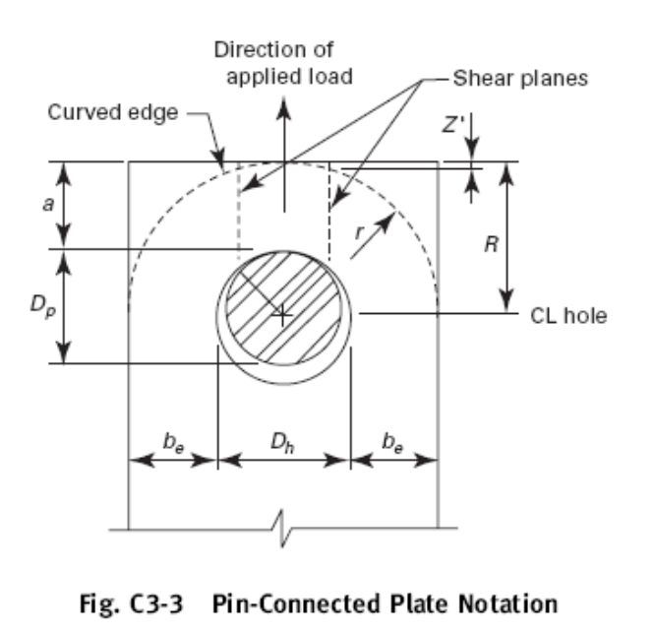
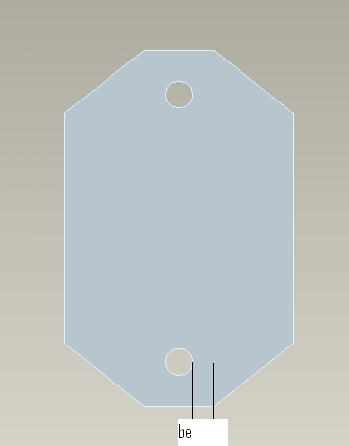

Figure 5. Hoist Lug Analytical Model.

Table 1. Hoist Luh Analytical Results.
CAD Model Parameters
a | 2.4375
Dp
be | 1.6875
Dh | 2.125
R | 3.5
r
t | 2
Material Properties
Fy | 3.60E+04 | psi | ref [3]
Fu | 5.80E+04 | psi | ref [3]
Design Factors
Nd | 2.4 |  | ref [3], [8]
Computations |  |  | Check Value < be |  | Reference [8]
beff | eq1 | eq2 | eq1 | eq2 | min
 | 8 | 1.8305 | 1.6875 | 1.6875 | 1.6875
Pt | 135937.5 | lbf | Allowable Tensile Strength of Pin
Pb | 145793.6 | lbf | Allowable Single Plane Fracture Strength of Pin
Av | 10.9948 | in^2 | Total Area of Shear Planes beyond Hole
Pv | 154996.1 | lbf | Allowable Double Plane Shear Strength beyond Pin Hole.

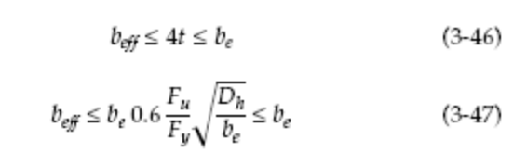
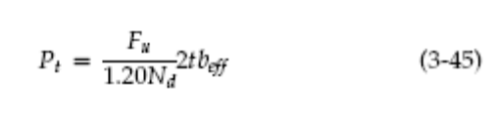
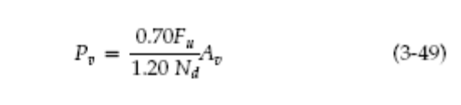
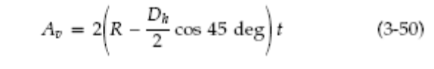

Hoist-Modular Coil Bolted Connection

Bolt Preload: Refer to the Appendix tables 3,4, 5 and figure 7 & 8.

Joint Separation Analysis

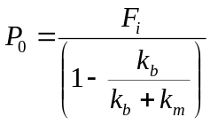

Equation 1. Load to Separate Joint.

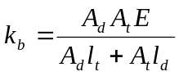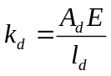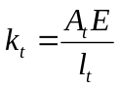
Equation 2. (a-c) Bolt stiffness.

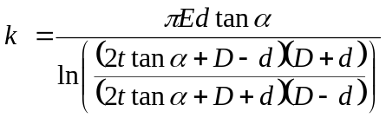
Equation 3. Joint Member Stiffness.

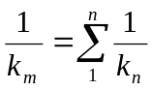
Equation 4. Joint Total Stiffness.

D1
t1
ά
d
D2
D3
t2

Figure 6. Member Stiffness Frustum Cone Model [1].

Table 2. Joint Separation Analysis.

Joint Member Parameters |  |  |  |  |  | degree | radian
 |  |  |  |  | alpha: ά | 30 | 0.523599
Bolt Shaft Nominal Diameter |  |  | 1.00 | in | Member | Stiffness | Units
Bolt (B1) Head Diameter |  |  | 1.69 | in | B1: kb | 4.82E+06 | psi
Elastic Modulus: B1 |  |  | 3.00E+07 | psi | FW1: k1 | 3.20E+08 | psi
B1 | At |  | 0.606 | in^2 | HMB: k2 | 7.58E+07 | psi
B1 | Ad |  | 0.770546 | in^2 | LW: k3 | 2.31E+08 | psi
Length of Bolt |  |  | 4.5 |  | FW2: k4 | 6.18E+08 | psi
Length of Threads |  |  | 2.25 | in | MCS: k5 | 9.51E+07 | psi
Grip Length |  |  | 4.25
Threads not in Grip |  |  | 0.25 |  | D1 | 1.69 | inch
 | lt |  | 2.00 |  | D2 | 1.877252086 | inch
 | ld |  | 2.25 |  | D3 | 1.84 | inch
Flat Washer #1 (FW1) Thickness |  |  | 0.16 | in | D4 | 2.189338365 | inch
Elastic Modulus: FW1 |  |  | 3.00E+07 | psi | D5 | 2.374090451 | inch
Hoist Mount Block (HMB) Thickness |  |  | 2.13 | in
Elastic Modulus: HMB |  |  | 3.00E+07 | psi | Joint Stiffness per Bolt
Nut Height |  |  | 0.984375 | in | km | 3.05E+07 | psi
Nut Head Diameter |  |  | 1.84 | in
Lock Washer (LW) Thickness |  |  | 0.31 | in
Elastic Modulus: LW |  |  | 3.00E+07 | psi | Load per Bolt to Separate Joint with
Flat Washer #2 (FW2) Thickness |  |  | 0.16 | in | PreLoad = | 47691 | lbf
Modular Coil Section (MCS) Thickness |  |  | 1.50 | in
Elastic Modulus: MCS |  |  | 2.10E+07 | psi | P0 | 55226.87 | lbf

FEA of Hoist Modular Coil Connection

FEA figures have STRESS in ProE Mechanica default units unless otherwise specifically stated.

CAD model filename: sta5-HOIST-MT-Blk-22008-FEA1.asm.1
Mechanica Results filename: ms_fea1_30708-hoist_modcoil.stt

NOTE: FEA may be compromised. Displacement model had merged parts, need to investigate or call for support to resolve concern.

Modular coil mounting section re-modeled for FEA, refer to figure XX for the FEM.

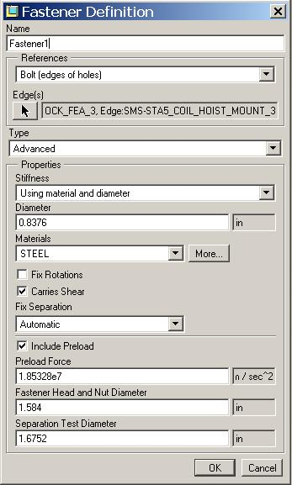
Connection modeled with ProE “built in” bolted connection, refer to figure XX, for the bolt model parameters.
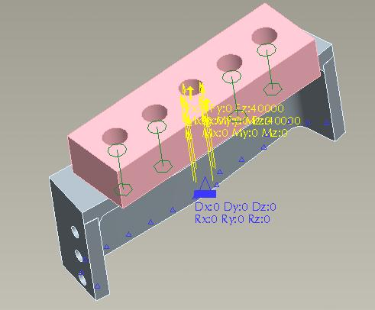
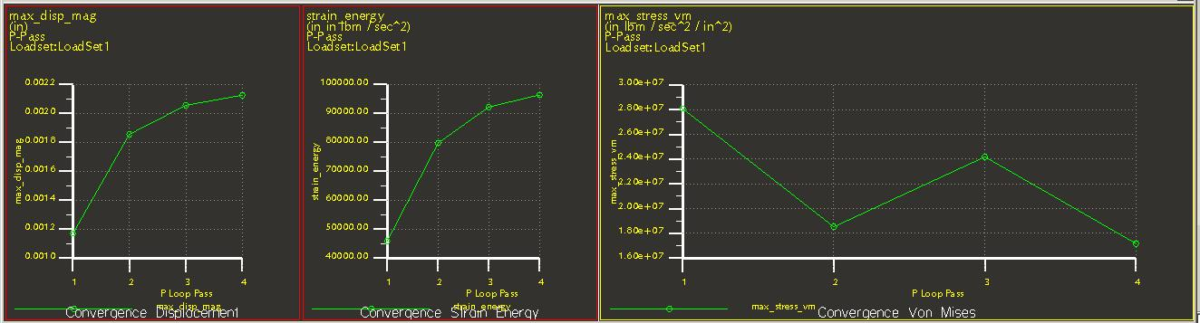
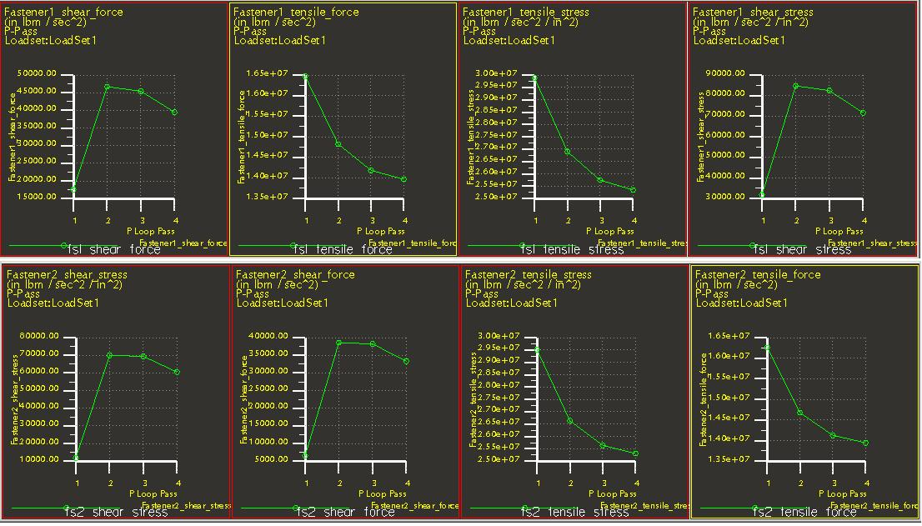
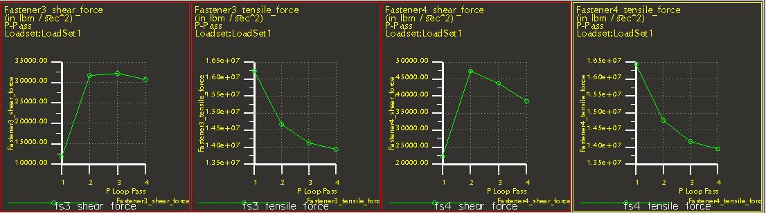

NOTE: FEA may be compromised. Displacement model had merged parts, need to investigate or call for support to resolve concern.

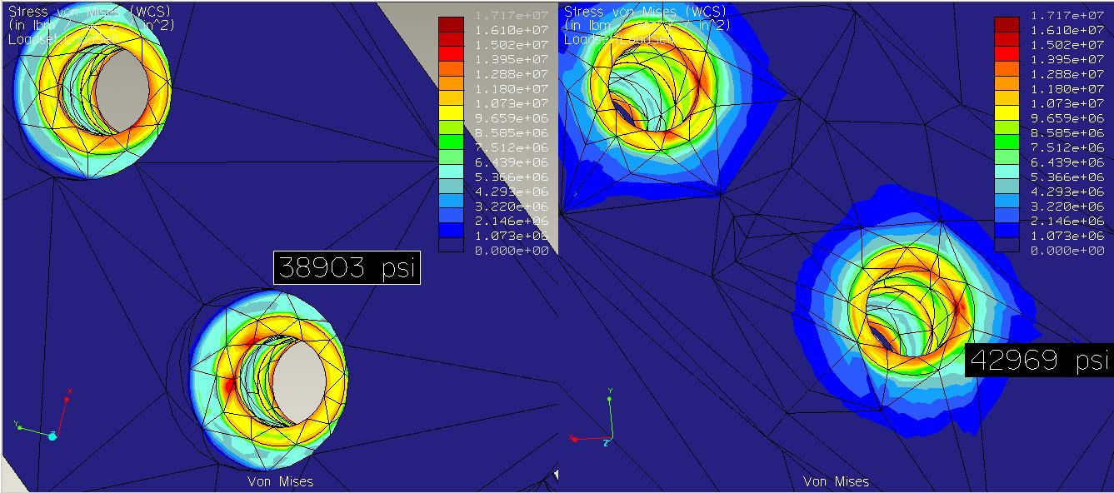

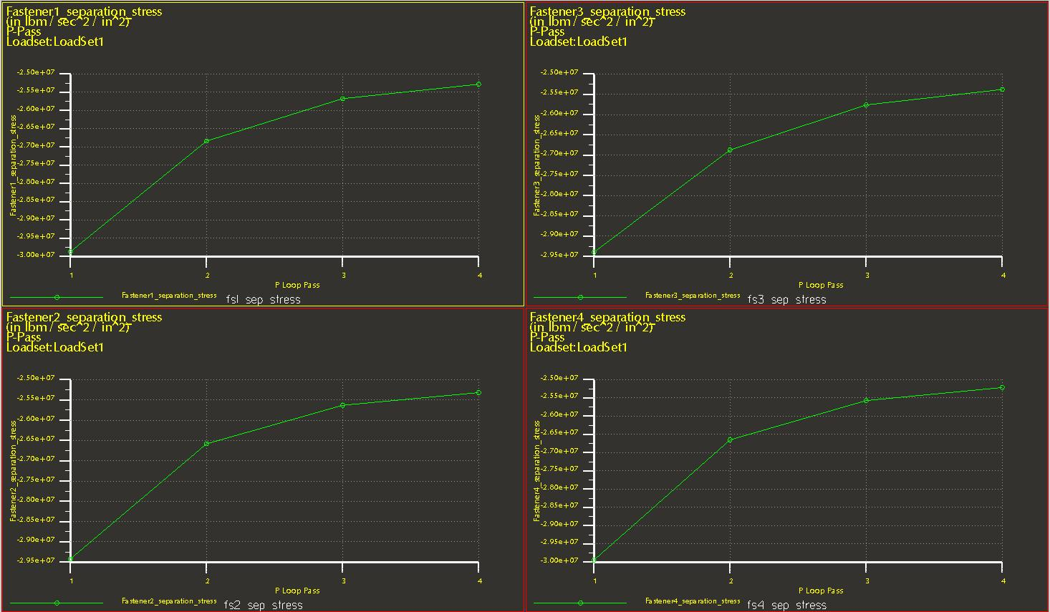

Bearing Stress

Table 3. Bearing Stress Hoist Modular Coil connection.

Bolt | Bolt
PreLoad (lbf) | FEA Loading (lbf)
51791 |  | Bearing Stress (lbf/in^2)
 | Area (in^2) | PreLoad | Total Load
Bolt Head | 1.119039185
Flat Washer Series R | 3.944729035 | 46281.668 | 0
Under Flat Washer |  | 13129.1654
Nut | 1.416451837
Lock Washer | 1.446251028 | 36563.8977
Under Lock Washer

Balance Cabling Connections

1. TF Coil Holes

2. Mounting Bracket

Station 5 Structural Support Integrity

Buckling Analysis

Part 1: Static analysis used to obtain reactions loads, refer to table 1.
ProE Mechanica results filename: ms_4jacks_fea_a1_30608.stt
See figure 2(a-b) for mesh parameters.

7.77 & 7.78 distances to center.

Analysis performed 3/8/06. The associated files are as follows:
PRoE Standard Application filename: SMS-STATION5-MODEL-FEA.ASM.1
ProE Mechanica Application results filename: ms_FP_model_fea_3608_v2

Datum points were inserted at approximately the center of the contacting surface of the jack stand at the FP/jack stand interface. These points were constrained in all 6 degree of freedom (DOF). The field period weight was positioned at the estimated center of gravity and used for the analysis loading conditions The finite element mesh was created from nodes manually and automatically generated. Refer to figure 1(a & b) for the model set up.

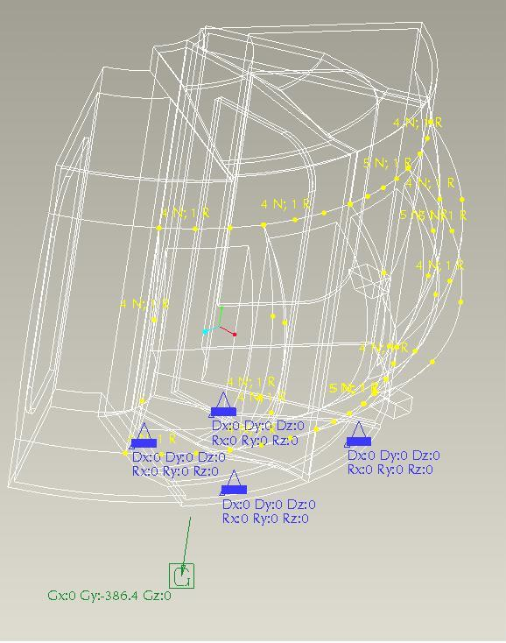
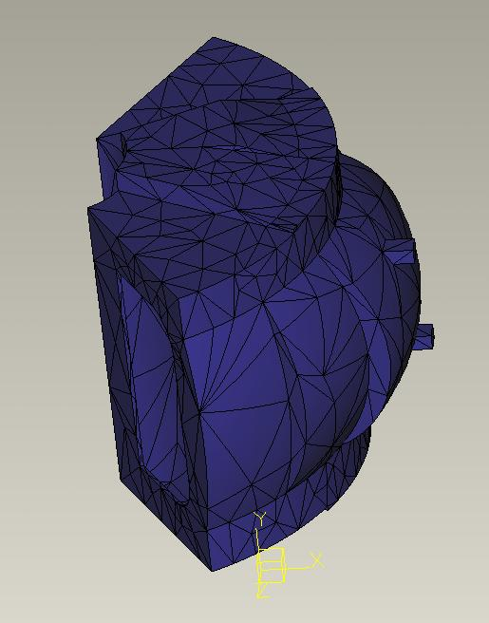
Figure 7. (a) FEM Loads & Constraints, (b) FEM Mesh.
Table 4. Reactions from FP Model 30608.

Location | Reaction Fx | Reaction Fy | Reaction Fz | Moment  x-axis | Moment  y-axis | Moment  z-axis
Jack 1  (28.21, 43.62, 24.49) | 4.060E3  lbf | 20.40E3  lbf | 3.789E3  lbf | 0 | 0 | 0
Jack 2  (28.21, 43.41, -24.49) | 3.121E3  lbf | 20.155E3  lbf | -4.049E3  lbf | 0 | 0 | 0
Jack 3  (-10.28, 37.87, -15.6) | -2.532E3  lbf | 19.987E3  lbf | -1.453E3  lbf | 0 | 0 | 0
Jack 4  (-10.28, 37.87, 15.6) | -4.649E3  lbf | 19.570E3  lbf | 1.713E3  lbf | 0 | 0 | 0

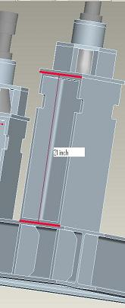
Buckling Analytical Analysis

Analysis using Euler Equation for Elastic Buckling [7].

Assumptions:
1. Load acts through centroid of the cross section area of the beam.
2. Beam is perfectly straight when initially loaded.
3. Beam composition is homogenous.
4. Deflections are small and within the elastic limit.
5. Beam is supported free at the applied load end and fixed at the other end.
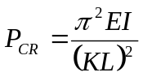
Equation 5. Critical Buckling Load.

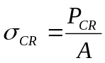Equation 6. Critcial Buckling Stress.

Figure 8. Jack Stand Support Beam.

where E is The elastic modulus of the material, I is the area moment of inertia, K is the effective-length factor, L is the length of the beam, and A is the area of the cross section. Refer to figure for an image of the beam section. Refer tp table XX for the beam parameters and the calculation results.

Table 5. Buckling Analysis.

Parameters
Beam W8x31
Cross Sectional Area | A | 9.13 | in^2
Area Inertial Moment | Ix | 110 | in^4
Radius of Gryration | rx | 3.47 | in
Area Inertial Moment | Iy | 37.1 | in^4
Radius of Gryration | ry | 2.02 | in
Effective-Length Factor | K | 0.5
Elastic Modulus | E | 3.00E+07 | psi
Length of Beam | L | 21 | in
 |  | Axis 1 (x) | units | Axis 2 (y) | units
Critical Load | P | 2.95E+08 | lbf | 9.96E+07 | lbf
Critical Stress | σ | 3.24E+07 | psi | 1.09E+07 | psi

CAD model filename:sms-station-model-fea.asm
Mechanica FEA filename: ms_4jacks_fea_a1-30608.rwd
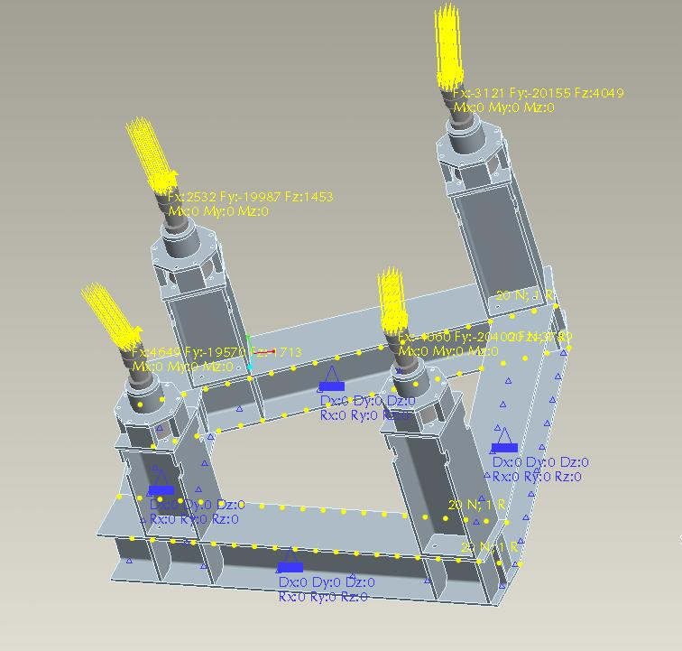

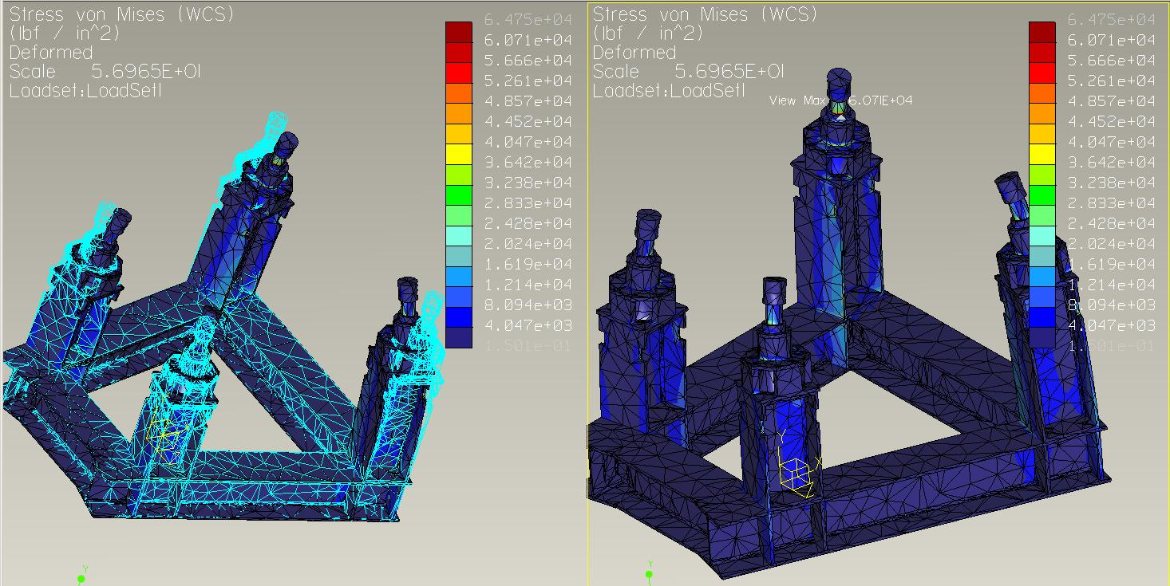
Units are in psi.

Impact Analysis

Results & Discussion

Conclusion

References

1. Machine Design 7th ed. Shigley 2004.

2. Multiple Coil Lift Calculation. PPT file. HM Fan.

3. Analysis performed on the FPA station 3 lift fixture for its FDR. NCSX-CALC-18-002-00.
Brown. 10 Dec. 2007.

4. Machinery's Handbook. 26th ed. Threads and Threading

5. Handbook for Bolted Joint Design. NCSX-CRIT-BOLT-00. HM Fan. 2007.

6. NASA Reference Publication 1228. Fastener Design Manual. 1990

Appendix

Table 6. Bolt Specifications and Preload
SAE J429 1-8 UNC Bolt
 | Value | Units | Notes
Proof Strength | 1.2000E+05 | psi
Yield Strength | 1.3000E+05 | psi
Tensile Strength | 1.5000E+05 | psi
Tensile Strength of Nut | 1.5000E+05 | psi
Number of Threads per Inch: n | 8 | quantity | reference [1]
Pitch: P | 0.125 | in | derived
Minor Diameter Area: A1 | 0.551 | in^2 | reference [1,4]
Maximum Minor Diameter: d1[4] | 0.849 | in | reference [4]
Minimum Diameter: d1 | 0.838 | in | derived
Basic Major Diameter: d | 1.000 | in | reference [1]
Mean Diameter: Davg | 0.919 | in | derived
Height of Threads: H | 0.108 | in | derived, equation [1]
Minimum Pitch Diameter: d2[2] | 0.910 | inch | reference [2,4]
Minimum Pitch Diameter Computed: d2 | 0.919 | in | derived, equation [1]
Basic Pitch Diameter: Pb | 0.919 | in | reference [4]
Tensile Stress Area Computed: At | 0.606 | in^2 | derived
Tensile Stress Area: At | 0.606 | in^2 | reference [1,4]
Tensile Stress Area: At[2] | 0.594 | in^2 | reference [2]
Shear Area of Bolt: As[2] | 1.187 | in^2 | reference [2]
Shear Area of Internal Thread (nut): An[2] | 1.673 | in^2 | reference [2]
Minimum Engagement Length: Le[2] | 0.717 | in | reference [2]
Maximum Minor Diameter Internal Thread: Kn | 0.890 | in | reference [4]
Maximum Pitch Diameter Internal Thread: En | 0.928 | in | reference [4]
Minimum Engagement Length: Le | 0.684 |  | derived
Engagement Length per Nut Thickness: Ln | 0.956 | in | reference [4]
Shear Area of Bolt: As | 1.211 |  | derived
Shear Area of Internal Thread (nut): An | 1.598 |  | derived
Force to Break Bolt: Fbb | 90862.141 | lbs | derived
Force to Shear Bolt Threads: Fsb | 90862.141 | lbs | derived
Force to Shear Nut Threads: Fsn | 119825.625 | lbs | derived
Preload: P0[2] | 49200.000 | lbs | reference [2]
Relaxation 5%---Effective Preload: Pe[2] | 46740.000 | lbs | reference [2]
Preload per Ref [2] equation: P0 | 50201.333 | lbs | derived, equation [2]
Relaxation 5%---Effective Preload: Pe | 47691.266 | lbs | derived
Preload per Ref [5] equation: P0' | 54517.285 | lbs | derived, equation [5]
Relaxation 5%---Effective Preload: Pe' | 51791.420 | lbs | derived

Table 7. Bolt Thread Specifications [4]
External Threads
 | Major Diameter |  | Pitch Diameter
Class | max | min | max | min
2A | 0.9980 | 0.983 | 0.9168 | 0.91
Internal Threads
 | Minor Diameter |  | Pitch diameter |  | Major Diameter
Class | min | max | min | max
2B | 0.865 | 0.89 | 0.9188 | 0.9276 | 1

Table 8. Maximum Torque Specifications for Preload
 | Torque Required to Achieve Preload at | P0= |  | 50201.33 | lbs.
 | with Relxation of 5%  Effective Preload: | Pe= |  | 47691.27 | lbs.
 |  | Torque: inch-lbs. |  | Torque: ft-lbs.
Torque Wrench Method |  | K=.2 | K=.15 | K=.2 | K=.15
 | Un-Lubricated Bolts:  Torque Error ± 35% | 7437.23 | 5577.93 | 619.77 | 464.83
 | Lubricated Bolts:  Torque Error ± 25% | 8032.21 | 6024.16 | 669.35 | 502.01
Hydraulic Tensioner:
 | Torque Error ± 15% | 8730.67 | 6548.00 | 727.56 | 545.67
 | Torque Required to Achieve Preload at | P0= |  | 54517.28 | lbs.
 | with Relxation of 5%  Effective Preload: | Pe= |  | 51791.42 | lbs.
 |  | Torque: inch-lbs. |  | Torque: ft-lbs.
Torque Wrench Method |  | K=.2 | K=.15 | K=.2 | K=.15
 | Un-Lubricated Bolts:  Torque Error ± 35% | 8076.63 | 6057.48 | 673.05 | 504.79
 | Lubricated Bolts:  Torque Error ± 25% | 8722.77 | 6542.07 | 726.90 | 545.17
Hydraulic Tensioner:
 | Torque Error ± 15% | 9481.27 | 7110.95 | 790.11 | 592.58
NOTE: K is typical nut factor:
Recommended K = 0.2 for un-lubricated and K = 0.11 to 0.15 lubricated: reference [5]
Recommended K = 0.15 for steel on steel: reference [6]

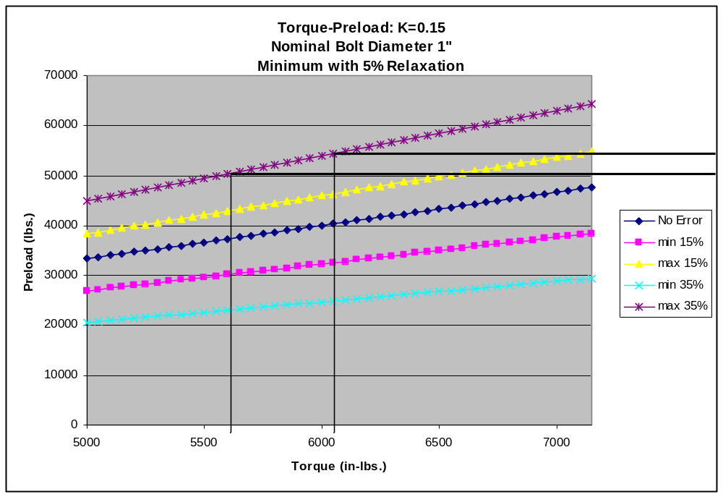
Figure 9. Torque-Preload Curve Typical Nut Factor: K=0.15.

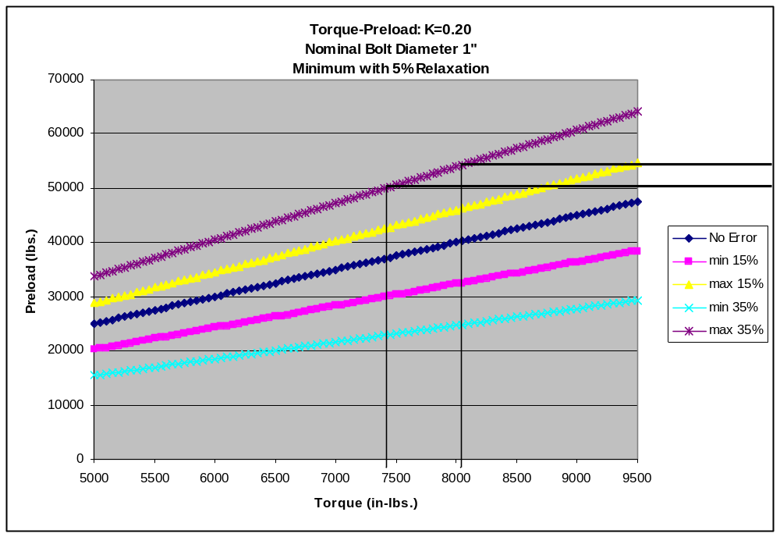
Figure 10. Torque-Preload Curve Typical Nut Factor: K =0.20.

