Attendees: Jim Chrzanowski, Buddy Kearns, Steve Raftopoulos, John Semler and Bill Slavin.

Minutes:
- Bakeout oven status
The electrical upgrade of the vacuum oven has been completed and the unit has been relocated to the basement area (photo no. 1). The first set of heat runs have been completed and the vacuum oven is now considered fully functional and ready for VPI trials. Some additional heat runs will be performed prior to the first VPI.

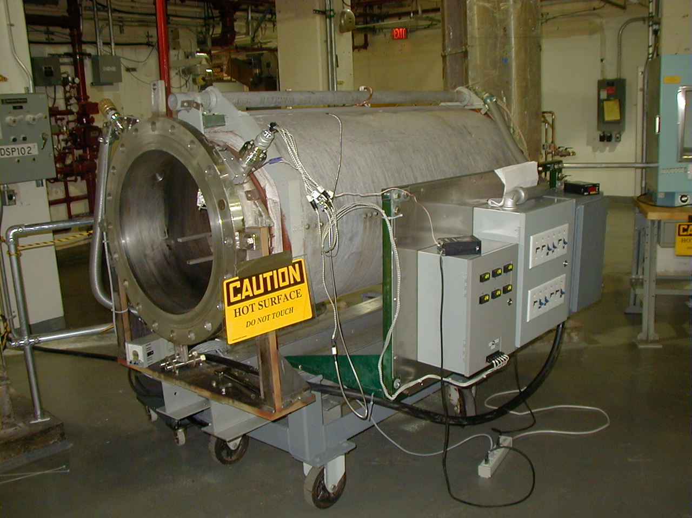
Photo No. 1 VPI Bakeout Oven

- Univ. of Tenn. Coil
Work will begin this week in preparing the UT coil for impregnation. These activities should be completed this week. The date for impregnation will be the first week of December. (Action: Jim Chrzanowski / Buddy Kearns)

- Characterization tests
The recalibration of the viscometers was not completed last week. This work has been rescheduled for this week. (Action: Tom Meighan)

- Area setup
The preparation of the R&D work area has been completed. Installation of a speed-rail fence around the work area was completed this past weekend. No additional preparation work is planned at this time.

- Tensile test mold
Work on the tensile specimen mold continues. Hopefully the mold will be completed by the end of this week. (Action: Steve Raftopoulos)

- Mold development
The drawings for the straight tee section were delivered to the shops for fabrication. The designs for the 2nd and 3rd. tees were completed and signed off last week. These stainless steel forms will be sent out for quotation this week. (Action: Jim Chrzanowski)

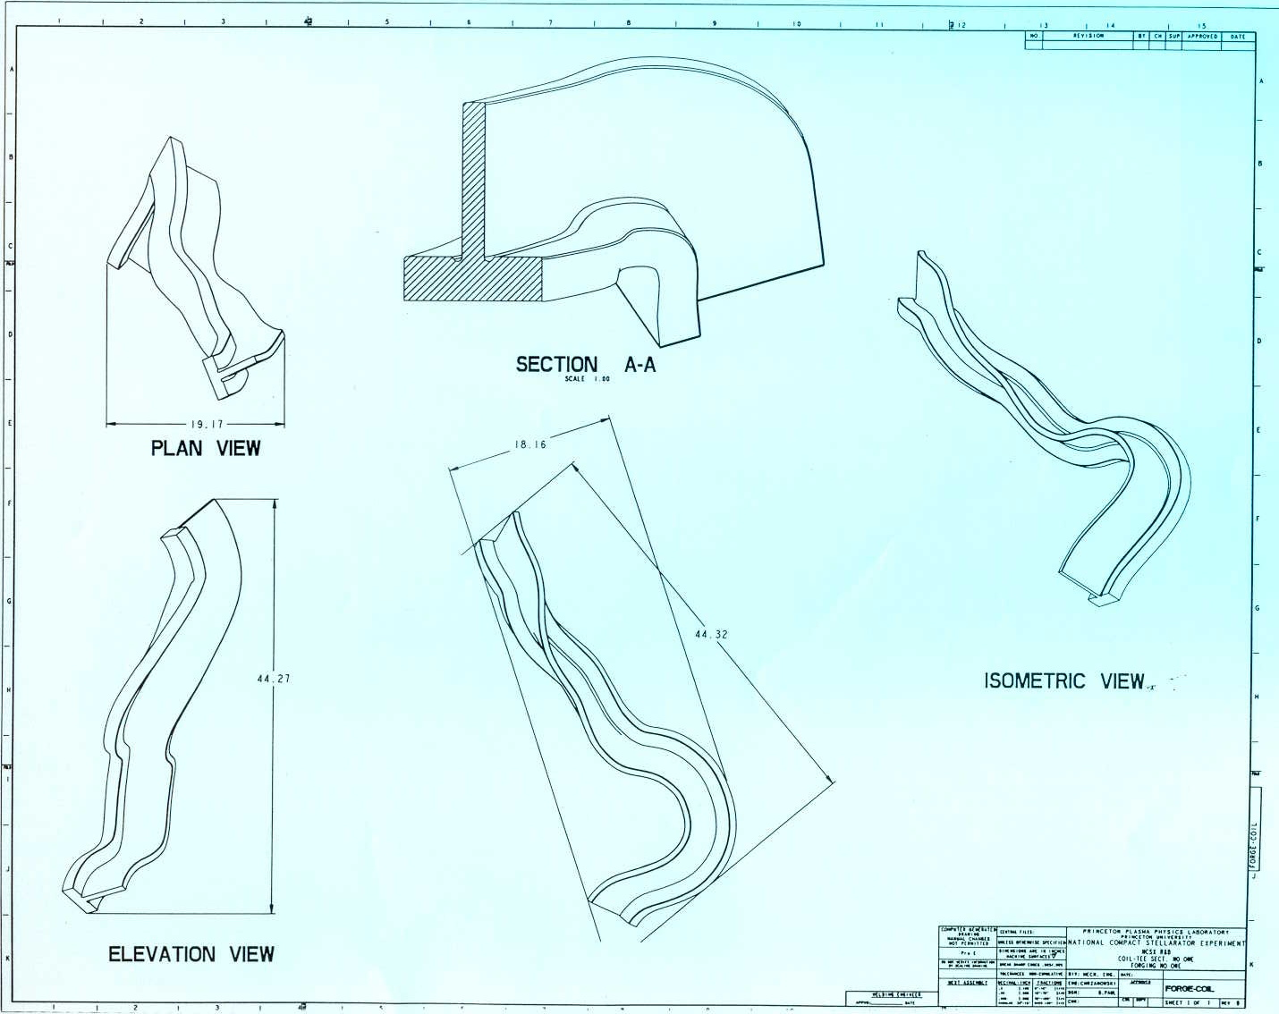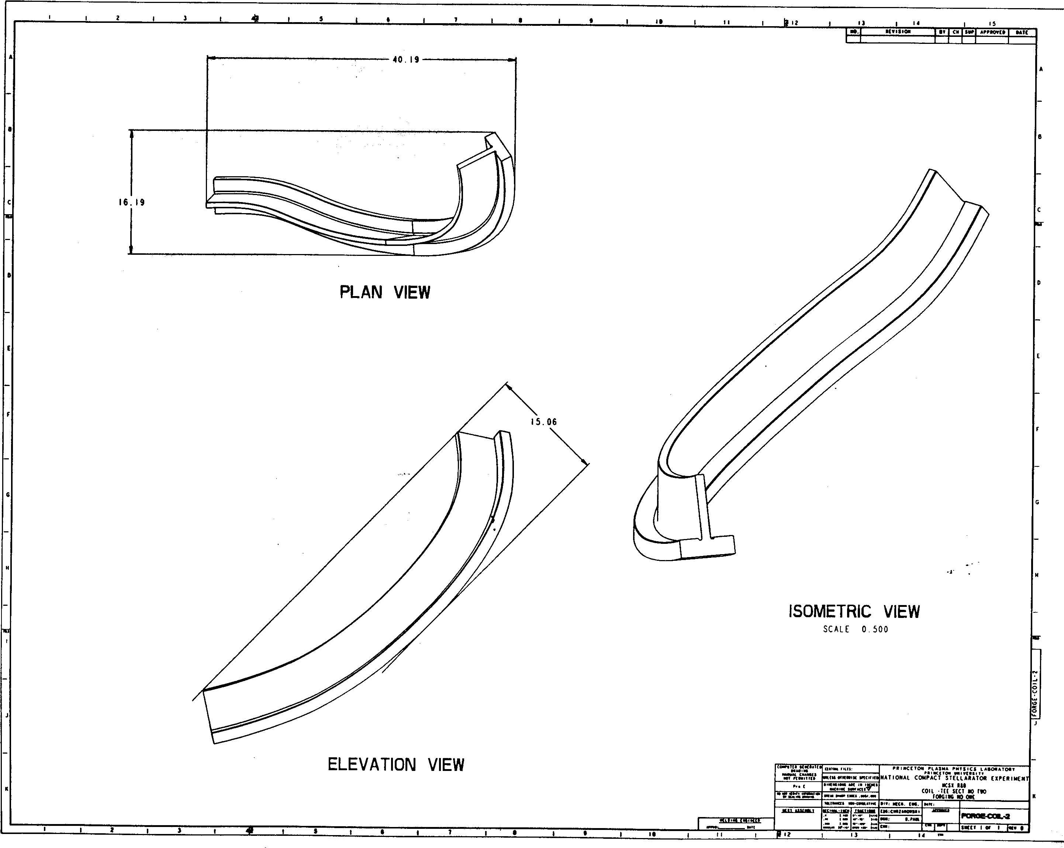

- Keystone Tests
The design of a winding form for the keystone winding tests is proceeding.
(Action: Bruce Paul & Jim Chrzanowski)

- Fiberglass applicator
A meeting was held last week to review the safety issues associated with using the fiberglass spray method for the molds. Representatives from a number of safety groups were in attendance including Bill Slavin (IH), Jerry Levine (ES&H), Virginia Finley (Environmental), Ray Jeanes (Fire Safety), Rich Borusovic (Electrical Safety), Henry Carnevale (HVAC), Maria Pueyo (ERWM), Jim Chrzanowski, Steve Raftopoulos and Tom Meighan. There were a significant number of issues both safety and cost related. The largest issue was that the styrene and acetone chemicals used are highly flammable and introduce numerous issues. Bill stated that appropriate personnel protective equipment and ventilation would provide the necessary protection. A new ventilation would be required to use the proposed system in the Test Cell plus the structure required for applying the material would be extremely expensive. Further investigation will be needed. (Action: Jim Chrzanowski)

- Taping Machine
The PPPL coil shop’s automatic taping machine has been located. (See photo) It will require some refurbishing, but once completed has the capability of applying up to 5 layers of insulation simultaneously. Some rewiring and controls are necessary. (Action: Jim Chrzanowski & Harry Bush)

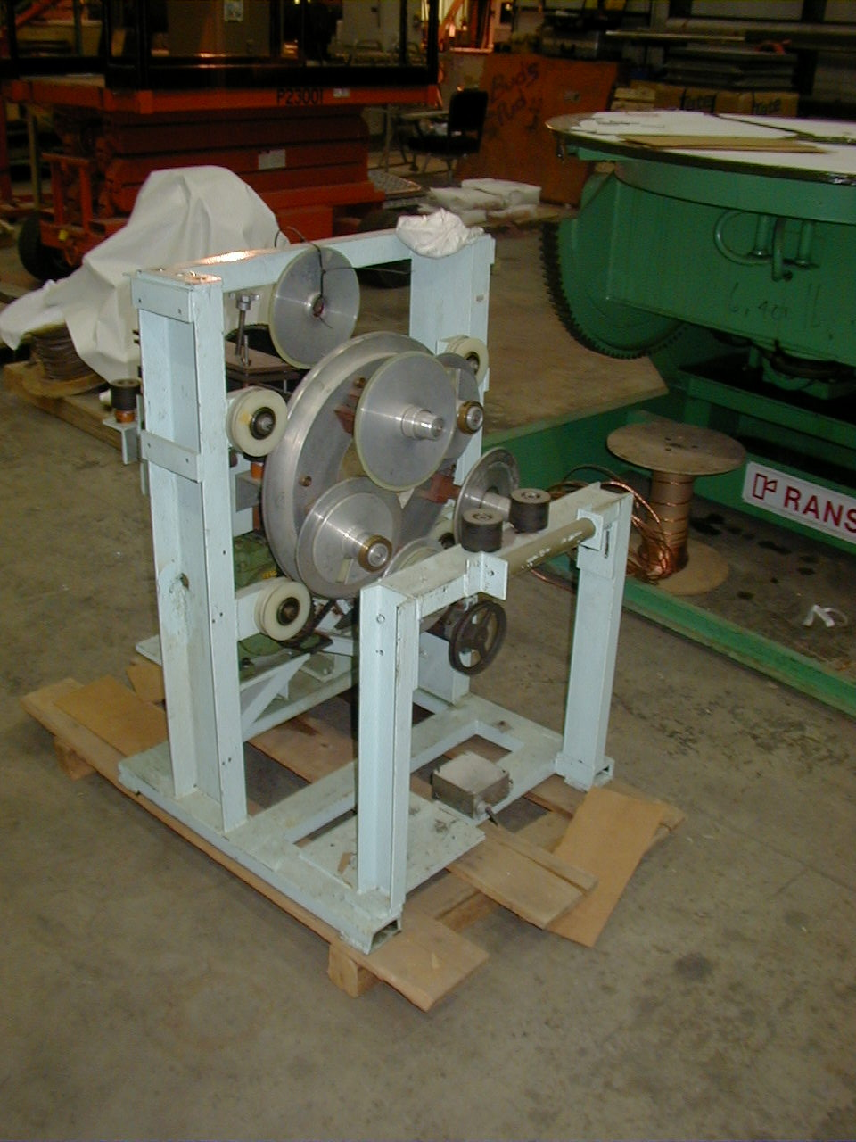

- SOW
The SOW has been redistributed for additional comments.

