- Keystone tests- (John Desandro).. Begin week of January 26, 2004

- Conductor Property Tests-
  - Generate test specification (ORNL)

  - Fabricate Molds (Steve Raftopoulos)
    - First tensile specimen mold by January 23, 2004
    - Second bundle specimen mold by January 30, 2004

  - Fabricate specimens (Tom Meighan, Buddy Kearns & Mike Hause)
    - Straight tee section…. Prepare and VPI specimen
    - Tensile specimens…. Begin preparation and VPI of samples by January 26, 2004
    - Bundle specimens

  - Test in-house (Tom Kozub, Steve Jurczynski)
    - Write test plan (how to)
    - Begin testing – Be prepared for tensile specimens by February 2, 2004

- Winding of Inch worm (Mike Anderson & Frank Terlitz)
  - Winding form……… Complete except for mounting brackets
  - Winding clamps… In fabrication needed by January 23, 2004
  - Winding station… Mount casting to turntable January 19, 2004
Conductor payout spools
Begin winding trials week of January 26, 2004

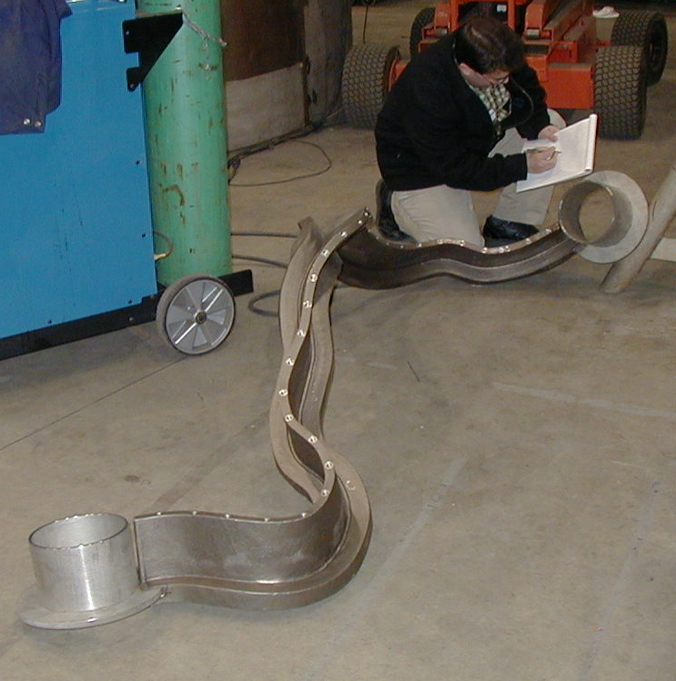

- Twisted Racetrack Coil
Coil will be wound in the D-site Test Cell using a Turning fixture in a clean room atmosphere.
Coil will be VPI’d in Autoclave
  - Casting- delivery by April 1st. 2004
  - Winding clamps- supplement the clamps used in Inch worm trials
  - Chill plates & coil clamps- designs to be provided by ORNL
  - Begin winding by April 19, 2004
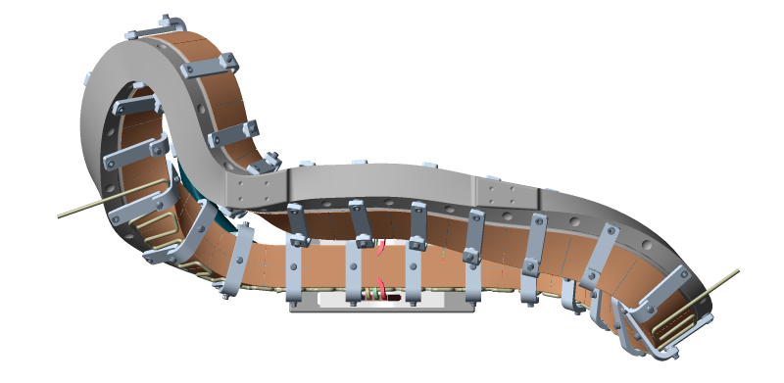

35-in

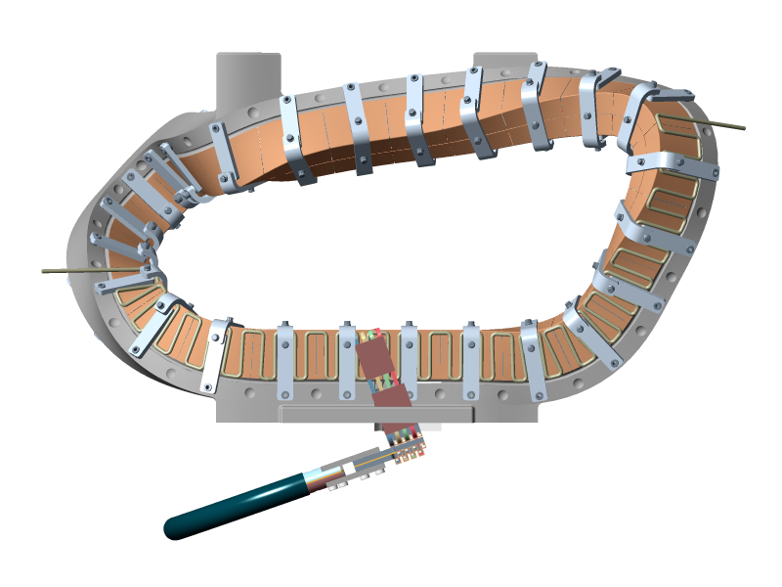
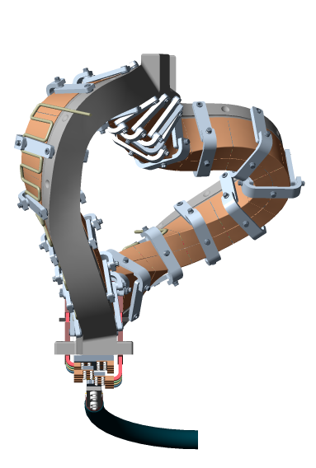

32-in

61-in

- Winding Facility-
  - Autoclave (Steve Raftopoulos, Frank Jones)
    - Work well underway
    - Upper dome on Sellers for machining
    - Lower dome- ports being added
    - Main chamber- upper flange being welded
    - Electrical controls under construction
    - Vacuum pumps- retrieved from PBX basement, some rework required
    - Gate valves for heating ductwork has been found
    - Catwalk components fabricated
    - Ports, conflats and man door in-house
    - Electrical components in house?????

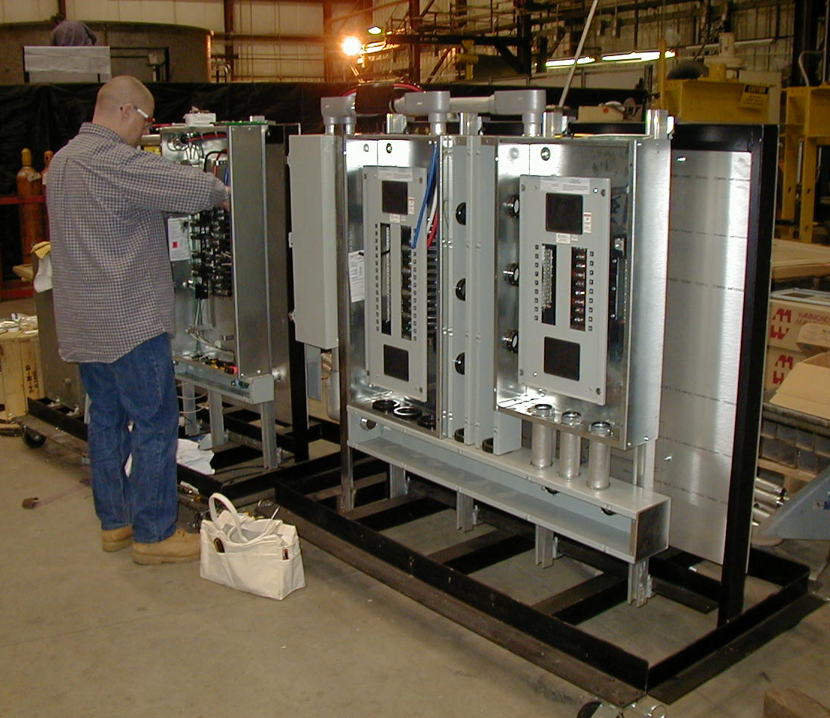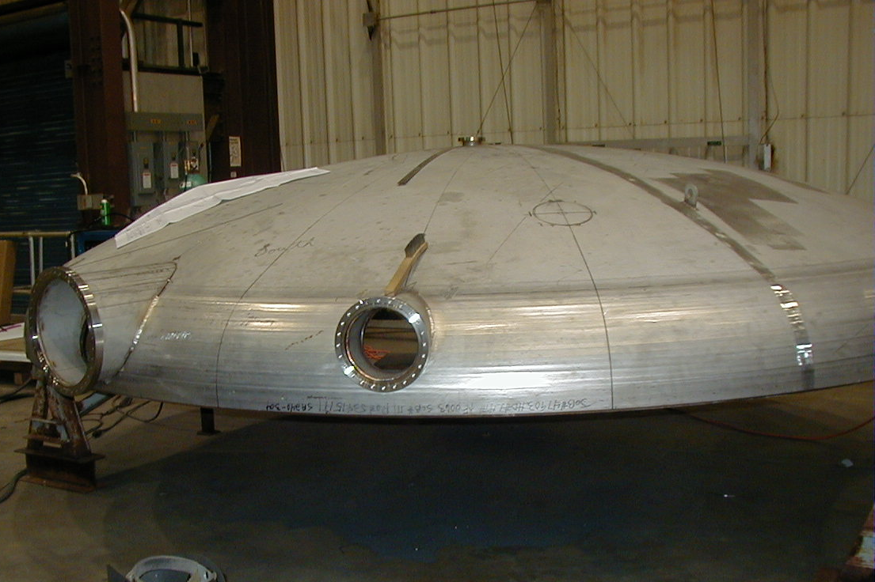

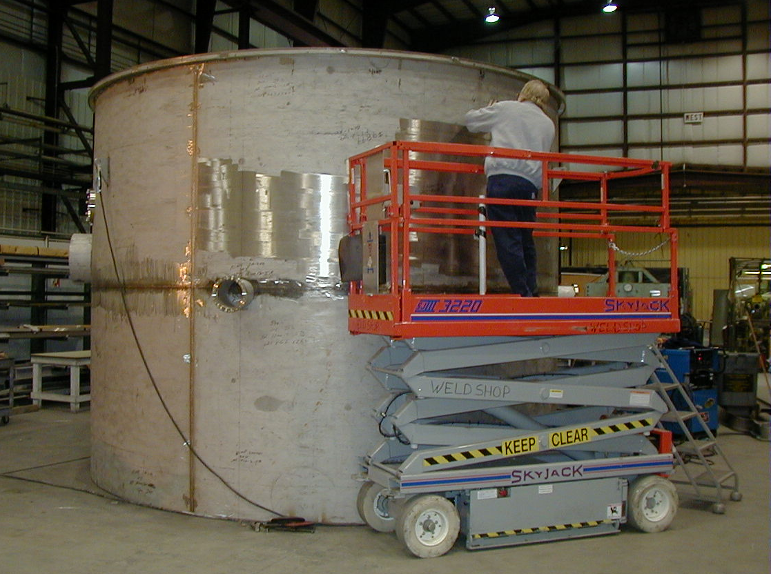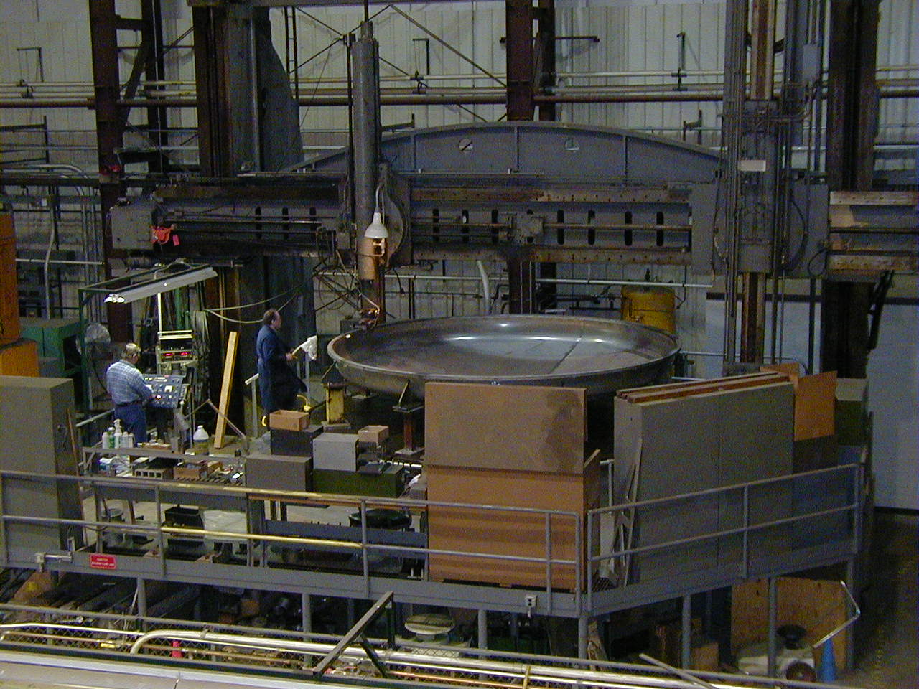

  - Turning fixtures… Work has begun on fixture frames and floor mounting plates

  - Conductor payout spool (Lew Morris needs to design)

  - Epoxy stands…. Design in progress near completion (Lew Morris)

  - Clean rooms… Plans are to procure custom rooms and assemble by PPPL staff (Jim Chrzanowski/Lou Morris)

  - Winding clamps…Finalize design

  - Winding Facility Layout. (Lew Morris and Jim C.) assume (2) winding station layout

  - Miscellaneous tooling. As required

- Manufacturing Inspection and Test Plan (Jim Chrzanowski, Tom Meighan & Steve Raftopoulos)
  - JC to generate MIT plan
  - TM and SR to support with procedure writing

