Modular Coil Manufacturing Update
SC Project Review of NCSX April 8-10, 2008
J.H. Chrzanowski- page 1

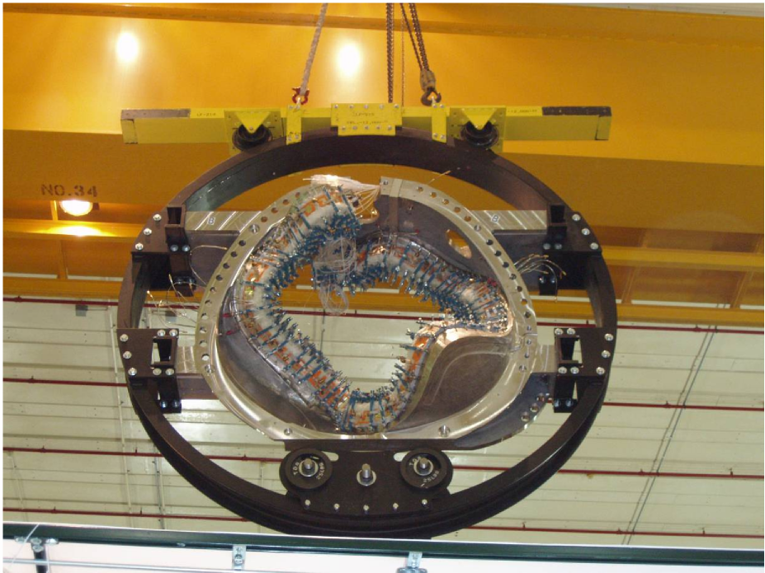
J. H. Chrzanowski for the NCSX Project

- Requirements:
SC Project Review of NCSX April 8-10, 2008
J.H. Chrzanowski- page 2

Requirements, Design & Interfaces

– Manufacture 18 modular coils that meet the design requirements
as defined in the GRD and SRD.
- Maintain Stellerator symmetry
- Maintain tight current center tolerances [+/-0.5 mm accuracy]
- Operate at liquid nitrogen temperatures
- Design:
– Design documents are complete
- SRD, Specifications, drawings, manufacturing procedures
- Interfaces:
– MC interfaces with numerous systems as outlined in SRD
- These interfaces are continuing to evolve as machine assembly is
completed
- Vacuum vessel, TF coils Cryo-systems, FPA, etc.

Modular Coil Status
- Progress at last Project Meeting- August 16, 2007 : – 13 Coils have been Vacuum Pressure Impregnated (VPI) and 14
SC Project Review of NCSX April 8-10, 2008
J.H. Chrzanowski- page 3

through the winding process
- Today's Status [April 8, 2008] – 16 Coils have been VPI’d and 17 are through the winding process

MC ID  Number | VPI Date | VPI Status | Post VPI  Completion Date | Post VPI Status
A5 | 9-20-07 | Complete | Complete | Complete
C6 | 2-14-08 | Complete | 4-18-08 | In progress
B5 | 2-28-08 | Complete | 5-9-08 | Not started
B6 | 5-15-08 | Bag Mold Prep | 6-23-08 | Not started
A6 | 7-15-06 | Pre-winding | 9-1 7-08 | Not started

- The last modular coil will be VPI’d by July 15, 2008
- All Post VPI work will be completed by September 17, 2008

Tracking Punch List Items

• Majority of punch list items have been completed.
SC Project Review of NCSX April 8-10, 2008
J.H. Chrzanowski- page 4
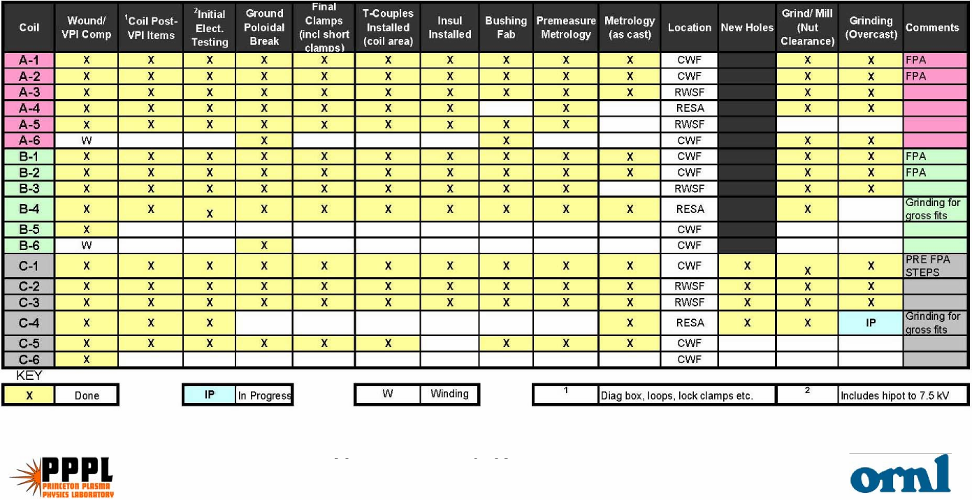
• Remaining items include: Strain gages, additional
thermocouples, flange interface modifications [as req’d]

Cost and Schedule
• Modular Coil cost estimate is based upon detail task breakdown and
SC Project Review of NCSX April 8-10, 2008
J.H. Chrzanowski- page 5

actual in-field times to complete coils
– Based on: 17 coils wound and 16 VPI’d
- Budget increased for procurement and installation of additional
thermocouples that were added to the design
- Budget increased additional shop hours - unidentified work associated
with modifications of winding forms during fit-up in support of FPA
- Last Modular Coil will be VPI’d by 7/15/08 [target date]
- Post VPI items complete by 9/17/08
- Punch list items complete by 11/6/08

VPI
Las
SC Project Review of NCSX April 8-10, 2008
J.H. Chrzanowski- page 6
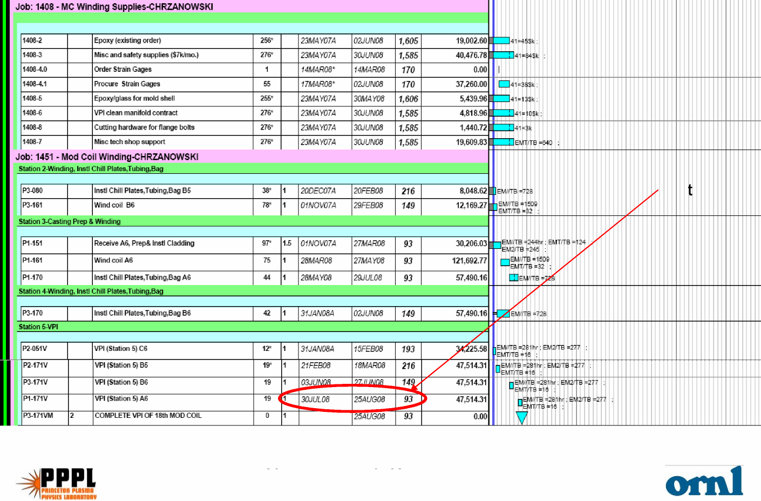
Schedule

Schedule-continued
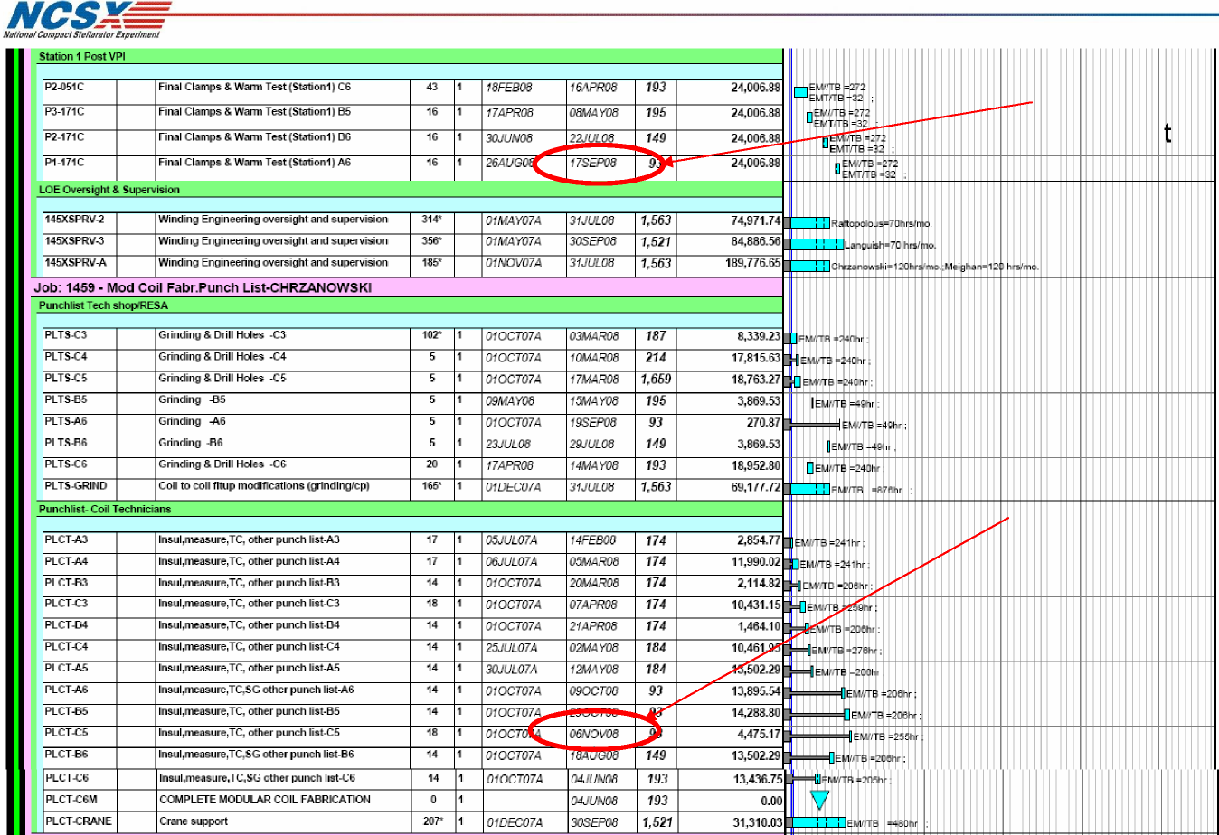
Post VPI items comple
items com
Punch list
plete
e
SC Project Review of NCSX April 8-10, 2008
J.H. Chrzanowski- page 7

Present
Schedule
0
1
2
3
4
5
6
7
8
9
10
11
145
145
12
13
14
15
16
• MC Manpower Plan:
– Presently working single shift x 5 days a week
– We have a plan for the orderly down sizing of modular coil
manufacturing team
– Size of production team will vary as required to complete modular
coils [Peak 18 technicians today 8 technicians]
Manpower Down Sizing Plan
SC Project Review of NCSX April 8-10, 2008
J.H. Chrzanowski- page 8
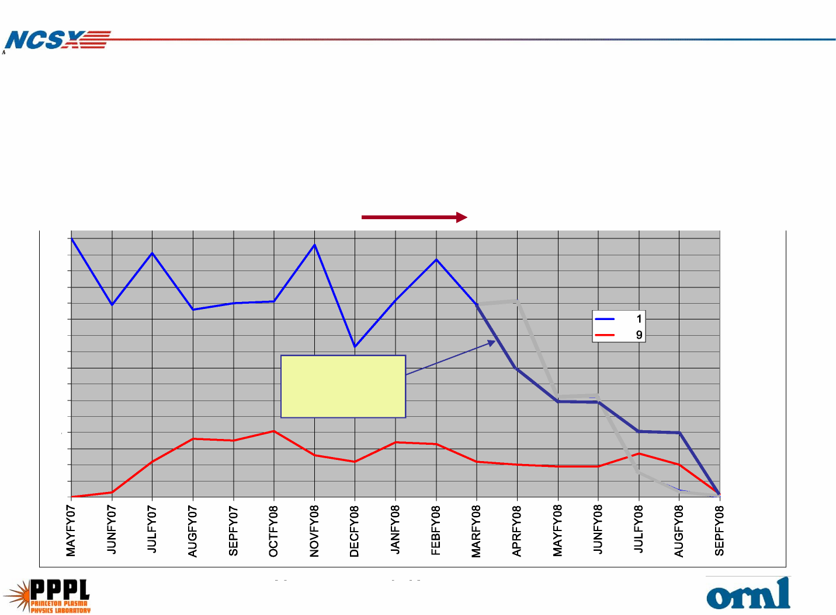

• We have begun transferring real estate to FPA teams as MC stations
SC Project Review of NCSX April 8-10, 2008
J.H. Chrzanowski- page 9
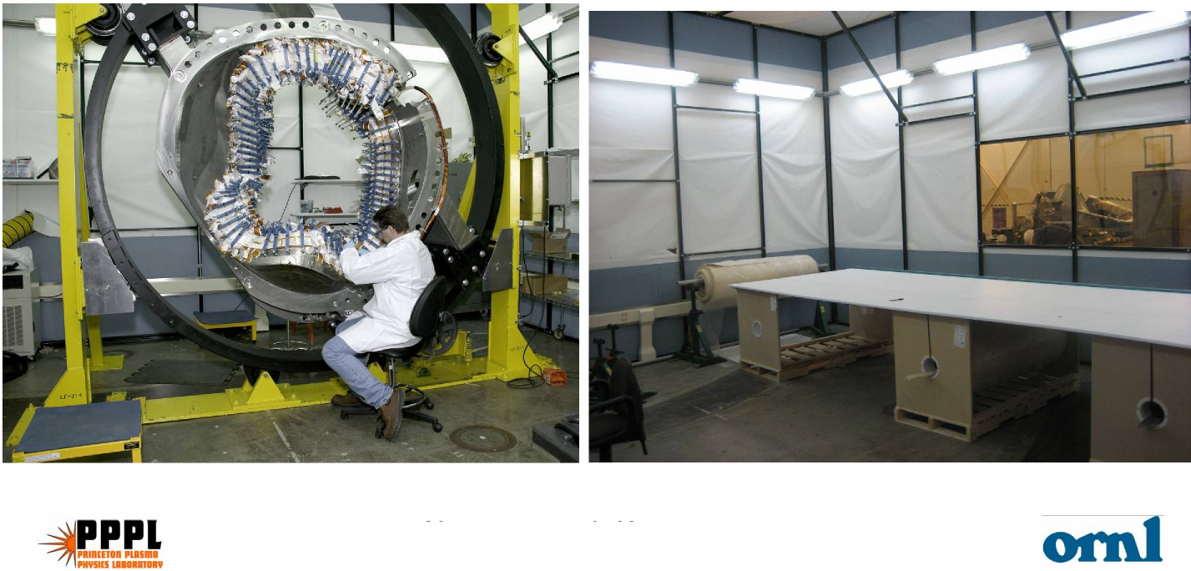
Manufacturing Area

are shut down.
- Station 2 winding station was transferred to FPA on 3/1/08
- By 7/31/08 all areas except for Station 4 and the autoclave will be
transferred to FPA

Uncertainty of Estimate

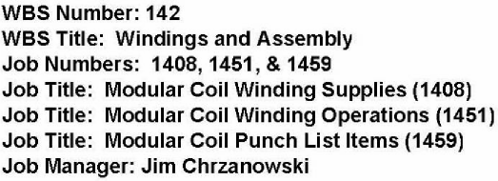
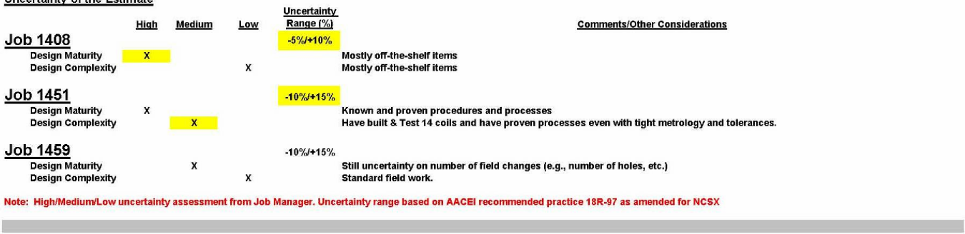
High level of confidence in estimate
SC Project Review of NCSX April 8-10, 2008
J.H. Chrzanowski- page 10

Results in highest impact [7.5 months to replace coil]
[14 coils have been electrically tested]
2-3 month impact on project schedule [If coil 18 had to be replaced]
Residual Impact
SC Project Review of NCSX April 8-10, 2008
J.H. Chrzanowski- page 11
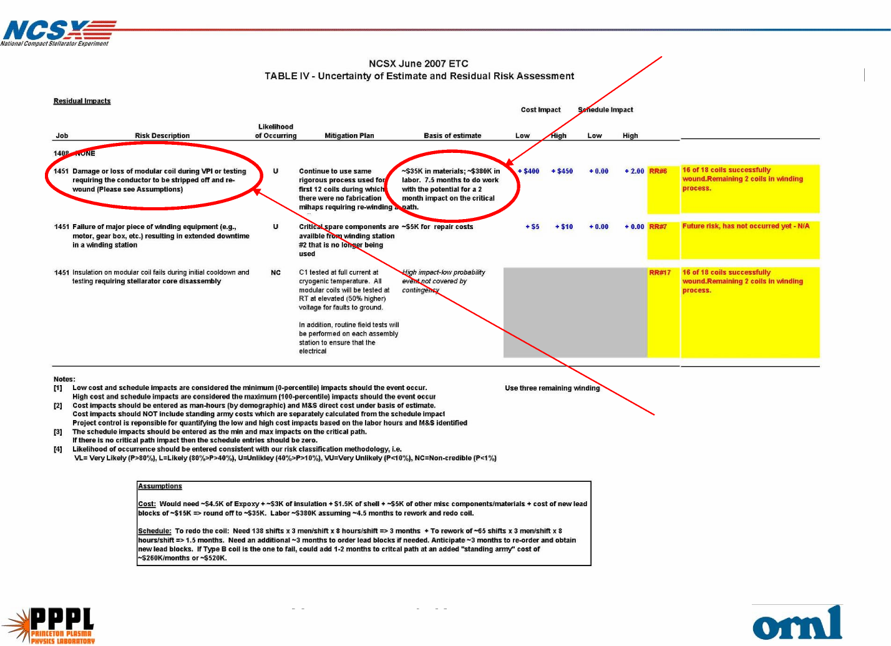

- 17 modular coils have been wound and 16 VPI’d
SC Project Review of NCSX April 8-10, 2008
J.H. Chrzanowski- page 12

In Summary....

- Have begun down sizing of coil manufacturing team from peak
level of 18 technicians to today’s level of 8 technicians
- Have begun transferring manufacturing real estate to FPA teams
- Successfully addressed all of the technological challenges.
- Safety continues to be in the forefront of all planning and
performance of field activities
- The NCSX Project is committed to completing the manufacturing of
the Modular coils by September 2008. (inc. final electrical tests)

