TO: Larry Dudek
FROM: James H. Chrzanowski

SUBJECT: Modular coil Winding Operations: 9450-1***-1451
Modular Coil Supplies: 9450-1***-1408
Modular Coil Punch List Items: 9450-1***-1459

Date: July 18, 2008

Scope
This job includes all Modular Coil manufacturing activities including materials and punch list items.

Status
Manufacturing operations are nearly complete except for the installation of strain gauges and balance of thermocouples. All of the (18) modular coils will be completed including VPI’d, and Post VPI by September 30, 2008. Procurement of materials and supplies will be complete by August 30, 2008 and all punch list items [machining/grinding] will be completed by September 30, 2008.

Interfaces
N/A – interfaces were addressed in the modular coil design jobs and not these fabrication jobs.

Specifications
All specifications are complete and current versions are post on NCSX Web Site.

Schematics and PIDs
N/A

Models
All models are complete.

Drawings
All modular coil drawings are complete and posted on the Engineering View Drawing Web Site

Analyses
N/A – required analyses were prepared and approved as part of the design jobs.

Testing
All final electrical test data is posted on the NCSX Web Site. Only final test results from modular coils B6 and A6 need to be completed. These tests will be completed by September 30, 2008, once all Post VPI activities are complete.

Costs
No pending costs following Post VPI activities are planned for closeout.

Remaining Work
- VPI A6 [7/22/08]
- Complete Post VPI activities including testing [9/30/08]
- Punch list items- will all be completed by 9/30/08, except for remaining thermocouples and strain gauges.

Closeout Documentation
Attachment A provides a generic index of the Modular Coil closeout files.

Lessons Learned:
R&D:
The R&D work that was performed up front was essential in getting a foot hold in the manufacturing process. Working with and understanding the copper rope conductor was extremely important. The development of epoxy filling methods was also invaluable. Even with all of this R&D work a total understanding of all manufacturing activities was not fully realized until the first modular coil was completed.

Drawings:
One of the biggest problems throughout the manufacturing was the impact of concurrent engineering. For example, fully approved coil drawings were never completed until coil #15, although some preliminary drawings were available. Nonetheless, time and problems could have been saved if the design was fully complete prior to the start of manufacturing.

Safety:
Safety was a high priority from day one with bi-weekly safety meetings and constant safety conversations and reminders used throughout manufacturing process.

Casting Preparation Activities:
The stud welding operations went extremely smooth. These studs were used for the winding clamps, but had to be removed following VPI. Even though the studs were removed after VPI, the cleanup due to high magnetic permeability was time consuming. By changing to Inconel studs these cleanup costs were reduced, but the initial costs for materials were increased.

If better/complete models were available early in the process, much of the interference grinding on the wings and the machining of the bolt holes could have been completed prior to winding the coils or at the casting manufacturer.

The turn stations with support rings worked well. The rings were able to be used for any of the modular coil types and provided both a means for rotating the coils and lifting them from station to station.

Chill Plate/Cladding:
The cooling system used for the modular coils was by far the costliest of activities. There were over 1500 individual pieces of copper cladding that had to be handled several times for each coil. The extensive cleaning and insulating of the cladding was not originally anticipated. Hopefully, a different design for cooling will be incorporated in future stellarator designs.

Coil Winding:
The coil winding activities went very smooth with very few problems. A good decision was winding the coils in the vertical position. This allowed many of the manufacturing tasks to be performed in parallel [both sides]. All of the tooling including the clamps, payout spool, lead brazing activities etc. worked out extremely well. Maintaining vigilance with cleanliness and extreme care throughout the winding tasks was crucial to the successes that we had. The procedures were very detailed and provided a solid basis for the repetitive operations. These procedures were regularly updated to reflect process or tooling changes throughout the operations of the first few coils.

Metrology:
This was an area that was entirely underestimated. The crews got better as time went on, but metrology support was light. One engineer had to address all of the problems, and at times that individual was overloaded. Also the equipment was not reliable. We had numerous breakdowns during crucial times in the operation.

VPI Operations:
In general the mold installation and VPI operations went smoothly. The bag mold concept worked well, but was very sensitive to damage that in turn could cause leaks. During the VPI operations repairs had to be made approximately 1/3rd of the time. Small cuts or sharp edges would cause unsuspecting leaks once the bag began to expand.

The epoxy filling of the coils went well. Adequate fill points were added to the coil due to its complex geometry. Perhaps fewer feeds could have been used, but having the extras gave us flexibility during the filling. No changes are recommended.

Conclusion:
The manufacturing of the modular coils is complete. Other than those items outlined above, no other recommendations are noted.
Attachment A

This section contains the closeout notes and index for Modular Coil closeout files. These files are located under the Coil/VVSA Tab on the NCSX Engineering Web : http://ncsx.pppl.gov/NCSX_Engineering/ModCoil_VVSA_Fab/ModCoil_VVSA_Fab_index.htm

- MC R&D Activities (001) - This section includes all of the R&D files for the work that was completed prior to manufacturing. Activities include VPI trials; trial windings; conductor keystoning activities; plus the Twisted Racetrack Coil.
- MC Materials (002) - This section includes information on the materials used for the modular coils including insulation; epoxy and conductor. It does not include information on the MC castings
- Modular Coil Photographs & Measurements (003) - This section includes specific information on each modular coil including photographs and coil measurements.
- Metrology Plans for Modular Coils (004) - This section includes information about the metrology plans for the modular coils.
- Modular Coil Tooling (005) - his section includes the equipment, tools and facility for manufacturing the modular coil.
- Specifications (006) - The final approved specifications are located on the Engineering Web under the heading of "Specifications" :(http://ncsx.pppl.gov/SystemsEngineering/Requirements/Specs/WBS1/WBS14/index_Specs_WBS14.htm).
- Thermocouples & Strain Gauges (007) - This section provides information on the thermocouples and strain gauges that were for the modular coils.
- Statements of Work (SOWs) (008) - The final approved SOWs are located on the Engineering Web under the heading of "SOWs": (http://ncsx.pppl.gov/SystemsEngineering/SOW/SOW_index.htm).
- VPI Actvities (009) - This section has the information for the VPI activities including pictures, equipment and plans.
- MC & TRC Manufacturing Documents (010) - This section includes all of the manufacturing documents used to fabricate the modular coils including MIT, procedures and operations plan.
- May FDR NCSX (011) - This section copies of the FDR presentations for the modular coils. This is posted on the NCSX Engineering Web under the heading of "Design Reviews". This file contains pertinent backup information.
- Hazard Analysis (012) - This is posted on the NCSX Engineering Web under the heading of "ES&H": (http://ncsx.pppl.gov/NCSX_Engineering/ES&H/HazardAnalyses/index_HazardAnalyses.htm ).
- Lead Braze (013) - This sections has photos and information for the lead brazes – lug to copper cable.
- Lacing (014) - This section contains information on the development of the lacing technique used to hold the turns in position.
- Lead Block Jumpers (015) - This section contains information on the modular coil leads.
- Cooling of Cladding & Chill Plates (016) - This section contains reference information on the cooling tubes for cooling the cladding/chill plates.
- MC Joint Concerns (017) - This section contains information about the joint concerns and corrective actions taken to improve quality and reliability of joint.
- Safety Items (018) - This section contains general safety notes, etc from the modular coil manufacturing program.
- MC Coil Lead Short (019) - This section contains information on the lead short and steps that were taken to correct the problem.
- Audit 0609 (020) - This is posted on the NCSX Engineering Web under the heading of "Audits" (http://ncsx.pppl.gov/NCSX_Admin/QualityAssurance/index_QA.htm).
- MC History (021) - This section contains general information of winding times, coil history and manufacturing tasks.
- Posters (022) - This section has several posters that were generally depicting the modular coil R&D and manufacturing operations.
- Groundwall & Floating Hardware (023) - This section contains two studies that discuss the floating hardware in the modular coils and the integrity of the groundwall insulation.

Modular Coil Manufacturing Update
 | SC Project Review of NCSX April 8-10, 2008  J.H. Chrzanowski- page 1 | 

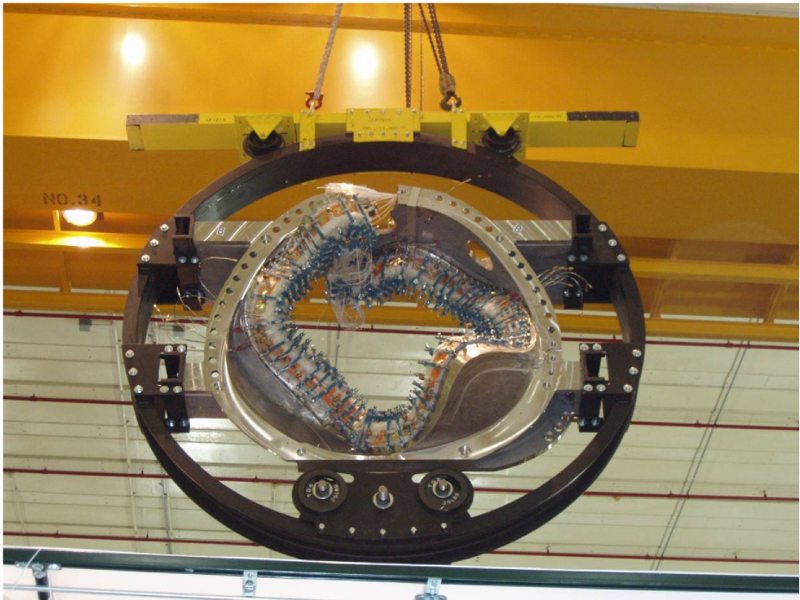
J. H. Chrzanowski for the NCSX Project
- Requirements:
 | Requirements, Design & Interfaces

SC Project Review of NCSX April 8-10, 2008
J.H. Chrzanowski- page 2

– Manufacture 18 modular coils that meet the design requirements
as defined in the GRD and SRD.
- Maintain Stellerator symmetry
- Maintain tight current center tolerances [+/-0.5 mm accuracy]
- Operate at liquid nitrogen temperatures
- Design:
– Design documents are complete
- SRD, Specifications, drawings, manufacturing procedures
- Interfaces:
– MC interfaces with numerous systems as outlined in SRD
- These interfaces are continuing to evolve as machine assembly is
completed
- Vacuum vessel, TF coils Cryo-systems, FPA, etc.
Modular Coil Status
- Progress at last Project Meeting- August 16, 2007 : – 13 Coils have been Vacuum Pressure Impregnated (VPI) and 14
SC Project Review of NCSX April 8-10, 2008
J.H. Chrzanowski- page 3

through the winding process
- Today's Status [April 8, 2008] – 16 Coils have been VPI’d and 17 are through the winding process

MC ID  Number | VPI Date | VPI Status | Post VPI  Completion Date | Post VPI Status
A5 | 9-20-07 | Complete | Complete | Complete
C6 | 2-14-08 | Complete | 4-18-08 | In progress
B5 | 2-28-08 | Complete | 5-9-08 | Not started
B6 | 5-15-08 | Bag Mold Prep | 6-23-08 | Not started
A6 | 7-15-06 | Pre-winding | 9-1 7-08 | Not started

- The last modular coil will be VPI’d by July 15, 2008
- All Post VPI work will be completed by September 17, 2008
Tracking Punch List Items

• Majority of punch list items have been completed.
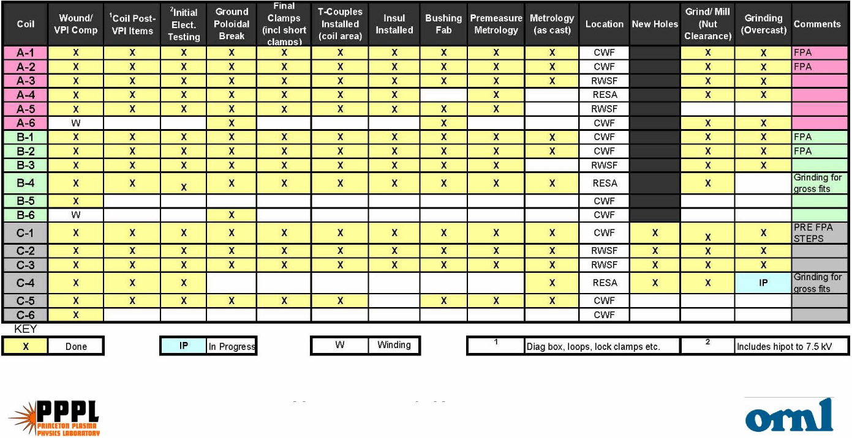
SC Project Review of NCSX April 8-10, 2008
J.H. Chrzanowski- page 4
• Remaining items include: Strain gages, additional
thermocouples, flange interface modifications [as req’d]

Cost and Schedule
• Modular Coil cost estimate is based upon detail task breakdown and
SC Project Review of NCSX April 8-10, 2008
J.H. Chrzanowski- page 5

actual in-field times to complete coils
– Based on: 17 coils wound and 16 VPI’d
- Budget increased for procurement and installation of additional
thermocouples that were added to the design
- Budget increased additional shop hours - unidentified work associated
with modifications of winding forms during fit-up in support of FPA
- Last Modular Coil will be VPI’d by 7/15/08 [target date]
- Post VPI items complete by 9/17/08
- Punch list items complete by 11/6/08
Schedule
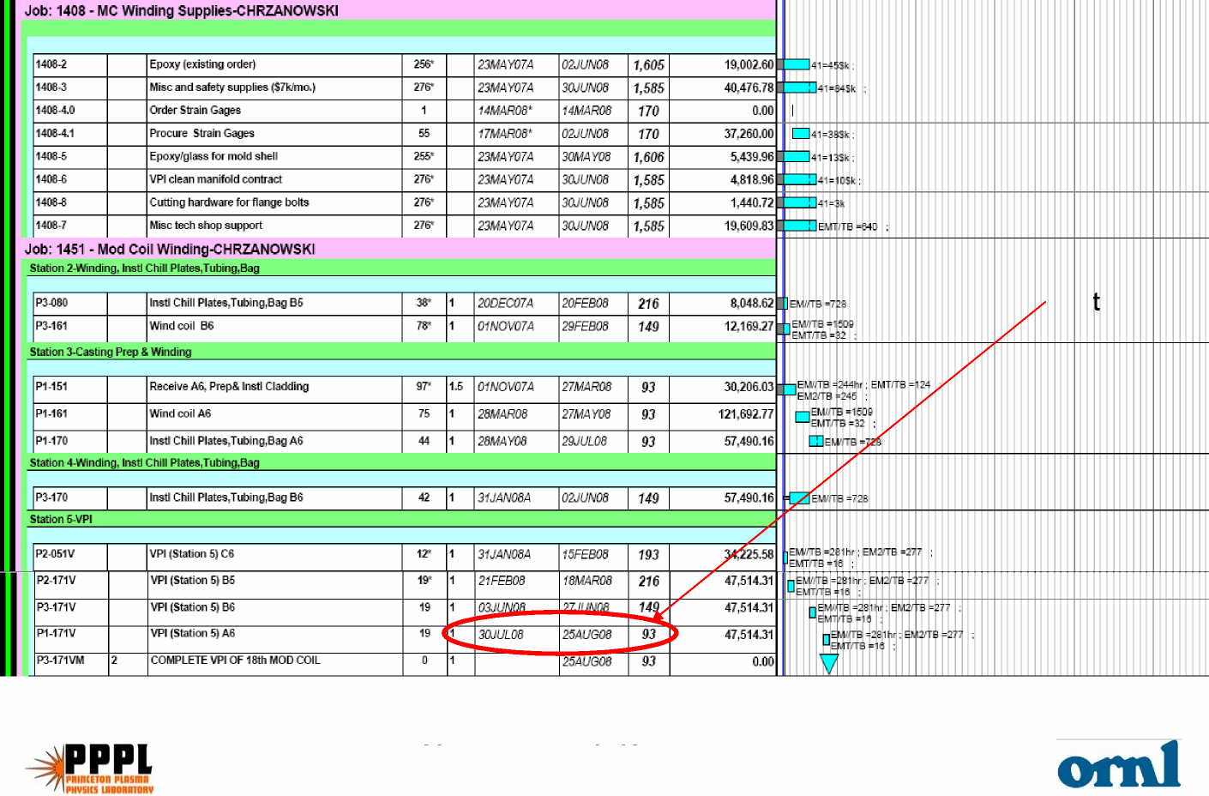
SC Project Review of NCSX April 8-10, 2008
J.H. Chrzanowski- page 6
Las
VPI
Schedule-continued
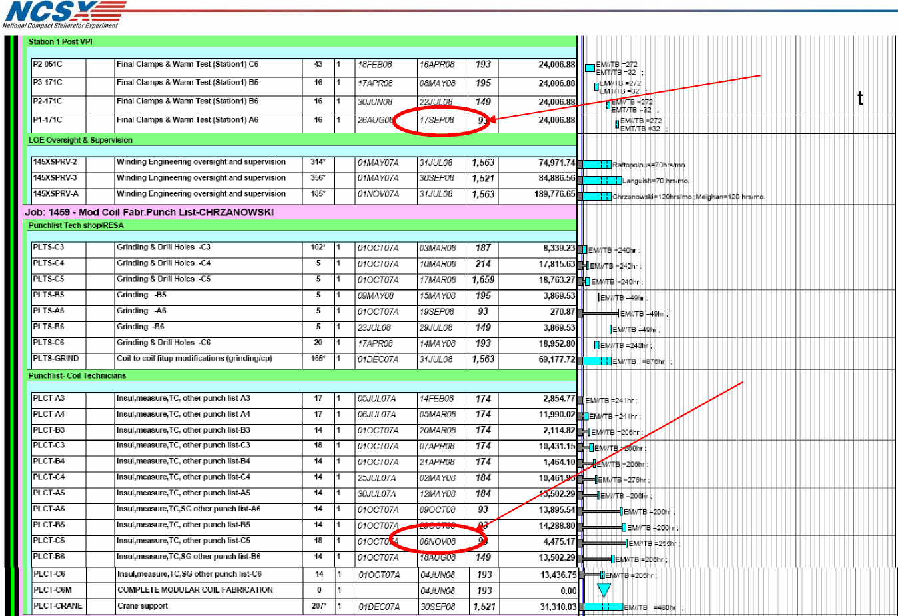
Post VPI items comple
items com
Punch list
plete
e
SC Project Review of NCSX April 8-10, 2008
J.H. Chrzanowski- page 7

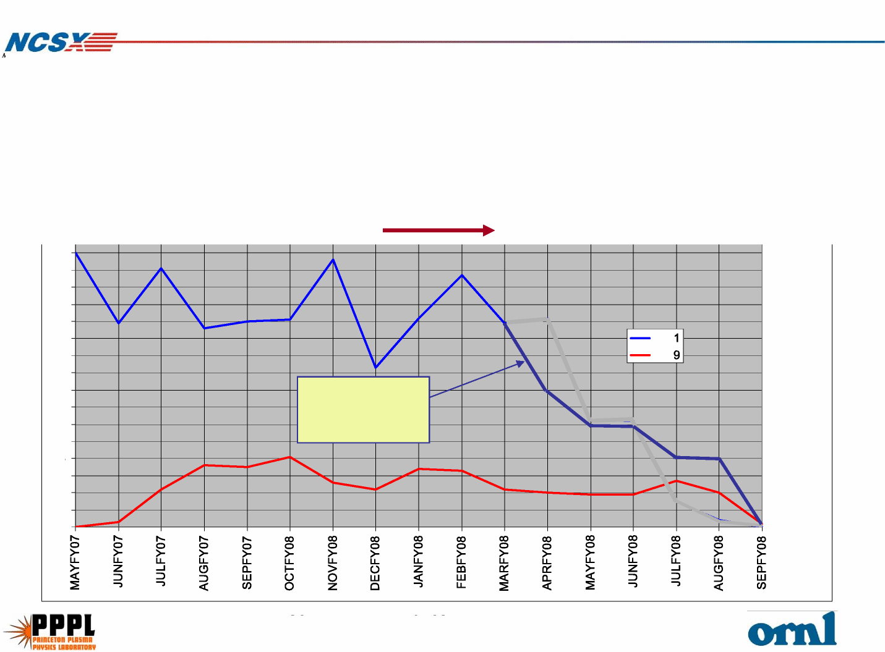
SC Project Review of NCSX April 8-10, 2008
J.H. Chrzanowski- page 8
Manpower Down Sizing Plan
• MC Manpower Plan:
– Presently working single shift x 5 days a week
– We have a plan for the orderly down sizing of modular coil
manufacturing team
– Size of production team will vary as required to complete modular
coils [Peak 18 technicians today 8 technicians]
16
15
14
13
12
145
145
11
10
9
8
7
6
5
4
3
2
1
0
Present
Schedule
• We have begun transferring real estate to FPA teams as MC stations
 | Manufacturing Area

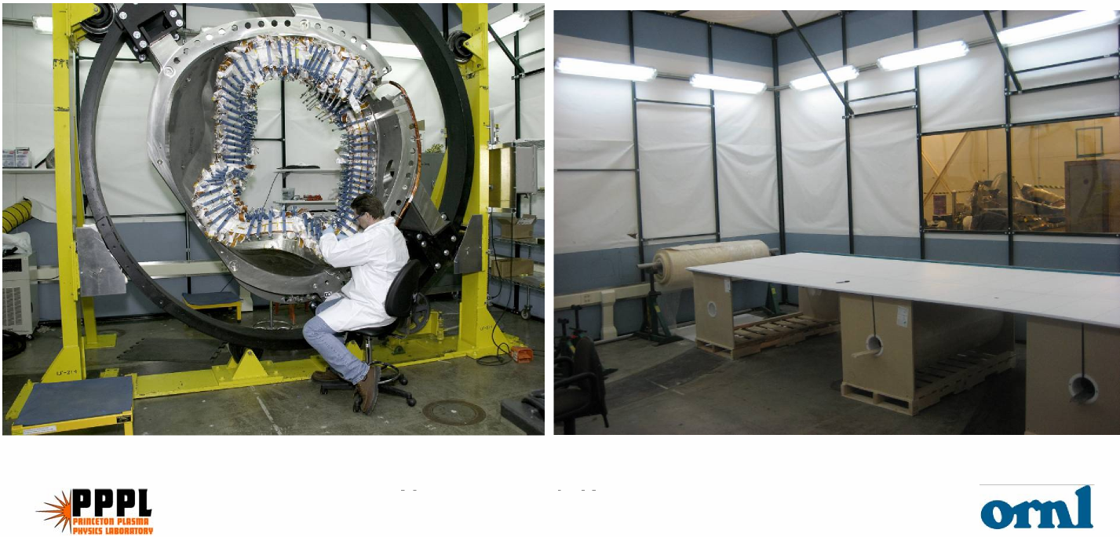
SC Project Review of NCSX April 8-10, 2008
J.H. Chrzanowski- page 9
are shut down.
- Station 2 winding station was transferred to FPA on 3/1/08
- By 7/31/08 all areas except for Station 4 and the autoclave will be
transferred to FPA
Uncertainty of Estimate

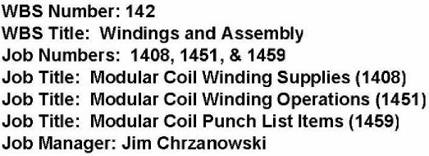
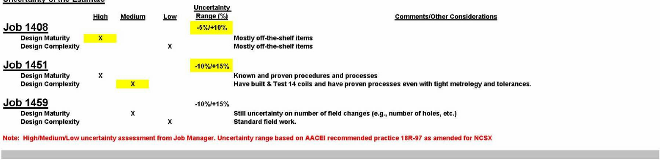
High level of confidence in estimate

SC Project Review of NCSX April 8-10, 2008
J.H. Chrzanowski- page 10

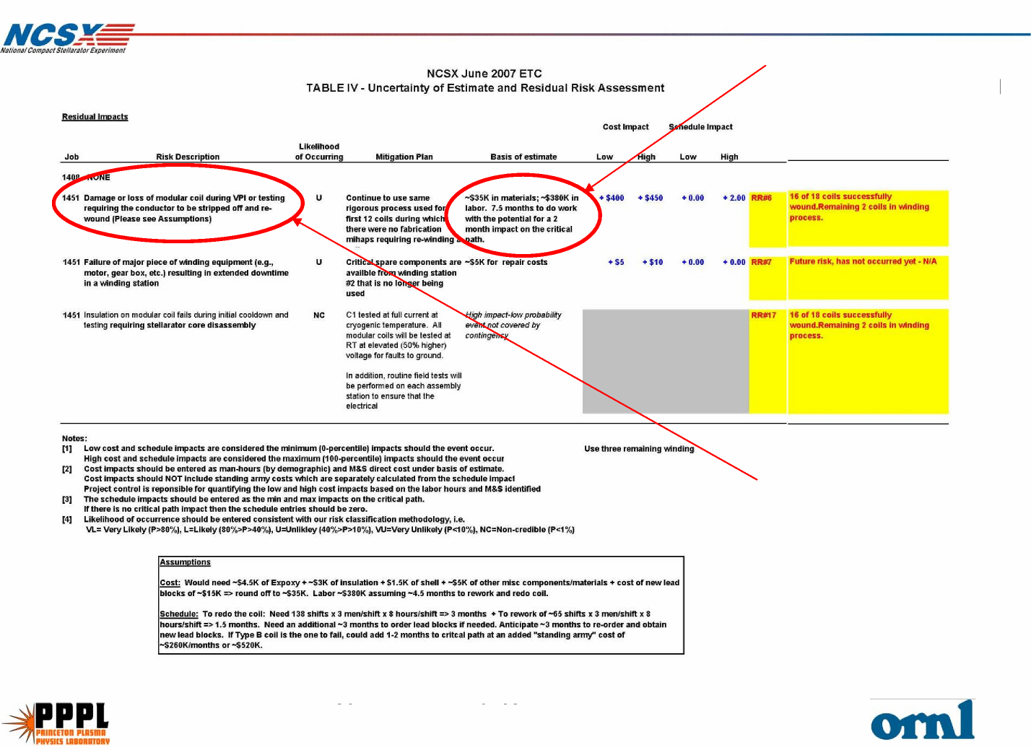
SC Project Review of NCSX April 8-10, 2008
J.H. Chrzanowski- page 11
Residual Impact
2-3 month impact on project schedule [If coil 18 had to be replaced]
Results in highest impact [7.5 months to replace coil]
[14 coils have been electrically tested]
- 17 modular coils have been wound and 16 VPI’d
In Summary....

SC Project Review of NCSX April 8-10, 2008
J.H. Chrzanowski- page 12

- Have begun down sizing of coil manufacturing team from peak
level of 18 technicians to today’s level of 8 technicians
- Have begun transferring manufacturing real estate to FPA teams
- Successfully addressed all of the technological challenges.
- Safety continues to be in the forefront of all planning and
performance of field activities
- The NCSX Project is committed to completing the manufacturing of
the Modular coils by September 2008. (inc. final electrical tests)

