Job 1260 Neutral Beam Transition Duct
SC Project Review of NCSX, April 8-10, 2008
(NBTD)
P. L. Goranson

Functional requirements
• NBTD provides interface for:
SC Project Review of NCSX, April 8-10, 2008
P. L. Goranson - page 2
- Man access into Vacuum Vessel (opening 13.5” wide x 34” tall)
- Mounting vacuum pumping system (13.5” id Port)
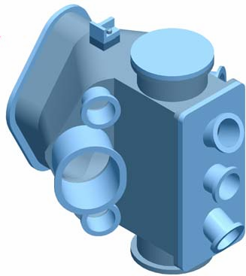
- Mounting Neutral Beam units
- Mounting diagnostics
- Mounting Lateral Supports and positioning
VV toroidally
- In addition, the NBTD must penetrate and
seal to the Cryostat.
- NBTD operates at 350C at its mounting flange during bakeout; most
of construction must be Inconel.

Design Status
- Models were completed (2003) and were reviewed several years
SC Project Review of NCSX, April 8-10, 2008
P. L. Goranson - page 3
ago
- Must reaffirm design, hold peer review and work toward SRD
- A PDR is required
- Baseline was changed for a time to incorporate simplified ducts
(Man Access Ports) which did not mount NB’s.
- Lateral support drawings were completed.

SC Project Review of NCSX, April 8-10, 2008
P. L. Goranson - page 4
Vacuum Pumping Port
NB Port
Man Access
VV Interface
Lateral Support (top and bottom)
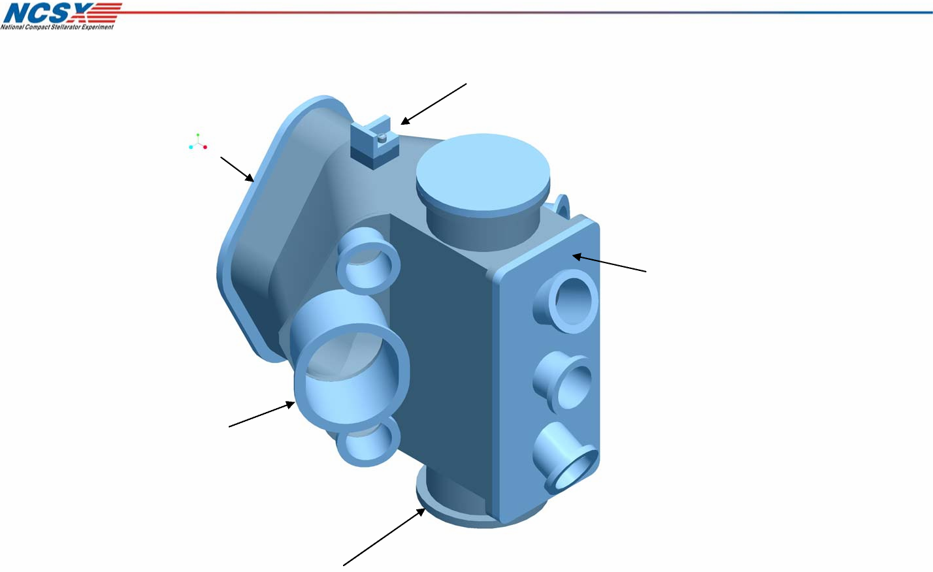
NBTD showing Lateral Supports

TOP VIEW
NBTD Preliminary Drawings
SC Project Review of NCSX, April 8-10, 2008
P. L. Goranson - page 5
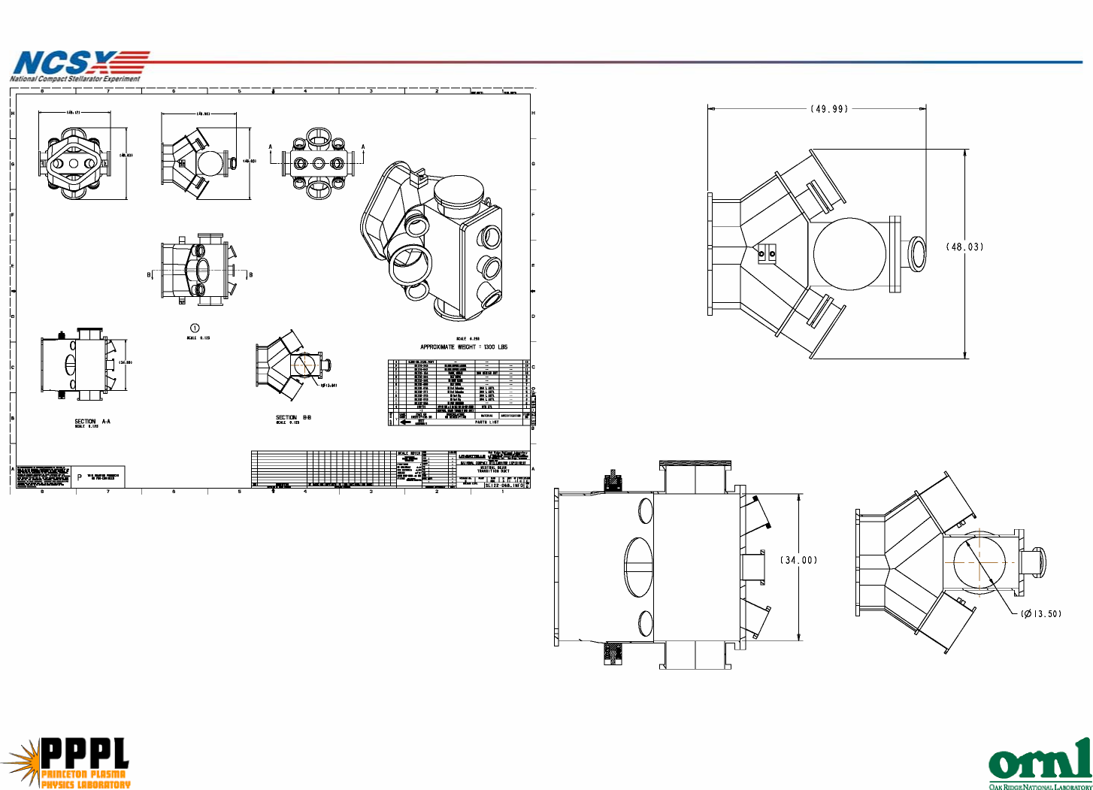

Based in recent MDL & NCSX experience
Based in recent MDL & NCSX experience
Based in recent MDL & NCSX experience
Based in recent MDL & NCSX experience
Based in recent MDL & NCSX experience
Based in recent MDL & NCSX experience
Based in recent MDL & NCSX experience
Assume 2 people for ~1/2 Weeks - based on MDL & NCSX experience
Assume 2 drawings @ 20 hr each - based on MDL & NCSX experience
Assume 3 drawings @ 40 hr each - based on MDL & NCSX experience
Assume 1 drawing @ 40 hr each - based on MDL & NCSX experience
Assume 1 drawing @ 40 hr each - based on MDL & NCSX experience
Assume 1 drawing @ 40 hr each - based on MDL & NCSX experience
Based in recent MDL & NCSX experience
Milestone - no resources
Based in recent MDL & NCSX experience
Assume 2 drawings @ 40 hr each - based on MDL & NCSX experience
Based in recent MDL & NCSX experience
Subtotal Title III Design 140
Procurement coordination 20
Update of drawings as Needed 80
Title III
Disposition of deviation requests and non-conformances 40
800
Subtotal Title I & II Design
Resolve PDR Chits 40
Final Design Review 0
Prepare for FDR Neutral Beam Transition Duct 40
Stress analysis 160
Review of Drawings 40
Review and Update Misc Det & Cuts Dwgs 40
Review and Update Weldment Dwgs 120
Review and Small Large Rect Port Dwg 40
Review and Update Large Rect Port Dwg 40
Review and Update Port Mod Dwg 40
Resolve PDR Chits 40
PDR for NBTD 0
Prepare for PDR Neutral Beam Transition Duct 40
Review and Update Assbly Dwgs 80
Title I an II Design
Peer Review to Establish Requirements 80
Labor Cost
SC Project Review of NCSX, April 8-10, 2008
P. L. Goranson - page 6
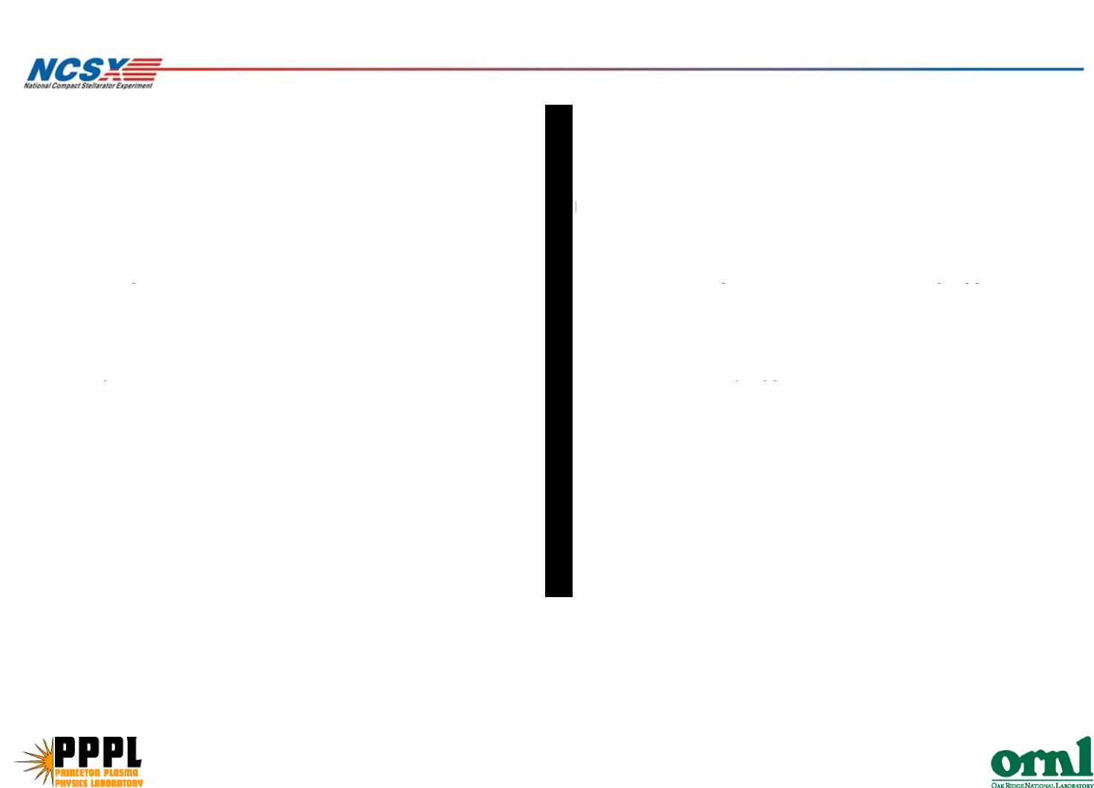

M&S Cost

Costs reflects recent significant increase in Inconel price.
Lateral supports added.
This element consists of the port duct, seals, and all cover flanges
weight of shell assembly, with ports 1400 lbs
$/lb for fabrication 51 $/lb Includes recent vendor Inconel quotes
subtotal, fab cost shell $71,400
Ports
8" o.d. flange, 6" tube 225
no. of 16.5" ports
o.d. rotatable cover flange $/ea MDC catalog 10
no. of 8" ports MDC catalog 10
1 25
7ea
cost for 8" ports $2,450
14.5" x 16.5" flange with tube(ss) 1500 $/ea NCSX/MDL experience
blank 14.5" x 16.5" flanges(ss) 1000 $/ea NCSX/MDL experience
no. of 14.5" x 16.5" ports 2ea
cost for 14.5" x 16.5" ports $5,000
16.5" o.d. flange, 14" tube 1000 $/ea MDC catalog 10
16.5" o.d. rotatable cover flange 710 $/ea
2ea
⁸"
$/ea
$3,420
cost for 16.5" ports
large square flange cover, ss $4,000
o-ring seals for diamond flange and square flange $2,530

subtotal, ports $17,400
Fabricate and install lateral support $8,000$/ea
number of supports 2 ea
subtotal for support $16,000
Total, each nbi port duct extension $104,800
no. of nbi duct extensions 3
total, 3 extensions $314,400
None of the above includes an interface to the cryostat.
SC Project Review of NCSX, April 8-10, 2008
P. L. Goranson - page 7

Schedule & Staffing
SC Project Review of NCSX, April 8-10, 2008
P. L. Goranson - page 8
Schedule
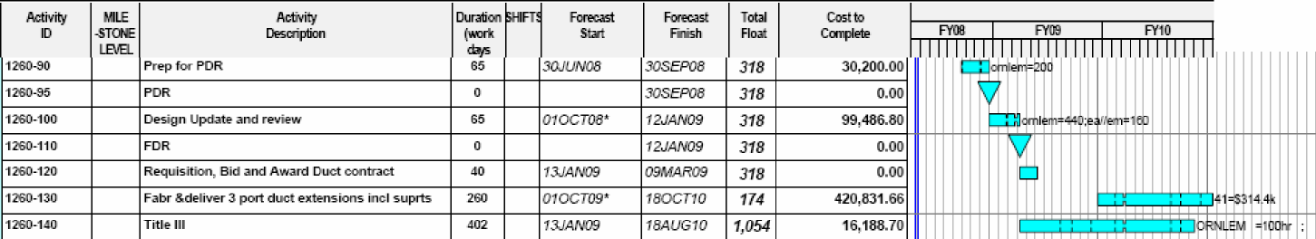
Staffing
P. L. Goranson – 80% during Title I & II design.
Gary Lovett – 100% during Title I & II.

Schedule and Cost Risk

Uncertainty of the Estimate
Uncertainty
High Medium Low Range (%)
Design Maturity X
-10%/+15%
Design Complexity X
Other Comments:
Mitigation
Cost Impact Schedule Impact

Likelihood
SC Project Review of NCSX, April 8-10, 2008
P. L. Goranson - page 9
Job Risk Description of Occurring Mitigation Plan Basis of estimate Low High Low High
1260 Design is vintage and revisit could result in criteria U Schedule was made more Engineering hours to redo 200 hrs 400 hrs 0 0
changes, i.e. diagnostic requirements, number of aggressive with early start to models and hold design ORNL EM ORNL EM
ports, NB alignment, further design review, etc. assure ageement with design. review.

