Stellarator Core Integration
SC Project Review of NCSX, April 8-10, 2008
M. J. Cole for the NCSX Design Team

Stellarator Core Integration Overview
- Integration at Oak Ridge
SC Project Review of NCSX, April 8-10, 2008
M. J. Cole - page 2
- Subsystem/component Interfaces
- Manpower Loading
- Risk Mitigation Activities

- This WBS provides integration support during fabrication and assembly
SC Project Review of NCSX, April 8-10, 2008
M. J. Cole - page 3
at PPPL
- Integration support consist of:
- Installation oversight and inspection of Stellarator Core components
- Verifying fabrication problems very early before fabrication starts is key to
preventing delays that impact cost and schedule
- Provide as built drawings and models to document the fabrication details
- Address risk mitigation activities and integrating results into the assembly

• Installation oversight and inspection of Stellarator Core components
SC Project Review of NCSX, April 8-10, 2008
M. J. Cole - page 4
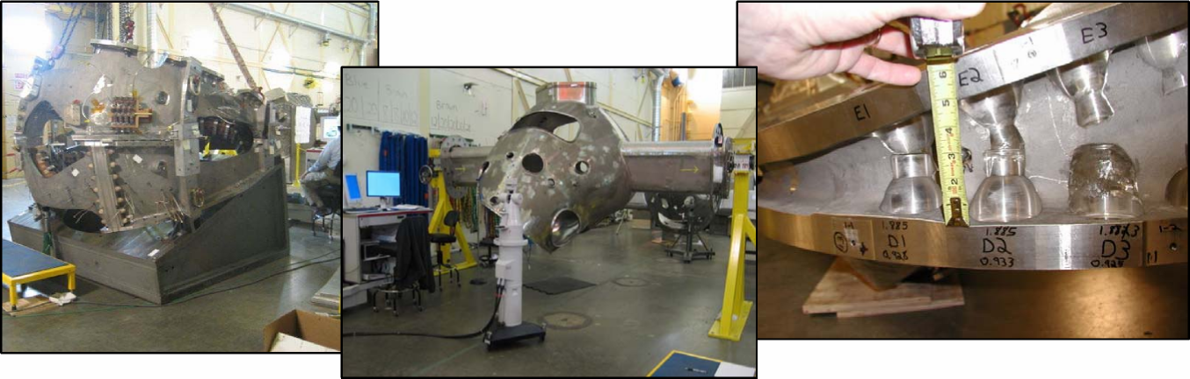
It is important to walk around even though you are not addressing a specific problem – it is amazing what you can learn

Integration at Oak Ridge/PPPL

• Verifying fabrication problems very early before fabrication starts is key
SC Project Review of NCSX, April 8-10, 2008
M. J. Cole - page 5
to preventing delays that impact cost and schedule
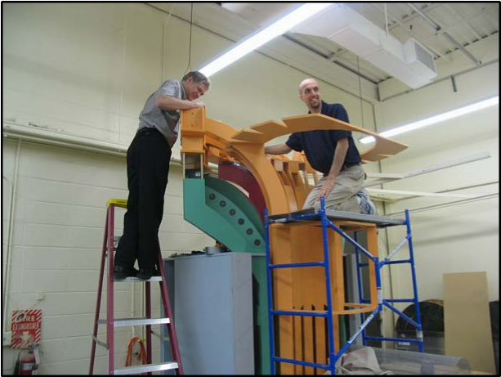
Station 6 machine assembly does not start for several years. Addressing problems early saves time and money if problems can be identified and
solutions resolved.

Integration and Subsystem/component
Interfaces

- Managing assembly interfaces is critical to meeting cost and schedule
SC Project Review of NCSX, April 8-10, 2008
M. J. Cole - page 6
objectives
- During the design phase, interface requirements are met by
- Reviewing and checking interfaces with mating components
- Coordinating requirements with responsible individuals of mating components
- Checking released information to verify requirements have been incorporated and interfaces are correct
- Checking CAD models for interferences
- During assembly operations
- Reviewing top level assembly models before assembly to assure assembly is possible and space is available using CAD models that have “as inspected” data reflected in the model

• Reviewing and checking interfaces with mating components

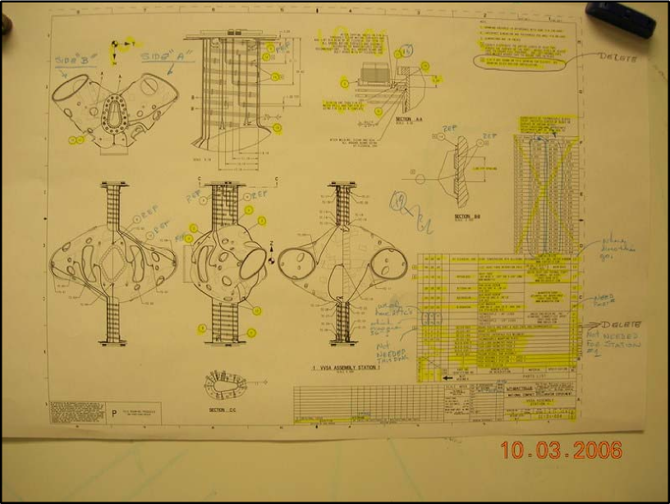
Integration is not always using the latest 3D Cad model

•Checking released information to verify requirements have been incorporated and interfaces are correct
SC Project Review of NCSX, April 8-10, 2008
M. J. Cole - page 7

Manpower Loading

SC Project Review of NCSX, April 8-10, 2008
M. J. Cole - page 8
Task | FY08 | Manpower Loading, FTE  FY09 FY10 FY11 |  |  | FY12 | Totals
Installation oversight and inspection | 0.20 | 0.40 | 0.40 | 0.40 | 0.00 | 1.40
Verify fabrication problems very early | 0.10 | 0.40 | 0.40 | 0.40 | 0.00 | 1.30
Provide as built fabrication dwgs | 0.10 | 0.20 | 0.20 | 0.20 | 0.00 | 0.70
Risk mitigation activities | 0.20 | 0.80 | 0.70 | 0.40 | 0.00 | 2.10
Reassigned staff availabe for support | 0.00 | 0.60 | 0.60 | 0.60 | 0.00 | 1.80
Totals by Year | 0.60 | 2.40 | 2.30 | 2.00 | 0.00

Risk Mitigation Activities
• Risk have been identified in the Risk Register, RR-28a, as shown below
SC Project Review of NCSX, April 8-10, 2008
M. J. Cole - page 9
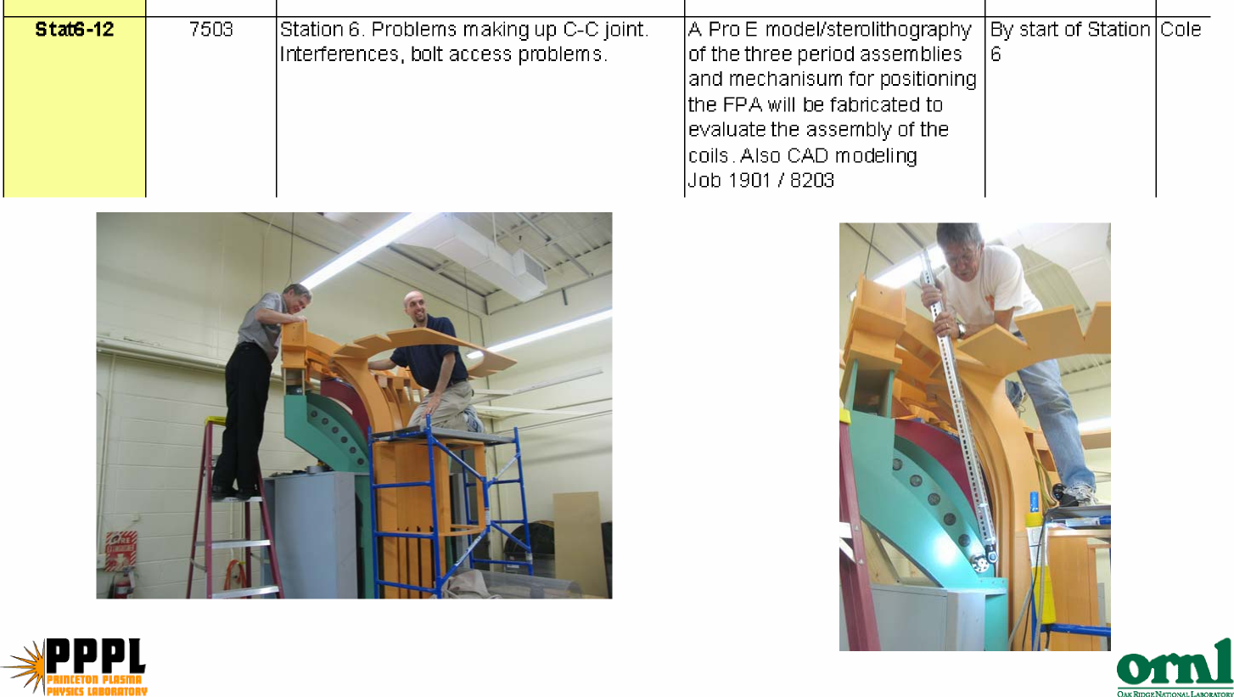

Summary
- Integration is an important part of the project
SC Project Review of NCSX, April 8-10, 2008
M. J. Cole - page 10
- Performing oversight is not just showing up when there is a problem. It is
about being involved.
- If a problem can be identified early and a solution found instead of waiting
until assembly the return in lower cost and lost schedule is significant
- Our Cad systems are almost as good as the real thing but sometimes a
stereo lithography model, prototype, or full scale mockup is really important.
- Risk Mitigation activities have been included to address critical issues as
early as possible to avoid possible schedule, cost, and assembly issues

