NCSX Vacuum Water & Utility
SC Project Review of NCSX, April 8-10, 2008
Gas
L. F. Dudek

Outline

- Scope / Requirements
- Interfaces
- Design plans
- Material and Labor Estimates
- Schedule
- Risks and uncertainty

SC Project Review of NCSX, April 8-10, 2008
L. E. Dudek - page 2

Scope
- Water Cooling Systems
SC Project Review of NCSX, April 8-10, 2008
L. E. Dudek - page 3
Ð Provide cooling water for the Vac Pumping System
Ð Provide drops for future NB Vac Pumps
- Utility Gas Systems
Ð Compressed air manifold
Ð Vacuum Vent piping

Water System Requirements
- Vacuum Pumping System Water
SC Project Review of NCSX, April 8-10, 2008
L. E. Dudek - page 4
– Requirements
- Load: 5-10 gpm
- Fluid: Treated Water
- Pressure: 140 psig
- Temperature: Ambient
- Controls: Local, Manual control of pump
– Provide a small loop <10 gpm
- Includes design, fabrication and installation
- Install Heat exchanger & pump

Water System Interfaces
SC Project Review of NCSX, April 8-10, 2008
L. E. Dudek - page 5
- Vacuum Pumping System
Ð Interfaces via the cooling water connection to the
vacuum pumps below the NCSX
- Heat sink
- Tie in to existing HVAC cooling water system
- Connection in the NCSX Test Cell Basement
- Power
Ð Local power supplied from local MCC (<10 hp)
- Mechanical
Ð Interfaces to the machine platform for support of
piping

FIGURE 2-17 PLANT CHILLED WATER
CS BASEMENT
NCSX TEST CELL
WBS 22
0.25 GPM
VV
TMP 2
30 PSI 20 GPM 45 DEG F
0.25 GPM
VV
TMP1
2' CU
NB 4
TMP
BOOSTER
PUMP
2' CU
NB 3
TMP
ROUGHING
PUMP
NB 2
TMP
3 GPM
NB
BACKING
SKID
NO WATER REQUIREMENTS
NB 1
TMP
VV
BACKING
SKID
WBS 22
WBS 623
WBS 623
WBS 25
Water System Design Plan
SC Project Review of NCSX, April 8-10, 2008 L. E. Dudek - page 6
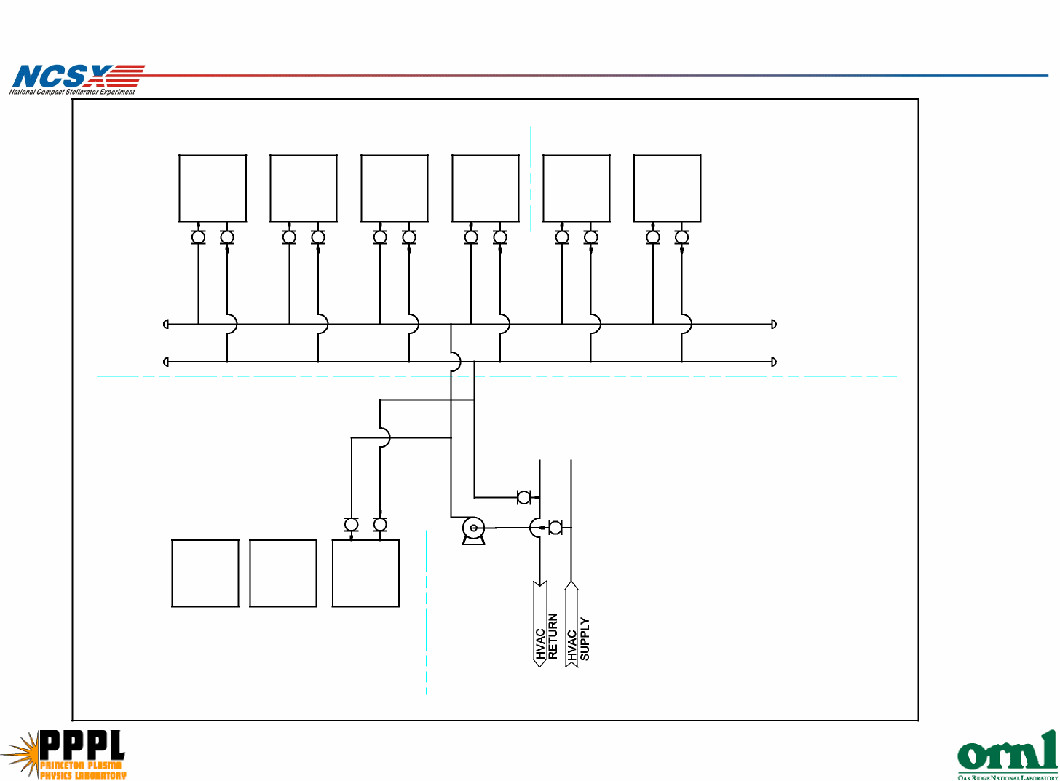

Water System Estimate

Task | 41 M&S | EMEM  hrs | EMSB  hrs | EMTB  hrs | EASB  hrs
Design
Conceptual Design |  | 40 |  |  | 20
Layout Drawings |  | 10 |  |  | 20
Final Design |  | 40 |  |  | 160
Fab / Installation |  |  |  | 265
Piping Estimate | $22,970
Supervision |  | 50 | 30
Test, PTP |  | 8 |  | 40

SC Project Review of NCSX, April 8-10, 2008
L. E. Dudek - page 7

Component | *Total Labor  Manhours | *M&S ($) (in  2002 $)
Copper Piping  38 |  | $3,970
Equipment | 133 | $6,948
Adders (see below) | 94 | 5,459.1
ESTIMATE TOTAL | 265 | 16,377.3
CURRENT Year / No. Yrs. | 2007 | 5
ESCALATED TOTAL | 265 | $22,970

*Rates taken from 2002 RS Means Plumbing Estimating guide
SC Project Review of NCSX, April 8-10, 2008
L. E. Dudek - page 8

Applicable Adders
15% | Overhead Work (15% Labor) *
10% | Piping Insulation (10% Material) *
40% | Added for Fittings (% Labor and Material) *

*Rates taken from 2002 RS Means Plumbing Estimating guide
• Work performed by PPPL Techs / Engineers

SC Project Review of NCSX, April 8-10, 2008
L. E. Dudek - page 9

Water Systems Schedule
- Design work starts May 2010
- Installation is completed in Feb 2011 in time for
Vacuum System Ops
- This work is off the critical path by 100 days

Dur Start Finish Float
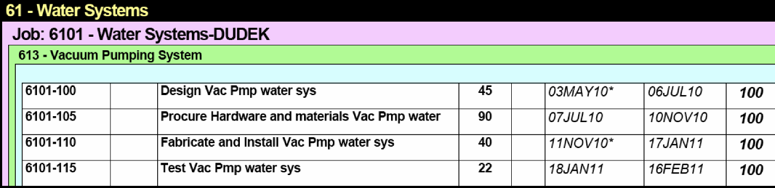

SC Project Review of NCSX, April 8-10, 2008
L. E. Dudek - page 10

Water Systems Risk and Uncertainty
Uncertainty of  the Estimate | Evaluation | Comment
Design  Maturity | Medium | Design not complicated, but  still in a conceptual stage
Design  Complexity | Low | Standard piping - off-the-  shelf components
Uncertainty  Range | -1 0%/+1 5%

No residual risk impacts were identified

SC Project Review of NCSX, April 8-10, 2008
L. E. Dudek - page 11

Gas Utilities Requirements

• Requirements
SC Project Review of NCSX, April 8-10, 2008
L. E. Dudek - page 12
Ð Flavors: Compressed Air, Vac. Vent
Ð Pressure: 90 psig , 14.7 psia
Ð Design: Copper manifold

Gas Utilities Interfaces

- Interfaces to the atmosphere outside the building
SC Project Review of NCSX, April 8-10, 2008
L. E. Dudek - page 13
(rooftop vent)
- Manifold around machine interfaces to the
platform for support
- Vent manifold interfaces to the vacuum vessel
pumping system

Gas Utilities Estimate

 | M&S | EMEM  hrs | EMTB  hrs | EASB  hrs
Preliminary Design |  | 60 |  | 80
Final design |  | 20 |  | 80
Installation |  | 40 | 322
Procurements | $24,398
Pre Ops Testing |  | 8 | 40

- Estimate: Use past experience on NSTX, Cost Estimating
Guide
- Work performed by PPPL Techs

SC Project Review of NCSX, April 8-10, 2008
L. E. Dudek - page 14

Gas Utilities Schedule
• Design work starts Oct 2010
- Installation is completed in Apr 2011 in time for
Vacuum System Ops
- This work is off the critical path by 134 days
Dur Start Finish Float
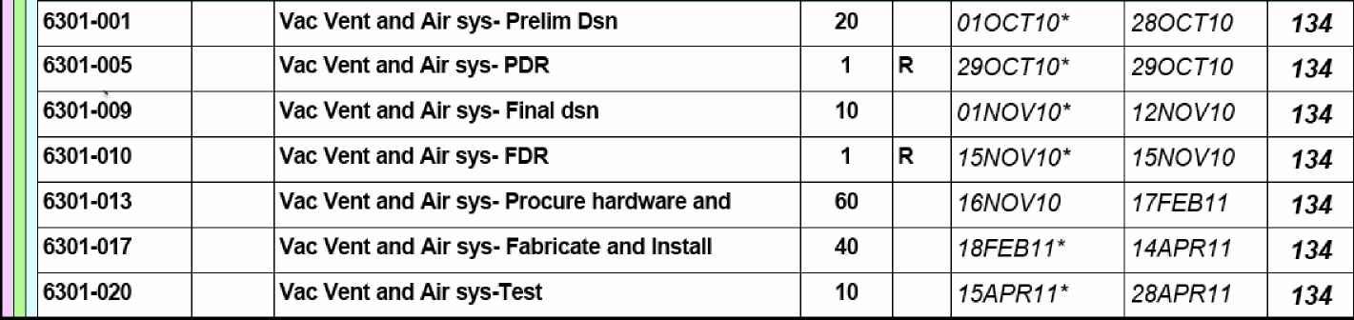
SC Project Review of NCSX, April 8-10, 2008
L. E. Dudek - page 15

Utility Systems Risk and Uncertainty
Uncertainty of  the Estimate | Evaluation | Comment
Design Maturity | ^{Medium} | Design not complicated, but  still in a conceptual stage
Design  Complexity | Low | Standard piping - off-the-  shelf components
Uncertainty  Range | -10%/  +15%

No residual risk impacts were identified

SC Project Review of NCSX, April 8-10, 2008
L. E. Dudek - page 16

