NCSX Startup (WBS 85)
SC Project Review of NCSX, April 8-10, 2008
C. A. Gentile
C.A.Gentile
NCSX CD-4 Startup

NCSX Startup
- WBS 85 Objective = Safely bring NCSX on-line
SC Project Review of NCSX, April 8-10, 2008
C. A. Gentile 2
- Concerns = People Safety, Environmental Safety, Machine Safety
- WBS 85 has two main components = Documentation + Safe Startup
- Startup Strategy = 10 week Startup Plan w/ First Plasma @ week 7
- Startup Documentation = Slides 7 & 8
- Startup Staffing and Positions = Slide 9
- Basis of Startup cost & staffing requirements = TFTR (during D-T transition),
NSTX
- Risks and Mitigation = Slide 10
- Strong emphasis on pre-operational system testing and Activity Certification
Committee (ACC) reviews. ACC is an independent cognizant group made up of
PPPL and PSO membership. ACC performs detailed technical reviews including
physical walk-down of reviewed system(s). Successfully implemented during NSTX startup.

What Startup Will Demonstrate
* Ohmically heated (first) plasma
SC Project Review of NCSX, April 8-10, 2008
C. A. Gentile 3
- 1.4 m major radius
- > 0.5 T magnetic field
-> 25 kA plasma current
- coils operated at cryogenic temperatures
- modular coils operated at 12 kA
- TF coils operated at 2 kA
-PF coils operated at 3 kA
-PF5 & PF6 operated at 2 kA
- central solenoid operated at 12 kA
- ability to maintain high vacuum in vv
- ability to bake at 150 C
- ability to perform (multiple) e-beam (surface) mapping
* see Hutch Neilson presentation for additional startup parameters

WBS 85 Schedule - 1
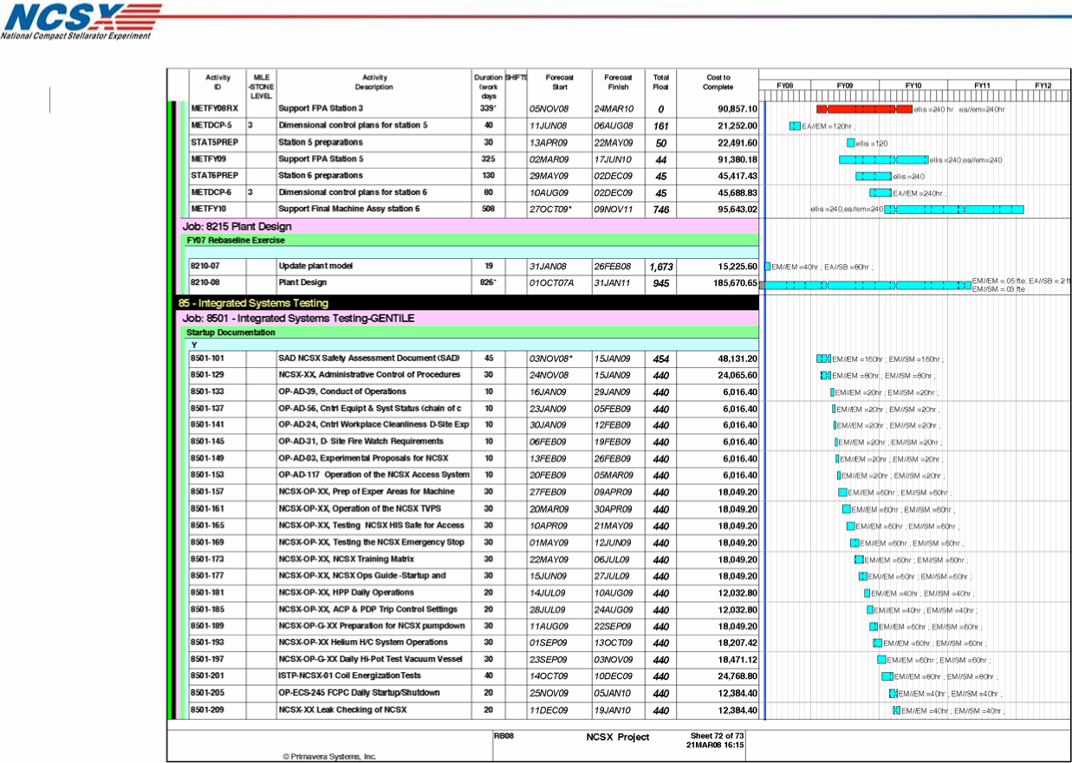
ISTP
SC Project Review of NCSX, April 8-10, 2008
C. A. Gentile 4

SC Project Review of NCSX, April 8-10, 2008
C. A. Gentile 5
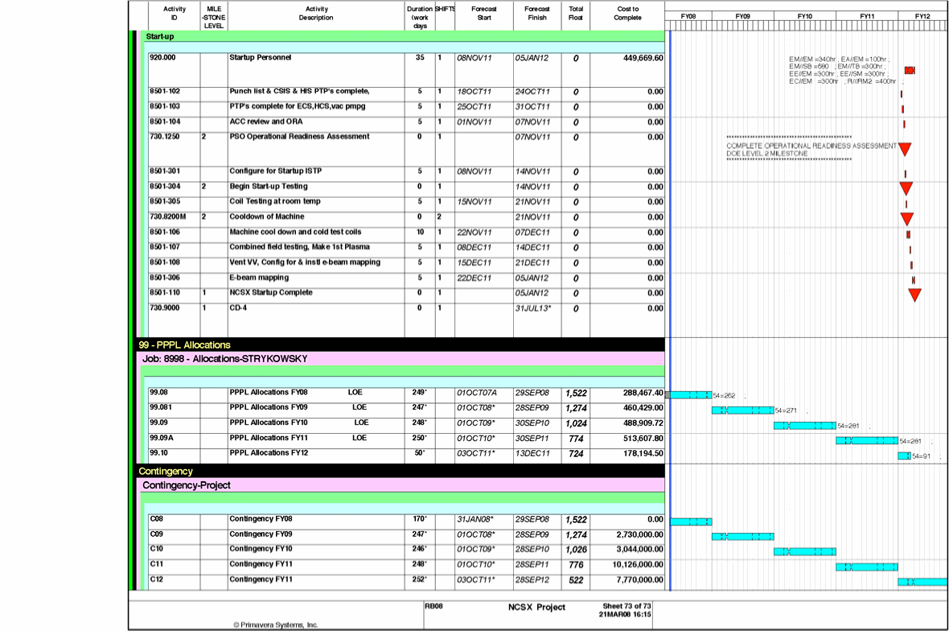

Subsystem PTPs
Walk down of NCSX by
Construction Manager & Startup
Test Director
Items NCSX Transferred to Test
Director
Close out
Punch List
Subsystem PTPs Complete
NCSX Construction Complete
NCSX Operations
Issuance of Amended Safety
Certificate
Commence e-beam Mapping
First Plasma
Startup Activities
Commence
Commence Coil ISTP
Cryostat Filled
NCSX Configured for
Operational Control
ES&H Executive Safety Board
Approval
Issuance of a Limited Safety
Certificate for First Plasma & e-
beam mapping
ORA Review & ACC Review and
Walkdown
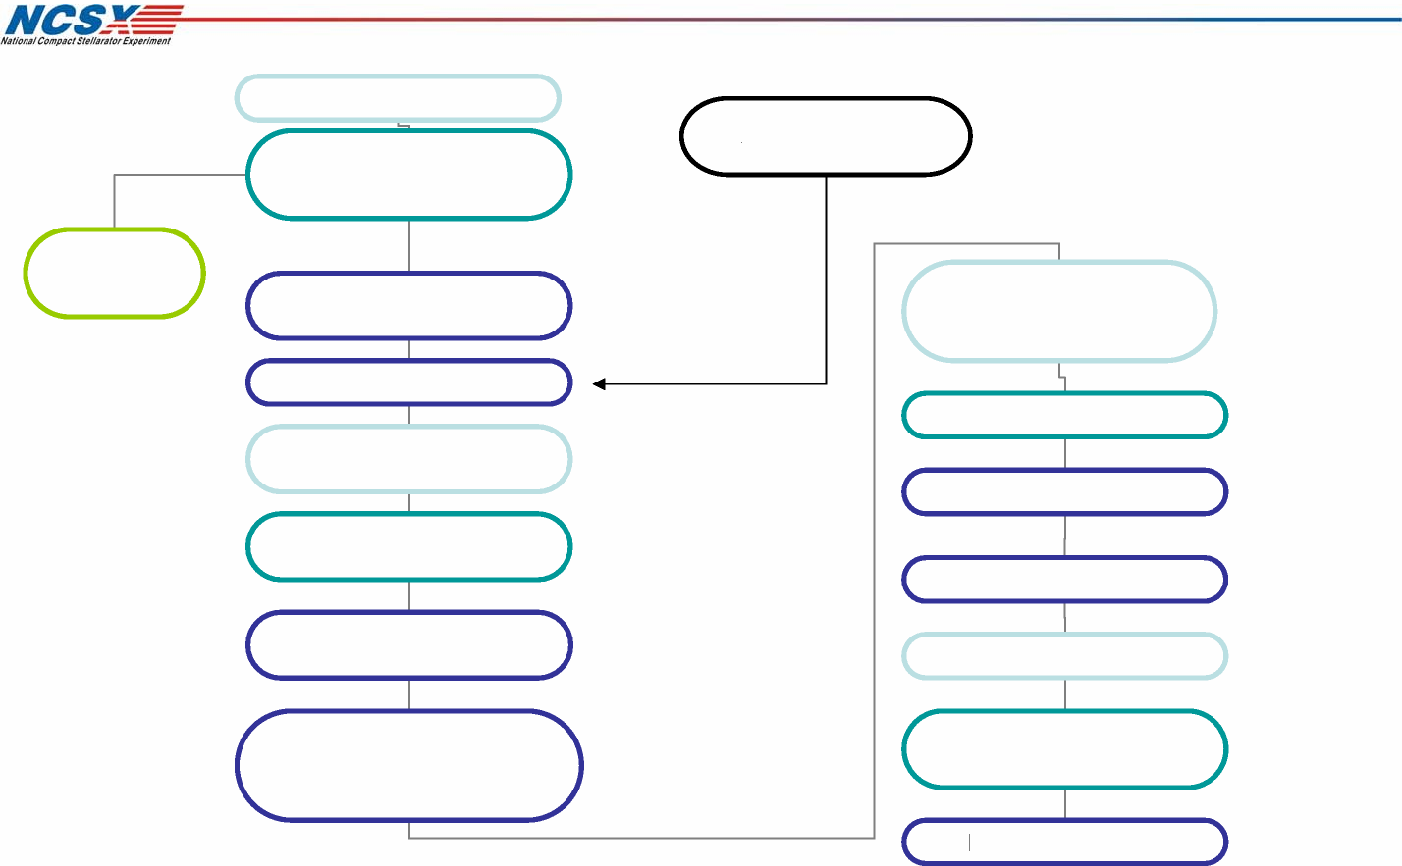
SC Project Review of NCSX, April 8-10, 2008
C. A. Gentile 6
Startup Flow Chart

Documentation needed for Startup
- NCSX Safety Assessment Document ( SAD)
SC Project Review of NCSX, April 8-10, 2008
C. A. Gentile 7
- NCSX Integrated System Test Procedure (ISTP)
- Completed (sub-system) Pre-operational Test
Procedures (PTP)
- NCSX Configuration and Interface Control Procedures
- NCSX Training Matrix
- First Plasma sub-system support procedures
Torus VV pumpdown, cryo operations, search & secure
procedures, power system procedures, coil operating
procedures, bakeout procedures, control system
procedures.

Startup Documentation Effort
• Documentation Costs = $345 K
SC Project Review of NCSX, April 8-10, 2008
C. A. Gentile 8
- Documentation Development Team
- Engineer @ 28.5 weeks ( 1140 hours )
- Senior Lab & Shop @ 28.5 week ( 1140 hours )
- Total for documentation development = 2280 hours
- Equivalent ~ 1.10 person years of effort

Startup Staffing and Positions
• Startup Team costs = $ 450 K
SC Project Review of NCSX, April 8-10, 2008
C. A. Gentile 9
- (1) Test Director = 10 weeks @ 100 % FTE
- (1) Chief Operations Engineer = 10 weeks @ 85 % FTE
- Project Engineer = 10 weeks @ 75 % FTE
- Machine Technicians = 10 weeks @ 85 % FTE
- (1) FCPC Technician = 10 weeks @ 75 % FTE
- (1) Cryo System Technician = 10 weeks @ 75 % FTE
- (1) AC Power Engineer = 10 weeks @ 75 % FTE
- (1) Computer Engineer = 10 weeks @ 75 % FTE
- Total Startup hours = 2720 hours
- Equivalent ~ 1.3 person years of effort to safely startup NCSX

Risks & Mitigation
- Incorrectly connecting power supply to coil leads -
SC Project Review of NCSX, April 8-10, 2008
C. A. Gentile 10
Coil leads to be clearly designated prior to startup,
low power compass test.
- Ground Faults - Check for ground fault conditions
during assembly (pre-startup) to mitigate impact on
startup.
- Loop Faults - Check for loop faults during assembly
(pre-startup).
- Control System - Pre-test wave forms and clock
cycles to ensure control system operation.
- Loss of sub-system components (i.e., pumps ) -
repair / replace.

Conclusion
- Based on the startup of similar machines at PPPL NCSX
SC Project Review of NCSX, April 8-10, 2008
C. A. Gentile 11
startup requirements are understood. Good experience
base and support for e-beam mapping from colleagues at
ORNL, UW, Auburn.
- NCSX startup concerns are mostly about safety (people,
environment, machine).
- Success of startup the result of prerequisite PTP’s, ACC
reviews, ES&H Executive Safety Board review, safety
certificate issuance, closing out post construction punch
list items.
- Completion of NCSX ISTP will transition the machine
from startup to operational.

