NCSX Coil Services
SC Project Review of NCSX, April 8-10, 2008

P.L. Goranson
Work Package 161, 162, and 163

Coil Services System Description
The coil services consist of the cryogenic feeds and electrical leads
SC Project Review of NCSX, April 8-10, 2008

inside the cryostat, serving all of the coils, including conventional.
It includes the specification of requirements
for the coil protection system.
Lower-level elements include:
LN2 Distribution System (WBS 161);
Coil Electrical Leads (WBS 162); and
Coil Protection Requirements (WBS 163)

SC Project Review of NCSX, April 8-10, 2008
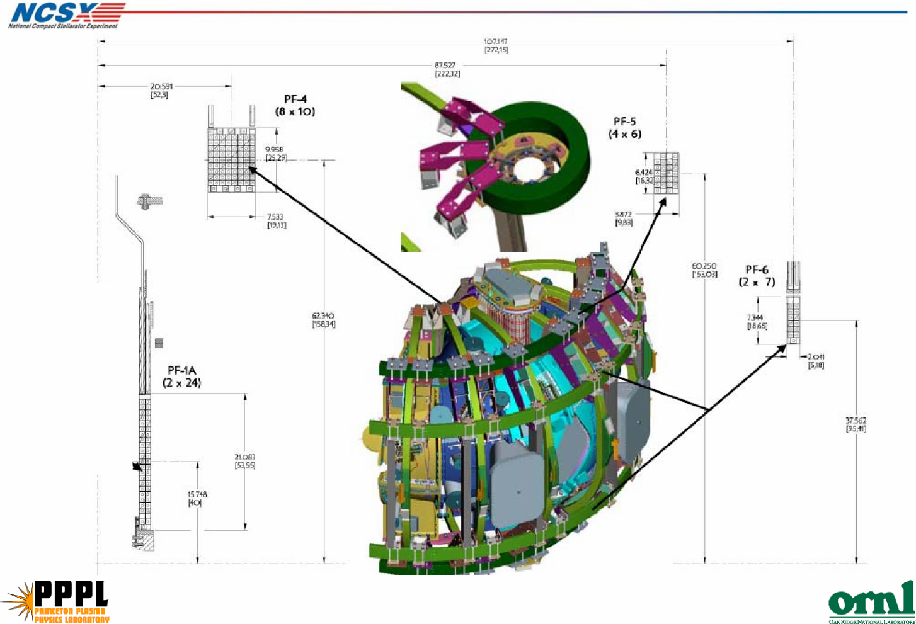
NCSX Coils

WBS 161 LN2 Distribution System
Description
SC Project Review of NCSX, April 8-10, 2008

This element covers the distribution of liquid nitrogen (LN2) coolant within
the cryostat. The system serves all the actively cooled coils:
TF (WBS 131)
PF (WBS 132)
Modular (WBS 14)
Scope
Work includes engineering design, procurement, and fabrication of
manifolds, cooling hoses, jumper hosing, valving, and associated supports.
Work in this WBS ends with delivery of components to machine assembly
operations.
Interfaces
I&C is procured in 1408. WBS161 includes routing and distribution of
coolant between coil input/output terminations and the supply/return
manifolds. WBS17 provides supply/return headers and hook up interfaces
in the Cryostat. Valves are included in WBS1 61.

PF1a coils from
NSTX are baseline
Baseline Configuration
Upgrade Configuration
- Baseline is PF1a, PF4, PF5, and PF6 (2 each, upper and lower).
- Device can be upgraded if desired, where PF1a is replaced by PF1, PF2, PF3.
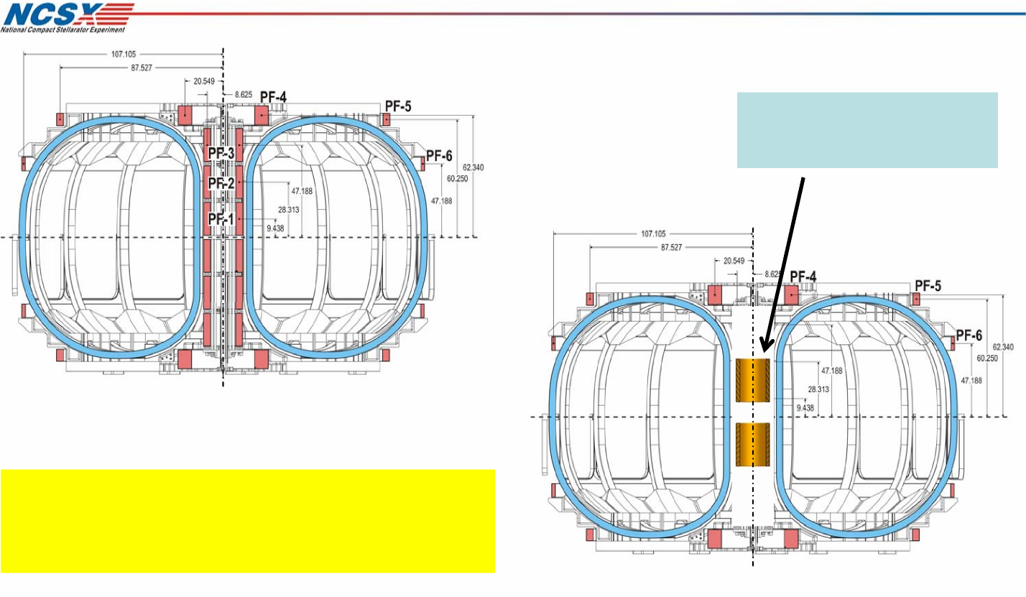
SC Project Review of NCSX, April 8-10, 2008

Central Solenoid, TF, and PF
Configurations

Modular Coil and Conventional Coil Cooling
Requirements
SC Project Review of NCSX, April 8-10, 2008

- Operate at 77 K with LN2.
- Operating pressure minimum 5 atmospheres absolute.
- Electric breaks in MC coil coolant lines poloidally.
- Electrical current limitation between cooling components. (bypass resistors
isolate hoses to ground)
- TF and PF hoses electrically isolated at coil terminations as
well as headers
- Provide flow balance between systems.

PF Coil pair 4,
5, or 6
1-6
2 1
1 2
4
1
48
5 6 7 45 46 47
1 2 3 4
TF Coils
1 2 34561 2
Supply Header
One side of a Modular Coil shown
Poloidal break
Insulated jumper
PF (4, 5, 6)
TF
PF1
MC
Outer
Inner
Return Header
PF Coil pair
TF Coils
2 1 2 14
1
1 2 3 4 56 745464748
Spares
1-14
PF pair
MC hook up 1-48
Return Header
Flow balance
Dual supply and return manifolds
- Individual controls are not required, a single valve in MC return balances both manifolds
- Valve and monitoring is outside cryostat where it is accessible - Individual circuits are passively (self) balanced
Costs reflect design in
Cooling System Diagram shown below
plg 3/20/08
SC Project Review of NCSX, April 8-10, 2008
Cryostat Boundary
PF Coil pair 1, 2, or3
MC hook up 1-48
Spares
1-14
Field Period Supply Header
1 2
23456
Resistor
G-10 Insulator
Flow volume
1-6
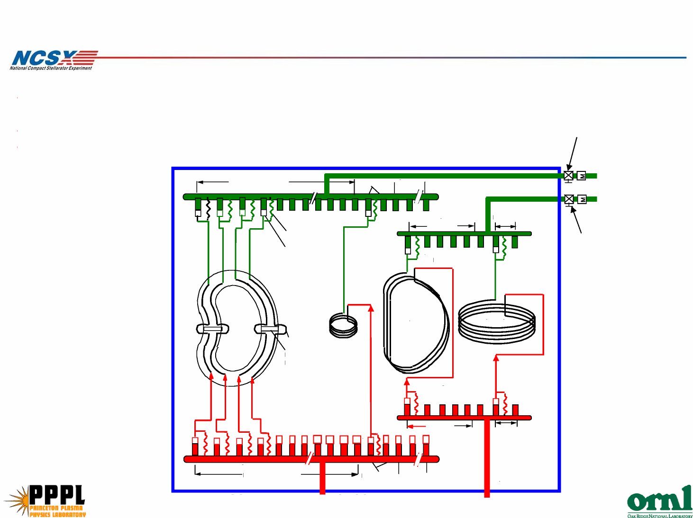

Flow distribution
PF1A is used in CD4, replace by PF1, PF2, and PF3 in future operation.
SC Project Review of NCSX, April 8-10, 2008
P. L. Goranson - page 8

Pressure drops fall in two well defined groups.
 | ID  (in) | Length of  tracing  (ft) | Length of  hose  (ft) | Minimum  flow required  (gpm) | Actual flow  (gpm) | Pressure  drop  (atmos)
MC | 0.18 | 4 | 18 | 1.1 | 1.2 | 2.42
PF1 | 0.354 | 304 | 24 | 1.1 | 1.1 | 2.42
PF2 | 0.354 | 304 | 24 | 1.1 | 1.1 | 2.42
PF3 | 0.354 | 304 | 24 | 1.1 | 1.1 | 2.42
PF1A | 0.354 | 178 | 24 | 1.1 | 1.2 | 2.42
spares |  |  |  | 0.5 | 0.5 | 2.42
PF4 | 0.354 | 861 | 21 | 1.1 | 1.4 | 4.51
PF5 | 0.354 | 1100 | 21 | 1.1 | 1.2 | 4.51
PF6 | 0.354 | 786 | 18 | 1.1 | 1.4 | 4.51
TF | 0.312 | 355 | 18 | 1.6 | 1.6 | 4.51

manifold
• Manifolds lie outside TF coils
- supply near bottom of VV
- return near top of VV
SC Project Review of NCSX, April 8-10, 2008
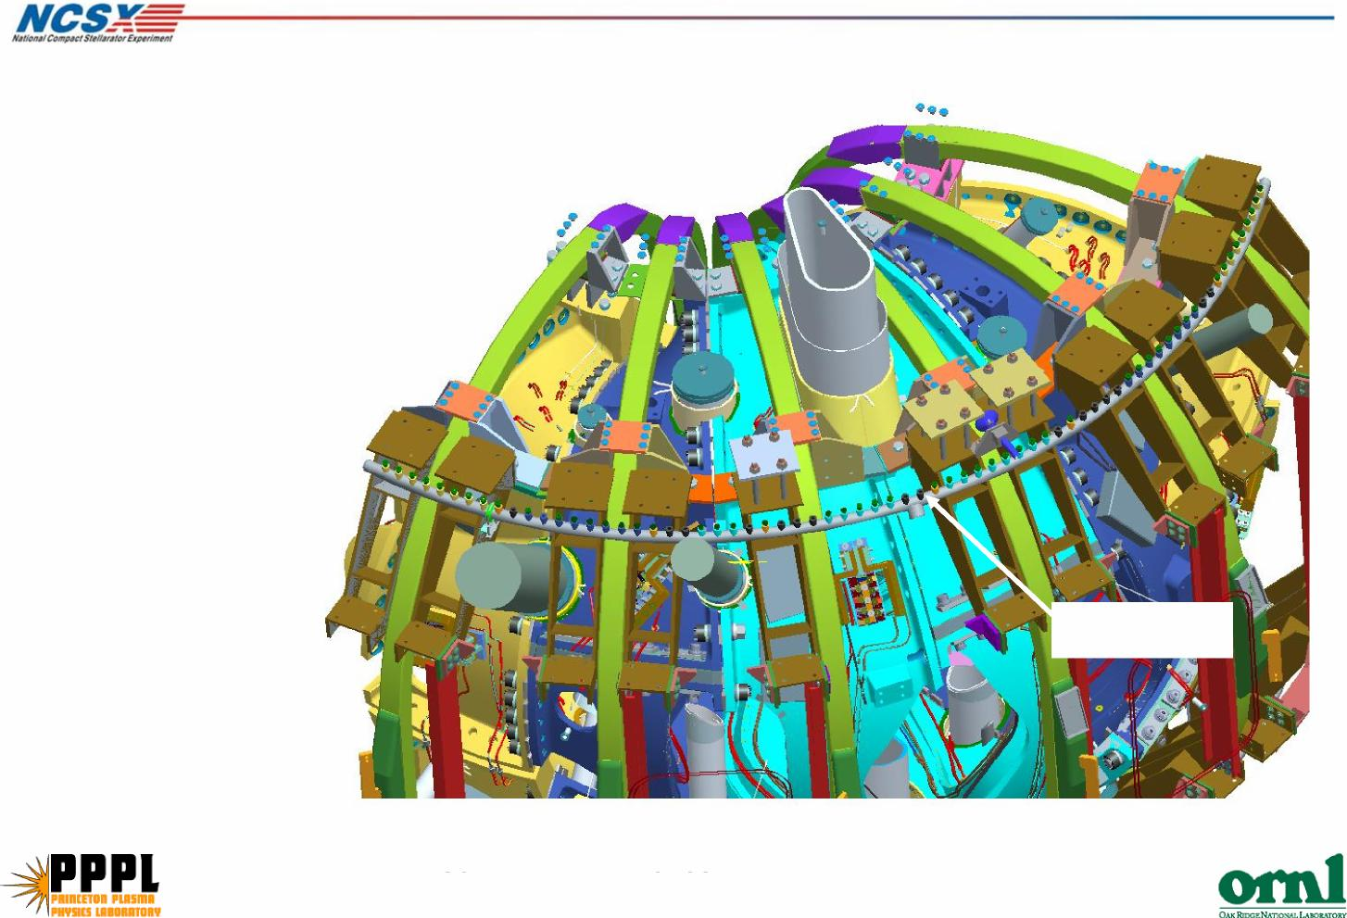
Typical manifold

Transition to flex hosing at the winding form
Manifold Jumpers
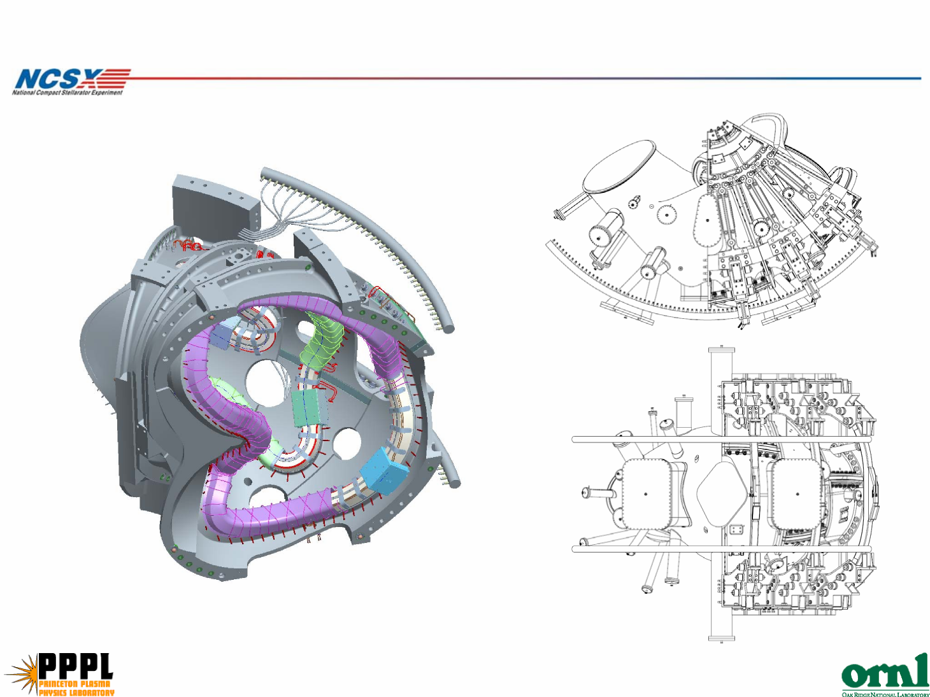

Resistor
G10 CR Male / Female coupling
316 SS Yor-Lok 5/16 OD tube one end and 1/4J NPT on other end
316 SS braided hose with 5/16 OD straight tube coupling at both ends
Hoses are isolated from the
manifolds by G10 plugs
- prototype will be tested
at 77K
-orientation of individual
connections is TBD
Manifold hose insulators
SC Project Review of NCSX, April 8-10, 2008
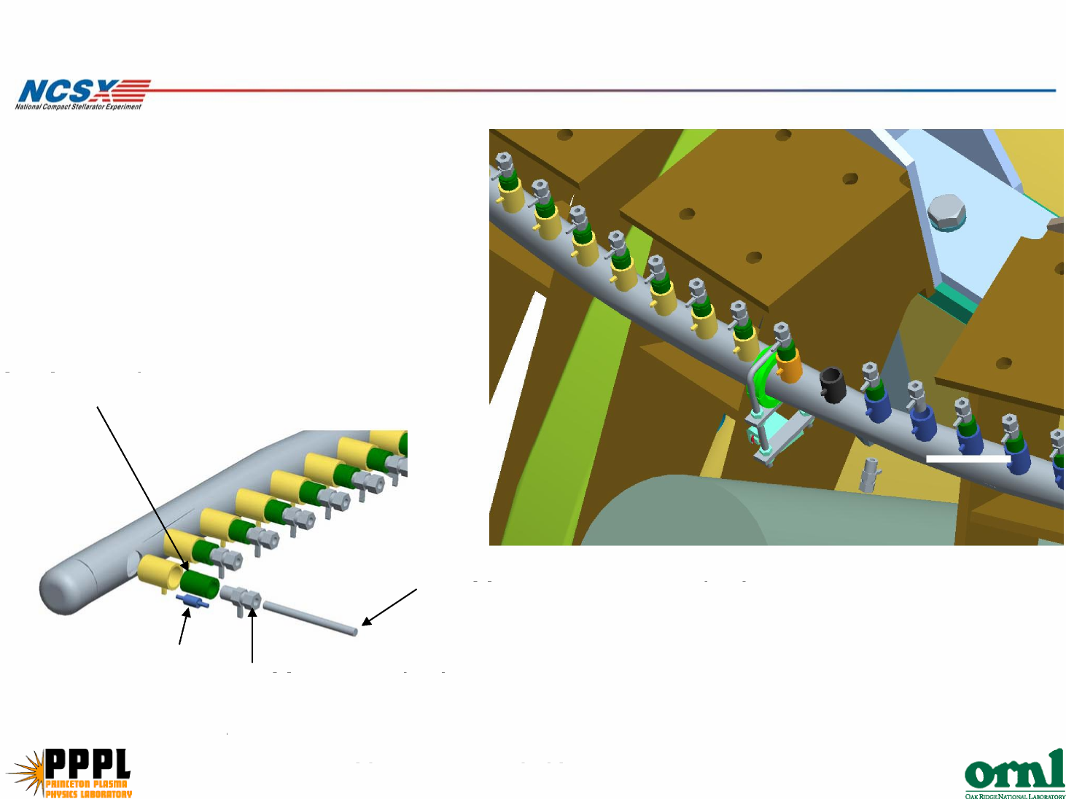

Cost Estimate Basis

- LN2 hoses are catalog items.
SC Project Review of NCSX, April 8-10, 2008
P. L. Goranson - page 12

– Lengths are based on ProE models.
- Manifold designs and prices are based on a similar design used
on the VV.
– Sizing is based on thermo hydraulics performed by
Engineering.
- Material cost is estimated on a $ per lb at current market.
- Supports are based on a $/length of hose.
- Engineering time is based on number and type of drawings for
each element, specifications, and the analyses anticipated.

s i m u l
a t i
o

Description:
Labor

This effort covers all R&D, Title I, II, and III engineering for the LN2 distribution system inside the cryostat,which includes all the necessarymanifolding
w
n
and connections to interface with the ex-cryostatLN2 supply system. This system will be fabricated in-house by PPPL. All Title III engr associated with installation is included in WBS 7.

p e s s u r |  |  | 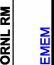 |  |  |  | 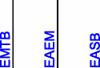

HOURS
Number of
Units Hours
Task ID Multiplier Unit
Title I an II Design

Pro-E models (avg) 8 hrs/model 21 168 168
o
SC Project Review of NCSX, April 8-10, 2008
f
t

i
assy dwgs 16 hrs/dwg 24 384 384
z
Detail drawings 8 hrs/dwg 13 104 104
e
installation dwg 16 hrs/dwg 14 224 224
d
cooling schematic 20 hrs/dwg 1 20 20
electrical schematic 0 hrs/dwg 1 0 0
L
I&C schematic 20 hrs/dwg 1 20 20
stress analysis 40 hrs/calc 1 40 40
N
²
thermal analysis 40 hrs/calc 1 40 40
special analysis (electromagnetics) 160 hrs/calc 0 0 0
fab specifications 160 hrs/spec 2 320320
a
preliminary and final design reviews 80 hrs/rev 2 160 160
n
Resolve PDR Comments | 40 hrs/PDR 1 40 40  d

meetings/reporting/presentations 10% % of tot hrs 152 152
Subtotal Title I & II Design 1672 1672 0 0 0 0 0 0 0
v
R&D Activities  R&D pressure drop simulation with pressurized LN2 and valve. Design of test unit. | a l  40 40  v  e
.
 |  | 38 | 0 | 0 | 0 | 0 | 0
104 | 0 | 0 | 0 | 0 | 0 | 0 | 0
0 | 0 | 40 | 40 | 0 | 0 | 0 | 0

Title III
g
n
222 0 104 0 78 40
i

Disposition of deviation requests and
non-conformances 1 hrs per 38 38
As-built drawings 2 # dwgs 52 104
Procurement coordination 80
0 0 0 0
Subtotal Title III Design

Total 1934

Materials and Supplies
Description:
SC Project Review of NCSX, April 8-10, 2008
P. L. Goranson - page 14

This effort covers procurement of materials for the LN2 distribution system by fixed price subcontract.
Assumptions:
outside engr rate = 120$ per hour
outside fab rate = 60$ per hour
outside inspection/technician rate = 80 $ per hour
MDL labor 80$per hour
Purchased parts:  coolant line pigtails from coils to manifolds Insulating Jumper hoses  Manifolds for cooling lines  valves  orifices & other hardware | $19,800 see notes below  $4,320  $9,085  $9,000 see notes below $10,000
Thermocouples $0 included in job 1408 for
R&D material and labor from below $18,000 the modular coil
subtotal, purchased parts $70,205 fabrication

Fabrication and Assembly

Description:

This effort covers all the fabrication of the LN2 system inside the cryostat including headers.
Worksheets

coolant line pigtails from coils to manifolds Average length of pigtail
Total
No. of coils
circuits per coil at header
total circuits
Total number of pigtails
 | 3 ft  TF Modular PF1 |  | PF2 | PF3 | PF4 | PF5 | PF6 | Trim
60 | 18 18 | 2 | 2 | 2 | 2 | 2 | 2 | 12
 | 1 8 | 0.5 | 0.5 | 0.5 | 0.5 | 0.5 | 0.5 | 0
168 | 18 144 | 1 | 1 | 1 | 1 | 1 | 1 | 0
336 | supply and return per circuit

Manifolds for cooling lines
SC Project Review of NCSX, April 8-10, 2008
P. L. Goranson - page 15

Assume 2 pairs of 1.5 inch manifolds for each field period, one above and one below the midplane inside the PF5 coil Each set of manifolds will have 1/3 of the required cooling connections plus 25% spare
The manifolds will connect via vertical pipes to the supply system below the cryostat
avg toroidal perimeter of field period 16 ft
avg vertical height of connection lines 9 ft
no of headers/FP 4
cost of tubing $15 per foot, 316 SSt
cost per field period $1,488
total number of coolant connections, all
headers 840
hours to weld each connection 0.5 hr per connection
shifts to form manifold tube 0.5 per manifold pair
crew size for forming 2
hours to cut vertical pipes 2 hrs per pipe
hours to weld vertical pipes to header 2 hrs per pipe
total shifts for manifolds 71
tech hours for manifolds 564 hours
technical oversight, inspection 141 hrs
total hours for manifolds 705 hrs

Schedule & Staffing

Schedule

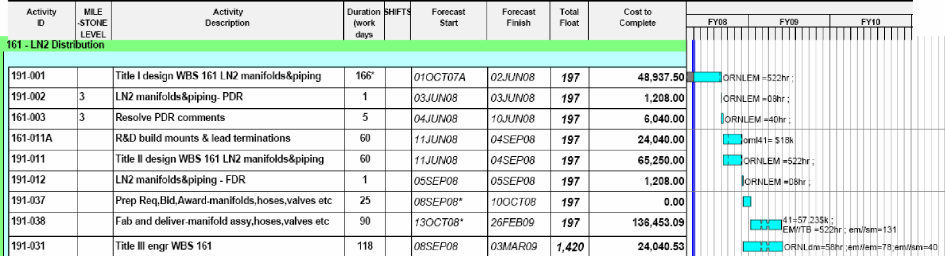
SC Project Review of NCSX, April 8-10, 2008
P. L. Goranson - page 16

Staff |  |  |  |  | Paul | Sorin | Scott
 |  |  |  |  | Goranson Homescu |  | Dixon | total | Total
 |  |  |  |  | 40% | 100% | 100% | work hours | WAF
Jobs | start | end | days | weeks | hrs | hrs | hrs | available | hours
leads(162) | 14-Mar | 1-Feb-09 | 324 | 46.3 | 692.6 | 1351.4 |  | 2044 | 2044
headers(161) | 1-Jan | 1-Oct-08 | 274 | 39.1 | 522.3 | 500 | 1565.7 | 2088 | 1934

Cost Estimate Risks
• LN2 Distribution System (WBS 161)
SC Project Review of NCSX, April 8-10, 2008
P. L. Goranson - page 17

Design is straight forward and procured items are by and large
commercially stocked. Manifolding is similar to gas system on VV,
which is complete and costs are well documented.
Maturity – medium
Routing and interfaces are in early design phase and design is pre
PDR. R&D required.
Complexity – low

Risk Mitigation
Schedule Milestones
SC Project Review of NCSX, April 8-10, 2008
P. L. Goranson - page 18

- An extra full time designer was assigned to Coil Services to assure schedule is met.
- Hoses will be 100% leak checked at delivery to prevent delays after installation. (lesson learned from VV)
Design Integrity
- R&D at MDL will confirm functionality of G10 insulators and flow rate in corrugated hoses.

WBS 162 Coil Electrical Leads
Description
SC Project Review of NCSX, April 8-10, 2008

This element covers the electrical leads within the cryostat, serving all the
coils: the TF, PF, External Trim (WBS 133), and Modular Coils.
Scope
Work includes engineering design, procurement, and fabrication of cables,
mounting brackets, thermal transition boxes, and associated supports. Work in
this WBS ends with delivery of components to machine assembly operations.
Interfaces
The WBS161 interface begins at coil terminations and ends at the cryostat
thermal transition/terminal box. It does not include I&C, bus work, or routing in
the test area.
Requires penetration of cryostat.
Share real estate used by core structural support, floor mounted utilities, bus
supplies, diagnostics, etc.

Lead Requirements
- Connect between bus supply in test cell and coil terminals inside
SC Project Review of NCSX, April 8-10, 2008
P. L. Goranson - page 20

cryostat.
- Operate nominally at 77-80 K but no active cooling is required, Cryo
environment is sufficient to return temperature to operating level
between shots.
- Provide Cryostat seal interface.
– Minimize icing
– Maintain positive pressure in Cryostat
- React internal magnetic loads.
- Cancel (minimize) field errors.

Status
- MC design is most mature.
SC Project Review of NCSX, April 8-10, 2008
P. L. Goranson - page 21

- To date, most of design effort has
concentrated in this area as it is the more
challenging.
- Conventional coils will be handled in a
similar manner and use similar
components.( cable, brackets, terminations,
spacers, etc.)

MC Lead Configuration
Cable is 250 MCM
SC Project Review of NCSX, April 8-10, 2008
P. L. Goranson - page 22

1” long spider/loom
Casting
Standard
1.5” Pipe Clamp
(1/8” thk x 1” Wide)
5/16” Stud
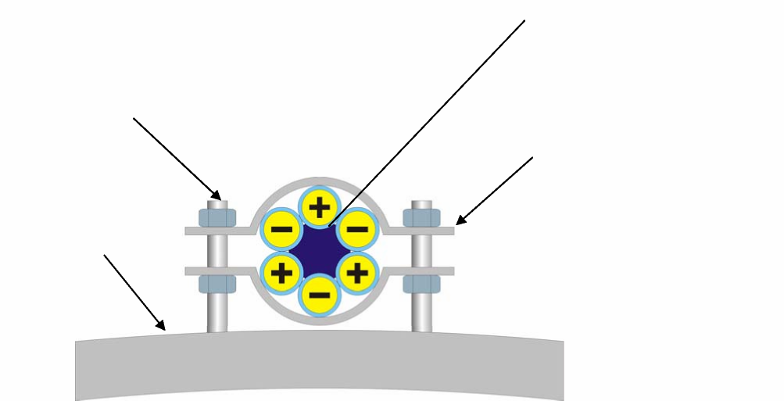

SC Project Review of NCSX, April 8-10, 2008
P. L. Goranson - page 23
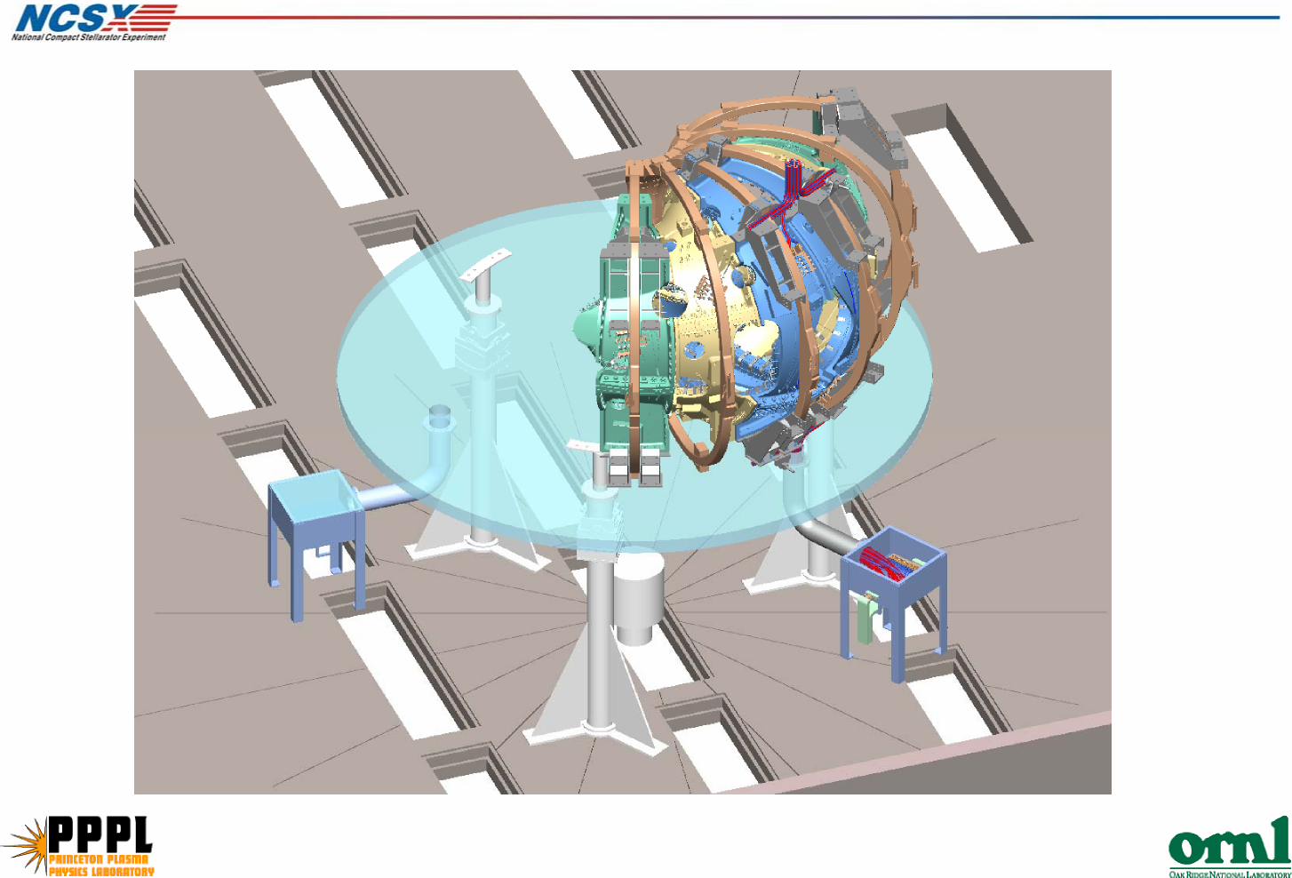
System Layout

MC leads
PF leads
TF & TC leads
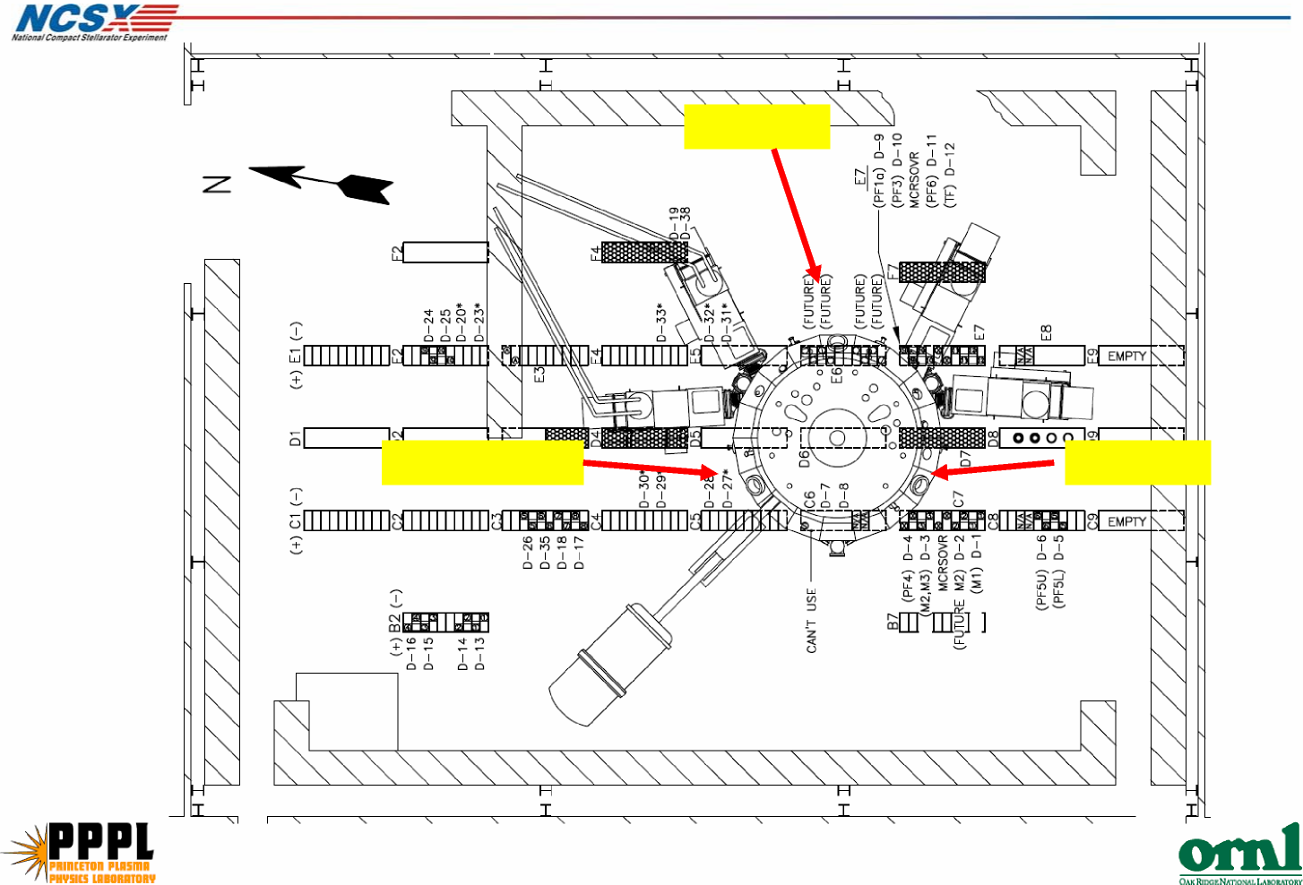
Service routing to test cell penetrations

MC Lead Stub Connections

MC A lead
stub
MC B lead
stub
SC Project Review of NCSX, April 8-10, 2008
P. L. Goranson - page 25
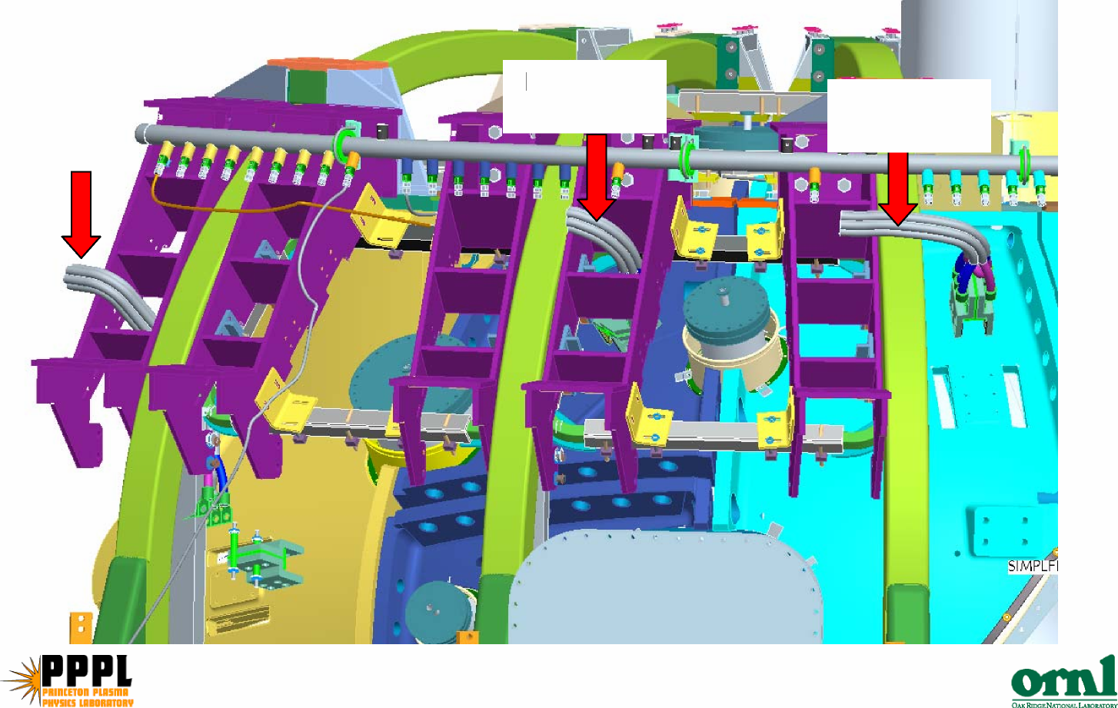

Lead Routing

Services will be routed to each of the three C-C
SC Project Review of NCSX, April 8-10, 2008
P. L. Goranson - page 26

interfaces.
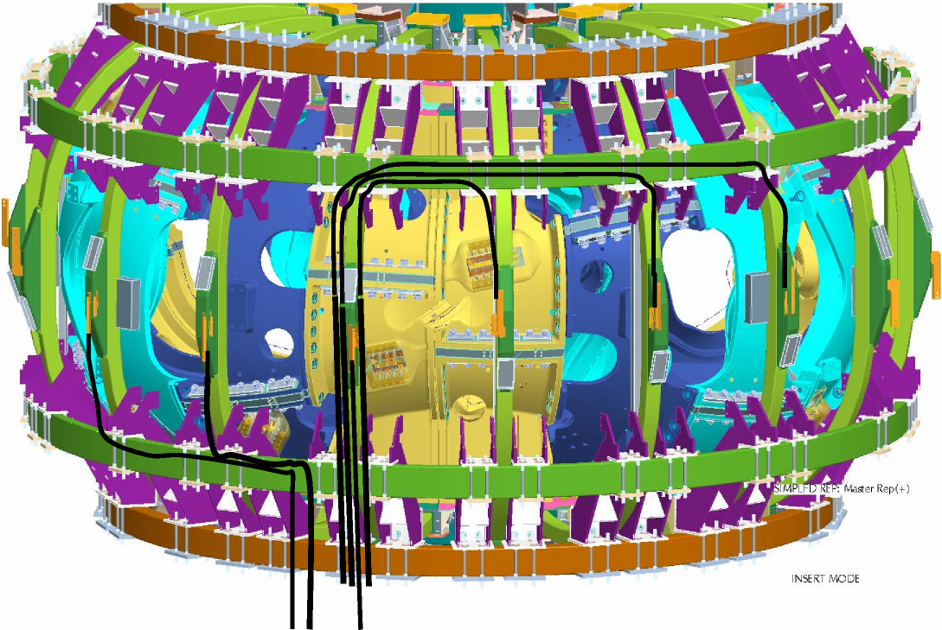

Hard Bus to
power supplies
Pipe Chase
Cryostat Floor Leads Junction Box
(Clear cover removed)
Top View of an 8” diameter pipe chase showing the
(6) modular coil leads cables from a field period
Leads transition thru the cryostat, to
room temp.
Modular coil Interface at Cryostat
SC Project Review of NCSX, April 8-10, 2008
P. L. Goranson - page 27
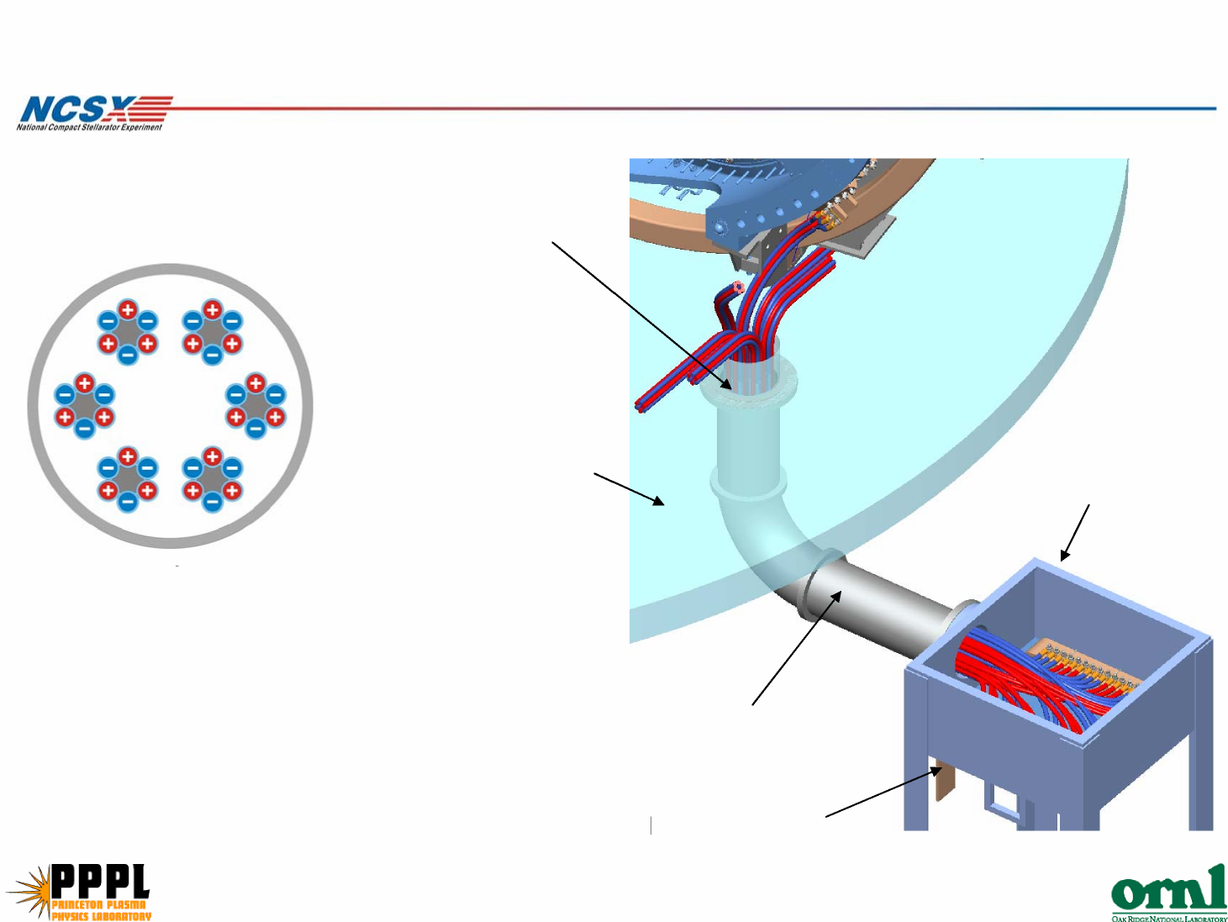

Cost Estimate Basis

- Cables are catalog items
SC Project Review of NCSX, April 8-10, 2008
P. L. Goranson - page 28

– Lengths are based on sketches in work sheet.
- Material cost of supports, spacers, and terminations is
estimated on either:
- $ per lb at current market or:
- $/length of cable.
- Engineering time is based on number and type of drawings for
each element, specifications, and the analyses anticipated.

SC Project Review of NCSX, April 8-10, 2008
Total 2042
HOURS
1892
172
40
40
40
40
24
0
0
112
0
464
320
240
400
84
8
10
8
110
84
8
10
8
40 40
172
40
40
40
40
24
0
0
112
0
464
320
240
400
Hours
Subtotal Title III Design
Title III
vendor inspection & oversight | 8 | hrs per | 1
Disposition of deviation requests and non- conformances | 0.5 | hrs/wk | 20
In-House fab/assy oversight & inspection | 2 | hrs/wk | 4
As-built drawings | 1 | hrs/dwg | 84

R&D Activities
R&D design time to build mounts (clamp, spider), lead terminations
Subtotal Title I & II Design
meetings/reporting/presentations
Resolve PDR comments
preliminary and final design reviews
Procuremnt Specifications
special analysis (electromagnetics)
thermal analysis
stress analysis
I&C schematic
electrical schematic
cooling schematic
installation dwg
Detail drawings
assy dwgs
Title I an II Design
Pro-E models (avg)
Task ID
Multiplier | Unit | Number of  Units
8 | hrs/model | 50
16 | hrs/dwg | 15
8 | hrs/dwg | 40
16 | hrs/dwg | 29
0 | hrs/dwg | 1
8 | hrs/dwg | 14
8 | hrs/dwg | 0
0 | hrs/calc | 0
24 | hrs/calc | 1
40 | hrs/calc | 1
40 | hrs/spec | 1
40 | hrs/rev | 1
40 | hrs/pdr | 1
10% | % of tot hrs

This effort covers all R&D, Title I, II, and III engineering design of the coil electrical leads inside the cryostat connecting the coils to the power supply bus or cables outside the cryostat.
Labor
Description:
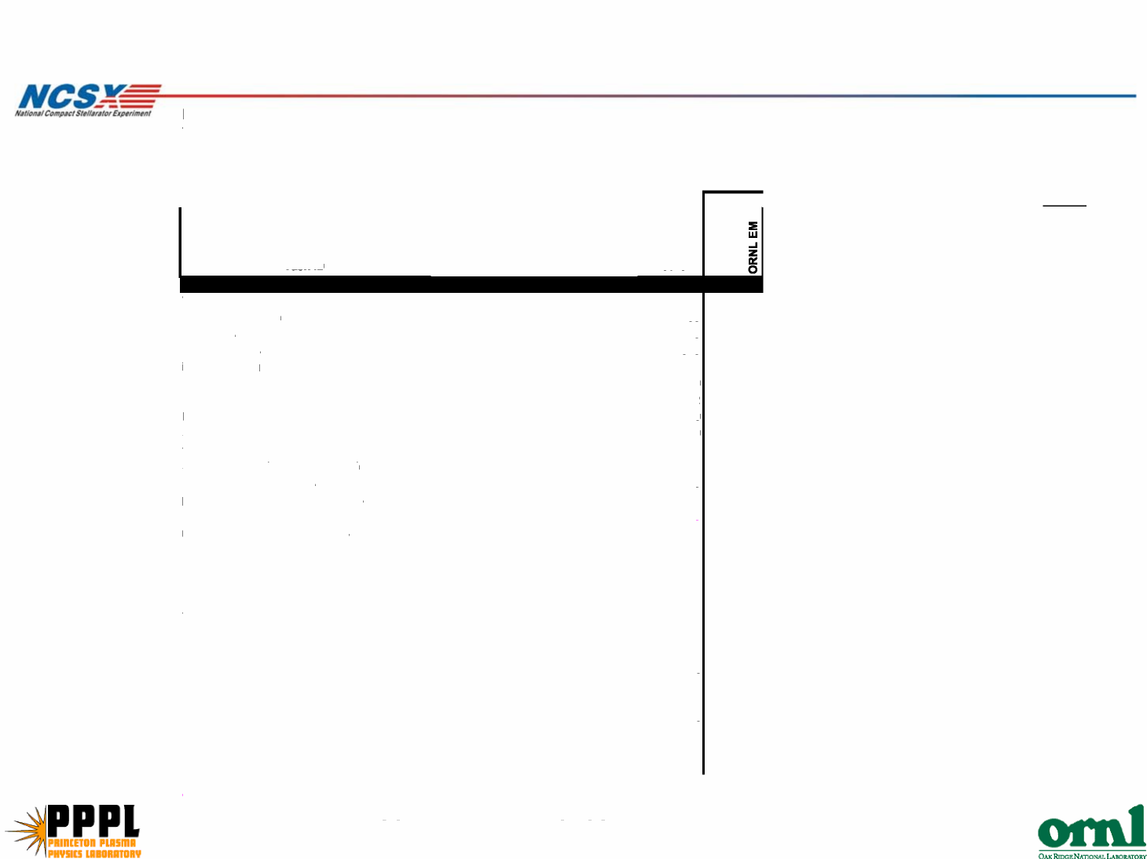

M&S
SC Project Review of NCSX, April 8-10, 2008
P. L. Goranson - page 30

Description:
This effort covers all coil leads that connect the coil terminals to the buswork at the boundary of the cryostat. Assumptions:
outside engr rate = 120 $ per hour
outside fab rate = 60 $ per hour
outside inspection/technician rate = 80 $ per hour
Purchased parts:
set of cables $32,552
misc attachment hardware $16,162 @10$/ft
thermal transition box material $0
subtotal, purchased parts | $48,715

Lead bundles consist of six, 250 MCM cable with teflon sleeve. Lead ends are cooled by bleed liquid nitrogen supplied by the coil coolant header (WBS 161) Leads connect from coil terminals to buswork at bottom of machine.
Each coil is connected separately except PF1 and PF2, which are connected in series within the central solenoid assembly

Schedule & Staffing

Schedule
SC Project Review of NCSX, April 8-10, 2008
P. L. Goranson - page 31

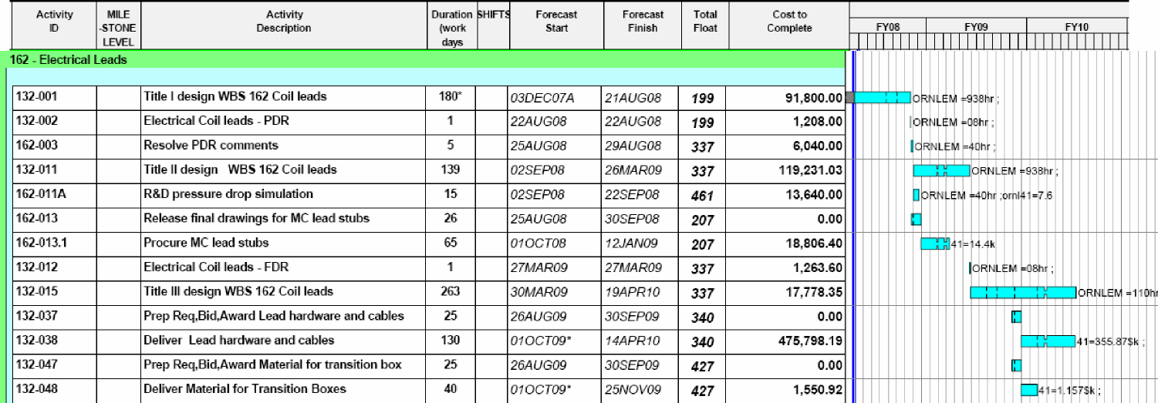
Staff
Paul G Sorin H Scott total Total
40% 100% 100% work hours WAF
Jobs start end days weeks hrs hrs hrs available hours
leads(162) |  |  | 14-Mar 1-Feb-09 324 46.3 692.6 1351.4 2044 2044

Cost Estimate Risks

Coil Electrical Leads (WBS 162)
SC Project Review of NCSX, April 8-10, 2008
P. L. Goranson - page 32

Maturity – medium
Routing and interfacing is in early stages of design.
Design of cables is not firmly established, satisfying field
error requirements could require more costly solutions and
longer lead time.
Complexity – low
Design is straight forward and large ticket procured items
(cable and mounts) are commercially stocked.
No complications such as active cooling are required.

Risk Mitigation
Schedule Milestones
SC Project Review of NCSX, April 8-10, 2008
P. L. Goranson - page 33

- The Designer was assigned to Leads full time and his LN2 System
responsibilities reassigned.
- Permitted acceleration of design schedule to assure
critical components (coil stubs) will be procured for Station
5 assembly.
- Field error calculations are being performed up front to minimize
the risk that designs will have to be redone.
Design Integrity
- The terminations and clamps will be prototyped at MDL to confirm
their design is acceptable.

WBS 163 Coil Protection System

Description
SC Project Review of NCSX, April 8-10, 2008

This element covers the specification of coil protection requirements for the
coil protection system.
Scope
Work covers Title I, II, and III Engineering support for development of the
system, including any drawings, electrical and I&C schematics, or analyses.
There is no design, fabrication, or hardware included under this package.
The results of thermal, electrical and mechanical analysis will be used to define
allowable operating limits for the coils for commissioning, normal research
operations, and fault conditions. Appropriate diagnostics and permissive,
alarm, and failsafe signals to the power supply controllers and I&C systems will
be defined.

20
40
0
40
0
0
0 120
0
0
0
0
0
0
meetings/reporting/presentations
preliminary and final design reviews
Procurement Specifications
special analysis (electromagnetics)
thermal analysis
stress analysis
I&C schematic
electrical schematic
cooling schematic
installation dwg
Detail drawings
assy dwgs
Title I an II Design Pro-E models (avg)
Task ID
Multiplier | Unit | Number of  Units Hours
8 | hrs/model |  | 0 | 0
24 | hrs/dwg | 120 | 0 | 0
16 | hrs/dwg |  | 0 | 0
16 | hrs/dwg |  | 0 | 0
0 | hrs/dwg |  | 0 | 0
8 | hrs/dwg |  | 0 | 0
20 | hrs/dwg | 120 | 4 | 80
0 | hrs/calc |  | 0 | 0
24 | hrs/calc |  | 0 | 0
40 | hrs/calc |  | 2 | 80
16 | hrs/spec |  | 0 | 0
40 | hrs/rev |  | 1 | 40
10% | % of tot hrs |  |  | 20

This effort covers all Title I, II, and III engineering for the Coil Protection System. No hardware is anticipated for this job, only design interface with WBS 4 and 5.
Description:
Cost
SC Project Review of NCSX, April 8-10, 2008
Subtotal Title I & II Design 220
100 120
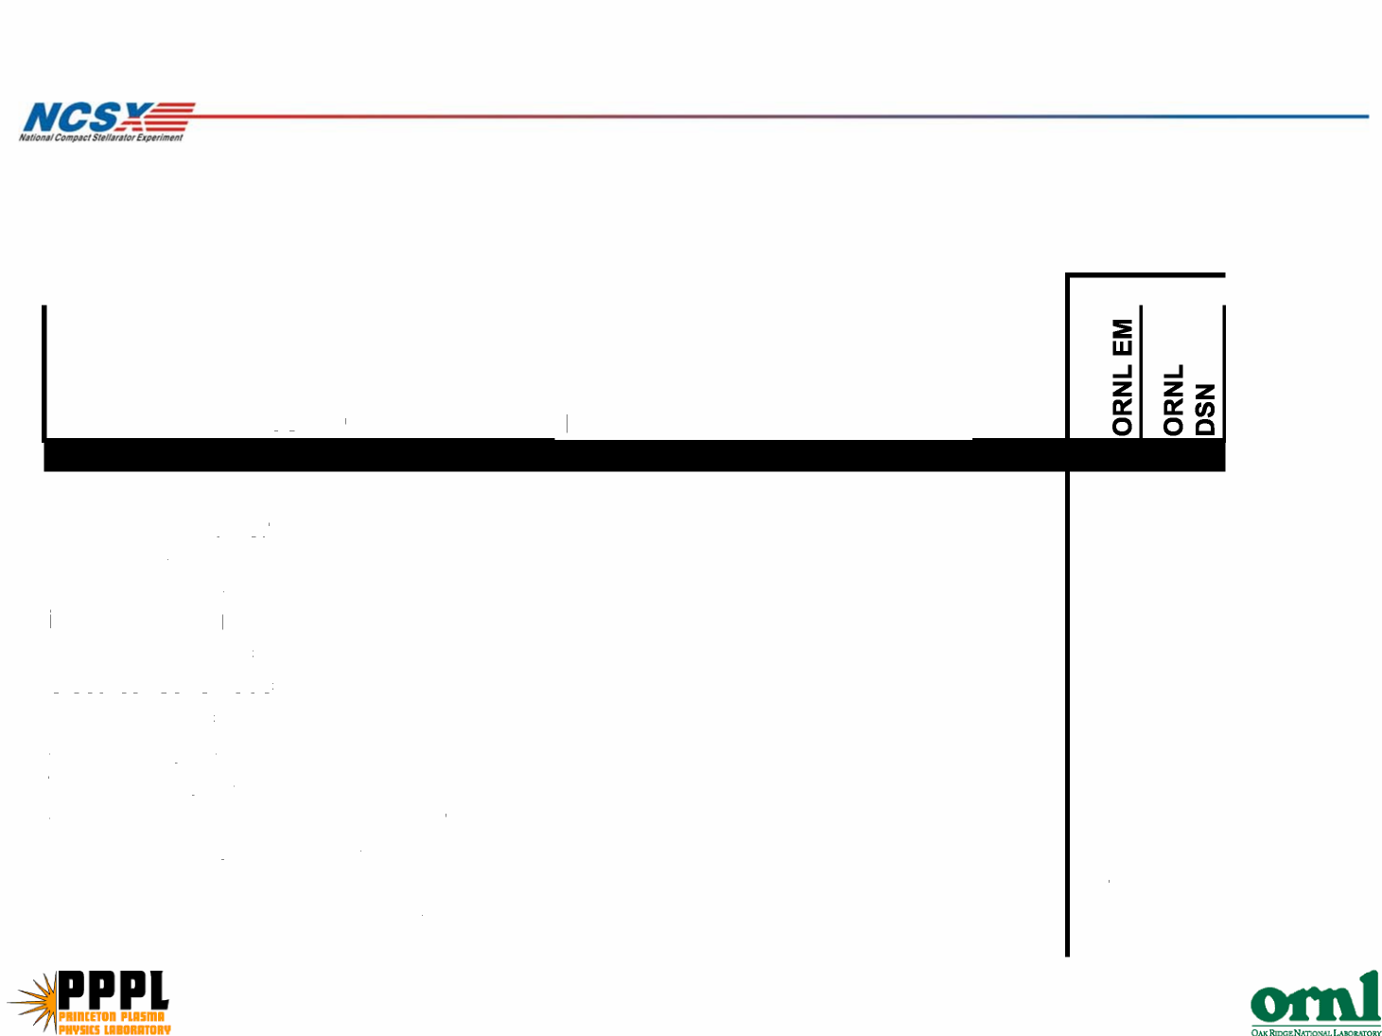

Schedule & Staffing
Schedule
SC Project Review of NCSX, April 8-10, 2008

Staffing
Jeff Harris – 270 hours in 2009

Cost Estimate Risks
Coil Protection Requirements (WBS 163)
SC Project Review of NCSX, April 8-10, 2008
P. L. Goranson - page 37

Maturity – low
Job is at conceptual design stage. It interacts simultaneously with a
several other WBS and relies on ongoing analysis. Number of
documents is not established.
Complexity – low
Specifications may be replaced with data sheets where procured items
are available as stock items.
Many parameters are supplied from other WBS areas and are already
available.
Protocols and systems must be compatible with both initial
commissioning and full research operations.

