NCSX Heater Control System
SC Project Review of NCSX, April 8-10, 2008
P. L. Goranson
Work package 1270

Outline
Updated 10/25/07 R. Gernhardt
SC Project Review of NCSX, April 8-10, 2008
P. L. Goranson - page 2
- Scope
- Requirements
- System Proposed
- Configuration
- Component details
- M&S and Labor cost details
- Total Cost (M&S and Labor)
- Schedule
- Risk and Mitigation

Scope
- Provide resistance heating temperature control system to
SC Project Review of NCSX, April 8-10, 2008
P. L. Goranson - page 3
maintain the NCSX inner port extension wall temperatures
during standby and bake out operation.
- Monitor temperatures of the vacuum vessel body and port
extensions during standby and bake out operation.
- Send temperature data to Central I & C for archival and
interface to other disciplines.

Requirements-1
Criteria
SC Project Review of NCSX, April 8-10, 2008
P. L. Goranson - page 4
- Monitor the VV temperature during standby and bake out operation.
- Operation range - room temperature to 375 C
- The leads must be insulated from all structure including VV and Cryostat.
- The signal conditioners must be the isolated type. Additionally, the instrument cabinet will be isolated from ground by insulation and isolation transformers.
- Each heater must be capable of continuous variable operation from 0 - 200 watts. Interfaces
- Provisions must be provided by WBS 171 for future hookup of additional thermocouples when outer port extensions are added. The interfacing electrical system must be capable of upgrade to accommodate the upgrade.
- WBS 12 will be responsible for overall design of the system including choice and location of components, mounting provisions, lead routing, signal conditioning, and electrical isolation.
- WBS 12 will be responsible for coordination of the thermocouple design with the other interfacing disciplines (WBS 171 and WBS 5).
- For purpose of assigning interface responsibility, the WBS 4 responsibility shall end at the power panel.

Requirements-2

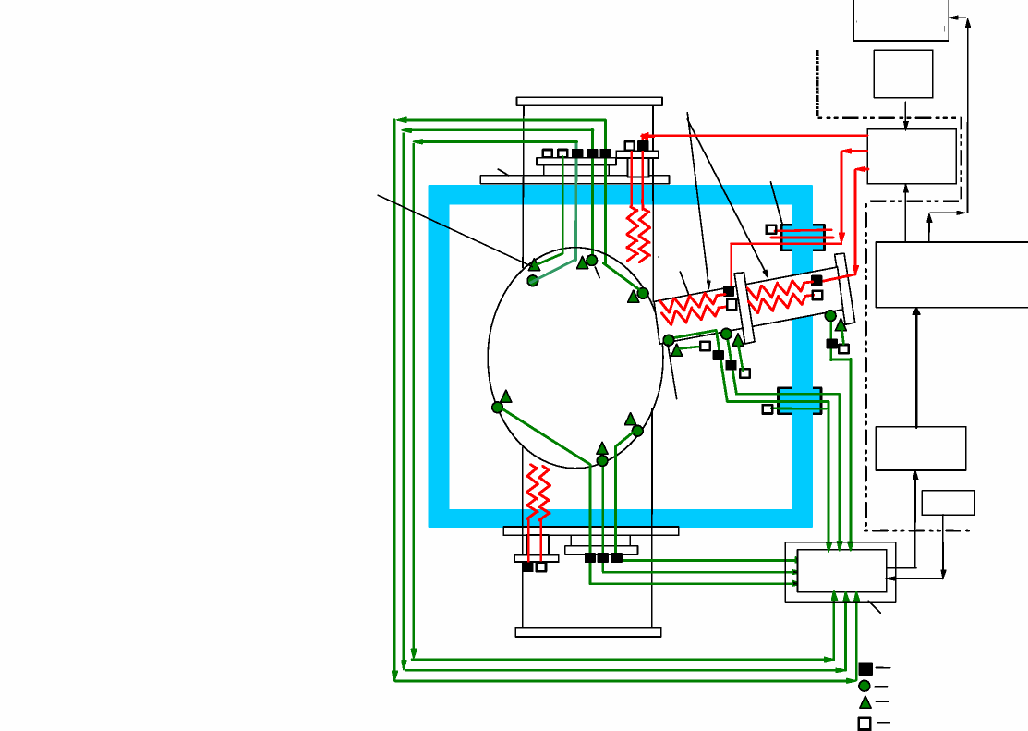
Coolant
Tube System
VERTICAL PORT
WBS 12
Interface
Heater Current Controllers
Heater Tape
Port Thermocouple
Power
CRYOSTAT BOUNDARY
Signal Conditioner
Electrical Isolation
Connectors Thermocouples
Connector not hooked up
Interface Block Diagram:
Diagnostic Flange (WBS 12)
CRYOSTAT BOUNDARY
VV Body Thermocouple
VACUUM VESSEL
Typical Inner and Outer Port Extension
Feedthrough (WBS 7)
WBS 12 Interface
Temperature
Monitor
Process/Temperature Programmable Controller
Heater
Power
Supply
SC Project Review of NCSX, April 8-10, 2008
P. L. Goranson - page 5
VACUUM VESSEL TEMPERATURE CONTROL | plg 4/08/05

- Provides for:
SC Project Review of NCSX, April 8-10, 2008
P. L. Goranson - page 6
– 120 Channels of Active Heater Temperature Control Zones
- 114 heating control zones (channels) requested.
– 282 Channels of Thermocouple monitoring points
- 279 (expandable) temperature monitoring points
requested.

- PLC based temperature control of heaters:
SC Project Review of NCSX, April 8-10, 2008
P. L. Goranson - page 7
– Rockwell Control Logix Platform
– Networking
- Control Net for PLC I/O and Local Programming/Control
- TCP/IP interface to Central I&C for data exchange. May use Rockwell
software.TBD
- Ethernet/IP network for Remote system control operator interfaces.
– Software
- RSLogix 5000 PLC programming software. PC platform
- RSView32 or SE MMI software---TBD. PC operator interface.

- Heater 120VAC control:
SC Project Review of NCSX, April 8-10, 2008
P. L. Goranson - page 8
– Zero crossing Time Pulsed Output (TPO) solid state relay supplies variable 120VAC pulse train to heater.
– TPO chosen to minimize RFI to diagnostics.
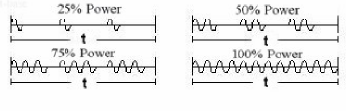
– Phased output SSR’s are noisy (i.e.. Standard lighting dimmers)
– Heater power limited by Variac.
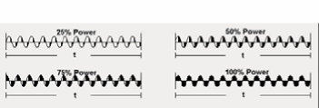
– Secondary SSR protects for thermal runaway (shorted TPO control SSR).
– One or more thermocouples provide feedback for each heating zone PID loop.
- Failed TC sets alarm, notifies operator and removes TC for heating zone mix allowing conditional heater zone control.

Sensor Specifications
- Thermocouples:
SC Project Review of NCSX, April 8-10, 2008
P. L. Goranson - page 9
– Ref: NCSX-PRL-1 2-003-00
- Type-E, Isolated, electrically floating junction Type-E, Isolated, electrically floating junction.
– Similar to type Omega XCIB-E-4-3-1 0.
- Heaters: – Manufacture: BriskHeat
- BIH series tapes are constant resistance type.
– Custom BIH Style Heating Tape: 1/2” W X 10 Ft. L, non-magnetic.
– Heavy Insulated Heating Tape, 520 Total Watts, 24” Leads Same End, Split Plug, 120 Volt. – Custom BIH Style Heating Tape: 1/2” W X 6 Ft. L, non-magnetic.
– Heavy Insulated Heating Tape, 310 Total Watts, 24” Leads Same End, Split Plug, 120 Volt

Control I/O M & S Costs

I/O M&S Total = $211,262

SC Project Review of NCSX, April 8-10, 2008
P. L. Goranson - page 10
NCSX Heater/TC Instrumentation and Control Component Parts List
Provides for 120 Heaters and 282 Thermocouples
Rev 1: 24 OCT 2007 R.Gernhardt
Item | Description | Mfgr | Model | unit cost | Qty | Item Cost | Comment | Source
 | PLC
1 | Logix 5560 processor with 2 M memory. (Is 2M enough?? | Allen-Bradley | 1756-L61 | $5,105.00 | 1 | $5,105.00 | memory size??? | Rumsey Electric
2 | Control Logix Chassis, 10 slot | Allen-Bradley | 1756-A10 | $542.00 | 8 | $4,336.00 | TBD | Rumsey Electric
3 | Control Logix Power supply, 10 A | Allen-Bradley | 1756-PA 72 | $805.00 | 8 | $6,440.00 |  | Rumsey Electric
4 | Controlnet interface module | Allen-Bradley | 1756-CNB | $1,312.00 | 8 | $10,496.00 |  | Rumsey Electric
5 | Control Logix Ethernet interface module | Allen-Bradley | 1756-ENBT | $1,760.00 | 1 | $1,760.00 |  | Rumsey Electric
6 | MODBUS-TCP/IP communications module for 1756 chassis | ProSoft | MV156-MNET | $2,228.00 | 1 | $2,228.00 | Rumsey Electric
7 | Control Logix Enhanced Isolated TC module, 6 Channel | Allen-Bradley | 1756-IT6I2 | $1,915.00 | 47 | $90,005.00 |  | Rumsey Electric
8 | Interface module for above 1756-IT6I2 | Allen-Bradley | 1492-AIFM 6TC-3 | $154.00 | 47 | $7,238.00 |  | Rumsey Electric
9 | Cable for above 1756-IT6I2 | Allen-Bradley | 1492-ACABLE 025-Y | $177.00 | 47 | $8,319.00 |  | Rumsey Electric
10 | Control Logix Ethernet interface module | Allen-Bradley | 1756-ENBT | $1,760.00 | 1 | $1,760.00 |  | Rumsey Electric
11 | Control Logix Analog Output, 8 Channel | Allen-Bradley | 1756-OFB | $1,787.00 | 15 | $26,805.00 |  | Rumsey Electric
12 | Cable for above 1756-IOFB | Allen-Bradley | ?????????? |  |  | $0.00 | TBD | Rumsey Electric
13 | Control Logix Digital Output, 16 Channel | Allen-Bradley | 1756-OB16D | $727.00 | 8 | $5,816.00 |  | Rumsey Electric
14 | Controlnet PCI interface card for local PC | Allen-Bradley | 1784-PCIC | $1,569.00 | 1 | $1,569.00 |  | Rumsey Electric
15 |  |  |  |  |  | $0.00 |  | Rumsey Electric
16
17 | SOFTWARE
18 | Logic Programming, RSLogix5000, standard, NetWorx editi | Rockwell | 9324-RLT300NXENE | $3,350.00 | 1 | $3,350.00 | TBD | Rumsey Electric
19 | PIDE_AUTOTUNE software for RSLogix5000 | Rockwell | 9323-ATUNEENE | $490.00 | 1 | $490.00 | TBD | Rumsey Electric
20 |  | Rockwell |  |  | 1 |  |  | Rumsey Electric
21 | RSView SE Server 25 Display w/RSLinx Enterprise | Rockwell | 9701-VWSS025LENE | 3,960.00 | 1 | $3,960.00 | Server-- local????? | Rumsey Electric
22 | RSView SE Server 25 Display | Rockwell | 9701 -VWSS025AENE |  | 1 | $0.00 | Client-- Remote???/? | Rumsey Electric
23
24 | CONTROL DISPLAY PC'S
25 | Test cell PC, display & keybord | TBD |  | $1,300.00 | 1 | $1,300.00
26 | Control room pc - supplied by CI&C | TBD
27
28 | HEATER DRIVE
29 | Solid State Relay, 4-20ma in, 25 A AC TPO output | Power I/O | DMA-6V25 | $99.00 | 120 | $11,880.00 |  | Power I/O
30 | Solid State Relay, 4-32 VDC control, 20 A | Crydom | CKRD2420 | $31.00 | 120 | $3,720.00 |  | Allied
31 | Variac, 120VAC, 5 A | Staco | 511 | $98.00 | 120 | $11,760.00 |  | Newark
32 | Fuse & holder, TBD |  |  | $1.00 | 120 | $120.00
33 | Bud Panels for Variac mounting, 5.25" x 19" | Bud | PS-1252 | $18.94 | 30 | $568.20 |  | Allied
34 | Bud Panels for PLC mounting, 7" x 19" | Bud | PS-1253 | $19.06 | 10 | $190.60 |  | Allied
35 | DIN Rails, 6' length to mount SSR's and TC interfaces | Various |  | $5.00 | 12 | $60.00
36
37 | FIELD CABLE CONNECTORS
38 | Heater cable connectors, 16 socket, crimp type MS | Amphenol | MS3126F20-16S | $61.62 | 16 | $985.92 |  | Allied
39 | Crimp tool, positioner, Ins/Ext for MS3126F20-163 | Amphenol | M22520/1-01 | $500.00 | 1 | $500.00
40 | TC cable connectors, socket crimp type - G.Labik to purchase |  |  |  |  |  | TBD
41 |  |  |  |  |  | $0.00
42 | Misc hardware various $500.00 1 $500.00
 |  |  |  |  | TOTAL: $211,261.72 |  | NOTE: List cost

AC Power, Field/Rack/Tray Wire M & S Costs

NCSX Resistance heating system field installation by: Frank Jones
Materials total: $42,894
SC Project Review of NCSX, April 8-10, 2008
P. L. Goranson - page 11
Wire: #2 awg $600
#4 awg $180
5-emi/rfi filters $1500
5 fan assemblies $500
30-25amp 1 pole breakers $1050
5-20amp 1 pole breakers $175
Panduit 2” x 2” in rack $250
4” x 18” fiberglass tray fittings
For thermo-wire $1700
4 x 12” fiberglass tray fittings
For heater power $1200
4” x 18” fiberglass straight tray
For thermo-wire $2000
4 x 12” fiberglass straight tray
For heater power $1200
Aluminum and fiberglass Strut $200
Isolation transformer
45 kva, 480v to 208/120v...41kvdc iso. $5500
#10 awg $1000
2/0 $250
#6 & #8 awg $140
Multi-conductor shielded (1 000ft.), 1 05c Power cable for heaters ($6/ft.) $6000
Thermo-extension cable (2000ft.):
Type-E shielded-8pr.($4/ft.) $8000
2-“GE” breakers & enclosure $2000
42 ckt. “GE” panelboard
3 ph. 4 wire, 150A $1500
480v, square-D 70a Breaker (250 af) $700
G-10 sheets
5-1/8” 24” x 36” $260
2-1/8” 36” x 76” $364
PVC shed. 40 conduit, 50 ft. $75
5-2.5kva MGE isolation Transformers $6000
5-20a plugmold strips $550

Instrumentation and Control- Labor Estimate

SC Project Review of NCSX, April 8-10, 2008
P. L. Goranson - page 12
FABRICATION |  |  | eng | dsn | sr lab |  | tech
Prototype R Gern hardt
Configure/Evaluate typical htr / TC control channel |  |  |  |  |  | 5
Rack Tech shop
Fabricate Variac and PLC mounting panels (40) |  |  |  |  |  |  |  | 2
Mount Variacs (120) to panels |  |  |  |  |  |  |  | 2
Mount Drive components (240- SSR's) on DIN rails |  |  |  |  |  |  |  | 2
Control |  | R Gernhardt
Configure & program PLC |  |  |  |  |  | 20
Program RSView control pages (heater ~6), (TC~6), (System~7) |  |  |  |  |  | 20
 |  | Fabrication Man Hours | 0 | 0 |  | 45 |  | 6
INSTALLATION |  |  | eng | dsn | sr lab |  | tech
Rack R Gernhardt/ Tech shop
Install and wire Drive components |  |  |  |  |  | 1 |  | 10
Control |  | R Gernhardt/Tech shop
Install / network PLC chassis (8), Wire PLC I/O, |  |  |  |  |  | 3 |  | 3
Test- PLC & Control software |  |  |  |  |  | 5
Install / network test cell PC ---- J.Dong |  |  | 1  5
Commission I&C interface, test ----R.Gernhardt/ J.Dong |  |  |  |  |  | 5
Test Procedure |  |  |  |  |  | 1
 |  | Installation Man Days | 6 | 0 |  | 15 |  | 13
LABOR |  |  | eng | dsn | sr lab |  | tech
TOTAL Man Days |  |  | 17 | 0 |  | 95 |  | 19
 |  | Man Hr | 136 |  |  | 760 |  | 152
 |  | Man Month | 0.85 |  |  | 4.75 |  | 0.95

NCSX RESISTANCE HEATING TEMPERATURE CONTROL SYSTEM
Instrumentation and Control - R.Gernhardt- 10/24/07
Task Man days
DESIGN |  |  | eng |  | dsn | sr lab |  | tech
Documentaion |  | R.Gernhardt |  | 5  1  5
Rack layout (1 dwg) |  |  |  |  |  |  | 1
Internal PLC terminal layout drawings (6) |  |  |  |  |  |  | 3
Create Spreadsheet- End to End - Device to PLC wire list |  |  |  |  |  |  | 5
Intra rackCWD's, PLC to Drive components ( 10 ) |  |  |  |  |  |  | 5
Control R Gernhardt, J.Dong, Sichta
Define temp control algorithms, Associate TC W/Htr zones. |  |  |  |  |  |  | 5
Prepare I&C interface doc. & PLC tag assignment |  |  |  |  |  |  | 10
Select/Evaluate Control software packages |  |  |  |  |  |  | 1
CI&C interface development |  |  |  |  |  |  | 2
 |  | Design Man Days |  | 11 | 0 |  | 32 |  | 0
PROCUREMENT |  |  | eng |  | dsn | sr lab |  | tech
Connectors R Gernhardt
Order Heater Field cable connectors (MS type) |  |  |  |  |  |  | 0.5
Hardware
Order PLC I/O hardware |  |  |  |  |  |  | 1
Order Heater Drive components |  |  |  |  |  |  | 0.5
Software
Order Control display software |  |  |  |  |  |  | 1
 |  | Procurement Man Days |  | 0 | 0 |  | 3 |  | 0

AC Power, Field/Rack/Tray Wire- Labor Estimate
NCSX RESISTANCE HEATING TEMPERATURE CONTROL SYSTEM
AC Power, Field/Rack/Tray Wire- F.Jones--- 10/24/07
Task Man days
DESIGN |  |  | eng |  | dsn | sr lab |  | tech
Design/drafting & supervision- F.Jones |  |  |  |  | 4  4  3 1 1 1  1  3  4  4  3  3  2
Machine elevation & tray details
Tray support fabrication detail
Rack internal layout details
Existing Panel draw rev.
New panel schedule dwg.
Shutdown dwg
AC power CWD for panel/xfmr
5 rack ac power CWDs
Heater power from rack to connector
Wiring diagrams & termination details
Thermocouple wiring from rack to
Machine and termination details
Tray test cell plan drawing
JHA, procedure, ECN, work order
Package issue and field walk down
 |  | Design Man Days |  | 0 | 34 |  | 0 |  | 0
PROCUREMENT eng |  |  |  |  | dsn | sr lab |  | tech
AC Power F.Jones/tech shop |  |  |  |  | 1  1  1
Order Breakers, Panels, Pwr cable, field cables, x-formers
Tray/Conduit |  | F.Jones/tech shop
Order tray/ conduit
Material research |  | F.Jones
 |  | Procurement Man Days |  | 0 | 3 |  | 0 |  | 0
FABRICATION eng |  |  |  |  | dsn | sr lab |  | tech
Tray Conduit prefab Tech shop |  |  |  |  |  |  |  |  | 4
INSTALLATION eng |  |  |  |  | dsn | sr lab |  | tech
Construction/Electricians |  |  |  |  | 5
Install 70a, 3 pole 480v breaker
(coordinate panel PP_141 shutdown) |  |  |  |  |  |  |  |  | 2
Install conduit thru wall to test cell |  |  |  |  |  |  |  |  | 2
Install 45 kva isolation transformer
(handling and secure to floor) |  |  |  |  |  |  |  |  | 4
Install primary & secondary breaker |  |  |  |  |  |  |  |  | 2
Install new panelboard
(assemble & install branch breakers) |  |  |  |  |  |  |  |  | 2
Install conduit between xfmr and breaker Enclosures |  |  |  |  |  |  |  |  | 2
Install ac power conductors & terminate |  |  |  |  |  |  |  |  | 6
Install power and instrument dedicated trays
around top and bottom of machine |  |  |  |  |  |  |  |  | 16
Fabricate & Install tray support system |  |  |  |  |  |  |  |  | 4
Install rack power conduit |  |  |  |  |  |  |  |  | 4
Install 2-trays from machine to racks |  |  |  |  |  |  |  |  | 8
Install 5 racks insulated to 5KV |  |  |  |  |  |  |  |  | 8
Install 5 isolation xfmrs at racks
(install 5 filters and plugmold strips) |  |  |  |  |  |  |  |  | 7
Hi-pot racks to verify isolation
(coordinate with TC work) |  |  |  |  |  |  |  |  | 2
Install rack power wire 1/c #10 |  |  |  |  |  |  |  |  | 2
Install heater power from panel to rack
(30-120v circuits-fan out at racks) |  |  |  |  |  |  |  |  | 10
Install/terminate heater power from racks to
Machine via tray12 |  |  |  |  |  |  |  |  | 12
Install/terminate thermocouple extension
Wire from rack to machine |  |  |  |  |  |  |  |  | 24
Revision/Construction Supervision
 |  |  |  | 5 |  |  | 0 |  | 117
 |  |  | eng |  | dsn | sr lab |  | tech
 | TOTAL AC Pwr/Fld Man Days |  |  | 0 | 42 |  | 0 |  | 121
 |  | Man Hr |  | 0 | 336 |  | 0 |  | 968
 |  | Man Month |  | 0 | 2.1 |  | 0 |  | 6.05

SC Project Review of NCSX, April 8-10, 2008
P. L. Goranson - page 13

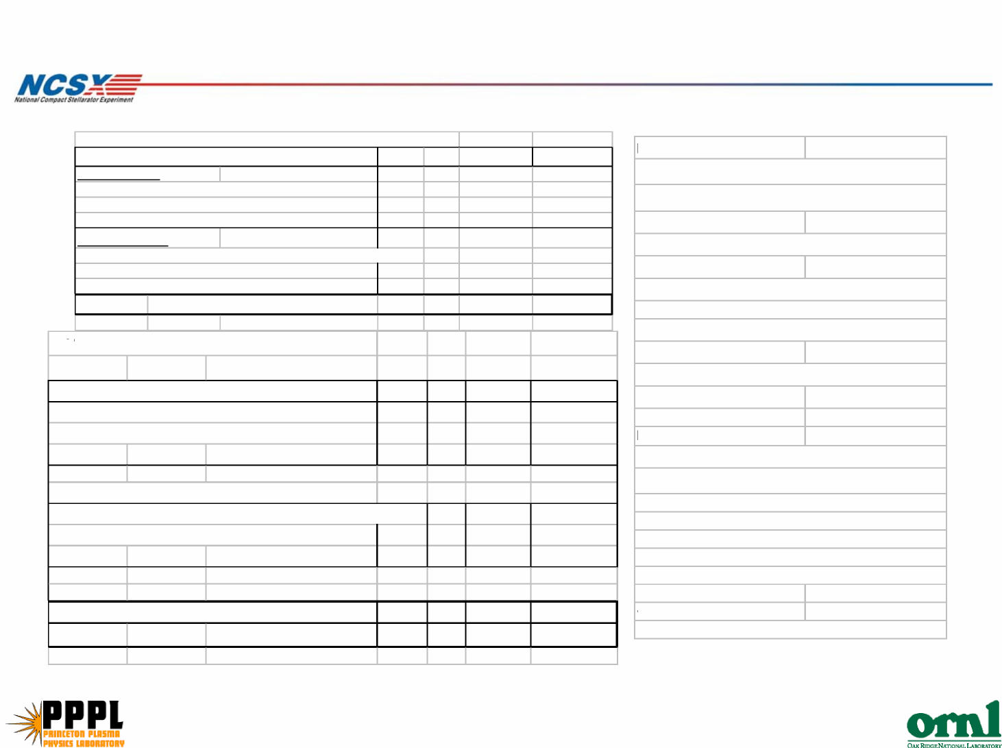
power in central I&C.
ESTIMATE INCLUDES:
SC Project Review of NCSX, April 8-10, 2008
P. L. Goranson - page 14
Total Costs- M&S and Labor
NCSX RESISTANCE HEATING TEMPERATURE CONTROL SYSTEM
MATERIALS & SUPPLY | Quantity units unit cst Total
Ray G estimate
A-B PLC hardware,Software, I/O modules, term blks
Control PC/Displays, Network modules,
Heater Drive components and Field Cable connectors |  |  |  | $211,262
F.Jones estimate
AC power, breakers, enclosures, panels, x-formers, wiring
Cable tray, conduit, TC/Htr Field cables
Rack filters, fans and installation materials |  |  |  | $42,894
TOTAL Materials cost (unloaded) $254,156
TAL LABOR ESTIMATE
Instrumentation & Control |  |  | eng | dsn | sr lab | tech
Computer Div. / R.Gernhardt / Electrical Tech |  |  |  | 0
Includes Design, Procurment, Fabrication and Installation
 |  | Man Days | 17 |  | 95 | 19
AC Power, Field/Rack/Tray Wire
F.Jones- Design/Drafting / Electrical Tech (Tech Shop) |  |  |  | 42
Includes Design, Procurment, Fabrication and Installation |  |  | 0
 |  | Man Days |  |  | 0 | 121
LABOR Totals (I&C + AC PWR) |  |  | eng | dsn | sr lab | tech
TOTAL Man Days |  |  | 17 | 42 | 95 | 140
TO
ESTIMATE BASED ON:
- PLC feedback control system to
maintain port temperatures during stanby
and bakeout operations.
- 120 zones of ACTIVE heater
temperature control.
- 282 thermocouple channels available for
monitoring and feedback control of
vacuum vessel and port extension
temperatures.
- Archival of TC temperatures and heater
- AC power labor and M&S costs.
- PLC programming and M&S costs
- Rack installations and wiring cost
- Includes TC/Htr Field cabling and
terminination costs from control racks
to feedthru ports at vessel.
- Test and commissioning costs.
COSTS NOT INCLUDED:
1) Control room PCs (2?) computer division

Schedule

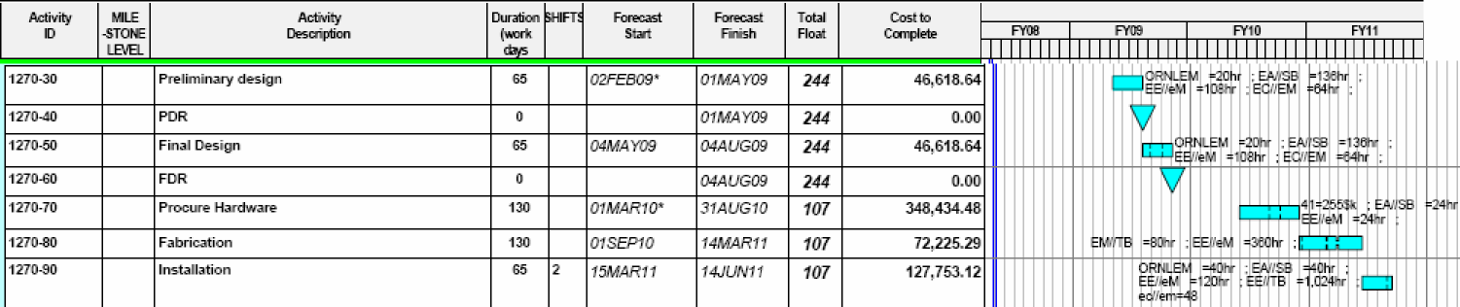
Staffing – Resources to be assigned by PPPL
SC Project Review of NCSX, April 8-10, 2008
P. L. Goranson - page 15

Cost Estimate Risks
Uncertainty of the Estimate Design Maturity Medium Design Complexity Low
SC Project Review of NCSX, April 8-10, 2008
P. L. Goranson - page 16
The design is straight forward, and uses industry standard components but is a conceptual design at this point.
Risk Mitigation
MDL built a prototype of the Heater and TC controller system
(driver and feedback control) and installed it as a furnace
controller, with good results.

